
RTL Design Sherpa
RAPIDS Hardware Architecture Specification
September 30, 2026

Table of Contents
1 Rapids Has Index 22
2 Document Information 23
2.1 Purpose 23
2.2 Scope 23
2.3 How This Book Relates to RAPIDS Beats 24
2.4 Audience 24
2.5 Document Conventions 24
2.5.1 Requirement Levels 24
2.5.2 Signal Directions 24
2.5.3 Byte and Beat Terms 25
2.5.4 Timing Diagrams 25
2.6 References 25
3 Revision History 27
3.1 Change Summary 29
3.1.1 Version 0.2 (2026-09-30) 29
3.1.2 Version 0.1 (2026-09-30) 29
4 Acronyms and Definitions 30
4.1 Acronyms 30
4.2 Definitions 30
4.3 Signal Naming Conventions 31
5 Product Overview 32
5.1 Introduction 32
5.2 System Context 32
5.2.1 Figure 1.1.1: RAPIDS in Its System 32
5.3 Target Applications 33
5.4 What the Byte Design Adds 33
5.4.1 Key Capabilities 34
5.5 Permanent Limitation 34
6 Key Features 35
6.1 Feature Summary 35
6.1.1 Multi-Channel Architecture 35
6.1.2 Byte-Granular Data Movement 35
6.1.3 Descriptor-Based Control 36
6.1.4 High-Performance Data Paths 36
6.1.5 Monitoring and Debug 36
6.2 Feature Details 37
6.2.1 SRAM Buffering 38
6.2.2 AXI Burst Optimization 38
6.2.3 Error Handling 39
7 System Context 40
7.1 Integration Overview 40
7.2 System Block Diagram 40
7.2.1 Figure 1.3.1: System Integration 40
7.3 Interface Connections 40
7.3.1 Memory Interface 40
7.3.2 Network Interface 41
7.3.3 Configuration Interface 42
7.4 Clock and Reset 42
7.4.1 Clock Domains 42
7.4.2 Reset Requirements 42
8 Block Diagram 44
8.1 Top-Level Architecture 44
8.1.1 Figure 2.1.1: RAPIDS Block Diagram 44
8.2 Top-Level Integration (rapids_top, rapids_cxs_top and the 8- and 16-channel tops) 44
8.3 Component Summary 45
8.3.1 Scheduler Group Array 45
8.3.2 Sink Data Path 46
8.3.3 Source Data Path 47
8.4 Hierarchy 47
8.5 Internal Buses 48
9 Data Flow 50
9.1 Overview 50
9.2 Byte Placement Rules 50
9.2.1 Figure 2.2.1: Sink Byte Placement 51
9.3 The Packet Record 51
9.3.1 Figure 2.2.2: Packet Record Flow 52
9.4 Concurrent Operation 53
9.4.1 Deadlock Prevention 53
10 Channel Architecture 55
10.1 Multi-Channel Design 55
10.2 Channel Resource Allocation 55
10.2.1 Figure 2.3.1: Per-Channel and Shared Resources 55
10.3 Per-Channel Resources 55
10.4 Shared Resources 56
10.5 Channel Scheduling 56
10.5.1 Arbitration Policy 56
10.5.2 Figure 2.3.2: Channel Arbitration onto a Shared AXI Port 56
10.6 Channel State Machine 57
10.7 Channel Isolation 59
10.7.1 Per-Channel Error Handling 59
11 Interface Summary 61
11.1 External Interface Overview 61
11.1.1 Figure 3.1.1: External Interfaces 61
11.2 Interface Port Summary 61
11.3 Clock and Reset 62
11.4 Interface Feature Matrix 62
11.5 Signal Count Summary 63
12 AXI4 Interface Specification 65
12.1 Overview 65
12.1.1 Byte Granularity on the Memory Side 65
12.2 Descriptor AXI Master 65
12.3 Sink AXI Master (Write) 66
12.3.1 Purpose 66
12.3.2 Configuration 66
12.3.3 Signal List 66
12.3.4 WSTRB Contract 67
12.4 Source AXI Master (Read) 68
12.4.1 Purpose 68
12.4.2 Configuration 68
12.4.3 Signal List 69
12.4.4 Read Coverage 69
12.5 AXI Protocol Constraints 70
12.5.1 Address Alignment 70
12.5.2 4 KB Boundary Handling 70
12.5.3 Response Handling 70
13 AXIS Interface Specification 72
13.1 Overview 72
13.1.1 Byte Semantics 72
13.2 Sink AXIS Slave 72
13.2.1 Purpose 72
13.2.2 Configuration 73
13.2.3 Signal List 73
13.2.4 Packet Contract 73
13.2.5 Descriptor-First Ordering 74
13.2.6 Backpressure Behavior 75
13.3 Source AXIS Master 75
13.3.1 Purpose 75
13.3.2 Configuration 75
13.3.3 Signal List 76
13.3.4 Egress Packet Contract 76
13.3.5 Timing 77
13.3.6 Data Availability 77
13.4 AXIS Protocol Notes 77
13.4.1 Handshake Rules 77
13.4.2 TLAST Semantics 77
13.4.3 TSTRB Usage 77
13.4.4 Channel Multiplexing via TID 78
14 APB Configuration Interface 79
14.1 Overview 79
14.2 APB Slave and Address Routing 79
14.2.1 APB Slave Signal List 80
14.2.2 Descriptor Kick-Off 80
14.3 Status Interface 81
14.3.1 Per-Channel Status Signals 81
14.3.2 Channel State Encoding 81
14.4 Configuration Registers 81
14.4.1 Address Range Validation 81
14.4.2 Configuration Registers 82
14.5 Programming Sequence 82
14.5.1 Initialization 82
14.5.2 Descriptor Kick-Off 83
15 Monitor Bus Interface 84
15.1 Overview 84
15.2 MonBus Packet Format 84
15.2.1 64-bit Packet Structure 84
15.2.2 Signal List 84
15.3 Packet Types 85
15.4 Agent IDs 85
15.5 Event Codes 86
15.5.1 Scheduler Events (Agent 0x30-0x37) 86
15.5.2 Descriptor Engine Events (Agent 0x10-0x17) 87
15.6 Event Data Encoding 87
15.6.1 Completion Event Data 87
15.6.2 Error Event Data 87
15.6.3 State Transition Event Data 87
15.7 MonBus Arbitration 87
15.7.1 Figure 3.5.1: MonBus Arbitration Tree 88
15.7.2 Arbitration Policy 88
15.8 Top-Level MonBus Delivery (monbus_axil4_axil4_group) 88
15.9 Integration Notes 89
15.9.1 Downstream Connection 89
15.9.2 Packet Rate 89
16 CXS Network Interface 90
16.1 Overview 90
16.1.1 Figure 3.6.1: Network Planes 90
16.2 Link Profile 91
16.3 Credits 92
16.4 Signal List 92
16.5 Flow Control and the Sink Contract 94
16.6 Monitoring 94
16.7 Routing and Payload Type (Proposed) 94
17 Use Case: Network-to-Memory Transfer 95
17.1 Scenario 95
17.2 Sequence 95
17.2.1 Ordering Rule 96
17.3 Worked Example 1: 77 Bytes at Offset 5 96
17.4 Worked Example 2: 4035 Bytes Crossing a 4 KB Boundary 97
17.5 Errors 98
17.6 Related Chapters 98
18 Use Case: Memory-to-Network Transfer 99
18.1 Scenario 99
18.2 Sequence 99
18.3 Worked Example 1: 77 Bytes at Offset 5 100
18.4 Worked Example 2: 4035 Bytes Crossing a 4 KB Boundary 101
18.5 Errors 101
18.6 Related Chapters 101
19 Use Case: Descriptor Chaining 102
19.1 Overview 102
19.2 Chain Structure 102
19.2.1 Figure 4.3.1: Descriptor Chain Structure 102
19.3 Descriptor Fields for Chaining 104
19.3.1 Relevant Fields 104
19.3.2 Chain Termination 104
19.4 Prefetch Optimization 106
19.4.1 Descriptor Prefetching 106
19.5 Multi-Channel Chaining 106
19.5.1 Figure 4.3.2: Independent Per-Channel Chains 107
19.6 Error During Chain 107
19.6.1 Error Handling 107
19.6.2 Recovery 108
20 Use Case: Multi-Channel Operation 109
20.1 Overview 109
20.2 Channel Independence 109
20.2.1 Figure 4.4.1: Independent Channels 109
20.3 Resource Arbitration 110
20.3.1 Descriptor Port Arbitration 110
20.3.2 Sink/Source Arbitration 110
20.3.3 Figure 4.4.2: Data-Path AXI Arbitration 110
20.4 Channel Isolation 111
20.4.1 Error Isolation 111
20.4.2 Per-Channel Soft Reset 111
20.5 Use Case Examples 111
20.5.1 Mixed Traffic Pattern 111
20.5.2 Bidirectional Transfer 112
20.5.3 Figure 4.4.3: Bidirectional Transfer 112
20.5.4 Load Balancing 112
20.5.5 Figure 4.4.4: Load Balancing by tid 113
20.6 Performance Considerations 113
20.6.1 Bandwidth Sharing 113
20.6.2 Latency Impact 114
20.7 MonBus Events 114
21 Descriptor Format 115
21.1 Overview 115
21.2 Descriptor Layout 115
21.2.1 256-Bit Structure 115
21.3 Field Descriptions 116
21.3.1 Control Bits [195:192] 116
21.3.2 Direction 116
21.3.3 Transfer Length [159:128] 116
21.3.4 Next Pointer [191:160] 116
21.3.5 Address Fields [127:0] 117
21.4 Alignment and Offsets 117
21.4.1 How the offset reaches the bus 118
21.4.2 4 KB boundaries 118
21.4.3 Zero-length descriptors 118
21.4.4 Packet record 119
21.5 Descriptor Opcodes (DATA / CTRL_READ / CTRL_WRITE) 119
21.6 Extended Descriptors (row/col-major addressing) 120
21.6.1 EXT descriptors stay beat-aligned (permanent limitation) 120
21.7 Descriptor Fetch 121
21.8 Alignment Requirements 121
21.9 What Changed from RAPIDS Beats 122
21.10 Descriptor Examples 123
21.10.1 Sink Descriptor (Network to Memory) 123
21.10.2 Source Descriptor (Memory to Network) 123
21.11 Software Construction 123
21.11.1 C Structure Example 123
21.11.2 Descriptor Ring Setup 124
22 Register Map 126
22.1 Overview 126
22.2 Address Space Layout 126
22.3 Base Registers (0x100-0x3FF) 127
22.4 Monitor Registers (+0x800 within each half) 128
22.5 Key Register Fields 129
22.5.1 GLOBAL_CTRL (0x100) - Read/Write 129
22.5.2 SCHED_TIMEOUT_LIMIT (0x208) - Read/Write 130
22.5.3 DESCENG_CONFIG (0x220) - Read/Write 130
22.5.4 Tile Header Status (0x2D0-0x2D8) - byte-granular RAPIDS with TILE_HDR = 1 130
22.6 Channel Kick Sequence 132
22.7 Address Decoding 132
23 16-Channel Register Map 134
24 Initialization Sequence 136
24.1 Overview 136
24.2 Boot Sequence 137
24.2.1 Figure 5.3.1: Bring-Up Sequence 137
24.3 What the Hardware Requires 138
24.4 Detailed Steps 138
24.4.1 Step 1: Verify Hardware Presence 138
24.4.2 Step 2: Optional Reset 139
24.4.3 Step 3: Configure the Engine 139
24.4.4 Step 4: Optional Monitor and Interrupt Egress 140
24.4.5 Step 5: Build Descriptors 140
24.4.6 Step 6: Enable 141
24.5 Starting Transfers 141
24.5.1 Kick a Channel 141
24.6 Completion and Interrupt Handling 142
24.7 Reset and Recovery 143
24.7.1 Per-Channel Reset 143
24.7.2 Global Reset 143
25 Error Handling 144
25.1 Overview 144
25.2 Error Classes 144
25.3 The Byte-Granular Error: Packet Length Mismatch 147
25.3.1 Contract 147
25.3.2 Exposure 147
25.3.3 How it Clears 148
25.3.4 Prevention 148
25.4 Shared Error Classes 148
25.4.1 Invalid or Unfetchable Descriptor 148
25.4.2 Data-Path AXI Errors 148
25.4.3 Control Engine Errors 148
25.4.4 Write-Progress Timeout 149
25.5 Not Errors 149
25.5.1 Packet Record Queue Full 149
25.5.2 Sink Beat With No Packet Record 149
25.5.3 The 4 KB Burst Cap 150
25.6 Error Reporting 150
25.6.1 Registers 150
25.6.2 MonBus 151
25.7 Recovery 151
25.7.1 Channel Reset 151
25.7.2 What the Reset Does to Work in Flight 152
25.8 Software Checklist 154
25.9 Related Chapters 154
26 Throughput 156
26.1 Theoretical Maximum 156
26.2 Byte Efficiency 156
26.2.1 4 KB Boundaries 157
26.2.2 Head-of-Line Delay on the Sink Stream 157
26.3 Measured Results 158
26.3.1 Byte Campaign (Correctness) 158
26.3.2 Shared Engines on the Board 159
26.3.3 RAPIDS Beats Performance Report 160
26.3.4 Using the Beats Numbers 162
26.4 Throughput Limiting Factors 162
26.5 Related Chapters 163
27 Latency Characteristics 164
27.1 Latency Components 164
27.1.1 Kick-to-First-Beat Breakdown 164
27.1.2 Total Latency Formula 165
27.2 First-Beat Latency 165
27.3 Control-Descriptor Latency 165
27.4 Latency Variability 166
27.4.1 Sources of Variability 166
27.4.2 Worst-Case Latency 166
27.5 Latency Optimization 166
27.5.1 Software Recommendations 166
27.5.2 Hardware Configuration 166
28 Resource Estimates 168
28.1 Build Configuration 168
28.2 FPGA Resource Summary 168
28.3 Timing 169
28.4 Board Result 170
28.5 Shared Engines: Before and After 170
28.6 Comparison with the Beats Build 171
28.7 What Depends on What 172
28.8 Related Chapters 173

List of Figures
Figure 1.1.1: RAPIDS in Its System 32
Figure 1.3.1: System Integration 40
Figure 2.1.1: RAPIDS Block Diagram 44
Figure 2.2.1: Sink Byte Placement 51
Figure 2.2.2: Packet Record Flow 52
Figure 2.3.1: Per-Channel and Shared Resources 55
Figure 2.3.2: Channel Arbitration onto a Shared AXI Port 56
Figure 3.1.1: External Interfaces 61
Figure 3.5.1: MonBus Arbitration Tree 88
Figure 3.6.1: Network Planes 90
Figure 4.3.1: Descriptor Chain Structure 102
Figure 4.3.2: Independent Per-Channel Chains 107
Figure 4.4.1: Independent Channels 109
Figure 4.4.2: Data-Path AXI Arbitration 110
Figure 4.4.3: Bidirectional Transfer 112
Figure 4.4.4: Load Balancing by tid 113
Figure 5.3.1: Bring-Up Sequence 137

List of Tables
Table 1: Target Audience 24
Table 2: Byte and Beat Terms 25
Table 3: Reference Documents 25
Table 4: Document Revision History 27
Table 5: Acronym Definitions 30
Table 6: Term Definitions 30
Table 7: Signal Naming Conventions 31
Table 8: Target Applications 33
Table 9: Byte Design Additions 33
Table 10: Data Path Summary 36
Table 11: SRAM Buffer Parameters 38
Table 12: AXI Optimization Features 38
Table 13: Error Handling Summary 39
Table 14: AXI Memory Interface Requirements 41
Table 15: AXIS Network Interface 41
Table 16: Configuration Methods 42
Table 17: Clock Domains 42
Table 18: Reset Signals 42
Table 19: Scheduler Array Components 45
Table 20: Sink Path Components 47
Table 21: Source Path Components 47
Table 22: Internal Bus Summary 48
Table 23: Byte Placement Rules 50
Table 24: Resource Isolation 53
Table 25: Per-Channel Resources 55
Table 26: Shared Resources 56
Table 27: Channel Isolation Features 59
Table 28: External Interface Summary 61
Table 29: Clock and Reset Signals 62
Table 30: Interface Feature Matrix 62
Table 31: Signal Count Summary 63
Table 32: Where byte granularity is carried on AXI4 65
Table 33: Sink AXI Configuration 66
Table 34: Sink AXI Signals 66
Table 35: WSTRB per beat 67
Table 36: Source AXI Configuration 68
Table 37: Source AXI Signals 69
Table 38: Address Alignment Requirements 70
Table 39: AXI Response Handling 70
Table 40: Byte Semantics of the RAPIDS Streams 72
Table 41: Sink AXIS Configuration 73
Table 42: Sink AXIS Signals 73
Table 43: Reasons the Sink Deasserts TREADY 75
Table 44: Source AXIS Configuration 75
Table 45: Source AXIS Signals 76
Table 46: Egress Packet Contract 76
Table 47: TLAST Usage 77
Table 48: TSTRB Examples 77
Table 49: APB Address Routing 79
Table 50: APB Slave Signals 80
Table 51: Status Signals 81
Table 52: Scheduler State Encoding 81
Table 53: Key Configuration Registers 82
Table 54: MonBus Signals 84
Table 55: MonBus Packet Types 85
Table 56: RAPIDS Agent IDs 85
Table 57: Scheduler Event Codes 86
Table 58: Descriptor Engine Event Codes 87
Table 59: Top-Level MonBus AXI-Lite Group 88
Table 60: MonBus Packet Rates 89
Table 61: CXS Link Profile 91
Table 62: CXS Top Parameters 92
Table 63: CXS Link Signals 93
Table 64: CXS Status Signals 93
Table 65: Network-to-Memory Sequence 95
Table 66: Example 1 Quantities 96
Table 67: Example 1 Write Beats 96
Table 68: Example 2 Quantities 97
Table 69: Example 2 Write Bursts 97
Table 70: Network-to-Memory Error Cases 98
Table 71: Memory-to-Network Sequence 99
Table 72: Example 1 Quantities 100
Table 73: Example 1 Egress Steps 100
Table 74: Example 2 Quantities 101
Table 75: Memory-to-Network Error Cases 101
Table 76: Chaining-Related Descriptor Fields 104
Table 77: Mixed Traffic Channel Assignment 111
Table 78: Bandwidth Distribution 113
Table 79: Arbitration Latency 114
Table 80: Control Bits 116
Table 81: Address Field Usage 117
Table 82: Beat Count Examples (BYTE_LANES = 32) 117
Table 83: Descriptor Opcodes 119
Table 84: Address and Length Alignment 121
Table 85: Descriptor Differences, RAPIDS Beats to RAPIDS 122
Table 86: Base Registers 127
Table 87: Monitor Registers (+0x800 within each half; SRC at 0x0800, SNK at 0x1800) 128
Table 88: GLOBAL_CTRL Register 129
Table 89: SCHED_TIMEOUT_LIMIT Register 130
Table 90: DESCENG_CONFIG Register 130
Table 91: Tile Header Status Registers 130
Table 92: Register Differences, 8- and 16-Channel Maps 134
Table 93: Conditions for a Channel to Run 138
Table 94: Error Classes 144
Table 95: Length Mismatch Cases 147
Table 96: Where the Length Mismatch Appears 147
Table 97: Timeout Configuration 149
Table 98: Error Registers 150
Table 99: Channel Reset: Handling of In-Flight Work 152
Table 100: Software Checklist 154
Table 101: Theoretical Maximum (256-bit Build) 156
Table 102: Beats and Efficiency for Small and Unaligned Transfers 157
Table 103: Sources of Measured Figures 158
Table 104: Byte Campaign on the Board (7 of 7 Pass) 158
Table 105: Board Results, SHARED_ENGINES 0 and 1 159
Table 106: Per-Point Comparison 159
Table 107: RAPIDS Beats Build, 8 Channels at 128 KB per Channel 161
Table 108: RAPIDS Beats Build, Transfer Size Sweep at 8 Channels 161
Table 109: RAPIDS Beats Build, Channel Scaling at 4096 Beats per Channel 161
Table 110: RAPIDS Beats Build, Burst Length Sweep at 8 Channels and 1024 Beats 162
Table 111: Throughput Limiting Factors 162
Table 112: Board Build Configuration 168
Table 113: Post-Route Utilization, 8 Channels, 256 Bits 169
Table 114: Timing at 100 MHz 169
Table 115: Post-Route Utilization, SHARED_ENGINES 0 and 1 170
Table 116: Beats and Byte-Granular Builds 172
Table 117: Scaling Notes 172

1 Rapids Has Index
Generated: 2026-10-17

RTL Design Sherpa · Learning Hardware Design Through Practice GitHub · Documentation Index · MIT License

2 Document Information
Document Title: RAPIDS Hardware Architecture Specification (HAS) Document Number: RAPIDS-HAS-002 Version: 0.2 Date: 2026-09-30 Status: Draft

2.1 Purpose
This Hardware Architecture Specification (HAS) defines the external interfaces, system integration requirements, and high-level architecture of RAPIDS, the byte-granular descriptor-driven DMA engine. RAPIDS counts bytes, not beats: a descriptor names a byte length and byte addresses, the write master carries byte enables, and the AXI-Stream ports carry packed bytes with a partial last beat.
RAPIDS Beats, the beat-granular design that came first, remains in the repository and remains supported. Its specification is the RAPIDS Beats HAS. The two designs share most of their external behavior, so this document links the RAPIDS Beats chapters that apply unchanged and rewrites only the chapters where the byte-granular design differs.

2.2 Scope
This document covers:
- External interface specifications (AXI4, AXIS, APB, MonBus) as they apply to the byte-granular design
- System-level block diagrams and data flows, including the byte placement rules
- Programming model and descriptor format (length in bytes)
- Use cases and operational sequences with unaligned transfers
- Performance characteristics and constraints
This document does NOT cover:
- Internal module architecture (see the RAPIDS MAS)
- RTL implementation details (see the RAPIDS MAS)
- The RAPIDS Beats design (see the RAPIDS Beats HAS)
- Verification test plans
- Physical design constraints

2.3 How This Book Relates to RAPIDS Beats
Chapters that are identical for both designs are not copied. The index links them from the RAPIDS Beats HAS, and the table of contents marks each one “(shared with RAPIDS Beats)”. When such a chapter names a module, the byte-granular module is the same name without the _beats suffix, for example rapids_top for rapids_beats_top.
Where a shared chapter says a descriptor length is a number of beats, read it as a number of bytes for RAPIDS. Every chapter that carries that distinction is rewritten in this book, so a reader following the RAPIDS chapters in order will not meet the beat unit except in the comparison tables.

2.4 Audience
Target Audience
Role | Relevance
System Architect | Primary - system integration
Hardware Integration Engineer | Primary - interface connection
Software Engineer | Primary - driver development, descriptor construction
Verification Engineer | Reference - interface protocols
RTL Designer | Reference - external constraints

2.5 Document Conventions

2.5.1 Requirement Levels
Term | Meaning
SHALL | Mandatory requirement
SHOULD | Recommended but not mandatory
MAY | Optional feature

2.5.2 Signal Directions
- Input: Signal driven by external logic into RAPIDS
- Output: Signal driven by RAPIDS to external logic

2.5.3 Byte and Beat Terms
Byte and Beat Terms
Term | Meaning
Beat | One transfer on a data bus, DATA_WIDTH/8 bytes wide (BYTE_LANES)
Offset | The low log2(BYTE_LANES) bits of a byte address: the lane where a transfer starts
Packet | The bytes of one descriptor as they appear on an AXI-Stream port, delimited by TLAST
Packet record | The {bytes, offset} pair the scheduler hands each data path for one descriptor

2.5.4 Timing Diagrams
Timing diagrams use WaveDrom format with the following conventions:
- p = Positive clock edge
- 0/1 = Logic low/high
- x = Unknown/don’t care
- = = Data value (with label)
- . = Previous value continues

2.6 References
Reference Documents
Document | Description
RAPIDS MAS | Micro-architecture Specification for the byte-granular design
RAPIDS Beats HAS | Architecture specification for the beat-granular design; source of every shared chapter
ARM AMBA AXI4 Specification | AXI4 protocol reference
ARM AMBA AXI-Stream Specification | AXIS protocol reference
Arm AMBA CXS Protocol Specification (IHI 0079, Issue D) | CXS protocol reference (CXS tops)
RAPIDS PRD | Product Requirements Document

RTL Design Sherpa · Learning Hardware Design Through Practice GitHub · Documentation Index · MIT License

3 Revision History
Document Revision History
Version | Date | Author | Changes
0.7 | 2026-10-17 | RTL Design Sherpa | Shared engines (SHARED_ENGINES, default 1): key features, block diagram components and hierarchy, and the whole-unit diagram; 8- and 16-channel tops; Resource Estimates gains the measured before-and-after builds and Throughput the board comparison of the two
0.6 | 2026-10-17 | RTL Design Sherpa | Tile packet header (TILE_HDR): descriptor ptype / op / destination fields implemented; new 16-Channel Register Map section (rapids_16ch_top, KICK_ENABLE at 0x080); tile status registers (shared Register Map)
0.5 | 2026-10-16 | RTL Design Sherpa | Routing and payload-type PROPOSAL (not implemented): the tile packet header is defined in the compute-engine tile’s TILE_SPEC Section 11; CXS only transports it. Descriptor Format points at the proposed fields
0.4 | 2026-10-16 | RTL Design Sherpa | Network planes and CXS: links the shared CXS Network Interface chapter; block diagram, hierarchy, system context and key features updated for rapids_top / rapids_cxs_top; all block diagrams updated
0.3 | 2026-10-16 | RTL Design Sherpa | SRAM_DEPTH stated as beats per channel, per direction
0.2 | 2026-09-30 | RTL Design Sherpa | Channel reset recovers every error class; the aresetn-only caveats are removed from Error Handling
0.1 | 2026-09-30 | RTL Design Sherpa | Initial release: the byte-granular RAPIDS, split from the RAPIDS Beats HAS

3.1 Change Summary

3.1.1 Version 0.2 (2026-09-30)
Channel reset closes the data-path error gap
- The per-channel reset now reaches the AXI read and write engines and both byte data paths. The data read and write response errors and the sink packet length error clear on a channel reset, and the channel takes a good descriptor afterwards. Error Handling no longer tells software to use aresetn for these.
- Error Handling gains the list of what a channel reset does to work in flight, including the sink tail discard and the unterminated source packet.
- Head-of-line blocking on a shared sink stream is unchanged and stays documented.

3.1.2 Version 0.1 (2026-09-30)
Initial Release
- The byte-granular RAPIDS (rapids TASK-019) is the product design. The RAPIDS Beats design was its stepping stone and keeps its own book, the RAPIDS Beats HAS.
- New chapters where the byte design differs: Product Overview, Key Features, System Context, Block Diagram, Data Flow, AXI4 Master Interface, AXIS Interface, both use cases, Descriptor Format, Error Handling, Throughput and Resource Estimates.
- Chapters unchanged from RAPIDS Beats are linked from the RAPIDS Beats HAS rather than copied, so a correction there reaches both books.
- Permanent limitation recorded: TYPE=EXT (row and column striding) descriptors stay beat-aligned. Linear descriptors may start at any byte.

RTL Design Sherpa · Learning Hardware Design Through Practice GitHub · Documentation Index · MIT License

4 Acronyms and Definitions

4.1 Acronyms
Acronym Definitions
Acronym | Definition
AXI | Advanced eXtensible Interface
AXIS | AXI-Stream
APB | Advanced Peripheral Bus
DMA | Direct Memory Access
FIFO | First-In First-Out
FSM | Finite State Machine
HAS | Hardware Architecture Specification
MAS | Module Architecture Specification
MonBus | Monitor Bus
RAPIDS | Rapid AXI Programmable In-band Descriptor System
SRAM | Static Random Access Memory

4.2 Definitions
Term Definitions
Term | Definition
Beat | Single data transfer unit (512 bits = 64 bytes in default configuration)
Channel | Independent DMA context with dedicated descriptor processing
Descriptor | 256-bit control structure defining a single DMA transfer
Descriptor Chain | Linked list of descriptors for multi-transfer operations
Sink Path | Data flow from network (AXIS slave) to memory (AXI write)
Source Path | Data flow from memory (AXI read) to network (AXIS master)
Fill | Operation writing data into SRAM buffer (sink path input)
Drain | Operation reading data from SRAM buffer (source path output)

4.3 Signal Naming Conventions
Signal Naming Conventions
Prefix/Suffix | Meaning
m_axi_* | AXI Master signals
s_axis_* | AXIS Slave signals
m_axis_* | AXIS Master signals
cfg_* | Configuration signals
*_valid | Handshake valid signal
*_ready | Handshake ready signal
*_n | Active-low signal

RTL Design Sherpa · Learning Hardware Design Through Practice GitHub · Documentation Index · MIT License

5 Product Overview

5.1 Introduction
RAPIDS is a high-performance network-to-memory accelerator for descriptor-based data movement. It bridges network interfaces (AXI-Stream) with system memory (AXI4), moving data without CPU intervention.
RAPIDS is byte-granular. A descriptor gives a length in bytes and byte addresses. The sink writes exactly the bytes the network sent, using byte enables on the AXI4 write data channel. The source emits exactly the bytes the descriptor names, packed from lane 0 of the AXI-Stream, with a partial last beat when the length is not a multiple of the bus width. A transfer may begin at any byte address.
The earlier RAPIDS Beats design moved whole beats only. It was the stepping stone to this design, it stays supported, and its specification is the RAPIDS Beats HAS.

5.2 System Context

5.2.1 Figure 1.1.1: RAPIDS in Its System
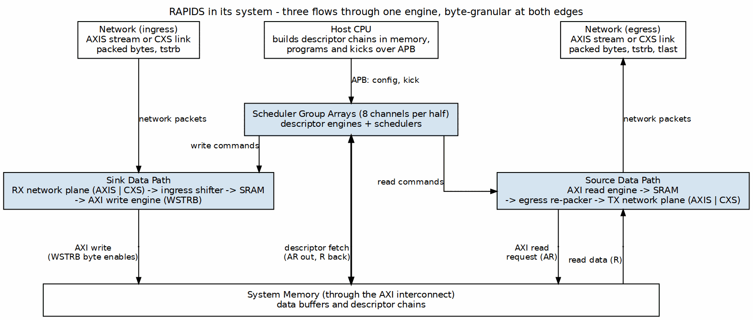
RAPIDS in Its System
Source: ch01_product_context.dot

5.3 Target Applications
Target Applications
Application | Description | Key Requirements
Network Offload | Receive packets from the network, store to memory | Low latency, arbitrary packet lengths
Scatter-Gather DMA | Multi-descriptor data movement | Descriptor chaining
Protocol Processing | Header and payload separation at byte boundaries | Any byte offset, one packet per descriptor
Streaming Accelerator | Front-end for compute engines | Continuous data flow

5.4 What the Byte Design Adds
Byte Design Additions
Capability | RAPIDS Beats | RAPIDS
Transfer unit | Full beats only | Bytes
Address alignment | Pre-aligned required | Any byte for linear descriptors
Sink write | Every lane written | Byte enables mark the bytes written
Source stream | Full beats | Packed bytes, partial last beat, TLAST per descriptor
Flow control | Backpressure-based | Backpressure-based
Flow control is unchanged: both designs rely on backpressure, and neither has credit management.

5.4.1 Key Capabilities
- 8 Independent Channels - Concurrent transfers with dedicated resources
- Byte-Granular Transfers - Length in bytes, start at any byte address
- Descriptor Chaining - Automatic next-descriptor fetch
- Dual Data Paths - Simultaneous sink (write) and source (read)
- Monitor Integration - Real-time event reporting via MonBus
- Error Detection - AXI error propagation, and a packet-length check on the sink
- Swappable Network Plane - AXI-Stream or CXS (Arm IHI 0079 Issue D) at the top, same core

5.5 Permanent Limitation
TYPE=EXT descriptors, which stride across rows and columns, stay beat-aligned by design. Their addresses SHALL be beat-aligned and their lengths SHALL be a multiple of the beat size. This is a permanent property of the design, not a phase of a schedule. Linear descriptors carry no such restriction. See the Descriptor Format chapter.

RTL Design Sherpa · Learning Hardware Design Through Practice GitHub · Documentation Index · MIT License

6 Key Features

6.1 Feature Summary

6.1.1 Multi-Channel Architecture
- 8 or 16 Independent Channels per direction, each with its own scheduler. The 16-channel tops use the 16-channel register map.
- Per-Channel State Machines for concurrent operation
- Shared Engines: each direction has one descriptor engine, one control-read engine and one control-write engine for all its channels (SHARED_ENGINES = 1, the default). Each engine picks channels round-robin and owns its AXI master. SHARED_ENGINES = 0 builds one of each per channel instead. On the Genesys 2 board build, sharing saves 20% of the RAPIDS LUTs and 37% of its flip-flops, and the 117-point board profile measures the same throughput on both builds (geometric-mean change under 0.2%).
- Channel Isolation prevents cross-channel interference

6.1.2 Byte-Granular Data Movement
- Length in Bytes. The descriptor length field counts bytes. A length of zero moves nothing.
- Any Start Byte. Source and destination byte addresses may have any offset within a beat (linear descriptors).
- Byte Enables on the Write Master. WSTRB is exactly the set of bytes the descriptor writes. The first beat of a transfer strobes from the start offset, the last beat strobes up to the final byte, and every beat between strobes all lanes.
- Packed AXI-Stream. The sink accepts packed bytes with a contiguous TSTRB on the last beat. The source emits packed bytes, contiguous TSTRB, and TLAST on the last beat of each descriptor.
- One Packet per Descriptor. The source ends every descriptor with TLAST. The sink expects one TLAST-delimited packet per descriptor and checks its byte count against the descriptor length.
- Beat-Aligned Bus Traffic. AXI addresses are beat-aligned and no burst crosses a 4 KB boundary. The byte offset never reaches an AXI address: the sink carries it in WSTRB and the source drops it at the egress.

6.1.3 Descriptor-Based Control
- 256-bit Descriptor Format with all transfer parameters
- Automatic Chaining follows next_descriptor_ptr links
- Last Descriptor Flag terminates chain processing
- IRQ Generation via gen_irq descriptor flag
- Control Descriptors (CTRL_READ consumer gate, CTRL_WRITE producer doorbell) for in-memory producer and consumer synchronization without moving payload. They are unchanged from RAPIDS Beats; see the Descriptor Format chapter and the shared Descriptor Chaining chapter.

6.1.4 High-Performance Data Paths
Data Path Summary
Path | Direction | Bandwidth | Features
Sink | Network to Memory | DATA_WIDTH per clock | Ingress byte shifter, SRAM buffering, AXI burst writes with byte enables
Source | Memory to Network | DATA_WIDTH per clock | AXI burst reads, SRAM buffering, egress byte re-packer

6.1.5 Monitoring and Debug
- 64-bit MonBus Packets for all significant events
- State Transition Reports track FSM activity
- Error Event Codes for fault diagnosis
- Performance Metrics for throughput analysis

6.2 Feature Details
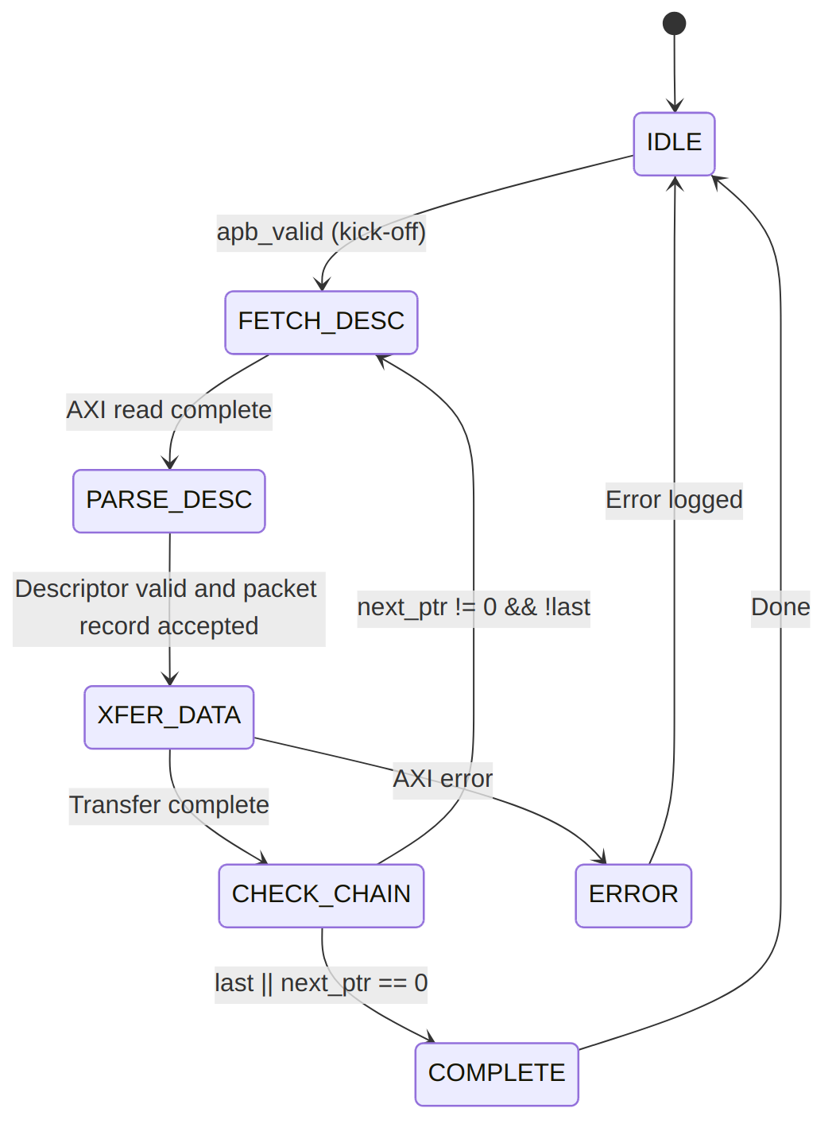
Descriptor Processing
The scheduler leaves the descriptor-fetch state only when every data path the descriptor uses has room for its packet record. A full record queue holds the channel there; it is backpressure, not an error.

6.2.1 SRAM Buffering
Each channel has its own buffer in each data path (sink and source), SRAM_DEPTH beats deep:
SRAM Buffer Parameters
Parameter | Default | Description
SRAM_DEPTH | 4096 | Beats per channel, per direction (parameter of rapids_top); one beat is one DATA_WIDTH entry
Source entry | DATA_WIDTH bits | Data only
Sink entry | DATA_WIDTH + DATA_WIDTH/8 bits | Data plus one byte-enable bit per lane
The buffer holds SRAM_DEPTH x DATA_WIDTH/8 bytes per channel per direction. At the defaults (4096 beats, 512 bits) that is 256 KB, a simulation size. The Genesys 2 builds use 128 beats of 32 bytes, 4 KB per channel.
Buffer Operation:
- Sink Path: Fill from AXIS (from the RX network plane, AXIS or CXS) through the ingress shifter, drain to the AXI write engine
- Source Path: Fill from the AXI read engine, drain through the egress re-packer to AXIS (to the TX network plane, AXIS or CXS)
- Flow Control: Backpressure when the buffer is full or empty

6.2.2 AXI Burst Optimization
AXI Optimization Features
Feature | Implementation
Burst Length | Up to 256 beats (AXI4 maximum)
Outstanding Transactions | Configurable
Address Alignment | Beat-aligned AxADDR; the byte offset rides in WSTRB or is dropped at the egress
4KB Boundary | Every burst is capped at the boundary

6.2.3 Error Handling
Error Handling Summary
Error Type | Detection | Response
AXI SLVERR | Response check | Transfer aborted
AXI DECERR | Response check | Transfer aborted
Timeout | Watchdog timer | Recoverable error
Packet length mismatch | Sink counts strobed bytes at TLAST | Sticky per-channel write error

RTL Design Sherpa · Learning Hardware Design Through Practice GitHub · Documentation Index · MIT License

7 System Context

7.1 Integration Overview
RAPIDS integrates into a system as a DMA engine bridging network interfaces and system memory. This chapter describes the external connections and the system-level requirements that differ from RAPIDS Beats. Everything not mentioned here matches the RAPIDS Beats System Context chapter.

7.2 System Block Diagram

7.2.1 Figure 1.3.1: System Integration
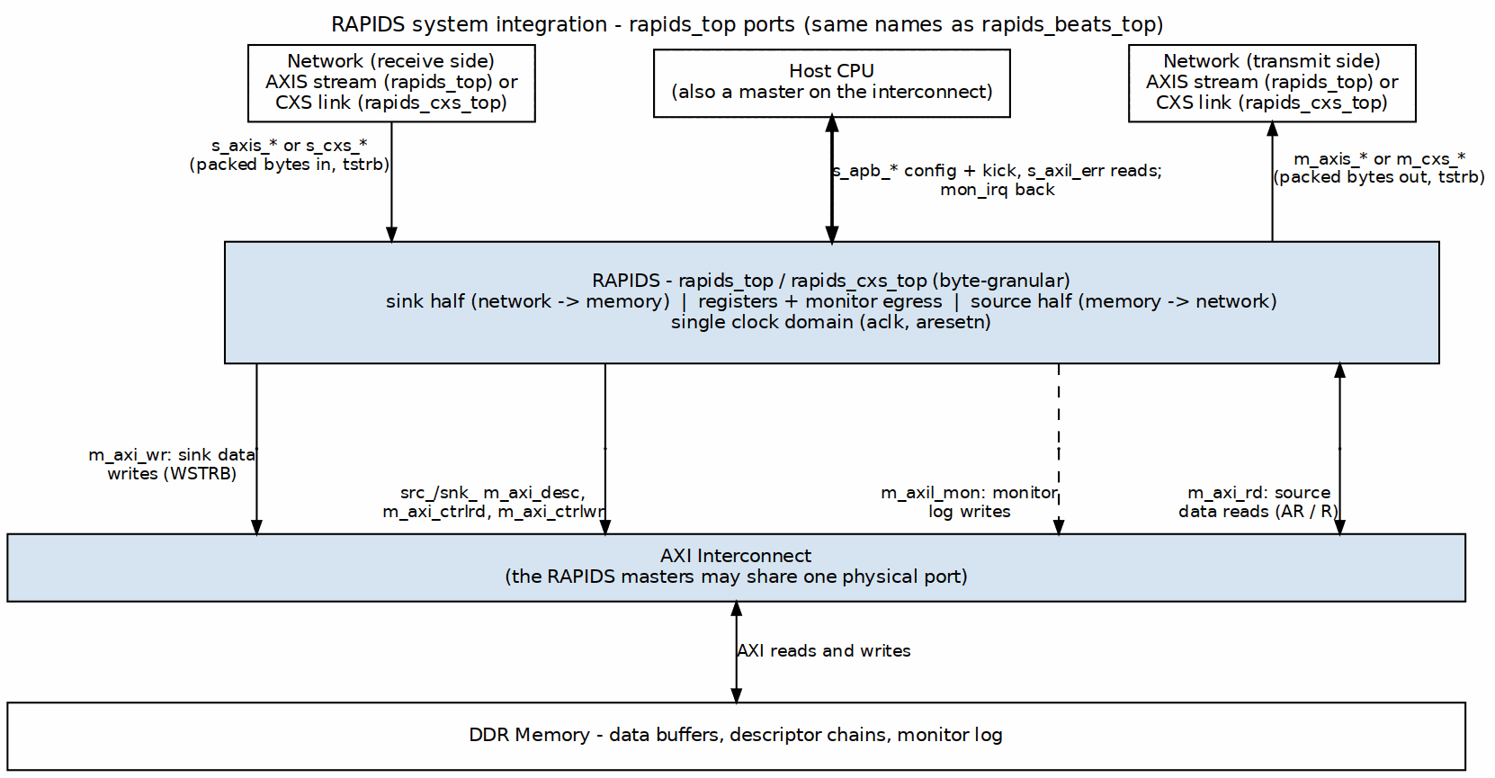
System Integration
Source: ch01_system_integration.dot

7.3 Interface Connections

7.3.1 Memory Interface
RAPIDS reaches system memory through the AXI4 masters below. Each half (src_, snk_) has its own descriptor master and its own two control masters (m_axi_ctrlrd, m_axi_ctrlwr). With monitors built, an AXI-Lite master (m_axil_mon) also writes the monitor log:
AXI Memory Interface Requirements
Port | Access Pattern | Typical Bandwidth
Descriptor AXI | Random read (256-bit) | Low (<100 MB/s)
Sink AXI | Sequential write with byte enables | High (up to interface max)
Source AXI | Sequential read | High (up to interface max)
Interconnect Requirements:
- All of these ports MAY share a single physical AXI port with arbitration
- The descriptor port has the lowest bandwidth requirement
- Sink and Source ports should have balanced bandwidth allocation
- The memory system SHALL honor WSTRB on the sink write master. A slave that ignores byte enables corrupts the bytes outside a partial beat. Every AXI4-conformant slave honors them.

7.3.2 Network Interface
The network side is a swappable plane. The AXIS tops use standard AXI-Stream, below; the CXS tops (*_cxs_top) replace the two streams with one CXS link per direction, with CXSSRCID carrying the channel (see the CXS Network Interface chapter):
AXIS Network Interface
Interface | Role | Signals
Sink AXIS | Receives data from the network | TDATA, TSTRB, TLAST, TID, TVALID, TREADY
Source AXIS | Sends data to the network | TDATA, TSTRB, TLAST, TID, TVALID, TREADY
Protocol Notes:
- Byte-granular: the byte lanes are strobed by TSTRB, and the strobed lanes of a beat SHALL be contiguous from lane 0. RAPIDS does not use TKEEP. Only the last beat of a packet may have a partial TSTRB.
- A packet is the bytes of one descriptor, delimited by TLAST. The source ends every descriptor with TLAST. The sink expects its packet to match the descriptor’s byte length.
- TID selects the channel. TDEST and TUSER are available for sideband information.
- The sink holds TREADY low for a beat until the packet record of that beat’s channel (TID) exists, which is after that channel’s descriptor has been fetched. TREADY is one signal, so a waiting beat also holds up the beats behind it on the same stream. Software SHOULD issue a channel’s descriptor before its packet arrives, or stream one channel at a time.

7.3.3 Configuration Interface
Software configures RAPIDS through register writes:
Configuration Methods
Method | Interface | Usage
Direct Write | Memory-mapped | Register configuration
Descriptor Kick | APB-style | Start descriptor processing

7.4 Clock and Reset

7.4.1 Clock Domains
Clock Domains
Clock | Frequency | Usage
aclk | 100-500 MHz | All RAPIDS logic
Note: RAPIDS uses a single clock domain. Crossing into other frequency domains is handled externally.

7.4.2 Reset Requirements
Reset Signals
Signal | Type | Description
aresetn | Active-low | Async assert, sync deassert
Reset Sequence:
- Assert aresetn low for minimum 4 clock cycles
- Ensure all AXI interfaces are idle before reset
- Release reset synchronously to aclk rising edge
- Wait 16 clock cycles before initiating transfers
Reset clears every packet record, every ingress spill, and every sticky write error.

RTL Design Sherpa · Learning Hardware Design Through Practice GitHub · Documentation Index · MIT License

8 Block Diagram

8.1 Top-Level Architecture
RAPIDS has the same block structure as RAPIDS Beats: a scheduler group array per direction, a data path per direction, and a top level that adds the registers, configuration mapping and monitoring. What the byte design adds sits at the edges of the two data paths: an ingress shifter on the sink, an egress re-packer on the source, and a packet record passed from each scheduler to its data path.

8.1.1 Figure 2.1.1: RAPIDS Block Diagram
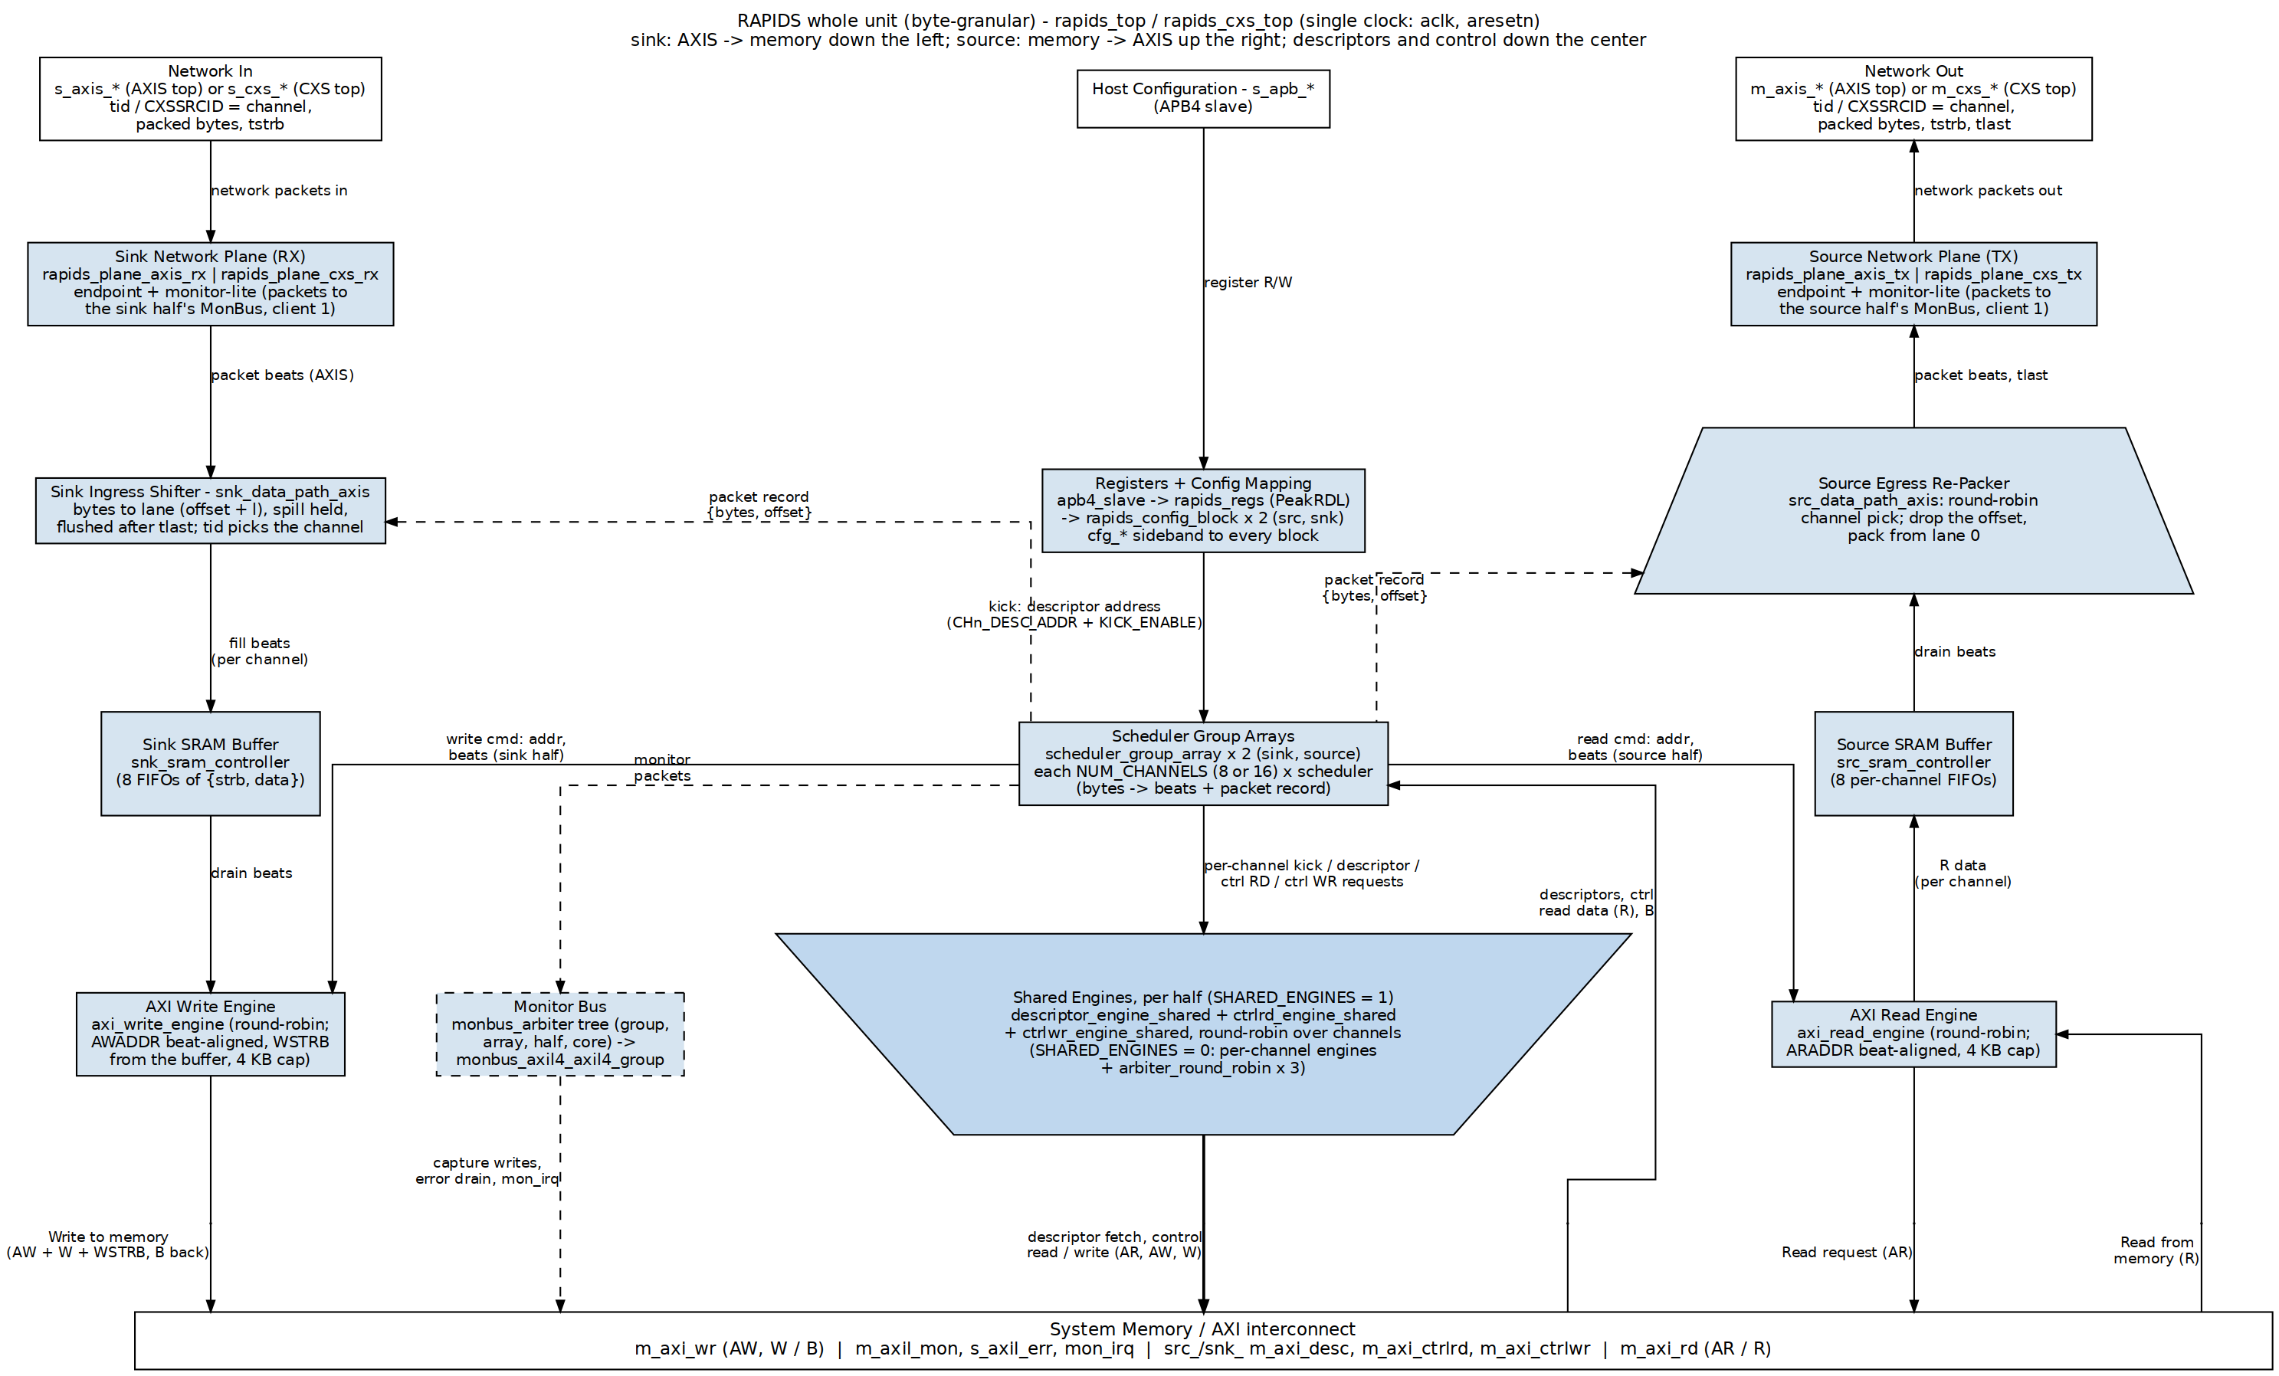
RAPIDS block diagram
Source: 01_byte_block_diagram.dot

8.2 Top-Level Integration (rapids_top, rapids_cxs_top and the 8- and 16-channel tops)
rapids_core is wrapped by rapids_top, which adds the software register interface, configuration mapping, and monitoring infrastructure. The integration is identical to rapids_beats_top: a single APB slave feeds a command/response router into the rapids_regs register block, rapids_config_block translates the register outputs into the cfg_* signals, and a monbus_axil4_axil4_group delivers the merged monitor stream to an AXI-Lite error-drain slave, an AXI-Lite capture master, and a mon_irq interrupt. The register map, the APB interface and the MonBus interface are shared with RAPIDS Beats; see the linked chapters.
The top-level ports have the same names as rapids_beats_top. The only port-level differences are the byte enables: the sink write master’s m_axi_wr_wstrb is driven from the buffered byte enables instead of all ones, and the two AXI-Stream ports use tstrb as a real byte mask.
The network endpoints sit in two network planes outside the core, exactly as in RAPIDS Beats: rapids_top uses the AXIS planes and rapids_cxs_top the CXS planes, both generated from rapids_top_base. The generator also emits rapids_8ch_top, rapids_16ch_top and their CXS twins, which fix NUM_CHANNELS and compile the matching register map. The CXS planes carry tstrb in CXSUSER, so partial last beats and unaligned starts cross the CXS link intact. See the shared CXS Network Interface chapter.

8.3 Component Summary

8.3.1 Scheduler Group Array
The scheduler group array manages NUM_CHANNELS (8 or 16) independent channels per direction. SHARED_ENGINES selects how its engines are built:
Scheduler Array Components
Component | SHARED_ENGINES = 1 (default) | SHARED_ENGINES = 0 | Purpose
scheduler | NUM_CHANNELS | NUM_CHANNELS | Transfer coordination per channel; converts bytes to beats, issues the packet record
Descriptor engine | 1 descriptor_engine_shared | NUM_CHANNELS descriptor_engine | Descriptor fetch and parse
Control-read engine | 1 ctrlrd_engine_shared | NUM_CHANNELS ctrlrd_engine | CTRL_READ consumer gate
Control-write engine | 1 ctrlwr_engine_shared | NUM_CHANNELS ctrlwr_engine | CTRL_WRITE producer doorbell
AXI-side arbiters | none (each engine owns its master) | 3 round-robin | Merge the per-channel masters onto the descriptor, control-read and control-write ports
A shared engine keeps each channel’s behaviour: the same kick policy, chaining, prefetch, errors and channel reset. Fetches carry the channel in ARID, so channels overlap on the bus while each stays in order. The only visible difference is that a polling CTRL_READ holds the control-read engine, so other channels’ control reads wait behind it; data transfers do not. The MAS Shared Engines chapter has the detail.

8.3.2 Sink Data Path
Network-to-memory data flow:
Sink Path Components
Component | Purpose
snk_data_path_axis | Ingress: accepts packed bytes, shifts them to offset + lane, holds the spill, flushes after TLAST, counts the packet
snk_sram_controller | Multi-channel SRAM management; each entry is data plus byte enables
axi_write_engine | AXI4 burst write generation; beat-aligned AWADDR, 4 KB cap, WSTRB from the buffer
alloc_ctrl, drain_ctrl | Space and data availability tracking (unchanged)

8.3.3 Source Data Path
Memory-to-network data flow:
Source Path Components
Component | Purpose
axi_read_engine | AXI4 burst read generation; beat-aligned ARADDR, 4 KB cap
src_sram_controller | Multi-channel SRAM management (data only)
src_data_path_axis | Egress: drops the start offset, re-packs from lane 0, sets TSTRB and TLAST
alloc_ctrl, drain_ctrl | Space and data availability tracking (unchanged)

8.4 Hierarchy
rapids_top | rapids_cxs_top (generated by bin/gen_plane_tops.py)
├── u_base: rapids_top_base (regs, rapids_config_block x2, monbus group)
│ └── u_core: rapids_core
├── u_snk_plane: rapids_plane_axis_rx | rapids_plane_cxs_rx
│ └── axis4_slave_monlite | cxs_slave_monlite + cxs_to_axis
└── u_src_plane: rapids_plane_axis_tx | rapids_plane_cxs_tx
└── axis4_master_monlite | axis_to_cxs + cxs_master_monlite
rapids_core
├── monbus_arbiter
├── rapids_src
│ ├── scheduler_group_array
│ │ ├── scheduler [0..NC-1] (SHARED_ENGINES = 1, default)
│ │ ├── descriptor_engine_shared
│ │ ├── ctrlrd_engine_shared
│ │ ├── ctrlwr_engine_shared
│ │ └── scheduler_group [0..NC-1] (SHARED_ENGINES = 0 instead)
│ │ ├── scheduler
│ │ ├── descriptor_engine
│ │ ├── ctrlrd_engine
│ │ └── ctrlwr_engine
│ ├── monbus_arbiter (3:1; client 1 = src_plane_mon_*)
│ └── src_data_path_axis
│ └── src_data_path
│ ├── axi_read_engine
│ └── src_sram_controller
└── rapids_snk
├── scheduler_group_array (same shape)
├── monbus_arbiter (3:1; client 1 = snk_plane_mon_*)
└── snk_data_path_axis
└── snk_data_path
├── axi_write_engine
└── snk_sram_controller

8.5 Internal Buses
Internal Bus Summary
Bus | Width | Description
Descriptor Bus | 256-bit | Parsed descriptor to scheduler
Scheduler Command | Variable | Beat count and byte address to the engines
Packet Record | Bytes count plus offset | One per descriptor and direction, scheduler to data path
Source SRAM Data | DATA_WIDTH | Data to and from the source SRAM
Sink SRAM Data | DATA_WIDTH + DATA_WIDTH/8 | Data plus byte enables
MonBus | 64-bit | Monitor packets (aggregated)

RTL Design Sherpa · Learning Hardware Design Through Practice GitHub · Documentation Index · MIT License

9 Data Flow

9.1 Overview
RAPIDS implements two independent data paths that can operate concurrently:
- Sink Path: Network to Memory (AXIS Slave -> AXI Write)
- Source Path: Memory to Network (AXI Read -> AXIS Master)
The flow is the RAPIDS Beats flow with three additions: a packet record that carries the byte length and offset from the scheduler to the data path, an ingress shifter on the sink, and an egress re-packer on the source.

9.2 Byte Placement Rules
A descriptor names a byte length L and a byte address A. With BYTE_LANES bytes per beat and OFF = A mod BYTE_LANES:
Byte Placement Rules
Quantity | Value
Start offset | OFF = the low log2(BYTE_LANES) bits of A
Memory beats | 0 if L = 0, else ceil((OFF + L) / BYTE_LANES)
First memory beat | address A rounded down to a beat boundary; lanes below OFF are not written (sink) or dropped (source)
Last memory beat | lanes above the final byte are not written (sink) or dropped (source)
Beats between | all lanes carry data
Later addresses | rounded-down address plus the beats already moved, times BYTE_LANES
The stream side is packed: a packet of L bytes occupies ceil(L / BYTE_LANES) stream beats, all full except possibly the last. The number of memory beats and stream beats can differ by one, because the offset shifts the boundary. The data paths absorb the difference.

9.2.1 Figure 2.2.1: Sink Byte Placement
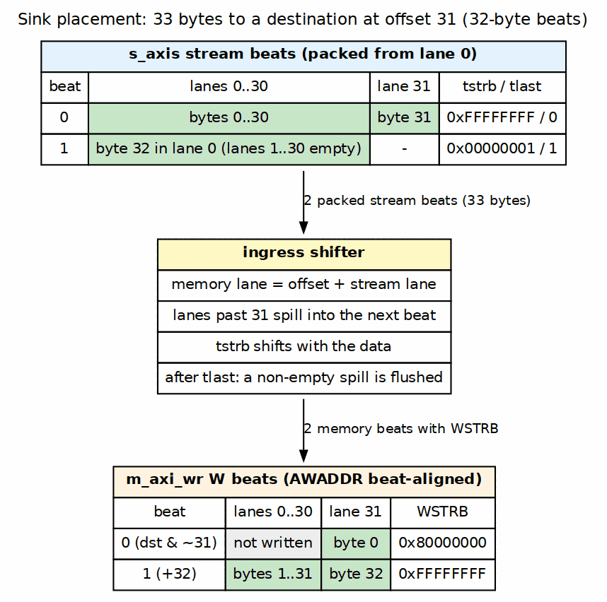
Sink byte placement
Source: 02_byte_placement.dot

9.3 The Packet Record
For every DATA descriptor, the scheduler hands each data path it uses a record: the byte count and the start offset. The scheduler pulses the record once per descriptor and direction as it leaves the descriptor-fetch state. Each data path keeps a small per-channel queue of records (four deep). If a queue is full, the scheduler stays in descriptor fetch until there is room, so a full queue holds the channel and never drops a record. A zero-length descriptor carries no record.
The record is what lets the data path work in bytes while the engines work in beats. The sink ingress uses it to place bytes and to check the packet length. The source egress uses it to drop the offset and to set TSTRB and TLAST.

9.3.1 Figure 2.2.2: Packet Record Flow
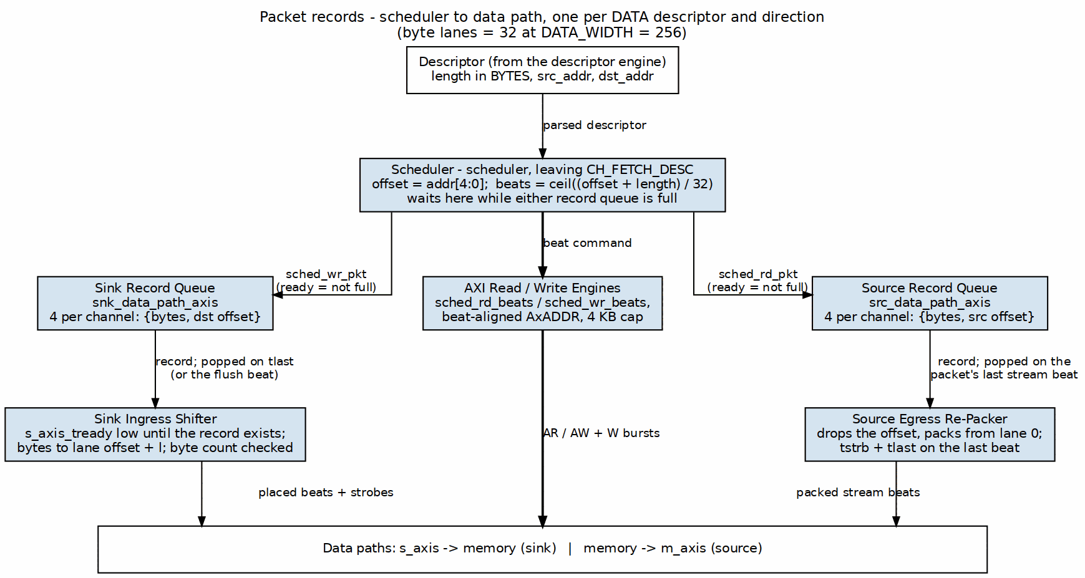
Packet record flow
Source: 03_packet_record_flow.dot
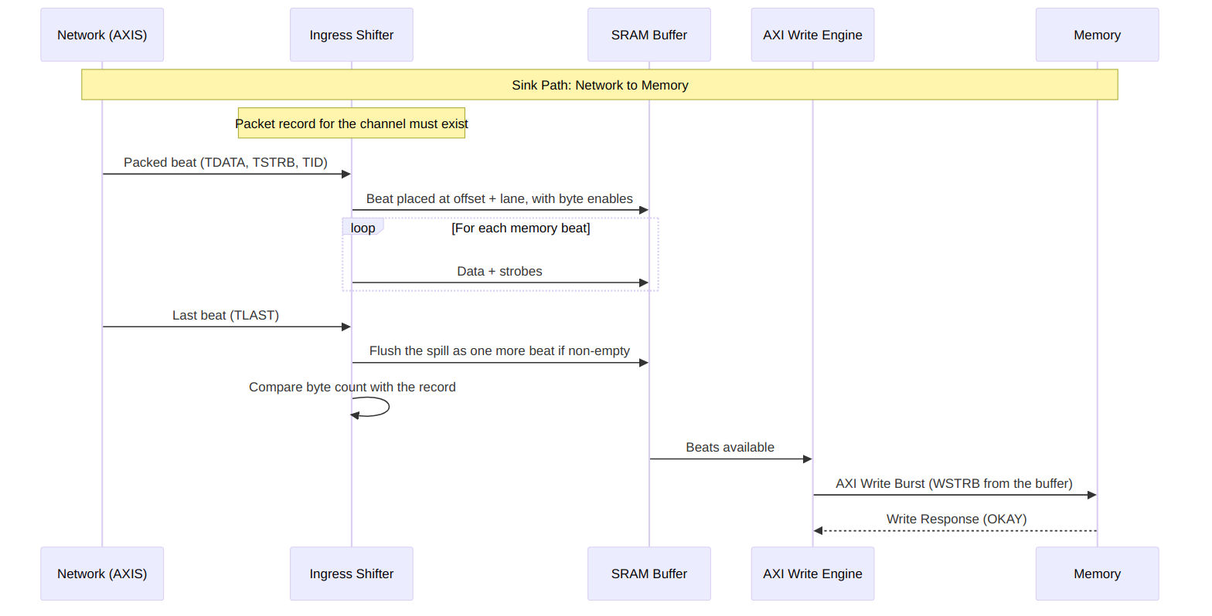
Sink Path Data Flow
The ingress accepts a beat only when the channel’s packet record exists. Until then TREADY stays low for that channel. After TLAST, if the offset pushed bytes into a further memory beat, the ingress flushes it as one more beat and holds TREADY low for that cycle.
The byte-enable timing on the write master is in the AXI4 Master Interface chapter.
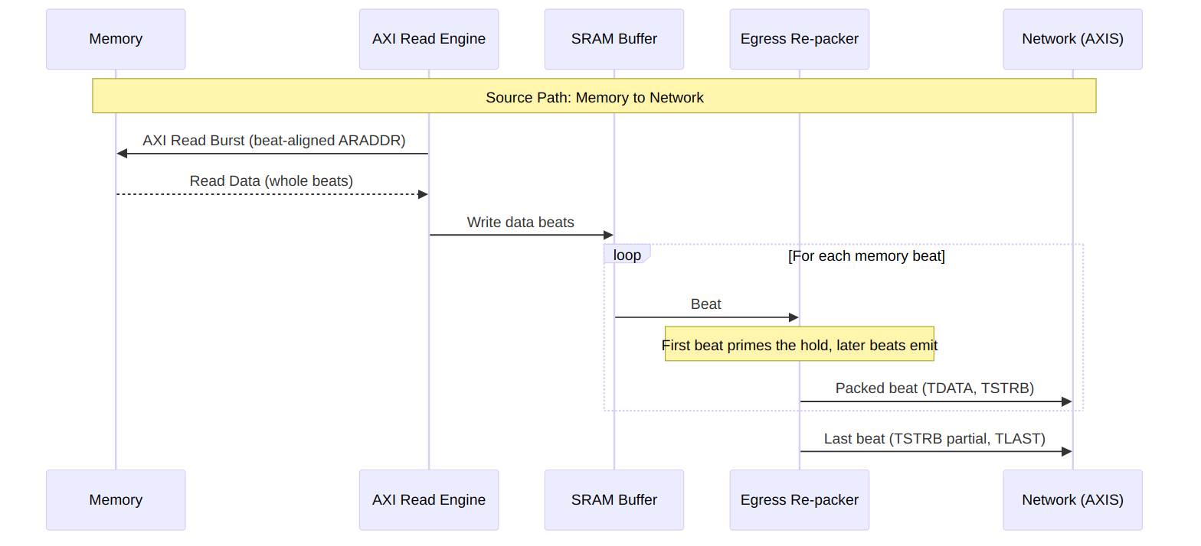
Source Path Data Flow
The source always reads whole beats and lets the egress discard the bytes outside the descriptor. The first memory beat only primes the egress hold when the offset is non-zero; every later beat emits one stream beat, and a final flush emits the bytes left in the hold. The result is one AXI-Stream packet per descriptor, TLAST on its last beat.
The AXI-Stream chapter carries the waveform for a packet whose last beat is partial.

9.4 Concurrent Operation
Both data paths operate independently and can run simultaneously. Neither shares a resource with the other.

9.4.1 Deadlock Prevention
RAPIDS prevents deadlock through independent resource allocation:
Resource Isolation
Resource | Sink Path | Source Path | Shared
SRAM Buffer | Dedicated | Dedicated | No
AXI Port | Write only | Read only | No
Scheduler | Per-channel | Per-channel | No
Packet record queue | Per-channel, sink | Per-channel, source | No
The sink’s TREADY is one signal, qualified by the TID of the beat on the bus. A beat for a channel whose descriptor has not been issued holds TREADY low, and it holds up any beats queued behind it on the same AXI-Stream, whatever their channel. A network source that interleaves channels on one stream SHOULD therefore issue every channel’s descriptor before it streams, or present one channel at a time. The record queues and the ingress hold are per channel, so a stalled channel never corrupts another; it can only delay it.

RTL Design Sherpa · Learning Hardware Design Through Practice GitHub · Documentation Index · MIT License

10 Channel Architecture

10.1 Multi-Channel Design
RAPIDS Beats supports 8 independent DMA channels, each with dedicated resources for concurrent operation.

10.2 Channel Resource Allocation

10.2.1 Figure 2.3.1: Per-Channel and Shared Resources
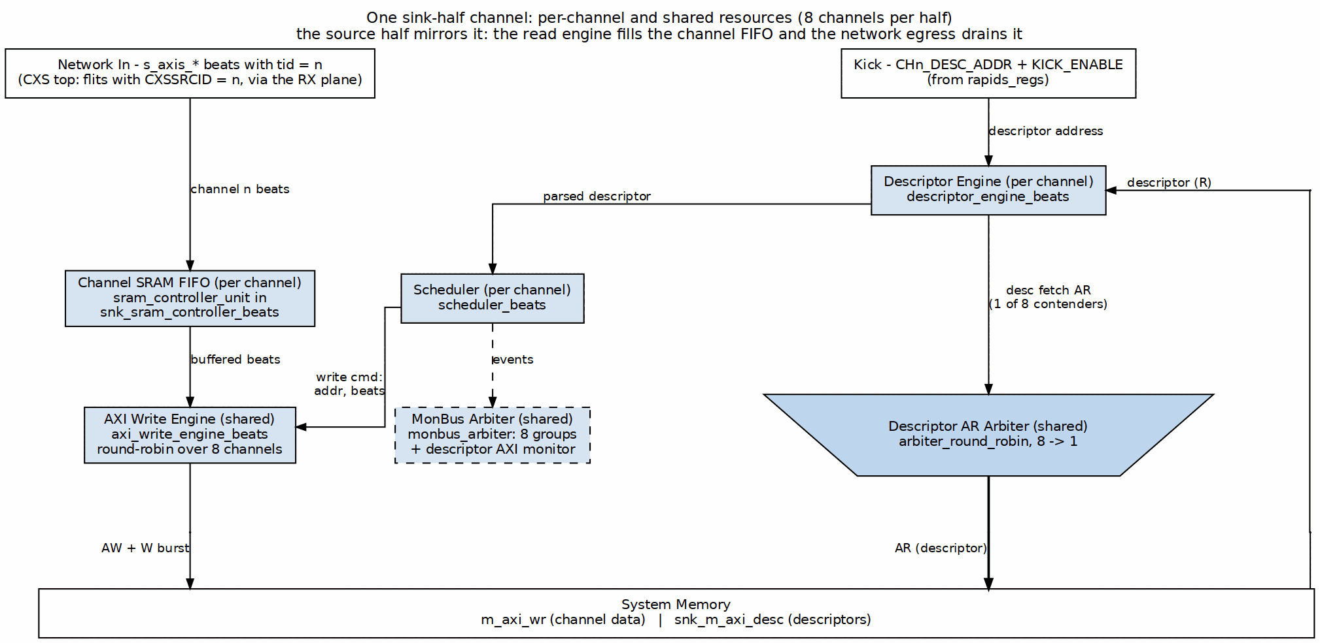
Per-Channel and Shared Resources
Source: ch02_channel_resources.dot

10.3 Per-Channel Resources
Each channel has dedicated:
Per-Channel Resources
Resource | Description | Size/Capacity
Scheduler | Transfer coordination FSM | 1 instance
Descriptor Engine | Descriptor fetch/parse | 8-deep FIFO
Sink SRAM Unit | Sink buffer, its own sram_controller | SRAM_DEPTH beats
Source SRAM Unit | Source buffer, its own sram_controller | SRAM_DEPTH beats
Configuration Registers | Per-channel config | ~16 registers

10.4 Shared Resources
Resources shared across all channels:
Shared Resources
Resource | Arbitration | Max Outstanding
Descriptor AXI | Round-robin | 8 (1 per channel)
Sink AXI Write | Round-robin | 8 configurable
Source AXI Read | Round-robin | 8 configurable
MonBus Output | Round-robin (monbus_arbiter tree) | 1 (serialized)

10.5 Channel Scheduling

10.5.1 Arbitration Policy

10.5.2 Figure 2.3.2: Channel Arbitration onto a Shared AXI Port
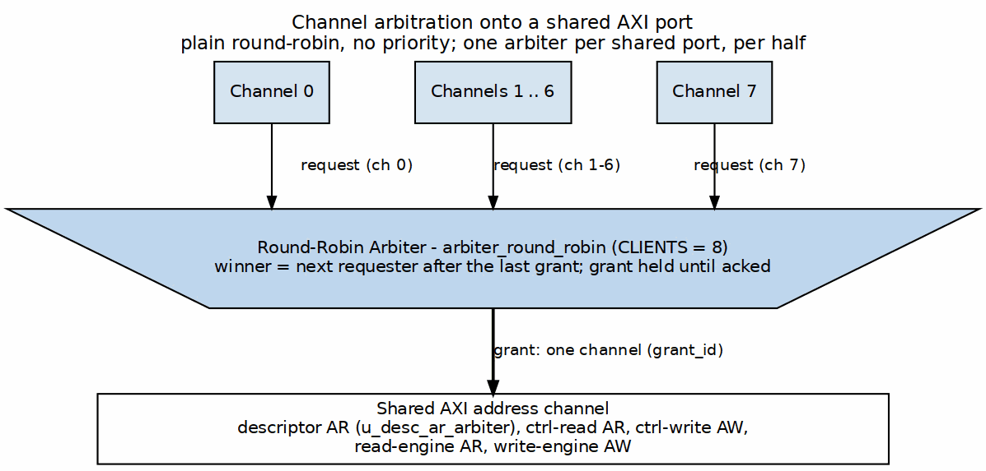
Channel Arbitration onto a Shared AXI Port
Source: ch02_channel_arbitration.dot
Arbitration Timing:

Waveform 1

10.6 Channel State Machine
Each channel scheduler follows this state machine:
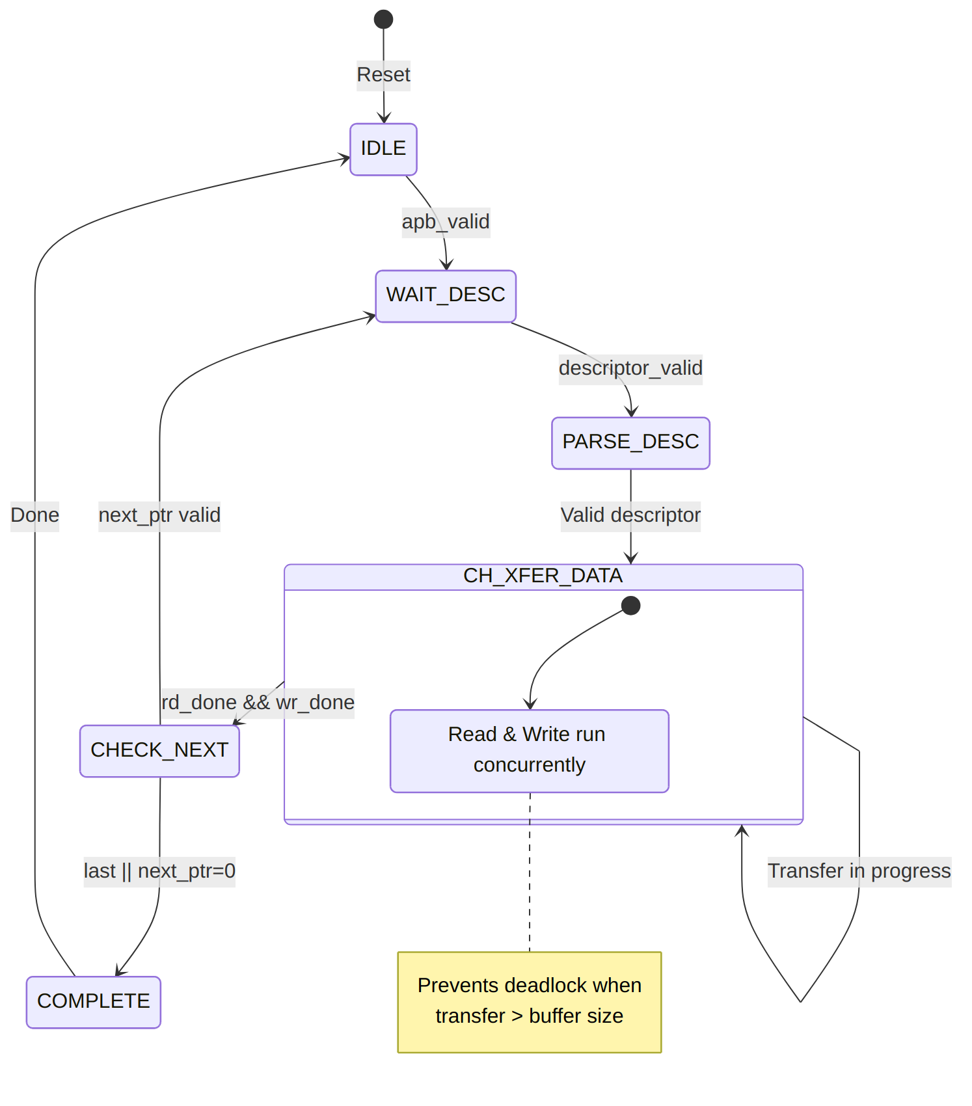
Diagram 4

Channel State Timing

10.7 Channel Isolation
Channels are isolated to prevent interference:
Channel Isolation Features
Isolation Type | Implementation
State Isolation | Separate FSM per channel
Buffer Isolation | Partitioned SRAM per channel
Error Isolation | Per-channel error flags
Reset Isolation | Per-channel soft reset

10.7.1 Per-Channel Error Handling
Each channel maintains independent error state:

Waveform 3
Channel 1 error does not affect Channel 0 or Channel 2 operation.

RTL Design Sherpa · Learning Hardware Design Through Practice GitHub · Documentation Index · MIT License

11 Interface Summary

11.1 External Interface Overview
RAPIDS Beats exposes the following external interfaces. The network side is a swappable plane: the AXIS tops (rapids_beats_top, rapids_top) carry the s_axis_* / m_axis_* streams, and the CXS tops (rapids_beats_cxs_top, rapids_cxs_top) carry one CXS link per direction in their place (see the CXS Network Interface chapter). Everything else is identical.

11.1.1 Figure 3.1.1: External Interfaces
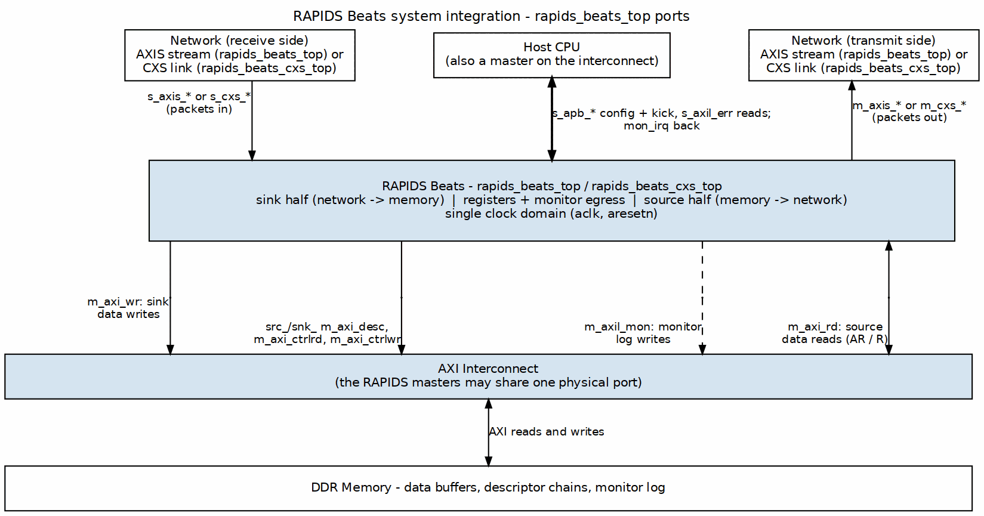
External Interfaces
Source: ch01_system_integration.dot

11.2 Interface Port Summary
External Interface Summary
Interface | Type | Direction | Data Width | Address Width
Descriptor AXI | AXI4 Master | Read | 256-bit | 64-bit
Sink AXI | AXI4 Master | Write | 512-bit | 64-bit
Source AXI | AXI4 Master | Read | 512-bit | 64-bit
Sink AXIS | AXIS Slave | Input | 512-bit | -
Source AXIS | AXIS Master | Output | 512-bit | -
Sink CXS (CXS tops only, replaces Sink AXIS) | CXS Receiver | Input | DATA_WIDTH (up to 1024-bit) | -
Source CXS (CXS tops only, replaces Source AXIS) | CXS Transmitter | Output | DATA_WIDTH (up to 1024-bit) | -
APB Config | APB-like | Input | 32-bit | 12-bit
MonBus | Custom | Output | 64-bit | -

11.3 Clock and Reset
All interfaces operate in the same clock domain:
Clock and Reset Signals
Signal | Type | Description
aclk | input | System clock (100-500 MHz typical)
aresetn | input | Active-low reset (async assert, sync deassert)

11.4 Interface Feature Matrix
Interface Feature Matrix
Feature | Desc AXI | Sink AXI | Src AXI | Sink AXIS | Src AXIS
Protocol | AXI4 | AXI4 | AXI4 | AXIS | AXIS
Direction | Read | Write | Read | Slave | Master
Burst Support | INCR | INCR | INCR | N/A | N/A
Max Burst | 1 | 256 | 256 | N/A | N/A
Outstanding | 8 | 8 | 8 | N/A | N/A
ID Width | 8-bit | 8-bit | 8-bit | Optional | Optional

11.5 Signal Count Summary
Signal Count Summary
Interface | Input Signals | Output Signals | Total
Descriptor AXI | ~20 | ~30 | ~50
Sink AXI | ~15 | ~40 | ~55
Source AXI | ~25 | ~25 | ~50
Sink AXIS | ~20 | ~5 | ~25
Source AXIS | ~5 | ~20 | ~25
Sink CXS (CXS tops) | ~8 | ~7 | ~15
Source CXS (CXS tops) | ~3 | ~10 | ~13
APB Config | ~15 | ~5 | ~20
MonBus | ~2 | ~5 | ~7
Total | ~102 | ~130 | ~232
Note: Signal counts are approximate and vary with configuration parameters. The total counts an AXIS top; a CXS top replaces the two AXIS rows with the two CXS rows (including the link-status pins).

RTL Design Sherpa · Learning Hardware Design Through Practice GitHub · Documentation Index · MIT License

12 AXI4 Interface Specification

12.1 Overview
RAPIDS uses AXI4 master interfaces for all memory access:
- Descriptor AXI - Fetches 256-bit descriptors (read-only), one master per half (src_m_axi_desc_*, snk_m_axi_desc_*)
- Sink AXI - Writes network data to memory (m_axi_wr_*)
- Source AXI - Reads memory data for the network (m_axi_rd_*)
- Control AXI - Single-word control reads and writes (*_m_axi_ctrlrd_*, *_m_axi_ctrlwr_*), unchanged from RAPIDS Beats
The descriptor and control masters behave exactly as in RAPIDS Beats; see the RAPIDS Beats AXI4 chapter for their timing. This chapter specifies what changed: the data masters carry byte-granular transfers.

12.1.1 Byte Granularity on the Memory Side
The descriptor length is a byte count and the source and destination addresses are byte addresses. The data masters keep AXI4 conventional by splitting the two concerns:
Where byte granularity is carried on AXI4
Concern | Where it is carried
Which beats are transferred | AxADDR (beat-aligned) and AxLEN
Which bytes within a beat are transferred | WSTRB on the write master; the egress drops unwanted bytes on the read side
AxSIZE is always the full beat (log2(DATA_WIDTH/8)), so the masters remain ordinary full-width INCR masters that any interconnect accepts.

12.2 Descriptor AXI Master
Unchanged from RAPIDS Beats. One 256-bit single-beat INCR read per descriptor, ARLEN = 0, ARSIZE = 5, ARID carries the channel. The source half and the sink half each own a master, and the descriptor address is 32-byte aligned. The descriptor’s contents (Chapter 5) differ: its length field is in bytes.

12.3 Sink AXI Master (Write)

12.3.1 Purpose
Writes packed network bytes from the SRAM buffer to system memory. The SRAM holds each beat as data plus a strobe ({strb, data}), placed by the sink ingress at the byte offset of the destination address. The write master emits that strobe on WSTRB unchanged.

12.3.2 Configuration
Sink AXI Configuration
Parameter | Default | Range | Description
DATA_WIDTH | 512 | 32-1024 (power of two) | Beat width; 32-byte beats (256-bit) in the Genesys 2 build
ADDR_WIDTH | 64 | Configurable | System address space
AXI_ID_WIDTH | 8 | Configurable | Transaction tracking (channel in low bits)
Max burst | WR_XFER_BEATS register | 1-256 | Per-channel burst cap, further capped at 4 KB
Outstanding | 8 | 1-16 | Concurrent AW requests

12.3.3 Signal List
Sink AXI Signals
Signal | Width | Direction | Description
m_axi_wr_awid | AXI_ID_WIDTH | output | Write ID
m_axi_wr_awaddr | ADDR_WIDTH | output | Write address, beat-aligned
m_axi_wr_awlen | 8 | output | Burst length - 1
m_axi_wr_awsize | 3 | output | Full beat, log2(DATA_WIDTH/8)
m_axi_wr_awburst | 2 | output | INCR
m_axi_wr_awvalid / awready | 1 | output / input | Address handshake
m_axi_wr_wdata | DATA_WIDTH | output | Write data
m_axi_wr_wstrb | DATA_WIDTH/8 | output | Byte enables: the bytes this beat writes
m_axi_wr_wlast | 1 | output | Last beat of the burst
m_axi_wr_wvalid / wready | 1 | output / input | Data handshake
m_axi_wr_bid | AXI_ID_WIDTH | input | Response ID
m_axi_wr_bresp | 2 | input | Write response
m_axi_wr_bvalid / bready | 1 | input / output | Response handshake

12.3.4 WSTRB Contract
For a descriptor that writes length bytes starting at byte address dst, let offset = dst mod (DATA_WIDTH/8). The transfer covers ceil((offset + length) / (DATA_WIDTH/8)) beats.
WSTRB per beat
Beat | WSTRB
First beat | Lanes offset to the end of the beat, or to the last byte if the transfer ends inside this beat
Middle beats | All ones
Last beat | Lanes 0 to the last byte, or up to the last lane if the transfer ends on a beat boundary
Single-beat transfer | Lanes offset to offset + length - 1
Lanes outside the run have WSTRB = 0 and their WDATA bytes are not significant. RAPIDS never writes a byte the descriptor did not name, so a destination memory that honors byte enables is left untouched outside [dst, dst + length). Every beat in the transfer carries at least one strobed byte.

12.3.4.1 Waveform 3.1: Unaligned Sink Write, Byte Enables on AXI4
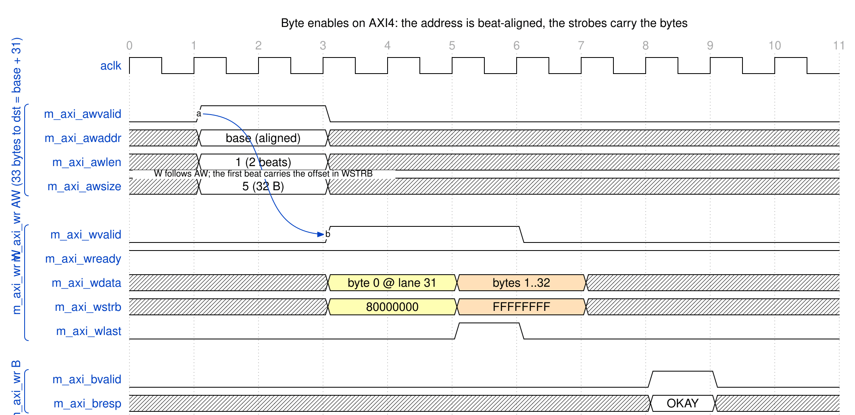
Byte enables on AXI4
Source: 02_axi_byte_enables.json
A 33-byte transfer to base + 31 occupies two beats of a 32-byte-beat interface. AWADDR is base, not base + 31. The first beat strobes only lane 31 (0x80000000) and carries byte 0 there; the second beat strobes all 32 lanes and carries bytes 1 to 32.

12.4 Source AXI Master (Read)

12.4.1 Purpose
Reads whole beats from system memory into the SRAM buffer. The read master does not use byte enables (AXI has none on the read side). It fetches every beat that overlaps [src, src + length), and the source egress (Chapter 3.2) drops the leading and trailing bytes that were fetched but not requested.

12.4.2 Configuration
Source AXI Configuration
Parameter | Default | Range | Description
DATA_WIDTH | 512 | 32-1024 (power of two) | Beat width
ADDR_WIDTH | 64 | Configurable | System address space
AXI_ID_WIDTH | 8 | Configurable | Transaction tracking
Max burst | RD_XFER_BEATS register | 1-256 | Per-channel burst cap, further capped at 4 KB
Outstanding | 8 | 1-16 | Concurrent AR requests

12.4.3 Signal List
Source AXI Signals
Signal | Width | Direction | Description
m_axi_rd_arid | AXI_ID_WIDTH | output | Read ID
m_axi_rd_araddr | ADDR_WIDTH | output | Read address, beat-aligned
m_axi_rd_arlen | 8 | output | Burst length - 1
m_axi_rd_arsize | 3 | output | Full beat
m_axi_rd_arburst | 2 | output | INCR
m_axi_rd_arvalid / arready | 1 | output / input | Address handshake
m_axi_rd_rid | AXI_ID_WIDTH | input | Response ID
m_axi_rd_rdata | DATA_WIDTH | input | Read data
m_axi_rd_rresp | 2 | input | Read response
m_axi_rd_rlast | 1 | input | Last beat
m_axi_rd_rvalid / rready | 1 | input / output | Data handshake

12.4.4 Read Coverage
A read of length bytes from byte address src fetches ceil((offset + length) / (DATA_WIDTH/8)) beats starting at src rounded down to a beat boundary. Bytes fetched outside [src, src + length) are never delivered to the network.

12.5 AXI Protocol Constraints

12.5.1 Address Alignment
Address Alignment Requirements
Transfer Type | Alignment Requirement
Descriptor | 32-byte aligned
Sink data, linear descriptor | None: any byte address
Source data, linear descriptor | None: any byte address
Sink or source data, TYPE=EXT descriptor | Beat-aligned address, beat-multiple length (permanent)
The AXI address on the wire is always beat-aligned, whatever the descriptor holds. Only EXT (row and column striding) descriptors restrict the descriptor’s own addresses; that is a permanent design decision, not a phase limitation.

12.5.2 4 KB Boundary Handling
AXI4 forbids a burst crossing a 4 KB boundary. RAPIDS caps every burst at the next 4 KB boundary, computed from the beat-aligned address, on both data masters. The cap combines with the configured burst limit: the burst is the smaller of the two.
Example: 4035 bytes to dst = 0x0CB (32-byte beats, offset = 0x0B)
Beats total = ceil((11 + 4035) / 32) = 127
Aligned start = 0x0C0; beats from there to the 4 KB boundary = 122
With WR_XFER_BEATS = 16 the bursts are 16-beat, the last one before the boundary
ends at 0x1000 (a 122-beat run is 7 bursts of 16 and one of 10);
the remaining 5 beats start at AWADDR = 0x1000.
The first burst’s WSTRB carries the offset (0xFFFFF800, lanes 11 to 31). After the first burst the working address is the aligned address plus the beats completed, so every later burst is beat-aligned.

12.5.3 Response Handling
AXI Response Handling
Response | Code | RAPIDS Behavior
OKAY | 2’b00 | Normal completion
EXOKAY | 2’b01 | Treated as OKAY
SLVERR | 2’b10 | Error, transfer aborted
DECERR | 2’b11 | Error, transfer aborted

RTL Design Sherpa · Learning Hardware Design Through Practice GitHub · Documentation Index · MIT License

13 AXIS Interface Specification

13.1 Overview
RAPIDS uses AXI-Stream interfaces for network data transfer:
- Sink AXIS Slave - Receives packed bytes from the network (ingress)
- Source AXIS Master - Sends packed bytes to the network (egress)
Both streams carry packed bytes: a packet is a contiguous run of bytes starting at lane 0 of its first beat, with every beat full except possibly the last. The stream is byte-granular through TSTRB, and TLAST delimits exactly one descriptor’s worth of data.

13.1.1 Byte Semantics
Byte Semantics of the RAPIDS Streams
Property | Rule
Byte qualifier | TSTRB (there is no TKEEP on RAPIDS)
Packing | Bytes are packed from lane 0; no gaps inside a packet
Full beats | TSTRB all ones
Last beat | TSTRB is a contiguous run from lane 0 (2^n - 1), n = bytes in the beat
Packet | One descriptor’s length bytes, ending with TLAST
The destination address offset never appears on the stream. A descriptor that writes to byte address 5 of a beat still receives its packet packed from lane 0; the sink places the bytes at the destination offset internally (Chapter 2).

13.2 Sink AXIS Slave

13.2.1 Purpose
Receives a packet, places its bytes at the descriptor’s destination offset, and writes them to the SRAM buffer for the sink AXI master.

13.2.2 Configuration
Sink AXIS Configuration
Parameter | Default | Range | Description
DATA_WIDTH | 512 | 32-1024 (power of two) | TDATA width
AXIS_ID_WIDTH | 8 | 1-8 | TID width; TID selects the channel
AXIS_DEST_WIDTH | 8 | 0-8 | TDEST width (not used to route)
AXIS_USER_WIDTH | 1 | 0-16 | TUSER width (not used)

13.2.3 Signal List
Sink AXIS Signals
Signal | Width | Direction | Description
s_axis_tdata | DATA_WIDTH | input | Data payload
s_axis_tstrb | DATA_WIDTH/8 | input | Byte qualifier, contiguous from lane 0
s_axis_tlast | 1 | input | Last beat of the packet
s_axis_tid | AXIS_ID_WIDTH | input | Channel select
s_axis_tdest | AXIS_DEST_WIDTH | input | Destination (accepted, not used)
s_axis_tuser | AXIS_USER_WIDTH | input | User sideband (accepted, not used)
s_axis_tvalid | 1 | input | Data valid
s_axis_tready | 1 | output | Ready to accept

13.2.4 Packet Contract
A sink packet SHALL:
- Be delimited by TLAST, with one TID for all its beats.
- Be packed: every beat but the last has TSTRB all ones, and the last beat’s TSTRB is a contiguous run from lane 0.
- Contain exactly as many strobed bytes as the descriptor’s length for that channel.
The byte count is checked at TLAST. A packet whose count differs from the descriptor length is not silently padded or dropped: the channel’s sticky sched_wr_error bit is set and stays set until reset.

13.2.5 Descriptor-First Ordering
The sink cannot place bytes until it knows the destination offset, and the offset comes from the channel’s descriptor. s_axis_tready is a single signal. It is qualified by the TID of the beat currently on the bus: it is low whenever that channel has no packet record, in addition to the output register being busy or a flush beat pending.
A beat for a channel whose descriptor has not been fetched therefore stalls the whole stream, including beats for other channels queued behind it. There is no per-channel backpressure. Software SHOULD issue a channel’s descriptor before its packet arrives, or stream one channel at a time until its descriptor is known.
This is the one flow-control difference from RAPIDS Beats, whose sink buffered beats before any descriptor existed. A transmitter that blocks its own descriptor kick behind the stalled stream will deadlock; kick first.

13.2.5.1 Waveform 3.1: Sink Packet With a Partial Last Beat
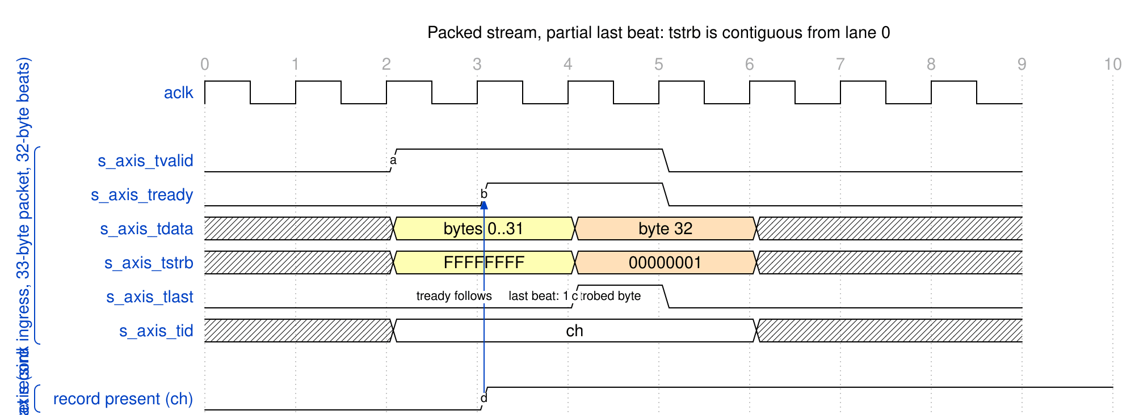
Packed stream, partial last beat
Source: 01_axis_partial_last_beat.json
A 33-byte packet occupies two 32-byte beats. The first beat is full (TSTRB = FFFFFFFF); the second carries one byte (TSTRB = 00000001) and TLAST. s_axis_tready rises only after the channel’s record exists, so TVALID waits for it.

13.2.6 Backpressure Behavior
s_axis_tready deasserts when:
Reasons the Sink Deasserts TREADY
Cause | Meaning
No record for the beat’s channel | The descriptor for the TID on the bus has not been fetched; the whole stream waits
SRAM space | The channel’s SRAM partition is full
Ingress output register busy | The write into the SRAM controller has not completed
Flush cycle | TREADY drops for one cycle while the spill beat that follows TLAST is emitted
The flush cycle occurs when a packet’s last bytes spill into a memory beat beyond the stream’s last beat: for example, 33 bytes to destination offset 5 occupy 38 bytes, so the stream’s second beat maps to two memory beats.

13.3 Source AXIS Master

13.3.1 Purpose
Reads memory beats through the SRAM buffer and emits the descriptor’s bytes as one packed AXIS packet.

13.3.2 Configuration
Source AXIS Configuration
Parameter | Default | Range | Description
DATA_WIDTH | 512 | 32-1024 (power of two) | TDATA width
AXIS_ID_WIDTH | 8 | 1-8 | TID width; carries the channel
AXIS_DEST_WIDTH | 8 | 0-8 | TDEST width; carries the channel
AXIS_USER_WIDTH | 1 | 0-16 | TUSER width; driven 0

13.3.3 Signal List
Source AXIS Signals
Signal | Width | Direction | Description
m_axis_tdata | DATA_WIDTH | output | Data payload
m_axis_tstrb | DATA_WIDTH/8 | output | Byte qualifier, contiguous from lane 0
m_axis_tlast | 1 | output | Last beat of the packet
m_axis_tid | AXIS_ID_WIDTH | output | Channel
m_axis_tdest | AXIS_DEST_WIDTH | output | Channel (zero-extended)
m_axis_tuser | AXIS_USER_WIDTH | output | Driven 0
m_axis_tvalid | 1 | output | Data valid
m_axis_tready | 1 | input | Downstream ready

13.3.4 Egress Packet Contract
Egress Packet Contract
Property | Behavior
Packet framing | One AXIS packet per descriptor, however many drain blocks it spans
Bytes | Exactly length bytes, from the descriptor’s source byte address
First beat | Starts at lane 0: the egress shifts memory beats down by the source offset
Middle beats | TSTRB all ones
Last beat | Contiguous TSTRB and TLAST
Zero-length descriptor | No packet
RAPIDS Beats cut a packet at the end of each drain block and asserted TLAST on every one. RAPIDS asserts TLAST once, on the last byte of the descriptor.

13.3.5 Timing
The partial last beat is the mirror image of the sink case (Waveform 3.1 above): the final beat carries a contiguous run of n bytes and TLAST. The re-pack mechanism that produces it, including the beat that only primes the shifter, is specified in the MAS.

13.3.6 Data Availability
The source asserts TVALID only when packed data is available. The first memory beat of a packet with a nonzero source offset only primes the egress shifter and produces no output unless the entire packet fits in that beat.

13.4 AXIS Protocol Notes

13.4.1 Handshake Rules
Standard AXI-Stream handshake applies:
- TVALID asserts when data is available
- TREADY asserts when the receiver can accept
- A transfer occurs on a clock edge when both are high
- TVALID SHALL NOT depend on TREADY
- TREADY MAY depend on TVALID

13.4.2 TLAST Semantics
TLAST Usage
Scenario | TLAST Behavior
Sink packet | Assert on the last beat of the packet; the byte count must equal the descriptor length
Source packet | Asserted once per descriptor, on its last stream beat
Continuous stream | Not supported: every transfer is a descriptor-sized packet

13.4.3 TSTRB Usage
TSTRB Examples
TSTRB Value (32-byte beat) | Meaning
FFFFFFFF | All 32 bytes valid (every beat but the last)
0000FFFF | Last beat, lower 16 bytes valid
00000001 | Last beat, one byte valid
Any non-contiguous pattern | Not produced by RAPIDS; not accepted on the sink

13.4.4 Channel Multiplexing via TID
Channels share each stream through TID. A sink packet SHALL keep one TID from its first beat to TLAST. Each channel is packed independently, so packets of different channels may follow one another, but s_axis_tready does not distinguish channels: a channel that is not ready stalls the stream for all of them (see Descriptor-First Ordering). The source stream emits one packet at a time, tagged with the channel in TID and TDEST.

RTL Design Sherpa · Learning Hardware Design Through Practice GitHub · Documentation Index · MIT License

14 APB Configuration Interface

14.1 Overview
At the top level (rapids_beats_top), RAPIDS Beats exposes a single APB4 slave (s_apb_*) for all software access. This interface allows software to:
- Configure channel and monitor parameters (via the register block)
- Initiate descriptor processing (kick-off)
- Read status and error information

14.2 APB Slave and Address Routing
The APB slave is converted to an internal command/response transaction and routed by address to two targets:
APB Address Routing
Address Range | Target | Purpose
0x000-0x03F | rapids_regs (staged descriptor addresses) | Per-channel CH*_DESC_ADDR_{LOW,HIGH}, stride 0x8
0x040 | rapids_regs (KICK_ENABLE) | Per-channel launch bits (singlepulse)
0x100-0x3FF | rapids_regs (base regfile) | Channel/scheduler/descriptor configuration and status
0x1000+ | rapids_regs (monitor regfile) | AXI-monitor configuration and performance counters
Because the monitor regfile is located at 0x1000, the APB address bus must be at least 13 bits wide to reach it. Configuration that was formerly imagined as discrete cfg_* ports is now driven internally by the register block through rapids_config_block; see the Register Map for the full address map, and the descriptor address ranges (DESCENG_ADDR0/1_* at 0x224-0x230).

14.2.1 APB Slave Signal List
APB Slave Signals
Signal | Width | Direction | Description
s_apb_paddr | APB_ADDR_WIDTH (>=13) | input | Address
s_apb_psel | 1 | input | Select
s_apb_penable | 1 | input | Enable phase
s_apb_pwrite | 1 | input | Write / read
s_apb_pwdata | 32 | input | Write data
s_apb_pstrb | 4 | input | Write byte strobes
s_apb_prdata | 32 | output | Read data
s_apb_pready | 1 | output | Ready
s_apb_pslverr | 1 | output | Slave error

14.2.2 Descriptor Kick-Off
To start descriptor processing on a channel:
- Write descriptor to memory
- Assert apb_valid[ch] with descriptor address on apb_addr
- Wait for apb_ready[ch] assertion
- Deassert apb_valid[ch]

Timing Diagram

14.3 Status Interface

14.3.1 Per-Channel Status Signals
Status Signals
Signal | Width | Direction | Description
channel_idle | NC | output | Channel idle status
channel_error | NC | output | Channel error flag
scheduler_state | 4*NC | output | FSM state per channel

14.3.2 Channel State Encoding
Scheduler State Encoding
State | Value | Description
IDLE | 4’h0 | Waiting for kick-off
WAIT_DESC | 4’h1 | Waiting for descriptor
PARSE_DESC | 4’h2 | Parsing descriptor
CH_XFER_DATA | 4’h3 | Transfer in progress
CHECK_NEXT | 4’h4 | Checking next descriptor
COMPLETE | 4’h5 | Transfer complete
ERROR | 4’hF | Error state

14.4 Configuration Registers

14.4.1 Address Range Validation
RAPIDS validates descriptor addresses against configurable ranges:
Valid if:
(addr >= cfg_addr0_base && addr < cfg_addr0_limit) ||
(addr >= cfg_addr1_base && addr < cfg_addr1_limit)

14.4.2 Configuration Registers
Configuration and status registers are provided by the rapids_regs register block. See the Register Map for the complete, RTL-accurate address map. The registers most relevant to bring-up are:
Key Configuration Registers
Register | Offset | Description
GLOBAL_CTRL | 0x100 | GLOBAL_EN, GLOBAL_RST (level; write 0 to release)
CHANNEL_ENABLE | 0x120 | Per-channel enable bitmap
SCHED_TIMEOUT_CYCLES | 0x200 | Write-progress timeout window
SCHED_TIMEOUT_LIMIT | 0x208 | Consecutive-timeout escalation limit (0 = never)
DESCENG_CONFIG | 0x220 | Descriptor-engine enable / prefetch / FIFO threshold
DESCENG_ADDR0_BASE/_LIMIT | 0x224/0x228 | Descriptor address range 0

14.5 Programming Sequence

14.5.1 Initialization
// 1. Optional global reset: GLOBAL_RST is a level, not self-clearing
GLOBAL_CTRL = 0x2; // assert
GLOBAL_CTRL = 0x0; // release
// 2. Configure descriptor address range(s)
DESCENG_ADDR0_BASE = 0x8000_0000;
DESCENG_ADDR0_LIMIT = 0x9000_0000;
// 3. Scheduler timeout policy
SCHED_TIMEOUT_CYCLES = 1000;
SCHED_TIMEOUT_LIMIT = 4; // escalate after 4 stalled windows; 0 = never
// 4. Enable channels and global enable
CHANNEL_ENABLE = 0xFF; // enable all 8 channels
GLOBAL_CTRL = 0x1; // GLOBAL_EN

14.5.2 Descriptor Kick-Off
// Prepare descriptor in memory
desc->src_addr = src;
desc->dst_addr = dst;
desc->length = beats;
desc->last = 1;
desc->valid = 1;
// Kick off channel 0: stage the address, then launch
CH0_DESC_ADDR_LOW = (uint32_t)desc_addr;
CH0_DESC_ADDR_HIGH = (uint32_t)(desc_addr >> 32);
KICK_ENABLE = 0x01; // KICK0, self-clearing
// Wait for completion: idle, or faulted (CH_ERROR is never idle)
while (!(SCHEDULER_IDLE & 0x01) && !(SCHED_ERROR & 0x01));
// Check for errors
if (SCHED_ERROR & 0x01) {
handle_error(0);
}

RTL Design Sherpa · Learning Hardware Design Through Practice GitHub · Documentation Index · MIT License

15 Monitor Bus Interface

15.1 Overview
RAPIDS Beats outputs a 64-bit Monitor Bus (MonBus) for real-time event reporting. The MonBus provides visibility into:
- State machine transitions
- Descriptor processing events
- Error conditions
- Performance metrics

15.2 MonBus Packet Format

15.2.1 64-bit Packet Structure
Bit Field Width Description
───────────────────────────────────────────────────────
[63:60] 4-bit packet_type (error, completion, etc.)
[59:57] 3-bit protocol (CORE for RAPIDS)
[56:53] 4-bit event_code (specific event)
[52:47] 6-bit channel_id
[46:43] 4-bit unit_id (subsystem)
[42:35] 8-bit agent_id (module)
[34:0] 35-bit event_data (event-specific)

15.2.2 Signal List
MonBus Signals
Signal | Width | Direction | Description
monbus_pkt_valid | 1 | output | Packet valid
monbus_pkt_data | 64 | output | Packet data
monbus_pkt_ready | 1 | input | Downstream ready

15.3 Packet Types
MonBus Packet Types
Type | Code | Description
ERROR | 4’h0 | Error event
COMPLETION | 4’h1 | Transfer/operation complete
THRESHOLD | 4’h2 | Threshold crossed
TIMEOUT | 4’h3 | Timeout event
PERF | 4’h4 | Performance metric
DEBUG | 4’hF | Debug/trace event

15.4 Agent IDs
RAPIDS modules use the following Agent IDs:
RAPIDS Agent IDs
Agent ID | Module | Description
0x08 | Descriptor AXI monitor | axi4_master_rd_monlite on the descriptor read master (per half, USE_AXI_MONITORS)
0x09 | Sink-ingress network monitor | The sink RX plane’s monitor-lite: axis4_slave_monlite on s_axis_* (AXIS top) or cxs_monitor_lite in cxs_slave_monlite on s_cxs_* (CXS top) (USE_AXI_MONITORS; config SNK.MON.WRMON_*)
0x0A | Source-egress network monitor | The source TX plane’s monitor-lite: axis4_master_monlite on m_axis_* (AXIS top) or cxs_monitor_lite in cxs_master_monlite on m_cxs_* (CXS top) (USE_AXI_MONITORS; config SRC.MON.RDMON_*)
0x10-0x17 | Descriptor Engine | Channels 0-7
0x20 | Control Read Engine | ctrlrd (one per half)
0x21 | Control Write Engine | ctrlwr (one per half)
0x30-0x37 | Scheduler | Channels 0-7
These are the values the scheduler group array and the halves pass down (DESC_AXI_MON_AGENT_ID, DESC_MON_BASE_AGENT_ID, CTRLRD_MON_AGENT_ID, CTRLWR_MON_AGENT_ID, SCHED_MON_BASE_AGENT_ID); the module defaults inside the engines differ and are overridden at instantiation. The data paths carry no MonBus emitters (an earlier revision listed data-path agents at 0x40-0x57, which nothing emits). Agents 0x09 and 0x0A live in the network planes, outside the core; their packets enter each half’s 3:1 monbus_arbiter as client 1 on snk_plane_mon_* / src_plane_mon_*. A CXS plane’s packets carry protocol PROTOCOL_CXS, which the top’s monitor group filters through its AXIS mask slot. A CXS PACKET_END completion carries the channel (CXSSRCID) in event_data[55:48]; its channel_id field holds {PRCLTYPE[2:0], TGTID[5:0]}.

15.5 Event Codes

15.5.1 Scheduler Events (Agent 0x30-0x37)
Scheduler Event Codes
Event Code | Type | Description
0x0 | COMPLETION | Descriptor complete
0x1 | COMPLETION | Chain complete
0x2 | ERROR | Timeout
0x3 | ERROR | AXI error
0x4 | DEBUG | State transition
The scheduler’s and the descriptor engine’s COMPLETION packets are reported only while the half’s SCHED_CONFIG.COMPL_EN is set (reset value 1). With the bit clear the scheduler group drops them before its monitor-bus arbiter and still acknowledges the emitters, so a channel runs identically either way; ERROR packets are reported regardless of ERR_EN.

15.5.2 Descriptor Engine Events (Agent 0x10-0x17)
Descriptor Engine Event Codes
Event Code | Type | Description
0x0 | COMPLETION | Descriptor fetched
0x1 | ERROR | Address range error
0x2 | ERROR | AXI read error
0x3 | DEBUG | Fetch started

Timing Diagram

15.6 Event Data Encoding

15.6.1 Completion Event Data
[34:32] - Reserved
[31:0] - Transfer length (beats completed)

15.6.2 Error Event Data
[34:32] - Error type
[31:16] - Reserved
[15:0] - Error details

15.6.3 State Transition Event Data
[34:32] - Reserved
[31:28] - Previous state
[27:24] - New state
[23:0] - Timestamp (lower bits)

15.7 MonBus Arbitration
Multiple RAPIDS modules generate MonBus packets. Internal arbitration ensures ordered delivery:

15.7.1 Figure 3.5.1: MonBus Arbitration Tree
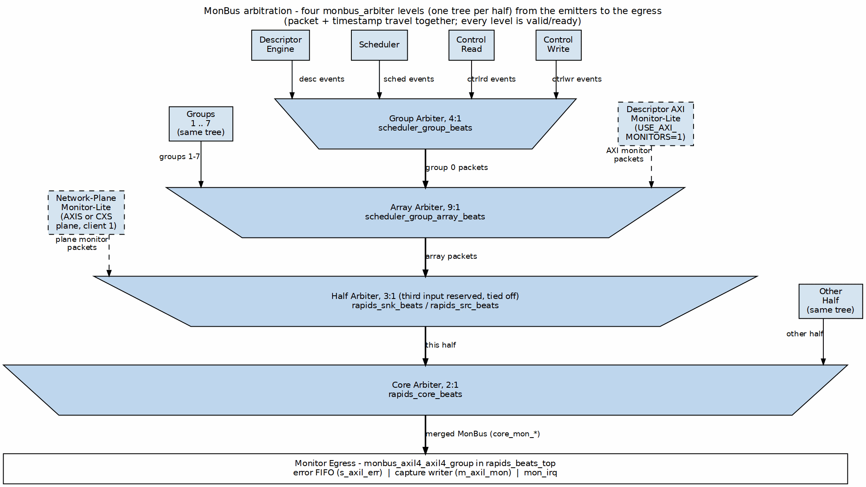
MonBus Arbitration Tree
Source: ch03_monbus_arbitration.dot

15.7.2 Arbitration Policy
- Round-robin across modules
- No packet loss (backpressure if output blocked)
- Priority boosting for ERROR packets

15.8 Top-Level MonBus Delivery (monbus_axil4_axil4_group)
At the top level (rapids_beats_top, rapids_beats_cxs_top), the internal MonBus is not exposed as a raw 64-bit port. Instead, when USE_AXI_MONITORS = 1, the core’s single merged stream (core_mon_*, which already carries the descriptor-monitor and network-plane packets) feeds a monbus_axil4_axil4_group. The data masters m_axi_rd and m_axi_wr carry no monitors. When USE_AXI_MONITORS = 0, the group is not built and its outputs are tied off (mon_irq = 0). The group presents three external interfaces:
Top-Level MonBus AXI-Lite Group
Interface | Signals | Purpose
Error-drain slave | s_axil_err_ar*, s_axil_err_r* (AXI-Lite, 32-bit read) | CPU reads captured error events from the error FIFO
Capture master | m_axil_mon_aw*, m_axil_mon_w* (64-bit wdata), m_axil_mon_b* | Bulk-writes the MonBus trace to system memory
Interrupt | mon_irq | Asserts on error/threshold events
The capture region and flush behavior are configured by cfg_mon_base_addr, cfg_mon_limit_addr, and cfg_mon_flush_watermark.

15.9 Integration Notes

15.9.1 Downstream Connection
Internally, MonBus output connects to:
- MonBus Arbiter - Combines core + rd/wr monitor sources
- monbus_axil4_axil4_group - Error-drain slave, capture master, and mon_irq
- Debug FIFO - Buffered access for debug tools

15.9.2 Packet Rate
MonBus Packet Rates
Scenario | Approximate Rate
Idle | 0 packets/cycle
Single channel active | ~1 packet/100 cycles
All channels active | ~1 packet/20 cycles
Error storm | Up to 1 packet/cycle

RTL Design Sherpa · Learning Hardware Design Through Practice GitHub · Documentation Index · MIT License

16 CXS Network Interface

16.1 Overview
The network side of RAPIDS is a swappable network plane. Each top is the tree’s base (core, registers, monitor group) plus one receive (RX) plane and one transmit (TX) plane, and the plane is chosen by the top’s module name:
- rapids_beats_top, rapids_top: AXI-Stream planes; the s_axis_* and m_axis_* ports described in the AXIS Interface chapter.
- rapids_beats_cxs_top, rapids_cxs_top: CXS planes; the sink port (s_cxs_*) into the sink half and the source port (m_cxs_*) out of the source half, one CXS link each.
The core never sees CXS. Every plane presents the same AXIS stream (tid = channel) to the core, so the descriptor engines, schedulers, SRAM buffers and AXI engines are identical in the AXIS and CXS tops. All four tops are generated from the tree’s base by bin/gen_plane_tops.py.

16.1.1 Figure 3.6.1: Network Planes
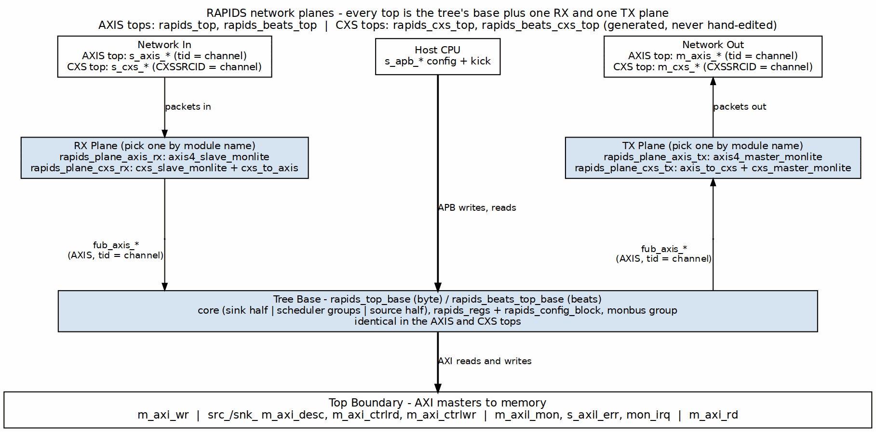
Network Planes
Source: ch03_network_planes.dot

16.2 Link Profile
The CXS planes use one fixed profile of Arm IHI 0079 (CXS) Issue D. Issue D is the first issue with the SRCID, TGTID and USER sidebands, which RAPIDS needs to carry the channel and the byte strobes.
CXS Link Profile
Property | Value
Links | One per direction: the sink port s_cxs_* into the sink half, the source port m_cxs_* out of the source half
Channel | CXSSRCID carries the RAPIDS channel (the AXIS tid)
CXSTGTID | The AXIS tdest
CXSUSER | {tuser, tstrb}; tuser is dropped when DATA_WIDTH/8 + AXIS_USER_WIDTH > 128
Packets per flit / start alignment | CXSMAXPKTPERFLIT = 2, 16-byte alignment; one AXIS packet is one CXS packet
Stream framing | Per stream, keyed on the channel bits of CXSSRCID: channels may interleave mid-packet
Link control | Explicit credit return, activation and deactivation; idle deactivation after CXS_IDLE_CYCLES
Parity | Off
Data width | DATA_WIDTH up to 1024 (CXSUSER is at most 128 bits and carries tstrb)
Channels interleave on one link. The byte-granular source arbitrates per drain block while a packet spans its whole descriptor, so with two or more source channels active the egress switches channel in the middle of a packet. That is legal CXS (streams may interleave, IHI 0079D 2.5.2) because every block on the link frames packets per stream rather than per link.

16.3 Credits
One credit permits one flit (IHI 0079D 2.1). Credits are a single pool for the whole link: a credit grant carries no ID, so it cannot be reserved for one channel.
CXS Top Parameters
Parameter | Default | Meaning
CXS_MAX_CREDIT | 32 | Credits the receiver grants. The grant-to-flit-to-free round trip is about 3 cycles, so 32 sustains one flit per cycle with margin for link pipelining or a clock crossing
CXS_RX_FIFO_DEPTH | CXS_MAX_CREDIT | The sink plane’s receive FIFO; it is the credit pool, so every granted credit is backed by space
CXS_CREDIT_BEYOND_SPEC | CXS_MAX_CREDIT > 63 | Above the spec’s limit of 63 the link is built beyond spec, and the far end must be built the same way
CXS_IDLE_CYCLES | 32 | Idle cycles before the TX plane deactivates the link
The credit count is not tied to SRAM_DEPTH. SRAM_DEPTH is the beats each channel buffers in each direction; the credit pool only has to cover the link’s round trip.

16.4 Signal List
The sink port (s_cxs_*) is a CXS receiver; the source port (m_cxs_*) is a CXS transmitter. Direction is given at the RAPIDS top.
CXS Link Signals
Signal | Sink port (s_cxs_*) | Source port (m_cxs_*) | Width | Description
*_cxs_valid | input | output | 1 | Flit valid
*_cxs_data | input | output | DATA_WIDTH | Flit data
*_cxs_cntl | input | output | CXS_CNTL_PW | Packet start/end control (CXSCNTL)
*_cxs_srcid | input | output | AXIS_ID_WIDTH | Source ID; the channel
*_cxs_tgtid | input | output | AXIS_DEST_WIDTH | Target ID; the AXIS tdest
*_cxs_user | input | output | CXS_UW | {tuser, tstrb}
*_cxs_crdgnt | output | input | 1 | Credit grant
*_cxs_crdrtn | input | output | 1 | Credit return
*_cxs_activereq | input | output | 1 | Link activation request
*_cxs_activeack | output | input | 1 | Link activation acknowledge
*_cxs_deacthint | output | input | 1 | Deactivation hint

CXS Status Signals
Signal | Direction | Description
snk_cxs_link_state, src_cxs_link_state | output [1:0] | {ACTIVEREQ, ACTIVEACK} of each link
snk_cxs_protocol_error, src_cxs_protocol_error | output | Sticky: the endpoint saw a CXS protocol violation
snk_cxs_unsupported | output | Sticky: a received flit that AXIS framing cannot represent

16.5 Flow Control and the Sink Contract
The byte-granular sink holds s_axis_tready low on an AXIS top until the channel’s descriptor has been fetched. On a CXS top the same backpressure appears as credits: the receive FIFO fills and the sink plane stops granting credits until the core drains it.

16.6 Monitoring
Each CXS plane carries a cxs_monitor_lite in place of the AXIS monitor-lite. It is programmed from the same CSRs (SNK.WRMON_* for the sink plane, SRC.RDMON_* for the source plane) and reports with the same agent IDs (0x09 sink, 0x0A source). Its packets are tagged PROTOCOL_CXS and join the half’s 3:1 monbus_arbiter as client 1, exactly where the AXIS plane’s packets go. See the Monitor Bus Interface chapter.

16.7 Routing and Payload Type (Proposed)
A proposal (2026-10-16, not implemented) gives every packet a header carrying its destination coordinate, source coordinate, payload type (cfg / prog / mem), length and target address. The header belongs to the tile network, not to CXS, and is described once in the compute-engine tile’s TILE_SPEC.md Section 11. CXS only transports it, as the first flit of the packet. Nothing on this page changes: CXSSRCID keeps the channel, so per-stream framing is the same. The descriptor fields that supply the header are in the Descriptor Format chapter.

RTL Design Sherpa · Learning Hardware Design Through Practice GitHub · Documentation Index · MIT License

17 Use Case: Network-to-Memory Transfer

17.1 Scenario
A network agent delivers a packet of L bytes on the sink AXI-Stream. RAPIDS writes exactly those bytes to system memory starting at the byte address A named by the channel’s descriptor. The packet may start anywhere in a beat, and the bytes before A and after A + L - 1 in the boundary beats are left untouched.
The examples use a 256-bit data path (32 byte lanes, DATA_WIDTH = 256, the Genesys 2 configuration). Byte lanes are numbered 0 to 31.

17.2 Sequence
Network-to-Memory Sequence
Step | Actor | Action
1 | Software | Builds a descriptor: destination byte address A, length L in bytes, and the channel’s sink direction enabled (Descriptor Format)
2 | Software | Kicks the channel so the descriptor engine fetches the descriptor
3 | Scheduler | Computes the beat count and hands the sink data path a packet record: {bytes = L, offset = A mod 32}
4 | Network agent | Streams the packet on s_axis_* with TID = channel. TREADY rises once the record exists
5 | Sink ingress | Shifts each packed stream beat up by the offset and writes memory-aligned beats, with byte enables, into the channel’s SRAM partition
6 | Sink AXI master | Drains the SRAM as AXI4 write bursts, never crossing 4 KB, with WSTRB from the stored byte enables
7 | Sink ingress | At TLAST, compares the packet’s byte count with L; a mismatch sets the channel’s sticky write-error flag
8 | Scheduler | On the last write response, completes the descriptor and reports it on the MonBus

17.2.1 Ordering Rule
Issue the descriptor before the packet arrives, or stream one channel at a time. s_axis_tready is one signal and it stays low for a beat whose channel has no packet record yet. Until that record exists the whole stream is held, including beats for other channels queued behind it. See AXIS Interface.

17.3 Worked Example 1: 77 Bytes at Offset 5
Destination A = base + 5, where base is beat-aligned, and L = 77.
Example 1 Quantities
Quantity | Value
Offset | 5
Beats written | (5 + 77 + 31) >> 5 = 3
Stream beats | 3: 32, 32 and 13 bytes
Last stream beat TSTRB | 0x00001FFF

Example 1 Write Beats
Memory beat | Address | Lanes written | Bytes | WSTRB
0 | base | 5 to 31 | 27 | 0xFFFFFFE0
1 | base + 32 | 0 to 31 | 32 | 0xFFFFFFFF
2 | base + 64 | 0 to 17 | 18 | 0x0003FFFF
The three beats carry 27 + 32 + 18 = 77 bytes. Stream byte 0 lands in lane 5 of the first memory beat. The five bytes that do not fit in that beat are held and join the next one, so each memory beat is assembled from two neighboring stream beats. The 13 bytes of the last stream beat plus the five held bytes fill lanes 0 to 17 of the last memory beat, so no extra flush beat is needed.
The write is one AXI4 burst of three beats at base. AxADDR is the aligned address and AxSIZE is the full 32-byte beat.

17.4 Worked Example 2: 4035 Bytes Crossing a 4 KB Boundary
Destination A = 0x0CB (byte address within a 4 KB page), L = 4035.
Example 2 Quantities
Quantity | Value
Offset | 0x0CB mod 32 = 11
Aligned start | 0x0C0
Beats written | (11 + 4035 + 31) >> 5 = 127
Beats before the 4 KB boundary | (0x1000 - 0x0C0) / 32 = 122
Beats after the boundary | 5
First beat WSTRB | lanes 11 to 31, 0xFFFFF800
Last beat | at 0x1080, lanes 0 to 13, WSTRB = 0x00003FFF
The 127 beats hold 21 + 125 x 32 + 14 = 4035 bytes. The sink write master cannot issue one 127-beat burst, because it would cross 0x1000. It splits at the boundary:
Example 2 Write Bursts
Burst | AWADDR | Beats
1 | 0x0C0 | up to 122
2 | 0x1000 | 5
If the configured write burst limit (WR_XFER_BEATS) is below 122, burst 1 is itself split; the 4 KB cap and the configured limit are combined and the smaller wins. After the first burst the address continues from the aligned address plus the beats already written.

17.5 Errors
Network-to-Memory Error Cases
Condition | Result
Packet byte count differs from L | Channel’s sticky write-error flag is set and stays set until reset (Error Handling)
Write response is not OKAY | AXI write error is reported through the same flag
Zero-length descriptor | No record, no packet expected, nothing written

17.6 Related Chapters
- Descriptor Chaining, shared with RAPIDS Beats
- Multi-Channel Operation, shared with RAPIDS Beats

RTL Design Sherpa · Learning Hardware Design Through Practice GitHub · Documentation Index · MIT License

18 Use Case: Memory-to-Network Transfer

18.1 Scenario
RAPIDS reads L bytes from system memory starting at the byte address A named by the channel’s descriptor and emits them on the source AXI-Stream as one packed packet. The read may start anywhere in a beat. The stream carries only the requested bytes: the first stream beat starts at lane 0 with byte A, and TLAST marks the descriptor’s last byte.
The examples use a 256-bit data path (32 byte lanes, the Genesys 2 configuration).

18.2 Sequence
Memory-to-Network Sequence
Step | Actor | Action
1 | Software | Builds a descriptor: source byte address A, length L in bytes, the channel’s source direction enabled (Descriptor Format)
2 | Software | Kicks the channel
3 | Scheduler | Computes the beat count and hands the source data path a packet record: {bytes = L, offset = A mod 32}
4 | Source AXI master | Reads whole aligned beats as AXI4 read bursts, never crossing 4 KB, into the channel’s SRAM partition
5 | Source egress | Pops beats from the SRAM and shifts them down by the offset. The first pop only primes the shifter
6 | Source egress | Emits packed stream beats with TID = TDEST = channel; the last beat carries a contiguous TSTRB and TLAST
7 | Scheduler | When the packet has left, completes the descriptor and reports it on the MonBus
Unlike the sink, the source needs no ordering rule against the network: the record is created before any read data is requested, so the egress always knows the packet length.

18.3 Worked Example 1: 77 Bytes at Offset 5
Source A = base + 5 with base beat-aligned, L = 77.
Example 1 Quantities
Quantity | Value
Offset | 5
Memory beats read | (5 + 77 + 31) >> 5 = 3
Stream beats | 3: 32, 32 and 13 bytes
Last stream beat TSTRB | 0x00001FFF
The read master issues one burst of three beats at base. The egress then works as follows:
Example 1 Egress Steps
Memory beat popped | Output
M0 | None. Bytes 5 to 31 are held: 27 bytes
M1 | Stream beat 0: the 27 held bytes plus bytes 0 to 4 of M1, TSTRB = 0xFFFFFFFF
M2 | Stream beat 1: bytes 5 to 31 of M1 plus bytes 0 to 4 of M2, TSTRB = 0xFFFFFFFF
(flush) | Stream beat 2: the remaining 13 bytes, TSTRB = 0x00001FFF, TLAST
The stream carries 32 + 32 + 13 = 77 bytes as one packet.

18.4 Worked Example 2: 4035 Bytes Crossing a 4 KB Boundary
Source A = 0x0CB, L = 4035.
Example 2 Quantities
Quantity | Value
Offset | 11
Memory beats read | 127
Beats before the 4 KB boundary | 122
Beats after the boundary | 5
Stream beats | 127: 126 full beats and a last beat of 3 bytes
Last stream beat TSTRB | 0x00000007
The read master splits at 0x1000: one burst of up to 122 beats from 0x0C0 and one of 5 beats from 0x1000, further split if the configured read burst limit (RD_XFER_BEATS) is smaller. The egress removes the 11 leading bytes and delivers 4035 bytes as one packet with a single TLAST, however many drain blocks and read bursts the transfer spanned. RAPIDS Beats asserted TLAST at the end of every drain block; RAPIDS does not.

18.5 Errors
Memory-to-Network Error Cases
Condition | Result
Read response is not OKAY | Channel’s read error is reported (Error Handling)
Zero-length descriptor | No record and no packet

18.6 Related Chapters
- Descriptor Chaining, shared with RAPIDS Beats
- Multi-Channel Operation, shared with RAPIDS Beats

RTL Design Sherpa · Learning Hardware Design Through Practice GitHub · Documentation Index · MIT License

19 Use Case: Descriptor Chaining

19.1 Overview
Descriptor chaining enables multiple transfers to execute sequentially without software intervention. Each descriptor contains a pointer to the next descriptor, forming a linked list that RAPIDS processes automatically.

19.2 Chain Structure

19.2.1 Figure 4.3.1: Descriptor Chain Structure
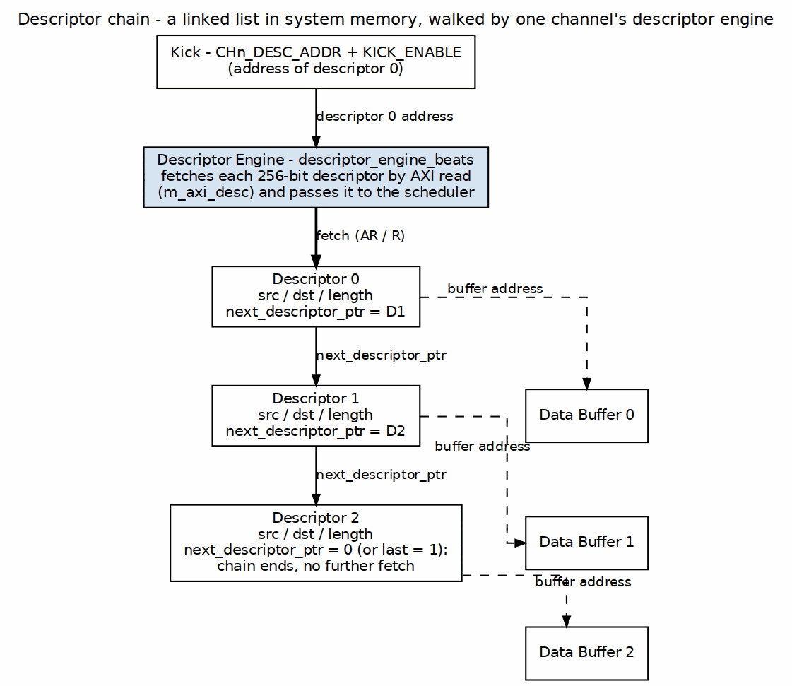
Descriptor Chain Structure
Source: ch04_chain_structure.dot

Chain Execution Flow

Timing Diagram

19.3 Descriptor Fields for Chaining

19.3.1 Relevant Fields
Chaining-Related Descriptor Fields
Field | Bits | Description
next_ptr | [191:128] | 64-bit pointer to next descriptor
last | [255] | Last descriptor in chain flag
irq_en | [254] | Generate interrupt on completion

19.3.2 Chain Termination
A chain terminates when ANY of these conditions is true:
- next_ptr == 0 (null pointer)
- last == 1 (explicit last flag)
- Error during transfer
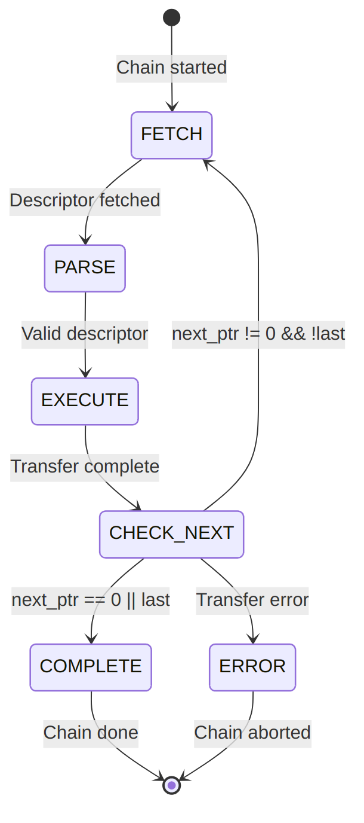
Diagram 6

19.4 Prefetch Optimization

19.4.1 Descriptor Prefetching
RAPIDS can prefetch the next descriptor while the current transfer executes:

Waveform 7
Benefit: Zero-cycle gap between chained transfers when prefetch completes before current transfer.
Prefetch depth is controlled by DESCENG_CONFIG.PREFETCH_EN and DESCENG_CONFIG.FIFO_THRESH (register block, offset 0x220). With prefetch disabled the descriptor engine fetches on demand (roughly one descriptor ahead of the scheduler); with prefetch enabled it buffers up to FIFO_THRESH descriptors ahead. A chain fetch that is throttled (output FIFO at the threshold) is deferred and reissued automatically once the FIFO drains, so no chain link is lost.

19.5 Multi-Channel Chaining
Each channel maintains independent chains:

19.5.1 Figure 4.3.2: Independent Per-Channel Chains

Independent Per-Channel Chains
Source: ch04_multichannel_chains.dot
Channels execute their chains concurrently and independently.

19.6 Error During Chain

19.6.1 Error Handling
When an error occurs mid-chain:

Waveform 8
Error Response: 1. Current transfer aborts 2. Chain processing stops 3. Error status captures failing descriptor index 4. MonBus reports error event 5. Interrupt generated (if enabled)

19.6.2 Recovery
Software must: 1. Read error status to identify failing descriptor 2. Fix the issue (descriptor content, memory mapping, etc.) 3. Restart chain from failing descriptor or beginning

RTL Design Sherpa · Learning Hardware Design Through Practice GitHub · Documentation Index · MIT License

20 Use Case: Multi-Channel Operation

20.1 Overview
RAPIDS Beats supports 8 independent DMA channels that can operate concurrently. This enables parallel data transfers for multiple network connections, priority-based scheduling, and efficient resource utilization.

20.2 Channel Independence

20.2.1 Figure 4.4.1: Independent Channels
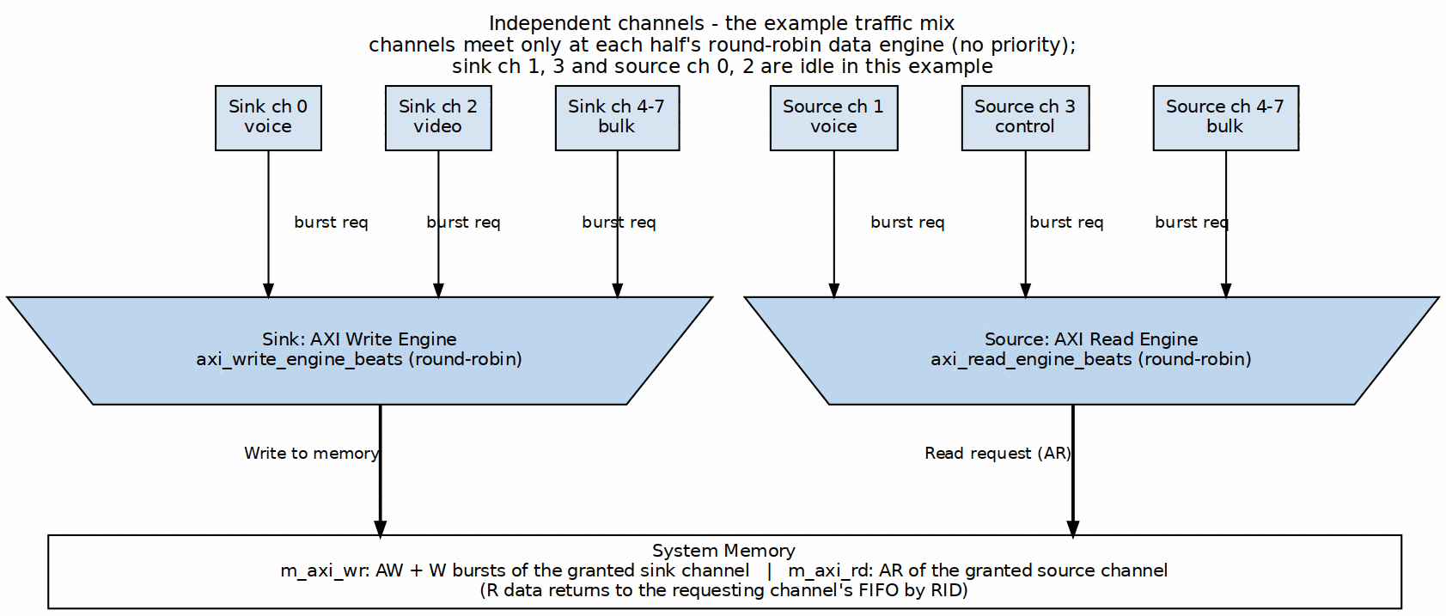
Independent Channels
Source: ch04_channel_independence.dot

Concurrent Operation Timing

20.3 Resource Arbitration

20.3.1 Descriptor Port Arbitration
All channels share a single AXI port for descriptor fetches:

Waveform 10

20.3.2 Sink/Source Arbitration
Data path AXI ports use plain round-robin arbitration (arbiter_round_robin inside each engine). There is no priority boost: the descriptor’s priority field is carried but not used for arbitration.

20.3.3 Figure 4.4.2: Data-Path AXI Arbitration
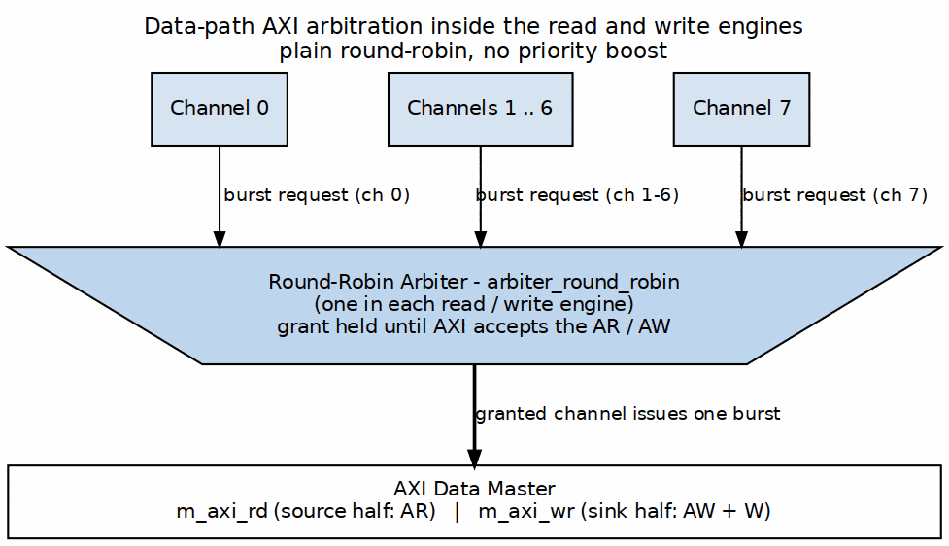
Data-Path AXI Arbitration
Source: ch04_datapath_arbitration.dot

20.4 Channel Isolation

20.4.1 Error Isolation
Errors in one channel do not affect other channels:

Waveform 11

20.4.2 Per-Channel Soft Reset
Individual channels can be reset without affecting others:

Waveform 12

20.5 Use Case Examples

20.5.1 Mixed Traffic Pattern
Typical network application with different traffic types:
Mixed Traffic Channel Assignment
Channel | Traffic Type | Direction | Priority | Notes
0 | Voice/RTP | Sink | High | Low latency required
1 | Voice/RTP | Source | High | Low latency required
2 | Video | Sink | Medium | High bandwidth
3 | Control | Source | Medium | Small packets
4-7 | Bulk data | Both | Low | Background transfers

20.5.2 Bidirectional Transfer
Single network connection using paired channels:

20.5.3 Figure 4.4.3: Bidirectional Transfer
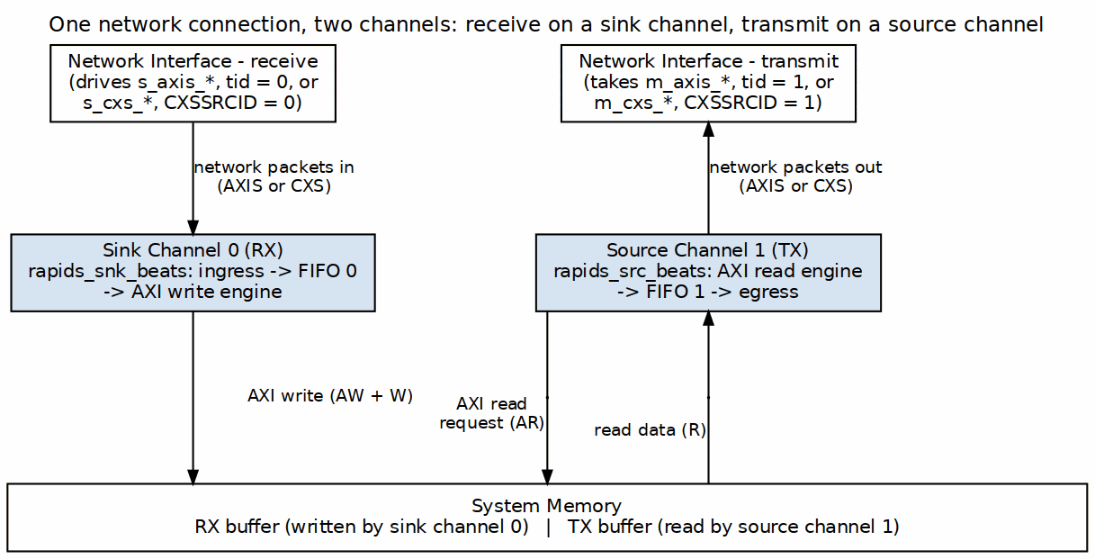
Bidirectional Transfer
Source: ch04_bidirectional.dot

20.5.4 Load Balancing
Multiple channels processing same traffic type:

20.5.5 Figure 4.4.4: Load Balancing by tid
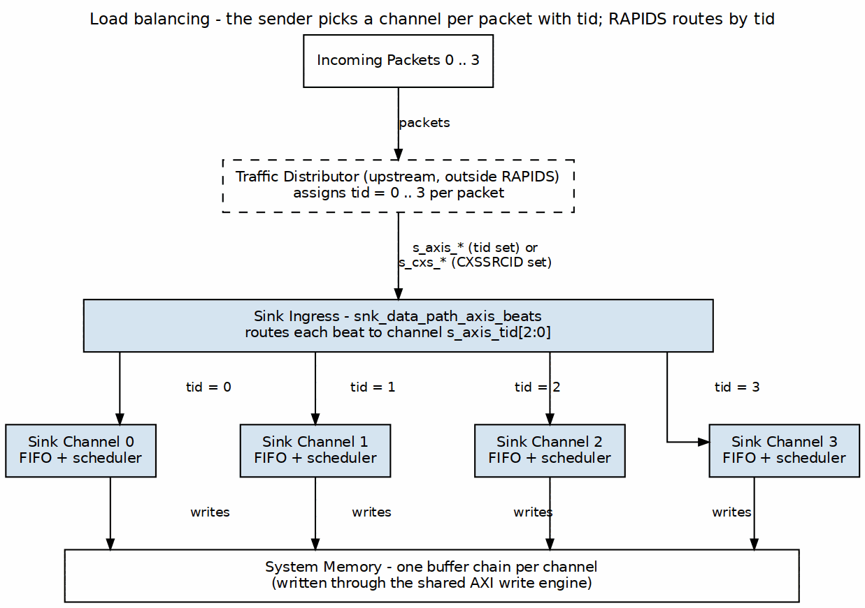
Load Balancing by tid
Source: ch04_load_balancing.dot

20.6 Performance Considerations

20.6.1 Bandwidth Sharing
Bandwidth Distribution
Active Channels | Per-Channel BW (% of max) | Notes
1 | 100% | Full bandwidth available
2 | ~50% each | Round-robin sharing
4 | ~25% each | Fair distribution
8 | ~12.5% each | All channels active
Note: Actual distribution depends on transfer sizes and memory latency.

20.6.2 Latency Impact
Multi-channel operation adds arbitration latency:
Arbitration Latency
Scenario | Additional Latency
Single channel | 0 cycles
2 channels contending | 1-2 cycles
8 channels contending | Up to 7 cycles

20.7 MonBus Events
Each channel generates independent MonBus events:

Waveform 13
Events are arbitrated and serialized on the shared MonBus output.

RTL Design Sherpa · Learning Hardware Design Through Practice GitHub · Documentation Index · MIT License

21 Descriptor Format

21.1 Overview
RAPIDS uses 256-bit (32-byte) descriptors to define DMA transfers. Descriptors are stored in system memory and fetched by the Descriptor Engine when a channel is kicked. The layout is the layout RAPIDS Beats uses, bit for bit. What changed is the meaning of two things: the length field counts BYTES, and src_addr / dst_addr are byte addresses with no alignment requirement.
A descriptor therefore describes a transfer the way software thinks of it. A packet of 37 bytes at address 0x1007 is a descriptor with length = 37 and dst_addr = 0x1007. The hardware turns that into beats, byte enables and a partial last beat; software never does the arithmetic.

21.2 Descriptor Layout

21.2.1 256-Bit Structure
Bit Range Field Name Width Description
────────────────────────────────────────────────────────────────────────
[255:213] reserved 43 Reserved (write 0)
[212:210] desc_type 3 0 = LEGACY, 1 = EXTENDED (see below)
[209:208] opcode 2 0 = DATA, 1 = CTRL_READ, 2 = CTRL_WRITE
[207:200] priority 8 Transfer priority (informational)
[199:196] channel_id 4 Channel ID (informational)
[195] error 1 Error flag (written by hardware)
[194] last 1 Last descriptor in chain
[193] gen_irq 1 Generate interrupt on completion
[192] valid 1 Descriptor valid flag
[191:160] next_descriptor_ptr 32 Address of next descriptor (0 = last)
[159:128] length 32 Transfer length in BYTES
[127:64] dst_addr 64 Destination byte address
[63:0] src_addr 64 Source byte address
: 256-Bit Descriptor Layout (rapids_pkg::descriptor_t)
Tile header fields (TILE_HDR = 1, 2026-10-17): ptype at [215:213], op (write / read) at [216] and, on SOURCE descriptors, a destination coordinate and target address in dst_addr, which is otherwise unused there. They supply the tile packet header defined in the compute-engine tile’s TILE_SPEC.md Section 11, and are ignored when TILE_HDR = 0. The field table is in the RAPIDS Beats Descriptor Format chapter (the positions are shared; only this design implements them).
The authoritative definition is rapids_pkg::descriptor_t in rtl/includes/rapids_pkg.sv. Only bits [255:0] are fetched and used. Every field position is the same as in RAPIDS Beats, so a descriptor builder needs one change: the value written to length.

21.3 Field Descriptions

21.3.1 Control Bits [195:192]
Control Bits
Bit | Field | Description
192 | valid | Must be 1; a descriptor with valid=0 puts the channel in the error state
193 | gen_irq | Set to 1 to generate a completion interrupt
194 | last | Set to 1 for the last descriptor in a chain
195 | error | Error flag; written by hardware, write 0

21.3.2 Direction
There is no direction field in the descriptor. Direction is a property of the half that owns the channel. The SOURCE half (memory to AXIS) reads from src_addr. The SINK half (AXIS to memory) writes to dst_addr. A descriptor is delivered to one half’s descriptor engine by the address it was staged at, so the same layout serves both. Each half looks only at its own address, so the two offsets never have to agree.

21.3.3 Transfer Length [159:128]
- 32-bit field specifying the transfer size in BYTES.
- The length is the packet length. On the sink it is the number of bytes the AXIS packet must carry. On the source it is the number of bytes in the one AXIS packet the descriptor produces.
- A length of 0 moves nothing and carries no packet record (see Alignment and Offsets).

21.3.4 Next Pointer [191:160]
- 32-bit address of the next descriptor, zero-extended to the engine’s 64-bit address width.
- A value of 0 terminates the chain, as does last = 1.
- Autonomous chaining also requires the address to fall inside one of the two configured descriptor address ranges.
Chain traversal is unchanged from RAPIDS Beats. See the shared Descriptor Chaining chapter.

21.3.5 Address Fields [127:0]
For SINK transfers (network to memory):
Field | Usage
dst_addr [127:64] | Memory write destination, any byte address
src_addr [63:0] | Not used (write 0)
For SOURCE transfers (memory to network):
Address Field Usage
Field | Usage
dst_addr [127:64] | Not used (write 0)
src_addr [63:0] | Memory read source, any byte address

21.4 Alignment and Offsets
Let BYTE_LANES be the beat size in bytes (DATA_WIDTH / 8, 32 for the 256-bit build) and OFF_W its log2 (5 for 256 bits). For a linear DATA descriptor:
offset = addr[OFF_W-1:0] (the low bits of the byte address)
beats_total = 0 if length == 0
= (offset + length + BYTE_LANES - 1) >> OFF_W otherwise
beats_total is the number of whole memory beats the transfer touches. The sum is computed with a 33-bit intermediate, so a length near 4 GB does not overflow. Each half applies the formula to its own address: the source uses src_addr, the sink uses dst_addr.
Beat Count Examples (BYTE_LANES = 32)
Length (bytes) | Offset | beats_total | Useful bytes / (beats x 32)
0 | any | 0 | no transfer
1 | 0 | 1 | 0.031
2 | 31 | 2 | 0.031
32 | 0 | 1 | 1.000
32 | 1 | 2 | 0.500
37 | 0 | 2 | 0.578
60 | 5 | 3 | 0.625
100 | 7 | 4 | 0.781
203 | 3 | 7 | 0.906
The last column is the fraction of the bus the transfer uses. A transfer that is a whole number of beats and starts on a beat boundary is 1.000. Everything else pays for the beats it touches, not the bytes it carries.

21.4.1 How the offset reaches the bus
- AXI address. AxADDR is always issued beat-aligned. The offset never appears in the address. Address progression inside a transfer is the aligned-down start plus a beat count times BYTE_LANES.
- Sink writes. The first beat’s WSTRB leaves lanes 0 to offset-1 clear, and the last beat’s WSTRB covers only the bytes that remain. Bytes outside the packet are never written, so a sub-beat transfer does not disturb its neighbors in memory.
- Source reads. The read master fetches whole beats from the aligned address. The egress re-packer drops the leading offset bytes and packs the rest, so the AXIS packet starts at byte lane 0.
- AXIS. The stream is packed. Only the last beat is partial: TSTRB is contiguous from lane 0 and TLAST is on that beat. See the AXIS Interface chapter.

21.4.2 4 KB boundaries
A burst never crosses a 4 KB boundary. The engines cut a burst at the boundary, so a transfer that straddles one is issued as more than one burst. This is a protocol rule handled in hardware, not something software arranges. Example: 203 bytes at an address whose low 12 bits are 0xFC3 has offset 3 and 7 beats. The first two beats (aligned addresses 0xFC0 and 0xFE0) end at the boundary. The remaining five beats start at the next 4 KB page.

21.4.3 Zero-length descriptors
A descriptor with length = 0 moves nothing. It issues no read or write request and it carries no packet record, whatever its addresses are. It still occupies its place in the chain, so last, next_descriptor_ptr and gen_irq are honored. A zero-length DATA descriptor is therefore a legal way to report a completion event or end a chain without moving data.

21.4.4 Packet record
Every non-zero DATA descriptor produces one packet record, {bytes, offset}, for each enabled direction. The data path uses the record to place bytes on the sink or to frame the packet on the source. The record is pulsed once, when the scheduler leaves the fetch state to start the transfer.
- Each channel’s record queue is PQ_DEPTH deep (4). A descriptor whose record does not fit waits. This is backpressure and not an error.
- The sink ingress does not accept the first beat of a packet until the channel’s record exists. Issue the descriptor before the packet arrives, or send them concurrently.
- s_axis_tready is one signal, qualified by the tid of the beat on the bus. A beat for a channel with no record stalls the whole stream, including beats for other channels queued behind it. The per-channel record queues and ingress holds keep the data intact, so the effect is delay and not corruption. A stream that must not head-of-line block should have every channel’s descriptor issued before the stream starts.

21.5 Descriptor Opcodes (DATA / CTRL_READ / CTRL_WRITE)
The 2-bit opcode selects one of three behaviors. Only DATA moves payload, and only DATA is affected by the byte-granular changes.
Descriptor Opcodes
Opcode | Value | Behavior
DATA | 2'b00 | Payload transfer; length in bytes, byte addresses
CTRL_READ | 2'b01 | Consumer gate: poll a memory location until (read & mask) == expected, then release the chain
CTRL_WRITE | 2'b10 | Producer doorbell: one 32-bit write to a memory location, then continue
The CTRL_READ and CTRL_WRITE field layouts are unchanged from RAPIDS Beats, and they carry no packet record. See the RAPIDS Beats descriptor chapter for the field tables and the retry limit.

21.6 Extended Descriptors (row/col-major addressing)
desc_type = 1 (EXTENDED) selects strided, 2-D or circular addressing instead of linear accumulation. It is enabled at build time by USE_ROW_COL_MAJOR_ADDRESSING, which defaults to 1. An extended descriptor is 512 bits in two 256-bit chunks. Chunk 0 is the layout above with desc_type = 1. Chunk 1 is fetched by a second single-beat read at descriptor_addr + 0x20, so the two chunks must be contiguous in memory.
Chunk 1 (at descriptor_addr + 0x20)
Bit Range Field Name Width Description
──────────────────────────────────────────────────────────────────────
[255:192] reserved_hi 64 Reserved (future 3rd dimension)
[191:188] wr_reserved 4 Reserved
[187:182] wr_wrap1_log2 6 Write outer wrap window, log2 (0 = off)
[181:176] wr_wrap0_log2 6 Write inner wrap window, log2 (0 = off)
[175:160] wr_inner_count 16 Write beats per contiguous run
[159:128] wr_stride_1 32 Write outer stride, SIGNED bytes
[127:96] wr_stride_0 32 Write inner stride, SIGNED bytes
[95:92] rd_reserved 4 Reserved
[91:86] rd_wrap1_log2 6 Read outer wrap window, log2 (0 = off)
[85:80] rd_wrap0_log2 6 Read inner wrap window, log2 (0 = off)
[79:64] rd_inner_count 16 Read beats per contiguous run
[63:32] rd_stride_1 32 Read outer stride, SIGNED bytes
[31:0] rd_stride_0 32 Read inner stride, SIGNED bytes
: Extended Descriptor Chunk 1 (rapids_pkg::descriptor_ext_t)
The mode selection, the address equation and the signed strides are unchanged from RAPIDS Beats. The layout is byte-compatible with STREAM’s descriptor_ext_t.

21.6.1 EXT descriptors stay beat-aligned (permanent limitation)
TYPE=EXT is not byte-granular, and it is not going to be. This is a deliberate, permanent limitation of RAPIDS. An extended descriptor must have:
- src_addr and dst_addr aligned to BYTE_LANES (32 bytes for the 256-bit build).
- A length that is a multiple of BYTE_LANES.
Row and column striding are counted in whole beats, so a run of inner_count beats is inner_count x BYTE_LANES bytes, and the strides step between beat-aligned rows. An EXT descriptor with an unaligned address or a length that is not a beat multiple is outside the contract and is not checked. Use a linear descriptor when the transfer starts or ends mid-beat. The byte-granular path (offsets, byte enables, partial last beat, packet records) applies to linear descriptors only.

21.7 Descriptor Fetch
Fetch is unchanged from RAPIDS Beats. The Descriptor Engine issues a single-beat AXI4 read (arlen = 0) at the descriptor address, and again at +0x20 for an EXTENDED descriptor. The parsed descriptor is handed to the scheduler, which converts length and the address to beats_total, the record and the address working registers as described above. The descriptor address and next_descriptor_ptr are 32-byte aligned; that is the only alignment rule that remains for linear descriptors.

21.8 Alignment Requirements
Address and Length Alignment
Field | Alignment | Notes
Descriptor address | 32-byte | One descriptor is 32 bytes; an EXTENDED descriptor’s chunk 1 is fetched at +0x20
next_ptr [191:160] | 32-byte | 32-bit descriptor address, zero-extended by the engine
dst_addr [127:64], linear | none | Any byte address
src_addr [63:0], linear | none | Any byte address
dst_addr / src_addr, EXT | DATA_WIDTH/8 | Permanent: EXT is beat-aligned
length, linear | none | Any byte count; 0 moves nothing
length, EXT | multiple of DATA_WIDTH/8 | Permanent: EXT counts whole beats

21.9 What Changed from RAPIDS Beats
Descriptor Differences, RAPIDS Beats to RAPIDS
Aspect | RAPIDS Beats | RAPIDS
Descriptor size and bit layout | 256 bits | Same
length unit | beats | bytes
length = 0 | Reserved | Legal: moves nothing, no record, chain continues
src_addr / dst_addr alignment (linear) | DATA_WIDTH/8 | None
Beats moved | length | (offset + length + BYTE_LANES - 1) >> OFF_W
Sink write strobes | All lanes | WSTRB marks the bytes written
Source packet | Full beats | One packed packet per descriptor, partial last beat
Per-descriptor packet record | None | {bytes, offset} per enabled direction
Sink accepts a packet | Before the descriptor | After the channel’s record exists
CTRL_READ / CTRL_WRITE | Defined | Unchanged
TYPE=EXT | Beat rows | Beat rows, aligned addresses and lengths (permanent)
Chaining, next_ptr, last, gen_irq | Defined | Unchanged

21.10 Descriptor Examples

21.10.1 Sink Descriptor (Network to Memory)
A 100-byte sink transfer to 0x1_0000_0007, chained to a descriptor at 0x2000, raising an interrupt on completion. The destination is 7 bytes into a beat, so offset = 7 and beats_total = (7 + 100 + 31) >> 5 = 4. The first beat writes lanes 7 to 31, the last beat writes 4 bytes.
64-bit words, LSB word first:
[63:0] = 0x0000_0000_0000_0000 // src_addr (unused by the SINK half)
[127:64] = 0x0000_0001_0000_0007 // dst_addr = 0x1_0000_0007
[191:128] = 0x0000_2000_0000_0064 // next_ptr[191:160]=0x2000, length[159:128]=100
[255:192] = 0x0000_0000_0000_0003 // valid=1, gen_irq=1, last=0

21.10.2 Source Descriptor (Memory to Network)
A 60-byte source transfer from 0x2_0000_0005, terminating the chain. offset = 5 and beats_total = (5 + 60 + 31) >> 5 = 3 memory beats. The source emits one AXIS packet of two stream beats: 32 bytes, then 28 bytes with TLAST.
64-bit words, LSB word first:
[63:0] = 0x0000_0002_0000_0005 // src_addr = 0x2_0000_0005
[127:64] = 0x0000_0000_0000_0000 // dst_addr (unused by the SOURCE half)
[191:128] = 0x0000_0000_0000_003C // next_ptr = 0, length = 60
[255:192] = 0x0000_0000_0000_0007 // valid=1, gen_irq=1, last=1

21.11 Software Construction

21.11.1 C Structure Example
typedef struct __attribute__((packed, aligned(32))) {
uint64_t src_addr; // [63:0] source byte address
uint64_t dst_addr; // [127:64] destination byte address
uint32_t length; // [159:128] transfer length in BYTES
uint32_t next_ptr; // [191:160] 32-bit, 0 terminates the chain
uint32_t flags; // [223:192] see macros below
uint32_t reserved[2]; // [255:224]
} rapids_descriptor_t;
// flags bit positions are relative to descriptor bit 192
#define DESC_VALID (1u << 0) // [192]
#define DESC_GEN_IRQ (1u << 1) // [193]
#define DESC_LAST (1u << 2) // [194]
#define DESC_ERROR (1u << 3) // [195] hardware-written
#define DESC_CHANNEL_ID(n) (((n) & 0xFu) << 4) // [199:196]
#define DESC_PRIORITY(n) (((n) & 0xFFu) << 8) // [207:200]
#define DESC_OPCODE(n) (((n) & 0x3u) << 16) // [209:208]
#define DESC_TYPE(n) (((n) & 0x7u) << 18) // [212:210]
#define DESC_OP_DATA 0x0
#define DESC_OP_CTRL_READ 0x1
#define DESC_OP_CTRL_WRITE 0x2
#define DESC_TYPE_LEGACY 0x0
#define DESC_TYPE_EXT 0x1
// Beats a linear DATA descriptor touches (BYTE_LANES = 32 for 256-bit)
static inline uint32_t rapids_beats_total(uint64_t addr, uint32_t length)
{
const uint64_t lanes = 32;
if (length == 0)
return 0;
return (uint32_t)(((addr & (lanes - 1)) + length + lanes - 1) / lanes);
}
The helper is for software that wants to size buffers or predict burst counts. The hardware does not need it.

21.11.2 Descriptor Ring Setup
// Descriptor ring: descriptors must be 32-byte aligned
rapids_descriptor_t *ring = aligned_alloc(32, NUM_DESC * sizeof(*ring));
for (int i = 0; i < NUM_DESC; i++) {
memset(&ring[i], 0, sizeof(ring[i]));
ring[i].dst_addr = dst[i]; // any byte address
ring[i].length = len[i]; // bytes
ring[i].flags = DESC_VALID | DESC_GEN_IRQ;
if (i < NUM_DESC - 1) {
ring[i].next_ptr = (uint32_t)(uintptr_t)&ring[i + 1];
} else {
ring[i].next_ptr = 0; // terminates the chain
ring[i].flags |= DESC_LAST;
}
}
The descriptor buffers themselves stay 32-byte aligned. The payload addresses do not have to be.

RTL Design Sherpa · Learning Hardware Design Through Practice GitHub · Documentation Index · MIT License

22 Register Map

22.1 Overview
RAPIDS Beats provides a memory-mapped register interface for configuration and status. All registers are accessed through the single top-level APB slave (s_apb_*) and are implemented by the PeakRDL-generated rapids_regs register block. One addrmap holds two independent halves of the same layout (rapids_engine_regs): SRC at 0x0000 and SNK at 0x1000, 4 KB each. Within a half, the staged descriptor addresses occupy +0x000-0x03F, the launch register KICK_ENABLE sits at +0x040, configuration and status at +0x100-0x3FF, and the nested monitor regfile (rapids_mon_regs) at +0x800. Every offset below is relative to its half; add 0x1000 for the SNK copy.
Because the SNK half lives at 0x1000, the APB address bus must be at least 13 bits wide; paddr[12] selects the half and paddr[11] the monitor window.

22.2 Address Space Layout
Range (per half) | Target | Purpose
+0x000-0x03F | rapids_engine_regs | Per-channel staged descriptor addresses
+0x040 | rapids_engine_regs | KICK_ENABLE per-channel launch bits
+0x100-0x3FF | rapids_engine_regs | Configuration and status
+0x800-0x9FF | rapids_mon_regs | AXI-monitor config and performance
0x0000 / 0x1000 | half base | SRC half / SNK half
The three *_PKT_MASK registers are masks: bit[type] = 1 masks (drops) that packet type, at the monitor-lite and again at the monbus group. They reset to all-masked (0xFFFF), so nothing reaches the group until the host clears the bits of the classes it wants to see. (rapids BUG-008: the description used to read “1 = enable”; the polarity and the reset are as intended.) *_TIMEOUT counts MICROSECONDS in its low 16 bits.
On a build with USE_MON_REGS = 0 (the default when USE_AXI_MONITORS = 0) the two monitor windows keep their addresses but answer every access with PSLVERR and zero read data: the config blocks drive nothing from them, and a read-back that succeeded would tell the host a monitor is configured that does not exist.
: Address Space Layout

22.3 Base Registers (0x100-0x3FF)
Base Registers
Offset | Name | Access | Description
0x100 | GLOBAL_CTRL | RW | GLOBAL_EN[0], GLOBAL_RST[1] (level; write 0 to release)
0x104 | GLOBAL_STATUS | RO | SYSTEM_IDLE[0]
0x108 | VERSION | RO | MINOR[7:0], MAJOR[15:8], NUM_CHANNELS[23:16]=8
0x120 | CHANNEL_ENABLE | RW | CH_EN[7:0] per-channel enable
0x124 | CHANNEL_RESET | RW | CH_RST[7:0] per-channel reset (level; write 0 to release)
0x140 | CHANNEL_IDLE | RO | CH_IDLE[7:0] – not driven at the top level, reads 0; use SCHEDULER_IDLE
0x144 | DESC_ENGINE_IDLE | RO | Per-channel descriptor-engine idle
0x148 | SCHEDULER_IDLE | RO | Per-channel scheduler idle (excludes CH_ERROR)
0x150-0x16C | CH_STATE[0..7] | RO | Per-channel FSM state (stride 0x4)
0x170 | SCHED_ERROR | RO | Per-channel sticky scheduler error
0x174 | AXI_RD_COMPLETE | RO | Per-channel read-complete (SRC half only; reads 0 in SNK)
0x178 | AXI_WR_COMPLETE | RO | Per-channel write-complete – not driven, reads 0
0x200 | SCHED_TIMEOUT_CYCLES | RW | Write-progress timeout window (cycles, reset 1000)
0x204 | SCHED_CONFIG | RW | SCHED_EN, TIMEOUT_EN, ERR_EN, COMPL_EN, PERF_EN
0x208 | SCHED_TIMEOUT_LIMIT | RW | LIMIT[7:0] escalation limit (reset 4, 0 = never)
0x220 | DESCENG_CONFIG | RW | DESCENG_EN[0], PREFETCH_EN[1], FIFO_THRESH[5:2] (reset 8)
0x224 | DESCENG_ADDR0_BASE | RW | Descriptor address range 0 base [31:0]
0x228 | DESCENG_ADDR0_LIMIT | RW | Descriptor address range 0 limit [31:0]
0x22C | DESCENG_ADDR1_BASE | RW | Descriptor address range 1 base [31:0]
0x230 | DESCENG_ADDR1_LIMIT | RW | Descriptor address range 1 limit [31:0]
0x240 | CTRL_CONFIG | RW | CTRLRD_MAX_TRY[8:0] control-read poll retry budget (0-511, reset 16)
0x2A0 | AXI_XFER_CONFIG | RW | AXI transfer sizing configuration
0x2B0 | PERF_CONFIG | RW | Performance profiler configuration
0x2C0-0x2CC | OBS_CTRL/OBS_FLAGS/OBS_DATA0/OBS_DATA1 | RW/RO | Observation mux
0x35C | PERF_CH_SEL | RW | Performance channel select
0x378-0x380 | HIST_SEL/HIST_DATA/HIST_TOTAL | RW/RO | Latency histogram

22.4 Monitor Registers (+0x800 within each half)
Monitor Registers (+0x800 within each half; SRC at 0x0800, SNK at 0x1800)
Offset | Name | Access | Description
+0x800 | MON_FIFO_STATUS | RO | MonBus capture/error FIFO status
+0x804 | MON_FIFO_COUNT | RO | MonBus FIFO occupancy
+0x8C0-0x8DC | DAXMON_* | RW | Descriptor-monitor config (enable/timeout/latency/masks)
+0x8E0-0x8FC | RDMON_* | RW | Source-egress AXIS monitor-lite config (same layout; live in the SRC half, rapids TASK-015)
+0x900-0x91C | WRMON_* | RW | Sink-ingress AXIS monitor-lite config (same layout; live in the SNK half, rapids TASK-015; the SRC copy’s COMPRESS_EN drives the group)
+0x950-0x978 | DAXMON_PERF_* | RO/RW | Descriptor-monitor performance counters
+0x980-0x9A8 | RDMON_PERF_* | RO/RW | Read-monitor performance counters
+0x9B0-0x9D8 | WRMON_PERF_* | RO/RW | Write-monitor performance counters
+0x9E0-0x9F4 | {RD,WR}MON_PERF_CH_* | RO | Per-channel producer/backpressure/starve/idle/overflow

22.5 Key Register Fields

22.5.1 GLOBAL_CTRL (0x100) - Read/Write
GLOBAL_CTRL Register
Bits | Field | Reset | Description
[0] | GLOBAL_EN | 0 | Master enable for the entire engine
[1] | GLOBAL_RST | 0 | Global reset: holds every channel of the half in reset while 1. Not self-clearing – write 0 to release
[31:2] | Reserved | 0 | Reserved

22.5.2 SCHED_TIMEOUT_LIMIT (0x208) - Read/Write
SCHED_TIMEOUT_LIMIT Register
Bits | Field | Reset | Description
[7:0] | LIMIT | 4 | Consecutive write-progress timeout windows before escalating to a fatal, sticky CH_ERROR. 0 = never escalate. Total escalation time ~= LIMIT x SCHED_TIMEOUT_CYCLES.

22.5.3 DESCENG_CONFIG (0x220) - Read/Write
DESCENG_CONFIG Register
Bits | Field | Reset | Description
[0] | DESCENG_EN | 1 | Descriptor engine master enable
[1] | PREFETCH_EN | 0 | Prefetch chaining (0 = on-demand, ~1 ahead)
[5:2] | FIFO_THRESH | 8 | Descriptors buffered ahead when prefetch enabled
[31:6] | Reserved | 0 | Reserved

22.5.4 Tile Header Status (0x2D0-0x2D8) - byte-granular RAPIDS with TILE_HDR = 1
These registers exist in both halves and read zero in RAPIDS Beats and in a TILE_HDR = 0 build. The sticky bits are write-1-to-clear.
Tile Header Status Registers
Register | Half | Fields
TILE_STATUS (0x2D0) | SNK | UNSUPPORTED [0]: the sink port consumed a packet it could not act on. TAG_MISMATCH [1]: a data packet’s tag differed from its stream ID
TILE_DESC_DROPPED (0x2D4) | SRC | DROPn [n]: channel n dropped a cell-issued descriptor (no free slot, EXT, or during channel reset)
TILE_COUNTS (0x2D8) | SNK | DESC_COUNT [15:0]: desc packets passed to the source half. CREDIT_COUNT [31:16]: credit packets received. Both wrap
A drop does not error the channel; TILE_DESC_DROPPED is the only record of it. See the compute-engine tile’s TILE_SPEC Section 11.12.

Register Access Timing

Waveform 15

22.6 Channel Kick Sequence
Staging a channel’s descriptor address, then writing that channel’s bit in KICK_ENABLE, triggers descriptor processing:

Waveform 16

22.7 Address Decoding
Registers are global (not per-channel windows); per-channel fields are packed as bit lanes within a single 32-bit register (e.g. CHANNEL_ENABLE.CH_EN[7:0], SCHEDULER_IDLE.SCHED_IDLE[7:0]). The only per-channel array is CH_STATE[0..7] at 0x150-0x16C (stride 0x4). Descriptor kick-off is part of this register block: staged addresses at 0x000-0x03F (CH*_DESC_ADDR_{LOW,HIGH}, stride 0x8) and the KICK_ENABLE launch register at 0x040.
+0x000 - 0x03F: Staged descriptor addresses (CH*_DESC_ADDR_{LOW,HIGH})
+0x040 : KICK_ENABLE (per-channel launch, singlepulse)
+0x100 - 0x3FF: Base configuration / status registers
+0x800 - 0x9FF: Monitor configuration / performance registers
SRC half at 0x0000, SNK half at 0x1000 (paddr[12]); PSLVERR on the monitor
window when USE_MON_REGS = 0.

RTL Design Sherpa · Learning Hardware Design Through Practice GitHub · Documentation Index · MIT License

23 16-Channel Register Map
RAPIDS comes in two register-map sizes. The shared Register Map chapter describes the 8-channel map, which rapids_top, rapids_cxs_top, rapids_8ch_top and rapids_8ch_cxs_top use. rapids_16ch_top and rapids_16ch_cxs_top use the 16-channel map. That map is the 8-channel map with only the channel-count-dependent registers changed:
Register Differences, 8- and 16-Channel Maps
Register | 8-channel map | 16-channel map
CHn_DESC_ADDR_LOW / _HIGH | n = 0..7 at 0x000-0x03C | n = 0..15 at 0x000-0x07C
KICK_ENABLE | 0x040, KICK0..KICK7 | 0x080, KICK0..KICK15
CHANNEL_ENABLE, CHANNEL_RESET, CHANNEL_IDLE, DESC_ENGINE_IDLE, SCHEDULER_IDLE, SCHED_ERROR, AXI_RD_COMPLETE, AXI_WR_COMPLETE | one bit per channel, [7:0] | [15:0]
CH_STATE[n] | n = 0..7 at 0x150 | n = 0..15 at 0x180
VERSION.NUM_CHANNELS | 8 | 16
PERF_CH_SEL.CH_SEL | [2:0] | [3:0]
RDMON_PERF_CH_OVERFLOW_HI, WRMON_PERF_CH_OVERFLOW_HI | absent | MON +0x1F8 / +0x1FC: channels 8..15 (4 bits each)
Every other register keeps the name, offset and fields it has in the 8-channel map. Software that addresses registers by name (the generated rtl/rapids_regmap.py and rtl/rapids_regmap_16ch.py) needs no change except loading the map for its build. Software that hard-codes KICK_ENABLE at 0x040 must move it to 0x080.
The 16-channel RDL is derived from the 8-channel one by bin/gen_rapids_regs_16ch.py, never edited by hand. The same script writes the per-size glue that the shared rapids_top_base includes.

RTL Design Sherpa · Learning Hardware Design Through Practice GitHub · Documentation Index · MIT License

24 Initialization Sequence

24.1 Overview
This section describes how software brings up RAPIDS Beats and starts a transfer. Every register named here is a register of the PeakRDL rapids_engine_regs register file (rtl/macro_beats/rapids_engine_regs.rdl), using the names in the generated per-instance map rapids_regmap.py. The two halves share one layout: SRC at 0x0000 and SNK at 0x1000. Each half is initialized on its own, and the offsets in the Register Map are relative to the half.
The code below uses reg_wr(half, NAME, value) and reg_rd(half, NAME) as shorthand for an APB access to register NAME in the SRC or SNK half. Resolve the names through the generated map instead of hard-coding offsets.

24.2 Boot Sequence

24.2.1 Figure 5.3.1: Bring-Up Sequence

Bring-Up Sequence
Source: ch05_boot_sequence.dot

24.3 What the Hardware Requires
A channel runs a descriptor only when every one of these terms is true. They are ANDed in rapids_config_block, so a missing one leaves the channel idle without raising an error:
Conditions for a Channel to Run
Term | Register.field | Reset | Effect when 0
Global enable | GLOBAL_CTRL.GLOBAL_EN | 0 | Masks CH_EN, SCHED_EN, DESCENG_EN and every monitor enable in the half
Channel enable | CHANNEL_ENABLE.CH_EN[n] | 0 | The scheduler stays in CH_IDLE with a descriptor waiting
Scheduler enable | SCHED_CONFIG.SCHED_EN | 1 | All schedulers in the half are disabled
Descriptor engine enable | DESCENG_CONFIG.DESCENG_EN | 1 | No descriptor is fetched
Descriptor window | DESCENG_ADDR0_BASE/_LIMIT, DESCENG_ADDR1_BASE/_LIMIT | 0 / 0xFFFFFFFF | A descriptor address outside both windows is refused and the channel errors
Kick | KICK_ENABLE.KICKn | – | Nothing is fetched until the bit is written
GLOBAL_EN and CH_EN both reset to 0. The other enables reset to 1, and both descriptor windows reset to the full 32-bit range, so a minimal bring-up only has to write CHANNEL_ENABLE, GLOBAL_CTRL, the staged address and KICK_ENABLE.

24.4 Detailed Steps

24.4.1 Step 1: Verify Hardware Presence
// VERSION (0x108): MINOR[7:0], MAJOR[15:8], NUM_CHANNELS[23:16]
uint32_t version = reg_rd(SRC, VERSION);
uint8_t minor = (version >> 0) & 0xFF; // 0x5A (90) in this release
uint8_t major = (version >> 8) & 0xFF; // 0x00: pre-release, version 0.90
uint8_t num_ch = (version >> 16) & 0xFF; // 8
if (num_ch == 0) {
printf("ERROR: RAPIDS not detected\n");
return -1;
}
There is no separate configuration register. The channel count is the only build parameter that software can read back. Data width and SRAM depth are not readable from the register file.

24.4.2 Step 2: Optional Reset
GLOBAL_CTRL.GLOBAL_RST and CHANNEL_RESET.CH_RST[n] are ordinary read/write bits. They do not self-clear. A channel is held in reset (scheduler forced to CH_IDLE, descriptor engine reset) for as long as its bit, or GLOBAL_RST, reads 1. Software must write the bit back to 0 to release it.
// Pulse the global reset: set, then clear. Keep GLOBAL_EN at 0 meanwhile.
reg_wr(half, GLOBAL_CTRL, GLOBAL_CTRL_GLOBAL_RST); // bit 1
reg_wr(half, GLOBAL_CTRL, 0);
// Every scheduler should now report idle (SYSTEM_IDLE = AND of SCHED_IDLE).
while (!(reg_rd(half, GLOBAL_STATUS) & 1)) { }

24.4.3 Step 3: Configure the Engine
// Scheduler: SCHED_EN[0] TIMEOUT_EN[1] ERR_EN[2] COMPL_EN[3] PERF_EN[4]
reg_wr(half, SCHED_TIMEOUT_CYCLES, 1000); // write-progress window, in clocks
reg_wr(half, SCHED_TIMEOUT_LIMIT, 4); // fatal after 4 stalled windows; 0 = never
reg_wr(half, SCHED_CONFIG, SCHED_EN | TIMEOUT_EN | ERR_EN | COMPL_EN);
// Descriptor engine: DESCENG_EN[0] PREFETCH_EN[1] FIFO_THRESH[5:2]
reg_wr(half, DESCENG_CONFIG, DESCENG_EN | PREFETCH_EN | (4 << 2));
// Descriptor address windows (lower 32 bits). A fetch address outside
// both windows is refused and the channel enters CH_ERROR.
reg_wr(half, DESCENG_ADDR0_BASE, desc_region_base);
reg_wr(half, DESCENG_ADDR0_LIMIT, desc_region_base + desc_region_size - 1);
// Burst sizing: RD_XFER_BEATS[7:0] WR_XFER_BEATS[15:8]
// ALLOC_SIZE[23:16] DRAIN_SIZE[31:24]
reg_wr(half, AXI_XFER_CONFIG, (16 << 24) | (16 << 16) | (8 << 8) | 8);
The SRC half uses the read-side fields and the SNK half uses the write-side fields. Writing the whole word in both halves does no harm.

24.4.4 Step 4: Optional Monitor and Interrupt Egress
The only interrupt output is mon_irq. It comes from the top-level monbus_axil4_axil4_group and is asserted while that group’s error FIFO is not empty. The scheduler error and completion packets travel on the CORE protocol. For both halves, the group takes its CORE filter from the SRC half’s WRMON_* registers:
// CORE packets: PKT_MASK bit[type] = 1 DROPS that type; reset is 0xFFFF.
reg_wr(SRC, WRMON_PKT_MASK, ~((1u << 0) | (1u << 1)) & 0xFFFF); // pass Error, Completion
// ERR_SELECT[3:0] bit[type] = 1 routes that type to the error FIFO (-> mon_irq).
// Bit 0 = Error. Bit 1 = Completion, which includes the gen_irq descriptor event.
reg_wr(SRC, WRMON_ERR_CFG, (0xFF << 8) | (1u << 0)); // keep ERR_MASK reset value
Packets that are passed but not selected for the error FIFO go to the capture path (m_axil_mon_*). The group, mon_irq and the s_axil_err_* drain exist only when USE_AXI_MONITORS = 1. With USE_AXI_MONITORS = 0, mon_irq is tied to 0, and software must poll SCHED_ERROR and SCHEDULER_IDLE instead.

24.4.5 Step 5: Build Descriptors
// rapids_pkg::descriptor_t, 256 bits (see Descriptor Format)
for (int i = 0; i < NUM_RX_DESC; i++) {
desc[i].src_addr = 0; // unused by a sink transfer
desc[i].dst_addr = rx_buffer + i * FRAME_SIZE;
desc[i].length = FRAME_LEN; // BEATS in RAPIDS Beats, BYTES in byte-granular RAPIDS
desc[i].next_descriptor_ptr = (i < NUM_RX_DESC - 1) ? (uint32_t)&desc[i + 1] : 0;
desc[i].valid = 1; // 0 -> CH_ERROR
desc[i].last = (i == NUM_RX_DESC - 1);
desc[i].gen_irq = 1; // completion event RAPIDS_EVENT_IRQ
}
__sync_synchronize(); // descriptors visible before the kick
The descriptors must lie inside a DESCENG_ADDR0/DESCENG_ADDR1 window.

24.4.6 Step 6: Enable
reg_wr(half, CHANNEL_ENABLE, 1u << ch); // CH_EN[n]
reg_wr(half, GLOBAL_CTRL, GLOBAL_CTRL_GLOBAL_EN); // bit 0; GLOBAL_RST stays 0

Initialization Timing
cfg_channel_enable[n] is CH_EN[n] & GLOBAL_EN, so it asserts only after the last of the two writes.

24.5 Starting Transfers

24.5.1 Kick a Channel
Stage the descriptor address, then launch it with a single write to KICK_ENABLE. The address registers only store the value, so writing them does not start anything. Each KICKn bit is a singlepulse field and clears itself. One 32-bit write can launch several channels on the same clock.
reg_wr(half, CH0_DESC_ADDR_LOW, (uint32_t)((uint64_t)&desc[0]));
reg_wr(half, CH0_DESC_ADDR_HIGH, (uint32_t)((uint64_t)&desc[0] >> 32));
reg_wr(half, KICK_ENABLE, 1u << 0); // KICK0
The APB write completes as soon as the request is raised. The RTL holds the request until the descriptor engine accepts it, so a completed write does not mean the engine has accepted the kick.

Waveform 18

24.6 Completion and Interrupt Handling
There is no interrupt status register and no per-channel interrupt clear. Software sees completion in one of two ways:
- Polling. SCHEDULER_IDLE.SCHED_IDLE[n] returns to 1 when the scheduler is back in CH_IDLE after the last descriptor of a chain. A channel in CH_ERROR never reports idle, and SCHED_ERROR.SCHED_ERR[n] reads 1 for it instead. Poll both registers, or the loop will hang on a faulted channel. Do not poll CHANNEL_IDLE, AXI_WR_COMPLETE, or the SNK half’s AXI_RD_COMPLETE. Those fields are not driven at the top level and always read 0 (see the Register Map).
- mon_irq. If Step 4 routed Completion packets to the error FIFO, every descriptor completion lands there, and so does every error. A completion is reported as RAPIDS_EVENT_DESC_COMPLETE, or as RAPIDS_EVENT_IRQ when the descriptor’s gen_irq is set. The descriptor engine’s descriptor-loaded completions land there too. mon_irq stays high until the records are drained over s_axil_err_*.
void rapids_irq_handler(void) {
// mon_irq == error FIFO not empty: drain every record
while (mon_irq_pending()) {
mon_record_t r = err_fifo_read(); // s_axil_err_* reads
if (r.pkt_type == PKT_TYPE_ERROR) {
handle_channel_error(r.half, r.channel_id); // see Error Handling
} else if (r.pkt_type == PKT_TYPE_COMPLETION) {
process_completed_buffer(r.half, r.channel_id, r.event_data);
}
}
}
To run the channel again, stage the next chain’s first descriptor address and write its KICK_ENABLE bit. No re-enable is needed, because CH_EN stays set.

24.7 Reset and Recovery

24.7.1 Per-Channel Reset
void reset_channel(int half, int ch) {
// Assert, then release: CH_RST is NOT self-clearing.
reg_wr(half, CHANNEL_RESET, 1u << ch);
reg_wr(half, CHANNEL_RESET, 0);
while (!(reg_rd(half, SCHEDULER_IDLE) & (1u << ch))) { }
// SCHED_ERROR[ch] is the CH_ERROR state, so it reads 0 again here.
}
The scheduler’s error state is sticky. The only ways out of CH_ERROR are a channel reset (CH_RST[n]) or a global reset (GLOBAL_RST). The reset leaves CH_EN[n] and the staged descriptor address unchanged. After the reset, re-stage the address if it should change, then kick.

24.7.2 Global Reset
void reset_rapids_half(int half) {
reg_wr(half, GLOBAL_CTRL, GLOBAL_CTRL_GLOBAL_RST); // GLOBAL_EN = 0, RST = 1
reg_wr(half, GLOBAL_CTRL, 0); // release
while (!(reg_rd(half, GLOBAL_STATUS) & 1)) { } // SYSTEM_IDLE
rapids_init_half(half); // Steps 3-6 again
}
GLOBAL_RST drives every channel’s reset in that half only. The other half, and the shared monitor group’s error FIFO, are not affected.

RTL Design Sherpa · Learning Hardware Design Through Practice GitHub · Documentation Index · MIT License

25 Error Handling

25.1 Overview
RAPIDS reports errors per channel and per direction. The error classes are the ones RAPIDS Beats already has, and the byte-granular design adds one: the packet on the sink stream does not carry the number of bytes the descriptor asked for. This chapter lists every condition that stops a channel, how software sees it, and how to recover. It also lists three conditions that look like errors and are not.
Two facts shape the whole chapter:
- A fatal error parks the channel. The scheduler enters its error state and stays there. Only a channel reset or a global reset leaves it.
- A channel reset recovers every class. The scheduler, the descriptor and control engines, both data engines and both data paths all take the per-channel reset. No error class needs the hardware reset aresetn, and resetting one channel does not disturb the others.

25.2 Error Classes
Error Classes
Class | Detected by | Fatal to the channel | Sticky until
Invalid descriptor (valid = 0) | Scheduler, on CH_FETCH_DESC | Yes | Channel reset
Descriptor address outside both configured ranges | Descriptor engine, before any fetch | Yes | Channel reset
Descriptor address of zero or otherwise invalid over APB | Descriptor engine | Yes | Channel reset
Descriptor fetch returns an AXI error (RRESP not OKAY) | Descriptor engine | Yes | Channel reset
Data read returns an AXI error (RRESP not OKAY) | AXI read engine | Yes | Channel reset
Data write returns an AXI error (BRESP not OKAY) | AXI write engine | Yes | Channel reset
Sink packet length mismatch (new) | Sink ingress, at tlast | Yes | Channel reset
Control read retry exhausted | Control read engine | Yes | Channel reset
Control write returns an AXI error | Control write engine | Yes | Channel reset
Write-progress timeout, first windows | Scheduler timeout counter | No | Any write progress
Write-progress timeout, escalated | Scheduler timeout counter | Yes | Channel reset
The first four rows and the control-engine rows behave exactly as in RAPIDS Beats. The data-path rows are the same conditions. In RAPIDS the channel reset also clears them; the “Recovery” section lists what it does to work still in flight.

25.3 The Byte-Granular Error: Packet Length Mismatch

25.3.1 Contract
A sink descriptor of length bytes on a channel promises one AXI-Stream packet on that channel. The packet is delimited by tlast. The number of valid bytes in the packet, counted from tstrb, must equal length.
The sink ingress counts the valid bytes of every accepted beat. On the beat that carries tlast it compares the running total, including that beat, with the byte count in the channel’s packet record. If the two differ, the ingress sets a sticky per-channel bit and raises it on the channel’s sched_wr_error line.
Length Mismatch Cases
Situation | Result
Packet shorter than length (early tlast) | Error
Packet longer than length (late tlast) | Error
Packet equals length | No error
Descriptor length = 0 | No packet record, no packet expected
The hardware does not pad a short packet and does not drop the extra bytes of a long one. Nothing is corrected silently. The bytes that were accepted are still written, so memory that the descriptor covers must not be trusted after this error.

25.3.2 Exposure
The mismatch is visible in three places.
Where the Length Mismatch Appears
Where | What software sees
SNK.SCHED_ERROR.SCHED_ERR | Bit for the channel set. This is the same per-channel bit that reports every fatal scheduler error, so the register does not say which class occurred.
MonBus | One error packet per error episode from the channel’s scheduler. Its data field carries the sticky write-error flag.
Scheduler state | The channel is in its error state, so SCHEDULER_IDLE.SCHED_IDLE does not show it idle.
The error is raised on the sink half only. The source half has no counterpart: the egress re-packer builds the packet from the descriptor, so the packet it emits always has length bytes.

25.3.3 How it Clears
The per-channel bit is cleared by the channel reset (and therefore by the global reset, which asserts every channel’s reset). It stays clear afterwards; the next packet is checked against its own record. See “Recovery” below for what the reset does to a packet that is part-way through the stream.

25.3.4 Prevention
- Issue the sink descriptor for a packet before, or together with, the first beat of that packet. The stream waits for the descriptor (see “Not Errors” below), so a late descriptor costs time and nothing else.
- Set length to the exact byte count of the packet. If the length is only known at the end of the packet, write the descriptor after the length is known.
- Do not split one packet across two descriptors and do not put two packets under one descriptor. One descriptor maps to one tlast delimited packet.

25.4 Shared Error Classes

25.4.1 Invalid or Unfetchable Descriptor
The scheduler leaves CH_FETCH_DESC only for a descriptor whose valid bit is set. A descriptor with valid = 0 sends the channel to its error state.
The descriptor engine rejects a descriptor fetch whose address falls outside the two configured address ranges. The rejection happens before any AXI read is issued. It also reports an error for a fetch address of zero or otherwise invalid on the APB path, and for an AXI error response on the fetch itself.
A descriptor whose length is zero is not invalid. See “Not Errors”.

25.4.2 Data-Path AXI Errors
The AXI read engine sets a sticky per-channel flag when a data read returns a response other than OKAY. The AXI write engine does the same for a write response. Both flags drive the channel’s error state.

25.4.3 Control Engine Errors
A control read that does not match after the configured number of retries reports an error. Retry exhaustion is what stops a control read that can never match from hanging the channel. A control write that returns an AXI error reports an error. Both are fatal to the descriptor that issued them.

25.4.4 Write-Progress Timeout
The scheduler counts the cycles in which it holds a write request that the write engine has not accepted. A write completion or a write commit resets the count. Its configuration is shared with RAPIDS Beats:
Timeout Configuration
Register field | Meaning | Default
SCHED_TIMEOUT_CYCLES.TIMEOUT_CYCLES | Length of one window in cycles | 0x3E8
SCHED_TIMEOUT_LIMIT.LIMIT | Consecutive expired windows that escalate to a fatal error. Zero never escalates. | 4
A window that expires is recoverable. Any write progress clears the strike count. Only the configured number of consecutive expired windows makes the timeout fatal. A LIMIT of zero keeps the timeout purely advisory. The timeout is unchanged by the byte-granular design.

25.5 Not Errors
Three conditions look like faults and are normal operation.

25.5.1 Packet Record Queue Full
Each channel keeps a queue of packet records, one per non-zero data descriptor per enabled direction. The queue holds four records. When it is full, the scheduler waits in CH_FETCH_DESC until a record is consumed. Software sees the channel busy and nothing else.
No error bit is set and no MonBus error is sent. The timeout counter runs only while the scheduler holds a write request the write engine has not accepted, so waiting for a record does not count toward it. Descriptor chains longer than the queue therefore run at the pace the data paths consume records.

25.5.2 Sink Beat With No Packet Record
The sink ingress accepts a stream beat for a channel only when that channel’s packet record exists. Until then s_axis_tready stays low.
s_axis_tready is a single signal. It is qualified by the tid of the beat that is on the bus. A beat for a channel with no record therefore stalls the whole stream, including beats for other channels that are queued behind it in the sender. The queues and holds inside RAPIDS are per channel, so no data is lost or mixed. The cost is delay, and it lands on every channel that shares the stream.
Two rules keep this delay short:
- Post the sink descriptor for a channel before the sender drives the first beat for that channel.
- A sender that interleaves channels on one stream must not assume that a waiting channel leaves the others unaffected at the AXI-Stream interface.

25.5.3 The 4 KB Burst Cap
An AXI burst must not cross a 4 KB boundary. The scheduler splits a transfer at each boundary. A descriptor that spans several pages issues several bursts, and every burst starts beat-aligned. The split is invisible to software, and it neither sets a flag nor counts against any timeout. The cost appears only as throughput, described in the throughput chapter.

25.6 Error Reporting

25.6.1 Registers
Software finds the failing channel from these fields. All names come from the shared register map and are the same as in RAPIDS Beats.
Error Registers
Register field | Use
SRC.SCHED_ERROR.SCHED_ERR | One bit per channel, source half
SNK.SCHED_ERROR.SCHED_ERR | One bit per channel, sink half
SCHEDULER_IDLE.SCHED_IDLE | One bit per channel, set when the scheduler is idle
CHANNEL_RESET.CH_RST | One bit per channel, resets the scheduler and its engines
GLOBAL_CTRL.GLOBAL_RST | Resets every channel
GLOBAL_CTRL.GLOBAL_EN | Global enable
The per-channel error bit is the summary of every fatal class in the “Error Classes” table. It does not name the class. To name the class, read the MonBus error packet or use the scheduler debug outputs.

25.6.2 MonBus
The scheduler sends one error packet the first time a channel enters its error state. It does not repeat the packet on every cycle. The packet carries the sticky write-error flag and the sticky read-error flag in its data field. MonBus decoding is described in the shared monitor bus chapter.

25.7 Recovery

25.7.1 Channel Reset
Writing the channel’s bit in CHANNEL_RESET.CH_RST of the half that reported the error, SNK or SRC (or GLOBAL_CTRL.GLOBAL_RST for every channel of that half), returns the channel to idle. The reset reaches the scheduler, the descriptor and control engines, the AXI read and write engines, and the sink and source data paths. Every sticky error flag in that chain clears, including the data read and write response flags and the sink packet length flag. Software should:
- Set the channel’s CH_RST bit for at least one clock, then clear it. A single-cycle pulse and a held level both work. To reset both directions of a channel, write both halves.
- Poll the SCHED_ERR bit and the SCHED_IDLE bit for the channel. The error bit stays clear and the idle bit sets.
- Rebuild the descriptor chain from a known-good state. Bytes that the failed chain already wrote stay in memory.
- Start the channel again as in the initialization sequence.
This recovers every error class in the “Error Classes” table. No hardware reset is needed, and the other channels keep running through it.

25.7.2 What the Reset Does to Work in Flight
A channel reset can arrive with beats, bursts and packets still moving. The hardware settles them as follows, so the channel is clean when the reset releases.
Channel Reset: Handling of In-Flight Work
Where | In-flight work | Effect
Sink stream, packet already started | Beats of the packet still to come | The ingress accepts and discards them up to and including tlast, so the tail of the old packet cannot be taken as the start of the next. The stream does not stall.
Sink stream, no packet started | None | Nothing to discard. A beat for the channel is held off while the reset is asserted.
Sink write path | An AXI write burst already open | The write engine finishes the burst with null beats (WSTRB = 0), so the AXI protocol stays legal and the null beats write nothing. A beat already presented on the write data channel when the reset hit is completed unchanged. No new burst opens for the channel until the open bursts and their responses have finished. Its AWADDR value is unchanged.
Sink write path | Write responses still due | They are consumed and ignored. A BRESP error that arrives after the reset does not set the error flag.
Source read path | Read bursts already issued | The read engine issues no further bursts, then drains and discards the returning read data until none is outstanding. A RRESP error in that data does not set the error flag.
Source stream, packet in progress | Beats not yet sent | The egress stops. A beat already on m_axis completes. The remaining beats are not sent (see below).
Other channels | Everything | Not affected. The data paths mask only the channel in reset.
The sink ingress discards only the tail of a packet of which at least one beat had been accepted when the reset hit. The sender must still send that packet’s tlast; the beat is taken and dropped, and the next beat for the channel is checked against the next packet record as usual. While the reset is asserted the channel’s beats are held off (s_axis_tready low).
The source stream is left unterminated. If the reset lands between the first and last beat of a source packet, RAPIDS stops sending it and does not emit a tlast (and no null terminator). The receiver sees a partial packet. A receiver that must resynchronize after a channel reset should treat the reset as the end of the packet, or flush its own per-channel state when it resets the channel. A packet that had not started, or that had already sent its tlast, is unaffected.
Head-of-line blocking is unchanged. A sink beat for a channel with no packet record still stalls the shared s_axis_tready, as described under “Not Errors”. A channel reset does not remove this. After the reset, post the next sink descriptor before the sender starts the next packet.

25.8 Software Checklist
Software Checklist
Step | Action
Before the run | Program SCHED_TIMEOUT_CYCLES and SCHED_TIMEOUT_LIMIT. Post the sink descriptor before the first beat of its packet.
During the run | Poll SCHED_ERR for the active channels, or watch MonBus for error packets.
On an error | Note the channel and read the MonBus packet. Decide which class from the descriptor state and the stream.
Recovery | Channel reset for every error class, including a length mismatch or an AXI response error.
After recovery | Re-post descriptors. Re-send the whole packet, not the tail. A source receiver discards the partial packet of a reset channel.

25.9 Related Chapters
- Descriptor Format: the byte length, the packet record and the zero-length rule.
- Register Map: the shared register layout.
- Monitor Bus Interface: the error packet format.

RTL Design Sherpa · Learning Hardware Design Through Practice GitHub · Documentation Index · MIT License

26 Throughput
RAPIDS moves bytes. The datapath moves beats. This chapter separates the two figures because they differ for small and unaligned transfers, and it labels every measured number with the build that produced it.
The sink path moves an AXI-Stream ingress stream into memory. The source path reads memory and drives an AXI-Stream egress stream. The two paths are independent engines with their own buffers, schedulers and AXI masters, so their bandwidths add.

26.1 Theoretical Maximum
A beat is DATA_WIDTH / 8 bytes. The board build uses DATA_WIDTH = 256, so a beat is 32 bytes. Per-direction bandwidth is the beat size times the clock.
Theoretical Maximum (256-bit Build)
Item | Value
Beat size | 32 bytes
Clock on the board | 100 MHz
Line rate per direction | 3.2 GB/s
Sink plus source together | 6.4 GB/s
The line rate scales linearly with the clock and with the data width. The width does not change the per-beat behavior of the engines, so every utilization figure below holds at any width and only the GB/s scale changes.

26.2 Byte Efficiency
The byte-granular design accepts any start address and any length. The memory side still moves whole beats. A transfer of length bytes that starts at byte offset inside a beat occupies
beats = (offset + length + BYTE_LANES - 1) >> OFF_W
beats on that side, with BYTE_LANES = 32 and OFF_W = 5 for 256 bits. The useful fraction of those beats is
efficiency = useful_bytes / (beats * BYTE_LANES)
Here useful_bytes is length. Efficiency is 1.0 only when both the start and the end land on beat boundaries. The bus meters count a beat with partial byte enables as a productive beat, so their utilization figures measure the beat stream. The byte throughput is the beat throughput multiplied by this efficiency.
Beats and Efficiency for Small and Unaligned Transfers
Length | Offset | Beats | Efficiency
1 | 0 | 1 | 0.031
2 | 31 | 2 | 0.031
32 | 0 | 1 | 1.000
32 | 1 | 2 | 0.500
37 | 0 | 2 | 0.578
60 | 5 | 3 | 0.625
100 | 7 | 4 | 0.781
203 | 3 | 7 | 0.906
The loss is at most two partial beats per descriptor: one at the head and one at the tail. It shrinks as the length grows. A 4 KB aligned transfer is 128 full beats and loses nothing. Software that needs the full line rate should align buffers to the beat size and use lengths that are multiples of it. Software that cannot align pays at most two beats per descriptor.
The offset applies to each half separately. The source half uses the source address and the sink half uses the destination address. A copy whose source and destination have different offsets can have a different beat count on each half.

26.2.1 4 KB Boundaries
AXI bursts do not cross a 4 KB boundary, so a transfer is split at every boundary it crosses. A page holds 128 beats at 32 bytes. The split adds one burst per extra page, and each burst starts beat-aligned. It costs burst-start overhead and no data. For large transfers the overhead amortizes in the same way as any other burst boundary. The burst-length sweep below gives the measured cost of short bursts.

26.2.2 Head-of-Line Delay on the Sink Stream
The sink stream has one s_axis_tready. It is qualified by the tid of the beat on the bus. A beat for a channel with no packet record yet stalls the whole stream, including beats for other channels behind it. The queues inside RAPIDS are per channel, so the cost is delay only. A sender that posts each sink descriptor before its first beat never sees this stall. The error chapter describes the rule.

26.3 Measured Results
Three sets of results exist. They answer different questions and must not be mixed.
Sources of Measured Figures
Set | Build | Question it answers
Byte campaign | Byte-granular RAPIDS on the Genesys 2 | Are byte lengths and offsets correct on the board?
Beats performance report | RAPIDS Beats on the Genesys 2 | How fast does the beat datapath run?
Byte-build performance | None yet | How fast does the byte build run in beat mode?
The byte checkers on the board build hold ready while they feed a transfer. A performance row measured with them therefore does not show the beat-mode backpressure behavior that the beats performance report was designed to show. The beat-mode rows in the beats performance report come from the beats build and are quoted as such below. A performance characterization of the byte build needs a build whose checkers run in beat mode, and that build does not exist yet.

26.3.1 Byte Campaign (Correctness)
Source: projects/fpga-systems/Genesys2/dma-ip/rapids/reports/board, files rapids_byte_bytes_20260930_072516.json and rapids_byte_smoke_20260930_072435.json. Two channels were active, one descriptor per channel.
Byte Campaign on the Board (7 of 7 Pass)
Packet bytes | Offset | Sink beats per channel | Result
1 | 1 | 1 | Pass
2 | 31 | 2 | Pass
32 | 0 | 1 | Pass
37 | 0 | 2 | Pass
100 | 7 | 4 | Pass
96 | 17 | 4 | Pass
203 | 3 (address 4035, crosses a 4 KB boundary) | 7 | Pass
The smoke run, four beats on two channels, also passes. The beat count the sink write master issued equals the formula in every row. Golden data matched in every row on both halves. These rows prove correctness. They are runs of one to seven beats, so their utilization figures are dominated by launch and are not throughput.

26.3.2 Shared Engines on the Board
Source: the two Genesys 2 bitstreams of the Resource Estimates chapter, rapids_byte_pce.bit (SHARED_ENGINES = 0) and rapids_byte.bit (SHARED_ENGINES = 1). Both were run back to back on 2026-10-17 on the same board, with the same host program. The records are projects/fpga-systems/Genesys2/dma-ip/rapids/reports/perf/json/rapids_byte_perf_20261017_shared_engines0.json and ..._shared_engines1.json. Each run is the 117-point byte performance profile (--byte-perf --profile standard, 8 channels, byte-wise checkers) and then every directed sequence (--byte-seq all).
Board Results, SHARED_ENGINES 0 and 1
Measure | Per-channel engines | Shared engines
Byte performance points passed | 117 of 117 | 117 of 117
Directed sequences passed | 5 of 5 (378 checks) | 5 of 5 (378 checks)
Highest sink rate | 2560 MB/s | 2560 MB/s
Highest source rate | 356 MB/s | 356 MB/s
Every point is compared with itself across the two bitstreams:
Per-Point Comparison
Half | Points compared | Geometric mean, shared / per-channel | Within 2 % | Shared slower by more than 2 % | Shared faster by more than 2 %
Sink | 109 | 1.000 | 99 | 6 (at most -2.4 %) | 4 (at most +5.8 %)
Source | 97 | 1.002 | 95 | 1 (-2.1 %) | 1 (+22.2 %)
The source rates are capped by the harness: the byte-wise checker takes 9 cycles per 32-byte beat, so 356 MB/s is 3200 / 9. The points that moved by more than 2 % are small transfers whose time is dominated by launch and descriptor fetch:
- The six slower sink points are all 8-channel, 33-byte, single-descriptor transfers (129.4 to 126.3 MB/s). All eight channels kick together, and the likely cause is that their first descriptor fetches now take turns at one AR issuer instead of eight. This has not been confirmed with a capture.
- The faster points are single-channel 203-byte sink transfers (up to +5.8 %) and a chain of 16 one-byte descriptors on 4 channels at the source (+22.2 %, 38.8 to 47.4 MB/s). These are consistent with the shared engine’s R path, which writes each descriptor straight into its channel’s FIFO, but the cause has not been isolated.
On sustained transfers the two builds measure the same. Sharing the engines costs no measurable throughput on this board.

26.3.3 RAPIDS Beats Performance Report
Source: projects/fpga-systems/Genesys2/dma-ip/rapids_beats/reports/perf/README.md, version 2.2. Build: RAPIDS Beats, 8 channels, 256 bits, 4 KB of buffer per channel, 100 MHz. Every row is golden-CRC checked. Utilization is engaged utilization: productive cycles over productive, backpressure and starvation cycles.
RAPIDS Beats Build, 8 Channels at 128 KB per Channel
Path | Interface | Engaged utilization | Effective bandwidth
Sink | AXIS in | 99.7 % | 3.19 GB/s
Sink | AXI4 write | 100.0 % | 3.20 GB/s
Source | AXI4 read | 100.0 % | 3.20 GB/s
Source | AXIS out | 100.0 % | 3.20 GB/s
The 0.3 point shortfall on the sink stream is a one-time 82-cycle fill stall of the 4 KB per-channel buffer. It does not repeat inside a run.
RAPIDS Beats Build, Transfer Size Sweep at 8 Channels
Beats per channel | AXIS in | AXI4 write | AXI4 read | AXIS out
1 | 88.9 % | 38.1 % | 27.6 % | 27.6 %
4 | 97.0 % | 84.2 % | 69.6 % | 69.6 %
16 | 99.2 % | 95.5 % | 90.1 % | 90.1 %
64 | 99.8 % | 98.5 % | 97.3 % | 97.3 %
256 | 96.1 % | 99.7 % | 99.3 % | 99.3 %
1024 | 99.0 % | 99.9 % | 99.8 % | 99.8 %
4096 | 99.7 % | 100.0 % | 100.0 % | 100.0 %

RAPIDS Beats Build, Channel Scaling at 4096 Beats per Channel
Active channels | AXIS in | AXI4 write | AXI4 read | AXIS out
1 | 100.0 % | 99.9 % | 99.7 % | 99.7 %
2 | 100.0 % | 99.9 % | 99.8 % | 99.8 %
4 | 100.0 % | 100.0 % | 99.9 % | 99.9 %
8 | 99.7 % | 100.0 % | 100.0 % | 100.0 %

RAPIDS Beats Build, Burst Length Sweep at 8 Channels and 1024 Beats
Beats per burst | AXIS in | AXI4 write | AXI4 read | AXIS out
1 | 35.9 % | 35.6 % | 99.8 % | 99.8 %
2 | 71.0 % | 71.0 % | 99.8 % | 99.8 %
4 | 99.0 % | 99.9 % | 99.8 % | 99.8 %
8 or more | 99.0 % | 99.9 % | 99.8 % | 99.8 %
The beats report also holds the memory-latency sweeps and the buffer-depth comparison. Those results belong to the beat datapath and are not repeated here.

26.3.4 Using the Beats Numbers
The byte build was not measured in beat mode, so the rows above are reference points and not measurements of it. The memory-side figures count beats. For a byte transfer, multiply the beat figure by the efficiency in the byte efficiency table to estimate the byte rate. Treat the result as an estimate until the byte build has its own performance run.

26.4 Throughput Limiting Factors
Throughput Limiting Factors
Factor | Effect | Mitigation
Partial head and tail beats | At most two beats per descriptor carry fewer than 32 useful bytes | Align buffers to the beat size and use beat-multiple lengths
4 KB boundaries | One extra burst per page crossed | Place large buffers on page boundaries
Short bursts | Below 4 beats the write side loses efficiency in the beats measurement | Keep the burst configuration at 4 beats or more
Buffer fill at run start | A one-time 82-cycle stall on the sink stream for the 4 KB build | A fixed cost per run, so its share shrinks as transfers grow
Head-of-line stall on the sink stream | Delay on all channels when one channel lacks a packet record | Post each sink descriptor before its first beat
Record queue full | The scheduler waits until a record is consumed; delay only | Chains longer than four descriptors run at the pace the data paths consume records
Memory latency | Reduces small-transfer efficiency | Use the beats report’s latency sweeps to size outstanding depth
TYPE=EXT descriptors | Beat rows only, so no head or tail loss but no unaligned addressing | Keep EXT buffers aligned, which they must be anyway
Control descriptors move no payload. A control read gates on a memory location and a control write issues a single write. Budget them as latency, not bandwidth.

26.5 Related Chapters
- Latency Characteristics: shared with RAPIDS Beats.
- Descriptor Format: the byte length, the offset and the beat-count formula.
- Error Handling: the length mismatch and the head-of-line rule.

RTL Design Sherpa · Learning Hardware Design Through Practice GitHub · Documentation Index · MIT License

27 Latency Characteristics
Latency is dominated by the one-time pipeline fill from a channel kick to the first data beat. Once running, both paths sustain the throughput of Section 6.1; control descriptors add a bounded synchronization delay.

27.1 Latency Components

27.1.1 Kick-to-First-Beat Breakdown
Stage | Typical Cycles (100 MHz) | Notes
Kick decode (APB write to KICK_ENABLE) | TBD – re-measure | Address is staged beforehand; the launch request is then held until the descriptor engine accepts it
Descriptor fetch (AXI read, 256-bit) | AXI read latency + 1 | Overlapped by prefetch on chains
Descriptor parse | 1-2 | Opcode + fields decoded
SRAM fill (sink) / AXI read issue (source) | AXI/AXIS latency | First beat into the buffer
First beat out | 1-2 | Drain to memory (sink) / AXIS (source)

27.1.2 Total Latency Formula
L_first_beat = L_kick + L_desc_fetch + L_parse + L_pipeline_fill
Note: L_kick predates the staged-address/KICK_ENABLE kick and has not been re-measured. The previous figure came from a path that stalled APB until the descriptor engine accepted the kick; acceptance is now asynchronous, so the term is no longer bounded by an APB stall.
L_desc_fetch is hidden on chained descriptors when the descriptor engine has prefetched the next descriptor (DESCENG_CONFIG.PREFETCH_EN).

27.2 First-Beat Latency
The dominant term is the memory/network round trip to fill the pipeline. For a sink transfer the first AXIS beat must arrive and be buffered before the first AXI write can drain; for a source transfer the first AXI read must return before the first AXIS egress beat. After the first beat the pipeline is full and throughput is bandwidth-bound, not latency-bound.

27.3 Control-Descriptor Latency
Control descriptors are latency, not throughput (Section 6.1):
Opcode | Latency
CTRL_WRITE (doorbell) | One single-beat AXI write: AW->W->B round trip
CTRL_READ (gate) | One poll per retry (AXI read + compare); retries paced by tick_1us, up to CTRL_CONFIG.CTRLRD_MAX_TRY (default 16, max 511)
A CTRL_READ gate blocks its descriptor (and the chain) until the polled value matches. The retry budget bounds the worst case: an unsatisfied gate cannot hang the channel – after CTRLRD_MAX_TRY polls the engine raises ctrlrd_error instead of waiting forever.

27.4 Latency Variability

27.4.1 Sources of Variability
- Memory read latency (descriptor fetch, source reads) and write-response timing.
- AXIS backpressure (s_axis_tready / m_axis_tready) on the network end.
- Multi-channel arbitration for the shared AXI master.
- CTRL_READ retry count when a gate is not yet satisfied.

27.4.2 Worst-Case Latency
Bounded by: memory timeout (SCHED_TIMEOUT_CYCLES / SCHED_TIMEOUT_LIMIT escalation on the scheduler side) and the control-read retry budget (CTRL_CONFIG.CTRLRD_MAX_TRY). Both convert an otherwise-unbounded wait into a reported error so a channel is never permanently stalled.

27.5 Latency Optimization

27.5.1 Software Recommendations
- Chain descriptors so the descriptor engine prefetches the next while the current transfers (hides L_desc_fetch).
- Keep the AXIS consumer/producer ready to avoid backpressure stalls.
- Size CTRL_READ gates so the expected value is already (or soon) present to minimize poll retries.

27.5.2 Hardware Configuration
- Adequate SRAM_DEPTH so the buffer covers memory/network latency without stalling.
- Tune AXI_XFER_CONFIG (RD/WR beats, ALLOC/DRAIN) so bursts amortize AXI setup.

Last Updated: 2026-07-13

RTL Design Sherpa · Learning Hardware Design Through Practice GitHub · Documentation Index · MIT License

28 Resource Estimates
The figures in this chapter are measured. They come from the placed and routed board build of the byte-granular RAPIDS on the Genesys 2, not from an estimate. The chapter states the configuration first because every number depends on it.

28.1 Build Configuration
Board Build Configuration
Item | Value
Top level | rapids_byte_genesys2_top (RAPIDS plus the characterization harness)
Device | xc7k325tffg900-2 (Kintex-7 325T)
Tool | Vivado 2025.1, design state Physopt postRoute
Clock | 100 MHz
Channels | 8, on both the sink and the source half
Data width | 256 bits (32-byte beats)
Buffer depth | 128 entries per channel, 4 KB per channel
Interface observers | On
AXI monitors | Off
The measured design includes the characterization harness: the UART bridge, the pattern generators, the byte checkers and the bus meters. The figures are therefore an upper bound for RAPIDS alone. The harness is not separated in the reports.

28.2 FPGA Resource Summary
Source: projects/fpga-systems/Genesys2/dma-ip/rapids/reports/perf/json/rapids_byte_build_bytecrc.json and rapids_byte_build_wordcrc.json, extracted from the post-route reports by reports/extract_build_metrics.py.
The harness has two checker builds. BYTE_CRC=1 is the standard bitstream: the byte-wise CRC checkers take 9 cycles per 32-byte beat and verify every byte and strobe. BYTE_CRC=0 is a measurement bitstream with word-wide checkers that take one beat per cycle, so the harness does not cap the measured rate.
Post-Route Utilization, 8 Channels, 256 Bits
Resource | Standard (BYTE_CRC=1) | Word-wide (BYTE_CRC=0) | Available
Slice LUTs | 92,874 (45.57 %) | 86,065 (42.23 %) | 203,800
LUT as logic | 81,352 | 75,695 | 203,800
LUT as distributed RAM | 11,522 | 10,370 | 64,000
Slice registers | 82,379 (20.21 %) | 79,527 (19.51 %) | 407,600
F7 muxes | 4,709 | 4,430 | 101,900
F8 muxes | 106 | 107 | 50,950
Block RAM tiles | 68 (15.28 %) | 52 (11.69 %) | 445
DSP | 0 | 0 | 0
All block RAM tiles are RAMB36E1. No RAMB18 is used, and no register is a latch. DSP use is zero because RAPIDS moves data and performs no multiply-accumulate. The 16 tiles and about 6,800 LUTs that the word-wide build saves are the byte checkers’ golden storage and CRC logic, which belong to the harness and not to RAPIDS.

28.3 Timing
Source: the same two build JSONs.
Timing at 100 MHz
Metric | Standard (BYTE_CRC=1) | Word-wide (BYTE_CRC=0)
Worst negative slack, setup | +0.301 ns | +0.077 ns
Total negative slack | 0.000 ns | 0.000 ns
Worst hold slack | +0.023 ns | +0.013 ns
Failing endpoints | 0 of 320,415 | 0 of 301,738
All user timing constraints are met in both builds. The slack is small and positive; treat 100 MHz as the design point and not as a margin.

28.4 Board Result
On the standard bitstream (sha256 cfad34c3...) the byte-wise campaign passes 117 of 117 points and the directed sequences 4 of 4. On the word-wide bitstream (sha256 48e1282c...) the beat-aligned profile passes 28 of 28 points and reaches 3182 MB/s on the sink and 3199 MB/s on the source at 8 channels and 4096 beats, against a theoretical peak of 3200 MB/s (100 MHz x 32 bytes). The word-wide checker CRCs only slice 0 of each beat and ignores strobes, so it is compared with the beats golden; byte-level integrity comes from the byte-wise campaign. Both runs are in the throughput chapter and the characterization report (reports/perf/README.md, v0.2).

28.5 Shared Engines: Before and After
Source: two Genesys 2 builds made on 2026-10-17 from the same RTL, differing only in SHARED_ENGINES. The bitstreams are rapids_byte_pce.bit (SHARED_ENGINES = 0, per-channel engines) and rapids_byte.bit (SHARED_ENGINES = 1, the default). Both builds use 8 channels per half, 256 bits, 128 entries per channel, BYTE_CRC = 1, AXI monitors off and observer taps off, at 100 MHz with Vivado 2025.1. The RAPIDS rows are the u_dut instance of the hierarchical post-route report, so they exclude the harness. These builds come from newer RTL and harness than the 2026-09-30 build above, so the two sets of numbers do not compare directly.
Post-Route Utilization, SHARED_ENGINES 0 and 1
Resource | Per-channel engines | Shared engines | Change
Whole design, Slice LUTs | 79,724 | 68,520 | -11,204 (-14.1 %)
Whole design, Slice registers | 58,107 | 41,497 | -16,610 (-28.6 %)
RAPIDS (u_dut), LUTs | 55,152 | 44,128 | -11,024 (-20.0 %)
RAPIDS (u_dut), flip-flops | 44,650 | 28,167 | -16,483 (-36.9 %)
rapids_core, LUTs / flip-flops | 46,350 / 37,984 | 35,595 / 21,507 | -10,755 / -16,477
Sink half, LUTs / flip-flops | 23,892 / 19,559 | 18,626 / 11,320 | -5,266 / -8,239
Source half, LUTs / flip-flops | 22,458 / 18,425 | 16,969 / 10,187 | -5,489 / -8,238
Block RAM tiles | 68 | 68 | 0
DSP | 0 | 0 | 0
Worst slack, setup and recovery (WNS) | +0.251 ns | +0.016 ns
Worst synchronous setup slack (clock group) | +0.259 ns | +0.593 ns
Worst hold slack | +0.040 ns | +0.009 ns
Almost all of the saving is in the engines. In the per-channel build the 16 descriptor engines (8 per half) take 11,009 LUTs and 7,360 flip-flops, the 16 control-read engines 2,388 and 7,038, and the 16 control-write engines 1,886 and 4,910. The shared build has one of each per half. The descriptor FIFOs stay per channel, which is why the descriptor saving is smaller than the control-engine saving. Block RAM and DSP are unchanged because none of the engines uses either.
Both builds meet timing at 100 MHz with no failing endpoint. The shared build’s worst slack is thinner (+0.016 ns), but that path is not in a shared engine: it is the asynchronous reset recovery path from the reset synchronizer to the sink write engine’s data registers. On synchronous setup paths the shared build has more margin than the per-channel build, +0.593 ns against +0.259 ns.

28.6 Comparison with the Beats Build
The RAPIDS Beats performance report lists the resources of its 256-bit build in its version 2.0 text. Both builds run 8 channels at 100 MHz on the same device with a buffer of 128 entries per channel.
Beats and Byte-Granular Builds
Item | RAPIDS Beats, 256-bit, v2.0 | RAPIDS, byte-granular (standard build)
Slice LUTs | 75,679 | 92,874
Block RAM tiles | 44 | 68
Worst negative slack | +0.608 ns | +0.301 ns
The columns are not a like-for-like comparison of the two designs. The two bitstreams come from different versions of the RTL and the harness. The byte checkers and the byte-wise golden logic are in the byte build and not in the beats build. The beats build has since been rebuilt, and the v2.2 beats report header gives a slack of +0.286 ns for it and no new resource counts. Use the table as a size comparison of two board images, and not as the cost of byte granularity.

28.7 What Depends on What
Apart from the engine breakdown above, the reports used here do not break the design down by block, and this chapter does not invent a breakdown. The relationships that follow from the design are these.
Scaling Notes
Change | Effect
Channels 8 to fewer, or 16 | Scheduler and buffer resources scale with channel count. With shared engines only the per-channel engine state scales; with per-channel engines every engine does
SHARED_ENGINES 1 to 0 | Adds 11,024 LUTs and 16,483 flip-flops at 8 channels (above)
Buffer depth | Block RAM scales with entries per channel, per direction, and with the entry width
Data width | Datapath logic and buffer width scale with it. The line rate scales with it.
Interface observers off | Removes the observer logic and its histograms
AXI monitors on | Adds monitor logic. They are off in this build.
The sink buffer entry is DATA_WIDTH + DATA_WIDTH / 8 bits wide, because each entry stores the byte enables beside the data. The source buffer entry stays DATA_WIDTH bits. The byte-granular sink therefore stores a wider entry than the beats sink for the same depth and width.
The byte-granular design adds per-channel state that the beats design lacks: a packet-record queue four deep, a sink spill register, an ingress packet byte counter and, on the source half, the re-pack hold register. The reports do not isolate their cost.

28.8 Related Chapters
- Throughput: the measured campaign and the beats report.
- Error Handling: the reset behavior of the sticky flags.

