Table of Contents
1 Bch Mas Index 4
2 Document Information 4
2.1 Binary BCH Codec Micro-Architecture Specification 4
2.2 Revision History 5
2.3 Document Purpose 5
2.4 Intended Audience 6
2.5 Related Documents 6
3 Methodology 7
3.1 HAS to MAS relationship 7
3.2 FSM policy 7
3.3 Prove-by-design / kmap philosophy 8
3.4 Carrying open PRD decisions 8
4 Block Inventory 9
5 Encoder Core (bch_encoder_core) 11
5.1 Purpose 11
5.1.1 Figure 2.1: Encoder core block diagram 12
5.2 Parameters 12
5.3 Interface 13
5.4 Microarchitecture internals 14
5.4.1 Bit serialiser / unpack 14
5.4.2 GF(2^m) LFSR parity generator 14
5.4.3 Parity mux 15
5.4.4 Bit packer 15
5.5 FSM policy 15
5.6 Timing 15
5.7 Notes 16
6 Syndrome Unit (bch_syndrome_unit) 16
6.1 Purpose 16
6.1.1 Figure 2.2: Syndrome unit block diagram 17
6.2 Parameters 17
6.3 Interface 18
6.4 Microarchitecture internals 19
6.4.1 Odd-syndrome recurrence 19
6.4.2 All-zero bypass qualifier 19
6.4.3 Completion qualifier 19
6.5 FSM policy 19
6.6 Timing 20
6.7 Notes 20
7 Key Equation Solver (bch_key_equation_solver) 20
7.1 Purpose 21
7.2 Parameters 21
7.3 Interface 21
7.4 Candidate algorithms 22
7.5 Microarchitecture internals 23
7.5.1 "RIBM" and "EUCLID" — fixed-iteration arrays 23
7.5.2 "SMALL_T" — conditional minimal control FSM 24
7.6 FSM policy 24
7.7 Timing 24
7.8 Notes 24
8 Chien Search (bch_chien_search) 25
8.1 Purpose 25
8.1.1 Figure 2.3: Chien search block diagram 26
8.2 Parameters 26
8.3 Interface 27
8.4 Microarchitecture internals 28
8.4.1 Parallel Horner cells 28
8.4.2 Direct bit-flip accumulation 28
8.4.3 Uncorrectability check 28
8.5 FSM policy 29
8.6 Timing 29
8.7 Notes 29
9 Decoder Core Integration (bch_decoder_core) 30
9.1 Purpose 30
9.1.1 Figure 2.4: Decoder core block diagram 31
9.2 Parameters 31
9.3 Interface 32
9.4 Microarchitecture internals 33
9.4.1 Block buffer 33
9.4.2 Stage sequencer 33
9.4.3 Corrected-stream re-check 33
9.4.4 Correctability verdict 34
9.5 FSM policy 34
9.6 Timing 34
9.7 Notes 34
10 Core Signals 35
10.1 Reset strategy 35
10.2 bch_encoder_core signal contract 35
10.3 bch_decoder_core signal contract 38
10.4 Timing rules 40
11 Signal Contracts and K-maps 41
11.1 What a contract is 41
11.2 Which signals have contracts 41
11.3 Pre-RTL citation posture 41
11.4 Regenerating the workbook 41
11.5 Workbook contents 42

1 Bch Mas Index
Generated: 2026-10-03

RTL Design Sherpa · Learning Hardware Design Through Practice GitHub · Documentation Index · MIT License

2 Document Information

2.1 Binary BCH Codec Micro-Architecture Specification
Property | Value
Document Title | Binary BCH Codec Micro-Architecture Specification
Version | 0.1 (draft)
Date | October 3, 2026
Status | Draft — no RTL exists; every structural choice is either carried from the PRD or open and tied to a PRD decision ID
Classification | Open Source - MIT License

2.2 Revision History
Version | Date | Author | Description
0.1 | 2026-10-03 | RTL Design Sherpa | First draft, written before any RTL exists. Carries the HAS architecture one level down: per-block signal-level intent, FSM policy, timing, and signal-contract references. Numbers are analytic placeholders derived from parameters; none are measured.

2.3 Document Purpose
This Micro-Architecture Specification (MAS) is the implementation-level view of the Binary BCH codec — the HAS (../bch_has/) taken one level down. It is the document an RTL author reads before writing SystemVerilog and a verification engineer reads before writing assertions.
It covers:
- each functional block’s internal structure, signals, and parameters
- the FSM policy for every block: where a state machine is forbidden, where one minimal control FSM is permitted, and what replaces FSMs elsewhere
- cycle-level timing and throughput placeholders tied to the open PRD decisions
- the signal-contract posture that will be checked by the generated kmap workbook

2.4 Intended Audience
- RTL implementers writing the encoder, decoder, and GF-datapath blocks
- Verification engineers checking the golden-model equivalence and the formal properties in formal/
- Architects reviewing whether a candidate D6 throughput or D11 solver choice fits a consumer’s area/latency target

2.5 Related Documents
Table 0.1: Related documents
Document | Location | Content
Product Requirements | ../../PRD.md | the decision table (D1-D12) and the candidate profiles
Hardware Architecture Specification | ../bch_has/bch_has_index.md | high-level block diagram, data flow, solver options, interfaces, parameters
Signal-contract workbook | ../../bch_signal_contracts.xlsx | generated contract sheets and kmap decision tables
Signal-contract generator | ../../gen_bch_signal_contracts_kmaps.py | Python generator for the workbook
References | ../../References/README.md | the standards and papers, with source and licence
CLAUDE.md | ../../CLAUDE.md | area facts for a session working here
Handbook | vault/handbook/design/ | streaming-no-fsm, minimal-fsm, signal-contracts-and-kmaps, valid-ready contracts

RTL Design Sherpa · Learning Hardware Design Through Practice GitHub · Documentation Index · MIT License

3 Methodology

3.1 HAS to MAS relationship
The Hardware Architecture Specification (../bch_has/) records what the BCH codec is, where it sits, what it presents at its boundaries, and what parameters configure it. This Micro-Architecture Specification carries that architecture one level down: per-block signal tables, cycle behavior, FSM policy, and the signal-contract references that will become the formal pre-RTL design review.
The rule in this repo is one source per fact. The MAS does not restate the PRD decision table or the HAS block diagram; it cross-references them and adds the implementation detail that belongs at this level. Parameters and throughput numbers that are not yet fixed are marked TBD and tied to the PRD decision ID that fixes them, following the convention in ../bch_has/ch06_integration/02_parameters.md.

3.2 FSM policy
The repo’s datapath FSM rule, taken from the design handbook, is:
No FSM in the per-beat data path. Not a minimal one, not a two-state one. FSMs belong to control: descriptor lifecycle, schedulers, init sequencers, error recovery. If a state machine can observe a data beat, it is in the wrong place. — vault/handbook/design/streaming-no-fsm.md
What replaces a datapath FSM in this block:
Instead of a state that… | Write
counts beats, or waits N cycles | a counter plus a comparator
remembers “I am mid-burst” | a r_valid flag on the pipeline stage
serializes because a resource is shared | an arbiter and a qualifier, not a turn-taking machine
gates until a condition holds | a qualifier ANDed into the handshake
Where a state machine is genuinely justified, the handbook requires:
Fewest states that carry the real distinctions. A state that only waits one fixed cycle, or that differs from a sibling only by a datapath value, is a register, not a state. Merge states whose outputs and successors are identical. Idiom: typedef enum logic [N-1:0] {...} state_t; + two-process form - registered r_state, combinational w_next_state with a default-hold first line and a default arm. One FSM per module; nested/communicating FSMs are a smell that the block wants splitting. Outputs: prefer registered (Moore) at module boundaries; combinational decode of r_state internally is fine but belongs in the K-maps. — vault/handbook/design/minimal-fsm.md
Every block page in this chapter states its FSM policy explicitly and cites this page. Blocks that are purely datapath carry no FSM; the one block that sequences decoder stages carries exactly one minimal control FSM.

3.3 Prove-by-design / kmap philosophy
The signal-contract and kmap discipline in this repo treats the act of mirroring RTL expressions in a computed workbook as a design review in itself:
The act of mirroring expressions IS a design review. The stream workbook’s first generation surfaced six findings the test suite had not… — vault/handbook/design/signal-contracts-and-kmaps.md
For the BCH MAS, that posture is adopted pre-RTL: the contracts in bch_signal_contracts.xlsx cite the MAS pages where the intended expressions are written verbatim. When RTL lands, those citations are re-pointed at the relevant .sv file and line. The workbook is generated by gen_bch_signal_contracts_kmaps.py; it is never hand-edited.

3.4 Carrying open PRD decisions
Every undecided item in the PRD is carried as TBD with the decision ID that resolves it. Examples in this document:
Parameter / choice | PRD decision
field dimension m | D1
correctable bits t | D2
block length N_BITS | D3
encoder/decoder build mix | D4
erasure support | D5
throughput architecture and cycle counts | D6
bits per beat BITS_PER_BEAT | D9
key-equation solver algorithm | D11
No numeric value is invented. Cycle-count formulas are stated in terms of the parameters above (for example, N_BITS cycles per syndrome pass in the serial case), and throughput trade-offs are placeholders tied to D6.

RTL Design Sherpa · Learning Hardware Design Through Practice Documentation Index · MIT License

4 Block Inventory
The MAS documents the target blocks below. Each page follows the FUB-page skeleton from the pumice MAS: header metadata, purpose, parameters, interface, microarch internals, timing, and notes. The GF(2^m) primitives are imported from the reed-solomon component per PRD D7 and are not re-documented here.
Table 1.1: MAS block inventory
Block | RTL target | Role | MAS page
bch_encoder_core | rtl/bch_encoder_core.sv | Systematic encoder: bit serialiser, GF LFSR parity generator, parity mux, bit packer | 01_encoder.md
bch_syndrome_unit | rtl/bch_syndrome_unit.sv | Computes the t odd syndromes S_1 ... S_2t-1 over the serial bit stream using t parallel GF MAC lanes | 02_syndrome_unit.md
bch_key_equation_solver | rtl/bch_key_equation_solver.sv | Inverts the key equation from odd syndromes to error-locator Lambda(x); D11 selects riBM, Euclid, or step-by-step/PGZ | 03_key_equation_solver.md
bch_chien_search | rtl/bch_chien_search.sv | Evaluates Lambda(x) at all N_BITS bit positions, flags roots, flips bits; no Forney stage | 04_chien_search.md
bch_decoder_core | rtl/bch_decoder_core.sv | Block buffer + stage sequencer between syndrome, solver, Chien, and corrector; exactly one minimal control FSM | 05_decoder_core.md
The GF layer is imported, not duplicated:
Table 1.2: Imported GF primitives
Primitive | Source in projects/components/ecc-ip/reed-solomon/rtl/gf/ | Used by
gf_pkg | gf_pkg.sv | all blocks (tables, constants, generator polynomial)
gf_mul | gf_mul.sv | syndrome unit, key-equation solver, Chien search
gf_mul_const | gf_mul_const.sv | LFSR encoder taps, Chien Horner cells
gf_inv | gf_inv.sv | Euclidean solver only (if D11 selects EUCLID)
The adapter blocks (axis_adapter, axi4_job_adapter, register block) are specified in ../bch_has/ch04_interfaces/ and are not taken to the signal level in this MAS.

RTL Design Sherpa · Learning Hardware Design Through Practice Documentation Index · MIT License

5 Encoder Core (bch_encoder_core)
Module: bch_encoder_core.sv Location: rtl/ Category: streaming datapath Parent: bch_top / standalone encoder wrapper Status: target — no RTL exists

5.1 Purpose
bch_encoder_core systematically encodes a K_BITS-bit data block into an N_BITS-bit BCH codeword. Data bits pass through unchanged; the block then appends the N_BITS - K_BITS parity bits produced by a GF(2^m) LFSR whose taps come from the generator polynomial computed by gf_pkg. The output stream is longer than the input stream, so the encoder is not a pure back-to-back pipeline: it holds in_ready low while parity drains.

5.1.1 Figure 2.1: Encoder core block diagram
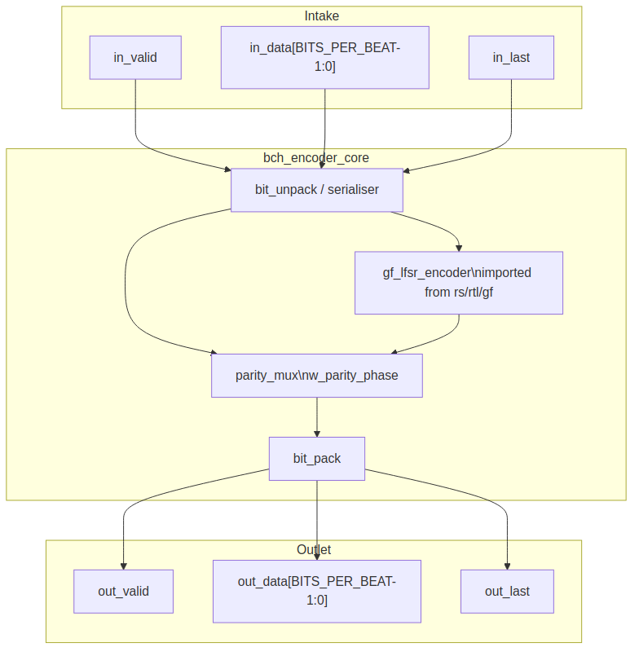
Encoder core block diagram

5.2 Parameters
Table 2.1: Encoder core parameters
Parameter | Type | Range | Default | Meaning | PRD
FIELD_DIM | int | 3..16 | TBD | m; field is GF(2^m) | D1
T_BITS | int | 1..(2^m-1)/2 | TBD | correctable bit errors | D2
N_BITS | int | 2t+1 .. 2^m-1 | TBD | codeword length in bits | D3
BITS_PER_BEAT | int | 1 .. K_BITS | TBD | bits per valid/ready beat | D9
Derived: K_BITS = N_BITS - DEGREE_G, where DEGREE_G is the degree of the generator polynomial computed by gf_pkg from m, t, and the profile parameters. DEGREE_G is at most m * T_BITS and equals N_BITS - K_BITS.

5.3 Interface
Table 2.2: Encoder core ports
Signal | Direction | Width | Description
aclk | in | 1 | one clock for the whole core
aresetn | in | 1 | active-low synchronous reset
in_valid | in | 1 | a beat of data bits is offered
in_ready | out | 1 | the core takes it this cycle
in_data | in | BITS_PER_BEAT | data bits, bit 0 in the low bit; partial final beat uses in_keep
in_keep | in | BITS_PER_BEAT | present-bit mask, low-aligned; partial only on the block’s final beat
in_last | in | 1 | this beat carries the K_BITS-th data bit
out_valid | out | 1 | a beat of coded bits is offered
out_ready | in | 1 | the consumer takes it
out_data | out | BITS_PER_BEAT | data bits while !w_parity_phase, parity bits while w_parity_phase
out_keep | out | BITS_PER_BEAT | present-bit mask; partial at the end of data and at the end of parity
out_last | out | 1 | this beat carries the N_BITS-th coded bit
frame_err | out | 1 | pulse: a block ended with other than K_BITS data bits

5.4 Microarchitecture internals

5.4.1 Bit serialiser / unpack
The input beat in_data is serialised beat-by-beat into a single bit stream. With BITS_PER_BEAT = 1 this is a pass-through. With BITS_PER_BEAT > 1 a small barrel or counter-driven mux presents one valid bit per cycle to the LFSR. The in_keep mask qualifies the final beat so that only real data bits enter the LFSR.

5.4.2 GF(2^m) LFSR parity generator
The parity generator is imported from the reed-solomon component per PRD D7: gf_lfsr_encoder in projects/components/ecc-ip/reed-solomon/rtl/gf/gf_lfsr_encoder.sv. It is a 2 * T_BITS-stage shift register over GF(2^m) with constant multipliers on the taps derived from g(x). The encoder clears at block start, consumes the K_BITS data bits serially, and then holds the parity symbols.
The binary BCH use is identical to the RS encoder shape; the only difference is that the input is bits, not symbols, so the LFSR advances once per bit.

5.4.3 Parity mux
The output mux selects data bits while the block is in the data phase and parity bits once the data phase completes:
w_parity_phase = (r_bit_count >= K_BITS) && w_beat_is_parity
w_beat_is_parity is true whenever the current output position is inside the parity region; it is derived from the same bit counter:
w_beat_is_parity = (r_bit_count + BITS_PER_BEAT - 1) >= K_BITS
The mux output is out_data = w_parity_phase ? w_parity_bits : w_data_bits.

5.4.4 Bit packer
The serial output stream is reassembled into BITS_PER_BEAT-bit output beats. out_keep is full except on the final data beat and the final parity beat, where it marks the partial beat. out_last raises on the beat that carries the N_BITS-th coded bit:
w_enc_out_last = w_parity_phase && (r_parity_count == N_BITS - K_BITS - 1)

5.5 FSM policy
This block carries no FSM (per vault/handbook/design/streaming-no-fsm.md). The sequencing that another design might put in a state machine is replaced by:
- r_bit_count: counts input/output bit position in the block, 0 .. N_BITS-1
- r_parity_count: counts parity bits emitted, 0 .. N_BITS-K_BITS-1
- r_valid pipeline flags on the packer output stage
- w_parity_phase: combinational qualifier selecting parity vs data
- w_last: combinational qualifier marking the final output beat
in_ready is combinational !r_valid || m_ready at the input skid, ANDed with the qualifier that the block is not currently draining parity.

5.6 Timing
- One input beat is accepted per cycle while in_ready is high.
- The data phase is ceil(K_BITS / BITS_PER_BEAT) beats.
- The parity phase is ceil((N_BITS - K_BITS) / BITS_PER_BEAT) beats.
- in_ready is held low during the parity phase; back-to-back blocks need an upstream FIFO sized for at least N_BITS - K_BITS bits.
- The exact blocks-per-cycle numbers are placeholders tied to PRD D6 and D9.

5.7 Notes
- Wrong-length block handling: If in_last arrives before or after the K_BITS-th data bit, frame_err pulses and the block is still encoded as given (systematic data pass-through with parity appended to whatever data arrived). This is the encoder-side analog of the decoder’s out_status_frame_err (R1/R2):
- w_frame_err = in_last && (r_bit_count != K_BITS - 1)
- OFF-state testing convention: For tests that need to verify the core tolerates idle cycles, the LFSR clears on in_last acceptance and the output pipeline stalls cleanly when out_ready is low.
- The gf_lfsr_encoder instance is configured by the same FIELD_DIM, T_BITS, N_BITS, PRIM_POLY, and FIRST_ROOT parameters as the rest of the codec; its generator polynomial comes from gf_pkg (PRD D3/D8).

RTL Design Sherpa · Learning Hardware Design Through Practice Documentation Index · MIT License

6 Syndrome Unit (bch_syndrome_unit)
Module: bch_syndrome_unit.sv Location: rtl/ Category: streaming datapath Parent: bch_decoder_core Status: target — no RTL exists

6.1 Purpose
bch_syndrome_unit computes the t odd syndromes S_1, S_3, ..., S_2t-1 of the received BCH codeword as the bits arrive. The even syndromes are not computed directly; they are recovered from the odd ones through the binary BCH evenness shortcut S_2j = S_j^2 (PRD §2). The unit contains t parallel GF(2^m) multiply-accumulate lanes, one per odd syndrome.

6.1.1 Figure 2.2: Syndrome unit block diagram
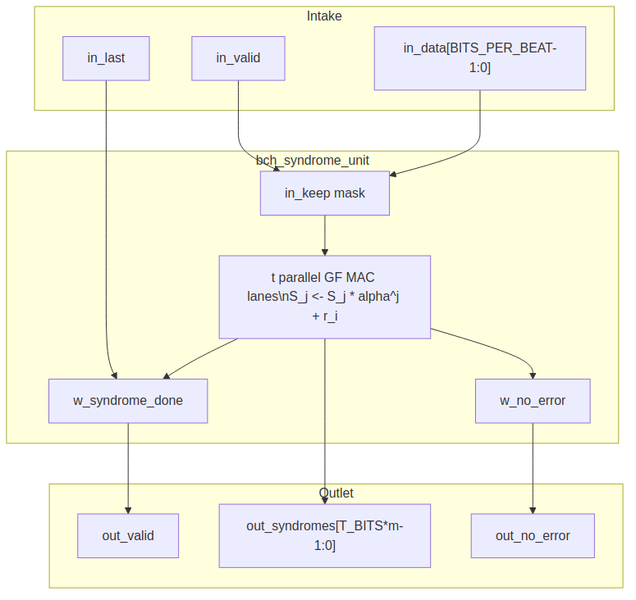
Syndrome unit block diagram

6.2 Parameters
Table 2.3: Syndrome unit parameters
Parameter | Type | Range | Default | Meaning | PRD
FIELD_DIM | int | 3..16 | TBD | m; field is GF(2^m) | D1
T_BITS | int | 1..(2^m-1)/2 | TBD | correctable bit errors | D2
N_BITS | int | 2t+1 .. 2^m-1 | TBD | codeword length in bits | D3
BITS_PER_BEAT | int | 1 .. K_BITS | TBD | bits per valid/ready beat | D9

6.3 Interface
Table 2.4: Syndrome unit ports
Signal | Direction | Width | Description
aclk | in | 1 | one clock
aresetn | in | 1 | active-low synchronous reset
in_valid | in | 1 | received bits are offered
in_ready | out | 1 | unit takes them this cycle
in_data | in | BITS_PER_BEAT | received bits, low-aligned
in_keep | in | BITS_PER_BEAT | present-bit mask for partial final beat
in_last | in | 1 | this beat carries the N_BITS-th received bit
out_valid | out | 1 | t odd syndromes are valid
out_ready | in | 1 | downstream accepts the syndromes
out_syndromes | out | T_BITS * m | {S_2t-1, ..., S_3, S_1} packed GF values
out_no_error | out | 1 | all odd syndromes are zero

6.4 Microarchitecture internals

6.4.1 Odd-syndrome recurrence
For a received polynomial r(x) = sum_{i=0}^{N_BITS-1} r_i x^i, the odd syndromes are:
S_j = r(alpha^j) = sum_i r_i * (alpha^j)^i for j = 1, 3, ..., 2t-1
As bits arrive one at a time, each lane accumulates by Horner’s rule:
S_j <- S_j * alpha^j + r_i
The multiplier by the constant alpha^j is a gf_mul_const instance (imported from projects/components/ecc-ip/reed-solomon/rtl/gf/gf_mul_const.sv). No per-position power table is stored; the constant alpha^j is wired once per lane.
With BITS_PER_BEAT = B > 1, each lane performs B Horner steps per cycle:
S_j <- (((S_j * alpha^j) + r_i0) * alpha^j + r_i1) * alpha^j + ... + r_iB-1
This is a short feed-forward chain of B constant multiplies and adds.

6.4.2 All-zero bypass qualifier
The no-error bypass is a combinational qualifier, not a state:
w_no_error = (S_1 == 0) && (S_3 == 0) && ... && (S_2t-1 == 0)
When w_no_error is true on the cycle w_syndrome_done raises, the decoder core skips the key-equation solver and Chien search and drains the block buffer unchanged.

6.4.3 Completion qualifier
The syndromes are complete once the last received bit has been accumulated:
w_syndrome_done = (r_bit_count == N_BITS - 1) && in_valid && in_ready
out_valid is a registered flag set by w_syndrome_done and cleared by the handshake with the downstream solver.

6.5 FSM policy
This block carries no FSM (per vault/handbook/design/streaming-no-fsm.md). Control is reduced to:
- r_bit_count: counts received bits, 0 .. N_BITS-1
- r_lane_valid: registered output valid flag
- w_syndrome_done: combinational completion qualifier
- w_no_error: combinational all-zero qualifier
Each lane is a pure multiply-accumulate datapath; the lane count and the output valid flag replace any state machine.

6.6 Timing
- One received bit advances every lane by one Horner step.
- Serial case (BITS_PER_BEAT = 1): N_BITS cycles per block.
- Parallel-beat case: ceil(N_BITS / BITS_PER_BEAT) cycles per block, with B chained GF constant multiplies per lane per cycle.
- The exact cycle count is a placeholder tied to PRD D6.

6.7 Notes
- A shortened code (N_BITS < 2^m - 1) is handled by treating the missing leading bits as zero: the Horner recurrence naturally accumulates starting from S_j = 0, which is equivalent to zero-padding the high-order coefficients.
- The evenness shortcut means the formal proof targets include S_2j == gf_square(S_j) for every odd j; the square in GF(2^m) is a linear bit-permutation and is cheap to verify.
- out_no_error is a combinational decode of the syndrome registers; it is stable from w_syndrome_done until the output handshake clears it.

RTL Design Sherpa · Learning Hardware Design Through Practice Documentation Index · MIT License

7 Key Equation Solver (bch_key_equation_solver)
Module: bch_key_equation_solver.sv Location: rtl/ Category: datapath + conditional control FSM Parent: bch_decoder_core Status: target — no RTL exists; algorithm choice is PRD D11

7.1 Purpose
bch_key_equation_solver inverts the key equation from the t odd syndromes S_1, S_3, ..., S_2t-1 to the error-locator polynomial Lambda(x). The choice of algorithm is PRD D11; this page documents all three candidates and their microarchitectural implications. Nothing outside the solver knows which algorithm produced Lambda: the Chien search, block buffer, and corrector are identical in every build.

7.2 Parameters
Table 2.5: Key-equation solver parameters
Parameter | Type | Range | Default | Meaning | PRD
FIELD_DIM | int | 3..16 | TBD | m; field is GF(2^m) | D1
T_BITS | int | 1..(2^m-1)/2 | TBD | correctable bit errors | D2
KES_ALGO | string | "RIBM", "EUCLID", "SMALL_T" | TBD | solver algorithm | D11

7.3 Interface
Table 2.6: Key-equation solver ports
Signal | Direction | Width | Description
aclk | in | 1 | one clock
aresetn | in | 1 | active-low synchronous reset
in_valid | in | 1 | odd syndromes are valid
in_ready | out | 1 | solver accepts syndromes
in_syndromes | in | T_BITS * m | {S_2t-1, ..., S_3, S_1} packed GF values
out_valid | out | 1 | Lambda(x) coefficients are valid
out_ready | in | 1 | downstream accepts Lambda
out_lambda | out | (T_BITS + 1) * m | locator coefficients Lambda_0 .. Lambda_T_BITS
out_lambda_degree | out | $clog2(T_BITS + 1) | actual degree of Lambda

7.4 Candidate algorithms
The trade-off table below is copied from ../bch_has/ch03_architecture/03_solver_options.md.
Table 2.7: Key-equation solver candidates
 | inversionless BM ("RIBM") | modified Euclidean ("EUCLID") | step-by-step / PGZ ("SMALL_T")
Algorithm | reformulated inversionless Berlekamp-Massey, Sarwate and Shanbhag 2001; seeded with the t odd syndromes | Sugiyama’s Euclidean algorithm with cross-multiplication in place of division (Shao et al. 1985) | Massey 1965 step-by-step correction, or the Peterson-Gorenstein-Zierler direct matrix solve for small t
Array | 3t + 1 processing elements, 2 registers each | four register arrays: R and Q of 2t + 1 symbols, the shifted locator pair of 2t + 3 | control-heavy but small datapath: one or a few GF multipliers and a syndrome update loop
GF multipliers | 2 per element: 6t + 2 | 2 per coefficient of each pair: 8t + 8 | O(t^2) logic or a single iterative multiplier
Iterations | exactly 2t | data-dependent, t + 1 .. 2t | one per located error position, up to t
Critical path per iteration | one multiply and one XOR, no feedback across the array | cross-multiply feeding a degree comparison that drives the swap: longer | depends on implementation; often dominated by syndrome-update MUX tree
Control | discrepancy select and gamma update | two nominal degree counters, the normalise / cross / swap rule | position counter, syndrome-test loop, error-counter update
Readability | dense; the reformulation is not obvious from the textbook | the textbook algorithm, recognisable step by step | the simplest conceptually for very small t
Best fit | general t; the default if no consumer names a small-t profile | a cross-check and a readable alternative | t <= 8 (flash pages often sit here); smallest area at tiny t
No default is selected at MAS v0.1. The choice is PRD D11.

7.5 Microarchitecture internals

7.5.1 "RIBM" and "EUCLID" — fixed-iteration arrays
Both the reformulated inversionless Berlekamp-Massey array and the modified Euclidean array are pure datapath structures. They need:
- an iteration counter, 0 .. 2 * T_BITS
- a start pulse from in_valid && in_ready
- a completion qualifier when the iteration count reaches its target
Neither implementation has a state machine in the data path. The control signals (discrepancy select, gamma update, degree comparison, swap) are combinational or registered qualifiers derived from the iteration counter and the array registers.

7.5.2 "SMALL_T" — conditional minimal control FSM
The step-by-step and PGZ approaches are control-heavy. If D11 selects "SMALL_T", this block is the one place in the decoder datapath where a minimal control FSM is permitted (per vault/handbook/design/minimal-fsm.md). The target state list is the fewest states that carry real distinctions:
IDLE -> wait for in_valid
RUN -> execute one iteration / error-position test
TEST -> evaluate the discrepancy / matrix determinant
DONE -> out_valid raised, hold until out_ready
The IDLE/RUN/TEST/DONE list is conditional on KES_ALGO == "SMALL_T" and is marked as such in the RTL. States that only wait one fixed cycle are merged into RUN with a sub-counter.

7.6 FSM policy
- For "RIBM" and "EUCLID": no FSM in the data path; only an iteration counter and completion qualifier.
- For "SMALL_T": one minimal control FSM is permitted, conditional on D11, with the state list above.

7.7 Timing
- "RIBM": exactly 2 * T_BITS iterations.
- "EUCLID": between T_BITS + 1 and 2 * T_BITS iterations, data-dependent.
- "SMALL_T": up to T_BITS error-position tests, plus setup cycles.
- Exact cycle counts are placeholders tied to PRD D11 and D6.

7.8 Notes
- Two solvers agreeing as a cross-check is the recommended verification posture from the HAS: the golden model runs every candidate on every block and requires identical roots, and the RTL is built with whichever algorithm the first consumer prefers.
- The locator degree out_lambda_degree is produced by the solver and is used by the Chien search to determine correctability.
- Lambda_0 is always 1 for a valid locator; the formal targets include this invariant and the relationship to the odd syndromes.

RTL Design Sherpa · Learning Hardware Design Through Practice Documentation Index · MIT License

8 Chien Search (bch_chien_search)
Module: bch_chien_search.sv Location: rtl/ Category: streaming datapath Parent: bch_decoder_core Status: target — no RTL exists

8.1 Purpose
bch_chien_search evaluates the error-locator polynomial Lambda(x) at every one of the N_BITS bit positions of the received codeword. Where Lambda has a root, the corresponding bit is in error. Because the code is binary, every error value is 1 (PRD §2); the block therefore flips the bit directly and needs no Forney evaluator. The block also feeds the uncorrectability verdict by comparing the root count to the locator degree.

8.1.1 Figure 2.3: Chien search block diagram
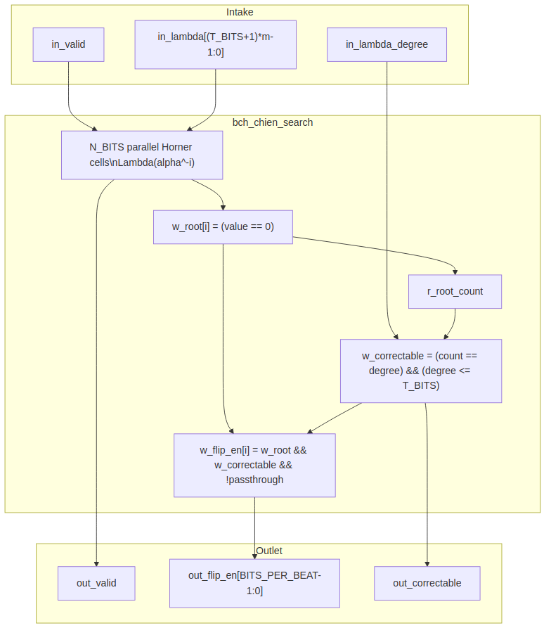
Chien search block diagram

8.2 Parameters
Table 2.8: Chien search parameters
Parameter | Type | Range | Default | Meaning | PRD
FIELD_DIM | int | 3..16 | TBD | m; field is GF(2^m) | D1
T_BITS | int | 1..(2^m-1)/2 | TBD | correctable bit errors | D2
N_BITS | int | 2t+1 .. 2^m-1 | TBD | codeword length in bits | D3
BITS_PER_BEAT | int | 1 .. K_BITS | TBD | bits per valid/ready beat | D9

8.3 Interface
Table 2.9: Chien search ports
Signal | Direction | Width | Description
aclk | in | 1 | one clock
aresetn | in | 1 | active-low synchronous reset
in_valid | in | 1 | Lambda(x) coefficients are valid
in_ready | out | 1 | unit accepts Lambda
in_lambda | in | (T_BITS + 1) * m | locator coefficients Lambda_0 .. Lambda_T_BITS
in_lambda_degree | in | $clog2(T_BITS + 1) | actual degree of Lambda
out_valid | out | 1 | a beat of correction flags is offered
out_ready | in | 1 | downstream accepts correction flags
out_flip_en | out | BITS_PER_BEAT | one-hot bit-flip enable per position in the beat
out_root_count | out | $clog2(T_BITS + 1) | roots found so far
out_last | out | 1 | final position of the block

8.4 Microarchitecture internals

8.4.1 Parallel Horner cells
Lambda(x) is evaluated at consecutive powers of alpha using Horner cells. For position i, the evaluation is:
Lambda(alpha^-i) = Lambda_0 + Lambda_1*alpha^-i + Lambda_2*alpha^-2i + ... + Lambda_t*alpha^-ti
Each cell holds a running partial sum and multiplies by a constant factor each cycle, stepping from one position to the next. With BITS_PER_BEAT = B > 1, each lane evaluates B positions per cycle by chaining B constant multiplies from the same starting register.
The root flag per position is:
w_root[i] = (w_lambda_at_pos[i] == 0)

8.4.2 Direct bit-flip accumulation
The correction qualifier for position i is:
w_flip_en[i] = w_root[i] && w_correctable && !w_release_passthrough
w_correctable comes from the decoder core and is true when the root count matches the locator degree and the degree does not exceed T_BITS. w_release_passthrough is true for uncorrectable blocks, which pass through unchanged (R2). There is no error-value computation; every root means flip.

8.4.3 Uncorrectability check
The block tracks the root count across the N_BITS positions:
w_correctable = (r_root_count == r_lambda_degree) && (r_lambda_degree <= T_BITS)
If the root count differs from the degree, or if the degree exceeds T_BITS, the block is uncorrectable. The final w_correctable value is captured on the last position and passed to the decoder core as the block verdict.

8.5 FSM policy
This block carries no FSM (per vault/handbook/design/streaming-no-fsm.md). The Chien walk is driven by:
- r_position: counts bit positions, 0 .. N_BITS-1
- r_root_count: running count of roots
- out_valid: registered pipeline flag
- w_last: combinational qualifier for the final position
The position counter replaces any state machine.

8.6 Timing
- Serial case (BITS_PER_BEAT = 1): N_BITS cycles per block to evaluate all positions.
- Parallel-beat case: ceil(N_BITS / BITS_PER_BEAT) cycles per block, with B Horner evaluations per lane per cycle.
- The exact cycle count and throughput trade-off are placeholders tied to PRD D6.

8.7 Notes
- A shortened code (N_BITS < 2^m - 1) is handled by starting the Chien walk at the appropriate offset so that the first emitted position corresponds to bit 0 of the shortened codeword.
- The no-Forney structure is a key formal target: prove that every root of Lambda in a correctable block corresponds to exactly one bit flip and that the resulting corrected block has zero syndrome.
- out_flip_en is a beat-wide vector; the corrector XORs it with the corresponding beat from the block buffer.

RTL Design Sherpa · Learning Hardware Design Through Practice Documentation Index · MIT License

9 Decoder Core Integration (bch_decoder_core)
Module: bch_decoder_core.sv Location: rtl/ Category: integration block + one minimal control FSM Parent: bch_top / standalone decoder wrapper Status: target — no RTL exists; conditional on PRD D4/D6/D11

9.1 Purpose
bch_decoder_core integrates the received-block buffer, syndrome unit, key-equation solver, Chien search, and corrector into one valid/ready streaming block. It is the only block in the decoder datapath that is allowed to contain a control FSM, because the sequencing of distinct algorithmic stages is genuine control, not per-beat datapath.

9.1.1 Figure 2.4: Decoder core block diagram
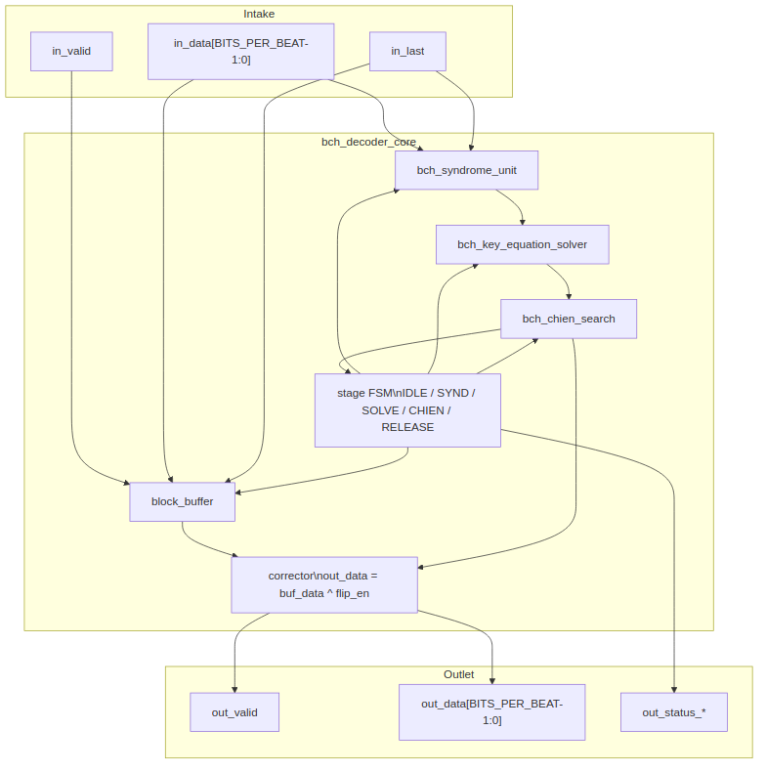
Decoder core block diagram

9.2 Parameters
Table 2.10: Decoder core parameters
Parameter | Type | Range | Default | Meaning | PRD
FIELD_DIM | int | 3..16 | TBD | m; field is GF(2^m) | D1
T_BITS | int | 1..(2^m-1)/2 | TBD | correctable bit errors | D2
N_BITS | int | 2t+1 .. 2^m-1 | TBD | codeword length in bits | D3
BITS_PER_BEAT | int | 1 .. K_BITS | TBD | bits per valid/ready beat | D9
ENABLE_ERASURES | bit |  | 0 TBD | erasure input and erasure-locator logic | D5
KES_ALGO | string | "RIBM", "EUCLID", "SMALL_T" | TBD | solver algorithm | D11

9.3 Interface
Table 2.11: Decoder core ports
Signal | Direction | Width | Description
aclk | in | 1 | one clock
aresetn | in | 1 | active-low synchronous reset
in_valid / in_ready | in / out | 1 | valid/ready for received bits
in_data | in | BITS_PER_BEAT | received bits
in_keep | in | BITS_PER_BEAT | present-bit mask
in_last | in | 1 | this beat carries the N_BITS-th received bit
in_erase | in | BITS_PER_BEAT | (only with ENABLE_ERASURES) known-bad bits
out_valid / out_ready | out / in | 1 | valid/ready for corrected data
out_data | out | BITS_PER_BEAT | corrected data bits; parity lanes dropped
out_keep | out | BITS_PER_BEAT | present-bit mask
out_last | out | 1 | this beat carries the K_BITS-th data bit
out_status_ok | out | 1 | block had no errors
out_status_corrected | out | $clog2(T_BITS + 1) | bits corrected (0 .. T_BITS)
out_status_uncorrectable | out | 1 | correction failed
out_status_frame_err | out | 1 | block length was not N_BITS

9.4 Microarchitecture internals

9.4.1 Block buffer
The received block is written into a buffer as it arrives and read out during the Chien/correction pass. The buffer depth is at least N_BITS bits, sized to absorb the latency of the syndrome pass and the solver. For an uncorrectable block, the buffer passes the received bits through unchanged (R2):
w_release_passthrough = w_uncorrectable || w_frame_err

9.4.2 Stage sequencer
The decoder core contains exactly one minimal control FSM (per vault/handbook/design/minimal-fsm.md). Stage sequencing is control, not per-beat datapath. The proposed state list merges any state that only waits one fixed cycle into its successor with a counter:
IDLE -> wait for a new block to begin arriving
SYND -> receiving the block into the buffer and the syndrome unit
SOLVE -> key-equation solver running
CHIEN -> Chien search / correction pass over the buffer
RELEASE -> outputting the corrected (or passthrough) block
A state like “wait one cycle for solver start” is killed: it becomes a registered r_solver_start pulse inside SYND or SOLVE.

9.4.3 Corrected-stream re-check
As an optional R2 mechanism, a second syndrome unit may accumulate over the corrected stream leaving the buffer. If any odd syndrome is non-zero after correction, the block is flagged uncorrectable even if the Chien root count matched the locator degree. This mirrors the release-on-verdict discipline in the sibling rs_decoder_core architecture. The re-check is gated by a build parameter and is an implementation detail, not part of the locator search.

9.4.4 Correctability verdict
The per-block uncorrectable verdict is:
w_uncorrectable = !w_correctable || (w_recheck_enabled && !w_recheck_zero)
w_correctable = (r_root_count == r_lambda_degree) && (r_lambda_degree <= T_BITS)
out_status_uncorrectable is held for every beat of the released block.

9.5 FSM policy
This block is the one place in the decoder datapath where a minimal control FSM is permitted. The FSM has at most the four states above; any state that only waits one fixed cycle is merged with its successor. All per-beat operations inside the stages (syndrome accumulation, solver array stepping, Chien evaluation) remain FSM-free pipelines.

9.6 Timing
- SYND phase: ceil(N_BITS / BITS_PER_BEAT) beats.
- SOLVE phase: depends on KES_ALGO and T_BITS (PRD D11).
- CHIEN / RELEASE phase: ceil(N_BITS / BITS_PER_BEAT) beats, overlapped so that the first corrected beat leaves as soon as the Chien walk starts.
- Total latency and throughput trade-offs are placeholders tied to PRD D6.

9.7 Notes
- This whole page is conditional on the build including the decoder (PRD D4) and on the throughput architecture (PRD D6) and solver choice (PRD D11).
- Frame error: a block whose in_last arrives before or after the N_BITS-th bit is flagged with out_status_frame_err and passes through unchanged. The first length - (N_BITS - K_BITS) bits of a too-long block are treated as data.
- Status outputs describe the block being emitted and are valid on every beat of it; a consumer may sample them with out_last.

RTL Design Sherpa · Learning Hardware Design Through Practice Documentation Index · MIT License

10 Core Signals
This page presents the valid/ready core signals as a contract table rather than restating the prose interface description in ../bch_has/ch04_interfaces/01_core_interface.md. The direction, reset value, and creator block for each signal are the source of truth here.

10.1 Reset strategy
All core logic uses synchronous active-low reset (aresetn), the house clocking convention. Reset clears block state, counters, the LFSR, syndrome registers, solver arrays, and the Chien position counter. The block buffer itself is not reset; its read/write pointers are reset, which makes the buffer contents logically invalid until overwritten.

10.2 bch_encoder_core signal contract
Table 3.1: bch_encoder_core signal contract
Signal | Dir | Width | Reset value | Creates / consumes | Contract | Source block page
aclk | in | 1 | — | clock source | one clock for the whole core | —
aresetn | in | 1 | — | reset source | synchronous active-low reset | —
in_valid | in | 1 | — | upstream | stable until in_ready high | encoder core
in_ready | out | 1 | 0 | encoder core | combinational !r_valid || m_ready gated by parity-drain | encoder core
in_data | in | BITS_PER_BEAT | — | upstream | data bits, low-aligned; partial final beat qualified by in_keep | encoder core
in_keep | in | BITS_PER_BEAT | — | upstream | present-bit mask, low-aligned; partial only on final beat | encoder core
in_last | in | 1 | — | upstream | this beat carries the K_BITS-th data bit | encoder core
out_valid | out | 1 | 0 | encoder core | registered pipeline flag; data beats then parity beats | encoder core
out_ready | in | 1 | — | downstream | may depend on out_valid | encoder core
out_data | out | BITS_PER_BEAT | 0 | encoder core | data while !w_parity_phase, parity while w_parity_phase | encoder core
out_keep | out | BITS_PER_BEAT | 0 | encoder core | full except on final data and final parity beats | encoder core
out_last | out | 1 | 0 | encoder core | this beat carries the N_BITS-th coded bit | encoder core
frame_err | out | 1 | 0 | encoder core | pulse when in_last does not coincide with K_BITS data bits | encoder core

10.3 bch_decoder_core signal contract
Table 3.2: bch_decoder_core signal contract
Signal | Dir | Width | Reset value | Creates / consumes | Contract | Source block page
in_valid | in | 1 | — | upstream | stable until in_ready high | decoder core
in_ready | out | 1 | 0 | decoder core | high while buffer has space; drops when full | decoder core
in_data | in | BITS_PER_BEAT | — | upstream | received bits, low-aligned | decoder core
in_keep | in | BITS_PER_BEAT | — | upstream | present-bit mask; partial only on final beat | decoder core
in_last | in | 1 | — | upstream | this beat carries the N_BITS-th received bit | decoder core
in_erase | in | BITS_PER_BEAT | — | upstream | (only with ENABLE_ERASURES) known-bad bits | decoder core
out_valid | out | 1 | 0 | decoder core | high once the block verdict is final | decoder core
out_ready | in | 1 | — | downstream | may depend on out_valid | decoder core
out_data | out | BITS_PER_BEAT | 0 | decoder core | corrected data bits; parity lanes dropped | decoder core
out_keep | out | BITS_PER_BEAT | 0 | decoder core | present-bit mask; partial only on final beat | decoder core
out_last | out | 1 | 0 | decoder core | this beat carries the K_BITS-th data bit | decoder core
out_status_ok | out | 1 | 0 | decoder core | held for every beat: block had no errors | syndrome unit, decoder core
out_status_corrected | out | $clog2(T_BITS+1) | 0 | decoder core | held for every beat: bits corrected (0 .. T_BITS) | Chien search, decoder core
out_status_uncorrectable | out | 1 | 0 | decoder core | held for every beat: correction failed; data pass through unchanged | Chien search, decoder core
out_status_frame_err | out | 1 | 0 | decoder core | held for every beat: block length was not N_BITS | decoder core

10.4 Timing rules
- in_last is the sole block boundary; the cores do not infer boundaries by counting.
- out_status_* describe the block being emitted and are valid on every beat of it, first to last. A consumer may sample them with out_last or with the first beat.
- An uncorrectable block leaves exactly as received; the corrector is disabled by w_release_passthrough.

RTL Design Sherpa · Learning Hardware Design Through Practice Documentation Index · MIT License

11 Signal Contracts and K-maps

11.1 What a contract is
A signal contract in this repo is a machine-checkable statement of what a signal is allowed to do. Each contract has three parts, in order:
- Term list: every signal or expression in play, with its defining expression and file:line citation.
- Invariants: the strict relationships between terms, each cited, each stating which rows of the decision table it renders impossible.
- Decision table: one row per combination of the terms. Rows the invariants forbid are marked ILLEGAL; legal rows carry the resulting output.
The canonical methodology is in vault/handbook/design/signal-contracts-and-kmaps.md; the shared generator machinery is in bin/kmaps/.

11.2 Which signals have contracts
The BCH workbook documents the control/qualifier signals whose correctness is non-obvious: parity-phase select, block-boundary and frame-error qualifiers, syndrome completion, no-error bypass, correctability verdict, Chien root-position enables, and uncorrectable pass-through. The complete list is in the generated workbook.

11.3 Pre-RTL citation posture
At MAS v0.1 there is no RTL, so the contracts cite the MAS pages where the intended expressions are written verbatim. When the first RTL lands, every MAS citation is re-pointed at the corresponding .sv file and line. The generator’s citation gate then enforces that the workbook and the RTL agree; a drift fails the run.

11.4 Regenerating the workbook
python3 projects/components/ecc-ip/bch/docs/gen_bch_signal_contracts_kmaps.py
The generator writes:
projects/components/ecc-ip/bch/docs/bch_signal_contracts.xlsx
Do not hand-edit the .xlsx; it is a build artifact of the generator.

11.5 Workbook contents
The generated workbook contains:
- a contract sheet for the core signals
- a kmap sheet per block with the key combinational decisions
- term lists, invariants, decision tables, depends_only_on sufficiency arguments, and rtl_sop expressions for pre-RTL review
For every kmap the verdict is currently NOT CHECKED because no RTL exists yet. That is the correct pre-RTL posture; the verdict becomes meaningful once rtl_sop can be diffed against the derived minimal cover.

