Table of Contents

1 Rapids Beats Has Index
Generated: 2026-01-17

2 Document Information
Document Title: RAPIDS Beats Hardware Architecture Specification (HAS) Document Number: RAPIDS-HAS-001 Version: 1.0 Date: 2026-01-17 Status: Released

2.1 Purpose
This Hardware Architecture Specification (HAS) defines the external interfaces, system integration requirements, and high-level architecture of the RAPIDS Beats accelerator. It is intended for system architects and integration engineers who need to understand RAPIDS Beats from an external perspective without requiring knowledge of internal implementation details.

2.2 Scope
This document covers:
- External interface specifications (AXI4, AXIS, APB, MonBus)
- System-level block diagrams and data flows
- Programming model and descriptor format
- Use cases and operational sequences
- Performance characteristics and constraints
This document does NOT cover:
- Internal module architecture (see MAS)
- RTL implementation details (see MAS)
- Verification test plans
- Physical design constraints

2.3 Audience
Target Audience
Role | Relevance
System Architect | Primary - system integration
Hardware Integration Engineer | Primary - interface connection
Software Engineer | Primary - driver development
Verification Engineer | Reference - interface protocols
RTL Designer | Reference - external constraints

2.4 Document Conventions

2.4.1 Requirement Levels
Term | Meaning
SHALL | Mandatory requirement
SHOULD | Recommended but not mandatory
MAY | Optional feature

2.4.2 Signal Directions
- Input: Signal driven by external logic into RAPIDS
- Output: Signal driven by RAPIDS to external logic
- Bidirectional: Signal can be driven by either side (rare)

2.4.3 Timing Diagrams
All timing diagrams use WaveDrom format with the following conventions:
- p = Positive clock edge
- n = Negative clock edge
- 0/1 = Logic low/high
- x = Unknown/don’t care
- = = Data value (with label)
- . = Previous value continues

2.5 References
Reference Documents
Document | Description
RAPIDS Beats MAS | Module Architecture Specification
ARM AMBA AXI4 Specification | AXI4 protocol reference
ARM AMBA AXI-Stream Specification | AXIS protocol reference
RAPIDS PRD | Product Requirements Document

3 Revision History
Document Revision History
Version | Date | Author | Changes
1.0 | 2026-01-17 | RTL Design Sherpa | Initial release

3.1 Change Summary

3.1.1 Version 1.0 (2026-01-17)
Initial Release
- Complete HAS for RAPIDS Beats Phase 1 architecture
- External interface specifications (AXI4, AXIS, APB, MonBus)
- System block diagrams with Mermaid
- Timing diagrams with WaveDrom
- Programming model and descriptor format
- Use case documentation

4 Acronyms and Definitions

4.1 Acronyms
Acronym Definitions
Acronym | Definition
AXI | Advanced eXtensible Interface
AXIS | AXI-Stream
APB | Advanced Peripheral Bus
DMA | Direct Memory Access
FIFO | First-In First-Out
FSM | Finite State Machine
HAS | Hardware Architecture Specification
MAS | Module Architecture Specification
MonBus | Monitor Bus
RAPIDS | Rapid AXI Programmable In-band Descriptor System
SRAM | Static Random Access Memory

4.2 Definitions
Term Definitions
Term | Definition
Beat | Single data transfer unit (512 bits = 64 bytes in default configuration)
Channel | Independent DMA context with dedicated descriptor processing
Descriptor | 256-bit control structure defining a single DMA transfer
Descriptor Chain | Linked list of descriptors for multi-transfer operations
Sink Path | Data flow from network (AXIS slave) to memory (AXI write)
Source Path | Data flow from memory (AXI read) to network (AXIS master)
Fill | Operation writing data into SRAM buffer (sink path input)
Drain | Operation reading data from SRAM buffer (source path output)

4.3 Signal Naming Conventions
Signal Naming Conventions
Prefix/Suffix | Meaning
m_axi_* | AXI Master signals
s_axis_* | AXIS Slave signals
m_axis_* | AXIS Master signals
cfg_* | Configuration signals
*_valid | Handshake valid signal
*_ready | Handshake ready signal
*_n | Active-low signal

5 Product Overview

5.1 Introduction
RAPIDS Beats is a high-performance network-to-memory accelerator designed for descriptor-based data movement operations. It bridges network interfaces (AXI-Stream) with system memory (AXI4), enabling efficient DMA transfers without CPU intervention.
The “Beats” architecture represents Phase 1 of the RAPIDS family, optimized for simplicity and throughput in streaming applications.

5.2 System Context
System Context Diagram
System Context Diagram
Source: 01_system_context.mmd
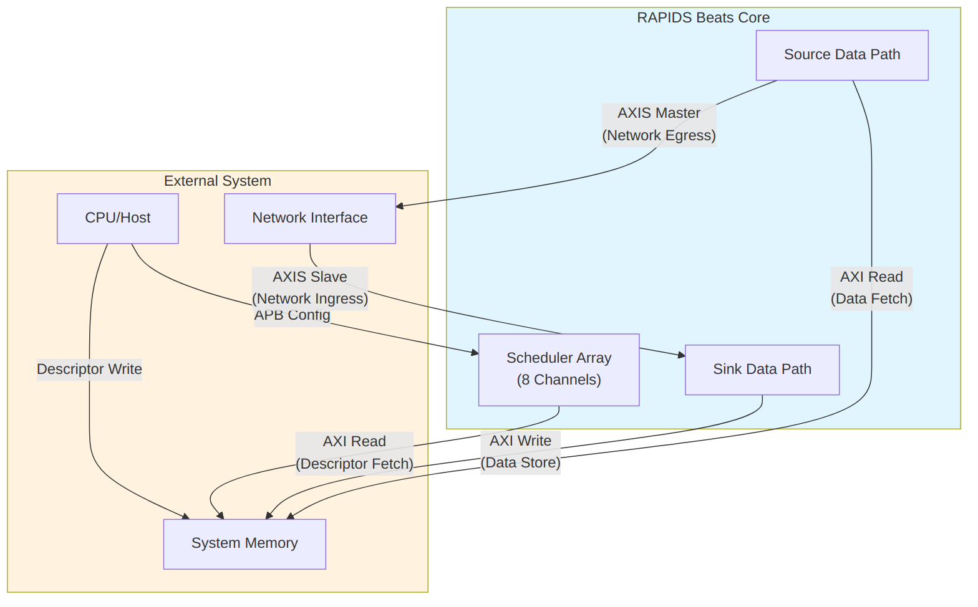
Diagram 1

5.3 Target Applications
Target Applications
Application | Description | Key Requirements
Network Offload | Receive packets from network, store to memory | Low latency, high throughput
Scatter-Gather DMA | Multi-descriptor data movement | Descriptor chaining
Streaming Accelerator | Front-end for compute engines | Continuous data flow
Protocol Processing | Header/payload separation | Multi-channel isolation

5.4 Architecture Highlights

5.4.1 Phase 1 “Beats” Simplifications
The Beats architecture prioritizes simplicity over feature completeness:
Phase 1 Simplifications
Feature | Beats (Phase 1) | Future Phases
Transfer Unit | Full beats only | Chunk-level alignment
Flow Control | Backpressure-based | Credit management
Address Alignment | Pre-aligned required | Hardware alignment fixup
Network Interface | Direct AXIS | Protocol conversion

5.4.2 Key Capabilities
- 8 Independent Channels - Concurrent transfers with dedicated resources
- Descriptor Chaining - Automatic next-descriptor fetch
- Dual Data Paths - Simultaneous sink (write) and source (read)
- Monitor Integration - Real-time event reporting via MonBus
- Error Detection - Address range checking, AXI error propagation

6 Key Features

6.1 Feature Summary

6.1.1 Multi-Channel Architecture
- 8 Independent Channels with dedicated schedulers
- Per-Channel State Machines for concurrent operation
- Shared AXI Infrastructure with arbitrated access
- Channel Isolation prevents cross-channel interference

6.1.2 Descriptor-Based Control
- 256-bit Descriptor Format with all transfer parameters
- Automatic Chaining follows next_descriptor_ptr links
- Last Descriptor Flag terminates chain processing
- IRQ Generation via gen_irq descriptor flag

6.1.3 High-Performance Data Paths
Data Path Summary
Path | Direction | Bandwidth | Features
Sink | Network to Memory | 512-bit @ clock | SRAM buffering, AXI burst writes
Source | Memory to Network | 512-bit @ clock | AXI burst reads, SRAM buffering

6.1.4 Monitoring and Debug
- 64-bit MonBus Packets for all significant events
- State Transition Reports track FSM activity
- Error Event Codes for fault diagnosis
- Performance Metrics for throughput analysis

6.2 Feature Details

6.2.1 Descriptor Processing
Descriptor Flow
Descriptor Flow
Source: 02_descriptor_flow.mmd
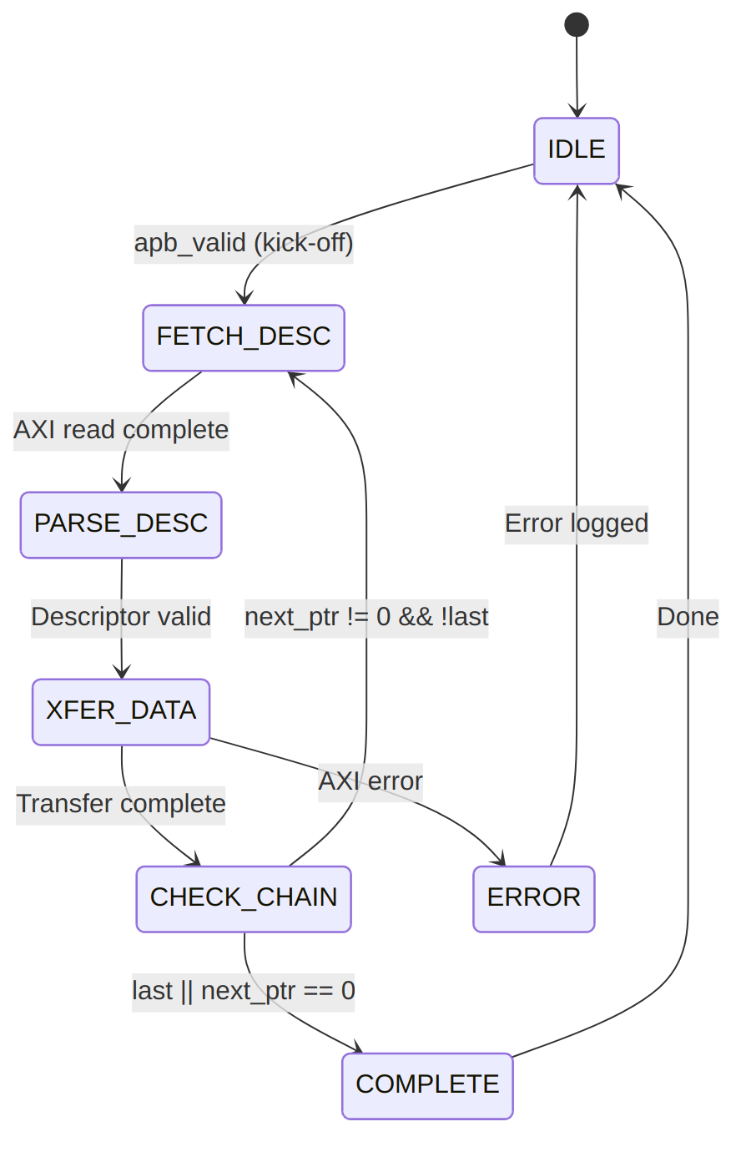
Diagram 2

6.2.2 SRAM Buffering
Each data path includes dedicated SRAM buffering:
SRAM Buffer Parameters
Parameter | Default | Range | Description
SRAM_DEPTH | 512 | 64-4096 | Entries per channel
Data Width | 512 | Fixed | Bits per entry
Total Size | 32KB | 4KB-256KB | Per data path
Buffer Operation:
- Sink Path: Fill from AXIS, drain to AXI write engine
- Source Path: Fill from AXI read engine, drain to AXIS
- Flow Control: Backpressure when buffer full/empty

6.2.3 AXI Burst Optimization
RAPIDS optimizes AXI transactions for maximum bandwidth:
AXI Optimization Features
Feature | Implementation
Burst Length | Up to 256 beats (AXI4 max)
Outstanding Transactions | Configurable (default 8)
Address Alignment | 64-byte aligned (beat size)
4KB Boundary | Automatic burst splitting

6.2.4 Error Handling
Error Handling Summary
Error Type | Detection | Response
Address Range | Pre-fetch validation | Descriptor rejected
AXI SLVERR | Response check | Transfer aborted
AXI DECERR | Response check | Transfer aborted
Timeout | Watchdog timer | Channel reset

7 System Context

7.1 Integration Overview
RAPIDS Beats integrates into a system as a DMA engine bridging network interfaces and system memory. This section describes the external connections and system-level requirements.

7.2 System Block Diagram
System Integration
System Integration
Source: 03_system_integration.mmd
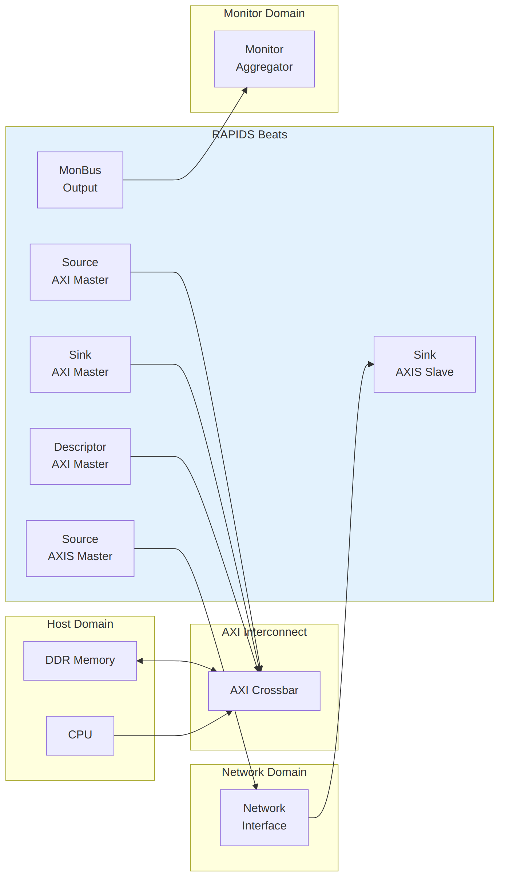
Diagram 3

7.3 Interface Connections

7.3.1 Memory Interface
RAPIDS requires three AXI4 master ports connected to system memory:
AXI Memory Interface Requirements
Port | Access Pattern | Typical Bandwidth
Descriptor AXI | Random read (256-bit) | Low (<100 MB/s)
Sink AXI | Sequential write (512-bit) | High (up to interface max)
Source AXI | Sequential read (512-bit) | High (up to interface max)
Interconnect Requirements:
- All three ports MAY share a single physical AXI port with arbitration
- Descriptor port has lowest bandwidth requirement
- Sink and Source ports should have balanced bandwidth allocation

7.3.2 Network Interface
RAPIDS uses standard AXI-Stream for network connectivity:
AXIS Network Interface
Interface | Role | Signals
Sink AXIS | Receives data from network | TDATA, TVALID, TREADY, TLAST
Source AXIS | Sends data to network | TDATA, TVALID, TREADY, TLAST
Protocol Notes:
- TKEEP/TSTRB supported for partial beat handling
- TID/TDEST may be used for channel routing (optional)
- TUSER available for sideband information

7.3.3 Configuration Interface
Software configures RAPIDS through register writes:
Configuration Methods
Method | Interface | Usage
Direct Write | Memory-mapped | Register configuration
Descriptor Kick | APB-style | Start descriptor processing

7.4 Clock and Reset

7.4.1 Clock Domains
Clock Domains
Clock | Frequency | Usage
aclk | 100-500 MHz | All RAPIDS logic
Note: RAPIDS Beats uses a single clock domain. CDC (clock domain crossing) to different frequency domains must be handled externally.

7.4.2 Reset Requirements
Reset Signals
Signal | Type | Description
aresetn | Active-low | Async assert, sync deassert
Reset Sequence:
- Assert aresetn low for minimum 4 clock cycles
- Ensure all AXI interfaces are idle before reset
- Release reset synchronously to aclk rising edge
- Wait 16 clock cycles before initiating transfers

7.5 Power Considerations

7.5.1 Clock Gating
RAPIDS supports optional clock gating for power reduction:
- Idle Detection: Automatic when no transfers pending
- Per-Channel Gating: Individual channels can be clock-gated
- External Control: cfg_clock_enable override available

7.5.2 Power States
Power States
State | Description | Exit Latency
Active | Normal operation | 0 cycles
Idle | No pending transfers | 1 cycle
Gated | Clock disabled | 4 cycles

8 Block Diagram

8.1 Top-Level Architecture
RAPIDS Beats Block Diagram
RAPIDS Beats Block Diagram
Source: 04_block_diagram.mmd
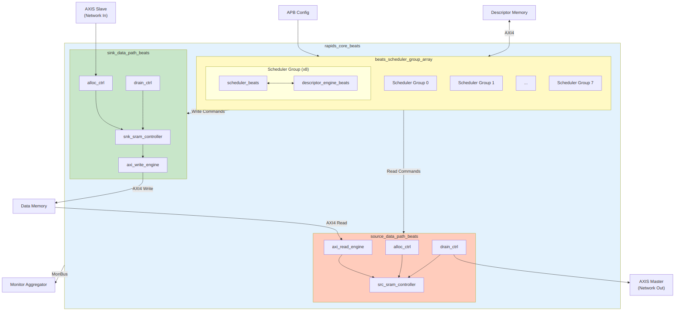
Diagram 4

8.2 Component Summary

8.2.1 Scheduler Group Array
The scheduler group array manages 8 independent channels:
Scheduler Array Components
Component | Instance Count | Purpose
scheduler_beats | 8 | Transfer coordination per channel
descriptor_engine_beats | 8 | Descriptor fetch and parse
Descriptor AXI Arbiter | 1 | Shared AXI4 for descriptor fetch

8.2.2 Sink Data Path
Network-to-memory data flow:
Sink Path Components
Component | Purpose
snk_sram_controller_beats | Multi-channel SRAM management
axi_write_engine_beats | AXI4 burst write generation
alloc_ctrl_beats | Space allocation tracking
drain_ctrl_beats | Data availability tracking

8.2.3 Source Data Path
Memory-to-network data flow:
Source Path Components
Component | Purpose
axi_read_engine_beats | AXI4 burst read generation
src_sram_controller_beats | Multi-channel SRAM management
alloc_ctrl_beats | Space allocation tracking
drain_ctrl_beats | Data availability tracking

8.3 Hierarchy
rapids_core_beats
├── beats_scheduler_group_array
│ ├── beats_scheduler_group [0]
│ │ ├── scheduler_beats
│ │ └── descriptor_engine_beats
│ ├── beats_scheduler_group [1..6]
│ │ └── ...
│ └── beats_scheduler_group [7]
│ └── ...
├── sink_data_path_beats
│ ├── snk_sram_controller_beats
│ │ └── snk_sram_controller_unit_beats [0..7]
│ ├── axi_write_engine_beats
│ ├── alloc_ctrl_beats
│ └── drain_ctrl_beats
└── source_data_path_beats
├── axi_read_engine_beats
├── src_sram_controller_beats
│ └── src_sram_controller_unit_beats [0..7]
├── alloc_ctrl_beats
└── drain_ctrl_beats

8.4 Internal Buses
Internal Bus Summary
Bus | Width | Description
Descriptor Bus | 256-bit | Parsed descriptor to scheduler
Scheduler Command | Variable | Transfer parameters to data paths
SRAM Data | 512-bit | Data to/from SRAM buffers
MonBus | 64-bit | Monitor packets (aggregated)

9 Data Flow

9.1 Overview
RAPIDS Beats implements two independent data paths that can operate concurrently:
- Sink Path: Network to Memory (AXIS Slave -> AXI Write)
- Source Path: Memory to Network (AXI Read -> AXIS Master)

9.2 Sink Path Data Flow
Sink Data Flow
Sink Data Flow
Source: 05_sink_flow.mmd
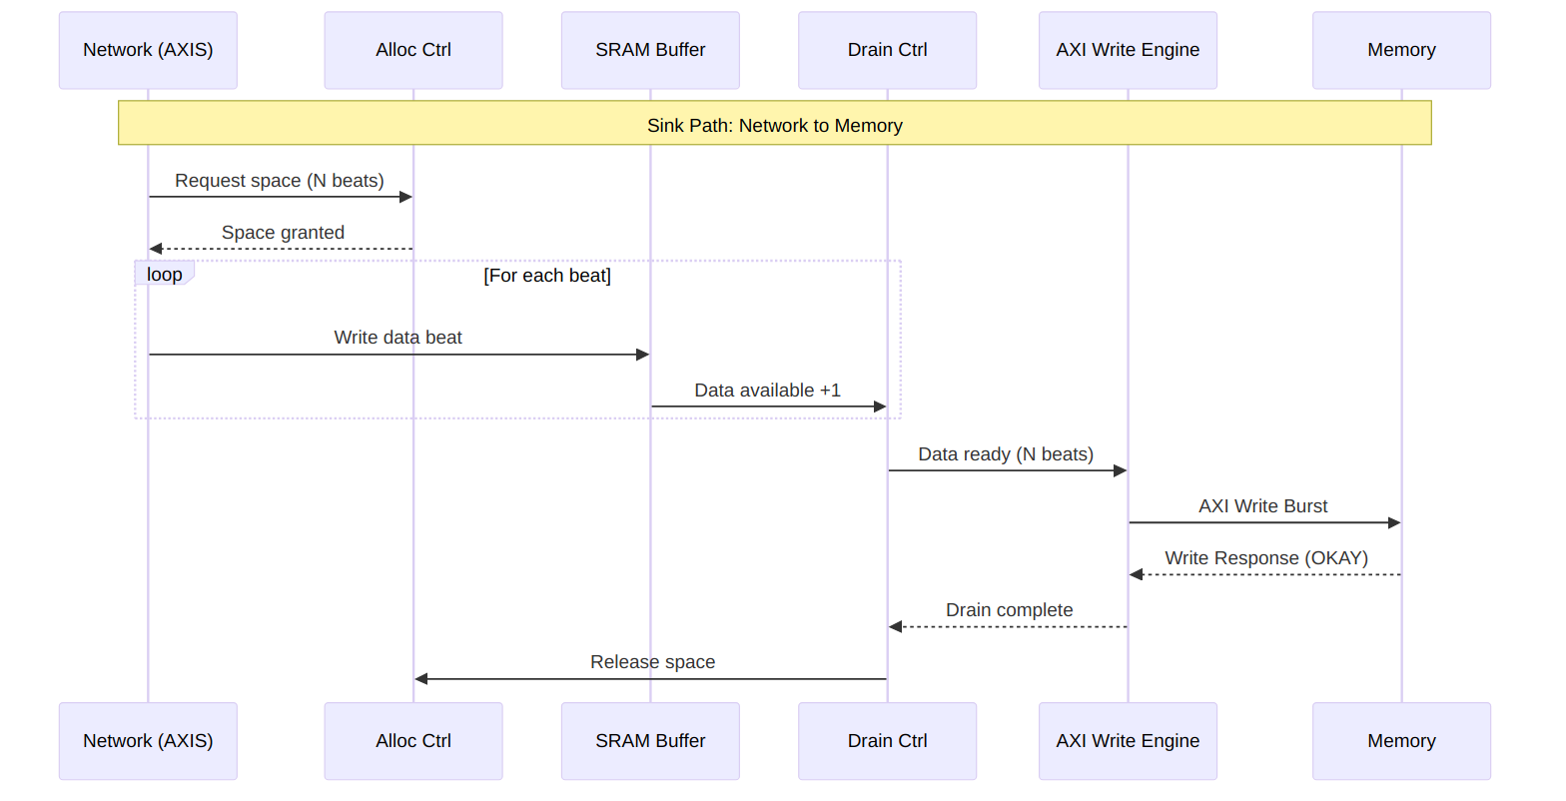
Diagram 5

9.2.1 Sink Path Timing
Sink Path Timing
Sink Path Timing
Source: sink_path_timing.json
Waveform 1

9.3 Source Path Data Flow
Source Data Flow
Source Data Flow
Source: 06_source_flow.mmd
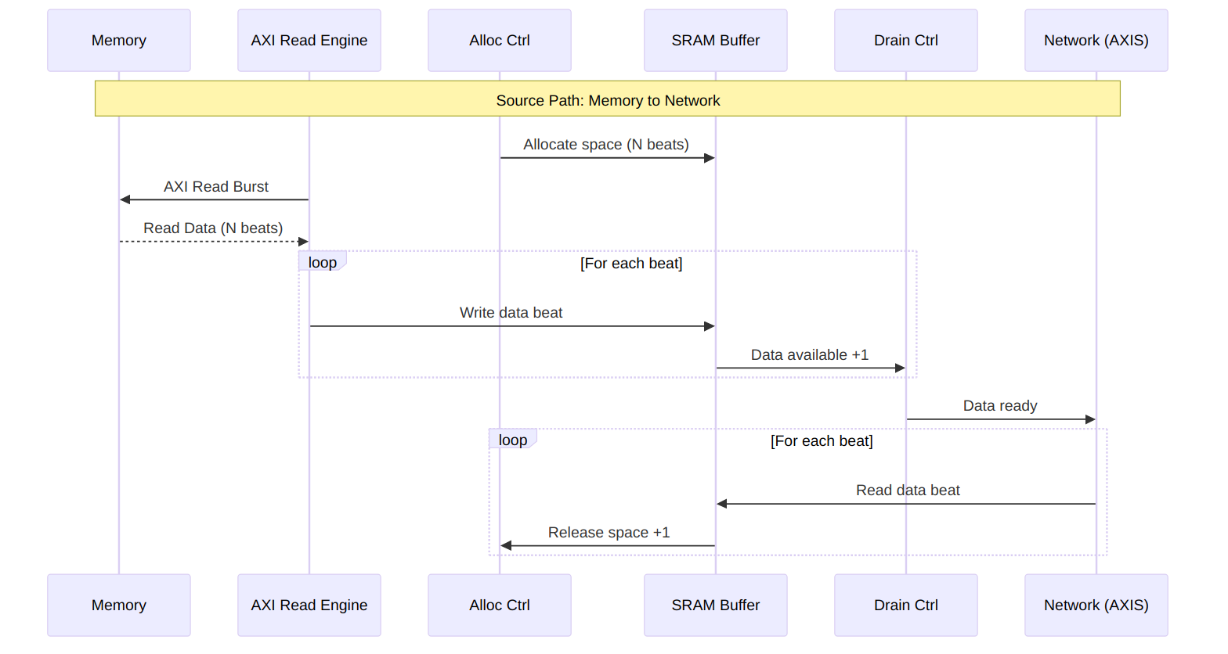
Diagram 6

9.3.1 Source Path Timing
Source Path Timing
Source Path Timing
Source: source_path_timing.json
Waveform 2

9.4 Concurrent Operation
Both data paths operate independently and can run simultaneously:
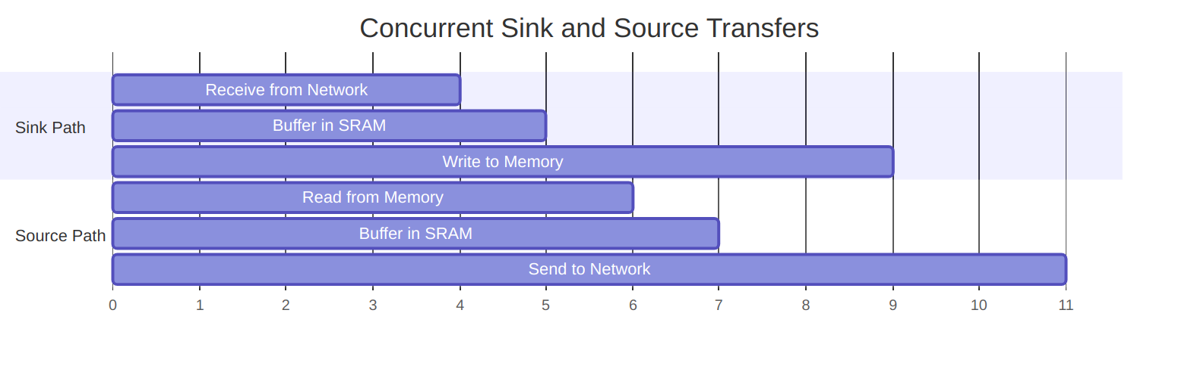
Diagram 7

9.4.1 Deadlock Prevention
RAPIDS prevents deadlock through independent resource allocation:
Resource Isolation
Resource | Sink Path | Source Path | Shared
SRAM Buffer | Dedicated | Dedicated | No
AXI Port | Write only | Read only | No
Scheduler | Per-channel | Per-channel | No

10 Channel Architecture

10.1 Multi-Channel Design
RAPIDS Beats supports 8 independent DMA channels, each with dedicated resources for concurrent operation.

10.2 Channel Resource Allocation
Channel Architecture
Channel Architecture
Source: 07_channel_arch.mmd
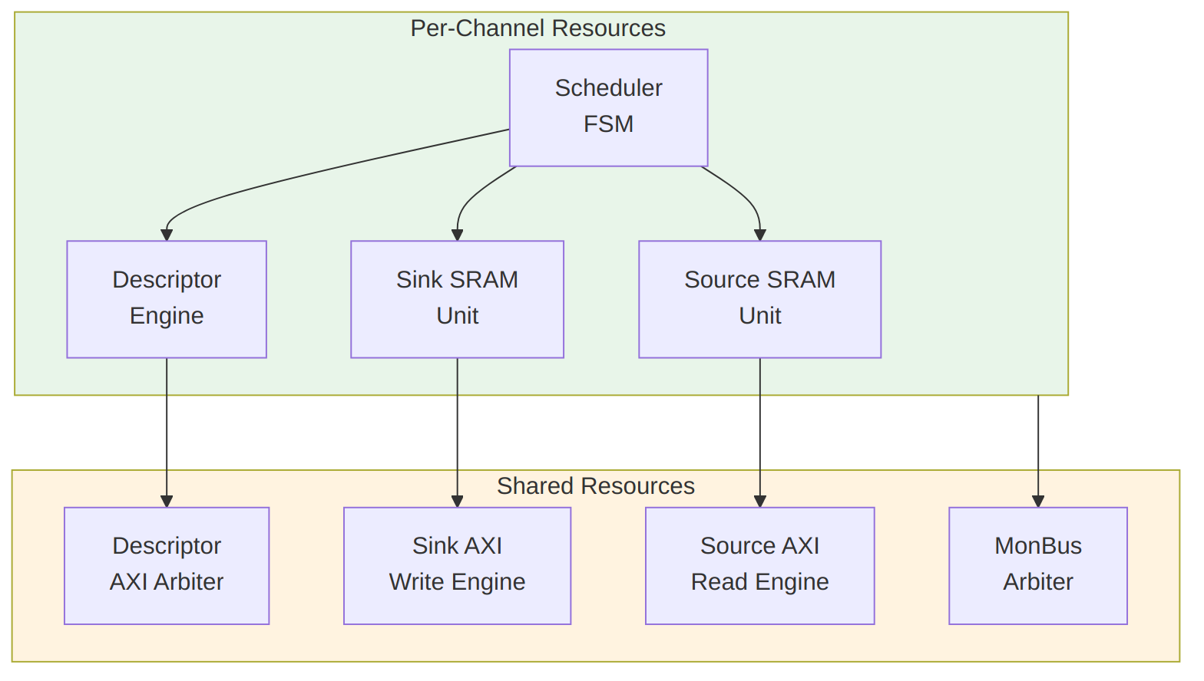
Diagram 8

10.3 Per-Channel Resources
Each channel has dedicated:
Per-Channel Resources
Resource | Description | Size/Capacity
Scheduler | Transfer coordination FSM | 1 instance
Descriptor Engine | Descriptor fetch/parse | 8-deep FIFO
Sink SRAM Unit | Sink buffer partition | SRAM_DEPTH/8 entries
Source SRAM Unit | Source buffer partition | SRAM_DEPTH/8 entries
Configuration Registers | Per-channel config | ~16 registers

10.4 Shared Resources
Resources shared across all channels:
Shared Resources
Resource | Arbitration | Max Outstanding
Descriptor AXI | Round-robin | 8 (1 per channel)
Sink AXI Write | Round-robin | 8 configurable
Source AXI Read | Round-robin | 8 configurable
MonBus Output | Priority | 1 (serialized)

10.5 Channel Scheduling
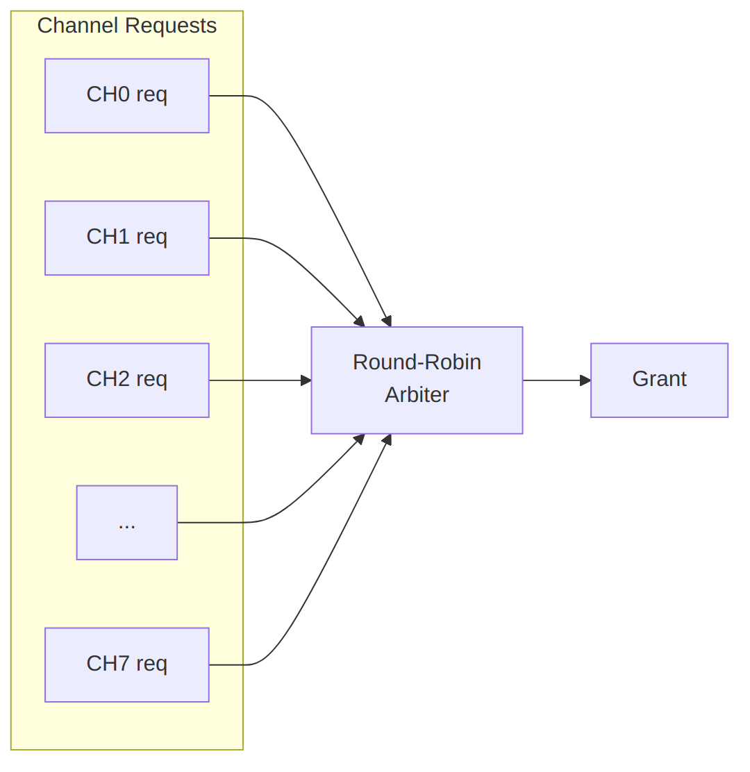
Arbitration Policy
Arbitration Timing:
Channel Arbitration
Channel Arbitration
Source: channel_arbitration.json
Waveform 3

10.6 Channel State Machine
Each channel scheduler follows this state machine:
Channel FSM
Channel FSM
Source: 08_channel_fsm.mmd
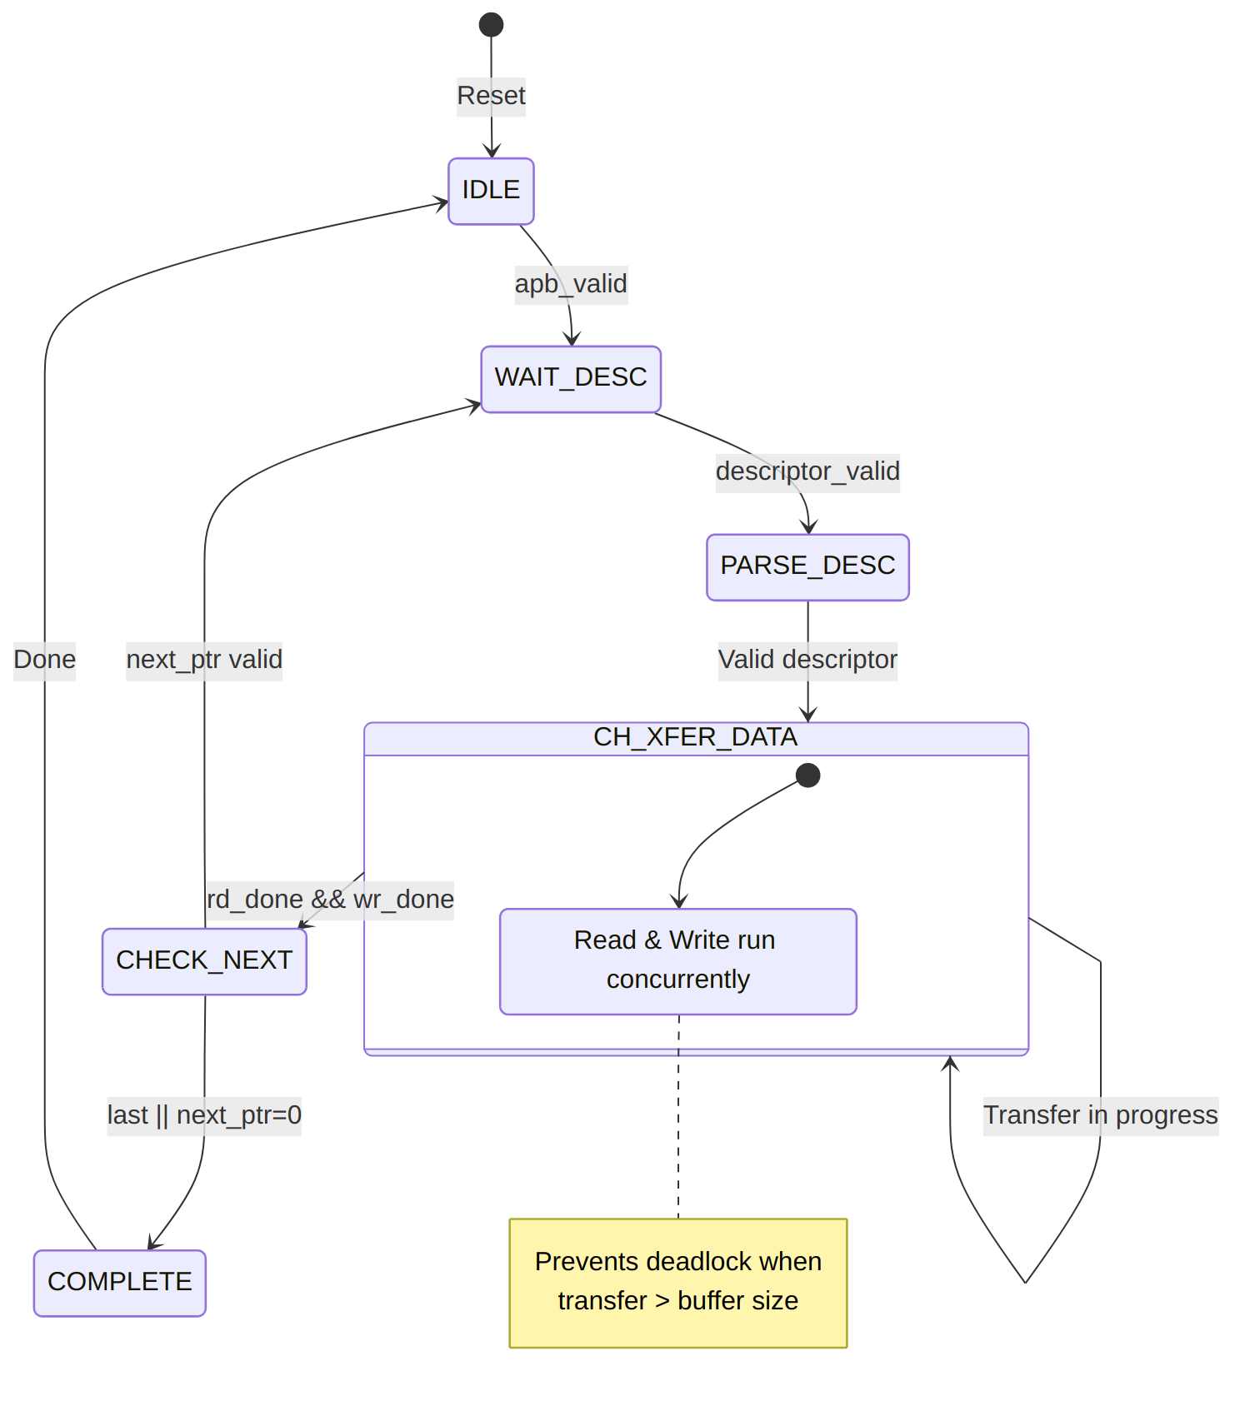
Diagram 10

10.6.1 Channel State Timing
Channel State Timing
Channel State Timing
Source: channel_state_timing.json
Waveform 4

10.7 Channel Isolation
Channels are isolated to prevent interference:
Channel Isolation Features
Isolation Type | Implementation
State Isolation | Separate FSM per channel
Buffer Isolation | Partitioned SRAM per channel
Error Isolation | Per-channel error flags
Reset Isolation | Per-channel soft reset

10.7.1 Per-Channel Error Handling
Each channel maintains independent error state:
Waveform 5
Channel 1 error does not affect Channel 0 or Channel 2 operation.

11 Interface Summary

11.1 External Interface Overview
RAPIDS Beats exposes the following external interfaces:
Interface Overview
Interface Overview
Source: 09_interface_overview.mmd
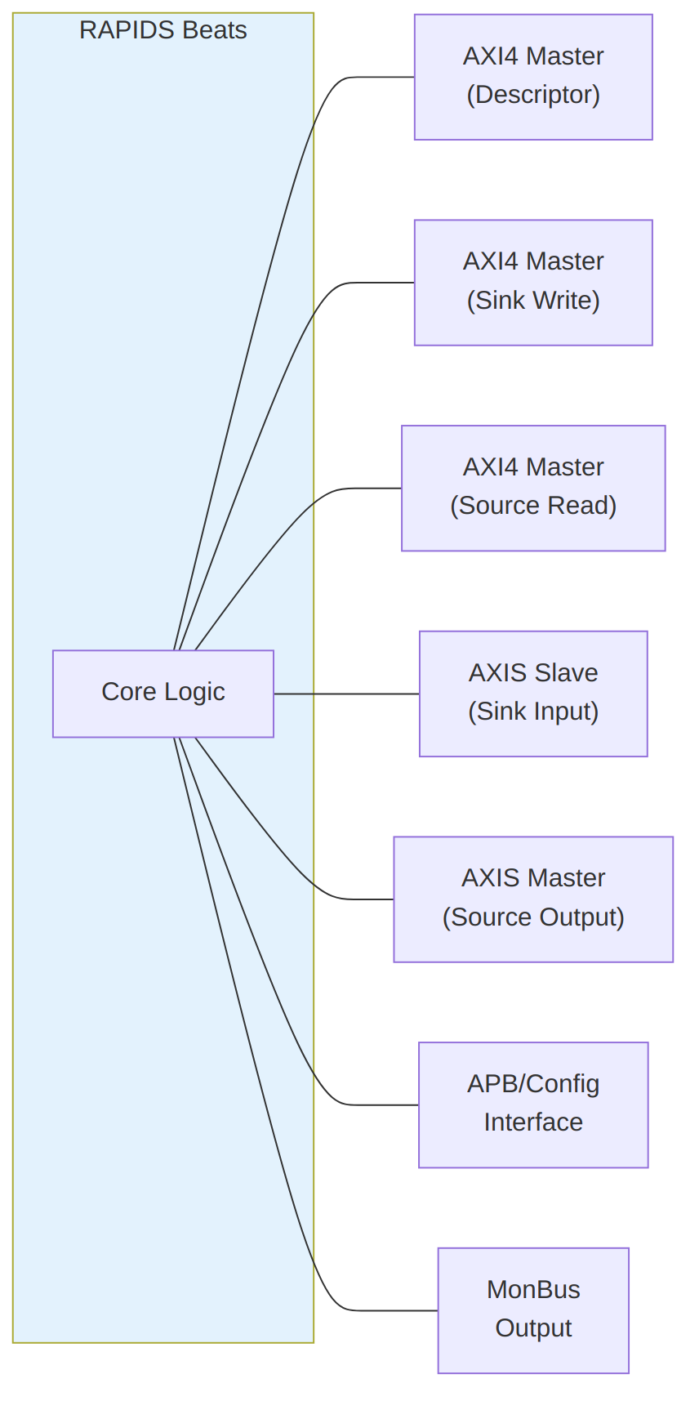
Diagram 11

11.2 Interface Port Summary
External Interface Summary
Interface | Type | Direction | Data Width | Address Width
Descriptor AXI | AXI4 Master | Read | 256-bit | 64-bit
Sink AXI | AXI4 Master | Write | 512-bit | 64-bit
Source AXI | AXI4 Master | Read | 512-bit | 64-bit
Sink AXIS | AXIS Slave | Input | 512-bit | -
Source AXIS | AXIS Master | Output | 512-bit | -
APB Config | APB-like | Input | 32-bit | 12-bit
MonBus | Custom | Output | 64-bit | -

11.3 Clock and Reset
All interfaces operate in the same clock domain:
Clock and Reset Signals
Signal | Type | Description
aclk | input | System clock (100-500 MHz typical)
aresetn | input | Active-low reset (async assert, sync deassert)

11.4 Interface Feature Matrix
Interface Feature Matrix
Feature | Desc AXI | Sink AXI | Src AXI | Sink AXIS | Src AXIS
Protocol | AXI4 | AXI4 | AXI4 | AXIS | AXIS
Direction | Read | Write | Read | Slave | Master
Burst Support | INCR | INCR | INCR | N/A | N/A
Max Burst | 1 | 256 | 256 | N/A | N/A
Outstanding | 8 | 8 | 8 | N/A | N/A
ID Width | 8-bit | 8-bit | 8-bit | Optional | Optional

11.5 Signal Count Summary
Signal Count Summary
Interface | Input Signals | Output Signals | Total
Descriptor AXI | ~20 | ~30 | ~50
Sink AXI | ~15 | ~40 | ~55
Source AXI | ~25 | ~25 | ~50
Sink AXIS | ~20 | ~5 | ~25
Source AXIS | ~5 | ~20 | ~25
APB Config | ~15 | ~5 | ~20
MonBus | ~2 | ~5 | ~7
Total | ~102 | ~130 | ~232
Note: Signal counts are approximate and vary with configuration parameters.

12 AXI4 Interface Specification

12.1 Overview
RAPIDS Beats uses three AXI4 master interfaces for memory access:
- Descriptor AXI - Fetches 256-bit descriptors (read-only)
- Sink AXI - Writes data to memory (write-only)
- Source AXI - Reads data from memory (read-only)

12.2 Descriptor AXI Master

12.2.1 Purpose
Fetches descriptor structures from system memory for all 8 channels.

12.2.2 Configuration
Descriptor AXI Configuration
Parameter | Value | Description
Data Width | 256-bit | Fixed descriptor size
Address Width | 64-bit | Configurable
ID Width | 8-bit | Configurable
Burst Length | 1 | Single-beat only
Burst Type | INCR | Fixed

12.2.3 Signal List
Descriptor AXI Signals
Signal | Width | Direction | Description
m_axi_desc_aclk | 1 | input | Clock
m_axi_desc_aresetn | 1 | input | Reset (active-low)
m_axi_desc_arid | 8 | output | Read ID (channel ID)
m_axi_desc_araddr | 64 | output | Read address
m_axi_desc_arlen | 8 | output | Burst length (always 0)
m_axi_desc_arsize | 3 | output | Beat size (5 = 32 bytes)
m_axi_desc_arburst | 2 | output | Burst type (INCR)
m_axi_desc_arvalid | 1 | output | Address valid
m_axi_desc_arready | 1 | input | Address ready
m_axi_desc_rid | 8 | input | Response ID
m_axi_desc_rdata | 256 | input | Read data
m_axi_desc_rresp | 2 | input | Read response
m_axi_desc_rlast | 1 | input | Last beat
m_axi_desc_rvalid | 1 | input | Data valid
m_axi_desc_rready | 1 | output | Data ready

12.2.4 Timing Diagram
Descriptor Fetch Timing
Descriptor Fetch Timing
Source: desc_axi_timing.json
Waveform 6

12.3 Sink AXI Master (Write)

12.3.1 Purpose
Writes data from SRAM buffer to system memory.

12.3.2 Configuration
Sink AXI Configuration
Parameter | Default | Range | Description
Data Width | 512-bit | Configurable | Match SRAM width
Address Width | 64-bit | Configurable | System address space
ID Width | 8-bit | Configurable | Transaction tracking
Max Burst | 256 | 1-256 | AXI4 maximum
Outstanding | 8 | 1-16 | Concurrent AW requests

12.3.3 Signal List
Sink AXI Signals
Signal | Width | Direction | Description
m_axi_sink_awid | 8 | output | Write ID
m_axi_sink_awaddr | 64 | output | Write address
m_axi_sink_awlen | 8 | output | Burst length - 1
m_axi_sink_awsize | 3 | output | Beat size (6 = 64 bytes)
m_axi_sink_awburst | 2 | output | Burst type (INCR)
m_axi_sink_awvalid | 1 | output | Address valid
m_axi_sink_awready | 1 | input | Address ready
m_axi_sink_wdata | 512 | output | Write data
m_axi_sink_wstrb | 64 | output | Write strobes
m_axi_sink_wlast | 1 | output | Last beat
m_axi_sink_wvalid | 1 | output | Data valid
m_axi_sink_wready | 1 | input | Data ready
m_axi_sink_bid | 8 | input | Response ID
m_axi_sink_bresp | 2 | input | Write response
m_axi_sink_bvalid | 1 | input | Response valid
m_axi_sink_bready | 1 | output | Response ready

12.3.4 Timing Diagram
Sink AXI Write Timing
Sink AXI Write Timing
Source: sink_axi_timing.json
Waveform 7

12.4 Source AXI Master (Read)

12.4.1 Purpose
Reads data from system memory to SRAM buffer.

12.4.2 Configuration
Source AXI Configuration
Parameter | Default | Range | Description
Data Width | 512-bit | Configurable | Match SRAM width
Address Width | 64-bit | Configurable | System address space
ID Width | 8-bit | Configurable | Transaction tracking
Max Burst | 256 | 1-256 | AXI4 maximum
Outstanding | 8 | 1-16 | Concurrent AR requests

12.4.3 Signal List
Source AXI Signals
Signal | Width | Direction | Description
m_axi_src_arid | 8 | output | Read ID
m_axi_src_araddr | 64 | output | Read address
m_axi_src_arlen | 8 | output | Burst length - 1
m_axi_src_arsize | 3 | output | Beat size (6 = 64 bytes)
m_axi_src_arburst | 2 | output | Burst type (INCR)
m_axi_src_arvalid | 1 | output | Address valid
m_axi_src_arready | 1 | input | Address ready
m_axi_src_rid | 8 | input | Response ID
m_axi_src_rdata | 512 | input | Read data
m_axi_src_rresp | 2 | input | Read response
m_axi_src_rlast | 1 | input | Last beat
m_axi_src_rvalid | 1 | input | Data valid
m_axi_src_rready | 1 | output | Data ready

12.4.4 Timing Diagram
Source AXI Read Timing
Source AXI Read Timing
Source: source_axi_timing.json
Waveform 8

12.5 AXI Protocol Constraints

12.5.1 Address Alignment
Address Alignment Requirements
Transfer Type | Alignment Requirement
Descriptor | 32-byte aligned
Sink Data | 64-byte aligned
Source Data | 64-byte aligned

12.5.2 4KB Boundary Handling
AXI4 requires burst transactions not to cross 4KB boundaries. RAPIDS automatically splits bursts at 4KB boundaries:
Example: 8-beat burst starting at 0x0FE0 (64 bytes/beat)
Beat 0-1: 0x0FE0 - 0x0FFF (to 4KB boundary)
Beat 2-7: 0x1000 - 0x117F (after boundary)
Split into two bursts:
Burst 1: ARLEN=1, ARADDR=0x0FE0
Burst 2: ARLEN=5, ARADDR=0x1000

12.5.3 Response Handling
AXI Response Handling
Response | Code | RAPIDS Behavior
OKAY | 2’b00 | Normal completion
EXOKAY | 2’b01 | Treated as OKAY
SLVERR | 2’b10 | Error, transfer aborted
DECERR | 2’b11 | Error, transfer aborted

13 AXIS Interface Specification

13.1 Overview
RAPIDS Beats uses AXI-Stream interfaces for network data transfer:
- Sink AXIS Slave - Receives data from network (ingress)
- Source AXIS Master - Sends data to network (egress)

13.2 Sink AXIS Slave

13.2.1 Purpose
Receives streaming data from external network interface and writes to SRAM buffer.

13.2.2 Configuration
Sink AXIS Configuration
Parameter | Default | Range | Description
Data Width | 512-bit | Configurable | TDATA width
ID Width | 8-bit | 0-8 | TID width (optional)
DEST Width | 8-bit | 0-8 | TDEST width (optional)
USER Width | 1-bit | 0-16 | TUSER width (optional)

13.2.3 Signal List
Sink AXIS Signals
Signal | Width | Direction | Description
s_axis_sink_tdata | 512 | input | Data payload
s_axis_sink_tkeep | 64 | input | Byte valid mask
s_axis_sink_tstrb | 64 | input | Byte position (optional)
s_axis_sink_tlast | 1 | input | End of packet
s_axis_sink_tid | 8 | input | Transaction ID (channel select)
s_axis_sink_tdest | 8 | input | Destination (optional)
s_axis_sink_tuser | 1 | input | User sideband (optional)
s_axis_sink_tvalid | 1 | input | Data valid
s_axis_sink_tready | 1 | output | Ready to accept

13.2.4 Timing Diagram
Sink AXIS Timing
Sink AXIS Timing
Source: sink_axis_timing.json
Waveform 9

13.2.5 Backpressure Behavior
When SRAM buffer is full, tready deasserts:
Waveform 10

13.3 Source AXIS Master

13.3.1 Purpose
Sends streaming data from SRAM buffer to external network interface.

13.3.2 Configuration
Source AXIS Configuration
Parameter | Default | Range | Description
Data Width | 512-bit | Configurable | TDATA width
ID Width | 8-bit | 0-8 | TID width (optional)
DEST Width | 8-bit | 0-8 | TDEST width (optional)
USER Width | 1-bit | 0-16 | TUSER width (optional)

13.3.3 Signal List
Source AXIS Signals
Signal | Width | Direction | Description
m_axis_src_tdata | 512 | output | Data payload
m_axis_src_tkeep | 64 | output | Byte valid mask
m_axis_src_tstrb | 64 | output | Byte position (optional)
m_axis_src_tlast | 1 | output | End of packet
m_axis_src_tid | 8 | output | Transaction ID (channel)
m_axis_src_tdest | 8 | output | Destination (optional)
m_axis_src_tuser | 1 | output | User sideband (optional)
m_axis_src_tvalid | 1 | output | Data valid
m_axis_src_tready | 1 | input | Downstream ready

13.3.4 Timing Diagram
Source AXIS Timing
Source AXIS Timing
Source: source_axis_timing.json
Waveform 11

13.3.5 Data Availability
Source AXIS only asserts tvalid when data is available in SRAM:
Waveform 12

13.4 AXIS Protocol Notes

13.4.1 Handshake Rules
Standard AXI-Stream handshake applies:
- tvalid asserts when data is available
- tready asserts when receiver can accept
- Transfer occurs on clock edge when both are high
- tvalid SHALL NOT depend on tready
- tready MAY depend on tvalid

13.4.2 TLAST Semantics
TLAST Usage
Scenario | TLAST Behavior
Descriptor transfer complete | Assert on last beat
Packet boundary | Assert on last beat of packet
Continuous stream | Not used (always 0)

13.4.3 TKEEP Usage
TKEEP indicates valid bytes within each beat:
TKEEP Examples
TKEEP Value | Meaning
64’hFFFF_FFFF_FFFF_FFFF | All 64 bytes valid
64’h0000_FFFF_FFFF_FFFF | Upper 16 bytes invalid
64’h0000_0000_0000_000F | Only lower 4 bytes valid

13.4.4 Channel Multiplexing via TID
Multiple channels can share a single AXIS interface using TID:
Waveform 13

14 APB Configuration Interface

14.1 Overview
RAPIDS Beats uses an APB-like interface for configuration and descriptor kick-off. This interface allows software to:
- Configure channel parameters
- Initiate descriptor processing (kick-off)
- Read status and error information

14.2 Configuration Interface

14.2.1 Signal List
APB Configuration Signals (NC = NUM_CHANNELS)
Signal | Width | Direction | Description
apb_valid | NC | input | Per-channel kick-off valid
apb_ready | NC | output | Per-channel ready
apb_addr | 64 | input | Descriptor address
cfg_channel_enable | NC | input | Per-channel enable
cfg_addr0_base | 64 | input | Address range 0 base
cfg_addr0_limit | 64 | input | Address range 0 limit
cfg_addr1_base | 64 | input | Address range 1 base
cfg_addr1_limit | 64 | input | Address range 1 limit

14.2.2 Descriptor Kick-Off
To start descriptor processing on a channel:
- Write descriptor to memory
- Assert apb_valid[ch] with descriptor address on apb_addr
- Wait for apb_ready[ch] assertion
- Deassert apb_valid[ch]

14.2.3 Timing Diagram
APB Kick-Off Timing
APB Kick-Off Timing
Source: apb_kickoff_timing.json
Waveform 14

14.3 Status Interface

14.3.1 Per-Channel Status Signals
Status Signals
Signal | Width | Direction | Description
channel_idle | NC | output | Channel idle status
channel_error | NC | output | Channel error flag
scheduler_state | 4*NC | output | FSM state per channel

14.3.2 Channel State Encoding
Scheduler State Encoding
State | Value | Description
IDLE | 4’h0 | Waiting for kick-off
WAIT_DESC | 4’h1 | Waiting for descriptor
PARSE_DESC | 4’h2 | Parsing descriptor
CH_XFER_DATA | 4’h3 | Transfer in progress
CHECK_NEXT | 4’h4 | Checking next descriptor
COMPLETE | 4’h5 | Transfer complete
ERROR | 4’hF | Error state

14.4 Configuration Registers

14.4.1 Address Range Validation
RAPIDS validates descriptor addresses against configurable ranges:
Valid if:
(addr >= cfg_addr0_base && addr < cfg_addr0_limit) ||
(addr >= cfg_addr1_base && addr < cfg_addr1_limit)

14.4.2 Configuration Parameters
Configuration Register Map
Register | Offset | Width | Description
CTRL | 0x00 | 32 | Global control
STATUS | 0x04 | 32 | Global status
CH_ENABLE | 0x08 | 8 | Channel enable bitmap
CH_STATUS | 0x0C | 8 | Channel busy bitmap
ADDR0_BASE | 0x10 | 64 | Address range 0 base
ADDR0_LIMIT | 0x18 | 64 | Address range 0 limit
ADDR1_BASE | 0x20 | 64 | Address range 1 base
ADDR1_LIMIT | 0x28 | 64 | Address range 1 limit
IRQ_ENABLE | 0x30 | 8 | IRQ enable per channel
IRQ_STATUS | 0x34 | 8 | IRQ status per channel

14.4.3 Control Register (CTRL)
CTRL Register Bits
Bit | Name | Description
0 | ENABLE | Global enable
1 | SOFT_RESET | Soft reset (self-clearing)
7:2 | Reserved | -

14.4.4 Status Register (STATUS)
STATUS Register Bits
Bit | Name | Description
0 | BUSY | Any channel busy
1 | ERROR | Any channel error
7:2 | Reserved | -

14.5 Programming Sequence

14.5.1 Initialization
// 1. Assert soft reset
CTRL = 0x02;
while (CTRL & 0x02); // Wait for reset complete
// 2. Configure address ranges
ADDR0_BASE = 0x80000000;
ADDR0_LIMIT = 0x90000000;
// 3. Enable desired channels
CH_ENABLE = 0xFF; // Enable all 8 channels
// 4. Enable IRQs if needed
IRQ_ENABLE = 0xFF;
// 5. Global enable
CTRL = 0x01;

14.5.2 Descriptor Kick-Off
// Prepare descriptor in memory
desc->src_addr = src;
desc->dst_addr = dst;
desc->length = beats;
desc->last = 1;
desc->valid = 1;
// Kick off channel 0
apb_kickoff(0, desc_addr);
// Wait for completion
while (!(channel_idle & 0x01));
// Check for errors
if (channel_error & 0x01) {
handle_error(0);
}

15 Monitor Bus Interface

15.1 Overview
RAPIDS Beats outputs a 64-bit Monitor Bus (MonBus) for real-time event reporting. The MonBus provides visibility into:
- State machine transitions
- Descriptor processing events
- Error conditions
- Performance metrics

15.2 MonBus Packet Format

15.2.1 64-bit Packet Structure
Bit Field Width Description
───────────────────────────────────────────────────────
[63:60] 4-bit packet_type (error, completion, etc.)
[59:57] 3-bit protocol (CORE for RAPIDS)
[56:53] 4-bit event_code (specific event)
[52:47] 6-bit channel_id
[46:43] 4-bit unit_id (subsystem)
[42:35] 8-bit agent_id (module)
[34:0] 35-bit event_data (event-specific)

15.2.2 Signal List
MonBus Signals
Signal | Width | Direction | Description
monbus_pkt_valid | 1 | output | Packet valid
monbus_pkt_data | 64 | output | Packet data
monbus_pkt_ready | 1 | input | Downstream ready

15.3 Packet Types
MonBus Packet Types
Type | Code | Description
ERROR | 4’h0 | Error event
COMPLETION | 4’h1 | Transfer/operation complete
THRESHOLD | 4’h2 | Threshold crossed
TIMEOUT | 4’h3 | Timeout event
PERF | 4’h4 | Performance metric
DEBUG | 4’hF | Debug/trace event

15.4 Agent IDs
RAPIDS modules use the following Agent IDs:
RAPIDS Agent IDs
Agent ID | Module | Description
0x10-0x17 | Descriptor Engine | Channels 0-7
0x30-0x37 | Scheduler | Channels 0-7
0x40-0x47 | Sink Data Path | Channels 0-7
0x50-0x57 | Source Data Path | Channels 0-7

15.5 Event Codes

15.5.1 Scheduler Events (Agent 0x30-0x37)
Scheduler Event Codes
Event Code | Type | Description
0x0 | COMPLETION | Descriptor complete
0x1 | COMPLETION | Chain complete
0x2 | ERROR | Timeout
0x3 | ERROR | AXI error
0x4 | DEBUG | State transition

15.5.2 Descriptor Engine Events (Agent 0x10-0x17)
Descriptor Engine Event Codes
Event Code | Type | Description
0x0 | COMPLETION | Descriptor fetched
0x1 | ERROR | Address range error
0x2 | ERROR | AXI read error
0x3 | DEBUG | Fetch started

15.6 Timing Diagram
MonBus Timing
MonBus Timing
Source: monbus_timing.json
Waveform 15

15.7 Event Data Encoding

15.7.1 Completion Event Data
[34:32] - Reserved
[31:0] - Transfer length (beats completed)

15.7.2 Error Event Data
[34:32] - Error type
[31:16] - Reserved
[15:0] - Error details

15.7.3 State Transition Event Data
[34:32] - Reserved
[31:28] - Previous state
[27:24] - New state
[23:0] - Timestamp (lower bits)

15.8 MonBus Arbitration
Multiple RAPIDS modules generate MonBus packets. Internal arbitration ensures ordered delivery:
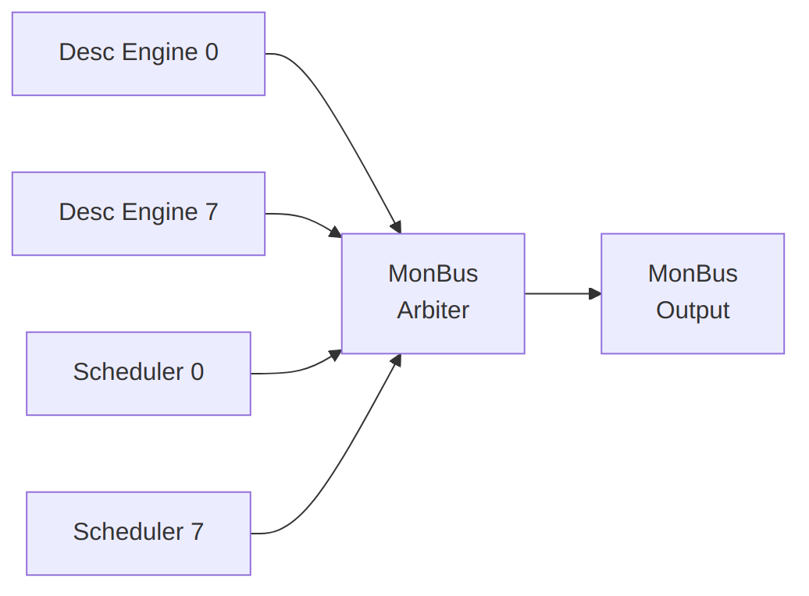
Diagram 12

15.8.1 Arbitration Policy
- Round-robin across modules
- No packet loss (backpressure if output blocked)
- Priority boosting for ERROR packets

15.9 Integration Notes

15.9.1 Downstream Connection
MonBus output typically connects to:
- MonBus Aggregator - Combines multiple sources
- AXIL Converter - Maps to AXI-Lite for CPU access
- Debug FIFO - Buffered access for debug tools

15.9.2 Packet Rate
MonBus Packet Rates
Scenario | Approximate Rate
Idle | 0 packets/cycle
Single channel active | ~1 packet/100 cycles
All channels active | ~1 packet/20 cycles
Error storm | Up to 1 packet/cycle

16 Use Case: Network to Memory (Sink Path)

16.1 Overview
The Sink Path transfers data from a network interface (AXI-Stream slave) to system memory (AXI4 write master). This is the primary receive data path for network applications.

16.2 Operation Flow
Sink Flow
Sink Flow
Source: 09_sink_flow.mmd
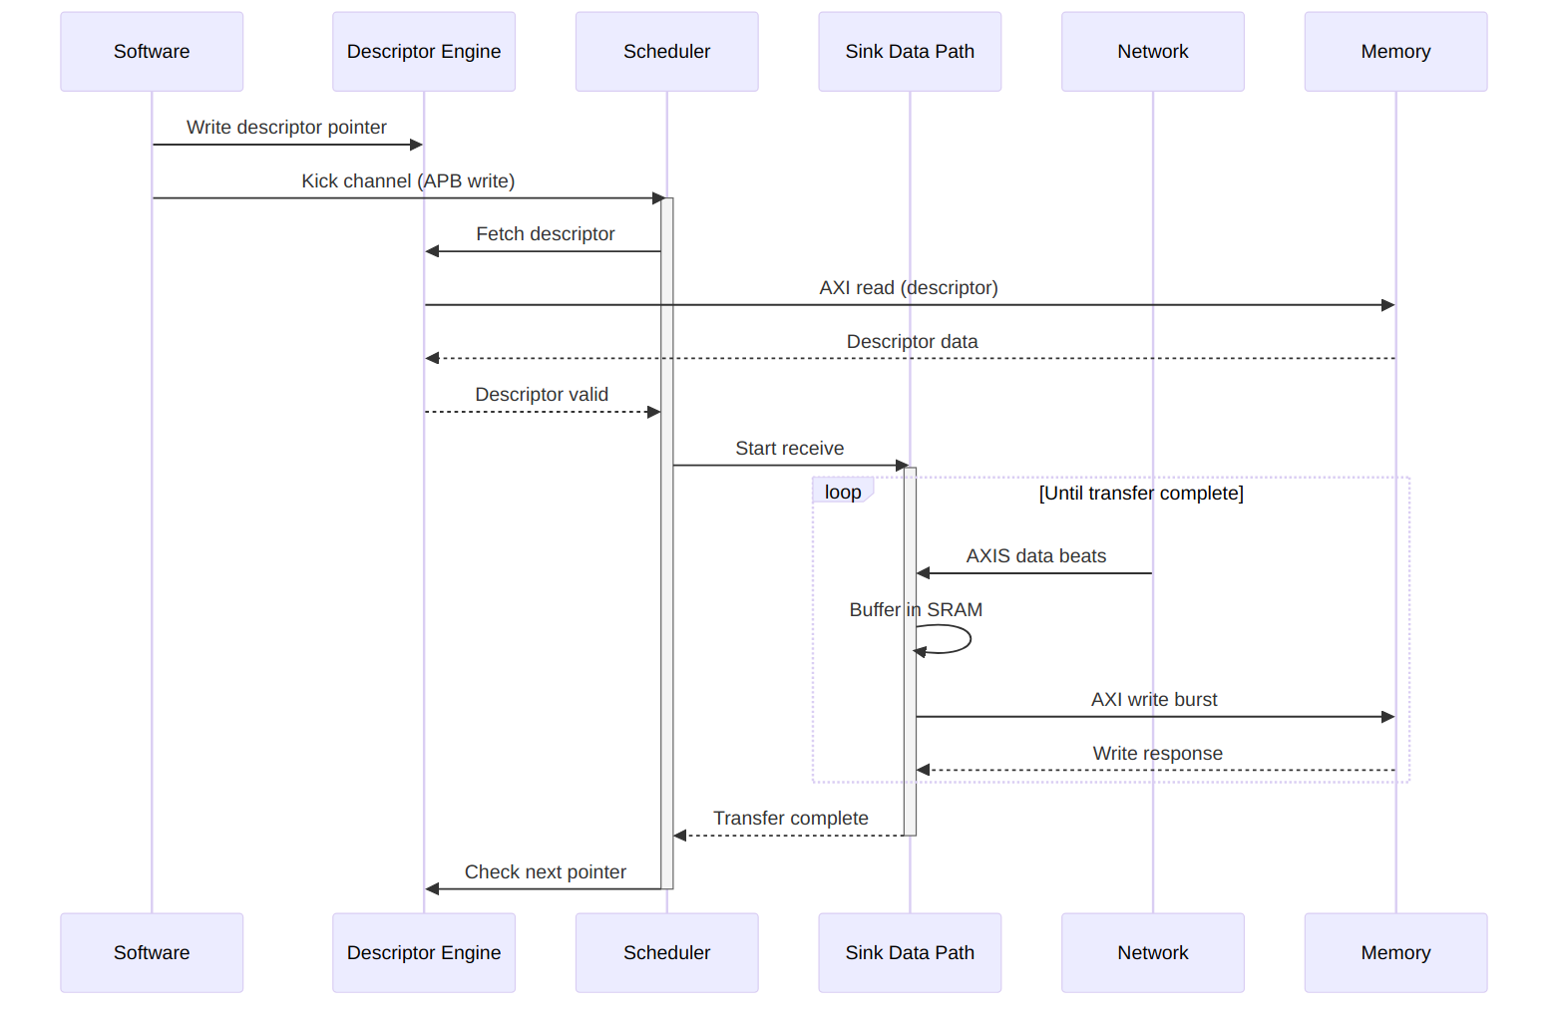
Diagram 13

16.3 Timing Diagram
Sink Transfer Timing
Sink Transfer Timing
Source: sink_transfer.json
Waveform 16

16.4 Buffer Management

16.4.1 SRAM Buffering Strategy
The sink path uses internal SRAM to decouple network timing from memory timing:
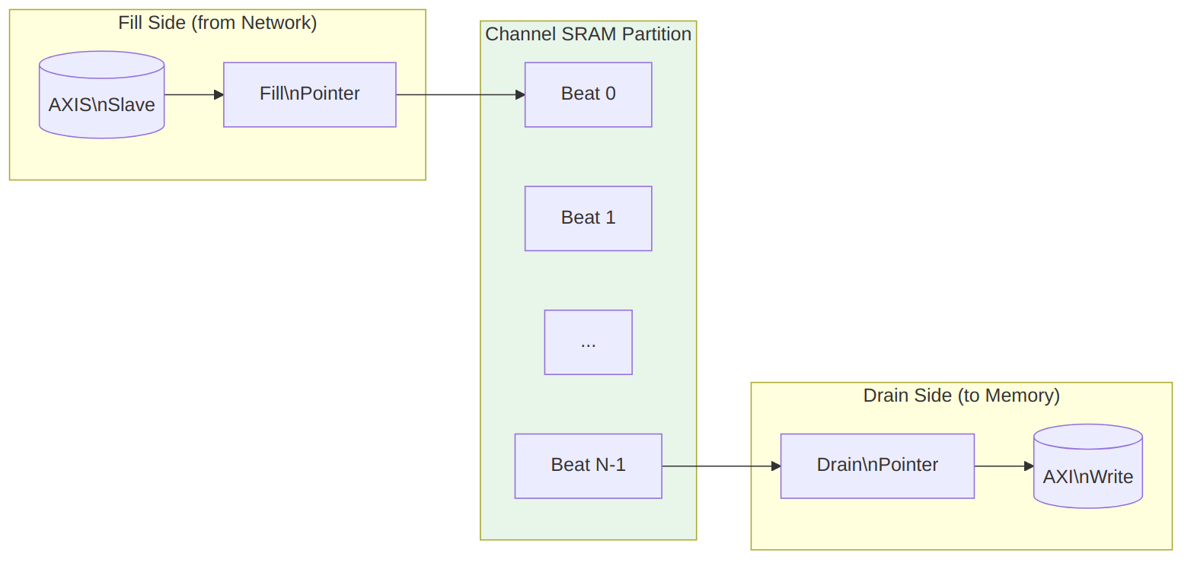
Diagram 14

16.4.2 Flow Control
Sink Path Flow Control
Condition | Behavior
SRAM full | Backpressure network (TREADY=0)
SRAM empty | Pause AXI writes
SRAM threshold | Optional early write start
Watermark Timing

16.5 Performance Considerations

16.5.1 Throughput
Sink Path Throughput Factors
Factor | Impact
Network bandwidth | Upper bound on receive rate
Memory bandwidth | Must match or exceed network
SRAM depth | Burst absorption capability
AXI outstanding | Overlapped write latency hiding

16.5.2 Latency
Sink Path Latency Breakdown
Phase | Typical Cycles
Descriptor fetch | 10-50 (memory dependent)
First beat to SRAM | 1
SRAM to AXI write | 2-4
AXI write completion | 10-100 (memory dependent)

16.6 Error Handling

16.6.1 Error Sources
Sink Path Error Handling
Error | Detection | Response
AXI write error | BRESP != OKAY | Stop transfer, report via MonBus
SRAM overflow | Fill pointer catches drain | Should never occur (TREADY control)
Timeout | Watchdog timer | Abort transfer, report error
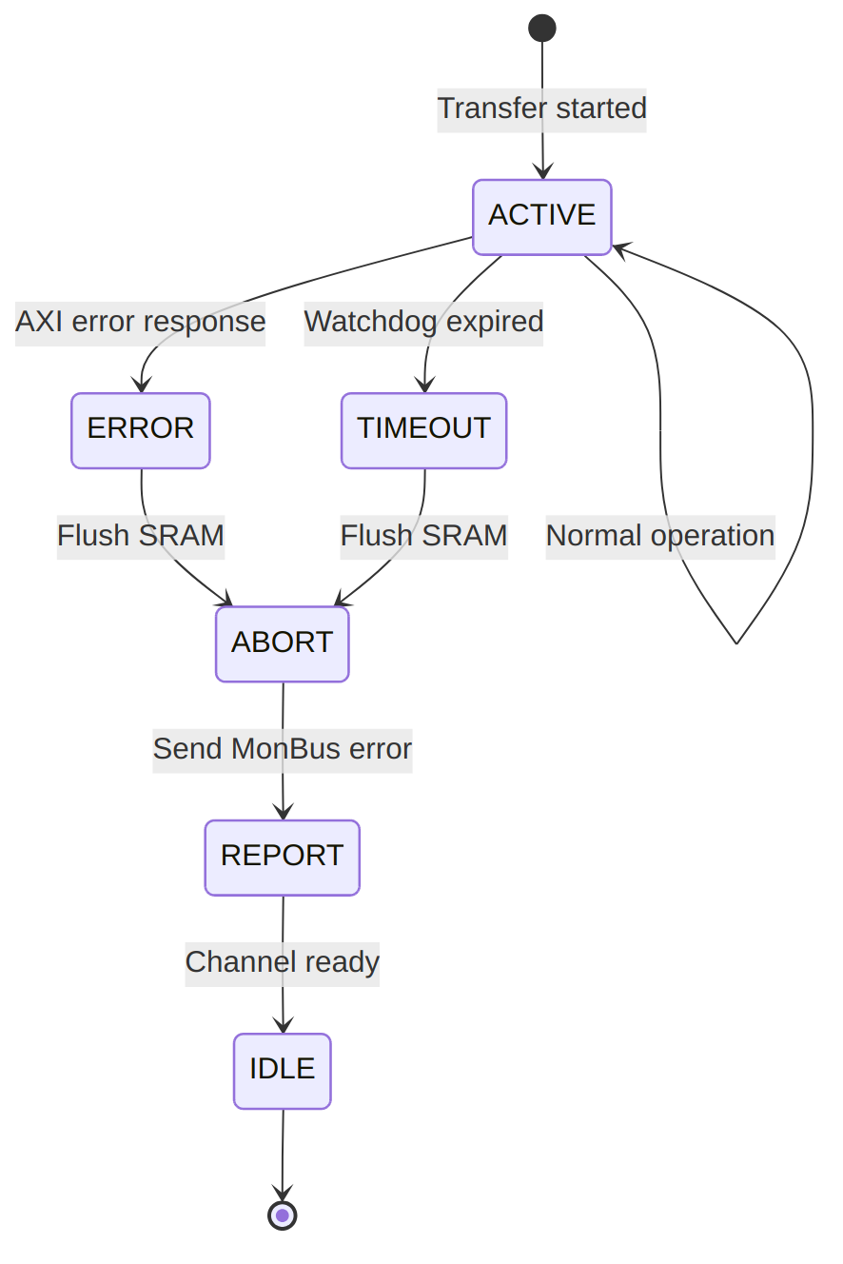
Error Recovery Sequence

17 Use Case: Memory to Network (Source Path)

17.1 Overview
The Source Path transfers data from system memory (AXI4 read master) to a network interface (AXI-Stream master). This is the primary transmit data path for network applications.

17.2 Operation Flow
Source Flow
Source Flow
Source: 10_source_flow.mmd
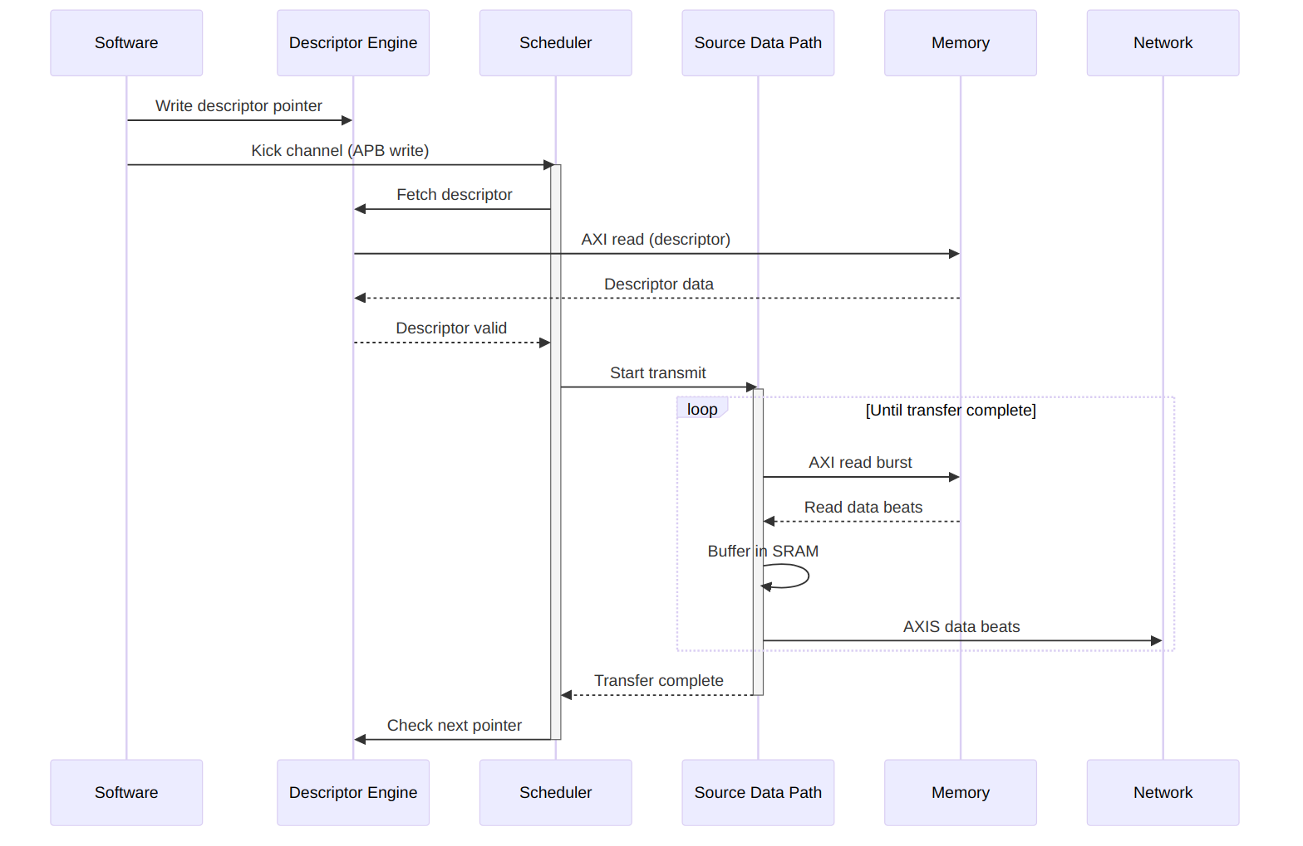
Diagram 16

17.3 Timing Diagram
Source Transfer Timing
Source Transfer Timing
Source: source_transfer.json
Waveform 18

17.4 Buffer Management

17.4.1 SRAM Buffering Strategy
The source path uses internal SRAM to prefetch data and maintain network throughput:
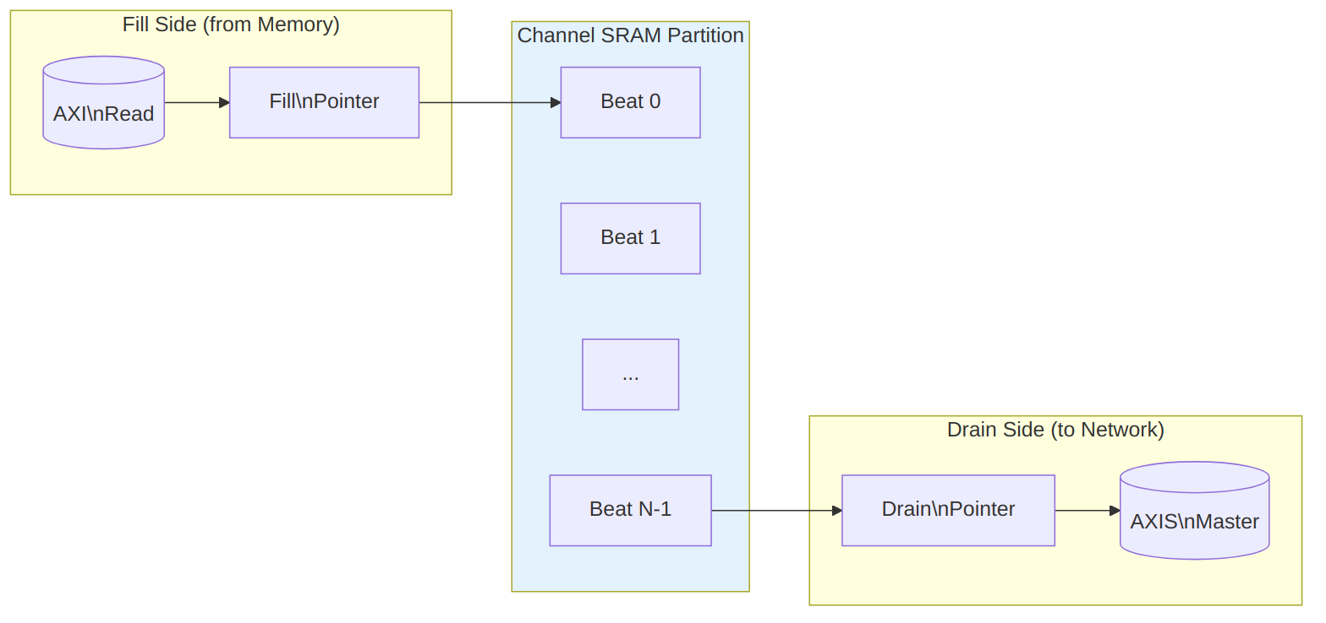
Diagram 17

17.4.2 Flow Control
Source Path Flow Control
Condition | Behavior
SRAM full | Pause AXI reads
SRAM empty | Hold TVALID low
Network backpressure | Stop draining SRAM
Prefetch Strategy

17.5 Concurrent Operation

17.5.1 Read-Ahead Pipeline
The source path can issue AXI reads ahead of network consumption:
Waveform 20

17.6 Performance Considerations

17.6.1 Throughput
Source Path Throughput Factors
Factor | Impact
Memory bandwidth | Upper bound on transmit rate
Network acceptance | Must keep pace with reads
SRAM depth | Read-ahead capability
AXI outstanding | Overlapped read latency hiding

17.6.2 Latency
Source Path Latency Breakdown
Phase | Typical Cycles
Descriptor fetch | 10-50 (memory dependent)
AXI read issue | 1-2
Memory read latency | 10-100 (memory dependent)
SRAM to network | 1-2

17.7 Error Handling

17.7.1 Error Sources
Source Path Error Handling
Error | Detection | Response
AXI read error | RRESP != OKAY | Stop transfer, report via MonBus
Network timeout | Watchdog timer | Abort transfer, report error
Address range | Descriptor validation | Reject descriptor
Backpressure Handling
When the network deasserts TREADY: 1. SRAM drain stalls immediately 2. SRAM continues filling until threshold 3. AXI reads pause when SRAM approaches full 4. Resume automatically when TREADY returns

18 Use Case: Descriptor Chaining

18.1 Overview
Descriptor chaining enables multiple transfers to execute sequentially without software intervention. Each descriptor contains a pointer to the next descriptor, forming a linked list that RAPIDS processes automatically.

18.2 Chain Structure
Descriptor Chain
Descriptor Chain
Source: 11_descriptor_chain.mmd
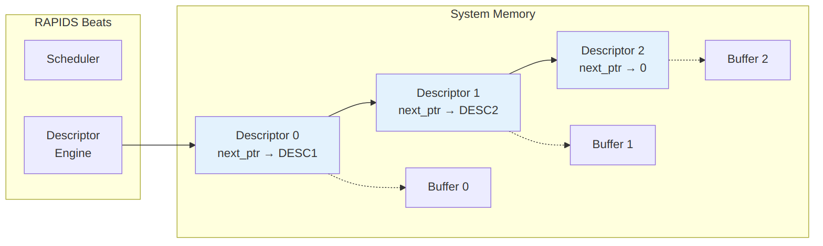
Diagram 18
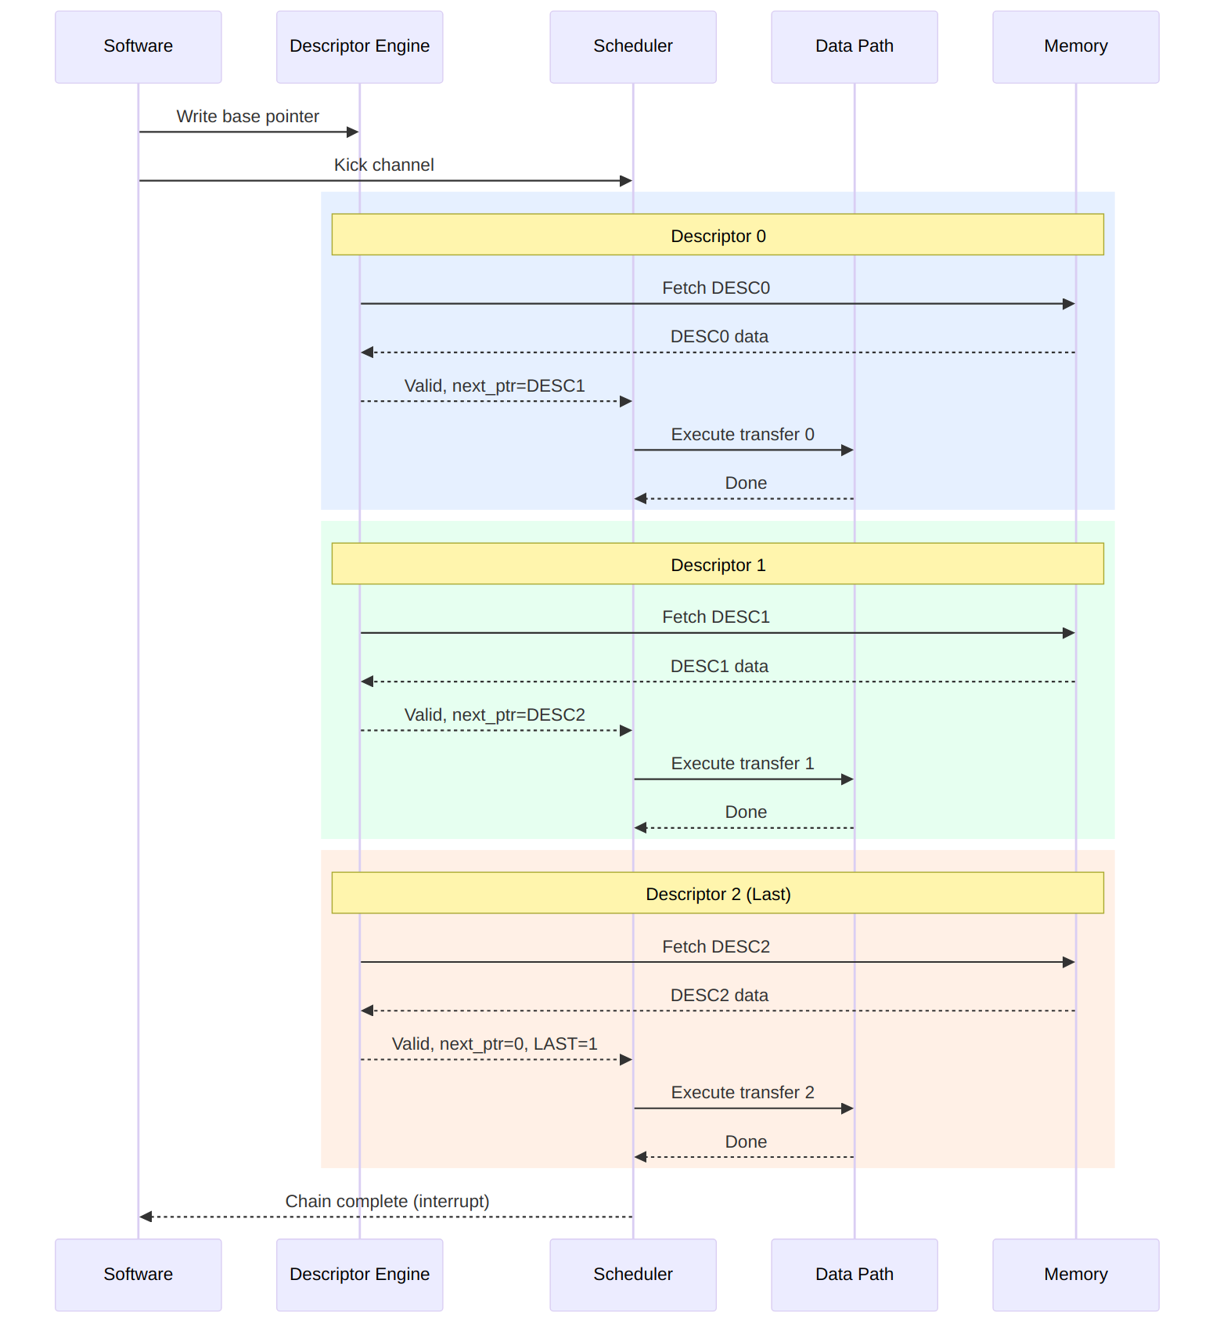
Chain Execution Flow

18.3 Timing Diagram
Chain Execution
Chain Execution
Source: chain_execution.json
Waveform 22

18.4 Descriptor Fields for Chaining

18.4.1 Relevant Fields
Chaining-Related Descriptor Fields
Field | Bits | Description
next_ptr | [191:128] | 64-bit pointer to next descriptor
last | [255] | Last descriptor in chain flag
irq_en | [254] | Generate interrupt on completion

18.4.2 Chain Termination
A chain terminates when ANY of these conditions is true:
- next_ptr == 0 (null pointer)
- last == 1 (explicit last flag)
- Error during transfer
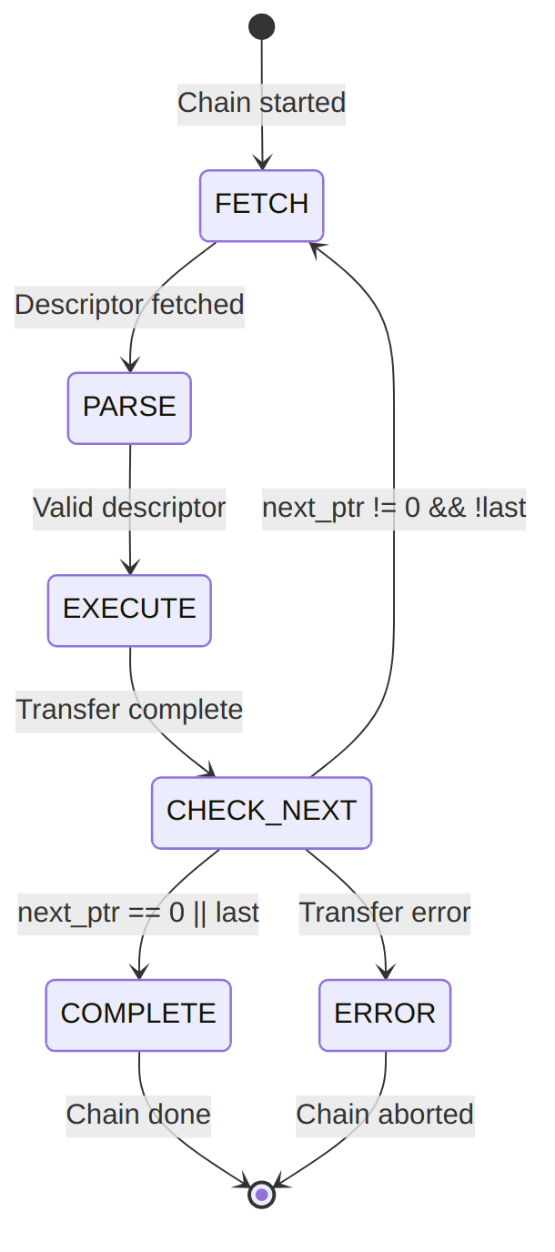
Diagram 20

18.5 Prefetch Optimization

18.5.1 Descriptor Prefetching
RAPIDS can prefetch the next descriptor while the current transfer executes:
Waveform 23
Benefit: Zero-cycle gap between chained transfers when prefetch completes before current transfer.

18.6 Multi-Channel Chaining
Each channel maintains independent chains:
Diagram 21
Channels execute their chains concurrently and independently.

18.7 Error During Chain

18.7.1 Error Handling
When an error occurs mid-chain:
Waveform 24
Error Response: 1. Current transfer aborts 2. Chain processing stops 3. Error status captures failing descriptor index 4. MonBus reports error event 5. Interrupt generated (if enabled)

18.7.2 Recovery
Software must: 1. Read error status to identify failing descriptor 2. Fix the issue (descriptor content, memory mapping, etc.) 3. Restart chain from failing descriptor or beginning

19 Use Case: Multi-Channel Operation

19.1 Overview
RAPIDS Beats supports 8 independent DMA channels that can operate concurrently. This enables parallel data transfers for multiple network connections, priority-based scheduling, and efficient resource utilization.

19.2 Channel Independence
Multi-Channel Architecture
Multi-Channel Architecture
Source: 12_multi_channel.mmd
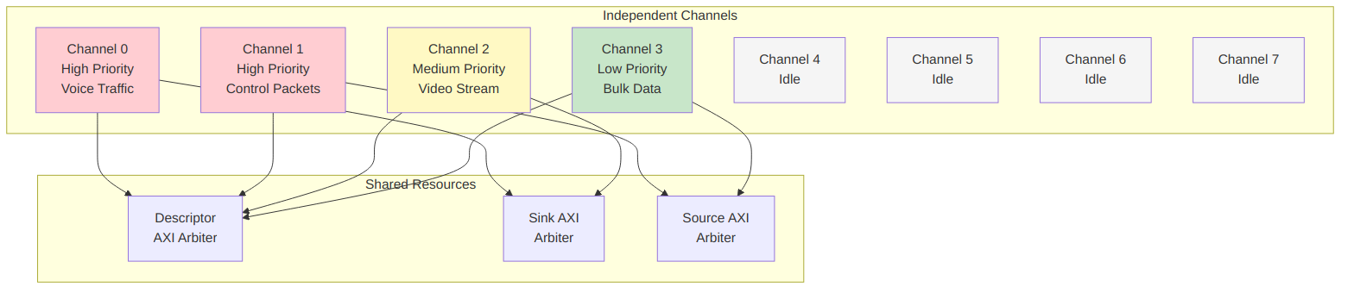
Diagram 22

19.3 Concurrent Operation Timing
Multi-Channel Timing
Multi-Channel Timing
Source: multi_channel_timing.json
Waveform 25

19.4 Resource Arbitration

19.4.1 Descriptor Port Arbitration
All channels share a single AXI port for descriptor fetches:
Waveform 26

19.4.2 Sink/Source Arbitration
Data path AXI ports use round-robin arbitration with optional priority:
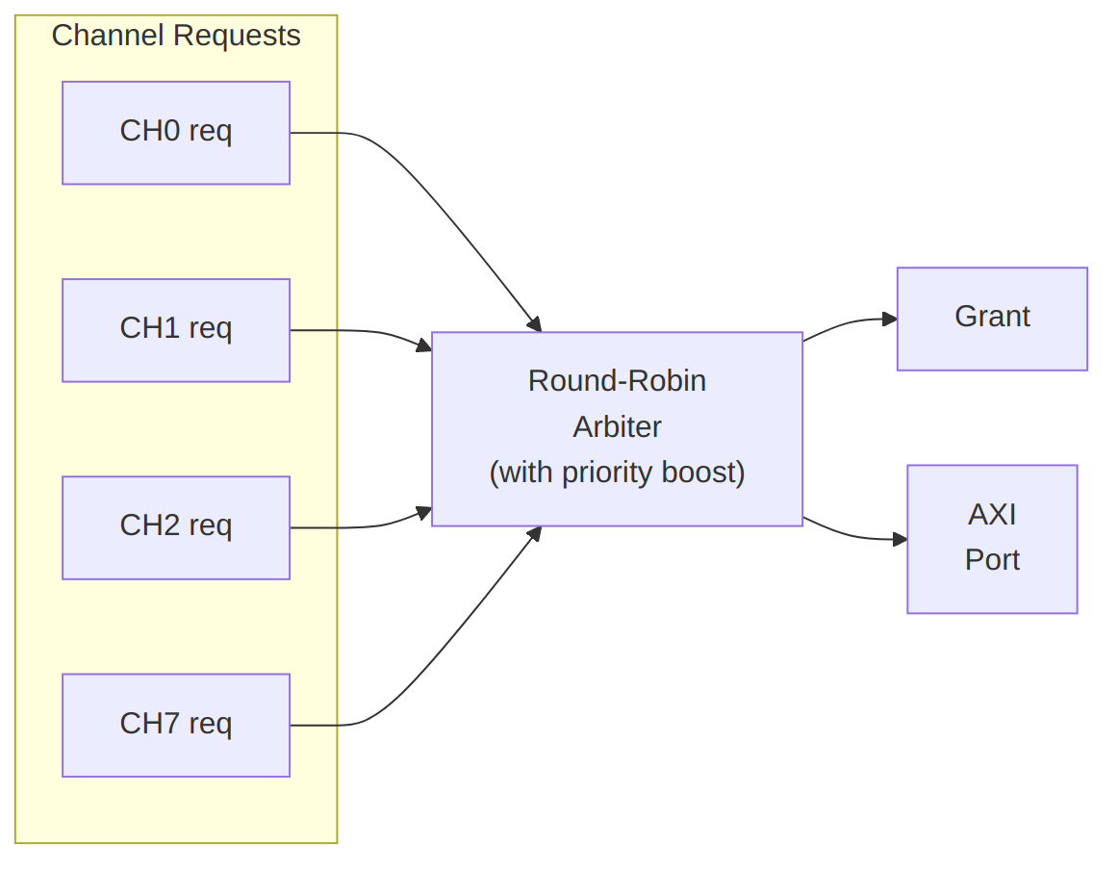
Diagram 23

19.5 Channel Isolation

19.5.1 Error Isolation
Errors in one channel do not affect other channels:
Waveform 27

19.5.2 Per-Channel Soft Reset
Individual channels can be reset without affecting others:
Waveform 28

19.6 Use Case Examples

19.6.1 Mixed Traffic Pattern
Typical network application with different traffic types:
Mixed Traffic Channel Assignment
Channel | Traffic Type | Direction | Priority | Notes
0 | Voice/RTP | Sink | High | Low latency required
1 | Voice/RTP | Source | High | Low latency required
2 | Video | Sink | Medium | High bandwidth
3 | Control | Source | Medium | Small packets
4-7 | Bulk data | Both | Low | Background transfers

19.6.2 Bidirectional Transfer
Single network connection using paired channels:
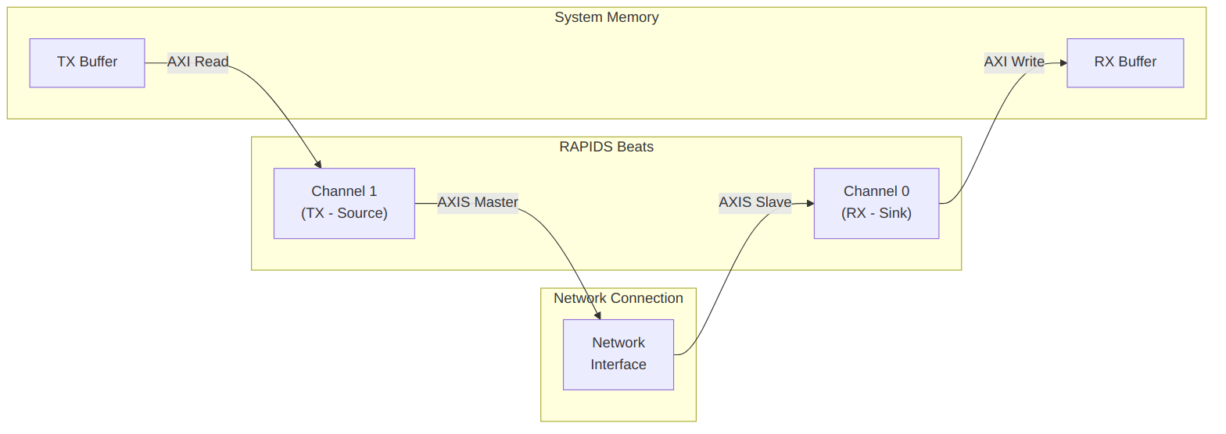
Diagram 24

19.6.3 Load Balancing
Multiple channels processing same traffic type:
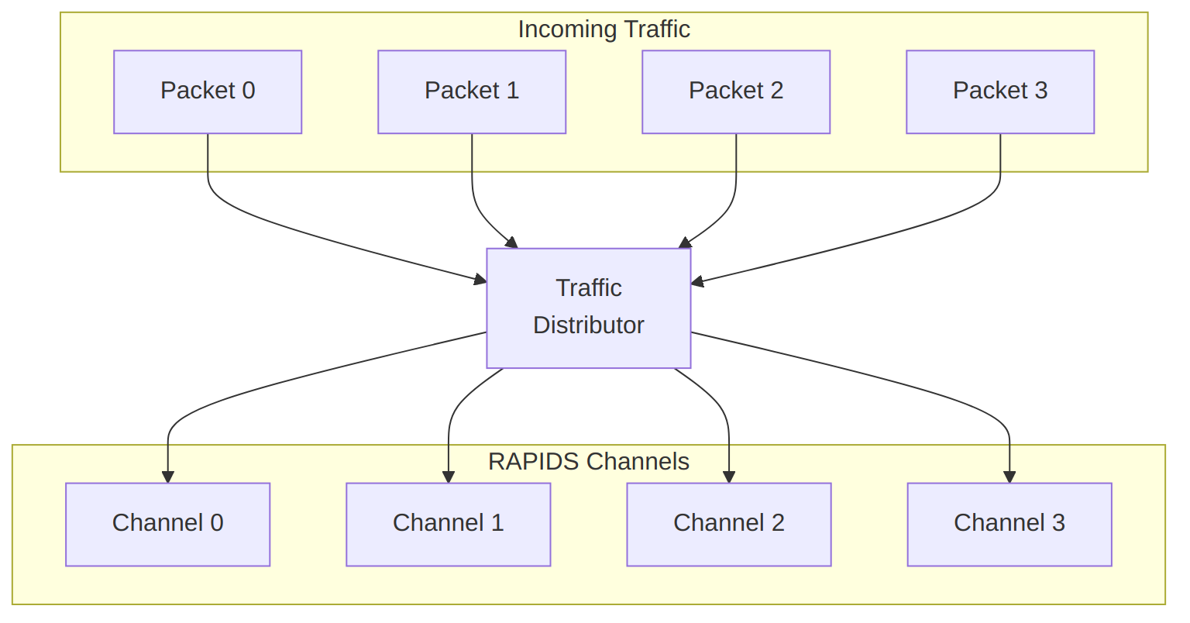
Diagram 25

19.7 Performance Considerations

19.7.1 Bandwidth Sharing
Bandwidth Distribution
Active Channels | Per-Channel BW (% of max) | Notes
1 | 100% | Full bandwidth available
2 | ~50% each | Round-robin sharing
4 | ~25% each | Fair distribution
8 | ~12.5% each | All channels active
Note: Actual distribution depends on transfer sizes and memory latency.

19.7.2 Latency Impact
Multi-channel operation adds arbitration latency:
Arbitration Latency
Scenario | Additional Latency
Single channel | 0 cycles
2 channels contending | 1-2 cycles
8 channels contending | Up to 7 cycles

19.8 MonBus Events
Each channel generates independent MonBus events:
Waveform 29
Events are arbitrated and serialized on the shared MonBus output.

20 Descriptor Format

20.1 Overview
RAPIDS Beats uses 256-bit (32-byte) descriptors to define DMA transfers. Descriptors are stored in system memory and fetched by the Descriptor Engine when a channel is kicked.

20.2 Descriptor Layout
Descriptor Format
Descriptor Format
Source: 13_descriptor_format.mmd

20.2.1 256-Bit Structure
Bit Range Field Name Width Description
────────────────────────────────────────────────────────────────
[255] last 1 Last descriptor in chain
[254] irq_en 1 Generate interrupt on completion
[253:252] reserved 2 Reserved (write 0)
[251:248] direction 4 Transfer direction
[247:240] reserved 8 Reserved (write 0)
[239:224] transfer_length 16 Transfer length in beats
[223:192] reserved 32 Reserved (write 0)
[191:128] next_ptr 64 Pointer to next descriptor
[127:64] dest_addr 64 Destination address (sink) or source address
[63:0] src_addr 64 Source address (source path) or buffer addr
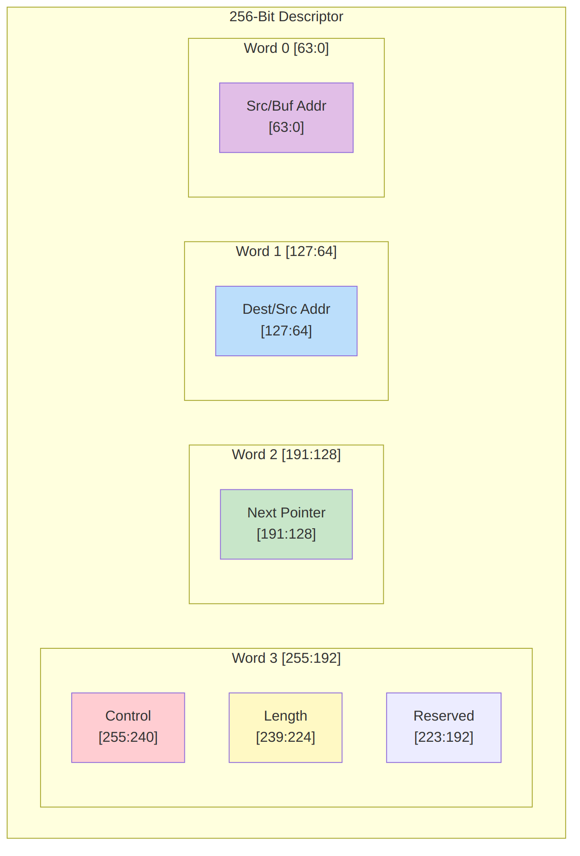
Visual Layout

20.3 Field Descriptions

20.3.1 Control Field [255:248]
Control Field Bits
Bit | Field | Description
255 | last | Set to 1 for last descriptor in chain
254 | irq_en | Set to 1 to generate completion interrupt
253:252 | Reserved | Write as 0
251:248 | direction | Transfer direction encoding

20.3.2 Direction Encoding
Direction Field Encoding
Value | Name | Description
4’h0 | SINK | Network to memory (AXIS slave to AXI write)
4’h1 | SOURCE | Memory to network (AXI read to AXIS master)
4’h2-F | Reserved | Reserved for future use

20.3.3 Transfer Length [239:224]
- 16-bit field specifying transfer size in beats
- 1 beat = DATA_WIDTH bits (default 512 bits = 64 bytes)
- Maximum transfer: 65,535 beats (4 MB at 64 bytes/beat)
- Length of 0 is reserved (no operation)

20.3.4 Next Pointer [191:128]
- 64-bit byte address of next descriptor
- Must be 32-byte aligned (bits [4:0] ignored)
- Value of 0 terminates chain (regardless of last bit)

20.3.5 Address Fields [127:0]
For SINK transfers (network to memory): | Field | Usage | |——-|——-| | dest_addr [127:64] | Memory write destination address | | src_addr [63:0] | Not used (write 0) |
For SOURCE transfers (memory to network): | Field | Usage | |——-|——-| | dest_addr [127:64] | Not used (write 0) | | src_addr [63:0] | Memory read source address |
: Address Field Usage

20.4 Descriptor Fetch Timing
Descriptor Fetch
Descriptor Fetch
Source: descriptor_fetch.json
Waveform 30

20.5 Alignment Requirements
Address Alignment Requirements
Field | Alignment | Notes
Descriptor address | 32-byte | Bits [4:0] ignored
next_ptr | 32-byte | Bits [4:0] ignored
dest_addr | DATA_WIDTH/8 | 64-byte for 512-bit data
src_addr | DATA_WIDTH/8 | 64-byte for 512-bit data
Note: Unaligned addresses may cause unpredictable behavior or AXI protocol violations.

20.6 Descriptor Examples

20.6.1 Sink Descriptor (Network to Memory)
Hex representation (LSB to MSB):
[63:0] = 0x0000_0000_0000_0000 // src_addr (unused)
[127:64] = 0x0000_0001_0000_0000 // dest_addr = 0x1_0000_0000
[191:128] = 0x0000_0000_0000_2000 // next_ptr = 0x2000
[255:192] = 0xC000_0100_0000_0000 // last=1, irq=1, dir=SINK, len=256
Binary control field:
[255] = 1 // Last descriptor
[254] = 1 // Interrupt enabled
[253:252] = 00 // Reserved
[251:248] = 0000 // Direction = SINK

20.6.2 Source Descriptor (Memory to Network)
Hex representation (LSB to MSB):
[63:0] = 0x0000_0002_0000_0000 // src_addr = 0x2_0000_0000
[127:64] = 0x0000_0000_0000_0000 // dest_addr (unused)
[191:128] = 0x0000_0000_0000_0000 // next_ptr = 0 (last)
[255:192] = 0x4001_0080_0000_0000 // last=0, irq=1, dir=SOURCE, len=128
Binary control field:
[255] = 0 // Not last (but next_ptr=0 terminates)
[254] = 1 // Interrupt enabled
[253:252] = 00 // Reserved
[251:248] = 0001 // Direction = SOURCE

20.7 Software Construction

20.7.1 C Structure Example
typedef struct __attribute__((packed, aligned(32))) {
uint64_t src_addr; // [63:0]
uint64_t dest_addr; // [127:64]
uint64_t next_ptr; // [191:128]
uint16_t reserved1; // [207:192]
uint16_t length; // [223:208] - Note: shifted in actual layout
uint8_t reserved2; // [231:224]
uint8_t direction; // [239:232] - lower 4 bits only
uint8_t reserved3; // [247:240]
uint8_t control; // [255:248] - last, irq_en, etc.
} rapids_descriptor_t;
// Helper macros
#define DESC_CTRL_LAST (1 << 7)
#define DESC_CTRL_IRQ_EN (1 << 6)
#define DESC_DIR_SINK 0x0
#define DESC_DIR_SOURCE 0x1

20.7.2 Descriptor Ring Setup
// Allocate descriptor ring (must be 32-byte aligned)
rapids_descriptor_t *desc_ring = aligned_alloc(32, NUM_DESC * sizeof(rapids_descriptor_t));
// Initialize chain
for (int i = 0; i < NUM_DESC - 1; i++) {
desc_ring[i].next_ptr = (uint64_t)&desc_ring[i + 1];
desc_ring[i].control = DESC_CTRL_IRQ_EN;
}
// Last descriptor
desc_ring[NUM_DESC - 1].next_ptr = 0;
desc_ring[NUM_DESC - 1].control = DESC_CTRL_LAST | DESC_CTRL_IRQ_EN;

21 Register Map

21.1 Overview
RAPIDS Beats provides a memory-mapped register interface for configuration and status. Registers are accessed via the APB interface and organized by function.

21.2 Register Summary

21.2.1 Global Registers (Offset 0x000-0x0FF)
Global Registers
Offset | Name | Width | Access | Description
0x000 | VERSION | 32 | RO | IP version register
0x004 | CONFIG | 32 | RO | Configuration parameters
0x008 | GLOBAL_CTRL | 32 | RW | Global control
0x00C | GLOBAL_STATUS | 32 | RO | Global status
0x010 | IRQ_STATUS | 32 | RW1C | Interrupt status
0x014 | IRQ_ENABLE | 32 | RW | Interrupt enable
0x018 | IRQ_FORCE | 32 | WO | Force interrupt (debug)

21.2.2 Per-Channel Registers (Offset 0x100 + ch*0x40)
Per-Channel Registers
Offset | Name | Width | Access | Description
+0x00 | CH_CTRL | 32 | RW | Channel control
+0x04 | CH_STATUS | 32 | RO | Channel status
+0x08 | DESC_PTR_LO | 32 | RW | Descriptor pointer [31:0]
+0x0C | DESC_PTR_HI | 32 | RW | Descriptor pointer [63:32]
+0x10 | XFER_COUNT | 32 | RO | Beats transferred
+0x14 | ERR_STATUS | 32 | RW1C | Error status
+0x18 | CH_CONFIG | 32 | RW | Channel configuration

21.3 Register Descriptions

21.3.1 VERSION (0x000) - Read Only
VERSION Register
Bits | Field | Reset | Description
[31:24] | major | 0x01 | Major version
[23:16] | minor | 0x00 | Minor version
[15:0] | patch | 0x0000 | Patch level

21.3.2 CONFIG (0x004) - Read Only
CONFIG Register
Bits | Field | Reset | Description
[31:24] | num_channels | 0x08 | Number of channels
[23:16] | data_width | 0x40 | Data width / 8 (64 = 512-bit)
[15:8] | sram_depth | varies | SRAM depth / 16
[7:0] | features | varies | Feature bits

21.3.3 GLOBAL_CTRL (0x008) - Read/Write
GLOBAL_CTRL Register
Bits | Field | Reset | Description
[31] | soft_reset | 0 | Write 1 to reset all channels
[30:8] | Reserved | 0 | Reserved
[7:0] | clock_gate_en | 0xFF | Per-channel clock gate enable

21.3.4 GLOBAL_STATUS (0x00C) - Read Only
GLOBAL_STATUS Register
Bits | Field | Reset | Description
[31:24] | Reserved | 0 | Reserved
[23:16] | error_channels | 0 | Channels with errors
[15:8] | active_channels | 0 | Channels in transfer
[7:0] | idle_channels | 0xFF | Channels idle

21.3.5 IRQ_STATUS (0x010) - Read/Write-1-to-Clear
IRQ_STATUS Register
Bits | Field | Reset | Description
[31:24] | ch_error | 0 | Channel error interrupts
[23:16] | Reserved | 0 | Reserved
[15:8] | ch_complete | 0 | Channel completion interrupts
[7:0] | Reserved | 0 | Reserved

21.3.6 CH_CTRL (0x100 + ch*0x40) - Read/Write
CH_CTRL Register
Bits | Field | Reset | Description
[31] | enable | 0 | Channel enable
[30] | kick | 0 | Write 1 to start (self-clearing)
[29] | abort | 0 | Write 1 to abort (self-clearing)
[28] | soft_reset | 0 | Write 1 to reset channel
[27:0] | Reserved | 0 | Reserved

21.3.7 CH_STATUS (0x104 + ch*0x40) - Read Only
CH_STATUS Register
Bits | Field | Reset | Description
[31:28] | state | 0 | FSM state encoding
[27:24] | Reserved | 0 | Reserved
[23:16] | desc_count | 0 | Descriptors processed
[15:8] | sram_level | 0 | Current SRAM fill level
[7:0] | flags | 0 | Status flags
State Encoding:
CH_STATUS State Encoding
Value | State
0x0 | IDLE
0x1 | WAIT_DESC
0x2 | PARSE_DESC
0x3 | XFER_DATA
0x4 | CHECK_NEXT
0x5 | COMPLETE
0xE | ERROR
0xF | RESET

21.3.8 ERR_STATUS (0x114 + ch*0x40) - Read/Write-1-to-Clear
ERR_STATUS Register
Bits | Field | Reset | Description
[31:28] | axi_resp | 0 | AXI error response code
[27:24] | error_type | 0 | Error type encoding
[23:16] | error_desc_idx | 0 | Descriptor index at error
[15:0] | Reserved | 0 | Reserved

21.4 Register Access Timing
Register Read
Register Read
Source: register_read.json
Waveform 31
Register Write
Register Write
Source: register_write.json
Waveform 32

21.5 Channel Kick Sequence
Writing to the kick bit triggers descriptor processing:
Waveform 33

21.6 Address Decoding

21.6.1 Address Space Layout
0x000 - 0x0FF: Global registers
0x100 - 0x13F: Channel 0 registers
0x140 - 0x17F: Channel 1 registers
0x180 - 0x1BF: Channel 2 registers
0x1C0 - 0x1FF: Channel 3 registers
0x200 - 0x23F: Channel 4 registers
0x240 - 0x27F: Channel 5 registers
0x280 - 0x2BF: Channel 6 registers
0x2C0 - 0x2FF: Channel 7 registers
0x300 - 0x3FF: Reserved

21.6.2 Channel Address Formula
channel_base = 0x100 + (channel_number * 0x40)
register_addr = channel_base + register_offset
Example: Channel 3 CH_STATUS = 0x100 + (3 * 0x40) + 0x04 = 0x1C4

22 Initialization Sequence

22.1 Overview
This section describes the required steps to initialize RAPIDS Beats and start DMA transfers. The initialization sequence ensures proper hardware state before beginning operations.

22.2 Boot Sequence
Initialization Flow
Initialization Flow
Source: 14_init_flow.mmd
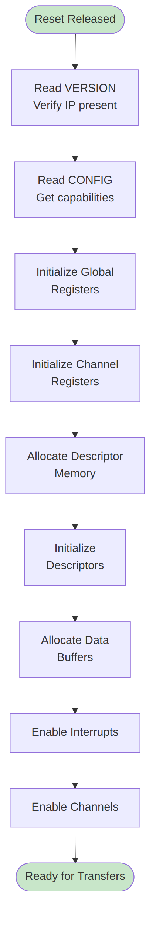
Diagram 27

22.3 Detailed Steps

22.3.1 Step 1: Verify Hardware Presence
// Read VERSION register
uint32_t version = read_reg(RAPIDS_BASE + VERSION);
uint8_t major = (version >> 24) & 0xFF;
uint8_t minor = (version >> 16) & 0xFF;
if (major < 1) {
printf("ERROR: RAPIDS not detected or incompatible version\n");
return -1;
}
printf("RAPIDS Beats v%d.%d detected\n", major, minor);

22.3.2 Step 2: Read Configuration
// Read CONFIG register
uint32_t config = read_reg(RAPIDS_BASE + CONFIG);
uint8_t num_channels = (config >> 24) & 0xFF;
uint8_t data_width = ((config >> 16) & 0xFF) * 8; // Convert to bits
uint8_t sram_depth = ((config >> 8) & 0xFF) * 16;
printf("Channels: %d, Data Width: %d bits, SRAM: %d entries\n",
num_channels, data_width, sram_depth);

22.3.3 Step 3: Global Reset
// Perform soft reset to ensure clean state
write_reg(RAPIDS_BASE + GLOBAL_CTRL, GLOBAL_CTRL_SOFT_RESET);
// Wait for reset completion
while (read_reg(RAPIDS_BASE + GLOBAL_STATUS) & GLOBAL_STATUS_RESET_ACTIVE) {
// Poll until reset complete
}
// Clear any pending interrupts
write_reg(RAPIDS_BASE + IRQ_STATUS, 0xFFFFFFFF);

22.3.4 Step 4: Allocate Resources
// Allocate descriptor ring (must be 32-byte aligned)
size_t desc_size = NUM_DESCRIPTORS * sizeof(rapids_descriptor_t);
rapids_descriptor_t *desc_ring = aligned_alloc(32, desc_size);
if (!desc_ring) {
return -ENOMEM;
}
// Allocate data buffers (must be 64-byte aligned for 512-bit AXI)
size_t buf_size = BUFFER_SIZE_BYTES;
void *rx_buffer = aligned_alloc(64, buf_size);
void *tx_buffer = aligned_alloc(64, buf_size);

22.3.5 Step 5: Initialize Descriptors
// Initialize sink descriptor chain
for (int i = 0; i < NUM_RX_DESC - 1; i++) {
desc_ring[i].dest_addr = (uint64_t)(rx_buffer + i * FRAME_SIZE);
desc_ring[i].src_addr = 0;
desc_ring[i].next_ptr = (uint64_t)&desc_ring[i + 1];
desc_ring[i].direction = DESC_DIR_SINK;
desc_ring[i].length = FRAME_SIZE / 64; // Convert to beats
desc_ring[i].control = DESC_CTRL_IRQ_EN;
}
// Last descriptor
desc_ring[NUM_RX_DESC - 1].dest_addr = (uint64_t)(rx_buffer + (NUM_RX_DESC-1) * FRAME_SIZE);
desc_ring[NUM_RX_DESC - 1].next_ptr = 0;
desc_ring[NUM_RX_DESC - 1].control = DESC_CTRL_LAST | DESC_CTRL_IRQ_EN;
// Ensure descriptors are visible to hardware
__sync_synchronize(); // Memory barrier

22.3.6 Step 6: Configure Channels
// Configure channel 0 for sink (receive)
uint32_t ch0_base = RAPIDS_BASE + 0x100;
// Set descriptor pointer
write_reg(ch0_base + DESC_PTR_LO, (uint32_t)((uint64_t)desc_ring & 0xFFFFFFFF));
write_reg(ch0_base + DESC_PTR_HI, (uint32_t)((uint64_t)desc_ring >> 32));
// Configure channel
write_reg(ch0_base + CH_CONFIG, CH_CONFIG_DEFAULT);

22.3.7 Step 7: Enable Interrupts
// Enable completion and error interrupts for channel 0
write_reg(RAPIDS_BASE + IRQ_ENABLE, IRQ_CH0_COMPLETE | IRQ_CH0_ERROR);

22.3.8 Step 8: Enable Channel
// Enable channel (but don't kick yet)
write_reg(ch0_base + CH_CTRL, CH_CTRL_ENABLE);

22.4 Initialization Timing
Initialization Timing
Initialization Timing
Source: init_timing.json
Waveform 34

22.5 Starting Transfers

22.5.1 Kick a Channel
After initialization, kick the channel to start processing:
// Kick channel 0 to start descriptor processing
write_reg(ch0_base + CH_CTRL, CH_CTRL_ENABLE | CH_CTRL_KICK);
Kick Timing
Kick Timing
Waveform 35

22.6 Interrupt Handling

22.6.1 Completion Interrupt
void rapids_irq_handler(void) {
uint32_t irq_status = read_reg(RAPIDS_BASE + IRQ_STATUS);
// Handle channel 0 completion
if (irq_status & IRQ_CH0_COMPLETE) {
// Read channel status
uint32_t ch_status = read_reg(ch0_base + CH_STATUS);
uint8_t desc_count = (ch_status >> 16) & 0xFF;
// Process completed buffers
process_rx_buffers(desc_count);
// Clear interrupt
write_reg(RAPIDS_BASE + IRQ_STATUS, IRQ_CH0_COMPLETE);
// Re-kick channel for continuous operation (if desired)
write_reg(ch0_base + CH_CTRL, CH_CTRL_ENABLE | CH_CTRL_KICK);
}
// Handle errors
if (irq_status & IRQ_CH0_ERROR) {
uint32_t err_status = read_reg(ch0_base + ERR_STATUS);
handle_error(err_status);
// Clear error interrupt
write_reg(RAPIDS_BASE + IRQ_STATUS, IRQ_CH0_ERROR);
}
}

22.7 Reset and Recovery

22.7.1 Per-Channel Reset
void reset_channel(int channel) {
uint32_t ch_base = RAPIDS_BASE + 0x100 + (channel * 0x40);
// Soft reset the channel
write_reg(ch_base + CH_CTRL, CH_CTRL_SOFT_RESET);
// Wait for reset complete
while ((read_reg(ch_base + CH_STATUS) >> 28) == 0xF) {
// State = RESET
}
// Clear error status
write_reg(ch_base + ERR_STATUS, 0xFFFFFFFF);
// Re-initialize descriptor pointer
write_reg(ch_base + DESC_PTR_LO, saved_desc_ptr_lo[channel]);
write_reg(ch_base + DESC_PTR_HI, saved_desc_ptr_hi[channel]);
// Re-enable
write_reg(ch_base + CH_CTRL, CH_CTRL_ENABLE);
}

22.7.2 Global Reset
void reset_rapids(void) {
// Disable all interrupts
write_reg(RAPIDS_BASE + IRQ_ENABLE, 0);
// Global soft reset
write_reg(RAPIDS_BASE + GLOBAL_CTRL, GLOBAL_CTRL_SOFT_RESET);
// Wait for all channels idle
while (read_reg(RAPIDS_BASE + GLOBAL_STATUS) & 0x00FF0000) {
// Wait for active channels to clear
}
// Clear all interrupts
write_reg(RAPIDS_BASE + IRQ_STATUS, 0xFFFFFFFF);
// Re-run full initialization
rapids_init();
}

23 Error Handling

23.1 Overview
RAPIDS Beats implements comprehensive error detection and reporting. This section describes error types, detection mechanisms, and recommended recovery procedures.

23.2 Error Categories
Error Hierarchy
Error Hierarchy
Source: 15_error_hierarchy.mmd
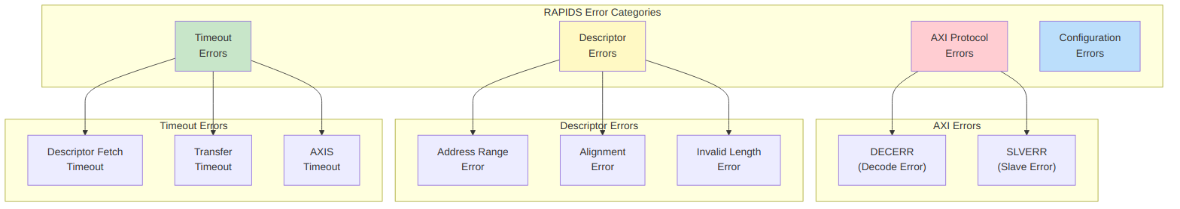
Diagram 28

23.3 Error Detection

23.3.1 AXI Response Errors
RAPIDS monitors all AXI transactions for error responses:
AXI Response Codes
Response | Code | Description | Typical Cause
OKAY | 2’b00 | Normal success | –
EXOKAY | 2’b01 | Exclusive OK | –
SLVERR | 2’b10 | Slave error | Memory protection, invalid access
DECERR | 2’b11 | Decode error | Address not mapped
AXI Error Detection
AXI Error Detection
Source: axi_error.json
Waveform 36

23.3.2 Descriptor Validation Errors
Descriptors are validated when parsed:
Descriptor Validation Errors
Check | Error Condition | ERR_STATUS Code
Address range | Address outside configured range | 0x10
Alignment | Address not properly aligned | 0x11
Length | Length = 0 or > max allowed | 0x12
Direction | Invalid direction code | 0x13
Waveform 37

23.3.3 Timeout Detection
RAPIDS implements watchdog timers for detecting stalled operations:
Timeout Thresholds
Timeout Type | Typical Value | Condition
Descriptor fetch | 1024 cycles | No AXI response
Transfer | 65536 cycles | No progress
AXIS receive | 4096 cycles | TVALID stuck low
AXIS transmit | 4096 cycles | TREADY stuck low
Waveform 38

23.4 Error Reporting

23.4.1 ERR_STATUS Register
When an error occurs, details are captured in the ERR_STATUS register:
ERR_STATUS [31:0]:
[31:28] - AXI response code (BRESP or RRESP)
[27:24] - Error type:
0x0 = AXI write error
0x1 = AXI read error
0x2 = Descriptor fetch error
0x3 = Descriptor validation error
0x4 = Timeout error
[23:16] - Descriptor index when error occurred
[15:0] - Reserved

23.4.2 MonBus Error Events
Errors generate MonBus packets for system-wide visibility:
Waveform 39

23.4.3 Interrupt Generation
Error interrupts are generated when enabled:
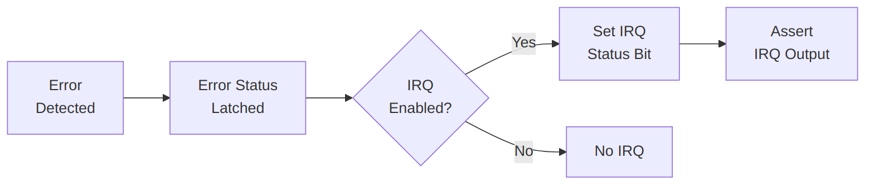
Diagram 29

23.5 Error Recovery

23.5.1 Recovery Flow
Error Recovery
Error Recovery
Source: 16_error_recovery.mmd
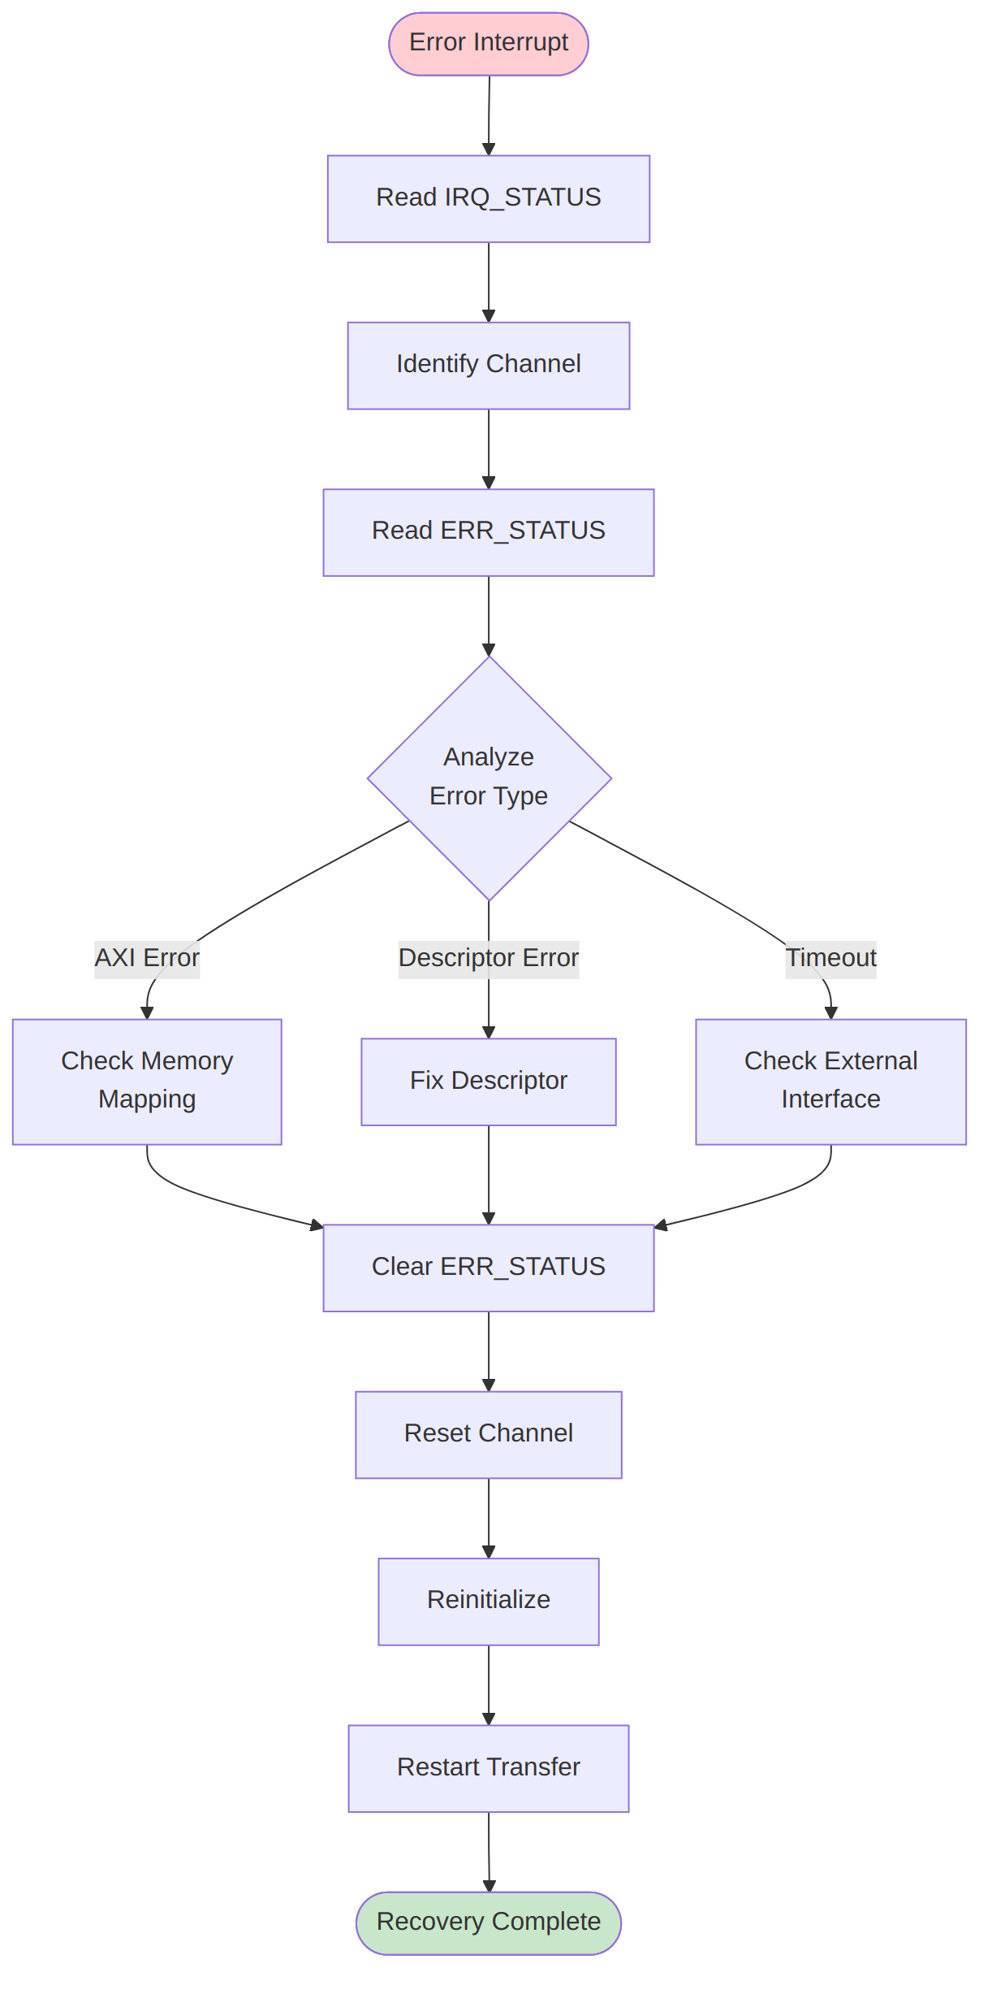
Diagram 30

23.5.2 AXI Error Recovery
void handle_axi_error(int channel) {
uint32_t ch_base = RAPIDS_BASE + 0x100 + (channel * 0x40);
uint32_t err_status = read_reg(ch_base + ERR_STATUS);
uint8_t axi_resp = (err_status >> 28) & 0xF;
uint8_t err_type = (err_status >> 24) & 0xF;
uint8_t desc_idx = (err_status >> 16) & 0xFF;
if (axi_resp == 0x3) { // DECERR
printf("CH%d: Address decode error at descriptor %d\n", channel, desc_idx);
// Check memory mapping, descriptor addresses
} else if (axi_resp == 0x2) { // SLVERR
printf("CH%d: Slave error at descriptor %d\n", channel, desc_idx);
// Check memory protection, peripheral status
}
// Clear error and reset channel
write_reg(ch_base + ERR_STATUS, 0xFFFFFFFF);
reset_channel(channel);
}

23.5.3 Descriptor Error Recovery
void handle_desc_error(int channel) {
uint32_t ch_base = RAPIDS_BASE + 0x100 + (channel * 0x40);
uint32_t err_status = read_reg(ch_base + ERR_STATUS);
uint8_t err_type = (err_status >> 24) & 0xF;
uint8_t desc_idx = (err_status >> 16) & 0xFF;
switch (err_type & 0xF) {
case 0x0: // Address range
printf("CH%d: Descriptor %d has invalid address\n", channel, desc_idx);
fix_descriptor_address(channel, desc_idx);
break;
case 0x1: // Alignment
printf("CH%d: Descriptor %d has alignment issue\n", channel, desc_idx);
fix_descriptor_alignment(channel, desc_idx);
break;
case 0x2: // Length
printf("CH%d: Descriptor %d has invalid length\n", channel, desc_idx);
fix_descriptor_length(channel, desc_idx);
break;
}
// Clear and restart from fixed descriptor
write_reg(ch_base + ERR_STATUS, 0xFFFFFFFF);
write_reg(ch_base + DESC_PTR_LO, (uint32_t)&desc_ring[desc_idx]);
write_reg(ch_base + DESC_PTR_HI, (uint32_t)((uint64_t)&desc_ring[desc_idx] >> 32));
reset_channel(channel);
}

23.5.4 Timeout Recovery
void handle_timeout(int channel) {
uint32_t ch_base = RAPIDS_BASE + 0x100 + (channel * 0x40);
uint32_t err_status = read_reg(ch_base + ERR_STATUS);
uint32_t ch_status = read_reg(ch_base + CH_STATUS);
uint8_t desc_idx = (err_status >> 16) & 0xFF;
uint8_t sram_level = (ch_status >> 8) & 0xFF;
printf("CH%d: Timeout at descriptor %d, SRAM level %d\n",
channel, desc_idx, sram_level);
// Check external interfaces
if (sram_level == 0) {
printf(" SRAM empty - check network input\n");
} else if (sram_level > 0) {
printf(" SRAM has data - check memory interface\n");
}
// Abort and reset
write_reg(ch_base + CH_CTRL, CH_CTRL_ABORT);
while ((read_reg(ch_base + CH_STATUS) >> 28) != 0x0) {
// Wait for IDLE
}
write_reg(ch_base + ERR_STATUS, 0xFFFFFFFF);
reset_channel(channel);
}

23.6 Error Prevention

23.6.1 Best Practices
Error Prevention Best Practices
Practice | Rationale
Validate descriptors before submission | Catch errors before hardware processing
Use aligned addresses | Avoid alignment errors
Set reasonable timeouts | Detect issues without false positives
Monitor SRAM levels | Identify flow control issues
Enable MonBus | System-wide error visibility

23.6.2 Descriptor Validation Example
int validate_descriptor(rapids_descriptor_t *desc) {
// Check alignment
if (desc->dest_addr & 0x3F) { // 64-byte alignment
return ERR_ALIGNMENT;
}
// Check length
if (desc->length == 0 || desc->length > MAX_BEATS) {
return ERR_LENGTH;
}
// Check direction
if (desc->direction > DESC_DIR_SOURCE) {
return ERR_DIRECTION;
}
// Check address range
if (desc->dest_addr < VALID_ADDR_MIN || desc->dest_addr > VALID_ADDR_MAX) {
return ERR_ADDRESS;
}
return 0; // Valid
}

RTL Design Sherpa · Learning Hardware Design Through Practice GitHub · Documentation Index · MIT License

24 RAPIDS Beats Architecture MAS
Version: 0.25 Date: 2025-01-10 Purpose: Module Architecture Specification for RAPIDS Phase 1 “Beats” Architecture

24.1 Document Organization
Note: All chapters linked below for automated document generation.

24.1.1 Front Matter
- Document Information

24.1.2 Chapter 1: Overview
- Architecture Overview
- Top-Level Port List
- Clocks and Reset

24.1.3 Chapter 2: FUB (Functional Unit Blocks)
Control Path: - Scheduler - Descriptor Engine
AXI Engines: - AXI Read Engine - AXI Write Engine
Flow Control: - Beats Alloc Control - Beats Drain Control - Beats Latency Bridge

24.1.4 Chapter 3: Macro (Integration Blocks)
Scheduler Integration: - Beats Scheduler Group - Beats Scheduler Group Array
Sink Data Path (Network to Memory): - Sink Data Path - Sink Data Path AXIS - Sink SRAM Controller - Sink SRAM Controller Unit
Source Data Path (Memory to Network): - Source Data Path - Source Data Path AXIS - Source SRAM Controller - Source SRAM Controller Unit
Top-Level Integration: - RAPIDS Core Beats

24.1.5 Chapter 4: Interfaces
- Interface Overview
- AXI4 Interface Specification
- AXIS Interface Specification
- MonBus Interface Specification

24.2 Quick Reference

24.2.1 FUB Modules (fub_beats/)
FUB Module Summary
Module | File | Purpose | Status
scheduler | scheduler.sv | Transfer coordinator, descriptor processing | Implemented
descriptor_engine | descriptor_engine.sv | Descriptor fetch/parse (256-bit) | Implemented
axi_read_engine | axi_read_engine.sv | AXI read master, streaming pipeline | Implemented
axi_write_engine | axi_write_engine.sv | AXI write master, streaming pipeline | Implemented
beats_alloc_ctrl | beats_alloc_ctrl.sv | Space allocation tracking (virtual FIFO) | Implemented
beats_drain_ctrl | beats_drain_ctrl.sv | Data availability tracking (virtual FIFO) | Implemented
beats_latency_bridge | beats_latency_bridge.sv | Latency compensation, backpressure management | Implemented

24.2.2 Macro Modules (macro_beats/)
Macro Module Summary
Module | File | Purpose | Status
beats_scheduler_group | beats_scheduler_group.sv | Scheduler + Descriptor Engine wrapper | Implemented
beats_scheduler_group_array | beats_scheduler_group_array.sv | 8-channel scheduler array with arbitration | Implemented
sink_data_path | sink_data_path.sv | Network-to-memory path integration | Implemented
sink_data_path_axis | sink_data_path_axis.sv | AXIS variant of sink path | Implemented
source_data_path | source_data_path.sv | Memory-to-network path integration | Implemented
source_data_path_axis | source_data_path_axis.sv | AXIS variant of source path | Implemented
snk_sram_controller | snk_sram_controller.sv | Sink SRAM buffer management | Implemented
snk_sram_controller_unit | snk_sram_controller_unit.sv | Per-channel sink SRAM unit | Implemented
src_sram_controller | src_sram_controller.sv | Source SRAM buffer management | Implemented
src_sram_controller_unit | src_sram_controller_unit.sv | Per-channel source SRAM unit | Implemented
rapids_core_beats | rapids_core_beats.sv | Top-level RAPIDS integration | Implemented

24.3 Architecture Comparison: RAPIDS vs STREAM
The “beats” architecture is a Phase 1 implementation of RAPIDS that shares concepts with STREAM but targets network-to-memory (and vice versa) transfers rather than memory-to-memory.
RAPIDS Beats vs STREAM Comparison
Feature | STREAM | RAPIDS Beats
Primary Use | Memory-to-memory DMA | Network-to-memory accelerator
Data Paths | Single bidirectional | Separate sink/source paths
Network Interface | None | AXIS master/slave
SRAM Buffering | Shared buffer | Separate sink/source buffers
Descriptor Format | 256-bit | 256-bit (compatible)
Channel Count | 8 | 8
Flow Control | alloc_ctrl/drain_ctrl | beats_alloc_ctrl/beats_drain_ctrl

24.4 Clock and Reset Summary

24.4.1 Clock Domains
Clock Domains
Clock | Frequency | Usage
aclk | 100-500 MHz | Primary - all RAPIDS logic, AXI/AXIS interfaces

24.4.2 Reset Signals
Reset Signals
Reset | Polarity | Type | Usage
aresetn | Active-low | Async assert, sync deassert | Primary - all RAPIDS logic
See: Clocks and Reset for complete timing specifications

24.5 Interface Summary

24.5.1 External Interfaces
External Interfaces
Interface | Type | Width | Purpose
AXI4 (Descriptor) | Master | 256-bit | Descriptor fetch
AXI4 (Sink Write) | Master | 512-bit (param) | Sink data write to memory
AXI4 (Source Read) | Master | 512-bit (param) | Source data read from memory
AXIS (Sink) | Slave | 512-bit (param) | Network data ingress
AXIS (Source) | Master | 512-bit (param) | Network data egress
MonBus | Master | 64-bit | Monitor packet output

24.5.2 Internal Buses
Internal Buses
Interface | Width | Purpose
MonBus | 64-bit | Internal monitoring bus
Descriptor Bus | 256-bit | Descriptor distribution
SRAM Data Bus | 512-bit | SRAM read/write data

24.6 Related Documentation
- PRD.md - Product requirements and overview
- CLAUDE.md - AI development guide
- RAPIDS Spec - Original RAPIDS specification

24.7 Specification Conventions

24.7.1 Signal Naming
- Clock: aclk
- Reset: aresetn (active-low)
- Valid/Ready: Standard AXI/AXIS handshake
- Registers: r_ prefix (e.g., r_state, r_counter)
- Wires: w_ prefix (e.g., w_next_state, w_grant)

24.7.2 Parameter Naming
- Uppercase: NUM_CHANNELS, DATA_WIDTH, ADDR_WIDTH
- Derived: CHAN_WIDTH = $clog2(NUM_CHANNELS)

24.7.3 Figure and Table Numbering
- Figures: Figure X.Y.Z: Title where X=chapter, Y=section, Z=figure number
- Tables: Caption line : Table Title after table markdown

Last Updated: 2025-01-10 Maintained By: RAPIDS Architecture Team

RTL Design Sherpa · Learning Hardware Design Through Practice GitHub · Documentation Index · MIT License

25 Product Requirements Document (PRD)

25.1 RAPIDS - Rapid AXI Programmable In-band Descriptor System
Version: 1.0 Date: 2025-09-30 Status: Active Development - Validation in Progress Owner: RTL Design Sherpa Project Parent Document: /PRD.md

25.2 1. Executive Summary
The Rapid AXI Programmable In-band Descriptor System (RAPIDS) is a custom hardware accelerator designed for efficient memory-to-memory data movement with network interface integration. It demonstrates complex FSM coordination, descriptor-based DMA operations, and comprehensive monitoring capabilities.

25.2.1 1.1 Quick Stats
- Modules: 17 SystemVerilog files
- Architecture: 3 major blocks (Scheduler, Sink, Source)
- Interfaces: AXI4 (memory), Network (network), AXIL4 (control), MonBus (monitoring)
- Test Coverage: ~80% functional (basic scenarios validated)
- Status: Active validation, known issues documented

25.2.2 1.2 Subsystem Goals
- Primary: Demonstrate complex accelerator design patterns
- Secondary: Provide DMA-style memory transfer capability
- Tertiary: Educational reference for descriptor-based engines

25.3 2. Documentation Structure
This PRD provides a high-level overview. Detailed specifications are maintained separately:

25.3.1 📚 Complete RAPIDS Specification
Location: projects/components/rapids/docs/rapids_spec/
- Index - Complete specification structure

25.3.1.1 Chapter 1: Overview
- Overview
- Architecture Requirements
- Clocking and Reset
- Acronyms
- References

25.3.1.2 Chapter 2: Block Specifications
- Blocks Overview
Scheduler Group: - Scheduler Group - Scheduler - Task management FSM - Descriptor Engine - Descriptor parsing - Program Engine - Program sequencing
Sink Data Path (Network → Memory): - Sink Data Path - Network Slave - Network ingress - Sink SRAM Control - Buffer management - Sink AXI Write Engine - Memory writes
Source Data Path (Memory → Network): - Source Data Path - Network Master - Network egress - Source SRAM Control - Buffer management - Source AXI Read Engine - Memory reads
Monitoring: - MonBus AXIL Group - Control/status - FSM Summary - State machine overview

25.3.1.3 Chapter 3: Interfaces
- Top-Level Ports
- AXIL4 Interface
- AXI4 Interface
- Network Interface
- MonBus Interface

25.3.1.4 Chapter 4 & 5: Programming
- Programming Model
- Register Definitions

25.3.2 🐛 Known Issues
Location: projects/components/rapids/known_issues/
- Scheduler - Credit counter initialization bug
- Sink Data Path - Minor issues
- Sink SRAM Control - Edge cases

25.3.3 📖 Other Documentation
- README - Quick start and integration guide
- CLAUDE - AI assistance guide for this subsystem
- TASKS - Current work items (to be created)
- Validation Report - Test results

25.4 2.4 Organizational Standards - RAPIDS Code Location
⚠ MANDATORY: All RAPIDS-specific code must be in the project area ⚠

25.4.1 Code Organization Principle
“All RAPIDS-specific verification code MUST reside in projects/components/rapids/dv/ for easy discovery.”
This subsystem follows the repository-wide organizational standard (see /PRD.md Section 2.3) requiring all project-specific code to be located in the project area, NOT the framework area.

25.4.2 RAPIDS Directory Structure
projects/components/rapids/
├── rtl/ # RTL source code
│ ├── includes/ # RAPIDS packages (rapids_pkg.sv)
│ ├── rapids_fub/ # Functional unit blocks
│ └── rapids_macro/ # Top-level integration
│
└── dv/ # Design verification (all RAPIDS-specific)
├── tbclasses/ # ★ RAPIDS TB classes HERE (not framework!)
│ ├── scheduler_tb.py # Scheduler testbench class
│ ├── descriptor_engine_tb.py
│ ├── program_engine_tb.py
│ └── rapids_integration_tb.py
│
├── components/ # ★ RAPIDS-specific BFMs
│ └── (project-specific components if needed)
│
├── scoreboards/ # ★ RAPIDS-specific scoreboards
│ └── (verification scoreboards)
│
└── tests/ # Test runners (import TB classes)
├── fub_tests/ # Functional unit block tests
│ ├── scheduler/
│ │ └── test_scheduler.py
│ ├── descriptor_engine/
│ └── program_engine/
├── integration_tests/ # Multi-block scenarios
└── system_tests/ # Full RAPIDS operation

25.4.3 What Goes Where?
Code Type | ✓ CORRECT Location | ✗ WRONG Location
RAPIDS TB Classes | projects/components/rapids/dv/tbclasses/ | bin/CocoTBFramework/tbclasses/rapids/
RAPIDS-Specific BFMs | projects/components/rapids/dv/components/ | bin/CocoTBFramework/components/rapids/
RAPIDS Scoreboards | projects/components/rapids/dv/scoreboards/ | bin/CocoTBFramework/scoreboards/rapids/
Test Runners | projects/components/rapids/dv/tests/ | Anywhere else
Shared AXI4/APB BFMs | bin/CocoTBFramework/components/{protocol}/ | Project area

25.4.4 Import Pattern for RAPIDS Tests
✓ CORRECT - Import from Project Area:
# Import framework utilities (PYTHONPATH includes bin/)
import os, sys
from CocoTBFramework.tbclasses.shared.utilities import get_repo_root
from CocoTBFramework.tbclasses.shared.tbbase import TBBase
# Add repo root to Python path using robust git-based method
repo_root = get_repo_root()
sys.path.insert(0, repo_root)
# Import RAPIDS TB classes from PROJECT AREA
from projects.components.rapids.dv.tbclasses.scheduler_tb import SchedulerTB
from projects.components.rapids.dv.tbclasses.descriptor_engine_tb import DescriptorEngineTB
# Shared framework components
from CocoTBFramework.components.axi4.axi4_master import AXI4Master
✗ WRONG - Don’t Import from Framework:
# DON'T DO THIS!
from CocoTBFramework.tbclasses.rapids.scheduler_tb import SchedulerTB # ✗ WRONG!

25.4.5 Benefits of This Organization
- Easy Discovery - All RAPIDS code in ONE place: projects/components/rapids/
- Clear Ownership - RAPIDS team owns their dv/ area completely
- No Confusion - Never wonder “where does this TB class live?”
- Maintainability - Changes isolated to RAPIDS area don’t affect other projects
- Framework Stays Clean - Only truly shared cross-project code in framework

25.4.6 Compliance Status
✓ RAPIDS is now compliant - All TB classes moved to project area as of 2025-10-18
Migration History: - Before: TB classes incorrectly in bin/CocoTBFramework/tbclasses/rapids/ - After: TB classes correctly in projects/components/rapids/dv/tbclasses/ - Test Imports: Updated to import from project area
📖 Complete Documentation: See /PRD.md Section 2.3 for repository-wide organizational standards.

25.5 3. Architecture Overview

25.5.1 3.1 Top-Level Block Diagram
RAPIDS (Rapid AXI Programmable In-band Descriptor System)
├── Scheduler Group
│ ├── Scheduler (Task FSM, credit management)
│ ├── Descriptor Engine (Descriptor FIFO, parsing)
│ └── Program Engine (Program sequencing, alignment)
│
├── Sink Data Path (Network → SRAM → System Memory)
│ ├── Network Slave (Network ingress interface)
│ ├── Sink SRAM Control (Buffering, flow control)
│ └── Sink AXI Writer (AXI4 write to system memory)
│
├── Source Data Path (System Memory → SRAM → Network)
│ ├── Source AXI Reader (AXI4 read from system memory)
│ ├── Source SRAM Control (Buffering, flow control)
│ └── Network Master (Network egress interface)
│
└── MonBus AXIL Group
├── AXIL4 Slave (Control/status registers)
└── MonBus Reporter (Monitor packet generation)
📖 See: rapids_spec/ch02_blocks/00_overview.md for detailed architecture

25.5.2 3.2 Data Flow
Sink Path (Receive): 1. Network packets arrive via Network Slave 2. Buffered in Sink SRAM 3. DMA’d to system memory via AXI4 Write Engine 4. Completion reported via MonBus
Source Path (Transmit): 1. Descriptor specifies data location in system memory 2. Source AXI Reader fetches data to Source SRAM 3. Network Master transmits to network 4. Completion reported via MonBus
Scheduler Coordination: - Parses descriptors from Descriptor Engine - Manages credit-based flow control - Sequences program engine operations - Coordinates sink/source data paths

25.6 4. Key Features

25.6.1 4.1 Descriptor-Based Operation
Feature | Status | Description
Descriptor FIFO | ✓ | Queued descriptor processing
Multi-field parsing | ✓ | Address, length, control fields
Chained descriptors | ⏳ | Future enhancement
Completion reporting | ✓ | Via MonBus packets

25.6.2 4.2 Data Path Features
Feature | Status | Description
SRAM buffering | ✓ | Decouple network from memory
AXI4 burst support | ✓ | Efficient memory transfers
Backpressure handling | ✓ | Flow control on all interfaces
Data alignment | ✓ | Handle unaligned transfers

25.6.3 4.3 Scheduler Features
Feature | Status | Description
Task FSM | ✓ | Multi-state coordination
Credit management | ✓ | Exponential encoding (0→1, 1→2, 2→4, …, 15→∞)
Program sequencing | ✓ | Coordinated operations
Error detection | ✓ | Timeout, overflow detection
Credit Management Details: - Uses exponential credit encoding for compact configuration - 4-bit cfg_initial_credit decodes to actual credit counts: - 0 → 1 credit (2^0), 4 → 16 credits (2^4), 8 → 256 credits (2^8) - 15 → ∞ (unlimited credits, 0xFFFFFFFF) - Encoding applied at initialization; runtime operations are linear (increment/decrement by 1) - Provides wide range (1 to 16384) with minimal configuration overhead
📖 See: rapids_spec/ch02_blocks/01_01_scheduler.md for complete encoding table

25.6.4 4.4 Monitoring Integration
Feature | Status | Description
MonBus packets | ✓ | StandardAMBA 64-bit format
Descriptor events | ✓ | Start/complete reporting
Error events | ✓ | Timeout, overflow, underflow
Performance metrics | ⏳ | Future enhancement

25.7 5. Interfaces

25.7.1 5.1 External Interfaces
Interface | Type | Width | Purpose
AXIL4 | Slave | 32-bit | Control/status registers
AXI4 (Sink) | Master | Configurable | Write to system memory
AXI4 (Source) | Master | Configurable | Read from system memory
Network (Sink) | Slave | Configurable | Network ingress
Network (Source) | Master | Configurable | Network egress
MonBus | Master | 64-bit | Monitor packet output
📖 See: rapids_spec/ch03_interfaces/ for complete interface specs

25.7.2 5.2 Configuration Parameters
// Example RAPIDS instantiation parameters
miop_top #(
.AXI_ADDR_WIDTH(32),
.AXI_DATA_WIDTH(64),
.Network_DATA_WIDTH(64),
.SRAM_DEPTH(1024),
.MAX_DESCRIPTORS(16)
) u_miop (
.aclk (clk),
.aresetn (rst_n),
// AXIL4 control interface
.s_axil_* (...),
// AXI4 memory interfaces
.m_axi_sink_* (...),
.m_axi_source_* (...),
// Network network interfaces
.s_network_* (...),
.m_network_* (...),
// MonBus output
.monbus_pkt_* (...)
);

25.8 6. Use Cases

25.8.1 6.1 DMA-Style Transfers
Scenario: Move data from network to system memory
Flow: 1. Software writes descriptor to Descriptor Engine 2. Scheduler parses descriptor, activates Sink path 3. Network packets arrive via Network Slave 4. Data buffered in Sink SRAM 5. AXI4 Write Engine DMAs to system memory 6. Completion packet on MonBus

25.8.2 6.2 Network Packet Processing
Scenario: Read data from memory, transmit to network
Flow: 1. Descriptor specifies source address, length 2. Source AXI Reader fetches data to SRAM 3. Network Master transmits to network 4. Completion/error reporting via MonBus

25.8.3 6.3 Custom Data Path Acceleration
Educational value: Shows how to build custom accelerators - Descriptor-based control - Multi-block FSM coordination - Buffering strategies - Error handling - Performance monitoring

25.9 7. Test Coverage

25.9.1 7.1 Current Status
Overall: ~85% functional coverage (basic scenarios validated, descriptor engine complete)
Component | Test Coverage | Status
Scheduler | ~95% | Credit encoding fixed and verified (43/43 tests passing)
Descriptor Engine | ✓ 100% | All tests passing (14/14 tests, 100% success rate)
Program Engine | ~85% | Alignment tested
Sink Data Path | ~75% | Basic flows working
Source Data Path | ~70% | Basic flows working
SRAM Controllers | ~80% | Buffer management tested
Integration | ~60% | More stress testing needed
Test Location: projects/components/rapids/dv/tests/fub_tests/ and projects/components/rapids/dv/tests/integration_tests/
Recent Achievements: - ✓ Descriptor Engine (2025-10-13): Achieved 100% test pass rate using continuous background monitoring pattern - 14/14 tests passing across all test levels (basic, medium, full) - All test classes passing (APB_ONLY, RDA_ONLY, MIXED) - All delay profiles passing (fast_producer, fast_consumer, fixed_delay, minimal_delay) - Applied continuous monitoring methodology for asynchronous output capture
📖 See: docs/RAPIDS_Validation_Status_Report.md for detailed results

25.9.2 7.2 Test Strategy
FUB (Functional Unit Block) Tests: - Individual block testing - Located in projects/components/rapids/dv/tests/fub_tests/ - Focus on module-level functionality
Integration Tests: - Multi-block scenarios - Located in projects/components/rapids/dv/tests/integration_tests/ - End-to-end data flow validation
System Tests: - Full RAPIDS operation - Located in projects/components/rapids/dv/tests/system_tests/ - Realistic traffic patterns

25.10 8. Known Issues Summary

25.10.1 8.1 Critical Issues
✓ Scheduler Credit Counter Initialization - FIXED (2025-10-11) - File: projects/components/rapids/rtl/rapids_fub/scheduler.sv:567-570 - Issue: Credit counter was initializing to 0 instead of using exponential encoding - Fix Applied: Implemented exponential credit encoding - Status: Fixed, awaiting test verification - Documentation: known_issues/scheduler.md
Fix Details:
// Previous (wrong):
r_descriptor_credit_counter <= 32'h0;
// Fixed - Exponential encoding:
// 0→1, 1→2, 2→4, 3→8, ..., 14→16384, 15→∞
r_descriptor_credit_counter <= (cfg_initial_credit == 4'hF) ? 32'hFFFFFFFF :
(cfg_initial_credit == 4'h0) ? 32'h00000001 :
(32'h1 << cfg_initial_credit);
Encoding Rationale: - Compact 4-bit configuration covers 1 to 16384 credits - Fine-grained control for low traffic (1, 2, 4, 8) - High-throughput support (256, 1024, 16384) - Special unlimited mode (15 → ∞) - Exponential encoding applied at initialization only; runtime operations are linear

25.10.2 8.2 Medium Priority Issues
Descriptor Engine Edge Cases: - Some stress test failures under high load - Edge case handling needs improvement - Priority: P2
SRAM Control Timing: - Rare timing issues in back-to-back operations - Priority: P2
📖 See: known_issues/ directory for complete issue tracking

25.11 9. Integration Guidelines

25.11.1 9.1 Quick Start
miop_top #(
.AXI_ADDR_WIDTH(32),
.AXI_DATA_WIDTH(64),
.Network_DATA_WIDTH(64)
) u_miop (
// Clocking & Reset
.aclk (system_clk),
.aresetn (system_rst_n),
// AXIL4 Control (connect to control fabric)
.s_axil_awaddr (ctrl_awaddr),
.s_axil_awvalid (ctrl_awvalid),
.s_axil_awready (ctrl_awready),
// ... other AXIL signals
// AXI4 Memory (connect to memory controller)
.m_axi_sink_awaddr (mem_awaddr),
.m_axi_sink_awvalid (mem_awvalid),
// ... AXI write channel for sink
// ... AXI read channel for source
// Network Network (connect to network fabric)
.s_network_tdata (net_rx_data),
.s_network_tvalid (net_rx_valid),
// ... Network slave (receive)
// ... Network master (transmit)
// MonBus Output (connect to monitor aggregator)
.monbus_pkt_valid (miop_mon_valid),
.monbus_pkt_ready (miop_mon_ready),
.monbus_pkt_data (miop_mon_data)
);

25.11.2 9.2 Configuration Steps
- Initialize via AXIL4:
  - Configure SRAM depths
  - Set timeout thresholds
  - Enable credit management (or disable if using workaround)
- Load Descriptors:
  - Write descriptors to Descriptor Engine FIFO
  - Each descriptor specifies: address, length, control bits
- Enable Operation:
  - Set enable bits via AXIL4 registers
  - Monitor MonBus for completion/error packets
📖 See: rapids_spec/ch04_programming_models/01_programming.md for register details

25.12 10. Development Status

25.12.1 10.1 Current Phase
Phase: Validation and Bug Fixing (In Progress)
- ✓ Core architecture implemented
- ✓ Basic functionality verified
- ✓ Scheduler credit counter bug fixed (exponential encoding implemented)
- ⏳ Credit management tests need verification (remove workarounds)
- ⏳ Stress testing ongoing
- ⏳ Edge case refinement
📖 See: TASKS.md for detailed work items

25.12.2 10.2 Roadmap
Near-Term (Q4 2025): - ✓ Fix scheduler credit counter bug (completed 2025-10-11) - ⏳ Verify credit management tests (remove workarounds) - ⏳ Complete descriptor engine stress testing - ⏳ Integration test suite expansion - ⏳ Performance benchmarking
Long-Term (2026+): - Chained descriptor support - Advanced error recovery - Performance optimizations - Multi-channel support

25.13 11. Performance Characteristics

25.13.1 11.1 Throughput
Target: Match network/memory interface bandwidth
Bottlenecks: - SRAM buffer size - AXI4 burst efficiency - Scheduler overhead
Optimization: - Increase SRAM depth for larger packets - Tune AXI4 burst parameters - Pipeline scheduler operations

25.13.2 11.2 Latency
Components: - Descriptor parsing: ~10 cycles - SRAM buffering: Configurable depth - AXI4 memory access: System dependent - End-to-end: Typically <100 cycles for small packets

25.13.3 11.3 Resource Utilization
Area: - Scheduler: ~2K LUTs - Each data path: ~3K LUTs - SRAM buffers: Configurable (dominant area) - Total: ~10K LUTs + SRAM
Power: - Clock gating opportunities in idle blocks - SRAM power depends on depth/width

25.14 12. Verification Infrastructure

25.14.1 12.1 Test Organization
Location: projects/components/rapids/dv/tests/
Structure:
projects/components/rapids/dv/tests/
├── fub_tests/ # Functional Unit Block tests
│ ├── scheduler/
│ ├── descriptor_engine/
│ ├── program_engine/
│ ├── network_interfaces/
│ └── simple_sram/
├── integration_tests/ # Multi-block scenarios
└── system_tests/ # Full RAPIDS operation

25.14.2 12.2 CocoTB Framework
Location: bin/CocoTBFramework/tbclasses/rapids/
Components: - RAPIDS-specific drivers - Descriptor generators - Traffic patterns - Monitor checkers
📖 See: docs/markdown/CocoTBFramework/ (once created)

25.14.3 12.2.1 MANDATORY: BFM Usage for FUB Tests
⚠ CRITICAL DESIGN REQUIREMENT ⚠
All RAPIDS FUB (Functional Unit Block) level tests MUST use CocoTB Framework BFMs. Manual handshake driving is NOT allowed.
Required BFM Components:
Interface Type | Framework Location | BFM Component
Custom valid/ready | bin/CocoTBFramework/components/gaxi/ | GAXI Master/Slave
AXI4 | bin/CocoTBFramework/components/axi4/ | AXI4 Master/Slave
AXI4-Lite (AXIL) | bin/CocoTBFramework/components/axil4/ | AXIL Master/Slave
APB | bin/CocoTBFramework/components/apb/ | APB Master/Slave
AXI-Stream (AXIS) | bin/CocoTBFramework/components/axis4/ | AXIS Master/Slave
Network | bin/CocoTBFramework/components/network/ | Network Master/Slave
MonBus | bin/CocoTBFramework/components/monbus/ | MonBus drivers
Rationale: 1. Consistency: All tests use standardized handshake protocols 2. Correctness: BFMs handle complex timing scenarios (backpressure, randomization) 3. Reusability: Same BFM across all RAPIDS tests 4. Maintainability: Fix once in BFM, all tests benefit 5. Coverage: BFMs include comprehensive timing profiles
Example - Program Engine:
# ✗ WRONG: Manual handshake (violates design requirement)
async def send_request(self, addr, data):
self.dut.program_valid.value = 1
self.dut.program_pkt_addr.value = addr
# ... manual handshaking logic ...
# ✓ CORRECT: Use GAXI Master BFM
from CocoTBFramework.components.gaxi.gaxi_master import GAXIMaster
class ProgramEngineTB(TBBase):
def __init__(self, dut):
super().__init__(dut)
self.program_master = GAXIMaster(
dut=dut,
clock=dut.clk,
valid_signal='program_valid',
ready_signal='program_ready',
data_signals=['program_pkt_addr', 'program_pkt_data'],
data_widths=[64, 32]
)
async def send_request(self, addr, data):
await self.program_master.write({'program_pkt_addr': addr, 'program_pkt_data': data})
📖 See: - projects/components/rapids/CLAUDE.md - Rule #1 for complete BFM usage guidelines - bin/CocoTBFramework/components/gaxi/README.md - GAXI BFM documentation - bin/CocoTBFramework/components/axi4/README.md - AXI4 BFM documentation

25.14.4 12.3 Test File Structure (Standard Pattern)
⚠ MANDATORY: All RAPIDS tests must follow this structure ⚠
RAPIDS tests follow the same pattern as AMBA tests for consistency across the repository:
# Example: projects/components/rapids/dv/tests/fub_tests/scheduler/test_scheduler.py
import os
import pytest
import cocotb
from cocotb_test.simulator import run
# Import REUSABLE testbench class (NOT defined in this file!)
from CocoTBFramework.tbclasses.rapids.scheduler_tb import SchedulerTB
from CocoTBFramework.tbclasses.shared.utilities import get_paths, create_view_cmd
from CocoTBFramework.tbclasses.shared.tbbase import TBBase
# ===========================================================================
# COCOTB TEST FUNCTIONS - prefix with "cocotb_" to prevent pytest collection
# ===========================================================================
@cocotb.test(timeout_time=100, timeout_unit="ms")
async def cocotb_test_basic_flow(dut):
"""Test basic descriptor flow."""
tb = SchedulerTB(dut)
await tb.setup_clocks_and_reset() # Mandatory init method
await tb.initialize_test()
result = await tb.test_basic_descriptor_flow()
assert result, "Basic descriptor flow test failed"
@cocotb.test(timeout_time=100, timeout_unit="ms")
async def cocotb_test_credit_encoding(dut):
"""Test exponential credit encoding."""
tb = SchedulerTB(dut)
await tb.setup_clocks_and_reset() # Mandatory init method
await tb.initialize_test()
result = await tb.test_exponential_encoding_all_values()
assert result, "Credit encoding test failed"
# ===========================================================================
# PARAMETER GENERATION - at bottom of file
# ===========================================================================
def generate_scheduler_test_params():
"""Generate test parameters for scheduler tests."""
return [
# (channel_id, num_channels, data_width, credit_width)
(0, 8, 512, 8), # Standard configuration
# Add more parameter sets as needed
]
scheduler_params = generate_scheduler_test_params()
# ===========================================================================
# PYTEST WRAPPER FUNCTIONS - at bottom of file
# ===========================================================================
@pytest.mark.parametrize("channel_id, num_channels, data_width, credit_width", scheduler_params)
def test_basic_flow(request, channel_id, num_channels, data_width, credit_width):
"""
Scheduler basic flow test.
Run with: pytest projects/components/rapids/dv/tests/fub_tests/scheduler/test_scheduler.py::test_basic_flow -v
"""
module, repo_root, tests_dir, log_dir, rtl_dict = get_paths({
'rtl_rapids_fub': '../../rtl/rapids_fub'
})
dut_name = "scheduler"
toplevel = dut_name
verilog_sources = [
os.path.join(repo_root, 'rtl', 'amba', 'includes', 'monitor_pkg.sv'),
os.path.join(repo_root, 'rtl', 'rapids', 'includes', 'rapids_pkg.sv'),
os.path.join(rtl_dict['rtl_rapids_fub'], f'{dut_name}.sv'),
]
# Format parameters for unique test name
cid_str = TBBase.format_dec(channel_id, 2)
nc_str = TBBase.format_dec(num_channels, 2)
dw_str = TBBase.format_dec(data_width, 4)
cw_str = TBBase.format_dec(credit_width, 2)
test_name_plus_params = f"test_{dut_name}_cid{cid_str}_nc{nc_str}_dw{dw_str}_cw{cw_str}"
# Add worker ID for pytest-xdist parallel execution
worker_id = os.environ.get('PYTEST_XDIST_WORKER', '')
if worker_id:
test_name_plus_params = f"{test_name_plus_params}_{worker_id}"
log_path = os.path.join(log_dir, f'{test_name_plus_params}.log')
sim_build = os.path.join(tests_dir, 'local_sim_build', test_name_plus_params)
os.makedirs(sim_build, exist_ok=True)
os.makedirs(log_dir, exist_ok=True)
rtl_parameters = {
'CHANNEL_ID': channel_id,
'NUM_CHANNELS': num_channels,
'DATA_WIDTH': data_width,
'CREDIT_WIDTH': credit_width,
# Add other RTL parameters as needed
}
extra_env = {
'LOG_PATH': log_path,
'TEST_CHANNEL_ID': str(channel_id),
'TEST_NUM_CHANNELS': str(num_channels),
'TEST_DATA_WIDTH': str(data_width),
}
compile_args = ["-Wno-TIMESCALEMOD"]
sim_args = []
plusargs = []
cmd_filename = create_view_cmd(log_dir, log_path, sim_build, module, test_name_plus_params)
try:
run(
python_search=[tests_dir],
verilog_sources=verilog_sources,
includes=[
os.path.join(repo_root, 'rtl', 'rapids', 'includes'),
os.path.join(repo_root, 'rtl', 'amba', 'includes'),
],
toplevel=toplevel,
module=module,
testcase="cocotb_test_basic_flow", # ← cocotb test function name
parameters=rtl_parameters,
sim_build=sim_build,
extra_env=extra_env,
waves=False,
keep_files=True,
compile_args=compile_args,
sim_args=sim_args,
plusargs=plusargs,
)
print(f"✓ Scheduler basic flow test completed!")
print(f"Logs: {log_path}")
except Exception as e:
print(f"✗ Scheduler basic flow test failed: {str(e)}")
print(f"Logs preserved at: {log_path}")
raise
Key Structure Requirements:
- Testbench Class Location:
  - ALWAYS in bin/CocoTBFramework/tbclasses/rapids/
  - NEVER inline in test file
  - Reusable across multiple test files
- CocoTB Test Functions:
  - Prefix with cocotb_ to prevent pytest collection
  - Located at top of test file
  - Use @cocotb.test() decorator
  - Call testbench methods
- Parameter Generation:
  - Function returns list of parameter tuples
  - Located near bottom of file (before pytest wrappers)
  - Stored in variable (e.g., scheduler_params)
- Pytest Wrapper Functions:
  - Located at bottom of file
  - Use @pytest.mark.parametrize() with parameter variable
  - Build unique test names with TBBase.format_dec()
  - Call run() with testcase="cocotb_test_function_name"
  - Handle parallel execution (PYTEST_XDIST_WORKER)
- Mandatory TB Methods:
  - async def setup_clocks_and_reset(self) - Complete initialization
  - async def assert_reset(self) - Assert reset signal(s)
  - async def deassert_reset(self) - Deassert reset signal(s)
📖 See: - val/amba/test_apb_slave.py - Reference example - projects/components/rapids/CLAUDE.md - Detailed TB requirements

25.15 13. Quick Reference

25.15.1 13.1 Key Files
File | Purpose
projects/components/rapids/PRD.md | This document (overview)
projects/components/rapids/README.md | Quick start guide
projects/components/rapids/CLAUDE.md | AI assistance guide
projects/components/rapids/TASKS.md | Work items (to be created)
projects/components/rapids/docs/rapids_spec/ | Complete specification
projects/components/rapids/known_issues/ | Bug tracking
docs/RAPIDS_Validation_Status_Report.md | Test results

25.15.2 13.2 Commands
# Run RAPIDS tests
pytest projects/components/rapids/dv/tests/fub_tests/ -v # Individual blocks
pytest projects/components/rapids/dv/tests/integration_tests/ -v # Multi-block
pytest projects/components/rapids/dv/tests/system_tests/ -v # Full system
# Run specific FUB test
pytest projects/components/rapids/dv/tests/fub_tests/scheduler/ -v
# Lint RAPIDS RTL
verilator --lint-only projects/components/rapids/rtl/rapids_fub/scheduler.sv
# View specifications
cat projects/components/rapids/docs/rapids_spec/miop_index.md
cat projects/components/rapids/docs/rapids_spec/ch02_blocks/01_01_scheduler.md

25.16 14. Success Criteria

25.16.1 14.1 Functional
- ✓ All major blocks implemented
- ✓ Basic data flows working
- ✓ Scheduler credit bug fixed (exponential encoding implemented)
- ⏳ Credit management tests verified (remove workarounds, run full suite)
- ⏳ 100% descriptor test pass rate (currently ~80%)
- ⏳ Stress tests passing

25.16.2 14.2 Quality
- ⏳ >90% functional coverage (currently ~80%)
- ⏳ >85% code coverage
- ✓ All FSMs documented
- ⏳ Integration guide complete

25.16.3 14.3 Documentation
- ✓ Complete specification in rapids_spec/
- ✓ Known issues documented
- ⏳ Integration examples
- ⏳ Performance characterization

25.17 15. Educational Value
RAPIDS demonstrates: - ✓ Complex FSM coordination (scheduler ↔ data paths) - ✓ Descriptor-based DMA design patterns - ✓ Buffer management strategies - ✓ Credit-based flow control with exponential encoding - ✓ Multi-interface integration - ✓ Comprehensive monitoring - ✓ Error detection and reporting - ✓ Compact configuration encoding strategies
Target Audience: - Advanced RTL designers - Accelerator architects - DMA engine developers - System integration engineers

25.18 15. Attribution and Contribution Guidelines

25.18.1 15.1 Git Commit Attribution
When creating git commits for RAPIDS documentation or implementation:
Use:
Documentation and implementation support by Claude.
Do NOT use:
Co-Authored-By: Claude <noreply@anthropic.com>
Rationale: RAPIDS documentation and organization receives AI assistance for structure and clarity, while design concepts and architectural decisions remain human-authored.

25.19 16. Documentation Generation

25.19.1 16.1 Generating PDF/DOCX from Specification
Tool: /mnt/data/github/rtldesignsherpa/bin/md_to_docx.py
Use this tool to convert the linked specification index into a single all-inclusive PDF or DOCX file.
Basic Usage:
# Generate DOCX from rapids_spec index
python bin/md_to_docx.py \
projects/components/rapids/docs/rapids_spec/rapids_index.md \
-o projects/components/rapids/docs/RAPIDS_Specification_v0.25.docx \
--toc \
--title-page
# Generate both DOCX and PDF
python bin/md_to_docx.py \
projects/components/rapids/docs/rapids_spec/rapids_index.md \
-o projects/components/rapids/docs/RAPIDS_Specification_v0.25.docx \
--toc \
--title-page \
--pdf
# With custom template (optional)
python bin/md_to_docx.py \
projects/components/rapids/docs/rapids_spec/rapids_index.md \
-o projects/components/rapids/docs/RAPIDS_Specification_v0.25.docx \
-t path/to/template.dotx \
--toc \
--title-page \
--pdf
Key Features: - Recursive Collection: Follows all markdown links in the index file - Heading Demotion: Automatically adjusts heading levels for included files - Table of Contents: --toc flag generates automatic ToC - Title Page: --title-page flag creates title page from first heading - PDF Export: --pdf flag generates both DOCX and PDF - Image Support: Resolves images relative to source directory - Template Support: Optional custom DOCX/DOTX template via -t flag
Common Workflow:
# 1. Update version number in index file (rapids_index.md)
# 2. Generate documentation
cd /mnt/data/github/rtldesignsherpa
python bin/md_to_docx.py \
projects/components/rapids/docs/rapids_spec/rapids_index.md \
-o projects/components/rapids/docs/RAPIDS_Specification_v0.25.docx \
--toc --title-page --pdf
# 3. Output files created:
# - RAPIDS_Specification_v0.25.docx
# - RAPIDS_Specification_v0.25.pdf (if --pdf used)
Debug Mode:
# Generate debug markdown to see combined output
python bin/md_to_docx.py \
projects/components/rapids/docs/rapids_spec/rapids_index.md \
-o output.docx \
--debug-md
# This creates debug.md showing the complete merged content
Tool Requirements: - Python 3.6+ - Pandoc installed and in PATH - For PDF generation: LaTeX (e.g., texlive) or use Pandoc’s built-in PDF writer
📖 See: /mnt/data/github/rtldesignsherpa/bin/md_to_docx.py for complete implementation details

25.20 16.2 PDF Generation Location
IMPORTANT: PDF files should be generated in the docs directory:
/mnt/data/github/rtldesignsherpa/projects/components/rapids/docs/
Quick Command: Use the provided shell script:
cd /mnt/data/github/rtldesignsherpa/projects/components/rapids/docs
./generate_pdf.sh
The shell script will automatically: 1. Use the md_to_docx.py tool from bin/ 2. Process the rapids_spec index file 3. Generate both DOCX and PDF files in the docs/ directory 4. Create table of contents and title page
📖 See: bin/md_to_docx.py for complete implementation details

25.21 17. References

25.21.1 16.1 Internal Documentation
- Complete Spec: rapids_spec/ ← Primary technical reference
- Validation: docs/RAPIDS_Validation_Status_Report.md
- Master PRD: /PRD.md
- Repository Guide: /CLAUDE.md

25.21.2 16.2 Related Subsystems
- AMBA: rtl/amba/ - Monitor infrastructure used in RAPIDS
- Common: rtl/common/ - Building blocks (counters, FIFOs, etc.)
- CocoTB Framework: bin/CocoTBFramework/tbclasses/rapids/

25.21.3 16.3 External References
- AXI4 Specification: ARM IHI0022E
- AXIL4 Specification: ARM IHI0022E (subset)
- Network interface specs (custom Network protocol)

Document Version: 1.0 Last Updated: 2025-09-30 Review Cycle: Monthly during active development Next Review: 2025-10-30 Owner: RTL Design Sherpa Project

25.22 Navigation
- ← Back to Root: /PRD.md
- Complete Specification: rapids_spec/miop_index.md
- Quick Start: README.md
- AI Guidance: CLAUDE.md
- Tasks: TASKS.md (to be created)
- Issues: known_issues/

26 Address Increment Patterns for DMA and Descriptor-Based Data Movement
Document Version: 1.0 Last Updated: 2026-01-13 Scope: Comprehensive analysis of address increment patterns for descriptor-based systems Reference Implementation: RAPIDS (Rapid AXI Programmable In-band Descriptor System)

26.1 Table of Contents
- Executive Summary
- RAPIDS Current Implementation
- AXI Protocol Burst Modes
- Linear Address Increment Patterns
- 2D Transfer Patterns (Stride-Based)
- 3D Transfer Patterns
- Scatter-Gather Patterns
- Circular and Ring Buffer Patterns
- Tensor Memory Access Patterns
- Implementation Comparison Matrix
- RAPIDS Extension Recommendations
- References

26.2 1. Executive Summary
Address increment patterns determine how DMA engines and descriptor-based data movement systems calculate memory addresses during transfers. The choice of pattern significantly impacts:
- Bandwidth efficiency: Alignment and burst optimization
- Application fit: Different workloads require different patterns
- Hardware complexity: More patterns = more control logic
- Software flexibility: Richer patterns = simpler programming model

26.2.1 Pattern Categories
Category | Description | Use Cases
Linear/Contiguous | Sequential address increment | Block copy, streaming data
2D Stride | Row-major with inter-row gaps | Image processing, video frames
3D Volume | Multi-plane with inter-plane gaps | 3D imaging, tensor operations
Scatter-Gather | Non-contiguous fragment list | Protocol buffers, fragmented memory
Circular | Wrap-around at boundary | Audio streaming, network buffers
Tensor | Multi-dimensional with strides | Neural network accelerators

26.3 2. RAPIDS Current Implementation

26.3.1 2.1 Descriptor Format (256-bit)
RAPIDS uses a fixed 256-bit descriptor structure defined in rapids_pkg.sv:
Bit Field Width Description
─────────────────────────────────────────────────────────
[63:0] 64-bit src_addr - Source address (byte-aligned)
[127:64] 64-bit dst_addr - Destination address (byte-aligned)
[159:128] 32-bit length - Transfer length in BEATS (not bytes)
[191:160] 32-bit next_descriptor_ptr - Next descriptor address
[207:200] 8-bit desc_priority - Transfer priority
[199:196] 4-bit channel_id - Channel ID
[195] 1-bit error - Error flag
[194] 1-bit last - Last descriptor in chain
[193] 1-bit gen_irq - Generate interrupt
[192] 1-bit valid - Valid descriptor
[255:208] 48-bit reserved - Future use

26.3.2 2.2 Current Address Increment Modes
Mode 1: Beat-Based Linear (Default)
Address Calculation:
next_addr = current_addr + (beat_count × 64 bytes)
Where: RAPIDS_BYTES_PER_BEAT = 64 bytes (512-bit data width)
- All transfers aligned to 64-byte boundaries for optimal throughput
- Descriptor length field specifies count in beats
- Software converts byte count to beats: beats = (bytes + 63) >> 6
Mode 2: Chunk-Based Alignment (Sub-Beat Transfers)
For alignment/final phases handling partial beats:
Address Calculation for Alignment Phase:
offset = address[5:0] // 6-bit offset (0-63)
bytes_to_boundary = (offset == 0) ? 0 : 64 - offset
Transfer Phases:
Phase 1 (Alignment): Transfer bytes_to_boundary to reach 64B boundary
Phase 2 (Streaming): Transfer full 64B beats
Phase 3 (Final): Transfer remaining < 64 bytes

26.3.3 2.3 Alignment Information Structure
typedef struct packed {
logic [15:0] first_chunk_enables; // Phase 1 chunk mask
logic [15:0] streaming_chunk_enables; // Phase 2 (always 0xFFFF)
logic [15:0] final_chunk_enables; // Phase 3 chunk mask
logic [31:0] first_transfer_bytes; // Phase 1 size
logic [31:0] streaming_bytes; // Phase 2 size
logic [31:0] final_transfer_bytes; // Phase 3 size
logic [3:0] first_start_chunk; // Starting chunk (0-15)
logic [3:0] first_valid_chunks; // Chunks in phase 1
logic [3:0] final_valid_chunks; // Chunks in phase 3
} alignment_info_t;

26.3.4 2.4 AXI Translation
Transfer Phase AxSIZE AxBURST Address Increment
────────────────────────────────────────────────────────
Alignment 3'b010 INCR 4 bytes × (AxLEN+1)
Streaming 3'b110 INCR 64 bytes × (AxLEN+1)
Final 3'b010 INCR 4 bytes × (AxLEN+1)

26.4 3. AXI Protocol Burst Modes
The AXI protocol defines three burst types that constrain address generation:

26.4.1 3.1 FIXED Burst (AxBURST = 2’b00)
Address Formula:
beat[n].addr = AxADDR (constant for all beats)
Use Cases: - FIFO access (single address register) - Memory-mapped I/O ports - Audio codec sample registers
Constraints: - All beats transfer to same address - Cannot cross 4KB boundary (trivially satisfied)

26.4.2 3.2 INCREMENT Burst (AxBURST = 2’b01)
Address Formula:
beat[n].addr = AxADDR + n × (1 << AxSIZE)
Example (AxSIZE=6, 64-byte):
beat[0] = 0x1000
beat[1] = 0x1040
beat[2] = 0x1080
...
Use Cases: - Linear memory access - Block copy operations - Stream data to/from memory
Constraints: - Cannot cross 4KB boundary - Maximum burst length varies by protocol version

26.4.3 3.3 WRAP Burst (AxBURST = 2’b10)
Address Formula:
wrap_boundary = AxADDR & ~((AxLEN+1) × (1<<AxSIZE) - 1)
wrap_size = (AxLEN+1) × (1 << AxSIZE)
beat[n].addr = wrap_boundary + ((AxADDR + n×(1<<AxSIZE)) mod wrap_size)
Example (AxADDR=0x1020, AxLEN=3, AxSIZE=4):
Wrap boundary: 0x1000
Wrap size: 64 bytes (4 × 16)
beat[0] = 0x1020
beat[1] = 0x1030
beat[2] = 0x1000 (wrapped)
beat[3] = 0x1010
Use Cases: - Cache line fills (critical-word-first) - Circular buffer access
Constraints: - AxLEN must be 1, 3, 7, or 15 - Starting address must be aligned to transfer size

26.5 4. Linear Address Increment Patterns

26.5.1 4.1 Simple Contiguous
The most basic pattern - sequential addresses:
Descriptor Fields:
src_addr: Starting source address
dst_addr: Starting destination address
length: Total transfer size
Address Calculation:
for each beat b in [0, length/beat_size):
src = src_addr + b × beat_size
dst = dst_addr + b × beat_size
RAPIDS Implementation: Native support via beat-based transfers.

26.5.2 4.2 Unaligned Start/End
Handling transfers that don’t start or end on natural boundaries:
Example: Transfer 200 bytes from 0x1040
Phase 1 (Align): Transfer 64 bytes (0x1040-0x107F) to reach 0x1080
Phase 2 (Stream): Transfer 128 bytes (0x1080-0x10FF) in 2 full beats
Phase 3 (Final): Transfer 8 bytes (0x1100-0x1107)
RAPIDS Implementation: Native support via alignment_info_t structure.

26.5.3 4.3 Size-Constrained Bursts
Breaking large transfers into AXI-compliant bursts:
Constraints:
- AXI4: Max 256 beats per burst
- No 4KB boundary crossing
Address Calculation:
remaining = total_length
current_addr = start_addr
while (remaining > 0):
burst_len = min(remaining, 256×beat_size)
burst_len = min(burst_len, next_4kb_boundary - current_addr)
issue_burst(current_addr, burst_len)
current_addr += burst_len
remaining -= burst_len
RAPIDS Implementation: Handled by AXI engine burst splitting.

26.6 5. 2D Transfer Patterns (Stride-Based)

26.6.1 5.1 Concept
2D transfers move rectangular regions where source and destination may have different memory layouts (pitches/strides).
Memory Layout:
┌─────────────────────────────────────┐
│ █ █ █ █ . . . . . . . . . . . . . . │ Row 0: Transfer 4 elements
│ █ █ █ █ . . . . . . . . . . . . . . │ Row 1: Transfer 4 elements
│ █ █ █ █ . . . . . . . . . . . . . . │ Row 2: Transfer 4 elements
│ . . . . . . . . . . . . . . . . . . │
└─────────────────────────────────────┘
←─────── src_stride (pitch) ────────→
←─ width ─→

26.6.2 5.2 Descriptor Fields (Extended)
2D Descriptor Format:
src_addr: Starting source address (top-left corner)
dst_addr: Starting destination address
x_length: Bytes per row (width of transfer region)
y_length: Number of rows
src_stride: Source bytes between row starts
dst_stride: Destination bytes between row starts

26.6.3 5.3 Address Calculation
for row in [0, y_length):
row_src = src_addr + row × src_stride
row_dst = dst_addr + row × dst_stride
transfer(row_src, row_dst, x_length)

26.6.4 5.4 Use Cases
Image Processing:
Example: Extract 640×480 ROI from 1920×1080 frame (32-bit pixels)
src_addr: frame_base + (y_offset × 1920 + x_offset) × 4
dst_addr: roi_buffer
x_length: 640 × 4 = 2560 bytes
y_length: 480
src_stride: 1920 × 4 = 7680 bytes
dst_stride: 640 × 4 = 2560 bytes (packed destination)
Video Frame Tiling:
Example: Copy 16×16 macroblock
x_length: 16 × bytes_per_pixel
y_length: 16
src_stride: frame_width × bytes_per_pixel
dst_stride: 16 × bytes_per_pixel

26.6.5 5.5 Analog Devices AXI DMAC Implementation
Reference implementation from ADI’s high-speed DMA controller:
Registers:
X_LENGTH (0x418): Row width - 1
Y_LENGTH (0x41C): Row count - 1
SRC_STRIDE (0x424): Source row spacing
DEST_STRIDE (0x420): Destination row spacing
Address Formulas:
ROW_SRC_ADDRESS = SRC_ADDRESS + SRC_STRIDE × N
ROW_DEST_ADDRESS = DEST_ADDRESS + DEST_STRIDE × N

26.7 6. 3D Transfer Patterns

26.7.1 6.1 Concept
3D transfers extend 2D with an additional depth/plane dimension:
Memory Layout (Z planes stacked):
Plane 0: Plane 1: Plane 2:
┌───────┐ ┌───────┐ ┌───────┐
│ █ █ █ │ │ █ █ █ │ │ █ █ █ │
│ █ █ █ │ │ █ █ █ │ │ █ █ █ │
└───────┘ └───────┘ └───────┘

26.7.2 6.2 Descriptor Fields (Extended)
3D Descriptor Format:
src_addr: Starting address (origin corner)
dst_addr: Destination address
x_length: Width in bytes
y_length: Height in rows
z_length: Depth in planes
src_stride_x: Source row stride (unused, implicit x_length)
src_stride_y: Source row-to-row stride
src_stride_z: Source plane-to-plane stride
dst_stride_y: Destination row stride
dst_stride_z: Destination plane stride

26.7.3 6.3 Address Calculation
for plane in [0, z_length):
for row in [0, y_length):
src = src_addr + plane×src_stride_z + row×src_stride_y
dst = dst_addr + plane×dst_stride_z + row×dst_stride_y
transfer(src, dst, x_length)

26.7.4 6.4 Use Cases
3D Medical Imaging:
Example: Extract 64×64×64 VOI from 512×512×256 CT volume
src_addr: volume_base + z_off×512×512 + y_off×512 + x_off
x_length: 64 bytes
y_length: 64
z_length: 64
src_stride_y: 512
src_stride_z: 512 × 512
Neural Network Tensors:
Example: Move 4D tensor slice [batch, channel, H, W]
Requires nested 3D operations or generalized tensor addressing

26.8 7. Scatter-Gather Patterns

26.8.1 7.1 Concept
Scatter-Gather (SG) handles non-contiguous memory regions using linked lists of descriptors:
Descriptor Chain:
┌──────────┐ ┌──────────┐ ┌──────────┐
│ Desc 0 │────→│ Desc 1 │────→│ Desc 2 │────→ NULL
│ addr=A0 │ │ addr=A1 │ │ addr=A2 │
│ len=L0 │ │ len=L1 │ │ len=L2 │
└──────────┘ └──────────┘ └──────────┘

26.8.2 7.2 SG Descriptor Fields
Scatter-Gather Descriptor:
buffer_addr: Address of this fragment
buffer_length: Size of this fragment
next_desc_ptr: Address of next descriptor (0 = last)
control_flags: Completion interrupt, error handling, etc.
status: Completion status (written by DMA)

26.8.3 7.3 Operation Modes
Gather (Multiple Source -> Single Destination):
Source fragments: [A0:L0], [A1:L1], [A2:L2]
Destination: Contiguous buffer B
Result: B = concat(mem[A0:A0+L0], mem[A1:A1+L1], mem[A2:A2+L2])
Scatter (Single Source -> Multiple Destinations):
Source: Contiguous buffer B of length L0+L1+L2
Destination fragments: [A0:L0], [A1:L1], [A2:L2]
Result: mem[A0:A0+L0] = B[0:L0]
mem[A1:A1+L1] = B[L0:L0+L1]
mem[A2:A2+L2] = B[L0+L1:end]

26.8.4 7.4 AMD/Xilinx AXI DMA SG Descriptor Format
Standard Descriptor (32-bit addressing):
Offset Field Description
──────────────────────────────────────────────
0x00 NXTDESC Next descriptor pointer
0x04 Reserved
0x08 BUFFER_ADDRESS Data buffer pointer
0x0C Reserved
0x10 Reserved
0x14 Reserved
0x18 CONTROL Transfer length, SOF, EOF
0x1C STATUS Completion status

26.8.5 7.5 Use Cases
Network Packet Assembly:
Example: Assemble TCP packet from scattered headers and payload
Desc 0: Ethernet header (14 bytes at addr_eth)
Desc 1: IP header (20 bytes at addr_ip)
Desc 2: TCP header (20 bytes at addr_tcp)
Desc 3: Payload (1460 bytes at addr_payload)
RAPIDS Implementation: Native support via next_descriptor_ptr chaining.

26.9 8. Circular and Ring Buffer Patterns

26.9.1 8.1 Concept
Circular buffers wrap addresses at a boundary, enabling continuous streaming without descriptor reload:
Memory Layout:
┌─────────────────────────────────────┐
│ 7 │ 0 │ 1 │ 2 │ 3 │ 4 │ 5 │ 6 │ 7 │ (wraps)
└─────────────────────────────────────┘
↑ ↑
write read

26.9.2 8.2 Descriptor Fields (Extended)
Circular Buffer Descriptor:
base_addr: Buffer base address
buffer_size: Total buffer size (must be power of 2 for efficient wrap)
current_ptr: Current read/write position
wrap_enable: Enable address wrapping

26.9.3 8.3 Address Calculation
Efficient wrap (power-of-2 size):
next_addr = base_addr + ((current_ptr + increment) & (buffer_size - 1))
General wrap:
offset = (current_ptr + increment) % buffer_size
next_addr = base_addr + offset

26.9.4 8.4 Ping-Pong Double Buffering
Common implementation using two descriptors pointing to each other:
Descriptor A: Descriptor B:
buffer_addr = BUF_A buffer_addr = BUF_B
next_desc = &Desc_B next_desc = &Desc_A
Operation:
While DMA processes BUF_A, CPU fills BUF_B
On completion, DMA auto-loads Desc_B, starts BUF_B
CPU processes BUF_A while DMA runs BUF_B
(repeat)

26.9.5 8.5 Use Cases
Audio Streaming:
Example: 48kHz stereo audio, 20ms buffers
buffer_size: 48000 × 2 channels × 2 bytes × 0.02s = 3840 bytes
Ring with 4 buffers: 15360 bytes total
Wrap at: base + 15360
Network RX Ring:
Example: Ethernet receive ring
descriptor_count: 256 (power of 2)
Each descriptor points to packet buffer
Last descriptor.next points to first descriptor
Hardware auto-advances through ring

26.10 9. Tensor Accelerator Memory Access Patterns (PRIORITY 0)
Tensor accelerators for neural network inference represent the most demanding and sophisticated address generation requirements. This section provides comprehensive coverage of industry-standard approaches.

26.10.1 9.1 Systolic Array Dataflow Fundamentals
Systolic arrays (used in Google TPU, NVIDIA Tensor Cores, etc.) require coordinated data movement across three matrices: inputs (activations), weights, and outputs (partial sums).
Three Primary Dataflows:
Dataflow | Stationary Data | Moving Data | Best For
Weight Stationary (WS) | Weights preloaded in PEs | Inputs + partial sums flow | Weight reuse (many inputs)
Input Stationary (IS) | Inputs held in PEs | Weights + partial sums flow | Input reuse (many kernels)
Output Stationary (OS) | Partial sums accumulate in PEs | Inputs + weights flow | Output accumulation
Address Pattern Implications:
Weight Stationary:
- Weights: Load once per layer, stream through array
- Inputs: Stream row-by-row, reuse across weight tiles
- Address pattern: 2D tiled with weight-tile-aligned boundaries
Output Stationary:
- Outputs: Accumulate in place
- Inputs/Weights: Double-buffered streaming
- Address pattern: Output-tile-centric addressing

26.10.2 9.2 Data Cube Model (NVDLA Reference)
NVIDIA’s Deep Learning Accelerator (NVDLA) defines tensor addressing using a “data cube” model with three key stride parameters:
Data Cube Structure:
Dimensions: Width (W) × Height (H) × Channels (C)
Memory Layout:
- Data divided into 1×1×32byte "atom cubes"
- Scanning order: C'(32B) → W → H → C (surfaces)
- C' changes fastest (innermost loop)
Address Calculation:
element_addr = base_addr
+ surface_index × surface_stride
+ line_index × line_stride
+ element_offset_within_line
Stride Parameters:
Parameter | Description | Alignment
line_stride | Bytes from line N to line N+1 | 32 bytes
surface_stride | Bytes from surface N to surface N+1 | 32 bytes
base_addr | Starting address | 32 bytes
NVDLA Register Configuration:
D_DATAIN_FORMAT : Data format selection
D_DATAIN_SIZE_0 : Width × Height
D_DATAIN_SIZE_1 : Channels
D_LINE_STRIDE : Line-to-line spacing (0x5040)
D_SURF_STRIDE : Surface-to-surface spacing
Example:
Width=26, Height=32, Channels=3
line_stride = 0x1A0 (aligned width)
surface_stride = 0x1520 (line_stride × height)

26.10.3 9.3 Tensor Memory Accelerator (TMA) - NVIDIA Hopper
NVIDIA’s Hopper architecture introduces hardware TMA for efficient multi-dimensional tensor transfers:
TMA Descriptor Format:
CUtensorMap structure (64-bit packed descriptor):
- Global memory base address
- Tensor rank (1D to 5D supported)
- Dimension sizes and strides
- Swizzle pattern for bank conflict avoidance
- Box dimensions (tile size for transfer)
Key Constraints:
Alignment Requirements:
- Contiguous dimension must have stride=1
- All other strides must be multiples of 16 bytes
- For float tensors [M,N] with stride [N,1]: N % 4 == 0
Tile Quantization:
- TPU/GPU systolic arrays process 128×128 or 128×8 tiles
- Tensors must align to tile boundaries to avoid padding waste
- Performance penalty for partial tiles (idle MACs)
Address Generation (Hardware):
TMA eliminates per-thread address calculation:
Traditional: Each thread computes addr = base + thread_id × stride
TMA: Single descriptor, hardware generates all addresses
Coordinate-based access:
ArithTuple(row, col) → Hardware translates to physical address
Automatic out-of-bounds predication (no manual boundary checks)

26.10.4 9.4 Convolution Address Patterns

26.10.4.1 9.4.1 Direct Convolution
Input Feature Map: [N, C_in, H_in, W_in]
Weight Kernel: [C_out, C_in, K_h, K_w]
Output Feature Map: [N, C_out, H_out, W_out]
Output position (n, c_out, h_out, w_out):
For each (c_in, k_h, k_w):
input_addr = base_in + n×(C_in×H_in×W_in)
+ c_in×(H_in×W_in)
+ (h_out×stride_h + k_h)×W_in
+ (w_out×stride_w + k_w)
weight_addr = base_w + c_out×(C_in×K_h×K_w)
+ c_in×(K_h×K_w)
+ k_h×K_w
+ k_w

26.10.4.2 9.4.2 Im2Col Transformation
Converts convolution to GEMM for systolic array efficiency:
Original Convolution:
Output[h,w] = sum(Input[h+kh, w+kw] × Weight[kh, kw])
Im2Col Transformation:
- Unroll each receptive field into a column
- Weight kernels become rows
- Convolution becomes matrix multiplication
Address Pattern for Im2Col:
For output position (h_out, w_out):
col_index = h_out × W_out + w_out
For kernel position (c_in, k_h, k_w):
row_index = c_in × K_h × K_w + k_h × K_w + k_w
src_addr = base + c_in×(H×W) + (h_out×s_h+k_h)×W + (w_out×s_w+k_w)
dst_addr = im2col_base + row_index × num_output_positions + col_index
Data Expansion Factor:
Naive: K_h × K_w × data replication
Hardware Im2Col: Generate addresses on-the-fly, no physical expansion

26.10.4.3 9.4.3 Strided and Dilated Convolution
Strided Convolution (stride > 1):
input_h = output_h × stride + kernel_h
input_w = output_w × stride + kernel_w
Reduces output spatial dimensions
Dilated/Atrous Convolution:
input_h = output_h + kernel_h × dilation
input_w = output_w + kernel_w × dilation
Expands receptive field without increasing parameters
Address Modification:
base_addr + (h × stride + kh × dilation) × line_stride
+ (w × stride + kw × dilation) × element_size

26.10.4.4 9.4.4 Depthwise Separable Convolution
Standard Convolution: C_in × C_out × K × K multiplications
Depthwise Separable: C_in × K × K + C_in × C_out multiplications
Phase 1 - Depthwise (per-channel):
For each channel c:
output[c, h, w] = conv2d(input[c], kernel[c])
Address Pattern:
Each channel processes independently
No cross-channel data movement
input_addr = base + c × H × W + h × W + w
Phase 2 - Pointwise (1×1 convolution):
Standard GEMM across channels
input_addr = base + c × (H × W) + position

26.10.5 9.5 Gemmini Accelerator Architecture (UC Berkeley Reference)
Open-source systolic array generator with well-documented DMA and addressing:
Memory Hierarchy:
┌─────────────────────────────────────────────┐
│ Main Memory │
│ (Virtual Addresses) │
└────────────────────┬────────────────────────┘
│ DMA (TileLink)
▼
┌─────────────────────────────────────────────┐
│ Scratchpad SRAM │
│ (Banked, Row-Addressed, Explicit Mgmt) │
│ Default: 256KB, 16 elements/row │
└────────────────────┬────────────────────────┘
│
▼
┌─────────────────────────────────────────────┐
│ Systolic Array (16×16 PEs) │
│ Weight Stationary or Output Stationary │
└────────────────────┬────────────────────────┘
│
▼
┌─────────────────────────────────────────────┐
│ Accumulator SRAM │
│ (32-bit accumulators, in-place addition) │
└─────────────────────────────────────────────┘
Scratchpad Address Format (32-bit):
Bit 31: 0=Scratchpad, 1=Accumulator
Bit 30: Accumulator mode (0=overwrite, 1=accumulate)
Bit 29: Read format (0=scaled inputType, 1=raw accType)
Bits 28:0: Row address within selected memory
Row Width:
Scratchpad: DIM × inputType bits (default: 16 × 8 = 128 bits)
Accumulator: DIM × accType bits (default: 16 × 32 = 512 bits)
DMA Operations:
// mvin: Move data from DRAM to scratchpad
// Configuration registers set stride
mvin(
dram_addr, // Virtual address (64-bit)
sp_addr, // Scratchpad row address
rows, // Number of rows to transfer
cols // Elements per row (≤ DIM)
);
// mvout: Move data from accumulator to DRAM
// Supports integrated max-pooling
mvout(
dram_addr, // Destination address
acc_addr, // Accumulator row address
rows, cols,
pool_size, // Optional pooling window
pool_stride
);
Stride Configuration:
config_mvin:
stride[0]: Source memory stride for mvin_A
stride[1]: Source memory stride for mvin_B
stride[2]: Source memory stride for mvin_D
config_mvout:
stride: Destination memory stride
pool_params: Pooling window and stride

26.10.6 9.6 Tiling for Large Matrices
When matrices exceed on-chip memory, tiling is essential:
Hierarchical Tiling (CUTLASS Model):
Level 1 - Thread Block Tile:
Load tile from global memory to shared memory
Tile size: M_tile × K_tile (A), K_tile × N_tile (B)
Level 2 - Warp Tile:
Load from shared memory to registers
Tile size: Warp_M × Warp_K (A), Warp_K × Warp_N (B)
Level 3 - Thread Tile:
Individual thread's computation
Register-to-register operations
Address Generation per Level:
Global: base + block_id × block_tile_size
Shared: smem_base + warp_id × warp_tile_size
Register: Direct indexing within tile
Double-Buffering for Latency Hiding:
Buffer Structure:
tile_buffer[2][TILE_ROWS][TILE_COLS]
Pipeline:
Cycle N: Compute on buffer[0], Load to buffer[1]
Cycle N+1: Compute on buffer[1], Load to buffer[0]
Address Pattern:
compute_addr = base + (cycle % 2) × tile_size + element_offset
load_addr = base + ((cycle + 1) % 2) × tile_size + element_offset

26.10.7 9.7 Sparse Tensor Patterns
Sparse accelerators require index-based indirect addressing:
Compressed Sparse Row (CSR) Format:
Dense: [a 0 b] CSR: values = [a, b, c, d]
[0 c 0] col_idx = [0, 2, 1, 0]
[d 0 0] row_ptr = [0, 2, 3, 4]
Address Calculation:
For row r, iterate col_idx[row_ptr[r]] to col_idx[row_ptr[r+1]-1]
value_addr = values_base + idx
col_addr = col_idx_base + idx
Indirect Access:
actual_col = memory[col_addr]
dense_addr = base + r × stride + actual_col × element_size
Hardware Implications:
Dense Accelerator (TPU): Initiation interval = 1 (fully pipelined)
Sparse Accelerator (EIE): Initiation interval = 17 (metadata overhead)
Trade-off:
- Sparse saves memory bandwidth (skip zeros)
- But adds index indirection latency
- Effective for >90% sparsity

26.10.8 9.8 Transformer/Attention Patterns
Modern LLM accelerators require specialized patterns:
Q, K, V Matrix Generation:
Input: X [seq_len, d_model]
Weights: W_Q, W_K, W_V [d_model, d_k]
Q = X × W_Q → [seq_len, d_k]
K = X × W_K → [seq_len, d_k]
V = X × W_V → [seq_len, d_k]
Address Pattern: Standard GEMM with different weight matrices
q_addr = q_base + seq_idx × d_k + head_idx
k_addr = k_base + seq_idx × d_k + head_idx
v_addr = v_base + seq_idx × d_k + head_idx
Attention Score Computation:
Attention = softmax(Q × K^T / sqrt(d_k)) × V
Memory Challenge:
Q × K^T produces [seq_len × seq_len] matrix
O(n^2) memory for sequence length n
FlashAttention Tiling:
Tile Q, K, V into blocks that fit in SRAM
Compute attention incrementally without materializing full matrix
Tile Address Pattern:
q_tile_addr = q_base + tile_row × tile_size × d_k
k_tile_addr = k_base + tile_col × tile_size × d_k
Online Softmax:
Track running max and sum across tiles
No need to store intermediate attention matrix

26.10.9 9.9 Programmable Address Generation Unit (PAGU)
Academic reference for flexible tensor addressing:
PAGU Instruction Set:
Operations Supported:
- Standard Convolution
- Padded Convolution
- Strided Convolution
- Dilated (Atrous) Convolution
- Pooling (Max, Average)
- Upsampled Convolution
- Transposed Convolution
Performance: 1.7 cycles per address for convolution
Area Overhead: ~4.6× vs fixed datapath (justified by flexibility)
Configuration Registers:
tensor_config_t:
base_addr[63:0] // Tensor base address
dim_sizes[4][31:0] // Size of each dimension
dim_strides[4][31:0] // Stride of each dimension
kernel_size[15:0] // Convolution kernel size
conv_stride[7:0] // Convolution stride
dilation[7:0] // Dilation factor
padding[7:0] // Padding amount
operation_mode[3:0] // Select operation type
Address Generation FSM:
always_ff @(posedge clk) begin
case (state)
IDLE: begin
if (start) begin
dim_counters <= '0;
state <= GENERATE;
end
end
GENERATE: begin
// Multi-dimensional address calculation
addr <= base_addr;
for (int d = 0; d < num_dims; d++) begin
case (operation_mode)
CONV_STANDARD:
addr <= addr + dim_counters[d] * dim_strides[d];
CONV_STRIDED:
addr <= addr + (dim_counters[d] * conv_stride) * dim_strides[d];
CONV_DILATED:
addr <= addr + (dim_counters[d] * dilation) * dim_strides[d];
endcase
end
// Increment counters (innermost first)
increment_counters();
if (done) state <= IDLE;
end
endcase
end

26.11 10. Implementation Comparison Matrix

26.11.1 10.1 Pattern Complexity vs. Capability
Pattern | Descriptor Fields | Address Logic | Hardware Cost | SW Flexibility
Linear | 3 (src, dst, len) | Simple add | Low | Limited
2D Stride | 6 (+x_len, y_len, strides) | Nested loop | Medium | Good
3D Volume | 9 (+z_len, z_strides) | Triple nested | Medium-High | Very Good
Scatter-Gather | 4 per fragment | List traversal | Medium | Excellent
Circular | 4 (+size, wrap) | Modulo/mask | Low-Medium | Good
Tensor | N (variable stride) | Sum-of-products | High | Excellent

26.11.2 10.2 Use Case Mapping
Application Domain | Primary Pattern | Secondary Pattern
Block memory copy | Linear | -
Network packets | Scatter-Gather | Linear
Audio streaming | Circular | Linear
Image processing | 2D Stride | Linear
Video encode/decode | 2D Stride | Scatter-Gather
3D graphics | 3D Volume | 2D Stride
Neural networks | Tensor | 2D Stride
Database operations | Scatter-Gather | Linear

26.11.3 10.3 RAPIDS Current vs. Extended Capability
Capability | Current RAPIDS | Industry Standard
Linear contiguous | YES | YES
Unaligned transfers | YES (3-phase) | Varies
Descriptor chaining | YES | YES
2D stride | NO | Common
3D volume | NO | Rare
Scatter-Gather | Partial (chain) | Full SG
Circular wrap | NO | Common
Tensor addressing | NO | Emerging

26.12 11. RAPIDS Extension Recommendations

26.12.1 11.0 PRIORITY 0: Tensor Accelerator Addressing (CRITICAL)
Rationale: Essential for AI/ML workloads. Tensor accelerators represent the highest-growth market for DMA engines. Without tensor addressing, RAPIDS cannot serve neural network inference applications.
Implementation Approach: Data Cube Model (NVDLA-style)
This approach provides the best balance of flexibility and hardware complexity, supporting convolution, pooling, and GEMM operations.
Extended Descriptor Format:
typedef struct packed {
// === Base Fields (existing, 256 bits) ===
logic [63:0] src_addr; // Base source address
logic [63:0] dst_addr; // Base destination address
logic [31:0] length; // For linear mode: beats
logic [31:0] next_descriptor_ptr;
logic [7:0] desc_priority;
logic [3:0] channel_id;
logic error;
logic last;
logic gen_irq;
logic valid;
// === Tensor Extension (repurpose reserved bits + add 2nd descriptor word) ===
// Mode selection
logic [3:0] transfer_mode; // 0=linear, 1=2D, 2=3D/tensor, 3=conv, 4=pool
// Data cube dimensions
logic [15:0] width; // W dimension (elements)
logic [15:0] height; // H dimension (lines)
logic [15:0] channels; // C dimension (surfaces)
// Stride parameters (32-byte aligned)
logic [31:0] line_stride; // Bytes between lines
logic [31:0] surface_stride; // Bytes between surfaces
// Convolution parameters (when transfer_mode == CONV)
logic [7:0] kernel_width; // Kw
logic [7:0] kernel_height; // Kh
logic [7:0] conv_stride_x; // Horizontal stride
logic [7:0] conv_stride_y; // Vertical stride
logic [7:0] dilation_x; // Horizontal dilation
logic [7:0] dilation_y; // Vertical dilation
logic [7:0] pad_left; // Left padding
logic [7:0] pad_right; // Right padding
logic [7:0] pad_top; // Top padding
logic [7:0] pad_bottom; // Bottom padding
// Pooling parameters (when transfer_mode == POOL)
logic [7:0] pool_width;
logic [7:0] pool_height;
logic [7:0] pool_stride_x;
logic [7:0] pool_stride_y;
logic [1:0] pool_type; // 0=max, 1=avg, 2=min
// Data type and precision
logic [3:0] data_type; // 0=int8, 1=int16, 2=fp16, 3=bf16, 4=fp32
logic [3:0] element_size; // Bytes per element (1, 2, 4)
} descriptor_tensor_t;
Address Generation Unit (AGU) Architecture:
module tensor_address_generator #(
parameter int PIPE_STAGES = 3 // Pipeline for multiply-accumulate
) (
input logic clk,
input logic rst_n,
// Configuration from descriptor
input descriptor_tensor_t desc,
input logic start,
// Address output stream
output logic [63:0] addr,
output logic addr_valid,
input logic addr_ready,
// Status
output logic done
);
// Dimension counters
logic [15:0] w_cnt, h_cnt, c_cnt;
logic [7:0] kw_cnt, kh_cnt; // Kernel position (for conv)
// Pipeline registers for address calculation
logic [63:0] addr_stage[PIPE_STAGES];
// FSM states
typedef enum logic [2:0] {
IDLE,
CALC_BASE,
CALC_LINE,
CALC_SURFACE,
OUTPUT
} state_t;
state_t state;
// Address calculation based on mode
always_ff @(posedge clk or negedge rst_n) begin
if (!rst_n) begin
state <= IDLE;
w_cnt <= '0;
h_cnt <= '0;
c_cnt <= '0;
end else begin
case (state)
IDLE: begin
if (start) begin
w_cnt <= '0;
h_cnt <= '0;
c_cnt <= '0;
state <= CALC_BASE;
end
end
CALC_BASE: begin
// Stage 1: Base address
addr_stage[0] <= desc.src_addr;
state <= CALC_LINE;
end
CALC_LINE: begin
// Stage 2: Add line offset
case (desc.transfer_mode)
MODE_LINEAR:
addr_stage[1] <= addr_stage[0] + (w_cnt * desc.element_size);
MODE_2D, MODE_3D:
addr_stage[1] <= addr_stage[0]
+ (h_cnt * desc.line_stride)
+ (w_cnt * desc.element_size);
MODE_CONV:
// Convolution: account for stride and kernel position
addr_stage[1] <= addr_stage[0]
+ ((h_cnt * desc.conv_stride_y + kh_cnt * desc.dilation_y) * desc.line_stride)
+ ((w_cnt * desc.conv_stride_x + kw_cnt * desc.dilation_x) * desc.element_size);
MODE_POOL:
addr_stage[1] <= addr_stage[0]
+ ((h_cnt * desc.pool_stride_y) * desc.line_stride)
+ ((w_cnt * desc.pool_stride_x) * desc.element_size);
endcase
state <= CALC_SURFACE;
end
CALC_SURFACE: begin
// Stage 3: Add surface offset (for 3D/tensor)
if (desc.transfer_mode inside {MODE_3D, MODE_CONV}) begin
addr_stage[2] <= addr_stage[1] + (c_cnt * desc.surface_stride);
end else begin
addr_stage[2] <= addr_stage[1];
end
state <= OUTPUT;
end
OUTPUT: begin
if (addr_ready) begin
// Increment counters (innermost first)
if (desc.transfer_mode == MODE_CONV) begin
// Convolution: iterate kernel, then spatial, then channels
if (kw_cnt < desc.kernel_width - 1) begin
kw_cnt <= kw_cnt + 1;
end else begin
kw_cnt <= '0;
if (kh_cnt < desc.kernel_height - 1) begin
kh_cnt <= kh_cnt + 1;
end else begin
kh_cnt <= '0;
// Continue to spatial/channel iteration
increment_spatial_counters();
end
end
end else begin
increment_spatial_counters();
end
if (transfer_complete())
state <= IDLE;
else
state <= CALC_BASE;
end
end
endcase
end
end
assign addr = addr_stage[PIPE_STAGES-1];
assign addr_valid = (state == OUTPUT);
assign done = (state == IDLE) && !start;
endmodule
Scratchpad Integration (Gemmini-style):
// Memory address format for tensor scratchpad
typedef struct packed {
logic mem_select; // 0=scratchpad, 1=accumulator
logic acc_mode; // 0=overwrite, 1=accumulate
logic read_format; // 0=scaled, 1=raw
logic [28:0] row_addr; // Row address within memory
} scratchpad_addr_t;
// DMA configuration for tensor loads
typedef struct packed {
logic [63:0] dram_addr; // Virtual address in main memory
scratchpad_addr_t sp_addr; // Scratchpad destination
logic [15:0] rows; // Number of rows to transfer
logic [15:0] cols; // Elements per row
logic [31:0] dram_stride; // Source memory stride
logic [15:0] sp_stride; // Scratchpad row stride (usually 1)
} tensor_dma_config_t;
Alignment Requirements:
All tensor addresses must satisfy:
- base_addr aligned to 32 bytes (NVDLA requirement)
- line_stride aligned to 32 bytes
- surface_stride aligned to 32 bytes
- For optimal performance: align to 64 bytes (RAPIDS beat size)
Verification:
assert((desc.src_addr & 32'h1F) == 0);
assert((desc.line_stride & 32'h1F) == 0);
assert((desc.surface_stride & 32'h1F) == 0);
Performance Considerations:
Address Generation Rate:
- Target: 1 address per cycle (pipelined)
- Convolution: 1.7 cycles/address typical (due to kernel iteration)
Memory Bandwidth:
- TPU-class: 600+ GB/s (HBM)
- FPGA-class: 20-80 GB/s (DDR4/5)
- RAPIDS target: Match AXI interface bandwidth
Tiling Support:
- Hardware computes tile boundaries
- Double-buffering via ping-pong descriptors
- Software provides tile dimensions, hardware handles addressing

26.12.2 11.1 Priority 1: 2D Stride Support
Rationale: High value for image/video processing with moderate complexity. Also serves as foundation for tensor addressing.
Descriptor Extension:
typedef struct packed {
// Existing fields (256 bits)...
// 2D extension (96 bits in reserved space)
logic [31:0] x_length; // Bytes per row
logic [15:0] y_length; // Number of rows
logic [31:0] src_stride; // Source row stride
logic [31:0] dst_stride; // Destination row stride
logic mode_2d; // Enable 2D mode
} descriptor_2d_t;
Address Generation:
always_comb begin
if (mode_2d) begin
row_src_addr = src_addr + current_row * src_stride;
row_dst_addr = dst_addr + current_row * dst_stride;
row_length = x_length;
end else begin
row_src_addr = src_addr;
row_dst_addr = dst_addr;
row_length = length * BYTES_PER_BEAT;
end
end

26.12.3 11.2 Priority 2: Circular Buffer Mode
Rationale: Essential for streaming applications, low complexity addition.
Descriptor Extension:
typedef struct packed {
// Existing fields...
// Circular buffer extension
logic [31:0] buffer_size; // Total buffer size
logic [31:0] buffer_mask; // Size-1 for power-of-2
logic circular_mode; // Enable wrap-around
logic src_circular; // Apply to source
logic dst_circular; // Apply to destination
} descriptor_circular_t;
Address Generation:
function automatic logic [63:0] wrap_address(
logic [63:0] base,
logic [63:0] offset,
logic [31:0] mask,
logic enable
);
if (enable)
return base + (offset & {32'b0, mask});
else
return base + offset;
endfunction

26.12.4 11.3 Priority 3: Enhanced Scatter-Gather
Rationale: Full SG capability for network and fragmented memory use cases.
Current Limitation: Chain-only SG requires one descriptor per fragment.
Enhancement: Add fragment list support within single descriptor:
typedef struct packed {
logic [63:0] fragment_list_ptr; // Pointer to fragment array
logic [15:0] fragment_count; // Number of fragments
logic sg_mode; // Enable SG mode
// Fragment entry format (in memory):
// [63:0] address
// [31:0] length
// [31:0] flags
} descriptor_sg_t;

26.13 12. References

26.13.1 Industry Documentation
- AMD AXI DMA Product Guide (PG021) - Scatter-Gather descriptor format
- Analog Devices AXI DMAC - 2D transfer implementation
- Understanding AXI Addressing (ZipCPU) - Burst mode analysis
- WRAP Address Calculation (Verification Guide) - Wrap burst formulas

26.13.2 GPU and Accelerator Patterns
- NVIDIA CUDA Memory Coalescing - Coalesced access patterns
- CUDA Pitch Linear Memory - 2D array allocation
- NVIDIA TMA Tutorial (CUTLASS) - Tensor Memory Accelerator
- Efficient GEMM in CUDA (CUTLASS) - Hierarchical tiling

26.13.3 DMA Architecture
- Intel DMA Descriptors - PCIe DMA linked lists
- DMA330 Microcode - Linked-list implementation

26.13.4 Neural Network Accelerators
- NVDLA Hardware Architecture - Data cube model, CDMA
- NVDLA In-Memory Data Formats - Line stride, surface stride
- NVDLA Unit Description - Convolution DMA details
- Gemmini Accelerator (UC Berkeley) - Open-source systolic array
- Gemmini Documentation (Chipyard) - DMA and scratchpad
- Google TPU Architecture - Systolic array overview
- TPU System Architecture - Memory hierarchy
- Programmable AGU for DNNs - Flexible address generation

26.13.5 Convolution and Tensor Operations
- Im2Col Characterization - Convolution memory patterns
- ST Neural-ART Programming Model - NPU descriptor concepts
- Systolic Array Dataflows Survey - Weight/input/output stationary
- FlashAttention Analysis - Attention tiling patterns
- Depthwise Separable Convolutions - Channel-wise addressing

26.13.6 Sparse Tensor Formats
- FLAASH Sparse Tensor Accelerator - CSR/CSF formats
- SparTen CNN Accelerator - Sparse tensor addressing
- Indirection Stream Architecture - Hardware indirect addressing

26.14 Document History
Version | Date | Author | Changes
1.0 | 2026-01-13 | RTL Design Sherpa | Initial comprehensive analysis

This document is part of the RAPIDS (Rapid AXI Programmable In-band Descriptor System) design documentation.

