
RTL Design Sherpa
RAPIDS Beats Micro-Architecture Specification 0.10
July 2, 2026

Table of Contents
1 Rapids Beats Mas Index 39
2 Document Information 40
2.1 References 41
2.1.1 Related Documents 41
2.2 Terminology 42
2.3 “Beats” Architecture Concept 44
2.4 Revision History 45
3 Architecture Overview 51
3.1 Overview 52
3.1.1 Key Features 52
3.1.2 Block Diagram 52
3.1.3 Figure 1.1.1: RAPIDS Beats Architecture Block Diagram 52
3.2 Data Flow Overview 54
3.2.1 Sink Path (Network to Memory) 54
3.2.2 Figure 1.1.2: Sink Path Data Flow 54
3.2.3 Source Path (Memory to Network) 54
3.2.4 Figure 1.1.3: Source Path Data Flow 54
3.3 Key Architectural Decisions 56
3.3.1 Beat-Level Tracking 56
3.3.2 Concurrent Read/Write 56
3.3.3 Virtual FIFOs (Alloc/Drain) 56
3.4 Module Hierarchy 58
3.5 Timing Diagram: Basic Transfer 60
3.5.1 Figure 1.1.4: Basic Sink Path Transfer Timing 60
3.6 Related Documentation 61
4 Top-Level Port List 62
4.1 Parameters 63
4.2 Port List (324 ports) 65
4.2.1 Clock and Reset (shared - single clock/reset for the whole wrapper) 65
4.3 SOURCE HALF (u_src) - shared-infrastructure ports (src_ prefixed) 66
4.3.1 APB Programming Interface 66
4.3.2 Per-channel configuration 66
4.3.3 Scheduler Configuration (global) 66
4.3.4 Descriptor Engine Configuration (global) 67
4.3.5 Control Engine Configuration (Phase 2, global) 67
4.3.6 Descriptor AXI Monitor Configuration 67
4.3.7 Network-plane monitor input (rapids TASK-024) 68
4.3.8 Status 69
4.3.9 Descriptor AXI Monitor Status 69
4.3.10 Descriptor AXI Monitor perf window (feeds SRC_.MON.DAXMON_PERF_*). 70
4.3.11 Descriptor Fetch AXI Master 70
4.3.12 Control Read AXI Master (32-bit) [Phase 2] 71
4.3.13 Control Write AXI Master (32-bit) [Phase 2] 72
4.4 SOURCE HALF (u_src) - direction-unique ports (no prefix) 74
4.4.1 AXI Transfer Configuration (source-only) 74
4.4.2 Source Path - AXIS Master Interface (SRAM -> Network); tid = channel id 74
4.4.3 AXI4 Master - Data Read (Memory -> Source SRAM) 74
4.5 SINK HALF (u_snk) - shared-infrastructure ports (snk_ prefixed) 76
4.5.1 APB Programming Interface 76
4.5.2 Per-channel configuration 76
4.5.3 Scheduler Configuration (global) 76
4.5.4 Descriptor Engine Configuration (global) 77
4.5.5 Control Engine Configuration (Phase 2, global) 77
4.5.6 Descriptor AXI Monitor Configuration 77
4.5.7 Network-plane monitor input (rapids TASK-024) 78
4.5.8 Status 79
4.5.9 Descriptor AXI Monitor Status 79
4.5.10 Descriptor AXI Monitor perf window (feeds SNK_.MON.DAXMON_PERF_*). 80
4.5.11 Descriptor Fetch AXI Master 80
4.5.12 Control Read AXI Master (32-bit) [Phase 2] 81
4.5.13 Control Write AXI Master (32-bit) [Phase 2] 82
4.6 Monitor Bus (SINGLE aggregated stream for the whole core) 84
4.6.1 Monitor Bus 84
4.7 SINK HALF (u_snk) - direction-unique ports (no prefix) 85
4.7.1 AXI Transfer Configuration (sink-only) 85
4.7.2 Sink Path - AXIS Slave Interface (Network -> SRAM); tid = channel id 85
4.7.3 AXI4 Master - Data Write (Sink SRAM -> Memory) 85
4.8 Debug Interface (per half, src_dbg_ / snk_dbg_ prefixed) 87
4.8.1 Source half debug 87
4.8.2 Sink half debug 87
4.8.3 Active-channel sideband for per-channel bus instrumentation 88
5 Clocks and Reset 89
5.1 Clock Domain 90
5.1.1 Clock Specifications 90
5.1.2 Clock Distribution 90
5.2 Reset Specification 91
5.2.1 Reset Signal 91
5.2.2 Reset Timing Diagram 91
5.2.3 Figure 1.3.1: Reset Timing 91
5.3 Reset Behavior 93
5.3.1 On Reset Assert 93
5.3.2 Reset Sequence 93
5.4 Configuration During Reset 94
5.5 Reset Macros 95
5.6 Power-On Reset Considerations 96
6 Scheduler Specification 97
6.1 Overview 98
6.1.1 Key Features 98
6.1.2 Block Diagram 98
6.1.3 Figure 2.1.1: Scheduler Block Diagram 98
6.2 Parameters 100
6.3 Port List 101
6.3.1 Clock and Reset 101
6.3.2 Configuration Interface 101
6.3.3 Descriptor Engine Interface 101
6.3.4 Data Read Interface 102
6.3.5 Data Write Interface 102
6.3.6 Control Interface 103
6.4 FSM States 105
6.4.1 Figure 2.1.2: Scheduler FSM State Diagram 105
6.4.2 State Encoding 107
6.5 Operation 108
6.5.1 Descriptor Format 108
6.5.2 Transfer Sequence 108
6.5.3 Figure 2.1.3: Basic Transfer Timing 108
6.6 Run-Base Generator Flush 109
6.7 Error Handling 110
6.7.1 Recoverable Write-Progress Timeout 110
6.8 MonBus Events 111
7 Descriptor Engine Specification 112
7.1 Overview 113
7.1.1 Key Features 113
7.1.2 Block Diagram 113
7.1.3 Figure 2.2.1: Descriptor Engine Block Diagram 113
7.2 Parameters 114
7.3 Port List 115
7.3.1 Clock and Reset 115
7.3.2 APB Programming Interface 115
7.3.3 Configuration Interface 115
7.3.4 AXI4 Read Master Interface 116
7.3.5 Scheduler Interface 117
7.4 FSM States 118
7.4.1 Figure 2.2.2: Descriptor Engine FSM 118
7.5 Operation 119
7.5.1 Descriptor Chain Processing 119
7.5.2 Figure 2.2.3: Descriptor Chain Timing 119
7.6 Address Range Checking 120
7.7 Prefetch and Autonomous Chaining 121
7.7.1 Chaining Decision 121
7.7.2 Deferred (Throttle-Blocked) Chain Fetch 121
8 AXI Read Engine Specification 123
8.1 Overview 124
8.1.1 Key Features 124
8.1.2 Block Diagram 124
8.1.3 Figure 2.3.1: AXI Read Engine Block Diagram 124
8.2 Parameters 126
8.3 Port List 127
8.3.1 Clock and Reset 127
8.3.2 Scheduler Interface 127
8.3.3 AXI4 Read Master Interface 127
8.3.4 SRAM Allocation and Fill Interface 128
8.4 Operation 129
8.4.1 Burst Length Cap (rapids BUG-009) 129
8.4.2 Streaming Pipeline Architecture 129
8.4.3 Timing Diagram 130
8.4.4 Figure 2.3.2: AXI Read Burst Timing 130
8.5 Burst Segmentation 131
8.6 Error Handling 132
9 AXI Write Engine Specification 133
9.1 Overview 134
9.1.1 Key Features 134
9.1.2 Block Diagram 135
9.1.3 Figure 2.4.1: AXI Write Engine Block Diagram 135
9.2 Parameters 136
9.3 Port List 137
9.3.1 Clock and Reset 137
9.3.2 Scheduler Interface 137
9.3.3 AXI4 Write Master Interface 138
9.3.4 SRAM Reservation and Drain Interface 139
9.4 Operation 140
9.4.1 Burst Length Cap (rapids BUG-009) 140
9.4.2 Write Transaction Phases 140
9.4.3 Timing Diagram 141
9.4.4 Figure 2.4.2: AXI Write Burst Timing 141
9.5 Error Handling 143
10 Beats Alloc Control Specification 144
10.1 Overview 145
10.1.1 Key Features 145
10.1.2 Block Diagram 145
10.1.3 Figure 2.5.1: Beats Alloc Control Block Diagram 145
10.2 Concept: Virtual FIFO 147
10.2.1 Use Case: Pre-Allocation for AXI Reads 147
10.3 Parameters 148
10.4 Port List 149
10.4.1 Clock and Reset 149
10.4.2 Write Interface (Allocation Requests) 149
10.4.3 Read Interface (Data Written) 149
10.4.4 Status Outputs 149
10.5 Operation 151
10.5.1 Pointer Arithmetic 151
10.5.2 Timing Diagram 151
10.5.3 Figure 2.5.2: Allocation and Release Timing 151
10.6 Integration Example 152
11 Beats Drain Control Specification 153
11.1 Overview 154
11.1.1 Key Features 154
11.1.2 Block Diagram 154
11.1.3 Figure 2.6.1: Beats Drain Control Block Diagram 154
11.2 Concept: Data Availability Tracking 156
11.2.1 Complementary Roles 156
11.3 Parameters 157
11.4 Port List 158
11.4.1 Clock and Reset 158
11.4.2 Write Interface (Data Written to SRAM) 158
11.4.3 Read Interface (Drain Requests) 158
11.4.4 Status Outputs 158
11.5 Operation 160
11.5.1 Pointer Arithmetic 160
11.5.2 Timing Diagram 160
11.5.3 Figure 2.6.2: Data Arrival and Drain Timing 160
11.6 Integration Example 161
11.7 Relationship: alloc_ctrl vs drain_ctrl 162
12 Latency Bridge (beats) Specification 163
12.1 Overview 164
12.1.1 Key Features 164
12.1.2 Block Diagram 165
12.1.3 Figure 2.7.1: Latency Bridge Block Diagram 165
12.2 Concept: bridging a registered read 166
12.3 Parameters 167
12.4 Port List 168
12.4.1 Clock and Reset 168
12.4.2 Upstream Interface (from the registered FIFO) 168
12.4.3 Downstream Interface (to the consumer) 168
12.4.4 Status and Debug 169
12.5 Operation 170
12.5.1 Figure 2.7.2: Latency Bridge Timing (consumer always ready) 170
12.6 Integration Context 171
12.7 Design Considerations 172
13 Control-Read Engine Specification 173
13.1 Overview 174
13.1.1 Key Features 174
13.1.2 Block Diagram 175
13.1.3 Figure 2.8.1: Control-Read Engine Block Diagram 175
13.2 Parameters 176
13.3 Port List 177
13.3.1 Clock and Reset 177
13.3.2 Scheduler Interface 177
13.3.3 Configuration Interface 178
13.3.4 AXI4 Read Master Interface 178
13.3.5 MonBus Interface 179
13.4 FSM States 180
13.4.1 Figure 2.8.2: Control-Read Engine FSM 180
13.5 Operation 182
13.5.1 Masked Compare 182
13.5.2 Retry Budget and Pacing 182
13.5.3 Null Address Fast-Path 182
13.5.4 AXI Read Transaction 182
13.5.5 Channel Reset 182
13.6 MonBus Reporting 184
13.7 Descriptor Field Mapping 185
14 Control-Write Engine Specification 186
14.1 Overview 187
14.1.1 Key Features 187
14.1.2 Block Diagram 188
14.1.3 Figure 2.9.1: Control-Write Engine Block Diagram 188
14.2 Parameters 189
14.3 Port List 190
14.3.1 Clock and Reset 190
14.3.2 Configuration Interface 190
14.3.3 Scheduler Interface 190
14.3.4 AXI4 Write Master Interface 191
14.3.5 MonBus Interface 192
14.4 FSM States 193
14.4.1 Figure 2.9.2: Control-Write Engine FSM 193
14.5 Operation 195
14.5.1 Doorbell Write Sequence 195
14.5.2 Figure 2.9.3: Control-Write Doorbell Timing 195
14.5.3 Request Handshake and Skid Buffer 196
14.5.4 Address Validation 196
14.5.5 Error Reporting 196
14.5.6 Channel Reset 196
14.6 Contrast with the Control-Read Engine 198
15 Beats Scheduler Group Specification 199
15.1 Overview 200
15.1.1 Key Features 200
15.1.2 Block Diagram 200
15.1.3 Figure 3.1.1: Beats Scheduler Group Block Diagram 200
15.2 Parameters 201
15.3 Port List 202
15.3.1 Clock and Reset 202
15.3.2 APB Programming Interface 202
15.3.3 Configuration Interface 202
15.3.4 Descriptor AXI Master Interface 204
15.3.5 Scheduler Data Interfaces 205
15.3.6 Status 205
15.3.7 MonBus Interface 206
15.4 Internal Architecture 207
16 Beats Scheduler Group Array Specification 208
16.1 Overview 209
16.1.1 Key Features 209
16.1.2 Block Diagram 209
16.1.3 Figure 3.2.1: Beats Scheduler Group Array Block Diagram 209
16.2 Parameters 210
16.3 Port List 211
16.3.1 Clock and Reset 211
16.3.2 Per-Channel APB Programming 211
16.3.3 Per-Channel Configuration 211
16.3.4 Shared Descriptor AXI Master Interface 212
16.3.5 Per-Channel Scheduler Data Interfaces 213
16.3.6 Aggregate Status 213
16.3.7 Unified MonBus Interface 214
16.3.8 Descriptor-AXI Perf Window 214
16.4 AXI Arbitration 216
16.4.1 Figure 3.2.2: Descriptor AXI Arbitration Sequence 216
16.5 MonBus Aggregation 217
16.6 Integration Context 218
17 Sink Data Path Specification 220
17.1 Overview 221
17.1.1 Key Features 221
17.1.2 Block Diagram 221
17.1.3 Figure 3.3.1: Sink Data Path Block Diagram 221
17.2 Parameters 222
17.3 Data Flow 223
17.3.1 Figure 3.3.2: Sink Path Data Flow Sequence 223
17.4 Timing Diagram 224
17.4.1 Figure 3.3.3: Sink Path Transfer Timing 224
17.5 Interface Summary 226
17.5.1 Fill Interface (Input) 226
17.5.2 Scheduler Interface 226
18 Sink Data Path AXIS Wrapper Specification 228
18.1 Overview 229
18.1.1 Key Features 229
18.1.2 Block Diagram 229
18.1.3 Figure 3.4.1: Sink Data Path AXIS Block Diagram 229
18.2 Parameters 230
18.3 Port List 231
18.3.1 Clock and Reset 231
18.3.2 AXI-Stream Slave Interface 231
18.3.3 Allocation Configuration 231
18.3.4 Scheduler Interface 232
18.3.5 AXI Write Master Interface 232
18.4 Signal Mapping 234
18.4.1 Figure 3.4.2: AXIS to Fill Interface Mapping 234
18.5 Timing Diagram 235
18.5.1 Figure 3.4.3: AXIS Ingress Timing 235
18.6 Usage Notes 236
19 Sink SRAM Controller Specification 237
19.1 Overview 238
19.1.1 Key Features 238
19.1.2 Block Diagram 239
19.1.3 Figure 3.5.1: Sink SRAM Controller Block Diagram 239
19.2 Parameters 240
19.3 Port List 241
19.3.1 Clock and Reset 241
19.3.2 Fill Interface (ID-Selected) 241
19.3.3 Arbitrated Drain Interface (to AXI Write Engine) 241
19.3.4 Debug Interface 242
19.4 Drain Selection 243
19.4.1 Figure 3.5.2: Drain Selection by the Consumer 243
19.5 Integration with AXI Write Engine 244
20 Source Data Path Specification 245
20.1 Overview 246
20.1.1 Key Features 246
20.1.2 Block Diagram 246
20.1.3 Figure 3.6.1: Source Data Path Block Diagram 246
20.2 Parameters 248
20.3 Data Flow 249
20.3.1 Figure 3.6.2: Source Path Data Flow Sequence 249
20.4 Port List 250
20.4.1 Clock and Reset 250
20.4.2 Configuration 250
20.4.3 Scheduler Interface 250
20.4.4 AXI Read Master Interface 250
20.4.5 Drain Interface (Output to Network) 251
20.5 Timing Diagram 253
20.5.1 Figure 3.6.3: Source Path Transfer Timing 253
20.6 Integration Example 254
21 Source Data Path AXIS Wrapper Specification 255
21.1 Overview 256
21.1.1 Key Features 256
21.1.2 Block Diagram 256
21.1.3 Figure 3.7.1: Source Data Path AXIS Block Diagram 256
21.2 Parameters 257
21.3 Port List 258
21.3.1 Clock and Reset 258
21.3.2 Configuration 258
21.3.3 Scheduler Interface 258
21.3.4 AXI Read Master Interface 259
21.3.5 AXI-Stream Master Interface 259
21.4 Signal Mapping 261
21.4.1 Figure 3.7.2: Drain to AXIS Interface Mapping 261
21.5 Timing Diagram 262
21.5.1 Figure 3.7.3: AXIS Egress Timing 262
21.6 Usage Notes 263
21.7 Integration Example 264
22 Source SRAM Controller Specification 265
22.1 Overview 266
22.1.1 Key Features 266
22.1.2 Block Diagram 267
22.1.3 Figure 3.8.1: Source SRAM Controller Block Diagram 267
22.2 Parameters 268
22.3 Port List 269
22.3.1 Clock and Reset 269
22.3.2 Fill Interface (ID-Selected, from AXI Read Engine) 269
22.3.3 Arbitrated Drain Interface (to Network) 269
22.3.4 Debug Interface 270
22.4 Drain Selection 271
22.4.1 Figure 3.8.2: Drain Selection by the Consumer 271
22.5 Comparison: Sink vs Source SRAM Controller 272
22.6 Integration Example 273
23 RAPIDS Core Beats Specification 274
23.1 Overview 275
23.1.1 Key Features 275
23.1.2 Block Diagram 275
23.1.3 Figure 3.9.1: RAPIDS Core Beats Block Diagram 275
23.2 Parameters 276
23.3 Port List 277
23.3.1 Clock and Reset 277
23.3.2 Per-Channel APB Programming 277
23.3.3 Per-Channel Configuration 277
23.3.4 Descriptor AXI Master Interfaces 279
23.3.5 Sink AXI Write Master Interface 280
23.3.6 Source AXI Read Master Interface 281
23.3.7 Sink Ingress – AXIS Slave 282
23.3.8 Source Egress – AXIS Master 283
23.3.9 Unified MonBus Interface 283
23.3.10 Aggregate Status 284
23.4 Data Flow 285
23.4.1 Figure 3.9.2: RAPIDS Core Complete Data Flow 285
23.5 MonBus Aggregation 286
23.6 Integration Example 287
24 RAPIDS Registers Specification 290
24.1 Overview 291
24.2 Base Register Map (0x100-0x3FF) 292
24.2.1 Key Register Fields 294
24.3 Monitor Register Map (rapids_mon_regs @ 0x1000) 295
25 RAPIDS Config Block Specification 297
25.1 Overview 298
25.2 Mapping Groups 299
25.2.1 Base Configuration 299
25.2.2 Monitor Configuration (hwif_out.MON.*) 299
25.2.3 Performance and Observation 300
26 RAPIDS Beats Top Specification 301
26.1 Overview 302
26.2 Integration Datapath 303
26.2.1 Figure 3.12.1: RAPIDS Beats Top Integration 303
26.2.2 Address Decode 303
26.3 Write-engine pipelining (PIPELINE) 304
26.4 AXI Monitors (USE_AXI_MONITORS) 305
26.4.1 Monitor registers on a monitors-off build (USE_MON_REGS) 305
26.5 Parameters 307
26.6 Top-Level Interfaces 308
27 Network Planes Specification 310
27.1 Overview 311
27.2 Generated Tops 312
27.3 CXS Planes 313
27.3.1 Figure 3.13.1: CXS Network Planes 313
27.3.2 Receive (sink) plane 313
27.3.3 Transmit (source) plane 314
27.3.4 Per-stream framing 314
27.3.5 Parameters 314
27.3.6 Monitoring 314
27.4 Proposed Changes 316
27.5 Verification 317
28 Interface Overview 318
28.1 External Interfaces 319
28.1.1 AXI4 Master Interfaces 319
28.1.2 Streaming Interfaces 319
28.1.3 Control/Monitor Interfaces 320
28.2 Interface Documentation 321
28.3 Interface Signal Naming Conventions 322
29 AXI4 Interface Specification 323
29.1 Overview 324
29.2 Descriptor AXI Master Interface 325
29.2.1 Purpose 325
29.2.2 Signal Table 325
29.2.3 Transaction Characteristics 326
29.2.4 Timing Diagram 326
29.2.5 Figure 4.1.1: Descriptor Fetch Timing 326
29.3 Sink AXI Write Master Interface 328
29.3.1 Purpose 328
29.3.2 Signal Table 328
29.3.3 Transaction Characteristics 329
29.3.4 Timing Diagram 329
29.3.5 Figure 4.1.2: Sink AXI Write Burst Timing 329
29.4 Source AXI Read Master Interface 331
29.4.1 Purpose 331
29.4.2 Signal Table 331
29.4.3 Transaction Characteristics 331
29.4.4 Timing Diagram 332
29.4.5 Figure 4.1.3: Source AXI Read Burst Timing 332
29.5 AXI Protocol Compliance 334
29.5.1 Supported Features 334
29.5.2 Error Handling 334
30 AXI-Stream Interface Specification 335
30.1 Overview 336
30.2 AXIS Sink Slave Interface 337
30.2.1 Purpose 337
30.2.2 Signal Table 337
30.2.3 Signal Details 337
30.2.4 Timing Diagram 339
30.2.5 Figure 4.2.1: AXIS Sink Slave Timing 339
30.2.6 Backpressure 339
30.3 AXIS Source Master Interface 340
30.3.1 Purpose 340
30.3.2 Signal Table 340
30.3.3 Timing Diagram 341
30.3.4 Figure 4.2.2: AXIS Source Master Timing 341
30.3.5 Flow Control 341
30.4 AXIS vs Custom Fill/Drain Interfaces 342
30.4.1 Comparison 342
30.4.2 Selection Guide 342
30.5 Configuration Parameters 343
31 MonBus Interface Specification 344
31.1 Overview 345
31.2 MonBus Signal Interface 346
31.2.1 Signal Table 346
31.2.2 Handshaking Protocol 346
31.2.3 Timing Diagram 346
31.2.4 Figure 4.3.1: MonBus Packet Transfer Timing 346
31.3 MonBus Packet Format 348
31.3.1 64-bit Packet Structure 348
31.3.2 Figure 4.3.2: MonBus Packet Format 348
31.4 Packet Types 349
31.4.1 Type Code Definitions 349
31.4.2 Payload Formats by Type 349
31.5 MonBus Source Aggregation 351
31.5.1 RAPIDS Core MonBus Sources 351
31.5.2 Aggregation Hierarchy 352
31.5.3 Figure 4.3.3: MonBus Aggregation Tree 352
31.6 Integration Guidelines 353
31.6.1 Consumer Requirements 353
31.6.2 Recommended Consumer Patterns 353
31.7 Timing Requirements 354
32 CXS Interface Specification 355
32.1 Overview 356
32.2 Link Profile 357
32.3 Signal Table 358
32.4 Credit Flow 360
32.5 Link Activation 361
32.6 Backpressure 362
32.7 Proposed Changes 363
33 Product Requirements Document (PRD) 364
33.1 RAPIDS - Rapid AXI Programmable In-band Descriptor System 364
33.2 1. Executive Summary 365
33.2.1 1.1 Quick Stats 365
33.2.2 1.2 Subsystem Goals 365
33.3 2. Documentation Structure 367
33.3.1 Complete RAPIDS Specification 367
33.3.2 Known Issues 367
33.3.3 Other Documentation 368
33.4 2.4 Organizational Standards - RAPIDS Code Location 369
33.4.1 Code Organization Principle 369
33.4.2 RAPIDS Directory Structure 369
33.4.3 What Goes Where? 369
33.4.4 Import Pattern for RAPIDS Tests 370
33.4.5 Benefits of This Organization 370
33.4.6 Compliance Status 371
33.5 3. Architecture Overview 372
33.5.1 3.1 Top-Level Block Diagram 372
33.5.2 3.2 Data Flow 372
33.6 4. Key Features 373
33.6.1 4.1 Descriptor-Based Operation 373
33.6.2 4.2 Data Path Features 373
33.6.3 4.3 Scheduler Features 373
33.6.4 4.4 Monitoring Integration 374
33.7 5. Interfaces 375
33.7.1 5.1 External Interfaces 375
33.7.2 5.2 Configuration Parameters 375
33.8 6. Use Cases 377
33.8.1 6.1 DMA-Style Transfers 377
33.8.2 6.2 Network Packet Processing 377
33.8.3 6.3 Custom Data Path Acceleration 377
33.9 7. Test Coverage 378
33.9.1 7.1 Current Status 378
33.9.2 7.2 Test Strategy 379
33.10 8. Known Issues Summary 380
33.10.1 8.1 Critical Issues 380
33.10.2 8.2 Medium Priority Issues 380
33.11 9. Integration Guidelines 381
33.11.1 9.1 Quick Start 381
33.11.2 9.2 Configuration Steps 381
33.12 10. Development Status 383
33.12.1 10.1 Current Phase 383
33.12.2 10.2 Roadmap 383
33.13 11. Performance Characteristics 384
33.13.1 11.1 Throughput 384
33.13.2 11.2 Latency 384
33.13.3 11.3 Resource Utilization 384
33.14 12. Verification Infrastructure 385
33.14.1 12.1 Test Organization 385
33.14.2 12.2 CocoTB Framework 385
33.14.3 12.2.1 MANDATORY: BFM Usage for FUB Tests 385
33.14.4 12.3 Test File Structure (Standard Pattern) 386
33.15 13. Quick Reference 392
33.15.1 13.1 Key Files 392
33.15.2 13.2 Commands 392
33.16 14. Success Criteria 394
33.16.1 14.1 Functional 394
33.16.2 14.2 Quality 394
33.16.3 14.3 Documentation 394
33.17 15. Educational Value 395
33.18 16. Documentation Generation 396
33.18.1 16.1 Generating PDF/DOCX from Specification 396
33.19 16.2 PDF Generation Location 398
33.20 17. References 399
33.20.1 16.1 Internal Documentation 399
33.20.2 16.2 Related Subsystems 399
33.20.3 16.3 External References 399
33.21 Navigation 400
34 Claude Code Guide: RAPIDS Subsystem 401
34.1 Quick Context 402
34.2 Global Requirements Reference 408
34.3 Critical Rules for This Subsystem 409
34.3.1 Rule #0.1: Testbench Location and Test Structure (MANDATORY) 409
34.3.2 Rule #0.5: Config Before Reset (RAPIDS-specific) 409
34.3.3 Rule #0.75: Audit Signal Naming BEFORE Writing Testbenches 410
34.3.4 Rule #1: MANDATORY BFM Usage for FUB-Level Tests 410
34.3.5 Rule #2: Know the Known Issues 410
34.3.6 Rule #3: RAPIDS is Complex - Understand Block Interactions 411
34.3.7 Rule #4: Test Strategy is Multi-Layered 411
34.4 Architecture Quick Reference 413
34.4.1 Block Organization 413
34.4.2 Module Quick Reference 413
34.4.3 Interface Summary 414
34.5 Common User Questions and Responses 416
34.5.1 Q: “How does the scheduler work?” 416
34.5.2 Q: “How do I configure RAPIDS?” 416
34.5.3 Q: “What’s the data flow for network to memory transfer?” 417
34.5.4 Q: “What’s the credit counter bug and how does exponential encoding work?” 418
34.5.5 Q: “How do I run RAPIDS tests?” 419
34.6 Integration Patterns 420
34.6.1 Pattern 1: Basic RAPIDS Instantiation 420
34.6.2 Pattern 2: Configuration Sequence 421
34.6.3 Pattern 3: MonBus Integration 422
34.7 Anti-Patterns to Catch 423
34.7.1 Anti-Pattern 1: Not Understanding Exponential Credit Encoding 423
34.7.2 Anti-Pattern 2: Insufficient SRAM Depth 423
34.7.3 Anti-Pattern 3: No MonBus Downstream Handling 423
34.7.4 Anti-Pattern 4: Testing Individual Blocks in Isolation 423
34.8 Debugging Workflow 425
34.8.1 Issue: Scheduler Not Processing Descriptors 425
34.8.2 Issue: Data Path Stalls 425
34.8.3 Issue: MonBus Packets Not Generated 425
34.9 Testing Guidance 426
34.9.1 Running Tests 426
34.9.2 Test Coverage Status 426
34.10 Key Documentation Links 427
34.11 Verification Patterns 428
34.12 Documentation Generation 429
35 RAPIDS Beats Architecture HAS 430
35.1 Document Organization 431
35.1.1 Front Matter 431
35.1.2 Chapter 1: Overview 431
35.1.3 Chapter 2: Architecture 431
35.1.4 Chapter 3: Interfaces 431
35.1.5 Chapter 4: Use Cases 431
35.1.6 Chapter 5: Programming Model 431
35.1.7 Chapter 6: Performance 432
35.2 Quick Reference 433
35.2.1 RAPIDS Beats at a Glance 433
35.2.2 Interface Summary 433
35.3 Related Documentation 434
35.4 Specification Conventions 435
35.4.1 Signal Naming 435
35.4.2 Diagram Conventions 435

List of Figures
Figure 1.1.1: RAPIDS Beats Architecture Block Diagram 52
Figure 1.1.2: Sink Path Data Flow 54
Figure 1.1.3: Source Path Data Flow 54
Figure 1.1.4: Basic Sink Path Transfer Timing 60
Figure 1.3.1: Reset Timing 91
Figure 2.1.1: Scheduler Block Diagram 98
Figure 2.1.2: Scheduler FSM State Diagram 105
Figure 2.1.3: Basic Transfer Timing 108
Figure 2.2.1: Descriptor Engine Block Diagram 113
Figure 2.2.2: Descriptor Engine FSM 118
Figure 2.2.3: Descriptor Chain Timing 119
Figure 2.3.1: AXI Read Engine Block Diagram 124
Figure 2.3.2: AXI Read Burst Timing 130
Figure 2.4.1: AXI Write Engine Block Diagram 135
Figure 2.4.2: AXI Write Burst Timing 141
Figure 2.5.1: Beats Alloc Control Block Diagram 145
Figure 2.5.2: Allocation and Release Timing 151
Figure 2.6.1: Beats Drain Control Block Diagram 154
Figure 2.6.2: Data Arrival and Drain Timing 160
Figure 2.7.1: Latency Bridge Block Diagram 165
Figure 2.7.2: Latency Bridge Timing (consumer always ready) 170
Figure 2.8.1: Control-Read Engine Block Diagram 175
Figure 2.8.2: Control-Read Engine FSM 180
Figure 2.9.1: Control-Write Engine Block Diagram 188
Figure 2.9.2: Control-Write Engine FSM 193
Figure 2.9.3: Control-Write Doorbell Timing 195
Figure 3.1.1: Beats Scheduler Group Block Diagram 200
Figure 3.2.1: Beats Scheduler Group Array Block Diagram 209
Figure 3.2.2: Descriptor AXI Arbitration Sequence 216
Figure 3.3.1: Sink Data Path Block Diagram 221
Figure 3.3.2: Sink Path Data Flow Sequence 223
Figure 3.3.3: Sink Path Transfer Timing 224
Figure 3.4.1: Sink Data Path AXIS Block Diagram 229
Figure 3.4.2: AXIS to Fill Interface Mapping 234
Figure 3.4.3: AXIS Ingress Timing 235
Figure 3.5.1: Sink SRAM Controller Block Diagram 239
Figure 3.5.2: Drain Selection by the Consumer 243
Figure 3.6.1: Source Data Path Block Diagram 246
Figure 3.6.2: Source Path Data Flow Sequence 249
Figure 3.6.3: Source Path Transfer Timing 253
Figure 3.7.1: Source Data Path AXIS Block Diagram 256
Figure 3.7.2: Drain to AXIS Interface Mapping 261
Figure 3.7.3: AXIS Egress Timing 262
Figure 3.8.1: Source SRAM Controller Block Diagram 267
Figure 3.8.2: Drain Selection by the Consumer 271
Figure 3.9.1: RAPIDS Core Beats Block Diagram 275
Figure 3.9.2: RAPIDS Core Complete Data Flow 285
Figure 3.12.1: RAPIDS Beats Top Integration 303
Figure 3.13.1: CXS Network Planes 313
Figure 4.1.1: Descriptor Fetch Timing 326
Figure 4.1.2: Sink AXI Write Burst Timing 329
Figure 4.1.3: Source AXI Read Burst Timing 332
Figure 4.2.1: AXIS Sink Slave Timing 339
Figure 4.2.2: AXIS Source Master Timing 341
Figure 4.3.1: MonBus Packet Transfer Timing 346
Figure 4.3.2: MonBus Packet Format 348
Figure 4.3.3: MonBus Aggregation Tree 352

List of Tables
Table 1: Table 0.1: Related Documents and Specifications 41
Table 2: Table 0.2: RAPIDS Beats MAS Document Revision History 45
Table 3: Table 1.1.1: Beat Granularity Examples 56
Table 4: Table 1.2.1: Parameters (from rapids_core_beats.sv) 63
Table 5: Table 1.2.2: Clock and Reset (shared - single clock/reset for the whole wrapper) 65
Table 6: Table 1.2.3: APB Programming Interface 66
Table 7: Table 1.2.4: Per-channel configuration 66
Table 8: Table 1.2.5: Scheduler Configuration (global) 66
Table 9: Table 1.2.6: Descriptor Engine Configuration (global) 67
Table 10: Table 1.2.7: Control Engine Configuration (Phase 2, global) 67
Table 11: Table 1.2.8: Descriptor AXI Monitor Configuration 67
Table 12: Table 1.2.9: Network-plane monitor input (rapids TASK-024) 69
Table 13: Table 1.2.10: Status 69
Table 14: Table 1.2.11: Descriptor AXI Monitor Status 69
Table 15: Table 1.2.12: Descriptor AXI Monitor perf window (feeds SRC_.MON.DAXMON_PERF_*). 70
Table 16: Table 1.2.13: Descriptor Fetch AXI Master 70
Table 17: Table 1.2.14: Control Read AXI Master (32-bit) [Phase 2] 71
Table 18: Table 1.2.15: Control Write AXI Master (32-bit) [Phase 2] 72
Table 19: Table 1.2.16: AXI Transfer Configuration (source-only) 74
Table 20: Table 1.2.17: Source Path - AXIS Master Interface (SRAM -> Network); tid = channel id 74
Table 21: Table 1.2.18: AXI4 Master - Data Read (Memory -> Source SRAM) 74
Table 22: Table 1.2.19: APB Programming Interface 76
Table 23: Table 1.2.20: Per-channel configuration 76
Table 24: Table 1.2.21: Scheduler Configuration (global) 76
Table 25: Table 1.2.22: Descriptor Engine Configuration (global) 77
Table 26: Table 1.2.23: Control Engine Configuration (Phase 2, global) 77
Table 27: Table 1.2.24: Descriptor AXI Monitor Configuration 77
Table 28: Table 1.2.25: Network-plane monitor input (rapids TASK-024) 79
Table 29: Table 1.2.26: Status 79
Table 30: Table 1.2.27: Descriptor AXI Monitor Status 79
Table 31: Table 1.2.28: Descriptor AXI Monitor perf window (feeds SNK_.MON.DAXMON_PERF_*). 80
Table 32: Table 1.2.29: Descriptor Fetch AXI Master 80
Table 33: Table 1.2.30: Control Read AXI Master (32-bit) [Phase 2] 81
Table 34: Table 1.2.31: Control Write AXI Master (32-bit) [Phase 2] 82
Table 35: Table 1.2.32: Monitor Bus 84
Table 36: Table 1.2.33: AXI Transfer Configuration (sink-only) 85
Table 37: Table 1.2.34: Sink Path - AXIS Slave Interface (Network -> SRAM); tid = channel id 85
Table 38: Table 1.2.35: AXI4 Master - Data Write (Sink SRAM -> Memory) 85
Table 39: Table 1.2.36: Source half debug 87
Table 40: Table 1.2.37: Sink half debug 87
Table 41: Table 1.2.38: Active-channel sideband for per-channel bus instrumentation 88
Table 42: Table 1.3.1: Clock Specifications 90
Table 43: Table 1.3.2: Reset Specifications 91
Table 44: Table 1.3.3: Reset States 93
Table 45: Table 1.3.4: Configuration Timing Requirements 94
Table 46: Table 2.1.2: Clock and Reset 101
Table 47: Table 2.1.3: Configuration Interface 101
Table 48: Table 2.1.4: Descriptor Engine Interface 101
Table 49: Table 2.1.5: Data Read Interface 102
Table 50: Table 2.1.6: Data Write Interface 102
Table 51: Table 2.1.7: Control Interface (CTRL_READ / CTRL_WRITE) 103
Table 52: Table 2.1.7: FSM State Encoding 107
Table 53: Table 2.1.8: Error Handling 110
Table 54: Table 2.1.9: MonBus Event Codes 111
Table 55: Table 2.2.2: Clock and Reset 115
Table 56: Table 2.2.3: APB Programming Interface 115
Table 57: Table 2.2.4: Configuration Interface 115
Table 58: Table 2.2.5: AXI4 Read Master Interface 116
Table 59: Table 2.2.6: Scheduler Interface 117
Table 60: Table 2.3.2: Clock and Reset 127
Table 61: Table 2.3.3: Scheduler Interface 127
Table 62: Table 2.3.4: AXI4 Read Master Interface 127
Table 63: Table 2.3.5: SRAM Write Interface 128
Table 64: Table 2.3.6: Error Handling 132
Table 65: Table 2.4.2: Clock and Reset 137
Table 66: Table 2.4.3: Scheduler Interface 137
Table 67: Table 2.4.4: AXI4 Write Master Interface 138
Table 68: Table 2.4.5: SRAM Read Interface 139
Table 69: Table 2.4.6: Error Handling 143
Table 70: Table 2.5.2: Clock and Reset 149
Table 71: Table 2.5.3: Write Interface 149
Table 72: Table 2.5.4: Read Interface 149
Table 73: Table 2.5.5: Status Outputs 149
Table 74: Table 2.6.2: Clock and Reset 158
Table 75: Table 2.6.3: Write Interface 158
Table 76: Table 2.6.4: Read Interface 158
Table 77: Table 2.6.5: Status Outputs 158
Table 78: Table 2.6.6: alloc_ctrl vs drain_ctrl Comparison 162
Table 79: Table 2.7.2: Clock and Reset 168
Table 80: Table 2.7.3: Upstream Interface 168
Table 81: Table 2.7.4: Downstream Interface 168
Table 82: Table 2.7.5: Status and Debug 169
Table 83: Table 2.7.6: Skid Depth Selection 172
Table 84: Table 2.8.2: Clock and Reset 177
Table 85: Table 2.8.3: Scheduler Interface 177
Table 86: Table 2.8.4: Configuration Interface 178
Table 87: Table 2.8.5: AXI4 Read Master Interface 178
Table 88: Table 2.8.6: MonBus Interface 179
Table 89: Table 2.8.7: MonBus Events 184
Table 90: Table 2.8.8: CTRL_READ Descriptor Field Mapping 185
Table 91: Table 2.9.2: Clock and Reset 190
Table 92: Table 2.9.3: Configuration Interface 190
Table 93: Table 2.9.4: Scheduler Interface 190
Table 94: Table 2.9.5: AXI4 Write Master Interface 191
Table 95: Table 2.9.6: MonBus Interface 192
Table 96: Table 3.1.2: Clock and Reset 202
Table 97: Table 3.1.3: APB Programming Interface 202
Table 98: Table 3.1.4: Configuration Interface 202
Table 99: Table 3.1.5: Descriptor AXI Master Interface 204
Table 100: Table 3.1.6: Scheduler Data Interfaces 205
Table 101: Table 3.1.7: Status Interface 205
Table 102: Table 3.1.8: MonBus Interface 206
Table 103: Table 3.2.2: Clock and Reset 211
Table 104: Table 3.2.3: APB Programming Interface 211
Table 105: Table 3.2.4: Per-Channel Configuration 211
Table 106: Table 3.2.5: Shared Descriptor AXI Master Interface 212
Table 107: Table 3.2.6: Per-Channel Scheduler Data Interfaces 213
Table 108: Table 3.2.7: Aggregate Status 213
Table 109: Table 3.2.8: Unified MonBus Interface 214
Table 110: Table 3.2.9: Descriptor-AXI Perf Window 214
Table 111: Table 3.2.10: MonBus Source Assignment 217
Table 112: Table 3.3.2: Fill Interface 226
Table 113: Table 3.3.3: Scheduler Interface 226
Table 114: Table 3.4.2: Clock and Reset 231
Table 115: Table 3.4.3: AXI-Stream Slave Interface 231
Table 116: Table 3.4.4: Allocation Configuration 231
Table 117: Table 3.4.5: Scheduler Interface 232
Table 118: Table 3.4.6: AXI Write Master Interface 232
Table 119: Table 3.5.2: Clock and Reset 241
Table 120: Table 3.5.3: Fill Interface (ID-Selected) 241
Table 121: Table 3.5.4: Arbitrated Drain Interface 241
Table 122: Table 3.5.5: Debug Interface 242
Table 123: Table 3.6.2: Clock and Reset 250
Table 124: Table 3.6.3: Configuration 250
Table 125: Table 3.6.4: Scheduler Interface 250
Table 126: Table 3.6.5: AXI Read Master Interface 250
Table 127: Table 3.6.6: Drain Interface 251
Table 128: Table 3.7.2: Clock and Reset 258
Table 129: Table 3.7.3: Configuration 258
Table 130: Table 3.7.4: Scheduler Interface 258
Table 131: Table 3.7.5: AXI Read Master Interface 259
Table 132: Table 3.7.6: AXI-Stream Master Interface 259
Table 133: Table 3.8.2: Clock and Reset 269
Table 134: Table 3.8.3: Fill Interface (ID-Selected) 269
Table 135: Table 3.8.4: Arbitrated Drain Interface 269
Table 136: Table 3.8.5: Debug Interface 270
Table 137: Table 3.8.6: Sink vs Source Controller Comparison 272
Table 138: Table 3.9.2: Clock and Reset 277
Table 139: Table 3.9.3: APB Programming Interface 277
Table 140: Table 3.9.4: Per-Channel Configuration 278
Table 141: Table 3.9.5: Descriptor AXI Master Interfaces (src and snk) 279
Table 142: Table 3.9.6: Sink AXI Write Master Interface 280
Table 143: Table 3.9.7: Source AXI Read Master Interface 281
Table 144: Table 3.9.8: Sink Ingress AXIS Slave 282
Table 145: Table 3.9.9: Source Egress AXIS Master 283
Table 146: Table 3.9.10: Unified MonBus Interface 283
Table 147: Table 3.9.11: Aggregate Status 284
Table 148: Table 3.9.12: MonBus Source Assignment 286
Table 149: Table 3.10.1: Base Register Map 292
Table 150: Table 3.10.2: Monitor Register Map (base 0x1000) 295
Table 151: Table 3.11.1: Monitor Register-to-Config Mapping 299
Table 152: Table 3.12.1: Top-Level Address Decode 303
Table 153: Table 3.12.3: Top-Level Interfaces 308
Table 154: Table 3.13.1: RAPIDS Network Planes 311
Table 155: Table 3.13.2: Generated Tops 312
Table 156: Table 3.13.3: CXS Plane Parameters 314
Table 157: Table 3.13.4: CXS Top Test Cells 317
Table 158: Table 4.0.1: AXI4 Master Interfaces 319
Table 159: Table 4.0.2: Streaming Interfaces 319
Table 160: Table 4.0.3: Control and Monitor Interfaces 320
Table 161: Table 4.0.4: Signal Naming Conventions 322
Table 162: Table 4.1.1: Descriptor AXI Master Interface Signals 325
Table 163: Table 4.1.2: Descriptor AXI Transaction Characteristics 326
Table 164: Table 4.1.3: Sink AXI Write Master Interface Signals 328
Table 165: Table 4.1.4: Sink AXI Write Transaction Characteristics 329
Table 166: Table 4.1.5: Source AXI Read Master Interface Signals 331
Table 167: Table 4.1.6: Source AXI Read Transaction Characteristics 331
Table 168: Table 4.1.7: AXI Feature Support 334
Table 169: Table 4.2.1: AXIS Sink Slave Interface Signals 337
Table 170: Table 4.2.2: TID Channel Mapping 337
Table 171: Table 4.2.3: TSTRB Configuration 338
Table 172: Table 4.2.4: AXIS Source Master Interface Signals 340
Table 173: Table 4.2.5: Interface Comparison 342
Table 174: Table 4.2.6: Interface Selection Guide 342
Table 175: Table 4.3.1: MonBus Interface Signals 346
Table 176: Table 4.3.2: MonBus Packet Fields 348
Table 177: Table 4.3.3: MonBus Packet Types 349
Table 178: Table 4.3.4: Descriptor Packet Payload 349
Table 179: Table 4.3.5: Scheduler Packet Payload 350
Table 180: Table 4.3.6: AXI Event Packet Payload 350
Table 181: Table 4.3.7: Error Packet Payload 350
Table 182: Table 4.3.8: MonBus Source Assignment 351
Table 183: Table 4.3.9: MonBus Timing Parameters 354
Table 184: Table 4.4.1: CXS Link Profile 357
Table 185: Table 4.4.2: CXS Interface Signals 358
Table 186: Table 4.4.3: Link Activation Sequence 361
Table 187: RAPIDS Beats Feature Summary 433
Table 188: External Interface Summary 433

List of Waveforms
No waveforms in this document.

1 Rapids Beats Mas Index
Generated: 2026-10-21

RTL Design Sherpa · Learning Hardware Design Through Practice GitHub · Documentation Index · MIT License

2 Document Information
This document describes the RAPIDS “Beats” architecture, a Phase 1 implementation of the Rapid AXI Programmable In-band Descriptor System. The beats architecture provides network-to-memory and memory-to-network data transfer capabilities using descriptor-based DMA with 8-channel support. It emphasizes “beat-level” tracking for precise flow control and latency management.

2.1 References

2.1.1 Related Documents
Table 0.1: Related Documents and Specifications
Source | Title | Version
RTL Design Sherpa | RAPIDS Product Requirements Document | 1.0
RTL Design Sherpa | RAPIDS Original Specification | 0.25
RTL Design Sherpa | STREAM MAS (Reference Architecture) | 0.90
ARM | AMBA AXI and ACE Protocol Specification | IHI0022H
ARM | AMBA AXI-Stream Protocol Specification | IHI0051A
ARM | AMBA CXS Protocol Specification | IHI0079D

2.2 Terminology
AXIS
AXI-Stream. ARM’s streaming protocol for high-bandwidth, low-latency data transfer without addressing.
AXI4
Version 4 of the AXI protocol, supporting burst transfers up to 256 beats.
Beat
A single data transfer within an AXI burst. For RAPIDS with 512-bit data width, one beat = 64 bytes.
Beats Architecture
The Phase 1 RAPIDS implementation that tracks transfers at beat granularity for precise flow control.
Burst
A group of consecutive data transfers (beats) initiated by a single address phase.
Channel
One of 8 independent DMA channels in RAPIDS. Each channel has its own descriptor chain and SRAM buffer allocation.
Descriptor
A 256-bit data structure containing transfer parameters: address, length, channel ID, and control flags.
Descriptor Chain
A linked list of descriptors where each descriptor points to the next, enabling scatter-gather operations.
DMA
Direct Memory Access. Hardware-controlled data movement between memory locations without CPU intervention.
FUB
Functional Unit Block. A self-contained RTL module with defined interfaces and testbench.
Latency Bridge
A module that provides buffering to compensate for pipeline latency between alloc/drain controllers.
MAC
Macro. An integration-level block that instantiates and connects multiple FUBs.
MonBus
Monitor Bus. A 64-bit internal bus for performance monitoring and debug event reporting.
RAPIDS
Rapid AXI Programmable In-band Descriptor System. A DMA accelerator for network-to-memory transfers.
Sink Path
The data path from network (AXIS slave) to system memory (AXI write master).
Source Path
The data path from system memory (AXI read master) to network (AXIS master).
SRAM
Static Random Access Memory. Used for internal data buffering between network and memory interfaces.
Virtual FIFO
A tracking mechanism (alloc_ctrl/drain_ctrl) that manages SRAM space without moving actual data.

2.3 “Beats” Architecture Concept
The “beats” architecture name reflects the key design decision to track all transfers at beat granularity (data-width units) rather than byte or chunk granularity:
- Beat-level Allocation: Space is allocated in beats (e.g., 64-byte units for 512-bit datapath)
- Beat-level Drain: Data availability is tracked in beats
- Beat-level Latency: The latency bridge compensates for pipeline delays in beat counts
- Beat-level Completion: AXI engines report completion in beats
This simplifies the math and aligns naturally with AXI burst semantics where each beat represents one data-width transfer.

2.4 Revision History
Revisions follow the convention x.y, where x is the major version and y is the minor version.
Table 0.2: RAPIDS Beats MAS Document Revision History
Rev | Date | Author | Notes
0.25 | 2025-01-10 | seang | Initial RAPIDS Beats MAS structure
0.6 | 2026-07-02 | seang | Resynced to RTL: scheduler recoverable write-progress timeout (cfg_sched_timeout_limit, strike escalation, scheduler_idle excludes CH_ERROR) and B-response commit gating; functional descriptor prefetch (cfg_prefetch_enable/cfg_fifo_threshold, deferred chaining); AXI write engine COMMIT strobes; commit/timeout-limit plumbing through rapids_core_beats; added rapids_regs register block (monitors @ 0x1000), rapids_config_block, and rapids_beats_top integration with the MonBus AXI-Lite group
0.7 | 2026-07-13 | seang | Documented the control-read / control-write engine subsystem that was in the RTL but undocumented: new fub-block specs for ctrlrd_engine (Section 2.8, consumer gate: poll-until-(rd & mask)==expected, retry budget) and ctrlwr_engine (Section 2.9, producer doorbell: single-beat write); scheduler Control Interface + three-opcode (DATA/CTRL_READ/CTRL_WRITE) operation (Section 2.1); CTRL_CONFIG @ 0x240 (CTRLRD_MAX_TRY) added to the register map (Section 3.12); scheduler_group_beats control-engine instantiation. Naming cleanup: the per-instance register file is rapids_engine_regs (was rapids_half_regs).
0.8 | 2026-09-21 | seang | Documentation hygiene: removed 30 **Source:** links pointing at assets/mermaid/*.mmd files that were never created (authored dead in a1760aaf6, 2026-07-17). None had an image above it, so no figure was lost; the 3 source links that resolve are unchanged.
0.9 | 2026-10-16 | seang | Network planes (rapids TASK-024/025): new Section 3.13 Network Planes (the four rapids_plane_* modules, generated tops, CXS plane internals and parameters, per-stream framing, monitoring, test cells) and Section 4.4 CXS Interface Specification (link profile, signals, credit flow, activation, backpressure); rapids_beats_top page covers the base / generated split, the plane monitors on client 1 and the AXIS / CXS network ports, and its parameter and interface tables are resynced (the fill / drain rows were never top ports); core hierarchy and port list drop the monitor-lite and its three parameters, which moved to the planes. All block diagrams updated for the planes. The CXS ID mapping is marked provisional: routing and payload-type fields are planned.
0.10 | 2026-10-16 | seang | Sections 3.13 and 4.4 point at the routing and payload-type proposal in the tile’s TILE_SPEC Section 11 (CXSSRCID keeps the channel)
0.11 | 2026-10-17 | seang | CXS interface spec names the sink and source ports
0.12 | 2026-10-20 | seang | Block diagrams redrawn to the repo element key (v3): class fills, double-bordered registered blocks, green return paths and a generated key under each figure. No technical content changed.
0.13 | 2026-10-20 | seang | Section (h2) headings now open a new page, the pipeline default. No technical content changed.
0.14 | 2026-10-21 | seang | Scheduler: run-base generators flushed by the channel reset (rapids BUG-017). Registers: per-channel CH_SCRATCH at 0x300.

Last Updated: 2026-09-21

RTL Design Sherpa · Learning Hardware Design Through Practice GitHub · Documentation Index · MIT License

3 Architecture Overview
Module: rapids_core_beats.sv Location: projects/components/dma-ip/rapids/rtl/macro_beats/ Status: Implemented Last Updated: 2025-01-10

3.1 Overview
The RAPIDS “Beats” architecture is a Phase 1 implementation providing network-to-memory and memory-to-network data transfer capabilities. The name “beats” reflects the design decision to track all transfers at beat granularity (data-width units) for simplified flow control.

3.1.1 Key Features
- 8 Independent Channels: Each channel has its own descriptor chain and SRAM allocation
- Separate Data Paths: Sink (network-to-memory) and source (memory-to-network) paths
- Beat-Level Tracking: All flow control operates at beat granularity
- SRAM Buffering: Separate sink and source SRAM buffers for data staging
- MonBus Integration: Comprehensive monitoring for all subsystems
- Streaming Pipelines: No FSM in data engines - pure streaming for maximum throughput

3.1.2 Block Diagram

3.1.3 Figure 1.1.1: RAPIDS Beats Architecture Block Diagram
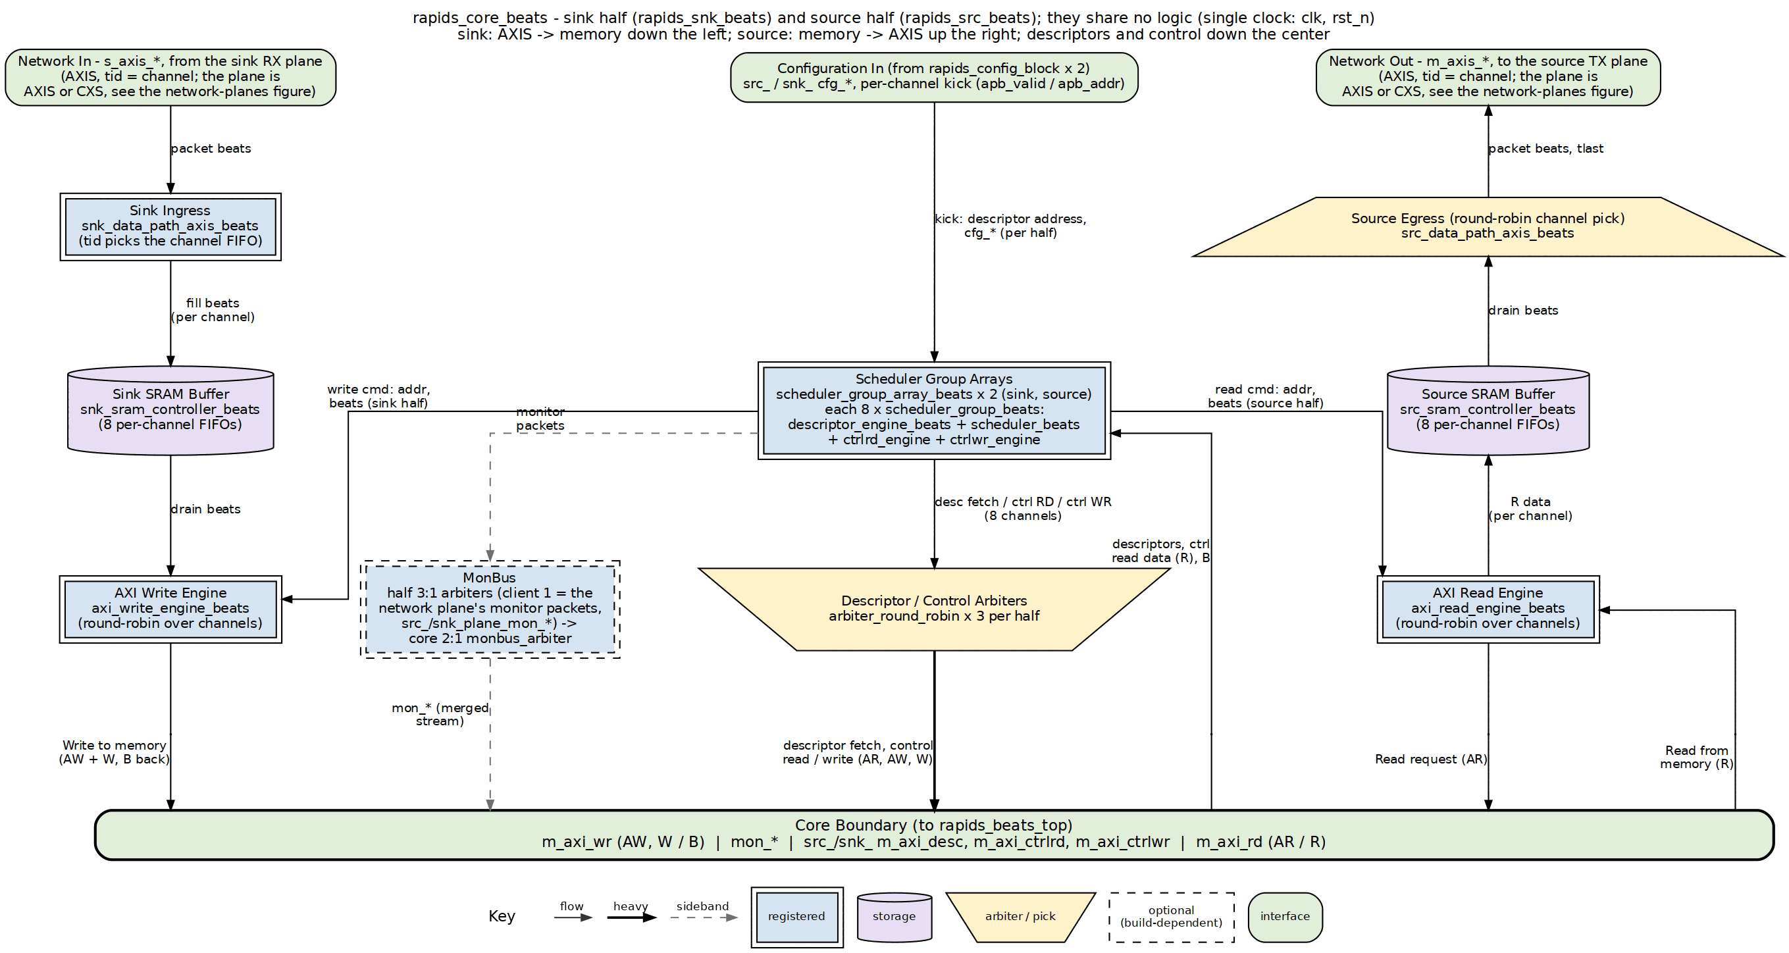
rapids_core_beats block diagram
Source: 19_rapids_core.dot

3.2 Data Flow Overview

3.2.1 Sink Path (Network to Memory)
The sink path receives data from an external source (via Fill interface) and writes it to system memory:

3.2.2 Figure 1.1.2: Sink Path Data Flow
1. External Fill Valid
|
v
2. sram_controller (STREAM): stream_alloc_ctrl reserves space
|
v
3. sram_controller: per-channel gaxi_fifo_sync takes the beats
|
v
4. sram_controller: stream_drain_ctrl reports data available
|
v
5. axi_write_engine_beats (AXI Burst Write)
|
v
6. System Memory

3.2.3 Source Path (Memory to Network)
The source path reads data from system memory and sends it to an external destination (via Drain interface):

3.2.4 Figure 1.1.3: Source Path Data Flow
1. Scheduler Request
|
v
2. sram_controller (STREAM): stream_alloc_ctrl reserves space
|
v
3. axi_read_engine_beats (AXI Burst Read)
|
v
4. sram_controller: per-channel gaxi_fifo_sync takes the beats
|
v
5. sram_controller: stream_drain_ctrl reports data available
|
v
6. External Drain Ready

3.3 Key Architectural Decisions

3.3.1 Beat-Level Tracking
All flow control uses beat granularity:
Table 1.1.1: Beat Granularity Examples
Operation | Granularity | Example (512-bit DW)
Space allocation | Beats | Request 8 beats = 512 bytes
Data availability | Beats | 16 beats ready = 1024 bytes
AXI burst length | Beats | ARLEN=15 = 16 beats
Latency compensation | Beats | 2-beat pipeline delay

3.3.2 Concurrent Read/Write
To prevent deadlock with large transfers:
Example: 100MB transfer with 2KB SRAM buffer
Sequential operation (WRONG):
1. Read 100MB -> DEADLOCK at 2KB (SRAM full, can't complete read)
Concurrent operation (CORRECT):
1. Read starts filling SRAM -> SRAM becomes full (2KB)
2. Read pauses (natural backpressure)
3. Write drains SRAM -> SRAM has free space
4. Read resumes -> Both continue until 100MB complete

3.3.3 Virtual FIFOs (Alloc/Drain)
The alloc_ctrl and drain_ctrl modules are “virtual FIFOs” that track space/data without storing actual data:
- stream_alloc_ctrl: Tracks allocated space (write pointer advances on allocation, read pointer on actual write)
- stream_drain_ctrl: Tracks available data (write pointer advances on data arrival, read pointer on drain reservation). Its virtual depth is 2 x SRAM_DEPTH so the latency bridge’s parked beats never make it refuse a real write (stream BUG-011)
- Both live inside STREAM’s sram_controller_unit, one per channel, reached through the snk_/src_sram_controller_beats naming wrappers since bdf4e0dff. RAPIDS’ own alloc_ctrl_beats / drain_ctrl_beats / latency_bridge_beats are kept and tested but no longer in this path.

3.4 Module Hierarchy
The core is wrapped by a generated top: rapids_beats_top (AXIS network planes) or rapids_beats_cxs_top (CXS network planes), each rapids_beats_top_base plus an RX plane in front of the sink half and a TX plane behind the source half. See Network Planes.
rapids_beats_top | rapids_beats_cxs_top (generated, bin/gen_plane_tops.py)
├── u_base: rapids_beats_top_base (regs, config blocks, monbus group)
│ └── u_core: rapids_core_beats (below)
├── u_snk_plane: rapids_plane_axis_rx | rapids_plane_cxs_rx
└── u_src_plane: rapids_plane_axis_tx | rapids_plane_cxs_tx
rapids_core_beats
├── monbus_arbiter (merges the two halves' monbus)
├── rapids_src_beats (SOURCE half)
│ ├── scheduler_group_array_beats
│ │ ├── scheduler_group_beats [0..7]
│ │ │ ├── scheduler_beats
│ │ │ ├── descriptor_engine_beats
│ │ │ ├── ctrlrd_engine
│ │ │ └── ctrlwr_engine
│ │ ├── arbiter_round_robin [x3] (desc / ctrlrd / ctrlwr AXI masters)
│ │ ├── axi4_master_rd_monlite (descriptor-fetch monitor)
│ │ └── axi_bus_meter
│ ├── monbus_arbiter (3:1) (client 1 = src_plane_mon_*)
│ └── src_data_path_axis_beats
│ └── src_data_path_beats
│ ├── axi_read_engine_beats
│ └── src_sram_controller_beats (naming wrapper)
│ └── sram_controller (STREAM, shared)
│ └── sram_controller_unit [0..7]
│ ├── stream_alloc_ctrl
│ ├── gaxi_fifo_sync (the per-channel SRAM)
│ ├── stream_drain_ctrl
│ └── stream_latency_bridge
└── rapids_snk_beats (SINK half, same shape)
├── scheduler_group_array_beats
│ └── ...
├── monbus_arbiter (3:1) (client 1 = snk_plane_mon_*)
└── snk_data_path_axis_beats
└── snk_data_path_beats
├── axi_write_engine_beats
└── snk_sram_controller_beats
└── sram_controller (STREAM, shared)
└── sram_controller_unit [0..7]
alloc_ctrl_beats, drain_ctrl_beats and latency_bridge_beats (fub_beats) are not in this tree: since bdf4e0dff the SRAM path is STREAM’s controller. They keep their tests and filelists as standalone FUBs.

3.5 Timing Diagram: Basic Transfer

3.5.1 Figure 1.1.4: Basic Sink Path Transfer Timing
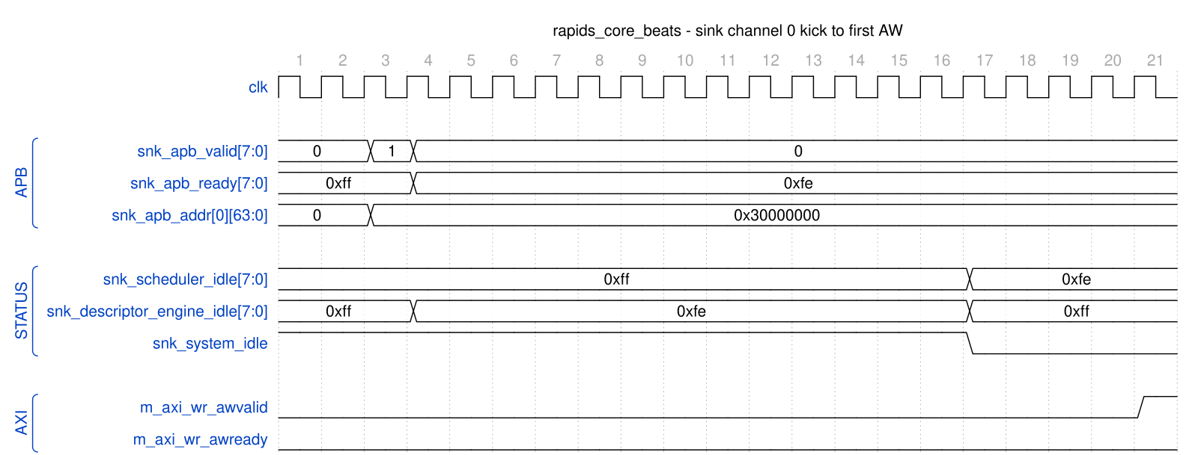
rapids_core_beats - sink channel 0 kick to first AW
Source: rapids_core_beats_sink_kick.json, captured from dv/tests/top_beats/test_rapids_core_beats.py (sink path, channel 0, 32 beats, 512-bit data, TEST_LEVEL=full) with WAVES=1.
Reading it: the AXIS packet is already sitting in the sink SRAM when software kicks channel 0 (snk_apb_valid[0] for one cycle with the descriptor address 0x30000000). snk_apb_ready[0] drops the same cycle and stays low while the channel is busy. The descriptor engine leaves idle immediately to fetch the descriptor; twelve cycles later it hands the descriptor to the scheduler, its own idle returns, and snk_scheduler_idle[0] and snk_system_idle fall together. The first AW follows four cycles after that. snk_system_idle returns after the last B response of the transfer (not in this window); the busy-then-idle sequence is what the top-level tests wait on.

3.6 Related Documentation
- Top-Level Port List - Complete port specification
- Clocks and Reset - Timing requirements
- Beats Scheduler Group - Scheduler integration
- Sink Data Path - Sink path details

Last Updated: 2025-01-10

RTL Design Sherpa · Learning Hardware Design Through Practice GitHub · Documentation Index · MIT License

4 Top-Level Port List
Module: rapids_core_beats.sv Location: projects/components/dma-ip/rapids/rtl/macro_beats/ Status: Implemented Last Updated: 2026-10-16

4.1 Parameters
Every parameter of rapids_core_beats, as declared. The short aliases at the end are what the port widths below are written in (NC, AW, DW, IW, SCW, CIW, SW).
Table 1.2.1: Parameters (from rapids_core_beats.sv)
Parameter | Type | Default | Notes
NUM_CHANNELS | int | 8 | -
CHAN_WIDTH | int | $clog2(NUM_CHANNELS) | -
ADDR_WIDTH | int | 64 | -
DATA_WIDTH | int | 512 | -
AXI_ID_WIDTH | int | 8 | -
SRAM_DEPTH | int | 512 | -
SEG_COUNT_WIDTH | int | $clog2(SRAM_DEPTH) + 1 | -
PIPELINE | int | 1 | write-engine pipelining; 1 is the perf design point (see rapids_beats_top)
AR_MAX_OUTSTANDING | int | 8 | -
AW_MAX_OUTSTANDING | int | 8 | -
W_PHASE_FIFO_DEPTH | int | 64 | -
B_PHASE_FIFO_DEPTH | int | 16 | -
AXIS_ID_WIDTH | int | 8 | -
AXIS_DEST_WIDTH | int | 4 | -
AXIS_USER_WIDTH | int | 1 | -
DESC_MON_BASE_AGENT_ID | int | 16 | 0x10 - Descriptor Engines (16-23)
SCHED_MON_BASE_AGENT_ID | int | 48 | 0x30 - Schedulers (48-55)
DESC_AXI_MON_AGENT_ID | int | 8 | 0x08 - Descriptor AXI Master Monitor
MON_UNIT_ID | int | 1 | 0x1
MON_MAX_TRANSACTIONS | int | 16 | -
USE_AXI_MONITORS | int | 1 | -
USE_ROW_COL_MAJOR_ADDRESSING | int | 1 | -
GEN_MON | bit | 1'b1 | -
NC | int | NUM_CHANNELS | -
AW | int | ADDR_WIDTH | -
DW | int | DATA_WIDTH | -
IW | int | AXI_ID_WIDTH | -
SD | int | SRAM_DEPTH | -
SCW | int | SEG_COUNT_WIDTH | -
CIW | int | (NC > 1) ? $clog2(NC) : 1 | -
SW | int | DW / 8 | -

4.2 Port List (324 ports)
The module is two independent halves. Ports both halves carry are prefixed src_ / snk_; the direction-unique ports (the source’s AXI read master and AXIS egress, the sink’s AXI write master and AXIS ingress) carry no prefix. Sections follow the declaration order in the RTL, so a reader can walk this page and the module side by side. Widths use the parameter aliases.

4.2.1 Clock and Reset (shared - single clock/reset for the whole wrapper)
Table 1.2.2: Clock and Reset (shared - single clock/reset for the whole wrapper)
Signal | Direction | Width | Description
clk | input | 1 | -
rst_n | input | 1 | -

4.3 SOURCE HALF (u_src) - shared-infrastructure ports (src_ prefixed)

4.3.1 APB Programming Interface
Table 1.2.3: APB Programming Interface
Signal | Direction | Width | Description
src_apb_valid | input | NC | -
src_apb_ready | output | NC | -
src_apb_addr | input | NC x AW | -

4.3.2 Per-channel configuration
Table 1.2.4: Per-channel configuration
Signal | Direction | Width | Description
src_cfg_channel_enable | input | NC | -
src_cfg_channel_reset | input | NC | -

4.3.3 Scheduler Configuration (global)
Table 1.2.5: Scheduler Configuration (global)
Signal | Direction | Width | Description
src_cfg_sched_enable | input | 1 | -
src_cfg_sched_timeout_cycles | input | 32 | -
src_cfg_sched_timeout_limit | input | 8 | -
src_cfg_sched_timeout_enable | input | 1 | -
src_cfg_sched_err_enable | input | 1 | -
src_cfg_sched_compl_enable | input | 1 | -
src_cfg_sched_perf_enable | input | 1 | -

4.3.4 Descriptor Engine Configuration (global)
Table 1.2.6: Descriptor Engine Configuration (global)
Signal | Direction | Width | Description
src_cfg_desceng_enable | input | 1 | -
src_cfg_desceng_prefetch | input | 1 | -
src_cfg_desceng_fifo_thresh | input | 4 | -
src_cfg_desceng_addr0_base | input | AW | -
src_cfg_desceng_addr0_limit | input | AW | -
src_cfg_desceng_addr1_base | input | AW | -
src_cfg_desceng_addr1_limit | input | AW | -

4.3.5 Control Engine Configuration (Phase 2, global)
Table 1.2.7: Control Engine Configuration (Phase 2, global)
Signal | Direction | Width | Description
src_cfg_ctrlrd_max_try | input | 9 | -
src_tick_1us | input | 1 | -

4.3.6 Descriptor AXI Monitor Configuration
Table 1.2.8: Descriptor AXI Monitor Configuration
Signal | Direction | Width | Description
src_cfg_desc_mon_enable | input | 1 | -
src_cfg_desc_mon_err_enable | input | 1 | -
src_cfg_desc_mon_perf_enable | input | 1 | -
src_cfg_desc_mon_perf_run | input | 1 | -
src_cfg_desc_mon_timeout_enable | input | 1 | -
src_cfg_desc_mon_timeout_cycles | input | 32 | -
src_cfg_desc_mon_latency_thresh | input | 32 | -
src_cfg_desc_mon_pkt_mask | input | 16 | -
src_cfg_desc_mon_err_select | input | 4 | -
src_cfg_desc_mon_err_mask | input | 8 | -
src_cfg_desc_mon_timeout_mask | input | 8 | -
src_cfg_desc_mon_compl_mask | input | 8 | -
src_cfg_desc_mon_thresh_mask | input | 8 | -
src_cfg_desc_mon_perf_mask | input | 8 | -
src_cfg_desc_mon_addr_mask | input | 8 | -
src_cfg_desc_mon_debug_mask | input | 8 | -

4.3.7 Network-plane monitor input (rapids TASK-024)
The network endpoint and its monitor-lite live in the plane (rtl/plane/) in the top. Its monbus packets enter here as client 1 of this half’s monbus arbiter; the plane’s monitor configuration and status come from this half’s register block in the top.
Table 1.2.9: Network-plane monitor input (rapids TASK-024)
Signal | Direction | Width | Description
src_plane_mon_valid | input | 1 | -
src_plane_mon_ready | output | 1 | -
src_plane_mon_packet | input | 128 | monitor_packet_t
src_plane_mon_timestamp | input | 64 | monbus_timestamp_t

4.3.8 Status
Table 1.2.10: Status
Signal | Direction | Width | Description
src_system_idle | output | 1 | -
src_descriptor_engine_idle | output | NC | -
src_scheduler_idle | output | NC | -
src_scheduler_state | output | NC x 7 | -
src_sched_error | output | NC | -

4.3.9 Descriptor AXI Monitor Status
Table 1.2.11: Descriptor AXI Monitor Status
Signal | Direction | Width | Description
src_cfg_sts_desc_mon_busy | output | 1 | -
src_cfg_sts_desc_mon_active_txns | output | 8 | -
src_cfg_sts_desc_mon_error_count | output | 16 | -
src_cfg_sts_desc_mon_txn_count | output | 32 | -
src_cfg_sts_desc_mon_conflict_error | output | 1 | -

4.3.10 Descriptor AXI Monitor perf window (feeds SRC_.MON.DAXMON_PERF_*).
Table 1.2.12: Descriptor AXI Monitor perf window (feeds SRC_.MON.DAXMON_PERF_*).
Signal | Direction | Width | Description
src_sts_desc_mon_win_active | output | 1 | -
src_sts_desc_mon_win_cycles | output | 32 | -
src_sts_desc_mon_prod_cycles | output | 32 | -
src_sts_desc_mon_bp_cycles | output | 32 | -
src_sts_desc_mon_starv_cycles | output | 32 | -
src_sts_desc_mon_idle_cycles | output | 32 | -
src_sts_desc_mon_beat_count | output | 32 | -
src_sts_desc_mon_byte_count | output | 64 | -
src_sts_desc_mon_burst_count | output | 32 | -

4.3.11 Descriptor Fetch AXI Master
Table 1.2.13: Descriptor Fetch AXI Master
Signal | Direction | Width | Description
src_m_axi_desc_arvalid | output | 1 | -
src_m_axi_desc_arready | input | 1 | -
src_m_axi_desc_araddr | output | AW | -
src_m_axi_desc_arlen | output | 8 | -
src_m_axi_desc_arsize | output | 3 | -
src_m_axi_desc_arburst | output | 2 | -
src_m_axi_desc_arid | output | IW | -
src_m_axi_desc_arlock | output | 1 | -
src_m_axi_desc_arcache | output | 4 | -
src_m_axi_desc_arprot | output | 3 | -
src_m_axi_desc_arqos | output | 4 | -
src_m_axi_desc_arregion | output | 4 | -
src_m_axi_desc_rvalid | input | 1 | -
src_m_axi_desc_rready | output | 1 | -
src_m_axi_desc_rdata | input | 256 | -
src_m_axi_desc_rresp | input | 2 | -
src_m_axi_desc_rlast | input | 1 | -
src_m_axi_desc_rid | input | IW | -

4.3.12 Control Read AXI Master (32-bit) [Phase 2]
Table 1.2.14: Control Read AXI Master (32-bit) [Phase 2]
Signal | Direction | Width | Description
src_m_axi_ctrlrd_arvalid | output | 1 | -
src_m_axi_ctrlrd_arready | input | 1 | -
src_m_axi_ctrlrd_araddr | output | AW | -
src_m_axi_ctrlrd_arlen | output | 8 | -
src_m_axi_ctrlrd_arsize | output | 3 | -
src_m_axi_ctrlrd_arburst | output | 2 | -
src_m_axi_ctrlrd_arid | output | IW | -
src_m_axi_ctrlrd_arlock | output | 1 | -
src_m_axi_ctrlrd_arcache | output | 4 | -
src_m_axi_ctrlrd_arprot | output | 3 | -
src_m_axi_ctrlrd_arqos | output | 4 | -
src_m_axi_ctrlrd_arregion | output | 4 | -
src_m_axi_ctrlrd_rvalid | input | 1 | -
src_m_axi_ctrlrd_rready | output | 1 | -
src_m_axi_ctrlrd_rdata | input | 32 | -
src_m_axi_ctrlrd_rresp | input | 2 | -
src_m_axi_ctrlrd_rlast | input | 1 | -
src_m_axi_ctrlrd_rid | input | IW | -

4.3.13 Control Write AXI Master (32-bit) [Phase 2]
Table 1.2.15: Control Write AXI Master (32-bit) [Phase 2]
Signal | Direction | Width | Description
src_m_axi_ctrlwr_awvalid | output | 1 | -
src_m_axi_ctrlwr_awready | input | 1 | -
src_m_axi_ctrlwr_awaddr | output | AW | -
src_m_axi_ctrlwr_awlen | output | 8 | -
src_m_axi_ctrlwr_awsize | output | 3 | -
src_m_axi_ctrlwr_awburst | output | 2 | -
src_m_axi_ctrlwr_awid | output | IW | -
src_m_axi_ctrlwr_awlock | output | 1 | -
src_m_axi_ctrlwr_awcache | output | 4 | -
src_m_axi_ctrlwr_awprot | output | 3 | -
src_m_axi_ctrlwr_awqos | output | 4 | -
src_m_axi_ctrlwr_awregion | output | 4 | -
src_m_axi_ctrlwr_wvalid | output | 1 | -
src_m_axi_ctrlwr_wready | input | 1 | -
src_m_axi_ctrlwr_wdata | output | 32 | -
src_m_axi_ctrlwr_wstrb | output | 4 | -
src_m_axi_ctrlwr_wlast | output | 1 | -
src_m_axi_ctrlwr_bvalid | input | 1 | -
src_m_axi_ctrlwr_bready | output | 1 | -
src_m_axi_ctrlwr_bid | input | IW | -
src_m_axi_ctrlwr_bresp | input | 2 | -

4.4 SOURCE HALF (u_src) - direction-unique ports (no prefix)

4.4.1 AXI Transfer Configuration (source-only)
Table 1.2.16: AXI Transfer Configuration (source-only)
Signal | Direction | Width | Description
cfg_axi_rd_xfer_beats | input | 8 | -
cfg_drain_size | input | 8 | source: beats drained per AXIS packet

4.4.2 Source Path - AXIS Master Interface (SRAM -> Network); tid = channel id
Table 1.2.17: Source Path - AXIS Master Interface (SRAM -> Network); tid = channel id
Signal | Direction | Width | Description
m_axis_tdata | output | DW | -
m_axis_tstrb | output | SW | -
m_axis_tlast | output | 1 | -
m_axis_tid | output | AXIS_ID_WIDTH | -
m_axis_tdest | output | AXIS_DEST_WIDTH | -
m_axis_tuser | output | AXIS_USER_WIDTH | -
m_axis_tvalid | output | 1 | -
m_axis_tready | input | 1 | -

4.4.3 AXI4 Master - Data Read (Memory -> Source SRAM)
Table 1.2.18: AXI4 Master - Data Read (Memory -> Source SRAM)
Signal | Direction | Width | Description
m_axi_rd_arid | output | IW | -
m_axi_rd_araddr | output | AW | -
m_axi_rd_arlen | output | 8 | -
m_axi_rd_arsize | output | 3 | -
m_axi_rd_arburst | output | 2 | -
m_axi_rd_arvalid | output | 1 | -
m_axi_rd_arready | input | 1 | -
m_axi_rd_rid | input | IW | -
m_axi_rd_rdata | input | DW | -
m_axi_rd_rresp | input | 2 | -
m_axi_rd_rlast | input | 1 | -
m_axi_rd_rvalid | input | 1 | -
m_axi_rd_rready | output | 1 | -

4.5 SINK HALF (u_snk) - shared-infrastructure ports (snk_ prefixed)

4.5.1 APB Programming Interface
Table 1.2.19: APB Programming Interface
Signal | Direction | Width | Description
snk_apb_valid | input | NC | -
snk_apb_ready | output | NC | -
snk_apb_addr | input | NC x AW | -

4.5.2 Per-channel configuration
Table 1.2.20: Per-channel configuration
Signal | Direction | Width | Description
snk_cfg_channel_enable | input | NC | -
snk_cfg_channel_reset | input | NC | -

4.5.3 Scheduler Configuration (global)
Table 1.2.21: Scheduler Configuration (global)
Signal | Direction | Width | Description
snk_cfg_sched_enable | input | 1 | -
snk_cfg_sched_timeout_cycles | input | 32 | -
snk_cfg_sched_timeout_limit | input | 8 | -
snk_cfg_sched_timeout_enable | input | 1 | -
snk_cfg_sched_err_enable | input | 1 | -
snk_cfg_sched_compl_enable | input | 1 | -
snk_cfg_sched_perf_enable | input | 1 | -

4.5.4 Descriptor Engine Configuration (global)
Table 1.2.22: Descriptor Engine Configuration (global)
Signal | Direction | Width | Description
snk_cfg_desceng_enable | input | 1 | -
snk_cfg_desceng_prefetch | input | 1 | -
snk_cfg_desceng_fifo_thresh | input | 4 | -
snk_cfg_desceng_addr0_base | input | AW | -
snk_cfg_desceng_addr0_limit | input | AW | -
snk_cfg_desceng_addr1_base | input | AW | -
snk_cfg_desceng_addr1_limit | input | AW | -

4.5.5 Control Engine Configuration (Phase 2, global)
Table 1.2.23: Control Engine Configuration (Phase 2, global)
Signal | Direction | Width | Description
snk_cfg_ctrlrd_max_try | input | 9 | -
snk_tick_1us | input | 1 | -

4.5.6 Descriptor AXI Monitor Configuration
Table 1.2.24: Descriptor AXI Monitor Configuration
Signal | Direction | Width | Description
snk_cfg_desc_mon_enable | input | 1 | -
snk_cfg_desc_mon_err_enable | input | 1 | -
snk_cfg_desc_mon_perf_enable | input | 1 | -
snk_cfg_desc_mon_perf_run | input | 1 | -
snk_cfg_desc_mon_timeout_enable | input | 1 | -
snk_cfg_desc_mon_timeout_cycles | input | 32 | -
snk_cfg_desc_mon_latency_thresh | input | 32 | -
snk_cfg_desc_mon_pkt_mask | input | 16 | -
snk_cfg_desc_mon_err_select | input | 4 | -
snk_cfg_desc_mon_err_mask | input | 8 | -
snk_cfg_desc_mon_timeout_mask | input | 8 | -
snk_cfg_desc_mon_compl_mask | input | 8 | -
snk_cfg_desc_mon_thresh_mask | input | 8 | -
snk_cfg_desc_mon_perf_mask | input | 8 | -
snk_cfg_desc_mon_addr_mask | input | 8 | -
snk_cfg_desc_mon_debug_mask | input | 8 | -

4.5.7 Network-plane monitor input (rapids TASK-024)
The network endpoint and its monitor-lite live in the plane (rtl/plane/) in the top. Its monbus packets enter here as client 1 of this half’s monbus arbiter; the plane’s monitor configuration and status come from this half’s register block in the top.
Table 1.2.25: Network-plane monitor input (rapids TASK-024)
Signal | Direction | Width | Description
snk_plane_mon_valid | input | 1 | -
snk_plane_mon_ready | output | 1 | -
snk_plane_mon_packet | input | 128 | monitor_packet_t
snk_plane_mon_timestamp | input | 64 | monbus_timestamp_t

4.5.8 Status
Table 1.2.26: Status
Signal | Direction | Width | Description
snk_system_idle | output | 1 | -
snk_descriptor_engine_idle | output | NC | -
snk_scheduler_idle | output | NC | -
snk_scheduler_state | output | NC x 7 | -
snk_sched_error | output | NC | -

4.5.9 Descriptor AXI Monitor Status
Table 1.2.27: Descriptor AXI Monitor Status
Signal | Direction | Width | Description
snk_cfg_sts_desc_mon_busy | output | 1 | -
snk_cfg_sts_desc_mon_active_txns | output | 8 | -
snk_cfg_sts_desc_mon_error_count | output | 16 | -
snk_cfg_sts_desc_mon_txn_count | output | 32 | -
snk_cfg_sts_desc_mon_conflict_error | output | 1 | -

4.5.10 Descriptor AXI Monitor perf window (feeds SNK_.MON.DAXMON_PERF_*).
Table 1.2.28: Descriptor AXI Monitor perf window (feeds SNK_.MON.DAXMON_PERF_*).
Signal | Direction | Width | Description
snk_sts_desc_mon_win_active | output | 1 | -
snk_sts_desc_mon_win_cycles | output | 32 | -
snk_sts_desc_mon_prod_cycles | output | 32 | -
snk_sts_desc_mon_bp_cycles | output | 32 | -
snk_sts_desc_mon_starv_cycles | output | 32 | -
snk_sts_desc_mon_idle_cycles | output | 32 | -
snk_sts_desc_mon_beat_count | output | 32 | -
snk_sts_desc_mon_byte_count | output | 64 | -
snk_sts_desc_mon_burst_count | output | 32 | -

4.5.11 Descriptor Fetch AXI Master
Table 1.2.29: Descriptor Fetch AXI Master
Signal | Direction | Width | Description
snk_m_axi_desc_arvalid | output | 1 | -
snk_m_axi_desc_arready | input | 1 | -
snk_m_axi_desc_araddr | output | AW | -
snk_m_axi_desc_arlen | output | 8 | -
snk_m_axi_desc_arsize | output | 3 | -
snk_m_axi_desc_arburst | output | 2 | -
snk_m_axi_desc_arid | output | IW | -
snk_m_axi_desc_arlock | output | 1 | -
snk_m_axi_desc_arcache | output | 4 | -
snk_m_axi_desc_arprot | output | 3 | -
snk_m_axi_desc_arqos | output | 4 | -
snk_m_axi_desc_arregion | output | 4 | -
snk_m_axi_desc_rvalid | input | 1 | -
snk_m_axi_desc_rready | output | 1 | -
snk_m_axi_desc_rdata | input | 256 | -
snk_m_axi_desc_rresp | input | 2 | -
snk_m_axi_desc_rlast | input | 1 | -
snk_m_axi_desc_rid | input | IW | -

4.5.12 Control Read AXI Master (32-bit) [Phase 2]
Table 1.2.30: Control Read AXI Master (32-bit) [Phase 2]
Signal | Direction | Width | Description
snk_m_axi_ctrlrd_arvalid | output | 1 | -
snk_m_axi_ctrlrd_arready | input | 1 | -
snk_m_axi_ctrlrd_araddr | output | AW | -
snk_m_axi_ctrlrd_arlen | output | 8 | -
snk_m_axi_ctrlrd_arsize | output | 3 | -
snk_m_axi_ctrlrd_arburst | output | 2 | -
snk_m_axi_ctrlrd_arid | output | IW | -
snk_m_axi_ctrlrd_arlock | output | 1 | -
snk_m_axi_ctrlrd_arcache | output | 4 | -
snk_m_axi_ctrlrd_arprot | output | 3 | -
snk_m_axi_ctrlrd_arqos | output | 4 | -
snk_m_axi_ctrlrd_arregion | output | 4 | -
snk_m_axi_ctrlrd_rvalid | input | 1 | -
snk_m_axi_ctrlrd_rready | output | 1 | -
snk_m_axi_ctrlrd_rdata | input | 32 | -
snk_m_axi_ctrlrd_rresp | input | 2 | -
snk_m_axi_ctrlrd_rlast | input | 1 | -
snk_m_axi_ctrlrd_rid | input | IW | -

4.5.13 Control Write AXI Master (32-bit) [Phase 2]
Table 1.2.31: Control Write AXI Master (32-bit) [Phase 2]
Signal | Direction | Width | Description
snk_m_axi_ctrlwr_awvalid | output | 1 | -
snk_m_axi_ctrlwr_awready | input | 1 | -
snk_m_axi_ctrlwr_awaddr | output | AW | -
snk_m_axi_ctrlwr_awlen | output | 8 | -
snk_m_axi_ctrlwr_awsize | output | 3 | -
snk_m_axi_ctrlwr_awburst | output | 2 | -
snk_m_axi_ctrlwr_awid | output | IW | -
snk_m_axi_ctrlwr_awlock | output | 1 | -
snk_m_axi_ctrlwr_awcache | output | 4 | -
snk_m_axi_ctrlwr_awprot | output | 3 | -
snk_m_axi_ctrlwr_awqos | output | 4 | -
snk_m_axi_ctrlwr_awregion | output | 4 | -
snk_m_axi_ctrlwr_wvalid | output | 1 | -
snk_m_axi_ctrlwr_wready | input | 1 | -
snk_m_axi_ctrlwr_wdata | output | 32 | -
snk_m_axi_ctrlwr_wstrb | output | 4 | -
snk_m_axi_ctrlwr_wlast | output | 1 | -
snk_m_axi_ctrlwr_bvalid | input | 1 | -
snk_m_axi_ctrlwr_bready | output | 1 | -
snk_m_axi_ctrlwr_bid | input | IW | -
snk_m_axi_ctrlwr_bresp | input | 2 | -

4.6 Monitor Bus (SINGLE aggregated stream for the whole core)
The two halves’ monitor outputs are merged through a top-level monbus_arbiter, so the core exposes exactly one monitor stream.

4.6.1 Monitor Bus
Table 1.2.32: Monitor Bus
Signal | Direction | Width | Description
mon_valid | output | 1 | -
mon_ready | input | 1 | -
mon_packet | output | ocelus_common_pkg::monitor_packet_t | -
mon_timestamp | output | ocelus_common_pkg::monbus_timestamp_t | -

4.7 SINK HALF (u_snk) - direction-unique ports (no prefix)

4.7.1 AXI Transfer Configuration (sink-only)
Table 1.2.33: AXI Transfer Configuration (sink-only)
Signal | Direction | Width | Description
cfg_axi_wr_xfer_beats | input | 8 | -
cfg_alloc_size | input | 8 | sink: SRAM alloc size per AXIS fill

4.7.2 Sink Path - AXIS Slave Interface (Network -> SRAM); tid = channel id
Table 1.2.34: Sink Path - AXIS Slave Interface (Network -> SRAM); tid = channel id
Signal | Direction | Width | Description
s_axis_tdata | input | DW | -
s_axis_tstrb | input | SW | -
s_axis_tlast | input | 1 | -
s_axis_tid | input | AXIS_ID_WIDTH | -
s_axis_tdest | input | AXIS_DEST_WIDTH | -
s_axis_tuser | input | AXIS_USER_WIDTH | -
s_axis_tvalid | input | 1 | -
s_axis_tready | output | 1 | -

4.7.3 AXI4 Master - Data Write (Sink SRAM -> Memory)
Table 1.2.35: AXI4 Master - Data Write (Sink SRAM -> Memory)
Signal | Direction | Width | Description
m_axi_wr_awid | output | IW | -
m_axi_wr_awaddr | output | AW | -
m_axi_wr_awlen | output | 8 | -
m_axi_wr_awsize | output | 3 | -
m_axi_wr_awburst | output | 2 | -
m_axi_wr_awlock | output | 1 | -
m_axi_wr_awcache | output | 4 | -
m_axi_wr_awprot | output | 3 | -
m_axi_wr_awqos | output | 4 | -
m_axi_wr_awregion | output | 4 | -
m_axi_wr_awvalid | output | 1 | -
m_axi_wr_awready | input | 1 | -
m_axi_wr_wdata | output | DW | -
m_axi_wr_wstrb | output | (DW/8) | -
m_axi_wr_wlast | output | 1 | -
m_axi_wr_wvalid | output | 1 | -
m_axi_wr_wready | input | 1 | -
m_axi_wr_bid | input | IW | -
m_axi_wr_bresp | input | 2 | -
m_axi_wr_bvalid | input | 1 | -
m_axi_wr_bready | output | 1 | -

4.8 Debug Interface (per half, src_dbg_ / snk_dbg_ prefixed)

4.8.1 Source half debug
Table 1.2.36: Source half debug
Signal | Direction | Width | Description
src_dbg_rd_all_complete | output | NC | -
src_dbg_r_beats_rcvd | output | 32 | -
src_dbg_sram_writes | output | 32 | -
src_dbg_arb_request | output | NC | -
src_dbg_src_sram_bridge_pending | output | NC | -
src_dbg_src_sram_bridge_out_valid | output | NC | -
src_dbg_axis_beats_sent | output | 32 | -
src_dbg_axis_packets_sent | output | 32 | -

4.8.2 Sink half debug
Table 1.2.37: Sink half debug
Signal | Direction | Width | Description
snk_dbg_snk_sram_bridge_pending | output | NC | -
snk_dbg_snk_sram_bridge_out_valid | output | NC | -
snk_dbg_axis_beats_received | output | 32 | -
snk_dbg_axis_packets_received | output | 32 | -

4.8.3 Active-channel sideband for per-channel bus instrumentation
(axi_bus_meter). The W bus carries no wid, so the write engine’s channel index must travel out of band to reach the meter at the top.
Table 1.2.38: Active-channel sideband for per-channel bus instrumentation
Signal | Direction | Width | Description
snk_active_channel_id | output | CIW | -
snk_active_channel_valid | output | 1 | -

Verified: every row above is a declared port of rapids_core_beats and every declared port has a row (324 of 324), generated from the module declaration on 2026-09-28. Regenerate rather than hand-edit when the interface changes.

RTL Design Sherpa · Learning Hardware Design Through Practice GitHub · Documentation Index · MIT License

5 Clocks and Reset
Module: rapids_core_beats.sv Location: projects/components/dma-ip/rapids/rtl/macro_beats/ Status: Implemented Last Updated: 2025-01-10

5.1 Clock Domain
RAPIDS Beats operates in a single clock domain for simplified design and maximum throughput.

5.1.1 Clock Specifications
Table 1.3.1: Clock Specifications
Parameter | Specification
Clock Signal | clk (also axi_aclk in some submodules)
Frequency Range | 100 - 500 MHz
Duty Cycle | 45% - 55%
Clock Jitter | < 100 ps peak-to-peak

5.1.2 Clock Distribution
clk (one clock domain; rst_n active-low, async assert)
├── scheduler_group_array_beats (one per half)
│ └── descriptor_engine_beats, scheduler_beats, ctrlrd_engine, ctrlwr_engine (x8)
├── snk_data_path_axis_beats
│ └── snk_sram_controller_beats, axi_write_engine_beats
└── src_data_path_axis_beats
└── axi_read_engine_beats, src_sram_controller_beats

5.2 Reset Specification
RAPIDS uses asynchronous assert, synchronous deassert reset methodology.

5.2.1 Reset Signal
Table 1.3.2: Reset Specifications
Parameter | Specification
Reset Signal | rst_n (also axi_aresetn in some submodules)
Polarity | Active-low
Assert | Asynchronous (immediate)
Deassert | Synchronous (on rising clock edge)
Minimum Duration | 10 clock cycles

5.2.2 Reset Timing Diagram

5.2.3 Figure 1.3.1: Reset Timing

scheduler_beats - reset release to first descriptor
Source: scheduler_reset.json, captured from dv/tests/fub_beats/test_scheduler_beats.py (basic transfer, the same run as Figure 2.1.3) with WAVES=1.
Reading it: rst_n is held low for ten cycles and released on a clock edge. Every state register is already at its reset value while reset is asserted – the FSM sits in IDLE, scheduler_idle is high, both control engines report idle and neither engine request is raised. Nothing changes at the release edge itself; the scheduler stays in IDLE until the testbench raises cfg_channel_enable ten cycles later and a descriptor becomes available, at which point it steps through FETCH_DESC to XFER_DATA and raises the read and write requests together.

5.3 Reset Behavior

5.3.1 On Reset Assert
All modules initialize to known states:
Table 1.3.3: Reset States
Component | Reset State
Scheduler FSM | IDLE
Descriptor Engine | IDLE, FIFOs empty
AXI Read Engine | Idle, no outstanding transactions
AXI Write Engine | Idle, no outstanding transactions
SRAM Pointers | All zeros
Alloc/Drain Controllers | Empty, full space available
MonBus | No packets pending

5.3.2 Reset Sequence
1. External reset asserted (rst_n = 0)
- All flip-flops async reset
- All outputs driven to safe states
- No AXI transactions
2. System stabilization (minimum 10 cycles)
- Clock running and stable
- Configuration registers programmed (optional)
3. Reset deasserted (rst_n = 1, sync to clk rising edge)
- FSMs begin operation
- Ready to accept descriptors/data

5.4 Configuration During Reset
Some configuration signals MUST be stable before reset deassertion:
Table 1.3.4: Configuration Timing Requirements
Signal | Requirement
src_cfg_channel_enable / snk_cfg_channel_enable | Stable before rst_n=1 (one per half)
src_cfg_sched_timeout_cycles / snk_cfg_sched_timeout_cycles | Stable before rst_n=1 (one per half)
cfg_axi_rd_xfer_beats | Stable before rst_n=1
cfg_axi_wr_xfer_beats | Stable before rst_n=1

5.5 Reset Macros
RAPIDS uses standardized reset macros from reset_defs.svh:
`include "reset_defs.svh"
// Standard reset pattern
`ALWAYS_FF_RST(clk, rst_n,
if (`RST_ASSERTED(rst_n)) begin
r_state <= IDLE;
r_counter <= '0;
end else begin
r_state <= w_next_state;
r_counter <= w_next_counter;
end
)

5.6 Power-On Reset Considerations
- External reset should be held for minimum 10 clock cycles after clock is stable
- Configuration registers should be programmed before or during reset
- No AXI transactions until reset is deasserted and channels are enabled

Last Updated: 2025-01-10

RTL Design Sherpa · Learning Hardware Design Through Practice GitHub · Documentation Index · MIT License

6 Scheduler Specification
Module: scheduler_beats.sv Location: projects/components/dma-ip/rapids/rtl/fub_beats/ Status: Implemented Last Updated: 2025-01-10

6.1 Overview
The Scheduler coordinates descriptor-based data transfers for a single RAPIDS channel. It receives descriptors from the descriptor engine, parses transfer parameters, and coordinates read/write operations through the data paths.

6.1.1 Key Features
- Descriptor Processing: Parses 256-bit descriptors for transfer parameters
- Beat-Based Tracking: All lengths tracked in beats (data-width units)
- Concurrent Read/Write: Simultaneous read and write to prevent deadlock
- Three descriptor opcodes: DATA (concurrent read/write), CTRL_READ (consumer gate via the control-read engine), CTRL_WRITE (producer doorbell via the control-write engine) – see Control Interface below
- Timeout Detection: Configurable watchdog for stalled transfers
- MonBus Integration: State transition and error event reporting
- Error Aggregation: Combines errors from descriptor engine and data paths

6.1.2 Block Diagram

6.1.3 Figure 2.1.1: Scheduler Block Diagram
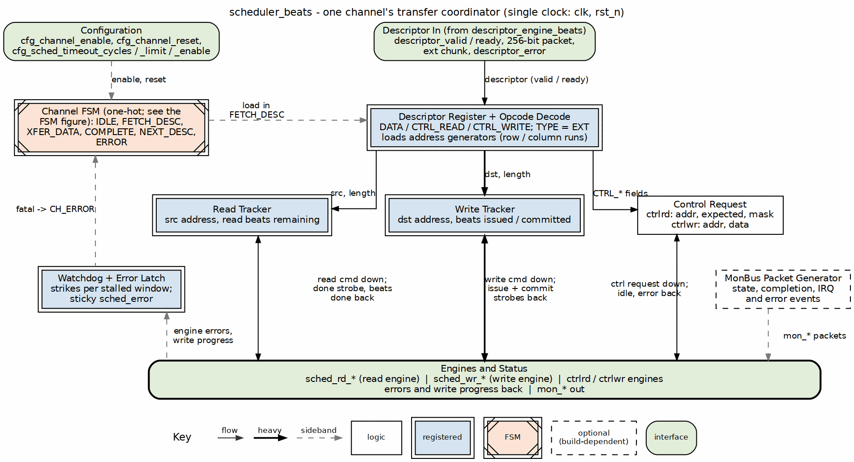
Scheduler block diagram
Source: 01_scheduler.dot

6.2 Parameters
parameter int CHANNEL_ID = 0; // Channel identifier
parameter int NUM_CHANNELS = 8; // Total channels in system
parameter int CHAN_WIDTH = $clog2(NUM_CHANNELS); // Channel ID width
parameter int ADDR_WIDTH = 64; // Address bus width
parameter int DATA_WIDTH = 512; // Data bus width (beats)
// Monitor Bus Parameters
parameter logic [7:0] MON_AGENT_ID = 8'h30; // RAPIDS Scheduler Agent ID
parameter logic [3:0] MON_UNIT_ID = 4'h1; // Unit identifier
parameter logic [5:0] MON_CHANNEL_ID = 6'h0; // Base channel ID
// Descriptor Width
parameter int DESC_WIDTH = 256; // RAPIDS descriptor width
: Table 2.1.1: Scheduler Parameters

6.3 Port List

6.3.1 Clock and Reset
Table 2.1.2: Clock and Reset
Signal | Direction | Width | Description
clk | input | 1 | System clock
rst_n | input | 1 | Active-low asynchronous reset

6.3.2 Configuration Interface
Table 2.1.3: Configuration Interface
Signal | Direction | Width | Description
cfg_channel_enable | input | 1 | Enable this channel
cfg_channel_reset | input | 1 | Channel soft reset
cfg_sched_timeout_cycles | input | 32 | Write-progress timeout window (cycles)
cfg_sched_timeout_limit | input | 8 | Consecutive-timeout windows before fatal escalation (0 = never)
cfg_sched_timeout_enable | input | 1 | Enable timeout detection

6.3.3 Descriptor Engine Interface
Table 2.1.4: Descriptor Engine Interface
Signal | Direction | Width | Description
descriptor_valid | input | 1 | Descriptor valid
descriptor_ready | output | 1 | Ready to accept descriptor
descriptor_packet | input | 256 | 256-bit descriptor
descriptor_error | input | 1 | Error from descriptor engine

6.3.4 Data Read Interface
Table 2.1.5: Data Read Interface
Signal | Direction | Width | Description
sched_rd_valid | output | 1 | Read request valid
sched_rd_addr | output | AW | Source address
sched_rd_beats | output | 32 | Beats to read
sched_rd_done_strobe | input | 1 | Read complete strobe
sched_rd_beats_done | input | 32 | Beats completed
sched_rd_error | input | 1 | Read error

6.3.5 Data Write Interface
Table 2.1.6: Data Write Interface
Signal | Direction | Width | Description
sched_wr_valid | output | 1 | Write request valid (gated on remaining ISSUE beats)
sched_wr_addr | output | AW | Destination address
sched_wr_beats | output | 32 | Beats to write
sched_wr_done_strobe | input | 1 | Write AW-issue strobe (burst accepted on AW)
sched_wr_beats_done | input | 32 | Beats issued this strobe
sched_wr_commit_strobe | input | 1 | Write COMMIT strobe (B response received)
sched_wr_commit_beats | input | 32 | Beats committed this strobe
sched_wr_error | input | 1 | Write error

6.3.6 Control Interface
For CTRL_READ / CTRL_WRITE descriptors the scheduler drives two per-channel control engines instead of the data path. Both are request/response handshakes whose completion is signalled by the engine’s *_idle going high after issue.
Table 2.1.7: Control Interface (CTRL_READ / CTRL_WRITE)
Signal | Direction | Width | Description
ctrlrd_valid | output | 1 | Control-read request valid (to ctrlrd_engine)
ctrlrd_ready | input | 1 | Engine accepted the poll request
ctrlrd_addr | output | AW | Gate poll address (descriptor poll_addr)
ctrlrd_data | output | 32 | Expected value (descriptor expected)
ctrlrd_mask | output | 32 | Compare mask (descriptor mask)
ctrlrd_error | input | 1 | Engine error (poll retries exhausted / AXI error)
ctrlrd_idle | input | 1 | ctrlrd_engine_idle – gate satisfied (completion)
ctrlwr_valid | output | 1 | Control-write request valid (to ctrlwr_engine)
ctrlwr_ready | input | 1 | Engine accepted the doorbell request
ctrlwr_addr | output | AW | Doorbell address (descriptor wr_addr)
ctrlwr_data | output | 32 | Doorbell value (descriptor wr_data)
ctrlwr_error | input | 1 | Engine error (AXI error)
ctrlwr_idle | input | 1 | ctrlwr_engine_idle – doorbell written (completion)
A CTRL_READ descriptor is a consumer gate: the scheduler asserts ctrlrd_valid and holds off the descriptor’s completion (and the chain) until the control-read engine reports the masked poll matched (ctrlrd_idle). The poll retry budget is bounded by CTRL_CONFIG.CTRLRD_MAX_TRY (Section 3.12) so a never-matching gate cannot hang the channel – exhaustion raises ctrlrd_error. A CTRL_WRITE descriptor is a producer doorbell: a single-beat write of ctrlwr_data to ctrlwr_addr, after which the chain continues. The scheduler decodes the opcode from the descriptor (rapids_pkg DESC_OP_DATA / DESC_OP_CTRL_READ / DESC_OP_CTRL_WRITE); DATA descriptors ignore this interface. The engines are instantiated per channel in scheduler_group_beats (u_ctrlrd_engine / u_ctrlwr_engine); see Sections 2.8 and 2.9.
Completion is gated on write-data COMMIT, not AW issue. The scheduler maintains two independent beat counters for the write side:
- r_write_beats_remaining decrements on sched_wr_done_strobe (AW handshake) and drives the destination address and sched_wr_valid (writes are requested only while ISSUE beats remain).
- r_write_beats_to_commit decrements on sched_wr_commit_strobe (B response). A transfer is considered write-complete only when this counter reaches zero (w_write_complete), so a channel is never reported done until every issued burst has been acknowledged on the B channel.

6.4 FSM States

6.4.1 Figure 2.1.2: Scheduler FSM State Diagram
States and transitions of scheduler_beats (one-hot channel_state_t in rapids_pkg).
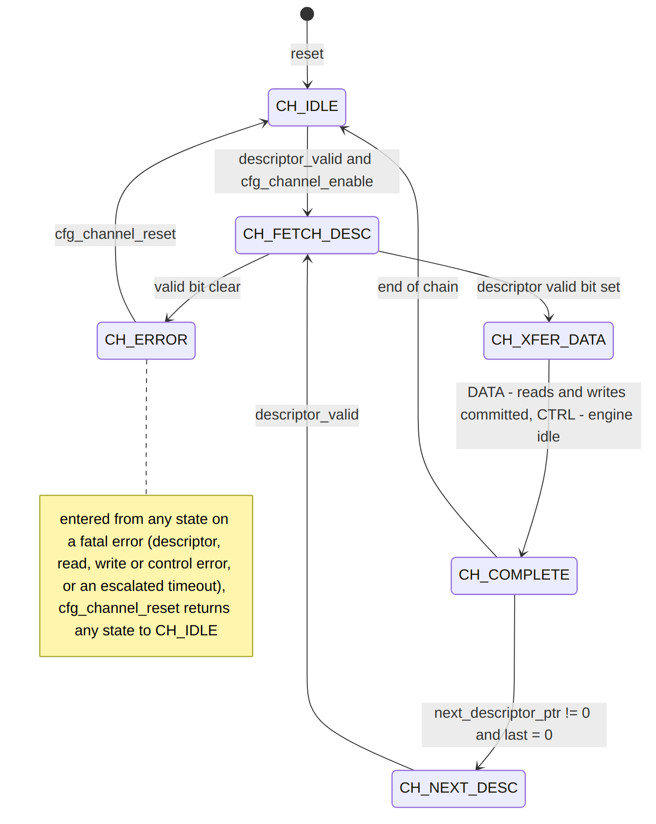
Diagram 1

6.4.2 State Encoding
Table 2.1.7: FSM State Encoding
State | Encoding | Description
CH_IDLE | 7’b0000001 | Waiting for a descriptor
CH_FETCH_DESC | 7’b0000010 | Descriptor latched and decoded
CH_XFER_DATA | 7’b0000100 | Concurrent read/write transfer, or the control operation
CH_COMPLETE | 7’b0001000 | Transfer complete; chain check
CH_NEXT_DESC | 7’b0010000 | Waiting for the next chained descriptor
CH_ERROR | 7’b0100000 | Sticky error; left only by channel reset
CH_RESERVED | 7’b1000000 | Reserved

6.5 Operation

6.5.1 Descriptor Format
Bits [63:0] - src_addr: Source memory address
Bits [127:64] - dst_addr: Destination memory address
Bits [159:128] - length: Transfer length in beats
Bits [191:160] - next_ptr: Next descriptor pointer (0 = last)
Bits [195:192] - channel_id: Channel identifier
Bits [196] - last: Last descriptor flag
Bits [197] - gen_irq: Generate interrupt
Bits [255:198] - reserved

6.5.2 Transfer Sequence

6.5.3 Figure 2.1.3: Basic Transfer Timing
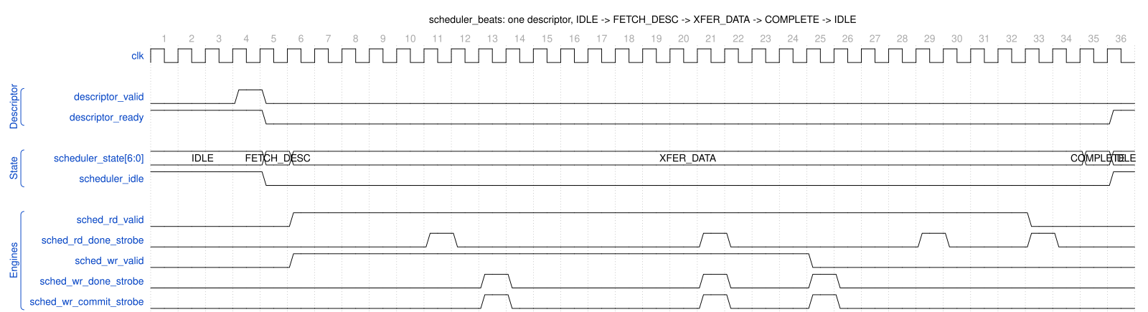
Scheduler - one descriptor through the FSM
Source: scheduler_basic_transfer.json, captured from dv/tests/fub_beats/test_scheduler_beats.py (basic_flow, channel 0 of 8, 512-bit, seed 7) with WAVES=1.
Reading it: descriptor_valid is accepted in IDLE; the FSM steps through FETCH_DESC into XFER_DATA and scheduler_idle drops. In XFER_DATA both engines are requested at once (sched_rd_valid and sched_wr_valid high together): the read engine reports each burst issued on sched_rd_done_strobe, the write engine reports issue on sched_wr_done_strobe and the B response on sched_wr_commit_strobe (here the model answers B immediately, so the two coincide). The write side finishes its beats first and drops sched_wr_valid; when the read side has issued its last burst the FSM moves to COMPLETE and back to IDLE, and descriptor_ready re-asserts for the next descriptor.

6.6 Run-Base Generator Flush
The two stream_run_addr_gen instances (EXT addressing) are flushed by the registered channel reset: generation stops, results in flight in dma_address_gen are discarded and the base FIFO (a gaxi_drop_fifo_sync) is dropped whole. Before 2026-10-21 nothing emptied it, and an EXT descriptor following a channel reset that interrupted another EXT descriptor began its second run at the interrupted descriptor’s base (rapids BUG-017, found in the byte-granular RAPIDS and fixed in RAPIDS, RAPIDS Beats and STREAM together). test_*_ext_channel_reset covers it.

6.7 Error Handling
Table 2.1.8: Error Handling
Error Source | Detection | Response
Descriptor engine | descriptor_error | Transition to CH_ERROR state
Read engine | sched_rd_error | Set sticky error flag
Write engine | sched_wr_error | Set sticky error flag
Write-progress timeout | Recoverable, escalates after limit | See below

6.7.1 Recoverable Write-Progress Timeout
The write-progress watchdog is recoverable and only escalates to a fatal fault after a configurable number of consecutive stalled windows:
- Window counting: r_timeout_counter increments while sched_wr_valid && !sched_wr_ready (a write request is stalled). The window expires when it reaches cfg_sched_timeout_cycles.
- Re-arm: On expiry the counter re-arms (resets to 0) and the scheduler keeps waiting; a single expired window is not fatal.
- Strike counting: r_timeout_strikes (8-bit) increments once per expired window. Any write progress – sched_wr_done_strobe (AW issue) or sched_wr_commit_strobe (B response) – clears both the window counter and the strike counter.
- Escalation: When cfg_sched_timeout_limit != 0 and r_timeout_strikes >= cfg_sched_timeout_limit, the channel escalates to a sticky CH_ERROR (surfaced on sched_error). Total time to escalate is approximately cfg_sched_timeout_limit * cfg_sched_timeout_cycles.
- Never-escalate mode: cfg_sched_timeout_limit == 0 is a pure soft timeout – the event may be reported, but the channel never faults.
scheduler_idle excludes CH_ERROR. Only CH_IDLE (with no active channel reset) is reported idle; a faulted channel in CH_ERROR is deliberately NOT reported idle so a wedged channel cannot read back as idle. The fault is surfaced via sched_error instead.

6.8 MonBus Events
Table 2.1.9: MonBus Event Codes
Event Code | Description
0x01 | Descriptor received
0x02 | Transfer started
0x03 | Transfer complete
0x04 | Error occurred
0x05 | Timeout

Last Updated: 2026-07-02

RTL Design Sherpa · Learning Hardware Design Through Practice GitHub · Documentation Index · MIT License

7 Descriptor Engine Specification
Module: descriptor_engine_beats.sv Location: projects/components/dma-ip/rapids/rtl/fub_beats/ Status: Implemented Last Updated: 2025-01-10

7.1 Overview
The Descriptor Engine fetches and manages 256-bit descriptors from memory via AXI4. It maintains a prefetch FIFO to hide memory latency and provides parsed descriptors to the scheduler.

7.1.1 Key Features
- AXI4 Descriptor Fetch: Single-beat 256-bit reads
- Prefetch FIFO: Configurable depth for latency hiding
- Address Range Checking: Validates descriptor addresses
- Error Detection: Address violations, AXI errors
- MonBus Integration: Fetch events and error reporting

7.1.2 Block Diagram

7.1.3 Figure 2.2.1: Descriptor Engine Block Diagram
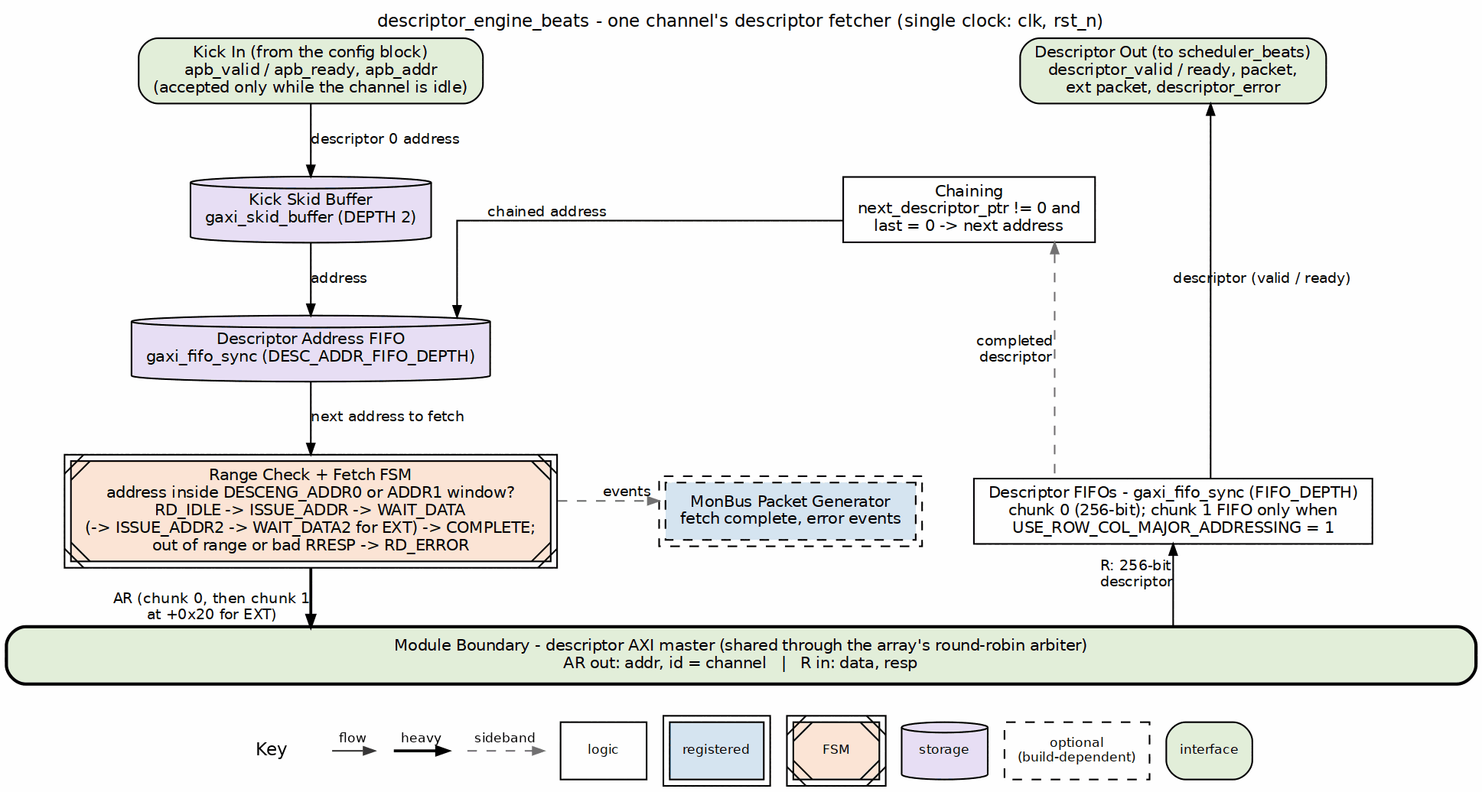
Descriptor engine block diagram
Source: 02_descriptor_engine.dot

7.2 Parameters
parameter int CHANNEL_ID = 0; // Channel identifier
parameter int NUM_CHANNELS = 8; // Total channels
parameter int ADDR_WIDTH = 64; // Address bus width
parameter int FIFO_DEPTH = 4; // Prefetch FIFO depth
// Monitor Bus Parameters
parameter logic [7:0] MON_AGENT_ID = 8'h10; // Descriptor Engine Agent ID
parameter logic [3:0] MON_UNIT_ID = 4'h1; // Unit identifier
: Table 2.2.1: Descriptor Engine Parameters

7.3 Port List

7.3.1 Clock and Reset
Table 2.2.2: Clock and Reset
Signal | Direction | Width | Description
clk | input | 1 | System clock
rst_n | input | 1 | Active-low asynchronous reset

7.3.2 APB Programming Interface
Table 2.2.3: APB Programming Interface
Signal | Direction | Width | Description
apb_valid | input | 1 | Kick-off valid (start descriptor chain)
apb_ready | output | 1 | Ready to accept kick-off
apb_addr | input | AW | First descriptor address

7.3.3 Configuration Interface
Table 2.2.4: Configuration Interface
Signal | Direction | Width | Description
cfg_prefetch_enable | input | 1 | Enable prefetch chaining (0 = on-demand, ~1 ahead)
cfg_fifo_threshold | input | 4 | Prefetch depth (descriptors buffered ahead when enabled)
cfg_addr0_base | input | AW | Valid address range 0 base
cfg_addr0_limit | input | AW | Valid address range 0 limit
cfg_addr1_base | input | AW | Valid address range 1 base
cfg_addr1_limit | input | AW | Valid address range 1 limit

7.3.4 AXI4 Read Master Interface
Table 2.2.5: AXI4 Read Master Interface
Signal | Direction | Width | Description
ar_valid | output | 1 | Address valid
ar_ready | input | 1 | Address ready
ar_addr | output | ADDR_WIDTH | Descriptor fetch address
ar_len | output | 8 | Burst length - 1
ar_size | output | 3 | Burst size (log2 bytes)
ar_burst | output | 2 | Burst type (INCR)
ar_id | output | AXI_ID_WIDTH | Transaction ID
ar_lock | output | 1 | Lock type
ar_cache | output | 4 | Cache attributes
ar_prot | output | 3 | Protection attributes
ar_qos | output | 4 | Quality of service
ar_region | output | 4 | Region identifier
r_valid | input | 1 | Data valid
r_ready | output | 1 | Data ready
r_data | input | 256 | Descriptor payload (fixed 256-bit)
r_resp | input | 2 | Read response
r_last | input | 1 | Last beat
r_id | input | AXI_ID_WIDTH | Response ID

7.3.5 Scheduler Interface
Table 2.2.6: Scheduler Interface
Signal | Direction | Width | Description
descriptor_valid | output | 1 | Descriptor valid
descriptor_ready | input | 1 | Scheduler ready
descriptor_packet | output | 256 | Parsed descriptor (fixed 256-bit)
descriptor_ext_packet | output | 256 | Extended chunk 1 (0 when unused)
descriptor_error | output | 1 | Error flag
descriptor_eos | output | 1 | End of Stream
descriptor_eol | output | 1 | End of Line
descriptor_eod | output | 1 | End of Data
descriptor_type | output | 2 | Packet type
channel_idle | input | 1 | Scheduler idle (enables APB kick-off)
descriptor_engine_idle | output | 1 | Engine idle

7.4 FSM States

7.4.1 Figure 2.2.2: Descriptor Engine FSM
States and transitions of the descriptor_engine_beats fetch FSM.
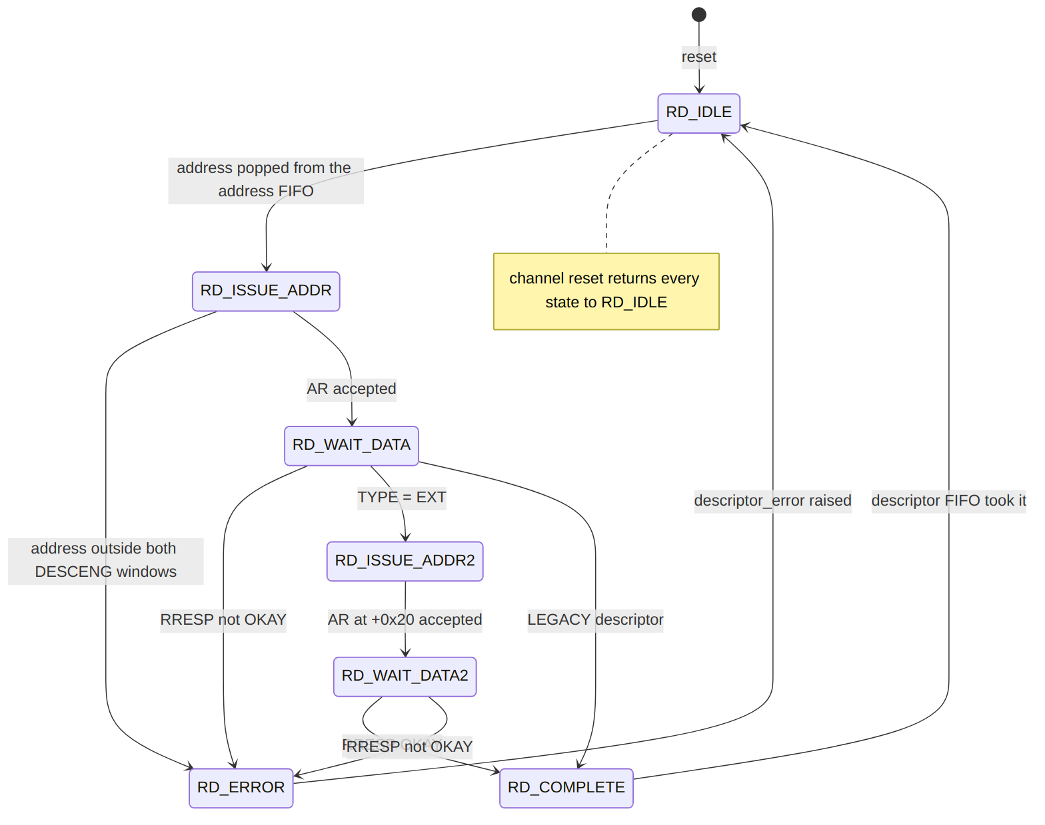
Diagram 2

7.5 Operation

7.5.1 Descriptor Chain Processing

7.5.2 Figure 2.2.3: Descriptor Chain Timing

Descriptor Engine - three-descriptor chain
Source: descriptor_engine_chain.json, captured from dv/tests/fub_beats/test_descriptor_engine_beats.py (descriptor_chaining, 32 channels, seed 7) with WAVES=1.
Reading it: one apb_valid kick carries the head address (0x10000). The engine issues an AXI read for it (ar_valid, ar_addr), the data returns on r_valid, and the parsed descriptor is presented on descriptor_valid to a ready scheduler. Because the descriptor’s next_ptr points at 0x10040 and last is clear, the engine fetches the next one on its own – and the one after that at 0x10080 – with no further APB traffic; descriptor_eol marks the last of the chain. Each fetch costs the same AR -> R -> present latency, so a chain streams at one descriptor per fetch round trip.

7.6 Address Range Checking
Descriptors must fall within configured valid address ranges:
Valid if: (addr >= cfg_addr0_base && addr <= cfg_addr0_limit)
|| (addr >= cfg_addr1_base && addr <= cfg_addr1_limit)
Invalid addresses generate an error and halt the descriptor chain.

7.7 Prefetch and Autonomous Chaining
cfg_prefetch_enable and cfg_fifo_threshold are functional prefetch controls (previously declared-but-unused, which left chaining permanently greedy). They throttle how far ahead the engine fetches chained descriptors by comparing the output descriptor FIFO occupancy (w_desc_fifo_count) against a computed w_prefetch_limit:
if (!cfg_prefetch_enable) w_prefetch_limit = 1; // on-demand
else if (cfg_fifo_threshold == 0) w_prefetch_limit = 1; // guard (0 would stall)
else w_prefetch_limit = cfg_fifo_threshold;
w_prefetch_allows = (w_desc_fifo_count < w_prefetch_limit);
- Prefetch OFF (cfg_prefetch_enable = 0): limit forced to 1, so a chained fetch is only allowed when the output FIFO has drained – the engine stays roughly one descriptor ahead of the scheduler (on-demand).
- Prefetch ON: the engine buffers up to cfg_fifo_threshold descriptors ahead.

7.7.1 Chaining Decision
A chain fetch issues immediately when all of the following hold:
w_should_chain = w_chain_eligible // valid non-last descriptor, in range, no error
&& w_desc_committed // current descriptor accepted into output FIFO
&& w_prefetch_allows // occupancy below prefetch limit
&& w_desc_addr_fifo_wr_ready; // address FIFO has a slot

7.7.2 Deferred (Throttle-Blocked) Chain Fetch
If a descriptor commits and is chain-eligible but the fetch cannot issue this cycle (throttled by w_prefetch_allows, or the address FIFO is full), the owed fetch is recorded rather than dropped:
- r_chain_pending is set and the next-descriptor pointer is held in r_pending_chain_addr.
- The deferred fetch is reissued (w_pending_push_fire) once the output FIFO drains enough that w_prefetch_allows is true again and the address FIFO has a slot, clearing r_chain_pending.

Last Updated: 2026-07-02

RTL Design Sherpa · Learning Hardware Design Through Practice GitHub · Documentation Index · MIT License

8 AXI Read Engine Specification
Module: axi_read_engine_beats.sv Location: projects/components/dma-ip/rapids/rtl/fub_beats/ Status: Implemented Last Updated: 2026-09-29

8.1 Overview
The AXI Read Engine performs burst reads from system memory and writes data to the SRAM buffer. It operates as a streaming pipeline with no FSM, maximizing throughput through continuous data flow.

8.1.1 Key Features
- Streaming Pipeline: No FSM - pure streaming architecture
- Multi-Channel Support: Channel ID passed through AXI ID field
- Configurable Burst Length: Up to 256 beats per burst
- SRAM fill only: writes R-channel beats straight into the SRAM controller’s fill_* port (the latency bridge lives in STREAM’s sram_controller_unit, not here)
- Error Handling: AXI RRESP error detection and reporting

8.1.2 Block Diagram

8.1.3 Figure 2.3.1: AXI Read Engine Block Diagram
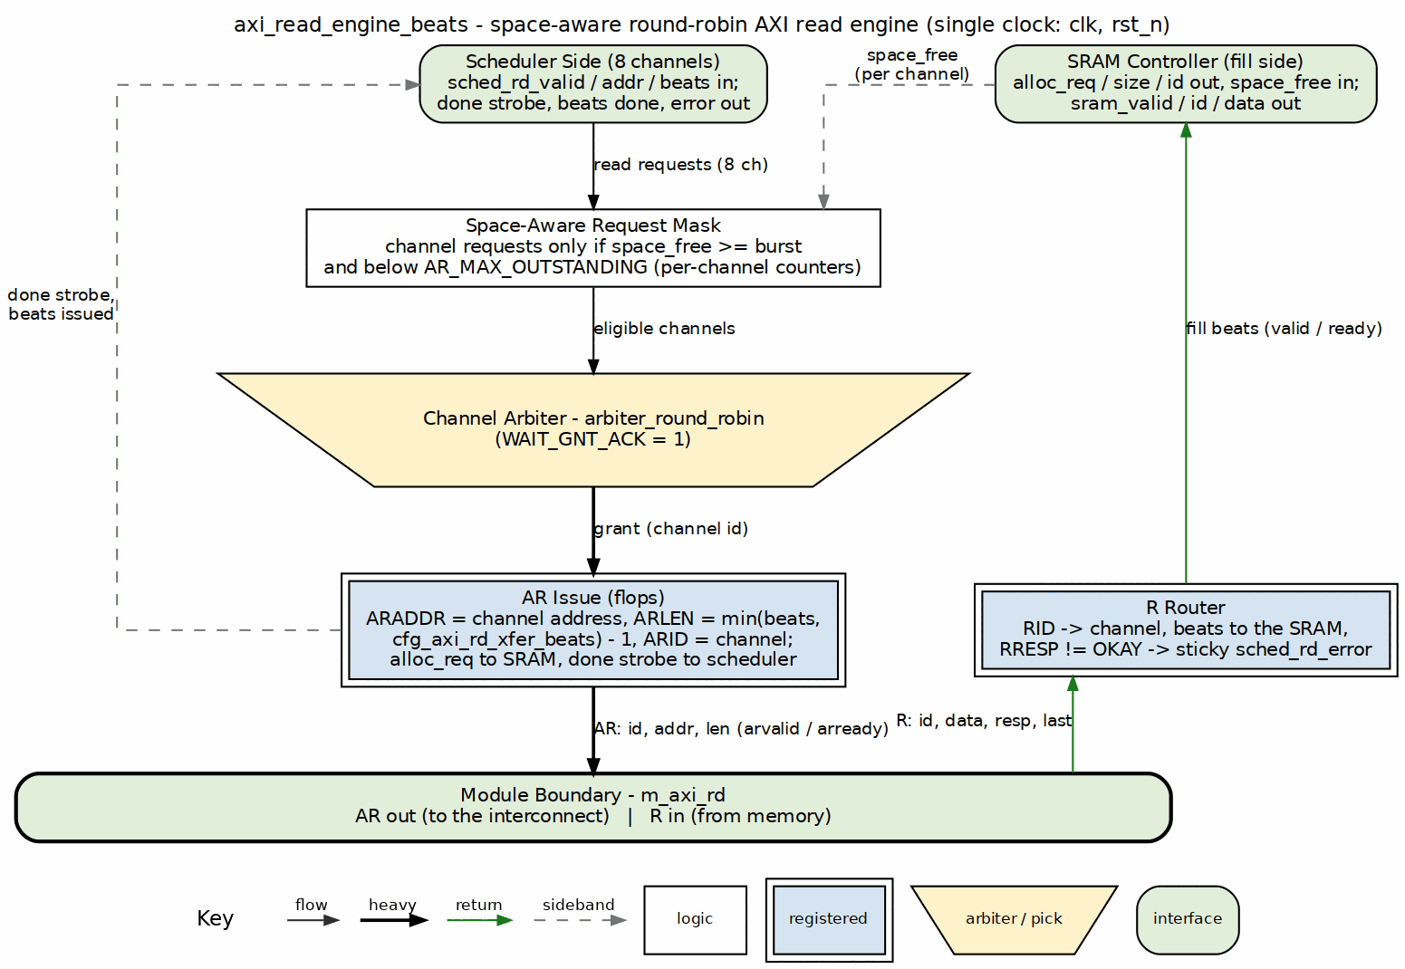
AXI read engine block diagram
Source: 03_axi_read_engine.dot

8.2 Parameters
parameter int NUM_CHANNELS = 8; // Number of channels
parameter int ADDR_WIDTH = 64; // Address bus width
parameter int DATA_WIDTH = 512; // Data bus width
parameter int AXI_ID_WIDTH = 8; // AXI ID width
parameter int MAX_OUTSTANDING = 8; // Max outstanding AR transactions
parameter int PIPELINE = 1; // Pipeline stages
// Derived
parameter int CHAN_WIDTH = $clog2(NUM_CHANNELS);
: Table 2.3.1: AXI Read Engine Parameters

8.3 Port List

8.3.1 Clock and Reset
Table 2.3.2: Clock and Reset
Signal | Direction | Width | Description
clk | input | 1 | System clock
rst_n | input | 1 | Active-low reset

8.3.2 Scheduler Interface
Table 2.3.3: Scheduler Interface
Signal | Direction | Width | Description
sched_rd_valid | input | NC | Channel requests read
sched_rd_addr | input | NC x AW | Source addresses
sched_rd_beats | input | NC x 32 | Beats remaining to read
sched_rd_done_strobe | output | NC | Burst completed (pulsed 1 cycle)
sched_rd_beats_done | output | NC x 32 | Beats completed in burst
sched_rd_error | output | NC | Sticky error flag per channel (bad R response)

8.3.3 AXI4 Read Master Interface
Table 2.3.4: AXI4 Read Master Interface
Signal | Direction | Width | Description
m_axi_arid | output | IW | Read address ID
m_axi_araddr | output | AW | Read address
m_axi_arlen | output | 8 | Burst length (beats - 1)
m_axi_arsize | output | 3 | Burst size
m_axi_arburst | output | 2 | Burst type (INCR)
m_axi_arvalid | output | 1 | Address valid
m_axi_arready | input | 1 | Address ready
m_axi_rid | input | IW | Read data ID
m_axi_rdata | input | DW | Read data
m_axi_rresp | input | 2 | Read response
m_axi_rlast | input | 1 | Last beat
m_axi_rvalid | input | 1 | Data valid
m_axi_rready | output | 1 | Data ready

8.3.4 SRAM Allocation and Fill Interface
Table 2.3.5: SRAM Write Interface
Signal | Direction | Width | Description
axi_rd_alloc_req | output | 1 | Channel requests space
axi_rd_alloc_size | output | 8 | Beats to reserve
axi_rd_alloc_id | output | IW | Transaction ID selects the channel
axi_rd_alloc_space_free | input | NC x SCW | Free space (beats available) per channel
axi_rd_sram_valid | output | 1 | Read data valid
axi_rd_sram_ready | input | 1 | SRAM ready to accept data
axi_rd_sram_id | output | IW | Transaction ID selects the channel
axi_rd_sram_data | output | DW | Read data payload

8.4 Operation

8.4.1 Burst Length Cap (rapids BUG-009)
cfg_axi_rd_xfer_beats is an ARLEN (0..255), but a burst can never be larger than the SRAM it lands in: w_space_ok pre-allocates the whole burst before the AR, and a burst the buffer cannot hold would never be allocatable. The engine therefore clamps the configured value to XFER_MAX = min(2^(SCW-1) - 1, 254) – the buffer depth SEG_COUNT_WIDTH encodes, minus one, and 254 beyond that so every beat count fits the 8-bit size ports shared with sram_controller. On the Genesys 2 build (128-deep) ARLEN 255 runs as 128-beat bursts.
Before the clamp (2026-09-29), ARLEN 255 was taken literally and the 8-bit ARLEN + 1 in the gate wrapped to 0: w_space_ok passed on any free count, the AR for 256 beats allocated 0, and the engine over-fetched past the buffer (4103 R beats for a 4096-beat descriptor on the board, golden mismatch).

8.4.2 Streaming Pipeline Architecture
The AXI read engine uses a streaming pipeline with no FSM:
- Scheduler request: per-channel beat count, masked by SRAM space.
- AR issue: round-robin grant, burst address and length, space allocation.
- R receive: data routed to the channel by RID.
- SRAM write: one fill beat per R beat.

8.4.3 Timing Diagram

8.4.4 Figure 2.3.2: AXI Read Burst Timing
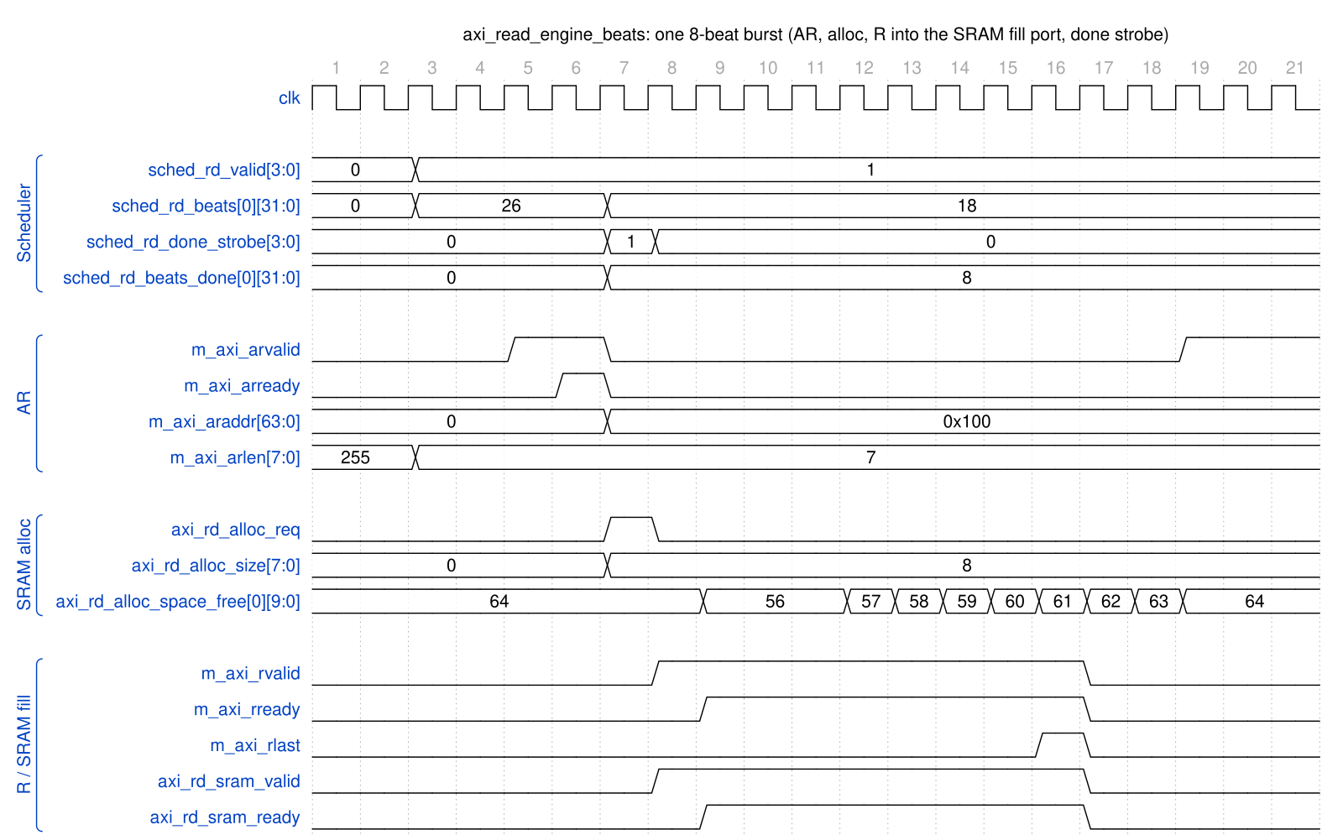
AXI Read Engine - one 8-beat burst
Source: axi_read_engine_burst.json, captured from dv/tests/fub_beats/test_axi_read_engine_beats.py (single, 4 ch, 256-bit, cfg_axi_rd_xfer_beats = 7, seed 7) with WAVES=1.
Reading it: the scheduler holds sched_rd_valid with 26 beats remaining; the arbiter grants channel 0 and the AR (arlen = 7) handshakes two cycles later. The cycle after the handshake the engine pulses sched_rd_done_strobe with beats_done = 8 (the scheduler advances address and remaining on it – note sched_rd_beats drops 26 to 18 and araddr for the next AR is already 0x100) and axi_rd_alloc_req with alloc_size = 8; the modelled space_free debits two cycles later, as the real controller does. R beats pass straight through to axi_rd_sram_valid; rlast closes the burst. The engine never waits for the data before issuing the next AR of another channel, but at PIPELINE = 0 this channel’s next AR waits for rlast.

8.5 Burst Segmentation
Large transfers are segmented into AXI-compliant bursts:
Total beats = 256
cfg_xfer_beats = 64
Bursts issued:
AR[0]: addr=0x1000, len=63 (64 beats)
AR[1]: addr=0x2000, len=63 (64 beats)
AR[2]: addr=0x3000, len=63 (64 beats)
AR[3]: addr=0x4000, len=63 (64 beats)

8.6 Error Handling
Table 2.3.6: Error Handling
Error | Detection | Response
AXI SLVERR | m_axi_rresp == 2'b10 | Set sched_rd_error, continue
AXI DECERR | m_axi_rresp == 2'b11 | Set sched_rd_error, continue

Last Updated: 2026-09-29

RTL Design Sherpa · Learning Hardware Design Through Practice GitHub · Documentation Index · MIT License

9 AXI Write Engine Specification
Module: axi_write_engine_beats.sv Location: projects/components/dma-ip/rapids/rtl/fub_beats/ Status: Implemented Last Updated: 2026-09-29

9.1 Overview
The AXI Write Engine reads data from SRAM and performs burst writes to system memory. It operates as a streaming pipeline and includes write response handling for completion tracking.

9.1.1 Key Features
- Streaming Pipeline: No FSM - pure streaming architecture
- Multi-Channel Support: Channel ID in AXI ID field
- Write Response Tracking: B channel completion handling
- Configurable Burst Length: Up to 256 beats per burst
- Registered SRAM read: consumes the SRAM controller’s registered drain_* stream (the latency bridge lives in STREAM’s sram_controller_unit, not here)

9.1.2 Block Diagram

9.1.3 Figure 2.4.1: AXI Write Engine Block Diagram
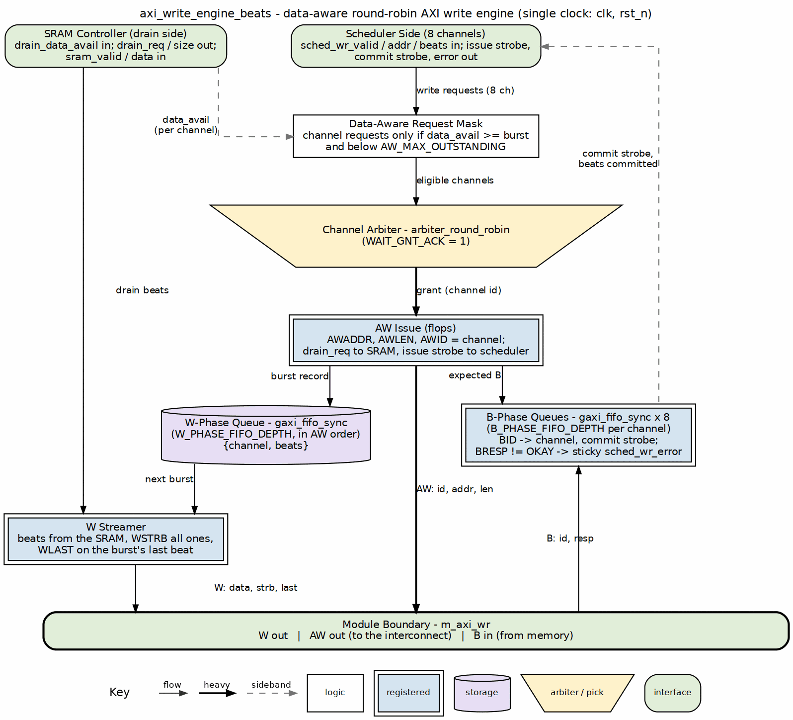
AXI write engine block diagram
Source: 04_axi_write_engine.dot

9.2 Parameters
parameter int NUM_CHANNELS = 8; // Number of channels
parameter int ADDR_WIDTH = 64; // Address bus width
parameter int DATA_WIDTH = 512; // Data bus width
parameter int AXI_ID_WIDTH = 8; // AXI ID width
parameter int MAX_OUTSTANDING = 8; // Max outstanding AW transactions
parameter int W_FIFO_DEPTH = 64; // Write data FIFO depth
parameter int B_FIFO_DEPTH = 16; // Write response FIFO depth
parameter int PIPELINE = 1; // Pipeline stages
// Derived
parameter int CHAN_WIDTH = $clog2(NUM_CHANNELS);
: Table 2.4.1: AXI Write Engine Parameters

9.3 Port List

9.3.1 Clock and Reset
Table 2.4.2: Clock and Reset
Signal | Direction | Width | Description
clk | input | 1 | System clock
rst_n | input | 1 | Active-low reset

9.3.2 Scheduler Interface
Table 2.4.3: Scheduler Interface
Signal | Direction | Width | Description
sched_wr_valid | input | NC | Channel requests write
sched_wr_ready | output | NC | Engine ready for channel
sched_wr_addr | input | NC x AW | Destination addresses
sched_wr_beats | input | NC x 32 | Beats remaining to write
sched_wr_burst_len | input | NC x 8 | Requested burst length
sched_wr_done_strobe | output | NC | Burst ISSUED on AW handshake (pulsed 1 cycle)
sched_wr_beats_done | output | NC x 32 | Beats issued in burst (awlen + 1)
sched_wr_commit_strobe | output | NC | Burst COMMITTED on B response (pulsed 1 cycle)
sched_wr_commit_beats | output | NC x 32 | Beats committed in burst
sched_wr_error | output | NC | Sticky error flag per channel (bad B response)
Two completion strobes per channel. The engine reports write progress to the scheduler at two points, letting the scheduler gate completion on data actually landing in memory:
- sched_wr_done_strobe / sched_wr_beats_done pulse when the AW command handshakes (m_axi_awvalid && m_axi_awready); the beat count is taken directly from m_axi_awlen + 1. This advances the scheduler’s destination address (ISSUE tracking).
- sched_wr_commit_strobe / sched_wr_commit_beats pulse when the matching B response arrives (m_axi_bvalid && m_axi_bready for the channel); the beat count is recovered from the per-channel B-phase transaction FIFO. This is the COMMIT the scheduler uses to declare the transfer complete.

9.3.3 AXI4 Write Master Interface
Table 2.4.4: AXI4 Write Master Interface
Signal | Direction | Width | Description
m_axi_awid | output | IW | Write address ID
m_axi_awaddr | output | AW | Write address
m_axi_awlen | output | 8 | Burst length (beats - 1)
m_axi_awsize | output | 3 | Burst size
m_axi_awburst | output | 2 | Burst type (INCR)
m_axi_awvalid | output | 1 | Address valid
m_axi_awready | input | 1 | Address ready
m_axi_wdata | output | DW | Write data
m_axi_wstrb | output | DW/8 | Write strobes
m_axi_wlast | output | 1 | Last beat
m_axi_wuser | output | UW | Channel ID for transaction tracking
m_axi_wvalid | output | 1 | Data valid
m_axi_wready | input | 1 | Data ready
m_axi_bid | input | IW | Response ID
m_axi_bresp | input | 2 | Write response
m_axi_bvalid | input | 1 | Response valid
m_axi_bready | output | 1 | Response ready

9.3.4 SRAM Reservation and Drain Interface
Table 2.4.5: SRAM Read Interface
Signal | Direction | Width | Description
axi_wr_drain_req | output | NC | Channel requests to reserve data
axi_wr_drain_size | output | NC x 8 | Beats to reserve
axi_wr_drain_data_avail | input | NC x SCW | Data available after reservations
axi_wr_sram_valid | input | NC | Per-channel valid (registered, for arbitration)
axi_wr_sram_valid_comb | input | NC | Per-channel valid (combinational, gates m_axi_wvalid)
axi_wr_sram_drain | output | 1 | Drain request (consumer ready)
axi_wr_sram_id | output | CIW | Channel ID select for drain
axi_wr_sram_data | input | DW | Data from the selected channel (muxed)

9.4 Operation

9.4.1 Burst Length Cap (rapids BUG-009)
cfg_axi_wr_xfer_beats is an AWLEN (0..255), but a burst can never be larger than the SRAM that stages it: w_has_data waits for the whole burst to be in the buffer, and a burst the buffer cannot hold would wait forever. The engine therefore clamps the configured value to XFER_MAX = min(2^(SCW-1) - 1, 254) – the buffer depth SEG_COUNT_WIDTH encodes, minus one, and 254 beyond that so every beat count fits the 8-bit size ports shared with sram_controller. On the Genesys 2 build (128-deep) AWLEN 255 runs as 128-beat bursts.
Before the clamp (2026-09-29), AWLEN 255 was taken literally and the 8-bit AWLEN + 1 in the gate wrapped to 0: w_has_data passed on an empty buffer, the AW went out, drain_ctrl reserved 0 beats and the W phase pulled 256 beats that were never reserved. The channel’s drain_data_available then read 0 for good (CHANNEL_RESET does not reach sram_controller), and every later run on the channel accepted one buffer of ingress and never issued an AW.

9.4.2 Write Transaction Phases
AXI writes have three phases that can overlap:
Phase 1: AW (Address) Phase 2: W (Data) Phase 3: B (Response)
| | |
+-- Issue address +-- Stream data +-- Receive response
before data from SRAM track completion

9.4.3 Timing Diagram

9.4.4 Figure 2.4.2: AXI Write Burst Timing
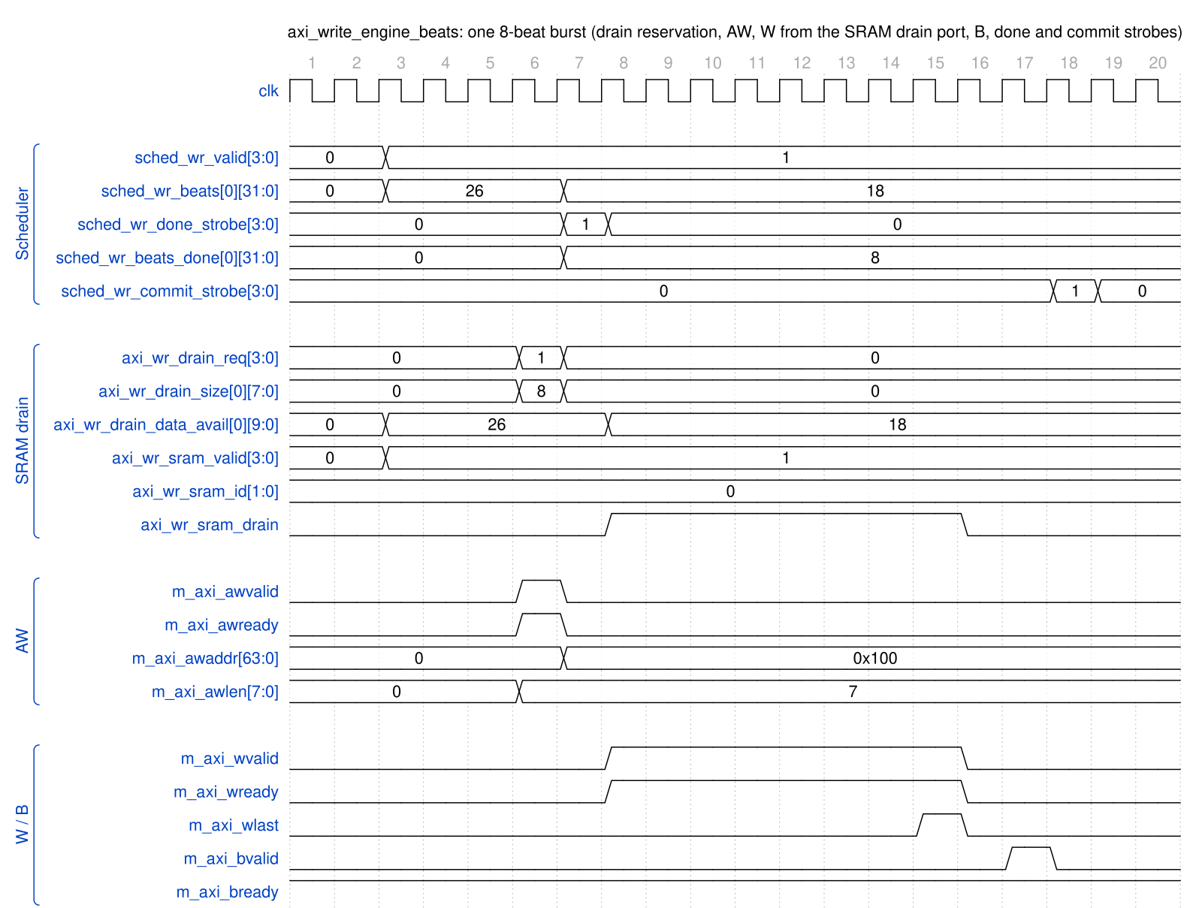
AXI Write Engine - one 8-beat burst
Source: axi_write_engine_burst.json, captured from dv/tests/fub_beats/test_axi_write_engine_beats.py (single, 4 ch, 256-bit, cfg_axi_wr_xfer_beats = 7, seed 7) with WAVES=1.
Reading it: the SRAM model reports 26 beats available for channel 0 and the scheduler holds sched_wr_valid. The arbiter grants the channel, the AW (awlen = 7) is registered and handshakes; in that same cycle axi_wr_drain_req reserves 8 beats (data_avail drops to 18 two cycles later, the controller’s reporting latency), and the cycle after, sched_wr_done_strobe reports 8 beats issued so the scheduler advances (awaddr for the next AW is already 0x100). W beats stream from the ID-selected drain port (axi_wr_sram_drain is exactly wvalid && wready), wlast closes the burst, and the B response two cycles later raises sched_wr_commit_strobe. At PIPELINE = 0 the channel’s next AW waits for that B.
That wait is the throughput cost of PIPELINE = 0: with 8-beat bursts a channel spends the AW-to-B round trip idle, and on the Genesys 2 the 8-channel sink write path measured 49.9 % engaged utilization at 4096 beats per channel once BUG-005 made the engine honour one-in-flight (the pre-fix engine had run two by accident and read 100 %). The top and core therefore default PIPELINE = 1, which restores line rate, and since 2026-09-28 so does every module that declares the parameter, this engine included: 0 is selectable, never the default.

9.5 Error Handling
Table 2.4.6: Error Handling
Error | Detection | Response
AXI SLVERR | m_axi_bresp == 2'b10 | Set sched_wr_error
AXI DECERR | m_axi_bresp == 2'b11 | Set sched_wr_error

Last Updated: 2026-09-29

RTL Design Sherpa · Learning Hardware Design Through Practice GitHub · Documentation Index · MIT License

10 Beats Alloc Control Specification
Module: alloc_ctrl_beats.sv Location: projects/components/dma-ip/rapids/rtl/fub_beats/ Status: Implemented Last Updated: 2025-01-10
No longer in the SRAM datapath (2026-09-26). RAPIDS’ SRAM path now uses STREAM’s stream_alloc_ctrl / stream_drain_ctrl / stream_latency_bridge, reached through the snk_/src_sram_controller_beats naming wrappers (bdf4e0dff). This FUB is still built and still verified – it keeps its own test, its own filelist and its rapids_all.f entry – it simply is not instantiated by the SRAM controllers any more. Treat this page as the FUB’s own specification, not as a description of the current SRAM path.

10.1 Overview
The Beats Alloc Control is a “virtual FIFO” that tracks space allocation without storing actual data. It uses FIFO pointer logic to manage pre-allocation for AXI engines, preventing race conditions between allocation and actual data arrival.

10.1.1 Key Features
- Virtual FIFO: Pointer tracking without data storage
- Variable-Size Allocation: Supports multi-beat allocation requests
- Single-Beat Release: Data writes release one beat at a time
- Status Flags: Full, almost full, empty, almost empty
- Space Tracking: Reports available space for flow control

10.1.2 Block Diagram

10.1.3 Figure 2.5.1: Beats Alloc Control Block Diagram
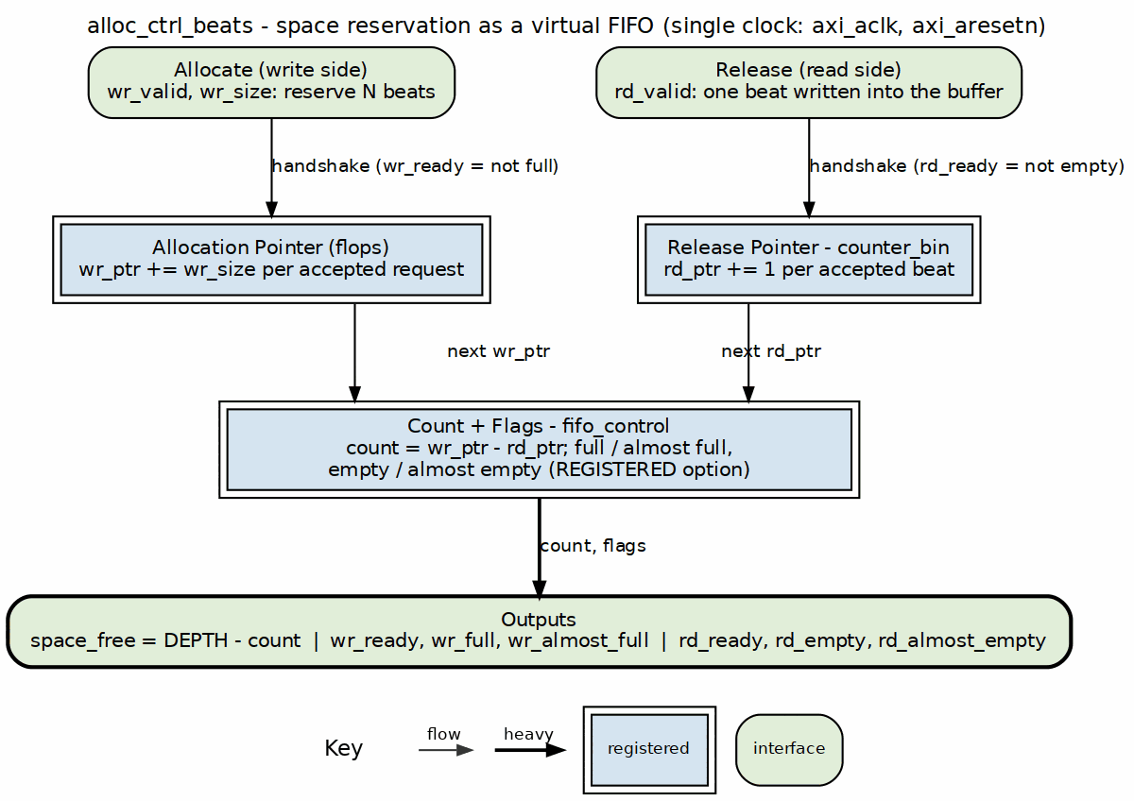
Alloc control block diagram
Source: 05_alloc_ctrl.dot

10.2 Concept: Virtual FIFO
Unlike a traditional FIFO that stores data, alloc_ctrl_beats only tracks space reservations:
 | Traditional FIFO | Virtual FIFO (alloc_ctrl_beats)
Write side | wr_data into storage | wr_size advances a pointer
Read side | rd_data out of storage | one beat advances a pointer
Output | data | space_free

10.2.1 Use Case: Pre-Allocation for AXI Reads
1. AXI engine requests N beats of space
- alloc_ctrl.wr_valid = 1
- alloc_ctrl.wr_size = N
- wr_ptr advances by N
2. As AXI read data arrives (1 beat at a time)
- alloc_ctrl.rd_valid = 1 (each beat)
- rd_ptr advances by 1
3. Space becomes available again
- space_free reflects available capacity

10.3 Parameters
parameter int DEPTH = 512; // Virtual FIFO depth
parameter int ALMOST_WR_MARGIN = 1; // Almost full margin
parameter int ALMOST_RD_MARGIN = 1; // Almost empty margin
parameter int REGISTERED = 1; // Registered outputs
// Derived
parameter int AW = $clog2(DEPTH); // Address width
: Table 2.5.1: Beats Alloc Control Parameters

10.4 Port List

10.4.1 Clock and Reset
Table 2.5.2: Clock and Reset
Signal | Direction | Width | Description
axi_aclk | input | 1 | System clock
axi_aresetn | input | 1 | Active-low reset

10.4.2 Write Interface (Allocation Requests)
Table 2.5.3: Write Interface
Signal | Direction | Width | Description
wr_valid | input | 1 | Allocate space
wr_size | input | 8 | Number of beats to allocate
wr_ready | output | 1 | Space available for allocation

10.4.3 Read Interface (Data Written)
Table 2.5.4: Read Interface
Signal | Direction | Width | Description
rd_valid | input | 1 | One beat of data written
rd_ready | output | 1 | Not full (can accept)

10.4.4 Status Outputs
Table 2.5.5: Status Outputs
Signal | Direction | Width | Description
space_free | output | AW+1 | Available space in beats
wr_full | output | 1 | No space available
wr_almost_full | output | 1 | Near full
rd_empty | output | 1 | No allocations pending
rd_almost_empty | output | 1 | Near empty

10.5 Operation

10.5.1 Pointer Arithmetic
space_free = DEPTH - (wr_ptr - rd_ptr)
Full condition: wr_ptr - rd_ptr >= DEPTH
Empty condition: wr_ptr == rd_ptr

10.5.2 Timing Diagram

10.5.3 Figure 2.5.2: Allocation and Release Timing

Allocation control - allocate then release
Source: alloc_ctrl_beats_alloc_release.json, captured from dv/tests/fub_beats/test_alloc_ctrl_beats.py (basic_alloc_drain, depth 512, seed 7) with WAVES=1.
Reading it: one wr_valid handshake with wr_size = 6 reserves six beats and space_free drops 512 to 506 the next cycle; rd_empty falls because reserved space is now outstanding. Each later rd_valid handshake releases one beat and space_free climbs back one at a time (507, 508, …). wr_full and wr_almost_full stay low: the virtual FIFO is nowhere near its depth.

10.6 Integration Example
// Source path: Pre-allocate SRAM space before AXI read
alloc_ctrl_beats #(
.DEPTH(SRAM_DEPTH),
.ALMOST_WR_MARGIN(8)
) u_src_alloc (
.axi_aclk (clk),
.axi_aresetn (rst_n),
// Scheduler allocates space before issuing AXI read
.wr_valid (sched_rd_valid),
.wr_size (sched_rd_beats[7:0]),
.wr_ready (alloc_ready),
// AXI read data arrival releases allocation
.rd_valid (m_axi_rvalid && m_axi_rready),
.rd_ready (), // Not used for single-beat
// Status
.space_free (sram_space_available),
.wr_full (sram_full),
.wr_almost_full (sram_almost_full)
);

Last Updated: 2025-01-10

RTL Design Sherpa · Learning Hardware Design Through Practice GitHub · Documentation Index · MIT License

11 Beats Drain Control Specification
Module: drain_ctrl_beats.sv Location: projects/components/dma-ip/rapids/rtl/fub_beats/ Status: Implemented Last Updated: 2025-01-10
No longer in the SRAM datapath (2026-09-26). RAPIDS’ SRAM path now uses STREAM’s stream_alloc_ctrl / stream_drain_ctrl / stream_latency_bridge, reached through the snk_/src_sram_controller_beats naming wrappers (bdf4e0dff). This FUB is still built and still verified – it keeps its own test, its own filelist and its rapids_all.f entry – it simply is not instantiated by the SRAM controllers any more. Treat this page as the FUB’s own specification, not as a description of the current SRAM path.

11.1 Overview
The Beats Drain Control is a “virtual FIFO” that tracks data availability without storing actual data. It complements alloc_ctrl_beats by tracking when data has been written to SRAM and is available for draining.

11.1.1 Key Features
- Virtual FIFO: Pointer tracking without data storage
- Single-Beat Write: Data arrivals tracked one beat at a time
- Variable-Size Drain: Supports multi-beat drain requests
- Status Flags: Full, almost full, empty, almost empty
- Data Availability: Reports beats available for drain

11.1.2 Block Diagram

11.1.3 Figure 2.6.1: Beats Drain Control Block Diagram
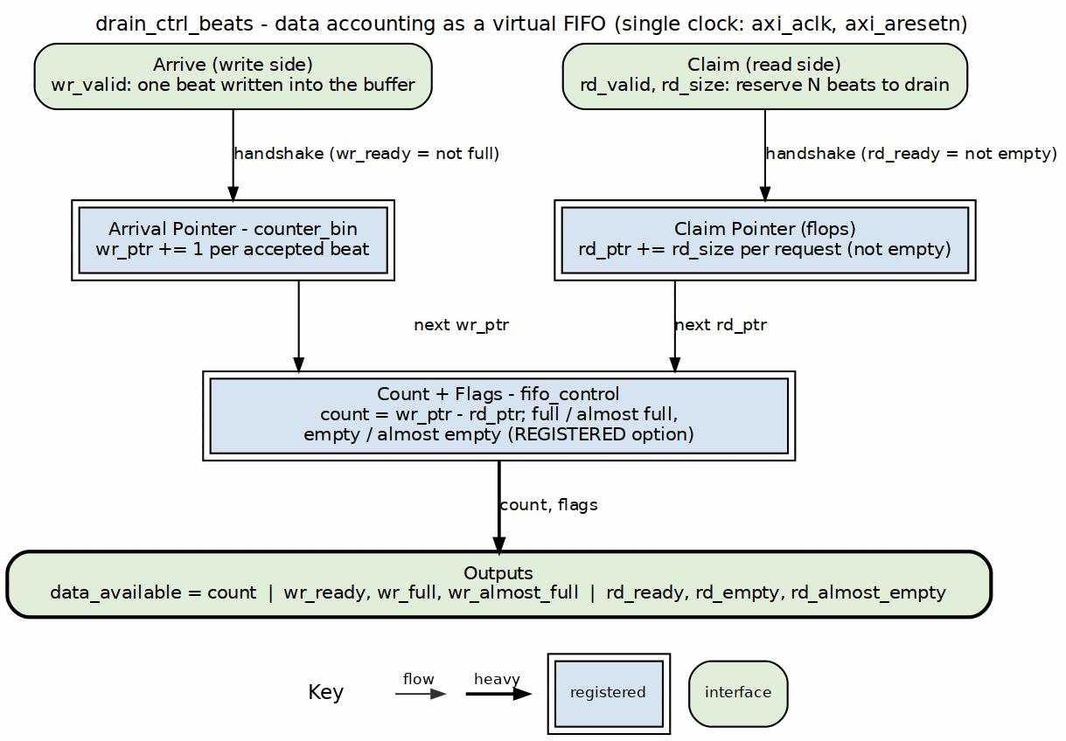
Drain control block diagram
Source: 06_drain_ctrl.dot

11.2 Concept: Data Availability Tracking
The drain_ctrl tracks when data has been written to SRAM:
alloc_ctrl: Tracks SPACE reservations (allocation -> actual write)
drain_ctrl: Tracks DATA availability (data write -> drain request)

11.2.1 Complementary Roles
Source Path:
1. Scheduler allocates space (alloc_ctrl.wr)
2. AXI reads data into SRAM
3. Data written to SRAM (drain_ctrl.wr)
4. Drain consumer reads (drain_ctrl.rd)
Sink Path:
1. Fill allocates space (alloc_ctrl.wr)
2. Fill writes to SRAM (alloc_ctrl.rd)
3. Data available in SRAM (drain_ctrl.wr)
4. AXI write drains SRAM (drain_ctrl.rd)

11.3 Parameters
parameter int DEPTH = 512; // Virtual FIFO depth
parameter int ALMOST_WR_MARGIN = 1; // Almost full margin
parameter int ALMOST_RD_MARGIN = 1; // Almost empty margin
parameter int REGISTERED = 1; // Registered outputs
// Derived
parameter int AW = $clog2(DEPTH); // Address width
: Table 2.6.1: Beats Drain Control Parameters

11.4 Port List

11.4.1 Clock and Reset
Table 2.6.2: Clock and Reset
Signal | Direction | Width | Description
axi_aclk | input | 1 | System clock
axi_aresetn | input | 1 | Active-low reset

11.4.2 Write Interface (Data Written to SRAM)
Table 2.6.3: Write Interface
Signal | Direction | Width | Description
wr_valid | input | 1 | One beat written to SRAM
wr_ready | output | 1 | Can track more data

11.4.3 Read Interface (Drain Requests)
Table 2.6.4: Read Interface
Signal | Direction | Width | Description
rd_valid | input | 1 | Drain request
rd_size | input | 8 | Number of beats to drain
rd_ready | output | 1 | Data available for drain

11.4.4 Status Outputs
Table 2.6.5: Status Outputs
Signal | Direction | Width | Description
data_available | output | AW+1 | Beats available to drain
wr_full | output | 1 | Tracking full
wr_almost_full | output | 1 | Near full
rd_empty | output | 1 | No data to drain
rd_almost_empty | output | 1 | Near empty

11.5 Operation

11.5.1 Pointer Arithmetic
data_avail = wr_ptr - rd_ptr
Full condition: wr_ptr - rd_ptr >= DEPTH
Empty condition: wr_ptr == rd_ptr

11.5.2 Timing Diagram

11.5.3 Figure 2.6.2: Data Arrival and Drain Timing

Drain control - single-beat arrivals then a multi-beat drain
Source: drain_ctrl_beats_arrive_drain.json, captured from dv/tests/fub_beats/test_drain_ctrl_beats.py (basic_write_drain, depth 512, seed 7) with WAVES=1.
Reading it: six wr_valid handshakes, one beat each, raise data_available 1, 2, … 6 and drop rd_empty on the first arrival. A single rd_valid handshake with rd_size = 6 then reserves all six at once: data_available returns to 0 and rd_empty rises the next cycle. The counter tracks beats, not bytes, and never touches the data itself.

11.6 Integration Example
// Sink path: Track data availability for AXI write engine
drain_ctrl_beats #(
.DEPTH(SRAM_DEPTH),
.ALMOST_RD_MARGIN(8)
) u_snk_drain (
.axi_aclk (clk),
.axi_aresetn (rst_n),
// Fill writes data to SRAM
.wr_valid (fill_valid && fill_ready),
.wr_ready (), // Single-beat, always ready
// AXI write engine drains data
.rd_valid (axi_wr_drain_req),
.rd_size (axi_wr_burst_len),
.rd_ready (data_ready_for_drain),
// Status
.data_available (beats_to_write),
.rd_empty (no_data_to_write)
);

11.7 Relationship: alloc_ctrl vs drain_ctrl
Table 2.6.6: alloc_ctrl vs drain_ctrl Comparison
Aspect | alloc_ctrl_beats | drain_ctrl_beats
Tracks | Space reservations | Data availability
Write port | Multi-beat allocation | Single-beat arrival
Read port | Single-beat release | Multi-beat drain
Output | space_free | data_available
Use case | Pre-allocate before fill | Know when to drain

Last Updated: 2025-01-10

RTL Design Sherpa · Learning Hardware Design Through Practice GitHub · Documentation Index · MIT License

12 Latency Bridge (beats) Specification
Module: latency_bridge_beats.sv Location: projects/components/dma-ip/rapids/rtl/fub_beats/ Status: Implemented, tested, not in the SRAM path Last Updated: 2026-09-27
Not in the SRAM datapath since 2026-09-26. RAPIDS’ SRAM path is STREAM’s sram_controller, which carries its own stream_latency_bridge (the same design), reached through the snk_/src_sram_controller_beats naming wrappers (bdf4e0dff). This FUB is still built and verified – it keeps its test, its filelist and its rapids_all.f entry – but nothing in rapids_core_beats instantiates it. This page is the FUB’s own specification.

12.1 Overview
latency_bridge_beats turns a registered-read FIFO – one whose data appears the cycle after the read handshake – into a plain valid/ready stream the consumer can stall at will. It is a data-width bridge: it moves DATA_WIDTH bits per beat and carries nothing else. There is no beat count, no channel ID and no programmable delay in it; an earlier version of this page described such an interface, and it never existed in this module.

12.1.1 Key Features
- One-cycle glue, one skid buffer: a single flop (r_drain_ip) remembers that a FIFO read was accepted, so the data that lands the next cycle is pushed into a gaxi_fifo_sync skid of depth SKID_DEPTH
- Full throughput when the consumer is ready: back-to-back reads are accepted as long as the skid keeps draining
- Backpressure absorbed in the skid: s_ready drops only when a skid write is actually stalled, so the FIFO is never read into a slot that does not exist
- Occupancy reported: occupancy counts the beats the bridge holds (the one in flight plus the skid contents), which is what an occupancy-based data-available counter needs
- Debug taps: dbg_r_pending and dbg_r_out_valid expose the in-flight flop and the skid output valid, for catching stuck data from a test

12.1.2 Block Diagram

12.1.3 Figure 2.7.1: Latency Bridge Block Diagram
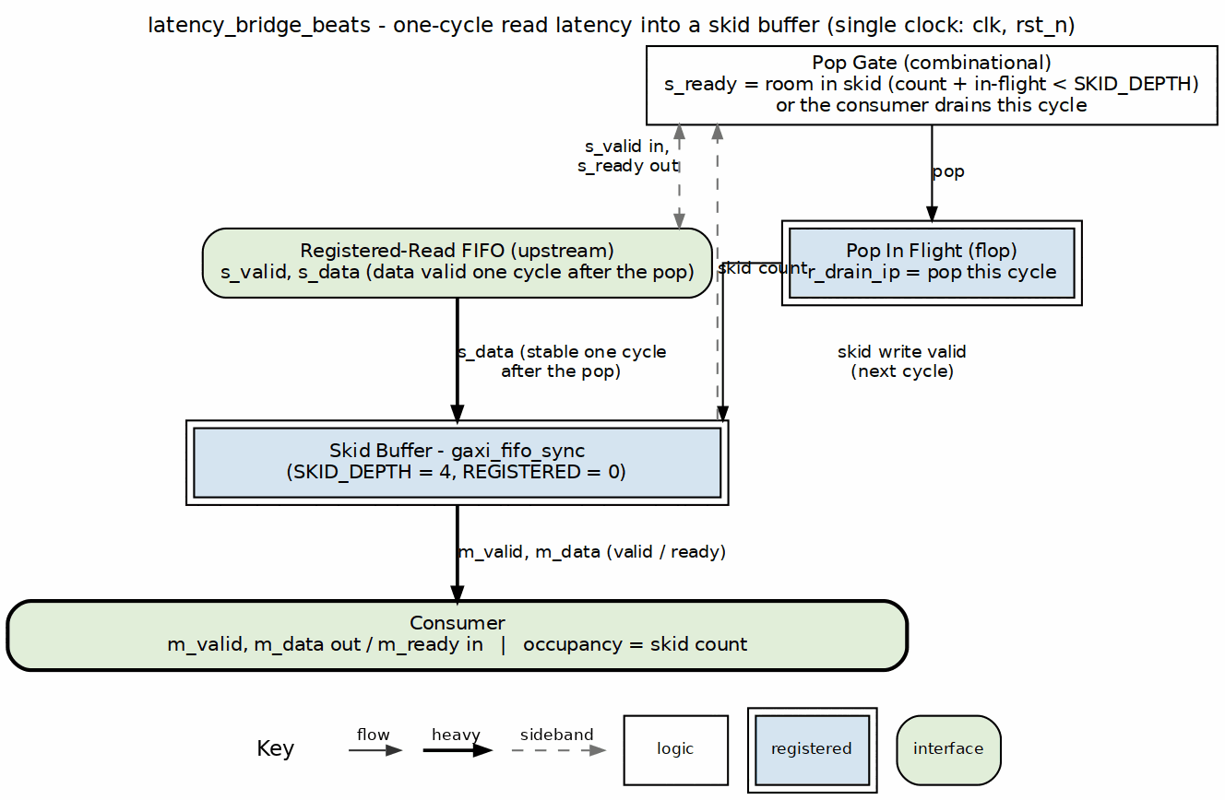
Latency bridge block diagram
Source: 07_latency_bridge.dot

12.2 Concept: bridging a registered read
A FIFO with REGISTERED=1 read (the SRAM style this repo uses so BRAM infers cleanly) answers a read handshake with data one cycle later. A consumer speaking valid/ready expects data with valid, and may deassert ready at any time. Without a bridge the FIFO has already popped a beat the consumer did not take.
cycle 0 s_valid && s_ready FIFO read accepted r_drain_ip <= 1
cycle 1 data arrives on s_data skid_wr_valid = r_drain_ip, data pushed
cycle N m_valid && m_ready consumer drains the skid at its own pace
The bridge never guesses about downstream readiness: s_ready is derived from the skid’s room, counting only a write that is stalled this cycle as pending (a write that completes this cycle frees its slot at the same edge). That is why full throughput holds while writes complete immediately, and why the FIFO is never over-read when they do not.

12.3 Parameters
parameter int DATA_WIDTH = 64; // Beat width
parameter int SKID_DEPTH = 4; // Skid buffer depth (2-4 recommended)
parameter int DW = DATA_WIDTH; // Short alias
: Table 2.7.1: Latency Bridge Parameters
occupancy is 3 bits wide and counts 0..5 at the default depth (one beat in flight plus four in the skid); a larger SKID_DEPTH needs the port widened.

12.4 Port List

12.4.1 Clock and Reset
Table 2.7.2: Clock and Reset
Signal | Direction | Width | Description
clk | input | 1 | System clock
rst_n | input | 1 | Active-low reset

12.4.2 Upstream Interface (from the registered FIFO)
Table 2.7.3: Upstream Interface
Signal | Direction | Width | Description
s_valid | input | 1 | FIFO has a beat to read (not empty)
s_ready | output | 1 | Bridge accepts a read this cycle; the data lands NEXT cycle
s_data | input | DW | Read data, valid one cycle after the s_valid && s_ready handshake

12.4.3 Downstream Interface (to the consumer)
Table 2.7.4: Downstream Interface
Signal | Direction | Width | Description
m_valid | output | 1 | Beat available
m_ready | input | 1 | Consumer takes the beat
m_data | output | DW | Beat data, valid with m_valid

12.4.4 Status and Debug
Table 2.7.5: Status and Debug
Signal | Direction | Width | Description
occupancy | output | 3 | Beats held by the bridge: the in-flight read plus the skid contents (0..5)
dbg_r_pending | output | 1 | r_drain_ip: a read was accepted and its data is due next cycle
dbg_r_out_valid | output | 1 | Skid output valid (mirrors m_valid)

12.5 Operation

12.5.1 Figure 2.7.2: Latency Bridge Timing (consumer always ready)

Latency bridge behind a registered-read FIFO
Source: latency_bridge_beats_streaming.json, captured from dv/tests/fub_beats/test_latency_bridge_beats.py (streaming, 256-bit, seed 7) with WAVES=1. The test drives a REGISTERED = 1 gaxi_fifo_sync in front of the bridge (dv/tb/latency_bridge_beats_tb_top.sv), because that is the only way to produce the bridge’s upstream contract: a valid/ready master presents data with valid, a registered FIFO presents it one cycle after the read handshake.
Reading it: each wr_valid beat lands in the FIFO and s_valid (FIFO not empty) rises a cycle later; the bridge reads it at once (s_ready stays high) and dbg_r_pending marks the cycle the data is in flight. Two cycles after the write the beat is on m_valid/m_data with its payload intact (1, 2, 3, …), and occupancy shows exactly one beat inside the bridge per transfer. With a consumer that is always ready the bridge adds the FIFO’s read latency and no more.
An earlier revision of this test drove s_* directly from the BFM and never compared m_data; every beat came out 0 and the test passed (rapids TASK-003). (dv/tests/fub_beats/test_latency_bridge_beats.py).

12.6 Integration Context
The bridge sits between a gaxi_fifo_sync with REGISTERED=1 and whatever consumes the stream. The same arrangement, with STREAM’s twin stream_latency_bridge, is what sram_controller_unit uses inside the shared SRAM controller today; occupancy there is what the drain accounting must allow for (stream BUG-011).
latency_bridge_beats #(
.DATA_WIDTH (512),
.SKID_DEPTH (4)
) u_bridge (
.clk (clk),
.rst_n (rst_n),
// registered-read FIFO side
.s_valid (fifo_rd_valid),
.s_ready (fifo_rd_ready),
.s_data (fifo_rd_data),
// consumer side
.m_valid (drain_valid),
.m_ready (drain_read),
.m_data (drain_data),
// status / debug
.occupancy (bridge_occupancy),
.dbg_r_pending (dbg_bridge_pending),
.dbg_r_out_valid (dbg_bridge_out_valid)
);

12.7 Design Considerations
Table 2.7.6: Skid Depth Selection
SKID_DEPTH | Behaviour
2 | Minimum: one stall of the consumer costs a bubble on the next read
4 | Default: absorbs a short consumer stall with no upstream bubble
8 | Deeper stall absorption; occupancy must be widened past 3 bits
The skid does not need to cover the FIFO’s read latency (that is the one r_drain_ip flop’s job); it needs to cover how long the consumer stalls without the bridge stopping upstream reads.

Last Updated: 2026-09-27

RTL Design Sherpa · Learning Hardware Design Through Practice GitHub · Documentation Index · MIT License

13 Control-Read Engine Specification
Module: ctrlrd_engine.sv Location: projects/components/dma-ip/rapids/rtl/fub/ Status: Implemented Last Updated: 2026-07-12

13.1 Overview
The Control-Read Engine implements the CTRL_READ descriptor opcode (DESC_OP_CTRL_READ = 2'b01) as a consumer gate. When the scheduler decodes a CTRL_READ descriptor, it hands the engine a poll address, an expected value, and a compare mask. The engine issues an AXI4 read to the poll address, applies the mask to the returned data, and compares (read_data & mask) against the expected value. If they match, the gate is satisfied and the descriptor chain proceeds; if not, the engine retries. Retries are bounded so a gate that never matches cannot hang the channel.
One Control-Read Engine is instantiated per channel in scheduler_group_beats.sv (u_ctrlrd_engine), configured for 32-bit AXI reads.

13.1.1 Key Features
- Consumer Gate Semantics: Polls memory until (read_data & mask) == expected
- Masked Comparison: Only the masked bits of the polled word participate in the match
- Bounded Retry: cfg_ctrlrd_max_try (0-511) caps the number of poll attempts
- 1 microsecond Retry Pacing: Retries wait for tick_1us from the scheduler group
- Error on Exhaustion: Asserts ctrlrd_error if the gate never matches within budget
- Null Address Fast-Path: A poll address of zero completes immediately as a match
- Channel Reset Support: cfg_channel_reset returns the FSM to idle and drains any read still on the fabric
- MonBus Integration: Completion, retry, and error events

13.1.2 Block Diagram

13.1.3 Figure 2.8.1: Control-Read Engine Block Diagram
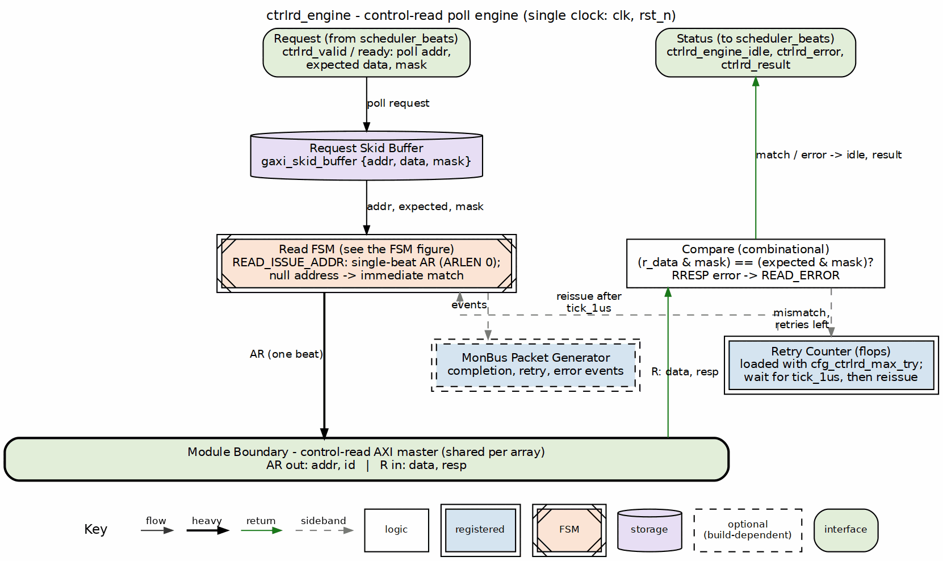
Control-read engine block diagram
Source: 08_ctrlrd_engine.dot

13.2 Parameters
parameter int CHANNEL_ID = 0; // Channel identifier
parameter int NUM_CHANNELS = 32; // Total channels
parameter int CHAN_WIDTH = $clog2(NUM_CHANNELS); // Channel index width (derived)
parameter int ADDR_WIDTH = 64; // Address bus width
parameter int AXI_DATA_WIDTH = 64; // AXI read data width (>= 32)
parameter int AXI_ID_WIDTH = 8; // AXI ID width (>= CHAN_WIDTH)
// Monitor Bus Parameters
parameter logic [15:0] MON_AGENT_ID = 16'h0030; // Control-Read Engine Agent ID
parameter logic [7:0] MON_UNIT_ID = 8'h02; // Unit identifier
parameter logic [8:0] MON_CHANNEL_ID = 9'h000; // Base channel ID
: Table 2.8.1: Control-Read Engine Parameters
Parameter validation enforces AXI_ID_WIDTH >= CHAN_WIDTH and AXI_DATA_WIDTH >= 32 (the engine consumes only the lower 32 bits of the read data). The per-channel instance in scheduler_group_beats.sv overrides AXI_DATA_WIDTH to 32.

13.3 Port List

13.3.1 Clock and Reset
Table 2.8.2: Clock and Reset
Signal | Direction | Width | Description
clk | input | 1 | System clock
rst_n | input | 1 | Active-low asynchronous reset

13.3.2 Scheduler Interface
Table 2.8.3: Scheduler Interface
Signal | Direction | Width | Description
ctrlrd_valid | input | 1 | Gate request valid from scheduler
ctrlrd_ready | output | 1 | Engine ready to accept a request
ctrlrd_pkt_addr | input | AW | Poll address (descriptor poll_addr[63:0])
ctrlrd_pkt_data | input | 32 | Expected value (descriptor expected[95:64])
ctrlrd_pkt_mask | input | 32 | Compare mask (descriptor mask[127:96])
ctrlrd_error | output | 1 | Gate failed (retries exhausted or AXI error)
ctrlrd_result | output | 32 | Last read value (lower 32 bits)
ctrlrd_engine_idle | output | 1 | Engine idle (post-issue completion indicator)

13.3.3 Configuration Interface
Table 2.8.4: Configuration Interface
Signal | Direction | Width | Description
cfg_ctrlrd_max_try | input | 9 | Poll retry budget, 0-511 (from CTRL_CONFIG.CTRLRD_MAX_TRY)
cfg_channel_reset | input | 1 | Per-channel reset request
tick_1us | input | 1 | 1 microsecond tick that paces retries

13.3.4 AXI4 Read Master Interface
Table 2.8.5: AXI4 Read Master Interface
Signal | Direction | Width | Description
ar_valid | output | 1 | Read address valid
ar_ready | input | 1 | Read address ready
ar_addr | output | AW | Read address (poll address)
ar_len | output | 8 | Burst length (8'h00, single beat)
ar_size | output | 3 | Burst size (3'b010, 4 bytes)
ar_burst | output | 2 | Burst type (2'b01, INCR)
ar_id | output | ID | Transaction ID (channel-derived)
ar_lock | output | 1 | Lock (1'b0, normal access)
ar_cache | output | 4 | Cache (4'b0010, non-cacheable bufferable)
ar_prot | output | 3 | Protection (3'b000)
ar_qos | output | 4 | Quality of service (4'h0)
ar_region | output | 4 | Region (4'h0)
r_valid | input | 1 | Read data valid (shared channel)
r_ready | output | 1 | Read data ready
r_data | input | ADW | Read data (lower 32 bits used)
r_id | input | ID | Read response ID (matched to our request)
r_resp | input | 2 | Read response
r_last | input | 1 | Read last beat

13.3.5 MonBus Interface
Table 2.8.6: MonBus Interface
Signal | Direction | Width | Description
i_mon_time | input | 64 | Side-band monitor timestamp
mon_valid | output | 1 | Monitor packet valid
mon_ready | input | 1 | Monitor consumer ready
mon_packet | output | 128 | Monitor packet (monitor_packet_t)
mon_timestamp | output | 64 | Monitor packet timestamp

13.4 FSM States

13.4.1 Figure 2.8.2: Control-Read Engine FSM
States and transitions of the ctrlrd_engine poll FSM.
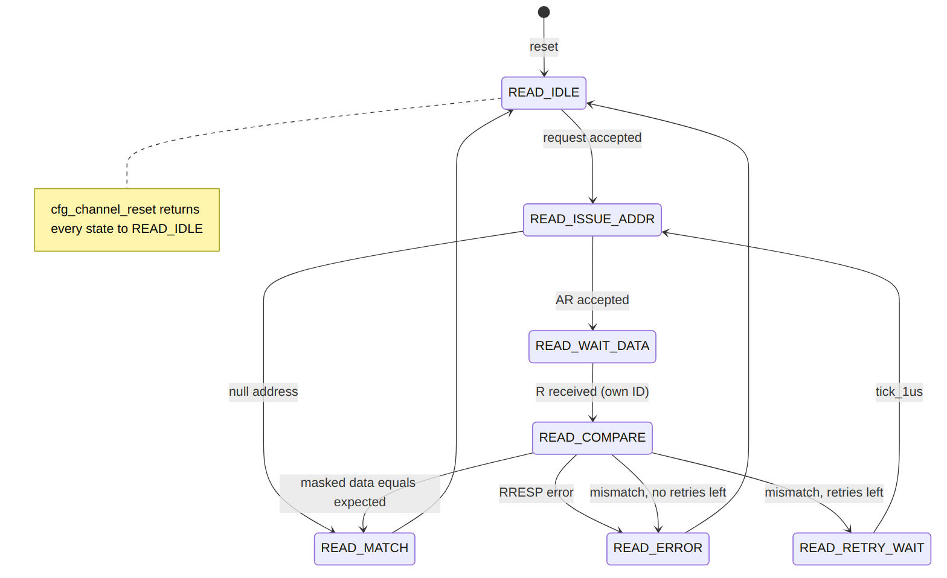
Diagram 3
State summary:
- READ_IDLE: Waits for a request from the scheduler (via a two-deep skid buffer). Latches poll address, expected value, mask, and the AXI ID; initializes the retry counter from cfg_ctrlrd_max_try.
- READ_ISSUE_ADDR: Drives ar_valid. A null address (64'h0) shortcuts to READ_MATCH; otherwise, once ar_ready handshakes, advances to READ_WAIT_DATA.
- READ_WAIT_DATA: Accepts the read response whose r_id matches the channel ID, capturing the lower 32 bits and the response code.
- READ_COMPARE: On an AXI error response, goes to READ_ERROR. On a masked match, goes to READ_MATCH. Otherwise, if retries remain, decrements the counter and goes to READ_RETRY_WAIT; if the budget is exhausted, goes to READ_ERROR.
- READ_RETRY_WAIT: Waits for tick_1us, then reissues the read.
- READ_MATCH: Gate satisfied. Clears the error flag and returns to READ_IDLE.
- READ_ERROR: Sets ctrlrd_error and returns to READ_IDLE.

13.5 Operation

13.5.1 Masked Compare
The engine gates on a masked equality check:
w_masked_expected = ctrlrd_pkt_data & ctrlrd_pkt_mask
w_masked_actual = r_data[31:0] & ctrlrd_pkt_mask
w_data_match = (w_masked_expected == w_masked_actual)
Only the bits set in mask participate. A mask of 32'hFFFFFFFF compares the full word; a mask of a single bit turns the gate into a flag-poll.

13.5.2 Retry Budget and Pacing
The retry counter is loaded from cfg_ctrlrd_max_try when the request is accepted. On each non-matching, non-error compare with retries remaining, the counter decrements and the engine parks in READ_RETRY_WAIT until the next tick_1us, which paces successive polls at roughly 1 microsecond intervals. When the counter reaches zero without a match, the engine transitions to READ_ERROR and asserts ctrlrd_error, so a never-matching gate cannot stall the channel indefinitely.
cfg_ctrlrd_max_try is driven by the CTRL_CONFIG register at offset 0x240, field CTRLRD_MAX_TRY[8:0] (0-511, reset 16).

13.5.3 Null Address Fast-Path
If the latched poll address is 64'h0, the engine treats the gate as already satisfied: READ_ISSUE_ADDR transitions directly to READ_MATCH without issuing an AXI read. This lets software emit an unconditional (no-op) gate.

13.5.4 AXI Read Transaction
Polls are single-beat, 4-byte INCR reads (ar_len = 0, ar_size = 3'b010, ar_burst = 2'b01). The ar_id is derived from CHANNEL_ID, and only responses whose r_id matches are consumed on the shared read data channel. ctrlrd_result exposes the last captured 32-bit value; in the per-channel instantiation the scheduler gates on match/error rather than the raw value, so ctrlrd_result is left unconnected there.

13.5.5 Channel Reset
cfg_channel_reset is registered into r_channel_reset_active. While asserted, the engine refuses new requests (ctrlrd_ready is forced low), the retry and error state is cleared, and the FSM is driven back to READ_IDLE.
What the reset cannot do is cancel a read already on the fabric, because AXI has no cancel. The engine therefore drains it (rapids TASK-014, 2026-09-27):
- an AR that was raised and not yet accepted stays raised until the slave takes it (r_drain_ar), then
- the R beat that the accepted AR is owed is taken and discarded (r_drain_pending, which alone lifts r_ready outside READ_WAIT_DATA).
Until the beat is gone ctrlrd_engine_idle stays low and the request path stays closed, so the next read on this ID cannot be answered by the stale beat. Before this the reset dropped the FSM to idle with r_ready low, the beat sat on the bus, and a re-kicked channel took it as its own answer.
ctrlrd_engine_idle asserts only in READ_IDLE with no pending request, no active channel reset and nothing left to drain.

13.6 MonBus Reporting
The engine emits monitor packets on notable events:
Table 2.8.7: MonBus Events
Event | Packet Type | Code | Payload
Gate satisfied (non-null) | PktTypeCompletion | CORE_COMPL_CTRLRD_COMPLETED | Poll address
Retry attempt | PktTypePerf | CORE_PERF_CTRLRD_RETRY | Remaining retry count
Retries exhausted | PktTypeError | CORE_ERR_CTRLRD_MAX_RETRIES | Poll address
AXI error response | PktTypeError | AXI_ERR_RESP_SLVERR / AXI_ERR_RESP_DECERR | Response code
All packets carry MON_AGENT_ID, MON_UNIT_ID, and MON_CHANNEL_ID, and are timestamped from i_mon_time.

13.7 Descriptor Field Mapping
The CTRL_READ opcode reinterprets the shared 256-bit descriptor (the descriptor engine’s existing field extraction is reused):
Table 2.8.8: CTRL_READ Descriptor Field Mapping
Descriptor Field | Bits | Engine Port
poll_addr | [63:0] | ctrlrd_pkt_addr
expected | [95:64] | ctrlrd_pkt_data
mask | [127:96] | ctrlrd_pkt_mask
max_try | [143:128] | Per-descriptor budget (0 = use cfg_ctrlrd_max_try default)

Last Updated: 2026-07-12

RTL Design Sherpa · Learning Hardware Design Through Practice GitHub · Documentation Index · MIT License

14 Control-Write Engine Specification
Module: ctrlwr_engine.sv Location: projects/components/dma-ip/rapids/rtl/fub/ Status: Implemented Last Updated: 2025-01-10

14.1 Overview
The Control-Write Engine executes a CTRL_WRITE control descriptor (DESC_OP_CTRL_WRITE = 2'b10). A CTRL_WRITE is a producer doorbell: the engine performs a single-beat AXI4 write of the descriptor’s 32-bit wr_data value to its 64-bit wr_addr target, then completes so the descriptor chain continues. One instance is dedicated per channel.
The write target address must be 4-byte aligned because the transfer is a 32-bit (aw_size = 3'b010) single-beat write. A null address (wr_addr == 0) is treated as a no-op and the request completes without issuing an AXI transaction.

14.1.1 Key Features
- Single-Beat AXI4 Write: One 32-bit doorbell write per request (aw_len = 0, w_last = 1)
- Producer Doorbell Semantics: Write value to target, then release the chain (no poll, no retry)
- Address Alignment Check: Requires 4-byte-aligned wr_addr; misalignment raises an error
- Null-Address Skip: wr_addr == 0 completes as a no-op
- Channel Reset Support: cfg_channel_reset returns the FSM to idle and drains any write still on the fabric
- MonBus Integration: Completion and error event reporting

14.1.2 Block Diagram

14.1.3 Figure 2.9.1: Control-Write Engine Block Diagram
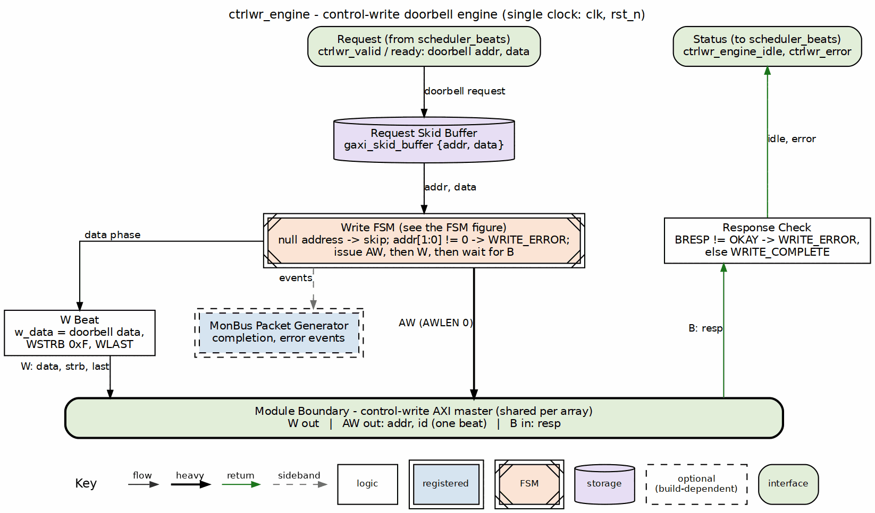
Control-write engine block diagram
Source: 09_ctrlwr_engine.dot

14.2 Parameters
parameter int CHANNEL_ID = 0; // Channel identifier
parameter int NUM_CHANNELS = 32; // Total channels
parameter int CHAN_WIDTH = $clog2(NUM_CHANNELS); // Derived channel index width
parameter int ADDR_WIDTH = 64; // Address bus width
parameter int AXI_ID_WIDTH = 8; // AXI transaction ID width
// Monitor Bus Parameters
parameter logic [15:0] MON_AGENT_ID = 16'h0020; // Ctrlwr Engine Agent ID
parameter logic [7:0] MON_UNIT_ID = 8'h01; // Unit identifier
parameter logic [8:0] MON_CHANNEL_ID = 9'h000; // Base channel ID
: Table 2.9.1: Control-Write Engine Parameters
Note: AXI_ID_WIDTH must be >= CHAN_WIDTH (checked by an elaboration-time $fatal). When instantiated in scheduler_group_beats.sv as u_ctrlwr_engine, MON_AGENT_ID is overridden to 16'h0021 (CTRLWR_MON_AGENT_ID) to distinguish it from the Control-Read Engine’s 16'h0020.

14.3 Port List

14.3.1 Clock and Reset
Table 2.9.2: Clock and Reset
Signal | Direction | Width | Description
clk | input | 1 | System clock
rst_n | input | 1 | Active-low asynchronous reset

14.3.2 Configuration Interface
Table 2.9.3: Configuration Interface
Signal | Direction | Width | Description
cfg_channel_reset | input | 1 | Per-channel reset: blocks new requests, drains transaction, forces idle

14.3.3 Scheduler Interface
Table 2.9.4: Scheduler Interface
Signal | Direction | Width | Description
ctrlwr_valid | input | 1 | Request valid (doorbell write requested)
ctrlwr_ready | output | 1 | Ready to accept request
ctrlwr_pkt_addr | input | AW | Doorbell target address (wr_addr, 4-byte aligned)
ctrlwr_pkt_data | input | 32 | Doorbell write value (wr_data)
ctrlwr_error | output | 1 | Error flag (alignment or AXI response error)
ctrlwr_engine_idle | output | 1 | Engine idle (in WRITE_IDLE, no active transaction, not in channel reset)

14.3.4 AXI4 Write Master Interface
Table 2.9.5: AXI4 Write Master Interface
Signal | Direction | Width | Description
aw_valid | output | 1 | Write address valid
aw_ready | input | 1 | Write address ready
aw_addr | output | AW | Write address (= wr_addr)
aw_len | output | 8 | Burst length (0 = single beat)
aw_size | output | 3 | Transfer size (3'b010 = 4 bytes / 32-bit)
aw_burst | output | 2 | Burst type (2'b01 = INCR)
aw_id | output | AXI_ID_WIDTH | Transaction ID (derived from CHANNEL_ID)
aw_lock | output | 1 | Lock type (0 = normal)
aw_cache | output | 4 | Cache type (4'b0010 = non-cacheable bufferable)
aw_prot | output | 3 | Protection type (3'b000)
aw_qos | output | 4 | Quality of service (0)
aw_region | output | 4 | Region identifier (0)
w_valid | output | 1 | Write data valid
w_ready | input | 1 | Write data ready
w_data | output | 32 | Write data (= wr_data)
w_strb | output | 4 | Write strobes (4'b1111 = all bytes)
w_last | output | 1 | Last beat (1 = single beat)
b_valid | input | 1 | Write response valid
b_ready | output | 1 | Write response ready
b_id | input | AXI_ID_WIDTH | Response ID (matched against expected AXI ID)
b_resp | input | 2 | Write response code

14.3.5 MonBus Interface
Table 2.9.6: MonBus Interface
Signal | Direction | Width | Description
i_mon_time | input | 64 | Monitor timestamp side-band input
mon_valid | output | 1 | Monitor packet valid
mon_ready | input | 1 | Monitor packet ready
mon_packet | output | 128 | Monitor packet (monitor_packet_t)
mon_timestamp | output | 64 | Monitor packet timestamp

14.4 FSM States

14.4.1 Figure 2.9.2: Control-Write Engine FSM
States and transitions of the ctrlwr_engine doorbell FSM.
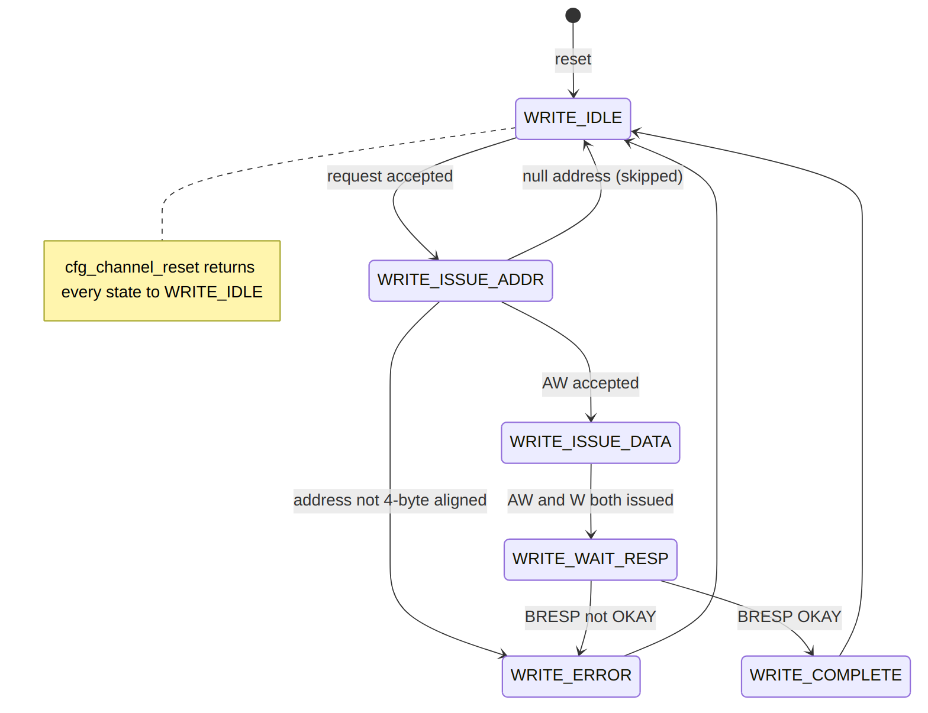
Diagram 4
State summary:
- WRITE_IDLE: Wait for a request from the request skid buffer; latch wr_addr/wr_data and the expected AXI ID.
- WRITE_ISSUE_ADDR: Drive aw_valid until aw_ready. A misaligned address routes to WRITE_ERROR; a null address returns to WRITE_IDLE (no-op skip).
- WRITE_ISSUE_DATA: Drive w_valid until w_ready; advance once both address and data phases have been issued.
- WRITE_WAIT_RESP: Accept the matching b-channel response; a non-OKAY b_resp routes to WRITE_ERROR, otherwise to WRITE_COMPLETE.
- WRITE_COMPLETE: Emit a completion MonBus packet (unless null address) and return to WRITE_IDLE.
- WRITE_ERROR: Latch ctrlwr_error, emit an error MonBus packet, and return to WRITE_IDLE. The error flag persists until reset or cfg_channel_reset.

14.5 Operation

14.5.1 Doorbell Write Sequence

14.5.2 Figure 2.9.3: Control-Write Doorbell Timing

ctrlwr_engine - one doorbell write
Source: ctrlwr_engine_doorbell.json, captured from dv/tests/fub/test_ctrlwr_engine.py (basic_write, channel 0, 64-bit address, REG_LEVEL=GATE) with WAVES=1; the AXI side is the framework write slave.
Reading it: the request handshakes in one cycle (ctrlwr_ready is held high by the skid buffer) with the doorbell address 0x1000 and data 0x12345678, and the engine leaves idle the next cycle. AW goes out two cycles after the request, W two cycles after AW, and the slave answers B (OKAY) two cycles after W; ctrlwr_engine_idle returns the cycle after the B handshake, eight cycles after the request. Nothing is pipelined across doorbells: the engine takes one request at a time.

14.5.3 Request Handshake and Skid Buffer
Incoming requests are captured through a depth-2 gaxi_skid_buffer. The engine accepts a request (ctrlwr_ready) only when not in an active channel reset. The FSM pops the buffered request in WRITE_IDLE, latching {wr_addr, wr_data} and computing the expected AXI ID from CHANNEL_ID:
aw_id = {{(AXI_ID_WIDTH-CHAN_WIDTH){1'b0}}, CHANNEL_ID[CHAN_WIDTH-1:0]};
The b-channel response is matched against this expected ID (b_id == r_expected_axi_id) so a shared write master can be demultiplexed per channel.

14.5.4 Address Validation
Null (skip) : wr_addr == 64'h0
Align error : wr_addr[1:0] != 2'b00 (and not null)
A null address completes immediately as a no-op with no AXI activity and no completion packet. A misaligned address never issues on AXI; it transitions to WRITE_ERROR, asserts ctrlwr_error, and emits an error MonBus packet.

14.5.5 Error Reporting
ctrlwr_error is a registered, sticky flag. It is set on an alignment error or on a non-OKAY AXI write response (b_resp != 2'b00), and it persists until rst_n or cfg_channel_reset. The MonBus error packet carries either the offending address (alignment error) or the captured b_resp code (AXI response error).

14.5.6 Channel Reset
Asserting cfg_channel_reset registers r_channel_reset_active, which blocks new requests (ctrlwr_ready low), clears the error flag and the phase-issued state, and drives the FSM back to WRITE_IDLE.
A write already on the fabric cannot be cancelled, so the engine drains it (rapids TASK-014, 2026-09-27): a raised AW stays up until accepted (r_drain_aw), an accepted AW is followed by its W beat with the latched data (r_drain_w), and the B response is taken and discarded (r_drain_b, which alone lifts b_ready outside WRITE_WAIT_RESP). The write that was already issued therefore lands. Until B is taken ctrlwr_engine_idle stays low and the request path stays closed. Before this the reset abandoned whatever phase was in flight and left a dangling response on the channel’s ID.
ctrlwr_engine_idle asserts only in WRITE_IDLE with no pending request, no active channel reset and nothing left to drain.

14.6 Contrast with the Control-Read Engine
The Control-Write Engine is the producer counterpart to the Control-Read Engine (Section 2.8). Both are per-channel control-descriptor executors, but they implement opposite half of the producer/consumer handshake:
Aspect | Control-Read Engine (2.8) | Control-Write Engine (2.9)
Opcode | DESC_OP_CTRL_READ (2'b01) | DESC_OP_CTRL_WRITE (2'b10)
Role | Consumer gate | Producer doorbell
AXI direction | Read (poll) | Single-beat write
Semantics | Poll until (rd & mask) == expected | Write wr_data to wr_addr, then continue
Retry budget | max_try retry budget (config default) | None (single unconditional write)
Chain effect | Holds off the chain until the gate passes | Releases the chain after the write completes
Descriptor fields | poll_addr / expected / mask / max_try | wr_addr / wr_data
A CTRL_WRITE therefore has no maximum-try configuration: it is one unconditional 32-bit write, whereas CTRL_READ polls with a bounded retry budget before either passing the gate or timing out.

Last Updated: 2026-07-12

RTL Design Sherpa · Learning Hardware Design Through Practice GitHub · Documentation Index · MIT License

15 Beats Scheduler Group Specification
Module: scheduler_group_beats.sv Location: projects/components/dma-ip/rapids/rtl/macro_beats/ Status: Implemented Last Updated: 2025-01-10

15.1 Overview
The Beats Scheduler Group wraps a single channel’s scheduler and descriptor engine together with MonBus aggregation. It provides a clean integration point for the scheduler_group_array.

15.1.1 Key Features
- Single Channel Integration: One scheduler + one descriptor engine
- MonBus Aggregation: Combines scheduler and descriptor engine MonBus outputs
- Configuration Pass-Through: Routes configuration to both sub-modules
- Status Aggregation: Combined idle and error status

15.1.2 Block Diagram

15.1.3 Figure 3.1.1: Beats Scheduler Group Block Diagram
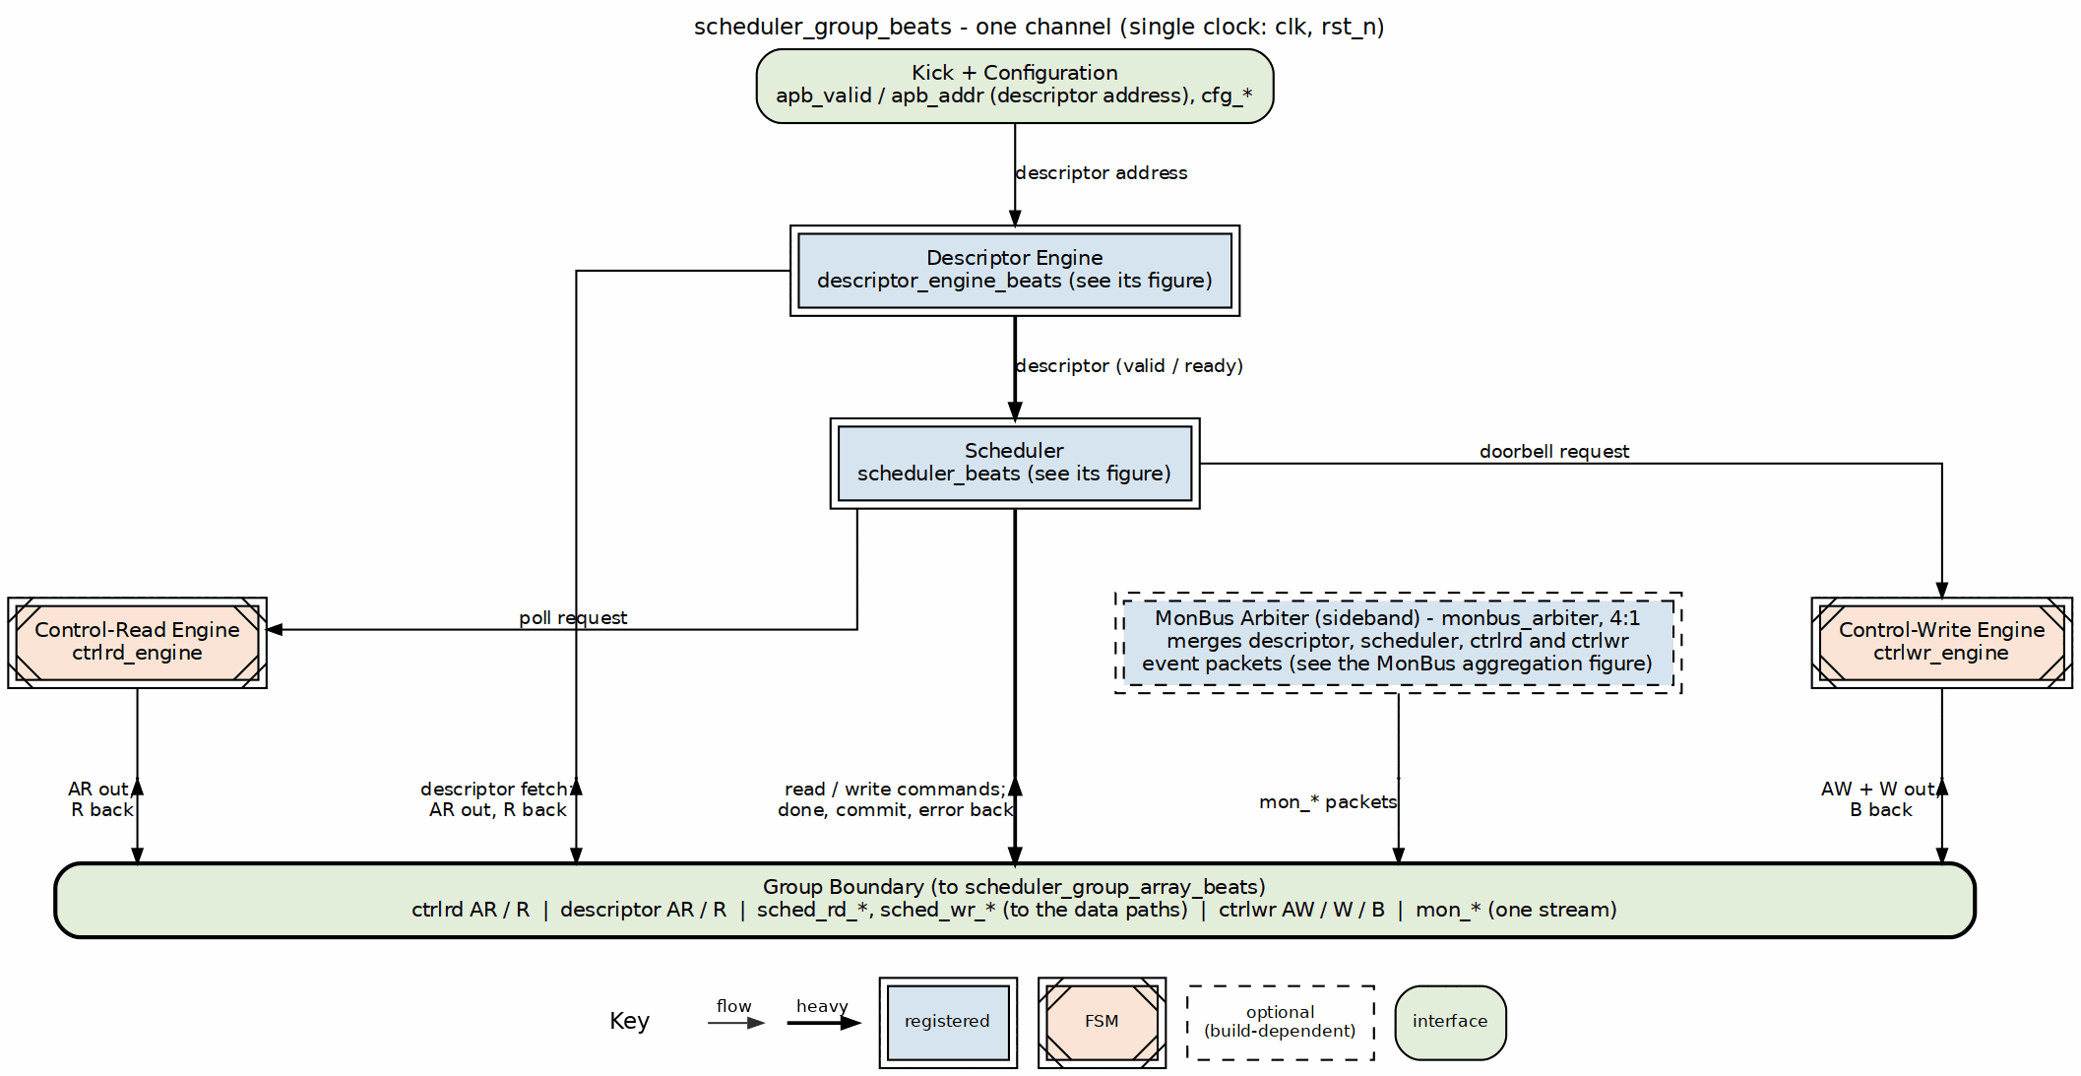
Scheduler group block diagram
Source: 10_scheduler_group.dot

15.2 Parameters
parameter int CHANNEL_ID = 0; // Channel identifier
parameter int NUM_CHANNELS = 8; // Total channels
parameter int ADDR_WIDTH = 64; // Address bus width
parameter int DATA_WIDTH = 512; // Data bus width
// Monitor Bus Parameters
parameter int DESC_MON_AGENT_ID = 16 + CHANNEL_ID; // Descriptor engine agent
parameter int SCHED_MON_AGENT_ID = 48 + CHANNEL_ID; // Scheduler agent
parameter int MON_UNIT_ID = 1;
: Table 3.1.1: Beats Scheduler Group Parameters

15.3 Port List

15.3.1 Clock and Reset
Table 3.1.2: Clock and Reset
Signal | Direction | Width | Description
clk | input | 1 | System clock
rst_n | input | 1 | Active-low reset

15.3.2 APB Programming Interface
Table 3.1.3: APB Programming Interface
Signal | Direction | Width | Description
apb_valid | input | 1 | Channel kick-off
apb_ready | output | 1 | Ready for kick-off
apb_addr | input | AW | First descriptor address

15.3.3 Configuration Interface
Table 3.1.4: Configuration Interface
Signal | Direction | Width | Description
cfg_channel_enable | input | 1 | Enable this channel
cfg_channel_reset | input | 1 | Per-channel soft reset
cfg_sched_timeout_cycles | input | 32 | Write-progress timeout window (cycles)
cfg_sched_timeout_limit | input | 8 | Consecutive-timeout windows before fatal escalation (0 = never)
cfg_sched_timeout_enable | input | 1 | Enable timeout detection
cfg_sched_err_enable | input | 1 | Enable error reporting
cfg_sched_compl_enable | input | 1 | SCHED_CONFIG.COMPL_EN: 1 = the scheduler’s and descriptor engine’s CORE Completion packets reach the group’s monitor bus; 0 = the group drops them at its arbiter inputs and acknowledges the emitters, so nothing stalls (rapids ISSUE-005). Errors are never gated.
cfg_sched_perf_enable | input | 1 | Enable performance monitoring
cfg_desceng_prefetch | input | 1 | Enable descriptor prefetch chaining
cfg_desceng_fifo_thresh | input | 4 | Prefetch threshold (descriptors buffered ahead)
cfg_desceng_addr0_base | input | ADDR_WIDTH | Valid address range 0 base
cfg_desceng_addr0_limit | input | ADDR_WIDTH | Valid address range 0 limit
cfg_desceng_addr1_base | input | ADDR_WIDTH | Valid address range 1 base
cfg_desceng_addr1_limit | input | ADDR_WIDTH | Valid address range 1 limit
cfg_ctrlrd_max_try | input | 9 | ctrlrd poll retry budget (0-511)
tick_1us | input | 1 | 1 us tick for ctrlrd retry spacing

15.3.4 Descriptor AXI Master Interface
Table 3.1.5: Descriptor AXI Master Interface
Signal | Direction | Width | Description
desc_ar_valid | output | 1 | AR valid
desc_ar_ready | input | 1 | AR ready
desc_ar_addr | output | ADDR_WIDTH | Descriptor fetch address
desc_ar_len | output | 8 | Burst length - 1
desc_ar_size | output | 3 | Burst size (log2 bytes)
desc_ar_burst | output | 2 | Burst type
desc_ar_id | output | AXI_ID_WIDTH | Transaction ID
desc_ar_lock | output | 1 | Lock type
desc_ar_cache | output | 4 | Cache attributes
desc_ar_prot | output | 3 | Protection attributes
desc_ar_qos | output | 4 | Quality of service
desc_ar_region | output | 4 | Region identifier
desc_r_valid | input | 1 | R valid
desc_r_ready | output | 1 | R ready
desc_r_data | input | 256 | Descriptor payload (fixed 256-bit)
desc_r_resp | input | 2 | Read response
desc_r_last | input | 1 | Last beat
desc_r_id | input | AXI_ID_WIDTH | Response ID

15.3.5 Scheduler Data Interfaces
Table 3.1.6: Scheduler Data Interfaces
Signal | Direction | Width | Description
sched_rd_valid | output | 1 | Read request
sched_rd_addr | output | AW | Read address
sched_rd_beats | output | 32 | Read beats
sched_rd_done_strobe | input | 1 | Read complete
sched_wr_valid | output | 1 | Write request
sched_wr_addr | output | AW | Write address
sched_wr_beats | output | 32 | Write beats
sched_wr_done_strobe | input | 1 | Write AW-issue strobe
sched_wr_commit_strobe | input | 1 | Write COMMIT strobe (B response)
sched_wr_commit_beats | input | 32 | Beats committed this strobe

15.3.6 Status
Table 3.1.7: Status Interface
Signal | Direction | Width | Description
scheduler_idle | output | 1 | Scheduler idle
descriptor_engine_idle | output | 1 | Descriptor engine idle
scheduler_state | output | 7 | FSM state
sched_error | output | 1 | Error flag

15.3.7 MonBus Interface
Table 3.1.8: MonBus Interface
Signal | Direction | Width | Description
i_mon_time | input | monbus_timestamp_t | Shared monitor timebase
mon_valid | output | 1 | Monitor packet valid
mon_ready | input | 1 | Consumer ready
mon_packet | output | monitor_packet_t | Monitor packet
mon_timestamp | output | monbus_timestamp_t | Packet timestamp

15.4 Internal Architecture
The descriptor engine hands each fetched descriptor to the scheduler over a valid/ready pair, and the four MonBus emitters (descriptor engine, scheduler, ctrlrd engine, ctrlwr engine) merge in the group’s 4:1 monbus_arbiter; both are drawn in Figure 3.1.1.

Last Updated: 2026-07-02

RTL Design Sherpa · Learning Hardware Design Through Practice GitHub · Documentation Index · MIT License

16 Beats Scheduler Group Array Specification
Module: scheduler_group_array_beats.sv Location: projects/components/dma-ip/rapids/rtl/macro_beats/ Status: Implemented Last Updated: 2025-01-10

16.1 Overview
The Beats Scheduler Group Array instantiates 8 scheduler groups with a shared descriptor AXI master and unified MonBus output. It provides the complete scheduler infrastructure for all RAPIDS channels.

16.1.1 Key Features
- 8-Channel Array: One scheduler_group per channel
- Shared Descriptor AXI: Round-robin arbitration for descriptor fetches
- Unified MonBus: Aggregates 9 MonBus sources (8 scheduler + 1 arbiter)
- Per-Channel Configuration: Individual enable/reset per channel
- Aggregate Status: Combined idle and error flags

16.1.2 Block Diagram

16.1.3 Figure 3.2.1: Beats Scheduler Group Array Block Diagram
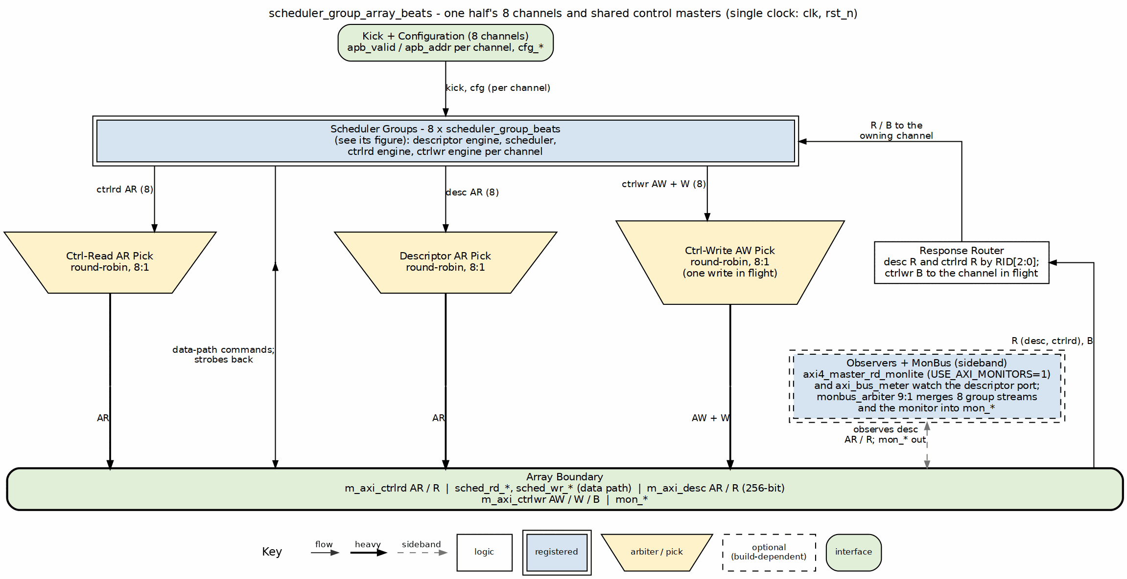
Scheduler group array block diagram
Source: 11_scheduler_group_array.dot

16.2 Parameters
parameter int NUM_CHANNELS = 8; // Number of channels
parameter int ADDR_WIDTH = 64; // Address bus width
parameter int DATA_WIDTH = 512; // Data bus width
parameter int DESC_DATA_WIDTH = 256; // Descriptor width
// AXI ID Management
parameter int AXI_ID_WIDTH = 8; // ID field width
parameter int MAX_OUTSTANDING = 8; // Outstanding descriptors
// Monitor Bus Parameters
parameter int MON_UNIT_ID = 1; // Unit ID for MonBus
: Table 3.2.1: Beats Scheduler Group Array Parameters

16.3 Port List

16.3.1 Clock and Reset
Table 3.2.2: Clock and Reset
Signal | Direction | Width | Description
clk | input | 1 | System clock
rst_n | input | 1 | Active-low reset

16.3.2 Per-Channel APB Programming
Table 3.2.3: APB Programming Interface
Signal | Direction | Width | Description
apb_valid | input | NC | Channel kick-off (per-channel)
apb_ready | output | NC | Ready for kick-off
apb_addr | input | NC*AW | First descriptor address

16.3.3 Per-Channel Configuration
Table 3.2.4: Per-Channel Configuration
Signal | Direction | Width | Description
cfg_channel_enable | input | NC | Enable per channel
cfg_channel_reset | input | NC | Soft reset per channel
cfg_sched_timeout_cycles | input | NC*16 | Timeout threshold
cfg_sched_timeout_enable | input | NC | Enable timeout
cfg_desceng_enable | input | NC | Enable descriptor engine
cfg_desceng_prefetch | input | NC | Enable prefetching
cfg_desceng_fifo_thresh | input | NC*4 | Prefetch threshold
cfg_desceng_addr0_base | input | NC*AW | Address range 0 base
cfg_desceng_addr0_limit | input | NC*AW | Address range 0 limit

16.3.4 Shared Descriptor AXI Master Interface
Table 3.2.5: Shared Descriptor AXI Master Interface
Signal | Direction | Width | Description
desc_axi_arvalid | output | 1 | AR valid
desc_axi_arready | input | 1 | AR ready
desc_axi_araddr | output | ADDR_WIDTH | Descriptor fetch address
desc_axi_arlen | output | 8 | Burst length - 1
desc_axi_arsize | output | 3 | Burst size
desc_axi_arburst | output | 2 | Burst type
desc_axi_arid | output | AXI_ID_WIDTH | Transaction ID
desc_axi_arlock | output | 1 | Lock type
desc_axi_arcache | output | 4 | Cache attributes
desc_axi_arprot | output | 3 | Protection attributes
desc_axi_arqos | output | 4 | Quality of service
desc_axi_arregion | output | 4 | Region identifier
desc_axi_rvalid | input | 1 | R valid
desc_axi_rready | output | 1 | R ready
desc_axi_rdata | input | 256 | Descriptor payload (fixed 256-bit)
desc_axi_rresp | input | 2 | Read response
desc_axi_rlast | input | 1 | Last beat
desc_axi_rid | input | AXI_ID_WIDTH | Response ID

16.3.5 Per-Channel Scheduler Data Interfaces
Table 3.2.6: Per-Channel Scheduler Data Interfaces
Signal | Direction | Width | Description
sched_rd_valid | output | NC | Read request per channel
sched_rd_addr | output | NC*AW | Read address
sched_rd_beats | output | NC*32 | Read beats
sched_rd_done_strobe | input | NC | Read complete
sched_wr_valid | output | NC | Write request per channel
sched_wr_addr | output | NC*AW | Write address
sched_wr_beats | output | NC*32 | Write beats
sched_wr_done_strobe | input | NC | Write complete

16.3.6 Aggregate Status
Table 3.2.7: Aggregate Status
Signal | Direction | Width | Description
descriptor_engine_idle | output | NC | Per-channel descriptor engine idle
scheduler_idle | output | NC | Per-channel scheduler idle
scheduler_state | output | NC x 7 | Per-channel FSM state (one-hot)
sched_error | output | NC | Per-channel scheduler error (sticky)

16.3.7 Unified MonBus Interface
Table 3.2.8: Unified MonBus Interface
Signal | Direction | Width | Description
i_mon_time | input | monbus_timestamp_t | Shared monitor timebase
mon_valid | output | 1 | Monitor packet valid
mon_ready | input | 1 | Consumer ready
mon_packet | output | monitor_packet_t | Monitor packet
mon_timestamp | output | monbus_timestamp_t | Packet timestamp

16.3.8 Descriptor-AXI Perf Window
The descriptor monitor is axi_monitor_lite, which has no performance cone. The DAXMON_PERF_* CSRs are fed instead by an always-on axi_bus_meter on the descriptor R channel plus window/beat/byte/burst accumulators beside it, the same meter rapids_beats_top uses for RDMON/WRMON. cfg_desc_mon_perf_run (DAXMON_PERF_CTRL.RUN) opens the window: counters clear on its rising edge, count while it is high and hold while it is low. The meter is not gated by USE_AXI_MONITORS.
Table 3.2.9: Descriptor-AXI Perf Window
Signal | Direction | Width | Description
cfg_desc_mon_perf_run | input | 1 | Window control (DAXMON_PERF_CTRL.RUN)
sts_desc_mon_win_active | output | 1 | Window open (equals RUN)
sts_desc_mon_win_cycles | output | 32 | Live cycle count; reads 0 while the window is closed
sts_desc_mon_prod_cycles | output | 32 | R valid and ready
sts_desc_mon_bp_cycles | output | 32 | R valid, not ready (backpressure)
sts_desc_mon_starv_cycles | output | 32 | R ready, not valid (starvation)
sts_desc_mon_idle_cycles | output | 32 | R neither valid nor ready
sts_desc_mon_beat_count | output | 32 | R handshakes in the window
sts_desc_mon_byte_count | output | 64 | 32 bytes per 256-bit descriptor beat
sts_desc_mon_burst_count | output | 32 | AR handshakes in the window

16.4 AXI Arbitration

16.4.1 Figure 3.2.2: Descriptor AXI Arbitration Sequence
Two channels contending for the descriptor master; responses return by RID.
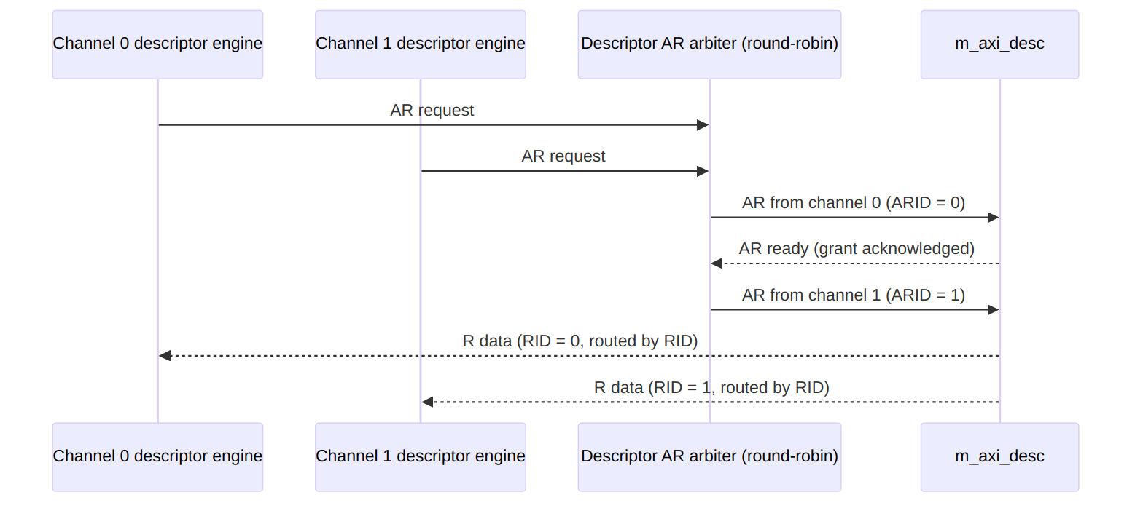
Diagram 5

16.5 MonBus Aggregation
The unified MonBus output aggregates 9 sources using round-robin arbitration:
Table 3.2.10: MonBus Source Assignment
Source ID | Origin | Description
0-7 | scheduler_group[0:7] | Per-channel aggregated MonBus
8 | Descriptor AXI monitor | axi4_master_rd_monlite packets (USE_AXI_MONITORS = 1)
Each scheduler_group provides a single MonBus output that combines its descriptor engine, scheduler, ctrlrd engine and ctrlwr engine packets (4:1 internal arbitration).

16.6 Integration Context
scheduler_group_array_beats #(
.NUM_CHANNELS(8),
.ADDR_WIDTH(64),
.DATA_WIDTH(512)
) u_scheduler_array (
.clk (clk),
.rst_n (rst_n),
// APB programming (per-channel)
.apb_valid (apb_kick_valid),
.apb_ready (apb_kick_ready),
.apb_addr (apb_kick_addr),
// Configuration (per-channel)
.cfg_channel_enable (cfg_ch_enable),
.cfg_sched_timeout_cycles(cfg_timeout_cycles),
// ... additional config ...
// Shared descriptor AXI
.desc_axi_arvalid (desc_axi_arvalid),
.desc_axi_arready (desc_axi_arready),
.desc_axi_araddr (desc_axi_araddr),
.desc_axi_rvalid (desc_axi_rvalid),
.desc_axi_rready (desc_axi_rready),
.desc_axi_rdata (desc_axi_rdata),
// Per-channel scheduler outputs
.sched_rd_valid (sched_rd_valid),
.sched_rd_addr (sched_rd_addr),
.sched_rd_beats (sched_rd_beats),
.sched_rd_done_strobe (sched_rd_done_strobe),
.sched_wr_valid (sched_wr_valid),
.sched_wr_addr (sched_wr_addr),
.sched_wr_beats (sched_wr_beats),
.sched_wr_done_strobe (sched_wr_done_strobe),
// Status
.scheduler_idle (all_schedulers_idle),
// Unified MonBus
.mon_valid (sched_array_monbus_valid),
.mon_ready (sched_array_monbus_ready),
.mon_packet (sched_array_monbus_data)
);

Last Updated: 2025-01-10

RTL Design Sherpa · Learning Hardware Design Through Practice GitHub · Documentation Index · MIT License

17 Sink Data Path Specification
Module: snk_data_path_beats.sv Location: projects/components/dma-ip/rapids/rtl/macro_beats/ Status: Implemented Last Updated: 2025-01-10

17.1 Overview
The Sink Data Path integrates the SRAM controller and AXI write engine for network-to-memory transfers. Data enters through the fill interface, is buffered in SRAM, and is written to system memory via AXI4.

17.1.1 Key Features
- 8-Channel SRAM Controller: Per-channel buffering with flow control
- AXI Write Engine: Streaming burst writes to system memory
- Beat-Level Tracking: Precise flow control at beat granularity
- Scheduler Integration: Receives transfer requests from scheduler

17.1.2 Block Diagram

17.1.3 Figure 3.3.1: Sink Data Path Block Diagram
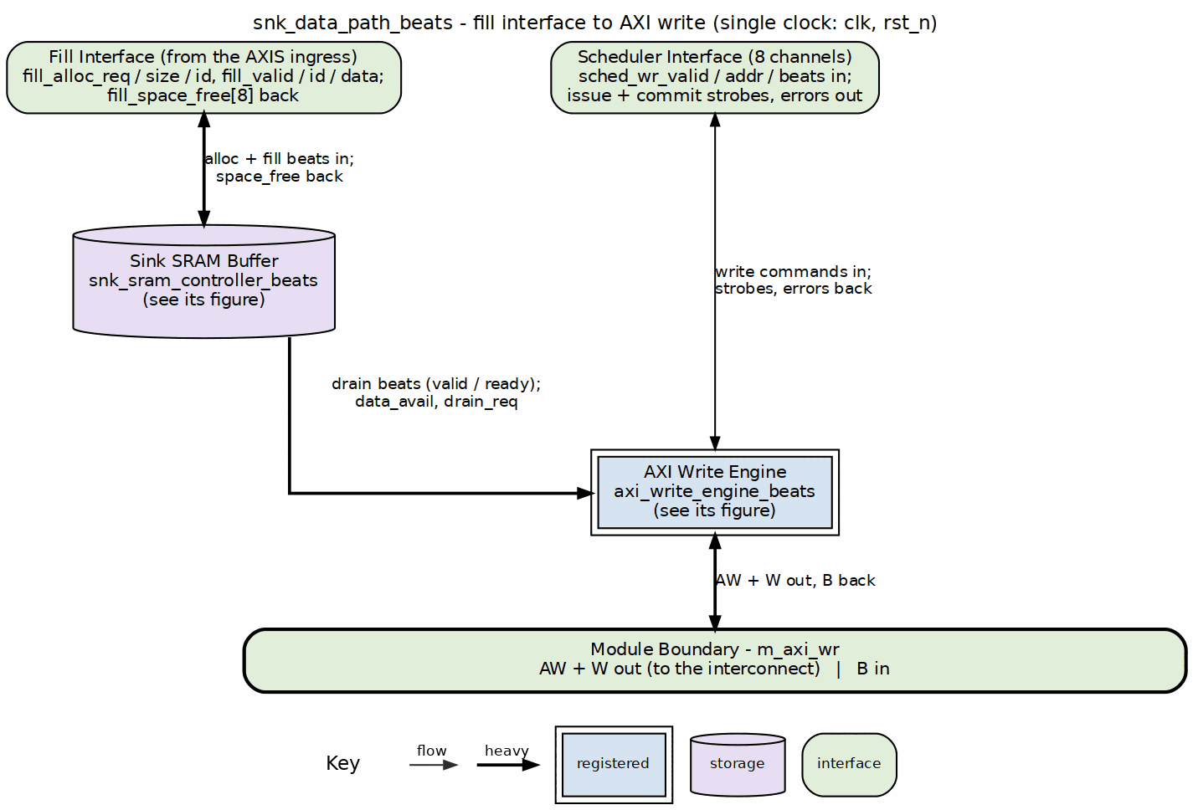
Sink data path block diagram
Source: 13_sink_data_path.dot

17.2 Parameters
parameter int NUM_CHANNELS = 8;
parameter int ADDR_WIDTH = 64;
parameter int DATA_WIDTH = 512;
parameter int AXI_ID_WIDTH = 8;
parameter int SRAM_DEPTH = 512;
parameter int AW_MAX_OUTSTANDING = 8;
parameter int W_PHASE_FIFO_DEPTH = 64;
parameter int B_PHASE_FIFO_DEPTH = 16;
: Table 3.3.1: Sink Data Path Parameters

17.3 Data Flow

17.3.1 Figure 3.3.2: Sink Path Data Flow Sequence
1. Fill Request
- snk_fill_alloc_req = 1
- snk_fill_alloc_size = N (beats to allocate)
- snk_fill_alloc_id = channel
|
v
2. Space Check (stream_alloc_ctrl inside STREAM's sram_controller)
- Check snk_fill_space_free[channel] >= N
- Allocate N beats of space
|
v
3. Fill Data Transfer
- snk_fill_valid = 1
- snk_fill_data = data beats
- snk_fill_id = channel
|
v
4. SRAM Write
- Data written to channel's SRAM partition
- stream_drain_ctrl notified of data availability
|
v
5. AXI Write Request
- Scheduler requests write: sched_wr_valid
- Address and beat count provided
|
v
6. SRAM Read + AXI Write
- axi_write_engine reads from SRAM
- Issues AXI bursts to memory
|
v
7. Completion
- B channel response received
- sched_wr_done_strobe = 1

17.4 Timing Diagram

17.4.1 Figure 3.3.3: Sink Path Transfer Timing
Three windows from one transfer: the allocation and fill, the first AXI write burst being issued, and the end of that burst with its response.
(a) Allocation and fill
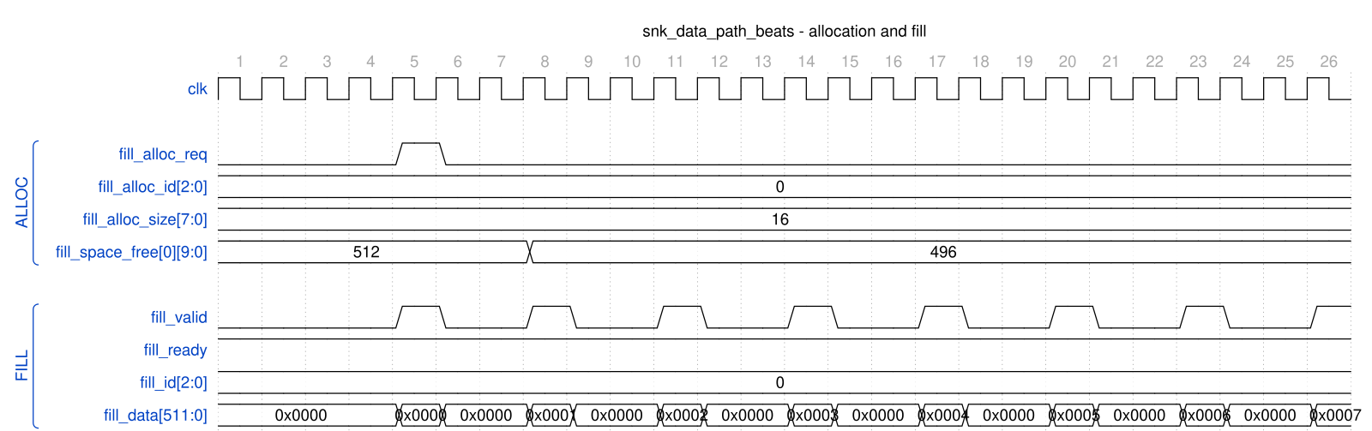
snk_data_path_beats - allocation and fill
(b) First AXI write burst issued
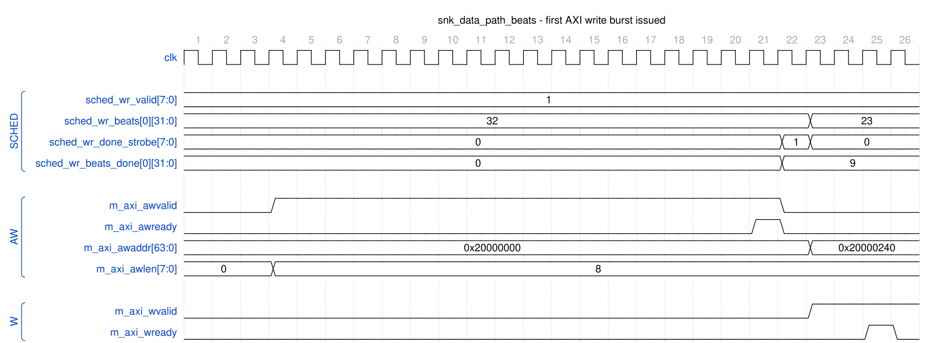
snk_data_path_beats - first AXI write burst issued
(c) Last W beats and the B response
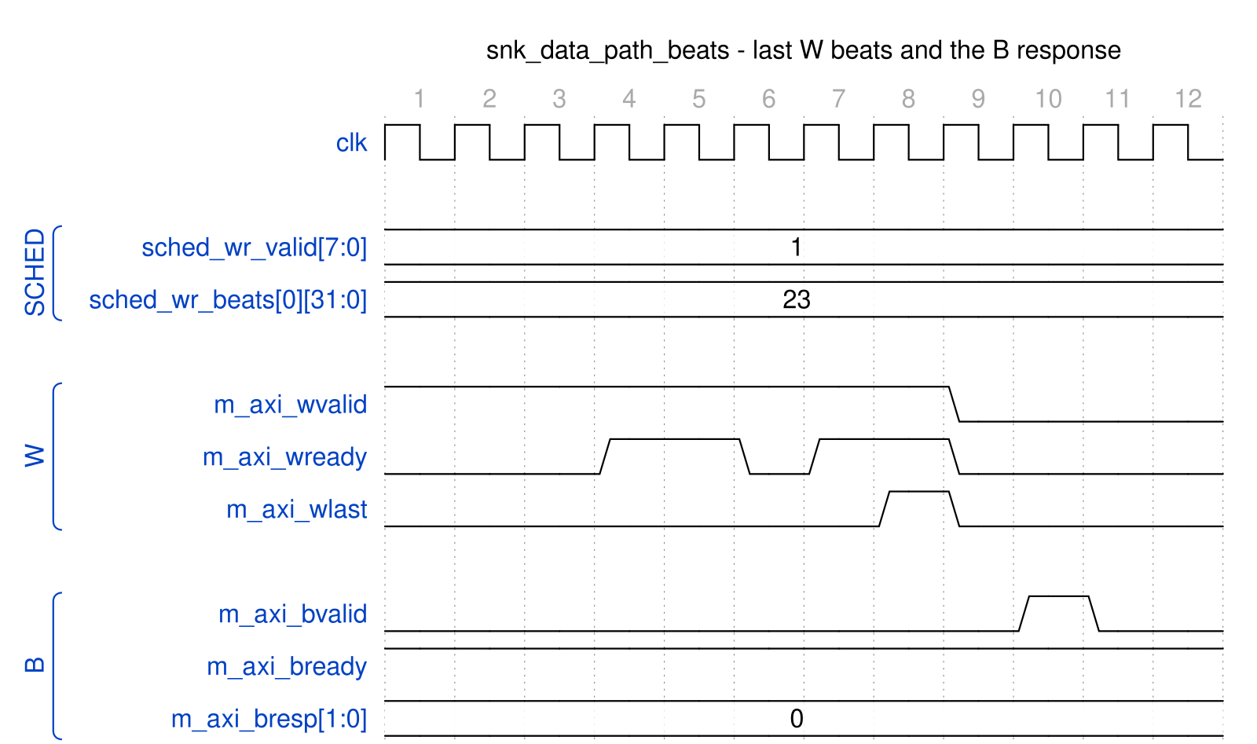
snk_data_path_beats - last W beats and the B response
Source: snk_data_path_fill_alloc.json, snk_data_path_axi_write_aw.json, snk_data_path_axi_write_b.json, captured inside rapids_core_beats.u_snk.u_sink_data_path from dv/tests/top_beats/test_rapids_core_beats.py (sink path, channel 0, 32 beats, 512-bit data, cfg_alloc_size = 16, TEST_LEVEL=full) with WAVES=1.
Reading (a): the first beat for channel 0 arrives with no space allocated, so the path raises fill_alloc_req for 16 beats; fill_space_free[0] drops 512 to 496 three cycles later and the beat is accepted on the same cycle as the request. The remaining beats are accepted one per handshake (fill_ready stays high; the gaps are the AXIS producer’s pacing). Reading (b): once the descriptor arrives the scheduler holds sched_wr_valid with 32 beats remaining; the engine issues the AW (awlen = 8, 9 beats) and, the cycle after the AW handshake, pulses sched_wr_done_strobe with beats_done = 9, on which the scheduler advances to 23 remaining and the next AW address is already 0x20000240. Reading (c): W beats drain at the memory’s pace (wready from the AXI slave BFM), wlast marks the ninth beat, and the B response arrives two cycles later with bresp = OKAY. The done strobe is reported at issue, not at B; completion of the whole transfer is what snk_system_idle reflects.

17.5 Interface Summary

17.5.1 Fill Interface (Input)
Table 3.3.2: Fill Interface
Signal | Direction | Description
fill_alloc_req | input | Allocation request (single, ID-selected)
fill_alloc_size | input | Beats to allocate
fill_alloc_id | input | Transaction ID selects the channel
fill_space_free | output | Available space per channel
fill_valid | input | Fill data valid
fill_ready | output | Ready for fill data
fill_id | input | Transaction ID selects the channel
fill_data | input | Fill data

17.5.2 Scheduler Interface
Table 3.3.3: Scheduler Interface
Signal | Direction | Description
sched_wr_valid | input | Channel requests write
sched_wr_ready | output | Path ready for channel
sched_wr_addr | input | Destination addresses
sched_wr_beats | input | Beats remaining to write
sched_wr_burst_len | input | Requested burst length
sched_wr_done_strobe | output | Burst ISSUED on AW handshake
sched_wr_beats_done | output | Beats issued in burst
sched_wr_commit_strobe | output | Burst COMMITTED on B response
sched_wr_commit_beats | output | Beats committed in burst
sched_wr_error | output | Sticky error flag per channel

Last Updated: 2025-01-10

RTL Design Sherpa · Learning Hardware Design Through Practice GitHub · Documentation Index · MIT License

18 Sink Data Path AXIS Wrapper Specification
Module: snk_data_path_axis_beats.sv Location: projects/components/dma-ip/rapids/rtl/macro_beats/ Status: Implemented Last Updated: 2026-09-29

18.1 Overview
The Sink Data Path AXIS wrapper adds an AXI-Stream slave interface to the sink data path, enabling standard AXIS ingress for network-to-memory transfers.

18.1.1 Key Features
- AXI-Stream Slave Interface: Standard AXIS for data ingress
- Per-Channel TID Mapping: AXIS TID maps to fill channel ID
- TLAST to Last Mapping: Packet boundary tracking
- Core Sink Integration: Wraps sink_data_path module

18.1.2 Block Diagram

18.1.3 Figure 3.4.1: Sink Data Path AXIS Block Diagram
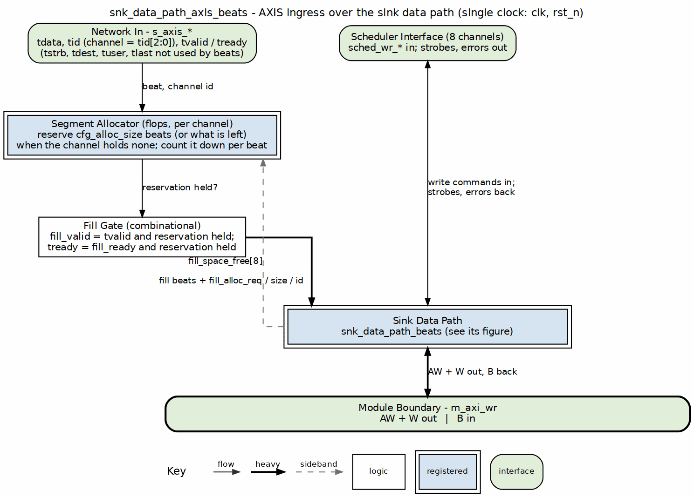
Sink data path AXIS block diagram
Source: 14_sink_data_path_axis.dot

18.2 Parameters
parameter int NUM_CHANNELS = 8;
parameter int ADDR_WIDTH = 64;
parameter int DATA_WIDTH = 512;
parameter int AXI_ID_WIDTH = 8;
parameter int SRAM_DEPTH = 512;
parameter int TID_WIDTH = 3; // log2(NUM_CHANNELS)
parameter int TDEST_WIDTH = 1;
parameter int TUSER_WIDTH = 1;
: Table 3.4.1: Sink Data Path AXIS Parameters

18.3 Port List

18.3.1 Clock and Reset
Table 3.4.2: Clock and Reset
Signal | Direction | Width | Description
clk | input | 1 | System clock
rst_n | input | 1 | Active-low reset

18.3.2 AXI-Stream Slave Interface
Table 3.4.3: AXI-Stream Slave Interface
Signal | Direction | Width | Description
s_axis_tvalid | input | 1 | Data valid
s_axis_tready | output | 1 | Ready for data
s_axis_tdata | input | DW | Data payload
s_axis_tstrb | input | SW | Byte strobes
s_axis_tlast | input | 1 | Last beat of packet
s_axis_tid | input | AXIS_ID_WIDTH | Stream ID (channel)
s_axis_tdest | input | AXIS_DEST_WIDTH | Destination
s_axis_tuser | input | AXIS_USER_WIDTH | User sideband

18.3.3 Allocation Configuration
Table 3.4.4: Allocation Configuration
Signal | Direction | Width | Description
cfg_alloc_size | input | 8 | Default allocation size per request (beats)

18.3.4 Scheduler Interface
Table 3.4.5: Scheduler Interface
Signal | Direction | Width | Description
sched_wr_valid | input | NC | Channel requests write
sched_wr_ready | output | NC | Path ready for channel
sched_wr_addr | input | NC x AW | Destination addresses
sched_wr_beats | input | NC x 32 | Beats remaining to write
sched_wr_burst_len | input | NC x 8 | Requested burst length
sched_wr_done_strobe | output | NC | Burst ISSUED on AW handshake
sched_wr_beats_done | output | NC x 32 | Beats issued in burst
sched_wr_commit_strobe | output | NC | Burst COMMITTED on B response
sched_wr_commit_beats | output | NC x 32 | Beats committed in burst
sched_wr_error | output | NC | Sticky error flag per channel

18.3.5 AXI Write Master Interface
Table 3.4.6: AXI Write Master Interface
Signal | Direction | Width | Description
m_axi_awvalid | output | 1 | AW channel valid
m_axi_awready | input | 1 | AW channel ready
m_axi_awaddr | output | AW | Write address
m_axi_awlen | output | 8 | Burst length
m_axi_awsize | output | 3 | Burst size
m_axi_awburst | output | 2 | Burst type
m_axi_awid | output | ID_W | Transaction ID
m_axi_wvalid | output | 1 | W channel valid
m_axi_wready | input | 1 | W channel ready
m_axi_wdata | output | DW | Write data
m_axi_wstrb | output | DW/8 | Write strobes
m_axi_wlast | output | 1 | Last beat
m_axi_bvalid | input | 1 | B channel valid
m_axi_bready | output | 1 | B channel ready
m_axi_bresp | input | 2 | Write response
m_axi_bid | input | ID_W | Response ID

18.4 Signal Mapping

18.4.1 Figure 3.4.2: AXIS to Fill Interface Mapping
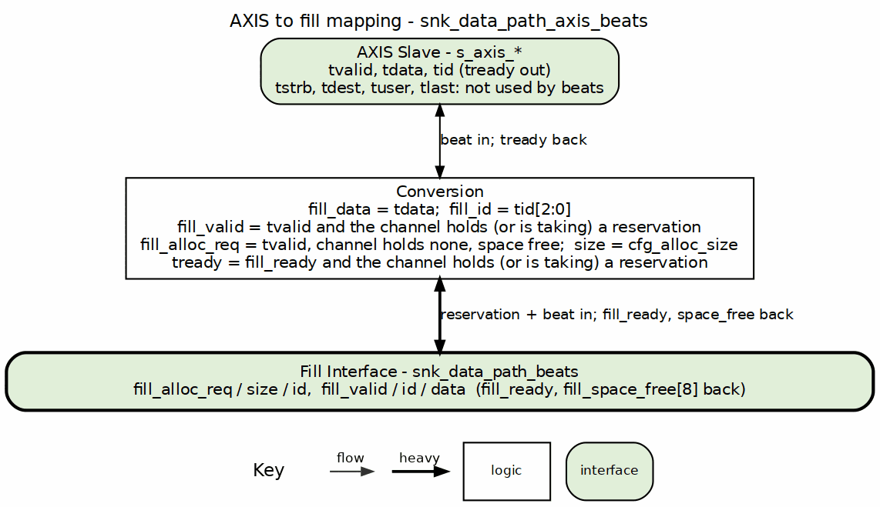
AXIS to fill mapping
Source: 14b_axis_to_fill.dot

18.5 Timing Diagram

18.5.1 Figure 3.4.3: AXIS Ingress Timing
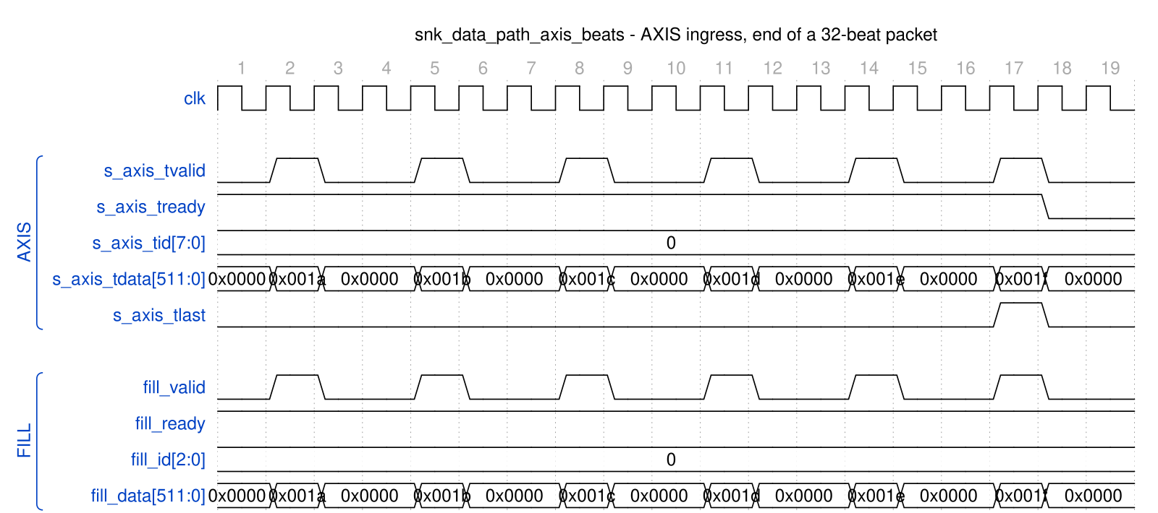
snk_data_path_axis_beats - AXIS ingress, end of a 32-beat packet
Source: snk_data_path_axis_ingress.json, captured from dv/tests/top_beats/test_rapids_core_beats.py (sink path, channel 0, 32 beats, 512-bit data, TEST_LEVEL=full) with WAVES=1.
Reading it: each AXIS beat is passed straight through to the fill interface in the same cycle – fill_valid mirrors s_axis_tvalid, fill_id is s_axis_tid, and fill_data is s_axis_tdata (the low 16 bits are shown; the payload counts up 0x1a..0x1f). s_axis_tready is high while channel 0 has allocated space and drops the cycle after s_axis_tlast because the packet count is now complete and the next beat would need a fresh allocation (Figure 3.3.3a).

18.6 Usage Notes
- TID Usage: AXIS TID directly maps to channel ID for multi-channel routing
- Allocation Required: Space must be allocated via snk_alloc_* before AXIS data arrives
- Backpressure: s_axis_tready deasserts when SRAM space exhausted
- Packet Boundaries: TLAST marks end of AXIS packets, mapped to fill_last
- Partial segments (rapids BUG-009, 2026-09-29): allocation is in cfg_alloc_size segments, and a packet that ends mid-segment leaves the rest of its segment allocated for the channel’s next packet (r_pending_alloc). That shifts the allocation phase: with whole-segment-only allocation the last segment - residue slots of the buffer could never be allocated again until something drained, and a write burst equal to the buffer depth – which needs every slot – waited forever (Genesys 2: a 4-beat run, then a 128-beat-burst run accepted 124 beats and issued no AW). The ingress now allocates the remainder when less than a segment is free (fill_alloc_size = min(cfg_alloc_size, space_free)), so the buffer can always be filled to the top. Regression: test_residue_full_burst.
- Allocation settle and no dropped beats (same bug, third finding): fill_space_free reflects an allocation three cycles after its handshake. A one- or two-beat partial allocation is consumed before that, and a second allocation against the stale view over-allocated the buffer (the 8-bit space count wrapped to 254 and the ingress ran into a full FIFO). Each channel now holds its next allocation for three cycles after the last (r_alloc_settle), and s_axis_tready includes fill_ready on allocation cycles as well, so a beat is never accepted that the FIFO cannot store.

Last Updated: 2026-09-29

RTL Design Sherpa · Learning Hardware Design Through Practice GitHub · Documentation Index · MIT License

19 Sink SRAM Controller Specification
Module: snk_sram_controller_beats.sv Location: projects/components/dma-ip/rapids/rtl/macro_beats/ Status: Implemented Last Updated: 2025-01-10

19.1 Overview
The Sink SRAM Controller is a naming wrapper, with no logic of its own, around STREAM’s sram_controller – the one per-channel SRAM implementation both DMAs share since bdf4e0dff. It maps the RAPIDS fill_*/drain_* names onto STREAM’s ports; the eight per-channel units (allocation counter, FIFO, drain counter, latency bridge) live inside STREAM’s block. It manages 8 channel units, providing per-channel buffering with channel arbitration for the shared AXI write engine.

19.1.1 Key Features
- One shared implementation: instantiates STREAM’s sram_controller once; it holds 8 sram_controller_units, each a gaxi_fifo_sync FIFO with stream_alloc_ctrl, stream_drain_ctrl and stream_latency_bridge
- Channel Arbitration: none inside the controller – the AXI write engine picks a channel and presents it on drain_id
- Flow Control Integration: per-channel stream_alloc_ctrl / stream_drain_ctrl virtual FIFOs; the drain counter’s virtual depth is 2 x SRAM_DEPTH (stream BUG-011)
- Space Tracking: Reports available space per channel

19.1.2 Block Diagram

19.1.3 Figure 3.5.1: Sink SRAM Controller Block Diagram
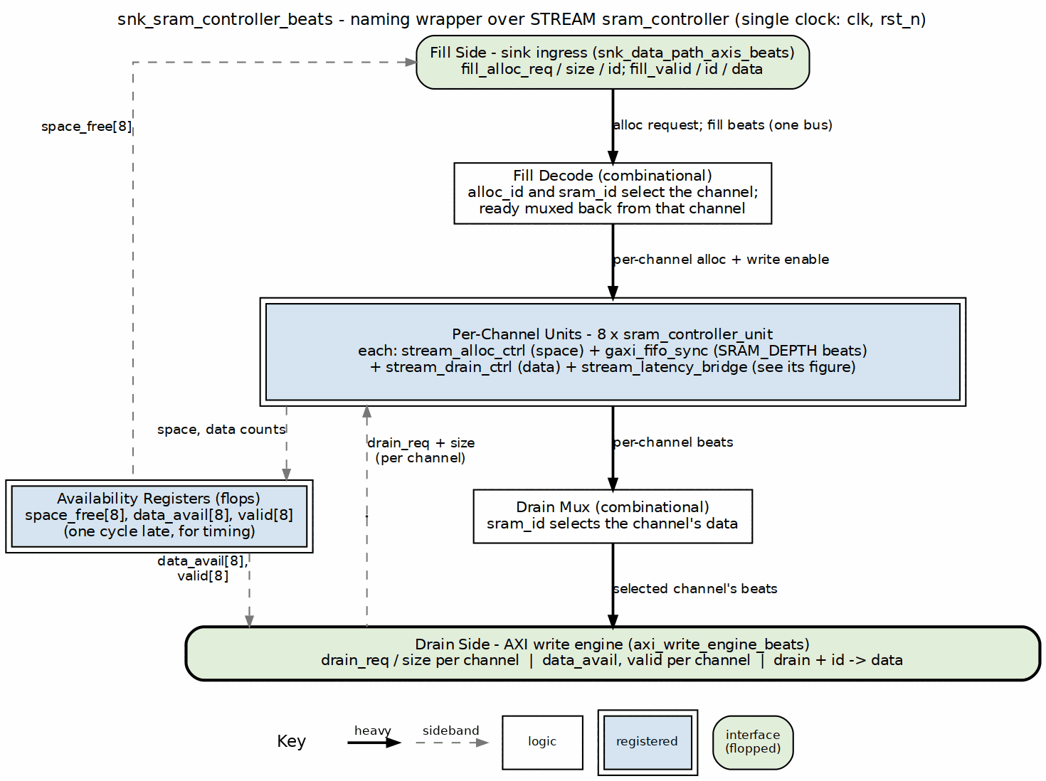
Sink SRAM controller block diagram
Source: 15_snk_sram_controller.dot

19.2 Parameters
parameter int NUM_CHANNELS = 8;
parameter int DATA_WIDTH = 512;
parameter int SRAM_DEPTH = 512; // Per-channel depth
parameter int ADDR_WIDTH = $clog2(SRAM_DEPTH);
: Table 3.5.1: Sink SRAM Controller Parameters

19.3 Port List

19.3.1 Clock and Reset
Table 3.5.2: Clock and Reset
Signal | Direction | Width | Description
clk | input | 1 | System clock
rst_n | input | 1 | Active-low reset

19.3.2 Fill Interface (ID-Selected)
Table 3.5.3: Fill Interface (ID-Selected)
Signal | Direction | Width | Description
fill_alloc_req | input | 1 | Allocation request (single, ID-selected)
fill_alloc_size | input | 8 | Beats to allocate
fill_alloc_id | input | CIW | Transaction ID selects the channel
fill_space_free | output | NC x SCW | Available space per channel
fill_valid | input | 1 | Fill data valid
fill_ready | output | 1 | Ready for fill data
fill_id | input | CIW | Transaction ID selects the channel
fill_data | input | DW | Fill data

19.3.3 Arbitrated Drain Interface (to AXI Write Engine)
Table 3.5.4: Arbitrated Drain Interface
Signal | Direction | Width | Description
drain_data_avail | output | NC x SCW | Data available per channel
drain_req | input | NC | Drain reservation request per channel
drain_size | input | NC x 8 | Beats to reserve
drain_valid | output | NC | Drain valid, registered (for arbitration)
drain_valid_comb | output | NC | Drain valid, combinational (gates m_axi_wvalid)
drain_read | input | 1 | Consumer read strobe
drain_id | input | CIW | Channel ID select for drain
drain_data | output | DW | Drain data (muxed from selected channel)

19.3.4 Debug Interface
Table 3.5.5: Debug Interface
Signal | Direction | Width | Description
dbg_bridge_pending | output | NC | Bridge has a pending beat per channel
dbg_bridge_out_valid | output | NC | Bridge output valid per channel

19.4 Drain Selection
There is no arbiter inside the controller. Every channel unit raises its own drain_valid[ch] / drain_size[ch] when it has data; the AXI write engine picks a channel, drives it on drain_id, and the controller steers that channel’s beats to the single drain_* port. Switching channels costs nothing beyond the consumer’s own decision, and a channel keeps presenting drain_valid until it is empty.

19.4.1 Figure 3.5.2: Drain Selection by the Consumer

snk_sram_controller_beats - consumer drains eight channels in turn
Source: snk_sram_controller_drain_select.json, captured from dv/tests/macro_beats/test_snk_sram_controller_beats.py (multi_channel, 8 channels, 512-bit data, 512-entry SRAM, REG_LEVEL=GATE) with WAVES=1.
Reading it: all eight channels have data (drain_valid = 0xff) and the consumer walks them in turn. It raises one bit of drain_req at a time; the controller answers with drain_id naming that channel and drain_data presenting its head word on the same cycle, and the consumer’s drain_read pulse pops it. Each channel’s turn lasts nine cycles here because the test releases the request and re-arms the next one; the controller itself needs no gap between channels.

19.5 Integration with AXI Write Engine
snk_sram_controller_beats #(
.NUM_CHANNELS(8),
.DATA_WIDTH(512),
.SRAM_DEPTH(512)
) u_snk_sram_ctrl (
.clk (clk),
.rst_n (rst_n),
// Per-channel fill interface
.fill_alloc_req (fill_alloc_req),
.fill_alloc_size (fill_alloc_size),
.fill_space_free (fill_space_free),
.fill_valid (fill_valid),
.fill_ready (fill_ready),
.fill_data (fill_data),
// Arbitrated drain interface
.drain_req (sram_drain_req),
.drain_id (sram_drain_id),
.drain_size (sram_drain_beats),
// Status
.drain_data_avail (channel_data_avail),
.dbg_bridge_pending (channel_empty),
.dbg_bridge_out_valid (channel_full)
);

Last Updated: 2025-01-10

RTL Design Sherpa · Learning Hardware Design Through Practice GitHub · Documentation Index · MIT License

20 Source Data Path Specification
Module: src_data_path_beats.sv Location: projects/components/dma-ip/rapids/rtl/macro_beats/ Status: Implemented Last Updated: 2025-01-10

20.1 Overview
The Source Data Path integrates the AXI read engine and SRAM controller for memory-to-network transfers. Data is read from system memory via AXI4, buffered in SRAM, and delivered through the drain interface to the network.

20.1.1 Key Features
- AXI Read Engine: Streaming burst reads from system memory
- 8-Channel SRAM Controller: Per-channel buffering with flow control
- Beat-Level Tracking: Precise flow control at beat granularity
- Scheduler Integration: Receives transfer requests from scheduler

20.1.2 Block Diagram

20.1.3 Figure 3.6.1: Source Data Path Block Diagram
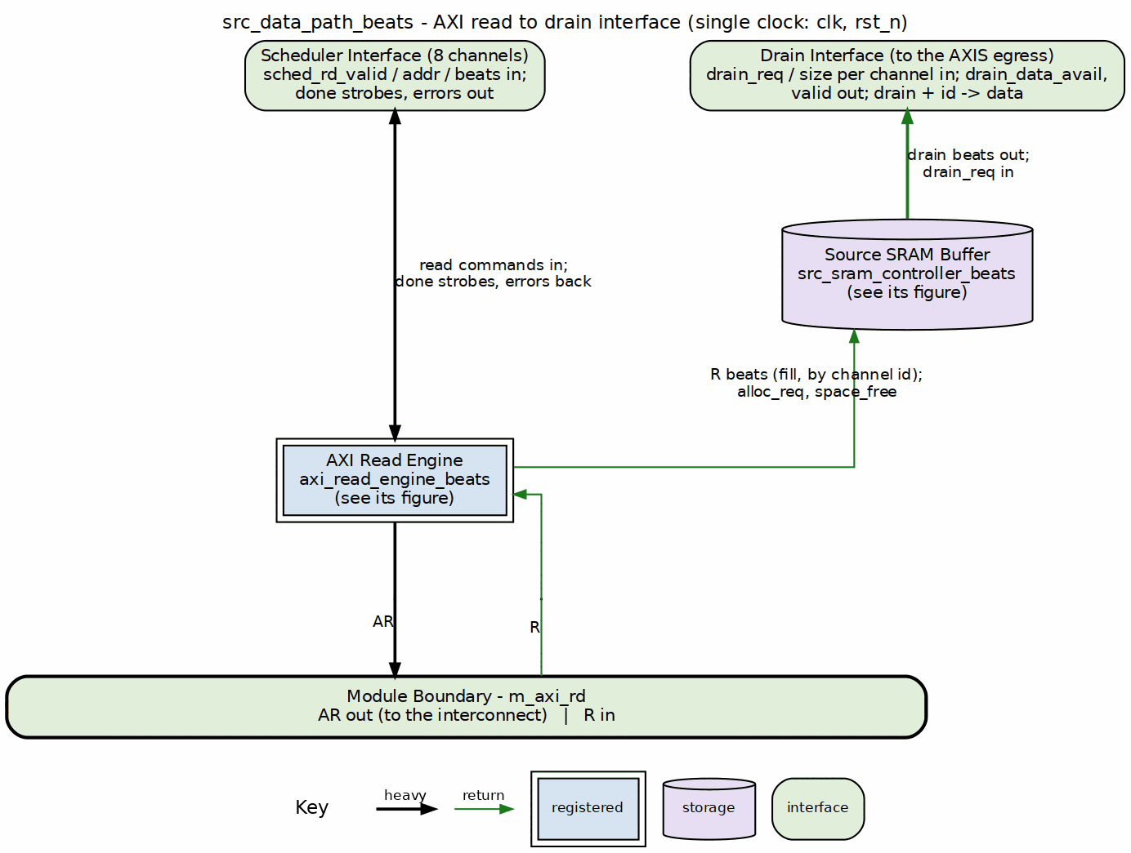
Source data path block diagram
Source: 16_source_data_path.dot

20.2 Parameters
parameter int NUM_CHANNELS = 8;
parameter int ADDR_WIDTH = 64;
parameter int DATA_WIDTH = 512;
parameter int AXI_ID_WIDTH = 8;
parameter int SRAM_DEPTH = 512;
parameter int AR_MAX_OUTSTANDING = 8;
parameter int R_PHASE_FIFO_DEPTH = 64;
: Table 3.6.1: Source Data Path Parameters

20.3 Data Flow

20.3.1 Figure 3.6.2: Source Path Data Flow Sequence
1. Scheduler Read Request
- sched_rd_valid = 1
- sched_rd_addr = source address
- sched_rd_beats = N
- sched_rd_id = channel
|
v
2. Space Check (stream_alloc_ctrl inside STREAM's sram_controller)
- Check src_drain_space_free[channel] >= N
- Allocate N beats of space
|
v
3. AXI Read Transaction
- axi_read_engine issues AR
- m_axi_araddr = sched_rd_addr
- m_axi_arlen = calculated from beats
|
v
4. R Channel Data
- Data arrives on m_axi_rdata
- Written to channel's SRAM partition
|
v
5. SRAM Write Complete
- stream_drain_ctrl notified via the unit's latency bridge
- Data available for drain
|
v
6. Drain Interface
- src_drain_valid = 1
- Data delivered to network master
|
v
7. Completion
- sched_rd_done_strobe = 1
- Scheduler notified of completion

20.4 Port List

20.4.1 Clock and Reset
Table 3.6.2: Clock and Reset
Signal | Direction | Width | Description
clk | input | 1 | System clock
rst_n | input | 1 | Active-low reset

20.4.2 Configuration
Table 3.6.3: Configuration
Signal | Direction | Width | Description
cfg_axi_rd_xfer_beats | input | 8 | AXI read transfer size in beats (all channels)

20.4.3 Scheduler Interface
Table 3.6.4: Scheduler Interface
Signal | Direction | Width | Description
sched_rd_valid | input | NC | Channel requests read
sched_rd_addr | input | NC x AW | Source addresses
sched_rd_beats | input | NC x 32 | Beats remaining to read
sched_rd_done_strobe | output | NC | Burst completed (pulsed 1 cycle)
sched_rd_beats_done | output | NC x 32 | Beats completed in burst
sched_rd_error | output | NC | Sticky error flag per channel

20.4.4 AXI Read Master Interface
Table 3.6.5: AXI Read Master Interface
Signal | Direction | Width | Description
m_axi_arvalid | output | 1 | AR channel valid
m_axi_arready | input | 1 | AR channel ready
m_axi_araddr | output | AW | Read address
m_axi_arlen | output | 8 | Burst length
m_axi_arsize | output | 3 | Burst size
m_axi_arburst | output | 2 | Burst type
m_axi_arid | output | ID_W | Transaction ID
m_axi_rvalid | input | 1 | R channel valid
m_axi_rready | output | 1 | R channel ready
m_axi_rdata | input | DW | Read data
m_axi_rresp | input | 2 | Read response
m_axi_rid | input | ID_W | Response ID
m_axi_rlast | input | 1 | Last beat

20.4.5 Drain Interface (Output to Network)
Table 3.6.6: Drain Interface
Signal | Direction | Width | Description
drain_data_avail | output | NC x SCW | Data available per channel
drain_req | input | NC | Drain reservation request per channel
drain_size | input | NC x 8 | Beats to reserve
drain_valid | output | NC | Drain data valid per channel
drain_valid_comb | output | NC | Combinational per-channel valid (beat gate)
drain_read | input | 1 | Consumer read strobe
drain_id | input | CIW | Channel ID select for drain
drain_data | output | DW | Drain data (muxed from selected channel)

20.5 Timing Diagram

20.5.1 Figure 3.6.3: Source Path Transfer Timing

src_data_path_beats - 4-beat transfer, command to done
Source: src_data_path_transfer.json, captured inside rapids_core_beats.u_src.u_source_data_path, captured from dv/tests/top_beats/test_rapids_core_beats.py (source path, channel 0, 4 beats, 512-bit data, REG_LEVEL=GATE) with WAVES=1.
Reading it: the scheduler holds sched_rd_valid[0] with 4 beats at 0x10000000. The read engine issues the AR (arlen = 3) two cycles later; the four R beats land from cycle 8, rlast on the fourth, and the cycle after it the engine pulses sched_rd_done_strobe[0] with beats_done = 4 – the scheduler advances its address to 0x10000100 on that strobe. The data reaches the source SRAM two cycles after the last R beat (drain_valid[0] rises) and the AXIS side drains it one word per drain_read pulse at the pace the egress consumer allows.

20.6 Integration Example
src_data_path_beats #(
.NUM_CHANNELS(8),
.ADDR_WIDTH(64),
.DATA_WIDTH(512),
.SRAM_DEPTH(512)
) u_source_path (
.clk (clk),
.rst_n (rst_n),
// Scheduler interface
.sched_rd_valid (sched_rd_valid),
.sched_rd_addr (sched_rd_addr),
.sched_rd_beats (sched_rd_beats),
.sched_rd_done_strobe (sched_rd_done_strobe),
.sched_rd_beats_done (sched_rd_beats_done),
.sched_rd_error (sched_rd_error),
// AXI read master
.m_axi_arvalid (src_axi_arvalid),
.m_axi_arready (src_axi_arready),
.m_axi_araddr (src_axi_araddr),
.m_axi_arlen (src_axi_arlen),
.m_axi_rvalid (src_axi_rvalid),
.m_axi_rready (src_axi_rready),
.m_axi_rdata (src_axi_rdata),
.m_axi_rlast (src_axi_rlast),
// Drain interface
.drain_valid (src_drain_valid),
.drain_data (src_drain_data),
.drain_id (src_drain_id),
.drain_data_avail (src_data_avail)
);

Last Updated: 2025-01-10

RTL Design Sherpa · Learning Hardware Design Through Practice GitHub · Documentation Index · MIT License

21 Source Data Path AXIS Wrapper Specification
Module: src_data_path_axis_beats.sv Location: projects/components/dma-ip/rapids/rtl/macro_beats/ Status: Implemented Last Updated: 2025-01-10

21.1 Overview
The Source Data Path AXIS wrapper adds an AXI-Stream master interface to the source data path, enabling standard AXIS egress for memory-to-network transfers.

21.1.1 Key Features
- AXI-Stream Master Interface: Standard AXIS for data egress
- Per-Channel TID Mapping: Drain channel ID maps to AXIS TID
- TLAST Generation: Packet boundary marking
- Core Source Integration: Wraps source_data_path module

21.1.2 Block Diagram

21.1.3 Figure 3.7.1: Source Data Path AXIS Block Diagram
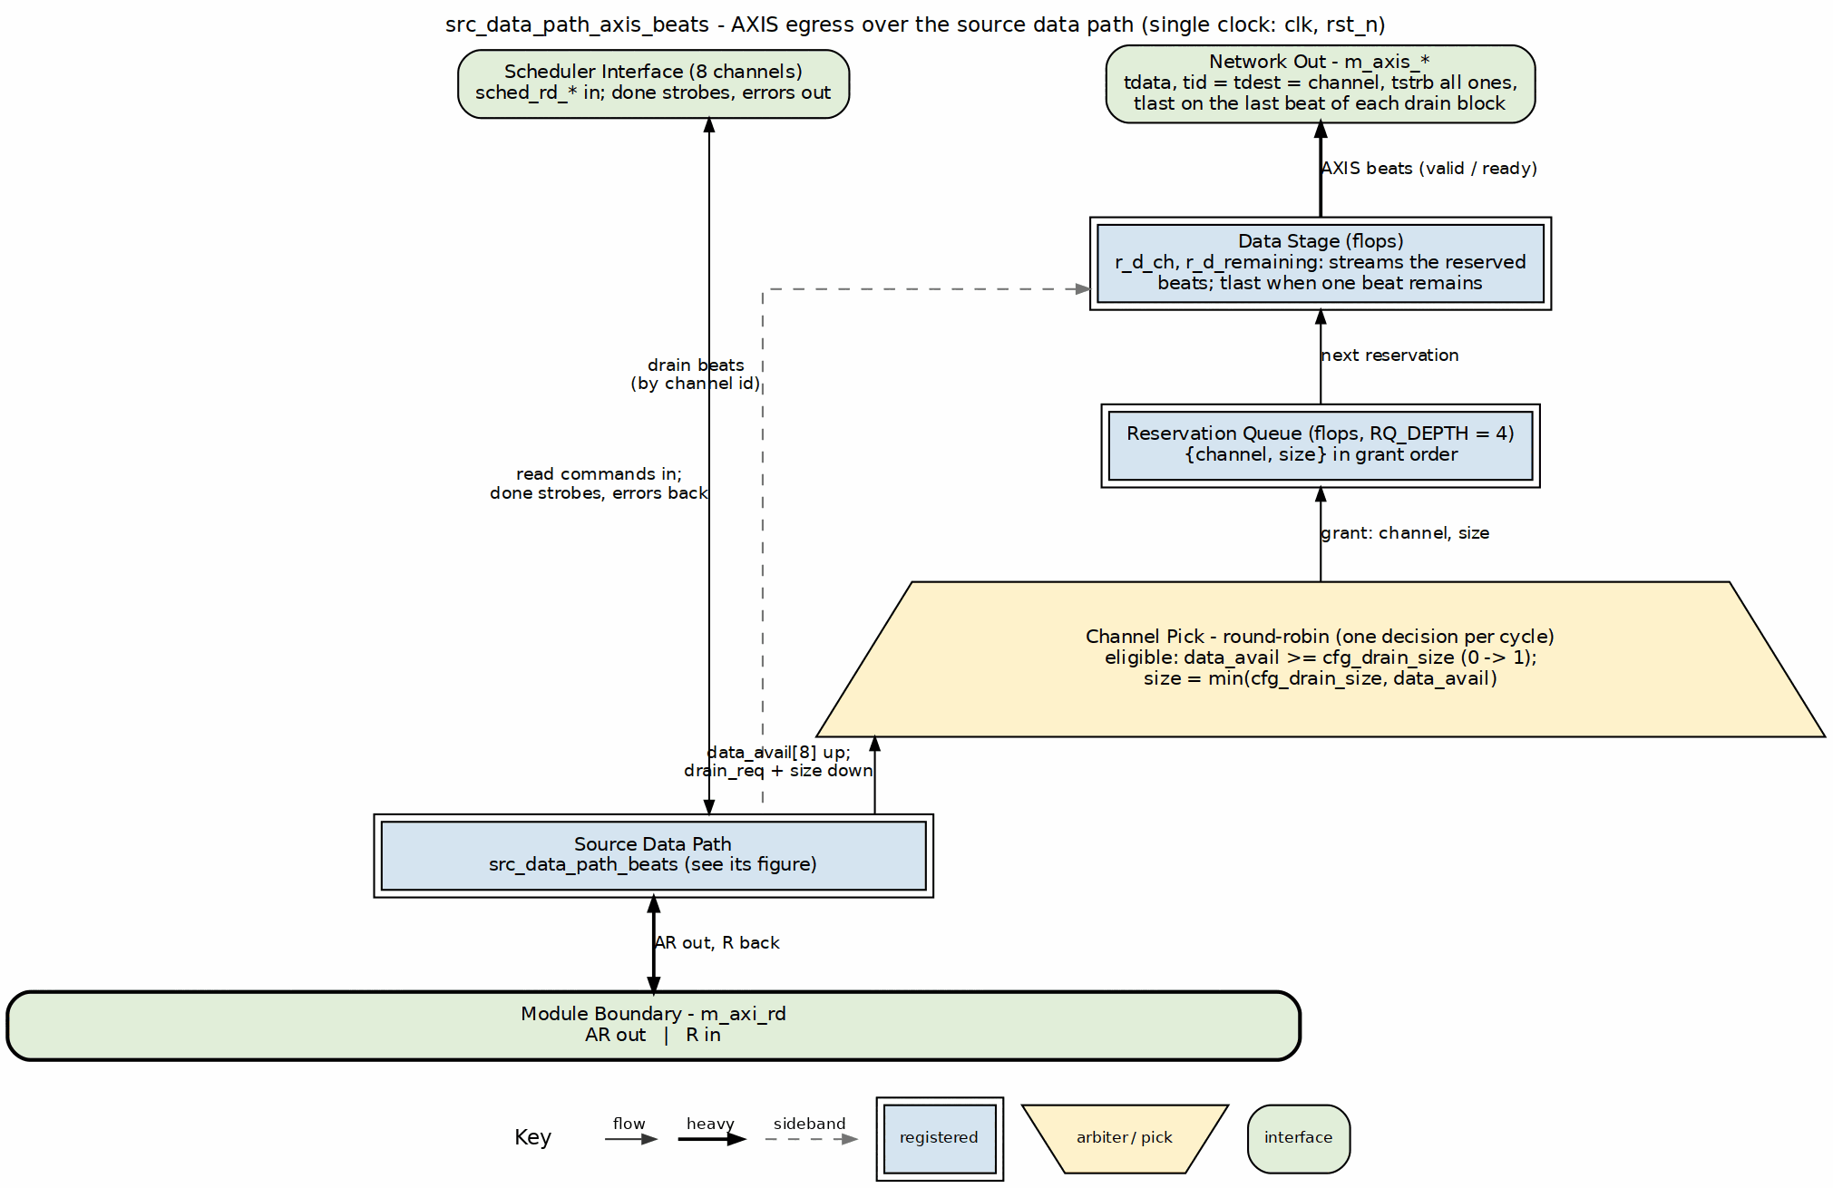
Source data path AXIS block diagram
Source: 17_source_data_path_axis.dot

21.2 Parameters
parameter int NUM_CHANNELS = 8;
parameter int ADDR_WIDTH = 64;
parameter int DATA_WIDTH = 512;
parameter int AXI_ID_WIDTH = 8;
parameter int SRAM_DEPTH = 512;
parameter int TID_WIDTH = 3; // log2(NUM_CHANNELS)
parameter int TDEST_WIDTH = 1;
parameter int TUSER_WIDTH = 1;
: Table 3.7.1: Source Data Path AXIS Parameters

21.3 Port List

21.3.1 Clock and Reset
Table 3.7.2: Clock and Reset
Signal | Direction | Width | Description
clk | input | 1 | System clock
rst_n | input | 1 | Active-low reset

21.3.2 Configuration
Table 3.7.3: Configuration
Signal | Direction | Width | Description
cfg_axi_rd_xfer_beats | input | 8 | AXI read transfer size in beats (all channels)
cfg_drain_size | input | 8 | Beats to drain per request

21.3.3 Scheduler Interface
Table 3.7.4: Scheduler Interface
Signal | Direction | Width | Description
sched_rd_valid | input | NC | Channel requests read
sched_rd_addr | input | NC x AW | Source addresses
sched_rd_beats | input | NC x 32 | Beats remaining to read
sched_rd_done_strobe | output | NC | Burst completed (pulsed 1 cycle)
sched_rd_beats_done | output | NC x 32 | Beats completed in burst
sched_rd_error | output | NC | Sticky error flag per channel

21.3.4 AXI Read Master Interface
Table 3.7.5: AXI Read Master Interface
Signal | Direction | Width | Description
m_axi_arvalid | output | 1 | AR channel valid
m_axi_arready | input | 1 | AR channel ready
m_axi_araddr | output | AW | Read address
m_axi_arlen | output | 8 | Burst length
m_axi_arsize | output | 3 | Burst size
m_axi_arburst | output | 2 | Burst type
m_axi_arid | output | ID_W | Transaction ID
m_axi_rvalid | input | 1 | R channel valid
m_axi_rready | output | 1 | R channel ready
m_axi_rdata | input | DW | Read data
m_axi_rresp | input | 2 | Read response
m_axi_rid | input | ID_W | Response ID
m_axi_rlast | input | 1 | Last beat

21.3.5 AXI-Stream Master Interface
Table 3.7.6: AXI-Stream Master Interface
Signal | Direction | Width | Description
m_axis_tvalid | output | 1 | Data valid
m_axis_tready | input | 1 | Consumer ready
m_axis_tdata | output | DW | Data payload
m_axis_tstrb | output | SW | Byte strobes
m_axis_tlast | output | 1 | Last beat of packet
m_axis_tid | output | AXIS_ID_WIDTH | Stream ID (channel)
m_axis_tdest | output | AXIS_DEST_WIDTH | Destination
m_axis_tuser | output | AXIS_USER_WIDTH | User sideband

21.4 Signal Mapping

21.4.1 Figure 3.7.2: Drain to AXIS Interface Mapping
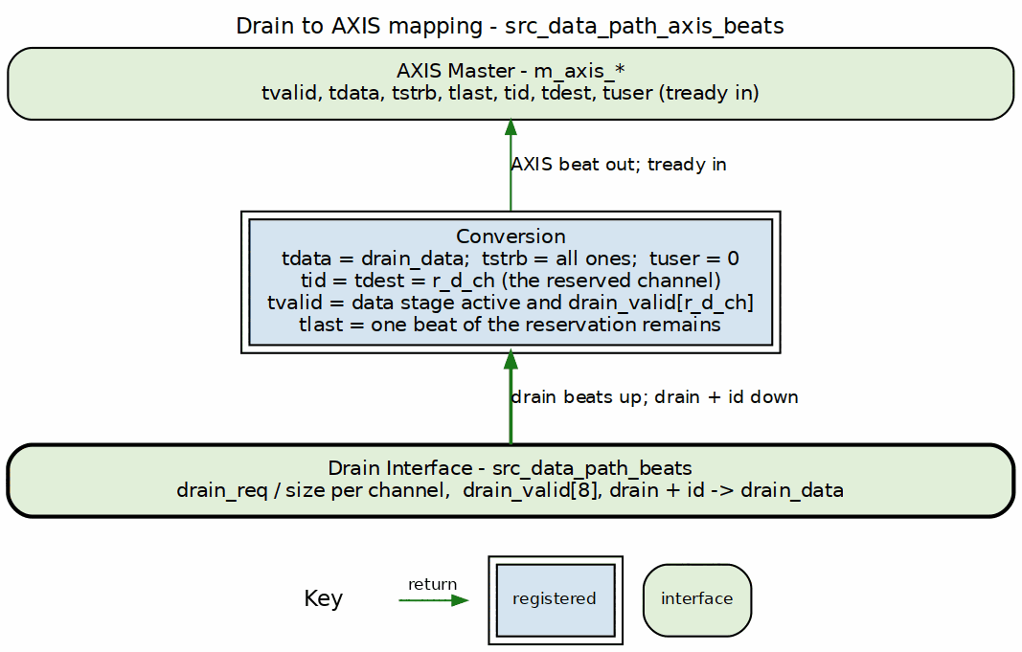
Drain to AXIS mapping
Source: 17b_drain_to_axis.dot

21.5 Timing Diagram

21.5.1 Figure 3.7.3: AXIS Egress Timing
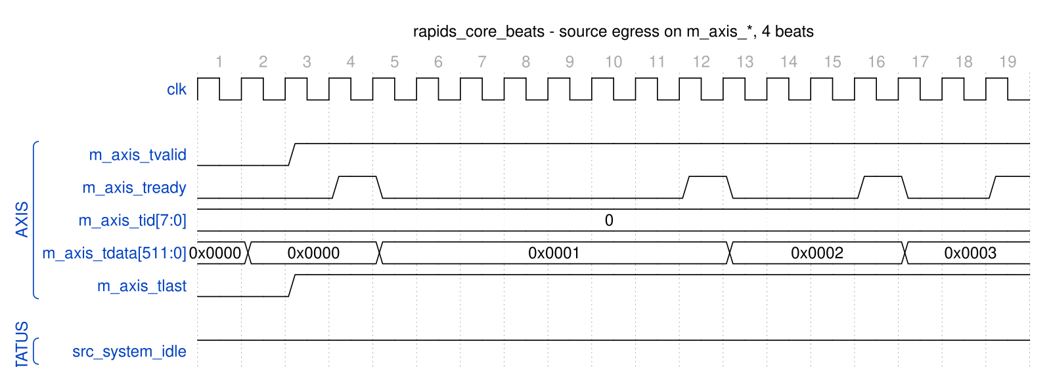
rapids_core_beats - source egress on m_axis_*, 4 beats
Source: src_data_path_axis_egress.json, captured from dv/tests/top_beats/test_rapids_core_beats.py (source path, channel 0, 4 beats, 512-bit data, REG_LEVEL=GATE) with WAVES=1; the consumer is the framework AXIS slave with its default ready pacing.
Reading it: m_axis_tvalid rises with the first word and stays high for the whole burst; each beat leaves on a tready pulse from the consumer (cycles 4, 12, 16 and 19), tdata advancing 0, 1, 2, 3 in the low bits and tid naming channel 0. tlast closes each drain request’s packet (cfg_drain_size beats at most); the words arrived from the read engine one at a time here, so every request carried a single word and every beat is marked last. src_system_idle is already back high: system_idle is the AND of the schedulers’ idle flags, and the source scheduler retires a descriptor on the read engine’s done strobe (Figure 3.6.3), before the words have drained to the AXIS side. The sink half is different – its scheduler waits for the write commits, so snk_system_idle follows the last B response.

21.6 Usage Notes
- TID Generation: Drain channel ID directly maps to AXIS TID
- TLAST Generation: Drain last signal maps to AXIS TLAST
- Backpressure: Network TREADY backpressure propagates to SRAM drain
- Packet Boundaries: TLAST marks end of AXIS packets

21.7 Integration Example
src_data_path_axis_beats #(
.NUM_CHANNELS(8),
.ADDR_WIDTH(64),
.DATA_WIDTH(512),
.AXIS_ID_WIDTH (3)
) u_source_axis (
.clk (clk),
.rst_n (rst_n),
// Scheduler interface
.sched_rd_valid (sched_rd_valid),
.sched_rd_addr (sched_rd_addr),
.sched_rd_beats (sched_rd_beats),
.sched_rd_done_strobe (sched_rd_done_strobe),
// AXI read master
.m_axi_arvalid (src_axi_arvalid),
.m_axi_arready (src_axi_arready),
.m_axi_araddr (src_axi_araddr),
.m_axi_rvalid (src_axi_rvalid),
.m_axi_rready (src_axi_rready),
.m_axi_rdata (src_axi_rdata),
// AXIS master
.m_axis_tvalid (network_tvalid),
.m_axis_tready (network_tready),
.m_axis_tdata (network_tdata),
.m_axis_tlast (network_tlast),
.m_axis_tid (network_tid)
);

Last Updated: 2025-01-10

RTL Design Sherpa · Learning Hardware Design Through Practice GitHub · Documentation Index · MIT License

22 Source SRAM Controller Specification
Module: src_sram_controller_beats.sv Location: projects/components/dma-ip/rapids/rtl/macro_beats/ Status: Implemented Last Updated: 2025-01-10

22.1 Overview
The Source SRAM Controller is a naming wrapper, with no logic of its own, around STREAM’s sram_controller – the one per-channel SRAM implementation both DMAs share since bdf4e0dff. It maps the RAPIDS fill_*/drain_* names onto STREAM’s ports; the eight per-channel units (allocation counter, FIFO, drain counter, latency bridge) live inside STREAM’s block. It manages 8 channel units for the source data path, providing per-channel buffering with channel arbitration for data delivery to the network.

22.1.1 Key Features
- One shared implementation: instantiates STREAM’s sram_controller once; it holds 8 sram_controller_units, each a gaxi_fifo_sync FIFO with stream_alloc_ctrl, stream_drain_ctrl and stream_latency_bridge
- Channel Arbitration: none inside the controller – the AXIS egress arbiter picks a channel and presents it on drain_id
- Flow Control Integration: per-channel stream_alloc_ctrl / stream_drain_ctrl virtual FIFOs; the drain counter’s virtual depth is 2 x SRAM_DEPTH (stream BUG-011)
- Data Availability Tracking: Reports available data per channel

22.1.2 Block Diagram

22.1.3 Figure 3.8.1: Source SRAM Controller Block Diagram
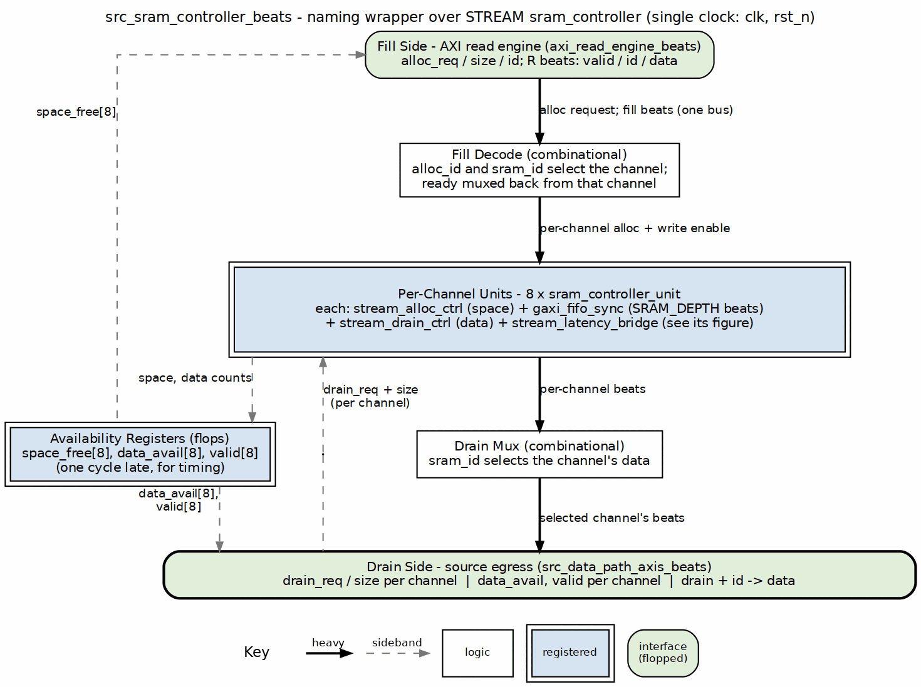
Source SRAM controller block diagram
Source: 18_src_sram_controller.dot

22.2 Parameters
parameter int NUM_CHANNELS = 8;
parameter int DATA_WIDTH = 512;
parameter int SRAM_DEPTH = 512; // Per-channel depth
parameter int ADDR_WIDTH = $clog2(SRAM_DEPTH);
: Table 3.8.1: Source SRAM Controller Parameters

22.3 Port List

22.3.1 Clock and Reset
Table 3.8.2: Clock and Reset
Signal | Direction | Width | Description
clk | input | 1 | System clock
rst_n | input | 1 | Active-low reset

22.3.2 Fill Interface (ID-Selected, from AXI Read Engine)
Table 3.8.3: Fill Interface (ID-Selected)
Signal | Direction | Width | Description
fill_alloc_req | input | 1 | Allocation request (single, ID-selected)
fill_alloc_size | input | 8 | Beats to allocate
fill_alloc_id | input | CIW | Transaction ID selects the channel
fill_space_free | output | NC x SCW | Available space per channel
fill_valid | input | 1 | Fill data valid
fill_ready | output | 1 | Ready for fill data
fill_id | input | CIW | Transaction ID selects the channel
fill_data | input | DW | Fill data

22.3.3 Arbitrated Drain Interface (to Network)
Table 3.8.4: Arbitrated Drain Interface
Signal | Direction | Width | Description
drain_data_avail | output | NC x SCW | Data available per channel
drain_req | input | NC | Drain reservation request per channel
drain_size | input | NC x 8 | Beats to reserve
drain_valid | output | NC | Drain data valid per channel
drain_valid_comb | output | NC | Combinational per-channel valid (beat gate)
drain_read | input | 1 | Consumer read strobe
drain_id | input | CIW | Channel ID select for drain
drain_data | output | DW | Drain data (muxed from selected channel)

22.3.4 Debug Interface
Table 3.8.5: Debug Interface
Signal | Direction | Width | Description
dbg_bridge_pending | output | NC | Bridge has a pending beat per channel
dbg_bridge_out_valid | output | NC | Bridge output valid per channel

22.4 Drain Selection
There is no arbiter inside the controller. Every channel unit raises its own drain_valid[ch] / drain_size[ch] when it has data; the AXIS egress arbiter picks a channel, drives it on drain_id, and the controller steers that channel’s beats to the single drain_* port. Switching channels costs nothing beyond the consumer’s own decision, and a channel keeps presenting drain_valid until it is empty.

22.4.1 Figure 3.8.2: Drain Selection by the Consumer

src_sram_controller_beats - consumer drains eight channels in turn
Source: src_sram_controller_drain_select.json, captured from dv/tests/macro_beats/test_src_sram_controller_beats.py (multi_channel, 8 channels, 512-bit data, 512-entry SRAM, REG_LEVEL=GATE) with WAVES=1.
Reading it: the same selection contract as the sink controller (Figure 3.5.2). With drain_valid = 0xff the consumer asks for one channel at a time through drain_req; drain_id and drain_data follow the request on the same cycle and drain_read pops the word. The nine-cycle turn per channel is the test’s pacing, not the controller’s.

22.5 Comparison: Sink vs Source SRAM Controller
Table 3.8.6: Sink vs Source Controller Comparison
Aspect | Sink Controller | Source Controller
Fill Source | Network ingress | AXI read data
Drain Destination | AXI write engine | Network egress
Fill Interface | Per-channel from network | Per-channel from AXI R
Drain Interface | Arbitrated SRAM read | Arbitrated drain to network
Primary Use | Network -> Memory | Memory -> Network

22.6 Integration Example
src_sram_controller_beats #(
.NUM_CHANNELS(8),
.DATA_WIDTH(512),
.SRAM_DEPTH(512)
) u_src_sram_ctrl (
.clk (clk),
.rst_n (rst_n),
// Per-channel fill interface (from AXI read engine)
.fill_alloc_req (fill_alloc_req),
.fill_alloc_size (fill_alloc_size),
.fill_space_free (fill_space_free),
.fill_valid (fill_valid),
.fill_ready (fill_ready),
.fill_data (fill_data),
// Arbitrated drain interface (to network)
.drain_valid (src_drain_valid),
.drain_data (src_drain_data),
.drain_id (src_drain_id),
// Status
.drain_data_avail (channel_data_avail),
.dbg_bridge_pending (channel_empty),
.dbg_bridge_out_valid (channel_full)
);

Last Updated: 2025-01-10

RTL Design Sherpa · Learning Hardware Design Through Practice GitHub · Documentation Index · MIT License

23 RAPIDS Core Beats Specification
Module: rapids_core_beats.sv Location: projects/components/dma-ip/rapids/rtl/macro_beats/ Status: Implemented Last Updated: 2025-01-10

23.1 Overview
The RAPIDS Core Beats module is the top-level integration of the “beats” architecture, combining the scheduler group array with sink and source data paths.

23.1.1 Key Features
- Complete RAPIDS Core: Scheduler array + sink path + source path
- 8-Channel Architecture: Full multi-channel support
- Unified MonBus: Aggregated monitoring from all subsystems
- Configurable Parameters: Data width, address width, SRAM depths

23.1.2 Block Diagram

23.1.3 Figure 3.9.1: RAPIDS Core Beats Block Diagram
RAPIDS core beats block diagram
Source: 19_rapids_core.dot

23.2 Parameters
parameter int NUM_CHANNELS = 8;
parameter int ADDR_WIDTH = 64;
parameter int DATA_WIDTH = 512;
parameter int DESC_DATA_WIDTH = 256;
parameter int AXI_ID_WIDTH = 8;
parameter int SRAM_DEPTH = 512;
// AXI Parameters
parameter int AR_MAX_OUTSTANDING = 8;
parameter int AW_MAX_OUTSTANDING = 8;
parameter int PIPELINE = 1; // write-engine pipelining: 1 = up to AW_MAX_OUTSTANDING bursts in flight per channel
parameter int R_PHASE_FIFO_DEPTH = 64;
parameter int W_PHASE_FIFO_DEPTH = 64;
parameter int B_PHASE_FIFO_DEPTH = 16;
// MonBus Parameters
parameter int MON_UNIT_ID = 1;
// Feature Enables
parameter bit ENABLE_AXIS_WRAPPERS = 0; // Use AXIS interfaces
: Table 3.9.1: RAPIDS Core Beats Parameters

23.3 Port List

23.3.1 Clock and Reset
Table 3.9.2: Clock and Reset
Signal | Direction | Width | Description
clk | input | 1 | System clock
rst_n | input | 1 | Active-low reset

23.3.2 Per-Channel APB Programming
The source and sink halves each carry their own kick-off port; there is no shared apb_* port.
Table 3.9.3: APB Programming Interface
Signal | Direction | Width | Description
src_apb_valid | input | NC | Source channel kick-off (per-channel)
src_apb_ready | output | NC | Source ready for kick-off
src_apb_addr | input | NC x AW | Source first descriptor address
snk_apb_valid | input | NC | Sink channel kick-off (per-channel)
snk_apb_ready | output | NC | Sink ready for kick-off
snk_apb_addr | input | NC x AW | Sink first descriptor address

23.3.3 Per-Channel Configuration
Configuration is per half as well: every knob exists as src_cfg_* and snk_cfg_* (76 configuration ports in total, the bulk of them the descriptor monitor masks). The scheduler-facing ones are:
Table 3.9.4: Per-Channel Configuration
Signal | Direction | Width | Description
src_cfg_channel_enable / snk_cfg_channel_enable | input | NC | Enable per channel
src_cfg_channel_reset / snk_cfg_channel_reset | input | NC | Soft reset per channel
src_cfg_sched_enable / snk_cfg_sched_enable | input | 1 | Enable the scheduler half
src_cfg_sched_timeout_cycles / snk_cfg_sched_timeout_cycles | input | 32 | Write-progress timeout window (cycles)
src_cfg_sched_timeout_limit / snk_cfg_sched_timeout_limit | input | 8 | Consecutive-timeout windows before fatal escalation (0 = never)
src_cfg_sched_timeout_enable / snk_cfg_sched_timeout_enable | input | 1 | Enable timeout detection
cfg_axi_rd_xfer_beats | input | 8 | Source read burst size (ARLEN encoding)
cfg_axi_wr_xfer_beats | input | 8 | Sink write burst size (ARLEN encoding)
cfg_alloc_size | input | 8 | Beats allocated per sink fill request
cfg_drain_size | input | 8 | Beats drained per source AXIS packet
*_cfg_sched_timeout_limit is passed straight through to the scheduler_group_array_beats instance (recoverable-timeout escalation, see the Scheduler FUB). The write-side COMMIT strobes (sched_wr_commit_strobe / sched_wr_commit_beats) generated by the sink data path’s axi_write_engine_beats are routed internally from the sink data path up into the scheduler array so completion is gated on B responses.

23.3.4 Descriptor AXI Master Interfaces
There are TWO descriptor masters, one per half, 18 ports each. Both are read-only, 256-bit.
Table 3.9.5: Descriptor AXI Master Interfaces (src and snk)
Signal | Direction | Width | Description
src_m_axi_desc_arvalid / snk_m_axi_desc_arvalid | output | 1 | AR channel valid
src_m_axi_desc_arready / snk_m_axi_desc_arready | input | 1 | AR channel ready
src_m_axi_desc_araddr / snk_m_axi_desc_araddr | output | AW | AR address
src_m_axi_desc_arid / snk_m_axi_desc_arid | output | IW | AR id
src_m_axi_desc_arlen / snk_m_axi_desc_arlen | output | 8 | Burst length
src_m_axi_desc_arsize / snk_m_axi_desc_arsize | output | 3 | Burst size
src_m_axi_desc_arburst / snk_m_axi_desc_arburst | output | 2 | Burst type
src_m_axi_desc_rvalid / snk_m_axi_desc_rvalid | input | 1 | R channel valid
src_m_axi_desc_rready / snk_m_axi_desc_rready | output | 1 | R channel ready
src_m_axi_desc_rdata / snk_m_axi_desc_rdata | input | 256 | R data (one descriptor)
src_m_axi_desc_rresp / snk_m_axi_desc_rresp | input | 2 | R response
src_m_axi_desc_rlast / snk_m_axi_desc_rlast | input | 1 | R last
src_m_axi_desc_rid / snk_m_axi_desc_rid | input | IW | R id
The AR sideband (arlock, arcache, arprot, arqos, arregion) is present on both masters and driven to AXI defaults.

23.3.5 Sink AXI Write Master Interface
Table 3.9.6: Sink AXI Write Master Interface
Signal | Direction | Width | Description
m_axi_wr_awvalid | output | 1 | AW channel valid
m_axi_wr_awready | input | 1 | AW channel ready
m_axi_wr_awaddr | output | AW | Write address
m_axi_wr_awid | output | IW | Write id (carries the channel index)
m_axi_wr_awlen | output | 8 | Burst length
m_axi_wr_awsize | output | 3 | Burst size
m_axi_wr_awburst | output | 2 | Burst type
m_axi_wr_wvalid | output | 1 | W channel valid
m_axi_wr_wready | input | 1 | W channel ready
m_axi_wr_wdata | output | DW | Write data
m_axi_wr_wstrb | output | DW/8 | Write strobes
m_axi_wr_wlast | output | 1 | Last beat
m_axi_wr_bvalid | input | 1 | B channel valid
m_axi_wr_bready | output | 1 | B channel ready
m_axi_wr_bid | input | IW | B id (routes the commit to a channel)
m_axi_wr_bresp | input | 2 | Write response
The AW sideband (awlock, awcache, awprot, awqos, awregion) is present and driven to AXI defaults. 21 ports in total.

23.3.6 Source AXI Read Master Interface
Table 3.9.7: Source AXI Read Master Interface
Signal | Direction | Width | Description
m_axi_rd_arvalid | output | 1 | AR channel valid
m_axi_rd_arready | input | 1 | AR channel ready
m_axi_rd_araddr | output | AW | Read address
m_axi_rd_arid | output | IW | Read id (carries the channel index)
m_axi_rd_arlen | output | 8 | Burst length
m_axi_rd_arsize | output | 3 | Burst size
m_axi_rd_arburst | output | 2 | Burst type
m_axi_rd_rvalid | input | 1 | R channel valid
m_axi_rd_rready | output | 1 | R channel ready
m_axi_rd_rdata | input | DW | Read data
m_axi_rd_rid | input | IW | R id (routes the beat to a channel)
m_axi_rd_rresp | input | 2 | Read response
m_axi_rd_rlast | input | 1 | Last beat

23.3.7 Sink Ingress – AXIS Slave
The sink takes network traffic on a standard AXI-Stream slave port. In a top this port is driven by the RX network plane (fub_axis_*), whichever protocol the plane speaks on the pins, so the core is the same in the AXIS and CXS tops (see Network Planes). There is no snk_fill_* port at core level: the fill handshake is internal to snk_data_path_axis_beats, which converts AXIS into it.
Table 3.9.8: Sink Ingress AXIS Slave
Signal | Direction | Width | Description
s_axis_tvalid | input | 1 | Beat valid
s_axis_tready | output | 1 | Ready for beat
s_axis_tdata | input | DW | Beat data
s_axis_tstrb | input | SW | Byte strobes
s_axis_tlast | input | 1 | Last beat of packet
s_axis_tid | input | AXIS_ID_WIDTH | Channel id (low CIW bits select the channel)
s_axis_tdest | input | AXIS_DEST_WIDTH | Destination
s_axis_tuser | input | AXIS_USER_WIDTH | User sideband

23.3.8 Source Egress – AXIS Master
Likewise there is no src_drain_* port at core level; the drain handshake is internal to src_data_path_axis_beats.
Table 3.9.9: Source Egress AXIS Master
Signal | Direction | Width | Description
m_axis_tvalid | output | 1 | Beat valid
m_axis_tready | input | 1 | Downstream ready
m_axis_tdata | output | DW | Beat data
m_axis_tstrb | output | SW | Byte strobes
m_axis_tlast | output | 1 | Last beat of packet
m_axis_tid | output | AXIS_ID_WIDTH | Channel id
m_axis_tdest | output | AXIS_DEST_WIDTH | Destination
m_axis_tuser | output | AXIS_USER_WIDTH | User sideband

23.3.9 Unified MonBus Interface
One packet port, carrying a struct rather than a flat 64-bit bus.
Table 3.9.10: Unified MonBus Interface
Signal | Direction | Width | Description
mon_valid | output | 1 | Packet valid
mon_ready | input | 1 | Consumer ready
mon_packet | output | ocelus_common_pkg::monitor_packet_t | Packet payload
mon_timestamp | output | ocelus_common_pkg::monbus_timestamp_t | Packet timestamp

23.3.10 Aggregate Status
Status is reported per half. There is no all_channels_idle, sink_idle, source_idle or error_flags port.
Table 3.9.11: Aggregate Status
Signal | Direction | Width | Description
src_system_idle | output | 1 | Source half idle (all source schedulers idle)
snk_system_idle | output | 1 | Sink half idle (all sink schedulers idle)
src_scheduler_idle / snk_scheduler_idle | output | NC | Per-channel scheduler idle
src_scheduler_state / snk_scheduler_state | output | NC x 7 | Per-channel FSM state
src_descriptor_engine_idle / snk_descriptor_engine_idle | output | NC | Per-channel descriptor engine idle
src_sched_error / snk_sched_error | output | NC | Per-channel sticky scheduler error

23.4 Data Flow

23.4.1 Figure 3.9.2: RAPIDS Core Complete Data Flow
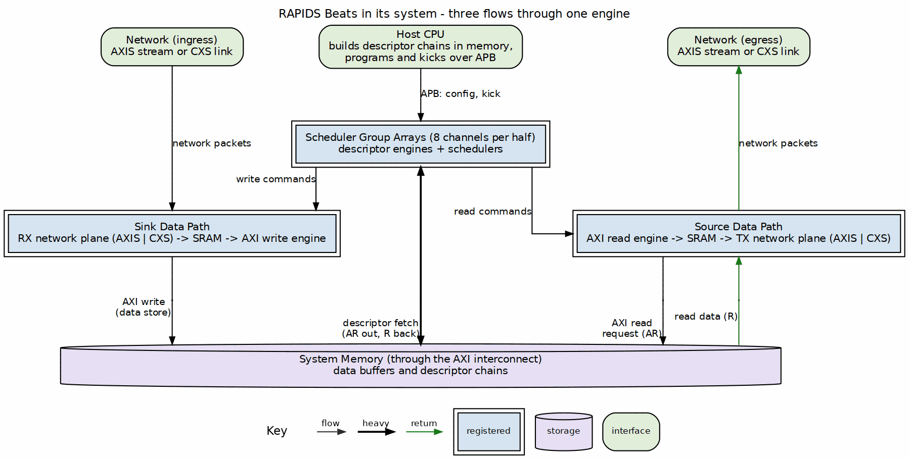
RAPIDS core data flow
Source: 22_core_data_flow.dot

23.5 MonBus Aggregation
The unified MonBus output aggregates sources from all subsystems:
Table 3.9.12: MonBus Source Assignment
Source Range | Origin | Description
0-15 | Scheduler Array | Per-channel scheduler + desc engine
16-23 | Sink Data Path | Sink SRAM controllers
24-31 | Source Data Path | Source SRAM controllers
32 | AXI Write Engine | Write completions
33 | AXI Read Engine | Read completions

23.6 Integration Example
rapids_core_beats #(
.NUM_CHANNELS(8),
.ADDR_WIDTH(64),
.DATA_WIDTH(512),
.SRAM_DEPTH(512)
) u_rapids_core (
.clk (clk),
.rst_n (rst_n),
// APB kick-off (per half)
.src_apb_valid (src_kick_valid),
.src_apb_ready (src_kick_ready),
.src_apb_addr (src_kick_addr),
.snk_apb_valid (snk_kick_valid),
.snk_apb_ready (snk_kick_ready),
.snk_apb_addr (snk_kick_addr),
// Configuration (per half)
.src_cfg_channel_enable (src_cfg_ch_enable),
.snk_cfg_channel_enable (snk_cfg_ch_enable),
.src_cfg_sched_timeout_cycles(src_cfg_timeout),
.snk_cfg_sched_timeout_cycles(snk_cfg_timeout),
.cfg_axi_rd_xfer_beats (cfg_rd_beats),
.cfg_axi_wr_xfer_beats (cfg_wr_beats),
.cfg_alloc_size (cfg_alloc_size),
.cfg_drain_size (cfg_drain_size),
// Descriptor AXI -- one master per half
.src_m_axi_desc_arvalid (src_desc_arvalid),
.src_m_axi_desc_arready (src_desc_arready),
.src_m_axi_desc_araddr (src_desc_araddr),
.src_m_axi_desc_rvalid (src_desc_rvalid),
.src_m_axi_desc_rready (src_desc_rready),
.src_m_axi_desc_rdata (src_desc_rdata),
.snk_m_axi_desc_arvalid (snk_desc_arvalid),
.snk_m_axi_desc_arready (snk_desc_arready),
.snk_m_axi_desc_araddr (snk_desc_araddr),
.snk_m_axi_desc_rvalid (snk_desc_rvalid),
.snk_m_axi_desc_rready (snk_desc_rready),
.snk_m_axi_desc_rdata (snk_desc_rdata),
// Sink AXI write master (memory side)
.m_axi_wr_awvalid (wr_awvalid),
.m_axi_wr_awready (wr_awready),
.m_axi_wr_awaddr (wr_awaddr),
.m_axi_wr_awlen (wr_awlen),
.m_axi_wr_wvalid (wr_wvalid),
.m_axi_wr_wready (wr_wready),
.m_axi_wr_wdata (wr_wdata),
.m_axi_wr_wlast (wr_wlast),
.m_axi_wr_bvalid (wr_bvalid),
.m_axi_wr_bready (wr_bready),
.m_axi_wr_bresp (wr_bresp),
// Source AXI read master (memory side)
.m_axi_rd_arvalid (rd_arvalid),
.m_axi_rd_arready (rd_arready),
.m_axi_rd_araddr (rd_araddr),
.m_axi_rd_arlen (rd_arlen),
.m_axi_rd_rvalid (rd_rvalid),
.m_axi_rd_rready (rd_rready),
.m_axi_rd_rdata (rd_rdata),
.m_axi_rd_rlast (rd_rlast),
// Sink ingress -- AXIS slave (network in)
.s_axis_tvalid (network_rx_tvalid),
.s_axis_tready (network_rx_tready),
.s_axis_tdata (network_rx_tdata),
.s_axis_tlast (network_rx_tlast),
.s_axis_tid (network_rx_tid),
// Source egress -- AXIS master (network out)
.m_axis_tvalid (network_tx_tvalid),
.m_axis_tready (network_tx_tready),
.m_axis_tdata (network_tx_tdata),
.m_axis_tlast (network_tx_tlast),
.m_axis_tid (network_tx_tid),
// Unified MonBus
.mon_valid (mon_valid),
.mon_ready (mon_ready),
.mon_packet (mon_packet),
.mon_timestamp (mon_timestamp),
// Status (per half)
.src_system_idle (src_idle),
.snk_system_idle (snk_idle)
);
Note: rapids_core_beats is a core-level block. The register interface, configuration mapping, and top-level integration (APB slave, descriptor kick-off, AXI monitors, and the MonBus AXI-Lite group) are provided by the rapids_regs, rapids_config_block, and rapids_beats_top modules – see RAPIDS Registers, RAPIDS Config Block, and RAPIDS Beats Top.

Last Updated: 2026-07-02

RTL Design Sherpa · Learning Hardware Design Through Practice GitHub · Documentation Index · MIT License

24 RAPIDS Registers Specification
Module: rapids_regs.sv (generated) Source: projects/components/dma-ip/rapids/rtl/macro_beats/rapids_regs.rdl, rapids_mon_regs.rdl Generated: projects/components/dma-ip/rapids/regs/generated/rtl/rapids_regs.sv Status: Implemented (PeakRDL-generated)

24.1 Overview
rapids_regs is the PeakRDL-generated register block for the RAPIDS Beats top-level. It exposes configuration and status through a single command/response CPU interface and drives the hardware via a hwif_out structure that rapids_config_block maps onto the core/monitor cfg_* signals.
A single addrmap (one APB slave) contains two regfiles:
- Base config/status registers at 0x100-0x3FF.
- A nested rapids_mon_regs monitor regfile at base 0x1000, decoded under hwif_out.MON.* (all DAXMON / RDMON / WRMON / MON_FIFO and per-monitor performance registers).
Because the monitor regfile lives at 0x1000, the register-block address decode requires at least 13 bits (cpuif_addr is a 13-bit compare in the generated RTL). The APB address bus feeding the block (APB_ADDR_WIDTH) must therefore be >= 13 to reach the monitor regfile.

24.2 Base Register Map (0x100-0x3FF)
Table 3.10.1: Base Register Map
Offset | Name | Access | Description
0x100 | GLOBAL_CTRL | RW | GLOBAL_EN[0], GLOBAL_RST[1] (level; write 0 to release)
0x104 | GLOBAL_STATUS | RO | SYSTEM_IDLE[0] (all channels idle)
0x108 | VERSION | RO | MINOR[7:0]=0x5A, MAJOR[15:8], NUM_CHANNELS[23:16]=0x08
0x120 | CHANNEL_ENABLE | RW | CH_EN[7:0] per-channel enable
0x124 | CHANNEL_RESET | RW | CH_RST[7:0] per-channel reset (level; write 0 to release)
0x140 | CHANNEL_IDLE | RO | CH_IDLE[7:0] – not driven at the top level, reads 0
0x144 | DESC_ENGINE_IDLE | RO | Per-channel descriptor-engine idle
0x148 | SCHEDULER_IDLE | RO | Per-channel scheduler idle (excludes CH_ERROR)
0x150-0x16C | CH_STATE[0..7].STATE | RO | Per-channel FSM state (stride 0x4)
0x170 | SCHED_ERROR | RO | Per-channel sticky scheduler error
0x174 | AXI_RD_COMPLETE | RO | Per-channel read-complete flags (SRC half only; reads 0 in SNK)
0x178 | AXI_WR_COMPLETE | RO | Per-channel write-complete flags – not driven, reads 0
0x200 | SCHED_TIMEOUT_CYCLES | RW | TIMEOUT_CYCLES[31:0] write-progress window (reset 1000)
0x204 | SCHED_CONFIG | RW | SCHED_EN, TIMEOUT_EN, ERR_EN, COMPL_EN, PERF_EN
0x208 | SCHED_TIMEOUT_LIMIT | RW | LIMIT[7:0] consecutive-timeout escalation limit (reset 4, 0 = never)
0x220 | DESCENG_CONFIG | RW | DESCENG_EN[0], PREFETCH_EN[1], FIFO_THRESH[5:2] (reset 8)
0x224 | DESCENG_ADDR0_BASE | RW | Descriptor address range 0 base [31:0]
0x228 | DESCENG_ADDR0_LIMIT | RW | Descriptor address range 0 limit [31:0]
0x22C | DESCENG_ADDR1_BASE | RW | Descriptor address range 1 base [31:0]
0x230 | DESCENG_ADDR1_LIMIT | RW | Descriptor address range 1 limit [31:0]
0x240 | CTRL_CONFIG | RW | CTRLRD_MAX_TRY[8:0] control-read poll retry budget (0-511, reset 16)
0x2A0 | AXI_XFER_CONFIG | RW | AXI transfer sizing configuration
0x2B0 | PERF_CONFIG | RW | Performance profiler configuration
0x2C0 | OBS_CTRL | RW | Observation mux control (channel/category select)
0x2C4 | OBS_FLAGS | RO | Observation flags
0x2C8 | OBS_DATA0 | RO | Observation data word 0
0x2CC | OBS_DATA1 | RO | Observation data word 1
0x300-0x31C | CH_SCRATCH[n].SCRATCH | RW | Eight software bits per channel, SCRATCH[7:0] (reset 0); storage only, for flags or semaphores between the host and, in rapids-g, the half’s gatling. Not atomic across masters: give each bit one writer
0x35C | PERF_CH_SEL | RW | Performance channel select
0x378 | HIST_SEL | RW | Histogram bucket select
0x37C | HIST_DATA | RO | Histogram bucket data
0x380 | HIST_TOTAL | RO | Histogram total count

24.2.1 Key Register Fields
SCHED_TIMEOUT_LIMIT (0x208) – LIMIT[7:0] sets the number of consecutive write-progress timeout windows a channel tolerates before the recoverable timeout escalates to a fatal, sticky CH_ERROR. 0 = never escalate (pure soft timeout). Total time to escalate is approximately LIMIT x TIMEOUT_CYCLES. Reset value is 4.
DESCENG_CONFIG (0x220) – PREFETCH_EN[1] and FIFO_THRESH[5:2] control the now-functional descriptor prefetch: prefetch off = on-demand chaining (~1 ahead), prefetch on = buffer up to FIFO_THRESH descriptors ahead.
CTRL_CONFIG (0x240) – CTRLRD_MAX_TRY[8:0] bounds the control-read poll retry budget (0-511, reset 16) fed to every channel’s ctrlrd_engine. A CTRL_READ descriptor polls its gate address once per retry; if the masked value never matches within CTRLRD_MAX_TRY attempts the engine raises ctrlrd_error so a never-satisfied gate cannot hang the channel. See the Control-Read / Control-Write Engine specs (Sections 2.8 / 2.9) and the Scheduler control interface (Section 2.1).

24.3 Monitor Register Map (rapids_mon_regs @ 0x1000)
The monitor regfile is instantiated at base 0x1000 under hwif_out.MON.*. It holds the MonBus FIFO status, the three AXI-monitor configuration groups (DAXMON = descriptor monitor, RDMON = read monitor, WRMON = write monitor), and per-monitor performance counters.
Table 3.10.2: Monitor Register Map (base 0x1000)
Offset | Name | Access | Description
0x1000 | MON.MON_FIFO_STATUS | RO | MonBus capture/error FIFO status
0x1004 | MON.MON_FIFO_COUNT | RO | MonBus FIFO occupancy
0x10C0 | MON.DAXMON_ENABLE | RW | Descriptor-monitor enables (incl. COMPRESS_EN)
0x10C4 | MON.DAXMON_TIMEOUT | RW | Descriptor-monitor timeout cycles
0x10C8 | MON.DAXMON_LATENCY_THRESH | RW | Descriptor-monitor latency threshold
0x10CC | MON.DAXMON_PKT_MASK | RW | Descriptor-monitor packet mask
0x10D0 | MON.DAXMON_ERR_CFG | RW | Descriptor-monitor error select/mask
0x10D4-0x10DC | MON.DAXMON_MASK1/2/3 | RW | Descriptor-monitor category masks
0x10E0-0x10FC | MON.RDMON_* | RW | Source-egress AXIS monitor-lite config (same layout as DAXMON; SRC instance, rapids TASK-015)
0x1100-0x111C | MON.WRMON_* | RW | Sink-ingress AXIS monitor-lite config (same layout as DAXMON; SNK instance, rapids TASK-015)
0x1150-0x1178 | MON.DAXMON_PERF_* | RO/RW | Descriptor-monitor performance counters
0x1180-0x11A8 | MON.RDMON_PERF_* | RO/RW | Read-monitor performance counters
0x11B0-0x11D8 | MON.WRMON_PERF_* | RO/RW | Write-monitor performance counters
0x11E0-0x11EC | MON.{RD,WR}MON_PERF_CH_* | RO | Per-channel producer/backpressure/starve/idle
0x11F0 | MON.RDMON_PERF_CH_OVERFLOW | RO | Read-monitor per-channel overflow
0x11F4 | MON.WRMON_PERF_CH_OVERFLOW | RO | Write-monitor per-channel overflow
Each *_ENABLE register carries MON_EN, ERR_EN, COMPL_EN, TIMEOUT_EN (and COMPRESS_EN on the write monitor); each *_PERF_* group provides window, producer, backpressure, starve, idle, beat, byte (lo/hi), and burst counters.

Last Updated: 2026-07-02

RTL Design Sherpa · Learning Hardware Design Through Practice GitHub · Documentation Index · MIT License

25 RAPIDS Config Block Specification
Module: rapids_config_block.sv Location: projects/components/dma-ip/rapids/rtl/macro_beats/ Status: Implemented

25.1 Overview
rapids_config_block is a combinational adapter that maps the register block’s hwif_out structure onto the flat cfg_* signals consumed by rapids_core_beats and the AXI monitors. It contains no state; every output is a direct assignment (with a small number of width expansions and global-enable gates).
The monitor registers arrive under hwif_out.MON.*; base configuration and status arrive at the top level of hwif_out.

25.2 Mapping Groups

25.2.1 Base Configuration
Routes scheduler, channel, and descriptor-engine configuration to the core:
- cfg_channel_enable = CHANNEL_ENABLE.CH_EN & {8{GLOBAL_CTRL.GLOBAL_EN}} (per-channel enable gated by the global master enable).
- cfg_sched_timeout_cycles = SCHED_TIMEOUT_CYCLES.TIMEOUT_CYCLES (32-bit).
- cfg_sched_timeout_limit = SCHED_TIMEOUT_LIMIT.LIMIT (8-bit, direct).
- cfg_sched_{timeout,err,compl,perf}_enable = SCHED_CONFIG.{TIMEOUT,ERR,COMPL,PERF}_EN. COMPL_EN is the one the scheduler group acts on for its monitor packets: 0 drops the scheduler’s and descriptor engine’s CORE Completion packets at the group (emitters still acknowledged); ERR_EN and PERF_EN reach the group but gate nothing today (errors always reported, perf not implemented).
- cfg_desceng_* from DESCENG_CONFIG (enable / prefetch / FIFO threshold).
- Descriptor address ranges (cfg_desceng_addr{0,1}_{base,limit}) are zero-extended from the 32-bit register fields to the 64-bit ADDR_WIDTH.

25.2.2 Monitor Configuration (hwif_out.MON.*)
Three parallel groups map to the descriptor-read monitor and, since rapids TASK-015, the two AXIS data-path monitor-lites (one per half):
Table 3.11.1: Monitor Register-to-Config Mapping
Register group | cfg_* target
MON.DAXMON_* | cfg_desc_mon_* (descriptor monitor)
MON.RDMON_* | cfg_rdeng_mon_* (source-egress AXIS monitor-lite; wired in the SRC half only)
MON.WRMON_* | cfg_wreng_mon_* (sink-ingress AXIS monitor-lite; wired in the SNK half only)
The *_ENABLE bits map onto the AXIS monitor-lite’s class enables: MON_EN (gated by GLOBAL_EN), ERR_EN (error, channel-change and TSTRB checks), COMPL_EN (one Completion/STREAM_END per packet), PERF_EN (stream start/pause/resume and Credit/BACKPRESSURE stall reports), TIMEOUT_EN. *_TIMEOUT is MICROSECONDS in its low 16 bits (0 = never), *_LATENCY_THRESH the stall CYCLES that raise a backpressure report, and *_PKT_MASK is a MASK: bit[type] = 1 masks (drops) that packet type at the monitor-lite and again at the monbus group. It resets to all-masked (0xFFFF); the host clears the bits of the classes it wants to see (rapids BUG-008 corrected the description, which used to read “1 = enable”; the polarity and the reset are as intended).
Within each group the enable/timeout/latency/mask fields map 1:1, e.g. cfg_desc_mon_enable = MON.DAXMON_ENABLE.MON_EN & GLOBAL_CTRL.GLOBAL_EN, cfg_desc_mon_timeout_cycles = MON.DAXMON_TIMEOUT.TIMEOUT_CYCLES, and the category masks (timeout/compl/thresh/perf/addr/debug) pass through directly. Key enables are gated by GLOBAL_CTRL.GLOBAL_EN; masks pass through ungated.

25.2.3 Performance and Observation
PERF_CONFIG, PERF_CH_SEL, and OBS_CTRL map to the profiler and channel-observation-mux cfg_* signals.

Last Updated: 2026-07-02

RTL Design Sherpa · Learning Hardware Design Through Practice GitHub · Documentation Index · MIT License

26 RAPIDS Beats Top Specification
Module: rapids_beats_top.sv, rapids_beats_cxs_top.sv (generated), rapids_beats_top_base.sv Location: projects/components/dma-ip/rapids/rtl/top_beats/ Status: Implemented

26.1 Overview
rapids_beats_top is the synthesizable top-level integration of the RAPIDS Beats accelerator. It wraps the register block, config-block adapter, and core with a single APB slave for all software access, and adds optional AXI transaction monitors whose events are merged with the core’s descriptor-monitor packet and delivered through a MonBus AXI-Lite group (error-drain slave, capture master, and interrupt).
The top is generated (rapids TASK-024). rapids_beats_top_base holds everything described on this page; bin/gen_plane_tops.py wraps it with one RX and one TX network plane to make rapids_beats_top (AXIS planes) and rapids_beats_cxs_top (CXS planes). The planes are described in the Network Planes chapter; edit the base or the generator, never a generated top.

26.2 Integration Datapath

26.2.1 Figure 3.12.1: RAPIDS Beats Top Integration
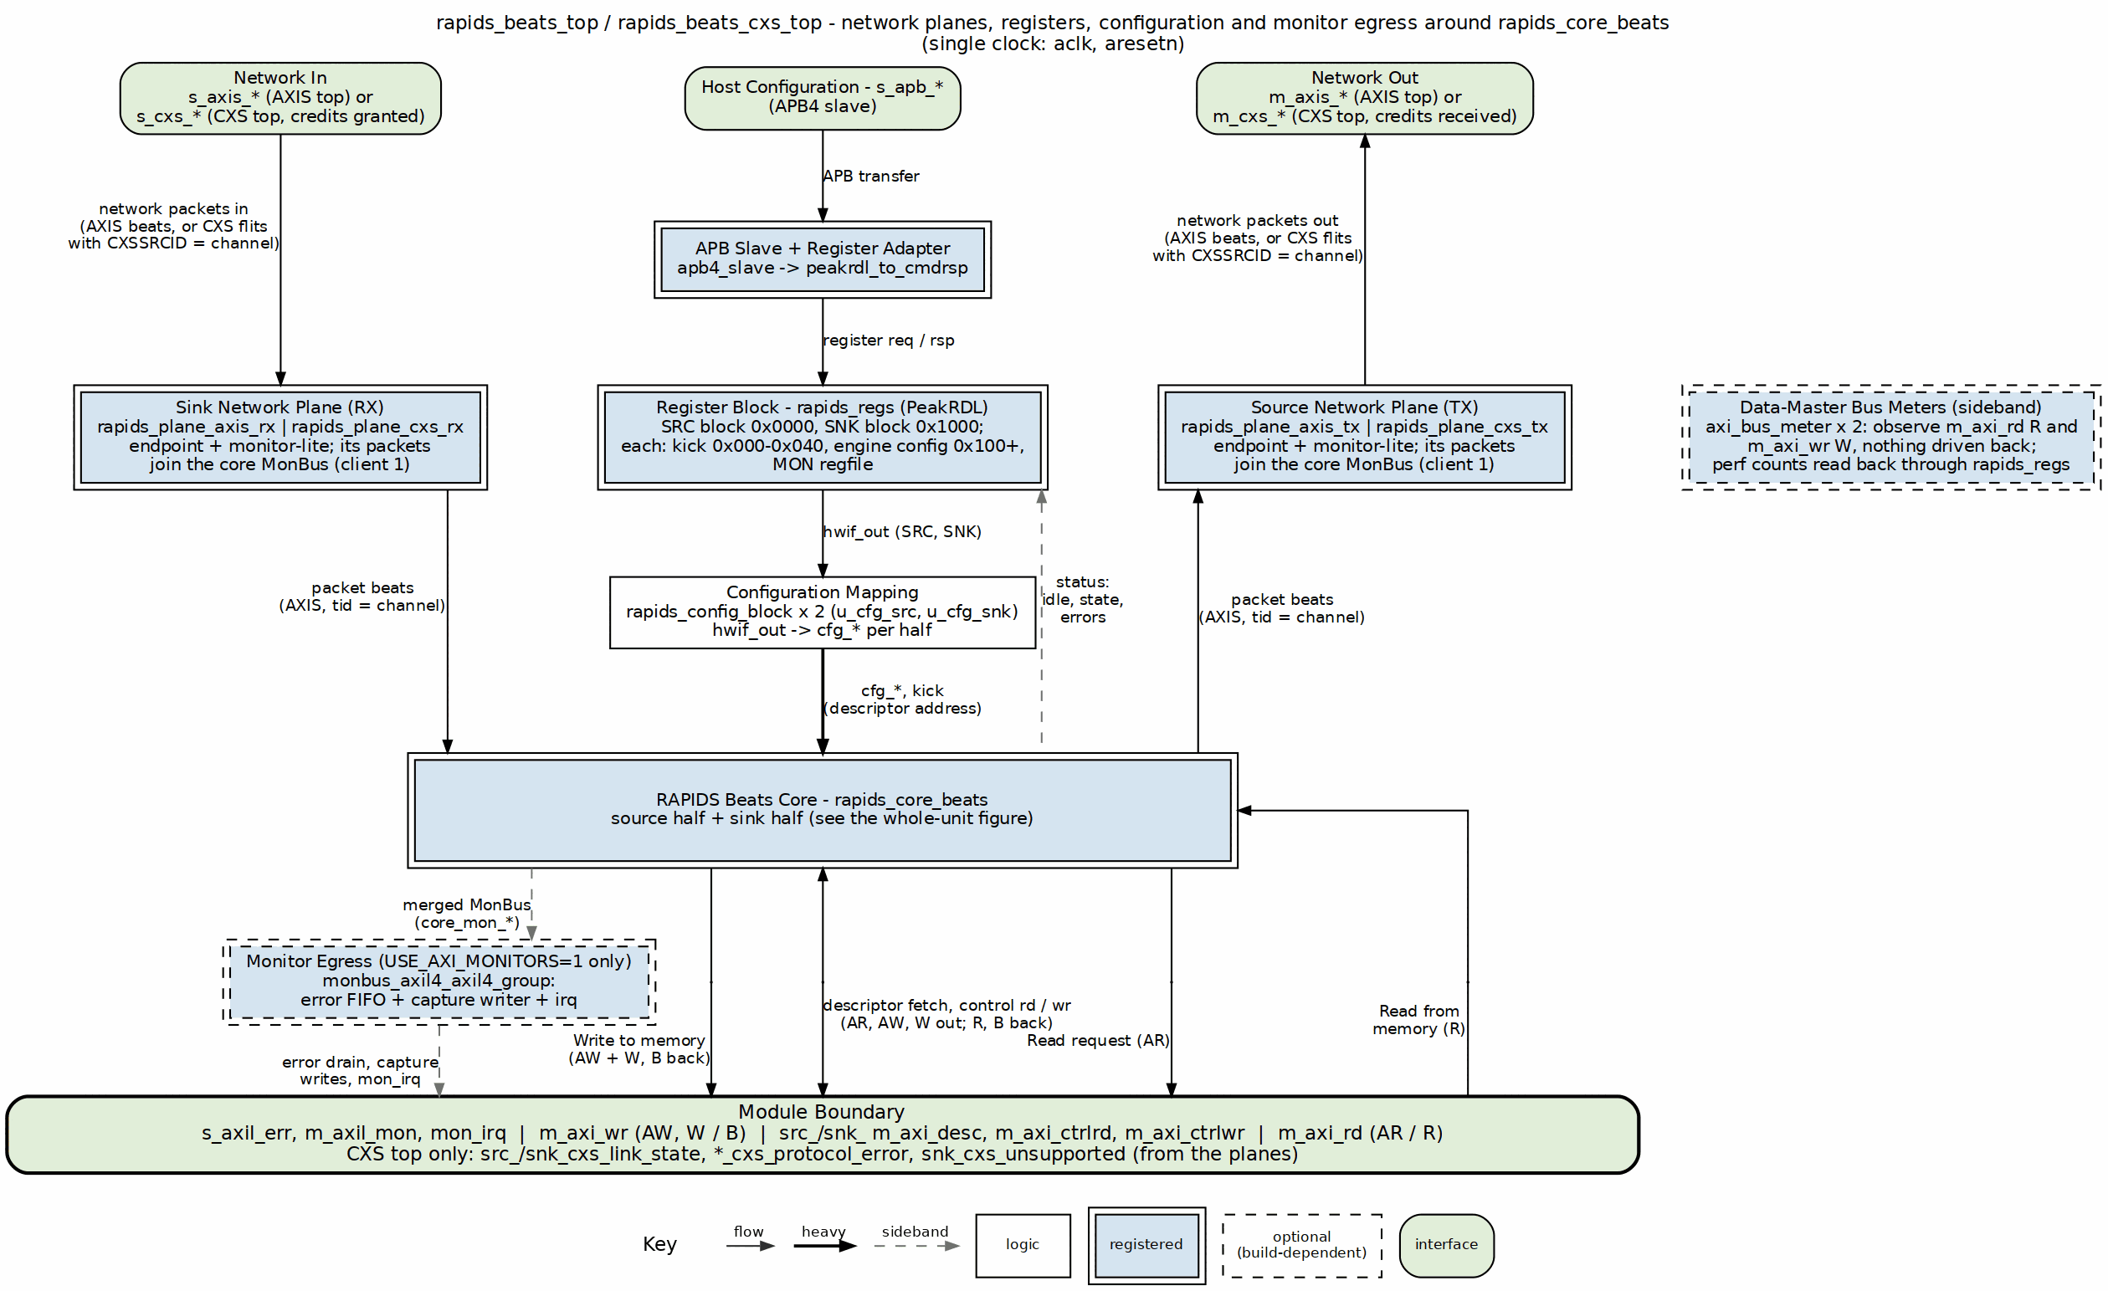
RAPIDS beats top integration
Source: 20_rapids_beats_top.dot

26.2.2 Address Decode
Table 3.12.1: Top-Level Address Decode
Range | Target | Purpose
0x000-0x03F | rapids_regs (kick) | Per-channel descriptor kick-off registers
0x100-0x3FF | rapids_regs (base) | Configuration / status registers
0x1000+ | rapids_regs (MON regfile) | Monitor configuration / performance
Because the monitor regfile is at 0x1000, the APB address bus must be at least 13 bits wide (APB_ADDR_WIDTH >= 13) to reach it.

26.3 Write-engine pipelining (PIPELINE)
PIPELINE reaches axi_write_engine_beats through the core and both halves. 0 is the engine’s original contract, one burst in flight per channel; 1 allows up to AW_MAX_OUTSTANDING per channel. Every module that declares the parameter, from the engines to this top, defaults to 1 since 2026-09-28: once rapids BUG-005 made PIPELINE = 0 honour one-in-flight, the 8-channel Genesys 2 build measured 49.9 % AXI4-wr engaged utilization at 4096 beats per channel (59.5 % at 1024), against 100 % on the bitstream before the fix – which had reached line rate only because the pre-fix engine ran two bursts in flight by accident. The harness simulation reproduces the same numbers (82.4 % at 1024 beats with PIPELINE = 0, 99.9 % with 1). One burst in flight cannot cover the write-response round trip at 8-beat bursts, so 1 is the design point at every level; 0 is selectable for a design that must bound each channel to a single outstanding write, never the default.

26.4 AXI Monitors (USE_AXI_MONITORS)
When USE_AXI_MONITORS = 1 the top builds the monbus_axil4_axil4_group and feeds it the core’s MonBus stream. That stream carries the scheduler groups’ completion and error events and two monitor-lite instances per half: axi4_master_rd_monlite on the half’s descriptor read master, inside scheduler_group_array_beats (agent 0x08), and a network monitor-lite in the half’s network plane (rapids TASK-015, moved to the planes by TASK-024): the sink plane’s lite on s_axis_* or s_cxs_* (agent 0x09, configured by SNK.MON.WRMON_*) and the source plane’s lite on m_axis_* or m_cxs_* (agent 0x0A, configured by SRC.MON.RDMON_*). The plane’s packets enter the core on snk_plane_mon_* / src_plane_mon_*. Each half merges its scheduler array (client 0), its plane monitor (client 1) and a tied-off placeholder client in a 3:1 monbus_arbiter; the core merges the two halves 2:1. The AXIS planes also place an axis4_slave / axis4_master skid stage (SKID_DEPTH = 4) on the network port in every build; the CXS planes buffer in the receive FIFO instead. Only the monitor tap is gated by USE_AXI_MONITORS. The data masters m_axi_rd and m_axi_wr carry NO monitors (an earlier revision of this page said rd/wr monitor-lite blocks sat on the data masters; the RTL has never had them). Data-master observation lives in the characterization harness as external instruments (axi_bus_meter, axis_bus_meter, and the interface observers on USE_OBSERVERS builds). The group’s AXIS filter slot is fed from SRC.MON.RDMON_*, so it filters both halves’ network packets (a CXS plane’s PROTOCOL_CXS packets ride the AXIS slot); *_PKT_MASK masks on a set bit and resets to all-masked (rapids BUG-008 corrected its description). The group provides:
- s_axil_err_* – AXI-Lite (32-bit) error-drain slave: CPU reads captured error events from the error FIFO.
- m_axil_mon_* – AXI-Lite (64-bit) capture master: bulk-writes the MonBus trace to system memory (base/limit/watermark from cfg_mon_*).
- mon_irq – interrupt on error/threshold events.
When USE_AXI_MONITORS = 0 the descriptor and network monitor-lites are omitted (the AXIS skid stages and CXS receive FIFO stay), the core MonBus is dropped (always-ready), and the AXI-Lite group outputs are tied off (s_axil_err read-inactive, m_axil_mon write-inactive, mon_irq = 0).

26.4.1 Monitor registers on a monitors-off build (USE_MON_REGS)
USE_MON_REGS defaults to USE_AXI_MONITORS != 0 and is passed to both config blocks. When it is 0 the blocks strap every cfg_*mon_* output off, and the APB path answers the two MON register windows – SRC MON at 0x0800-0x0FFF and SNK MON at 0x1800-0x1FFF, i.e. paddr[11] set in either 4 KB half – with PSLVERR and zero read data instead of letting the registers accept a write and read it back. The address map does not change, so one host image still addresses both builds; what changes is that “not built” is distinguishable from “built and set to zero”. A blocked access is still accepted (holding cmd_ready low would hang the bus) and the guard’s error beat replaces the adapter’s response for that one transfer (rapids ISSUE-003; the shape is STREAM’s TASK-002 guard). With USE_MON_REGS = 1 the guard folds away to the straight-through wiring.

26.5 Parameters
parameter int NUM_CHANNELS = 8;
parameter int DATA_WIDTH = 512;
parameter int ADDR_WIDTH = 64;
parameter int AXI_ID_WIDTH = 8;
parameter int SRAM_DEPTH = 4096;
parameter int APB_ADDR_WIDTH = 13; // bit 12 selects SRC (0) / SNK (1)
parameter int APB_DATA_WIDTH = 32;
parameter int USE_AXI_MONITORS = 1; // 1 = descriptor + network monitor-lites + MonBus group
parameter bit USE_MON_REGS = (USE_AXI_MONITORS != 0); // 0 = MON windows answer PSLVERR
parameter int MON_MAX_TRANSACTIONS = 16;
parameter int AR_MAX_OUTSTANDING = 8;
parameter int AW_MAX_OUTSTANDING = 8;
parameter int PIPELINE = 1; // write-engine pipelining; see the note below
parameter int AXIS_ID_WIDTH = 8; // network stream tid (carries the channel)
parameter int AXIS_DEST_WIDTH = 4;
parameter int AXIS_USER_WIDTH = 1;
// rapids_beats_cxs_top only (see the Network Planes chapter):
parameter int CXS_MAX_CREDIT = 32; // one credit = one flit
parameter int CXS_RX_FIFO_DEPTH = CXS_MAX_CREDIT;
parameter bit CXS_CREDIT_BEYOND_SPEC = (CXS_MAX_CREDIT > 63);
parameter logic [7:0] CXS_IDLE_CYCLES = 8'd32;
: Table 3.12.2: RAPIDS Beats Top Parameters

26.6 Top-Level Interfaces
Table 3.12.3: Top-Level Interfaces
Interface | Signals | Notes
Clock / reset | aclk, aresetn, cam_clear | Single clock domain; cam_clear for monitor CAMs
APB slave | s_apb_paddr (APB_ADDR_WIDTH), s_apb_psel/penable/pwrite/pwdata/pstrb, s_apb_prdata/pready/pslverr | 32-bit data
Descriptor AXI (master) | m_axi_desc_ar*, m_axi_desc_r* | 256-bit read data
Data read AXI (master) | m_axi_rd_ar*, m_axi_rd_r* | DATA_WIDTH; no monitor
Data write AXI (master) | m_axi_wr_aw*, m_axi_wr_w*, m_axi_wr_b* | DATA_WIDTH; no monitor
Network in (AXIS top) | s_axis_tdata/tstrb/tlast/tid/tdest/tuser/tvalid/tready | Sink ingress, tid = channel
Network out (AXIS top) | m_axis_tdata/tstrb/tlast/tid/tdest/tuser/tvalid/tready | Source egress, tid = channel
Network in (CXS top) | s_cxs_*, snk_cxs_link_state, snk_cxs_protocol_error, snk_cxs_unsupported | CXS receiver, CXSSRCID = channel
Network out (CXS top) | m_cxs_*, src_cxs_link_state, src_cxs_protocol_error | CXS transmitter, CXSSRCID = channel
MonBus error-drain slave | s_axil_err_ar*, s_axil_err_r* | AXI-Lite, 32-bit read
MonBus capture master | m_axil_mon_aw*, m_axil_mon_w* (64-bit wdata), m_axil_mon_b* | AXI-Lite write
MonBus interrupt | mon_irq | Error/threshold interrupt
MonBus config | cfg_mon_base_addr, cfg_mon_limit_addr, cfg_mon_flush_watermark | Capture region + flush watermark
Status | system_idle, sched_error[NC-1:0] | Aggregate status

Last Updated: 2026-10-16

RTL Design Sherpa · Learning Hardware Design Through Practice GitHub · Documentation Index · MIT License

27 Network Planes Specification
Modules: rapids_plane_axis_rx.sv, rapids_plane_axis_tx.sv, rapids_plane_cxs_rx.sv, rapids_plane_cxs_tx.sv Location: projects/components/dma-ip/rapids/rtl/plane/ Generator: projects/components/dma-ip/rapids/bin/gen_plane_tops.py Status: Implemented (rapids TASK-024, TASK-025)

27.1 Overview
A network plane is the endpoint between the core’s network-side AXIS stream and the pins: the RX plane feeds the sink half’s ingress, the TX plane takes the source half’s egress. Each plane carries the monitor-lite for its port. Both RAPIDS trees (byte-granular rtl/top, beat-granular rtl/top_beats) share the same four planes.
Every plane has the same parameters and the same inner interface, so a top selects AXIS or CXS by module name alone:
- fub_axis_*: the core-facing AXIS stream (tdata, tstrb, tlast, tid = channel, tdest, tuser)
- cfg_mon_* in, sts_mon_* out: the SNK.WRMON_* / SRC.RDMON_* monitor CSRs, from rapids_config_block
- monbus_* out: client 1 of the half’s 3:1 monbus_arbiter, entering the core on snk_plane_mon_* / src_plane_mon_*
Table 3.13.1: RAPIDS Network Planes
Plane | Contents | Outer pins
rapids_plane_axis_rx | axis4_slave_monlite (skid stage, SKID_DEPTH = 4, + axis_monitor_lite tap) | s_axis_*
rapids_plane_axis_tx | axis4_master_monlite (skid stage + tap) | m_axis_*
rapids_plane_cxs_rx | cxs_slave_monlite (u_endpoint) + cxs_to_axis (u_cxs_to_axis) | s_cxs_*, snk_cxs_* status
rapids_plane_cxs_tx | axis_to_cxs (u_axis_to_cxs) + cxs_master_monlite (u_endpoint) | m_cxs_*, src_cxs_* status
The monitor counters of every plane are at u_snk_plane.u_endpoint and u_src_plane.u_endpoint in the top.

27.2 Generated Tops
Table 3.13.2: Generated Tops
Top | Tree | Base | Planes
rapids_top | byte | rapids_top_base | AXIS
rapids_cxs_top | byte | rapids_top_base | CXS
rapids_beats_top | beats | rapids_beats_top_base | AXIS
rapids_beats_cxs_top | beats | rapids_beats_top_base | CXS
gen_plane_tops.py copies the base’s parameter and port text verbatim, then instantiates the base (u_base) and the two planes (u_snk_plane, u_src_plane). The AXIS tops therefore keep exactly the interface they had before the split, and existing instantiations are unchanged. Run the generator with --check to fail on a stale top.

27.3 CXS Planes

27.3.1 Figure 3.13.1: CXS Network Planes
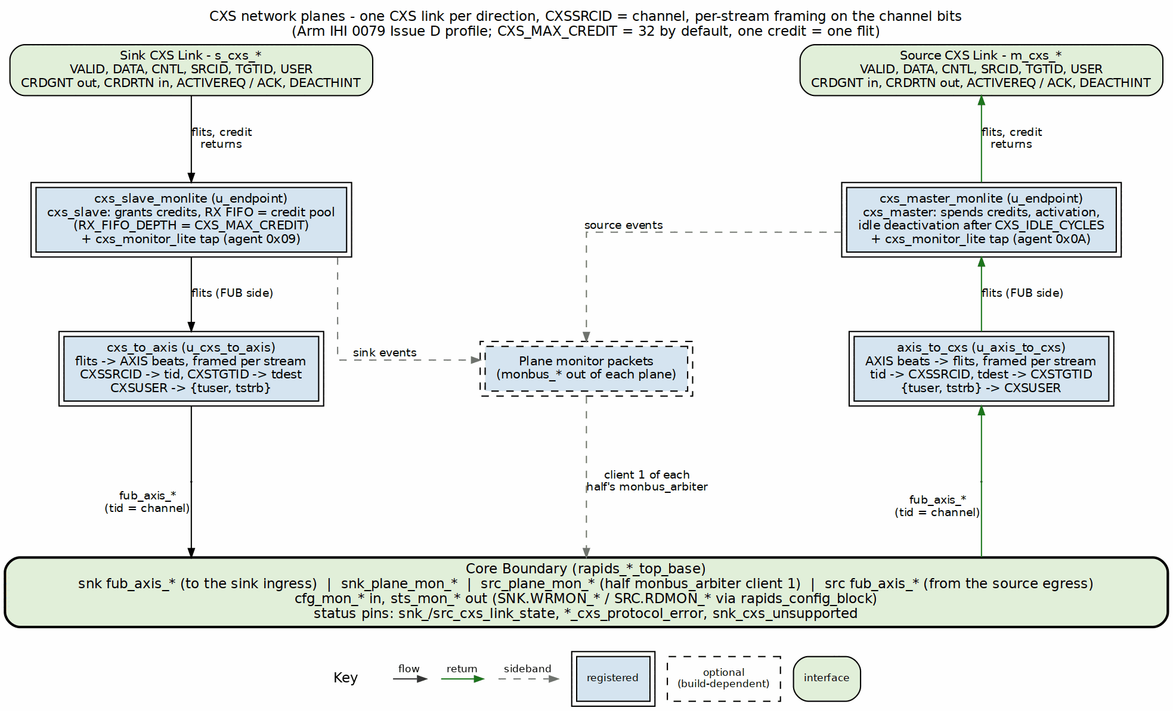
CXS network planes
Source: 23_cxs_planes.dot

27.3.2 Receive (sink) plane
cxs_slave_monlite is cxs_slave with a cxs_monitor_lite tap. cxs_slave grants credits up to CXS_MAX_CREDIT, runs the activation handshake, and holds received flits in a receive FIFO of RX_FIFO_DEPTH (default CXS_MAX_CREDIT) entries. The FIFO is the credit pool: a credit is only granted for a free entry, so a flit always has space. cxs_to_axis turns flits back into AXIS beats: CXSSRCID becomes tid, CXSTGTID becomes tdest, and CXSUSER is split into {tuser, tstrb}. When the core stops taking beats the FIFO fills, and the slave stops granting credits; that is the CXS form of the sink’s tready backpressure.
cxs_to_axis is combinational and stateless, so it can only represent the flits axis_to_cxs makes: at most one START and one END per flit, with a packet starting at byte 0. Any other flit (a transmitter that packs two packets into one flit) is still passed on, with tlast from END[0], and sets the sticky snk_cxs_unsupported.

27.3.3 Transmit (source) plane
axis_to_cxs packs AXIS beats into flits (tid -> CXSSRCID, tdest -> CXSTGTID, {tuser, tstrb} -> CXSUSER) and cxs_master_monlite sends them, one credit per flit. The master requests activation when it has a flit to send and deactivates the link after CXS_IDLE_CYCLES idle cycles.

27.3.4 Per-stream framing
axis_to_cxs and both endpoints’ control checkers track an open packet per stream, keyed on the low CXS_STREAM_SRCID_BITS = CIW bits of CXSSRCID (the channel); cxs_to_axis needs no state because each beat carries its own tid. The byte-granular source arbitrates per drain block while a packet spans the whole descriptor, so with two or more channels active the egress switches channel in the middle of a packet. Per-link framing (one open packet per link) rejects that traffic; per-stream framing accepts it, as IHI 0079D 2.5.2 allows.

27.3.5 Parameters
Table 3.13.3: CXS Plane Parameters
Parameter | Default | Description
CXS_MAX_CREDIT | 32 | Credits granted by the receiver. One credit is one flit; the grant -> flit -> free round trip is about 3 cycles
CXS_RX_FIFO_DEPTH | CXS_MAX_CREDIT | Receive FIFO depth (the credit pool); need not be a power of two
CXS_CREDIT_BEYOND_SPEC | CXS_MAX_CREDIT > 63 | Permits more credits than IHI 0079D allows; the far end must match
CXS_IDLE_CYCLES | 32 | Idle cycles before the transmitter deactivates the link
CXS_IW, CXS_DESTW, CXS_UW, CXS_CNTL_PW | derived | Port widths; do not override
DATA_WIDTH must be at most 1024: CXSUSER is at most 128 bits and carries tstrb (DATA_WIDTH/8 bits). tuser is dropped from CXSUSER when DATA_WIDTH/8 + AXIS_USER_WIDTH > 128.

27.3.6 Monitoring
The CXS planes drive cxs_monitor_lite from the same cfg_mon_* CSRs as the AXIS planes and use the same agent IDs (sink 0x09, source 0x0A). Packets are tagged PROTOCOL_CXS; the top’s monitor group filters them through its AXIS mask slot. A PACKET_END completion carries the channel in event_data[55:48]; channel_id holds {PRCLTYPE[2:0], TGTID[5:0]}. The lite’s output queue is 4 entries deep; when events outrun it the lite drops and counts them (an Error / EVENT_DROPPED packet), so a check on completions counts delivered plus dropped.

27.4 Proposed Changes
A proposal (2026-10-16, not implemented) puts a tile packet header at the front of every packet: destination and source coordinates, payload type (cfg / prog / mem), length and target address. It is described once in the compute-engine tile’s TILE_SPEC.md Section 11; CXS carries it as the first flit. The link signals, credits and per-stream framing on this page do not change, because CXSSRCID keeps the channel.

27.5 Verification
Table 3.13.4: CXS Top Test Cells
Suite | Cells
dv/tests/top/test_rapids_cxs_top.py | source, sink, source_bytes, sink_bytes, source_concurrent, sink_concurrent, cxs_mon, ext_addressing
dv/tests/top_beats/test_rapids_beats_cxs_top.py | source, sink, source_concurrent, sink_concurrent, cxs_mon, ext_addressing
The concurrent cells start four channels with one KICK_ENABLE write, so channels interleave on the link. Every cell also requires a clean link: no BFM or wire-monitor violation and the DUT’s protocol-error flags low. The core testbenches drive packets on plane_mon_* and require them on the MonBus output.

Last Updated: 2026-10-16

RTL Design Sherpa · Learning Hardware Design Through Practice GitHub · Documentation Index · MIT License

28 Interface Overview
Last Updated: 2026-10-16

28.1 External Interfaces
The RAPIDS Beats architecture exposes the following external interfaces:

28.1.1 AXI4 Master Interfaces
Table 4.0.1: AXI4 Master Interfaces
Interface | Purpose | Data Width
Descriptor AXI | Fetch descriptors from memory | 256-bit
Sink AXI Write | Write sink data to memory | 512-bit (param)
Source AXI Read | Read source data from memory | 512-bit (param)

28.1.2 Streaming Interfaces
Table 4.0.2: Streaming Interfaces
Interface | Type | Purpose
Fill Interface | Custom | Network data ingress (to SRAM), inside the core
Drain Interface | Custom | Network data egress (from SRAM), inside the core
AXIS Sink | AXI-Stream Slave | Network ingress on the AXIS tops; the core-facing stream of every plane
AXIS Source | AXI-Stream Master | Network egress on the AXIS tops; the core-facing stream of every plane
CXS Sink | CXS receiver | Network ingress on the CXS tops (one link, CXSSRCID = channel)
CXS Source | CXS transmitter | Network egress on the CXS tops (one link, CXSSRCID = channel)

28.1.3 Control/Monitor Interfaces
Table 4.0.3: Control and Monitor Interfaces
Interface | Type | Purpose
APB | APB slave | Per-channel kick-off
Configuration | Custom | Global/per-channel config
Status | Custom | Idle, state, error flags
MonBus | Custom 64-bit | Monitor packet output

28.2 Interface Documentation
- AXI4 Interface Specification - Descriptor, sink write, source read
- AXIS Interface Specification - Optional streaming wrappers
- MonBus Interface Specification - Monitor packet format
- CXS Interface Specification - CXS network links (CXS tops)

28.3 Interface Signal Naming Conventions
Table 4.0.4: Signal Naming Conventions
Prefix | Meaning | Example
m_axi_ | AXI master port | m_axi_arvalid
s_axi_ | AXI slave port | s_axi_awready
m_axis_ | AXIS master port | m_axis_tvalid
s_axis_ | AXIS slave port | s_axis_tready
m_cxs_ | CXS transmitter port | m_cxs_valid
s_cxs_ | CXS receiver port | s_cxs_crdgnt
cfg_ | Configuration input | cfg_enable
snk_ | Sink data path | snk_fill_valid
src_ | Source data path | src_drain_ready
sched_ | Scheduler interface | sched_rd_valid
monbus_ | Monitor bus | monbus_pkt_data

Last Updated: 2026-10-16

RTL Design Sherpa · Learning Hardware Design Through Practice GitHub · Documentation Index · MIT License

29 AXI4 Interface Specification
Last Updated: 2025-01-10

29.1 Overview
The RAPIDS Beats architecture uses three AXI4 master interfaces: 1. Descriptor AXI: Fetches descriptors from memory (256-bit data) 2. Sink AXI Write: Writes sink data to memory (512-bit data, configurable) 3. Source AXI Read: Reads source data from memory (512-bit data, configurable)

29.2 Descriptor AXI Master Interface

29.2.1 Purpose
Fetches descriptor packets from system memory. Shared across all 8 channels with round-robin arbitration.

29.2.2 Signal Table
Table 4.1.1: Descriptor AXI Master Interface Signals
Signal | Direction | Width | Description
m_axi_arvalid | output | 1 | AR channel valid
m_axi_arready | input | 1 | AR channel ready
m_axi_araddr | output | AW | Read address
m_axi_arid | output | ID_W | Transaction ID
m_axi_arlen | output | 8 | Burst length (fixed: 0 = 1 beat)
m_axi_arsize | output | 3 | Burst size (fixed: 5 = 32 bytes)
m_axi_arburst | output | 2 | Burst type (fixed: INCR)
m_axi_rvalid | input | 1 | R channel valid
m_axi_rready | output | 1 | R channel ready
m_axi_rdata | input | 256 | Read data (descriptor)
m_axi_rid | input | ID_W | Response ID
m_axi_rresp | input | 2 | Read response
m_axi_rlast | input | 1 | Last beat

29.2.3 Transaction Characteristics
Table 4.1.2: Descriptor AXI Transaction Characteristics
Parameter | Value | Description
Data Width | 256 bits | Fixed descriptor size
Burst Length | 1 beat | Single descriptor per transaction
Burst Type | INCR | Incrementing burst
Max Outstanding | 8 | Configurable via parameter
ID Usage | Per-channel | ID encodes source channel

29.2.4 Timing Diagram

29.2.5 Figure 4.1.1: Descriptor Fetch Timing
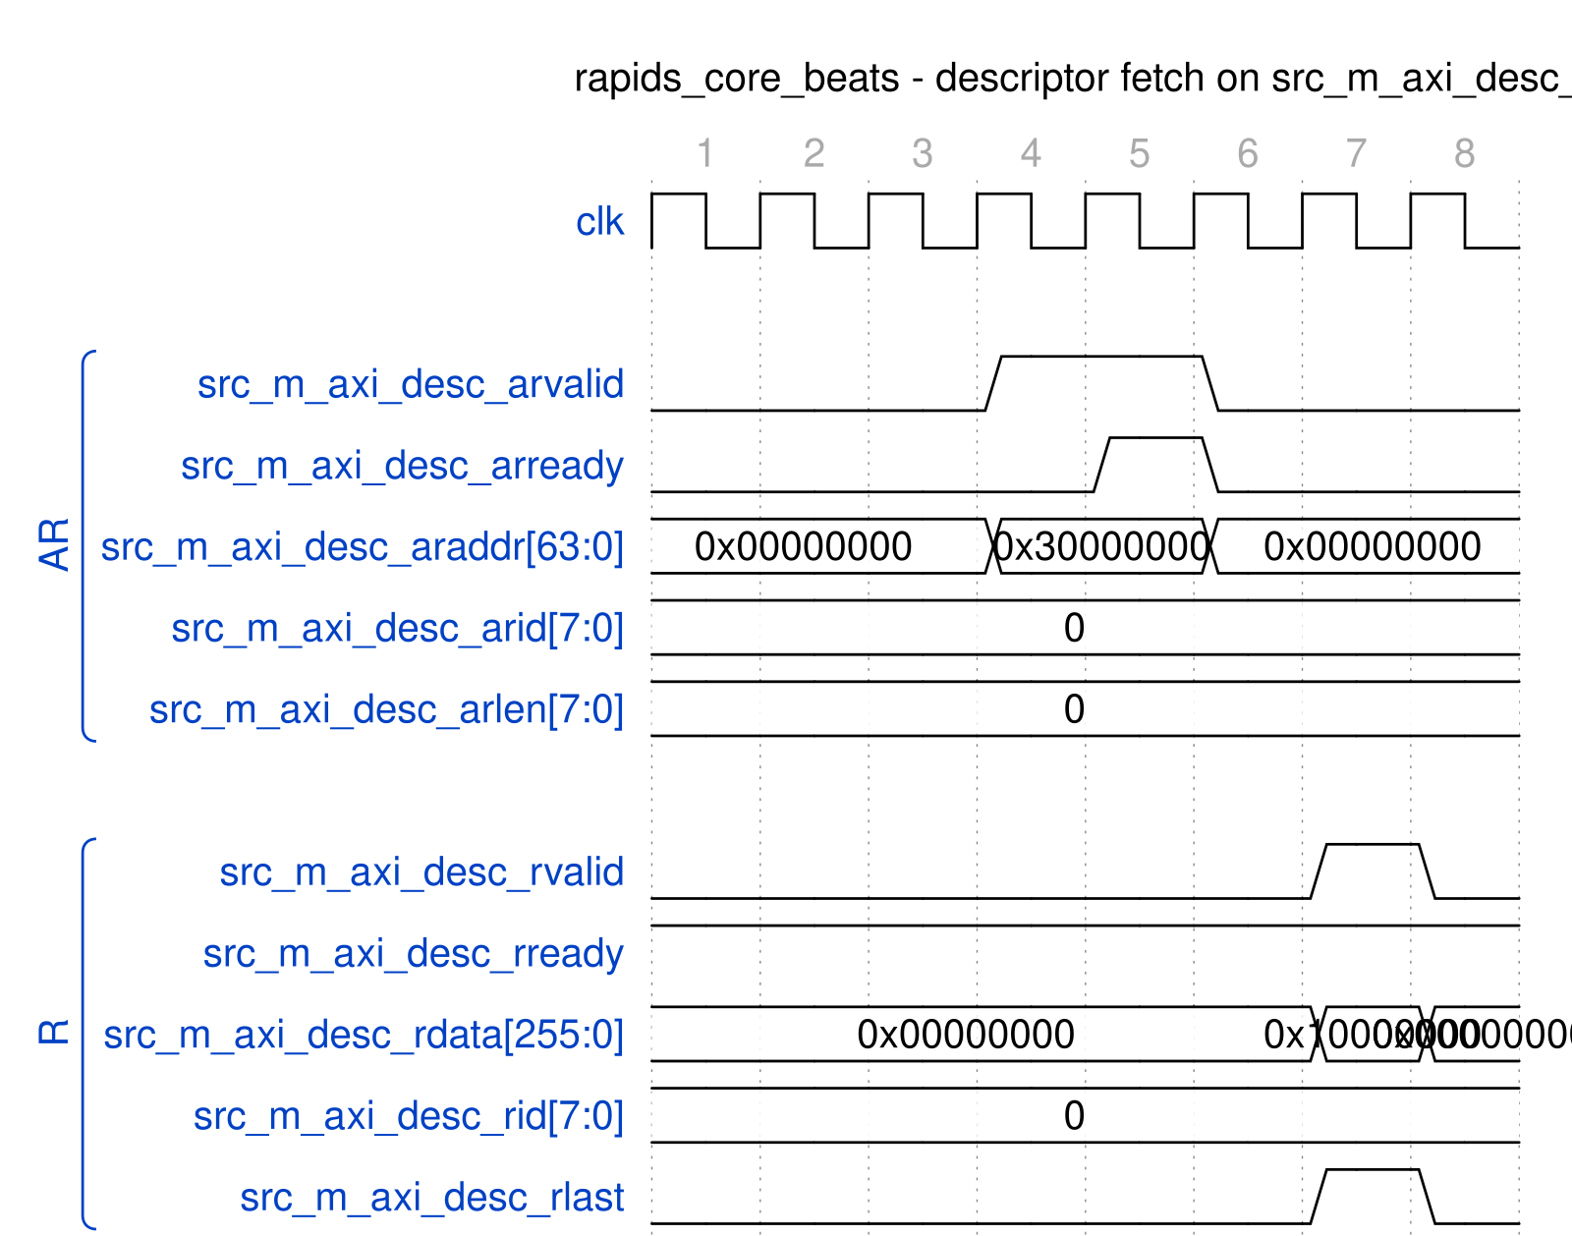
rapids_core_beats - descriptor fetch on src_m_axi_desc_*
Source: axi4_descriptor_fetch.json, captured from dv/tests/top_beats/test_rapids_core_beats.py (source path, channel 0, 4 beats, 512-bit data, REG_LEVEL=GATE) with WAVES=1.
Reading it: one single-beat read (arlen = 0) of the 256-bit descriptor at 0x30000000 with arid = channel 0. The AR handshakes when the slave raises arready two cycles after arvalid; the R beat returns two cycles after that with rlast set and rid echoing the channel. The descriptor itself is the 256-bit rdata (its low word, 0x10000000, is the source address).

29.3 Sink AXI Write Master Interface

29.3.1 Purpose
Writes sink data from SRAM to system memory. Supports burst transactions for efficient memory bandwidth.

29.3.2 Signal Table
Table 4.1.3: Sink AXI Write Master Interface Signals
Signal | Direction | Width | Description
m_axi_awvalid | output | 1 | AW channel valid
m_axi_awready | input | 1 | AW channel ready
m_axi_awaddr | output | AW | Write address
m_axi_awid | output | ID_W | Transaction ID
m_axi_awlen | output | 8 | Burst length (0-255)
m_axi_awsize | output | 3 | Burst size
m_axi_awburst | output | 2 | Burst type
m_axi_wvalid | output | 1 | W channel valid
m_axi_wready | input | 1 | W channel ready
m_axi_wdata | output | DW | Write data
m_axi_wstrb | output | DW/8 | Write strobes
m_axi_wlast | output | 1 | Last beat
m_axi_bvalid | input | 1 | B channel valid
m_axi_bready | output | 1 | B channel ready
m_axi_bid | input | ID_W | Response ID
m_axi_bresp | input | 2 | Write response

29.3.3 Transaction Characteristics
Table 4.1.4: Sink AXI Write Transaction Characteristics
Parameter | Value | Description
Data Width | 512 bits | Configurable
Burst Length | 1-256 beats | Based on transfer size
Burst Type | INCR | Incrementing burst
Max Outstanding AW | 8 | Configurable
W FIFO Depth | 64 | Configurable
B FIFO Depth | 16 | Configurable

29.3.4 Timing Diagram

29.3.5 Figure 4.1.2: Sink AXI Write Burst Timing
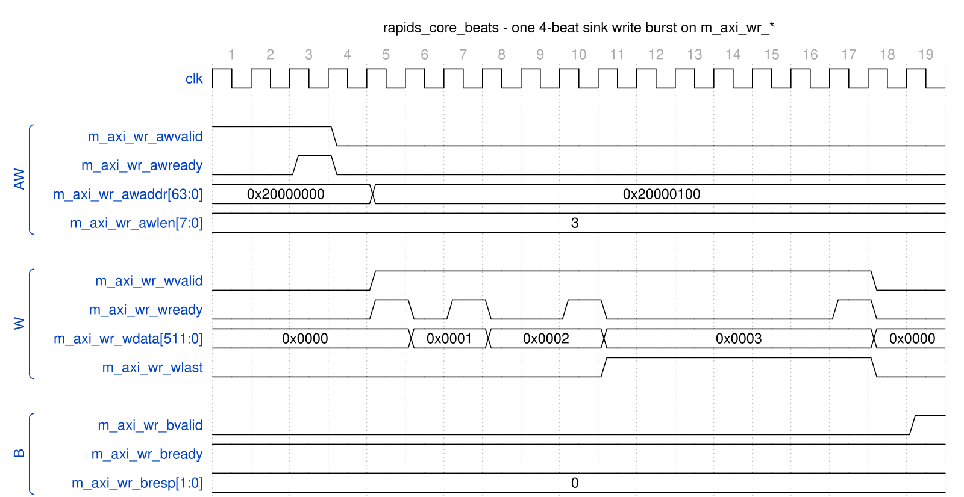
rapids_core_beats - one 4-beat sink write burst on m_axi_wr_*
Source: axi4_sink_write_burst.json, captured from dv/tests/top_beats/test_rapids_core_beats.py (sink path, channel 0, 4 beats, 512-bit data, REG_LEVEL=GATE) with WAVES=1; the memory is the framework AXI4 write slave with its default pacing.
Reading it: the AW (awlen = 3, address 0x20000000) had been held for the slave and handshakes at cycle 3; awaddr steps to the next burst’s 0x20000100 immediately. W starts two cycles later and the four beats go out on the slave’s wready pulses, the low word of wdata counting 0 to 3 and wlast on the fourth; bvalid (OKAY) comes one cycle after the last W handshake.

29.4 Source AXI Read Master Interface

29.4.1 Purpose
Reads source data from system memory into SRAM. Supports burst transactions for efficient memory bandwidth.

29.4.2 Signal Table
Table 4.1.5: Source AXI Read Master Interface Signals
Signal | Direction | Width | Description
m_axi_arvalid | output | 1 | AR channel valid
m_axi_arready | input | 1 | AR channel ready
m_axi_araddr | output | AW | Read address
m_axi_arid | output | ID_W | Transaction ID
m_axi_arlen | output | 8 | Burst length (0-255)
m_axi_arsize | output | 3 | Burst size
m_axi_arburst | output | 2 | Burst type
m_axi_rvalid | input | 1 | R channel valid
m_axi_rready | output | 1 | R channel ready
m_axi_rdata | input | DW | Read data
m_axi_rid | input | ID_W | Response ID
m_axi_rresp | input | 2 | Read response
m_axi_rlast | input | 1 | Last beat

29.4.3 Transaction Characteristics
Table 4.1.6: Source AXI Read Transaction Characteristics
Parameter | Value | Description
Data Width | 512 bits | Configurable
Burst Length | 1-256 beats | Based on transfer size
Burst Type | INCR | Incrementing burst
Max Outstanding AR | 8 | Configurable
R FIFO Depth | 64 | Configurable

29.4.4 Timing Diagram

29.4.5 Figure 4.1.3: Source AXI Read Burst Timing
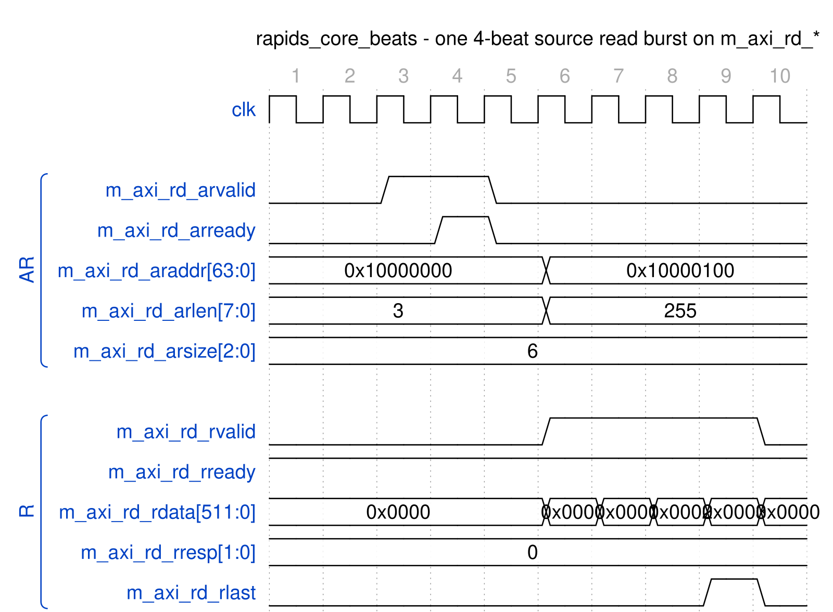
rapids_core_beats - one 4-beat source read burst on m_axi_rd_*
Source: axi4_source_read_burst.json, captured from dv/tests/top_beats/test_rapids_core_beats.py (source path, channel 0, 4 beats, 512-bit data, REG_LEVEL=GATE) with WAVES=1.
Reading it: AR for four 64-byte beats (arlen = 3, arsize = 6) at 0x10000000 handshakes at cycle 4; the four R beats follow back to back from cycle 6 with rready held high, rresp OKAY and rlast on the fourth. araddr and arlen return to their idle values (the next address, 0x10000100, and 0xff) once the AR is accepted.

29.5 AXI Protocol Compliance

29.5.1 Supported Features
Table 4.1.7: AXI Feature Support
Feature | Descriptor | Sink Write | Source Read
Burst Type INCR | Yes | Yes | Yes
Burst Type FIXED | No | No | No
Burst Type WRAP | No | No | No
Exclusive Access | No | No | No
Locked Access | No | No | No
Unaligned Access | No | Yes | Yes
Narrow Transfers | No | Yes | Yes

29.5.2 Error Handling
- SLVERR: Transaction aborted, error reported to scheduler
- DECERR: Transaction aborted, error reported to scheduler
- Timeout: Configurable watchdog, error reported to scheduler

Last Updated: 2025-01-10

RTL Design Sherpa · Learning Hardware Design Through Practice GitHub · Documentation Index · MIT License

30 AXI-Stream Interface Specification
Last Updated: 2025-01-10

30.1 Overview
The RAPIDS Beats architecture provides optional AXI-Stream (AXIS) wrappers for network interfaces: 1. AXIS Sink Slave: Receives network data for memory writes 2. AXIS Source Master: Transmits network data from memory reads
These wrappers are available when ENABLE_AXIS_WRAPPERS = 1.

30.2 AXIS Sink Slave Interface

30.2.1 Purpose
Receives streaming network data and routes to per-channel SRAM buffers based on TID.

30.2.2 Signal Table
Table 4.2.1: AXIS Sink Slave Interface Signals
Signal | Direction | Width | Description
s_axis_tvalid | input | 1 | Data valid
s_axis_tready | output | 1 | Ready to accept data
s_axis_tdata | input | DATA_WIDTH | Data payload
s_axis_tstrb | input | DATA_WIDTH/8 | Byte enables (not used by the beats design)
s_axis_tlast | input | 1 | Last beat of packet
s_axis_tid | input | TID_WIDTH | Stream ID (channel select)
s_axis_tdest | input | TDEST_WIDTH | Destination routing
s_axis_tuser | input | TUSER_WIDTH | User sideband

30.2.3 Signal Details

30.2.3.1 TID (Transaction ID)
TID is used for per-channel routing:
Table 4.2.2: TID Channel Mapping
TID Value | Destination
0 | Channel 0 SRAM
1 | Channel 1 SRAM
2 | Channel 2 SRAM
3 | Channel 3 SRAM
4 | Channel 4 SRAM
5 | Channel 5 SRAM
6 | Channel 6 SRAM
7 | Channel 7 SRAM

30.2.3.2 TSTRB (Byte Enables)
The ports are s_axis_tstrb / m_axis_tstrb (there is no tkeep). In the beats design they are not load-bearing: the source drives all ones and the sink ignores the ingress strobes, so every beat carries DATA_WIDTH/8 valid bytes. The byte-granular RAPIDS (rtl/top/rapids_top.sv, rapids TASK-019) packs bytes from lane 0 and uses a contiguous tstrb on the last beat of a packet.
Table 4.2.3: TSTRB Configuration
DATA_WIDTH | TSTRB Width | Beats design | Byte-granular RAPIDS
512 bits | 64 bits | all ones | contiguous from lane 0, partial on the last beat
256 bits | 32 bits | all ones | contiguous from lane 0, partial on the last beat

30.2.3.3 TLAST (Packet Boundary)
TLAST marks the end of an AXIS packet. This is mapped to the internal fill_last signal for packet boundary tracking.

30.2.4 Timing Diagram

30.2.5 Figure 4.2.1: AXIS Sink Slave Timing
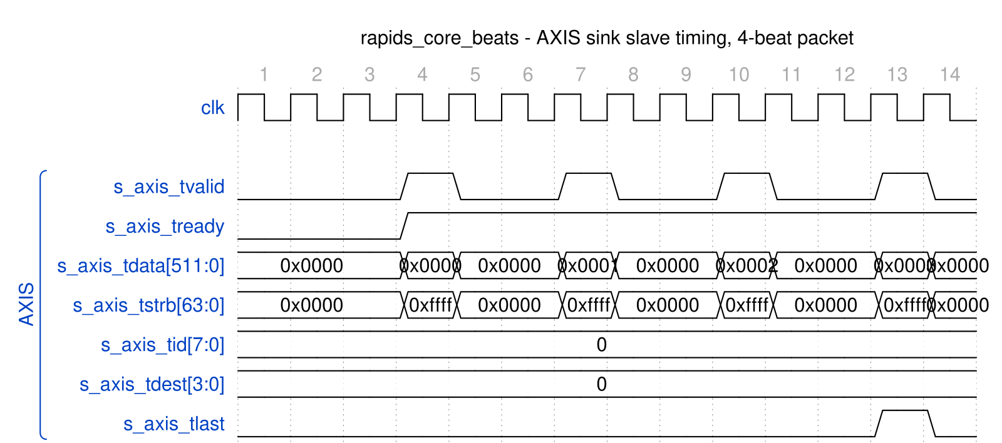
rapids_core_beats - AXIS sink slave timing, 4-beat packet
Source: axis_sink_slave.json, captured from dv/tests/top_beats/test_rapids_core_beats.py (sink path, channel 0, 4 beats, 512-bit data, REG_LEVEL=GATE) with WAVES=1; the producer is the framework AXIS master.
Reading it: s_axis_tready is high from the moment the sink has space, so each beat is accepted the cycle it is offered; the producer’s pacing leaves two idle cycles between beats. tstrb is all ones on every beat, tid selects channel 0 and tlast marks the fourth beat as the end of the packet.

30.2.6 Backpressure
The sink interface asserts backpressure (s_axis_tready = 0) when: - Target channel SRAM is full - No space allocated for incoming data - Internal pipeline stalls

30.3 AXIS Source Master Interface

30.3.1 Purpose
Transmits streaming network data from per-channel SRAM buffers with TID indicating source channel.

30.3.2 Signal Table
Table 4.2.4: AXIS Source Master Interface Signals
Signal | Direction | Width | Description
m_axis_tvalid | output | 1 | Data valid
m_axis_tready | input | 1 | Ready to accept data
m_axis_tdata | output | DATA_WIDTH | Data payload
m_axis_tstrb | output | DATA_WIDTH/8 | Byte enables (all ones in the beats design)
m_axis_tlast | output | 1 | Last beat of packet
m_axis_tid | output | TID_WIDTH | Stream ID (source channel)
m_axis_tdest | output | TDEST_WIDTH | Destination routing
m_axis_tuser | output | TUSER_WIDTH | User sideband

30.3.3 Timing Diagram

30.3.4 Figure 4.2.2: AXIS Source Master Timing
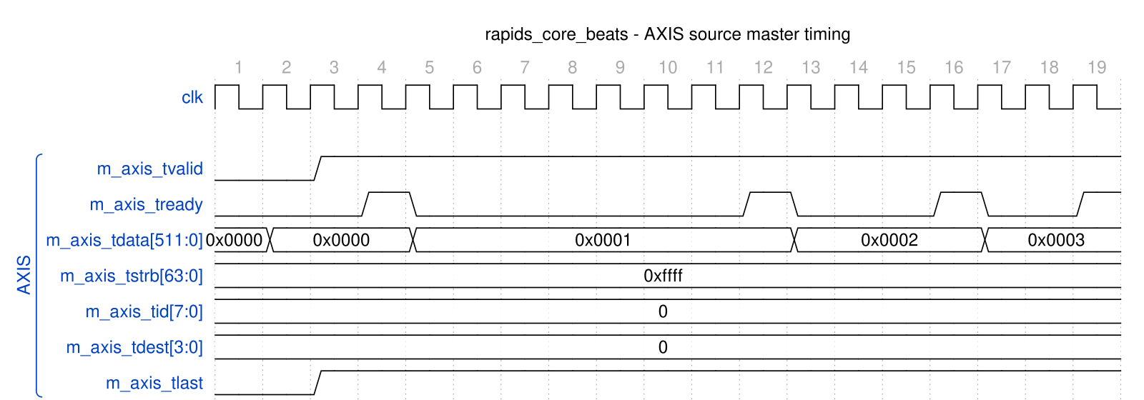
rapids_core_beats - AXIS source master timing
Source: axis_source_master.json, captured from dv/tests/top_beats/test_rapids_core_beats.py (source path, channel 0, 4 beats, 512-bit data, REG_LEVEL=GATE) with WAVES=1; the consumer is the framework AXIS slave with its default ready pacing.
Reading it: the master raises m_axis_tvalid and holds it, with tdata, tstrb (all ones), tid and tdest stable, until the consumer’s tready pulse takes the beat; it then presents the next word without dropping tvalid. Four beats leave on four tready pulses. tlast is high on every beat of this capture because the source packetises per drain request and each request carried one word (see Figure 3.7.3); with cfg_drain_size larger than one and data queued, a packet spans several beats and tlast marks only its final one.

30.3.5 Flow Control
The source interface respects network backpressure: - Data held when m_axis_tready = 0 - No data loss on backpressure - SRAM drain pauses until ready

30.4 AXIS vs Custom Fill/Drain Interfaces

30.4.1 Comparison
Table 4.2.5: Interface Comparison
Aspect | Custom Fill/Drain | AXIS
Standard | Proprietary | AXI-Stream
Channel ID | fill_id / drain_id | TID
Packet Boundary | fill_last / drain_last | TLAST
Byte Enables | fill_strb / drain_strb | TSTRB
Interoperability | RAPIDS only | Industry standard

30.4.2 Selection Guide
Table 4.2.6: Interface Selection Guide
Use Case | Recommended Interface
Internal RAPIDS testing | Custom Fill/Drain
Network IP integration | AXIS
FPGA board-level design | AXIS
Maximum performance | Custom Fill/Drain

30.5 Configuration Parameters
// AXIS Interface Parameters
parameter int DATA_WIDTH = 512; // Data payload width
parameter int TID_WIDTH = 3; // Stream ID width (log2 channels)
parameter int TDEST_WIDTH = 1; // Destination width
parameter int TUSER_WIDTH = 1; // User sideband width

Last Updated: 2025-01-10

RTL Design Sherpa · Learning Hardware Design Through Practice GitHub · Documentation Index · MIT License

31 MonBus Interface Specification
Last Updated: 2025-01-10

31.1 Overview
The MonBus (Monitor Bus) is a 64-bit packet-based interface for reporting internal events, status, and performance data. All RAPIDS subsystems generate MonBus packets that are aggregated and output through a unified interface.

31.2 MonBus Signal Interface

31.2.1 Signal Table
Table 4.3.1: MonBus Interface Signals
Signal | Direction | Width | Description
monbus_pkt_valid | output | 1 | Packet valid
monbus_pkt_ready | input | 1 | Consumer ready
monbus_pkt_data | output | 64 | Packet data

31.2.2 Handshaking Protocol
Standard valid/ready handshaking: - Data transfers when valid & ready both high - Producer holds valid until ready seen - Consumer asserts ready when able to accept

31.2.3 Timing Diagram

31.2.4 Figure 4.3.1: MonBus Packet Transfer Timing

monbus_axil_group_2in - packets from two producers through the arbiter
Source: monbus_group_packet_transfer.json, captured from dv/tests/macro/test_monbus_axil_group.py (basic_flow, error FIFO 64 x 32, TEST_LEVEL=full) with WAVES=1. The 128-bit packets are shown as their top 24 bits ([127:104]: packet type nibble, then the protocol field at [108:105], so 0x000002 is AXIS and 0x000008 is CORE).
Reading it: a MonBus link is a single-beat valid/ready handshake with the packet presented alongside valid. The group holds ready high on both inputs, so the source and sink packets are accepted the cycle they are offered, and each one reappears on the arbiter output three cycles later as another one-cycle valid/ready pair. Between packets the links idle low; nothing is held across transfers.

31.3 MonBus Packet Format

31.3.1 64-bit Packet Structure
63 56 55 48 47 40 39 32 31 0
+--------+---------+---------+---------+-------------------+
| Type | Unit ID | Agent ID| Channel | Payload (32 bits) |
+--------+---------+---------+---------+-------------------+

31.3.2 Figure 4.3.2: MonBus Packet Format
Table 4.3.2: MonBus Packet Fields
Field | Bits | Description
Type | [63:56] | Packet type code
Unit ID | [55:48] | Reporting unit identifier
Agent ID | [47:40] | Source agent within unit
Channel | [39:32] | Channel number (0-7)
Payload | [31:0] | Type-specific payload

31.4 Packet Types

31.4.1 Type Code Definitions
Table 4.3.3: MonBus Packet Types
Type Code | Name | Description
0x01 | DESC_FETCH | Descriptor fetch started
0x02 | DESC_COMPLETE | Descriptor fetch completed
0x03 | SCHED_START | Scheduler started transfer
0x04 | SCHED_DONE | Scheduler transfer complete
0x10 | AXI_RD_START | AXI read burst started
0x11 | AXI_RD_DONE | AXI read burst completed
0x12 | AXI_WR_START | AXI write burst started
0x13 | AXI_WR_DONE | AXI write burst completed
0x20 | SRAM_FILL | SRAM fill event
0x21 | SRAM_DRAIN | SRAM drain event
0x30 | ERROR | Error event
0x31 | TIMEOUT | Timeout event
0xFF | HEARTBEAT | Periodic heartbeat

31.4.2 Payload Formats by Type

31.4.2.1 DESC_FETCH / DESC_COMPLETE (0x01, 0x02)
Table 4.3.4: Descriptor Packet Payload
Bits | Description
[31:16] | Descriptor address [47:32]
[15:0] | Descriptor address [31:16]

31.4.2.2 SCHED_START / SCHED_DONE (0x03, 0x04)
Table 4.3.5: Scheduler Packet Payload
Bits | Description
[31:16] | Transfer ID
[15:0] | Beat count

31.4.2.3 AXI_RD/WR_START/DONE (0x10-0x13)
Table 4.3.6: AXI Event Packet Payload
Bits | Description
[31:24] | AXI ID
[23:16] | Burst length
[15:0] | Reserved

31.4.2.4 ERROR (0x30)
Table 4.3.7: Error Packet Payload
Bits | Description
[31:24] | Error code
[23:16] | Error source
[15:0] | Error details

31.5 MonBus Source Aggregation

31.5.1 RAPIDS Core MonBus Sources
Table 4.3.8: MonBus Source Assignment
Source ID | Agent | Description
0-7 | Scheduler[0:7] | Per-channel scheduler events
8-15 | DescEngine[0:7] | Per-channel descriptor events
16-23 | SnkSRAM[0:7] | Sink SRAM controller events
24-31 | SrcSRAM[0:7] | Source SRAM controller events
32 | AXI Write Engine | Write transaction events
33 | AXI Read Engine | Read transaction events
34 | Error Handler | Error events
Scheduler and DescEngine COMPLETION packets are subject to the half’s SCHED_CONFIG.COMPL_EN (reset 1): the scheduler group drops them ahead of its arbiter when the bit is clear and acknowledges the emitter, so the data path is unaffected. Their ERROR packets are always forwarded (rapids ISSUE-005).

31.5.2 Aggregation Hierarchy

31.5.3 Figure 4.3.3: MonBus Aggregation Tree
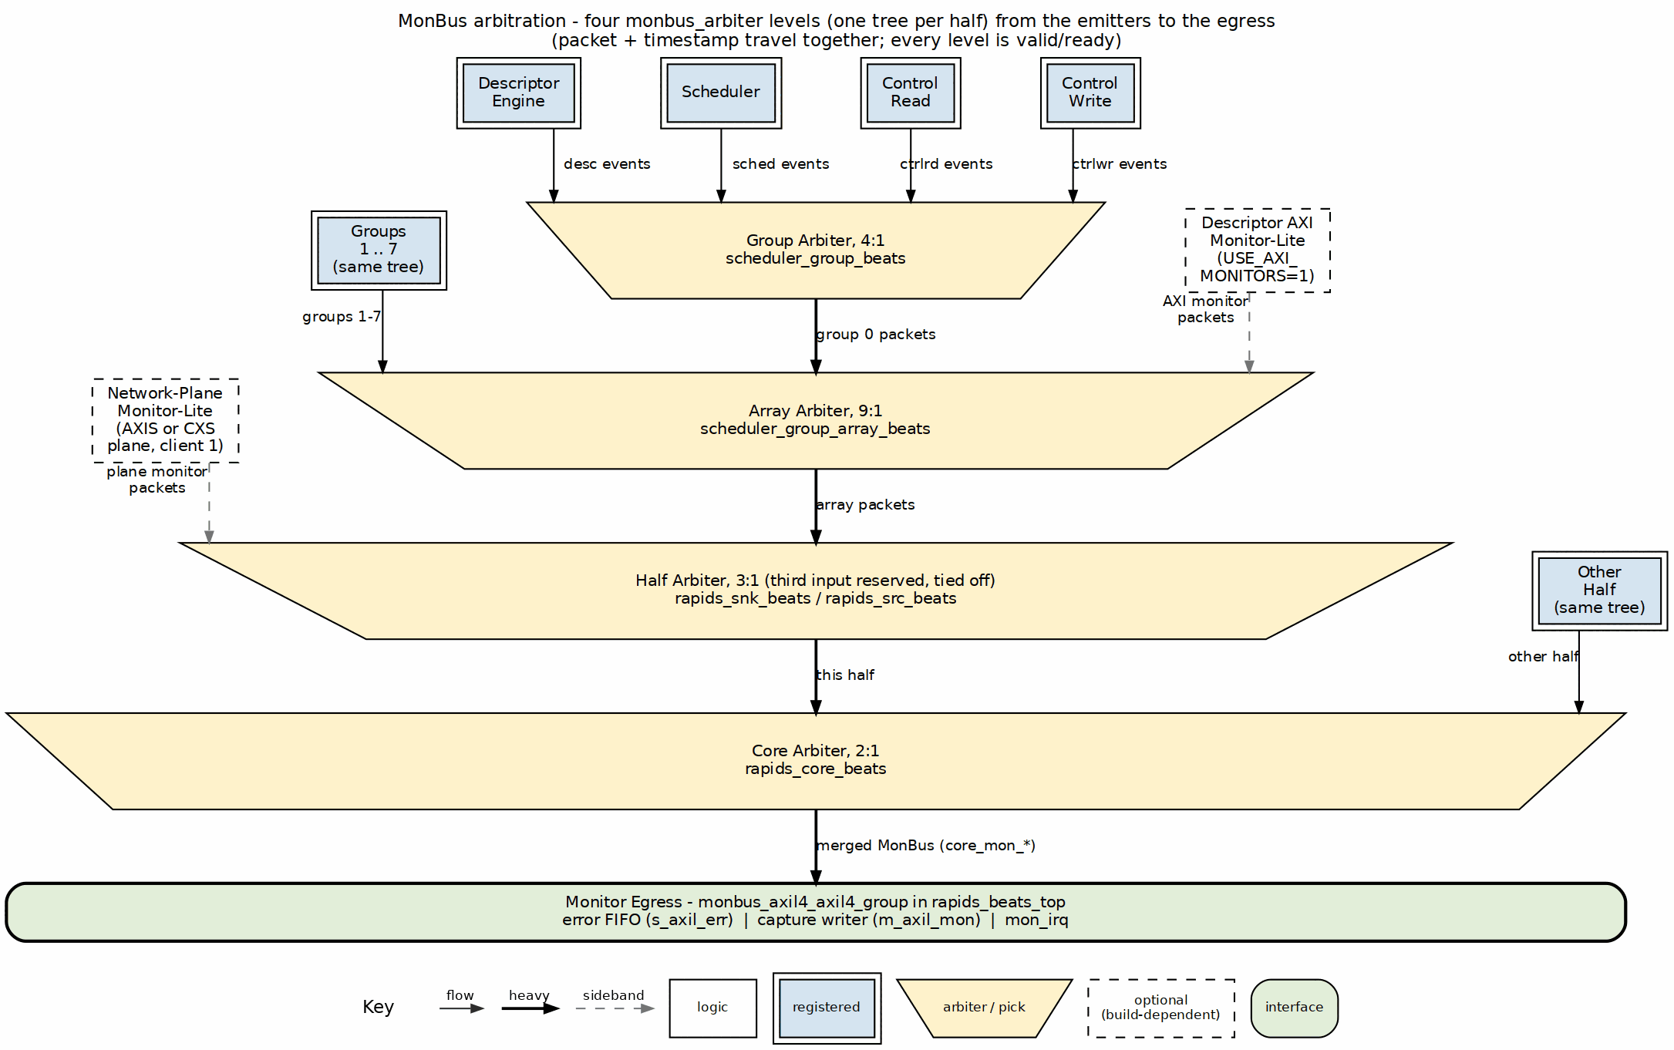
MonBus aggregation tree
Source: 21_monbus_aggregation.dot

31.6 Integration Guidelines

31.6.1 Consumer Requirements
MonBus consumers must: 1. Provide sufficient ready cycles to prevent packet loss 2. Handle bursty traffic (multiple sources may have packets simultaneously) 3. Process or buffer packets at wire rate

31.6.2 Recommended Consumer Patterns
// Pattern 1: Direct FIFO buffering
gaxi_fifo_sync #(
.DATA_WIDTH(64),
.DEPTH(256)
) u_gaxi_fifo_sync (
.axi_aclk (axi_aclk),
.axi_aresetn (axi_aresetn),
.wr_valid (wr_valid),
.wr_ready (wr_ready),
.wr_data (wr_data),
.rd_ready (rd_ready),
.count (count),
.rd_valid (rd_valid),
.rd_data (rd_data)
);

31.7 Timing Requirements
Table 4.3.9: MonBus Timing Parameters
Parameter | Value | Description
Min Ready | 1 cycle | Must assert ready within N cycles
Max Latency | Configurable | Before packet dropped
Packet Rate | Variable | Depends on activity

Last Updated: 2025-01-10

RTL Design Sherpa · Learning Hardware Design Through Practice GitHub · Documentation Index · MIT License

32 CXS Interface Specification
Applies to: rapids_beats_cxs_top, rapids_cxs_top Protocol: Arm IHI 0079 (CXS) Issue D, one fixed profile Last Updated: 2026-10-16

32.1 Overview
The CXS tops replace the two AXIS network ports with one CXS link per direction: the sink port s_cxs_* (a CXS receiver) into the sink half and the source port m_cxs_* (a CXS transmitter) out of the source half. One link carries every channel; the channel rides in CXSSRCID. The planes that implement the links are described in the Network Planes chapter (Section 3.13).

32.2 Link Profile
Table 4.4.1: CXS Link Profile
Property | Value
Issue | D (the issue with SRCID, TGTID and USER)
CXSMAXPKTPERFLIT | 2
Packet start alignment | 16 bytes; RAPIDS always starts a packet at byte 0
Packet mapping | One AXIS packet (tlast-delimited) is one CXS packet
CXSSRCID | The channel (AXIS tid)
CXSTGTID | AXIS tdest
CXSUSER | {tuser, tstrb}; tuser dropped when DATA_WIDTH/8 + AXIS_USER_WIDTH > 128
Stream framing | Per stream on the channel bits of CXSSRCID
Link control | Explicit credit return, activation, deactivation
Parity | Off

32.3 Signal Table
Table 4.4.2: CXS Interface Signals
Signal | Sink port | Source port | Width | Description
{s,m}_cxs_valid | in | out | 1 | Flit valid
{s,m}_cxs_data | in | out | DATA_WIDTH | Flit data
{s,m}_cxs_cntl | in | out | CXS_CNTL_PW | START / END / pointers
{s,m}_cxs_srcid | in | out | AXIS_ID_WIDTH | Channel
{s,m}_cxs_tgtid | in | out | AXIS_DEST_WIDTH | tdest
{s,m}_cxs_user | in | out | CXS_UW | {tuser, tstrb}
{s,m}_cxs_crdgnt | out | in | 1 | Credit grant (receiver to transmitter)
{s,m}_cxs_crdrtn | in | out | 1 | Credit return (transmitter to receiver)
{s,m}_cxs_activereq | in | out | 1 | Transmitter requests the link
{s,m}_cxs_activeack | out | in | 1 | Receiver acknowledges
{s,m}_cxs_deacthint | out | in | 1 | Receiver asks the transmitter to deactivate
snk_cxs_link_state, src_cxs_link_state | out | out | 2 | {ACTIVEREQ, ACTIVEACK}
snk_cxs_protocol_error, src_cxs_protocol_error | out | out | 1 | Sticky protocol violation
snk_cxs_unsupported | out | - | 1 | Sticky: a flit AXIS framing cannot carry

32.4 Credit Flow
One credit permits one flit (IHI 0079D 2.1). The receiver grants up to CXS_MAX_CREDIT (default 32) credits, one per free entry in its receive FIFO, so every flit sent against a credit has space. The transmitter spends one credit per flit and returns the credits it still holds on deactivation. Credits are a single pool for the link; a grant carries no ID and cannot be reserved for a channel.
The grant -> flit -> free round trip between the RAPIDS endpoints is about 3 cycles, so 32 credits sustains one flit per cycle with margin for pipeline stages or a clock crossing on the link. More than 63 credits is beyond the spec and requires CXS_CREDIT_BEYOND_SPEC on both ends.

32.5 Link Activation
Table 4.4.3: Link Activation Sequence
Step | Transmitter (m_cxs_*) | Receiver (s_cxs_*)
1 | Raises ACTIVEREQ when it has a flit to send (and only once the previous activation’s ACTIVEACK has fallen: 4-phase) | -
2 | - | Raises ACTIVEACK; starts granting credits
3 | Sends flits, one credit each | Frees an entry and regrants as the core drains
4 | After CXS_IDLE_CYCLES idle cycles in RUN (or on DEACTHINT) drops ACTIVEREQ, then returns every held credit on CRDRTN, one per cycle | -
5 | - | Drops ACTIVEACK once its credits are back

32.6 Backpressure
On the sink port, a full receive FIFO means no further grants: the transmitter stalls for lack of credit. This is the CXS form of the AXIS sink’s s_axis_tready = 0, including the byte-granular sink’s hold until a channel’s descriptor has been fetched. On the source port, the plane stalls the core’s egress (fub_axis_tready = 0) while it has no credit.

32.7 Proposed Changes
A proposal (2026-10-16, not implemented) puts a tile packet header at the front of every packet: destination and source coordinates, payload type (cfg / prog / mem), length and target address. It is described once in the compute-engine tile’s TILE_SPEC.md Section 11; CXS carries it as the first flit. The link signals, credits and per-stream framing on this page do not change, because CXSSRCID keeps the channel.

RTL Design Sherpa · Learning Hardware Design Through Practice GitHub · Documentation Index · MIT License

33 Product Requirements Document (PRD)

33.1 RAPIDS - Rapid AXI Programmable In-band Descriptor System
Version: 1.0 Date: 2025-09-30 Status: Active Development - Validation in Progress Owner: RTL Design Sherpa Project Parent Document: /PRD.md

33.2 1. Executive Summary
The Rapid AXI Programmable In-band Descriptor System (RAPIDS) is a custom hardware accelerator designed for efficient memory-to-memory data movement with network interface integration. It demonstrates complex FSM coordination, descriptor-based DMA operations, and comprehensive monitoring capabilities.
Status (2026-07-22): RAPIDS was rearchitected to the “beats” design. Current RTL is in rtl/fub_beats/, rtl/macro_beats/, rtl/top_beats/ (control engines in rtl/fub/); current specs are docs/rapids_beats_has/ and docs/rapids_beats_mas/. The old rapids_fub//rapids_macro/ RTL, the docs/rapids_spec/ tree, and the program engine / network master / network slave blocks described in parts of this PRD were retired (network interfaces are now AXIS; control is APB). Sections describing the pre-beats design are kept as history and marked where practical.
Status (2026-09-29, rapids TASK-019): RAPIDS is byte-granular. The product RTL is the un-suffixed tree rtl/fub/, rtl/macro/, rtl/top/rapids_top.sv: descriptor length in BYTES, byte-granular addresses, WSTRB/TSTRB carry partial beats, one AXIS packet per descriptor. The *_beats tree is the beat-granular stepping stone, kept runnable and green as the characterized Genesys 2 design. Tests: dv/tests/fub, macro, top.

33.2.1 1.1 Quick Stats
- Modules: ~20 SystemVerilog files (beats architecture)
- Architecture: 3 major groups (Scheduler group, Sink path, Source path)
- Interfaces: AXI4 (memory), AXIS (network), APB (control), MonBus (monitoring)
- Test Coverage: see dv/tests/ beats suites (fub_beats/macro_beats/top_beats)
- Status: Active validation, known issues documented

33.2.2 1.2 Subsystem Goals
- Primary: Demonstrate complex accelerator design patterns
- Secondary: Provide DMA-style memory transfer capability
- Tertiary: Educational reference for descriptor-based engines

33.3 2. Documentation Structure
This PRD provides a high-level overview. Detailed specifications are maintained separately:

33.3.1 Complete RAPIDS Specification
Status (2026-07-22): The old docs/rapids_spec/ tree was replaced by two beats spec trees.
Byte-granular RAPIDS books (the product design): HAS Index, MAS Index. Chapters that are identical for both designs are linked from the Beats books below.
Architecture Spec (HAS), RAPIDS Beats: docs/rapids_beats_has/
- HAS Index - Complete HAS structure
- Product Overview
- Block Diagram / Data Flow / Channel Architecture
- Interfaces: Summary, AXI4, AXIS, APB, MonBus
- Use cases: docs/rapids_beats_has/ch04_use_cases/
- Programming: Descriptor Format, Register Map, Initialization, Error Handling
- Performance: docs/rapids_beats_has/ch06_performance/
Micro-Architecture Spec (MAS): docs/rapids_beats_mas/
- MAS Index - Complete MAS structure
- Overview: Architecture, Port List, Clocks and Reset
FUB blocks (docs/rapids_beats_mas/ch02_fub_blocks/): - Scheduler - Per-channel scheduler FSM - Descriptor Engine - Descriptor fetch/parsing - AXI Read Engine / AXI Write Engine - Alloc Ctrl / Drain Ctrl / Latency Bridge - CtrlRd Engine / CtrlWr Engine
Macro blocks (docs/rapids_beats_mas/ch03_macro_blocks/): - Scheduler Group / Scheduler Group Array - Sink Data Path + AXIS wrapper, SRAM controllers - Source Data Path + AXIS wrapper, SRAM controllers - RAPIDS Core / Registers / Top
Interfaces (docs/rapids_beats_mas/ch04_interfaces/): - AXI4 Interface - AXIS Interface - MonBus Interface

33.3.2 Known Issues
Location: projects/components/dma-ip/rapids/known_issues/
- Index - Issue tracking overview (the old scheduler.md credit-counter write-up was retired with the pre-beats RTL)
- Sink Data Path - RESOLVED 2026-09-25 (write-error flag wired; timeouts are the monitor’s job by design)
- Sink SRAM Control - RESOLVED (moved to resolved/ in d587852c2)
- Plus known_issues/active/ for current beats issues

33.3.3 Other Documentation
- CLAUDE - AI assistance guide for this subsystem
- TASKS - Work items (largely pre-beats history)
- Validation Report - Test results (pre-beats snapshot)

33.4 2.4 Organizational Standards - RAPIDS Code Location
MANDATORY: All RAPIDS-specific code must be in the project area

33.4.1 Code Organization Principle
“All RAPIDS-specific verification code MUST reside in projects/components/dma-ip/rapids/dv/ for easy discovery.”
This subsystem follows the repository-wide organizational standard (see /PRD.md Section 2.3) requiring all project-specific code to be located in the project area, NOT the framework area.

33.4.2 RAPIDS Directory Structure
projects/components/dma-ip/rapids/
├── rtl/ # RTL source code
│ ├── includes/ # RAPIDS packages
│ ├── fub/ # Control engines (ctrlrd/ctrlwr)
│ ├── fub_beats/ # Beats functional unit blocks
│ ├── macro_beats/ # Beats assemblies + registers
│ ├── macro/ # MonBus group
│ └── top_beats/ # rapids_beats_top.sv
│
└── dv/ # Design verification (all RAPIDS-specific)
├── tbclasses/ # RAPIDS TB classes HERE (not framework!)
│ ├── scheduler_tb.py # Scheduler testbench class
│ ├── descriptor_engine_tb.py
│ └── rapids_core_beats_tb.py
│
├── components/ # RAPIDS-specific BFMs
│ └── data_mover_bfm.py
│
└── tests/ # Test runners (import TB classes)
├── fub/ # Control engine tests
├── fub_beats/ # Beats FUB tests (test_scheduler_beats.py, ...)
├── macro/ # MonBus group test
├── macro_beats/ # Multi-block scenarios
└── top_beats/ # Full RAPIDS operation

33.4.3 What Goes Where?
Code Type | CORRECT Location | WRONG Location
RAPIDS TB Classes | projects/components/dma-ip/rapids/dv/tbclasses/ | bin/TBClasses/ (framework area)
RAPIDS-Specific BFMs | projects/components/dma-ip/rapids/dv/components/ | bin/TBClasses/ (framework area)
RAPIDS Scoreboards | projects/components/dma-ip/rapids/dv/ (project area) | bin/TBClasses/scoreboards/
Test Runners | projects/components/dma-ip/rapids/dv/tests/ | Anywhere else
Shared AXI4/APB BFMs | bin/TBClasses/{protocol}/ | Project area

33.4.4 Import Pattern for RAPIDS Tests
CORRECT - Import from Project Area:
# Import framework utilities (PYTHONPATH includes bin/)
import os, sys
from TBClasses.shared.utilities import get_repo_root
from TBClasses.shared.tbbase import TBBase
# Add repo root to Python path using robust git-based method
repo_root = get_repo_root()
sys.path.insert(0, repo_root)
# Import RAPIDS TB classes from PROJECT AREA
from projects.components.dma_ip.rapids.dv.tbclasses.scheduler_tb import SchedulerTB
from projects.components.dma_ip.rapids.dv.tbclasses.descriptor_engine_tb import DescriptorEngineTB
# Shared framework components
from CocoTBFramework.components.axi4.axi4_master import AXI4Master
WRONG - Don’t Import from Framework:
# DON'T DO THIS!
from TBClasses.rapids.scheduler_tb import SchedulerTB # WRONG!

33.4.5 Benefits of This Organization
- Easy Discovery - All RAPIDS code in ONE place: projects/components/dma-ip/rapids/
- Clear Ownership - RAPIDS team owns their dv/ area completely
- No Confusion - Never wonder “where does this TB class live?”
- Maintainability - Changes isolated to RAPIDS area don’t affect other projects
- Framework Stays Clean - Only truly shared cross-project code in framework

33.4.6 Compliance Status
RAPIDS is now compliant - All TB classes moved to project area as of 2025-10-18
Migration History: - Before: TB classes incorrectly in bin/TBClasses/rapids/ - After: TB classes correctly in projects/components/dma-ip/rapids/dv/tbclasses/ - Test Imports: Updated to import from project area
Complete Documentation: See /PRD.md Section 2.3 for repository-wide organizational standards.

33.5 3. Architecture Overview

33.5.1 3.1 Top-Level Block Diagram
RAPIDS Beats (Rapid AXI Programmable In-band Descriptor System)
├── Scheduler Group (scheduler_group_beats / scheduler_group_array_beats)
│ ├── Scheduler (Per-channel FSM, scheduler_beats.sv)
│ ├── Descriptor Engine (Descriptor fetch/parsing, descriptor_engine_beats.sv)
│ └── Control Engines (ctrlrd_engine.sv / ctrlwr_engine.sv)
│
├── Sink Data Path (AXIS Network → SRAM → System Memory)
│ ├── AXIS Slave ingress (snk_data_path_axis_beats.sv)
│ ├── Sink SRAM Controller (snk_sram_controller_beats.sv + alloc/drain ctrl)
│ └── AXI Write Engine (axi_write_engine_beats.sv)
│
├── Source Data Path (System Memory → SRAM → AXIS Network)
│ ├── AXI Read Engine (axi_read_engine_beats.sv)
│ ├── Source SRAM Controller (src_sram_controller_beats.sv + alloc/drain ctrl)
│ └── AXIS Master egress (src_data_path_axis_beats.sv)
│
└── Control and Monitoring
├── APB CSRs (rapids_config_block.sv, PeakRDL rapids_regs.rdl)
└── MonBus Group (macro/monbus_axil_group_2in.sv)
See: docs/rapids_beats_mas/ch01_overview/01_architecture.md for detailed architecture

33.5.2 3.2 Data Flow
Sink Path (Receive): 1. Network packets arrive via Network Slave 2. Buffered in Sink SRAM 3. DMA’d to system memory via AXI4 Write Engine 4. Completion reported via MonBus
Source Path (Transmit): 1. Descriptor specifies data location in system memory 2. Source AXI Reader fetches data to Source SRAM 3. Network Master transmits to network 4. Completion reported via MonBus
Scheduler Coordination: - Parses descriptors from Descriptor Engine - Manages credit-based flow control - Sequences program engine operations - Coordinates sink/source data paths

33.6 4. Key Features

33.6.1 4.1 Descriptor-Based Operation
Feature | Status | Description
Descriptor FIFO | yes | Queued descriptor processing
Multi-field parsing | yes | Address, length, control fields
Chained descriptors | ⏳ | Future enhancement
Completion reporting | yes | Via MonBus packets

33.6.2 4.2 Data Path Features
Feature | Status | Description
SRAM buffering | yes | Decouple network from memory
AXI4 burst support | yes | Efficient memory transfers
Backpressure handling | yes | Flow control on all interfaces
Data alignment | yes | Handle unaligned transfers

33.6.3 4.3 Scheduler Features
Feature | Status | Description
Task FSM | yes | Multi-state coordination
Credit management | ⏳ | Pre-beats scheduler had exponential encoding (0→1, 1→2, …, 15→∞); scheduler_beats.sv has no credit management yet (planned later phase)
Program sequencing | yes | Coordinated operations
Error detection | yes | Timeout, overflow detection
Credit Management Details (pre-beats, historical): - Uses exponential credit encoding for compact configuration - 4-bit cfg_initial_credit decodes to actual credit counts: - 0 → 1 credit (2^0), 4 → 16 credits (2^4), 8 → 256 credits (2^8) - 15 → ∞ (unlimited credits, 0xFFFFFFFF) - Encoding applied at initialization; runtime operations are linear (increment/decrement by 1) - Provides wide range (1 to 16384) with minimal configuration overhead
See: docs/rapids_beats_mas/ch02_fub_blocks/01_scheduler.md for the current scheduler specification
rapids-g (2026-10-21, rapids TASK-034): a build of the byte-granular RAPIDS whose schedulers are sequenced by firmware on one gatling per half (projects/components/riscv-ip/gatling-rv32itetrad), sharing the scheduler datapath (rtl/fub/scheduler_core.sv) with the FSM scheduler. The firmware makes the channel decisions and computes the beat totals and the EXT run bases; it pre-validates the next descriptor while the current one runs. Register-compatible with RAPIDS; 4 or 8 channels per half, SHARED_ENGINES = 1. Trees: rtl/fub_g/, rtl/macro_g/, rtl/top_g/ (the macro and top files generated by bin/gen_rapids_g.py), firmware rtl/fw_g/sched_g.S. Specification: RAPIDS MAS Chapter 5; measured cost: MAS 5.5. Owner direction: the next-address algorithm becomes selectable by an 8-bit descriptor field (rapids TASK-035); custom gatling instructions for DMA (gatling_dma) if the firmware cost calls for them.

33.6.4 4.4 Monitoring Integration
Feature | Status | Description
MonBus packets | yes | StandardAMBA 64-bit format
Descriptor events | yes | Start/complete reporting
Error events | yes | Timeout, overflow, underflow
Performance metrics | ⏳ | Future enhancement

33.7 5. Interfaces

33.7.1 5.1 External Interfaces
Interface | Type | Width | Purpose
APB | Slave | 32-bit | Control/status registers
AXI4 (Sink) | Master | Configurable | Write to system memory
AXI4 (Source) | Master | Configurable | Read from system memory
AXIS (Sink) | Slave | Configurable | Network ingress (tid = channel)
AXIS (Source) | Master | Configurable | Network egress (tid = channel)
MonBus | Master | 64-bit | Monitor packet output
See: docs/rapids_beats_mas/ch04_interfaces/ and docs/rapids_beats_has/ch03_interfaces/ for complete interface specs

33.7.2 5.2 Configuration Parameters
// Example RAPIDS instantiation sketch (see rtl/top_beats/rapids_beats_top.sv for the
// full parameter/port list)
rapids_beats_top #(
.ADDR_WIDTH(64),
.DATA_WIDTH(512),
.NUM_CHANNELS(8)
) u_rapids (
.clk (clk),
.rst_n (rst_n),
// APB control interface
.s_apb_* (...),
// AXI4 memory interfaces (read + write masters)
.m_axi_* (...),
// AXIS network interfaces (tid = channel)
.s_axis_* (...),
.m_axis_* (...),
// MonBus / monitor group egress
.mon_* (...)
);

33.8 6. Use Cases

33.8.1 6.1 DMA-Style Transfers
Scenario: Move data from network to system memory
Flow: 1. Software writes descriptor to Descriptor Engine 2. Scheduler parses descriptor, activates Sink path 3. Network packets arrive via Network Slave 4. Data buffered in Sink SRAM 5. AXI4 Write Engine DMAs to system memory 6. Completion packet on MonBus

33.8.2 6.2 Network Packet Processing
Scenario: Read data from memory, transmit to network
Flow: 1. Descriptor specifies source address, length 2. Source AXI Reader fetches data to SRAM 3. Network Master transmits to network 4. Completion/error reporting via MonBus

33.8.3 6.3 Custom Data Path Acceleration
Educational value: Shows how to build custom accelerators - Descriptor-based control - Multi-block FSM coordination - Buffering strategies - Error handling - Performance monitoring

33.9 7. Test Coverage

33.9.1 7.1 Current Status
Status (2026-07-22): The numbers below are a pre-beats snapshot (they include the retired program engine). Current beats regression: fub 232+ and macro 182 tests passing; run the beats suites for live numbers.
Overall (pre-beats snapshot): ~85% functional coverage (basic scenarios validated, descriptor engine complete)
Component | Test Coverage | Status
Scheduler | ~95% | Credit encoding fixed and verified (43/43 tests passing)
Descriptor Engine | 100% | All tests passing (14/14 tests, 100% success rate)
Program Engine | ~85% | Alignment tested
Sink Data Path | ~75% | Basic flows working
Source Data Path | ~70% | Basic flows working
SRAM Controllers | ~80% | Buffer management tested
Integration | ~60% | More stress testing needed
Test Location: projects/components/dma-ip/rapids/dv/tests/fub_beats/ and projects/components/dma-ip/rapids/dv/tests/macro_beats/ (plus fub/, macro/, top_beats/)
Recent Achievements: - Descriptor Engine (2025-10-13): Achieved 100% test pass rate using continuous background monitoring pattern - 14/14 tests passing across all test levels (basic, medium, full) - All test classes passing (APB_ONLY, MIXED) - All delay profiles passing (fast_producer, fast_consumer, fixed_delay, minimal_delay) - Applied continuous monitoring methodology for asynchronous output capture
See: vault/tracking/projects/components/dma-ip/rapids/RAPIDS_Validation_Status_Report.md for detailed results

33.9.2 7.2 Test Strategy
FUB (Functional Unit Block) Tests: - Individual block testing - Located in projects/components/dma-ip/rapids/dv/tests/fub_beats/ (+ fub/ for control engines) - Focus on module-level functionality
Macro Tests: - Multi-block scenarios - Located in projects/components/dma-ip/rapids/dv/tests/macro_beats/ (+ macro/ for the monbus group) - End-to-end data flow validation
Top Tests: - Full RAPIDS operation - Located in projects/components/dma-ip/rapids/dv/tests/top_beats/ - Realistic traffic patterns

33.10 8. Known Issues Summary

33.10.1 8.1 Critical Issues
Scheduler Credit Counter Initialization - FIXED (2025-10-11, pre-beats) - File: the retired pre-beats scheduler.sv (replaced by rtl/fub_beats/scheduler_beats.sv, which currently has no credit management - planned for a later phase) - Issue: Credit counter was initializing to 0 instead of using exponential encoding - Fix Applied: Implemented exponential credit encoding - Status: Fixed and verified pre-beats; the known_issues/scheduler.md write-up was retired with that RTL (see known_issues/README.md)
Fix Details:
// Previous (wrong):
r_descriptor_credit_counter <= 32'h0;
// Fixed - Exponential encoding:
// 0→1, 1→2, 2→4, 3→8, ..., 14→16384, 15→∞
r_descriptor_credit_counter <= (cfg_initial_credit == 4'hF) ? 32'hFFFFFFFF :
(cfg_initial_credit == 4'h0) ? 32'h00000001 :
(32'h1 << cfg_initial_credit);
Encoding Rationale: - Compact 4-bit configuration covers 1 to 16384 credits - Fine-grained control for low traffic (1, 2, 4, 8) - High-throughput support (256, 1024, 16384) - Special unlimited mode (15 → ∞) - Exponential encoding applied at initialization only; runtime operations are linear

33.10.2 8.2 Medium Priority Issues
Descriptor Engine Edge Cases: - Some stress test failures under high load - Edge case handling needs improvement - Priority: P2
SRAM Control Timing: - Rare timing issues in back-to-back operations - Priority: P2
See: known_issues/ directory for complete issue tracking

33.11 9. Integration Guidelines

33.11.1 9.1 Quick Start
rapids_beats_top #(
.ADDR_WIDTH(64),
.DATA_WIDTH(512),
.NUM_CHANNELS(8)
) u_rapids (
// Clocking & Reset
.clk (system_clk),
.rst_n (system_rst_n),
// APB Control (connect to control fabric)
.s_apb_paddr (ctrl_paddr),
.s_apb_psel (ctrl_psel),
.s_apb_penable (ctrl_penable),
// ... other APB signals
// AXI4 Memory (connect to memory controller)
// ... AXI write channels (sink), AXI read channels (source)
// AXIS Network (connect to network fabric; tid = channel)
.s_axis_tdata (net_rx_data),
.s_axis_tvalid (net_rx_valid),
// ... AXIS slave (receive), AXIS master (transmit)
// Monitor group egress (AXI-Lite drain / IRQ)
// ... mon_* signals
);
See rtl/top_beats/rapids_beats_top.sv for the complete, authoritative port list.

33.11.2 9.2 Configuration Steps
- Initialize via APB registers (use the generated regmap, access registers by name):
  - Configure channel enables and thresholds
  - Set timeout thresholds
- Load Descriptors:
  - Write descriptors to Descriptor Engine FIFO
  - Each descriptor specifies: address, length, control bits
- Enable Operation:
  - Set enable bits via APB registers
  - Monitor MonBus for completion/error packets
See: docs/rapids_beats_has/ch05_programming/ for register and programming details

33.12 10. Development Status

33.12.1 10.1 Current Phase
Phase: Validation and Bug Fixing (In Progress)
- Core architecture implemented
- Basic functionality verified
- Scheduler credit counter bug fixed (exponential encoding implemented)
- ⏳ Credit management tests need verification (remove workarounds)
- ⏳ Stress testing ongoing
- ⏳ Edge case refinement
See: TASKS.md for detailed work items

33.12.2 10.2 Roadmap
Near-Term (Q4 2025): - Fix scheduler credit counter bug (completed 2025-10-11) - ⏳ Verify credit management tests (remove workarounds) - ⏳ Complete descriptor engine stress testing - ⏳ Integration test suite expansion - ⏳ Performance benchmarking
Long-Term (2026+): - Chained descriptor support - Advanced error recovery - Performance optimizations - Multi-channel support

33.13 11. Performance Characteristics

33.13.1 11.1 Throughput
Target: Match network/memory interface bandwidth
Bottlenecks: - SRAM buffer size - AXI4 burst efficiency - Scheduler overhead
Optimization: - Increase SRAM depth for larger packets - Tune AXI4 burst parameters - Pipeline scheduler operations

33.13.2 11.2 Latency
Components: - Descriptor parsing: ~10 cycles - SRAM buffering: Configurable depth - AXI4 memory access: System dependent - End-to-end: Typically <100 cycles for small packets

33.13.3 11.3 Resource Utilization
Area: - Scheduler: ~2K LUTs - Each data path: ~3K LUTs - SRAM buffers: Configurable (dominant area) - Total: ~10K LUTs + SRAM
Power: - Clock gating opportunities in idle blocks - SRAM power depends on depth/width

33.14 12. Verification Infrastructure

33.14.1 12.1 Test Organization
Location: projects/components/dma-ip/rapids/dv/tests/
Structure:
projects/components/dma-ip/rapids/dv/tests/
├── fub/ # Control engine tests (ctrlrd/ctrlwr)
├── fub_beats/ # Beats FUB tests (scheduler, descriptor engine,
│ # alloc/drain ctrl, latency bridge)
├── macro/ # MonBus group test
├── macro_beats/ # Multi-block scenarios (scheduler group, data paths,
│ # SRAM controllers)
└── top_beats/ # Full RAPIDS operation

33.14.2 12.2 CocoTB Framework
Location: projects/components/dma-ip/rapids/dv/tbclasses/ (RAPIDS-specific) plus shared BFMs in bin/TBClasses/
Components: - RAPIDS-specific drivers - Descriptor generators - Traffic patterns - Monitor checkers
See: ../RTLDesignSherpa-DV/docs/components/<family>/ for shared framework docs

33.14.3 12.2.1 MANDATORY: BFM Usage for FUB Tests
CRITICAL DESIGN REQUIREMENT
All RAPIDS FUB (Functional Unit Block) level tests MUST use CocoTB Framework BFMs. Manual handshake driving is NOT allowed.
Required BFM Components:
Interface Type | Framework Location | BFM Component
Custom valid/ready | bin/TBClasses/gaxi/ | GAXI Master/Slave
AXI4 | bin/TBClasses/axi4/ | AXI4 Master/Slave
AXI4-Lite (AXIL) | bin/TBClasses/axil4/ | AXIL Master/Slave
APB | bin/TBClasses/apb/ | APB Master/Slave
AXI-Stream (AXIS) | bin/TBClasses/axis4/ | AXIS Master/Slave (RAPIDS network interfaces are AXIS)
MonBus | bin/TBClasses/monbus/ | MonBus drivers
Rationale: 1. Consistency: All tests use standardized handshake protocols 2. Correctness: BFMs handle complex timing scenarios (backpressure, randomization) 3. Reusability: Same BFM across all RAPIDS tests 4. Maintainability: Fix once in BFM, all tests benefit 5. Coverage: BFMs include comprehensive timing profiles
Example - Program Engine:
# WRONG: Manual handshake (violates design requirement)
async def send_request(self, addr, data):
self.dut.program_valid.value = 1
self.dut.program_pkt_addr.value = addr
# ... manual handshaking logic ...
# CORRECT: Use GAXI Master BFM
from CocoTBFramework.components.gaxi.gaxi_master import GAXIMaster
class ProgramEngineTB(TBBase):
def __init__(self, dut):
super().__init__(dut)
self.program_master = GAXIMaster(
dut=dut,
clock=dut.clk,
valid_signal='program_valid',
ready_signal='program_ready',
data_signals=['program_pkt_addr', 'program_pkt_data'],
data_widths=[64, 32]
)
async def send_request(self, addr, data):
await self.program_master.write({'program_pkt_addr': addr, 'program_pkt_data': data})
See: - projects/components/dma-ip/rapids/CLAUDE.md - Rule #1 for complete BFM usage guidelines - ../RTLDesignSherpa-DV/docs/components/gaxi/ - GAXI BFM documentation - bin/TBClasses/axi4/ - AXI4 BFM sources (full framework docs in the RTLDesignSherpa-DV repo)

33.14.4 12.3 Test File Structure (Standard Pattern)
MANDATORY: All RAPIDS tests must follow this structure
RAPIDS tests follow the same pattern as AMBA tests for consistency across the repository:
# Example: projects/components/dma-ip/rapids/dv/tests/fub_beats/test_scheduler_beats.py
import os
import pytest
import cocotb
from cocotb_test.simulator import run
# Import REUSABLE testbench class (NOT defined in this file!)
from projects.components.dma_ip.rapids.dv.tbclasses.scheduler_tb import SchedulerTB
from TBClasses.shared.utilities import get_paths, create_view_cmd
from TBClasses.shared.tbbase import TBBase
# ===========================================================================
# COCOTB TEST FUNCTIONS - prefix with "cocotb_" to prevent pytest collection
# ===========================================================================
@cocotb.test(timeout_time=100, timeout_unit="ms")
async def cocotb_test_basic_flow(dut):
"""Test basic descriptor flow."""
tb = SchedulerTB(dut)
await tb.setup_clocks_and_reset() # Mandatory init method
await tb.initialize_test()
result = await tb.test_basic_descriptor_flow()
assert result, "Basic descriptor flow test failed"
@cocotb.test(timeout_time=100, timeout_unit="ms")
async def cocotb_test_credit_encoding(dut):
"""Test exponential credit encoding."""
tb = SchedulerTB(dut)
await tb.setup_clocks_and_reset() # Mandatory init method
await tb.initialize_test()
result = await tb.test_exponential_encoding_all_values()
assert result, "Credit encoding test failed"
# ===========================================================================
# PARAMETER GENERATION - at bottom of file
# ===========================================================================
def generate_scheduler_test_params():
"""Generate test parameters for scheduler tests."""
return [
# (channel_id, num_channels, data_width, credit_width)
(0, 8, 512, 8), # Standard configuration
# Add more parameter sets as needed
]
scheduler_params = generate_scheduler_test_params()
# ===========================================================================
# PYTEST WRAPPER FUNCTIONS - at bottom of file
# ===========================================================================
@pytest.mark.parametrize("channel_id, num_channels, data_width, credit_width", scheduler_params)
def test_basic_flow(request, channel_id, num_channels, data_width, credit_width):
"""
Scheduler basic flow test.
Run with: pytest projects/components/dma-ip/rapids/dv/tests/fub_beats/test_scheduler_beats.py::test_basic_flow -v
"""
module, repo_root, tests_dir, log_dir, rtl_dict = get_paths({
'rtl_fub_beats': '../../rtl/fub_beats'
})
dut_name = "scheduler_beats"
toplevel = dut_name
verilog_sources = [
os.path.join(repo_root, 'rtl', 'amba', 'includes', 'ocelus_pkg.sv'),
# RAPIDS package(s) from the project includes area
# (prefer get_sources_from_filelist() with rtl/filelists/ in real tests)
os.path.join(rtl_dict['rtl_fub_beats'], '..', 'includes', 'rapids_pkg.sv'),
os.path.join(rtl_dict['rtl_fub_beats'], f'{dut_name}.sv'),
]
# Format parameters for unique test name
cid_str = TBBase.format_dec(channel_id, 2)
nc_str = TBBase.format_dec(num_channels, 2)
dw_str = TBBase.format_dec(data_width, 4)
cw_str = TBBase.format_dec(credit_width, 2)
test_name_plus_params = f"test_{dut_name}_cid{cid_str}_nc{nc_str}_dw{dw_str}_cw{cw_str}"
# Add worker ID for pytest-xdist parallel execution
worker_id = os.environ.get('PYTEST_XDIST_WORKER', '')
if worker_id:
test_name_plus_params = f"{test_name_plus_params}_{worker_id}"
log_path = os.path.join(log_dir, f'{test_name_plus_params}.log')
sim_build = os.path.join(tests_dir, 'local_sim_build', test_name_plus_params)
os.makedirs(sim_build, exist_ok=True)
os.makedirs(log_dir, exist_ok=True)
rtl_parameters = {
'CHANNEL_ID': channel_id,
'NUM_CHANNELS': num_channels,
'DATA_WIDTH': data_width,
'CREDIT_WIDTH': credit_width,
# Add other RTL parameters as needed
}
extra_env = {
'LOG_PATH': log_path,
'TEST_CHANNEL_ID': str(channel_id),
'TEST_NUM_CHANNELS': str(num_channels),
'TEST_DATA_WIDTH': str(data_width),
}
compile_args = ["-Wno-TIMESCALEMOD"]
sim_args = []
plusargs = []
cmd_filename = create_view_cmd(log_dir, log_path, sim_build, module, test_name_plus_params)
try:
run(
python_search=[tests_dir],
verilog_sources=verilog_sources,
includes=[
os.path.join(repo_root, 'projects', 'components', 'dma-ip', 'rapids', 'rtl', 'includes'),
os.path.join(repo_root, 'rtl', 'amba', 'includes'),
],
toplevel=toplevel,
module=module,
testcase="cocotb_test_basic_flow", # ← cocotb test function name
parameters=rtl_parameters,
sim_build=sim_build,
extra_env=extra_env,
waves=False,
keep_files=True,
compile_args=compile_args,
sim_args=sim_args,
plusargs=plusargs,
)
print(f"Scheduler basic flow test completed!")
print(f"Logs: {log_path}")
except Exception as e:
print(f"Scheduler basic flow test failed: {str(e)}")
print(f"Logs preserved at: {log_path}")
raise
Key Structure Requirements:
- Testbench Class Location:
  - ALWAYS in projects/components/dma-ip/rapids/dv/tbclasses/
  - NEVER inline in test file
  - Reusable across multiple test files
- CocoTB Test Functions:
  - Prefix with cocotb_ to prevent pytest collection
  - Located at top of test file
  - Use @cocotb.test() decorator
  - Call testbench methods
- Parameter Generation:
  - Function returns list of parameter tuples
  - Located near bottom of file (before pytest wrappers)
  - Stored in variable (e.g., scheduler_params)
- Pytest Wrapper Functions:
  - Located at bottom of file
  - Use @pytest.mark.parametrize() with parameter variable
  - Build unique test names with TBBase.format_dec()
  - Call run() with testcase="cocotb_test_function_name"
  - Handle parallel execution (PYTEST_XDIST_WORKER)
- Mandatory TB Methods:
  - async def setup_clocks_and_reset(self) - Complete initialization
  - async def assert_reset(self) - Assert reset signal(s)
  - async def deassert_reset(self) - Deassert reset signal(s)
See: - val/amba/test_apb4_slave.py - Reference example - projects/components/dma-ip/rapids/CLAUDE.md - Detailed TB requirements

33.15 13. Quick Reference

33.15.1 13.1 Key Files
File | Purpose
projects/components/dma-ip/rapids/PRD.md | This document (overview)
projects/components/dma-ip/rapids/CLAUDE.md | AI assistance guide
projects/components/dma-ip/rapids/TASKS.md | Work items (largely pre-beats history)
projects/components/dma-ip/rapids/docs/rapids_beats_has/ | Architecture specification
projects/components/dma-ip/rapids/docs/rapids_beats_mas/ | Micro-architecture specification
projects/components/dma-ip/rapids/known_issues/ | Bug tracking
vault/tracking/projects/components/dma-ip/rapids/RAPIDS_Validation_Status_Report.md | Test results (pre-beats snapshot)

33.15.2 13.2 Commands
# Run RAPIDS tests
pytest projects/components/dma-ip/rapids/dv/tests/fub_beats/ -v # Individual blocks
pytest projects/components/dma-ip/rapids/dv/tests/macro_beats/ -v # Multi-block
pytest projects/components/dma-ip/rapids/dv/tests/top_beats/ -v # Full system
# Run specific FUB test
pytest projects/components/dma-ip/rapids/dv/tests/fub_beats/test_scheduler_beats.py -v
# Lint RAPIDS RTL
verilator --lint-only projects/components/dma-ip/rapids/rtl/fub_beats/scheduler_beats.sv
# View specifications
cat projects/components/dma-ip/rapids/docs/rapids_beats_mas/rapids_beats_mas_index.md
cat projects/components/dma-ip/rapids/docs/rapids_beats_mas/ch02_fub_blocks/01_scheduler.md

33.16 14. Success Criteria

33.16.1 14.1 Functional
- All major blocks implemented
- Basic data flows working
- Scheduler credit bug fixed (exponential encoding implemented)
- ⏳ Credit management tests verified (remove workarounds, run full suite)
- ⏳ 100% descriptor test pass rate (currently ~80%)
- ⏳ Stress tests passing

33.16.2 14.2 Quality
- ⏳ >90% functional coverage (currently ~80%)
- ⏳ >85% code coverage
- All FSMs documented
- ⏳ Integration guide complete

33.16.3 14.3 Documentation
- Complete specification in docs/rapids_beats_has/ + docs/rapids_beats_mas/
- Known issues documented
- ⏳ Integration examples
- ⏳ Performance characterization

33.17 15. Educational Value
RAPIDS demonstrates: - Complex FSM coordination (scheduler ↔ data paths) - Descriptor-based DMA design patterns - Buffer management strategies - Credit-based flow control with exponential encoding - Multi-interface integration - Comprehensive monitoring - Error detection and reporting - Compact configuration encoding strategies
Target Audience: - Advanced RTL designers - Accelerator architects - DMA engine developers - System integration engineers

33.18 16. Documentation Generation

33.18.1 16.1 Generating PDF/DOCX from Specification
Tool: bin/md_to_docx.py (driven by the wrapper scripts in docs/ - preferred)
Use the wrapper scripts to convert the linked HAS/MAS spec indexes into single all-inclusive PDF/DOCX files:
Basic Usage:
# Preferred: wrapper scripts (they call md_to_docx.py with the house style)
cd projects/components/dma-ip/rapids/docs
./generate_has_pdf.sh --rev 0.8 # builds RAPIDS_Beats_HAS_v0.8.docx/.pdf
./generate_mas_pdf.sh --rev 0.7 # builds RAPIDS_Beats_MAS_v0.7.docx/.pdf
# Direct tool invocation (from repo root), if you need custom options
python bin/md_to_docx.py \
projects/components/dma-ip/rapids/docs/rapids_beats_mas/rapids_beats_mas_index.md \
-o projects/components/dma-ip/rapids/docs/RAPIDS_Beats_MAS_draft.docx \
--toc \
--title-page \
--pdf
Key Features: - Recursive Collection: Follows all markdown links in the index file - Heading Demotion: Automatically adjusts heading levels for included files - Table of Contents: --toc flag generates automatic ToC - Title Page: --title-page flag creates title page from first heading - PDF Export: --pdf flag generates both DOCX and PDF - Image Support: Resolves images relative to source directory - Template Support: Optional custom DOCX/DOTX template via -t flag
Common Workflow:
# 1. Update spec content under rapids_beats_has/ or rapids_beats_mas/
# 2. Generate documentation with a bumped revision
cd projects/components/dma-ip/rapids/docs
./generate_mas_pdf.sh --rev 0.8
# 3. Output files created in docs/:
# - RAPIDS_Beats_MAS_v0.8.docx
# - RAPIDS_Beats_MAS_v0.8.pdf
Debug Mode:
# Generate debug markdown to see combined output
python bin/md_to_docx.py \
projects/components/dma-ip/rapids/docs/rapids_beats_mas/rapids_beats_mas_index.md \
-o output.docx \
--debug-md
# This creates debug.md showing the complete merged content
Tool Requirements: - Python 3.6+ - Pandoc installed and in PATH - For PDF generation: LaTeX (e.g., texlive) or use Pandoc’s built-in PDF writer
See: bin/md_to_docx.py for complete implementation details

33.19 16.2 PDF Generation Location
IMPORTANT: PDF files should be generated in the docs directory:
projects/components/dma-ip/rapids/docs/
Quick Command: Use the provided shell scripts:
cd projects/components/dma-ip/rapids/docs
./generate_has_pdf.sh # Architecture spec (HAS)
./generate_mas_pdf.sh # Micro-architecture spec (MAS)
The shell scripts will automatically: 1. Use the md_to_docx.py tool from bin/ 2. Process the rapids_beats_has / rapids_beats_mas index files 3. Generate both DOCX and PDF files in the docs/ directory 4. Create table of contents and title page
See: bin/md_to_docx.py for complete implementation details

33.20 17. References

33.20.1 16.1 Internal Documentation
- Complete Spec: docs/rapids_beats_has/ + docs/rapids_beats_mas/ ← Primary technical reference
- Validation: vault/tracking/projects/components/dma-ip/rapids/RAPIDS_Validation_Status_Report.md (pre-beats snapshot)
- Master PRD: /PRD.md
- Repository Guide: /CLAUDE.md

33.20.2 16.2 Related Subsystems
- AMBA: rtl/amba/ - Monitor infrastructure used in RAPIDS (monitors in rtl/amba/ocelus/)
- Common: rtl/common/ - Building blocks (counters, FIFOs, etc.)
- CocoTB Framework: bin/TBClasses/ (shared) + projects/components/dma-ip/rapids/dv/tbclasses/ (RAPIDS)

33.20.3 16.3 External References
- AXI4 Specification: ARM IHI0022E
- AXIL4 Specification: ARM IHI0022E (subset)
- Network interface specs (custom Network protocol)

Document Version: 1.0 Last Updated: 2025-09-30 Review Cycle: Monthly during active development Next Review: 2025-10-30 Owner: RTL Design Sherpa Project

33.21 Navigation
- ← Back to Root: /PRD.md
- Complete Specification: docs/rapids_beats_has/rapids_beats_has_index.md + docs/rapids_beats_mas/rapids_beats_mas_index.md
- AI Guidance: CLAUDE.md
- Tasks: TASKS.md
- Issues: known_issues/

RTL Design Sherpa · Learning Hardware Design Through Practice GitHub · Documentation Index · MIT License

34 Claude Code Guide: RAPIDS Subsystem
Version: 1.0 Last Updated: 2025-10-11 Purpose: AI-specific guidance for working with RAPIDS subsystem

34.1 Quick Context
What: Rapid AXI Programmable In-band Descriptor System - Custom DMA-style accelerator with AXIS network interfaces Status: Active development - “beats” rearchitecture is the current RTL Your Role: Help users understand architecture, fix bugs, extend functionality
Status (2026-07-22): RAPIDS was rearchitected to the “beats” design. Current RTL lives in rtl/fub_beats/, rtl/macro_beats/, and rtl/top_beats/rapids_beats_top.sv (plus control engines in rtl/fub/). The old rapids_fub//rapids_macro/ modules (scheduler.sv, program_engine.sv, network_slave.sv, …) and the old docs/rapids_spec/ tree are gone. Sections below that describe the pre-beats design are marked accordingly.
Status (2026-09-29, rapids TASK-019): RAPIDS is byte-granular. The product tree is the un-suffixed rtl/fub/, rtl/macro/, rtl/top/rapids_top.sv (descriptor length in BYTES, byte addresses, WSTRB/TSTRB carry partial beats, one AXIS packet per descriptor), tested in dv/tests/fub, macro, top. The *_beats tree is the beat-granular stepping stone: it stays runnable and green (the characterized Genesys 2 design) and is not maintained forward. The two trees share rapids_config_block, the regs, rapids_pkg and the control engines. Byte-specific contracts: the sink ingress holds s_axis_tready until the channel’s descriptor is fetched (issue the descriptor first, or stream concurrently); a tlast packet whose byte count differs from the descriptor sets that channel’s sticky sched_wr_error. TYPE=EXT (row/column striding) descriptors stay beat-aligned by design: aligned addresses, beat-multiple lengths. Linear descriptors may start at any byte on either side.
Silicon (2026-09-30, projects/fpga-systems/Genesys2/dma-ip/rapids/reports/perf/README.md v0.2): 117/117 byte-wise points on the standard bitstream; beat-aligned rows on the word-wide checker bitstream reach 3182 MB/s sink and 3199 MB/s source of the 3200 MB/s peak. Traps: the word-wide checker CRCs only slice 0 of each beat and ignores strobes (beats golden, not byte-wise); the aligned utilization is NOT within 0.5 pp of RAPIDS Beats because of fixed start-up terms from the packet-record gating, accepted as by design (rapids TASK-021); head-of-line blocking on a shared AXIS stream is documented, not fixed; RRESP/BRESP injection is unexercised (rapids TASK-020).
Status (2026-10-15, rapids TASK-024): network planes. The network endpoints moved out of rapids_src/rapids_snk into swappable planes in rtl/plane/ (rapids_plane_{axis,cxs}_{rx,tx}), shared by both trees. The four tops rapids_top, rapids_cxs_top, rapids_beats_top and rapids_beats_cxs_top are GENERATED by bin/gen_plane_tops.py from rtl/top/rapids_top_base.sv and rtl/top_beats/rapids_beats_top_base.sv. Edit the base or the generator, never a top, and run --check. The AXIS tops keep their old interface. CXS profile, limits (DATA_WIDTH <= 1024) and tests: docs/rapids_planes.md. Traps: the core’s plane monitor rides src_/snk_plane_mon_* (monbus_arbiter client 1); the monitor counters live at u_{src,snk}_plane.u_endpoint.
rapids TASK-025 (2026-10-16): ONE CXS link per direction, CXSSRCID = channel. Packets are framed per stream on the channel bits (the byte source interleaves channels mid-packet). CXS_MAX_CREDIT defaults to 32 (one credit = one flit; ~3-cycle credit round trip), owner 2026-10-16; above 63 needs CXS_CREDIT_BEYOND_SPEC. It is not tied to SRAM_DEPTH, which is beats per channel. CXS cells must include a concurrent-channel case: single-channel cells hid the framing bug.
Shared engines (2026-10-16, byte tree): scheduler_group_array has SHARED_ENGINES (default 1, threaded through rapids_src/rapids_snk/rapids_core/rapids_top_base and the generated tops): ONE descriptor_engine_shared, ctrlrd_engine_shared, ctrlwr_engine_shared per half (rtl/fub/), arbitrating on the scheduler side and owning their AXI masters; 0 restores the per-channel engines and AXI-side arbiters. Measured OOC synthesis, rapids_core 256-bit, monitors off: 16 channels = 77.6k LUTs shared vs 109.5k per-channel. Traps: a shared ctrl engine keeps its error until the next success, so the wrapper clears a stale error before handing the engine to another channel (test_..._ctrl_error_handoff guards it, mutation-checked); the descriptor engine registers its pick in an issue slot because the unregistered pick -> 16:1 mux -> range compare path missed 100 MHz at 16 channels.
Tile header (2026-10-17, byte tree, rapids TASK-026): TILE_HDR (default 0) on the core / base / generated tops puts the compute-eng-ip tile packet header (TILE_SPEC 11.5; status table 11.12) on both network ports as the FIRST BEAT of every packet, bits [127:0]. Needs SHARED_ENGINES = 1 and DW >= 256. Source: the scheduler latches ptype/op from the descriptor and the packet record carries {op, ptype, dst_addr} to src_data_path_axis, which emits the header; op = 1 is a header-only packet with no memory read. Sink: rtl/fub/rapids_tile_hdr_rx.sv (in rapids_snk) strips headers and sends desc packets over desc_inj_* into descriptor_engine_shared’s per-channel one-entry slot. Traps: the planes are untouched (CXS is just transport); a disabled channel’s scheduler still pops and discards descriptors from its queue in IDLE (pre-existing, also hits host kicks), so a slot-overflow test must hold the channel busy, not disabled.
Tile credits (2026-10-18, rapids TASK-027 part 1): TILE_CREDITS (default 0, needs TILE_HDR) adds rtl/fub/rapids_tile_credits.sv in rapids_src: 64 destination counters (rapids_pkg::tile_dest_index = {ext, n}: n 0-15 cell-level nodes, 16-19 tetrads, 20-21 roots; ext 1 = what is attached, so cells are 32-47) filled by set/add credit packets the sink’s rapids_tile_hdr_rx passes over credit_*. When SRC.TILE_ADV_WINDOW cycles from reset elapse, a counter still at 0 is illegal (SRC.TILE_LEGAL_DEST_LO/HI, SRC.TILE_CREDIT_STATUS.ADV_DONE). delta nodes only transport and never originate, so a node’s internal ID (0-21) is legal by topology, never charged, its credits are ignored, and a read request to it is refused (rapids_pkg::tile_dest_is_node). The scheduler holds tile descriptors until then and refuses one to an illegal destination. src_data_path_axis charges each head packet’s flits (tile_acq_*) before its header or further reservations. Traps: the window counts from RESET, so a TB must advertise during bring-up; the tile coordinate is 15 bits {ext, level, X, Y, Z}; a channel reset does not refund charged credits.
Tile straps (2026-10-19, rapids TASK-027 part 2): the same TILE_CREDITS builds the straps TOWARD RAPIDS (TILE_SPEC 11.9-11.11). Sink: rapids_tile_hdr_rx (STRAPS) tags each data packet with its sender’s cell slot (rapids_pkg::tile_ext_slot, slot = index - 32) and rapids_tile_landing holds TILE_LAND_FLITS beats per cell, draining one whole packet at a time only when snk_data_path_axis chan_can_take (record + TILE_LAND_FLITS+4 free). Core desc packets go through rapids_tile_desc_intake (4 x TILE_DESC_PER_CORE deep) into descriptor_engine_shared with INJ_HOLD (a full slot waits, never drops). rapids_tile_credit_tx returns every consumed flit / entry as coalesced add packets on the top-level m_tile_credit_* port (its own interface), and on SRC.TILE_RESYNC sends one set per legal sender while tile_quiescent is high; channel resets of both halves are gated by tile_quiescent too. rapids_tile_stall_mon on client 2 of each half’s MonBus arbiter flags data stuck for SRC.TILE_STALL_CYCLES (sink SRAM data with no W beat; source reads with no R beat). Traps: the byte TB drives tile_quiescent = 1 and m_tile_credit_ready = 1 by default; a data packet must come from a CELL coordinate (ext = 1, level 0) or it is dropped as unsupported; SRAM_DEPTH per channel >= TILE_LAND_FLITS + 4; an allocated-but-unfilled SRAM segment is free space, not data (the stall check’s first cut got this wrong). Tests: test_rapids_cxs_top_tile_straps[...] (dv/tbclasses/rapids_cxs_tile_straps_tb.py). TILE_STRAPS (rapids TASK-031) reports the two build parameters at 0x7FC, the last config word of each half (owner: top or bottom of the config space, monitor block excluded); keep it there. The runner exports TEST_TILE_{CREDITS,LAND_FLITS,DESC_PER_CORE} from the build parameters, so the sender models follow a non-default strap build (tile_straps_alt).
8- and 16-channel builds (2026-10-17, byte tree): one rapids_top_base, two register maps. The 8-channel map is today’s hand-written RDL (rtl/macro_beats/rapids_{regs,engine_regs,mon_regs,regmap}.rdl, regblock rapids_regs, rtl/rapids_regmap.py). The 16-channel map is DERIVED by bin/gen_rapids_regs_16ch.py into rtl/macro_beats/generated_16ch/ (regblock rapids_regs_16ch in regs/generated_16ch/, rtl/rapids_regmap_16ch.py); edit the 8-ch files, rerun it (--check), then regenerate both regblocks with bin/peakrdl_generate.py (check_rdl_regen.py covers both). The base picks its regblock and the per-channel-by-name glue (KICKn, CHn_DESC_ADDR) from rtl/top/generated/regsel_{8,16}ch/, chosen by +incdir in rtl/filelists/top/rapids_top_base{,_16ch}.f. Tops: rapids_top/rapids_cxs_top (8, unchanged, used by the FPGA flows) plus generated rapids_{8,16}ch_top and rapids_{8,16}ch_cxs_top. The 16-ch map moves KICK_ENABLE to 0x080 and CH_STATE to 0x180: by-name access only. HAS: rapids_has/ch05_programming/02_register_map_16ch.md. Measured OOC synthesis, rapids_core 256-bit, 16 channels shared: 77.1k LUTs, +0.56 ns at 100 MHz once the descriptor engine’s chunk-1 +32 moved to the R side.
rapids-g (2026-10-21, rapids TASK-034): the byte tree with its schedulers sequenced by firmware on one gatling per half. rtl/fub/scheduler.sv is now the FSM + ceilings + run-base generators around rtl/fub/scheduler_core.sv (the shared datapath); rtl/fub_g/scheduler_g.sv wraps the same core with a command window. rtl/macro_g/rapids_seq_g.sv (gatling + ROM + scratch) and the hand-written rtl/macro_g/scheduler_group_array_g_seq.svh; everything else in macro_g/generated/ and top_g/generated/ is DERIVED by bin/gen_rapids_g.py (--check) from the product files – edit the product, rerun. Firmware: rtl/fw_g/sched_g.S -> bin/gen_rapids_g_fw.py -> rtl/macro_g/generated/fw/sched_g_fw.svh (never edit). 4 or 8 channels, SHARED_ENGINES = 1. Tests: dv/tests/fub_g (FSM-vs-firmware equivalence bench with an independent golden model; edge table), macro_g (product array tests by module name), top_g (product top wrappers re-hosted, rapids_g_rehost.py). Traps: the TB’s SCHED_WAIT_FLOOR env floors every wait for a scheduler reaction (firmware takes hundreds of cycles a step; the -g runners set it); cocotb matches a testcase name as a prefix pattern, so no cell may be another’s prefix (ext ran ext_reset too); the firmware’s per-slot scratch is 64 words, so SCRATCH_WORDS < 64 x slots aliases slot 1 onto slot 0 (elaboration refuses it); CMD_ERR counts the firmware’s stale commands after a channel reset, so it is checked only on channels never reset. Pre-validation (the firmware ARMs a descriptor and STAGEs the next; the hardware completes and starts it) has three ordering rules, each a race the equivalence bench found: an EXT descriptor auto-completes only with both bases-done bits set; GEN_OK is written BEFORE the EXT set-up; refill_both judges both directions on one STATUS snapshot (a re-read can already be the next descriptor’s). Register path: each half’s gatling reaches its own half of rapids_regs through a per-hart mailbox (rapids_seq_g 0x1000_3000) and rapids_g_reg_arb in front of the MON guard (host + SRC + SNK, one outstanding, offset pinned per half); CH_SCRATCH[n] (0x300 per half, 8 bits, storage only) is shared by host and gatling. MAS Chapter 5.
Complete Specification: - projects/components/dma-ip/rapids/docs/rapids_beats_has/ - Architecture spec (HAS); index: rapids_beats_has_index.md - projects/components/dma-ip/rapids/docs/rapids_beats_mas/ - Micro-architecture spec (MAS); index: rapids_beats_mas_index.md - projects/components/dma-ip/rapids/docs/rapids_has/ and rapids_mas/ - the byte-granular RAPIDS books (index: rapids_has_index.md, rapids_mas_index.md); chapters identical to Beats are linked from the rapids_beats_* books, not copied - Built PDFs: docs/RAPIDS_HAS_v0.7.pdf, docs/RAPIDS_MAS_v0.6.pdf (byte design; shared engines, 16 channels, tile header, measured board A/B); docs/RAPIDS_Beats_HAS_v0.13.pdf, docs/RAPIDS_Beats_MAS_v0.11.pdf (beats design) - Network planes / CXS: HAS rapids_beats_has/ch03_interfaces/06_cxs_interface.md, MAS rapids_beats_mas/ch03_macro_blocks/13_network_planes.md and ch04_interfaces/04_cxs_interface_spec.md (all shared by the byte books). Routing / payload-type PROPOSAL (2026-10-16, not implemented) is defined ONLY in compute-eng-ip/tile/docs/TILE_SPEC.md §11 (CXS is just the transport); RAPIDS docs hold only the descriptor fields (beats HAS Descriptor Format) and pointers

34.2 Global Requirements Reference
IMPORTANT: Check /GLOBAL_REQUIREMENTS.md before starting RAPIDS work
All mandatory requirements are consolidated in the global requirements document: - See: /GLOBAL_REQUIREMENTS.md - Repository-wide mandatory requirements - RAPIDS-Specific: Attribution format, BFM usage requirements - Universal: TB location, three methods, TBBase inheritance, 100% success
This CLAUDE.md provides RAPIDS-specific guidance. Also review: - Root /CLAUDE.md - Repository-wide patterns - projects/components/CLAUDE.md - Project area standards (reset macros, FPGA attributes) - bin/TBClasses/ - Shared TB framework (flat protocol dirs: gaxi/, axi4/, apb/, …); the full CocoTBFramework (components/, tbclasses/) lives in the separate RTLDesignSherpa-DV repo

34.3 Critical Rules for This Subsystem

34.3.1 Rule #0.1: Testbench Location and Test Structure (MANDATORY)
See: /GLOBAL_REQUIREMENTS.md Section 2.1. Test structure itself – Pattern B, the cocotb_test_* prefix, pytest wrapper naming – is the test-patterns skill.
RAPIDS keeps all of its verification in the project area:
projects/components/dma-ip/rapids/dv/
├── tbclasses/ # 22 TB classes: scheduler_tb, descriptor_engine_tb,
│ # rapids_core_beats_tb, rapids_beats_top_tb, ...
├── components/ # RAPIDS-specific BFMs (data_mover_bfm.py)
└── tests/ # runners by layer: fub/ fub_beats/ macro/ macro_beats/ top_beats/
Scoring choice (GR 2.4). The descriptor and program engines are in-order, so they verify by queue access – monitor._recvQ.popleft() compared against an expected value. The memory model is for integration tests, where several masters are in flight and order is not guaranteed. Reaching for the memory model on an in-order engine buys nothing and hides ordering bugs.

34.3.2 Rule #0.5: Config Before Reset (RAPIDS-specific)
The three mandatory TB methods are /GLOBAL_REQUIREMENTS.md Section 2.2. What is particular to RAPIDS is when configuration is applied: several modules latch config during reset, so a value written after deassert_reset() is simply never seen.
Set these in setup_clocks_and_reset() before asserting reset:
Signal | Why it must be early
cfg_initial_credit | the credit counter initialises to (1 << cfg) during reset
cfg_use_credit | selects the flow-control mode the counter comes up in
cfg_timeout_threshold | watchdog loads at reset
cfg_sram_depth | must be stable before the memory controllers leave reset
(The credit signals belong to the retired pre-beats scheduler.sv; rtl/fub_beats/scheduler_beats.sv has no credit management yet. The config-before-reset rule still holds for the beats modules.)

34.3.3 Rule #0.75: Audit Signal Naming BEFORE Writing Testbenches
Why factory prefix collisions break BFM discovery, and the audit tool that catches them, are in vault/handbook/design/naming-and-style.md. Run bin/audit_signal_naming_conflicts.py over rtl/ before writing a TB. What is RAPIDS-specific is below.
Known RAPIDS Conflicts: None (audited 2026-10-19: rtl/ audits clean). The pre-beats desc_valid/desc_ar_valid collision is now desceng_to_sched_* in both scheduler groups; history in known_issues/resolved/scheduler_group_signal_naming_conflicts.md.
Recommended Workflow: 1. Write RTL module with signals 2. Run audit script to detect conflicts 3. Fix naming conflicts (rename internal signals with _to_sched suffix) 4. Write testbench using factory pattern matching
Three Solutions When Conflicts Found: 1. Rename internal signals (recommended): desc_valid → desc_to_sched_valid 2. Use explicit signal_map: Bypass pattern matching with manual signal mapping 3. Test at higher level: Where internal signals aren’t visible (e.g., rapids_top)
Complete Guide: bin/SIGNAL_NAMING_AUDIT.md

34.3.4 Rule #1: MANDATORY BFM Usage for FUB-Level Tests
Never hand-drive a valid/ready handshake and never write a custom protocol driver. The interface-to-BFM map, the factory list, the trap list and the extract-vs-embed criteria are in vault/handbook/dv/bfm-usage.md.
RAPIDS-specific: the network interfaces are AXIS, so they take the axis4 factories; the custom valid/ready interfaces (program, descriptor) take GAXI. dv/components/data_mover_bfm.py is the one extracted RAPIDS BFM.
Manual driving is acceptable for throwaway debug and for clock/reset init – never in a production testbench.

34.3.5 Rule #2: Know the Known Issues
Check projects/components/dma-ip/rapids/known_issues/ (and active/) before diagnosing anything.
Historical: the pre-beats scheduler.sv credit counter was hardcoded to 0, then fixed with exponential encoding (0->1, 1->2, …, 15->inf). That scheduler was replaced by rtl/fub_beats/scheduler_beats.sv, which has no credit management yet, and its known_issues/scheduler.md write-up was retired with it. Do not chase that bug in beats code.

34.3.6 Rule #3: RAPIDS is Complex - Understand Block Interactions
Key Interaction Patterns:
- Descriptor Flow:
- Software → AXIL4 → Descriptor Engine → Scheduler → Data Paths
- Sink Data Path (Network → Memory):
- Network Slave → Sink SRAM Control → Sink AXI Write Engine → System Memory
- Source Data Path (Memory → Network):
- System Memory → Source AXI Read Engine → Source SRAM Control → Network Master
- Monitoring:
- All Blocks → MonBus Reporter → MonBus Output
Never work on one block in isolation without understanding its upstream/downstream dependencies!

34.3.7 Rule #4: Test Strategy is Multi-Layered
RAPIDS testing follows this hierarchy:
- FUB (Functional Unit Block) Tests: projects/components/dma-ip/rapids/dv/tests/fub_beats/ (+ fub/ for control engines)
  - Individual block testing
  - Focus: Module-level functionality
  - Example: Scheduler FSM, Descriptor Engine FIFO
- Macro Tests: projects/components/dma-ip/rapids/dv/tests/macro_beats/ (+ macro/ for the monbus group)
  - Multi-block scenarios
  - Focus: Block-to-block interfaces
  - Example: Scheduler group, sink/source data path end-to-end
- Top Tests: projects/components/dma-ip/rapids/dv/tests/top_beats/
  - Full RAPIDS operation
  - Focus: Realistic traffic patterns
  - Example: Complete DMA transfer with monitoring
When creating/modifying tests, ensure appropriate test layer is used!

34.4 Architecture Quick Reference

34.4.1 Block Organization
RAPIDS Beats Architecture (rtl/)
├── fub_beats/ (per-block engines)
│ ├── scheduler_beats.sv (per-channel scheduler FSM)
│ ├── descriptor_engine_beats.sv (descriptor fetch, parsing)
│ ├── axi_read_engine_beats.sv (AXI4 read from system memory)
│ ├── axi_write_engine_beats.sv (AXI4 write to system memory)
│ ├── alloc_ctrl_beats.sv (SRAM space allocation)
│ ├── drain_ctrl_beats.sv (SRAM drain control)
│ └── latency_bridge_beats.sv (latency-hiding bridge)
├── fub/ (control engines)
│ ├── ctrlrd_engine.sv (control read engine)
│ └── ctrlwr_engine.sv (control write engine)
├── macro_beats/ (assemblies)
│ ├── scheduler_group_beats.sv / scheduler_group_array_beats.sv
│ ├── snk_data_path_beats.sv / snk_data_path_axis_beats.sv (AXIS network → SRAM → memory)
│ ├── src_data_path_beats.sv / src_data_path_axis_beats.sv (memory → SRAM → AXIS network)
│ ├── snk_sram_controller_beats.sv / src_sram_controller_beats.sv
│ ├── rapids_config_block.sv + rapids_*_regs.rdl (APB CSRs via PeakRDL)
│ └── rapids_core_beats.sv (core integration)
├── macro/
│ └── monbus_axil_group_2in.sv (MonBus aggregation / AXI-Lite drain)
└── top_beats/
└── rapids_beats_top.sv (top level: APB config, AXI4 masters, AXIS in/out, MonBus)
See: docs/rapids_beats_mas/ch02_fub_blocks/ and docs/rapids_beats_mas/ch03_macro_blocks/ for detailed block descriptions

34.4.2 Module Quick Reference
Module | Location | Purpose | Documentation (docs/rapids_beats_mas/)
scheduler_beats.sv | fub_beats/ | Per-channel scheduler FSM | ch02_fub_blocks/01_scheduler.md
descriptor_engine_beats.sv | fub_beats/ | Descriptor fetch, parsing | ch02_fub_blocks/02_descriptor_engine.md
axi_read_engine_beats.sv | fub_beats/ | Memory reads | ch02_fub_blocks/03_axi_read_engine.md
axi_write_engine_beats.sv | fub_beats/ | Memory writes | ch02_fub_blocks/04_axi_write_engine.md
alloc_ctrl_beats.sv | fub_beats/ | SRAM allocation | ch02_fub_blocks/05_beats_alloc_ctrl.md
drain_ctrl_beats.sv | fub_beats/ | SRAM drain control | ch02_fub_blocks/06_beats_drain_ctrl.md
latency_bridge_beats.sv | fub_beats/ | Latency-hiding bridge | ch02_fub_blocks/07_beats_latency_bridge.md
snk_data_path_beats.sv | macro_beats/ | Sink data path | ch03_macro_blocks/03_sink_data_path.md
src_data_path_beats.sv | macro_beats/ | Source data path | ch03_macro_blocks/06_source_data_path.md
rapids_core_beats.sv | macro_beats/ | Core integration | ch03_macro_blocks/09_rapids_core_beats.md
rapids_beats_top.sv | top_beats/ | Top-level integration | ch03_macro_blocks/12_rapids_beats_top.md

34.4.3 Interface Summary
Interface | Type | Width | Purpose | Specification
APB4 | Slave | 32-bit | Control/status registers | docs/rapids_beats_has/ch03_interfaces/04_apb_interface.md
AXI4 (Sink) | Master | Configurable | Write to system memory | docs/rapids_beats_mas/ch04_interfaces/01_axi4_interface_spec.md
AXI4 (Source) | Master | Configurable | Read from system memory | docs/rapids_beats_mas/ch04_interfaces/01_axi4_interface_spec.md
AXIS (Sink) | Slave | Configurable | Network ingress (tid = channel) | docs/rapids_beats_mas/ch04_interfaces/02_axis_interface_spec.md
AXIS (Source) | Master | Configurable | Network egress (tid = channel) | docs/rapids_beats_mas/ch04_interfaces/02_axis_interface_spec.md
CXS (Sink / Source) | Receiver / Transmitter | DATA_WIDTH <= 1024 | Network on the *_cxs_top (one link per direction, CXSSRCID = channel) | docs/rapids_beats_mas/ch04_interfaces/04_cxs_interface_spec.md
MonBus | Master | 64-bit | Monitor packet output | docs/rapids_beats_mas/ch04_interfaces/03_monbus_interface_spec.md

34.5 Common User Questions and Responses

34.5.1 Q: “How does the scheduler work?”
A: Direct answer:
The scheduler is a complex FSM that coordinates RAPIDS operations:
- Idle State: Waits for descriptors from Descriptor Engine
- Parse State: Extracts descriptor fields (address, length, control)
- Credit Check: Verifies credit availability (if credit mode enabled)
- Execute State: Activates appropriate data path (sink or source)
- Monitor State: Tracks operation progress
- Complete State: Generates completion packets, updates credits
Key FSM States: - IDLE → PARSE → CREDIT_CHECK → EXECUTE → MONITOR → COMPLETE → IDLE
Credit Management: - Historical: the pre-beats scheduler.sv implemented exponential credit encoding (0→1, 1→2, 2→4, …, 15→∞) - see Q&A below for the historical details - Current: rtl/fub_beats/scheduler_beats.sv has no credit management yet (planned later phase)
See: - projects/components/dma-ip/rapids/docs/rapids_beats_mas/ch02_fub_blocks/01_scheduler.md - Complete FSM specification - projects/components/dma-ip/rapids/known_issues/README.md - Known bugs and workarounds

34.5.2 Q: “How do I configure RAPIDS?”
Status (2026-07-22): The beats top (rapids_beats_top.sv) exposes an APB4 config slave (s_apb_*) with PeakRDL-generated registers (rtl/macro_beats/rapids_regs.rdl); access registers by name via the generated regmap, not hardcoded offsets. The AXIL4 write sequence below is from the pre-beats design and is kept for historical flavor only.
A: Configuration via memory-mapped register interface:
// 1. Initialize RAPIDS via AXIL4 writes
// Configure SRAM depths
write_axil(ADDR_SINK_SRAM_DEPTH, 1024);
write_axil(ADDR_SOURCE_SRAM_DEPTH, 1024);
// Set timeout thresholds
write_axil(ADDR_TIMEOUT_THRESHOLD, 1000);
// Configure initial credits (exponential encoding)
// 0→1, 1→2, 2→4, 3→8, 4→16, etc.
write_axil(ADDR_INITIAL_CREDIT, 4); // 4 = 16 credits (2^4)
write_axil(ADDR_CREDIT_ENABLE, 1); // Enable credit mode (now fixed!)
// 2. Load descriptors
write_descriptor(addr, length, control_bits);
// 3. Enable operation
write_axil(ADDR_ENABLE, 1);
See: - projects/components/dma-ip/rapids/docs/rapids_beats_has/ch05_programming/03_initialization.md - Programming model - projects/components/dma-ip/rapids/docs/rapids_beats_has/ch05_programming/02_register_map.md - Register definitions

34.5.3 Q: “What’s the data flow for network to memory transfer?”
A: Sink path data flow:
1. Network Packet Arrives
↓
2. Network Slave receives packet
- Validates packet format
- Handshakes with Network interface
↓
3. Sink SRAM Control buffers data
- Writes to SRAM
- Manages write pointers
- Handles backpressure
↓
4. Sink AXI Write Engine
- Reads from SRAM
- Generates AXI4 write transactions
- Bursts data to system memory
↓
5. Completion Reporting
- Generates MonBus completion packet
- Updates scheduler state
Key Considerations: - SRAM acts as buffer to decouple network from memory timing - AXI4 bursts used for efficient memory access - Backpressure propagates from memory to network
See: projects/components/dma-ip/rapids/docs/rapids_beats_mas/ch03_macro_blocks/03_sink_data_path.md

34.5.4 Q: “What’s the credit counter bug and how does exponential encoding work?”
Status (2026-07-22): Historical. This bug and fix lived in the retired pre-beats scheduler.sv; rtl/fub_beats/scheduler_beats.sv currently has no credit management (planned for a later phase). Kept as background for when credits return.
A: Scheduler credit counter exponential encoding (pre-beats):
The scheduler uses exponential credit encoding to provide a wide range of credit values (1 to 16384) with a compact 4-bit configuration:
Encoding Table: | cfg_initial_credit | Actual Credits | Use Case | |———————|—————-|———-| | 0 | 1 | Minimum (2^0) | | 1 | 2 | Very low traffic (2^1) | | 2 | 4 | Low traffic (2^2) | | 3 | 8 | (2^3) | | 4 | 16 | Typical (2^4) | | 5 | 32 | (2^5) | | 6 | 64 | Medium traffic (2^6) | | 7 | 128 | (2^7) | | 8 | 256 | High traffic (2^8) | | 10 | 1024 | Very high traffic (2^10) | | 14 | 16384 | Maximum finite (2^14) | | 15 | ∞ (0xFFFFFFFF) | Unlimited credits |
FIXED Implementation (in the retired pre-beats scheduler.sv):
// Exponential credit encoding: 0→1, 1→2, 2→4, ..., 14→16384, 15→∞
r_descriptor_credit_counter <= (cfg_initial_credit == 4'hF) ? 32'hFFFFFFFF :
(cfg_initial_credit == 4'h0) ? 32'h00000001 :
(32'h1 << cfg_initial_credit);
Was Broken (Before Fix):
r_descriptor_credit_counter <= 32'h0; // WRONG: Hardcoded to 0
Impact (Before Fix): - Credit-based flow control didn’t work - All operations blocked if credit mode enabled - Descriptors never processed
Encoding Rationale: - Compact 4-bit config covers wide range: 1 to 16384 credits - Fine-grained control for low traffic (1, 2, 4, 8) - High-throughput support (256, 1024, 16384) - Special unlimited mode (15 → ∞)
Important: Exponential encoding applies only at initialization. Once running, the counter operates linearly (increment/decrement by 1).
See: - projects/components/dma-ip/rapids/docs/rapids_beats_mas/ch02_fub_blocks/01_scheduler.md - Current scheduler specification - projects/components/dma-ip/rapids/known_issues/README.md - Issue tracking (the old scheduler.md write-up was retired with the pre-beats RTL)

34.5.5 Q: “How do I run RAPIDS tests?”
A: Multi-layered test approach:
# All of these go through the area Makefile. A bare pytest drops the level,
# the derived worker count and the reruns, and skips clean-all -- see
# vault/handbook/dv/running-regressions.md
cd projects/components/dma-ip/rapids/dv/tests
# 1. FUB tests - individual blocks. AREAS narrows the sweep;
# the dispatcher's areas are: fub fub_beats macro macro_beats top_beats
make run-scheduler_beats-gate AREAS=fub_beats
make run-all-gate AREAS=fub_beats # every beats FUB test
make run-all-gate AREAS=fub # control engines
# 2. Macro tests - multi-block scenarios
make run-all-func AREAS=macro_beats
# 3. Top tests - full RAPIDS operation
make run-all-func AREAS=top_beats
# Waves: WAVES=1 via the target, not --vcd. create_view_cmd() writes a
# ready-made gtkwave command beside the log.
make run-scheduler_beats-gate-waves AREAS=fub_beats
Test Organization: - FUB tests: Focus on individual block functionality - Macro tests: Verify block-to-block interfaces - Top tests: Validate complete data flows
Current status: regenerate it – dv/tests/analyze_beats_coverage.py writes to dv/tests/coverage_reports/. The ~80% figure that sat here was a pre-beats snapshot, as is vault/tracking/projects/components/dma-ip/rapids/RAPIDS_Validation_Status_Report.md, which remains the written-up version of that era.

34.6 Integration Patterns

34.6.1 Pattern 1: Basic RAPIDS Instantiation
The byte-granular top (rtl/top/rapids_top.sv, rapids TASK-019). The beat-granular stepping stone rapids_beats_top has the same ports with the same names; only the descriptor’s length unit differs (bytes here, beats there).
rapids_top #(
.NUM_CHANNELS (8),
.DATA_WIDTH (256),
.ADDR_WIDTH (64),
.AXI_ID_WIDTH (8),
.SRAM_DEPTH (1024),
.USE_AXI_MONITORS (1)
) u_rapids (
.aclk (system_clk),
.aresetn (system_rst_n),
// APB4 configuration slave (SRC block at 0x0000, SNK block at 0x1000)
.s_apb_paddr (cfg_paddr),
.s_apb_psel (cfg_psel),
.s_apb_penable (cfg_penable),
.s_apb_pwrite (cfg_pwrite),
.s_apb_pwdata (cfg_pwdata),
.s_apb_pstrb (cfg_pstrb),
.s_apb_prdata (cfg_prdata),
.s_apb_pready (cfg_pready),
.s_apb_pslverr (cfg_pslverr),
// AXI4 read master (source: memory -> m_axis)
.m_axi_rd_arvalid (mem_arvalid),
.m_axi_rd_arready (mem_arready),
.m_axi_rd_araddr (mem_araddr),
.m_axi_rd_arlen (mem_arlen),
.m_axi_rd_rdata (mem_rdata),
.m_axi_rd_rvalid (mem_rvalid),
.m_axi_rd_rready (mem_rready),
// ... remaining m_axi_rd_* AR/R signals
// AXI4 write master (sink: s_axis -> memory), WSTRB carries the byte enables
.m_axi_wr_awvalid (mem_awvalid),
.m_axi_wr_awready (mem_awready),
.m_axi_wr_awaddr (mem_awaddr),
.m_axi_wr_awlen (mem_awlen),
.m_axi_wr_wdata (mem_wdata),
.m_axi_wr_wstrb (mem_wstrb),
.m_axi_wr_wvalid (mem_wvalid),
.m_axi_wr_wready (mem_wready),
// ... remaining m_axi_wr_* AW/W/B signals
// AXI-Stream: ingress to the sink, egress from the source (tid = channel)
.s_axis_tdata (net_in_tdata),
.s_axis_tstrb (net_in_tstrb),
.s_axis_tlast (net_in_tlast),
.s_axis_tid (net_in_tid),
.s_axis_tvalid (net_in_tvalid),
.s_axis_tready (net_in_tready),
.m_axis_tdata (net_out_tdata),
.m_axis_tstrb (net_out_tstrb),
.m_axis_tlast (net_out_tlast),
.m_axis_tid (net_out_tid),
.m_axis_tvalid (net_out_tvalid),
.m_axis_tready (net_out_tready),
// ... tdest/tuser, the descriptor and control AXI masters, MonBus
.mon_irq (dma_irq)
);

34.6.2 Pattern 2: Configuration Sequence
// Recommended initialization sequence
initial begin
// 1. Assert reset
aresetn = 0;
repeat(10) @(posedge aclk);
aresetn = 1;
// 2. Configure RAPIDS via AXIL4
axil_write(ADDR_SINK_SRAM_DEPTH, 1024);
axil_write(ADDR_SOURCE_SRAM_DEPTH, 1024);
axil_write(ADDR_TIMEOUT_THRESHOLD, 1000);
axil_write(ADDR_INITIAL_CREDIT, 4); // 4 = 16 credits (2^4, exponential encoding)
axil_write(ADDR_CREDIT_ENABLE, 1); // Enable credit mode (now fixed!)
// 3. Load descriptors
for (int i = 0; i < num_descriptors; i++) begin
axil_write(ADDR_DESC_ADDR, descriptor[i].addr);
axil_write(ADDR_DESC_LEN, descriptor[i].length);
axil_write(ADDR_DESC_CTRL, descriptor[i].control);
axil_write(ADDR_DESC_COMMIT, 1);
end
// 4. Enable RAPIDS operation
axil_write(ADDR_ENABLE, 1);
end

34.6.3 Pattern 3: MonBus Integration
// Always add downstream FIFO for MonBus
gaxi_fifo_sync #(
.DATA_WIDTH(64),
.DEPTH(256)
) u_rapids_mon_fifo (
.axi_aclk (aclk),
.axi_aresetn(aresetn),
// producer side: wr_ready is "not full", so it is what backpressures MonBus
.wr_valid (monbus_pkt_valid),
.wr_data (monbus_pkt_data),
.wr_ready (monbus_pkt_ready),
// consumer side
.rd_valid (fifo_mon_valid),
.rd_data (fifo_mon_data),
.rd_ready (consumer_ready)
);

34.7 Anti-Patterns to Catch

34.7.1 Anti-Pattern 1: Not Understanding Exponential Credit Encoding
WRONG:
.cfg_initial_credit(4'd16), // Thinks this gives 16 credits - it doesn't!
CORRECTED:
"Credits use exponential encoding:
- cfg_initial_credit = 4 → 16 credits (2^4)
- cfg_initial_credit = 8 → 256 credits (2^8)
- cfg_initial_credit = 15 → ∞ credits (unlimited)
(Pre-beats behavior; scheduler_beats.sv has no credit management yet. See the encoding
table in the credit-counter Q&A above.)"

34.7.2 Anti-Pattern 2: Insufficient SRAM Depth
WRONG:
.SRAM_DEPTH(16) // Too small for realistic packets
CORRECTED:
"SRAM depth should match typical packet sizes.
Recommended: 1024-4096 entries depending on data width and packet sizes."

34.7.3 Anti-Pattern 3: No MonBus Downstream Handling
WRONG:
assign monbus_pkt_ready = 1'b1; // Always ready = potential packet loss
CORRECTED:
"Connect to FIFO or proper consumer:
gaxi_fifo_sync #(.DATA_WIDTH(64), .DEPTH(256)) u_mon_fifo (
.wr_valid(monbus_pkt_valid),
.wr_data (monbus_pkt_data),
.wr_ready(monbus_pkt_ready),
...
);"

34.7.4 Anti-Pattern 4: Testing Individual Blocks in Isolation
WRONG:
"Only test scheduler without descriptor engine"
CORRECTED:
"RAPIDS blocks are tightly coupled. Always test:
1. FUB tests for basic block functionality
2. Integration tests for block interactions
3. System tests for complete flows"

34.8 Debugging Workflow

34.8.1 Issue: Scheduler Not Processing Descriptors
Check in order: 1. Credit configuration correct? (Remember exponential encoding!) 2. Descriptors loaded via AXIL4? 3. RAPIDS enabled? (ADDR_ENABLE = 1) 4. Reset properly deasserted? 5. Descriptor engine FIFO not empty?
Debug commands:
cd projects/components/dma-ip/rapids/dv/tests
make run-scheduler_beats-gate AREAS=fub_beats # -v --tb=short by default
make run-scheduler_beats-gate-waves AREAS=fub_beats # WAVES=1, not --vcd
# create_view_cmd() writes the gtkwave command beside the log

34.8.2 Issue: Data Path Stalls
Check in order: 1. SRAM depth sufficient? 2. Downstream interfaces ready? 3. AXI4 backpressure handling? 4. Network flow control? 5. Buffer overflow/underflow detection?
Waveform Analysis: - Check SRAM read/write pointers - Verify AXI4 handshakes - Inspect Network TREADY signals

34.8.3 Issue: MonBus Packets Not Generated
Check in order: 1. Operations completing successfully? 2. MonBus ready signal asserted? 3. MonBus reporter enabled? 4. Downstream FIFO not full?

34.9 Testing Guidance

34.9.1 Running Tests
Tests are organised by layer under dv/tests/: fub/ and fub_beats/ for single blocks, macro/ and macro_beats/ for multi-block scenarios, top_beats/ for full RAPIDS operation. make list enumerates the roots.
This area’s Makefile takes an AREAS variable (default fub fub_beats macro macro_beats top_beats) to scope a run to some layers:
cd projects/components/dma-ip/rapids/dv/tests
make run-all-gate AREAS=fub_beats # one layer
make run-scheduler_beats-gate AREAS=fub_beats
make clean-all && make run-all-full-parallel # everything; clean-all first
Target grammar, the levels and why clean-all is not optional: vault/handbook/dv/running-regressions.md.

34.9.2 Test Coverage Status
Generate it, do not read it from here – a pasted table is stale the day after it is written. dv/tests/analyze_beats_coverage.py writes to dv/tests/coverage_reports/.

34.10 Key Documentation Links
Specification (projects/components/dma-ip/rapids/docs/): - rapids_beats_has/rapids_beats_has_index.md - architecture spec (HAS) - rapids_beats_mas/rapids_beats_mas_index.md - micro-architecture spec (MAS) - MAS ch02_fub_blocks/, ch03_macro_blocks/, ch04_interfaces/ - per-block and interface detail; HAS ch05_programming/ - the programming model
This component: PRD.md, TASKS.md, known_issues/.
Validation: vault/tracking/projects/components/dma-ip/rapids/RAPIDS_Validation_Status_Report.md – test results, but a pre-beats snapshot (last updated 2026-07-22; it still discusses program_engine, network_slave and the retired scheduler.sv). PRD.md labels it the same way. For current numbers run dv/tests/analyze_beats_coverage.py.
Framework BFM docs: ../RTLDesignSherpa-DV/docs/components/<family>/ (published at sean-galloway.github.io/RTLDesignSherpa-DV).

34.11 Verification Patterns
These were ~270 lines of general DV method sitting in a component file. They now live in the handbook, where every area can find them:
- Asynchronous outputs need a background monitor – vault/handbook/dv/async-output-capture.md. This is RAPIDS’ own lesson: the descriptor-engine test found 5 of 12 descriptors and filed it as a 42% engine defect, when the engine was correct and the test was not watching.
- Delay profiles – vault/handbook/dv/randomization.md. RAPIDS’ DelayProfile enum re-implements DEFAULT_PROFILES; name a catalogue profile instead.
- Extract a BFM or embed it – vault/handbook/dv/bfm-usage.md, which uses RAPIDS’ own data_mover_bfm.py (extracted) and the embedded AXI responder in descriptor_engine_tb.py as the worked pair.
- 100% success is required – /GLOBAL_REQUIREMENTS.md 3.3, which names this file as its source. A 70% threshold hides a defect rather than tolerating it.

34.12 Documentation Generation
Both specs build from their index file into DOCX and PDF, written into docs/. Use the wrapper scripts – they apply the house style:
cd projects/components/dma-ip/rapids/docs
./generate_has_pdf.sh --rev 0.8 # RAPIDS_Beats_HAS_v0.8.docx/.pdf
./generate_mas_pdf.sh --rev 0.7 # RAPIDS_Beats_MAS_v0.7.docx/.pdf
They call bin/md_to_docx.py, which follows the markdown links out of the index, demotes headings and builds the ToC. Pipeline details, the LaTeX/PDF engine choice and the caption traps: vault/handbook/authoring/doc-pipeline.md.

Version: 1.2 Last Updated: 2025-10-14 Maintained By: RTL Design Sherpa Project

RTL Design Sherpa · Learning Hardware Design Through Practice GitHub · Documentation Index · MIT License

35 RAPIDS Beats Architecture HAS
Version: 0.16 Date: 2026-10-20 Purpose: Hardware Architecture Specification for RAPIDS Phase 1 “Beats” Architecture Classification: External Interface Specification

35.1 Document Organization
Note: All chapters linked below for automated document generation.

35.1.1 Front Matter
- Document Information
- Revision History
- Acronyms and Definitions

35.1.2 Chapter 1: Overview
- Product Overview
- Key Features
- System Context

35.1.3 Chapter 2: Architecture
- Block Diagram
- Data Flow
- Channel Architecture

35.1.4 Chapter 3: Interfaces
- Interface Summary
- AXI4 Master Interface
- AXIS Interface
- APB Configuration Interface
- Monitor Bus Interface
- CXS Network Interface

35.1.5 Chapter 4: Use Cases
- Network-to-Memory Transfer
- Memory-to-Network Transfer
- Descriptor Chaining
- Multi-Channel Operation

35.1.6 Chapter 5: Programming Model
- Descriptor Format
- Register Map
- Initialization Sequence
- Error Handling

35.1.7 Chapter 6: Performance
- Throughput Targets
- Latency Characteristics
- Resource Estimates

35.2 Quick Reference

35.2.1 RAPIDS Beats at a Glance
RAPIDS Beats Feature Summary
Feature | Specification
Architecture | Network-to-Memory Accelerator
Channels | 8 independent DMA channels
Data Width | 512-bit (configurable)
Address Width | 64-bit
Descriptor Size | 256-bit
AXI Protocol | AXI4 (Read/Write Masters)
Network Protocol | AXI-Stream (Sink/Source)
Monitoring | 64-bit MonBus packets

35.2.2 Interface Summary
External Interface Summary
Interface | Type | Direction | Width | Purpose
Descriptor AXI | AXI4 Master | Bidirectional | 256-bit | Descriptor fetch
Sink AXI | AXI4 Master | Write | 512-bit | Memory write
Source AXI | AXI4 Master | Read | 512-bit | Memory read
Sink AXIS | AXIS Slave | Input | 512-bit | Network ingress
Source AXIS | AXIS Master | Output | 512-bit | Network egress
MonBus | Custom | Output | 64-bit | Monitoring

35.3 Related Documentation
- RAPIDS Beats MAS - Module Architecture Specification
- PRD.md - Product requirements
- ADDRESS_INCREMENT_PATTERNS.md - DMA addressing patterns

35.4 Specification Conventions

35.4.1 Signal Naming
- Clock: aclk (AXI clock domain)
- Reset: aresetn (active-low, async assert, sync deassert)
- AXI Signals: Standard ARM AMBA naming
- AXIS Signals: Standard AXI-Stream naming

35.4.2 Diagram Conventions
- Mermaid: Block diagrams and flowcharts
- WaveDrom: Timing diagrams
- Tables: Interface specifications and register maps

Last Updated: 2026-07-02 Maintained By: RAPIDS Architecture Team

