
RTL Design Sherpa
RAPIDS Micro-Architecture Specification
September 30, 2026

Table of Contents
1 Rapids Mas Index 37
2 Document Information 38
2.1 Revision History 39
2.2 References 42
2.2.1 Related Documents 42
2.3 Terminology 43
2.4 Document Conventions 45
3 Architecture Overview 46
3.1 Overview 47
3.1.1 Key Features 47
3.1.2 What Is Shared with RAPIDS Beats 47
3.2 Block Diagram 48
3.2.1 Figure 1.1.1: RAPIDS Architecture Block Diagram 48
3.3 Data Flow Overview 50
3.3.1 Sink Path (Network to Memory) 50
3.3.2 Figure 1.1.2: Sink Path Data Flow 50
3.3.3 Source Path (Memory to Network) 50
3.3.4 Figure 1.1.3: Source Path Data Flow 50
3.4 Byte-Granular Design Points 52
3.5 Chapter Map 53
4 Top-Level Port List 54
4.1 Parameters 55
4.2 Port List (324 ports) 57
4.2.1 Clock and Reset (shared - single clock/reset for the whole wrapper) 57
4.3 SOURCE HALF (u_src) - shared-infrastructure ports (src_ prefixed) 58
4.3.1 APB Programming Interface 58
4.3.2 Per-channel configuration 58
4.3.3 Scheduler Configuration (global) 58
4.3.4 Descriptor Engine Configuration (global) 59
4.3.5 Control Engine Configuration (Phase 2, global) 59
4.3.6 Descriptor AXI Monitor Configuration 59
4.3.7 Network-plane monitor input (rapids TASK-024) 60
4.3.8 Status 61
4.3.9 Descriptor AXI Monitor Status 61
4.3.10 Descriptor AXI Monitor perf window (feeds SRC_.MON.DAXMON_PERF_*). 62
4.3.11 Descriptor Fetch AXI Master 62
4.3.12 Control Read AXI Master (32-bit) [Phase 2] 63
4.3.13 Control Write AXI Master (32-bit) [Phase 2] 64
4.4 SOURCE HALF (u_src) - direction-unique ports (no prefix) 66
4.4.1 AXI Transfer Configuration (source-only) 66
4.4.2 Source Path - AXIS Master Interface (SRAM -> Network); tid = channel id 66
4.4.3 AXI4 Master - Data Read (Memory -> Source SRAM) 66
4.5 SINK HALF (u_snk) - shared-infrastructure ports (snk_ prefixed) 68
4.5.1 APB Programming Interface 68
4.5.2 Per-channel configuration 68
4.5.3 Scheduler Configuration (global) 68
4.5.4 Descriptor Engine Configuration (global) 69
4.5.5 Control Engine Configuration (Phase 2, global) 69
4.5.6 Descriptor AXI Monitor Configuration 69
4.5.7 Network-plane monitor input (rapids TASK-024) 70
4.5.8 Status 71
4.5.9 Descriptor AXI Monitor Status 71
4.5.10 Descriptor AXI Monitor perf window (feeds SNK_.MON.DAXMON_PERF_*). 72
4.5.11 Descriptor Fetch AXI Master 72
4.5.12 Control Read AXI Master (32-bit) [Phase 2] 73
4.5.13 Control Write AXI Master (32-bit) [Phase 2] 74
4.6 Monitor Bus (SINGLE aggregated stream for the whole core) 76
4.6.1 Monitor Bus 76
4.7 SINK HALF (u_snk) - direction-unique ports (no prefix) 77
4.7.1 AXI Transfer Configuration (sink-only) 77
4.7.2 Sink Path - AXIS Slave Interface (Network -> SRAM); tid = channel id 77
4.7.3 AXI4 Master - Data Write (Sink SRAM -> Memory) 77
4.8 Debug Interface (per half, src_dbg_ / snk_dbg_ prefixed) 79
4.8.1 Source half debug 79
4.8.2 Sink half debug 79
4.8.3 Active-channel sideband for per-channel bus instrumentation 80
5 Clocks and Reset 81
5.1 Clock Domain 82
5.1.1 Clock Specifications 82
5.1.2 Clock Distribution 82
5.2 Reset Specification 83
5.2.1 Reset Signal 83
5.2.2 Reset Timing Diagram 83
5.2.3 Figure 1.3.1: Reset Timing 83
5.3 Reset Behavior 85
5.3.1 On Reset Assert 85
5.3.2 Reset Sequence 85
5.4 Configuration During Reset 86
5.5 Reset Macros 87
5.6 Power-On Reset Considerations 88
6 Scheduler 89
6.1 Overview 90
6.1.1 Structure: the FSM around scheduler_core 90
6.1.2 Key Features 90
6.1.3 Block Diagram 91
6.1.4 Figure 2.1.1: Scheduler Byte Math 91
6.2 Parameters 92
6.3 Port List 93
6.3.1 Clock, Reset and Configuration 93
6.3.2 Status 93
6.3.3 Descriptor Engine Interface 94
6.3.4 Descriptor Skid Buffer 94
6.3.5 Data Read Interface (to AXI Read Engine) 95
6.3.6 Data Write Interface (to AXI Write Engine) 95
6.3.7 Completion Interface 96
6.3.8 Control Engine Interface 96
6.3.9 Monitor Bus Interface 97
6.4 Descriptor Format 98
6.5 Byte-to-Beat Math 99
6.6 Address Advance 101
6.7 Packet Records 102
6.8 Finite State Machine 103
6.9 Operation 105
6.9.1 Data Request Outputs 105
6.9.2 Write Completion 105
6.9.3 Control Descriptors 105
6.10 Error Handling 106
6.11 Recoverable Write-Progress Timeout 107
6.12 MonBus Events 108
6.13 Run-Base Generator Flush 109
6.14 Waveforms 110
7 Descriptor Engine Specification 111
7.1 Overview 112
7.1.1 Key Features 112
7.1.2 Block Diagram 112
7.1.3 Figure 2.2.1: Descriptor Engine Block Diagram 112
7.2 Parameters 113
7.3 Port List 114
7.3.1 Clock and Reset 114
7.3.2 APB Programming Interface 114
7.3.3 Configuration Interface 114
7.3.4 AXI4 Read Master Interface 115
7.3.5 Scheduler Interface 116
7.4 FSM States 117
7.4.1 Figure 2.2.2: Descriptor Engine FSM 117
7.5 Operation 118
7.5.1 Descriptor Chain Processing 118
7.5.2 Figure 2.2.3: Descriptor Chain Timing 118
7.6 Address Range Checking 119
7.7 Prefetch and Autonomous Chaining 120
7.7.1 Chaining Decision 120
7.7.2 Deferred (Throttle-Blocked) Chain Fetch 120
8 AXI Read Engine 122
8.1 Overview 123
8.1.1 Key Features 123
8.1.2 Block Diagram 124
8.1.3 Figure 2.3.1: AXI Read Engine Block Diagram 124
8.2 Parameters 125
8.2.1 Derived Constants 125
8.3 Port List 127
8.3.1 Clock, Reset and Configuration 127
8.3.2 Scheduler Interface 127
8.3.3 SRAM Allocation and Fill Interface 128
8.3.4 AXI4 Read Master Interface 128
8.3.5 Debug 129
8.4 Operation 130
8.4.1 Burst Length Cap (rapids BUG-009) 130
8.4.2 Byte-Granular Burst Sizing 130
8.4.3 Streaming Pipeline 130
8.4.4 Figure 2.3.2: Burst Segmentation with a Mid-Beat Start 131
8.4.5 Done Strobe 131
8.5 Error Handling 132
8.5.1 Channel Reset 132
8.6 Differences from RAPIDS Beats 133
9 AXI Write Engine 134
9.1 Overview 135
9.1.1 Key Features 135
9.1.2 Block Diagram 136
9.1.3 Figure 2.4.1: AXI Write Engine Block Diagram 136
9.2 Parameters 137
9.2.1 Derived Constants 137
9.3 Port List 139
9.3.1 Clock, Reset and Configuration 139
9.3.2 Scheduler Interface 139
9.3.3 SRAM Reservation and Drain Interface 140
9.3.4 AXI4 Write Master Interface 141
9.3.5 Debug and Status 142
9.4 Operation 143
9.4.1 Burst Length Cap (rapids BUG-009) 143
9.4.2 Byte-Granular Burst Sizing 143
9.4.3 Write Strobes 143
9.4.4 Streaming Pipeline 143
9.4.5 Two Completion Strobes 144
9.5 Error Handling 145
9.5.1 Channel Reset 145
9.6 Differences from RAPIDS Beats 147
10 Beats Alloc Control Specification 148
10.1 Overview 149
10.1.1 Key Features 149
10.1.2 Block Diagram 149
10.1.3 Figure 2.5.1: Beats Alloc Control Block Diagram 149
10.2 Concept: Virtual FIFO 151
10.2.1 Use Case: Pre-Allocation for AXI Reads 151
10.3 Parameters 152
10.4 Port List 153
10.4.1 Clock and Reset 153
10.4.2 Write Interface (Allocation Requests) 153
10.4.3 Read Interface (Data Written) 153
10.4.4 Status Outputs 153
10.5 Operation 155
10.5.1 Pointer Arithmetic 155
10.5.2 Timing Diagram 155
10.5.3 Figure 2.5.2: Allocation and Release Timing 155
10.6 Integration Example 156
11 Beats Drain Control Specification 157
11.1 Overview 158
11.1.1 Key Features 158
11.1.2 Block Diagram 158
11.1.3 Figure 2.6.1: Beats Drain Control Block Diagram 158
11.2 Concept: Data Availability Tracking 160
11.2.1 Complementary Roles 160
11.3 Parameters 161
11.4 Port List 162
11.4.1 Clock and Reset 162
11.4.2 Write Interface (Data Written to SRAM) 162
11.4.3 Read Interface (Drain Requests) 162
11.4.4 Status Outputs 162
11.5 Operation 164
11.5.1 Pointer Arithmetic 164
11.5.2 Timing Diagram 164
11.5.3 Figure 2.6.2: Data Arrival and Drain Timing 164
11.6 Integration Example 165
11.7 Relationship: alloc_ctrl vs drain_ctrl 166
12 Latency Bridge (beats) Specification 167
12.1 Overview 168
12.1.1 Key Features 168
12.1.2 Block Diagram 169
12.1.3 Figure 2.7.1: Latency Bridge Block Diagram 169
12.2 Concept: bridging a registered read 170
12.3 Parameters 171
12.4 Port List 172
12.4.1 Clock and Reset 172
12.4.2 Upstream Interface (from the registered FIFO) 172
12.4.3 Downstream Interface (to the consumer) 172
12.4.4 Status and Debug 173
12.5 Operation 174
12.5.1 Figure 2.7.2: Latency Bridge Timing (consumer always ready) 174
12.6 Integration Context 175
12.7 Design Considerations 176
13 Control-Read Engine Specification 177
13.1 Overview 178
13.1.1 Key Features 178
13.1.2 Block Diagram 179
13.1.3 Figure 2.8.1: Control-Read Engine Block Diagram 179
13.2 Parameters 180
13.3 Port List 181
13.3.1 Clock and Reset 181
13.3.2 Scheduler Interface 181
13.3.3 Configuration Interface 182
13.3.4 AXI4 Read Master Interface 182
13.3.5 MonBus Interface 183
13.4 FSM States 184
13.4.1 Figure 2.8.2: Control-Read Engine FSM 184
13.5 Operation 186
13.5.1 Masked Compare 186
13.5.2 Retry Budget and Pacing 186
13.5.3 Null Address Fast-Path 186
13.5.4 AXI Read Transaction 186
13.5.5 Channel Reset 186
13.6 MonBus Reporting 188
13.7 Descriptor Field Mapping 189
14 Control-Write Engine Specification 190
14.1 Overview 191
14.1.1 Key Features 191
14.1.2 Block Diagram 192
14.1.3 Figure 2.9.1: Control-Write Engine Block Diagram 192
14.2 Parameters 193
14.3 Port List 194
14.3.1 Clock and Reset 194
14.3.2 Configuration Interface 194
14.3.3 Scheduler Interface 194
14.3.4 AXI4 Write Master Interface 195
14.3.5 MonBus Interface 196
14.4 FSM States 197
14.4.1 Figure 2.9.2: Control-Write Engine FSM 197
14.5 Operation 199
14.5.1 Doorbell Write Sequence 199
14.5.2 Figure 2.9.3: Control-Write Doorbell Timing 199
14.5.3 Request Handshake and Skid Buffer 200
14.5.4 Address Validation 200
14.5.5 Error Reporting 200
14.5.6 Channel Reset 200
14.6 Contrast with the Control-Read Engine 202
15 Shared Engines 203
15.1 Overview 204
15.1.1 Key Features 204
15.1.2 Cost 204
15.2 descriptor_engine_shared 205
15.2.1 Parameters 205
15.2.2 Port List 205
15.2.3 Per-Channel State 206
15.2.4 Operation 207
15.2.5 MonBus 208
15.3 ctrlrd_engine_shared and ctrlwr_engine_shared 209
15.3.1 Parameters 209
15.3.2 Port List 210
15.3.3 Trade-off 210
15.4 Related Chapters 211
16 Scheduler Group 212
16.1 Overview 213
16.1.1 Key Features 213
16.1.2 Block Diagram 214
16.1.3 Figure 3.1.1: Scheduler Group Block Diagram 214
16.2 Parameters 215
16.3 Port List 217
16.3.1 Clock, Reset and Kick-Off 217
16.3.2 Configuration Interface 217
16.3.3 Status 218
16.3.4 Descriptor AXI Master Interface 219
16.3.5 Control Read and Control Write AXI Interfaces 219
16.3.6 Scheduler Data Interface 220
16.3.7 Packet Record Interface 221
16.3.8 MonBus Interface 221
16.4 Internal Architecture 223
16.4.1 Descriptor Path 223
16.4.2 Control Engines 223
16.4.3 MonBus Aggregation 223
16.5 Differences from RAPIDS Beats 224
17 Scheduler Group Array 225
17.1 Overview 226
17.1.1 Key Features 226
17.1.2 Block Diagram 227
17.1.3 Figure 3.2.1: Scheduler Group Array Block Diagram 227
17.2 Parameters 228
17.3 Port List 230
17.3.1 Clock, Reset and Kick-Off 230
17.3.2 Global Scheduler and Descriptor Engine Configuration 230
17.3.3 Descriptor Monitor Configuration and Status 231
17.3.4 Descriptor-AXI Perf Window 232
17.3.5 Status 233
17.3.6 Shared AXI Masters 233
17.3.7 Per-Channel Scheduler Data Interface 234
17.3.8 Per-Channel Packet Record Interface 235
17.3.9 MonBus Interface 235
17.4 Shared Engines 236
17.5 Shared Master Arbitration (SHARED_ENGINES = 0) 238
17.5.1 Figure 3.2.2: Shared Master Arbitration 238
17.6 MonBus Aggregation 239
17.7 Differences from RAPIDS Beats 240
18 Sink Data Path 241
18.1 Overview 242
18.1.1 Key Features 242
18.1.2 Figure 3.3.1: Sink Data Path Block Diagram 242
18.2 Parameters 244
18.3 Interfaces 245
18.3.1 Fill Interface 245
18.3.2 Configuration 245
18.3.3 Scheduler Interface 246
18.3.4 AXI4 Write Master 246
18.4 Byte Enable Path 247
18.4.1 Channel Reset 247
18.5 Differences from RAPIDS Beats 248
19 Sink Data Path with AXIS (Ingress) 249
19.1 Overview 250
19.1.1 Key Features 250
19.1.2 Figure 3.4.1: Ingress Shifter 251
19.2 Parameters 252
19.3 Interfaces 253
19.3.1 AXI-Stream Slave 253
19.3.2 Scheduler Interface 253
19.3.3 Other Ports 254
19.4 Ingress Operation 255
19.4.1 Packet Records 255
19.4.2 Placement 255
19.4.3 Flush and Completion 255
19.4.4 Length Check 255
19.4.5 Channel Reset 255
19.4.6 Allocation 257
19.5 Differences from RAPIDS Beats 258
20 Sink SRAM Controller Specification 259
20.1 Overview 260
20.1.1 Key Features 260
20.1.2 Block Diagram 261
20.1.3 Figure 3.5.1: Sink SRAM Controller Block Diagram 261
20.2 Parameters 262
20.3 Port List 263
20.3.1 Clock and Reset 263
20.3.2 Fill Interface (ID-Selected) 263
20.3.3 Arbitrated Drain Interface (to AXI Write Engine) 263
20.3.4 Debug Interface 264
20.4 Drain Selection 265
20.4.1 Figure 3.5.2: Drain Selection by the Consumer 265
20.5 Integration with AXI Write Engine 266
21 Source Data Path Specification 267
21.1 Overview 268
21.1.1 Key Features 268
21.1.2 Block Diagram 268
21.1.3 Figure 3.6.1: Source Data Path Block Diagram 268
21.2 Parameters 270
21.3 Data Flow 271
21.3.1 Figure 3.6.2: Source Path Data Flow Sequence 271
21.4 Port List 272
21.4.1 Clock and Reset 272
21.4.2 Configuration 272
21.4.3 Scheduler Interface 272
21.4.4 AXI Read Master Interface 272
21.4.5 Drain Interface (Output to Network) 273
21.5 Timing Diagram 275
21.5.1 Figure 3.6.3: Source Path Transfer Timing 275
21.6 Integration Example 276
22 Source Data Path with AXIS (Egress) 277
22.1 Overview 278
22.1.1 Key Features 278
22.1.2 Figure 3.7.1: Egress Shifter 279
22.2 Parameters 280
22.3 Interfaces 281
22.3.1 Configuration 281
22.3.2 Scheduler Interface 281
22.3.3 AXI-Stream Master 282
22.3.4 Other Ports 282
22.4 Egress Operation 283
22.4.1 Reservation and Drain 283
22.4.2 Pop 283
22.4.3 Shift and Hold 283
22.4.4 Strobe and Last 284
22.4.5 Waveform 3.7: Egress Re-pack 284
22.5 Channel Reset 285
22.6 Differences from RAPIDS Beats 286
23 Source SRAM Controller Specification 287
23.1 Overview 288
23.1.1 Key Features 288
23.1.2 Block Diagram 289
23.1.3 Figure 3.8.1: Source SRAM Controller Block Diagram 289
23.2 Parameters 290
23.3 Port List 291
23.3.1 Clock and Reset 291
23.3.2 Fill Interface (ID-Selected, from AXI Read Engine) 291
23.3.3 Arbitrated Drain Interface (to Network) 291
23.3.4 Debug Interface 292
23.4 Drain Selection 293
23.4.1 Figure 3.8.2: Drain Selection by the Consumer 293
23.5 Comparison: Sink vs Source SRAM Controller 294
23.6 Integration Example 295
24 RAPIDS Core, Sink Half and Source Half 296
24.1 Overview 297
24.1.1 Figure 3.9.1: Core Block Diagram 297
24.2 Byte-Granular Content 298
24.2.1 Packet Record Nets 298
24.2.2 Port Renames 298
24.2.3 Data Ports 298
24.3 Parameters 300
24.3.1 Channel Reset Routing 301
24.4 Differences from RAPIDS Beats 303
25 RAPIDS Registers Specification 304
25.1 Overview 305
25.2 Base Register Map (0x100-0x3FF) 306
25.2.1 Key Register Fields 308
25.3 Monitor Register Map (rapids_mon_regs @ 0x1000) 309
26 RAPIDS Config Block Specification 311
26.1 Overview 312
26.2 Mapping Groups 313
26.2.1 Base Configuration 313
26.2.2 Monitor Configuration (hwif_out.MON.*) 313
26.2.3 Performance and Observation 314
27 RAPIDS Top 315
27.1 Overview 316
27.1.1 Channel-Count Variants 316
27.1.2 Figure 3.12.1: Top Hierarchy 317
27.2 APB Address Map 318
27.3 Parameters 319
27.4 Differences from RAPIDS Beats 321
28 Network Planes Specification 322
28.1 Overview 323
28.2 Generated Tops 324
28.3 CXS Planes 325
28.3.1 Figure 3.13.1: CXS Network Planes 325
28.3.2 Receive (sink) plane 325
28.3.3 Transmit (source) plane 326
28.3.4 Per-stream framing 326
28.3.5 Parameters 326
28.3.6 Monitoring 326
28.4 Proposed Changes 328
28.5 Verification 329
29 Tile Packet Header 330
29.1 Overview 331
29.2 Header Beat 332
29.2.1 Header Beat Chaining on Narrow Fabric Links (2026-10-19) 332
29.3 Source Half 333
29.4 Sink Half: rapids_tile_hdr_rx 334
29.5 Cell-Issued Descriptors: descriptor_engine_shared (INJ_EN) 335
29.6 End-to-End Credits: rapids_tile_credits (TILE_CREDITS) 336
29.7 Straps Toward RAPIDS (TILE_CREDITS) 338
29.8 Ordering Across the Fabric (open: delta DELTA-013) 341
29.9 Interleaved and Out-of-Order Intake (pencilled in, rapids TASK-033) 343
29.10 Status Registers 345
29.11 Verification 346
30 AXI4 Interface Specification 349
30.1 Overview 350
30.2 Byte Address to Beat Mapping 351
30.3 Burst Rules 352
30.4 Write Strobes 353
30.5 Limitations 354
31 AXI-Stream Interface Specification 355
31.1 Overview 356
31.2 Packet Contract 357
31.3 Source Master Signals 358
31.4 Sink Slave Signals 359
31.5 Length Check 360
32 MonBus Interface Specification 361
32.1 Overview 362
32.2 MonBus Signal Interface 363
32.2.1 Signal Table 363
32.2.2 Handshaking Protocol 363
32.2.3 Timing Diagram 363
32.2.4 Figure 4.3.1: MonBus Packet Transfer Timing 363
32.3 MonBus Packet Format 365
32.3.1 64-bit Packet Structure 365
32.3.2 Figure 4.3.2: MonBus Packet Format 365
32.4 Packet Types 366
32.4.1 Type Code Definitions 366
32.4.2 Payload Formats by Type 366
32.5 MonBus Source Aggregation 368
32.5.1 RAPIDS Core MonBus Sources 368
32.5.2 Aggregation Hierarchy 369
32.5.3 Figure 4.3.3: MonBus Aggregation Tree 369
32.6 Integration Guidelines 370
32.6.1 Consumer Requirements 370
32.6.2 Recommended Consumer Patterns 370
32.7 Timing Requirements 371
33 Packet Record Interface Specification 372
33.1 Overview 373
33.1.1 Figure 4.4.1: Scheduler Byte Math 373
33.2 Signals 374
33.3 Protocol 375
33.4 Unused Direction 376
33.5 Consumer Behavior 377
34 CXS Interface Specification 378
34.1 Overview 379
34.2 Link Profile 380
34.3 Signal Table 381
34.4 Credit Flow 383
34.5 Link Activation 384
34.6 Backpressure 385
34.7 Proposed Changes 386
35 rapids-g Overview 387
35.1 What rapids-g Is 388
35.2 Structure 389
35.3 Channels per gatling 390
35.4 What stays hardware, and why 391
36 scheduler_g 392
36.1 Overview 393
36.2 Sequencer Port 394
36.3 Register Window 395
36.4 Commands and the Edge Table 398
36.5 Pre-validation and the Automatic Edges 399
36.6 Firmware Packets 401
36.7 Attention 402
36.8 Run-Base FIFOs 403
37 rapids_seq_g and the Scheduler Firmware 404
37.1 rapids_seq_g 405
37.1.1 Data Memory Map 405
37.1.2 Register Mailbox 406
37.1.3 Faults 406
37.2 Firmware 407
37.2.1 Main Loop 407
37.2.2 Figure 5.3.1: One Hart’s Poll Loop 408
37.2.3 Figure 5.3.2: service(), Dispatched on the Channel State 410
37.2.4 FETCH_DESC 410
37.2.5 EXT Run Bases 411
37.2.6 Building the Image 411
38 The Generated rapids-g Tree 412
39 rapids-g Verification and Measurements 414
39.1 Verification 415
39.2 Performance on the Board 417
39.3 Scheduler Limit 420
39.4 Area and Timing 421
40 RAPIDS Beats Architecture MAS 422
40.1 Document Organization 423
40.1.1 Front Matter 423
40.1.2 Chapter 1: Overview 423
40.1.3 Chapter 2: FUB (Functional Unit Blocks) 423
40.1.4 Chapter 3: Macro (Integration Blocks) 423
40.1.5 Chapter 4: Interfaces 423
40.2 Quick Reference 425
40.2.1 FUB Modules (fub_beats/) 425
40.2.2 Macro Modules (macro_beats/) 426
40.3 Architecture Comparison: RAPIDS vs STREAM 428
40.4 Clock and Reset Summary 429
40.4.1 Clock Domains 429
40.4.2 Reset Signals 429
40.5 Interface Summary 430
40.5.1 External Interfaces 430
40.5.2 Internal Buses 430
40.6 Related Documentation 431
40.7 Specification Conventions 432
40.7.1 Signal Naming 432
40.7.2 Parameter Naming 432
40.7.3 Figure and Table Numbering 432

List of Figures
Figure 1.1.1: RAPIDS Architecture Block Diagram 48
Figure 1.1.2: Sink Path Data Flow 50
Figure 1.1.3: Source Path Data Flow 50
Figure 1.3.1: Reset Timing 83
Figure 2.1.1: Scheduler Byte Math 91
Figure 2.2.1: Descriptor Engine Block Diagram 112
Figure 2.2.2: Descriptor Engine FSM 117
Figure 2.2.3: Descriptor Chain Timing 118
Figure 2.3.1: AXI Read Engine Block Diagram 124
Figure 2.3.2: Burst Segmentation with a Mid-Beat Start 131
Figure 2.4.1: AXI Write Engine Block Diagram 136
Figure 2.5.1: Beats Alloc Control Block Diagram 149
Figure 2.5.2: Allocation and Release Timing 155
Figure 2.6.1: Beats Drain Control Block Diagram 158
Figure 2.6.2: Data Arrival and Drain Timing 164
Figure 2.7.1: Latency Bridge Block Diagram 169
Figure 2.7.2: Latency Bridge Timing (consumer always ready) 174
Figure 2.8.1: Control-Read Engine Block Diagram 179
Figure 2.8.2: Control-Read Engine FSM 184
Figure 2.9.1: Control-Write Engine Block Diagram 192
Figure 2.9.2: Control-Write Engine FSM 197
Figure 2.9.3: Control-Write Doorbell Timing 199
Figure 3.1.1: Scheduler Group Block Diagram 214
Figure 3.2.1: Scheduler Group Array Block Diagram 227
Figure 3.2.2: Shared Master Arbitration 238
Figure 3.3.1: Sink Data Path Block Diagram 242
Figure 3.4.1: Ingress Shifter 251
Figure 3.5.1: Sink SRAM Controller Block Diagram 261
Figure 3.5.2: Drain Selection by the Consumer 265
Figure 3.6.1: Source Data Path Block Diagram 268
Figure 3.6.2: Source Path Data Flow Sequence 271
Figure 3.6.3: Source Path Transfer Timing 275
Figure 3.7.1: Egress Shifter 279
Figure 3.8.1: Source SRAM Controller Block Diagram 289
Figure 3.8.2: Drain Selection by the Consumer 293
Figure 3.9.1: Core Block Diagram 297
Figure 3.12.1: Top Hierarchy 317
Figure 3.13.1: CXS Network Planes 325
Figure 4.3.1: MonBus Packet Transfer Timing 363
Figure 4.3.2: MonBus Packet Format 365
Figure 4.3.3: MonBus Aggregation Tree 369
Figure 4.4.1: Scheduler Byte Math 373
Figure 5.3.1: One Hart’s Poll Loop 408
Figure 5.3.2: service(), Dispatched on the Channel State 410

List of Tables
Table 1: Table 0.1: Revision History 39
Table 2: Table 0.2: Related Documents and Specifications 42
Table 3: Table 1.1.1: Block Roles 48
Table 4: Table 1.1.2: Design Points 52
Table 5: Table 1.2.1: Parameters (from rapids_core_beats.sv) 55
Table 6: Table 1.2.2: Clock and Reset (shared - single clock/reset for the whole wrapper) 57
Table 7: Table 1.2.3: APB Programming Interface 58
Table 8: Table 1.2.4: Per-channel configuration 58
Table 9: Table 1.2.5: Scheduler Configuration (global) 58
Table 10: Table 1.2.6: Descriptor Engine Configuration (global) 59
Table 11: Table 1.2.7: Control Engine Configuration (Phase 2, global) 59
Table 12: Table 1.2.8: Descriptor AXI Monitor Configuration 59
Table 13: Table 1.2.9: Network-plane monitor input (rapids TASK-024) 61
Table 14: Table 1.2.10: Status 61
Table 15: Table 1.2.11: Descriptor AXI Monitor Status 61
Table 16: Table 1.2.12: Descriptor AXI Monitor perf window (feeds SRC_.MON.DAXMON_PERF_*). 62
Table 17: Table 1.2.13: Descriptor Fetch AXI Master 62
Table 18: Table 1.2.14: Control Read AXI Master (32-bit) [Phase 2] 63
Table 19: Table 1.2.15: Control Write AXI Master (32-bit) [Phase 2] 64
Table 20: Table 1.2.16: AXI Transfer Configuration (source-only) 66
Table 21: Table 1.2.17: Source Path - AXIS Master Interface (SRAM -> Network); tid = channel id 66
Table 22: Table 1.2.18: AXI4 Master - Data Read (Memory -> Source SRAM) 66
Table 23: Table 1.2.19: APB Programming Interface 68
Table 24: Table 1.2.20: Per-channel configuration 68
Table 25: Table 1.2.21: Scheduler Configuration (global) 68
Table 26: Table 1.2.22: Descriptor Engine Configuration (global) 69
Table 27: Table 1.2.23: Control Engine Configuration (Phase 2, global) 69
Table 28: Table 1.2.24: Descriptor AXI Monitor Configuration 69
Table 29: Table 1.2.25: Network-plane monitor input (rapids TASK-024) 71
Table 30: Table 1.2.26: Status 71
Table 31: Table 1.2.27: Descriptor AXI Monitor Status 71
Table 32: Table 1.2.28: Descriptor AXI Monitor perf window (feeds SNK_.MON.DAXMON_PERF_*). 72
Table 33: Table 1.2.29: Descriptor Fetch AXI Master 72
Table 34: Table 1.2.30: Control Read AXI Master (32-bit) [Phase 2] 73
Table 35: Table 1.2.31: Control Write AXI Master (32-bit) [Phase 2] 74
Table 36: Table 1.2.32: Monitor Bus 76
Table 37: Table 1.2.33: AXI Transfer Configuration (sink-only) 77
Table 38: Table 1.2.34: Sink Path - AXIS Slave Interface (Network -> SRAM); tid = channel id 77
Table 39: Table 1.2.35: AXI4 Master - Data Write (Sink SRAM -> Memory) 77
Table 40: Table 1.2.36: Source half debug 79
Table 41: Table 1.2.37: Sink half debug 79
Table 42: Table 1.2.38: Active-channel sideband for per-channel bus instrumentation 80
Table 43: Table 1.3.1: Clock Specifications 82
Table 44: Table 1.3.2: Reset Specifications 83
Table 45: Table 1.3.3: Reset States 85
Table 46: Table 1.3.4: Configuration Timing Requirements 86
Table 47: Table 2.1.1: Scheduler Parameters 92
Table 48: Table 2.1.2: Clock, Reset and Configuration Ports 93
Table 49: Table 2.1.3: Status Ports 93
Table 50: Table 2.1.4: Descriptor Engine Interface 94
Table 51: Table 2.1.5: Data Read Interface 95
Table 52: Table 2.1.6: Data Write Interface 95
Table 53: Table 2.1.7: Completion and Error Interface 96
Table 54: Table 2.1.8: Control Engine Interface 96
Table 55: Table 2.1.9: Monitor Bus Interface 97
Table 56: Table 2.1.10: Descriptor Layout 98
Table 57: Table 2.1.11: Beat Totals for a 32-byte Beat 99
Table 58: Table 2.1.12: State Encoding 103
Table 59: Table 2.1.13: Transitions 103
Table 60: Table 2.1.14: MonBus Events 108
Table 61: Table 2.2.2: Clock and Reset 114
Table 62: Table 2.2.3: APB Programming Interface 114
Table 63: Table 2.2.4: Configuration Interface 114
Table 64: Table 2.2.5: AXI4 Read Master Interface 115
Table 65: Table 2.2.6: Scheduler Interface 116
Table 66: Table 2.3.1: AXI Read Engine Parameters 125
Table 67: Table 2.3.2: AXI Read Engine Derived Constants 125
Table 68: Table 2.3.3: Clock, Reset and Configuration 127
Table 69: Table 2.3.4: Scheduler Interface 127
Table 70: Table 2.3.5: SRAM Allocation and Fill Interface 128
Table 71: Table 2.3.6: AXI4 Read Master Interface 128
Table 72: Table 2.3.7: Debug Outputs 129
Table 73: Table 2.3.8: Burst Segmentation Example 131
Table 74: Table 2.3.9: Error Handling 132
Table 75: Table 2.3.10: Read Engine Delta 133
Table 76: Table 2.4.1: AXI Write Engine Parameters 137
Table 77: Table 2.4.2: AXI Write Engine Derived Constants 137
Table 78: Table 2.4.3: Clock, Reset and Configuration 139
Table 79: Table 2.4.4: Scheduler Interface 139
Table 80: Table 2.4.5: SRAM Drain Interface 140
Table 81: Table 2.4.6: AXI4 Write Master Interface 141
Table 82: Table 2.4.7: Debug and Status Outputs 142
Table 83: Table 2.4.8: Completion Strobes 144
Table 84: Table 2.4.9: Error Handling 145
Table 85: Table 2.4.10: Write Engine Delta 147
Table 86: Table 2.5.2: Clock and Reset 153
Table 87: Table 2.5.3: Write Interface 153
Table 88: Table 2.5.4: Read Interface 153
Table 89: Table 2.5.5: Status Outputs 153
Table 90: Table 2.6.2: Clock and Reset 162
Table 91: Table 2.6.3: Write Interface 162
Table 92: Table 2.6.4: Read Interface 162
Table 93: Table 2.6.5: Status Outputs 162
Table 94: Table 2.6.6: alloc_ctrl vs drain_ctrl Comparison 166
Table 95: Table 2.7.2: Clock and Reset 172
Table 96: Table 2.7.3: Upstream Interface 172
Table 97: Table 2.7.4: Downstream Interface 172
Table 98: Table 2.7.5: Status and Debug 173
Table 99: Table 2.7.6: Skid Depth Selection 176
Table 100: Table 2.8.2: Clock and Reset 181
Table 101: Table 2.8.3: Scheduler Interface 181
Table 102: Table 2.8.4: Configuration Interface 182
Table 103: Table 2.8.5: AXI4 Read Master Interface 182
Table 104: Table 2.8.6: MonBus Interface 183
Table 105: Table 2.8.7: MonBus Events 188
Table 106: Table 2.8.8: CTRL_READ Descriptor Field Mapping 189
Table 107: Table 2.9.2: Clock and Reset 194
Table 108: Table 2.9.3: Configuration Interface 194
Table 109: Table 2.9.4: Scheduler Interface 194
Table 110: Table 2.9.5: AXI4 Write Master Interface 195
Table 111: Table 2.9.6: MonBus Interface 196
Table 112: Table 2.10.1: descriptor_engine_shared Parameters 205
Table 113: Table 2.10.2: descriptor_engine_shared Ports 205
Table 114: Table 2.10.3: Per-Channel Fetch States 207
Table 115: Table 2.10.4: Shared Control Engine Wrapper 209
Table 116: Table 2.10.5: Shared Control Engine Parameters 209
Table 117: Table 2.10.6: Shared Control Engine Ports 210
Table 118: Table 3.1.1: Scheduler Group Parameters 215
Table 119: Table 3.1.2: Clock, Reset and Kick-Off 217
Table 120: Table 3.1.3: Configuration Interface 217
Table 121: Table 3.1.4: Status Interface 218
Table 122: Table 3.1.5: Descriptor AXI Master Interface 219
Table 123: Table 3.1.6: Scheduler Data Interface 220
Table 124: Table 3.1.7: Packet Record Interface 221
Table 125: Table 3.1.8: MonBus Interface 221
Table 126: Table 3.1.9: Scheduler Group Delta 224
Table 127: Table 3.2.1: Scheduler Group Array Parameters 228
Table 128: Table 3.2.2: Clock, Reset and Kick-Off 230
Table 129: Table 3.2.3: Global Configuration 230
Table 130: Table 3.2.4: Descriptor Monitor Configuration and Status 231
Table 131: Table 3.2.5: Descriptor-AXI Perf Window 233
Table 132: Table 3.2.6: Status 233
Table 133: Table 3.2.7: Per-Channel Scheduler Data Interface 234
Table 134: Table 3.2.8: Per-Channel Packet Record Interface 235
Table 135: Table 3.2.9: MonBus Interface 235
Table 136: Table 3.2.11: Shared Engines 236
Table 137: Table 3.2.10: MonBus Source Assignment 239
Table 138: Table 3.2.11: Array Delta 240
Table 139: Table 3.3.1: Sink Data Path Parameters 244
Table 140: Table 3.3.2: Fill Interface 245
Table 141: Table 3.3.3: Configuration 245
Table 142: Table 3.3.4: Scheduler Interface 246
Table 143: Table 3.3.5: Sink Data Path Delta 248
Table 144: Table 3.4.1: Additional Parameters 252
Table 145: Table 3.4.2: AXI-Stream Slave 253
Table 146: Table 3.4.3: Packet Record Ports 254
Table 147: Table 3.4.4: Channel Reset Actions 256
Table 148: Table 3.4.5: Ingress Delta 258
Table 149: Table 3.5.2: Clock and Reset 263
Table 150: Table 3.5.3: Fill Interface (ID-Selected) 263
Table 151: Table 3.5.4: Arbitrated Drain Interface 263
Table 152: Table 3.5.5: Debug Interface 264
Table 153: Table 3.6.2: Clock and Reset 272
Table 154: Table 3.6.3: Configuration 272
Table 155: Table 3.6.4: Scheduler Interface 272
Table 156: Table 3.6.5: AXI Read Master Interface 272
Table 157: Table 3.6.6: Drain Interface 273
Table 158: Table 3.7.1: Parameters 280
Table 159: Table 3.7.2: Configuration 281
Table 160: Table 3.7.3: Scheduler Interface 281
Table 161: Table 3.7.4: AXI-Stream Master 282
Table 162: Table 3.7.5: Egress Shift Rules 283
Table 163: Table 3.7.6: Channel Reset Actions 285
Table 164: Table 3.7.7: Egress Delta 286
Table 165: Table 3.8.2: Clock and Reset 291
Table 166: Table 3.8.3: Fill Interface (ID-Selected) 291
Table 167: Table 3.8.4: Arbitrated Drain Interface 291
Table 168: Table 3.8.5: Debug Interface 292
Table 169: Table 3.8.6: Sink vs Source Controller Comparison 294
Table 170: Table 3.9.1: Packet Record Nets per Half 298
Table 171: Table 3.9.2: Core Port Renames 298
Table 172: Table 3.9.3: Data Ports 298
Table 173: Table 3.9.4: Core Parameters 300
Table 174: Table 3.9.5: Channel Reset Routing 301
Table 175: Table 3.9.6: Core Delta 303
Table 176: Table 3.10.1: Base Register Map 306
Table 177: Table 3.10.2: Monitor Register Map (base 0x1000) 309
Table 178: Table 3.11.1: Monitor Register-to-Config Mapping 313
Table 179: Table 3.12.1: Top Variants 316
Table 180: Table 3.12.2: APB Address Map 318
Table 181: Table 3.12.3: Top Parameters 319
Table 182: Table 3.12.4: Top Delta 321
Table 183: Table 3.13.1: RAPIDS Network Planes 323
Table 184: Table 3.13.2: Generated Tops 324
Table 185: Table 3.13.3: CXS Plane Parameters 326
Table 186: Table 3.13.4: CXS Top Test Cells 329
Table 187: Table 3.14.1: Header Fields and Their Sources 332
Table 188: Table 3.14.2: Sink-Port Packet Handling 334
Table 189: Table 3.14.3: Credit Counter Index 336
Table 190: Table 3.14.4: Straps toward RAPIDS 338
Table 191: Table 3.14.5: Stalled-data checks 339
Table 192: Table 3.14.6: RAPIDS ordering hazards under multi-path routing 341
Table 193: Table 3.14.7: Tagged intake by class (pencilled in) 343
Table 194: Table 3.14.8: Model payload flits per cycle (link peak 1; headers take the rest) 344
Table 195: Table 3.14.7: Tile Header Test Cells 346
Table 196: Table 4.1.1: Address Split 351
Table 197: Table 4.1.2: Burst Rules 352
Table 198: Table 4.1.3: Byte-Granular Write Signal 353
Table 199: Table 4.2.1: Packet Contract 357
Table 200: Table 4.2.2: Source Master Signals 358
Table 201: Table 4.2.3: Sink Slave Signals 359
Table 202: Table 4.3.1: MonBus Interface Signals 363
Table 203: Table 4.3.2: MonBus Packet Fields 365
Table 204: Table 4.3.3: MonBus Packet Types 366
Table 205: Table 4.3.4: Descriptor Packet Payload 366
Table 206: Table 4.3.5: Scheduler Packet Payload 367
Table 207: Table 4.3.6: AXI Event Packet Payload 367
Table 208: Table 4.3.7: Error Packet Payload 367
Table 209: Table 4.3.8: MonBus Source Assignment 368
Table 210: Table 4.3.9: MonBus Timing Parameters 371
Table 211: Table 4.4.1: Packet Record Signals 374
Table 212: Table 4.4.2: Record Rules 375
Table 213: Table 4.4.1: CXS Link Profile 380
Table 214: Table 4.4.2: CXS Interface Signals 381
Table 215: Table 4.4.3: Link Activation Sequence 384
Table 216: Table 5.1.1: rapids and rapids-g, level by level 389
Table 217: Table 5.2.1: Sequencer port 394
Table 218: Table 5.2.2: The window, by word 395
Table 219: Table 5.2.3: STATUS 396
Table 220: Table 5.2.4: Legal edges 398
Table 221: Table 5.2.5: Firmware packets 401
Table 222: Table 5.3.1: rapids_seq_g 405
Table 223: Table 5.3.2: Data memory map 405
Table 224: Table 5.4.1: Generated files 412
Table 225: Table 5.5.1: rapids-g suites 415
Table 226: Table 5.5.2: Genesys 2 gcompare, MB/s (peak 3,200; – = not measured: the source side has no interleaved variant) 417
Table 227: Table 5.5.3: Firmware cost per chained descriptor 419
Table 228: Table 5.5.4: Cycles to finish, schedulers alone 420
Table 229: Table 5.5.5: Out-of-context results 421
Table 230: FUB Module Summary 425
Table 231: Macro Module Summary 426
Table 232: RAPIDS Beats vs STREAM Comparison 428
Table 233: Clock Domains 429
Table 234: Reset Signals 429
Table 235: External Interfaces 430
Table 236: Internal Buses 430

List of Waveforms
Waveform 2.1: Byte Descriptor Start 110
Waveform 3.7: Egress Re-pack 284

1 Rapids Mas Index
Generated: 2026-10-22

RTL Design Sherpa · Learning Hardware Design Through Practice GitHub · Documentation Index · MIT License

2 Document Information
This document describes RAPIDS, the byte-granular Rapid AXI Programmable In-band Descriptor System. RAPIDS provides network-to-memory and memory-to-network data transfer using descriptor-based DMA with 8 or 16 channels. A descriptor length is a byte count, source and destination addresses are byte addresses, and the sink write master drives byte enables. The earlier “Beats” architecture, which counted everything in beats, was the stepping stone to this design and is documented separately in the RAPIDS Beats MAS.

2.1 Revision History
Table 0.1: Revision History
Version | Date | Author | Description
0.6 | 2026-10-17 | RTL Design Sherpa | New Section 2.10 Shared Engines (descriptor_engine_shared, ctrlrd_engine_shared, ctrlwr_engine_shared: parameters, ports, per-channel state, operation, measured cost). SHARED_ENGINES and TILE_HDR added to the core and top parameter tables; 8- and 16-channel top variants; scheduler group marked per-channel-build only; scheduler group array overview corrected (one engine of each kind per array, not per channel)
0.5 | 2026-10-17 | RTL Design Sherpa | New Section 3.14 Tile Packet Header (TILE_HDR: header build and decode, cell-issued descriptors, status registers). Scheduler group array: shared descriptor / control-read / control-write engines per half (SHARED_ENGINES, default 1), with block diagram
0.4 | 2026-10-16 | RTL Design Sherpa | Shared Sections 3.13 and 4.4 point at the routing and payload-type proposal in the tile’s TILE_SPEC Section 11
0.3 | 2026-10-16 | RTL Design Sherpa | Network planes (rapids TASK-024/025): rapids_top / rapids_cxs_top generated from rapids_top_base; links the shared Network Planes chapter and CXS Interface Specification; block diagrams updated for the planes; the CXS ID mapping is marked provisional.
0.2 | 2026-09-30 | RTL Design Sherpa | Channel reset recovers every error class: cfg_channel_reset routed into the AXI read and write engines, both data paths and the SRAM wrappers; scheduler clears sticky flags on the reset.
0.1 | 2026-09-30 | RTL Design Sherpa | First byte-granular MAS. Rewrites the chapters that changed from RAPIDS Beats and links the rest.
0.7 | 2026-10-20 | RTL Design Sherpa | Block diagrams redrawn to the repo element key (v3): class fills, double-bordered registered blocks, green return paths and a generated key under each figure. No technical content changed.
0.8 | 2026-10-20 | RTL Design Sherpa | Section (h2) headings now open a new page, the pipeline default. No technical content changed.
0.81 | 2026-10-21 | RTL Design Sherpa | New Chapter 5, rapids-g: gatling-sequenced schedulers (scheduler_g, rapids_seq_g, firmware, the generated tree, verification, measured cost). Scheduler: split into the FSM and scheduler_core; MonBus events on state entry (rapids BUG-016); run-base generators flushed by the channel reset (rapids BUG-017).
0.82 | 2026-10-22 | RTL Design Sherpa | rapids-g at one hart per channel (NUM_HARTS = NUM_CHANNELS): Section 5.3 describes the one-slot tight loop, with flow charts of the poll loop and service (Figures 5.3.1 and 5.3.2), and no longer says the firmware computes beat totals (the hardware does); Section 5.5 gains the Genesys 2 gcompare table for rapids-8ch and rapids-g-8ch (45 points, interleaved sink), sim/board match and the chunk warm-up, the firmware-cost history, and the 8-hart bench and out-of-context results.

2.2 References

2.2.1 Related Documents
Table 0.2: Related Documents and Specifications
Source | Title | Version
RTL Design Sherpa | RAPIDS Beats MAS (shared chapters) | 0.7
RTL Design Sherpa | RAPIDS HAS | 0.92
RTL Design Sherpa | RAPIDS Product Requirements Document | 1.0
ARM | AMBA AXI and ACE Protocol Specification | IHI0022H
ARM | AMBA AXI-Stream Protocol Specification | IHI0051A
ARM | AMBA CXS Protocol Specification | IHI0079D

2.3 Terminology
Beat
One data transfer of an AXI burst or an AXI-Stream transfer. One beat is BYTE_LANES bytes, where BYTE_LANES = DATA_WIDTH/8. The board design uses 256 bits, so a beat is 32 bytes.
Byte offset
The low OFF_W bits of a byte address, where OFF_W = $clog2(BYTE_LANES). It is the lane at which a transfer begins inside its first memory beat.
Memory beat
A beat as it appears on the AXI side, aligned to BYTE_LANES. A packet that starts at a non-zero offset occupies one more memory beat than a stream of the same length would.
Stream beat
A beat as it appears on AXI-Stream, packed from lane 0 with no offset.
Packet record
The pair {bytes, offset} that the scheduler issues once per DATA descriptor, so the AXIS shifter knows how the memory-side and stream-side layouts relate.
Spill
The bytes of a stream beat that did not fit in the current memory beat during ingress shifting. They are held for the next memory beat.
Channel
One of 8 independent DMA channels. Each has its own descriptor chain, scheduler and SRAM allocation.
Descriptor
A 256-bit structure holding the source address, destination address, length in bytes, next pointer, and control flags.
TYPE=EXT
The descriptor type that describes a row/column transfer. It stays beat-aligned by design: addresses are aligned and lengths are multiples of the beat size.
DMA
Direct Memory Access. Data movement without processor involvement.
MonBus
The 64-bit monitor bus that carries event packets out of the design.

2.4 Document Conventions
- Shared chapters are linked from the RAPIDS Beats MAS and marked “(shared with RAPIDS Beats)” in the index. Module names in those chapters carry a _beats suffix that this design drops.
- Requirement priorities follow the RAPIDS PRD.
- No emojis appear in this document.

RTL Design Sherpa · Learning Hardware Design Through Practice GitHub · Documentation Index · MIT License

3 Architecture Overview
Module: rapids_core.sv Location: projects/components/dma-ip/rapids/rtl/macro/ Status: Implemented Last Updated: 2026-09-30

3.1 Overview
RAPIDS moves data between AXI-Stream and system memory in units of bytes. A descriptor’s length is a byte count in the existing 32-bit field, and its source and destination are byte addresses. A linear descriptor may start at any byte on either side. The design keeps the streaming, no-FSM data path of RAPIDS Beats and adds three things around it: byte-to-beat math in the scheduler, byte enables through the sink SRAM to the write master, and a shifter at each AXI-Stream edge that converts between packed stream beats and memory-aligned beats.

3.1.1 Key Features
- 8 or 16 Independent Channels: Each channel has its own descriptor chain and SRAM allocation. The 16-channel tops use the 16-channel register map.
- Shared Engines: By default each half has one descriptor engine, one control-read engine and one control-write engine for all its channels (SHARED_ENGINES = 1).
- Separate Data Paths: Sink (network to memory) and source (memory to network).
- Byte Granularity: Length in bytes, byte addresses, any starting offset for linear descriptors.
- Byte Enables: The sink SRAM entry is {strb, data}; the write engine drives WSTRB from it.
- Packet Records: The scheduler issues one {bytes, offset} record per DATA descriptor to the AXIS shifter.
- One AXIS Packet per Descriptor: The source path emits exactly one packet, with TLAST on the final byte.
- Safe Bursts: AXI bursts never cross a 4 KB boundary; AxADDR is beat-aligned.
- MonBus Integration: Same monitor packets as RAPIDS Beats.

3.1.2 What Is Shared with RAPIDS Beats
The SRAM controllers, the register block and config block, and the MonBus specification are unchanged. Those chapters are linked from the RAPIDS Beats MAS. The per-channel descriptor, control-read and control-write engines are also unchanged and are built when SHARED_ENGINES = 0. The default build replaces them with the Shared Engines, which keep their per-channel behaviour.

3.2 Block Diagram

3.2.1 Figure 1.1.1: RAPIDS Architecture Block Diagram
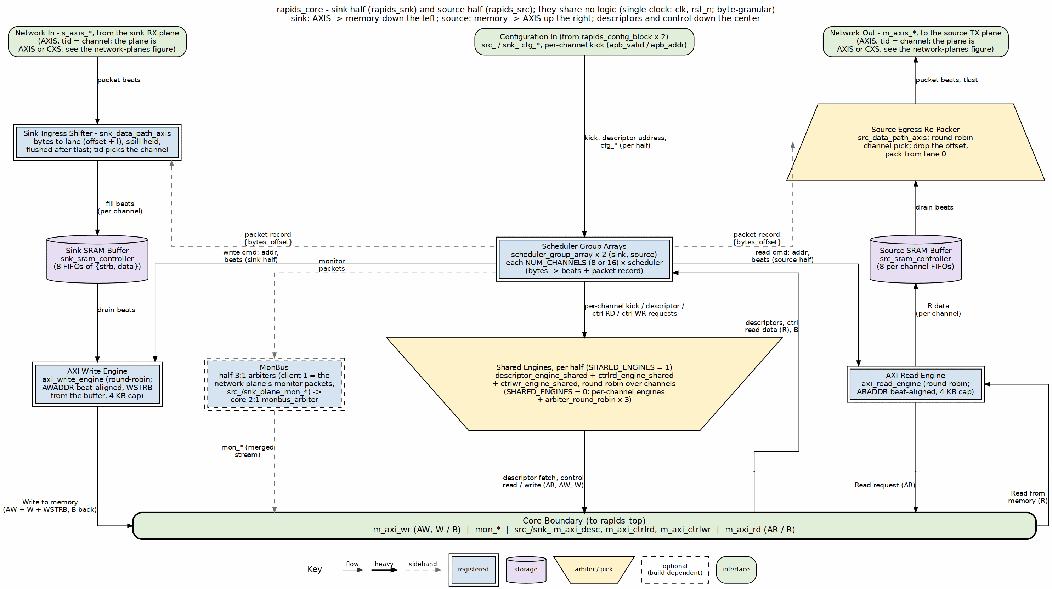
RAPIDS core block diagram
Source: 04_rapids_core.dot
Source: rapids_core.sv, rapids_snk.sv, rapids_src.sv
Table 1.1.1: Block Roles
Block | Role
scheduler | Loads a descriptor, computes beats from offset and length, issues the packet record, tracks completion
scheduler_group_array | Eight scheduler groups sharing one descriptor AXI master; per-channel packet-record ports
snk_data_path_axis | Converts packed AXIS beats into memory-aligned beats with byte enables; checks the packet length
snk_data_path | SRAM of {strb, data} entries plus the AXI write engine
src_data_path | SRAM of data entries plus the AXI read engine; unchanged from Beats
src_data_path_axis | Converts memory-aligned beats into packed stream beats with a partial last beat

3.3 Data Flow Overview

3.3.1 Sink Path (Network to Memory)

3.3.2 Figure 1.1.2: Sink Path Data Flow
1. Scheduler loads a descriptor, computes beats_total, pulses sched_wr_pkt_valid
| (record {bytes, offset} enters the per-channel record queue)
v
2. s_axis packet arrives; tready is held low until the channel's record is known
|
v
3. Ingress shifter: stream beat << (offset*8), OR the spill of the previous beat
| low DATA_WIDTH bits = this memory beat, high bits become the new spill
v
4. Fill logic writes {strb, data} into the sink SRAM (snk_sram_controller)
|
v
5. axi_write_engine: aligned AWADDR, capped burst, WSTRB from the SRAM entry
|
v
6. System memory; B response commits the beats and completes the descriptor

3.3.3 Source Path (Memory to Network)

3.3.4 Figure 1.1.3: Source Path Data Flow
1. Scheduler loads a descriptor, computes beats_total, pulses sched_rd_pkt_valid
|
v
2. axi_read_engine: aligned ARADDR, capped burst, beats into the source SRAM
|
v
3. src_data_path_axis reserves drain blocks (round-robin, cfg_drain_size beats)
|
v
4. Egress shifter: memory beat >> (offset*8), OR the next beat's low lanes
| the first pop only primes the hold; the last beat is partial
v
5. m_axis: TDATA packed from lane 0, TSTRB contiguous, TLAST on the final byte

3.4 Byte-Granular Design Points
Table 1.1.2: Design Points
Point | Rule
Length unit | Bytes, in the existing 32-bit descriptor field
Beats moved | (offset + length + BYTE_LANES - 1) >> OFF_W, zero when length is zero
First burst | May begin mid-beat; the address it presents is beat-aligned and the offset is carried by the record
Later bursts | Beat-aligned
4 KB rule | A burst is truncated at the next 4 KB boundary
Sink lanes not written | WSTRB bit is 0
Source last beat | Partial; TSTRB marks the valid low lanes, TLAST set
TYPE=EXT | Beat-aligned by design (permanent): aligned addresses, beat-multiple lengths
The 4 KB rule and the byte math are specified in Scheduler and AXI Read Engine.

3.5 Chapter Map
Topic | Chapter
Scheduler byte math and record issue | Scheduler
Record queue interface | Packet Record Interface
Ingress shifter | Sink Data Path AXIS
Egress shifter | Source Data Path AXIS
Everything else | Linked from the RAPIDS Beats MAS via the index

RTL Design Sherpa · Learning Hardware Design Through Practice GitHub · Documentation Index · MIT License

4 Top-Level Port List
Module: rapids_core_beats.sv Location: projects/components/dma-ip/rapids/rtl/macro_beats/ Status: Implemented Last Updated: 2026-10-16

4.1 Parameters
Every parameter of rapids_core_beats, as declared. The short aliases at the end are what the port widths below are written in (NC, AW, DW, IW, SCW, CIW, SW).
Table 1.2.1: Parameters (from rapids_core_beats.sv)
Parameter | Type | Default | Notes
NUM_CHANNELS | int | 8 | -
CHAN_WIDTH | int | $clog2(NUM_CHANNELS) | -
ADDR_WIDTH | int | 64 | -
DATA_WIDTH | int | 512 | -
AXI_ID_WIDTH | int | 8 | -
SRAM_DEPTH | int | 512 | -
SEG_COUNT_WIDTH | int | $clog2(SRAM_DEPTH) + 1 | -
PIPELINE | int | 1 | write-engine pipelining; 1 is the perf design point (see rapids_beats_top)
AR_MAX_OUTSTANDING | int | 8 | -
AW_MAX_OUTSTANDING | int | 8 | -
W_PHASE_FIFO_DEPTH | int | 64 | -
B_PHASE_FIFO_DEPTH | int | 16 | -
AXIS_ID_WIDTH | int | 8 | -
AXIS_DEST_WIDTH | int | 4 | -
AXIS_USER_WIDTH | int | 1 | -
DESC_MON_BASE_AGENT_ID | int | 16 | 0x10 - Descriptor Engines (16-23)
SCHED_MON_BASE_AGENT_ID | int | 48 | 0x30 - Schedulers (48-55)
DESC_AXI_MON_AGENT_ID | int | 8 | 0x08 - Descriptor AXI Master Monitor
MON_UNIT_ID | int | 1 | 0x1
MON_MAX_TRANSACTIONS | int | 16 | -
USE_AXI_MONITORS | int | 1 | -
USE_ROW_COL_MAJOR_ADDRESSING | int | 1 | -
GEN_MON | bit | 1'b1 | -
NC | int | NUM_CHANNELS | -
AW | int | ADDR_WIDTH | -
DW | int | DATA_WIDTH | -
IW | int | AXI_ID_WIDTH | -
SD | int | SRAM_DEPTH | -
SCW | int | SEG_COUNT_WIDTH | -
CIW | int | (NC > 1) ? $clog2(NC) : 1 | -
SW | int | DW / 8 | -

4.2 Port List (324 ports)
The module is two independent halves. Ports both halves carry are prefixed src_ / snk_; the direction-unique ports (the source’s AXI read master and AXIS egress, the sink’s AXI write master and AXIS ingress) carry no prefix. Sections follow the declaration order in the RTL, so a reader can walk this page and the module side by side. Widths use the parameter aliases.

4.2.1 Clock and Reset (shared - single clock/reset for the whole wrapper)
Table 1.2.2: Clock and Reset (shared - single clock/reset for the whole wrapper)
Signal | Direction | Width | Description
clk | input | 1 | -
rst_n | input | 1 | -

4.3 SOURCE HALF (u_src) - shared-infrastructure ports (src_ prefixed)

4.3.1 APB Programming Interface
Table 1.2.3: APB Programming Interface
Signal | Direction | Width | Description
src_apb_valid | input | NC | -
src_apb_ready | output | NC | -
src_apb_addr | input | NC x AW | -

4.3.2 Per-channel configuration
Table 1.2.4: Per-channel configuration
Signal | Direction | Width | Description
src_cfg_channel_enable | input | NC | -
src_cfg_channel_reset | input | NC | -

4.3.3 Scheduler Configuration (global)
Table 1.2.5: Scheduler Configuration (global)
Signal | Direction | Width | Description
src_cfg_sched_enable | input | 1 | -
src_cfg_sched_timeout_cycles | input | 32 | -
src_cfg_sched_timeout_limit | input | 8 | -
src_cfg_sched_timeout_enable | input | 1 | -
src_cfg_sched_err_enable | input | 1 | -
src_cfg_sched_compl_enable | input | 1 | -
src_cfg_sched_perf_enable | input | 1 | -

4.3.4 Descriptor Engine Configuration (global)
Table 1.2.6: Descriptor Engine Configuration (global)
Signal | Direction | Width | Description
src_cfg_desceng_enable | input | 1 | -
src_cfg_desceng_prefetch | input | 1 | -
src_cfg_desceng_fifo_thresh | input | 4 | -
src_cfg_desceng_addr0_base | input | AW | -
src_cfg_desceng_addr0_limit | input | AW | -
src_cfg_desceng_addr1_base | input | AW | -
src_cfg_desceng_addr1_limit | input | AW | -

4.3.5 Control Engine Configuration (Phase 2, global)
Table 1.2.7: Control Engine Configuration (Phase 2, global)
Signal | Direction | Width | Description
src_cfg_ctrlrd_max_try | input | 9 | -
src_tick_1us | input | 1 | -

4.3.6 Descriptor AXI Monitor Configuration
Table 1.2.8: Descriptor AXI Monitor Configuration
Signal | Direction | Width | Description
src_cfg_desc_mon_enable | input | 1 | -
src_cfg_desc_mon_err_enable | input | 1 | -
src_cfg_desc_mon_perf_enable | input | 1 | -
src_cfg_desc_mon_perf_run | input | 1 | -
src_cfg_desc_mon_timeout_enable | input | 1 | -
src_cfg_desc_mon_timeout_cycles | input | 32 | -
src_cfg_desc_mon_latency_thresh | input | 32 | -
src_cfg_desc_mon_pkt_mask | input | 16 | -
src_cfg_desc_mon_err_select | input | 4 | -
src_cfg_desc_mon_err_mask | input | 8 | -
src_cfg_desc_mon_timeout_mask | input | 8 | -
src_cfg_desc_mon_compl_mask | input | 8 | -
src_cfg_desc_mon_thresh_mask | input | 8 | -
src_cfg_desc_mon_perf_mask | input | 8 | -
src_cfg_desc_mon_addr_mask | input | 8 | -
src_cfg_desc_mon_debug_mask | input | 8 | -

4.3.7 Network-plane monitor input (rapids TASK-024)
The network endpoint and its monitor-lite live in the plane (rtl/plane/) in the top. Its monbus packets enter here as client 1 of this half’s monbus arbiter; the plane’s monitor configuration and status come from this half’s register block in the top.
Table 1.2.9: Network-plane monitor input (rapids TASK-024)
Signal | Direction | Width | Description
src_plane_mon_valid | input | 1 | -
src_plane_mon_ready | output | 1 | -
src_plane_mon_packet | input | 128 | monitor_packet_t
src_plane_mon_timestamp | input | 64 | monbus_timestamp_t

4.3.8 Status
Table 1.2.10: Status
Signal | Direction | Width | Description
src_system_idle | output | 1 | -
src_descriptor_engine_idle | output | NC | -
src_scheduler_idle | output | NC | -
src_scheduler_state | output | NC x 7 | -
src_sched_error | output | NC | -

4.3.9 Descriptor AXI Monitor Status
Table 1.2.11: Descriptor AXI Monitor Status
Signal | Direction | Width | Description
src_cfg_sts_desc_mon_busy | output | 1 | -
src_cfg_sts_desc_mon_active_txns | output | 8 | -
src_cfg_sts_desc_mon_error_count | output | 16 | -
src_cfg_sts_desc_mon_txn_count | output | 32 | -
src_cfg_sts_desc_mon_conflict_error | output | 1 | -

4.3.10 Descriptor AXI Monitor perf window (feeds SRC_.MON.DAXMON_PERF_*).
Table 1.2.12: Descriptor AXI Monitor perf window (feeds SRC_.MON.DAXMON_PERF_*).
Signal | Direction | Width | Description
src_sts_desc_mon_win_active | output | 1 | -
src_sts_desc_mon_win_cycles | output | 32 | -
src_sts_desc_mon_prod_cycles | output | 32 | -
src_sts_desc_mon_bp_cycles | output | 32 | -
src_sts_desc_mon_starv_cycles | output | 32 | -
src_sts_desc_mon_idle_cycles | output | 32 | -
src_sts_desc_mon_beat_count | output | 32 | -
src_sts_desc_mon_byte_count | output | 64 | -
src_sts_desc_mon_burst_count | output | 32 | -

4.3.11 Descriptor Fetch AXI Master
Table 1.2.13: Descriptor Fetch AXI Master
Signal | Direction | Width | Description
src_m_axi_desc_arvalid | output | 1 | -
src_m_axi_desc_arready | input | 1 | -
src_m_axi_desc_araddr | output | AW | -
src_m_axi_desc_arlen | output | 8 | -
src_m_axi_desc_arsize | output | 3 | -
src_m_axi_desc_arburst | output | 2 | -
src_m_axi_desc_arid | output | IW | -
src_m_axi_desc_arlock | output | 1 | -
src_m_axi_desc_arcache | output | 4 | -
src_m_axi_desc_arprot | output | 3 | -
src_m_axi_desc_arqos | output | 4 | -
src_m_axi_desc_arregion | output | 4 | -
src_m_axi_desc_rvalid | input | 1 | -
src_m_axi_desc_rready | output | 1 | -
src_m_axi_desc_rdata | input | 256 | -
src_m_axi_desc_rresp | input | 2 | -
src_m_axi_desc_rlast | input | 1 | -
src_m_axi_desc_rid | input | IW | -

4.3.12 Control Read AXI Master (32-bit) [Phase 2]
Table 1.2.14: Control Read AXI Master (32-bit) [Phase 2]
Signal | Direction | Width | Description
src_m_axi_ctrlrd_arvalid | output | 1 | -
src_m_axi_ctrlrd_arready | input | 1 | -
src_m_axi_ctrlrd_araddr | output | AW | -
src_m_axi_ctrlrd_arlen | output | 8 | -
src_m_axi_ctrlrd_arsize | output | 3 | -
src_m_axi_ctrlrd_arburst | output | 2 | -
src_m_axi_ctrlrd_arid | output | IW | -
src_m_axi_ctrlrd_arlock | output | 1 | -
src_m_axi_ctrlrd_arcache | output | 4 | -
src_m_axi_ctrlrd_arprot | output | 3 | -
src_m_axi_ctrlrd_arqos | output | 4 | -
src_m_axi_ctrlrd_arregion | output | 4 | -
src_m_axi_ctrlrd_rvalid | input | 1 | -
src_m_axi_ctrlrd_rready | output | 1 | -
src_m_axi_ctrlrd_rdata | input | 32 | -
src_m_axi_ctrlrd_rresp | input | 2 | -
src_m_axi_ctrlrd_rlast | input | 1 | -
src_m_axi_ctrlrd_rid | input | IW | -

4.3.13 Control Write AXI Master (32-bit) [Phase 2]
Table 1.2.15: Control Write AXI Master (32-bit) [Phase 2]
Signal | Direction | Width | Description
src_m_axi_ctrlwr_awvalid | output | 1 | -
src_m_axi_ctrlwr_awready | input | 1 | -
src_m_axi_ctrlwr_awaddr | output | AW | -
src_m_axi_ctrlwr_awlen | output | 8 | -
src_m_axi_ctrlwr_awsize | output | 3 | -
src_m_axi_ctrlwr_awburst | output | 2 | -
src_m_axi_ctrlwr_awid | output | IW | -
src_m_axi_ctrlwr_awlock | output | 1 | -
src_m_axi_ctrlwr_awcache | output | 4 | -
src_m_axi_ctrlwr_awprot | output | 3 | -
src_m_axi_ctrlwr_awqos | output | 4 | -
src_m_axi_ctrlwr_awregion | output | 4 | -
src_m_axi_ctrlwr_wvalid | output | 1 | -
src_m_axi_ctrlwr_wready | input | 1 | -
src_m_axi_ctrlwr_wdata | output | 32 | -
src_m_axi_ctrlwr_wstrb | output | 4 | -
src_m_axi_ctrlwr_wlast | output | 1 | -
src_m_axi_ctrlwr_bvalid | input | 1 | -
src_m_axi_ctrlwr_bready | output | 1 | -
src_m_axi_ctrlwr_bid | input | IW | -
src_m_axi_ctrlwr_bresp | input | 2 | -

4.4 SOURCE HALF (u_src) - direction-unique ports (no prefix)

4.4.1 AXI Transfer Configuration (source-only)
Table 1.2.16: AXI Transfer Configuration (source-only)
Signal | Direction | Width | Description
cfg_axi_rd_xfer_beats | input | 8 | -
cfg_drain_size | input | 8 | source: beats drained per AXIS packet

4.4.2 Source Path - AXIS Master Interface (SRAM -> Network); tid = channel id
Table 1.2.17: Source Path - AXIS Master Interface (SRAM -> Network); tid = channel id
Signal | Direction | Width | Description
m_axis_tdata | output | DW | -
m_axis_tstrb | output | SW | -
m_axis_tlast | output | 1 | -
m_axis_tid | output | AXIS_ID_WIDTH | -
m_axis_tdest | output | AXIS_DEST_WIDTH | -
m_axis_tuser | output | AXIS_USER_WIDTH | -
m_axis_tvalid | output | 1 | -
m_axis_tready | input | 1 | -

4.4.3 AXI4 Master - Data Read (Memory -> Source SRAM)
Table 1.2.18: AXI4 Master - Data Read (Memory -> Source SRAM)
Signal | Direction | Width | Description
m_axi_rd_arid | output | IW | -
m_axi_rd_araddr | output | AW | -
m_axi_rd_arlen | output | 8 | -
m_axi_rd_arsize | output | 3 | -
m_axi_rd_arburst | output | 2 | -
m_axi_rd_arvalid | output | 1 | -
m_axi_rd_arready | input | 1 | -
m_axi_rd_rid | input | IW | -
m_axi_rd_rdata | input | DW | -
m_axi_rd_rresp | input | 2 | -
m_axi_rd_rlast | input | 1 | -
m_axi_rd_rvalid | input | 1 | -
m_axi_rd_rready | output | 1 | -

4.5 SINK HALF (u_snk) - shared-infrastructure ports (snk_ prefixed)

4.5.1 APB Programming Interface
Table 1.2.19: APB Programming Interface
Signal | Direction | Width | Description
snk_apb_valid | input | NC | -
snk_apb_ready | output | NC | -
snk_apb_addr | input | NC x AW | -

4.5.2 Per-channel configuration
Table 1.2.20: Per-channel configuration
Signal | Direction | Width | Description
snk_cfg_channel_enable | input | NC | -
snk_cfg_channel_reset | input | NC | -

4.5.3 Scheduler Configuration (global)
Table 1.2.21: Scheduler Configuration (global)
Signal | Direction | Width | Description
snk_cfg_sched_enable | input | 1 | -
snk_cfg_sched_timeout_cycles | input | 32 | -
snk_cfg_sched_timeout_limit | input | 8 | -
snk_cfg_sched_timeout_enable | input | 1 | -
snk_cfg_sched_err_enable | input | 1 | -
snk_cfg_sched_compl_enable | input | 1 | -
snk_cfg_sched_perf_enable | input | 1 | -

4.5.4 Descriptor Engine Configuration (global)
Table 1.2.22: Descriptor Engine Configuration (global)
Signal | Direction | Width | Description
snk_cfg_desceng_enable | input | 1 | -
snk_cfg_desceng_prefetch | input | 1 | -
snk_cfg_desceng_fifo_thresh | input | 4 | -
snk_cfg_desceng_addr0_base | input | AW | -
snk_cfg_desceng_addr0_limit | input | AW | -
snk_cfg_desceng_addr1_base | input | AW | -
snk_cfg_desceng_addr1_limit | input | AW | -

4.5.5 Control Engine Configuration (Phase 2, global)
Table 1.2.23: Control Engine Configuration (Phase 2, global)
Signal | Direction | Width | Description
snk_cfg_ctrlrd_max_try | input | 9 | -
snk_tick_1us | input | 1 | -

4.5.6 Descriptor AXI Monitor Configuration
Table 1.2.24: Descriptor AXI Monitor Configuration
Signal | Direction | Width | Description
snk_cfg_desc_mon_enable | input | 1 | -
snk_cfg_desc_mon_err_enable | input | 1 | -
snk_cfg_desc_mon_perf_enable | input | 1 | -
snk_cfg_desc_mon_perf_run | input | 1 | -
snk_cfg_desc_mon_timeout_enable | input | 1 | -
snk_cfg_desc_mon_timeout_cycles | input | 32 | -
snk_cfg_desc_mon_latency_thresh | input | 32 | -
snk_cfg_desc_mon_pkt_mask | input | 16 | -
snk_cfg_desc_mon_err_select | input | 4 | -
snk_cfg_desc_mon_err_mask | input | 8 | -
snk_cfg_desc_mon_timeout_mask | input | 8 | -
snk_cfg_desc_mon_compl_mask | input | 8 | -
snk_cfg_desc_mon_thresh_mask | input | 8 | -
snk_cfg_desc_mon_perf_mask | input | 8 | -
snk_cfg_desc_mon_addr_mask | input | 8 | -
snk_cfg_desc_mon_debug_mask | input | 8 | -

4.5.7 Network-plane monitor input (rapids TASK-024)
The network endpoint and its monitor-lite live in the plane (rtl/plane/) in the top. Its monbus packets enter here as client 1 of this half’s monbus arbiter; the plane’s monitor configuration and status come from this half’s register block in the top.
Table 1.2.25: Network-plane monitor input (rapids TASK-024)
Signal | Direction | Width | Description
snk_plane_mon_valid | input | 1 | -
snk_plane_mon_ready | output | 1 | -
snk_plane_mon_packet | input | 128 | monitor_packet_t
snk_plane_mon_timestamp | input | 64 | monbus_timestamp_t

4.5.8 Status
Table 1.2.26: Status
Signal | Direction | Width | Description
snk_system_idle | output | 1 | -
snk_descriptor_engine_idle | output | NC | -
snk_scheduler_idle | output | NC | -
snk_scheduler_state | output | NC x 7 | -
snk_sched_error | output | NC | -

4.5.9 Descriptor AXI Monitor Status
Table 1.2.27: Descriptor AXI Monitor Status
Signal | Direction | Width | Description
snk_cfg_sts_desc_mon_busy | output | 1 | -
snk_cfg_sts_desc_mon_active_txns | output | 8 | -
snk_cfg_sts_desc_mon_error_count | output | 16 | -
snk_cfg_sts_desc_mon_txn_count | output | 32 | -
snk_cfg_sts_desc_mon_conflict_error | output | 1 | -

4.5.10 Descriptor AXI Monitor perf window (feeds SNK_.MON.DAXMON_PERF_*).
Table 1.2.28: Descriptor AXI Monitor perf window (feeds SNK_.MON.DAXMON_PERF_*).
Signal | Direction | Width | Description
snk_sts_desc_mon_win_active | output | 1 | -
snk_sts_desc_mon_win_cycles | output | 32 | -
snk_sts_desc_mon_prod_cycles | output | 32 | -
snk_sts_desc_mon_bp_cycles | output | 32 | -
snk_sts_desc_mon_starv_cycles | output | 32 | -
snk_sts_desc_mon_idle_cycles | output | 32 | -
snk_sts_desc_mon_beat_count | output | 32 | -
snk_sts_desc_mon_byte_count | output | 64 | -
snk_sts_desc_mon_burst_count | output | 32 | -

4.5.11 Descriptor Fetch AXI Master
Table 1.2.29: Descriptor Fetch AXI Master
Signal | Direction | Width | Description
snk_m_axi_desc_arvalid | output | 1 | -
snk_m_axi_desc_arready | input | 1 | -
snk_m_axi_desc_araddr | output | AW | -
snk_m_axi_desc_arlen | output | 8 | -
snk_m_axi_desc_arsize | output | 3 | -
snk_m_axi_desc_arburst | output | 2 | -
snk_m_axi_desc_arid | output | IW | -
snk_m_axi_desc_arlock | output | 1 | -
snk_m_axi_desc_arcache | output | 4 | -
snk_m_axi_desc_arprot | output | 3 | -
snk_m_axi_desc_arqos | output | 4 | -
snk_m_axi_desc_arregion | output | 4 | -
snk_m_axi_desc_rvalid | input | 1 | -
snk_m_axi_desc_rready | output | 1 | -
snk_m_axi_desc_rdata | input | 256 | -
snk_m_axi_desc_rresp | input | 2 | -
snk_m_axi_desc_rlast | input | 1 | -
snk_m_axi_desc_rid | input | IW | -

4.5.12 Control Read AXI Master (32-bit) [Phase 2]
Table 1.2.30: Control Read AXI Master (32-bit) [Phase 2]
Signal | Direction | Width | Description
snk_m_axi_ctrlrd_arvalid | output | 1 | -
snk_m_axi_ctrlrd_arready | input | 1 | -
snk_m_axi_ctrlrd_araddr | output | AW | -
snk_m_axi_ctrlrd_arlen | output | 8 | -
snk_m_axi_ctrlrd_arsize | output | 3 | -
snk_m_axi_ctrlrd_arburst | output | 2 | -
snk_m_axi_ctrlrd_arid | output | IW | -
snk_m_axi_ctrlrd_arlock | output | 1 | -
snk_m_axi_ctrlrd_arcache | output | 4 | -
snk_m_axi_ctrlrd_arprot | output | 3 | -
snk_m_axi_ctrlrd_arqos | output | 4 | -
snk_m_axi_ctrlrd_arregion | output | 4 | -
snk_m_axi_ctrlrd_rvalid | input | 1 | -
snk_m_axi_ctrlrd_rready | output | 1 | -
snk_m_axi_ctrlrd_rdata | input | 32 | -
snk_m_axi_ctrlrd_rresp | input | 2 | -
snk_m_axi_ctrlrd_rlast | input | 1 | -
snk_m_axi_ctrlrd_rid | input | IW | -

4.5.13 Control Write AXI Master (32-bit) [Phase 2]
Table 1.2.31: Control Write AXI Master (32-bit) [Phase 2]
Signal | Direction | Width | Description
snk_m_axi_ctrlwr_awvalid | output | 1 | -
snk_m_axi_ctrlwr_awready | input | 1 | -
snk_m_axi_ctrlwr_awaddr | output | AW | -
snk_m_axi_ctrlwr_awlen | output | 8 | -
snk_m_axi_ctrlwr_awsize | output | 3 | -
snk_m_axi_ctrlwr_awburst | output | 2 | -
snk_m_axi_ctrlwr_awid | output | IW | -
snk_m_axi_ctrlwr_awlock | output | 1 | -
snk_m_axi_ctrlwr_awcache | output | 4 | -
snk_m_axi_ctrlwr_awprot | output | 3 | -
snk_m_axi_ctrlwr_awqos | output | 4 | -
snk_m_axi_ctrlwr_awregion | output | 4 | -
snk_m_axi_ctrlwr_wvalid | output | 1 | -
snk_m_axi_ctrlwr_wready | input | 1 | -
snk_m_axi_ctrlwr_wdata | output | 32 | -
snk_m_axi_ctrlwr_wstrb | output | 4 | -
snk_m_axi_ctrlwr_wlast | output | 1 | -
snk_m_axi_ctrlwr_bvalid | input | 1 | -
snk_m_axi_ctrlwr_bready | output | 1 | -
snk_m_axi_ctrlwr_bid | input | IW | -
snk_m_axi_ctrlwr_bresp | input | 2 | -

4.6 Monitor Bus (SINGLE aggregated stream for the whole core)
The two halves’ monitor outputs are merged through a top-level monbus_arbiter, so the core exposes exactly one monitor stream.

4.6.1 Monitor Bus
Table 1.2.32: Monitor Bus
Signal | Direction | Width | Description
mon_valid | output | 1 | -
mon_ready | input | 1 | -
mon_packet | output | ocelus_common_pkg::monitor_packet_t | -
mon_timestamp | output | ocelus_common_pkg::monbus_timestamp_t | -

4.7 SINK HALF (u_snk) - direction-unique ports (no prefix)

4.7.1 AXI Transfer Configuration (sink-only)
Table 1.2.33: AXI Transfer Configuration (sink-only)
Signal | Direction | Width | Description
cfg_axi_wr_xfer_beats | input | 8 | -
cfg_alloc_size | input | 8 | sink: SRAM alloc size per AXIS fill

4.7.2 Sink Path - AXIS Slave Interface (Network -> SRAM); tid = channel id
Table 1.2.34: Sink Path - AXIS Slave Interface (Network -> SRAM); tid = channel id
Signal | Direction | Width | Description
s_axis_tdata | input | DW | -
s_axis_tstrb | input | SW | -
s_axis_tlast | input | 1 | -
s_axis_tid | input | AXIS_ID_WIDTH | -
s_axis_tdest | input | AXIS_DEST_WIDTH | -
s_axis_tuser | input | AXIS_USER_WIDTH | -
s_axis_tvalid | input | 1 | -
s_axis_tready | output | 1 | -

4.7.3 AXI4 Master - Data Write (Sink SRAM -> Memory)
Table 1.2.35: AXI4 Master - Data Write (Sink SRAM -> Memory)
Signal | Direction | Width | Description
m_axi_wr_awid | output | IW | -
m_axi_wr_awaddr | output | AW | -
m_axi_wr_awlen | output | 8 | -
m_axi_wr_awsize | output | 3 | -
m_axi_wr_awburst | output | 2 | -
m_axi_wr_awlock | output | 1 | -
m_axi_wr_awcache | output | 4 | -
m_axi_wr_awprot | output | 3 | -
m_axi_wr_awqos | output | 4 | -
m_axi_wr_awregion | output | 4 | -
m_axi_wr_awvalid | output | 1 | -
m_axi_wr_awready | input | 1 | -
m_axi_wr_wdata | output | DW | -
m_axi_wr_wstrb | output | (DW/8) | -
m_axi_wr_wlast | output | 1 | -
m_axi_wr_wvalid | output | 1 | -
m_axi_wr_wready | input | 1 | -
m_axi_wr_bid | input | IW | -
m_axi_wr_bresp | input | 2 | -
m_axi_wr_bvalid | input | 1 | -
m_axi_wr_bready | output | 1 | -

4.8 Debug Interface (per half, src_dbg_ / snk_dbg_ prefixed)

4.8.1 Source half debug
Table 1.2.36: Source half debug
Signal | Direction | Width | Description
src_dbg_rd_all_complete | output | NC | -
src_dbg_r_beats_rcvd | output | 32 | -
src_dbg_sram_writes | output | 32 | -
src_dbg_arb_request | output | NC | -
src_dbg_src_sram_bridge_pending | output | NC | -
src_dbg_src_sram_bridge_out_valid | output | NC | -
src_dbg_axis_beats_sent | output | 32 | -
src_dbg_axis_packets_sent | output | 32 | -

4.8.2 Sink half debug
Table 1.2.37: Sink half debug
Signal | Direction | Width | Description
snk_dbg_snk_sram_bridge_pending | output | NC | -
snk_dbg_snk_sram_bridge_out_valid | output | NC | -
snk_dbg_axis_beats_received | output | 32 | -
snk_dbg_axis_packets_received | output | 32 | -

4.8.3 Active-channel sideband for per-channel bus instrumentation
(axi_bus_meter). The W bus carries no wid, so the write engine’s channel index must travel out of band to reach the meter at the top.
Table 1.2.38: Active-channel sideband for per-channel bus instrumentation
Signal | Direction | Width | Description
snk_active_channel_id | output | CIW | -
snk_active_channel_valid | output | 1 | -

Verified: every row above is a declared port of rapids_core_beats and every declared port has a row (324 of 324), generated from the module declaration on 2026-09-28. Regenerate rather than hand-edit when the interface changes.

RTL Design Sherpa · Learning Hardware Design Through Practice GitHub · Documentation Index · MIT License

5 Clocks and Reset
Module: rapids_core_beats.sv Location: projects/components/dma-ip/rapids/rtl/macro_beats/ Status: Implemented Last Updated: 2025-01-10

5.1 Clock Domain
RAPIDS Beats operates in a single clock domain for simplified design and maximum throughput.

5.1.1 Clock Specifications
Table 1.3.1: Clock Specifications
Parameter | Specification
Clock Signal | clk (also axi_aclk in some submodules)
Frequency Range | 100 - 500 MHz
Duty Cycle | 45% - 55%
Clock Jitter | < 100 ps peak-to-peak

5.1.2 Clock Distribution
clk (one clock domain; rst_n active-low, async assert)
├── scheduler_group_array_beats (one per half)
│ └── descriptor_engine_beats, scheduler_beats, ctrlrd_engine, ctrlwr_engine (x8)
├── snk_data_path_axis_beats
│ └── snk_sram_controller_beats, axi_write_engine_beats
└── src_data_path_axis_beats
└── axi_read_engine_beats, src_sram_controller_beats

5.2 Reset Specification
RAPIDS uses asynchronous assert, synchronous deassert reset methodology.

5.2.1 Reset Signal
Table 1.3.2: Reset Specifications
Parameter | Specification
Reset Signal | rst_n (also axi_aresetn in some submodules)
Polarity | Active-low
Assert | Asynchronous (immediate)
Deassert | Synchronous (on rising clock edge)
Minimum Duration | 10 clock cycles

5.2.2 Reset Timing Diagram

5.2.3 Figure 1.3.1: Reset Timing

scheduler_beats - reset release to first descriptor
Source: scheduler_reset.json, captured from dv/tests/fub_beats/test_scheduler_beats.py (basic transfer, the same run as Figure 2.1.3) with WAVES=1.
Reading it: rst_n is held low for ten cycles and released on a clock edge. Every state register is already at its reset value while reset is asserted – the FSM sits in IDLE, scheduler_idle is high, both control engines report idle and neither engine request is raised. Nothing changes at the release edge itself; the scheduler stays in IDLE until the testbench raises cfg_channel_enable ten cycles later and a descriptor becomes available, at which point it steps through FETCH_DESC to XFER_DATA and raises the read and write requests together.

5.3 Reset Behavior

5.3.1 On Reset Assert
All modules initialize to known states:
Table 1.3.3: Reset States
Component | Reset State
Scheduler FSM | IDLE
Descriptor Engine | IDLE, FIFOs empty
AXI Read Engine | Idle, no outstanding transactions
AXI Write Engine | Idle, no outstanding transactions
SRAM Pointers | All zeros
Alloc/Drain Controllers | Empty, full space available
MonBus | No packets pending

5.3.2 Reset Sequence
1. External reset asserted (rst_n = 0)
- All flip-flops async reset
- All outputs driven to safe states
- No AXI transactions
2. System stabilization (minimum 10 cycles)
- Clock running and stable
- Configuration registers programmed (optional)
3. Reset deasserted (rst_n = 1, sync to clk rising edge)
- FSMs begin operation
- Ready to accept descriptors/data

5.4 Configuration During Reset
Some configuration signals MUST be stable before reset deassertion:
Table 1.3.4: Configuration Timing Requirements
Signal | Requirement
src_cfg_channel_enable / snk_cfg_channel_enable | Stable before rst_n=1 (one per half)
src_cfg_sched_timeout_cycles / snk_cfg_sched_timeout_cycles | Stable before rst_n=1 (one per half)
cfg_axi_rd_xfer_beats | Stable before rst_n=1
cfg_axi_wr_xfer_beats | Stable before rst_n=1

5.5 Reset Macros
RAPIDS uses standardized reset macros from reset_defs.svh:
`include "reset_defs.svh"
// Standard reset pattern
`ALWAYS_FF_RST(clk, rst_n,
if (`RST_ASSERTED(rst_n)) begin
r_state <= IDLE;
r_counter <= '0;
end else begin
r_state <= w_next_state;
r_counter <= w_next_counter;
end
)

5.6 Power-On Reset Considerations
- External reset should be held for minimum 10 clock cycles after clock is stable
- Configuration registers should be programmed before or during reset
- No AXI transactions until reset is deasserted and channels are enabled

Last Updated: 2025-01-10

RTL Design Sherpa · Learning Hardware Design Through Practice GitHub · Documentation Index · MIT License

6 Scheduler
Module: scheduler.sv Location: projects/components/dma-ip/rapids/rtl/fub/ Status: Implemented Last Updated: 2026-10-21

6.1 Overview
The scheduler coordinates one channel. It accepts a 256-bit descriptor from the descriptor engine, turns the descriptor’s byte length and byte addresses into beat counts for the AXI engines, tells the data paths how the packet is laid out, and tracks progress until every source beat is read and every destination beat is committed.
Compared with the RAPIDS Beats scheduler, the state machine, the timeout logic, the control-descriptor path and the MonBus events are the same. Three things change: the beat math, the address advance, and the packet record.

6.1.1 Structure: the FSM around scheduler_core
Since rapids TASK-034 the scheduler is two modules. scheduler_core.sv holds the datapath and nothing that decides: the descriptor skid and latch, the strobe-driven counters, the address advance, run accounting, timeouts, sticky errors, control-engine issue, tile checks, packet records and MonBus packets. Its state, its descriptor take, its beat totals and its EXT run bases are inputs. scheduler.sv keeps the port list it always had and supplies those inputs: the finite state machine below, the byte-to-beat ceiling and the two stream_run_addr_gen run-base generators. The gatling-sequenced scheduler_g (Chapter 5) wraps the same core and takes the four from firmware, so there is one copy of the datapath for both.

6.1.2 Key Features
- Byte length: the descriptor’s 32-bit length is a byte count.
- Byte addresses: the offset of a transfer inside its first beat is addr[OFF_W-1:0].
- Beat math: beats moved are derived from offset and length, in a 33-bit intermediate.
- Packet record: one {bytes, offset} pulse per DATA descriptor, per enabled direction, held back while the data path cannot take it.
- Concurrent read and write: both directions run inside one XFER_DATA state.
- Recoverable write-progress timeout: strikes escalate to a sticky error only when a limit is set.
- Control descriptors: CTRL_READ and CTRL_WRITE drive the control engines, unchanged.
- Directional halves: EN_READ and EN_WRITE select the source or sink half.

6.1.3 Block Diagram

6.1.4 Figure 2.1.1: Scheduler Byte Math
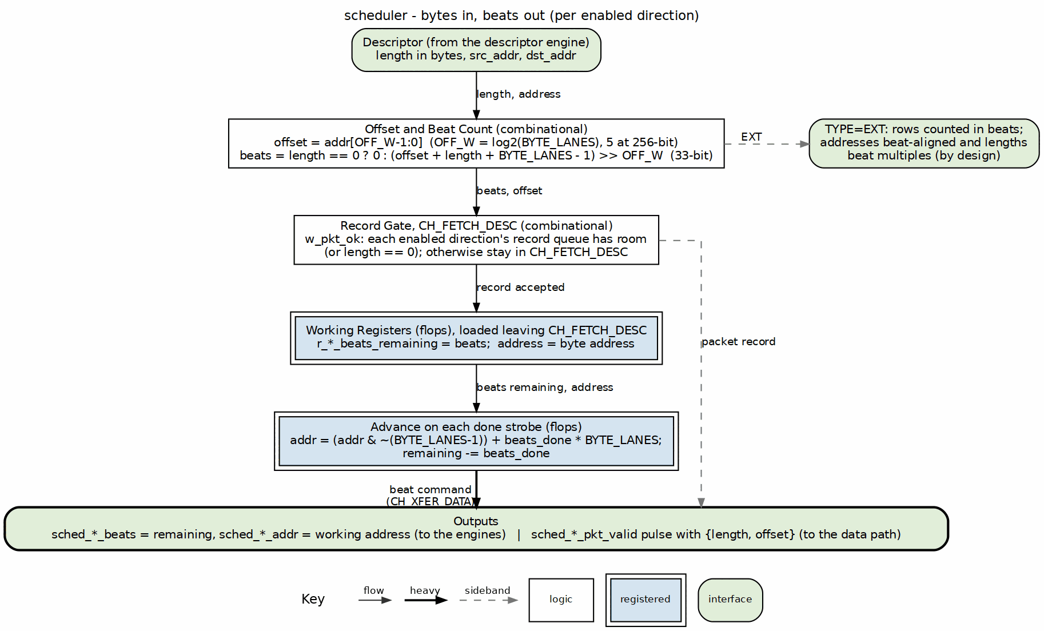
Scheduler byte math
Source: assets/graphviz/03_scheduler_byte_math.dot

6.2 Parameters
Table 2.1.1: Scheduler Parameters
Parameter | Type | Default | Description
CHANNEL_ID | int | 0 | Channel index of this scheduler
NUM_CHANNELS | int | 8 | Channel count
CHAN_WIDTH | int | $clog2(NUM_CHANNELS) | Channel field width
ADDR_WIDTH | int | 64 | Address width
DATA_WIDTH | int | 512 | Data width in bits; the board design uses 256
MON_AGENT_ID | logic [15:0] | 16’h0040 | MonBus agent ID
MON_UNIT_ID | logic [7:0] | 8’h01 | MonBus unit ID
MON_CHANNEL_ID | logic [8:0] | 9’h000 | MonBus base channel ID
DESC_WIDTH | int | 256 | Descriptor width; fixed at 256 (elaboration fails otherwise)
EN_READ | bit | 1 | Enable the read direction for DATA descriptors
EN_WRITE | bit | 1 | Enable the write direction for DATA descriptors
USE_ROW_COL_MAJOR_ADDRESSING | int | 1 | Enable TYPE=EXT run-base generators
BYTE_LANES | int | DATA_WIDTH/8 | Bytes per beat
OFF_W | int | (BYTE_LANES>1) ? $clog2(BYTE_LANES) : 1 | Offset field width
BYTE_LANES and OFF_W are the two parameters that do not exist in the Beats scheduler. A directional half sets exactly one of EN_READ and EN_WRITE: the source half reads only, the sink half writes only.

6.3 Port List

6.3.1 Clock, Reset and Configuration
Table 2.1.2: Clock, Reset and Configuration Ports
Signal | Dir | Width | Description
clk | in | 1 | Clock
rst_n | in | 1 | Active-low reset
cfg_channel_enable | in | 1 | Channel enable; IDLE leaves only when set
cfg_channel_reset | in | 1 | Channel reset; forces IDLE and clears sticky state
cfg_sched_timeout_cycles | in | 32 | Write-progress timeout window in cycles
cfg_sched_timeout_limit | in | 8 | Consecutive windows before escalation; 0 = never
cfg_sched_timeout_enable | in | 1 | Enable timeout detection

6.3.2 Status
Table 2.1.3: Status Ports
Signal | Dir | Width | Description
scheduler_idle | out | 1 | High in CH_IDLE with no channel reset pending and the descriptor skid empty
scheduler_state | out | 7 | One-hot state (see Table 2.1.12)
sched_error | out | 1 | Sticky, high in CH_ERROR
dbg_descriptor_error | out | 1 | Latched fatal descriptor-level error
dbg_read_error_sticky | out | 1 | Latched read-engine error
dbg_write_error_sticky | out | 1 | Latched write-engine error
dbg_timeout_expired | out | 1 | Live: the timeout window has elapsed

6.3.3 Descriptor Engine Interface
Table 2.1.4: Descriptor Engine Interface
Signal | Dir | Width | Description
descriptor_valid | in | 1 | A descriptor is available
descriptor_ready | out | 1 | The descriptor skid has room (see Descriptor Skid Buffer)
descriptor_packet | in | 256 | Descriptor (layout in Table 2.1.10)
descriptor_ext_packet | in | 256 | Extended chunk; used only when TYPE=EXT
descriptor_error | in | 1 | Descriptor fetch or parse error

6.3.4 Descriptor Skid Buffer
Every scheduler takes its descriptors through a two-deep skid buffer (gaxi_skid_buffer, DEPTH 2) on {descriptor_packet, descriptor_ext_packet}, in front of the descriptor engine’s per-channel FIFO, which stays (rapids TASK-028). The FSM reads the descriptor from the skid’s flops rather than straight off the engine’s 256-bit output, one engine for every channel under SHARED_ENGINES, and a running channel holds two more descriptors.
- descriptor_ready is the skid’s wr_ready: high while it has room, whatever the FSM state. The FSM’s own take (CH_IDLE while cfg_channel_enable is set, CH_NEXT_DESC) pops the skid.
- A disabled channel’s descriptor waits in the skid (or behind it in the engine FIFO) until the channel is enabled; it is not consumed and dropped.
- scheduler_idle stays low while the skid holds a descriptor, so the engine and the scheduler never both read idle with work pending.
- Channel reset: the engine masks descriptor_valid during its reset, so nothing is written during one, and the skid drains while the reset is active. Each entry carries the reset epoch it was written in, and the epoch flips as a reset starts, so an entry a reset too short to drain it left behind is dropped at the head, never run.

6.3.5 Data Read Interface (to AXI Read Engine)
Table 2.1.5: Data Read Interface
Signal | Dir | Width | Description
sched_rd_valid | out | 1 | Read request
sched_rd_addr | out | ADDR_WIDTH | Source byte address (working register)
sched_rd_beats | out | 32 | Beats remaining to read
sched_rd_pkt_valid | out | 1 | Packet record pulse to the source egress
sched_rd_pkt_ready | in | 1 | Source egress record queue has room
sched_rd_pkt_bytes | out | 32 | Descriptor length in bytes
sched_rd_pkt_offset | out | OFF_W | Source byte offset inside the first beat

6.3.6 Data Write Interface (to AXI Write Engine)
Table 2.1.6: Data Write Interface
Signal | Dir | Width | Description
sched_wr_valid | out | 1 | Write request
sched_wr_ready | in | 1 | Write engine can take the channel
sched_wr_addr | out | ADDR_WIDTH | Destination byte address (working register)
sched_wr_beats | out | 32 | Beats remaining to issue
sched_wr_pkt_valid | out | 1 | Packet record pulse to the sink ingress
sched_wr_pkt_ready | in | 1 | Sink ingress record queue has room
sched_wr_pkt_bytes | out | 32 | Descriptor length in bytes
sched_wr_pkt_offset | out | OFF_W | Destination byte offset inside the first beat

6.3.7 Completion Interface
Table 2.1.7: Completion and Error Interface
Signal | Dir | Width | Description
sched_rd_done_strobe | in | 1 | A read burst completed
sched_rd_beats_done | in | 32 | Beats in that burst
sched_wr_done_strobe | in | 1 | A write burst was issued (AW handshake)
sched_wr_beats_done | in | 32 | Beats in that burst
sched_wr_commit_strobe | in | 1 | A write burst was committed (B response)
sched_wr_commit_beats | in | 32 | Beats in that burst
sched_rd_error | in | 1 | Read engine error
sched_wr_error | in | 1 | Write engine error, including the sink packet length error

6.3.8 Control Engine Interface
Table 2.1.8: Control Engine Interface
Signal | Dir | Width | Description
ctrlrd_valid | out | 1 | CTRL_READ request
ctrlrd_ready | in | 1 | Engine accepted the request
ctrlrd_addr | out | ADDR_WIDTH | Poll address (descriptor source slot)
ctrlrd_data | out | 32 | Expected value (dst_addr[31:0])
ctrlrd_mask | out | 32 | Compare mask (dst_addr[63:32])
ctrlrd_error | in | 1 | Engine error (retries exhausted or AXI error)
ctrlrd_idle | in | 1 | Engine idle
ctrlwr_valid | out | 1 | CTRL_WRITE request
ctrlwr_ready | in | 1 | Engine accepted the request
ctrlwr_addr | out | ADDR_WIDTH | Doorbell address (descriptor source slot)
ctrlwr_data | out | 32 | Doorbell data (dst_addr[31:0])
ctrlwr_error | in | 1 | Engine error
ctrlwr_idle | in | 1 | Engine idle

6.3.9 Monitor Bus Interface
Table 2.1.9: Monitor Bus Interface
Signal | Dir | Width | Description
i_mon_time | in | timestamp | Time base for packets
mon_valid | out | 1 | Packet valid
mon_ready | in | 1 | Consumer ready
mon_packet | out | 128 | Monitor packet
mon_timestamp | out | 64 | Side-band timestamp
The control interface tables do not change from RAPIDS Beats. The packet-record ports in Tables 2.1.5 and 2.1.6 are the new ports.

6.4 Descriptor Format
Table 2.1.10: Descriptor Layout
Bits | Field | Notes
[63:0] | src_addr | Byte address
[127:64] | dst_addr | Byte address
[159:128] | length | Bytes
[191:160] | next_descriptor_ptr | Chain pointer
[192] | valid | Must be 1
[193] | gen_irq | Emit an IRQ event on completion
[194] | last | End of chain
[195] | error | Error flag
[199:196] | channel_id
[207:200] | priority
[209:208] | opcode | DATA = 0, CTRL_READ = 1, CTRL_WRITE = 2
[212:210] | type | LEGACY = 0, EXT = 1
For CTRL_READ and CTRL_WRITE the address and data slots are reinterpreted as in Tables 2.1.8; the length field does not describe a byte count and no packet record is issued.

6.5 Byte-to-Beat Math
For each enabled direction the scheduler forms the offset from the low OFF_W bits of that side’s address and derives the number of memory beats the transfer touches.
w_rd_off = src_addr[OFF_W-1:0]
w_wr_off = dst_addr[OFF_W-1:0]
w_rd_span = 33'(w_rd_off) + 33'(length) + 33'(BYTE_LANES-1)
w_wr_span = 33'(w_wr_off) + 33'(length) + 33'(BYTE_LANES-1)
w_rd_beats_total = (length == 0) ? 0 : 32'(w_rd_span >> OFF_W)
w_wr_beats_total = (length == 0) ? 0 : 32'(w_wr_span >> OFF_W)
The span is 33 bits wide so a length near 4 GiB does not overflow. The read and write beat totals are computed separately because the two addresses can have different offsets; a 60-byte transfer read from offset 5 and written at offset 0 touches three source beats and two destination beats on a 32-byte design.
Table 2.1.11: Beat Totals for a 32-byte Beat
Length (bytes) | Offset | Beats
0 | any | 0
1 | 0 | 1
32 | 0 | 1
32 | 1 | 2
60 | 5 | 3
60 | 0 | 2
64 | 0 | 2
The values load in CH_FETCH_DESC:
- r_beats_remaining loads EN_READ ? rd_total : wr_total.
- r_read_beats_remaining loads EN_READ ? rd_total : 0.
- r_write_beats_remaining and r_write_beats_to_commit load EN_WRITE ? wr_total : 0.
A disabled direction therefore loads zero, so its valid never asserts and its completion term is true from the start. Completion collapses onto the enabled direction.
For TYPE=EXT the run counters load min(run_size, beats_total) instead of the whole total, and stream_run_addr_gen.cfg_total_beats takes the beats total. TYPE=EXT is beat-aligned by design: addresses are aligned and lengths are beat multiples, so the offset is zero and the math reduces to the Beats result.

6.6 Address Advance
The working address registers start at the descriptor’s byte addresses. On each done strobe the address moves forward by the beats reported:
r_src_addr <= {r_src_addr[AW-1:OFF_W], {OFF_W{1'b0}}} + (AW'(sched_rd_beats_done) << OFF_W) // on sched_rd_done_strobe
r_dst_addr <= {r_dst_addr[AW-1:OFF_W], {OFF_W{1'b0}}} + (AW'(sched_wr_beats_done) << OFF_W) // on sched_wr_done_strobe
The low bits are cleared before the add. Only the first burst of a descriptor starts inside a beat; every later burst starts on a beat boundary, so aligning down first is correct for both. The write address advances on the AW handshake (issue), not on the B response. The B response decrements r_write_beats_to_commit instead.
The scheduler reports the working address to the engines unmodified. The engines align it (see AXI Read Engine); the offset reaches the data path through the packet record, not through the address bus.

6.7 Packet Records
A DATA descriptor with a non-zero length causes one record pulse per enabled direction, on the cycle the scheduler leaves CH_FETCH_DESC:
w_pkt_ok = !w_is_data || length == 0 ||
((!EN_READ || sched_rd_pkt_ready) &&
(!EN_WRITE || sched_wr_pkt_ready))
sched_{rd,wr}_pkt_valid = w_state_fetch_desc && r_descriptor.valid && w_is_data &&
EN_{READ,WRITE} && w_pkt_ok && (length != 0)
sched_{rd,wr}_pkt_bytes = r_descriptor.length
sched_{rd,wr}_pkt_offset = w_{rd,wr}_off
Both directions share w_pkt_ok, so each enabled direction sees exactly one pulse. w_pkt_ok also gates the FETCH_DESC to XFER_DATA transition: while a record queue is full, the scheduler holds in CH_FETCH_DESC and the pulse does not fire. Control descriptors and zero-length transfers carry no record. See Packet Record Interface.

6.8 Finite State Machine
The state is one-hot and is rapids_pkg::channel_state_t.
Table 2.1.12: State Encoding
State | Encoding | Description
CH_IDLE | 7’b0000001 | Waiting for a descriptor and cfg_channel_enable
CH_FETCH_DESC | 7’b0000010 | Descriptor latched; working registers and counters load; record pulses
CH_XFER_DATA | 7’b0000100 | Read and write engines run concurrently; control ops issue
CH_COMPLETE | 7’b0001000 | Descriptor done; chain decision
CH_NEXT_DESC | 7’b0010000 | Waiting for the chained descriptor
CH_ERROR | 7’b0100000 | Sticky; only channel reset leaves it
CH_RESERVED | 7’b1000000 | Unused
Transition priority is: registered channel reset to IDLE, then a hard error or timeout escalation to ERROR, then the normal case.
Table 2.1.13: Transitions
From | To | Condition
IDLE | FETCH_DESC | descriptor_valid && cfg_channel_enable
FETCH_DESC | XFER_DATA | r_descriptor.valid && w_pkt_ok
FETCH_DESC | FETCH_DESC | r_descriptor.valid and w_pkt_ok false (record queue full)
FETCH_DESC | ERROR | descriptor valid bit clear
XFER_DATA | COMPLETE | w_exec_complete
COMPLETE | NEXT_DESC | next_descriptor_ptr != 0 && !last
COMPLETE | IDLE | otherwise
NEXT_DESC | FETCH_DESC | descriptor_valid
ERROR | ERROR | always; channel reset is the only exit
any other | ERROR | default
w_exec_complete is w_transfer_complete for a DATA descriptor and w_ctrl_complete for a control descriptor. w_transfer_complete is the read remaining count reaching zero together with the commit remaining count reaching zero. w_ctrl_complete is the control request having been accepted and the control engine having returned to idle.
scheduler_idle is CH_IDLE && !r_channel_reset_active && !w_desc_skid_valid. sched_error is the ERROR state.

6.9 Operation

6.9.1 Data Request Outputs
sched_rd_valid is high in XFER_DATA for a DATA descriptor while !w_read_complete, !w_sched_rd_completing_this_cycle and, for TYPE=EXT, !w_rd_need_base. sched_rd_beats is the read remaining count, or for EXT the current run’s remainder. sched_wr_valid is high in XFER_DATA for a DATA descriptor while r_write_beats_remaining != 0, the commit count has not reached zero, !w_sched_wr_completing_this_cycle and !w_wr_need_base.
The look-ahead terms drop the valid on the same cycle the last done strobe arrives. Without them the engine would see a still-asserted valid for one more cycle and issue an extra burst.

6.9.2 Write Completion
The write direction has two counters. r_write_beats_remaining decrements on the AW done strobe and drives burst sizing and the destination address. r_write_beats_to_commit decrements on the B commit strobe and gates w_write_complete. The channel therefore completes only after every issued burst has been acknowledged.

6.9.3 Control Descriptors
CTRL_READ and CTRL_WRITE do not use the data engines. ctrlrd_valid and ctrlwr_valid assert in XFER_DATA until the engine accepts (r_ctrl_issued), and completion is the engine returning to idle after acceptance.

6.10 Error Handling
w_hard_error is the OR of:
- descriptor_error, sched_rd_error, sched_wr_error
- the sticky read and write error flags
- ctrlrd_error while the descriptor is CTRL_READ
- ctrlwr_error while the descriptor is CTRL_WRITE
A hard error, or a timeout escalation, moves the FSM to CH_ERROR. The sink packet length check reports through sched_wr_error (see Sink Data Path AXIS), so a stream packet whose byte count differs from the descriptor length is a hard error for that channel. Sticky read and write flags and the descriptor error clear in CH_IDLE and also on the registered channel reset, in every state. Clearing on the reset matters: the data engines and the data paths clear their own error levels on the same channel reset, so the scheduler no longer re-enters CH_ERROR from a stale level when it reaches CH_IDLE. A channel reset therefore recovers a data read or write response error and a sink packet length error, and the channel accepts a good descriptor afterwards. The reset also clears the descriptor-loaded flag, the remaining beat counts and the control issued flag, so nothing of the failed descriptor carries into the next one.

6.11 Recoverable Write-Progress Timeout
The timeout counter increments while sched_wr_valid && !sched_wr_ready. It resets on sched_wr_done_strobe or sched_wr_commit_strobe, and also when the condition is false. When the counter reaches cfg_sched_timeout_cycles with cfg_sched_timeout_enable set, w_timeout_expired pulses and the counter re-arms.
Each expiry adds one strike, in an 8-bit counter that saturates. Strikes clear on write progress, in CH_IDLE, and on channel reset. Escalation is:
w_timeout_escalate = (cfg_sched_timeout_limit != 0) && (strikes >= cfg_sched_timeout_limit)
A limit of zero never escalates: the timeout is then purely informational.

6.12 MonBus Events
Packets are PktTypeCompletion from PROTOCOL_CORE unless noted.
Table 2.1.14: MonBus Events
State | Event | Data
entry to CH_FETCH_DESC | RAPIDS_EVENT_DESC_START | descriptor length (bytes)
entry to CH_COMPLETE | RAPIDS_EVENT_IRQ when gen_irq, else RAPIDS_EVENT_DESC_COMPLETE
CH_ERROR | RAPIDS_EVENT_ERROR (PktTypeError), once per error episode | {29'h0, wr_sticky, rd_sticky, 33'h0}
There are no events during XFER_DATA. The only difference from RAPIDS Beats is that the DESC_START data field is a byte count.
DESC_START and the completion events fire on the first cycle of their state, from an entry pulse in scheduler_core. Until 2026-10-21 DESC_START fired on every cycle in CH_FETCH_DESC; the byte tree holds that state while the record queue is full or the tile advertisement window is open, and one held descriptor sent 62 packets in the record-backpressure test (rapids BUG-016).

6.13 Run-Base Generator Flush
A channel reset flushes both stream_run_addr_gen instances (flush = the registered channel reset): generation stops, results still in dma_address_gen’s pipeline are discarded, and the base FIFO (a gaxi_drop_fifo_sync) is dropped whole. Before 2026-10-21 nothing emptied it: a generator started for an EXT descriptor kept producing that descriptor’s bases through the reset, and the next EXT descriptor began its second run at the reset descriptor’s base (rapids BUG-017; the same in RAPIDS Beats and STREAM, fixed in all three). test_scheduler_ext_channel_reset covers it.

6.14 Waveforms

6.14.0.1 Waveform 2.1: Byte Descriptor Start
The beat-count arithmetic and the record pulse are combinational functions of the latched descriptor, so the start of a descriptor is short:
cycle : 0 1 2 3
state : IDLE FETCH XFER XFER
descriptor_valid : 1 0 0 0
sched_wr_pkt_ready : 1 1 1 1
sched_wr_pkt_valid : 0 1 0 0 (one pulse, the last FETCH cycle)
r_write_beats_remaining : 0 0 N N (loads at the end of FETCH)
sched_wr_valid : 0 0 1 1
If sched_wr_pkt_ready is low in FETCH, the state holds and the pulse is delayed until it rises.

RTL Design Sherpa · Learning Hardware Design Through Practice GitHub · Documentation Index · MIT License

7 Descriptor Engine Specification
Module: descriptor_engine_beats.sv Location: projects/components/dma-ip/rapids/rtl/fub_beats/ Status: Implemented Last Updated: 2025-01-10

7.1 Overview
The Descriptor Engine fetches and manages 256-bit descriptors from memory via AXI4. It maintains a prefetch FIFO to hide memory latency and provides parsed descriptors to the scheduler.

7.1.1 Key Features
- AXI4 Descriptor Fetch: Single-beat 256-bit reads
- Prefetch FIFO: Configurable depth for latency hiding
- Address Range Checking: Validates descriptor addresses
- Error Detection: Address violations, AXI errors
- MonBus Integration: Fetch events and error reporting

7.1.2 Block Diagram

7.1.3 Figure 2.2.1: Descriptor Engine Block Diagram
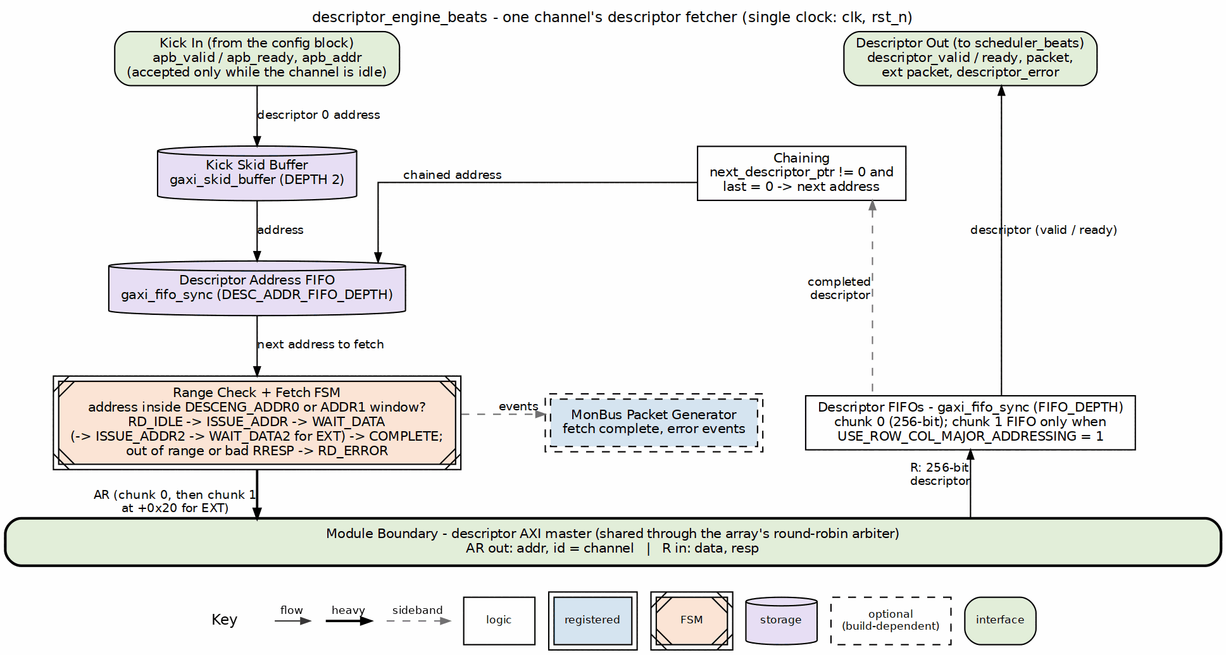
Descriptor engine block diagram
Source: 02_descriptor_engine.dot

7.2 Parameters
parameter int CHANNEL_ID = 0; // Channel identifier
parameter int NUM_CHANNELS = 8; // Total channels
parameter int ADDR_WIDTH = 64; // Address bus width
parameter int FIFO_DEPTH = 4; // Prefetch FIFO depth
// Monitor Bus Parameters
parameter logic [7:0] MON_AGENT_ID = 8'h10; // Descriptor Engine Agent ID
parameter logic [3:0] MON_UNIT_ID = 4'h1; // Unit identifier
: Table 2.2.1: Descriptor Engine Parameters

7.3 Port List

7.3.1 Clock and Reset
Table 2.2.2: Clock and Reset
Signal | Direction | Width | Description
clk | input | 1 | System clock
rst_n | input | 1 | Active-low asynchronous reset

7.3.2 APB Programming Interface
Table 2.2.3: APB Programming Interface
Signal | Direction | Width | Description
apb_valid | input | 1 | Kick-off valid (start descriptor chain)
apb_ready | output | 1 | Ready to accept kick-off
apb_addr | input | AW | First descriptor address

7.3.3 Configuration Interface
Table 2.2.4: Configuration Interface
Signal | Direction | Width | Description
cfg_prefetch_enable | input | 1 | Enable prefetch chaining (0 = on-demand, ~1 ahead)
cfg_fifo_threshold | input | 4 | Prefetch depth (descriptors buffered ahead when enabled)
cfg_addr0_base | input | AW | Valid address range 0 base
cfg_addr0_limit | input | AW | Valid address range 0 limit
cfg_addr1_base | input | AW | Valid address range 1 base
cfg_addr1_limit | input | AW | Valid address range 1 limit

7.3.4 AXI4 Read Master Interface
Table 2.2.5: AXI4 Read Master Interface
Signal | Direction | Width | Description
ar_valid | output | 1 | Address valid
ar_ready | input | 1 | Address ready
ar_addr | output | ADDR_WIDTH | Descriptor fetch address
ar_len | output | 8 | Burst length - 1
ar_size | output | 3 | Burst size (log2 bytes)
ar_burst | output | 2 | Burst type (INCR)
ar_id | output | AXI_ID_WIDTH | Transaction ID
ar_lock | output | 1 | Lock type
ar_cache | output | 4 | Cache attributes
ar_prot | output | 3 | Protection attributes
ar_qos | output | 4 | Quality of service
ar_region | output | 4 | Region identifier
r_valid | input | 1 | Data valid
r_ready | output | 1 | Data ready
r_data | input | 256 | Descriptor payload (fixed 256-bit)
r_resp | input | 2 | Read response
r_last | input | 1 | Last beat
r_id | input | AXI_ID_WIDTH | Response ID

7.3.5 Scheduler Interface
Table 2.2.6: Scheduler Interface
Signal | Direction | Width | Description
descriptor_valid | output | 1 | Descriptor valid
descriptor_ready | input | 1 | Scheduler ready
descriptor_packet | output | 256 | Parsed descriptor (fixed 256-bit)
descriptor_ext_packet | output | 256 | Extended chunk 1 (0 when unused)
descriptor_error | output | 1 | Error flag
descriptor_eos | output | 1 | End of Stream
descriptor_eol | output | 1 | End of Line
descriptor_eod | output | 1 | End of Data
descriptor_type | output | 2 | Packet type
channel_idle | input | 1 | Scheduler idle (enables APB kick-off)
descriptor_engine_idle | output | 1 | Engine idle

7.4 FSM States

7.4.1 Figure 2.2.2: Descriptor Engine FSM
States and transitions of the descriptor_engine_beats fetch FSM.
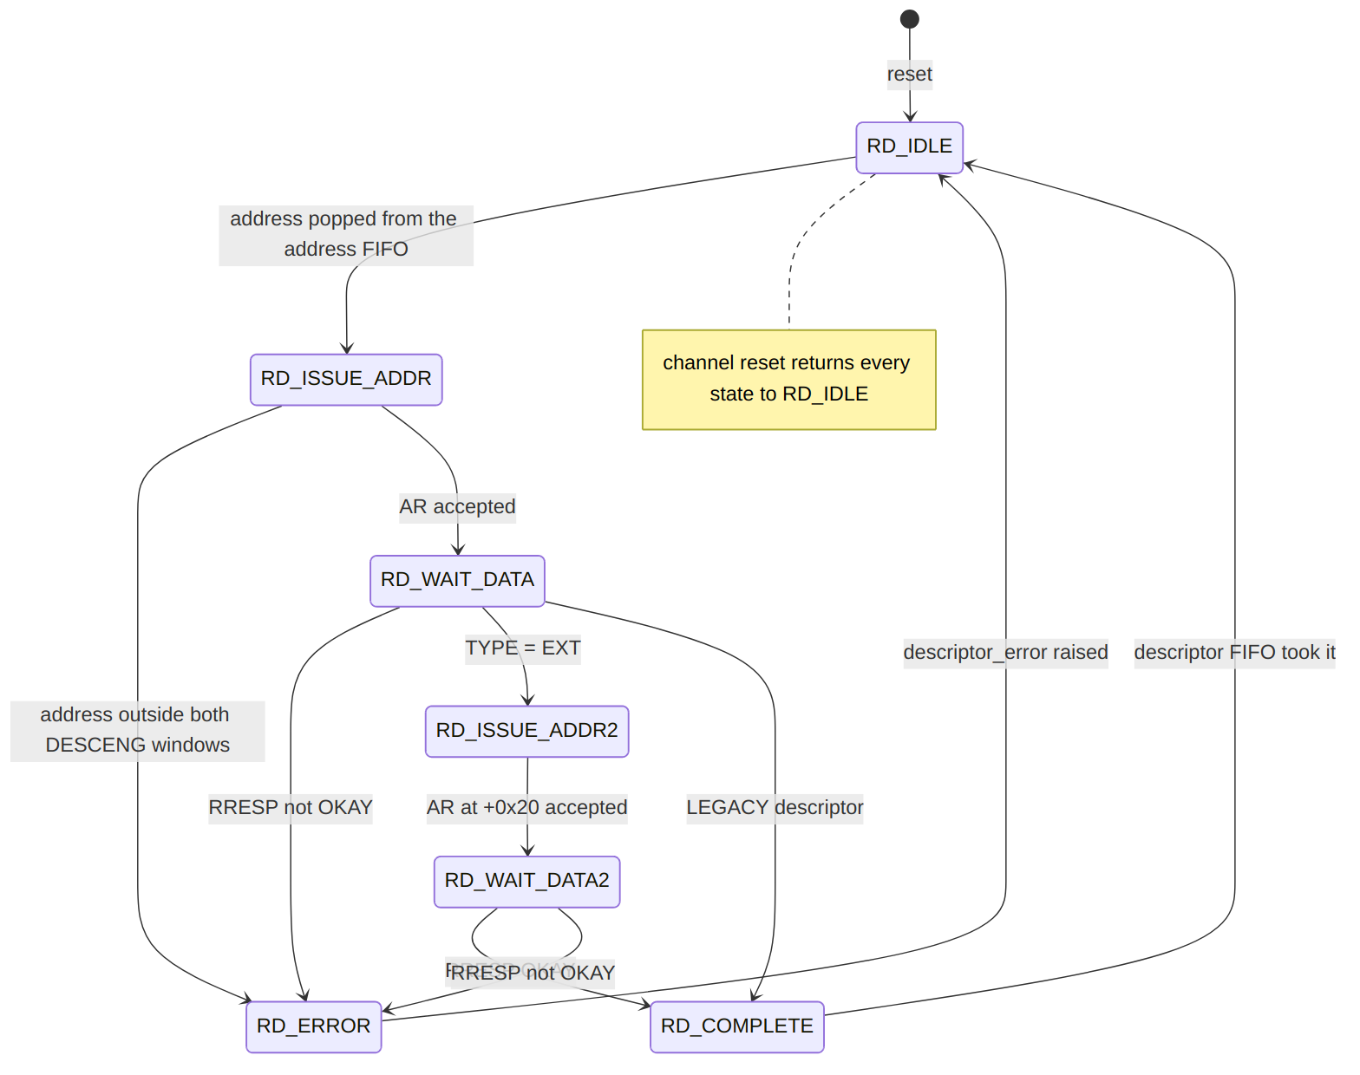
Diagram 1

7.5 Operation

7.5.1 Descriptor Chain Processing

7.5.2 Figure 2.2.3: Descriptor Chain Timing

Descriptor Engine - three-descriptor chain
Source: descriptor_engine_chain.json, captured from dv/tests/fub_beats/test_descriptor_engine_beats.py (descriptor_chaining, 32 channels, seed 7) with WAVES=1.
Reading it: one apb_valid kick carries the head address (0x10000). The engine issues an AXI read for it (ar_valid, ar_addr), the data returns on r_valid, and the parsed descriptor is presented on descriptor_valid to a ready scheduler. Because the descriptor’s next_ptr points at 0x10040 and last is clear, the engine fetches the next one on its own – and the one after that at 0x10080 – with no further APB traffic; descriptor_eol marks the last of the chain. Each fetch costs the same AR -> R -> present latency, so a chain streams at one descriptor per fetch round trip.

7.6 Address Range Checking
Descriptors must fall within configured valid address ranges:
Valid if: (addr >= cfg_addr0_base && addr <= cfg_addr0_limit)
|| (addr >= cfg_addr1_base && addr <= cfg_addr1_limit)
Invalid addresses generate an error and halt the descriptor chain.

7.7 Prefetch and Autonomous Chaining
cfg_prefetch_enable and cfg_fifo_threshold are functional prefetch controls (previously declared-but-unused, which left chaining permanently greedy). They throttle how far ahead the engine fetches chained descriptors by comparing the output descriptor FIFO occupancy (w_desc_fifo_count) against a computed w_prefetch_limit:
if (!cfg_prefetch_enable) w_prefetch_limit = 1; // on-demand
else if (cfg_fifo_threshold == 0) w_prefetch_limit = 1; // guard (0 would stall)
else w_prefetch_limit = cfg_fifo_threshold;
w_prefetch_allows = (w_desc_fifo_count < w_prefetch_limit);
- Prefetch OFF (cfg_prefetch_enable = 0): limit forced to 1, so a chained fetch is only allowed when the output FIFO has drained – the engine stays roughly one descriptor ahead of the scheduler (on-demand).
- Prefetch ON: the engine buffers up to cfg_fifo_threshold descriptors ahead.

7.7.1 Chaining Decision
A chain fetch issues immediately when all of the following hold:
w_should_chain = w_chain_eligible // valid non-last descriptor, in range, no error
&& w_desc_committed // current descriptor accepted into output FIFO
&& w_prefetch_allows // occupancy below prefetch limit
&& w_desc_addr_fifo_wr_ready; // address FIFO has a slot

7.7.2 Deferred (Throttle-Blocked) Chain Fetch
If a descriptor commits and is chain-eligible but the fetch cannot issue this cycle (throttled by w_prefetch_allows, or the address FIFO is full), the owed fetch is recorded rather than dropped:
- r_chain_pending is set and the next-descriptor pointer is held in r_pending_chain_addr.
- The deferred fetch is reissued (w_pending_push_fire) once the output FIFO drains enough that w_prefetch_allows is true again and the address FIFO has a slot, clearing r_chain_pending.

Last Updated: 2026-07-02

RTL Design Sherpa · Learning Hardware Design Through Practice GitHub · Documentation Index · MIT License

8 AXI Read Engine
Module: axi_read_engine.sv Location: projects/components/dma-ip/rapids/rtl/fub/ Status: Implemented Last Updated: 2026-09-30

8.1 Overview
The AXI read engine turns per-channel read requests from the schedulers into AXI4 read bursts and routes the returning data to the SRAM controller. It is a streaming pipeline with no state machine. The channel identity travels in the AXI ID.
The engine is beat based, as in RAPIDS Beats. The scheduler has already converted the descriptor’s byte length into a beat count. Two things change for byte-granular RAPIDS: the engine must cope with a channel address that is not beat aligned, and it must never let a burst cross a 4 KB boundary.

8.1.1 Key Features
- Streaming pipeline: no FSM, round-robin arbitration across channels.
- Aligned AR address: ARADDR is the channel address rounded down to a beat boundary. The lanes below the offset are read and ignored by the data path.
- 4 KB burst cap: the burst length is limited so that no burst crosses a 4 KB boundary, whatever the start address.
- Configurable burst length: cfg_axi_rd_xfer_beats, clamped to what the buffer can hold (rapids BUG-009).
- Space-checked: a channel is only granted when the SRAM controller has room for the whole burst.
- Sticky error: SLVERR or DECERR on R sets sched_rd_error for the channel.

8.1.2 Block Diagram

8.1.3 Figure 2.3.1: AXI Read Engine Block Diagram
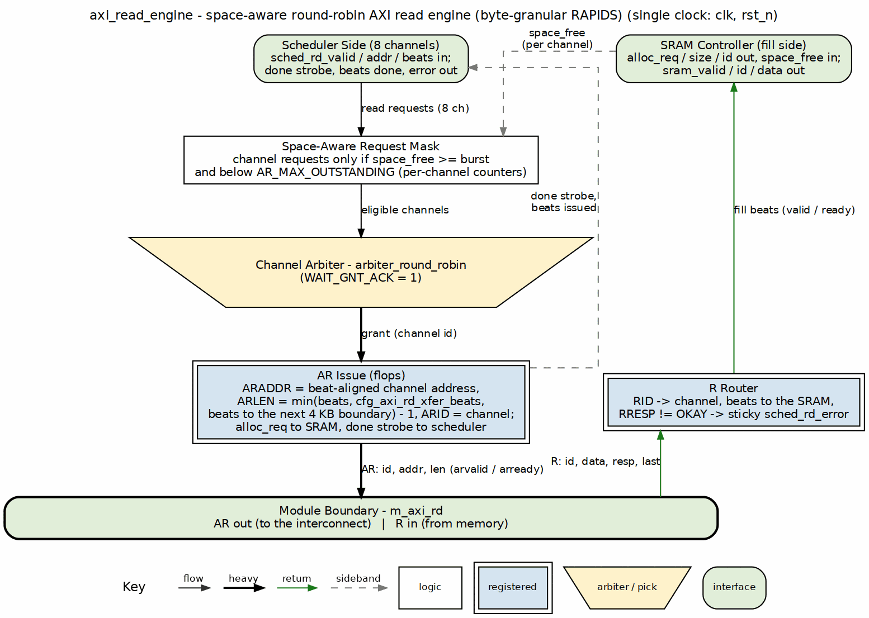
AXI read engine block diagram
Source: 05_axi_read_engine.dot

8.2 Parameters
Table 2.3.1: AXI Read Engine Parameters
Parameter | Default | Description
NUM_CHANNELS | 8 | Number of channels. Channel id is carried in the AXI ID.
ADDR_WIDTH | 64 | AXI address width.
DATA_WIDTH | 512 | AXI data width in bits. The Genesys 2 build uses 256.
ID_WIDTH | 8 | AXI ID width.
SEG_COUNT_WIDTH | 8 | Width of the per-channel free-space count from the SRAM controller. Sets the burst clamp.
PIPELINE | 1 | 1 allows the next AR before the previous burst’s data has returned. 0 waits for the burst to complete.
AR_MAX_OUTSTANDING | 8 | Maximum outstanding AR transactions.
STROBE_EVERY_BEAT | 0 | Declared for compatibility with STREAM. The completion strobe in this engine is generated on the AR handshake regardless of its value.
The module also accepts the short aliases NC, AW, DW, IW, SCW and CIW (the channel id width, $clog2(NUM_CHANNELS)).

8.2.1 Derived Constants
Table 2.3.2: AXI Read Engine Derived Constants
Constant | Definition | Meaning
BYTES_PER_BEAT | DW / 8 | Bytes per beat.
AXSIZE | $clog2(BYTES_PER_BEAT) | Value driven on ARSIZE. Full-width beats.
SD_BEATS | 1 << (SCW - 1) | Buffer depth in beats implied by SEG_COUNT_WIDTH.
XFER_MAX | SD_BEATS < 256 ? SD_BEATS - 1 : 254 | Largest burst length value the engine will use.

8.3 Port List

8.3.1 Clock, Reset and Configuration
Table 2.3.3: Clock, Reset and Configuration
Signal | Direction | Width | Description
clk | input | 1 | Clock.
rst_n | input | 1 | Active-low reset.
cfg_axi_rd_xfer_beats | input | 8 | Configured burst length (ARLEN value, 0 to 255). Clamped to XFER_MAX.
cfg_channel_reset | input | NC | Per-channel reset, level or pulse. Stops the channel’s ARs, drains and discards its in-flight R data, and clears its error flag.

8.3.2 Scheduler Interface
Table 2.3.4: Scheduler Interface
Signal | Direction | Width | Description
sched_rd_valid | input | NC | Channel has a read request.
sched_rd_addr | input | NC x AW | Working source byte address.
sched_rd_beats | input | NC x 32 | Beats still to read for the channel.
sched_rd_done_strobe | output | NC | Registered pulse, one cycle after the AR handshake for the channel.
sched_rd_beats_done | output | NC x 32 | Beats issued by that AR (ARLEN + 1).
sched_rd_error | output | NC | Sticky read error for the channel, set by any non-OKAY R response.
The address is a byte address and may carry an offset in its low bits. The scheduler advances it to the next beat boundary after each done strobe, so only the first burst of a descriptor can see a non-zero offset.

8.3.3 SRAM Allocation and Fill Interface
Table 2.3.5: SRAM Allocation and Fill Interface
Signal | Direction | Width | Description
axi_rd_alloc_req | output | 1 | Registered pulse, one cycle after the AR handshake, reserving space for the burst.
axi_rd_alloc_size | output | 8 | Beats to reserve.
axi_rd_alloc_id | output | IW | Channel that owns the reservation.
axi_rd_alloc_space_free | input | NC x SCW | Free space per channel. A channel is granted only if it fits the burst.
axi_rd_sram_valid | output | 1 | Follows m_axi_rvalid.
axi_rd_sram_ready | input | 1 | SRAM controller accepts the beat. Drives m_axi_rready.
axi_rd_sram_id | output | IW | Follows m_axi_rid.
axi_rd_sram_data | output | DW | Follows m_axi_rdata.

8.3.4 AXI4 Read Master Interface
Table 2.3.6: AXI4 Read Master Interface
Signal | Direction | Width | Description
m_axi_arid | output | IW | Read address ID (the channel).
m_axi_araddr | output | AW | Beat-aligned read address.
m_axi_arlen | output | 8 | Burst length minus one.
m_axi_arsize | output | 3 | AXSIZE, full-width beats.
m_axi_arburst | output | 2 | INCR.
m_axi_arvalid | output | 1 | Address valid.
m_axi_arready | input | 1 | Address ready.
m_axi_rid | input | IW | Response ID.
m_axi_rdata | input | DW | Read data.
m_axi_rresp | input | 2 | Read response.
m_axi_rlast | input | 1 | Last beat of the burst.
m_axi_rvalid | input | 1 | Data valid.
m_axi_rready | output | 1 | Data ready.

8.3.5 Debug
Table 2.3.7: Debug Outputs
Signal | Direction | Width | Description
dbg_rd_all_complete | output | NC | Channel has no outstanding reads.
dbg_r_beats_rcvd | output | 32 | Total R beats received.
dbg_sram_writes | output | 32 | Total beats written to the SRAM controller.
dbg_arb_request | output | NC | Arbiter request vector.

8.4 Operation

8.4.1 Burst Length Cap (rapids BUG-009)
cfg_axi_rd_xfer_beats is an ARLEN value, but a burst must fit in the buffer that stages it. The engine clamps the configured value to XFER_MAX, giving the working limit w_xfer_cfg. Without the clamp an ARLEN of 255 wraps the 8-bit ARLEN + 1 and a channel is granted with no space reserved. This is the same fix as in RAPIDS Beats.

8.4.2 Byte-Granular Burst Sizing
The engine sizes each burst from the channel’s current byte address and remaining beats. Three steps produce ARLEN:
- Distance to the next 4 KB boundary, in beats: w_beats_to_4k = (4096 - {sched_rd_addr[11:AXSIZE], AXSIZE'b0}) >> AXSIZE. The offset bits are dropped first, so the distance is measured from the aligned beat.
- Burst cap: w_cap_beats = min(w_xfer_cfg + 1, w_beats_to_4k).
- Burst length: w_transfer_size = (sched_rd_beats <= w_cap_beats) ? sched_rd_beats - 1 : w_cap_beats - 1.
m_axi_araddr is {sched_rd_addr[grant][AW-1:AXSIZE], AXSIZE'b0}. The offset never reaches the bus. The first beat of the burst carries the bytes before the offset, and the data path discards them.
Because the cap always rounds toward the boundary, a burst can be shorter than the configured length, and a later burst restarts on the boundary. The scheduler needs no knowledge of this. It only sees beats_done per burst.

8.4.3 Streaming Pipeline
An arbiter picks a channel that has sched_rd_valid set and enough axi_rd_alloc_space_free for its burst. When the AR handshakes, the engine pulses axi_rd_alloc_req one cycle later with the burst size so the SRAM controller reserves the space, and pulses sched_rd_done_strobe for the channel. R beats pass straight through: axi_rd_sram_valid, axi_rd_sram_id and axi_rd_sram_data follow the R channel, and m_axi_rready is axi_rd_sram_ready.
With PIPELINE = 1 the next AR for a channel can issue while earlier data is still in flight. With PIPELINE = 0 the channel waits for the burst to finish. The top and core default to 1.

8.4.4 Figure 2.3.2: Burst Segmentation with a Mid-Beat Start
The example uses 32-byte beats (OFF_W 5) and a configured burst of 16 beats. A descriptor reads 8,200 bytes from address 0xFF8. The scheduler computes offset 0x18 (24) and beats_total = (24 + 8200 + 31) >> 5 = 257.
Table 2.3.8: Burst Segmentation Example
Burst | Channel address | ARADDR | Beats to 4 KB | ARLEN | Beats left after
1 | 0x0FF8 | 0x0FE0 | 1 | 0 | 256
2 | 0x1000 | 0x1000 | 128 | 15 | 240
3 | 0x1200 | 0x1200 | 112 | 15 | 224
… |  |  |  | 15 | continues
The first burst is one beat because the aligned start is 32 bytes below the 4 KB boundary. From then on each burst is the configured 16 beats until the remainder runs out. The scheduler advances its address to the next beat boundary after each done strobe, which is why burst 2 starts at 0x1000, not 0x0FF8 plus a beat.

8.4.5 Done Strobe
The engine pulses sched_rd_done_strobe[ch] once per AR handshake, with sched_rd_beats_done[ch] equal to ARLEN + 1. The scheduler subtracts this from its remaining count and advances the address. The strobe therefore reports beats issued, not beats returned.

8.5 Error Handling
Table 2.3.9: Error Handling
Error | Detection | Response
AXI SLVERR | m_axi_rresp == 2'b10 on an accepted beat | Set sticky sched_rd_error for the channel
AXI DECERR | m_axi_rresp == 2'b11 on an accepted beat | Set sticky sched_rd_error for the channel
Any other non-zero response | m_axi_rresp != 2'b00 on an accepted beat | Same: the test is not-OKAY, and the channel is taken from RID
The scheduler turns the sticky error into its ERROR state and a MonBus event. The engine does not abort the burst: the remaining R beats still pass through, so the interconnect is not left mid-burst.

8.5.1 Channel Reset
cfg_channel_reset[ch] clears the sticky sched_rd_error[ch], so a channel reset recovers a read error without aresetn. The reset also has to settle AR bursts that are already on the bus, because an AXI master cannot recall them:
- A channel in reset, or flushing, issues no new AR and does not enter the allocation pipeline.
- r_rd_flush[ch] is set by the reset and holds until the channel has no burst outstanding. While it holds, each R beat whose RID names the channel is accepted (m_axi_rready is forced high) and dropped: axi_rd_sram_valid stays low, so nothing reaches the SRAM, and its RRESP does not set the error flag.
- The completion strobe and pending allocation of the channel are cleared, so the scheduler does not see a stale done pulse after the reset.
- Other channels are not affected: every term is indexed by channel, and R beats of other channels pass as usual.
The channel’s SRAM partition is cleared by the SRAM controller wrapper (see Sink Data Path and Source Data Path AXIS). The discard is what guarantees that no beat of the reset channel reaches the partition after it has been cleared.

8.6 Differences from RAPIDS Beats
Table 2.3.10: Read Engine Delta
Item | RAPIDS Beats | RAPIDS
ARADDR | Channel address as given (always aligned) | Aligned down to the beat
Burst cap | Configured length and remaining beats | Also capped at the 4 KB boundary
Everything else |  | Unchanged
The beat-count chapter for the beats engine is AXI Read Engine (RAPIDS Beats). The scheduler that feeds this engine is described in Scheduler.

Last Updated: 2026-09-30

RTL Design Sherpa · Learning Hardware Design Through Practice GitHub · Documentation Index · MIT License

9 AXI Write Engine
Module: axi_write_engine.sv Location: projects/components/dma-ip/rapids/rtl/fub/ Status: Implemented Last Updated: 2026-09-30

9.1 Overview
The AXI write engine drains data from the SRAM controller and issues AXI4 write bursts to system memory. It is a streaming pipeline with no state machine. It also tracks the write responses, which is how the scheduler learns that data has been committed.
Byte-granular RAPIDS changes the engine in three places. Write strobes now come from the SRAM instead of being all ones, so a partial first or last beat writes only the bytes that belong to the packet. Burst lengths are capped at the 4 KB boundary. AWADDR is beat aligned.

9.1.1 Key Features
- Streaming pipeline: no FSM, round-robin arbitration across channels.
- Real write strobes: m_axi_wstrb is the strobe word stored beside each data beat (axi_wr_sram_strb). Lanes outside the packet are not written.
- Aligned AW address: AWADDR is the channel address rounded down to a beat boundary.
- 4 KB burst cap: the same cap as the read engine, applied to both the burst length and the final-burst test.
- Configurable burst length: cfg_axi_wr_xfer_beats, clamped to what the buffer can hold (rapids BUG-009).
- Two completion strobes: done on the AW handshake, commit on the B response.
- Sticky error: a non-OKAY B response sets sched_wr_error.

9.1.2 Block Diagram

9.1.3 Figure 2.4.1: AXI Write Engine Block Diagram
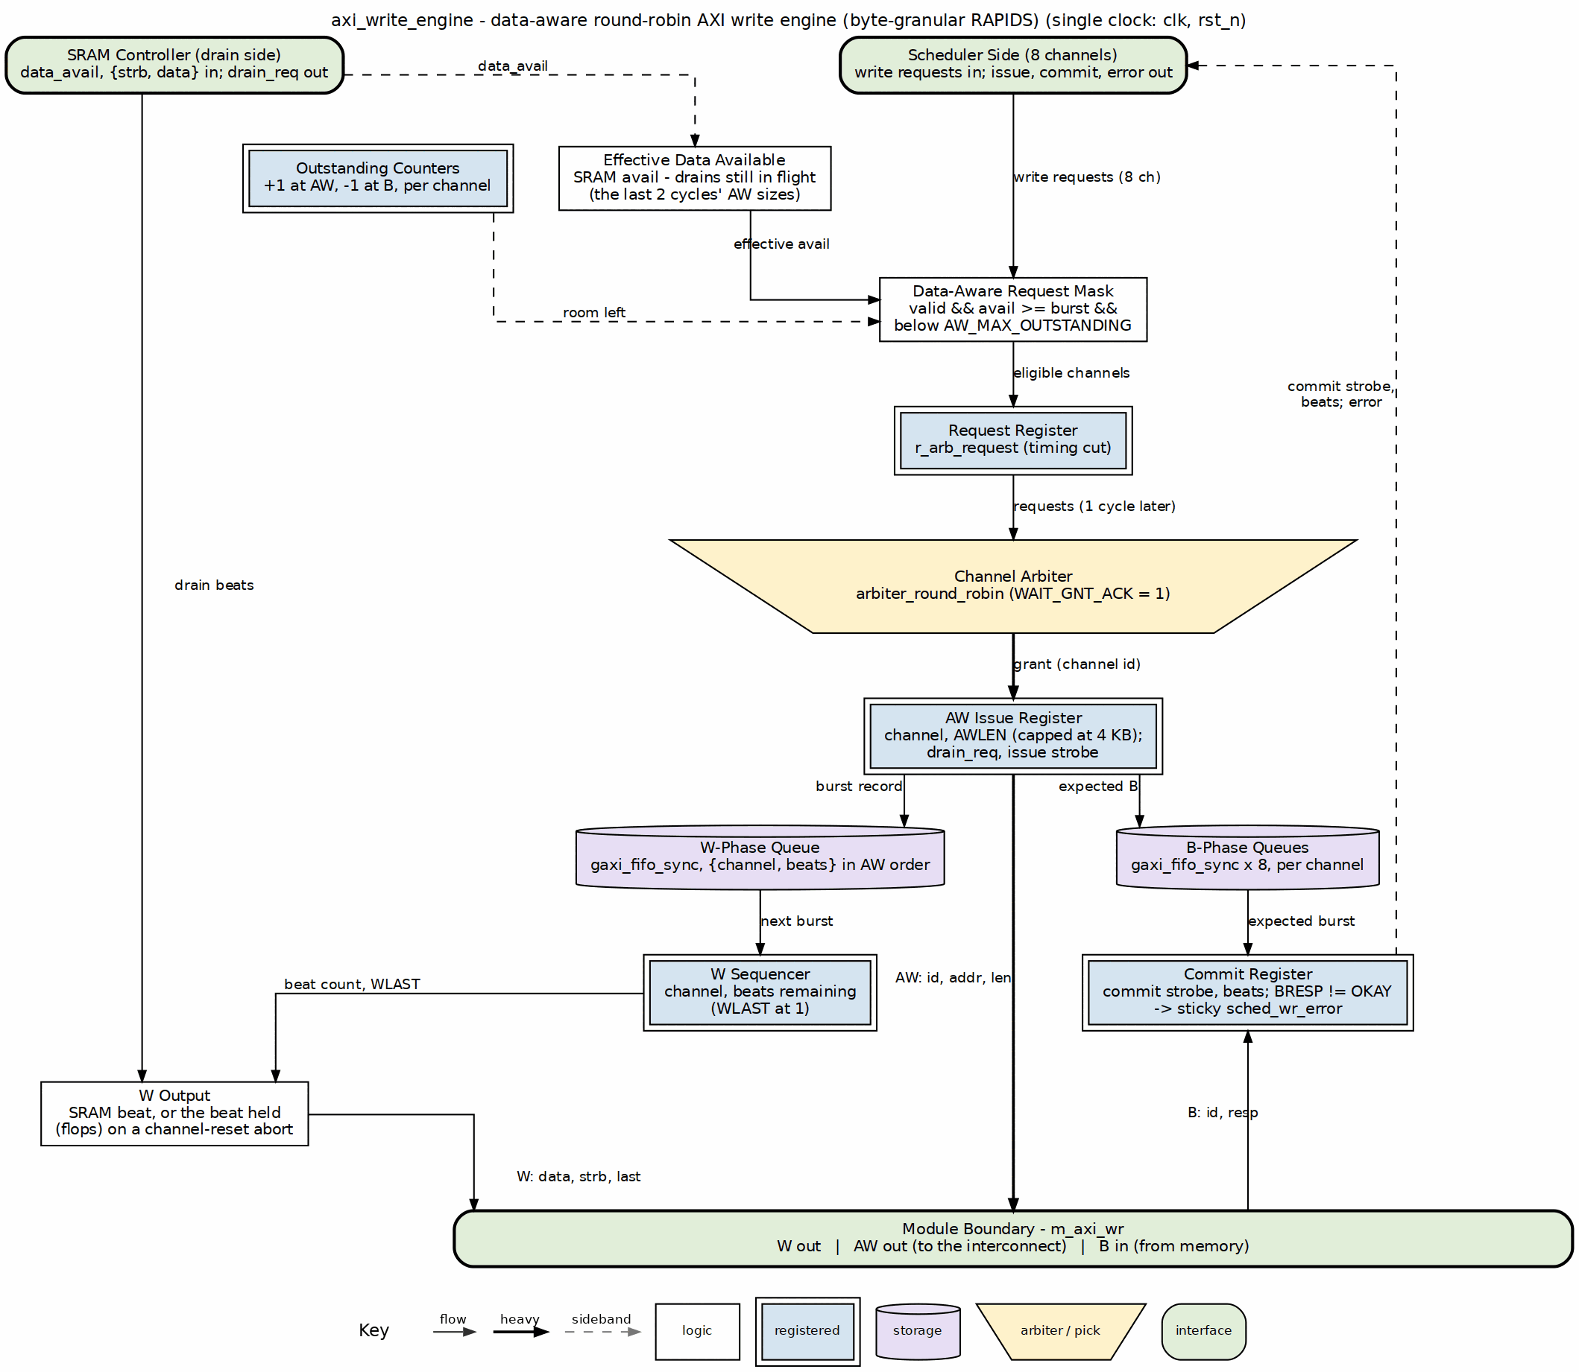
AXI write engine block diagram
Source: 06_axi_write_engine.dot

9.2 Parameters
Table 2.4.1: AXI Write Engine Parameters
Parameter | Default | Description
NUM_CHANNELS | 8 | Number of channels. Channel id is carried in the AXI ID.
ADDR_WIDTH | 64 | AXI address width.
DATA_WIDTH | 512 | AXI data width in bits. The Genesys 2 build uses 256.
ID_WIDTH | 8 | AXI ID width.
USER_WIDTH | 8 | Width of m_axi_wuser, which carries the active channel.
SEG_COUNT_WIDTH | 8 | Width of the per-channel available-data count from the SRAM controller. Sets the burst clamp.
PIPELINE | 1 | 1 allows further AWs before earlier B responses return. 0 waits for the B.
AW_MAX_OUTSTANDING | 8 | Maximum outstanding AW transactions per channel.
W_PHASE_FIFO_DEPTH | 64 | Depth of the W-phase transaction FIFO, kept in order with the AW issue.
B_PHASE_FIFO_DEPTH | 16 | Depth of the B-phase transaction FIFO used to match responses.
The module also accepts the short aliases NC, AW, DW, IW, UW, SCW and CIW (the channel id width).

9.2.1 Derived Constants
Table 2.4.2: AXI Write Engine Derived Constants
Constant | Definition | Meaning
BYTES_PER_BEAT | DW / 8 | Bytes per beat.
AXSIZE | $clog2(BYTES_PER_BEAT) | Value driven on AWSIZE.
XFER_MAX | min(2^(SCW-1) - 1, 254) | Largest burst length value the engine will use.

9.3 Port List

9.3.1 Clock, Reset and Configuration
Table 2.4.3: Clock, Reset and Configuration
Signal | Direction | Width | Description
clk | input | 1 | Clock.
rst_n | input | 1 | Active-low reset.
cfg_axi_wr_xfer_beats | input | 8 | Configured burst length (AWLEN value, 0 to 255). Clamped to XFER_MAX.
cfg_channel_reset | input | NC | Per-channel reset, level or pulse. Stops new bursts, completes open bursts with null beats, and clears the channel’s error flag.

9.3.2 Scheduler Interface
Table 2.4.4: Scheduler Interface
Signal | Direction | Width | Description
sched_wr_valid | input | NC | Channel has a write request.
sched_wr_ready | output | NC | Pulses when the B response of the last burst of a descriptor arrives.
sched_wr_addr | input | NC x AW | Working destination byte address.
sched_wr_beats | input | NC x 32 | Beats still to write for the channel.
sched_wr_burst_len | input | NC x 8 | Requested burst length. Present on the port; the engine sizes bursts from cfg_axi_wr_xfer_beats and the 4 KB cap.
sched_wr_done_strobe | output | NC | Pulses on the AW handshake for the channel.
sched_wr_beats_done | output | NC x 32 | Beats issued by that AW (AWLEN + 1).
sched_wr_commit_strobe | output | NC | Pulses when the B response for the channel arrives.
sched_wr_commit_beats | output | NC x 32 | Beats confirmed by that B response, recovered from the B-phase FIFO.
sched_wr_error | output | NC | Sticky write error for the channel.
The done strobe advances the scheduler’s destination address, which lets the next AW issue without waiting for a response. The commit strobe is what the scheduler counts when it decides the descriptor is complete. Both strobes are per channel and report beat counts, not bytes.

9.3.3 SRAM Reservation and Drain Interface
Table 2.4.5: SRAM Drain Interface
Signal | Direction | Width | Description
axi_wr_drain_req | output | NC | Pulses for the granted channel on the AW handshake.
axi_wr_drain_size | output | NC x 8 | Beats to reserve (AWLEN + 1).
axi_wr_drain_data_avail | input | NC x SCW | Data available per channel after reservations.
axi_wr_sram_valid | input | NC | Per-channel valid, registered. Used for arbitration.
axi_wr_sram_valid_comb | input | NC | Per-channel valid, combinational. Gates m_axi_wvalid.
axi_wr_sram_drain | output | 1 | Drain request. Equal to wvalid && wready.
axi_wr_sram_id | output | CIW | Channel selected for the drain.
axi_wr_sram_data | input | DW | Data from the selected channel.
axi_wr_sram_strb | input | DW/8 | Byte strobes stored with that data beat. New in RAPIDS.

9.3.4 AXI4 Write Master Interface
Table 2.4.6: AXI4 Write Master Interface
Signal | Direction | Width | Description
m_axi_awid | output | IW | Write address ID (the channel).
m_axi_awaddr | output | AW | Beat-aligned write address.
m_axi_awlen | output | 8 | Burst length minus one.
m_axi_awsize | output | 3 | AXSIZE, full-width beats.
m_axi_awburst | output | 2 | INCR.
m_axi_awvalid | output | 1 | Address valid.
m_axi_awready | input | 1 | Address ready.
m_axi_wdata | output | DW | Write data.
m_axi_wstrb | output | DW/8 | Write strobes, equal to axi_wr_sram_strb.
m_axi_wlast | output | 1 | Last beat of the burst.
m_axi_wuser | output | UW | Channel of the beat being written.
m_axi_wvalid | output | 1 | Data valid.
m_axi_wready | input | 1 | Data ready.
m_axi_bid | input | IW | Response ID.
m_axi_bresp | input | 2 | Write response.
m_axi_bvalid | input | 1 | Response valid.
m_axi_bready | output | 1 | Response ready.

9.3.5 Debug and Status
Table 2.4.7: Debug and Status Outputs
Signal | Direction | Width | Description
dbg_wr_all_complete | output | NC | Channel has no outstanding writes.
dbg_aw_transactions | output | 32 | Total AW handshakes.
dbg_w_beats | output | 32 | Total W beats.
o_active_channel_id | output | CIW | Channel whose burst is driving, or about to drive, the W bus.
o_active_channel_valid | output | 1 | o_active_channel_id is meaningful.

9.4 Operation

9.4.1 Burst Length Cap (rapids BUG-009)
cfg_axi_wr_xfer_beats is an AWLEN value, but a burst cannot be larger than the SRAM that stages it: the engine waits for the whole burst to be present before issuing the AW, and a burst the buffer cannot hold would wait forever. The engine clamps the configured value to XFER_MAX. Without the clamp an AWLEN of 255 wraps the 8-bit AWLEN + 1 and the engine issues an AW on an empty buffer. This is the same fix as in RAPIDS Beats.

9.4.2 Byte-Granular Burst Sizing
The sizing follows the read engine:
- w_beats_to_4k is the distance from the aligned channel address to the next 4 KB boundary, in beats.
- w_cap_beats = min(w_xfer_cfg + 1, w_beats_to_4k).
- w_transfer_size (the AWLEN) is sched_wr_beats - 1 if sched_wr_beats <= w_cap_beats, otherwise w_cap_beats - 1.
A channel may issue when the buffer holds at least w_transfer_size + 1 beats (w_has_data), or when this is the final burst. The final-burst test is sched_wr_beats > 0, sched_wr_beats <= w_cap_beats, and the available data covers all remaining beats. The 4 KB cap therefore applies to both tests, so a descriptor that ends just past a boundary still finishes on a short final burst.
m_axi_awaddr is {sched_wr_addr[ch][AW-1:AXSIZE], AXSIZE'b0}. The offset of a descriptor that starts mid-beat never reaches the bus. The first W beat of that descriptor carries WSTRB bits only for the bytes at and above the offset, and the last carries only the bytes up to the end of the packet.

9.4.3 Write Strobes
Each SRAM word holds a data beat and its strobe word side by side (see Sink Data Path). The write engine takes both from the drain port and presents them together, so the strobe always matches the data. In RAPIDS Beats WSTRB was tied high.

9.4.4 Streaming Pipeline
Each channel with sched_wr_valid and a burst that passes the data test requests arbitration. On grant the AW is issued, and on the AW handshake the engine pulses axi_wr_drain_req with the burst size so the drain controller reserves the beats. W beats stream from the drain port that axi_wr_sram_id selects. axi_wr_sram_drain equals m_axi_wvalid && m_axi_wready. m_axi_wlast closes each burst, and m_axi_wuser carries the channel.
With PIPELINE = 1 a channel may issue further AWs before earlier B responses return, up to AW_MAX_OUTSTANDING. With PIPELINE = 0 the channel waits for each B. That costs throughput, so the top and core default to 1.

9.4.5 Two Completion Strobes
Table 2.4.8: Completion Strobes
Strobe | Raised when | Scheduler use
sched_wr_done_strobe | AW handshake for the channel | Advance the destination address and the issued-beat count.
sched_wr_commit_strobe | B response for the channel | Count committed beats. The descriptor is complete when all beats are committed.
sched_wr_ready is a third, coarser pulse: it fires when the B response belongs to the last burst of a descriptor.

9.5 Error Handling
Table 2.4.9: Error Handling
Error | Detection | Response
AXI SLVERR | m_axi_bresp == 2'b10 | Set sticky sched_wr_error for the channel
AXI DECERR | m_axi_bresp == 2'b11 | Set sticky sched_wr_error for the channel
Any other non-zero response | m_axi_bresp != 2'b00 | Same: the test is not-OKAY, and the channel is taken from BID
The sink data path ORs sched_wr_error with its own packet-length error before passing it to the scheduler.

9.5.1 Channel Reset
cfg_channel_reset[ch] clears the sticky sched_wr_error[ch], so a channel reset recovers a B-response error without aresetn. A burst whose AW has been accepted must still receive all of its W beats, so the engine settles in-flight work rather than dropping it:
- w_kill[ch] is the reset level ORed with r_wr_flush[ch]. The flush bit is set by the reset and holds until the channel has no open burst and no B response due.
- No new AW is arbitrated for a channel with w_kill set. AWADDR comes from sched_wr_addr, which the scheduler does not clear, so the value on the bus stays stable across the reset.
- An open burst is completed with null W beats: WSTRB is zero, WDATA repeats the last captured value and the SRAM drain is not popped, so the null beats modify no byte at the destination. A beat that was presented on W and not accepted when the reset hit is the one exception: it is replayed unchanged, with its own strobes, from a captured copy, so the W channel does not change its payload while WVALID is high. At most one beat per reset is replayed this way.
- B responses of a channel with w_kill set are consumed. The commit strobe, sched_wr_ready, the done strobe and the error flag are suppressed for them.
- Other channels are not affected.
The reset therefore leaves no partial state in the engine: the B-phase FIFO drains through the flush, and the channel restarts with clean counters when the scheduler next raises sched_wr_valid.

9.6 Differences from RAPIDS Beats
Table 2.4.10: Write Engine Delta
Item | RAPIDS Beats | RAPIDS
WSTRB | All ones | axi_wr_sram_strb
SRAM drain port | Data only | Data plus strobe word
AWADDR | Channel address as given (always aligned) | Aligned down to the beat
Burst cap and final-burst test | Configured length and remaining beats | Also capped at the 4 KB boundary
Everything else |  | Unchanged
The beats chapter is AXI Write Engine (RAPIDS Beats). The read-side counterpart is AXI Read Engine.

Last Updated: 2026-09-30

RTL Design Sherpa · Learning Hardware Design Through Practice GitHub · Documentation Index · MIT License

10 Beats Alloc Control Specification
Module: alloc_ctrl_beats.sv Location: projects/components/dma-ip/rapids/rtl/fub_beats/ Status: Implemented Last Updated: 2025-01-10
No longer in the SRAM datapath (2026-09-26). RAPIDS’ SRAM path now uses STREAM’s stream_alloc_ctrl / stream_drain_ctrl / stream_latency_bridge, reached through the snk_/src_sram_controller_beats naming wrappers (bdf4e0dff). This FUB is still built and still verified – it keeps its own test, its own filelist and its rapids_all.f entry – it simply is not instantiated by the SRAM controllers any more. Treat this page as the FUB’s own specification, not as a description of the current SRAM path.

10.1 Overview
The Beats Alloc Control is a “virtual FIFO” that tracks space allocation without storing actual data. It uses FIFO pointer logic to manage pre-allocation for AXI engines, preventing race conditions between allocation and actual data arrival.

10.1.1 Key Features
- Virtual FIFO: Pointer tracking without data storage
- Variable-Size Allocation: Supports multi-beat allocation requests
- Single-Beat Release: Data writes release one beat at a time
- Status Flags: Full, almost full, empty, almost empty
- Space Tracking: Reports available space for flow control

10.1.2 Block Diagram

10.1.3 Figure 2.5.1: Beats Alloc Control Block Diagram
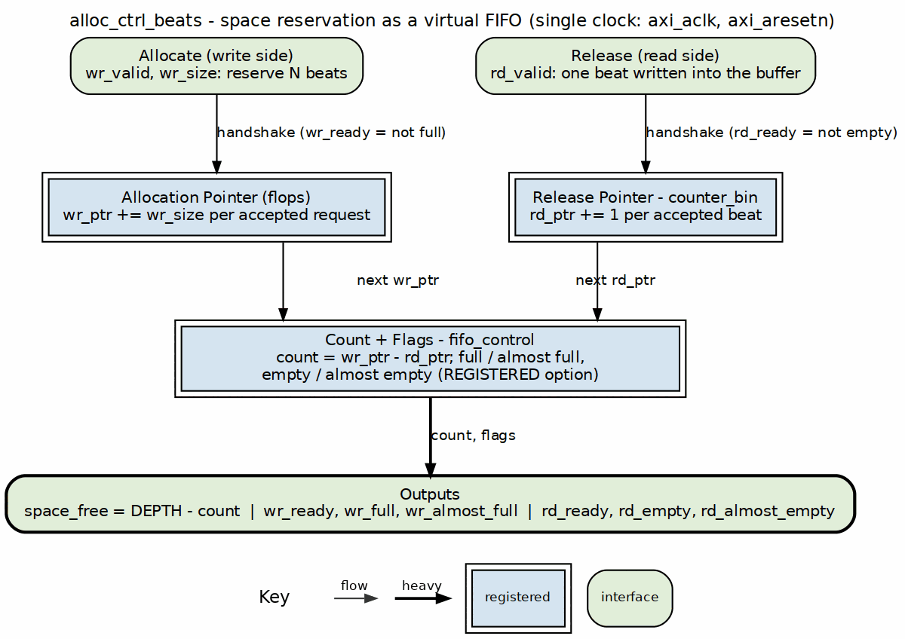
Alloc control block diagram
Source: 05_alloc_ctrl.dot

10.2 Concept: Virtual FIFO
Unlike a traditional FIFO that stores data, alloc_ctrl_beats only tracks space reservations:
 | Traditional FIFO | Virtual FIFO (alloc_ctrl_beats)
Write side | wr_data into storage | wr_size advances a pointer
Read side | rd_data out of storage | one beat advances a pointer
Output | data | space_free

10.2.1 Use Case: Pre-Allocation for AXI Reads
1. AXI engine requests N beats of space
- alloc_ctrl.wr_valid = 1
- alloc_ctrl.wr_size = N
- wr_ptr advances by N
2. As AXI read data arrives (1 beat at a time)
- alloc_ctrl.rd_valid = 1 (each beat)
- rd_ptr advances by 1
3. Space becomes available again
- space_free reflects available capacity

10.3 Parameters
parameter int DEPTH = 512; // Virtual FIFO depth
parameter int ALMOST_WR_MARGIN = 1; // Almost full margin
parameter int ALMOST_RD_MARGIN = 1; // Almost empty margin
parameter int REGISTERED = 1; // Registered outputs
// Derived
parameter int AW = $clog2(DEPTH); // Address width
: Table 2.5.1: Beats Alloc Control Parameters

10.4 Port List

10.4.1 Clock and Reset
Table 2.5.2: Clock and Reset
Signal | Direction | Width | Description
axi_aclk | input | 1 | System clock
axi_aresetn | input | 1 | Active-low reset

10.4.2 Write Interface (Allocation Requests)
Table 2.5.3: Write Interface
Signal | Direction | Width | Description
wr_valid | input | 1 | Allocate space
wr_size | input | 8 | Number of beats to allocate
wr_ready | output | 1 | Space available for allocation

10.4.3 Read Interface (Data Written)
Table 2.5.4: Read Interface
Signal | Direction | Width | Description
rd_valid | input | 1 | One beat of data written
rd_ready | output | 1 | Not full (can accept)

10.4.4 Status Outputs
Table 2.5.5: Status Outputs
Signal | Direction | Width | Description
space_free | output | AW+1 | Available space in beats
wr_full | output | 1 | No space available
wr_almost_full | output | 1 | Near full
rd_empty | output | 1 | No allocations pending
rd_almost_empty | output | 1 | Near empty

10.5 Operation

10.5.1 Pointer Arithmetic
space_free = DEPTH - (wr_ptr - rd_ptr)
Full condition: wr_ptr - rd_ptr >= DEPTH
Empty condition: wr_ptr == rd_ptr

10.5.2 Timing Diagram

10.5.3 Figure 2.5.2: Allocation and Release Timing

Allocation control - allocate then release
Source: alloc_ctrl_beats_alloc_release.json, captured from dv/tests/fub_beats/test_alloc_ctrl_beats.py (basic_alloc_drain, depth 512, seed 7) with WAVES=1.
Reading it: one wr_valid handshake with wr_size = 6 reserves six beats and space_free drops 512 to 506 the next cycle; rd_empty falls because reserved space is now outstanding. Each later rd_valid handshake releases one beat and space_free climbs back one at a time (507, 508, …). wr_full and wr_almost_full stay low: the virtual FIFO is nowhere near its depth.

10.6 Integration Example
// Source path: Pre-allocate SRAM space before AXI read
alloc_ctrl_beats #(
.DEPTH(SRAM_DEPTH),
.ALMOST_WR_MARGIN(8)
) u_src_alloc (
.axi_aclk (clk),
.axi_aresetn (rst_n),
// Scheduler allocates space before issuing AXI read
.wr_valid (sched_rd_valid),
.wr_size (sched_rd_beats[7:0]),
.wr_ready (alloc_ready),
// AXI read data arrival releases allocation
.rd_valid (m_axi_rvalid && m_axi_rready),
.rd_ready (), // Not used for single-beat
// Status
.space_free (sram_space_available),
.wr_full (sram_full),
.wr_almost_full (sram_almost_full)
);

Last Updated: 2025-01-10

RTL Design Sherpa · Learning Hardware Design Through Practice GitHub · Documentation Index · MIT License

11 Beats Drain Control Specification
Module: drain_ctrl_beats.sv Location: projects/components/dma-ip/rapids/rtl/fub_beats/ Status: Implemented Last Updated: 2025-01-10
No longer in the SRAM datapath (2026-09-26). RAPIDS’ SRAM path now uses STREAM’s stream_alloc_ctrl / stream_drain_ctrl / stream_latency_bridge, reached through the snk_/src_sram_controller_beats naming wrappers (bdf4e0dff). This FUB is still built and still verified – it keeps its own test, its own filelist and its rapids_all.f entry – it simply is not instantiated by the SRAM controllers any more. Treat this page as the FUB’s own specification, not as a description of the current SRAM path.

11.1 Overview
The Beats Drain Control is a “virtual FIFO” that tracks data availability without storing actual data. It complements alloc_ctrl_beats by tracking when data has been written to SRAM and is available for draining.

11.1.1 Key Features
- Virtual FIFO: Pointer tracking without data storage
- Single-Beat Write: Data arrivals tracked one beat at a time
- Variable-Size Drain: Supports multi-beat drain requests
- Status Flags: Full, almost full, empty, almost empty
- Data Availability: Reports beats available for drain

11.1.2 Block Diagram

11.1.3 Figure 2.6.1: Beats Drain Control Block Diagram
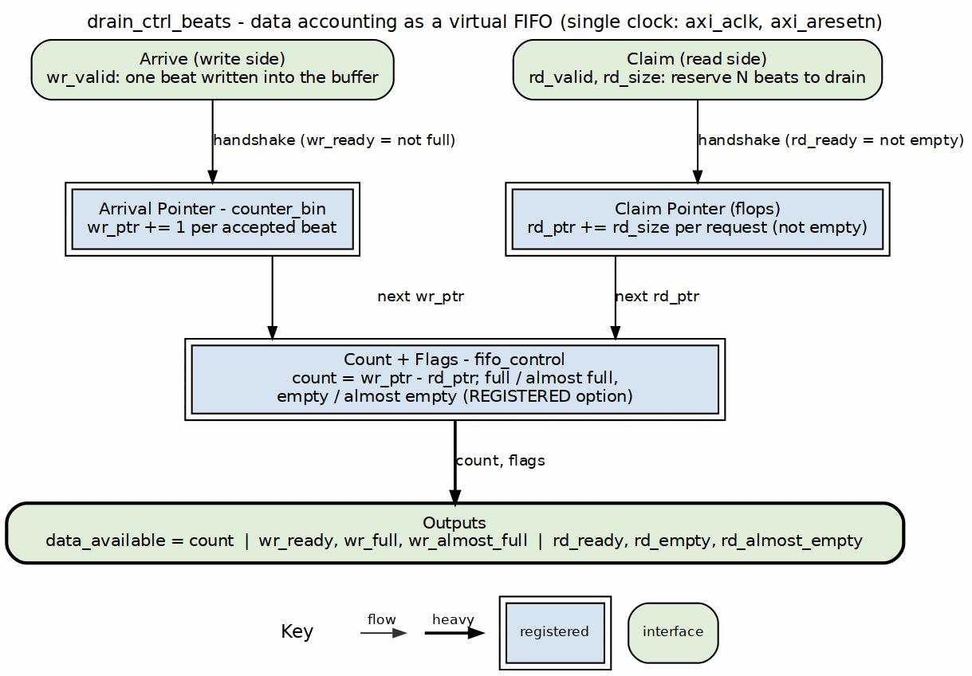
Drain control block diagram
Source: 06_drain_ctrl.dot

11.2 Concept: Data Availability Tracking
The drain_ctrl tracks when data has been written to SRAM:
alloc_ctrl: Tracks SPACE reservations (allocation -> actual write)
drain_ctrl: Tracks DATA availability (data write -> drain request)

11.2.1 Complementary Roles
Source Path:
1. Scheduler allocates space (alloc_ctrl.wr)
2. AXI reads data into SRAM
3. Data written to SRAM (drain_ctrl.wr)
4. Drain consumer reads (drain_ctrl.rd)
Sink Path:
1. Fill allocates space (alloc_ctrl.wr)
2. Fill writes to SRAM (alloc_ctrl.rd)
3. Data available in SRAM (drain_ctrl.wr)
4. AXI write drains SRAM (drain_ctrl.rd)

11.3 Parameters
parameter int DEPTH = 512; // Virtual FIFO depth
parameter int ALMOST_WR_MARGIN = 1; // Almost full margin
parameter int ALMOST_RD_MARGIN = 1; // Almost empty margin
parameter int REGISTERED = 1; // Registered outputs
// Derived
parameter int AW = $clog2(DEPTH); // Address width
: Table 2.6.1: Beats Drain Control Parameters

11.4 Port List

11.4.1 Clock and Reset
Table 2.6.2: Clock and Reset
Signal | Direction | Width | Description
axi_aclk | input | 1 | System clock
axi_aresetn | input | 1 | Active-low reset

11.4.2 Write Interface (Data Written to SRAM)
Table 2.6.3: Write Interface
Signal | Direction | Width | Description
wr_valid | input | 1 | One beat written to SRAM
wr_ready | output | 1 | Can track more data

11.4.3 Read Interface (Drain Requests)
Table 2.6.4: Read Interface
Signal | Direction | Width | Description
rd_valid | input | 1 | Drain request
rd_size | input | 8 | Number of beats to drain
rd_ready | output | 1 | Data available for drain

11.4.4 Status Outputs
Table 2.6.5: Status Outputs
Signal | Direction | Width | Description
data_available | output | AW+1 | Beats available to drain
wr_full | output | 1 | Tracking full
wr_almost_full | output | 1 | Near full
rd_empty | output | 1 | No data to drain
rd_almost_empty | output | 1 | Near empty

11.5 Operation

11.5.1 Pointer Arithmetic
data_avail = wr_ptr - rd_ptr
Full condition: wr_ptr - rd_ptr >= DEPTH
Empty condition: wr_ptr == rd_ptr

11.5.2 Timing Diagram

11.5.3 Figure 2.6.2: Data Arrival and Drain Timing

Drain control - single-beat arrivals then a multi-beat drain
Source: drain_ctrl_beats_arrive_drain.json, captured from dv/tests/fub_beats/test_drain_ctrl_beats.py (basic_write_drain, depth 512, seed 7) with WAVES=1.
Reading it: six wr_valid handshakes, one beat each, raise data_available 1, 2, … 6 and drop rd_empty on the first arrival. A single rd_valid handshake with rd_size = 6 then reserves all six at once: data_available returns to 0 and rd_empty rises the next cycle. The counter tracks beats, not bytes, and never touches the data itself.

11.6 Integration Example
// Sink path: Track data availability for AXI write engine
drain_ctrl_beats #(
.DEPTH(SRAM_DEPTH),
.ALMOST_RD_MARGIN(8)
) u_snk_drain (
.axi_aclk (clk),
.axi_aresetn (rst_n),
// Fill writes data to SRAM
.wr_valid (fill_valid && fill_ready),
.wr_ready (), // Single-beat, always ready
// AXI write engine drains data
.rd_valid (axi_wr_drain_req),
.rd_size (axi_wr_burst_len),
.rd_ready (data_ready_for_drain),
// Status
.data_available (beats_to_write),
.rd_empty (no_data_to_write)
);

11.7 Relationship: alloc_ctrl vs drain_ctrl
Table 2.6.6: alloc_ctrl vs drain_ctrl Comparison
Aspect | alloc_ctrl_beats | drain_ctrl_beats
Tracks | Space reservations | Data availability
Write port | Multi-beat allocation | Single-beat arrival
Read port | Single-beat release | Multi-beat drain
Output | space_free | data_available
Use case | Pre-allocate before fill | Know when to drain

Last Updated: 2025-01-10

RTL Design Sherpa · Learning Hardware Design Through Practice GitHub · Documentation Index · MIT License

12 Latency Bridge (beats) Specification
Module: latency_bridge_beats.sv Location: projects/components/dma-ip/rapids/rtl/fub_beats/ Status: Implemented, tested, not in the SRAM path Last Updated: 2026-09-27
Not in the SRAM datapath since 2026-09-26. RAPIDS’ SRAM path is STREAM’s sram_controller, which carries its own stream_latency_bridge (the same design), reached through the snk_/src_sram_controller_beats naming wrappers (bdf4e0dff). This FUB is still built and verified – it keeps its test, its filelist and its rapids_all.f entry – but nothing in rapids_core_beats instantiates it. This page is the FUB’s own specification.

12.1 Overview
latency_bridge_beats turns a registered-read FIFO – one whose data appears the cycle after the read handshake – into a plain valid/ready stream the consumer can stall at will. It is a data-width bridge: it moves DATA_WIDTH bits per beat and carries nothing else. There is no beat count, no channel ID and no programmable delay in it; an earlier version of this page described such an interface, and it never existed in this module.

12.1.1 Key Features
- One-cycle glue, one skid buffer: a single flop (r_drain_ip) remembers that a FIFO read was accepted, so the data that lands the next cycle is pushed into a gaxi_fifo_sync skid of depth SKID_DEPTH
- Full throughput when the consumer is ready: back-to-back reads are accepted as long as the skid keeps draining
- Backpressure absorbed in the skid: s_ready drops only when a skid write is actually stalled, so the FIFO is never read into a slot that does not exist
- Occupancy reported: occupancy counts the beats the bridge holds (the one in flight plus the skid contents), which is what an occupancy-based data-available counter needs
- Debug taps: dbg_r_pending and dbg_r_out_valid expose the in-flight flop and the skid output valid, for catching stuck data from a test

12.1.2 Block Diagram

12.1.3 Figure 2.7.1: Latency Bridge Block Diagram
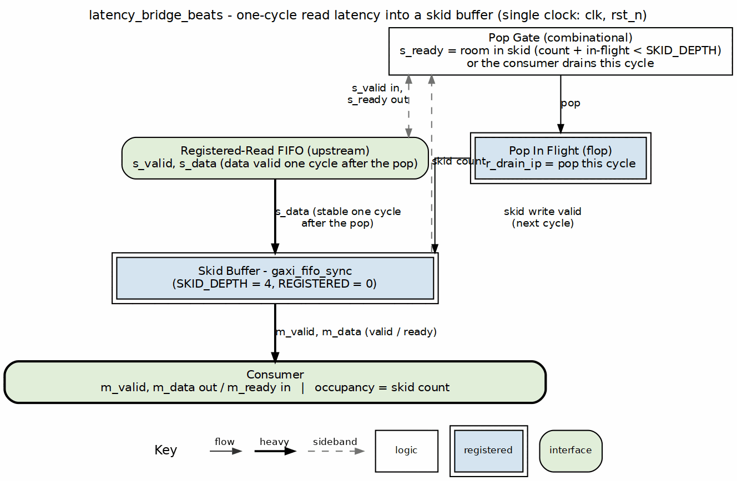
Latency bridge block diagram
Source: 07_latency_bridge.dot

12.2 Concept: bridging a registered read
A FIFO with REGISTERED=1 read (the SRAM style this repo uses so BRAM infers cleanly) answers a read handshake with data one cycle later. A consumer speaking valid/ready expects data with valid, and may deassert ready at any time. Without a bridge the FIFO has already popped a beat the consumer did not take.
cycle 0 s_valid && s_ready FIFO read accepted r_drain_ip <= 1
cycle 1 data arrives on s_data skid_wr_valid = r_drain_ip, data pushed
cycle N m_valid && m_ready consumer drains the skid at its own pace
The bridge never guesses about downstream readiness: s_ready is derived from the skid’s room, counting only a write that is stalled this cycle as pending (a write that completes this cycle frees its slot at the same edge). That is why full throughput holds while writes complete immediately, and why the FIFO is never over-read when they do not.

12.3 Parameters
parameter int DATA_WIDTH = 64; // Beat width
parameter int SKID_DEPTH = 4; // Skid buffer depth (2-4 recommended)
parameter int DW = DATA_WIDTH; // Short alias
: Table 2.7.1: Latency Bridge Parameters
occupancy is 3 bits wide and counts 0..5 at the default depth (one beat in flight plus four in the skid); a larger SKID_DEPTH needs the port widened.

12.4 Port List

12.4.1 Clock and Reset
Table 2.7.2: Clock and Reset
Signal | Direction | Width | Description
clk | input | 1 | System clock
rst_n | input | 1 | Active-low reset

12.4.2 Upstream Interface (from the registered FIFO)
Table 2.7.3: Upstream Interface
Signal | Direction | Width | Description
s_valid | input | 1 | FIFO has a beat to read (not empty)
s_ready | output | 1 | Bridge accepts a read this cycle; the data lands NEXT cycle
s_data | input | DW | Read data, valid one cycle after the s_valid && s_ready handshake

12.4.3 Downstream Interface (to the consumer)
Table 2.7.4: Downstream Interface
Signal | Direction | Width | Description
m_valid | output | 1 | Beat available
m_ready | input | 1 | Consumer takes the beat
m_data | output | DW | Beat data, valid with m_valid

12.4.4 Status and Debug
Table 2.7.5: Status and Debug
Signal | Direction | Width | Description
occupancy | output | 3 | Beats held by the bridge: the in-flight read plus the skid contents (0..5)
dbg_r_pending | output | 1 | r_drain_ip: a read was accepted and its data is due next cycle
dbg_r_out_valid | output | 1 | Skid output valid (mirrors m_valid)

12.5 Operation

12.5.1 Figure 2.7.2: Latency Bridge Timing (consumer always ready)

Latency bridge behind a registered-read FIFO
Source: latency_bridge_beats_streaming.json, captured from dv/tests/fub_beats/test_latency_bridge_beats.py (streaming, 256-bit, seed 7) with WAVES=1. The test drives a REGISTERED = 1 gaxi_fifo_sync in front of the bridge (dv/tb/latency_bridge_beats_tb_top.sv), because that is the only way to produce the bridge’s upstream contract: a valid/ready master presents data with valid, a registered FIFO presents it one cycle after the read handshake.
Reading it: each wr_valid beat lands in the FIFO and s_valid (FIFO not empty) rises a cycle later; the bridge reads it at once (s_ready stays high) and dbg_r_pending marks the cycle the data is in flight. Two cycles after the write the beat is on m_valid/m_data with its payload intact (1, 2, 3, …), and occupancy shows exactly one beat inside the bridge per transfer. With a consumer that is always ready the bridge adds the FIFO’s read latency and no more.
An earlier revision of this test drove s_* directly from the BFM and never compared m_data; every beat came out 0 and the test passed (rapids TASK-003). (dv/tests/fub_beats/test_latency_bridge_beats.py).

12.6 Integration Context
The bridge sits between a gaxi_fifo_sync with REGISTERED=1 and whatever consumes the stream. The same arrangement, with STREAM’s twin stream_latency_bridge, is what sram_controller_unit uses inside the shared SRAM controller today; occupancy there is what the drain accounting must allow for (stream BUG-011).
latency_bridge_beats #(
.DATA_WIDTH (512),
.SKID_DEPTH (4)
) u_bridge (
.clk (clk),
.rst_n (rst_n),
// registered-read FIFO side
.s_valid (fifo_rd_valid),
.s_ready (fifo_rd_ready),
.s_data (fifo_rd_data),
// consumer side
.m_valid (drain_valid),
.m_ready (drain_read),
.m_data (drain_data),
// status / debug
.occupancy (bridge_occupancy),
.dbg_r_pending (dbg_bridge_pending),
.dbg_r_out_valid (dbg_bridge_out_valid)
);

12.7 Design Considerations
Table 2.7.6: Skid Depth Selection
SKID_DEPTH | Behaviour
2 | Minimum: one stall of the consumer costs a bubble on the next read
4 | Default: absorbs a short consumer stall with no upstream bubble
8 | Deeper stall absorption; occupancy must be widened past 3 bits
The skid does not need to cover the FIFO’s read latency (that is the one r_drain_ip flop’s job); it needs to cover how long the consumer stalls without the bridge stopping upstream reads.

Last Updated: 2026-09-27

RTL Design Sherpa · Learning Hardware Design Through Practice GitHub · Documentation Index · MIT License

13 Control-Read Engine Specification
Module: ctrlrd_engine.sv Location: projects/components/dma-ip/rapids/rtl/fub/ Status: Implemented Last Updated: 2026-07-12

13.1 Overview
The Control-Read Engine implements the CTRL_READ descriptor opcode (DESC_OP_CTRL_READ = 2'b01) as a consumer gate. When the scheduler decodes a CTRL_READ descriptor, it hands the engine a poll address, an expected value, and a compare mask. The engine issues an AXI4 read to the poll address, applies the mask to the returned data, and compares (read_data & mask) against the expected value. If they match, the gate is satisfied and the descriptor chain proceeds; if not, the engine retries. Retries are bounded so a gate that never matches cannot hang the channel.
One Control-Read Engine is instantiated per channel in scheduler_group_beats.sv (u_ctrlrd_engine), configured for 32-bit AXI reads.

13.1.1 Key Features
- Consumer Gate Semantics: Polls memory until (read_data & mask) == expected
- Masked Comparison: Only the masked bits of the polled word participate in the match
- Bounded Retry: cfg_ctrlrd_max_try (0-511) caps the number of poll attempts
- 1 microsecond Retry Pacing: Retries wait for tick_1us from the scheduler group
- Error on Exhaustion: Asserts ctrlrd_error if the gate never matches within budget
- Null Address Fast-Path: A poll address of zero completes immediately as a match
- Channel Reset Support: cfg_channel_reset returns the FSM to idle and drains any read still on the fabric
- MonBus Integration: Completion, retry, and error events

13.1.2 Block Diagram

13.1.3 Figure 2.8.1: Control-Read Engine Block Diagram
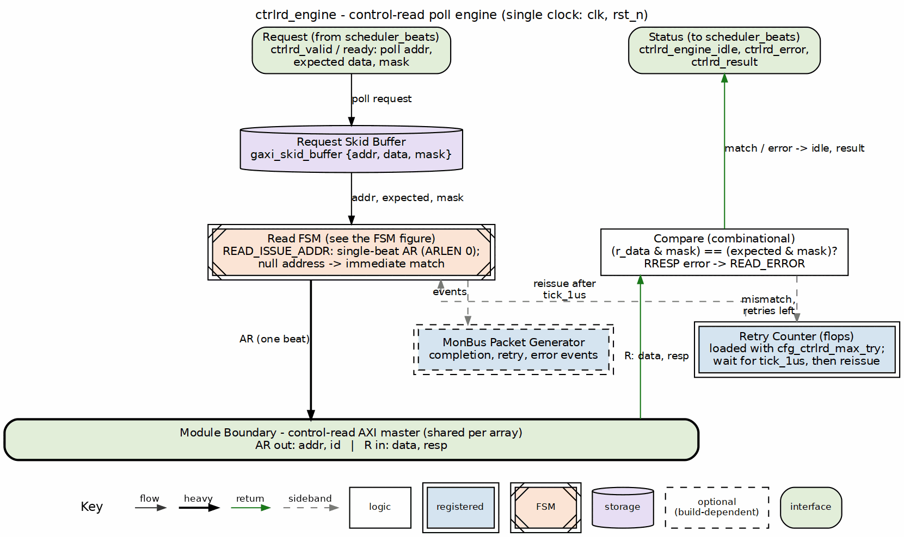
Control-read engine block diagram
Source: 08_ctrlrd_engine.dot

13.2 Parameters
parameter int CHANNEL_ID = 0; // Channel identifier
parameter int NUM_CHANNELS = 32; // Total channels
parameter int CHAN_WIDTH = $clog2(NUM_CHANNELS); // Channel index width (derived)
parameter int ADDR_WIDTH = 64; // Address bus width
parameter int AXI_DATA_WIDTH = 64; // AXI read data width (>= 32)
parameter int AXI_ID_WIDTH = 8; // AXI ID width (>= CHAN_WIDTH)
// Monitor Bus Parameters
parameter logic [15:0] MON_AGENT_ID = 16'h0030; // Control-Read Engine Agent ID
parameter logic [7:0] MON_UNIT_ID = 8'h02; // Unit identifier
parameter logic [8:0] MON_CHANNEL_ID = 9'h000; // Base channel ID
: Table 2.8.1: Control-Read Engine Parameters
Parameter validation enforces AXI_ID_WIDTH >= CHAN_WIDTH and AXI_DATA_WIDTH >= 32 (the engine consumes only the lower 32 bits of the read data). The per-channel instance in scheduler_group_beats.sv overrides AXI_DATA_WIDTH to 32.

13.3 Port List

13.3.1 Clock and Reset
Table 2.8.2: Clock and Reset
Signal | Direction | Width | Description
clk | input | 1 | System clock
rst_n | input | 1 | Active-low asynchronous reset

13.3.2 Scheduler Interface
Table 2.8.3: Scheduler Interface
Signal | Direction | Width | Description
ctrlrd_valid | input | 1 | Gate request valid from scheduler
ctrlrd_ready | output | 1 | Engine ready to accept a request
ctrlrd_pkt_addr | input | AW | Poll address (descriptor poll_addr[63:0])
ctrlrd_pkt_data | input | 32 | Expected value (descriptor expected[95:64])
ctrlrd_pkt_mask | input | 32 | Compare mask (descriptor mask[127:96])
ctrlrd_error | output | 1 | Gate failed (retries exhausted or AXI error)
ctrlrd_result | output | 32 | Last read value (lower 32 bits)
ctrlrd_engine_idle | output | 1 | Engine idle (post-issue completion indicator)

13.3.3 Configuration Interface
Table 2.8.4: Configuration Interface
Signal | Direction | Width | Description
cfg_ctrlrd_max_try | input | 9 | Poll retry budget, 0-511 (from CTRL_CONFIG.CTRLRD_MAX_TRY)
cfg_channel_reset | input | 1 | Per-channel reset request
tick_1us | input | 1 | 1 microsecond tick that paces retries

13.3.4 AXI4 Read Master Interface
Table 2.8.5: AXI4 Read Master Interface
Signal | Direction | Width | Description
ar_valid | output | 1 | Read address valid
ar_ready | input | 1 | Read address ready
ar_addr | output | AW | Read address (poll address)
ar_len | output | 8 | Burst length (8'h00, single beat)
ar_size | output | 3 | Burst size (3'b010, 4 bytes)
ar_burst | output | 2 | Burst type (2'b01, INCR)
ar_id | output | ID | Transaction ID (channel-derived)
ar_lock | output | 1 | Lock (1'b0, normal access)
ar_cache | output | 4 | Cache (4'b0010, non-cacheable bufferable)
ar_prot | output | 3 | Protection (3'b000)
ar_qos | output | 4 | Quality of service (4'h0)
ar_region | output | 4 | Region (4'h0)
r_valid | input | 1 | Read data valid (shared channel)
r_ready | output | 1 | Read data ready
r_data | input | ADW | Read data (lower 32 bits used)
r_id | input | ID | Read response ID (matched to our request)
r_resp | input | 2 | Read response
r_last | input | 1 | Read last beat

13.3.5 MonBus Interface
Table 2.8.6: MonBus Interface
Signal | Direction | Width | Description
i_mon_time | input | 64 | Side-band monitor timestamp
mon_valid | output | 1 | Monitor packet valid
mon_ready | input | 1 | Monitor consumer ready
mon_packet | output | 128 | Monitor packet (monitor_packet_t)
mon_timestamp | output | 64 | Monitor packet timestamp

13.4 FSM States

13.4.1 Figure 2.8.2: Control-Read Engine FSM
States and transitions of the ctrlrd_engine poll FSM.
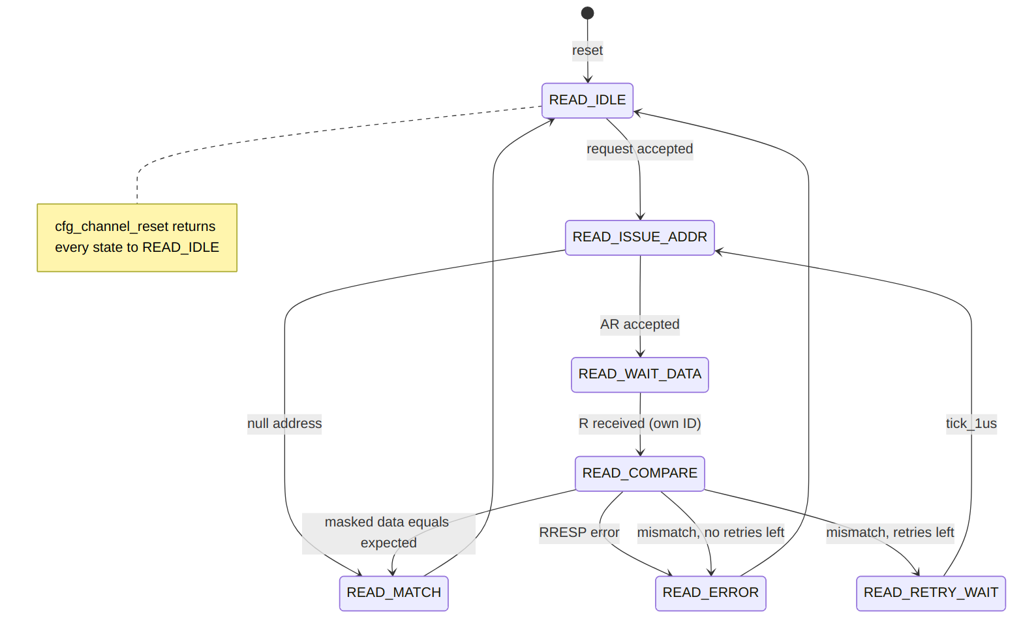
Diagram 2
State summary:
- READ_IDLE: Waits for a request from the scheduler (via a two-deep skid buffer). Latches poll address, expected value, mask, and the AXI ID; initializes the retry counter from cfg_ctrlrd_max_try.
- READ_ISSUE_ADDR: Drives ar_valid. A null address (64'h0) shortcuts to READ_MATCH; otherwise, once ar_ready handshakes, advances to READ_WAIT_DATA.
- READ_WAIT_DATA: Accepts the read response whose r_id matches the channel ID, capturing the lower 32 bits and the response code.
- READ_COMPARE: On an AXI error response, goes to READ_ERROR. On a masked match, goes to READ_MATCH. Otherwise, if retries remain, decrements the counter and goes to READ_RETRY_WAIT; if the budget is exhausted, goes to READ_ERROR.
- READ_RETRY_WAIT: Waits for tick_1us, then reissues the read.
- READ_MATCH: Gate satisfied. Clears the error flag and returns to READ_IDLE.
- READ_ERROR: Sets ctrlrd_error and returns to READ_IDLE.

13.5 Operation

13.5.1 Masked Compare
The engine gates on a masked equality check:
w_masked_expected = ctrlrd_pkt_data & ctrlrd_pkt_mask
w_masked_actual = r_data[31:0] & ctrlrd_pkt_mask
w_data_match = (w_masked_expected == w_masked_actual)
Only the bits set in mask participate. A mask of 32'hFFFFFFFF compares the full word; a mask of a single bit turns the gate into a flag-poll.

13.5.2 Retry Budget and Pacing
The retry counter is loaded from cfg_ctrlrd_max_try when the request is accepted. On each non-matching, non-error compare with retries remaining, the counter decrements and the engine parks in READ_RETRY_WAIT until the next tick_1us, which paces successive polls at roughly 1 microsecond intervals. When the counter reaches zero without a match, the engine transitions to READ_ERROR and asserts ctrlrd_error, so a never-matching gate cannot stall the channel indefinitely.
cfg_ctrlrd_max_try is driven by the CTRL_CONFIG register at offset 0x240, field CTRLRD_MAX_TRY[8:0] (0-511, reset 16).

13.5.3 Null Address Fast-Path
If the latched poll address is 64'h0, the engine treats the gate as already satisfied: READ_ISSUE_ADDR transitions directly to READ_MATCH without issuing an AXI read. This lets software emit an unconditional (no-op) gate.

13.5.4 AXI Read Transaction
Polls are single-beat, 4-byte INCR reads (ar_len = 0, ar_size = 3'b010, ar_burst = 2'b01). The ar_id is derived from CHANNEL_ID, and only responses whose r_id matches are consumed on the shared read data channel. ctrlrd_result exposes the last captured 32-bit value; in the per-channel instantiation the scheduler gates on match/error rather than the raw value, so ctrlrd_result is left unconnected there.

13.5.5 Channel Reset
cfg_channel_reset is registered into r_channel_reset_active. While asserted, the engine refuses new requests (ctrlrd_ready is forced low), the retry and error state is cleared, and the FSM is driven back to READ_IDLE.
What the reset cannot do is cancel a read already on the fabric, because AXI has no cancel. The engine therefore drains it (rapids TASK-014, 2026-09-27):
- an AR that was raised and not yet accepted stays raised until the slave takes it (r_drain_ar), then
- the R beat that the accepted AR is owed is taken and discarded (r_drain_pending, which alone lifts r_ready outside READ_WAIT_DATA).
Until the beat is gone ctrlrd_engine_idle stays low and the request path stays closed, so the next read on this ID cannot be answered by the stale beat. Before this the reset dropped the FSM to idle with r_ready low, the beat sat on the bus, and a re-kicked channel took it as its own answer.
ctrlrd_engine_idle asserts only in READ_IDLE with no pending request, no active channel reset and nothing left to drain.

13.6 MonBus Reporting
The engine emits monitor packets on notable events:
Table 2.8.7: MonBus Events
Event | Packet Type | Code | Payload
Gate satisfied (non-null) | PktTypeCompletion | CORE_COMPL_CTRLRD_COMPLETED | Poll address
Retry attempt | PktTypePerf | CORE_PERF_CTRLRD_RETRY | Remaining retry count
Retries exhausted | PktTypeError | CORE_ERR_CTRLRD_MAX_RETRIES | Poll address
AXI error response | PktTypeError | AXI_ERR_RESP_SLVERR / AXI_ERR_RESP_DECERR | Response code
All packets carry MON_AGENT_ID, MON_UNIT_ID, and MON_CHANNEL_ID, and are timestamped from i_mon_time.

13.7 Descriptor Field Mapping
The CTRL_READ opcode reinterprets the shared 256-bit descriptor (the descriptor engine’s existing field extraction is reused):
Table 2.8.8: CTRL_READ Descriptor Field Mapping
Descriptor Field | Bits | Engine Port
poll_addr | [63:0] | ctrlrd_pkt_addr
expected | [95:64] | ctrlrd_pkt_data
mask | [127:96] | ctrlrd_pkt_mask
max_try | [143:128] | Per-descriptor budget (0 = use cfg_ctrlrd_max_try default)

Last Updated: 2026-07-12

RTL Design Sherpa · Learning Hardware Design Through Practice GitHub · Documentation Index · MIT License

14 Control-Write Engine Specification
Module: ctrlwr_engine.sv Location: projects/components/dma-ip/rapids/rtl/fub/ Status: Implemented Last Updated: 2025-01-10

14.1 Overview
The Control-Write Engine executes a CTRL_WRITE control descriptor (DESC_OP_CTRL_WRITE = 2'b10). A CTRL_WRITE is a producer doorbell: the engine performs a single-beat AXI4 write of the descriptor’s 32-bit wr_data value to its 64-bit wr_addr target, then completes so the descriptor chain continues. One instance is dedicated per channel.
The write target address must be 4-byte aligned because the transfer is a 32-bit (aw_size = 3'b010) single-beat write. A null address (wr_addr == 0) is treated as a no-op and the request completes without issuing an AXI transaction.

14.1.1 Key Features
- Single-Beat AXI4 Write: One 32-bit doorbell write per request (aw_len = 0, w_last = 1)
- Producer Doorbell Semantics: Write value to target, then release the chain (no poll, no retry)
- Address Alignment Check: Requires 4-byte-aligned wr_addr; misalignment raises an error
- Null-Address Skip: wr_addr == 0 completes as a no-op
- Channel Reset Support: cfg_channel_reset returns the FSM to idle and drains any write still on the fabric
- MonBus Integration: Completion and error event reporting

14.1.2 Block Diagram

14.1.3 Figure 2.9.1: Control-Write Engine Block Diagram
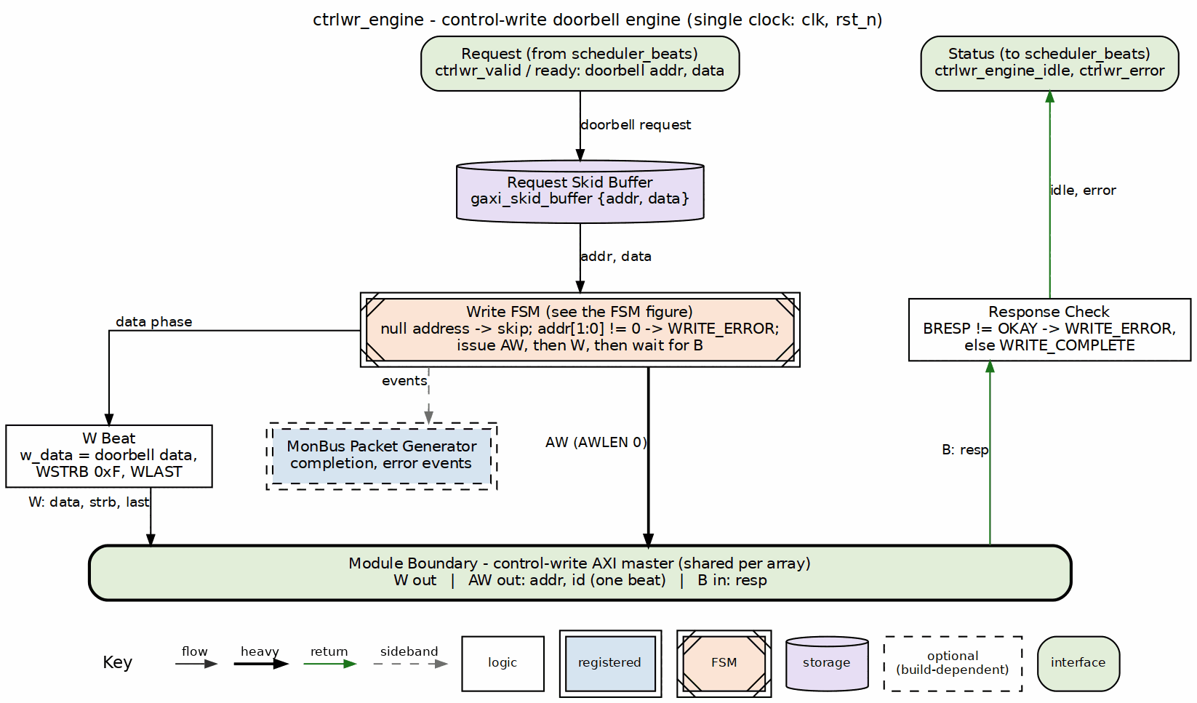
Control-write engine block diagram
Source: 09_ctrlwr_engine.dot

14.2 Parameters
parameter int CHANNEL_ID = 0; // Channel identifier
parameter int NUM_CHANNELS = 32; // Total channels
parameter int CHAN_WIDTH = $clog2(NUM_CHANNELS); // Derived channel index width
parameter int ADDR_WIDTH = 64; // Address bus width
parameter int AXI_ID_WIDTH = 8; // AXI transaction ID width
// Monitor Bus Parameters
parameter logic [15:0] MON_AGENT_ID = 16'h0020; // Ctrlwr Engine Agent ID
parameter logic [7:0] MON_UNIT_ID = 8'h01; // Unit identifier
parameter logic [8:0] MON_CHANNEL_ID = 9'h000; // Base channel ID
: Table 2.9.1: Control-Write Engine Parameters
Note: AXI_ID_WIDTH must be >= CHAN_WIDTH (checked by an elaboration-time $fatal). When instantiated in scheduler_group_beats.sv as u_ctrlwr_engine, MON_AGENT_ID is overridden to 16'h0021 (CTRLWR_MON_AGENT_ID) to distinguish it from the Control-Read Engine’s 16'h0020.

14.3 Port List

14.3.1 Clock and Reset
Table 2.9.2: Clock and Reset
Signal | Direction | Width | Description
clk | input | 1 | System clock
rst_n | input | 1 | Active-low asynchronous reset

14.3.2 Configuration Interface
Table 2.9.3: Configuration Interface
Signal | Direction | Width | Description
cfg_channel_reset | input | 1 | Per-channel reset: blocks new requests, drains transaction, forces idle

14.3.3 Scheduler Interface
Table 2.9.4: Scheduler Interface
Signal | Direction | Width | Description
ctrlwr_valid | input | 1 | Request valid (doorbell write requested)
ctrlwr_ready | output | 1 | Ready to accept request
ctrlwr_pkt_addr | input | AW | Doorbell target address (wr_addr, 4-byte aligned)
ctrlwr_pkt_data | input | 32 | Doorbell write value (wr_data)
ctrlwr_error | output | 1 | Error flag (alignment or AXI response error)
ctrlwr_engine_idle | output | 1 | Engine idle (in WRITE_IDLE, no active transaction, not in channel reset)

14.3.4 AXI4 Write Master Interface
Table 2.9.5: AXI4 Write Master Interface
Signal | Direction | Width | Description
aw_valid | output | 1 | Write address valid
aw_ready | input | 1 | Write address ready
aw_addr | output | AW | Write address (= wr_addr)
aw_len | output | 8 | Burst length (0 = single beat)
aw_size | output | 3 | Transfer size (3'b010 = 4 bytes / 32-bit)
aw_burst | output | 2 | Burst type (2'b01 = INCR)
aw_id | output | AXI_ID_WIDTH | Transaction ID (derived from CHANNEL_ID)
aw_lock | output | 1 | Lock type (0 = normal)
aw_cache | output | 4 | Cache type (4'b0010 = non-cacheable bufferable)
aw_prot | output | 3 | Protection type (3'b000)
aw_qos | output | 4 | Quality of service (0)
aw_region | output | 4 | Region identifier (0)
w_valid | output | 1 | Write data valid
w_ready | input | 1 | Write data ready
w_data | output | 32 | Write data (= wr_data)
w_strb | output | 4 | Write strobes (4'b1111 = all bytes)
w_last | output | 1 | Last beat (1 = single beat)
b_valid | input | 1 | Write response valid
b_ready | output | 1 | Write response ready
b_id | input | AXI_ID_WIDTH | Response ID (matched against expected AXI ID)
b_resp | input | 2 | Write response code

14.3.5 MonBus Interface
Table 2.9.6: MonBus Interface
Signal | Direction | Width | Description
i_mon_time | input | 64 | Monitor timestamp side-band input
mon_valid | output | 1 | Monitor packet valid
mon_ready | input | 1 | Monitor packet ready
mon_packet | output | 128 | Monitor packet (monitor_packet_t)
mon_timestamp | output | 64 | Monitor packet timestamp

14.4 FSM States

14.4.1 Figure 2.9.2: Control-Write Engine FSM
States and transitions of the ctrlwr_engine doorbell FSM.
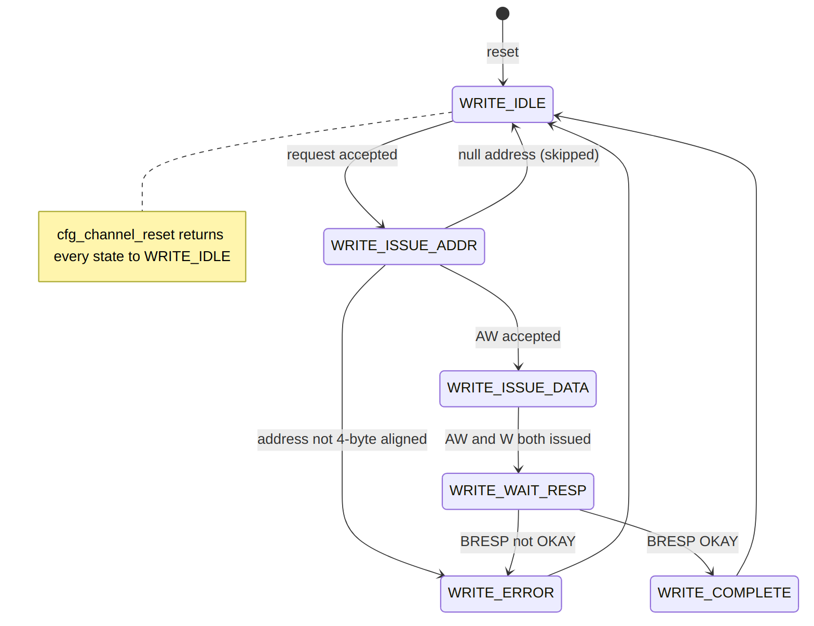
Diagram 3
State summary:
- WRITE_IDLE: Wait for a request from the request skid buffer; latch wr_addr/wr_data and the expected AXI ID.
- WRITE_ISSUE_ADDR: Drive aw_valid until aw_ready. A misaligned address routes to WRITE_ERROR; a null address returns to WRITE_IDLE (no-op skip).
- WRITE_ISSUE_DATA: Drive w_valid until w_ready; advance once both address and data phases have been issued.
- WRITE_WAIT_RESP: Accept the matching b-channel response; a non-OKAY b_resp routes to WRITE_ERROR, otherwise to WRITE_COMPLETE.
- WRITE_COMPLETE: Emit a completion MonBus packet (unless null address) and return to WRITE_IDLE.
- WRITE_ERROR: Latch ctrlwr_error, emit an error MonBus packet, and return to WRITE_IDLE. The error flag persists until reset or cfg_channel_reset.

14.5 Operation

14.5.1 Doorbell Write Sequence

14.5.2 Figure 2.9.3: Control-Write Doorbell Timing

ctrlwr_engine - one doorbell write
Source: ctrlwr_engine_doorbell.json, captured from dv/tests/fub/test_ctrlwr_engine.py (basic_write, channel 0, 64-bit address, REG_LEVEL=GATE) with WAVES=1; the AXI side is the framework write slave.
Reading it: the request handshakes in one cycle (ctrlwr_ready is held high by the skid buffer) with the doorbell address 0x1000 and data 0x12345678, and the engine leaves idle the next cycle. AW goes out two cycles after the request, W two cycles after AW, and the slave answers B (OKAY) two cycles after W; ctrlwr_engine_idle returns the cycle after the B handshake, eight cycles after the request. Nothing is pipelined across doorbells: the engine takes one request at a time.

14.5.3 Request Handshake and Skid Buffer
Incoming requests are captured through a depth-2 gaxi_skid_buffer. The engine accepts a request (ctrlwr_ready) only when not in an active channel reset. The FSM pops the buffered request in WRITE_IDLE, latching {wr_addr, wr_data} and computing the expected AXI ID from CHANNEL_ID:
aw_id = {{(AXI_ID_WIDTH-CHAN_WIDTH){1'b0}}, CHANNEL_ID[CHAN_WIDTH-1:0]};
The b-channel response is matched against this expected ID (b_id == r_expected_axi_id) so a shared write master can be demultiplexed per channel.

14.5.4 Address Validation
Null (skip) : wr_addr == 64'h0
Align error : wr_addr[1:0] != 2'b00 (and not null)
A null address completes immediately as a no-op with no AXI activity and no completion packet. A misaligned address never issues on AXI; it transitions to WRITE_ERROR, asserts ctrlwr_error, and emits an error MonBus packet.

14.5.5 Error Reporting
ctrlwr_error is a registered, sticky flag. It is set on an alignment error or on a non-OKAY AXI write response (b_resp != 2'b00), and it persists until rst_n or cfg_channel_reset. The MonBus error packet carries either the offending address (alignment error) or the captured b_resp code (AXI response error).

14.5.6 Channel Reset
Asserting cfg_channel_reset registers r_channel_reset_active, which blocks new requests (ctrlwr_ready low), clears the error flag and the phase-issued state, and drives the FSM back to WRITE_IDLE.
A write already on the fabric cannot be cancelled, so the engine drains it (rapids TASK-014, 2026-09-27): a raised AW stays up until accepted (r_drain_aw), an accepted AW is followed by its W beat with the latched data (r_drain_w), and the B response is taken and discarded (r_drain_b, which alone lifts b_ready outside WRITE_WAIT_RESP). The write that was already issued therefore lands. Until B is taken ctrlwr_engine_idle stays low and the request path stays closed. Before this the reset abandoned whatever phase was in flight and left a dangling response on the channel’s ID.
ctrlwr_engine_idle asserts only in WRITE_IDLE with no pending request, no active channel reset and nothing left to drain.

14.6 Contrast with the Control-Read Engine
The Control-Write Engine is the producer counterpart to the Control-Read Engine (Section 2.8). Both are per-channel control-descriptor executors, but they implement opposite half of the producer/consumer handshake:
Aspect | Control-Read Engine (2.8) | Control-Write Engine (2.9)
Opcode | DESC_OP_CTRL_READ (2'b01) | DESC_OP_CTRL_WRITE (2'b10)
Role | Consumer gate | Producer doorbell
AXI direction | Read (poll) | Single-beat write
Semantics | Poll until (rd & mask) == expected | Write wr_data to wr_addr, then continue
Retry budget | max_try retry budget (config default) | None (single unconditional write)
Chain effect | Holds off the chain until the gate passes | Releases the chain after the write completes
Descriptor fields | poll_addr / expected / mask / max_try | wr_addr / wr_data
A CTRL_WRITE therefore has no maximum-try configuration: it is one unconditional 32-bit write, whereas CTRL_READ polls with a bounded retry budget before either passing the gate or timing out.

Last Updated: 2026-07-12

RTL Design Sherpa · Learning Hardware Design Through Practice GitHub · Documentation Index · MIT License

15 Shared Engines
Modules: descriptor_engine_shared.sv, ctrlrd_engine_shared.sv, ctrlwr_engine_shared.sv Location: projects/components/dma-ip/rapids/rtl/fub/ Status: Implemented Last Updated: 2026-10-17

15.1 Overview
With SHARED_ENGINES = 1 (the default) each scheduler group array, one per half, builds one descriptor engine, one control-read engine and one control-write engine for all of its channels. These replace the NUM_CHANNELS copies of each that SHARED_ENGINES = 0 builds. Each shared engine picks the next channel to serve round-robin on the scheduler side and owns its AXI master outright, so the array’s AXI-side arbiters are gone. ARID and AWID carry the channel.
Each scheduler sees the same per-channel interface as with a dedicated engine. The schedulers, the array’s ports and everything above the array are the same in both builds. The Scheduler Group Array chapter describes how the array instantiates the engines and the MonBus sources they add. This chapter describes the engines themselves.

15.1.1 Key Features
- One fetch path per half: a single AR issuer, one set of address-range comparators and one R path for every channel.
- Per-channel ordering: each channel keeps one descriptor fetch in flight, so its descriptors arrive in order. Fetches for different channels overlap on the bus under their own ARIDs.
- No R-channel blocking: a fetch issues only when its channel’s FIFO has room, and an R beat for a channel reset mid-fetch is accepted and dropped.
- Owner-register control engines: one ctrlrd_engine and one ctrlwr_engine, each wrapped with a round-robin pick and an owner register.
- Descriptor injection (INJ_EN): a second writer into the descriptor FIFOs for the tile’s cell-issued descriptors. See Tile Packet Header.

15.1.2 Cost
On the Genesys 2 board build (8 channels per half, 256 bits) the three per-channel engine sets took 15,283 LUTs and 19,308 flip-flops across both halves:
- descriptor engines: 11,009 LUTs and 7,360 flip-flops for 16 engines;
- control-read engines: 2,388 LUTs and 7,038 flip-flops;
- control-write engines: 1,886 LUTs and 4,910 flip-flops.
Sharing removed 11,024 LUTs (20%) and 16,483 flip-flops (37%) from RAPIDS. The HAS Resource Estimates chapter has the full before and after.

15.2 descriptor_engine_shared

15.2.1 Parameters
Table 2.10.1: descriptor_engine_shared Parameters
Parameter | Default | Description
NUM_CHANNELS | 8 | Channels served.
CHAN_WIDTH | $clog2(NUM_CHANNELS) (1 minimum) | Channel ID width. AXI_ID_WIDTH must be at least this; elaboration fails otherwise.
ADDR_WIDTH | 64 | Address width.
AXI_ID_WIDTH | 8 | ARID and RID width. ARID = channel.
FIFO_DEPTH | 8 | Descriptor FIFO depth per channel.
USE_ROW_COL_MAJOR_ADDRESSING | 1 | Enables the EXTENDED descriptor’s second fetch and its chunk-1 FIFO.
MON_AGENT_BASE | 0x10 | MonBus agent is MON_AGENT_BASE + channel.
MON_UNIT_ID | 0x01 | MonBus unit ID.
MON_FIFO_DEPTH | 4 | Depth of the MonBus packet FIFO.
INJ_EN | 0 | 1 builds the injection slot (set by the array when TILE_HDR = 1).

15.2.2 Port List
Every per-channel port is a packed [NUM_CHANNELS-1:0] vector of the signal a dedicated descriptor_engine has, so channel c sees bit or element c.
Table 2.10.2: descriptor_engine_shared Ports
Group | Signals | Description
Clock and reset | clk, rst_n | Single clock, active-low asynchronous reset.
Kick (per channel) | apb_valid, apb_ready, apb_addr | Staged descriptor address from the configuration block.
Scheduler (per channel) | channel_idle, descriptor_valid, descriptor_ready, descriptor_packet, descriptor_ext_packet, descriptor_error, descriptor_eos, descriptor_eol, descriptor_eod, descriptor_type | The same handshake and flags as descriptor_engine.
AXI4 read master | ar_*, r_* (256-bit r_data) | Owned outright; one master per half.
Configuration | cfg_prefetch_enable, cfg_fifo_threshold, cfg_addr0_base/limit, cfg_addr1_base/limit, cfg_channel_reset | Shared by every channel, as before; the reset is per channel.
Injection | inj_valid, inj_ch, inj_data, inj_dropped, inj_dropped_clr | Unused (tied off) unless INJ_EN = 1.
Status | descriptor_engine_idle (per channel) | Channel has no fetch pending or in flight.
MonBus | i_mon_time, mon_valid, mon_ready, mon_packet, mon_timestamp | One stream for every channel.

15.2.3 Per-Channel State
Each channel keeps only what a fetch needs between the kick and the FIFO write:
Table 2.10.3: Per-Channel Fetch States
State | Meaning
S_IDLE | Nothing to fetch.
S_PEND | Chunk-0 address pending (from a kick or from chaining).
S_ISSUE | Chunk-0 request is in the shared issue slot.
S_WAIT | Chunk-0 AR accepted, waiting for R.
S_PEND2, S_ISSUE2, S_WAIT2 | The same three steps for an EXTENDED descriptor’s chunk 1.
Beside the state code each channel has one pending fetch address, a kick-in-progress flag, an owed-beat flag (r_owe), its descriptor FIFO and, when EXTENDED descriptors are built, a chunk-1 FIFO kept in lockstep with it. An injection slot is added when INJ_EN = 1.

15.2.4 Operation
Issue. A round-robin pick among channels in S_PEND or S_PEND2 loads one request into the issue slot. A channel is eligible only while its FIFO has a free entry, so a channel that has stopped consuming never takes an R beat it cannot store. The range check runs at the slot: an address outside both configured ranges is refused with no AR and raises the channel’s descriptor error. Once ARVALID is high, the address and ID hold until accepted.
Return. Each R beat is routed by RID to its channel and written straight into that channel’s FIFO, so there is no 256-bit holding register per channel. The exception is an EXTENDED descriptor’s chunk 0, which waits for chunk 1. A non-OKAY response, or a beat that does not parse as a valid descriptor, raises the channel’s descriptor error.
Chaining and prefetch. The next-pointer decision and the prefetch throttle are the per-channel engine’s: autonomous chaining while the descriptor allows it, up to the FIFO threshold plus one buffered.
Channel reset. A reset in the middle of a fetch sets r_owe. The owed beat is accepted and dropped when it arrives, and the channel takes no new kick until then. Reset also drains the channel’s FIFO, so descriptors prefetched for an aborted chain are never delivered.
Injection. An injected descriptor is a pulse with no backpressure. It waits in its channel’s one-entry slot and is written into the FIFO, with no fetch, once the channel’s fetch side is idle and the FIFO has room. An injection therefore never takes an entry an R beat needs. A descriptor that arrives while the slot is full, while the channel is held in reset, or that is EXTENDED is dropped and sets the channel’s sticky inj_dropped bit. A drop is not a descriptor error.

15.2.5 MonBus
Completion and error packets go through a MON_FIFO_DEPTH-entry FIFO. Two behaviours differ from the per-channel engine:
- A refused kick address reports 0 in the response field. The per-channel engine reported its last latched read response, which was stale.
- An issue-side refusal and an R-side event can occur in the same cycle. The issue-side packet waits one cycle. If a second collision arrives while it waits, the waiting packet is dropped. Tests that count descriptor-engine packets must allow for this.

15.3 ctrlrd_engine_shared and ctrlwr_engine_shared
The two control engines share one structure: an unmodified ctrlrd_engine or ctrlwr_engine with three things around it. A control engine runs one request at a time, so nothing inside it has to change.
Table 2.10.4: Shared Control Engine Wrapper
Element | Behaviour
Round-robin pick | Offered to the engine only while it is idle, its last MonBus packet has drained, and no error remains from the previous owner. A stale error is cleared with a one-cycle engine reset before the next channel is taken.
Owner register | Set when the engine accepts a request. ARID or AWID carries the owner, and every R or B response belongs to the engine.
Per-channel view | The owner sees the engine’s *_idle and *_error as a dedicated engine would show them. Every other channel sees idle 1 and error 0.
Channel reset | The owner’s cfg_channel_reset resets the engine only while the owner’s operation is in flight, so a channel held in reset cannot hold the engine for the others.
MonBus | Packets are re-tagged with the owner’s channel and agent ID: 0x20 + channel for control reads, 0x28 + channel for control writes.

15.3.1 Parameters
Table 2.10.5: Shared Control Engine Parameters
Parameter | Default | Description
NUM_CHANNELS | 8 | Channels served.
CHAN_WIDTH | $clog2(NUM_CHANNELS) (1 minimum) | Channel ID width.
ADDR_WIDTH | 64 | Address width.
AXI_ID_WIDTH | 8 | ARID or AWID width.
MON_AGENT_BASE | 0x20 (read), 0x28 (write) | MonBus agent is MON_AGENT_BASE + channel.
MON_UNIT_ID | 0x01 | MonBus unit ID.

15.3.2 Port List
Table 2.10.6: Shared Control Engine Ports
Group | ctrlrd_engine_shared | ctrlwr_engine_shared
Requests (per channel) | ctrlrd_valid, ctrlrd_ready, ctrlrd_addr, ctrlrd_data, ctrlrd_mask | ctrlwr_valid, ctrlwr_ready, ctrlwr_addr, ctrlwr_data
Status (per channel) | ctrlrd_error, ctrlrd_idle | ctrlwr_error, ctrlwr_idle
Configuration | cfg_ctrlrd_max_try, cfg_channel_reset, tick_1us | cfg_channel_reset
AXI4 master | ar_*, r_* (32-bit data) | aw_*, w_* (32-bit data, 4-bit strobe), b_*
MonBus | i_mon_time, mon_valid, mon_ready, mon_packet, mon_timestamp | the same

15.3.3 Trade-off
A CTRL_READ that keeps polling holds the control-read engine, so other channels’ control reads wait behind it, up to cfg_ctrlrd_max_try retries. Data transfers are not affected. The control-write engine keeps one write in flight, which the array-level serializer of the per-channel build also enforced.

15.4 Related Chapters
- Scheduler Group Array: instantiation, MonBus sources, and the SHARED_ENGINES = 0 AXI arbiters.
- Descriptor Engine, Control-Read Engine, Control-Write Engine: the per-channel engines whose behaviour the shared engines keep.
- Tile Packet Header: the descriptor injection path.

RTL Design Sherpa · Learning Hardware Design Through Practice GitHub · Documentation Index · MIT License

16 Scheduler Group
Module: scheduler_group.sv Location: projects/components/dma-ip/rapids/rtl/macro/ Status: Implemented Last Updated: 2026-09-30

16.1 Overview
The scheduler group is used only when SHARED_ENGINES = 0. The default build instantiates the schedulers directly and uses the Shared Engines instead. The scheduler group wraps one channel: a descriptor engine, the scheduler, the two control engines (control read and control write) and a MonBus arbiter that merges their monitor packets. It is the unit the scheduler group array instantiates once per channel.
The structure is identical to the RAPIDS Beats group. The one change is the packet-record port set: the scheduler now publishes a per-direction record of the packet’s byte length and start offset, and the group passes it through unchanged.

16.1.1 Key Features
- One channel, four engines: descriptor engine, scheduler, control read engine, control write engine.
- Packet-record pass-through: sched_rd_pkt_* and sched_wr_pkt_* connect the scheduler straight to the group boundary.
- MonBus aggregation: a four-client arbiter merges the four engines’ packets.
- Completion gating: cfg_sched_compl_enable drops CORE Completion packets from the descriptor engine and the scheduler at the arbiter input and acknowledges the emitters, so nothing stalls (rapids ISSUE-005). Errors are never gated.
- Status aggregation: idle, FSM state and sticky error are exported.

16.1.2 Block Diagram

16.1.3 Figure 3.1.1: Scheduler Group Block Diagram
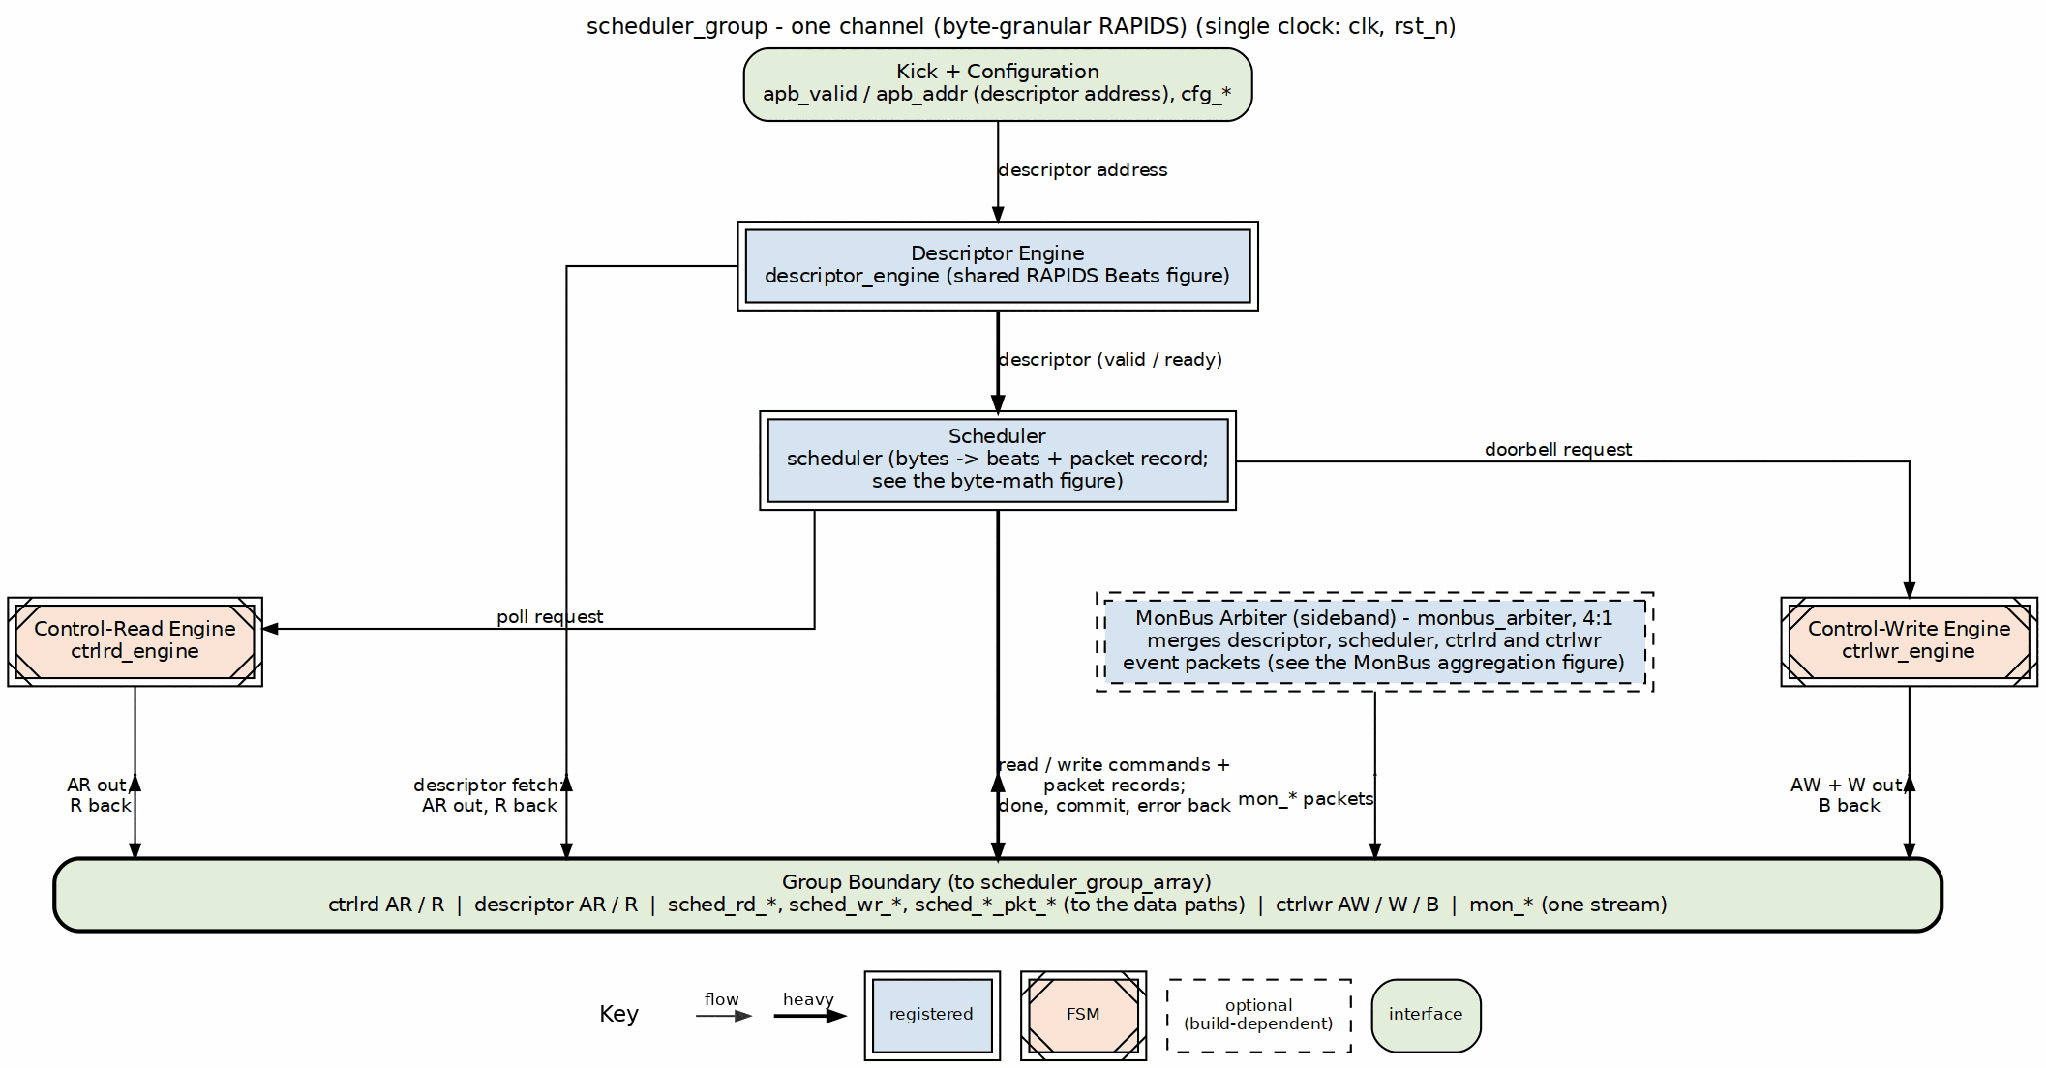
Scheduler group block diagram
Source: 07_scheduler_group.dot

16.2 Parameters
Table 3.1.1: Scheduler Group Parameters
Parameter | Default | Description
CHANNEL_ID | 0 | Channel identifier.
NUM_CHANNELS | 8 | Total channels.
CHAN_WIDTH | $clog2(NUM_CHANNELS) | Channel id width.
ADDR_WIDTH | 64 | Address width.
DATA_WIDTH | 512 | Data width in bits. Sets the beat size seen by the scheduler.
AXI_ID_WIDTH | 8 | AXI ID width for the descriptor and control masters.
DESC_MON_AGENT_ID | 16 | MonBus agent id of the descriptor engine.
SCHED_MON_AGENT_ID | 48 | MonBus agent id of the scheduler.
CTRLRD_MON_AGENT_ID | 32 | MonBus agent id of the control read engine.
CTRLWR_MON_AGENT_ID | 33 | MonBus agent id of the control write engine.
MON_UNIT_ID | 1 | MonBus unit id.
MON_CHANNEL_ID | 0 | Base MonBus channel id.
EN_READ | 1 | Enable the read direction of the scheduler.
EN_WRITE | 1 | Enable the write direction of the scheduler.
USE_ROW_COL_MAJOR_ADDRESSING | 1 | Descriptor engine addressing mode.
GEN_MON | 1 | Enable monitor packet generation.
OFF_W | $clog2(DATA_WIDTH/8) | Width of the packet-record byte offset. New in RAPIDS.

16.3 Port List

16.3.1 Clock, Reset and Kick-Off
Table 3.1.2: Clock, Reset and Kick-Off
Signal | Direction | Width | Description
clk | input | 1 | System clock.
rst_n | input | 1 | Active-low reset.
apb_valid | input | 1 | Channel kick-off.
apb_ready | output | 1 | Descriptor engine ready for kick-off.
apb_addr | input | AW | First descriptor address.

16.3.2 Configuration Interface
Table 3.1.3: Configuration Interface
Signal | Direction | Width | Description
cfg_channel_enable | input | 1 | Enable this channel.
cfg_channel_reset | input | 1 | Per-channel soft reset.
cfg_sched_timeout_cycles | input | 32 | Write-progress timeout window in cycles.
cfg_sched_timeout_limit | input | 8 | Consecutive timeout windows before a fatal error. 0 means never.
cfg_sched_timeout_enable | input | 1 | Enable timeout detection.
cfg_sched_err_enable | input | 1 | Enable error reporting.
cfg_sched_compl_enable | input | 1 | 1 passes CORE Completion packets to the monitor bus; 0 drops them at the arbiter inputs.
cfg_sched_perf_enable | input | 1 | Enable performance monitoring.
cfg_ctrlrd_max_try | input | 9 | Control-read poll retry budget, 0 to 511.
tick_1us | input | 1 | 1 us tick for control-read retry spacing.
cfg_desceng_prefetch | input | 1 | Enable descriptor prefetch.
cfg_desceng_fifo_thresh | input | 4 | Prefetch threshold.
cfg_desceng_addr0_base | input | AW | Valid descriptor address range 0 base.
cfg_desceng_addr0_limit | input | AW | Valid descriptor address range 0 limit.
cfg_desceng_addr1_base | input | AW | Valid descriptor address range 1 base.
cfg_desceng_addr1_limit | input | AW | Valid descriptor address range 1 limit.

16.3.3 Status
Table 3.1.4: Status Interface
Signal | Direction | Width | Description
descriptor_engine_idle | output | 1 | Descriptor engine idle.
scheduler_idle | output | 1 | Scheduler idle.
scheduler_state | output | 7 | Scheduler FSM state, one-hot.
sched_error | output | 1 | Scheduler error, sticky.

16.3.4 Descriptor AXI Master Interface
Table 3.1.5: Descriptor AXI Master Interface
Signal | Direction | Width | Description
desc_ar_valid / desc_ar_ready | output / input | 1 | AR handshake.
desc_ar_addr | output | AW | Descriptor fetch address.
desc_ar_len | output | 8 | Burst length minus one.
desc_ar_size | output | 3 | Burst size.
desc_ar_burst | output | 2 | Burst type.
desc_ar_id | output | IW | Transaction ID.
desc_ar_lock, _cache, _prot, _qos, _region | output | 1, 4, 3, 4, 4 | Attribute fields.
desc_r_valid / desc_r_ready | input / output | 1 | R handshake.
desc_r_data | input | 256 | Descriptor payload, fixed 256 bits.
desc_r_resp | input | 2 | Read response.
desc_r_last | input | 1 | Last beat.
desc_r_id | input | IW | Response ID.

16.3.5 Control Read and Control Write AXI Interfaces
The control read engine fetches a 32-bit semaphore word: ctrlrd_ar_* carries the AR channel (address, length, size, burst, id and the same attribute fields as above) and ctrlrd_r_valid, ctrlrd_r_ready, ctrlrd_r_data[31:0], ctrlrd_r_id, ctrlrd_r_resp and ctrlrd_r_last the R channel. The control write engine writes a 32-bit word: ctrlwr_aw_* carries the AW channel, ctrlwr_w_valid, ctrlwr_w_ready, ctrlwr_w_data[31:0], ctrlwr_w_strb[3:0] and ctrlwr_w_last the W channel, and ctrlwr_b_valid, ctrlwr_b_ready, ctrlwr_b_id and ctrlwr_b_resp the B channel. These are unchanged from RAPIDS Beats. See Control Read Engine and Control Write Engine.

16.3.6 Scheduler Data Interface
Table 3.1.6: Scheduler Data Interface
Signal | Direction | Width | Description
sched_rd_valid | output | 1 | Read request.
sched_rd_addr | output | AW | Working source byte address.
sched_rd_beats | output | 32 | Beats still to read.
sched_wr_valid | output | 1 | Write request.
sched_wr_ready | input | 1 | Write engine reports the last burst of the descriptor committed.
sched_wr_addr | output | AW | Working destination byte address.
sched_wr_beats | output | 32 | Beats still to write.
sched_rd_done_strobe | input | 1 | Read burst issued.
sched_rd_beats_done | input | 32 | Beats in that burst.
sched_wr_done_strobe | input | 1 | Write AW issued.
sched_wr_beats_done | input | 32 | Beats in that AW.
sched_wr_commit_strobe | input | 1 | Write B response received.
sched_wr_commit_beats | input | 32 | Beats committed by that B response.
sched_rd_error | input | 1 | Sticky read error from the read engine.
sched_wr_error | input | 1 | Sticky write error, including a packet-length error from the sink path.

16.3.7 Packet Record Interface
Table 3.1.7: Packet Record Interface
Signal | Direction | Width | Description
sched_rd_pkt_valid | output | 1 | One-cycle pulse: a read-side packet record is available.
sched_rd_pkt_ready | input | 1 | Consumer has room in its record queue.
sched_rd_pkt_bytes | output | 32 | Packet length in bytes.
sched_rd_pkt_offset | output | OFF_W | Byte offset of the packet start within its first memory beat.
sched_wr_pkt_valid | output | 1 | One-cycle pulse: a write-side packet record is available.
sched_wr_pkt_ready | input | 1 | Consumer has room in its record queue.
sched_wr_pkt_bytes | output | 32 | Packet length in bytes.
sched_wr_pkt_offset | output | OFF_W | Byte offset of the packet start within its first memory beat.
The group wires these signals directly to the scheduler. The read-side record goes to the source data path and the write-side record to the sink data path. The scheduler holds a descriptor in its fetch state while a required record queue is full, using the ready inputs. See Packet Record Interface.

16.3.8 MonBus Interface
Table 3.1.8: MonBus Interface
Signal | Direction | Width | Description
i_mon_time | input | monbus_timestamp_t | Shared monitor timebase.
mon_valid | output | 1 | Monitor packet valid.
mon_ready | input | 1 | Consumer ready.
mon_packet | output | monitor_packet_t | Monitor packet.
mon_timestamp | output | monbus_timestamp_t | Packet timestamp.

16.4 Internal Architecture

16.4.1 Descriptor Path
The descriptor engine fetches 256-bit descriptors from the address range the configuration allows and hands each one to the scheduler with its type, end-of-stream, end-of-list and error flags. The scheduler reports scheduler_idle back to the descriptor engine as channel_idle. No byte or beat arithmetic happens in the descriptor engine.

16.4.2 Control Engines
When a descriptor asks the scheduler to wait on or update a semaphore, the scheduler talks to the control engines through valid and ready handshakes with an address, data and mask. Both engines share the group’s AXI_ID_WIDTH and each raises its own MonBus packets.

16.4.3 MonBus Aggregation
A four-client arbiter merges the descriptor engine, scheduler, control read and control write packets. cfg_sched_compl_enable gates only the CORE Completion packets of the descriptor engine and the scheduler: with it low, those packets are consumed at the arbiter input and never reach mon_packet. Error packets are never gated. GEN_MON masks every arbiter input when clear.

16.5 Differences from RAPIDS Beats
Table 3.1.9: Scheduler Group Delta
Item | RAPIDS Beats | RAPIDS
Parameter OFF_W | absent | present, $clog2(DATA_WIDTH/8)
sched_rd_pkt_*, sched_wr_pkt_* ports | absent | present, wired to the scheduler
Everything else |  | Unchanged
The beats chapter is Beats Scheduler Group. The scheduler is described in Scheduler.

Last Updated: 2026-09-30

RTL Design Sherpa · Learning Hardware Design Through Practice GitHub · Documentation Index · MIT License

17 Scheduler Group Array
Module: scheduler_group_array.sv Location: projects/components/dma-ip/rapids/rtl/macro/ Status: Implemented Last Updated: 2026-10-16

17.1 Overview
The scheduler group array runs one scheduler per channel and three engines that issue the array’s AXI traffic: the descriptor fetch engine, the control-read engine and the control-write engine. SHARED_ENGINES (default 1) selects how the engines are built. With 1, the array has one of each engine for all of its channels, and each engine picks among the schedulers round-robin (see Shared Engines below and the Shared Engines chapter). With 0, every channel has its own three engines inside a scheduler group, and three AXI-side arbiters merge their masters (the original structure). It also owns the descriptor-AXI monitor and merges every channel’s MonBus output with the monitor’s into one stream.
Compared with the RAPIDS Beats array, the sharing, arbitration and monitoring are unchanged. The array adds one parameter, OFF_W, and the per-channel packet-record ports, which it connects to each group by channel index.

17.1.1 Key Features
- One group per channel: NUM_CHANNELS scheduler groups.
- Shared engines (SHARED_ENGINES = 1, default): one descriptor_engine_shared, one ctrlrd_engine_shared and one ctrlwr_engine_shared per array, arbitrating on the scheduler side and owning their AXI masters.
- Per-channel engines (SHARED_ENGINES = 0): one scheduler group per channel, and three round-robin arbiters with grant acknowledgment on the AXI side (u_desc_ar_arbiter, u_ctrlrd_ar_arbiter, u_ctrlwr_aw_arbiter).
- Descriptor-AXI monitor: a lite AXI read monitor on the shared descriptor master, plus an always-on bus meter for the perf window.
- Unified MonBus: one round-robin arbiter over NUM_CHANNELS + 4 sources (shared engines) or NUM_CHANNELS + 1 (per-channel engines).
- Direction gating: EN_READ and EN_WRITE let the source array be read-only and the sink array write-only.
- Per-channel packet records: vector ports for the byte length and offset of each channel’s packet.

17.1.2 Block Diagram

17.1.3 Figure 3.2.1: Scheduler Group Array Block Diagram
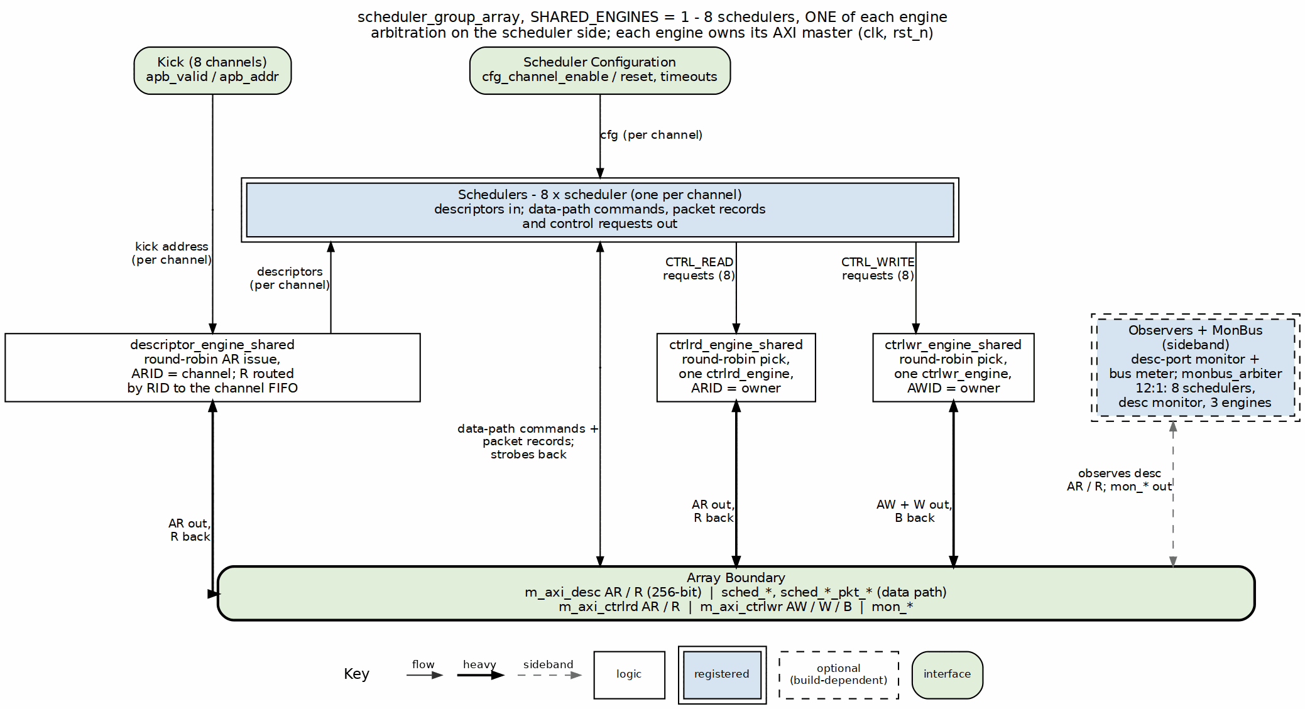
Scheduler group array block diagram
Source: 08_scheduler_group_array.dot

17.2 Parameters
Table 3.2.1: Scheduler Group Array Parameters
Parameter | Default | Description
NUM_CHANNELS | 8 | Number of channels.
CHAN_WIDTH | $clog2(NUM_CHANNELS) | Channel id width.
ADDR_WIDTH | 64 | Address width.
DATA_WIDTH | 512 | Data width in bits.
AXI_ID_WIDTH | 8 | AXI ID width.
DESC_MON_BASE_AGENT_ID | 16 | Base MonBus agent id of the descriptor engines.
SCHED_MON_BASE_AGENT_ID | 48 | Base MonBus agent id of the schedulers.
DESC_AXI_MON_AGENT_ID | 8 | MonBus agent id of the descriptor AXI monitor.
MON_UNIT_ID | 1 | MonBus unit id.
MON_MAX_TRANSACTIONS | 16 | Transaction table depth of the descriptor monitor.
EN_READ | 1 | Enable the read direction in every scheduler. Clear for a sink array.
EN_WRITE | 1 | Enable the write direction in every scheduler. Clear for a source array.
USE_AXI_MONITORS | 1 | 0 omits the descriptor-AXI monitor hardware and ties its MonBus source to zero.
USE_ROW_COL_MAJOR_ADDRESSING | 1 | 0 compiles out the extended addressing path.
GEN_MON | 1 | 0 omits the per-channel completion and error emitters.
SHARED_ENGINES | 1 | 1: one descriptor, control-read and control-write engine for the array. 0: one of each per channel.
OFF_W | $clog2(DATA_WIDTH/8) | Width of the packet-record byte offset. New in RAPIDS.

17.3 Port List
Vector ports are NUM_CHANNELS wide (NC), indexed by channel.

17.3.1 Clock, Reset and Kick-Off
Table 3.2.2: Clock, Reset and Kick-Off
Signal | Direction | Width | Description
clk | input | 1 | System clock.
rst_n | input | 1 | Active-low reset.
apb_valid | input | NC | Per-channel kick-off.
apb_ready | output | NC | Per-channel ready.
apb_addr | input | NC x AW | First descriptor address per channel.
cfg_channel_enable | input | NC | Per-channel enable.
cfg_channel_reset | input | NC | Per-channel soft reset.

17.3.2 Global Scheduler and Descriptor Engine Configuration
These inputs are applied to every channel.
Table 3.2.3: Global Configuration
Signal | Direction | Width | Description
cfg_sched_enable | input | 1 | Master scheduler enable.
cfg_sched_timeout_cycles | input | 32 | Timeout window in cycles.
cfg_sched_timeout_limit | input | 8 | Consecutive timeouts before a fatal error. 0 means never.
cfg_sched_timeout_enable | input | 1 | Enable timeout detection.
cfg_sched_err_enable | input | 1 | Enable error reporting.
cfg_sched_compl_enable | input | 1 | Enable CORE Completion packets.
cfg_sched_perf_enable | input | 1 | Enable performance monitoring.
cfg_desceng_enable | input | 1 | Master descriptor engine enable.
cfg_desceng_prefetch | input | 1 | Enable descriptor prefetch.
cfg_desceng_fifo_thresh | input | 4 | Prefetch threshold.
cfg_desceng_addr0_base, _limit | input | AW | Valid descriptor address range 0.
cfg_desceng_addr1_base, _limit | input | AW | Valid descriptor address range 1.
cfg_ctrlrd_max_try | input | 9 | Control-read poll retry budget.
tick_1us | input | 1 | 1 us tick for control-read retry spacing.

17.3.3 Descriptor Monitor Configuration and Status
Table 3.2.4: Descriptor Monitor Configuration and Status
Signal | Direction | Width | Description
cfg_desc_mon_enable | input | 1 | Enable the descriptor AXI monitor.
cfg_desc_mon_err_enable | input | 1 | Enable error packets.
cfg_desc_mon_perf_enable | input | 1 | Enable performance packets.
cfg_desc_mon_perf_run | input | 1 | Perf window control.
cfg_desc_mon_timeout_enable | input | 1 | Enable timeout packets.
cfg_desc_mon_timeout_cycles | input | 32 | Timeout threshold.
cfg_desc_mon_latency_thresh | input | 32 | Latency threshold.
cfg_desc_mon_pkt_mask | input | 16 | Packet type mask.
cfg_desc_mon_err_select | input | 4 | Error select.
cfg_desc_mon_err_mask, _timeout_mask, _compl_mask, _thresh_mask, _perf_mask, _addr_mask, _debug_mask | input | 8 each | Per-class event masks.
cfg_sts_desc_mon_busy | output | 1 | Monitor busy.
cfg_sts_desc_mon_active_txns | output | 8 | Active transactions.
cfg_sts_desc_mon_error_count | output | 16 | Error count.
cfg_sts_desc_mon_txn_count | output | 32 | Transaction count.
cfg_sts_desc_mon_conflict_error | output | 1 | Conflict error.

17.3.4 Descriptor-AXI Perf Window
The perf counters come from an always-on bus meter on the descriptor R channel, not from the monitor. cfg_desc_mon_perf_run opens the window: counters clear on its rising edge, count while it is high and hold while it is low. USE_AXI_MONITORS does not gate the meter.
Table 3.2.5: Descriptor-AXI Perf Window
Signal | Direction | Width | Description
sts_desc_mon_win_active | output | 1 | Window open.
sts_desc_mon_win_cycles | output | 32 | Cycles in the window.
sts_desc_mon_prod_cycles | output | 32 | R valid and ready.
sts_desc_mon_bp_cycles | output | 32 | R valid, not ready.
sts_desc_mon_starv_cycles | output | 32 | R ready, not valid.
sts_desc_mon_idle_cycles | output | 32 | Neither valid nor ready.
sts_desc_mon_beat_count | output | 32 | R handshakes.
sts_desc_mon_byte_count | output | 64 | Bytes moved on R (32 per descriptor beat).
sts_desc_mon_burst_count | output | 32 | AR handshakes.

17.3.5 Status
Table 3.2.6: Status
Signal | Direction | Width | Description
descriptor_engine_idle | output | NC | Per-channel descriptor engine idle.
scheduler_idle | output | NC | Per-channel scheduler idle.
scheduler_state | output | NC x 7 | Per-channel FSM state, one-hot.
sched_error | output | NC | Per-channel scheduler error, sticky.

17.3.6 Shared AXI Masters
The three shared masters carry the same signals as the per-group ports in Scheduler Group, prefixed desc_axi_, ctrlrd_axi_ and ctrlwr_axi_. The descriptor master returns 256-bit data. The control read master returns 32-bit data. The control write master is 32 bits wide with a 4-bit strobe. Each is a single interface: the arbiter selects one channel’s request onto it and steers the response back by ID.

17.3.7 Per-Channel Scheduler Data Interface
Table 3.2.7: Per-Channel Scheduler Data Interface
Signal | Direction | Width | Description
sched_rd_valid | output | NC | Read request per channel.
sched_rd_addr | output | NC x AW | Working source byte address.
sched_rd_beats | output | NC x 32 | Beats still to read.
sched_wr_valid | output | NC | Write request per channel.
sched_wr_ready | input | NC | Last burst of the descriptor committed.
sched_wr_addr | output | NC x AW | Working destination byte address.
sched_wr_beats | output | NC x 32 | Beats still to write.
sched_rd_done_strobe | input | NC | Read burst issued.
sched_rd_beats_done | input | NC x 32 | Beats in that burst.
sched_wr_done_strobe | input | NC | Write AW issued.
sched_wr_beats_done | input | NC x 32 | Beats in that AW.
sched_wr_commit_strobe | input | NC | Write B response received.
sched_wr_commit_beats | input | NC x 32 | Beats committed.
sched_rd_error | input | NC | Sticky read error.
sched_wr_error | input | NC | Sticky write error.

17.3.8 Per-Channel Packet Record Interface
Table 3.2.8: Per-Channel Packet Record Interface
Signal | Direction | Width | Description
sched_rd_pkt_valid | output | NC | Read-side record pulse per channel.
sched_rd_pkt_ready | input | NC | Read-side consumer has room.
sched_rd_pkt_bytes | output | NC x 32 | Packet length in bytes.
sched_rd_pkt_offset | output | NC x OFF_W | Start offset in the first memory beat.
sched_wr_pkt_valid | output | NC | Write-side record pulse per channel.
sched_wr_pkt_ready | input | NC | Write-side consumer has room.
sched_wr_pkt_bytes | output | NC x 32 | Packet length in bytes.
sched_wr_pkt_offset | output | NC x OFF_W | Start offset in the first memory beat.
Element [ch] of each vector connects to the matching port of scheduler_group[ch]. The array adds no logic between them. A source array uses only the read set and a sink array only the write set.

17.3.9 MonBus Interface
Table 3.2.9: MonBus Interface
Signal | Direction | Width | Description
i_mon_time | input | monbus_timestamp_t | Shared monitor timebase.
mon_valid | output | 1 | Packet valid.
mon_ready | input | 1 | Consumer ready.
mon_packet | output | monitor_packet_t | Packet.
mon_timestamp | output | monbus_timestamp_t | Timestamp.

17.4 Shared Engines
With SHARED_ENGINES = 1 the per-channel descriptor and control engines are replaced by one of each for the whole array. The arbitration moves from the AXI side to the scheduler side: each engine picks the next channel to serve round-robin, and it owns its AXI master outright, with no arbiter behind it. ARID and AWID carry the channel. The schedulers, the array’s ports and every interface above the array are unchanged.
Table 3.2.11: Shared Engines
Engine | What is shared | What stays per channel
descriptor_engine_shared | AR issuer, address-range comparators, the R path (each beat routed by RID straight into its channel’s FIFO), MonBus reporter | State code, one pending fetch address, kick-in-progress flag, owed-beat flag, descriptor FIFO (and EXT chunk-1 FIFO)
ctrlrd_engine_shared | One ctrlrd_engine | Nothing: an owner register says which channel the engine serves
ctrlwr_engine_shared | One ctrlwr_engine | Nothing: an owner register says which channel the engine serves
Descriptor engine. Each channel keeps one fetch in flight and stays in order. Different channels’ fetches overlap on the bus because each carries its own ARID. Each scheduler sees exactly the per-channel engine’s behaviour: - the same kick policy, and refusal of a kicked address outside both ranges; - the extended-descriptor second fetch; - the prefetch throttle, up to the threshold plus one buffered; - autonomous chaining, the error pulse, and completion and error MonBus packets.
A fetch issues only when its channel’s FIFO has a free entry, so a channel that stops consuming can never hold the shared R channel. A channel reset in the middle of a fetch records the owed beat. The beat is drained when it arrives, and the channel takes no new kick until then. Reset also drains the channel’s FIFO, so descriptors prefetched for an aborted chain are not delivered afterwards. Once ARVALID is raised, the AR address and ID hold until accepted.
The shared descriptor engine’s MonBus output differs from the per-channel engine’s in two ways: - Range refusal: the error packet for a refused kicked address carries 0 in its response field. The per-channel engine carried whatever read response it had last latched, which was stale. - Colliding events: packets go through a small FIFO, and two events can occur in one cycle: a refusal on the issue side, and a completion or error on the R side. The issue-side packet waits one cycle. If another collision arrives while it waits, the waiting packet is dropped. The per-channel engine also dropped packets, whenever MonBus backpressured it. Tests that count descriptor-engine packets should allow for this.
Control engines. The engine runs one request at a time. - A request is offered only while the engine is idle, its last MonBus packet has drained, and no error remains from the previous owner. A stale error is cleared with a one-cycle engine reset before the next channel’s request is taken. - The owner sees the engine’s idle and error exactly as a dedicated engine would show them; every other channel sees idle 1 and error 0. - The owner’s channel reset resets the engine only while the owner’s operation is in flight, so a channel parked in reset cannot hold the engine for everyone else. - MonBus packets are re-tagged with the owner’s channel and agent ID (0x20 + channel for control reads, 0x28 + channel for control writes).
Trade-off: a CTRL_READ that keeps polling holds the control-read engine, so other channels’ control reads wait behind it. Data transfers are unaffected.

17.5 Shared Master Arbitration (SHARED_ENGINES = 0)
Each shared master has a round-robin arbiter over NUM_CHANNELS requesters in acknowledge mode. The grant is held until the granted channel’s request is accepted (grant_ack), so a granted channel always sees its own valid and ready. The AR or AW ready seen by a channel is the downstream ready gated by that channel’s grant.

17.5.1 Figure 3.2.2: Shared Master Arbitration
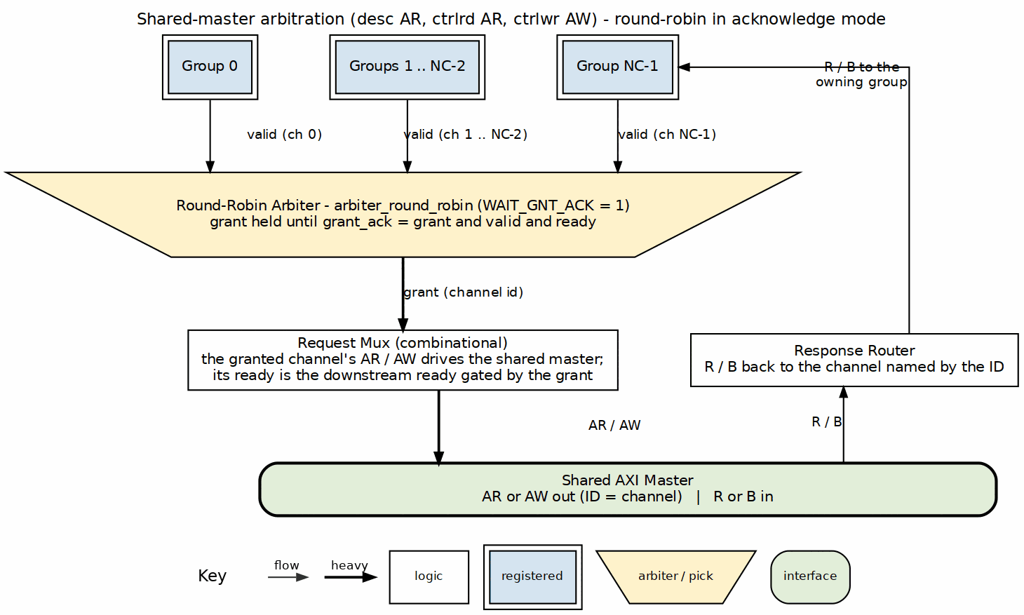
Shared master arbitration
Source: 11_shared_master_arbitration.dot

17.6 MonBus Aggregation
Table 3.2.10: MonBus Source Assignment
Source | Origin | Content
0 to NC-1 | scheduler_group[ch] (per-channel engines) or scheduler[ch] (shared engines) | Per-channel engines: that channel’s descriptor engine, scheduler, control read and control write packets. Shared engines: that channel’s scheduler packets
NC | Descriptor AXI monitor | Descriptor fetch monitor packets
NC+1 | Shared descriptor engine (shared engines only) | Every channel’s descriptor completion and error packets
NC+2 | Shared control-read engine (shared engines only) | Every channel’s control-read packets
NC+3 | Shared control-write engine (shared engines only) | Every channel’s control-write packets
One round-robin arbiter with acknowledge mode merges the sources into mon_*: NUM_CHANNELS + 4 with shared engines, NUM_CHANNELS + 1 with per-channel engines. Each source carries its own timestamp alongside the packet.

17.7 Differences from RAPIDS Beats
Table 3.2.11: Array Delta
Item | RAPIDS Beats | RAPIDS
Parameter OFF_W | absent | present
sched_rd_pkt_*, sched_wr_pkt_* vectors | absent | present, wired by channel
Everything else |  | Unchanged
The beats chapter is Beats Scheduler Group Array.

Last Updated: 2026-09-30

RTL Design Sherpa · Learning Hardware Design Through Practice GitHub · Documentation Index · MIT License

18 Sink Data Path
Module: snk_data_path.sv Location: projects/components/dma-ip/rapids/rtl/macro/ Status: Implemented Last Updated: 2026-09-30

18.1 Overview
The sink data path joins the per-channel SRAM controller to the AXI write engine. Data enters through the fill interface, waits in the channel’s SRAM partition and leaves as AXI4 write bursts.
In RAPIDS every SRAM word carries the byte enables of its data. The fill interface widens from DW to DW + SW bits, where SW = DW/8, and the write engine drives m_axi_wstrb from the stored enables. Everything else, including the allocation protocol, the scheduler interface and the burst rules, is as in RAPIDS Beats.

18.1.1 Key Features
- Per-channel SRAM partitions: flow control by allocation and space-free counts.
- Byte enables stored with the data: the SRAM is DW + SW bits wide.
- AXI write engine: 4 KB-safe, beat-aligned bursts. See AXI Write Engine.
- Scheduler integration: beat counts in, issue and commit strobes out.

18.1.2 Figure 3.3.1: Sink Data Path Block Diagram
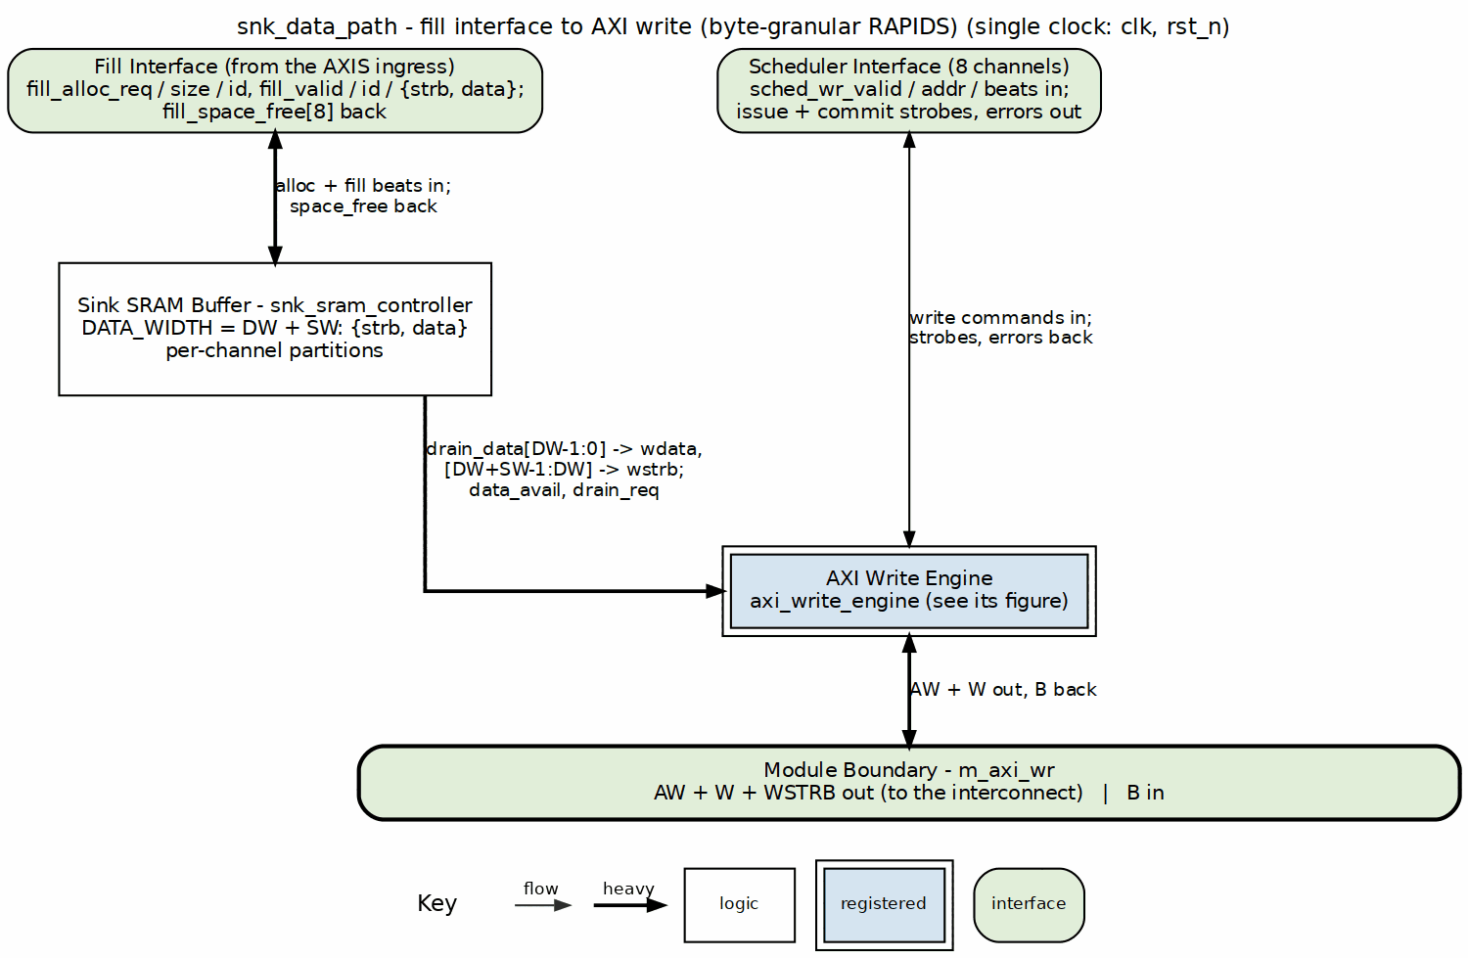
Sink data path block diagram
Source: 09_snk_data_path.dot

18.2 Parameters
Table 3.3.1: Sink Data Path Parameters
Parameter | Default | Description
NUM_CHANNELS | 8 | Number of channels (alias NC).
ADDR_WIDTH | 64 | Address width (alias AW).
DATA_WIDTH | 512 | Data width in bits (alias DW). The board uses 256.
AXI_ID_WIDTH | 8 | AXI ID width (alias IW).
SRAM_DEPTH | 512 | Words per channel partition (alias SD).
SEG_COUNT_WIDTH | $clog2(SRAM_DEPTH) + 1 | Space counter width (alias SCW).
PIPELINE | 1 | SRAM read pipeline setting.
AW_MAX_OUTSTANDING | 8 | AW commands the write engine may have in flight.
W_PHASE_FIFO_DEPTH | 64 | Depth of the write engine W-phase queue.
B_PHASE_FIFO_DEPTH | 16 | Depth of the write engine B-phase queue.
CIW | $clog2(NC) | Channel id width.
SW | DW / 8 | Byte enables per beat. New in RAPIDS.

18.3 Interfaces

18.3.1 Fill Interface
Table 3.3.2: Fill Interface
Signal | Direction | Width | Description
fill_alloc_req | input | 1 | Space allocation request.
fill_alloc_size | input | 8 | Beats to allocate.
fill_alloc_id | input | CIW | Channel to allocate in.
fill_space_free | output | NC x SCW | Free space per channel.
fill_valid | input | 1 | Fill beat valid.
fill_ready | output | 1 | Ready for a fill beat.
fill_id | input | CIW | Channel of the fill beat.
fill_data | input | DW + SW | {byte enables, data}. Bits [DW-1:0] are data. Bits [DW+SW-1:DW] are enables.

18.3.2 Configuration
Table 3.3.3: Configuration
Signal | Direction | Width | Description
cfg_axi_wr_xfer_beats | input | 8 | Write burst size cap in beats, minus one. Renamed from cfg_axi_wr_xfer.
cfg_channel_reset | input | NC | Per-channel reset, level or pulse. Forwarded to the write engine and the SRAM controller wrapper.

18.3.3 Scheduler Interface
Table 3.3.4: Scheduler Interface
Signal | Direction | Width | Description
sched_wr_valid | input | NC | Channel requests writes.
sched_wr_ready | output | NC | Last burst of a descriptor committed.
sched_wr_addr | input | NC x AW | Working destination byte address.
sched_wr_beats | input | NC x 32 | Beats still to write.
sched_wr_burst_len | input | NC x 8 | Requested burst length. Not used for sizing.
sched_wr_done_strobe | output | NC | AW issued.
sched_wr_beats_done | output | NC x 32 | Beats in that AW.
sched_wr_commit_strobe | output | NC | B response received.
sched_wr_commit_beats | output | NC x 32 | Beats committed by that B.
sched_wr_error | output | NC | Sticky write error (bad B response).

18.3.4 AXI4 Write Master
The write master is m_axi_aw*, m_axi_w* and m_axi_b* with IW-bit IDs and DW-bit data. See AXI4 Interface Specification. m_axi_wstrb is DW/8 bits and carries the stored byte enables.

18.4 Byte Enable Path
- The upstream stage presents {strb, data} on fill_data with fill_valid.
- The SRAM controller stores the whole DW + SW word. It is instantiated with DATA_WIDTH = DW + SW.
- The drain side returns the same word as drain_data.
- drain_data[DW-1:0] goes to axi_wr_sram_data and drain_data[DW+SW-1:DW] goes to axi_wr_sram_strb on the write engine.
- The write engine drives m_axi_wdata and m_axi_wstrb from those two.
The SRAM depth counts words, so capacity in beats is unchanged. Only the width grows, by one bit per data byte.

18.4.1 Channel Reset
cfg_channel_reset[ch] reaches two blocks. The AXI Write Engine stops issuing for the channel, completes an open burst with null beats and clears its error flag. The SRAM controller wrapper (snk_sram_controller) holds one single-channel sram_controller per channel. Each instance’s reset is a registered flop, r_ch_rst_n[ch], which goes low one cycle after cfg_channel_reset[ch] rises, so the partition’s pointers and counters return to empty. The shared STREAM sram_controller has no channel reset of its own and is not modified; giving each channel its own instance and reset is what makes the reset per channel. A reset of one channel leaves the instances of the other channels untouched.

18.5 Differences from RAPIDS Beats
Table 3.3.5: Sink Data Path Delta
Item | RAPIDS Beats | RAPIDS
fill_data width | DW | DW + SW
SRAM word width | DW | DW + SW
m_axi_wstrb | all ones | stored per-beat enables
Config port name | cfg_axi_wr_xfer | cfg_axi_wr_xfer_beats
Scheduler port names | sched_wr, sched_wr_done, sched_wr_commit | sched_wr_beats, sched_wr_beats_done, sched_wr_commit_beats
Fill allocation, drain, error export |  | Unchanged
The beats chapter is Sink Data Path. Its timing diagrams apply to the AW, W and B sequencing unchanged.

Last Updated: 2026-09-30

RTL Design Sherpa · Learning Hardware Design Through Practice GitHub · Documentation Index · MIT License

19 Sink Data Path with AXIS (Ingress)
Module: snk_data_path_axis.sv Location: projects/components/dma-ip/rapids/rtl/macro/ Status: Implemented Last Updated: 2026-09-30

19.1 Overview
This module puts an AXI-Stream slave in front of the Sink Data Path and converts a packed byte stream into beat-aligned memory beats with byte enables. It is the block that makes the sink side byte-granular.
A packet arrives with its bytes packed from lane 0. Its destination in memory starts at a byte offset inside the first memory beat. The scheduler supplies that offset in a packet record. The module shifts each stream beat up by the offset, holds the bytes that spill past the beat boundary, and merges them into the next memory beat. After the last stream beat, a non-empty spill becomes one more, partial, memory beat.

19.1.1 Key Features
- Barrel shift by the destination offset: stream lane l lands in memory lane offset + l.
- Byte enables follow the data: the shifted strobe is stored beside the data and becomes WSTRB.
- Per-channel state: spill hold, received-byte count and length-error flag per channel, so packets of different channels interleave by beat.
- Packet record queue: four records per channel, fed by the scheduler.
- Descriptor gating: the stream is accepted only when the channel has a packet record.
- Length check: a packet whose byte count differs from the descriptor sets a sticky channel error.
- Allocation logic unchanged from RAPIDS Beats, including the settle wait.

19.1.2 Figure 3.4.1: Ingress Shifter
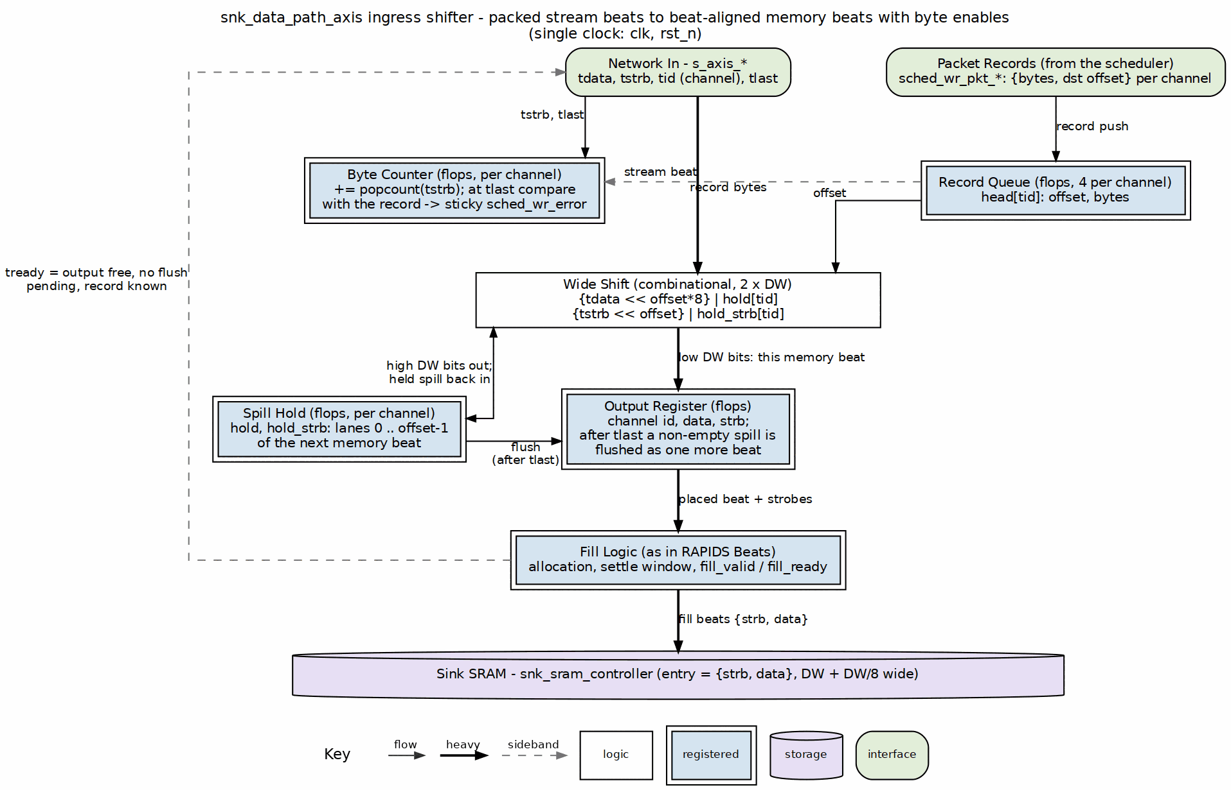
Ingress shifter
Source: 01_ingress_shifter.dot

19.2 Parameters
Parameters of Sink Data Path apply unchanged. The additions are:
Table 3.4.1: Additional Parameters
Parameter | Default | Description
AXIS_ID_WIDTH | 8 | tid width. The low CIW bits select the channel.
AXIS_DEST_WIDTH | 4 | tdest width. Not used to select a channel.
AXIS_USER_WIDTH | 1 | tuser width. Not used.
SW | DW / 8 | Byte lanes per beat.
OFF_W | $clog2(SW) | Width of the packet-record offset.

19.3 Interfaces

19.3.1 AXI-Stream Slave
Table 3.4.2: AXI-Stream Slave
Signal | Direction | Width | Description
s_axis_tdata | input | DW | Packed data.
s_axis_tstrb | input | SW | Byte strobes. Contiguous from lane 0. Partial only on the tlast beat.
s_axis_tlast | input | 1 | Last beat of the packet.
s_axis_tid | input | AXIS_ID_WIDTH | Channel select.
s_axis_tdest | input | AXIS_DEST_WIDTH | Unused.
s_axis_tuser | input | AXIS_USER_WIDTH | Unused.
s_axis_tvalid | input | 1 | Beat valid.
s_axis_tready | output | 1 | Beat accepted.
s_axis_tready is high when the output register is free, no flush beat is pending and the addressed channel has a packet record queued. A channel’s stream therefore stalls until its scheduler has fetched the descriptor. s_axis_tready is a single signal qualified by the TID of the beat on the bus, so a beat for a channel that has no record blocks the stream, and any channel’s beats behind it, until that record arrives. Channels on one stream are not isolated from each other; a system that needs isolation gives each channel its own stream or guarantees the descriptor is queued before the packet is sent. s_axis_tready is also low for a beat whose TID names a channel in reset, and high without a record for a channel that is discarding the tail of a cut packet (see Channel Reset).

19.3.2 Scheduler Interface
The write request and completion ports are those of Sink Data Path. The packet record ports are new:
Table 3.4.3: Packet Record Ports
Signal | Direction | Width | Description
sched_wr_pkt_valid | input | NC | Record pulse from the scheduler.
sched_wr_pkt_ready | output | NC | Record queue not full.
sched_wr_pkt_bytes | input | NC x 32 | Packet length in bytes.
sched_wr_pkt_offset | input | NC x OFF_W | Destination offset in the first memory beat.
cfg_channel_reset | input | NC | Per-channel reset, level or pulse. Clears the channel’s queue, hold, byte count and length error, and discards the tail of a cut packet.
sched_wr_error is the OR of the write engine’s B-response error and the packet length error of the channel. Both clear on cfg_channel_reset (see Channel Reset).

19.3.3 Other Ports
The AXI4 write master is that of Sink Data Path. cfg_alloc_size (8 bits) is the allocation segment per request, with 0 treated as 1. The debug outputs are dbg_sram_bridge_pending, dbg_sram_bridge_out_valid, dbg_axis_beats_received and dbg_axis_packets_received. o_active_channel_id and o_active_channel_valid carry the write engine’s active channel to the per-channel bus meter.

19.4 Ingress Operation

19.4.1 Packet Records
Each channel has a four-entry queue of {offset, bytes}. A record is pushed on sched_wr_pkt_valid when the queue is not full and popped when the packet completes. The head record supplies the offset for every beat of the packet and the expected length at tlast.

19.4.2 Placement
For an accepted stream beat, with off the head record’s offset:
- The wide word is (tdata_m << off*8) | hold_data, of width 2*DW, where tdata_m is tdata with every lane whose tstrb bit is clear forced to zero.
- The wide strobe is (tstrb << off) | hold_strb, of width 2*SW.
- The low half goes to the output register as the memory beat and its enables.
- The high half becomes the new hold for the channel.
The strobe mask matters on a partial last beat: the non-strobed lanes carry whatever the sender left there, and unmasked they would shift into the spill hold. A packet that ends without a spill never flushes the hold, so that junk would be ORed into the first memory beat of the channel’s next packet. Masking by tstrb keeps the hold to real payload bytes.
The first memory beat has its low off strobe bits clear, so the bytes below the start address are not written.

19.4.3 Flush and Completion
On tlast the received-byte total is compared with the head record. If the wide strobe’s high half is non-zero, a flush is scheduled and s_axis_tready drops until the hold has been emitted as the last memory beat. The packet then completes and its record pops. If the high half is empty the packet completes on the tlast beat itself.

19.4.4 Length Check
r_pkt_rx_bytes counts the popcount of tstrb over the packet. At tlast, a total that differs from the record’s byte count sets the channel’s sticky error. Nothing is padded or dropped. The error is visible on sched_wr_error and the scheduler treats it as fatal. It clears on cfg_channel_reset.

19.4.5 Channel Reset
cfg_channel_reset[ch] is a register level in the system (SNK.CHANNEL_RESET.CH_RST ORed with GLOBAL_CTRL.GLOBAL_RST), so a pulse and a held level must both work. The ingress registers it once into r_rst_d1 and uses w_rst[ch] = cfg_channel_reset[ch] | r_rst_d1[ch], which stretches a one-cycle pulse to two cycles and lets every clear see the reset on a cycle where it is asserted. The stretch is what settles an output-register beat and an allocation that were launched on the cycle of the reset. The reset is written for one channel; every term is indexed by channel, so the other channels are not affected.
Table 3.4.4: Channel Reset Actions
State | Action on w_rst[ch]
Packet record queue | Write and read pointers cleared. A record arriving on the reset cycle is not pushed.
Spill hold, r_pkt_rx_bytes | Cleared.
r_pkt_len_error | Cleared. The channel’s sched_wr_error contribution drops.
r_pending_alloc, r_alloc_settle | Cleared, so no allocation request of the old packet is issued.
Output register (r_out_valid), flush beat (r_flush_valid) | Dropped when the beat belongs to the channel, so no beat of the old packet enters the SRAM after the reset.
s_axis_tready | Low for a beat whose TID names a channel in reset.
r_discard[ch] | Set when a packet was part-way through the stream (received bytes non-zero and no flush of its own pending).
With r_discard[ch] set the ingress accepts the channel’s beats without a record and drops them: s_axis_tready does not wait for a packet record, and no state is updated. r_discard[ch] clears on the dropped beat that carries tlast. The next beat is then an ordinary first beat of a new packet. The sender is not asked to do anything special: it finishes the packet it was sending and the tail is discarded. A packet whose beats had all been accepted (the flush beat aside) is not discarded.
Head-of-line blocking is unchanged. A beat for a channel with no record, and not discarding, still holds s_axis_tready low for every channel. After a reset the next packet for the channel waits for its descriptor as before.
The channel’s write engine and SRAM partition are cleared by the blocks that own them; see AXI Write Engine and Sink Data Path. All of them settle within a few cycles of the reset, and the scheduler’s own reset returns it to CH_IDLE, so a channel reset recovers the channel without aresetn.

19.4.6 Allocation
The output register holds one memory beat for the fill interface. Allocation follows the beats design:
- A channel requests cfg_alloc_size beats, or the remainder when less is free.
- The next allocation of a channel waits three cycles after its previous one so fill_space_free is current.
- A beat leaves the output register only when the fill interface accepts it.

19.5 Differences from RAPIDS Beats
Table 3.4.5: Ingress Delta
Item | RAPIDS Beats | RAPIDS
Stream beat to memory beat | one to one, full lanes | shifted by the offset, spill held
s_axis_tstrb | full only | partial on the tlast beat
Byte enables into SRAM | none | {strb, data} word
Packet record queue | absent | four per channel
Stream gating | buffers before the descriptor | waits for the packet record
Length mismatch | not checked | sticky channel error, cleared by channel reset
Channel reset | not applicable | per-channel clear, cut packet tail discarded
The beats chapter is Sink Data Path with AXIS.

Last Updated: 2026-09-30

RTL Design Sherpa · Learning Hardware Design Through Practice GitHub · Documentation Index · MIT License

20 Sink SRAM Controller Specification
Module: snk_sram_controller_beats.sv Location: projects/components/dma-ip/rapids/rtl/macro_beats/ Status: Implemented Last Updated: 2025-01-10

20.1 Overview
The Sink SRAM Controller is a naming wrapper, with no logic of its own, around STREAM’s sram_controller – the one per-channel SRAM implementation both DMAs share since bdf4e0dff. It maps the RAPIDS fill_*/drain_* names onto STREAM’s ports; the eight per-channel units (allocation counter, FIFO, drain counter, latency bridge) live inside STREAM’s block. It manages 8 channel units, providing per-channel buffering with channel arbitration for the shared AXI write engine.

20.1.1 Key Features
- One shared implementation: instantiates STREAM’s sram_controller once; it holds 8 sram_controller_units, each a gaxi_fifo_sync FIFO with stream_alloc_ctrl, stream_drain_ctrl and stream_latency_bridge
- Channel Arbitration: none inside the controller – the AXI write engine picks a channel and presents it on drain_id
- Flow Control Integration: per-channel stream_alloc_ctrl / stream_drain_ctrl virtual FIFOs; the drain counter’s virtual depth is 2 x SRAM_DEPTH (stream BUG-011)
- Space Tracking: Reports available space per channel

20.1.2 Block Diagram

20.1.3 Figure 3.5.1: Sink SRAM Controller Block Diagram
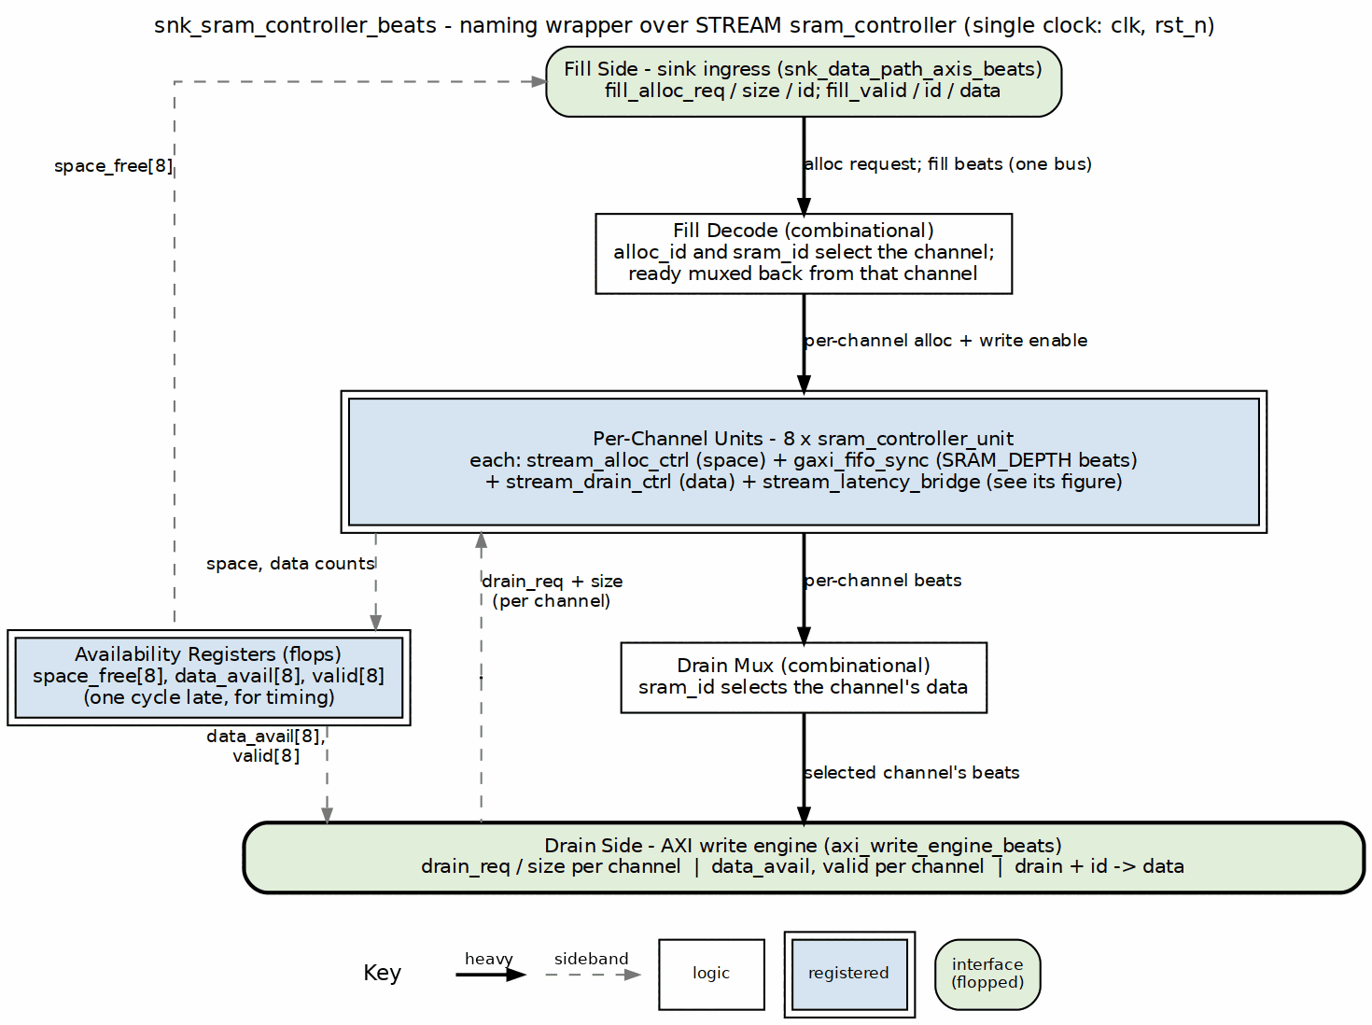
Sink SRAM controller block diagram
Source: 15_snk_sram_controller.dot

20.2 Parameters
parameter int NUM_CHANNELS = 8;
parameter int DATA_WIDTH = 512;
parameter int SRAM_DEPTH = 512; // Per-channel depth
parameter int ADDR_WIDTH = $clog2(SRAM_DEPTH);
: Table 3.5.1: Sink SRAM Controller Parameters

20.3 Port List

20.3.1 Clock and Reset
Table 3.5.2: Clock and Reset
Signal | Direction | Width | Description
clk | input | 1 | System clock
rst_n | input | 1 | Active-low reset

20.3.2 Fill Interface (ID-Selected)
Table 3.5.3: Fill Interface (ID-Selected)
Signal | Direction | Width | Description
fill_alloc_req | input | 1 | Allocation request (single, ID-selected)
fill_alloc_size | input | 8 | Beats to allocate
fill_alloc_id | input | CIW | Transaction ID selects the channel
fill_space_free | output | NC x SCW | Available space per channel
fill_valid | input | 1 | Fill data valid
fill_ready | output | 1 | Ready for fill data
fill_id | input | CIW | Transaction ID selects the channel
fill_data | input | DW | Fill data

20.3.3 Arbitrated Drain Interface (to AXI Write Engine)
Table 3.5.4: Arbitrated Drain Interface
Signal | Direction | Width | Description
drain_data_avail | output | NC x SCW | Data available per channel
drain_req | input | NC | Drain reservation request per channel
drain_size | input | NC x 8 | Beats to reserve
drain_valid | output | NC | Drain valid, registered (for arbitration)
drain_valid_comb | output | NC | Drain valid, combinational (gates m_axi_wvalid)
drain_read | input | 1 | Consumer read strobe
drain_id | input | CIW | Channel ID select for drain
drain_data | output | DW | Drain data (muxed from selected channel)

20.3.4 Debug Interface
Table 3.5.5: Debug Interface
Signal | Direction | Width | Description
dbg_bridge_pending | output | NC | Bridge has a pending beat per channel
dbg_bridge_out_valid | output | NC | Bridge output valid per channel

20.4 Drain Selection
There is no arbiter inside the controller. Every channel unit raises its own drain_valid[ch] / drain_size[ch] when it has data; the AXI write engine picks a channel, drives it on drain_id, and the controller steers that channel’s beats to the single drain_* port. Switching channels costs nothing beyond the consumer’s own decision, and a channel keeps presenting drain_valid until it is empty.

20.4.1 Figure 3.5.2: Drain Selection by the Consumer

snk_sram_controller_beats - consumer drains eight channels in turn
Source: snk_sram_controller_drain_select.json, captured from dv/tests/macro_beats/test_snk_sram_controller_beats.py (multi_channel, 8 channels, 512-bit data, 512-entry SRAM, REG_LEVEL=GATE) with WAVES=1.
Reading it: all eight channels have data (drain_valid = 0xff) and the consumer walks them in turn. It raises one bit of drain_req at a time; the controller answers with drain_id naming that channel and drain_data presenting its head word on the same cycle, and the consumer’s drain_read pulse pops it. Each channel’s turn lasts nine cycles here because the test releases the request and re-arms the next one; the controller itself needs no gap between channels.

20.5 Integration with AXI Write Engine
snk_sram_controller_beats #(
.NUM_CHANNELS(8),
.DATA_WIDTH(512),
.SRAM_DEPTH(512)
) u_snk_sram_ctrl (
.clk (clk),
.rst_n (rst_n),
// Per-channel fill interface
.fill_alloc_req (fill_alloc_req),
.fill_alloc_size (fill_alloc_size),
.fill_space_free (fill_space_free),
.fill_valid (fill_valid),
.fill_ready (fill_ready),
.fill_data (fill_data),
// Arbitrated drain interface
.drain_req (sram_drain_req),
.drain_id (sram_drain_id),
.drain_size (sram_drain_beats),
// Status
.drain_data_avail (channel_data_avail),
.dbg_bridge_pending (channel_empty),
.dbg_bridge_out_valid (channel_full)
);

Last Updated: 2025-01-10

RTL Design Sherpa · Learning Hardware Design Through Practice GitHub · Documentation Index · MIT License

21 Source Data Path Specification
Module: src_data_path_beats.sv Location: projects/components/dma-ip/rapids/rtl/macro_beats/ Status: Implemented Last Updated: 2025-01-10

21.1 Overview
The Source Data Path integrates the AXI read engine and SRAM controller for memory-to-network transfers. Data is read from system memory via AXI4, buffered in SRAM, and delivered through the drain interface to the network.

21.1.1 Key Features
- AXI Read Engine: Streaming burst reads from system memory
- 8-Channel SRAM Controller: Per-channel buffering with flow control
- Beat-Level Tracking: Precise flow control at beat granularity
- Scheduler Integration: Receives transfer requests from scheduler

21.1.2 Block Diagram

21.1.3 Figure 3.6.1: Source Data Path Block Diagram
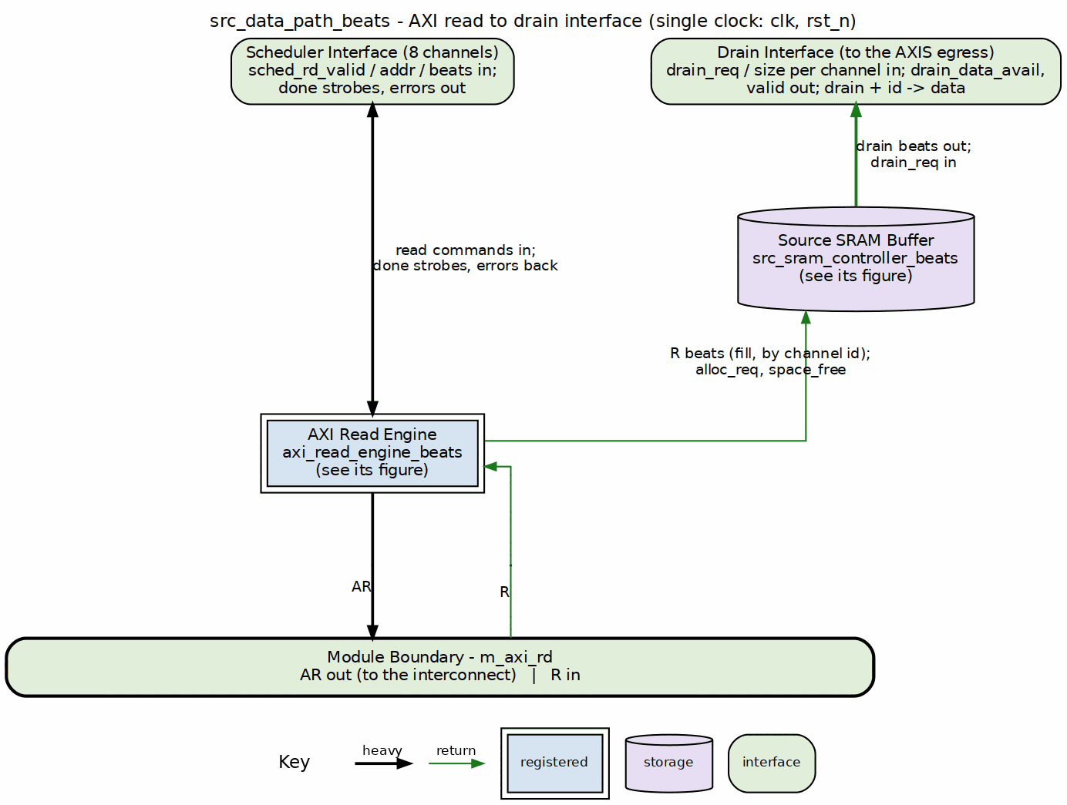
Source data path block diagram
Source: 16_source_data_path.dot

21.2 Parameters
parameter int NUM_CHANNELS = 8;
parameter int ADDR_WIDTH = 64;
parameter int DATA_WIDTH = 512;
parameter int AXI_ID_WIDTH = 8;
parameter int SRAM_DEPTH = 512;
parameter int AR_MAX_OUTSTANDING = 8;
parameter int R_PHASE_FIFO_DEPTH = 64;
: Table 3.6.1: Source Data Path Parameters

21.3 Data Flow

21.3.1 Figure 3.6.2: Source Path Data Flow Sequence
1. Scheduler Read Request
- sched_rd_valid = 1
- sched_rd_addr = source address
- sched_rd_beats = N
- sched_rd_id = channel
|
v
2. Space Check (stream_alloc_ctrl inside STREAM's sram_controller)
- Check src_drain_space_free[channel] >= N
- Allocate N beats of space
|
v
3. AXI Read Transaction
- axi_read_engine issues AR
- m_axi_araddr = sched_rd_addr
- m_axi_arlen = calculated from beats
|
v
4. R Channel Data
- Data arrives on m_axi_rdata
- Written to channel's SRAM partition
|
v
5. SRAM Write Complete
- stream_drain_ctrl notified via the unit's latency bridge
- Data available for drain
|
v
6. Drain Interface
- src_drain_valid = 1
- Data delivered to network master
|
v
7. Completion
- sched_rd_done_strobe = 1
- Scheduler notified of completion

21.4 Port List

21.4.1 Clock and Reset
Table 3.6.2: Clock and Reset
Signal | Direction | Width | Description
clk | input | 1 | System clock
rst_n | input | 1 | Active-low reset

21.4.2 Configuration
Table 3.6.3: Configuration
Signal | Direction | Width | Description
cfg_axi_rd_xfer_beats | input | 8 | AXI read transfer size in beats (all channels)

21.4.3 Scheduler Interface
Table 3.6.4: Scheduler Interface
Signal | Direction | Width | Description
sched_rd_valid | input | NC | Channel requests read
sched_rd_addr | input | NC x AW | Source addresses
sched_rd_beats | input | NC x 32 | Beats remaining to read
sched_rd_done_strobe | output | NC | Burst completed (pulsed 1 cycle)
sched_rd_beats_done | output | NC x 32 | Beats completed in burst
sched_rd_error | output | NC | Sticky error flag per channel

21.4.4 AXI Read Master Interface
Table 3.6.5: AXI Read Master Interface
Signal | Direction | Width | Description
m_axi_arvalid | output | 1 | AR channel valid
m_axi_arready | input | 1 | AR channel ready
m_axi_araddr | output | AW | Read address
m_axi_arlen | output | 8 | Burst length
m_axi_arsize | output | 3 | Burst size
m_axi_arburst | output | 2 | Burst type
m_axi_arid | output | ID_W | Transaction ID
m_axi_rvalid | input | 1 | R channel valid
m_axi_rready | output | 1 | R channel ready
m_axi_rdata | input | DW | Read data
m_axi_rresp | input | 2 | Read response
m_axi_rid | input | ID_W | Response ID
m_axi_rlast | input | 1 | Last beat

21.4.5 Drain Interface (Output to Network)
Table 3.6.6: Drain Interface
Signal | Direction | Width | Description
drain_data_avail | output | NC x SCW | Data available per channel
drain_req | input | NC | Drain reservation request per channel
drain_size | input | NC x 8 | Beats to reserve
drain_valid | output | NC | Drain data valid per channel
drain_valid_comb | output | NC | Combinational per-channel valid (beat gate)
drain_read | input | 1 | Consumer read strobe
drain_id | input | CIW | Channel ID select for drain
drain_data | output | DW | Drain data (muxed from selected channel)

21.5 Timing Diagram

21.5.1 Figure 3.6.3: Source Path Transfer Timing

src_data_path_beats - 4-beat transfer, command to done
Source: src_data_path_transfer.json, captured inside rapids_core_beats.u_src.u_source_data_path, captured from dv/tests/top_beats/test_rapids_core_beats.py (source path, channel 0, 4 beats, 512-bit data, REG_LEVEL=GATE) with WAVES=1.
Reading it: the scheduler holds sched_rd_valid[0] with 4 beats at 0x10000000. The read engine issues the AR (arlen = 3) two cycles later; the four R beats land from cycle 8, rlast on the fourth, and the cycle after it the engine pulses sched_rd_done_strobe[0] with beats_done = 4 – the scheduler advances its address to 0x10000100 on that strobe. The data reaches the source SRAM two cycles after the last R beat (drain_valid[0] rises) and the AXIS side drains it one word per drain_read pulse at the pace the egress consumer allows.

21.6 Integration Example
src_data_path_beats #(
.NUM_CHANNELS(8),
.ADDR_WIDTH(64),
.DATA_WIDTH(512),
.SRAM_DEPTH(512)
) u_source_path (
.clk (clk),
.rst_n (rst_n),
// Scheduler interface
.sched_rd_valid (sched_rd_valid),
.sched_rd_addr (sched_rd_addr),
.sched_rd_beats (sched_rd_beats),
.sched_rd_done_strobe (sched_rd_done_strobe),
.sched_rd_beats_done (sched_rd_beats_done),
.sched_rd_error (sched_rd_error),
// AXI read master
.m_axi_arvalid (src_axi_arvalid),
.m_axi_arready (src_axi_arready),
.m_axi_araddr (src_axi_araddr),
.m_axi_arlen (src_axi_arlen),
.m_axi_rvalid (src_axi_rvalid),
.m_axi_rready (src_axi_rready),
.m_axi_rdata (src_axi_rdata),
.m_axi_rlast (src_axi_rlast),
// Drain interface
.drain_valid (src_drain_valid),
.drain_data (src_drain_data),
.drain_id (src_drain_id),
.drain_data_avail (src_data_avail)
);

Last Updated: 2025-01-10

RTL Design Sherpa · Learning Hardware Design Through Practice GitHub · Documentation Index · MIT License

22 Source Data Path with AXIS (Egress)
Module: src_data_path_axis.sv Location: projects/components/dma-ip/rapids/rtl/macro/ Status: Implemented Last Updated: 2026-09-30

22.1 Overview
This module puts an AXI-Stream master behind the source data path. It pops beat-aligned memory beats from the SRAM and re-packs them into stream beats that start at lane 0, so a packet leaves as exactly the bytes its descriptor named.
A descriptor’s source address may start in the middle of a beat. The scheduler supplies that offset and the byte length in a packet record. The module shifts each memory beat down by the offset, holds the bytes that belong to the next stream beat, and marks the last stream beat with a contiguous strobe and tlast. One descriptor produces one AXI-Stream packet.

22.1.1 Key Features
- Barrel shift by the source offset: memory lane offset + l goes out on stream lane l.
- Partial last beat: tstrb is the low min(bytes_left, SW) lanes and tlast marks the final beat.
- Packets follow descriptors, not drain reservations.
- Two-stage reservation and drain, unchanged from RAPIDS Beats. The drain stage advances on memory-beat pops, not on stream handshakes.
- Per-channel state: hold, bytes-left and beats-left per channel, so reservations of different channels interleave.
- Packet record queue: four records per channel, fed by the scheduler.

22.1.2 Figure 3.7.1: Egress Shifter
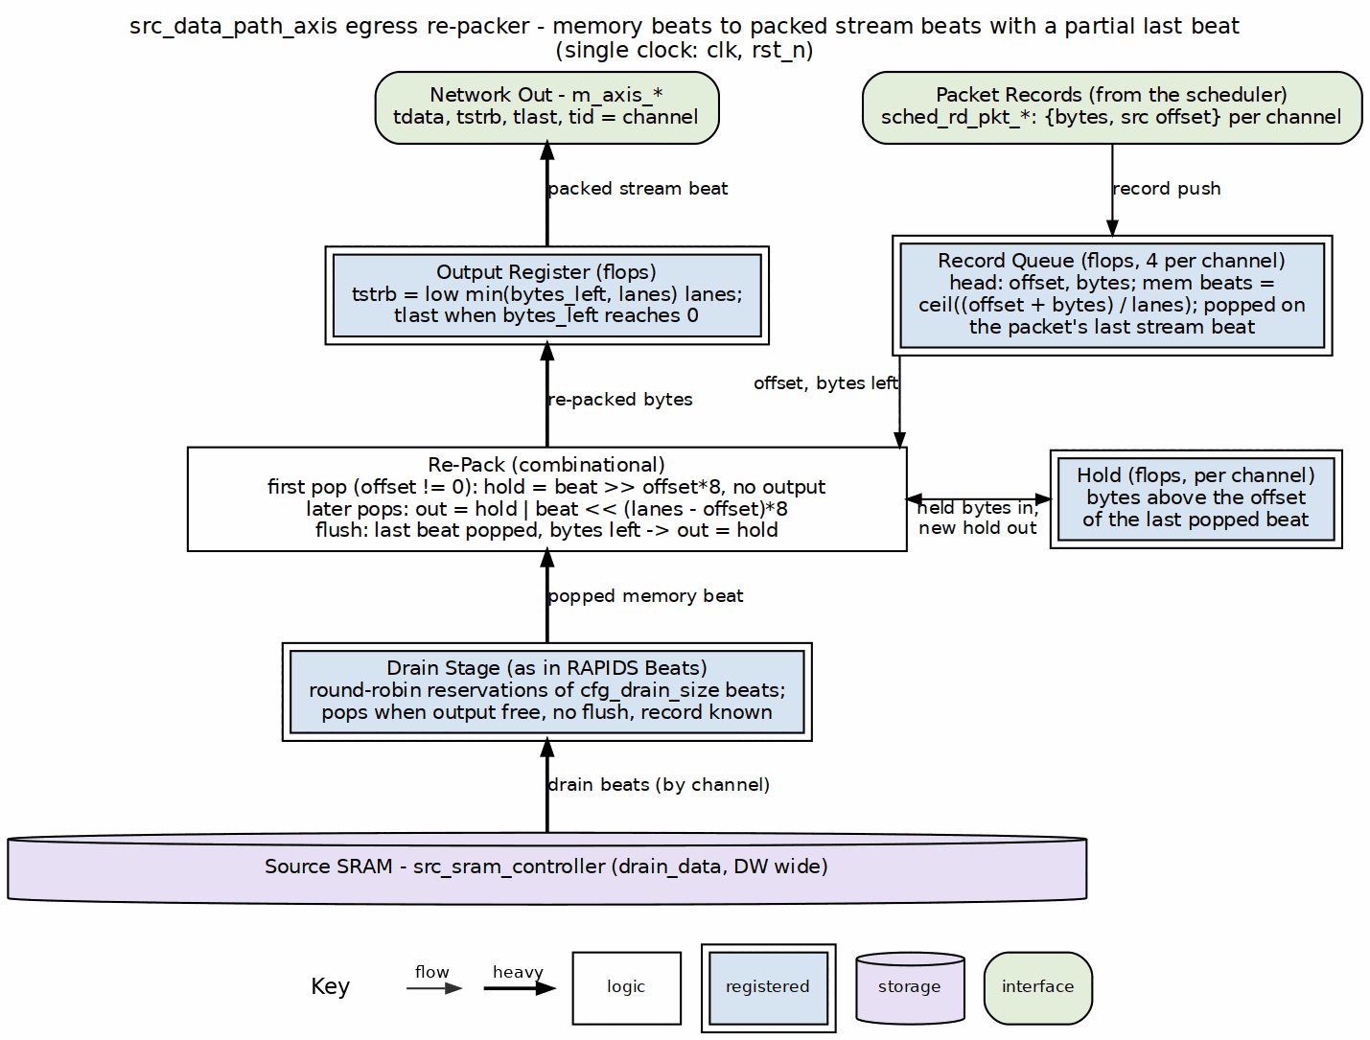
Egress shifter
Source: 02_egress_shifter.dot

22.2 Parameters
Table 3.7.1: Parameters
Parameter | Default | Description
NUM_CHANNELS | 8 | Channels (alias NC).
ADDR_WIDTH | 64 | Address width (alias AW).
DATA_WIDTH | 512 | Data width in bits (alias DW). The board uses 256.
AXI_ID_WIDTH | 8 | AXI ID width (alias IW).
SRAM_DEPTH | 512 | Words per channel partition.
SEG_COUNT_WIDTH | $clog2(SRAM_DEPTH) + 1 | Space counter width.
PIPELINE | 1 | SRAM read pipeline setting.
AR_MAX_OUTSTANDING | 8 | ARs the read engine may have in flight.
AXIS_ID_WIDTH | 8 | tid width.
AXIS_DEST_WIDTH | 4 | tdest width.
AXIS_USER_WIDTH | 1 | tuser width.
SW | DW / 8 | Byte lanes per beat.
OFF_W | $clog2(SW) | Width of the packet-record offset.

22.3 Interfaces

22.3.1 Configuration
Table 3.7.2: Configuration
Signal | Direction | Width | Description
cfg_axi_rd_xfer_beats | input | 8 | Read burst size cap in beats, minus one.
cfg_drain_size | input | 8 | Beats per drain reservation. 0 is treated as 1.
cfg_channel_reset | input | NC | Per-channel reset, level or pulse. Clears the channel’s queue, hold, egress counters, drain reservations and error flag.

22.3.2 Scheduler Interface
Table 3.7.3: Scheduler Interface
Signal | Direction | Width | Description
sched_rd_valid | input | NC | Channel requests reads.
sched_rd_addr | input | NC x AW | Working source byte address.
sched_rd_beats | input | NC x 32 | Beats still to read.
sched_rd_pkt_valid | input | NC | Record pulse from the scheduler.
sched_rd_pkt_ready | output | NC | Record queue not full.
sched_rd_pkt_bytes | input | NC x 32 | Packet length in bytes.
sched_rd_pkt_offset | input | NC x OFF_W | Source offset in the first memory beat.
sched_rd_done_strobe | output | NC | AR issued.
sched_rd_beats_done | output | NC x 32 | Beats in that AR.
sched_rd_error | output | NC | Sticky read error.

22.3.3 AXI-Stream Master
Table 3.7.4: AXI-Stream Master
Signal | Direction | Width | Description
m_axis_tdata | output | DW | Packed data.
m_axis_tstrb | output | SW | Contiguous from lane 0. Partial only on the tlast beat.
m_axis_tlast | output | 1 | Last beat of the packet.
m_axis_tid | output | AXIS_ID_WIDTH | Channel.
m_axis_tdest | output | AXIS_DEST_WIDTH | Channel.
m_axis_tuser | output | AXIS_USER_WIDTH | Zero.
m_axis_tvalid | output | 1 | Beat valid.
m_axis_tready | input | 1 | Consumer ready.

22.3.4 Other Ports
The AXI4 read master is that of the AXI Read Engine, with IW-bit IDs and DW-bit data. The debug outputs are dbg_rd_all_complete, dbg_r_beats_rcvd, dbg_sram_writes, dbg_arb_request, dbg_sram_bridge_pending, dbg_sram_bridge_out_valid, dbg_axis_beats_sent and dbg_axis_packets_sent.

22.4 Egress Operation

22.4.1 Reservation and Drain
Unchanged from RAPIDS Beats. A round-robin decision per cycle selects a channel whose available data, less reservations still in flight, reaches cfg_drain_size beats. It may also select one whose fill is finished and has any data left. Each decision is a one-cycle drain_req of up to cfg_drain_size beats. Up to four reservations queue ahead of the drain stage, which loads the next entry on the last beat of the current one.

22.4.2 Pop
A memory beat is popped when all of these hold:
- The drain stage is active on channel c and has a beat.
- The output register is free or being taken.
- No flush is pending.
- The channel’s packet record is known.
Each pop counts against the reservation block, so the drain stage advances on pops.

22.4.3 Shift and Hold
With off the head record’s offset:
Table 3.7.5: Egress Shift Rules
Situation | Action
off = 0 | Every pop emits a stream beat.
off > 0, first pop | The pop only primes the hold with beat >> off*8. It emits only when the packet fits in that single memory beat.
off > 0, later pops | Emit hold | (beat << (SW - off)*8). The new hold is beat >> off*8.
Last memory beat popped, bytes left | The flush emits the hold alone.
The memory beat count of a packet is (off + bytes + SW - 1) >> OFF_W, computed in 33 bits.

22.4.4 Strobe and Last
Each emitted beat carries n = min(bytes_left, SW) bytes. tstrb is the low n lanes. tlast is set on the beat where bytes_left equals n. That beat also retires the packet record and clears the channel’s hold, started flag and counters.

22.4.5 Waveform 3.7: Egress Re-pack
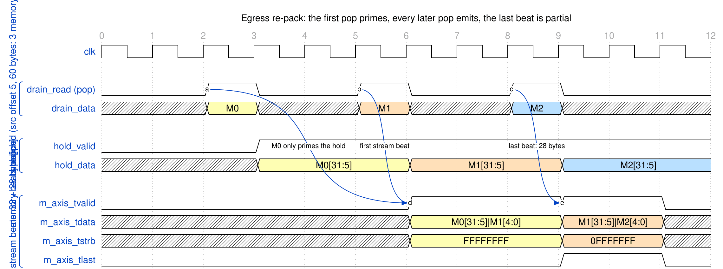
Egress re-pack
Source: 01_egress_repack.json
Offset 5, 60 bytes and a 256-bit beat give three memory beats. The first pop, M0, only primes the hold. The second pop emits the first stream beat with 32 bytes. The third pop emits the last beat with 28 bytes, tstrb 0FFFFFFF and tlast.

22.5 Channel Reset
cfg_channel_reset[ch] is a register level, so a pulse and a held level must both work. As in the sink ingress the data path forms w_rst[ch] = cfg_channel_reset[ch] | r_rst_d1[ch], a two-cycle stretch of a pulse. The read engine clears its error flag and settles the reads in flight (see AXI Read Engine); the data path clears everything that would otherwise let the old descriptor keep streaming:
Table 3.7.6: Channel Reset Actions
State | Action on w_rst[ch]
Packet record queue | Pointers cleared. A record arriving on the reset cycle is not pushed.
Egress state | r_eg_started, r_hold_valid, r_hold_data, r_eg_bytes_left and r_eg_mem_left cleared.
Drain reservation | Grants for the channel are masked. r_drain_tminus1[ch] is cleared.
Reservation queue | Entries that belong to the channel are zeroed. An entry of size 0 loads the drain stage idle, so the drain stage skips it. A reservation being drained for the channel is dropped.
Output register | A beat already in r_out completes, so m_axis stays stable.
The channel’s SRAM partition is cleared by src_sram_controller, which holds one single-channel sram_controller per channel with a registered per-channel reset r_ch_rst_n[ch]. The shared STREAM controller has no channel reset of its own and is not modified. Reads of the old descriptor that are already on the bus are discarded by the read engine, so no stale data reaches the cleared partition.
A packet cut by the reset is left unterminated. If the reset lands after the first beat of a packet has gone out and before its tlast beat, the data path does not send a tlast and does not send a null terminator. The downstream receiver sees the packet stop. A packet that had not started, or whose tlast beat was already in r_out when the reset hit, is unaffected. A receiver that needs to resynchronize after a channel reset treats the reset as the end of the packet.
Other channels are unaffected: every term above is indexed by channel, the drain and reservation stages skip only the channel in reset, and their beats keep flowing through the shared m_axis.

22.6 Differences from RAPIDS Beats
Table 3.7.7: Egress Delta
Item | RAPIDS Beats | RAPIDS
Stream beat from memory beat | one to one, full lanes | shifted by the offset, hold merged
m_axis_tstrb | all ones | contiguous, partial on the last beat
m_axis_tlast | on the drain block boundary | on the last byte of the descriptor
Drain advance | stream handshakes | memory-beat pops
Packet framing | one per drain block | one per descriptor
Packet record queue | absent | four per channel
Channel reset | not applicable | per-channel clear of every stage, cut packet left unterminated
Reservation stage, allocation of drain |  | Unchanged
The beats chapter is Source Data Path with AXIS.

Last Updated: 2026-09-30

RTL Design Sherpa · Learning Hardware Design Through Practice GitHub · Documentation Index · MIT License

23 Source SRAM Controller Specification
Module: src_sram_controller_beats.sv Location: projects/components/dma-ip/rapids/rtl/macro_beats/ Status: Implemented Last Updated: 2025-01-10

23.1 Overview
The Source SRAM Controller is a naming wrapper, with no logic of its own, around STREAM’s sram_controller – the one per-channel SRAM implementation both DMAs share since bdf4e0dff. It maps the RAPIDS fill_*/drain_* names onto STREAM’s ports; the eight per-channel units (allocation counter, FIFO, drain counter, latency bridge) live inside STREAM’s block. It manages 8 channel units for the source data path, providing per-channel buffering with channel arbitration for data delivery to the network.

23.1.1 Key Features
- One shared implementation: instantiates STREAM’s sram_controller once; it holds 8 sram_controller_units, each a gaxi_fifo_sync FIFO with stream_alloc_ctrl, stream_drain_ctrl and stream_latency_bridge
- Channel Arbitration: none inside the controller – the AXIS egress arbiter picks a channel and presents it on drain_id
- Flow Control Integration: per-channel stream_alloc_ctrl / stream_drain_ctrl virtual FIFOs; the drain counter’s virtual depth is 2 x SRAM_DEPTH (stream BUG-011)
- Data Availability Tracking: Reports available data per channel

23.1.2 Block Diagram

23.1.3 Figure 3.8.1: Source SRAM Controller Block Diagram
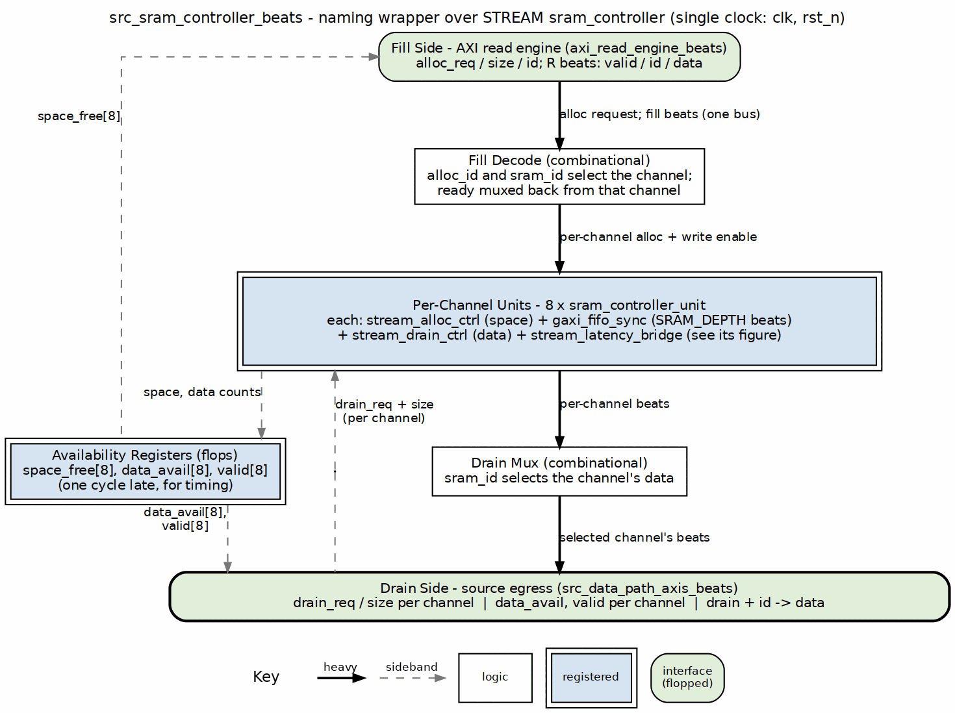
Source SRAM controller block diagram
Source: 18_src_sram_controller.dot

23.2 Parameters
parameter int NUM_CHANNELS = 8;
parameter int DATA_WIDTH = 512;
parameter int SRAM_DEPTH = 512; // Per-channel depth
parameter int ADDR_WIDTH = $clog2(SRAM_DEPTH);
: Table 3.8.1: Source SRAM Controller Parameters

23.3 Port List

23.3.1 Clock and Reset
Table 3.8.2: Clock and Reset
Signal | Direction | Width | Description
clk | input | 1 | System clock
rst_n | input | 1 | Active-low reset

23.3.2 Fill Interface (ID-Selected, from AXI Read Engine)
Table 3.8.3: Fill Interface (ID-Selected)
Signal | Direction | Width | Description
fill_alloc_req | input | 1 | Allocation request (single, ID-selected)
fill_alloc_size | input | 8 | Beats to allocate
fill_alloc_id | input | CIW | Transaction ID selects the channel
fill_space_free | output | NC x SCW | Available space per channel
fill_valid | input | 1 | Fill data valid
fill_ready | output | 1 | Ready for fill data
fill_id | input | CIW | Transaction ID selects the channel
fill_data | input | DW | Fill data

23.3.3 Arbitrated Drain Interface (to Network)
Table 3.8.4: Arbitrated Drain Interface
Signal | Direction | Width | Description
drain_data_avail | output | NC x SCW | Data available per channel
drain_req | input | NC | Drain reservation request per channel
drain_size | input | NC x 8 | Beats to reserve
drain_valid | output | NC | Drain data valid per channel
drain_valid_comb | output | NC | Combinational per-channel valid (beat gate)
drain_read | input | 1 | Consumer read strobe
drain_id | input | CIW | Channel ID select for drain
drain_data | output | DW | Drain data (muxed from selected channel)

23.3.4 Debug Interface
Table 3.8.5: Debug Interface
Signal | Direction | Width | Description
dbg_bridge_pending | output | NC | Bridge has a pending beat per channel
dbg_bridge_out_valid | output | NC | Bridge output valid per channel

23.4 Drain Selection
There is no arbiter inside the controller. Every channel unit raises its own drain_valid[ch] / drain_size[ch] when it has data; the AXIS egress arbiter picks a channel, drives it on drain_id, and the controller steers that channel’s beats to the single drain_* port. Switching channels costs nothing beyond the consumer’s own decision, and a channel keeps presenting drain_valid until it is empty.

23.4.1 Figure 3.8.2: Drain Selection by the Consumer

src_sram_controller_beats - consumer drains eight channels in turn
Source: src_sram_controller_drain_select.json, captured from dv/tests/macro_beats/test_src_sram_controller_beats.py (multi_channel, 8 channels, 512-bit data, 512-entry SRAM, REG_LEVEL=GATE) with WAVES=1.
Reading it: the same selection contract as the sink controller (Figure 3.5.2). With drain_valid = 0xff the consumer asks for one channel at a time through drain_req; drain_id and drain_data follow the request on the same cycle and drain_read pops the word. The nine-cycle turn per channel is the test’s pacing, not the controller’s.

23.5 Comparison: Sink vs Source SRAM Controller
Table 3.8.6: Sink vs Source Controller Comparison
Aspect | Sink Controller | Source Controller
Fill Source | Network ingress | AXI read data
Drain Destination | AXI write engine | Network egress
Fill Interface | Per-channel from network | Per-channel from AXI R
Drain Interface | Arbitrated SRAM read | Arbitrated drain to network
Primary Use | Network -> Memory | Memory -> Network

23.6 Integration Example
src_sram_controller_beats #(
.NUM_CHANNELS(8),
.DATA_WIDTH(512),
.SRAM_DEPTH(512)
) u_src_sram_ctrl (
.clk (clk),
.rst_n (rst_n),
// Per-channel fill interface (from AXI read engine)
.fill_alloc_req (fill_alloc_req),
.fill_alloc_size (fill_alloc_size),
.fill_space_free (fill_space_free),
.fill_valid (fill_valid),
.fill_ready (fill_ready),
.fill_data (fill_data),
// Arbitrated drain interface (to network)
.drain_valid (src_drain_valid),
.drain_data (src_drain_data),
.drain_id (src_drain_id),
// Status
.drain_data_avail (channel_data_avail),
.dbg_bridge_pending (channel_empty),
.dbg_bridge_out_valid (channel_full)
);

Last Updated: 2025-01-10

RTL Design Sherpa · Learning Hardware Design Through Practice GitHub · Documentation Index · MIT License

24 RAPIDS Core, Sink Half and Source Half
Module: rapids_core.sv, rapids_snk.sv, rapids_src.sv Location: projects/components/dma-ip/rapids/rtl/macro/ Status: Implemented Last Updated: 2026-09-30

24.1 Overview
rapids_core is a thin structural wrapper over two independent halves. rapids_src moves memory to the network. rapids_snk moves the network to memory. The halves share no logic and no signals. The core only presents one boundary and merges the two MonBus streams.
The structure, the port naming convention and the register and monitor plumbing are those of RAPIDS Beats. This chapter records what the byte-granular RTL contains and how it differs. The full port tables are in RAPIDS Core Beats, with the port renames below applied.

24.1.1 Figure 3.9.1: Core Block Diagram
Core block diagram
Source: 04_rapids_core.dot

24.2 Byte-Granular Content

24.2.1 Packet Record Nets
Each half declares the packet record nets of its direction and connects them between its scheduler group array and its AXIS data path:
Table 3.9.1: Packet Record Nets per Half
Half | Nets | Producer | Consumer
rapids_src | sched_rd_pkt_valid, _ready, _bytes, _offset | array read set | src_data_path_axis
rapids_snk | sched_wr_pkt_valid, _ready, _bytes, _offset | array write set | snk_data_path_axis
The offset nets are $clog2(DW/8) bits wide. The unused direction of each array is tied off: valid, bytes and offset are left open and ready is held at all ones so nothing stalls. The record nets are internal, so the core port list has no packet record ports.

24.2.2 Port Renames
The core ports that carry the beat-count unit are renamed. Everything else keeps its Beats name.
Table 3.9.2: Core Port Renames
RAPIDS Beats | RAPIDS
cfg_axi_rd_xfer | cfg_axi_rd_xfer_beats
cfg_axi_wr_xfer | cfg_axi_wr_xfer_beats
src_dbg_r_rcvd | src_dbg_r_beats_rcvd
src_dbg_axis_sent | src_dbg_axis_beats_sent
snk_dbg_axis_received | snk_dbg_axis_beats_received

24.2.3 Data Ports
Table 3.9.3: Data Ports
Interface | Signals | Notes
Source AXIS | m_axis_* | tstrb is contiguous, partial on the tlast beat.
Sink AXIS | s_axis_* | tid selects the channel. Partial tstrb only on tlast.
Source AXI read | m_axi_rd_* | ARADDR is beat-aligned, bursts stop at 4 KB.
Sink AXI write | m_axi_wr_* | wstrb carries the stored byte enables.

24.3 Parameters
Table 3.9.4: Core Parameters
Parameter | Default | Description
NUM_CHANNELS | 8 | Channels.
ADDR_WIDTH | 64 | Address width.
DATA_WIDTH | 512 | Data width in bits. The board uses 256.
AXI_ID_WIDTH | 8 | AXI ID width.
SRAM_DEPTH | 512 | Words per channel.
PIPELINE | 1 | Write engine pipelining.
AR_MAX_OUTSTANDING, AW_MAX_OUTSTANDING | 8 | Outstanding bursts.
W_PHASE_FIFO_DEPTH, B_PHASE_FIFO_DEPTH | 64, 16 | Write engine queues.
AXIS_ID_WIDTH, AXIS_DEST_WIDTH, AXIS_USER_WIDTH | 8, 4, 1 | AXIS side widths.
DESC_MON_BASE_AGENT_ID | 16 | Descriptor engine agents.
SCHED_MON_BASE_AGENT_ID | 48 | Scheduler agents.
DESC_AXI_MON_AGENT_ID | 8 | Descriptor AXI monitor.
MON_UNIT_ID, MON_MAX_TRANSACTIONS | 1, 16 | Monitor unit id and table depth.
USE_AXI_MONITORS | 1 | 0 omits the monitor hardware.
USE_ROW_COL_MAJOR_ADDRESSING | 1 | 0 compiles out extended addressing.
GEN_MON | 1 | 0 omits the completion and error emitters.
SHARED_ENGINES | 1 | 1: one descriptor, control-read and control-write engine per half (Shared Engines). 0: one of each per channel.
TILE_HDR, TILE_SRC_COORD | 0, 14’h3000 | Tile packet header on both network ports (Tile Packet Header). Needs SHARED_ENGINES = 1.
TILE_CREDITS | 0 | End-to-end tile credits: 64 destination counters (each node’s internal and external ID) in the source half, the advertisement window and the legal-destination mask (Tile Packet Header). Needs TILE_HDR = 1.
The network endpoint and its monitor-lite moved to the top’s network planes (rapids TASK-024), so SNK_AXIS_MON_AGENT_ID, SRC_AXIS_MON_AGENT_ID and ACLK_MHZ are top parameters now. The core takes each plane’s monbus packets on src_plane_mon_* / snk_plane_mon_*. See docs/rapids_planes.md.

24.3.1 Channel Reset Routing
Each half has its own configuration block, and that block drives the half’s per-channel reset from its CHANNEL_RESET.CH_RST field ORed with GLOBAL_CTRL.GLOBAL_RST. The core exposes it as src_cfg_channel_reset and snk_cfg_channel_reset, and each half forwards it twice: to its scheduler group array (scheduler, descriptor engine, control engines) and to its byte data path (src_data_path_axis or snk_data_path_axis, through which it reaches the AXI engine and the SRAM wrapper). A reset therefore reaches every block that holds a sticky flag or an in-flight beat of the channel, and a channel reset recovers every error class without aresetn. Table 3.9.5 lists the blocks reached.
Table 3.9.5: Channel Reset Routing
Half | Blocks reached | Chapter
rapids_snk | scheduler, axi_write_engine, snk_sram_controller, snk_data_path_axis | Sink Data Path AXIS
rapids_src | scheduler, axi_read_engine, src_sram_controller, src_data_path_axis | Source Data Path AXIS
The two halves are independent: a reset of a sink channel does not touch the source channel with the same index, so software resets both directions of a channel by writing both halves’ reset fields. A reset of one channel never disturbs another channel of the same half.

24.4 Differences from RAPIDS Beats
Table 3.9.6: Core Delta
Item | RAPIDS Beats | RAPIDS
Half structure, monitor merge |  | Unchanged
Packet record nets inside each half | absent | present
Data path instances | *_axis_beats | byte-granular *_axis
Beat-unit port names | no suffix | _beats suffix, see Table 3.9.2
The Beats chapters for the halves are folded into the core chapter there.

Last Updated: 2026-09-30

RTL Design Sherpa · Learning Hardware Design Through Practice GitHub · Documentation Index · MIT License

25 RAPIDS Registers Specification
Module: rapids_regs.sv (generated) Source: projects/components/dma-ip/rapids/rtl/macro_beats/rapids_regs.rdl, rapids_mon_regs.rdl Generated: projects/components/dma-ip/rapids/regs/generated/rtl/rapids_regs.sv Status: Implemented (PeakRDL-generated)

25.1 Overview
rapids_regs is the PeakRDL-generated register block for the RAPIDS Beats top-level. It exposes configuration and status through a single command/response CPU interface and drives the hardware via a hwif_out structure that rapids_config_block maps onto the core/monitor cfg_* signals.
A single addrmap (one APB slave) contains two regfiles:
- Base config/status registers at 0x100-0x3FF.
- A nested rapids_mon_regs monitor regfile at base 0x1000, decoded under hwif_out.MON.* (all DAXMON / RDMON / WRMON / MON_FIFO and per-monitor performance registers).
Because the monitor regfile lives at 0x1000, the register-block address decode requires at least 13 bits (cpuif_addr is a 13-bit compare in the generated RTL). The APB address bus feeding the block (APB_ADDR_WIDTH) must therefore be >= 13 to reach the monitor regfile.

25.2 Base Register Map (0x100-0x3FF)
Table 3.10.1: Base Register Map
Offset | Name | Access | Description
0x100 | GLOBAL_CTRL | RW | GLOBAL_EN[0], GLOBAL_RST[1] (level; write 0 to release)
0x104 | GLOBAL_STATUS | RO | SYSTEM_IDLE[0] (all channels idle)
0x108 | VERSION | RO | MINOR[7:0]=0x5A, MAJOR[15:8], NUM_CHANNELS[23:16]=0x08
0x120 | CHANNEL_ENABLE | RW | CH_EN[7:0] per-channel enable
0x124 | CHANNEL_RESET | RW | CH_RST[7:0] per-channel reset (level; write 0 to release)
0x140 | CHANNEL_IDLE | RO | CH_IDLE[7:0] – not driven at the top level, reads 0
0x144 | DESC_ENGINE_IDLE | RO | Per-channel descriptor-engine idle
0x148 | SCHEDULER_IDLE | RO | Per-channel scheduler idle (excludes CH_ERROR)
0x150-0x16C | CH_STATE[0..7].STATE | RO | Per-channel FSM state (stride 0x4)
0x170 | SCHED_ERROR | RO | Per-channel sticky scheduler error
0x174 | AXI_RD_COMPLETE | RO | Per-channel read-complete flags (SRC half only; reads 0 in SNK)
0x178 | AXI_WR_COMPLETE | RO | Per-channel write-complete flags – not driven, reads 0
0x200 | SCHED_TIMEOUT_CYCLES | RW | TIMEOUT_CYCLES[31:0] write-progress window (reset 1000)
0x204 | SCHED_CONFIG | RW | SCHED_EN, TIMEOUT_EN, ERR_EN, COMPL_EN, PERF_EN
0x208 | SCHED_TIMEOUT_LIMIT | RW | LIMIT[7:0] consecutive-timeout escalation limit (reset 4, 0 = never)
0x220 | DESCENG_CONFIG | RW | DESCENG_EN[0], PREFETCH_EN[1], FIFO_THRESH[5:2] (reset 8)
0x224 | DESCENG_ADDR0_BASE | RW | Descriptor address range 0 base [31:0]
0x228 | DESCENG_ADDR0_LIMIT | RW | Descriptor address range 0 limit [31:0]
0x22C | DESCENG_ADDR1_BASE | RW | Descriptor address range 1 base [31:0]
0x230 | DESCENG_ADDR1_LIMIT | RW | Descriptor address range 1 limit [31:0]
0x240 | CTRL_CONFIG | RW | CTRLRD_MAX_TRY[8:0] control-read poll retry budget (0-511, reset 16)
0x2A0 | AXI_XFER_CONFIG | RW | AXI transfer sizing configuration
0x2B0 | PERF_CONFIG | RW | Performance profiler configuration
0x2C0 | OBS_CTRL | RW | Observation mux control (channel/category select)
0x2C4 | OBS_FLAGS | RO | Observation flags
0x2C8 | OBS_DATA0 | RO | Observation data word 0
0x2CC | OBS_DATA1 | RO | Observation data word 1
0x300-0x31C | CH_SCRATCH[n].SCRATCH | RW | Eight software bits per channel, SCRATCH[7:0] (reset 0); storage only, for flags or semaphores between the host and, in rapids-g, the half’s gatling. Not atomic across masters: give each bit one writer
0x35C | PERF_CH_SEL | RW | Performance channel select
0x378 | HIST_SEL | RW | Histogram bucket select
0x37C | HIST_DATA | RO | Histogram bucket data
0x380 | HIST_TOTAL | RO | Histogram total count

25.2.1 Key Register Fields
SCHED_TIMEOUT_LIMIT (0x208) – LIMIT[7:0] sets the number of consecutive write-progress timeout windows a channel tolerates before the recoverable timeout escalates to a fatal, sticky CH_ERROR. 0 = never escalate (pure soft timeout). Total time to escalate is approximately LIMIT x TIMEOUT_CYCLES. Reset value is 4.
DESCENG_CONFIG (0x220) – PREFETCH_EN[1] and FIFO_THRESH[5:2] control the now-functional descriptor prefetch: prefetch off = on-demand chaining (~1 ahead), prefetch on = buffer up to FIFO_THRESH descriptors ahead.
CTRL_CONFIG (0x240) – CTRLRD_MAX_TRY[8:0] bounds the control-read poll retry budget (0-511, reset 16) fed to every channel’s ctrlrd_engine. A CTRL_READ descriptor polls its gate address once per retry; if the masked value never matches within CTRLRD_MAX_TRY attempts the engine raises ctrlrd_error so a never-satisfied gate cannot hang the channel. See the Control-Read / Control-Write Engine specs (Sections 2.8 / 2.9) and the Scheduler control interface (Section 2.1).

25.3 Monitor Register Map (rapids_mon_regs @ 0x1000)
The monitor regfile is instantiated at base 0x1000 under hwif_out.MON.*. It holds the MonBus FIFO status, the three AXI-monitor configuration groups (DAXMON = descriptor monitor, RDMON = read monitor, WRMON = write monitor), and per-monitor performance counters.
Table 3.10.2: Monitor Register Map (base 0x1000)
Offset | Name | Access | Description
0x1000 | MON.MON_FIFO_STATUS | RO | MonBus capture/error FIFO status
0x1004 | MON.MON_FIFO_COUNT | RO | MonBus FIFO occupancy
0x10C0 | MON.DAXMON_ENABLE | RW | Descriptor-monitor enables (incl. COMPRESS_EN)
0x10C4 | MON.DAXMON_TIMEOUT | RW | Descriptor-monitor timeout cycles
0x10C8 | MON.DAXMON_LATENCY_THRESH | RW | Descriptor-monitor latency threshold
0x10CC | MON.DAXMON_PKT_MASK | RW | Descriptor-monitor packet mask
0x10D0 | MON.DAXMON_ERR_CFG | RW | Descriptor-monitor error select/mask
0x10D4-0x10DC | MON.DAXMON_MASK1/2/3 | RW | Descriptor-monitor category masks
0x10E0-0x10FC | MON.RDMON_* | RW | Source-egress AXIS monitor-lite config (same layout as DAXMON; SRC instance, rapids TASK-015)
0x1100-0x111C | MON.WRMON_* | RW | Sink-ingress AXIS monitor-lite config (same layout as DAXMON; SNK instance, rapids TASK-015)
0x1150-0x1178 | MON.DAXMON_PERF_* | RO/RW | Descriptor-monitor performance counters
0x1180-0x11A8 | MON.RDMON_PERF_* | RO/RW | Read-monitor performance counters
0x11B0-0x11D8 | MON.WRMON_PERF_* | RO/RW | Write-monitor performance counters
0x11E0-0x11EC | MON.{RD,WR}MON_PERF_CH_* | RO | Per-channel producer/backpressure/starve/idle
0x11F0 | MON.RDMON_PERF_CH_OVERFLOW | RO | Read-monitor per-channel overflow
0x11F4 | MON.WRMON_PERF_CH_OVERFLOW | RO | Write-monitor per-channel overflow
Each *_ENABLE register carries MON_EN, ERR_EN, COMPL_EN, TIMEOUT_EN (and COMPRESS_EN on the write monitor); each *_PERF_* group provides window, producer, backpressure, starve, idle, beat, byte (lo/hi), and burst counters.

Last Updated: 2026-07-02

RTL Design Sherpa · Learning Hardware Design Through Practice GitHub · Documentation Index · MIT License

26 RAPIDS Config Block Specification
Module: rapids_config_block.sv Location: projects/components/dma-ip/rapids/rtl/macro_beats/ Status: Implemented

26.1 Overview
rapids_config_block is a combinational adapter that maps the register block’s hwif_out structure onto the flat cfg_* signals consumed by rapids_core_beats and the AXI monitors. It contains no state; every output is a direct assignment (with a small number of width expansions and global-enable gates).
The monitor registers arrive under hwif_out.MON.*; base configuration and status arrive at the top level of hwif_out.

26.2 Mapping Groups

26.2.1 Base Configuration
Routes scheduler, channel, and descriptor-engine configuration to the core:
- cfg_channel_enable = CHANNEL_ENABLE.CH_EN & {8{GLOBAL_CTRL.GLOBAL_EN}} (per-channel enable gated by the global master enable).
- cfg_sched_timeout_cycles = SCHED_TIMEOUT_CYCLES.TIMEOUT_CYCLES (32-bit).
- cfg_sched_timeout_limit = SCHED_TIMEOUT_LIMIT.LIMIT (8-bit, direct).
- cfg_sched_{timeout,err,compl,perf}_enable = SCHED_CONFIG.{TIMEOUT,ERR,COMPL,PERF}_EN. COMPL_EN is the one the scheduler group acts on for its monitor packets: 0 drops the scheduler’s and descriptor engine’s CORE Completion packets at the group (emitters still acknowledged); ERR_EN and PERF_EN reach the group but gate nothing today (errors always reported, perf not implemented).
- cfg_desceng_* from DESCENG_CONFIG (enable / prefetch / FIFO threshold).
- Descriptor address ranges (cfg_desceng_addr{0,1}_{base,limit}) are zero-extended from the 32-bit register fields to the 64-bit ADDR_WIDTH.

26.2.2 Monitor Configuration (hwif_out.MON.*)
Three parallel groups map to the descriptor-read monitor and, since rapids TASK-015, the two AXIS data-path monitor-lites (one per half):
Table 3.11.1: Monitor Register-to-Config Mapping
Register group | cfg_* target
MON.DAXMON_* | cfg_desc_mon_* (descriptor monitor)
MON.RDMON_* | cfg_rdeng_mon_* (source-egress AXIS monitor-lite; wired in the SRC half only)
MON.WRMON_* | cfg_wreng_mon_* (sink-ingress AXIS monitor-lite; wired in the SNK half only)
The *_ENABLE bits map onto the AXIS monitor-lite’s class enables: MON_EN (gated by GLOBAL_EN), ERR_EN (error, channel-change and TSTRB checks), COMPL_EN (one Completion/STREAM_END per packet), PERF_EN (stream start/pause/resume and Credit/BACKPRESSURE stall reports), TIMEOUT_EN. *_TIMEOUT is MICROSECONDS in its low 16 bits (0 = never), *_LATENCY_THRESH the stall CYCLES that raise a backpressure report, and *_PKT_MASK is a MASK: bit[type] = 1 masks (drops) that packet type at the monitor-lite and again at the monbus group. It resets to all-masked (0xFFFF); the host clears the bits of the classes it wants to see (rapids BUG-008 corrected the description, which used to read “1 = enable”; the polarity and the reset are as intended).
Within each group the enable/timeout/latency/mask fields map 1:1, e.g. cfg_desc_mon_enable = MON.DAXMON_ENABLE.MON_EN & GLOBAL_CTRL.GLOBAL_EN, cfg_desc_mon_timeout_cycles = MON.DAXMON_TIMEOUT.TIMEOUT_CYCLES, and the category masks (timeout/compl/thresh/perf/addr/debug) pass through directly. Key enables are gated by GLOBAL_CTRL.GLOBAL_EN; masks pass through ungated.

26.2.3 Performance and Observation
PERF_CONFIG, PERF_CH_SEL, and OBS_CTRL map to the profiler and channel-observation-mux cfg_* signals.

Last Updated: 2026-07-02

RTL Design Sherpa · Learning Hardware Design Through Practice GitHub · Documentation Index · MIT License

27 RAPIDS Top
Module: rapids_top.sv, rapids_cxs_top.sv, rapids_8ch_top.sv, rapids_8ch_cxs_top.sv, rapids_16ch_top.sv, rapids_16ch_cxs_top.sv (all generated), rapids_top_base.sv Location: projects/components/dma-ip/rapids/rtl/top/ Status: Implemented Last Updated: 2026-10-17

27.1 Overview
rapids_top is the synthesizable top level. It wraps RAPIDS Core with an APB4 register interface, two config blocks, the register file, per-channel bus meters and the MonBus AXI-Lite group. It has the same hierarchy as RAPIDS Beats. Only the beat-count unit names differ.
The byte-granular behavior is entirely below the top: the packet record nets are internal to the core halves, so the top port list has no new signals. The full port list is in Top-Level Port List and the top integration description is in RAPIDS Beats Top.
Both tops are generated by bin/gen_plane_tops.py from rapids_top_base: rapids_top adds the AXIS network planes and rapids_cxs_top the CXS planes, one CXS link per direction with CXSSRCID carrying the channel. The CXS planes carry tstrb in CXSUSER, so the byte-granular partial last beats and unaligned starts cross the link intact; that caps DATA_WIDTH at 1024. The planes are shared with RAPIDS Beats: see Network Planes and the CXS Interface Specification.

27.1.1 Channel-Count Variants
The generator also emits fixed-width variants that pair NUM_CHANNELS with the register map built for it:
Table 3.12.1: Top Variants
Top | NUM_CHANNELS | Register map | Filelist
rapids_top, rapids_cxs_top | 8 (parameter) | 8-channel | rtl/filelists/top/rapids_top.f, rapids_cxs_top.f
rapids_8ch_top, rapids_8ch_cxs_top | 8 | 8-channel | rapids_8ch_top.f, rapids_8ch_cxs_top.f
rapids_16ch_top, rapids_16ch_cxs_top | 16 | 16-channel (regs/generated_16ch/) | rapids_16ch_top.f, rapids_16ch_cxs_top.f
rapids_top_base stops elaboration if NUM_CHANNELS is larger than the register map compiled with it. The 16-channel map is described in the HAS 16-Channel Register Map.

27.1.2 Figure 3.12.1: Top Hierarchy
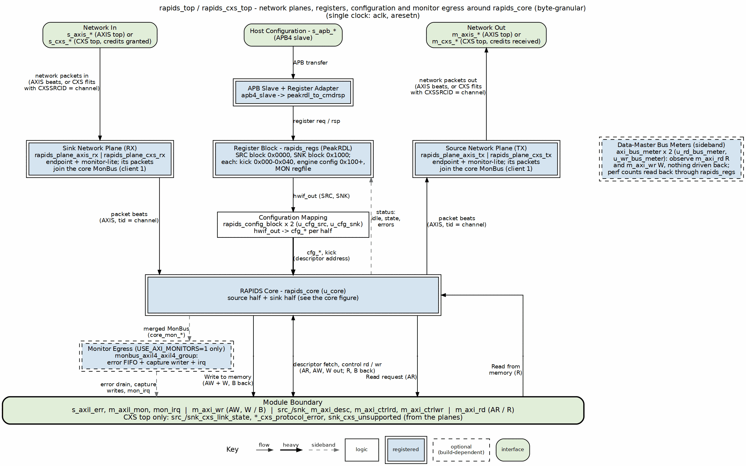
RAPIDS top integration
Source: 10_rapids_top.dot

27.2 APB Address Map
The APB address is 13 bits. Bit 12 selects the half.
Table 3.12.2: APB Address Map
Range | Content
0x0000 to 0x003F | Source staged descriptor addresses.
0x0040 | Source kick-off, one single-pulse bit per channel.
0x0040 to 0x0FFF | Source configuration registers.
0x1000 to 0x103F | Sink staged descriptor addresses.
0x1040 | Sink kick-off, one single-pulse bit per channel.
0x1040 to 0x1FFF | Sink configuration registers.
The monitor register windows sit at +0x800 of each half’s 4 KB space. With USE_MON_REGS clear the windows answer with an APB error, so a host can tell a build without monitors from a zero setting.

27.3 Parameters
Table 3.12.3: Top Parameters
Parameter | Default | Description
NUM_CHANNELS | 8 | Channels.
DATA_WIDTH | 512 | Data width in bits. The board uses 256.
ADDR_WIDTH | 64 | Address width.
AXI_ID_WIDTH | 8 | AXI ID width.
SRAM_DEPTH | 4096 | Words per channel at the top.
APB_ADDR_WIDTH, APB_DATA_WIDTH | 13, 32 | APB widths.
MON_MAX_TRANSACTIONS | 16 | Monitor table depth.
SNK_AXIS_MON_AGENT_ID, SRC_AXIS_MON_AGENT_ID | 9, 10 | Network-plane monitor agent ids (AXIS or CXS plane).
ACLK_MHZ | 100 | Clock in MHz for the network-plane monitor tick.
USE_AXI_MONITORS | 1 | 0 omits the monitors and the MonBus AXI-Lite group.
USE_ROW_COL_MAJOR_ADDRESSING | 1 | 0 compiles out extended addressing.
GEN_MON | 1 | 0 omits the completion and error emitters.
SHARED_ENGINES | 1 | 1: one descriptor, control-read and control-write engine per half. 0: one of each per channel. See Shared Engines.
TILE_HDR, TILE_SRC_COORD | 0, 14’h3000 | Tile packet header; needs SHARED_ENGINES = 1 and DATA_WIDTH of at least 256. See Tile Packet Header.
TILE_CREDITS | 0 | End-to-end tile credits and the legal-destination mask (SRC.TILE_ADV_WINDOW, SRC.TILE_LEGAL_DEST_LO / _HI, SRC.TILE_CREDIT_STATUS); needs TILE_HDR = 1. See Tile Packet Header.
USE_MON_REGS | USE_AXI_MONITORS != 0 | Wire the monitor register windows.
AR_MAX_OUTSTANDING, AW_MAX_OUTSTANDING | 8 | Outstanding bursts.
PIPELINE | 1 | Write engine pipelining.
AXIS_ID_WIDTH, AXIS_DEST_WIDTH, AXIS_USER_WIDTH | 8, 4, 1 | AXIS side widths.
Clock and reset are aclk and aresetn. cam_clear synchronously clears the MonBus group transaction tables.
Each half’s configuration block drives its per-channel reset vector (src_cfg_channel_reset, snk_cfg_channel_reset) from SRC/SNK.CHANNEL_RESET.CH_RST and GLOBAL_CTRL.GLOBAL_RST. The top wires each vector to its half of the core (see RAPIDS Core), and it reaches every block that can hold a channel error: a channel reset recovers every error class, including the AXI response and sink packet length errors, and aresetn is needed only at power-up. The top has no port change.

27.4 Differences from RAPIDS Beats
Table 3.12.4: Top Delta
Item | RAPIDS Beats | RAPIDS
Module | rapids_beats_top | rapids_top
Core instance | rapids_core_beats | rapids_core
Register file, APB map, config blocks |  | Unchanged
Bus meter beat counters | r_rd, r_wr | r_rd_beats, r_wr_beats
Config nets | *_xfer | *_xfer_beats
Port list |  | Unchanged
The register-file field names RD_XFER_BEATS and WR_XFER_BEATS are the same in both designs. Their meaning is beats in both, since bursts are beat-based.

Last Updated: 2026-09-30

RTL Design Sherpa · Learning Hardware Design Through Practice GitHub · Documentation Index · MIT License

28 Network Planes Specification
Modules: rapids_plane_axis_rx.sv, rapids_plane_axis_tx.sv, rapids_plane_cxs_rx.sv, rapids_plane_cxs_tx.sv Location: projects/components/dma-ip/rapids/rtl/plane/ Generator: projects/components/dma-ip/rapids/bin/gen_plane_tops.py Status: Implemented (rapids TASK-024, TASK-025)

28.1 Overview
A network plane is the endpoint between the core’s network-side AXIS stream and the pins: the RX plane feeds the sink half’s ingress, the TX plane takes the source half’s egress. Each plane carries the monitor-lite for its port. Both RAPIDS trees (byte-granular rtl/top, beat-granular rtl/top_beats) share the same four planes.
Every plane has the same parameters and the same inner interface, so a top selects AXIS or CXS by module name alone:
- fub_axis_*: the core-facing AXIS stream (tdata, tstrb, tlast, tid = channel, tdest, tuser)
- cfg_mon_* in, sts_mon_* out: the SNK.WRMON_* / SRC.RDMON_* monitor CSRs, from rapids_config_block
- monbus_* out: client 1 of the half’s 3:1 monbus_arbiter, entering the core on snk_plane_mon_* / src_plane_mon_*
Table 3.13.1: RAPIDS Network Planes
Plane | Contents | Outer pins
rapids_plane_axis_rx | axis4_slave_monlite (skid stage, SKID_DEPTH = 4, + axis_monitor_lite tap) | s_axis_*
rapids_plane_axis_tx | axis4_master_monlite (skid stage + tap) | m_axis_*
rapids_plane_cxs_rx | cxs_slave_monlite (u_endpoint) + cxs_to_axis (u_cxs_to_axis) | s_cxs_*, snk_cxs_* status
rapids_plane_cxs_tx | axis_to_cxs (u_axis_to_cxs) + cxs_master_monlite (u_endpoint) | m_cxs_*, src_cxs_* status
The monitor counters of every plane are at u_snk_plane.u_endpoint and u_src_plane.u_endpoint in the top.

28.2 Generated Tops
Table 3.13.2: Generated Tops
Top | Tree | Base | Planes
rapids_top | byte | rapids_top_base | AXIS
rapids_cxs_top | byte | rapids_top_base | CXS
rapids_beats_top | beats | rapids_beats_top_base | AXIS
rapids_beats_cxs_top | beats | rapids_beats_top_base | CXS
gen_plane_tops.py copies the base’s parameter and port text verbatim, then instantiates the base (u_base) and the two planes (u_snk_plane, u_src_plane). The AXIS tops therefore keep exactly the interface they had before the split, and existing instantiations are unchanged. Run the generator with --check to fail on a stale top.

28.3 CXS Planes

28.3.1 Figure 3.13.1: CXS Network Planes
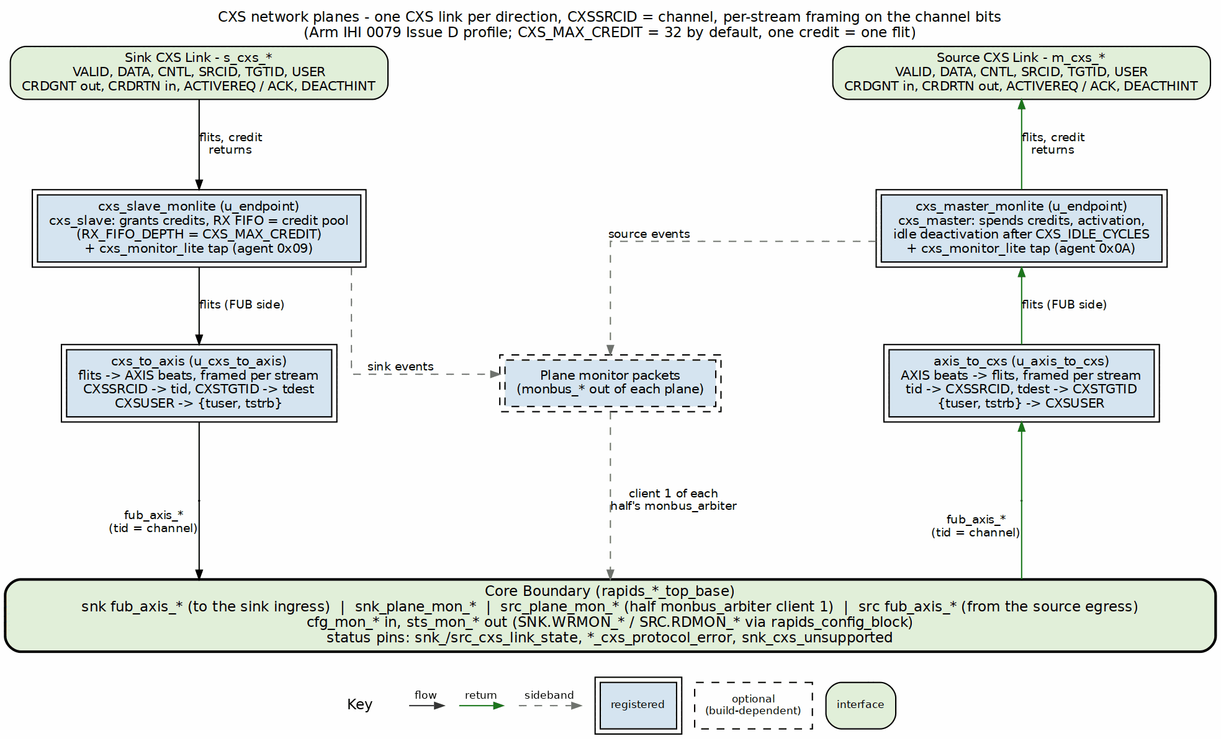
CXS network planes
Source: 23_cxs_planes.dot

28.3.2 Receive (sink) plane
cxs_slave_monlite is cxs_slave with a cxs_monitor_lite tap. cxs_slave grants credits up to CXS_MAX_CREDIT, runs the activation handshake, and holds received flits in a receive FIFO of RX_FIFO_DEPTH (default CXS_MAX_CREDIT) entries. The FIFO is the credit pool: a credit is only granted for a free entry, so a flit always has space. cxs_to_axis turns flits back into AXIS beats: CXSSRCID becomes tid, CXSTGTID becomes tdest, and CXSUSER is split into {tuser, tstrb}. When the core stops taking beats the FIFO fills, and the slave stops granting credits; that is the CXS form of the sink’s tready backpressure.
cxs_to_axis is combinational and stateless, so it can only represent the flits axis_to_cxs makes: at most one START and one END per flit, with a packet starting at byte 0. Any other flit (a transmitter that packs two packets into one flit) is still passed on, with tlast from END[0], and sets the sticky snk_cxs_unsupported.

28.3.3 Transmit (source) plane
axis_to_cxs packs AXIS beats into flits (tid -> CXSSRCID, tdest -> CXSTGTID, {tuser, tstrb} -> CXSUSER) and cxs_master_monlite sends them, one credit per flit. The master requests activation when it has a flit to send and deactivates the link after CXS_IDLE_CYCLES idle cycles.

28.3.4 Per-stream framing
axis_to_cxs and both endpoints’ control checkers track an open packet per stream, keyed on the low CXS_STREAM_SRCID_BITS = CIW bits of CXSSRCID (the channel); cxs_to_axis needs no state because each beat carries its own tid. The byte-granular source arbitrates per drain block while a packet spans the whole descriptor, so with two or more channels active the egress switches channel in the middle of a packet. Per-link framing (one open packet per link) rejects that traffic; per-stream framing accepts it, as IHI 0079D 2.5.2 allows.

28.3.5 Parameters
Table 3.13.3: CXS Plane Parameters
Parameter | Default | Description
CXS_MAX_CREDIT | 32 | Credits granted by the receiver. One credit is one flit; the grant -> flit -> free round trip is about 3 cycles
CXS_RX_FIFO_DEPTH | CXS_MAX_CREDIT | Receive FIFO depth (the credit pool); need not be a power of two
CXS_CREDIT_BEYOND_SPEC | CXS_MAX_CREDIT > 63 | Permits more credits than IHI 0079D allows; the far end must match
CXS_IDLE_CYCLES | 32 | Idle cycles before the transmitter deactivates the link
CXS_IW, CXS_DESTW, CXS_UW, CXS_CNTL_PW | derived | Port widths; do not override
DATA_WIDTH must be at most 1024: CXSUSER is at most 128 bits and carries tstrb (DATA_WIDTH/8 bits). tuser is dropped from CXSUSER when DATA_WIDTH/8 + AXIS_USER_WIDTH > 128.

28.3.6 Monitoring
The CXS planes drive cxs_monitor_lite from the same cfg_mon_* CSRs as the AXIS planes and use the same agent IDs (sink 0x09, source 0x0A). Packets are tagged PROTOCOL_CXS; the top’s monitor group filters them through its AXIS mask slot. A PACKET_END completion carries the channel in event_data[55:48]; channel_id holds {PRCLTYPE[2:0], TGTID[5:0]}. The lite’s output queue is 4 entries deep; when events outrun it the lite drops and counts them (an Error / EVENT_DROPPED packet), so a check on completions counts delivered plus dropped.

28.4 Proposed Changes
A proposal (2026-10-16, not implemented) puts a tile packet header at the front of every packet: destination and source coordinates, payload type (cfg / prog / mem), length and target address. It is described once in the compute-engine tile’s TILE_SPEC.md Section 11; CXS carries it as the first flit. The link signals, credits and per-stream framing on this page do not change, because CXSSRCID keeps the channel.

28.5 Verification
Table 3.13.4: CXS Top Test Cells
Suite | Cells
dv/tests/top/test_rapids_cxs_top.py | source, sink, source_bytes, sink_bytes, source_concurrent, sink_concurrent, cxs_mon, ext_addressing
dv/tests/top_beats/test_rapids_beats_cxs_top.py | source, sink, source_concurrent, sink_concurrent, cxs_mon, ext_addressing
The concurrent cells start four channels with one KICK_ENABLE write, so channels interleave on the link. Every cell also requires a clean link: no BFM or wire-monitor violation and the DUT’s protocol-error flags low. The core testbenches drive packets on plane_mon_* and require them on the MonBus output.

Last Updated: 2026-10-16

RTL Design Sherpa · Learning Hardware Design Through Practice GitHub · Documentation Index · MIT License

29 Tile Packet Header
Modules: rapids_tile_hdr_rx.sv and rapids_tile_credits.sv (new), with header and credit logic in scheduler.sv, src_data_path_axis.sv and descriptor_engine_shared.sv Location: projects/components/dma-ip/rapids/rtl/fub/, rtl/macro/ Status: Header behind TILE_HDR = 1, end-to-end credits behind TILE_CREDITS = 1 (both default 0) Last Updated: 2026-10-18

29.1 Overview
With TILE_HDR = 1, RAPIDS is the I/O of a compute-engine tile. Every packet on the source port and the sink port starts with one header beat. The header and its packing are defined in the tile’s TILE_SPEC Section 11.5; this section describes the RAPIDS hardware that builds and reads it. The network planes do not change: on a CXS link the header is the data of the first flit of the packet, which is what TILE_SPEC 11.6 asks of CXS, and an AXIS plane carries it as the first beat in the same way.
TILE_HDR needs SHARED_ENGINES = 1, because cell-issued descriptors are written into the shared descriptor engine’s queues, and DATA_WIDTH >= 256, so that a descriptor arrives in one beat. Both are elaboration-time checks.

29.2 Header Beat
The header occupies bits [127:0] of its beat (rapids_pkg::tile_hdr_pack) and its strobe is the low 16 bytes. Bits [127:119] are zero. A coordinate is 15 bits, {ext, level, X, Y, Z}: ext picks the node’s internal ID (0, the node itself) or its external ID (1, what is attached to it, such as a cell).
Table 3.14.1: Header Fields and Their Sources
Bits | Field | Source half fills it from
[14:0] | Destination coordinate {ext, level, X, Y, Z} | descriptor dst_addr[63:49]
[29:15] | Source coordinate | TILE_SRC_COORD (level 3, the tile I/O)
[32:30] | ptype | descriptor [215:213]
[33] | op (0 write, 1 read) | descriptor [216]
[65:34] | Length in bytes | descriptor length
[114:66] | Target address | descriptor dst_addr[48:0]
[118:115] | Tag | the issuing channel

29.2.1 Header Beat Chaining on Narrow Fabric Links (2026-10-19)
RAPIDS ports are 256 bits or wider, so the 128-bit tile header is one payload beat and the existing DATA_WIDTH >= 256 elaboration check stays in force. On narrower fabric links the header occupies the first ceil(128 / DATA_WIDTH) payload beats, LSB-first, per TILE_SPEC §11.6. That chaining rule is the contract toward narrow delta links (delta DATA_WIDTH = 64 today → 2 beats); consumers on those links parse the header per TILE_SPEC §11.6, and RAPIDS does not insert a width converter for the header.

29.3 Source Half
Scheduler. It latches ptype and op with the descriptor and passes {op, ptype, dst_addr} (sched_rd_pkt_tile) with the packet record it already sends the source data path. A read request (op = 1) loads zero read beats, so no memory is read, and completes like any data descriptor once its record is queued. A source descriptor whose ptype is not cfg, prog or mem is refused as an invalid descriptor (CH_ERROR): credit and desc packets are built by the tile, never by a descriptor.
Source data path. The packet-record queue stores the tile fields beside the byte length and offset. Before a packet’s first data beat, the egress emits its header from the head record:
- The output register takes, in priority order, a flush beat, a header beat, then a data pop.
- A data packet’s header goes only when its first memory beat is at the drain stage, so header and payload leave back to back. Only the channel the drain stage is parked on can need a header, so it is served first.
- A header-only packet (read request) can go at any time. When it competes with a data pop, the two alternate, and header-only channels are scanned round-robin, so neither a run of read requests nor a long data packet starves the other.
- The header-only record is popped when its header leaves.

29.4 Sink Half: rapids_tile_hdr_rx
The module sits between the sink plane and snk_data_path_axis. Packets are framed per stream, and the stream is the TID (CXSSRCID, the channel), so the “next beat is a header” state is kept per stream.
Table 3.14.2: Sink-Port Packet Handling
Header | Action
cfg / prog / mem, op = 0 | Header dropped; payload beats to the sink data path unchanged, delivered by stream ID
desc, op = 0 | First payload beat [255:0] goes out on desc_inj_* with the tag as the source channel; never stored in the sink
credit | Consumed and counted (TILE_COUNTS.CREDIT_COUNT); {source coordinate, op, count, class} goes to the source half’s counters on credit_* (used when TILE_CREDITS = 1)
Anything else | Consumed; sets UNSUPPORTED: a read request to RAPIDS, a reserved ptype, a desc with no payload or a tag past NUM_CHANNELS, extra desc payload, or DATA_WIDTH < 256
Only data payload waits on the sink data path’s tready. Header, desc, credit and dropped beats are taken at once, so a full sink channel never holds a descriptor or a credit behind it. A data packet whose tag differs from its stream ID is still delivered by stream ID and sets TAG_MISMATCH.

29.5 Cell-Issued Descriptors: descriptor_engine_shared (INJ_EN)
desc_inj_* is a single-cycle pulse with no backpressure. Each channel has a one-descriptor slot:
- Capture. A descriptor for a channel whose slot is empty is captured. The chain decision (non-zero next pointer, not last, valid, in range) is taken once at capture, so one set of comparators serves every channel.
- Write. The slot is written into the channel’s descriptor FIFO when the channel’s fetch side is idle (S_IDLE), no R beat is owed from a fetch a channel reset aborted, and the FIFO has room. Idle means no fetch is in flight, so the R path never writes that FIFO in the same cycle and the injection never takes the entry an outstanding fetch needs.
- Start and chain. An idle channel starts on the descriptor as if kicked; a busy one runs it after what is already queued. A chaining descriptor moves the channel to S_PEND with its next pointer, and the chain continues from memory.
- Kicks wait while the slot is full.
- Drops. A descriptor that arrives while the slot is full, while the channel is held in reset, or of type EXT (its second chunk has no way in) is dropped and sets the channel’s sticky drop bit. A drop is not a descriptor error: the channel and the work it holds carry on.
- Hold (INJ_HOLD, TILE_CREDITS = 1). inj_* becomes a valid/ready handshake from the descriptor intake queue (below). A descriptor for a channel whose slot is full waits (inj_ready low) instead of being dropped; one for a channel in reset, or an EXT one, is still taken and dropped.

29.6 End-to-End Credits: rapids_tile_credits (TILE_CREDITS)
With TILE_CREDITS = 1 (it needs TILE_HDR = 1), a packet leaves the source port only when its destination has room for it (TILE_SPEC 11.9, 11.10). The credits are end to end, between RAPIDS and the cells and control cores. A delta node only transports: it never originates a packet, so it never advertises or returns credits, and it consumes what is addressed to it on arrival.
Counters. The source half keeps 64 counters in flits, one per destination index {ext, n} (rapids_pkg::tile_dest_index): the internal and the external ID of every node. Only the external IDs carry credits: a node’s internal ID is legal by topology, and a packet to it is never held for credits or charged. An external ID with nothing behind it never advertises and so is never legal.
Table 3.14.3: Credit Counter Index
Index | Destination
0-15 | Cell-level node (internal), {Y[1:0], X[1:0]}
16-19 | Tetrad node (internal), {Y[0], X[0]} of its group
20-21 | Root node 0, 1 (internal)
32-47 | Cell: the cell-level node’s external ID
48-51 | Tetrad control core: the tetrad node’s external ID
others | Spare: never advertised, always illegal
A coordinate outside this map (the tile I/O itself, a cell past 4x4, a tetrad past 2x2, a root past 1) has no index. Every external counter starts at 0. A class-0 credit packet from an external ID fills it: op = 1 (set) replaces the count and op = 0 (add) adds to it, saturating. Class-1 credits (descriptor entries), credits carrying a node’s internal ID and credits from a coordinate with no index are ignored.
Advertisement window. rapids_tile_credits counts cycles from reset up to SRC.TILE_ADV_WINDOW (default 4096). When the window closes, every node index is legal and every external counter still at 0 marks an illegal destination, and the 64-bit result is saved in SRC.TILE_LEGAL_DEST_LO (internal IDs) and _HI (external IDs) until the next reset. SRC.TILE_CREDIT_STATUS.ADV_DONE reports the close. A later advertisement updates the count but never makes a destination legal.
Scheduler. A tile data descriptor with a non-zero length waits in CH_FETCH_DESC until the window closes. Its destination must then be legal (an index whose bit is set in the mask), or the descriptor is refused as invalid (CH_ERROR) and nothing is sent. A read request to a node’s internal ID is refused the same way, with or without TILE_CREDITS: a node never replies.
Source data path. Each channel asks for its head packet’s flits, the header and ceil(bytes / beat) data beats or the header alone for a read request, against its destination (tile_acq_*). rapids_tile_credits grants one request per cycle, round-robin, and only when the counter covers the whole packet. It charges the counter in the same cycle and pulses tile_acq_gnt the next. A request to a node is granted without a count check and charges nothing. Until the grant, neither the packet’s header nor any further SRAM reservation of the channel goes ahead, so a channel waiting for credits does not hold the shared drain stage. A reservation made under the previous packet can still run into this one’s first beat, and the drain stage then waits there for the grant. Counters are per destination, so concurrent channels to one cell share its buffer.
Limits. A channel reset that discards a packet whose credits are already charged does not refund them. With TILE_CREDITS a channel reset acts only while the tile is quiescent (below), when no packet is in flight against a charge, so the case does not arise under the quiescent rule.

29.7 Straps Toward RAPIDS (TILE_CREDITS)
What a cell or control core sends into the sink port is charged against a strap RAPIDS reserves, and RAPIDS returns the credit as it consumes (TILE_SPEC 11.9, 11.11). The straps are fixed by construction, not granted: a sender starts from its strap after reset. They are Hive-level parameters that the cells and cores must be built with too.
Table 3.14.4: Straps toward RAPIDS
Sender (external slot = index - 32) | Strap | Reserved in RAPIDS | Returned when
Cell, slots 0-15 | TILE_LAND_FLITS flits (default 16), header included | A landing space of TILE_LAND_FLITS beats | Each beat leaves the landing space; the header when it is decoded
Control core, slots 16-19 | TILE_DESC_PER_CORE entries (default 2), credit class 1 | A share of the intake queue (4 x TILE_DESC_PER_CORE deep) | The descriptor moves into the descriptor queue
Header decode (rapids_tile_hdr_rx, STRAPS). The sender is the header’s source coordinate as an external slot (rapids_pkg::tile_ext_slot). Data payload goes on with the sender’s cell slot to the landing space; the header flit returns at once. A packet the decode drops (a read request into RAPIDS, a reserved ptype) returns every beat. A desc packet refused at its header returns its entry. A data packet from a sender with no landing space (not a cell) is dropped and flagged UNSUPPORTED, and returns nothing: it was charged to no strap. Credit packets are never charged.
Landing space (rapids_tile_landing, in rapids_snk). One FIFO of TILE_LAND_FLITS beats per cell, holding payload by sender. A cell under its strap can never fill its FIFO, so the sink port never waits on a landing space. The drain moves one whole packet at a time into snk_data_path_axis, round-robin over the cells. A packet is a candidate once its tlast beat has landed, so the drain never waits on the network, and only when its channel can take all of it now: snk_data_path_axis chan_can_take says the channel is out of reset, has the packet’s record (its descriptor is running), no spill is waiting, and TILE_LAND_FLITS + 4 beats are free (the packet, a spill and what the previous packet may still hold in the shifter). A packet for a disabled channel is drained and thrown away. A cell whose channel has no descriptor yet holds only its own landing space; every other cell’s data keeps flowing. Each beat that leaves, delivered or thrown away, returns one flit. A beat arriving for a full landing space (a cell past its strap) waits and sets TILE_CREDIT_STATUS.LAND_OVERRUN. The per-channel sink SRAM must be at least TILE_LAND_FLITS + 4 beats (an elaboration check).
Descriptor intake (rapids_tile_desc_intake, in rapids_core). desc packets go into a FIFO 4 x TILE_DESC_PER_CORE deep with their channel and sender, and leave in order through the INJ_HOLD handshake into descriptor_engine_shared. A descriptor for a busy channel at the head waits there; the schedulers’ two-deep descriptor skid keeps that short. When an entry leaves, its class-1 credit returns. A desc arriving at a full queue (a core past its strap) is dropped, sets TILE_CREDIT_STATUS.INTAKE_OVERRUN, and still returns its entry: no path consumes a descriptor silently.
Credit returns (rapids_tile_credit_tx, in rapids_core). Pending returns are kept per external slot and class and taken round-robin into one output register as soon as it is free; whatever arrives while a return waits is coalesced into that slot’s next one, and nothing is held back to build a batch. A return is a header-only credit packet (ptype = credit, op = add, count in the length, class in target bits [1:0]) addressed to the sender’s source coordinate as last seen in a header, on its own interface, m_tile_credit_* (valid/ready, the 128-bit header): a return never waits behind data. TILE_CREDIT_STATUS.RET_COUNT counts them.
Resync (TILE_SPEC 11.10). A write of SRC.TILE_RESYNC.GO requests one; it is taken only while the top-level tile_quiescent input is high and waits for it otherwise (TILE_CREDIT_STATUS.RESYNC_BUSY). It then sends one set per legal sender in the saved mask: TILE_LAND_FLITS (class 0) to each cell and TILE_DESC_PER_CORE (class 1) to each control core, replacing that slot’s pending add. Sets go before adds. RAPIDS sends one set per sender rather than the multicast TILE_SPEC 11.10 describes: it has no multicast header to build. The answering advertisements refill RAPIDS’s own counters as at boot.
Quiescent gating. With TILE_CREDITS, a channel reset of either half (CHANNEL_RESET) acts only while tile_quiescent is high; a reset bit written while it is low has no effect until it rises.
Stalled-data checks (rapids_tile_stall_mon). Data that stops moving is a monitor error (TILE_SPEC 11.9, hazard rules). Each half carries one check, on the spare client 2 of its MonBus arbiter:
Table 3.14.5: Stalled-data checks
Half | Pending | Moves on | Agent
Sink | The channel’s sink SRAM holds data not yet written out (an allocated, unfilled segment does not count) | A W beat of the channel | 0x0B
Source | The channel has read bursts outstanding (AR accepted, RLAST not seen; ARID low bits = channel) | An R beat for the channel | 0x0C
A channel pending for SRC.TILE_STALL_CYCLES cycles (default 1000, 10 us at 100 MHz; 0 turns both off) with no movement raises one error packet (PktTypeError, PROTOCOL_CORE, RAPIDS_EVENT_STALL; event data bit 32 = 0 sink / 1 source, bits [31:0] the threshold) and sets its bit in that half’s TILE_STALLED, and raises nothing more until the data moves or drains.

29.8 Ordering Across the Fabric (open: delta DELTA-013)
Delta is moving to multi-path route tables, with failover as a table write (delta HAS ch07, Resilient Routing: Open Hazards). A request and its reply can then take different paths with different latencies, so delta guarantees the order of flits within one packet and nothing between packets. RAPIDS must not rely on fabric order. Under correct configuration, four places would; O4 has an interim rule (2026-10-19), the rest are open:
Table 3.14.6: RAPIDS ordering hazards under multi-path routing
# | Where | Mechanism | Candidate direction
O1 | Read replies | The tag is the sink channel only. Two reads outstanding on one sink channel, to different cells or to one cell over two paths, can reply in either order, and the sink lands the bytes in arrival order | A transaction ID per read, echoed in the reply, and the sink places by ID (AXI-ID style), or one read outstanding per sink channel
O2 | Credit set vs add | A resync set (TILE_SPEC 11.10) can overtake, or be overtaken by, an add sent before it, and the counter ends wrong | A sequence or epoch on credit packets; an add older than the last set is discarded
O3 | Write, then a dependent packet | A cell’s data write and a later packet that depends on it (a desc whose source is that data, a flag) can arrive in either order | Completion is signalled (the credit return says the data was consumed), never implied by send order
O4 | Writes from one cell to one sink channel | The sink lands a channel’s data in arrival order, so a cell’s later write that overtakes an earlier one lands in the wrong place | Interim rule: delta may interleave and reorder packets (delta HAS, Interface Assumptions), so the cell sends its next packet only once RAPIDS has returned every flit it has sent (its strap is whole). RAPIDS never returns a flit it has not received, so a whole strap proves every earlier packet landed and drained. No RAPIDS change, at the cost of one round trip per packet. Pencilled in (rapids TASK-033): tagged, indexed intake, below
The flits of one packet stay in order. The header-then-payload framing of the source and sink halves also needs each CXS plane port to deliver a packet’s flits together; whether delta keeps that at its plane ports once it interleaves is open.

29.9 Interleaved and Out-of-Order Intake (pencilled in, rapids TASK-033)
Not built. Validated in a cycle model only (dv/models/tile_intake_model.py, dv/tests/models/test_tile_intake_model.py). It lets delta interleave and reorder packets into the sink port with no send rule beyond the straps.
The tag. Every flit, data flits included, carries a sideband tag beside its data: {sender, pos, head}. sender is the source’s 5-bit external slot (rapids_pkg::tile_ext_slot: cells 0-15, control cores 16-19). head marks a header flit. pos is the flit’s place in the space RAPIDS holds for that sender and class. About 10 bits; delta carries it on AXIS tuser and CXS user (delta HAS, Interface Assumptions).
Table 3.14.7: Tagged intake by class (pencilled in)
Class | Sender | Packet | pos | RAPIDS storage | Leaves in
0, data | Cells | Header + up to TILE_LAND_FLITS - 1 beats | Flits sent, header included, mod TILE_LAND_FLITS | The landing space as a ring, written at pos, a valid bit per slot | Ring order: the packet at the read pointer, once its header and every flit to its last are present
1, desc | Control cores | Header + one descriptor beat | Packets sent mod TILE_DESC_PER_CORE | One intake entry per pos | Entry order
Debug never rides the fabric. Each cell emits one MonBus on AXI4-Lite, each tetrad merges its cells and its node into one AXI4-Lite MonBus, and the tile merges the tetrads and the root nodes into one MonBus (owner 2026-10-19, TILE_SPEC 5). So nodes never send into RAPIDS, and a MonBus class on the fabric (pencilled in earlier the same day) is retired. A header’s class-0 flit returns when its packet drains, not on arrival, because its slot holds the packet’s channel and length. The strap keeps a sender’s flits in flight below the space, so a pos is never reused while its slot is full. Resync clears the rings and entries and both sides’ pos.
Model results (one flit per cycle into RAPIDS, random packet sizes, fabric latency 2-120 cycles): both classes delivered exactly once and in send order at TILE_LAND_FLITS 16 and 8, every strap whole at the end. Controls: today’s arrival-order landing corrupts as soon as a cell has two packets in flight (strap-only and the retired one-flit rule both fail); the wait-for- every-credit rule is correct on it. Mutations caught: draining any complete packet instead of the one at the read pointer; pos counting payload only. Payload throughput, tagged intake vs wait-for-every-credit:
Table 3.14.8: Model payload flits per cycle (link peak 1; headers take the rest)
Cells | Fabric latency 2-10 | Fabric latency 8-40
1 | 0.36 vs 0.28 | 0.21 vs 0.18
2 | 0.65 vs 0.48 | 0.42 vs 0.32
4 | 0.85 vs 0.77 | 0.70 vs 0.55
16 | 0.89 vs 0.89 | 0.88 vs 0.88
A cell’s own ceiling is its strap over the round trip, so the gain is largest with few active cells; with many, the link saturates either way.

29.10 Status Registers
SNK.TILE_STATUS (UNSUPPORTED, TAG_MISMATCH), SRC.TILE_DESC_DROPPED (DROPn) and SNK.TILE_COUNTS, plus, for TILE_CREDITS, SRC.TILE_ADV_WINDOW (RW), SRC.TILE_LEGAL_DEST_LO / _HI, SRC.TILE_CREDIT_STATUS (ADV_DONE, RESYNC_BUSY, LAND_OVERRUN, INTAKE_OVERRUN, RET_COUNT), SRC.TILE_RESYNC (GO, singlepulse), SRC.TILE_STALL_CYCLES (RW), SRC / SNK.TILE_STALLED and TILE_STRAPS (see the Register Map). TILE_STRAPS is the last config word of each half, 0x7FC below the monitor block (SRC 0x07FC, SNK 0x17FC, on the 8- and 16-channel maps alike), so the Hive finds it without the rest of the map: LAND_FLITS [15:0] = TILE_LAND_FLITS and DESC_PER_CORE [31:16] = TILE_DESC_PER_CORE, both 0 when TILE_CREDITS = 0. The W1C fields are live mirrors of stickies owned by the RTL. rapids_top_base decodes a write to either register from the register block’s own request and sends a one-cycle clear (wr_data & wr_biten) to the owner, where a same-cycle event wins. The same values are on the top-level sts_tile_* ports.

29.11 Verification
test_rapids_cxs_top.py builds rapids_cxs_top (and rapids_16ch_cxs_top) with TILE_HDR = 1:
Table 3.14.7: Tile Header Test Cells
Cell | Proves
tile_source_write | Header fields from the descriptor, ahead of the payload
tile_source_read | op = 1 is a header-only packet with no memory read
tile_sink_write | Header stripped, payload to memory
tile_cell_descriptors | Idle, busy and chaining injections on four channels (and channels 12-15 at 16)
tile_desc_overflow | A slot overflow drops, flags DROPn (and clears it by W1C); the running transfer and queued work finish
tile_source_bad_ptype | A source descriptor with ptype credit is refused
tile_unsupported | credit counted, a read request to RAPIDS flagged and cleared by W1C, the stream still carries data
tile_credits[window] | TILE_CREDITS: every node legal unadvertised, node credits ignored; the cells and core that advertise are legal; a zero and a late advertisement stay illegal; a descriptor kicked during the window waits for it
tile_credits[no_oversend] | A destination takes only what it advertised and returned; one flit short holds the packet; class-1 and unindexed credits change nothing
tile_credits[shared_counter] | Two channels to one cell share its counter (also on rapids_16ch_cxs_top)
tile_credits[node] | cfg writes to an unadvertised tetrad node go out uncharged; its control core stays illegal; a read request to the node is refused
tile_credits[illegal] | Descriptors to an unadvertised cell or core, a zero-advertised cell, an out-of-map or the tile-I/O destination are refused; one to a legal cell and one to that cell’s node still go
tile_straps[land] | A cell streams past its strap into one channel: every packet lands, the cell keeps going only on the returns, every flit (header included) comes back, the first promptly
tile_straps[isolation] | A cell whose channel has no descriptor holds only its own landing space: another cell’s packets land meanwhile; the waiting data drains once the descriptors arrive (also on rapids_16ch_cxs_top)
tile_straps[discard] | A disabled channel’s data, a read request into RAPIDS and a reserved ptype are consumed and return every flit; a core’s data packet returns none; the channel works afterwards
tile_straps[coalesce] | Returns held by m_tile_credit_ready leave as the held one plus one coalesced add
tile_straps[intake] | Core descriptors under the strap all run, in order per channel, none dropped, one class-1 entry back each
tile_straps[intake_overrun] | A flood past the intake queue: INTAKE_OVERRUN, every entry returned, the descriptor queue drops none, the survivors run in send order
tile_straps[resync] | A resync waits for tile_quiescent, then sets exactly the legal cells (TILE_LAND_FLITS) and core (TILE_DESC_PER_CORE)
tile_straps[quiescent_reset] | A channel reset written while not quiescent does nothing; written while quiescent it clears the channel’s error
tile_strap_regs[off] / [default] / [alt] | TILE_STRAPS sits at 0x7FC in both halves and reads 0 / 16, 2 / 8, 1 (also on rapids_16ch_cxs_top)
tile_straps_alt[land] / [isolation] / [intake] | The straps hold in a TILE_LAND_FLITS = 8, TILE_DESC_PER_CORE = 1 build, with the senders modelling the same straps
tile_straps[stall_sink] / [stall_source] | Held WREADY / late R data raise one MonBus stall record (agent, channel, kind, threshold) and the TILE_STALLED bit, which clears when the data moves; the data then lands / goes out correctly
test_descriptor_engine_shared.py inject_owed_beat covers the owed-beat guard. Every cell was mutation-checked.

RTL Design Sherpa · Learning Hardware Design Through Practice GitHub · Documentation Index · MIT License

30 AXI4 Interface Specification
Module: axi_read_engine.sv (source AXI read master), axi_write_engine.sv (sink AXI write master) Location: projects/components/dma-ip/rapids/rtl/fub/ Status: Implemented Last Updated: 2026-09-30

30.1 Overview
RAPIDS drives two AXI4 masters: a read master on the source half and a write master on the sink half. The channel signals, the outstanding-transaction limits and the response handling are those of RAPIDS Beats and are specified in AXI4 Interface Specification (shared with RAPIDS Beats). This chapter records only what the byte-granular design adds.
The AXI side stays beat-oriented. Every burst starts at a beat-aligned address and moves whole beats. A descriptor that starts or ends inside a beat is handled by the byte lanes of the data path, not by narrow AXI transfers. Both engines are specified in AXI Read Engine and AXI Write Engine.

30.2 Byte Address to Beat Mapping
The scheduler splits a byte address into a beat address and a byte offset. OFF_W is $clog2(DATA_WIDTH/8), which is 5 for the 256-bit board build.
Table 4.1.1: Address Split
Quantity | Value
Offset | addr[OFF_W-1:0]
First beat address | addr with the low OFF_W bits cleared
Beats for a descriptor | (offset + length + lanes - 1) >> OFF_W, zero for zero length
The engines receive the working byte address and the remaining beat count. ARADDR and AWADDR are driven with the low OFF_W bits at zero, so every burst is beat-aligned.

30.3 Burst Rules
Table 4.1.2: Burst Rules
Rule | Read master | Write master
Burst start | beat-aligned | beat-aligned
Burst size | full bus width | full bus width
4 KB boundary | no burst crosses one | no burst crosses one
Burst cap | smaller of the configured burst and the beats left to the 4 KB boundary | same
The number of beats left to the boundary is computed from the beat-aligned address, so a byte offset never lets a burst run past it.

30.4 Write Strobes
The write master carries a byte enable with every beat. The data path stores the strobe next to the data in the sink SRAM, and the write engine drives it onto WSTRB. Interior beats of a packet are fully strobed. The first beat and the last beat of a descriptor that start or end inside a beat carry a partial strobe, so only the bytes of the descriptor are written and neighbouring bytes in memory are untouched.
The read master has no byte enables. It always reads whole beats and the source data path discards the bytes outside the descriptor.
Table 4.1.3: Byte-Granular Write Signal
Signal | Width | Meaning
m_axi_wstrb | DATA_WIDTH/8 | Byte lanes written by the beat, from the stored strobe.

30.5 Limitations
- TYPE=EXT descriptors remain beat-aligned in address and length. This is a permanent limitation.
- A descriptor never issues a narrow AXI transfer. Sub-beat behavior is entirely in the strobes.

Last Updated: 2026-09-30

RTL Design Sherpa · Learning Hardware Design Through Practice GitHub · Documentation Index · MIT License

31 AXI-Stream Interface Specification
Module: src_data_path_axis.sv (source master), snk_data_path_axis.sv (sink slave) Location: projects/components/dma-ip/rapids/rtl/macro/ Status: Implemented Last Updated: 2026-09-30

31.1 Overview
RAPIDS has one AXI-Stream master on the source half and one AXI-Stream slave on the sink half. Both carry packed bytes. Unlike RAPIDS Beats, the stream is no longer a train of full beats: each descriptor is one packet, the last beat of a packet may be partial, and TSTRB says which byte lanes are valid. The handshake, the width parameters and the monitor tap are those of RAPIDS Beats, see AXI-Stream Interface Specification (shared with RAPIDS Beats). The two data paths are specified in Source Data Path AXIS and Sink Data Path AXIS.

31.2 Packet Contract
Table 4.2.1: Packet Contract
Property | Rule
Packet | One descriptor is one packet, ending with TLAST.
Packing | Bytes are packed from lane 0 upward. The descriptor start offset in memory does not appear on the stream.
TSTRB | Contiguous from lane 0. All ones on every beat but the last.
Partial beat | Only the TLAST beat may be partial, carrying the remaining bytes.
Packet length | Equals the descriptor length in bytes.
Zero length | A zero-length descriptor produces no packet.

31.3 Source Master Signals
Table 4.2.2: Source Master Signals
Signal | Value
m_axis_tdata | Re-packed bytes from the drain shifter.
m_axis_tstrb | Low min(bytes_left, DATA_WIDTH/8) lanes set.
m_axis_tlast | Set when the remaining byte count equals the bytes in this beat.
m_axis_tid | Channel number.
m_axis_tdest | Channel number.
m_axis_tuser | Zero.
The source path pops memory beats and re-packs them, so a stream beat is not tied one to one to a memory beat. The first pop of an offset descriptor only primes the hold register and produces no output unless the packet fits in that single beat. When the last memory beat leaves bytes in the hold register, one extra flush beat carries them.

31.4 Sink Slave Signals
Table 4.2.3: Sink Slave Signals
Signal | Use
s_axis_tdata | Payload, shifted into the per-channel hold by the descriptor offset.
s_axis_tstrb | Valid byte lanes. Only the TLAST beat may be partial.
s_axis_tid | Channel select, low CIW bits.
s_axis_tdest, s_axis_tuser | Unused.
s_axis_tlast | Ends the packet.
s_axis_tready | Deasserted while the output register is busy, a flush beat is pending, or the selected channel has no packet record.
The sink stalls a packet until the scheduler has issued the record of its descriptor. A packet for a channel whose record queue is empty is not accepted, so no byte enters the SRAM before the destination offset is known. The queue holds four records per channel.
The spill of a shifted beat is held per channel. After TLAST, if the hold register still holds bytes, TREADY drops for one flush beat that writes them to the SRAM.

31.5 Length Check
At TLAST the sink compares the bytes received with the length in the head record of the channel. A mismatch sets the sticky per-channel r_pkt_len_error bit, which is ORed with the write engine error into sched_wr_error. Nothing is padded or dropped silently. The bytes received are counted from the lanes set in TSTRB on each beat.

Last Updated: 2026-09-30

RTL Design Sherpa · Learning Hardware Design Through Practice GitHub · Documentation Index · MIT License

32 MonBus Interface Specification
Last Updated: 2025-01-10

32.1 Overview
The MonBus (Monitor Bus) is a 64-bit packet-based interface for reporting internal events, status, and performance data. All RAPIDS subsystems generate MonBus packets that are aggregated and output through a unified interface.

32.2 MonBus Signal Interface

32.2.1 Signal Table
Table 4.3.1: MonBus Interface Signals
Signal | Direction | Width | Description
monbus_pkt_valid | output | 1 | Packet valid
monbus_pkt_ready | input | 1 | Consumer ready
monbus_pkt_data | output | 64 | Packet data

32.2.2 Handshaking Protocol
Standard valid/ready handshaking: - Data transfers when valid & ready both high - Producer holds valid until ready seen - Consumer asserts ready when able to accept

32.2.3 Timing Diagram

32.2.4 Figure 4.3.1: MonBus Packet Transfer Timing

monbus_axil_group_2in - packets from two producers through the arbiter
Source: monbus_group_packet_transfer.json, captured from dv/tests/macro/test_monbus_axil_group.py (basic_flow, error FIFO 64 x 32, TEST_LEVEL=full) with WAVES=1. The 128-bit packets are shown as their top 24 bits ([127:104]: packet type nibble, then the protocol field at [108:105], so 0x000002 is AXIS and 0x000008 is CORE).
Reading it: a MonBus link is a single-beat valid/ready handshake with the packet presented alongside valid. The group holds ready high on both inputs, so the source and sink packets are accepted the cycle they are offered, and each one reappears on the arbiter output three cycles later as another one-cycle valid/ready pair. Between packets the links idle low; nothing is held across transfers.

32.3 MonBus Packet Format

32.3.1 64-bit Packet Structure
63 56 55 48 47 40 39 32 31 0
+--------+---------+---------+---------+-------------------+
| Type | Unit ID | Agent ID| Channel | Payload (32 bits) |
+--------+---------+---------+---------+-------------------+

32.3.2 Figure 4.3.2: MonBus Packet Format
Table 4.3.2: MonBus Packet Fields
Field | Bits | Description
Type | [63:56] | Packet type code
Unit ID | [55:48] | Reporting unit identifier
Agent ID | [47:40] | Source agent within unit
Channel | [39:32] | Channel number (0-7)
Payload | [31:0] | Type-specific payload

32.4 Packet Types

32.4.1 Type Code Definitions
Table 4.3.3: MonBus Packet Types
Type Code | Name | Description
0x01 | DESC_FETCH | Descriptor fetch started
0x02 | DESC_COMPLETE | Descriptor fetch completed
0x03 | SCHED_START | Scheduler started transfer
0x04 | SCHED_DONE | Scheduler transfer complete
0x10 | AXI_RD_START | AXI read burst started
0x11 | AXI_RD_DONE | AXI read burst completed
0x12 | AXI_WR_START | AXI write burst started
0x13 | AXI_WR_DONE | AXI write burst completed
0x20 | SRAM_FILL | SRAM fill event
0x21 | SRAM_DRAIN | SRAM drain event
0x30 | ERROR | Error event
0x31 | TIMEOUT | Timeout event
0xFF | HEARTBEAT | Periodic heartbeat

32.4.2 Payload Formats by Type

32.4.2.1 DESC_FETCH / DESC_COMPLETE (0x01, 0x02)
Table 4.3.4: Descriptor Packet Payload
Bits | Description
[31:16] | Descriptor address [47:32]
[15:0] | Descriptor address [31:16]

32.4.2.2 SCHED_START / SCHED_DONE (0x03, 0x04)
Table 4.3.5: Scheduler Packet Payload
Bits | Description
[31:16] | Transfer ID
[15:0] | Beat count

32.4.2.3 AXI_RD/WR_START/DONE (0x10-0x13)
Table 4.3.6: AXI Event Packet Payload
Bits | Description
[31:24] | AXI ID
[23:16] | Burst length
[15:0] | Reserved

32.4.2.4 ERROR (0x30)
Table 4.3.7: Error Packet Payload
Bits | Description
[31:24] | Error code
[23:16] | Error source
[15:0] | Error details

32.5 MonBus Source Aggregation

32.5.1 RAPIDS Core MonBus Sources
Table 4.3.8: MonBus Source Assignment
Source ID | Agent | Description
0-7 | Scheduler[0:7] | Per-channel scheduler events
8-15 | DescEngine[0:7] | Per-channel descriptor events
16-23 | SnkSRAM[0:7] | Sink SRAM controller events
24-31 | SrcSRAM[0:7] | Source SRAM controller events
32 | AXI Write Engine | Write transaction events
33 | AXI Read Engine | Read transaction events
34 | Error Handler | Error events
Scheduler and DescEngine COMPLETION packets are subject to the half’s SCHED_CONFIG.COMPL_EN (reset 1): the scheduler group drops them ahead of its arbiter when the bit is clear and acknowledges the emitter, so the data path is unaffected. Their ERROR packets are always forwarded (rapids ISSUE-005).

32.5.2 Aggregation Hierarchy

32.5.3 Figure 4.3.3: MonBus Aggregation Tree
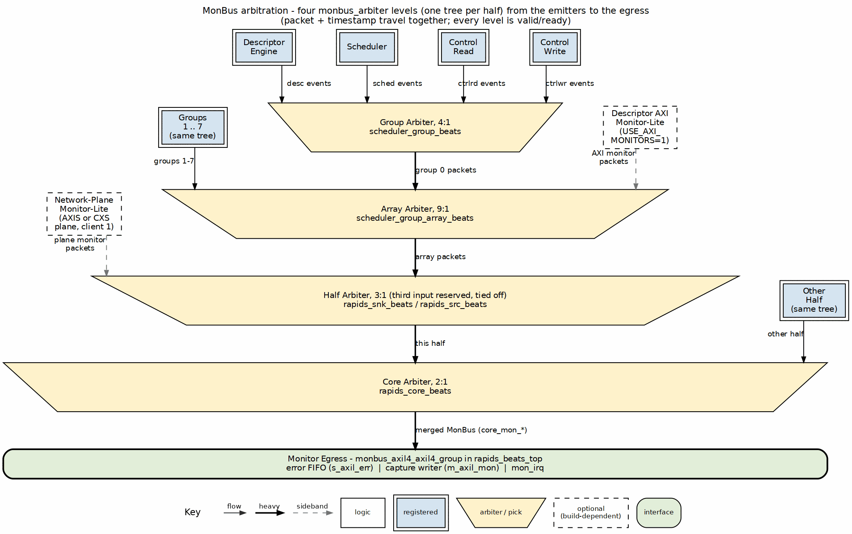
MonBus aggregation tree
Source: 21_monbus_aggregation.dot

32.6 Integration Guidelines

32.6.1 Consumer Requirements
MonBus consumers must: 1. Provide sufficient ready cycles to prevent packet loss 2. Handle bursty traffic (multiple sources may have packets simultaneously) 3. Process or buffer packets at wire rate

32.6.2 Recommended Consumer Patterns
// Pattern 1: Direct FIFO buffering
gaxi_fifo_sync #(
.DATA_WIDTH(64),
.DEPTH(256)
) u_gaxi_fifo_sync (
.axi_aclk (axi_aclk),
.axi_aresetn (axi_aresetn),
.wr_valid (wr_valid),
.wr_ready (wr_ready),
.wr_data (wr_data),
.rd_ready (rd_ready),
.count (count),
.rd_valid (rd_valid),
.rd_data (rd_data)
);

32.7 Timing Requirements
Table 4.3.9: MonBus Timing Parameters
Parameter | Value | Description
Min Ready | 1 cycle | Must assert ready within N cycles
Max Latency | Configurable | Before packet dropped
Packet Rate | Variable | Depends on activity

Last Updated: 2025-01-10

RTL Design Sherpa · Learning Hardware Design Through Practice GitHub · Documentation Index · MIT License

33 Packet Record Interface Specification
Module: scheduler.sv (producer), src_data_path_axis.sv and snk_data_path_axis.sv (consumers) Location: projects/components/dma-ip/rapids/rtl/fub/ and rtl/macro/ Status: Implemented Last Updated: 2026-09-30

33.1 Overview
The packet record interface is new in the byte-granular design. It tells a data path how many bytes a descriptor covers and where in its first beat the data starts. RAPIDS Beats has no equivalent, because every transfer there is a whole number of aligned beats.
The scheduler is the producer. It emits one record per data descriptor. The source or sink data path is the consumer and holds the records in a small queue per channel. The record interface is internal to each half: it does not appear on the rapids_core or rapids_top ports.

33.1.1 Figure 4.4.1: Scheduler Byte Math
Scheduler byte math
Source: assets/graphviz/03_scheduler_byte_math.dot

33.2 Signals
There is one set per direction. The source half uses sched_rd_pkt_* and the sink half uses sched_wr_pkt_*. Each signal is a vector with one entry per channel.
Table 4.4.1: Packet Record Signals
Signal | Direction (scheduler view) | Width per channel | Description
sched_*_pkt_valid | output | 1 | One-cycle pulse: a record is presented.
sched_*_pkt_ready | input | 1 | The consumer queue has room.
sched_*_pkt_bytes | output | 32 | Descriptor length in bytes.
sched_*_pkt_offset | output | OFF_W | Address offset inside the first beat.
OFF_W is $clog2(DATA_WIDTH/8), 5 for a 256-bit build.

33.3 Protocol
The scheduler raises valid for one cycle, in the cycle it leaves the descriptor fetch state. It does not leave that state until every enabled direction can take the record, so ready is a pre-condition of the pulse, not a wait state after it. Both directions of a channel see exactly one pulse per data descriptor.
A consumer accepts a record when valid and its queue is not full. It drives ready low when the queue is full, which is what holds the scheduler in its fetch state.
Table 4.4.2: Record Rules
Rule | Detail
Records per descriptor | One, for data descriptors of nonzero length.
Zero-length descriptors | No record.
Non-data descriptors | No record.
Order | Records are consumed in the order pushed, per channel.
Queue depth | Four records per channel in each data path.
Pop | The record pops on the last beat of its packet.
The offset is taken from the source address in the read direction and from the destination address in the write direction. The length is the same for both. When both directions are enabled, each data path receives its own offset.

33.4 Unused Direction
A scheduler group array instantiated for only one direction ties the other direction off inside the half. The unused valid, bytes and offset outputs are left open and the unused ready inputs are held at all ones, so the scheduler never waits on a queue that does not exist.

33.5 Consumer Behavior
- The source data path uses the record to compute the number of memory beats, to decide when a pop emits a stream beat, to set TSTRB and TLAST, and to retire the record.
- The sink data path uses the record to decide how far to shift each incoming beat, to check the received length at TLAST, and it holds off TREADY for a channel until the record exists.

Last Updated: 2026-09-30

RTL Design Sherpa · Learning Hardware Design Through Practice GitHub · Documentation Index · MIT License

34 CXS Interface Specification
Applies to: rapids_beats_cxs_top, rapids_cxs_top Protocol: Arm IHI 0079 (CXS) Issue D, one fixed profile Last Updated: 2026-10-16

34.1 Overview
The CXS tops replace the two AXIS network ports with one CXS link per direction: the sink port s_cxs_* (a CXS receiver) into the sink half and the source port m_cxs_* (a CXS transmitter) out of the source half. One link carries every channel; the channel rides in CXSSRCID. The planes that implement the links are described in the Network Planes chapter (Section 3.13).

34.2 Link Profile
Table 4.4.1: CXS Link Profile
Property | Value
Issue | D (the issue with SRCID, TGTID and USER)
CXSMAXPKTPERFLIT | 2
Packet start alignment | 16 bytes; RAPIDS always starts a packet at byte 0
Packet mapping | One AXIS packet (tlast-delimited) is one CXS packet
CXSSRCID | The channel (AXIS tid)
CXSTGTID | AXIS tdest
CXSUSER | {tuser, tstrb}; tuser dropped when DATA_WIDTH/8 + AXIS_USER_WIDTH > 128
Stream framing | Per stream on the channel bits of CXSSRCID
Link control | Explicit credit return, activation, deactivation
Parity | Off

34.3 Signal Table
Table 4.4.2: CXS Interface Signals
Signal | Sink port | Source port | Width | Description
{s,m}_cxs_valid | in | out | 1 | Flit valid
{s,m}_cxs_data | in | out | DATA_WIDTH | Flit data
{s,m}_cxs_cntl | in | out | CXS_CNTL_PW | START / END / pointers
{s,m}_cxs_srcid | in | out | AXIS_ID_WIDTH | Channel
{s,m}_cxs_tgtid | in | out | AXIS_DEST_WIDTH | tdest
{s,m}_cxs_user | in | out | CXS_UW | {tuser, tstrb}
{s,m}_cxs_crdgnt | out | in | 1 | Credit grant (receiver to transmitter)
{s,m}_cxs_crdrtn | in | out | 1 | Credit return (transmitter to receiver)
{s,m}_cxs_activereq | in | out | 1 | Transmitter requests the link
{s,m}_cxs_activeack | out | in | 1 | Receiver acknowledges
{s,m}_cxs_deacthint | out | in | 1 | Receiver asks the transmitter to deactivate
snk_cxs_link_state, src_cxs_link_state | out | out | 2 | {ACTIVEREQ, ACTIVEACK}
snk_cxs_protocol_error, src_cxs_protocol_error | out | out | 1 | Sticky protocol violation
snk_cxs_unsupported | out | - | 1 | Sticky: a flit AXIS framing cannot carry

34.4 Credit Flow
One credit permits one flit (IHI 0079D 2.1). The receiver grants up to CXS_MAX_CREDIT (default 32) credits, one per free entry in its receive FIFO, so every flit sent against a credit has space. The transmitter spends one credit per flit and returns the credits it still holds on deactivation. Credits are a single pool for the link; a grant carries no ID and cannot be reserved for a channel.
The grant -> flit -> free round trip between the RAPIDS endpoints is about 3 cycles, so 32 credits sustains one flit per cycle with margin for pipeline stages or a clock crossing on the link. More than 63 credits is beyond the spec and requires CXS_CREDIT_BEYOND_SPEC on both ends.

34.5 Link Activation
Table 4.4.3: Link Activation Sequence
Step | Transmitter (m_cxs_*) | Receiver (s_cxs_*)
1 | Raises ACTIVEREQ when it has a flit to send (and only once the previous activation’s ACTIVEACK has fallen: 4-phase) | -
2 | - | Raises ACTIVEACK; starts granting credits
3 | Sends flits, one credit each | Frees an entry and regrants as the core drains
4 | After CXS_IDLE_CYCLES idle cycles in RUN (or on DEACTHINT) drops ACTIVEREQ, then returns every held credit on CRDRTN, one per cycle | -
5 | - | Drops ACTIVEACK once its credits are back

34.6 Backpressure
On the sink port, a full receive FIFO means no further grants: the transmitter stalls for lack of credit. This is the CXS form of the AXIS sink’s s_axis_tready = 0, including the byte-granular sink’s hold until a channel’s descriptor has been fetched. On the source port, the plane stalls the core’s egress (fub_axis_tready = 0) while it has no credit.

34.7 Proposed Changes
A proposal (2026-10-16, not implemented) puts a tile packet header at the front of every packet: destination and source coordinates, payload type (cfg / prog / mem), length and target address. It is described once in the compute-engine tile’s TILE_SPEC.md Section 11; CXS carries it as the first flit. The link signals, credits and per-stream framing on this page do not change, because CXSSRCID keeps the channel.

RTL Design Sherpa · Learning Hardware Design Through Practice GitHub · Documentation Index · MIT License

35 rapids-g Overview
Status: Implemented (rapids TASK-034) Last Updated: 2026-10-22

35.1 What rapids-g Is
rapids-g is RAPIDS with its scheduler state machines replaced by firmware. Each half of the core (source and sink) has one gatling, the four-context barrel RV32I core (projects/components/riscv-ip/gatling-rv32i), running one firmware image for all of that half’s 4 or 8 channels. The firmware makes every decision RAPIDS’s state machine makes and does the EXT address arithmetic RAPIDS’s scheduler does in hardware:
- taking a descriptor, validating it, starting it, finishing it, and following a chain;
- the EXT run bases, base + ((i0 * stride_0) & wrap_0) + ((i1 * stride_1) & wrap_1), computed by repeated addition (gatling has no multiplier) and pushed ahead into a small queue per direction.
Everything that happens at the engines’ rate stays hardware: the counters the done strobes decrement, the address advance within a run, the timeouts, the sticky errors, the packet records and the MonBus packets. That hardware is scheduler_core, the same module RAPIDS’s scheduler uses (Section 2.1), so the two designs share one datapath.
rapids-g is register-compatible with RAPIDS: the same register map, the same descriptor format, the same host software, the same network planes.
Two capabilities RAPIDS does not have: the firmware pre-validates the next descriptor while the current one runs, so the hardware starts it the moment the current one completes (Section 5.2); and each half’s gatling can read and write its own half’s registers – including the eight per-channel CH_SCRATCH bits it shares with the host – through the host’s register command queue (Section 5.3).

35.2 Structure
Table 5.1.1: rapids and rapids-g, level by level
Level | rapids | rapids-g | How the -g module is made
fub | scheduler = state machine + ceilings + 2 run-base generators + scheduler_core | scheduler_g = command port + ceilings + base FIFOs + scheduler_core | hand-written (rtl/fub_g/)
macro | scheduler_group_array | scheduler_group_array_g: the same, with scheduler_g and one rapids_seq_g | generated
macro | rapids_src, rapids_snk, rapids_core | rapids_src_g, rapids_snk_g, rapids_core_g | generated
top | rapids_top_base, rapids_top, rapids_cxs_top | rapids_g_top_base, rapids_g_top, rapids_g_cxs_top | generated
sequencer | – | rapids_seq_g: gatling + instruction ROM + scratch + window decoder | hand-written (rtl/macro_g/)
firmware | – | rtl/fw_g/sched_g.S | assembled into rtl/macro_g/generated/fw/sched_g_fw.svh
bin/gen_rapids_g.py derives every generated file from the RAPIDS file of the same name (Section 5.4); a change to RAPIDS reaches rapids-g by rerunning it.

35.3 Channels per gatling
By default each hart serves one channel (NUM_HARTS = NUM_CHANNELS): 4 or 8 harts, one slot each, every hart issuing one instruction every NUM_HARTS clocks. NUM_HARTS = 4 at 8 channels gives each hart two slots, channels h and h + 4. The generated array refuses any other channel count, and SHARED_ENGINES = 0, at elaboration. An 8-channel core therefore has two gatlings, one per half, each sequencing eight schedulers.

35.4 What stays hardware, and why
Two transitions are interlocks, not policy, and stay hardware so they take effect in the cycle RAPIDS’s scheduler would take them:
- a channel reset forces CH_IDLE;
- a fatal fault – a descriptor, engine or control error, an escalated timeout, or the serving hart halting – forces CH_ERROR, which drops the engine valids at once.
Every other transition is a firmware command, checked against an edge table (Section 5.2).

RTL Design Sherpa · Learning Hardware Design Through Practice GitHub · Documentation Index · MIT License

36 scheduler_g
Module: scheduler_g.sv, scheduler_g_base_fifo.sv Location: projects/components/dma-ip/rapids/rtl/fub_g/ Status: Implemented (rapids TASK-034) Last Updated: 2026-10-22

36.1 Overview
scheduler_g has the whole port list of RAPIDS’s scheduler plus a sequencer window. Inside it is scheduler_core (Section 2.1), the same two byte-to-beat ceilings as scheduler, and small pieces in place of its state machine and run-base generators:
- a state register written by command, with an edge table and the two interlocks;
- pre-validation: the firmware judges the next descriptor while this one runs, and the hardware takes the approved edges itself;
- the beat totals, computed in hardware with scheduler’s own ceiling and loaded from the skid head on the cycle it is taken, and the bases-done flags, written by the firmware;
- two four-entry run-base FIFOs (scheduler_g_base_fifo), one per direction.

36.2 Sequencer Port
Table 5.2.1: Sequencer port
Signal | Dir | Description
seq_wr_en, seq_wr_addr[4:0], seq_wr_data[31:0] | in | a word write into the window (registered in rapids_seq_g)
seq_rd_addr[4:0], seq_rd_data[31:0] | in / out | a word read; combinational here, registered in rapids_seq_g
seq_attn | out | the firmware has something to do on this channel
seq_fault | in | the hart serving this channel has halted: a fatal fault

36.3 Register Window
Table 5.2.2: The window, by word
Word | Read | Write
0 | STATUS | CMD: [6:0] next state (0 = none), [8] read bases done, [9] write bases done, [10] STAGE, [11] ARM, [12] ARM to NEXT_DESC, [13] GEN_OK, [14] DECLINE, [15] STAGE_ARM, [16] STAGE_ARM to NEXT_DESC
1-2 | SRC_LO, SRC_HI | 1: FW_ERROR (sends an error packet, data {word, PKT_LO}); 2: reserved
3-4 | DST_LO, DST_HI | 3: RD_BASE_LO, 4: RD_BASE_HI (the HI write pushes {HI, LO})
5 | LENGTH (bytes) | WR_BASE_LO
6 | NEXT_PTR | WR_BASE_HI (pushes)
7-12 | chunk 1 words 0-5 (descriptor_ext_t) | 7: PKT_LO (the next packet’s low data word); 8: FW_DEBUG (sends a debug packet, data {word, PKT_LO}); 9-12: reserved
13 | FIFO: [2:0] read bases queued, [6:4] write bases queued, [15:8] CMD_ERR, [16] firmware packet pending | –
14 | CFG: [15:0] BYTE_LANES, [19:16] OFF_W, [20] EN_READ, [21] EN_WRITE, [22] EXT built, [23] TILE_HDR built | –
15-18 | the skid head, before it is taken: src [31:0], dst [31:0], length, descriptor [223:192] (valid, opcode, type, tile op) | –
19-20 | the beat totals in use (hardware) | –
21 | HEAD_SUM: the skid head’s [0] valid, [1] last, [2] chain (next_ptr != 0), [3] open (not yet staged or declined, in a state where STAGE and DECLINE are legal) | –

Table 5.2.3: STATUS
STATUS bits | Field
[6:0] | state (channel_state_t)
[7] | seq_attn
[8], [9], [10] | descriptor at the skid head, channel enable, channel reset active
[11], [13:12] | descriptor valid, opcode
[14], [15], [16] | last, gen_irq, chain (next_ptr != 0)
[17], [18], [19] | tile_bad, pkt_ok, exec_complete
[20], [21] | start pending, cmd_err (sticky)
[22], [23], [24], [25] | EXT, header only, read per-beat, write per-beat
[26], [27] | read bases done, write bases done
[28], [29], [30], [31] | armed, head staged, EXT set-up needed, head declined

36.4 Commands and the Edge Table
A CMD write names the next state. The table below is the only way state changes outside the interlocks. A command it does not list is ignored, sets the sticky cmd_err and counts in CMD_ERR (saturating at 255; a channel reset clears both).
Table 5.2.4: Legal edges
From | Command | Condition | Effect
IDLE | FETCH_DESC | a descriptor at the head, channel enabled | the head is taken on the same edge
NEXT_DESC | FETCH_DESC | a descriptor at the head | taken
FETCH_DESC | XFER_DATA | descriptor valid, not tile_bad | start pending; taken the cycle pkt_ok holds, which is the cycle the packet records fire
XFER_DATA | COMPLETE | exec_complete
COMPLETE | IDLE or NEXT_DESC | –
FETCH_DESC, XFER_DATA, COMPLETE, NEXT_DESC | ERROR | –
CH_ERROR is left only by a channel reset, as in RAPIDS’s scheduler. The pending start is what keeps the packet records a single handshake: scheduler_core raises them only with start_req, so a FETCH_DESC held by the firmware never offers a record early.
A command that arrives after a channel reset it was not written for – the firmware was part-way through a handler when the reset came – is ignored by the same table and counted. The equivalence tests expect CMD_ERR to stay 0 on every channel that is never reset.

36.5 Pre-validation and the Automatic Edges
Owner direction, 2026-10-21: “Pre validation is a must.” While descriptor N transfers, the firmware:
- ARMs N: complete it on exec_complete, then go to NEXT_DESC ([12] = 1) or IDLE. Legal once per descriptor, in XFER_DATA.
- judges the descriptor at the skid head: valid -> STAGE; not valid -> DECLINE. Legal while a descriptor is at the head and not yet judged, from XFER_DATA through NEXT_DESC.
- with STAGE, may set STAGE_ARM ([15]) and its NEXT_DESC choice ([16]): the head’s own chain outcome, decided from HEAD_SUM. The hardware then takes that head already armed. STAGE_ARM without STAGE is illegal and counted.
STAGE_ARM is how the firmware keeps up with short descriptors. Without it, every descriptor needs an ARM written inside its own XFER_DATA, and the firmware’s path to that write is about 25 instructions – 200 clocks at 8 harts, where a 64-beat descriptor transfers in under 90. Each such descriptor finished before it was armed and went the hand path: 672 clocks per descriptor on a 64-beat sink chain (Section 5.5). With STAGE_ARM, a descriptor needs one firmware write, made any time before its predecessor completes.
With N armed, the hardware then takes, in the cycles RAPIDS’s scheduler would: XFER_DATA -> COMPLETE (on exec_complete) -> IDLE or NEXT_DESC -> FETCH_DESC (the staged head, its totals, the start already requested) -> XFER_DATA (when pkt_ok). The latched descriptor is still checked (valid, tile_bad) as on the hand path. Anything not approved stops the sequence and raises attention: an unarmed descriptor, an unstaged or declined head, a disabled channel.
Three ordering rules make it safe, each the fix of a race the equivalence bench found:
Rule | Why
An EXT descriptor completes automatically only once both directions’ bases-done bits are set | the firmware writes them after its last push, so no push or done bit of this descriptor can land after the next is taken
GEN_OK (set-up done) is written before the set-up | a descriptor cannot complete before its done bits, which the set-up writes after GEN_OK, so a GEN_OK can never land on the next descriptor
The firmware judges both directions’ refills on one STATUS snapshot | a fresh STATUS read after the first direction’s last done bit may already describe the next descriptor
A head the hardware takes is flagged ([30]) when it is EXT, and the firmware sets up its run bases in XFER_DATA; run 0 uses the descriptor’s own address, so only short first runs wait for them.

36.6 Firmware Packets
The firmware can put its own packets on the channel’s MonBus port, from the channel’s agent:
Table 5.2.5: Firmware packets
Write | Packet type | Event code | Event data
FW_DEBUG (word 8) | PktTypeDebug | RAPIDS_EVENT_FW_DEBUG (0x09) | {written word, PKT_LO}
FW_ERROR (word 1) | PktTypeError | RAPIDS_EVENT_FW_ERROR (0x0A) | {written word, PKT_LO}
scheduler_core’s own packets are one-cycle pulses and always win the cycle; a firmware packet leaves in the first cycle with none and mon_ready high. One packet waits at a time (FIFO [16]); a send while one waits is dropped and counted in CMD_ERR, like a push to a full base FIFO. A firmware error packet only reports: it does not move the channel to CH_ERROR, which stays a CMD or an interlock. Neither packet type is a completion, so cfg_sched_compl_enable does not filter them.

36.7 Attention
seq_attn is high when the firmware has work on the channel, and is what the sequencer’s SUMMARY register reports:
- IDLE with the channel enabled and an unstaged descriptor at the head; NEXT_DESC with an unstaged descriptor at the head;
- FETCH_DESC with no start pending, or turned tile_bad;
- XFER_DATA not yet armed, EXT set-up needed, an EXT base FIFO with room and bases still to come, or an unjudged head;
- COMPLETE not armed (the hand path).
Nothing raises attention in CH_ERROR, during a channel reset, or on a fault.

36.8 Run-Base FIFOs
scheduler_g_base_fifo holds four 64-bit bases (the depth of stream_run_addr_gen’s own queue). A LO write is held; the HI write pushes {HI, LO}. The FIFO is flushed whenever the channel is outside FETCH_DESC and XFER_DATA, and on a channel reset, so a base can never outlive its descriptor. A push to a full FIFO is dropped and counted in CMD_ERR. scheduler_core takes a base only between runs, exactly as from the generator.

RTL Design Sherpa · Learning Hardware Design Through Practice GitHub · Documentation Index · MIT License

37 rapids_seq_g and the Scheduler Firmware
Module: rapids_seq_g.sv; firmware rtl/fw_g/sched_g.S Location: projects/components/dma-ip/rapids/rtl/macro_g/ Status: Implemented (rapids TASK-034) Last Updated: 2026-10-22

37.1 rapids_seq_g
One gatling_core, used unchanged through its own filelist, with the three memories it needs, each answering in one stage as gatling requires:
Table 5.3.1: rapids_seq_g
Block | What | Size
Instruction ROM | the firmware image, from sched_g_fw.svh; one read port serves every hart (the barrel fetches for one context per cycle) | IMEM_WORDS = 1024
Scratch | per-hart memory, indexed {context, word}; the run-base generator state of each slot | SCRATCH_WORDS = 128 per hart
Window decoder | routes a data access to the slot’s scheduler_g by context and slot | –
Parameters: NUM_CHANNELS (4 or 8), NUM_HARTS (4 or 8, dividing NUM_CHANNELS; default NUM_CHANNELS, one hart and one slot per channel; hart h serves channels h + NUM_HARTS x s), IMEM_WORDS, SCRATCH_WORDS (a power of 2, at least 64 per slot; a smaller scratch would alias slot 1 onto slot 0, and elaboration refuses it).

37.1.1 Data Memory Map
Table 5.3.2: Data memory map
Address | Region
0x0000_0000 | instruction ROM (fetch only; a data read returns 0)
0x1000_0000 | slot 0 window (Section 5.2), word-indexed
0x1000_0100 | slot 1 window
0x1000_1000 | SUMMARY: [1:0] seq_attn of this hart’s slots
0x1000_1004 | SLOTS: slots per hart (1 or 2)
0x1000_3000 | register mailbox (below), aliased by context
0x2000_0000 | scratch, aliased by context
Contexts stay implicit (gatling PRD 7): every hart runs the same image, and “slot 0” is a different channel for each, chosen by the context the access comes from. Reads are registered (address in X, data in W); window writes are registered into scheduler_g one cycle after X, so a hart’s next instruction, NUM_HARTS (at least four) cycles later, always sees the effect of its own write. Each hart issues one instruction every NUM_HARTS clocks: at the default 8 harts an instruction costs a hart 8 clocks, which is the unit of every firmware cost in Section 5.5.

37.1.2 Register Mailbox
Each hart can read and write its own half’s PeakRDL registers – the same rapids_regs the host programs – through a mailbox: REG_ADDR (+0x00, byte offset within the half), REG_WDATA (+0x04), REG_CTRL (+0x08: [0] go, [1] write), REG_STATUS (+0x0C: [0] busy, [1] done, [2] error), REG_RDATA (+0x10). The firmware posts an access and polls; a single-stage barrel cannot wait on a bus. The harts’ accesses go out one at a time (arbiter_round_robin_simple_ack) on the gatling’s one master port, seq_reg_*, which the generated tree carries up to the top base. There rapids_g_reg_arb decides who pushes into the register block’s command queue: the host’s APB, the SOURCE gatling and the SINK gatling, round robin, one access outstanding, the response steered back by the held grant. Each gatling’s offset is pinned to its half (SRC at 0x0000, SNK at 0x1000), so neither can reach the other’s registers. The per-channel CH_SCRATCH[n].SCRATCH bits (0x300 in each half) are there for the host and the gatling to share flags or semaphores (not atomic across masters: give each bit one writer). The scheduler firmware does not use the mailbox today.

37.1.3 Faults
seq_fault[c] is the halted bit of the hart serving channel c, so a firmware trap is a fatal fault for that hart’s channels: they enter CH_ERROR and send the scheduler’s error packet. A halted hart restarts from address 0 once every channel it serves is in channel reset.

37.2 Firmware
sched_g.S is RV32I with no stack and no data section; state that outlives one service call lives in the slot’s scratch.

37.2.1 Main Loop
The image reads SLOTS at start-up and takes one of two poll loops.
One slot per hart (the default, NUM_HARTS = NUM_CHANNELS). The loop reads HEAD_SUM first. HEAD_SUM = 13 (open, valid, next_ptr != 0, not last) is a chained head: the loop writes STAGE | STAGE_ARM | STAGE_ARM_NEXT, held in a register, so a running chain costs four instructions from the read to the CMD write. Any other open head is judged inline (JUDGE: stage it armed with its own chain outcome, or decline it). With no open head the loop reads SUMMARY; the idle pass is seven instructions. When SUMMARY shows attention, the loop reads HEAD_SUM again before it calls service: a head that arrived between the two reads is judged inline. Without that re-read such a head went down service’s IDLE / NEXT_DESC path, about 30 instructions later than the inline path, which a fixed-time test (tile_source_bad_ptype, 3 seeds in 8) caught.
Two slots per hart (NUM_HARTS = 4 at 8 channels). The loop reads SUMMARY, then for each slot with attention reads HEAD_SUM and judges an open head inline, else calls service.

37.2.2 Figure 5.3.1: One Hart’s Poll Loop
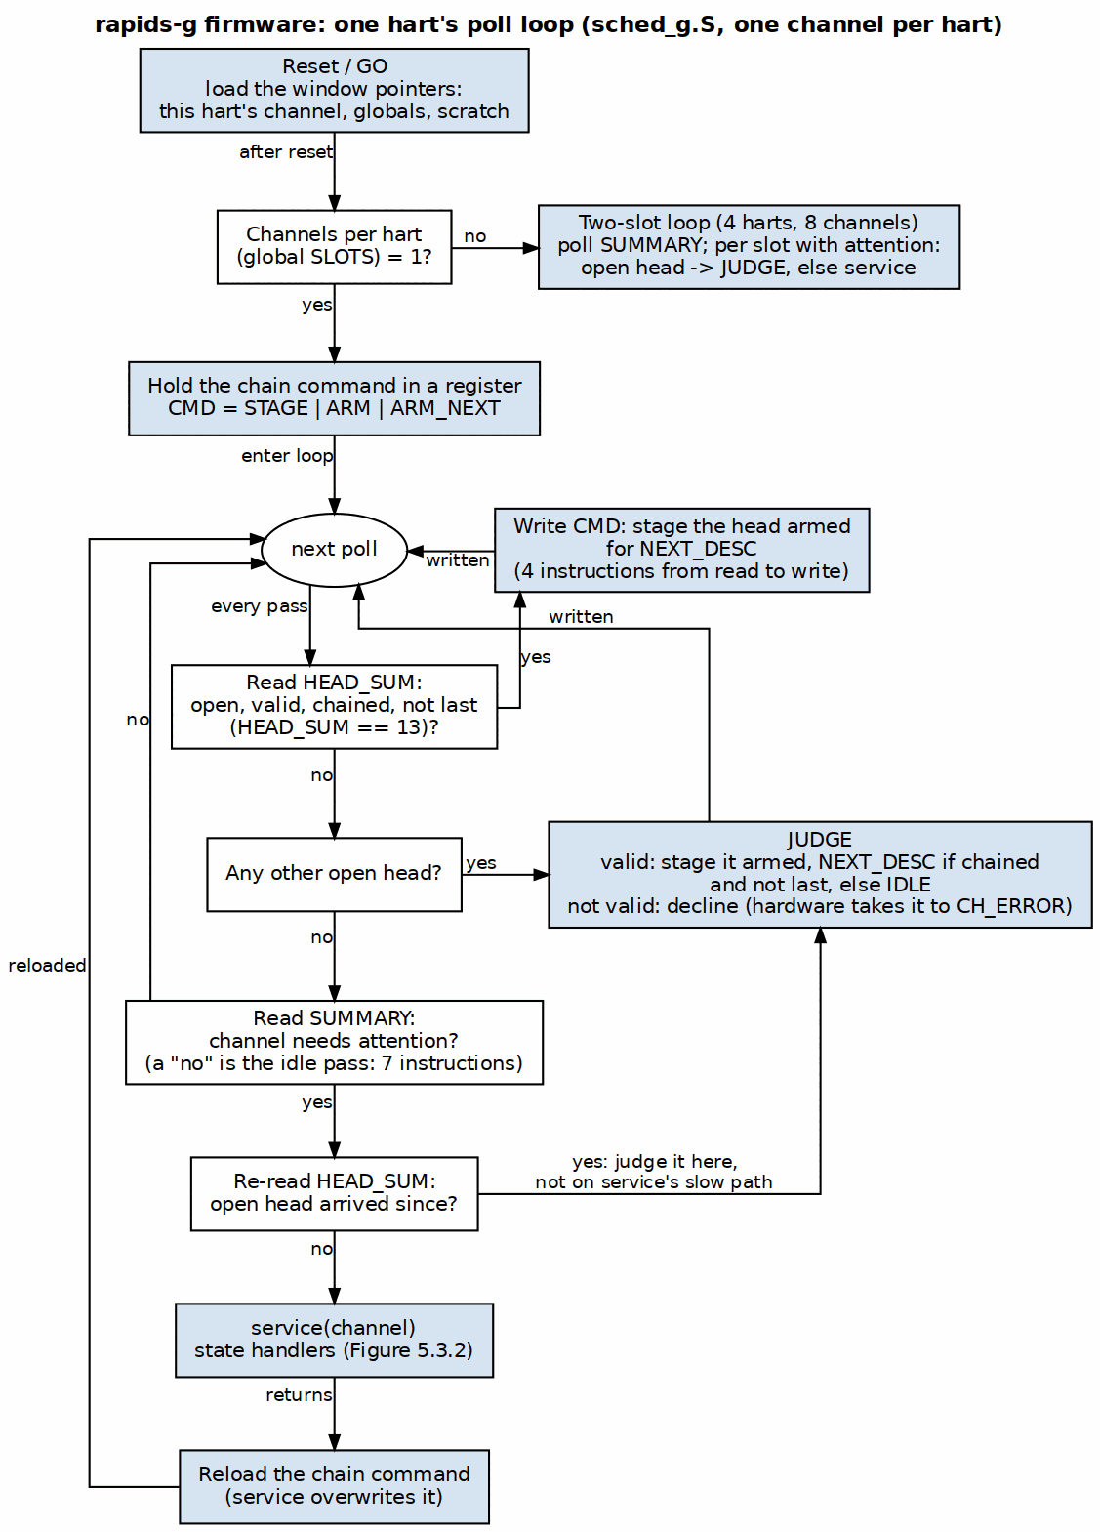
rapids-g firmware poll loop
Source: assets/graphviz/12_rapids_g_fw_poll_loop.dot
A service call reads STATUS and takes the slot as far as it can. Whatever the state, a head not yet judged is judged first: valid -> STAGE with STAGE_ARM and the head’s own chain outcome from HEAD_SUM, so the hardware takes it armed and runs it to completion on its own; not valid -> DECLINE (Section 5.2). In XFER_DATA it then sets up the run bases if the hardware took an EXT descriptor, and tops them up. The hand path covers a descriptor taken unarmed and a declined head: ARM, or COMPLETE, IDLE or NEXT_DESC, then FETCH_DESC and everything FETCH_DESC needs. When a handler’s last STATUS read shows the slot has moved on, the call carries on from the new state rather than returning to the poll loop. The dispatch tests XFER_DATA, then NEXT_DESC, the two states a chain sits in. That carry-on is also the call’s cost: a hart that enters service during a chain can stay in it for several descriptors at about 32 instructions each, which is why the one-slot loop judges every open head itself (measured in Section 5.5; a run-to-completion executive with one handler per step is rapids TASK-037).

37.2.3 Figure 5.3.2: service(), Dispatched on the Channel State
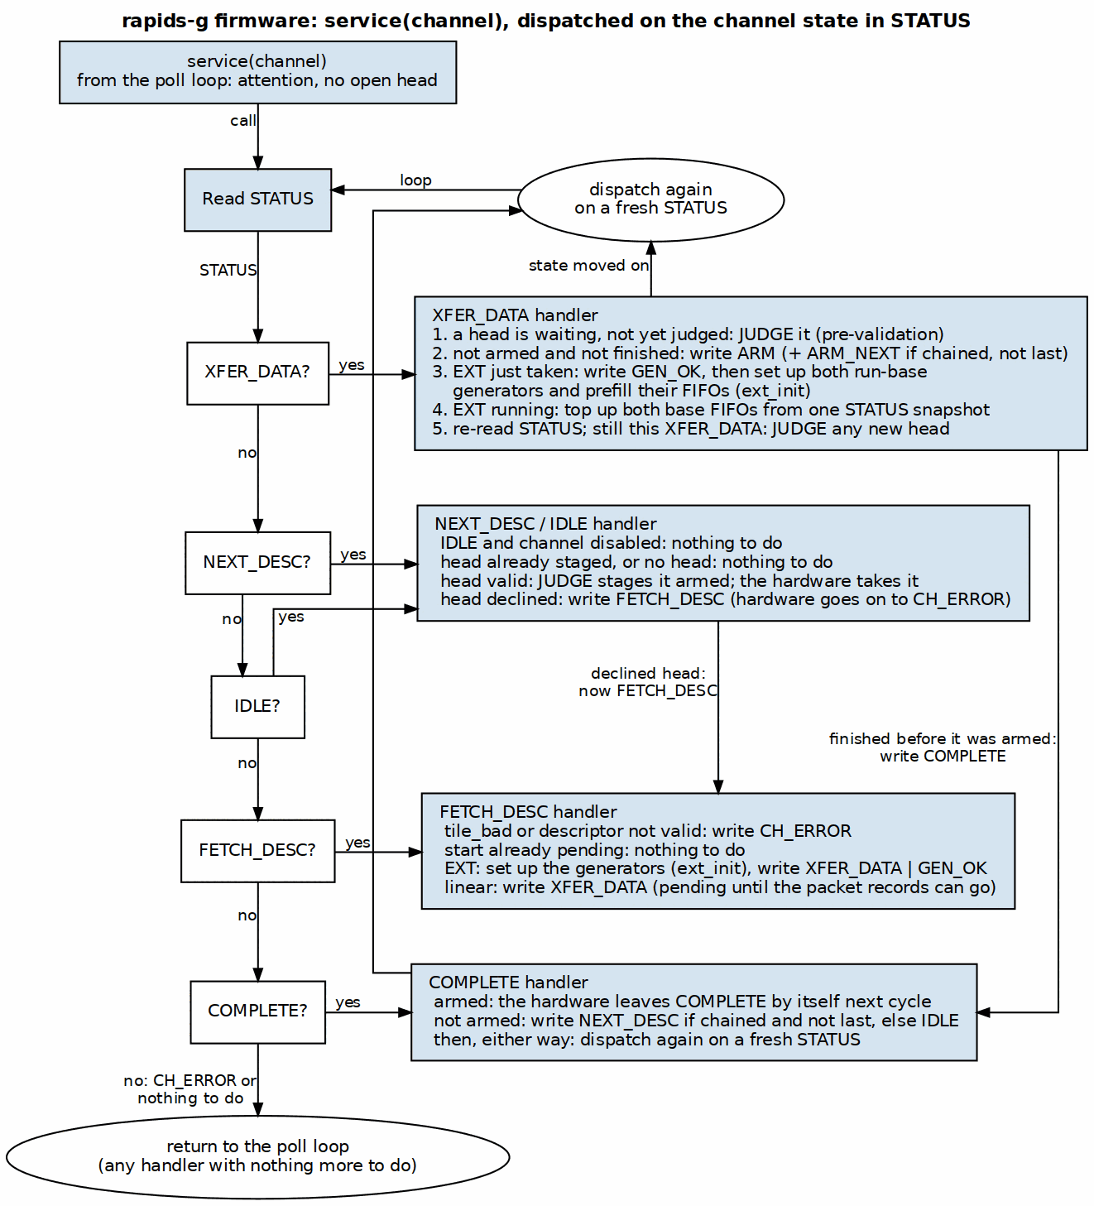
rapids-g firmware service call
Source: assets/graphviz/13_rapids_g_fw_service.dot

37.2.4 FETCH_DESC
- An invalid or tile_bad descriptor: CMD ERROR.
- Beat totals need no firmware: scheduler_g computes them in hardware, with scheduler’s own ceiling, when it takes the head (Section 5.2). The EXT set-up reads them back.
- For TYPE=EXT, the run-base generator of each enabled direction is set up in scratch and its FIFO prefilled.
- CMD XFER_DATA (pending until the records can go).

37.2.5 EXT Run Bases
The positions, the step and the 16-bit index wrap are exactly stream_run_addr_gen’s: run-contiguous when stride_0 equals the beat size (one base per run of inner_count beats, rows 1, 2, …), otherwise per beat (every beat after the first, inner index fastest). A base is base + ((i0 * s0) & m0) + ((i1 * s1) & m1) in 64 bits. Without wrap masks (the common case) the firmware keeps the address itself and a base is one 64-bit add (cur += s0 along a row, row += s1 at a row’s end); with masks it keeps the two products as running sums and masks them for each base. Whenever an EXT descriptor’s FIFO has room, attention brings the firmware back to top it up; the last base sets the direction’s bases-done bit.

37.2.6 Building the Image
bin/gen_rapids_g_fw.py runs riscv-none-elf-as / ld (text at 0) / objcopy -O binary and writes FW_WORDS and FW_IMAGE[] into rtl/macro_g/generated/fw/sched_g_fw.svh, which rapids_seq_g includes, so neither simulation nor synthesis needs a file path. --check fails when the include is stale. Never edit the include.

RTL Design Sherpa · Learning Hardware Design Through Practice GitHub · Documentation Index · MIT License

38 The Generated rapids-g Tree
Generator: bin/gen_rapids_g.py Status: Implemented (rapids TASK-034) Last Updated: 2026-10-21

Above scheduler_g the rapids-g RTL is RAPIDS’s, so it is derived rather than copied:
Table 5.4.1: Generated files
Generated | From | Edits
rtl/macro_g/generated/scheduler_group_array_g.sv | rtl/macro/scheduler_group_array.sv | rename; scheduler becomes scheduler_g; the seq_* ports wired; scheduler_group_array_g_seq.svh (one rapids_seq_g) included in front of the scheduler loop; $fatal unless SHARED_ENGINES = 1 and NUM_CHANNELS is 4 or 8
rtl/macro_g/generated/rapids_src_g.sv, rapids_snk_g.sv | rtl/macro/rapids_src.sv, rapids_snk.sv | rename; the array becomes scheduler_group_array_g
rtl/macro_g/generated/rapids_core_g.sv | rtl/macro/rapids_core.sv | rename; the halves become _g
rtl/top_g/generated/rapids_g_top_base.sv | rtl/top/rapids_top_base.sv | rename; the core becomes rapids_core_g; apb4_slave’s cmd/rsp outputs renamed host_*; rapids_g_top_reg_arb.svh (host + both gatlings into the register command queue) included after it
rtl/top_g/generated/rapids_g_top.sv, rapids_g_cxs_top.sv | the -g base | the thin-top derivation of bin/gen_plane_tops.py
The register-mailbox master (seq_reg_*) is added to every level’s port list after rst_n and connected at every instance (array -> half -> core as src_ / snk_ -> top base), so the RAPIDS files need no knowledge of it.
Every edit matches its anchor exactly once or the generator fails, so a RAPIDS change that moves an anchor is a failed run, not a wrong file. python3 bin/gen_rapids_g.py --check exits 1 when any generated file is stale. The filelists are rtl/filelists/fub_g/, macro_g/ and top_g/; they pull gatling through $GATLING_ROOT/rtl/filelists/top/gatling_core.f, and the 8-channel register map as top/rapids_top_base.f does.

RTL Design Sherpa · Learning Hardware Design Through Practice GitHub · Documentation Index · MIT License

39 rapids-g Verification and Measurements
Status: Implemented (rapids TASK-034) Last Updated: 2026-10-22

39.1 Verification
Table 5.5.1: rapids-g suites
Suite | What it shows
dv/tests/fub_g/test_rapids_g_equiv.py | RAPIDS’s scheduler and scheduler_g + firmware side by side (rapids_g_equiv_tb_top), 4 and 8 channels, 256 and 512 bits, same descriptors, engine models with different latencies per side. Every engine command, packet record, MonBus packet and state transition must match in order. The address sequences are also checked against an independent golden model (RapidsGEquivTB.golden_cmds: the byte-to-beat ceiling and dma_address_gen’s formula). Cells: linear, ext, reset_ext, backpressure, error_reset, reset_any (a channel reset in every state), hart_fault (every hart halted by an illegal word patched over its SUMMARY poll, found by encoding, faults its channels and restarts), perf.
dv/tests/fub_g/test_scheduler_g_edges.py | scheduler_g alone with the testbench as its firmware: every command and flag in every state, 57 checks; legal edges taken, the rest ignored and counted, CH_ERROR left only by a reset; the automatic COMPLETE -> IDLE -> FETCH -> XFER of an armed descriptor with a staged head, and the stop at a declined head.
dv/tests/top_g/test_rapids_g_regpath.py | Both gatlings run a test program that reads and writes their own half’s registers (SCHED_TIMEOUT_CYCLES, SCHED_TIMEOUT_LIMIT, CH_SCRATCH) through the mailbox while the host hammers the same command queue: every hart reads its own half’s value, each gatling’s writes land in its own half only, no host read is wrong.
dv/tests/macro_g/ | Every RAPIDS scheduler_group_array test on scheduler_group_array_g, at 4 and 8 channels.
dv/tests/top_g/ | Every RAPIDS rapids_top and rapids_cxs_top test, unchanged, on rapids_g_top and rapids_g_cxs_top (the 16-channel cells skip).
The test files are RAPIDS’s own: the -g runners load the RAPIDS cocotb tests by module name (macro_g) or re-host the RAPIDS wrappers (top_g/rapids_g_rehost.py), so rapids-g is held to exactly RAPIDS’s checks. They caught a firmware race on the way: a head that arrived between the tight loop’s HEAD_SUM and SUMMARY reads went down service’s slower path, and tile_source_bad_ptype saw its channel error after the test’s wait on three of eight seed bases; the loop now re-reads HEAD_SUM before service.
Mutation: six firmware mutants (chain never followed, chain pre-armed wrong, beat ceiling off by one, stride sign, wrap mask dropped, the STATUS re-read in refill_both restored), six RTL mutants (edge-table holes for COMPLETE, ERROR, FETCH and the head flags; the fault interlock removed; auto-complete without the bases-done gate) and the register path’s half pin each fail a test. Two survived the first bench and led to its state comparison and to the edge-table test.
Two RAPIDS bugs were found on the way and fixed in RAPIDS: rapids BUG-016 (a held CH_FETCH_DESC sent DESC_START every cycle) and rapids BUG-017 (stale EXT run bases after a channel reset; also in RAPIDS Beats and STREAM).

39.2 Performance on the Board
rapids-8ch and rapids-g-8ch ran the same 45-point gcompare profile on the Genesys 2 harness (projects/fpga-systems/Genesys2/dma-ip/rapids/flows-rapids): 8 channels, DATA_WIDTH 256, 100 MHz, peak 3,200 MB/s per direction. A figure is the bytes moved over the hardware timer’s cycles from the first request to the last write, descriptor fetch and launch included. Every point is golden-checked and passes on both designs. The point names read <group>_ch<N>_b<B>[_d<D>][_il]: beat is one descriptor per channel and chain a linked chain, ch<N> the active channels, b<B> beats (32 bytes) per descriptor, d<D> descriptors per channel (absent: one), and il an interleaved sink. Without il the sink stream feeds the channels one after another, so only one channel holds data at a time; the source reads memory for every channel at once in every point.
Records: reports/board/flow_results/byte_perf_gcompare_fsm_il_rc.json (rapids-8ch) and byte_perf_gcompare_gfin_rc.json (rapids-g-8ch).
The simulation of the board build (make sim-gcompare, run in seven chunks) matches the board cycle for cycle: 85 of 85 windows on each design. Matching needed one change to the host program. The shared descriptor engine’s round-robin pointer (descriptor_engine_shared, r_rr_ptr) is reset only by aresetn, so it carries from one point to the next. A chunk that starts cold in simulation served the channels in a different order from the board, where the previous point had run, and took 16 clocks longer (8 on rapids-8ch). Each chunk after the first now runs the previous chunk’s last point first, unrecorded (byte_perf.chunk_warmup). The RTL is unchanged.
Table 5.5.2: Genesys 2 gcompare, MB/s (peak 3,200; – = not measured: the source side has no interleaved variant)
Point | rapids-8ch sink | rapids-g-8ch sink | rapids-8ch source | rapids-g-8ch source
beat_ch1_b1 | 54 | 14 | 50 | 14
beat_ch1_b4 | 197 | 56 | 191 | 56
beat_ch1_b16 | 624 | 210 | 648 | 212
beat_ch1_b64 | 1,575 | 701 | 1,613 | 709
beat_ch1_b256 | 2,544 | 1,693 | 2,568 | 1,703
beat_ch1_b1024 | 3,006 | 2,617 | 3,015 | 2,624
beat_ch1_b4096 | 3,149 | 3,031 | 3,152 | 3,033
beat_ch1_b32768 | 3,194 | 3,178 | 3,194 | 3,178
beat_ch2_b1 | 77 | 29 | 74 | 28
beat_ch2_b4 | 281 | 111 | 281 | 110
beat_ch2_b16 | 853 | 394 | 890 | 398
beat_ch2_b64 | 1,896 | 1,151 | 1,941 | 1,160
beat_ch2_b256 | 2,731 | 2,214 | 2,754 | 2,223
beat_ch2_b1024 | 3,068 | 2,879 | 3,075 | 2,883
beat_ch2_b4096 | 3,166 | 3,113 | 3,168 | 3,114
beat_ch2_b32768 | 3,196 | 3,189 | 3,196 | 3,189
beat_ch4_b1 | 99 | 45 | 100 | 45
beat_ch4_b4 | 363 | 174 | 368 | 180
beat_ch4_b16 | 1,056 | 589 | 1,095 | 621
beat_ch4_b64 | 2,122 | 1,517 | 2,161 | 1,569
beat_ch4_b256 | 2,840 | 2,505 | 2,857 | 2,540
beat_ch4_b1024 | 3,102 | 2,993 | 3,107 | 3,005
beat_ch4_b4096 | 3,175 | 3,145 | 3,176 | 3,149
beat_ch4_b32768 | 3,197 | 3,193 | 3,197 | 3,194
beat_ch8_b1 | 116 | 66 | 121 | 66
beat_ch8_b4 | 425 | 252 | 436 | 250
beat_ch8_b16 | 1,198 | 806 | 1,237 | 811
beat_ch8_b64 | 2,257 | 1,837 | 2,291 | 1,843
beat_ch8_b256 | 2,897 | 2,699 | 2,911 | 2,703
beat_ch8_b1024 | 3,119 | 3,058 | 3,123 | 3,059
beat_ch8_b4096 | 3,179 | 3,163 | 3,180 | 3,164
beat_ch8_b32768 | 3,197 | 3,195 | 3,198 | 3,195
chain_ch1_b1_d16 | 149 | 73 | 278 | 73
chain_ch1_b64_d16 | 2,214 | 1,875 | 3,015 | 1,788
chain_ch1_b1024_d16 | 3,113 | 3,103 | 3,188 | 3,177
chain_ch1_b8192_d4 | 3,186 | 3,180 | 3,194 | 3,188
chain_ch8_b1_d16 | 164 | 74 | 1,177 | 419
chain_ch8_b64_d16 | 2,276 | 1,975 | 3,123 | 3,059
chain_ch8_b1024_d16 | 3,121 | 3,117 | 3,195 | 3,191
chain_ch8_b8192_d4 | 3,190 | 3,188 | 3,198 | 3,195
beat_ch8_b16_il | 1,048 | 726 | – | –
beat_ch8_b64_il | 2,098 | 1,717 | – | –
chain_ch8_b1_d16_il | 822 | 418 | – | –
chain_ch8_b64_d16_il | 2,709 | 2,662 | – | –
chain_ch8_b1024_d16_il | 3,166 | 3,162 | – | –
The firmware’s cost per descriptor sets the gap. Its history on the hardest point, a one-channel chain of 64-beat sink descriptors:
Table 5.5.3: Firmware cost per chained descriptor
Firmware | chain_ch1_b64_d16 sink | Clocks per descriptor
first 8-hart image (one hart per channel) | 1,118 MB/s | about 288
one-slot tight chain loop, HEAD_SUM re-read before service | 1,833 MB/s (board) | about 90
seven-instruction idle pass (this image) | 1,875 MB/s | about 90
rapids-8ch, for reference | 2,214 MB/s | –
Before STAGE_ARM (Section 5.2) the same point cost 672 clocks a descriptor. The tight loop (Section 5.3) follows a chained head in four instructions; the shorter idle pass recovered a 1-2% dip on the eight-channel single-descriptor sink points (beat_ch8_b4 to b256).

39.3 Scheduler Limit
Measured with cocotb_test_perf: engines that take every burst in one cycle and never stall, so the scheduler is the only limit; 8 channels and 8 harts, DATA_WIDTH 256, cycles at 100 MHz. The bench runs both directions on every channel, twice the load of one RAPIDS half (each half moves one direction).
Table 5.5.4: Cycles to finish, schedulers alone
Scenario | rapids-8ch | rapids-g-8ch | rapids-g-8ch / rapids-8ch
16 one-beat descriptors, one channel | 131 | 2,371 | 18x
16 one-beat descriptors on each channel | 131 | 2,316 | 18x
16 64-beat descriptors on each channel | 1,255 | 2,389 | 1.9x
4 64 KB descriptors on each channel | 9,248 | 9,529 | 1.03x
2 1 MB descriptors on each channel | 84,277 | 84,420 | 1.002x
EXT, runs of 4, 64 beats, 4 per channel | 407 | 40,433 | 99x
EXT, per beat, 64 beats, 4 per channel | 1,043 | 135,848 | 130x
EXT, runs of 256, 1 MB, 1 per channel | 29,574 | 72,329 | 2.4x
With one hart per channel the channels no longer share a hart, so one busy channel and eight busy channels cost the same (2,371 and 2,316). On 4 harts the same rows were 7,215 and 14,139. Pre-validation hides the firmware behind the descriptor in flight whenever the transfer outlasts it: two 1 MB descriptors per channel finish 0.17% behind rapids-8ch, and what remains is each channel’s first descriptor. Descriptors shorter than the firmware’s work still pay it in full. EXT descriptors are limited by base generation: a base costs the firmware about 15-35 instructions, each NUM_HARTS clocks, against one cycle in stream_run_addr_gen, so with both directions on every channel even 256-beat runs cannot be fed at the engines’ rate. Custom gatling instructions for DMA (gatling_dma) are the lever for that case.

39.4 Area and Timing
rapids_core and rapids_core_g, out of context on the Genesys 2 part (xc7k325t-2), 8 channels, DATA_WIDTH 256, SHARED_ENGINES 1, USE_AXI_MONITORS 0, 8 harts, placed and routed at 100 MHz:
Table 5.5.5: Out-of-context results
 | rapids_core | rapids_core_g
LUTs | 68,773 | 76,958 (+11.9%)
Registers | 55,550 | 58,673
Block RAM tiles | 64 | 70
DSPs | 64 | 0
WNS at 100 MHz | +0.601 ns | +0.393 ns
The register arbiter (rapids_g_reg_arb) is in the top, outside rapids_core_g, and not in these numbers. Per half, rapids_seq_g is about 1.95k LUTs (gatling about 1.39k of it); the sink half is 38,693 LUTs against 34,943 for rapids_snk, and the source half 37,180 against 32,746 for rapids_src. The 4-hart build measured 76,350 LUTs, 56,645 registers, 69 block RAM tiles and +0.249 ns: eight harts cost about 600 LUTs and 2k registers, and gatling’s own path is no longer the worst. The worst path of rapids_core_g is now in the source half, from a scheduler’s source address (gen_schedulers[3].u_scheduler/u_core/r_src_addr_reg) to the AXI read engine’s outstanding counter enable, 20 levels. The 64 DSPs of rapids_core are the run-base generators’ index-by-stride multipliers, which the firmware replaces with additions.
In the full Genesys 2 harness of Table 5.5.2, rapids-g-8ch takes 110,662 LUTs (54.3%), 65,083 registers, 58 block RAM tiles and no DSPs and closes 100 MHz at +0.072 ns; rapids-8ch takes 100,007 LUTs at +0.357 ns.

RTL Design Sherpa · Learning Hardware Design Through Practice GitHub · Documentation Index · MIT License

40 RAPIDS Beats Architecture MAS
Version: 0.14 Date: 2026-10-20 Purpose: Module Architecture Specification for RAPIDS Phase 1 “Beats” Architecture

40.1 Document Organization
Note: All chapters linked below for automated document generation.

40.1.1 Front Matter
- Document Information

40.1.2 Chapter 1: Overview
- Architecture Overview
- Top-Level Port List
- Clocks and Reset

40.1.3 Chapter 2: FUB (Functional Unit Blocks)
Control Path: - Scheduler - Descriptor Engine
AXI Engines: - AXI Read Engine - AXI Write Engine
Flow Control: - Beats Alloc Control - Beats Drain Control - Beats Latency Bridge
Control Engines: - Control-Read Engine - Control-Write Engine

40.1.4 Chapter 3: Macro (Integration Blocks)
Scheduler Integration: - Beats Scheduler Group - Beats Scheduler Group Array
Sink Data Path (Network to Memory): - Sink Data Path - Sink Data Path AXIS - Sink SRAM Controller
Source Data Path (Memory to Network): - Source Data Path - Source Data Path AXIS - Source SRAM Controller
Top-Level Integration: - RAPIDS Core Beats - RAPIDS Registers - RAPIDS Config Block - RAPIDS Beats Top - Network Planes

40.1.5 Chapter 4: Interfaces
- Interface Overview
- AXI4 Interface Specification
- AXIS Interface Specification
- MonBus Interface Specification
- CXS Interface Specification

40.2 Quick Reference

40.2.1 FUB Modules (fub_beats/)
FUB Module Summary
Module | File | Purpose | Status
scheduler_beats | scheduler_beats.sv | Transfer coordinator, descriptor processing | Implemented
descriptor_engine_beats | descriptor_engine_beats.sv | Descriptor fetch/parse (256-bit) | Implemented
axi_read_engine_beats | axi_read_engine_beats.sv | AXI read master, streaming pipeline | Implemented
axi_write_engine_beats | axi_write_engine_beats.sv | AXI write master, streaming pipeline | Implemented
alloc_ctrl_beats | alloc_ctrl_beats.sv | Space allocation tracking (virtual FIFO); kept and tested, no longer in the SRAM path since bdf4e0dff | Implemented
drain_ctrl_beats | drain_ctrl_beats.sv | Data availability tracking (virtual FIFO); kept and tested, no longer in the SRAM path | Implemented
latency_bridge_beats | latency_bridge_beats.sv | Registered-FIFO to valid/ready skid bridge; kept and tested, no longer in the SRAM path | Implemented
ctrlrd_engine | ctrlrd_engine.sv | Control-read consumer gate (poll-until-match, retry budget) | Implemented
ctrlwr_engine | ctrlwr_engine.sv | Control-write producer doorbell (single-beat write) | Implemented

40.2.2 Macro Modules (macro_beats/)
Macro Module Summary
Module | File | Purpose | Status
scheduler_group_beats | scheduler_group_beats.sv | Scheduler + Descriptor Engine wrapper | Implemented
scheduler_group_array_beats | scheduler_group_array_beats.sv | 8-channel scheduler array with arbitration | Implemented
snk_data_path_beats | snk_data_path_beats.sv | Network-to-memory path integration | Implemented
snk_data_path_axis_beats | snk_data_path_axis_beats.sv | AXIS variant of sink path | Implemented
src_data_path_beats | src_data_path_beats.sv | Memory-to-network path integration | Implemented
src_data_path_axis_beats | src_data_path_axis_beats.sv | AXIS variant of source path | Implemented
snk_sram_controller_beats | snk_sram_controller_beats.sv | Sink SRAM: naming wrapper around STREAM’s sram_controller (one instance, per-channel FIFOs inside it) | Implemented
src_sram_controller_beats | src_sram_controller_beats.sv | Source SRAM: naming wrapper around STREAM’s sram_controller | Implemented
rapids_src_beats / rapids_snk_beats | rapids_src_beats.sv, rapids_snk_beats.sv | One half each: scheduler array + data path + monbus merge | Implemented
rapids_core_beats | rapids_core_beats.sv | Both halves + the core monbus arbiter | Implemented
rapids_regs | regs/generated/rtl/rapids_regs.sv (generated from rtl/macro_beats/rapids_regs.rdl) | PeakRDL register block (base + MON regfile @ 0x1000) | Implemented
rapids_config_block | rapids_config_block.sv | Maps register hwif_out to core/monitor cfg_* | Implemented
rapids_beats_top | rapids_beats_top.sv | Top-level: APB slave, kickoff, monitors, MonBus AXI-Lite group | Implemented

40.3 Architecture Comparison: RAPIDS vs STREAM
The “beats” architecture is a Phase 1 implementation of RAPIDS that shares concepts with STREAM but targets network-to-memory (and vice versa) transfers rather than memory-to-memory.
RAPIDS Beats vs STREAM Comparison
Feature | STREAM | RAPIDS Beats
Primary Use | Memory-to-memory DMA | Network-to-memory accelerator
Data Paths | Single bidirectional | Separate sink/source paths
Network Interface | None | AXIS master/slave
SRAM Buffering | Shared buffer | Separate sink/source buffers
Descriptor Format | 256-bit | 256-bit (compatible)
Channel Count | 8 | 8
Flow Control | alloc_ctrl/drain_ctrl | STREAM stream_alloc_ctrl/stream_drain_ctrl inside the shared sram_controller (alloc_ctrl_beats/drain_ctrl_beats kept, out of the path)

40.4 Clock and Reset Summary

40.4.1 Clock Domains
Clock Domains
Clock | Frequency | Usage
aclk | 100-500 MHz | Primary - all RAPIDS logic, AXI/AXIS interfaces

40.4.2 Reset Signals
Reset Signals
Reset | Polarity | Type | Usage
aresetn | Active-low | Async assert, sync deassert | Primary - all RAPIDS logic
See: Clocks and Reset for complete timing specifications

40.5 Interface Summary

40.5.1 External Interfaces
External Interfaces
Interface | Type | Width | Purpose
AXI4 (Descriptor) | Master | 256-bit | Descriptor fetch
AXI4 (Sink Write) | Master | 512-bit (param) | Sink data write to memory
AXI4 (Source Read) | Master | 512-bit (param) | Source data read from memory
AXIS (Sink) | Slave | 512-bit (param) | Network data ingress
AXIS (Source) | Master | 512-bit (param) | Network data egress
MonBus | Master | 64-bit | Monitor packet output

40.5.2 Internal Buses
Internal Buses
Interface | Width | Purpose
MonBus | 64-bit | Internal monitoring bus
Descriptor Bus | 256-bit | Descriptor distribution
SRAM Data Bus | 512-bit | SRAM read/write data

40.6 Related Documentation
- PRD.md - Product requirements and overview
- CLAUDE.md - AI development guide
- RAPIDS Beats HAS - Architecture specification (the original pre-beats rapids_spec/ tree was retired)

40.7 Specification Conventions

40.7.1 Signal Naming
- Clock: aclk
- Reset: aresetn (active-low)
- Valid/Ready: Standard AXI/AXIS handshake
- Registers: r_ prefix (e.g., r_state, r_counter)
- Wires: w_ prefix (e.g., w_next_state, w_grant)

40.7.2 Parameter Naming
- Uppercase: NUM_CHANNELS, DATA_WIDTH, ADDR_WIDTH
- Derived: CHAN_WIDTH = $clog2(NUM_CHANNELS)

40.7.3 Figure and Table Numbering
- Figures: Figure X.Y.Z: Title where X=chapter, Y=section, Z=figure number
- Tables: Caption line : Table Title after table markdown

Last Updated: 2026-07-13 Maintained By: RAPIDS Architecture Team

