
RTL Design Sherpa
STREAM on the Genesys 2 The FPGA System: Harness, Builds, Flow -- Version 1.1
September 2026

Table of Contents
1 Document Information 9
1.1 Revision History 10
1.2 How to read this book 12
2 The System 13
2.1 What it is 13
2.1.1 Figure 1.1: The bench 13
2.2 The board 14
2.3 The two USB chips 15
2.4 The stack, top to bottom 16
2.5 What the host sees 17
3 The Harness 18
3.0.1 Figure 2.1: The harness block map 18
3.1 The host front-end and the bridge 19
3.2 The harness CSR 20
3.3 The run timer and the verdict 22
3.4 Stimulus and the memory model 23
3.5 The three instruments 24
4 The Address Map 25
4.0.1 Figure 2.2: Host address map 25
4.1 Bridge slave map 26
4.2 Harness CSR detail 28
4.3 By-name access 31
5 One RTL, Three Builds 32
5.1 The rule 32
5.1.1 Figure 3.1: One source tree, three bitstreams 33
5.2 Why three, and why not two 35
5.3 What the builds measured 36
5.4 The knobs behind the rows 40
6 Host Tools and Flow 42
6.1 The shared flow 42
6.2 The host layers 43
6.2.1 Figure 4.1: What each build measures, end to end 44
6.3 One program, two targets 45
6.4 Where the results go 46
7 STREAM against stream-g on This Board 48
7.1 The stream-g build 49
7.1.1 Figure 5.1: The stream-g DUT in the harness 50
7.2 The two bitstreams 52
7.3 The first stream-g bitstream 54
7.4 How the two designs were compared 55
7.4.1 Figure 5.2: The A/B, end to end 55
7.4.2 The simulation against the board 56
7.5 Single descriptor per channel (gcompare) 57
7.6 Descriptor chains (gcompare) 60
7.7 The size sweeps (gscale, gscale1) 61
7.8 The matrix at three descriptor sizes 63
7.9 Artifacts 64

List of Figures
Figure 1.1: The bench 13
Figure 2.1: The harness block map 18
Figure 2.2: Host address map 25
Figure 3.1: One source tree, three bitstreams 33
Figure 4.1: What each build measures, end to end 44
Figure 5.1: The stream-g DUT in the harness 50
Figure 5.2: The A/B, end to end 55

List of Tables
Table 1: Table 0.1: Document information 9
Table 2: Table 0.2: Revision history 10
Table 3: Table 1.1: The part and what the builds use of it 14
Table 4: Table 1.2: The stack 16
Table 5: Table 2.1: Harness CSR, the registers that define a run 20
Table 6: Table 2.2: Stimulus and memory model 23
Table 7: Table 2.3: Bridge address map (from bridge_stream_mon_axil.toml) 26
Table 8: Table 2.4: harness_csr register map (base 0x0001_0000) 28
Table 9: Table 3.1: The builds 32
Table 10: Table 3.2: Sign-off builds 36
Table 11: Table 3.3: The knobs 40
Table 12: Table 4.1: Flow targets (from make/fpga_flow.mk) 42
Table 13: Table 4.2: Per-build host programs 43
Table 14: Table 4.3: Reports 46
Table 15: Table 5.1: The two Genesys 2 builds 52
Table 16: Table 5.2: The cores out of context on the xc7k325t-2 (128-bit data, 32-bit addresses, 8 outstanding each way, SRAM depth 256, shared engines, no AXI monitors, EXT addressing built; placed and routed at 100 MHz, 2026-10-24) 52
Table 17: Table 5.3: One descriptor per channel, 2026-10-24 (peak 1,600 MB/s) 57
Table 18: Table 5.4: Chains of descriptors per channel, 2026-10-24 60
Table 19: Table 5.5: STREAM / stream-g cycles over the size sweep (-- = not in the sweep) 61
Table 20: Table 5.6: Bytes per descriptor for stream-g to be within 10 %, 5 % and 1 % of STREAM 61
Table 21: Table 5.7: Cycles, STREAM / stream-g (stream-g relative to STREAM) 63

List of Waveforms
No waveforms in this document.

RTL Design Sherpa · Learning Hardware Design Through Practice GitHub · Documentation Index · MIT License

RTL Design Sherpa · Learning Hardware Design Through Practice GitHub · Documentation Index · MIT License

1 Document Information
Table 0.1: Document information
Field | Value
Title | STREAM on the Genesys 2 – The FPGA System
Version | 1.4
Date | 2026-10-24
Scope | The STREAM characterization and monitor-validation system: board, harness, the builds (mon, obs, perf and perf with stream-g), host flow, and the board-side STREAM / stream-g comparison
Not in scope | The STREAM core itself and the choice between STREAM and stream-g (HAS/MAS under projects/components/dma-ip/stream/docs/); the monitor and extended-addressing results (reports/, stable/MANIFEST.md)
Status | Current; written against the tree at the stream BUG-018 close (commit 022fa0e3e), run timer updated 2026-10-15

1.1 Revision History
Table 0.2: Revision history
Version | Date | Change
1.0 | 2026-09-29 | First edition, after the component-level consolidation (one harness, one top, three parameter sets) and the mon and obs sign-off builds of September 2026.
1.1 | 2026-10-15 | The run timer and CRC verdict are now char_run_timer from utility-ip/misc, shared with the RAPIDS harnesses: Figure 2.1 adds the block, Section 2 describes it, Figure 4.1’s verdict names it, and the address map no longer calls TIMER_CYCLES free-running.
1.2 | 2026-10-20 | Block diagrams redrawn to the repo element key (v3): class fills, double-bordered registered blocks, green return paths and a generated key under each figure. No technical content changed.
1.3 | 2026-10-20 | Section (h2) headings now open a new page, the pipeline default. No technical content changed.
1.4 | 2026-10-24 | Chapter 5, STREAM against stream-g on this board (stream TASK-020): the STREAM_G / FW_WRITABLE build, Figure 5.1 (the stream-g DUT’s register path and sequencing in the harness), the two bitstreams’ area and timing, the A/B method (Figure 5.2: one tree, one host program, the gcompare / gscale / gscale1 point profiles on the board and in simulation), every measured table, the first dead stream-g bitstream and the undriven-net scan it added to make bitstream, and the ILA build. Chapter 3 gains the stream-g build row and the STREAM_G, FW_WRITABLE, STREAM_CHAR_ILA, STREAM_SHARED_ENGINES and clock knobs; Figures 2.1 and 3.1 name the second DUT.

1.2 How to read this book
Chapter 1 is the bench. Chapter 2 is the bitstream around the DUT, block by block, with the bridge address map every host tool depends on. Chapter 3 is why there are three bitstreams from one source and what each is for; it is the chapter to read before trusting a zero. Chapter 4 is the shared flow, the per-build host layers, and the one-program-two-targets rule. Chapter 5 is STREAM against stream-g on this board: the build, the method and the numbers. Every diagram is a Graphviz source under assets/graphviz/, rendered to PNG by regenerate_all_graphviz.sh.

RTL Design Sherpa · Learning Hardware Design Through Practice GitHub · Documentation Index · MIT License

2 The System

2.1 What it is
The STREAM system on the Genesys 2 is two things sharing one bitstream source. It is a characterization harness: a synthesizable wrapper that feeds the STREAM scatter-gather DMA from an on-chip LFSR memory model, sinks its writes into a CRC checker, adds programmable memory latency, and counts every cycle of every interface. And it is a monitor-validation environment: the same wrapper carries the tally memories, capture SRAM and drains that let the host see every MonBus packet type from every agent in the DUT, whether the packets come from the in-core monitors or from interface observers standing outside the DUT.
Which of those it is on a given day is a question of which build is programmed. Chapter 3 is about that. The rest of this chapter is what does not change between them.

2.1.1 Figure 1.1: The bench
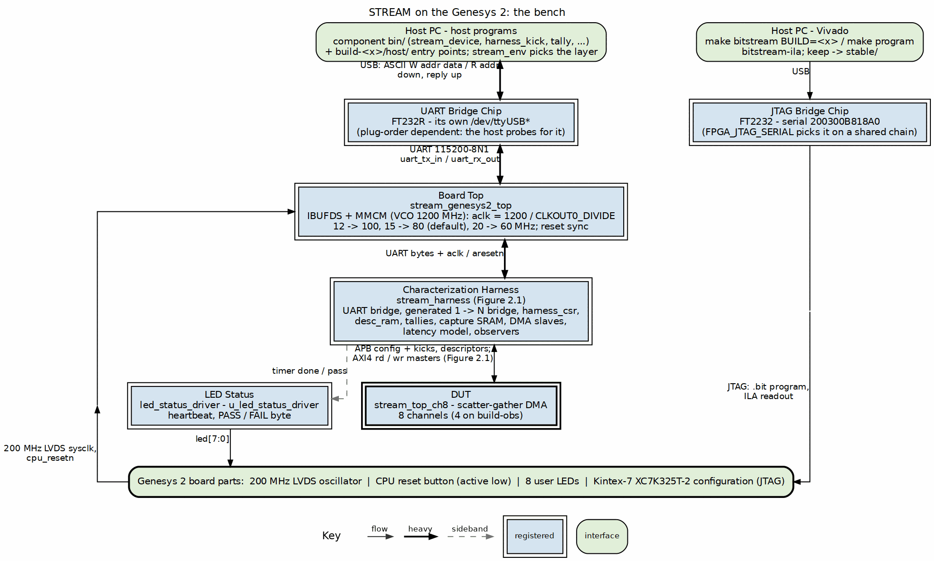
The bench: host, two USB chips, the FPGA
Source: 01_board_and_host.dot

2.2 The board
Digilent Genesys 2, Kintex-7 XC7K325T-2. The Nexys A7 version of this system (stream_char_top) was the original; the Genesys 2 top, stream_genesys2_top, adds an IBUFDS and an MMCM for the board’s 200 MHz LVDS system clock and drops the seven-segment display for the eight user LEDs. Everything below the top is the same RTL on both boards.
The harness clock is a parameter, not a constant. The MMCM runs its VCO at 1200 MHz and the harness clock is 1200 divided by CLKOUT0_DIVIDE: 12 gives 100 MHz, 15 gives 80, 20 gives 60. FPGA_CLK_HZ, which sizes the UART divisor, the heartbeat and the timer, is derived from the same parameter, so the two can never disagree. The mon sign-off build ran at 60 MHz, which is where the full-cone monitor build closed with margin; the perf build is the one that cares about the clock, and it is small enough to run faster.
Table 1.1: The part and what the builds use of it
Resource | XC7K325T-2 | The builds
Slice LUTs | 203,800 | mon sign-off 139,293 (68%); the two instruments together would need 217,761, which is why they are never built together (2026-10-03 re-measurement: 86,865 LUTs / 42.6%, WNS +1.914 ns; RTL has moved since the original sign-off)
Block RAM tiles | 445 | 20 to 24 on the current reports
User LEDs | 8 | status bank; PASS and FAIL are one-byte patterns
Reset | red CPU reset button, active low | synchronized in the top

2.3 The two USB chips
The Genesys 2 carries JTAG on an FT2232 (serial 200300B818A0, the one FPGA_JTAG_SERIAL names, because a Nexys A7 shares the chain in this lab) and the UART on a separate FT232R that enumerates as its own /dev/ttyUSB*. The host tools probe for the harness rather than pin a device node. The link is 115200-8N1 with the ASCII W addr data / R addr protocol, one 32-bit AXI4-Lite access per line.

2.4 The stack, top to bottom
Table 1.2: The stack
Layer | Module | Role
Board top | stream_genesys2_top | LVDS clock in, MMCM, reset sync, LEDs, the geometry generics
Harness | stream_harness | UART to AXI4-Lite bridge, the generated one-to-many bridge, harness CSRs, descriptor RAM, tallies, capture SRAM, DMA slaves, latency model, observers
DUT | stream_top_ch8 | the STREAM DMA: APB configuration and kicks, eight channels (four on the obs build), one descriptor AXI4 master, read and write data masters, MonBus egress
The harness is component-level: one stream_harness.sv, one stream_genesys2_top.sv, one harness_csr.sv, one axi_response_delay.sv, one set of generated bridges, one Tcl set and one XDC, shared by every build. Every geometry default the harness uses comes from stream_cfg_pkg, which is the single source the board top and the simulation share. A literal in the harness is how the simulation and the board once drifted apart, with the perf characterization run at sixteen outstanding transactions against a board built at two.

2.5 What the host sees
One AXI4-Lite master, fanned out by a generated bridge to every slave in the harness: the STREAM APB window, the harness CSRs, the descriptor RAM, the MonBus error drains, the two tally memories and their configuration, the slave-monitor and observer register blocks, and the capture SRAM. Chapter 2 has the map. Every register the host touches is reached by name through a register map generated from regs/harness_csr.rdl; a hand-kept Python table used to exist, drifted, and declared ten registers the RTL did not decode, which three host tools then read as zeros off a running board.

RTL Design Sherpa · Learning Hardware Design Through Practice GitHub · Documentation Index · MIT License

3 The Harness
stream_harness is the bitstream minus the pins. Unlike the RAPIDS harness, whose host front-end was moved inside it late, this one was built with the UART bridge and the CSRs inside from the start, so the cosim and the board have always run the same host programs over the same bytestream. Figure 2.1 is the block map.

3.0.1 Figure 2.1: The harness block map
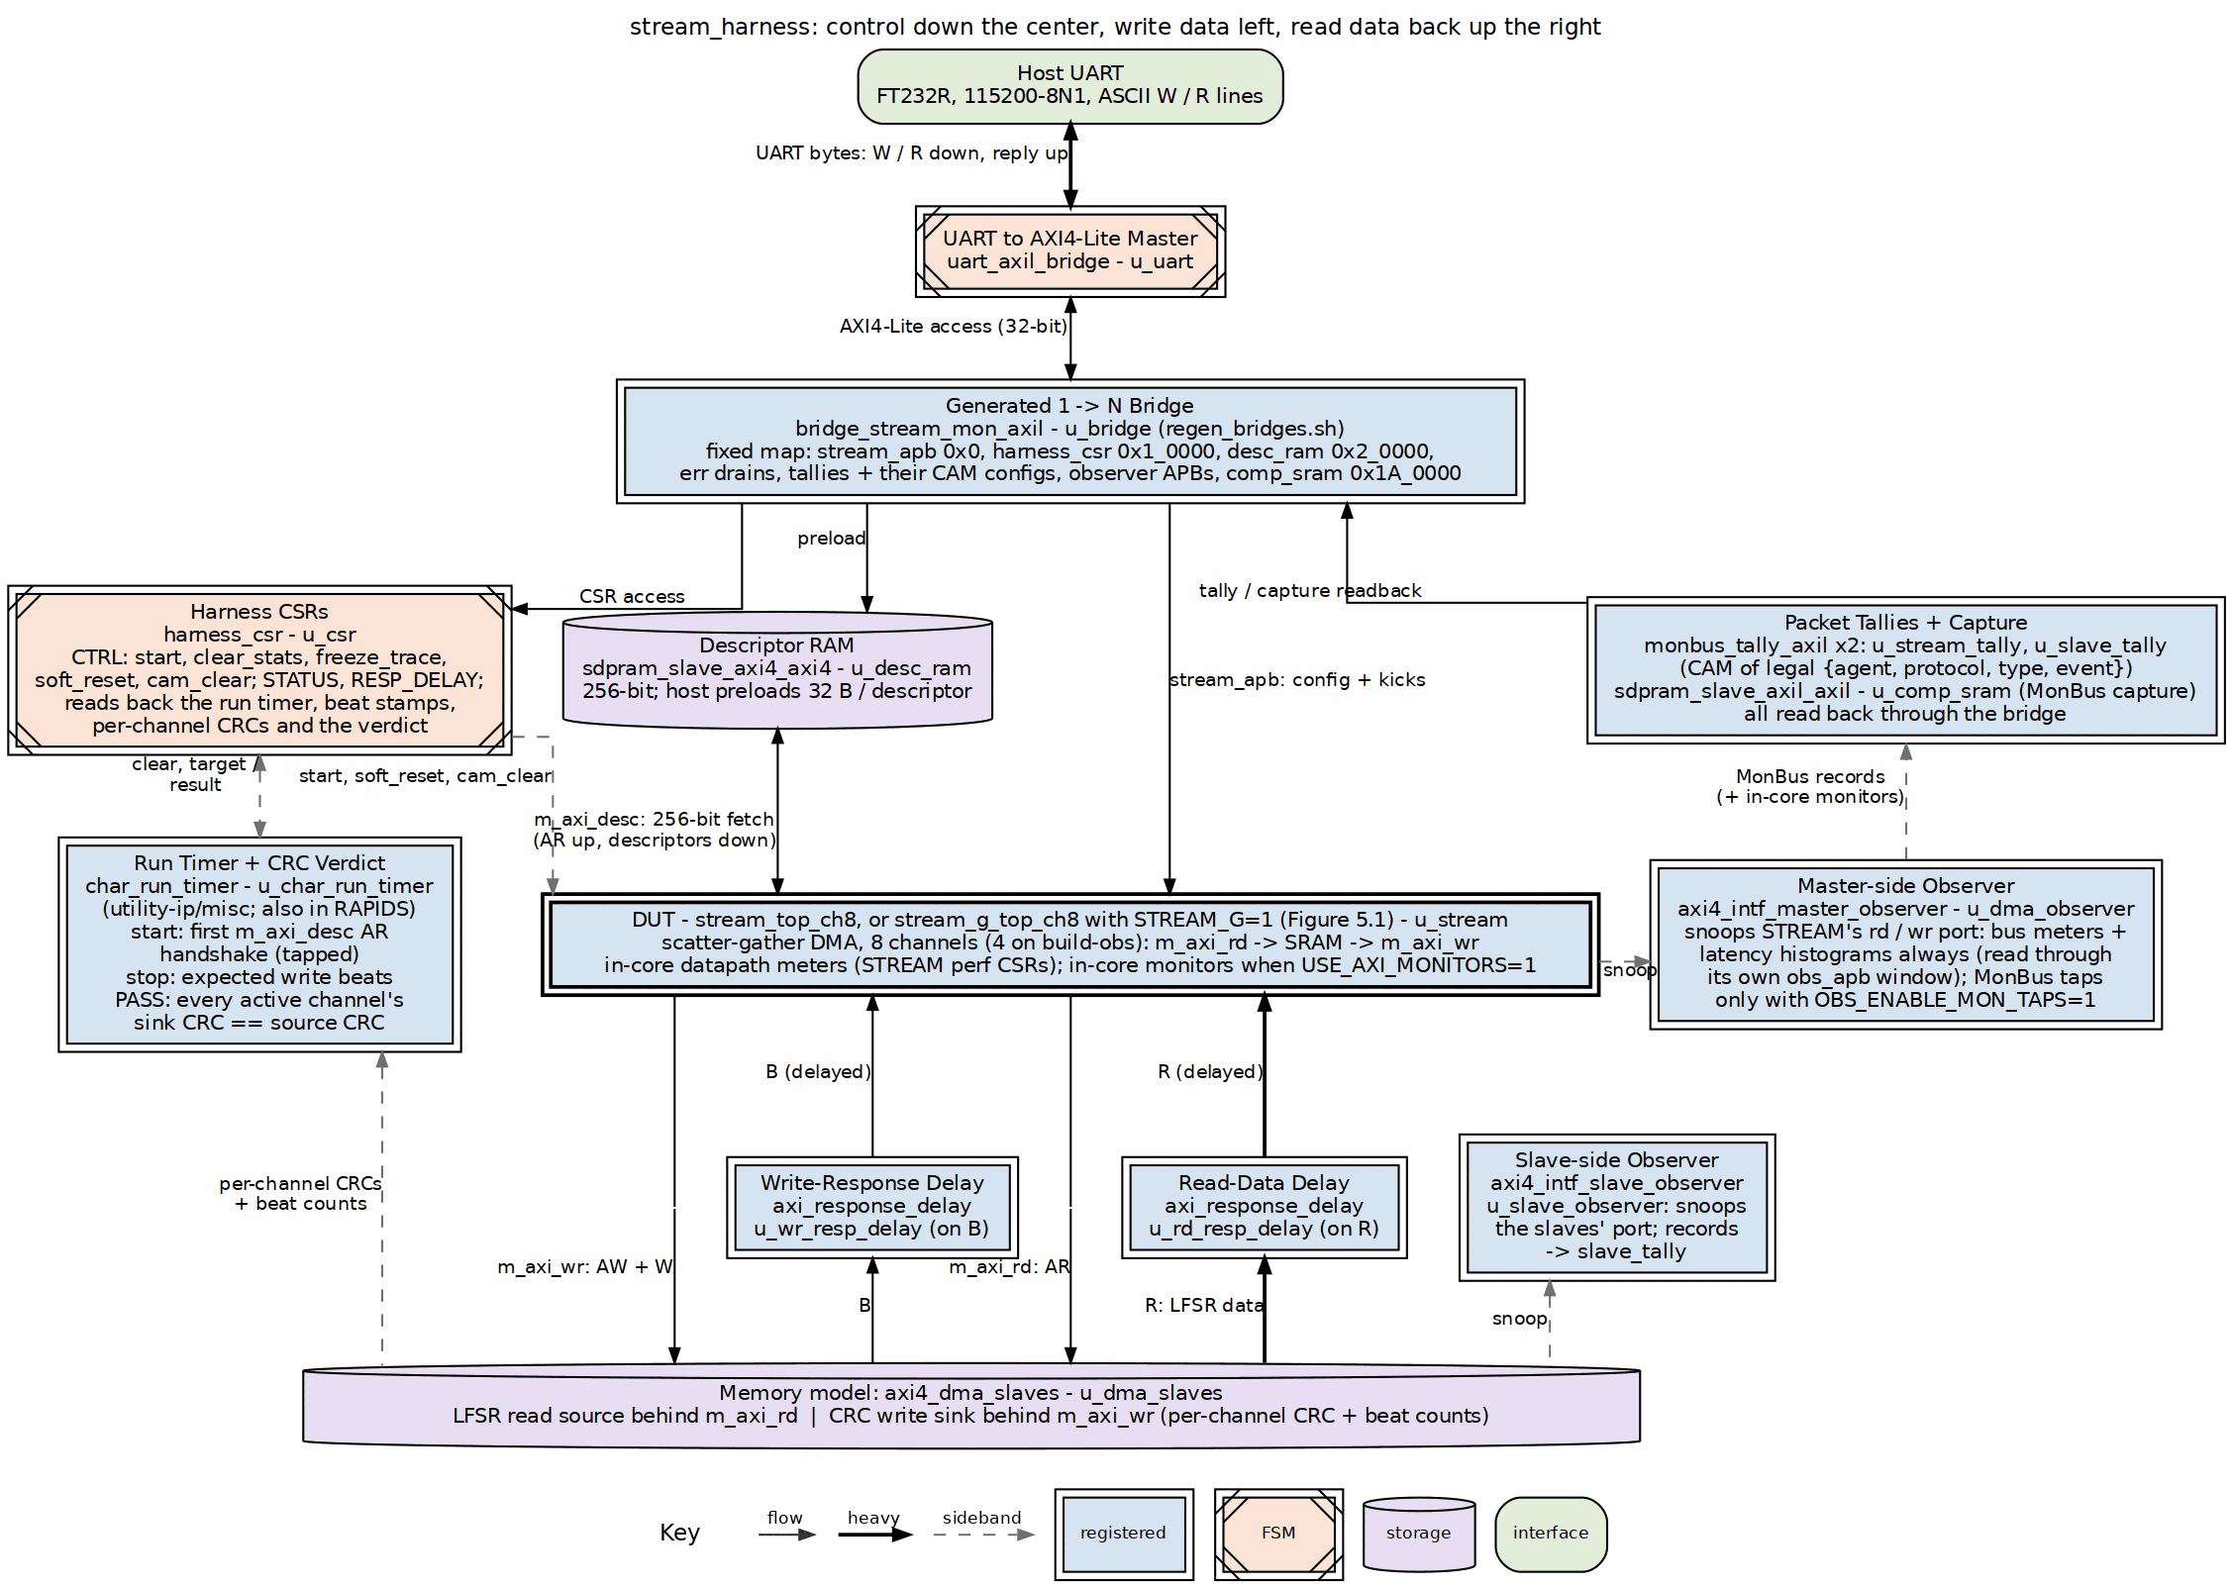
The harness: front-end, stimulus, DUT, the three instruments
Source: 02_harness_blocks.dot
The DUT is stream_top_ch8, or stream_g_top_ch8 when the perf build is made with STREAM_G=1: the same map, the same engines and masters, with the schedulers sequenced by firmware on a gatling core; its register path and sequencing structure are Figure 5.1, and the harness around it does not change.

3.1 The host front-end and the bridge
uart_axil_bridge turns the UART bytestream into one 32-bit AXI4-Lite master. A generated bridge (bridge_stream_mon_axil, from the bridge generator in projects/components/fabric-gen-ip/bridge) fans it out to every slave, converting protocol and width per port; it is regenerated by bin/regen_bridges.sh as the flow’s PREBUILD step, so a slave added to the map is a generator input, not hand-written glue. The complete host address map – bridge slaves and the harness CSR register detail – is drawn in The Address Map.
Every MonBus-carrying AXI path is 64 bits wide. The descriptor read path is a direct 256-bit AXI4 from the DUT to desc_ram, bypassing the bridge, and the data masters are 128-bit into the pattern generator and CRC checker.

3.2 The harness CSR
harness_csr is the host’s control and status surface, separate from the STREAM registers in the APB window. Its map is generated from regs/harness_csr.rdl; the RTL is hand-written against it and every external AXI4-Lite channel sits behind a skid buffer for timing.
Table 2.1: Harness CSR, the registers that define a run
Register | Role
CTRL | start (opens the measurement window), clear_stats, freeze_trace (stops capture writes), soft_reset, cam_clear (clears every CAM in the DUT’s monitors and the tally)
STATUS | latched stream_irq, sticky any_error, sticky trace_overflow, clear_busy (poll to zero after clear_stats before the next capture)
DBG_WR_PTR, DBG_OVERFLOW | how much of the capture memory is written, and whether it overflowed
CRC_RD_EXPECTED, CRC_WR_EXPECTED, CRC_WR_COMPUTED | the source’s pseudo-random CRC, the expected sink CRC, and what the sink actually wrote
(no meter registers) | 0x100-0x128, where the retired harness bus meters were read back, is unallocated; the per-interface cycle classification is read from the observers’ own register blocks (OBS_STAT_SEL / OBS_STAT_DATA) and from STREAM’s in-core perf CSRs
soft_reset clears every instrument in the harness, which is what lets one programming run a long sequence of host programs without inheriting state; the runner hooks on the host issue it between programs.

3.3 The run timer and the verdict
char_run_timer (u_char_run_timer) times each run and judges it. It lives in projects/components/utility-ip/misc/rtl/. The two Genesys 2 RAPIDS harnesses use the same module and the fabric benchmark harness will, so every harness built on the LFSR source and CRC sink measures and judges a run the same way.
- Start: the first m_axi_desc AR handshake after a TIMER_CTRL clear, so the run begins with the first descriptor fetch.
- Stop: the sink’s write-beat count reaching TIMER_EXPECTED_BEATS. TIMER_CYCLES freezes there, so the throughput is exact.
- Pass: sampled 5 cycles after the stop, once the last beat’s CRC has settled. Every channel that ran must have a valid sink CRC equal to its source CRC; a channel that never ran neither passes nor fails. No channel is masked out of the verdict.
- Stamps: the cycle of the first and last read and write beat, so the host can separate steady-state engine throughput from descriptor fill and drain.
TIMER_STATUS.pass and the per-channel CRC registers in Table 2.1 are this block’s outputs.

3.4 Stimulus and the memory model
Table 2.2: Stimulus and memory model
Block | Role
axi4_dma_slaves | an LFSR read-source pattern generator behind m_axi_rd and a write-sink CRC checker behind m_axi_wr; both accept the next transaction on the last beat of the current one (an earlier two-state version inserted a dead cycle per burst and cost the datapath a phantom 6 percent)
axi_response_delay x2 | a programmable memory-latency model on the read and on the write path, the knob of the latency sweeps
desc_ram | the descriptor store the host preloads and the DUT fetches from directly

3.5 The three instruments
The harness carries three ways of measuring, and Chapter 3 is about which build has which.
- Bus meters, always built, inside the interface observers and STREAM’s in-core datapath (the harness’s own axi_bus_meter blocks are retired). Per interface, every cycle of the window is productive, backpressure, starvation or idle. They sit outside the monitor gate on purpose: the perf build has no monitor and must still count. That separation regressed once, when the gate over-reached and the perf build reported zeros, and the monitor test now asserts the meters are non-zero in that flavour.
- Tallies, monbus_tally_axil twice. A direct count over every possible MonBus identity would be a 20,480-cell matrix of which about 245 tuples are legal; crossed with a 16-bit agent id it would be 99 percent empty. The tally instead loads the legal {agent, protocol, packet type, event} tuples into a CAM (MON_N_PROFILE slots, 32 on the sign-off builds) and counts densely, so the host can prove every agent emitted every packet type it may legally emit. stream_tally counts the in-core monitors, slave_tally the observers.
- Capture, comp_sram. The MonBus stream itself, compressed on the mon build, downloadable by the host and decoded against the cosim reference; stream_err and slave_err drain the error and IRQ FIFOs.
The two optional sources of packets are the DUT’s in-core monitors (USE_AXI_MONITORS) and the interface observers standing on the DUT’s masters and on the slaves (OBS_ENABLE_MON_TAPS). Both feed the same tally and capture machinery; they are never built together, and the reason is in Chapter 3.

RTL Design Sherpa · Learning Hardware Design Through Practice GitHub · Documentation Index · MIT License

4 The Address Map
The host sees one 32-bit AXI4-Lite master. uart_axil_bridge turns the ASCII W addr data / R addr lines into that master, and the generated bridge_stream_mon_axil fans it out to every slave in the harness. The bridge is generated from rtl/bridges/configs/bridge_stream_mon_axil.toml; the table below is the as-built map from that file. Anything not listed decodes to a tied-off dma_axil port or returns DECERR.

4.0.1 Figure 2.2: Host address map
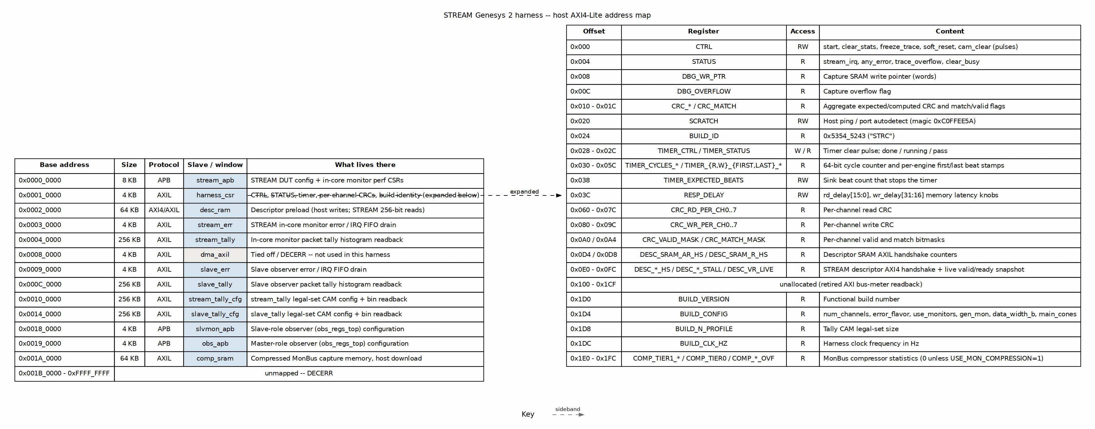
Host address map
Source: 05_address_map.dot

4.1 Bridge slave map
Table 2.3: Bridge address map (from bridge_stream_mon_axil.toml)
Base | Size | Protocol | Slave | Purpose
0x0000_0000 | 8 KB | APB | stream_apb | STREAM DUT config and in-core monitor perf CSRs
0x0001_0000 | 4 KB | AXIL | harness_csr | Harness control/status/timer/CRC/build identity
0x0002_0000 | 64 KB | AXI4/AXIL | desc_ram | Descriptor preload: host writes 32-bit, STREAM reads 256-bit
0x0003_0000 | 4 KB | AXIL | stream_err | STREAM in-core monitor error / IRQ FIFO drain
0x0004_0000 | 256 KB | AXIL | stream_tally | In-core monitor packet tally histogram readback
0x0008_0000 | 4 KB | AXIL | dma_axil | Tied off / DECERR – not used in this harness
0x0009_0000 | 4 KB | AXIL | slave_err | Slave observer error / IRQ FIFO drain
0x000C_0000 | 256 KB | AXIL | slave_tally | Slave observer packet tally histogram readback
0x0010_0000 | 256 KB | AXIL | stream_tally_cfg | stream_tally legal-set CAM config + bin readback
0x0014_0000 | 256 KB | AXIL | slave_tally_cfg | slave_tally legal-set CAM config + bin readback
0x0018_0000 | 4 KB | APB | slvmon_apb | Slave-role observer (obs_regs_top) configuration
0x0019_0000 | 4 KB | APB | obs_apb | Master-role observer (obs_regs_top) configuration
0x001A_0000 | 64 KB | AXIL | comp_sram | Compressed MonBus capture memory, host download
The two tally windows (stream_tally / slave_tally) are read-only for the host in normal use: records arrive directly from the observers or in-core monitors, and the host reads the resulting histogram. Their companion _cfg windows are where the host loads the legal {agent, protocol, type, event} CAM profile and where direct bin readback also lives.

4.2 Harness CSR detail
harness_csr occupies 0x0001_0000 and is the source of truth for run control, build identity, and the memory-latency knob. The map is generated from regs/harness_csr_regs.rdl and decoded by hand in rtl/harness_csr.sv; a test (bin/tests/test_harness_regmap.py) asserts every RDL register has a matching hardware decode.
Table 2.4: harness_csr register map (base 0x0001_0000)
Offset | Register | Access | Content
0x000 | CTRL | RW | start, clear_stats, freeze_trace, soft_reset, cam_clear pulses
0x004 | STATUS | R | stream_irq, any_error, trace_overflow, clear_busy
0x008 | DBG_WR_PTR | R | Capture SRAM write pointer (words)
0x00C | DBG_OVERFLOW | R | Capture overflow flag
0x010 | CRC_RD_EXPECTED | R | Aggregate expected read-source CRC
0x014 | CRC_WR_EXPECTED | R | Aggregate expected write-sink CRC
0x018 | CRC_WR_COMPUTED | R | Actual CRC computed by write sink
0x01C | CRC_MATCH | R | match[0], valid[1]
0x020 | SCRATCH | RW | Host ping / port autodetect (magic 0xC0FFEE5A)
0x024 | BUILD_ID | R | 0x5354_5243 (“STRC”) – harness family
0x028 | TIMER_CTRL | W | Timer clear pulse
0x02C | TIMER_STATUS | R | done, running, pass
0x030 / 0x034 | TIMER_CYCLES_LO / HI | R | Run length in cycles, first descriptor AR to the expected write beat (char_run_timer; frozen at the end of the run, not free-running)
0x038 | TIMER_EXPECTED_BEATS | RW | Sink beat count that stops the timer
0x03C | RESP_DELAY | RW | rd_delay[15:0], wr_delay[31:16] latency knobs
0x040 - 0x05C | TIMER_R_FIRST_* / TIMER_R_LAST_* / TIMER_W_FIRST_* / TIMER_W_LAST_* | R | Per-engine first/last beat cycle stamps
0x060 - 0x07C | CRC_RD_PER_CH0..7 | R | Per-channel read CRC
0x080 - 0x09C | CRC_WR_PER_CH0..7 | R | Per-channel write CRC
0x0A0 / 0x0A4 | CRC_VALID_MASK / CRC_MATCH_MASK | R | Per-channel valid/match bitmasks
0x0D4 / 0x0D8 | DESC_SRAM_AR_HS / DESC_SRAM_R_HS | R | Descriptor SRAM AXIL handshake counters
0x0E0 - 0x0FC | DESC_AR_HS, DESC_AR_STALL, DESC_R_HS, DESC_R_STALL, DESC_AW_HS, DESC_W_HS, DESC_B_HS, DESC_VR_LIVE | R | STREAM descriptor AXI4 handshake + live valid/ready snapshot
0x100 - 0x1CF | – | – | Unallocated (retired AXI bus-meter readback)
0x1D0 | BUILD_VERSION | R | Functional build number
0x1D4 | BUILD_CONFIG | R | num_channels, error_flavor, use_monitors, gen_mon, data_width_b, main_cones
0x1D8 | BUILD_N_PROFILE | R | Tally CAM legal-set size
0x1DC | BUILD_CLK_HZ | R | Harness clock frequency in Hz
0x1E0 - 0x1FC | COMP_TIER1_A/B/C, COMP_TIER0, COMP_CAM_MISS, COMP_DELTA_TS_OVF, COMP_EVENT_DATA_OVF, COMP_ED_DELTA_OVF | R | MonBus compressor statistics (0 unless USE_MON_COMPRESSION=1)

4.3 By-name access
Host tools must resolve addresses by name, not by hardcoded offset:
- bin/harness_addrs.py H("CTRL") resolves harness CSR registers against rtl/harness_csr_regmap.py (generated from the RDL).
- bin/stream_addrs.py A("SCHED_CONFIG") resolves STREAM APB registers against the component-level stream_regmap.py.
- bin/obs_addrs.py O("MON_CTRL") resolves observer APB registers against obs_regs_top_regmap.py; use base=SLAVE_OBS_APB_BASE (0x0018_0000) for the slave-role observer.
This indirection is what keeps host scripts valid when a register moves inside its window.

RTL Design Sherpa · Learning Hardware Design Through Practice GitHub · Documentation Index · MIT License

5 One RTL, Three Builds

5.1 The rule
There is one harness, one board top, one CSR block, one latency model, one set of generated bridges, one Tcl set and one XDC, all at component level. build-mon/, build-obs/ and build-perf/ each hold a Makefile of variables and nothing else; the flow logic is the shared make/fpga_flow.mk. Which build you want is a question about what is under test, and the answer is a row in this table:
Table 3.1: The builds
Build | USE_AXI_MONITORS | OBS_ENABLE_MON_TAPS | Channels | Measures
mon | 1 | 0 | 8 | the in-core monitors: coverage, compression, error and fault probes
obs | 0 | 1 | 4 | the interface observers, watching the same DUT from outside it
perf | 0 | 0 | 8 | the datapath itself, with no instrument in the way
perf, STREAM_G=1 | 0 | 0 | 8 | the same, around stream_g_top_ch8: the STREAM / stream-g A/B of Chapter 5 (FW_WRITABLE=1 for a host-loadable firmware memory)
Two near-identical harnesses, one per flavour, used to exist. They were retired because a variant that is a copy drifts: the board and the simulation once disagreed on the outstanding-transaction limit for exactly that reason. Now a variant is a parameter, the parameter is a generic handed to Vivado, and stream_cfg_pkg stays every build’s default; editing the package to retarget one build silently retargets the other two.

5.1.1 Figure 3.1: One source tree, three bitstreams
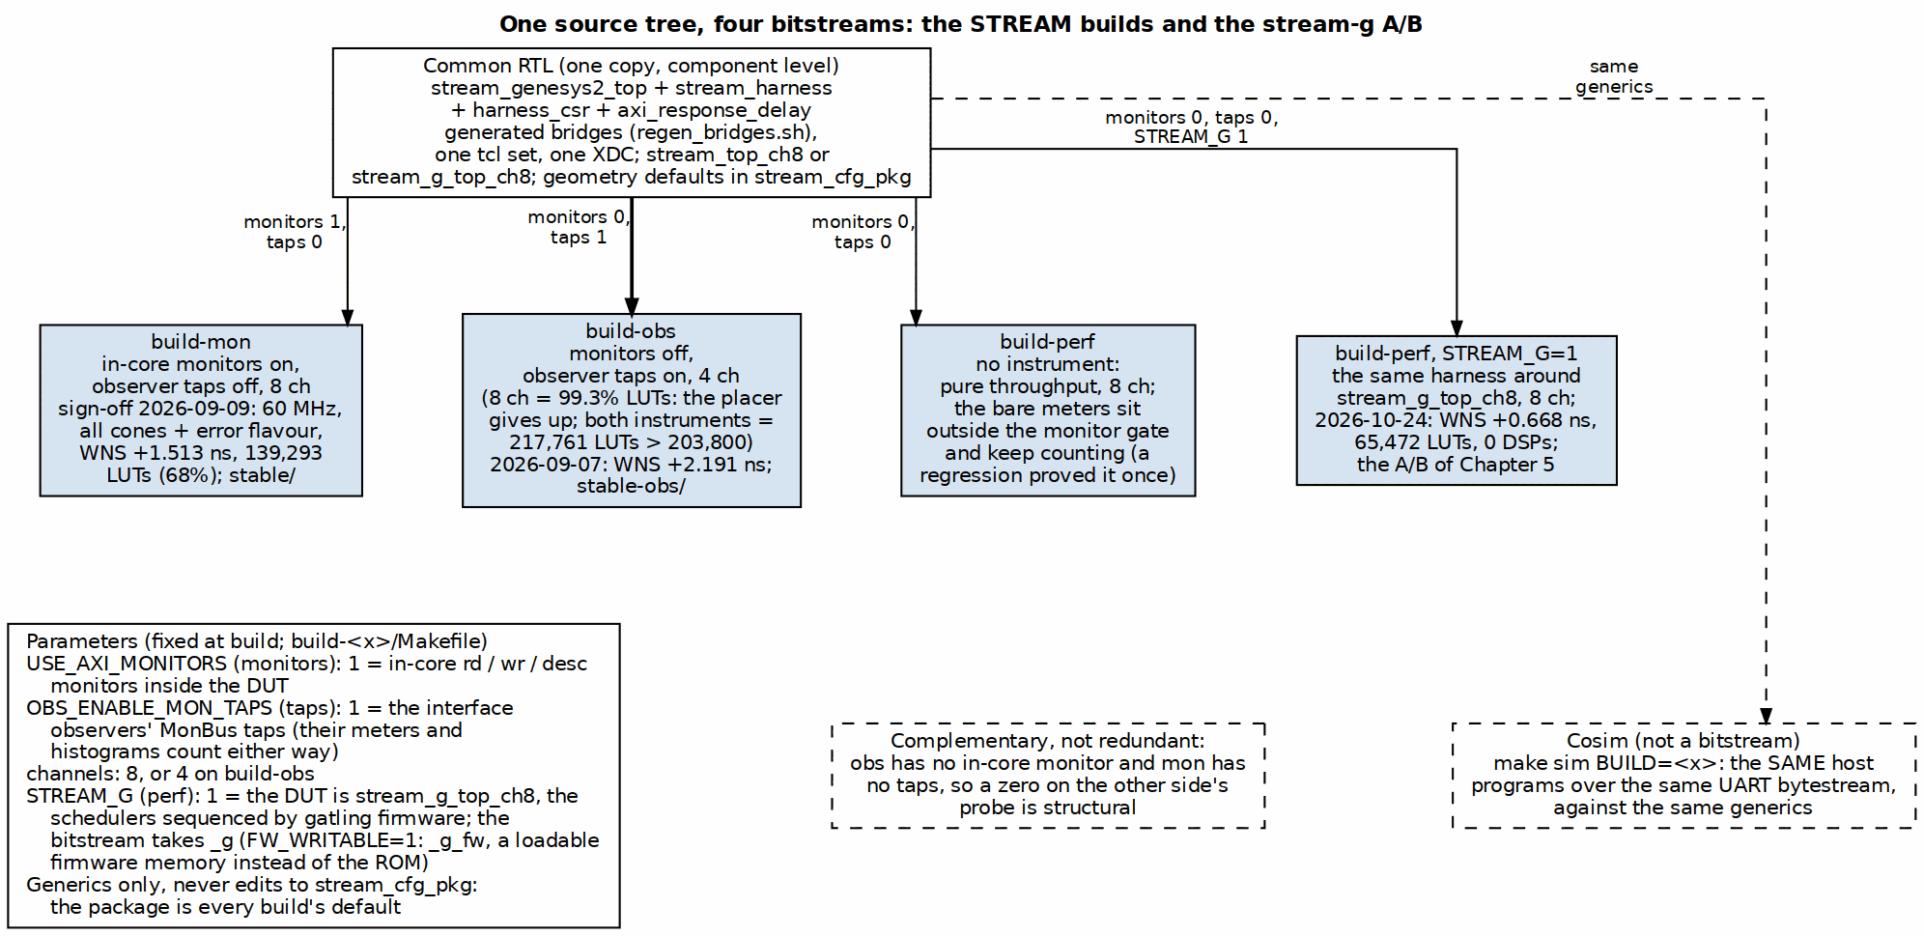
One RTL, the knobs, the three builds
Source: 03_build_variants.dot

5.2 Why three, and why not two
The mon and obs builds are complementary, not redundant. They exercise the monitor code from two directions: the in-core monitors see transactions from inside the DUT, the observers see them on the interfaces outside it, and both push their packets through the same tally and capture machinery. So build-obs has no in-core STREAM monitor at all, and a zero on any mon_* probe there is structural; build-mon has its observer taps off, and a zero on an observer probe there is equally structural. Reading either zero as a defect has cost an afternoon before, which is why the Makefile says so in capitals.
They cannot be one build. With every monitor cone and both observers at eight channels the design needs 217,761 LUTs against the 203,800 on the part, and the placer never runs. Even the obs build alone does not fit at eight channels: it reached 99.33 percent of the LUTs and “could not place all instances”, so obs is pinned at four (six does not route either). The eight-channel design point is perf’s requirement; the obs channel count is incidental, not a traded-away requirement.
The perf build exists so that a number about the datapath is a number about the datapath. Its bus meters are instantiated outside the monitor gate and keep counting with every instrument removed; that arrangement is what lets the design fit a small part, and it is guarded by a test after it regressed once.

5.3 What the builds measured
Table 3.2: Sign-off builds
Build | Sign-off | Clock | Result
mon | 2026-09-09, stable/MANIFEST.md | 60 MHz | all cones plus the error flavour, compression built, 8 channels, MON_N_PROFILE=32: WNS +1.513 ns, 139,293 LUTs (68.35%), 0 failed nets; 512 packets in 516 slots on the board, 66.4% smaller than the raw encoding, CRC match, cosim reference within 4 points (2026-10-03 re-measurement: 66.0% / 1.02 slots/packet, within data-dependent noise; bit sha256 aceec688043ad630879779ddae211814fcc4dc457365d7c06ec95b8a4f348e6b, WNS +1.914 ns, 86,865 LUTs)
obs | 2026-09-07, stable-obs/MANIFEST.md | as built | 4 channels, 32-entry tally CAM, WNS +2.191 ns, archived the day a make clean-all destroyed the previous obs bitstream and it turned out obs had been synthesizing at 100.01 percent of the LUTs and placing by luck (2026-10-03 re-measurement: build-obs/results/obs_board_2026-10-03.txt, bit sha256 60696ace63fed2c77ad4d3f1f511d06dd85801c9b5a9dac1d4078454192bfa5f, WNS +3.925 ns, 73,809 LUTs; the observer instrument changed 2026-09-27, commit 78cddb5e2 — lite taps, no perf/debug cone, caps0 bit4/bit5 read 0)
perf | current reports on disk | as built | 68,139 LUTs (33.4%), 24 BRAM tiles in build-perf/fpga/reports; the sweeps behind reports/perf and reports/ext_addressing (2026-10-03 re-measurement: build-perf/results/perf_sweep_2026-10-03.{csv,json}, bit sha256 d26f9b7b3ac534a1507ab5a519e728d541b1045cf67000329fbedf77e3b9512c, WNS +1.175 ns, 64,305 LUTs)
perf | 2026-10-24, build-perf/fpga/bitstream/stream_perf_genesys2_8ch.bit | 100 MHz | the STREAM side of the Chapter 5 A/B: 66,221 LUTs (32.5 %), 26 BRAM, 64 DSP, WNS +0.790 ns, hold +0.032 ns; bit sha256 ff9a6b95ff7d58f091e77acd23c5ee8c175d4451e72b75bd060664dc8889452a; its 1 MB matrix cycle-identical to 2026-10-03
perf, STREAM_G=1 | 2026-10-24, build-perf/fpga/bitstream/stream_perf_genesys2_8ch_g.bit | 100 MHz | stream-g, ROM firmware: 65,472 LUTs (32.1 %), 29 BRAM, 0 DSP, WNS +0.668 ns, hold +0.050 ns; bit sha256 b403115324623aa04d272c1710c5d0d35eec2bf157060d268300d0d9981687d1; 192 of 192 profile points and 120 of 120 matrix runs passing
The stable/ directories hold exactly one build each, with the bitstream, the Vivado reports for that bitstream, the board results measured on it and a manifest naming the tree SHA it was built from. They exist because make clean-all in a build directory deletes tracked bitstreams and reports, and that has destroyed a verified bitstream more than once; stable/ is a sibling of the build directories, outside that blast radius.

5.4 The knobs behind the rows
Table 3.3: The knobs
Knob | Where | What it selects
STREAM_NUM_CHANNELS | build Makefile | channel count: 8 for mon and perf, 4 for obs
USE_AXI_MONITORS | build Makefile, DUT generic | the in-core rd/wr/descriptor monitors, their CAMs, and the compression pipeline (gated on this flavour only)
OBS_ENABLE_MON_TAPS | build Makefile, harness generic | arm the observers’ MonBus event taps; the observers’ meters and histograms count without them
MON_ERROR_FLAVOR, MON_CONES | build Makefile | which monitor cones are built; the sign-off is the union including error
MON_N_PROFILE | build Makefile | tally CAM depth
STREAM_SHARED_ENGINES | build Makefile, DUT generic | 1 (default): one descriptor engine fetches for every channel; 0: one per channel behind an arbiter (bitstream _pce)
STREAM_G, FW_WRITABLE | build-perf Makefile, harness define | STREAM_G=1: the DUT is stream_g_top_ch8 (bitstream _g, BUILD_CONFIG.STREAM_G=1); FW_WRITABLE=1: its firmware memory is a block RAM the host loads through FW_* (bitstream _g_fw) instead of a ROM
STREAM_CHAR_ILA | make bitstream-ila (fpga/tcl/build_ila.tcl) | marks the host AXI4-Lite, STREAM APB, DUT-master and monitor-writer handshakes for an ILA; the ordinary builds carry no trace of it
BOARD, A7_CLK_MHZ | build Makefile | the target (genesys2, 8 channels at 100 MHz by default; nexysa7 at 4) and the harness clock, which sets STREAM_VCO_MHZ / STREAM_CLKOUT0_DIVIDE and HARNESS_CLK_HZ; the bitstream name carries clk<MHz> when not 100
CLKOUT0_DIVIDE | board top parameter | 100, 80 or 60 MHz harness clock
stream_env | host | which build’s host/ layer goes on the Python path (default mon; perf sets it explicitly so a perf program cannot import mon’s copy of a sibling)

RTL Design Sherpa · Learning Hardware Design Through Practice GitHub · Documentation Index · MIT License

6 Host Tools and Flow

6.1 The shared flow
The area Makefile is a dispatcher: make bitstream BUILD=obs runs the target in build-obs/, whose Makefile is variables plus an include of make/fpga_flow.mk. The flow’s targets are therefore identical across the three builds and across the other Genesys 2 and Nexys A7 systems that use it.
Table 4.1: Flow targets (from make/fpga_flow.mk)
Target | What it does
lint, flat-filelist, lint-decl-order | Verilator lint of the whole harness against the expanded filelist, before any Vivado run
prebuild | the build’s PREBUILD step: here, regenerate the bridges
project, synth, bitstream | create the Vivado project; synthesis only with utilization and failing-path reports; the full flow with every report
bitstream-ila | the same design plus an ILA on the marked debug nets
sim | this build’s harness cosim (cocotb, Verilator)
program | flash the board, naming the file, falling back to the hold copy after a clean
run SEQUENCES="...", seq-list | drive the programmed board through the area’s sequences
utilization, timing | print the latest reports
keep | copy the bitstream to RDS_HOLD_DIR outside the repo and the reports to ../stable/
clean, clean-build, clean-all | remove Vivado artifacts, cosim trees, everything; clean-all is what stable/ protects against

6.2 The host layers
Two levels of Python. The component bin/ holds what every build uses: stream_device.py (the UART link and register access by name), harness_kick.py (staging the channel kicks), bus_meters.py (the meter packing, one definition shared with the cosim so both measure the same thing), tally.py and dump_monbus.py (reading the tallies and decoding a capture), characterization.py and stream_ext_suite.py (the campaign runners), stream_monitors.py (monitor and observer configuration), and the plotting scripts. Each build then has its own host/ with the programs that only make sense on that bitstream:
Table 4.2: Per-build host programs
Build | Programs
perf | host_characterize, host_bus_meters, host_desc_perf, host_rw_perf, host_ext_char, host_ext_soak, host_probe_multichannel, host_verify_descriptors, host_status, host_perf_json_to_csv
mon | host_mon_coverage, host_mon_compress, host_mon_matrix, host_mon_err_probe, host_mon_fault_probe, host_reg_walk
obs | host_obs_campaign, host_obs_matrix, host_reg_walk
stream_env selects which build’s host/ goes on the Python path. Its default is mon; build-perf sets it explicitly because without that a perf program importing a sibling from its own directory would get mon’s copy, and it would appear to work, since Python also puts the running script’s own directory first.

6.2.1 Figure 4.1: What each build measures, end to end
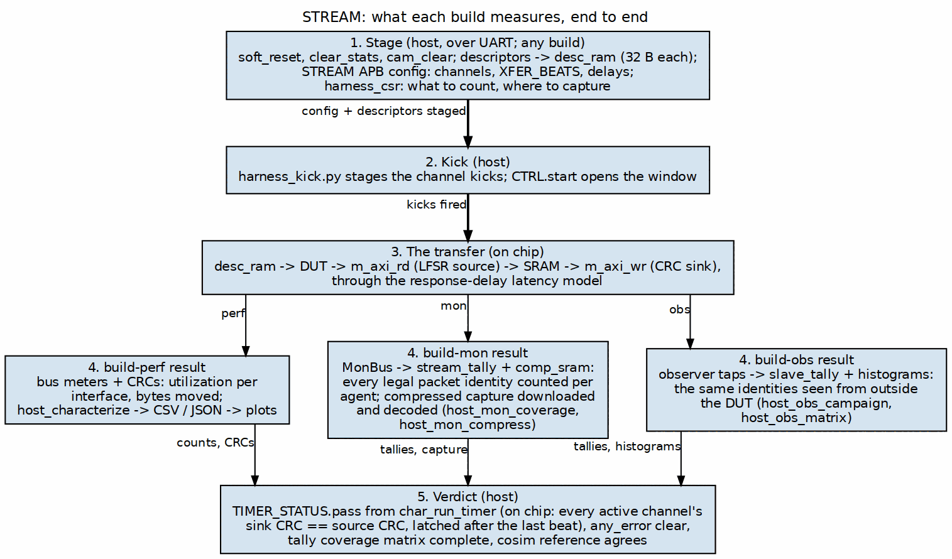
The three measurement paths
Source: 04_measurement_path.dot

6.3 One program, two targets
The same host program runs against the cosim and against the board. The cocotb harness testbench presents the UART bytestream to stream_harness exactly as the FT232R does, the harness carries the bridge and the CSRs, and the generics are the build’s. A monitor coverage result on the board is therefore compared with the same program’s result in cosim, and the sign-off manifest records both (512 packets in 516 slots on the board against 1.12 slots per packet in cosim, for the compression program). A host program that only works on one target is a defect in the harness or the program, not a difference in kind.
The sign-off discipline before a build is the same on every flavour: the FULL-level sim suites of all three builds green on a verified-clean tree, recorded in the manifest with the tree SHA, so the bitstream is reproducible from the recorded source.

6.4 Where the results go
The STREAM / stream-g comparison has its own entry points: the point profiles under build-perf/csv/ go to the board through make host-characterize ARGS="--csv csv/<profile>.csv --json-output ..." with STREAM_G=0 and 1 programmed in turn, and through the harness simulation of each design with make sim-gcompare | sim-gscale | sim-gscale1 (dv/tests/test_stream_g_profiles.py, the char_csv test type, results under build-perf/results/sim/); bin/compare_profiles.py puts the two designs, and the simulation against the board, side by side. Chapter 5 has the method and the numbers.
Table 4.3: Reports
Report | Source build | Content
reports/perf | perf | utilization sweeps: channels, descriptors, sizes, latency (the CSV data under docs/data/)
reports/compression | mon | MonBus compression on the board against the cosim
reports/area | any | what the monitors and the readback logic cost in LUTs per channel count
reports/ext_addressing | perf | the extended row/column addressing campaign
stable/results | mon | the board sweeps measured on the sign-off bitstream
Each report directory has its own README and, where a deliverable exists, the versioned DOCX and PDF built through the house pipeline.

RTL Design Sherpa · Learning Hardware Design Through Practice GitHub · Documentation Index · MIT License

7 STREAM against stream-g on This Board
Last Updated: 2026-10-24
stream-g (STREAM MAS Chapter 7) keeps STREAM’s descriptors, register map, engines and masters and replaces the per-channel scheduler state machines with firmware on one gatling core. This chapter is the board side of the comparison: the build that puts stream-g in the harness, what the two bitstreams cost, how the two designs were measured against each other, and every number measured. Which design to choose is STREAM HAS Chapter 5.4, which rests on the tables here; rapids HAS Chapter 6.4 is the same comparison for RAPIDS.

7.1 The stream-g build
STREAM_G=1 on build-perf makes the DUT stream_g_top_ch8 instead of stream_top_ch8; the harness is otherwise the same bitstream (the STREAM_G define reaches Vivado through fpga/tcl/create_project.tcl, lint through LINT_DEFINES, and the harness sim through TEST_STREAM_G). The bitstream name takes _g, FW_WRITABLE=1 makes the firmware memory a block RAM the host loads through the FW_CTRL / FW_ADDR / FW_DATA / FW_RDATA registers (bitstream _g_fw) instead of a ROM of the generated image, and the host reads which design it has from BUILD_CONFIG.STREAM_G in the harness CSRs and FW_CTRL.STREAM_G in the STREAM map. seq_restart is tied low in the harness: the harts run from reset and the firmware polls. Figure 5.1 is the DUT’s register path and sequencing structure as it sits in the harness; the engines, the SRAM and the three masters below it are the product’s and are drawn in Figure 2.1.

7.1.1 Figure 5.1: The stream-g DUT in the harness
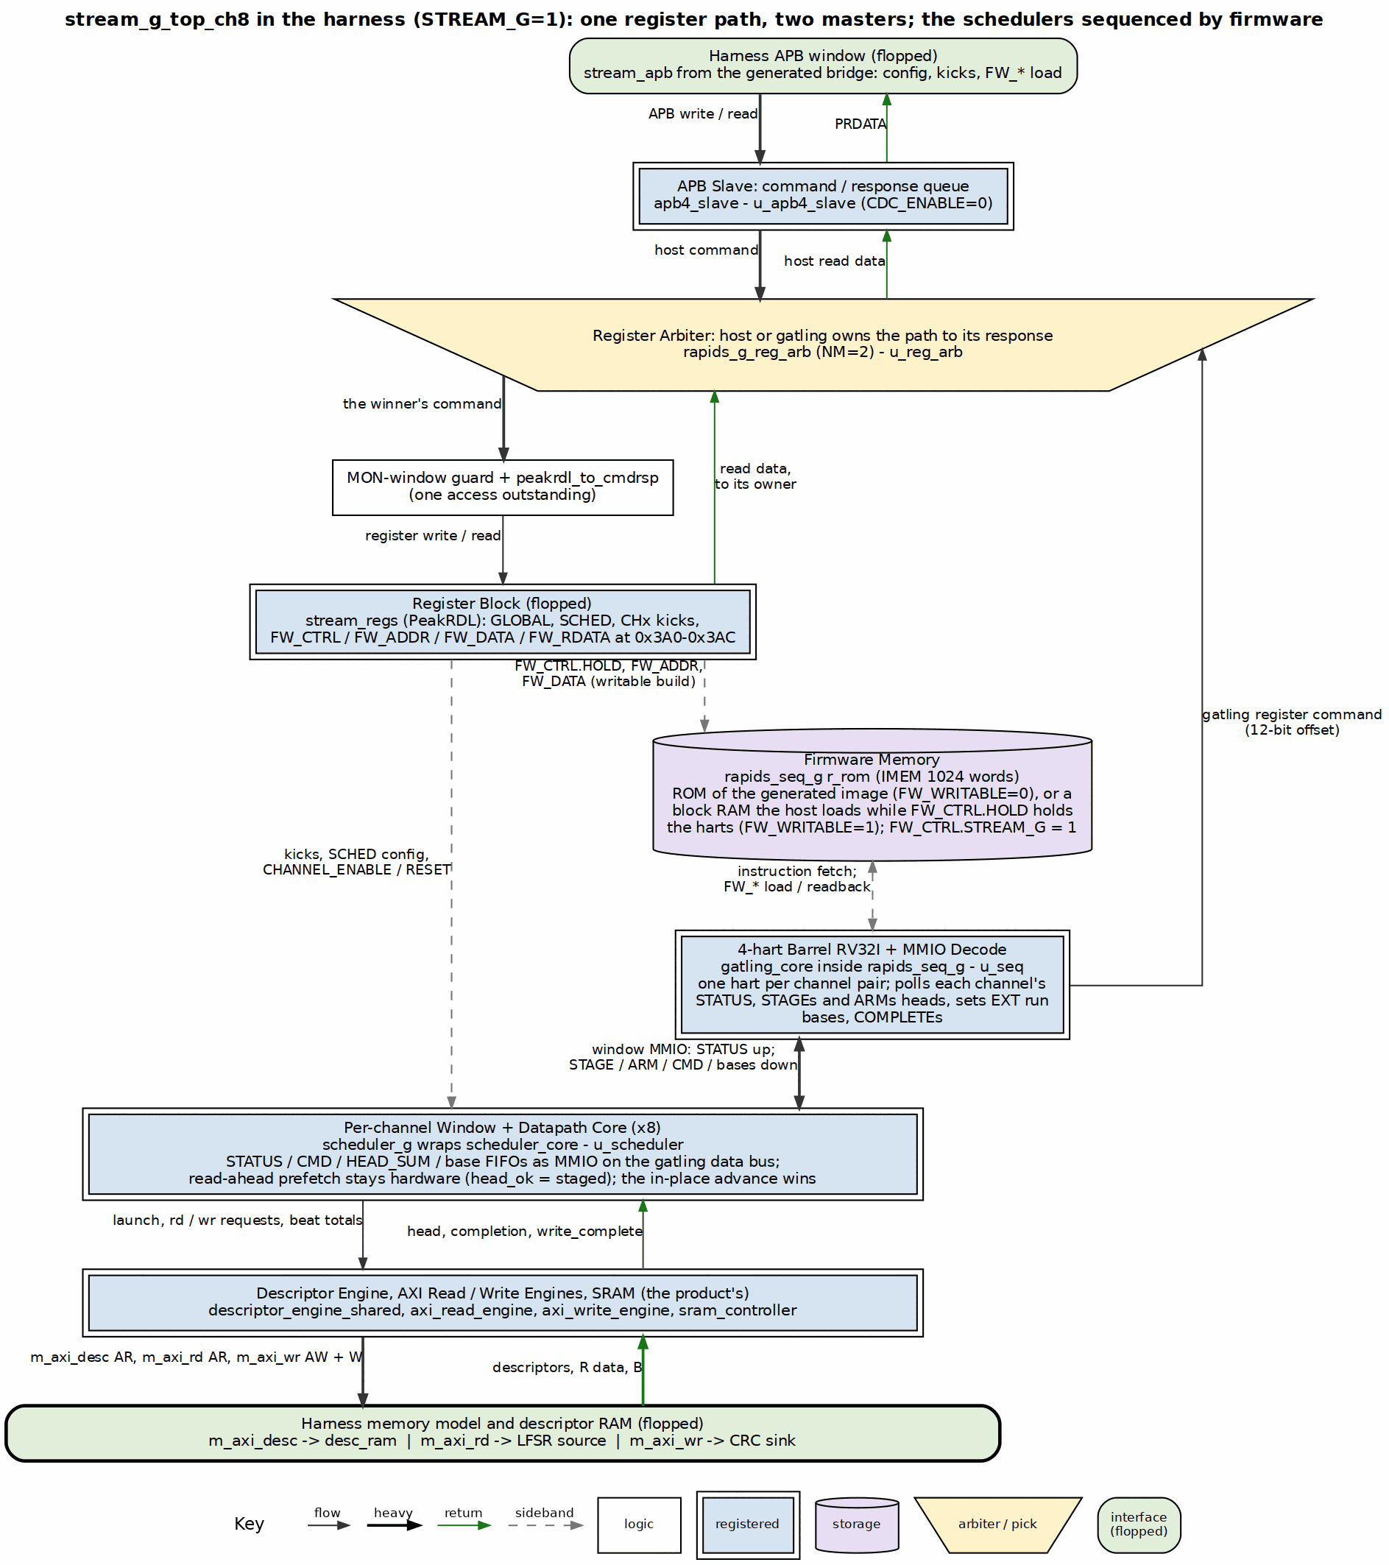
stream_g_top_ch8 in the harness: one register path, two masters
Source: 06_stream_g_dut.dot
For a board question that needs a waveform, the harness carries mark_debug marks under STREAM_CHAR_ILA on the host AXI4-Lite, the STREAM APB, the three DUT masters, the monitor writer and the unit reset; make bitstream-ila [STREAM_G=1] builds the same design with an ILA on them (fpga/tcl/build_ila.tcl) and make tcl-capture_ila programs it, arms on the first DUT-master or host command and writes the capture as CSV (fpga/tcl/capture_ila.tcl). The marks cost the ordinary builds nothing.

7.2 The two bitstreams
Both from the same tree and the same flow, 8 channels, 100 MHz, built minutes apart on 2026-10-24:
Table 5.1: The two Genesys 2 builds
 | STREAM (stream_perf_genesys2_8ch.bit) | stream-g (stream_perf_genesys2_8ch_g.bit, ROM firmware)
Slice LUTs | 66,221 (32.5 %) | 65,472 (32.1 %)
Slice registers | 59,652 | 58,265
LUT as memory | 6,390 | 6,742
Block RAM tiles | 26 | 29
DSP48 | 64 | 0
Setup WNS / hold WHS (ns) | +0.790 / +0.032 | +0.668 / +0.050
sha256 | ff9a6b95ff7d58f091e77acd23c5ee8c175d4451e72b75bd060664dc8889452a | b403115324623aa04d272c1710c5d0d35eec2bf157060d268300d0d9981687d1
The 64 DSPs are the state machine’s EXT run-base generators (a multiplier pair per channel per direction, stream_run_addr_gen); stream-g computes the bases in firmware and the gatling’s own datapath is LUTs. The three extra block RAMs are the firmware ROM and the harts’ scratch. The cores on their own, out of context at 8 and 16 channels in the board geometry (fpga/tcl/ooc_stream_core.tcl, reports/ooc/), are Table 5.2.
Table 5.2: The cores out of context on the xc7k325t-2 (128-bit data, 32-bit addresses, 8 outstanding each way, SRAM depth 256, shared engines, no AXI monitors, EXT addressing built; placed and routed at 100 MHz, 2026-10-24)
stream_core / stream_core_g, out of context | STREAM 8ch | stream-g 8ch | STREAM 16ch | stream-g 16ch
LUTs | 32,025 | 32,164 (+0.4 %) | 61,106 | 59,386 (-2.8 %)
LUT as distributed RAM | 3,216 | 3,568 | 6,232 | 6,936
Registers | 24,532 | 23,027 | 46,231 | 41,942
Block RAM tiles | 16 | 19 | 32 | 35
DSPs | 64 | 0 | 128 | 0
Setup WNS at 100 MHz (ns) | +0.581 | +0.626 | +0.256 | +0.127
Hold WHS (ns) | +0.052 | +0.051 | +0.057 | +0.051
In the board geometry the gatling and its windows cost about what the eight state machines and their run-base generators cost in LUTs (+0.4 % at 8 channels, -2.8 % at 16), fewer registers, three more block RAM tiles (the firmware memory and the harts’ scratch) and no DSPs; both close 100 MHz at both channel counts, the 16-channel builds with the thinner margin. The register arbiter (rapids_g_reg_arb) sits in the top, outside stream_core_g, and is in Table 5.1 but not here.

7.3 The first stream-g bitstream
The first STREAM_G=1 bitstream answered nothing on the UART, not even the harness’s own CSRs, while a STREAM_G=0 control built from the same tree answered on the same port. The Vivado log named it: Net host_cmd_valid in module/entity stream_g_top_ch8 does not have driver. The generated top had connected the APB slave to the host_* nets before the include that declares them; Verilator resolved the names and every lint and the harness sim were green, Vivado made implicit undriven nets, and the host register path did not exist in silicon. The generator anchors the include ahead of the APB slave now, and make bitstream prints every such line from the log after every build (the scan also surfaced the observers’ undriven w_comp_stat_* nets, utility-ip misc BUG-002). The lesson is in the handbook’s generated-RTL note; the control build is the A/B that settled it, and the bridge the build had regenerated was cleared the same way (its 1 MB matrix is cycle-identical to the 2026-10-03 one).

7.4 How the two designs were compared
Figure 5.2 is the method. The host program is host_characterize.py, the one every perf matrix on this board has run; a point is a configuration (channels, descriptors per channel, bytes per descriptor) that it stages, configures, kicks and times with the harness timer (first descriptor AR to the expected write-beat count, Section 2), with the CRC verdict on every channel that ran. The point profiles are rapids-g’s three (gcompare, gscale, gscale1) in STREAM terms, as CSV inputs under build-perf/csv/: STREAM is memory to memory, so there is no sink, source or interleave split, and a beat is 16 bytes. Names read beat_ch<N>_b<B> (one descriptor per channel) and chain_ch<N>_b<B>_d<D> (a chain of D per channel), N active channels, B beats per descriptor. Every figure is bytes moved over the timer’s cycles, so it includes the descriptor fetch and the launch; the peak is 1,600 MB/s.
The same points run on the harness simulation of each design through the same host code (make sim-gcompare | sim-gscale | sim-gscale1, the char_csv test type, one JSON per chunk under results/sim/), so the board can be checked against its simulation point for point. bin/compare_profiles.py <profile> --date 2026-10-24 --crossover tabulates both designs, marks the sim-against-board agreement, and derives the sizes at which stream-g is within 10 %, 5 % and 1 %.

7.4.1 Figure 5.2: The A/B, end to end
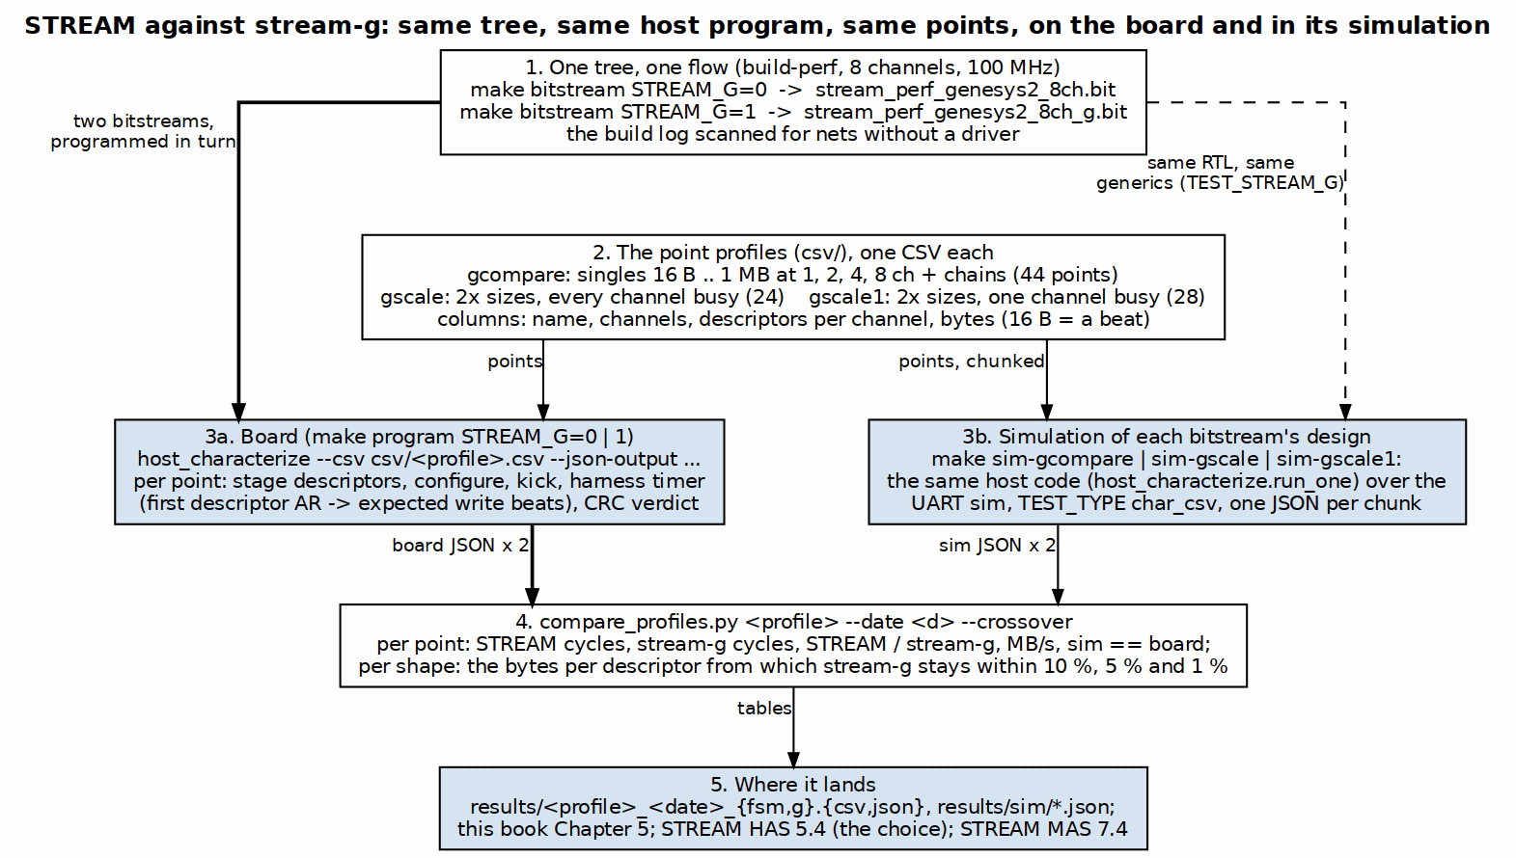
STREAM against stream-g: same tree, same host program, same points
Source: 07_ab_measurement.dot

7.4.2 The simulation against the board
The harness simulation of each bitstream’s design, in the bitstream’s own configuration (the perf geometry with USE_AXI_MONITORS=0; a first pass had taken the package default and built the in-core monitors in, which is not this bitstream), reproduces the board. On STREAM the first chunk run both ways is the board to the cycle on all eight points (233, 310, 559, 1,071, 2,095, 4,143, 8,239, 16,431 for the lone channel’s chains from 8 to 1,024 beats). On stream-g the traced run of the lone channel’s 16-descriptor chains gives 688 / 1,900 / 1,739 / 2,410 cycles at 16 / 32 / 64 / 128 beats against the board’s 684 / 1,890 / 1,737 / 2,409, and the residue is the design’s own run-to-run spread: the firmware’s poll loop runs free of the host, so where a hart’s pass stands when the kick lands decides whether a chain opens on an in-place advance or on a COMPLETE / NEXT_DESC walk, one walk being about 170 cycles (the board itself gave 1,737 and 1,911-1,935 for the same 64-beat point on different runs, with identical first-read to last-read spans). The simulation trace of channel 0’s scheduler (bin/sched_trace_timeline.py, results/task021_trace_2026-10-24_g.jsonl) is what settled the mechanism behind Table 5.5’s one-channel chain column, recorded under stream TASK-021: from 32 beats up every second chained head is staged after the running descriptor’s last read and walks instead of advancing in place, a 216-cycle pair whatever the size, until the data itself outlasts the firmware’s 26-to-106-cycle reaction above about 96 beats. The full three-profile campaign on both designs (make sim-gcompare | sim-gscale | sim-gscale1, results/sim/): on STREAM all 96 points are the board to the cycle; on stream-g 3 of 96 are identical and the rest differ by 24 cycles on average and 190 at most, every one of them a poll-phase effect, with the largest on the lone channel’s short chains. The reason the firmware’s reaction varies that much is in the shared image’s one-slot poll: a chained head that opens after the pass’s first HEAD_SUM read is routed to the full JUDGE path instead of the four- instruction chain hook, and in stream-g a chained head opens at the hardware’s in-place advance, out of phase with the pass, where in rapids-g it opens at the firmware’s own take (TASK-021).

7.5 Single descriptor per channel (gcompare)
Table 5.3: One descriptor per channel, 2026-10-24 (peak 1,600 MB/s)
Point | ch | per descriptor | STREAM cycles | stream-g cycles | STREAM MB/s | stream-g MB/s | stream-g / STREAM
beat_ch1_b1 | 1 | 16 B | 33 | 167 | 46 | 9 | 19.8 %
beat_ch1_b4 | 1 | 64 B | 39 | 172 | 157 | 35 | 22.7 %
beat_ch1_b16 | 1 | 256 B | 63 | 204 | 388 | 120 | 30.9 %
beat_ch1_b64 | 1 | 1 KB | 111 | 241 | 880 | 405 | 46.1 %
beat_ch1_b256 | 1 | 4 KB | 303 | 445 | 1,289 | 878 | 68.1 %
beat_ch1_b1024 | 1 | 16 KB | 1,071 | 1,234 | 1,459 | 1,266 | 86.8 %
beat_ch1_b4096 | 1 | 64 KB | 4,143 | 4,273 | 1,509 | 1,463 | 97.0 %
beat_ch1_b32768 | 1 | 512 KB | 32,815 | 32,955 | 1,524 | 1,517 | 99.6 %
beat_ch1_b65536 | 1 | 1 MB | 65,583 | 65,722 | 1,525 | 1,522 | 99.8 %
beat_ch2_b1 | 2 | 16 B | 35 | 188 | 87 | 16 | 18.6 %
beat_ch2_b4 | 2 | 64 B | 43 | 210 | 284 | 58 | 20.5 %
beat_ch2_b16 | 2 | 256 B | 79 | 216 | 618 | 226 | 36.6 %
beat_ch2_b64 | 2 | 1 KB | 175 | 318 | 1,116 | 614 | 55.0 %
beat_ch2_b256 | 2 | 4 KB | 559 | 703 | 1,398 | 1,111 | 79.5 %
beat_ch2_b1024 | 2 | 16 KB | 2,095 | 2,242 | 1,492 | 1,394 | 93.4 %
beat_ch2_b4096 | 2 | 64 KB | 8,239 | 8,394 | 1,517 | 1,489 | 98.2 %
beat_ch2_b32768 | 2 | 512 KB | 65,583 | 65,720 | 1,525 | 1,522 | 99.8 %
beat_ch2_b65536 | 2 | 1 MB | 131,119 | 131,257 | 1,525 | 1,524 | 99.9 %
beat_ch4_b1 | 4 | 16 B | 39 | 172 | 157 | 35 | 22.7 %
beat_ch4_b4 | 4 | 64 B | 51 | 215 | 479 | 114 | 23.7 %
beat_ch4_b16 | 4 | 256 B | 111 | 254 | 880 | 384 | 43.7 %
beat_ch4_b64 | 4 | 1 KB | 303 | 439 | 1,289 | 890 | 69.0 %
beat_ch4_b256 | 4 | 4 KB | 1,071 | 1,213 | 1,459 | 1,288 | 88.3 %
beat_ch4_b1024 | 4 | 16 KB | 4,143 | 4,285 | 1,509 | 1,459 | 96.7 %
beat_ch4_b4096 | 4 | 64 KB | 16,431 | 16,570 | 1,522 | 1,509 | 99.2 %
beat_ch4_b32768 | 4 | 512 KB | 131,119 | 131,272 | 1,525 | 1,524 | 99.9 %
beat_ch4_b65536 | 4 | 1 MB | 262,191 | 262,331 | 1,526 | 1,525 | 99.9 %
beat_ch8_b1 | 8 | 16 B | 47 | 205 | 260 | 60 | 22.9 %
beat_ch8_b4 | 8 | 64 B | 67 | 209 | 729 | 234 | 32.1 %
beat_ch8_b16 | 8 | 256 B | 175 | 309 | 1,116 | 632 | 56.6 %
beat_ch8_b64 | 8 | 1 KB | 559 | 701 | 1,398 | 1,114 | 79.7 %
beat_ch8_b256 | 8 | 4 KB | 2,095 | 2,232 | 1,492 | 1,400 | 93.9 %
beat_ch8_b1024 | 8 | 16 KB | 8,239 | 8,396 | 1,517 | 1,489 | 98.1 %
beat_ch8_b4096 | 8 | 64 KB | 32,815 | 32,966 | 1,524 | 1,517 | 99.5 %
beat_ch8_b32768 | 8 | 512 KB | 262,191 | 262,325 | 1,526 | 1,525 | 99.9 %
beat_ch8_b65536 | 8 | 1 MB | 524,335 | 524,470 | 1,526 | 1,525 | 100.0 %

7.6 Descriptor chains (gcompare)
Table 5.4: Chains of descriptors per channel, 2026-10-24
Point | ch | chain | STREAM cycles | stream-g cycles | STREAM MB/s | stream-g MB/s | stream-g / STREAM
chain_ch1_b1_d16 | 1 | 16 x 16 B | 212 | 759 | 115 | 32 | 27.9 %
chain_ch1_b64_d16 | 1 | 16 x 1 KB | 1,071 | 1,930 | 1,459 | 810 | 55.5 %
chain_ch1_b1024_d16 | 1 | 16 x 16 KB | 16,431 | 16,563 | 1,522 | 1,509 | 99.2 %
chain_ch1_b8192_d4 | 1 | 4 x 128 KB | 32,815 | 32,946 | 1,524 | 1,518 | 99.6 %
chain_ch8_b1_d16 | 8 | 16 x 16 B | 287 | 803 | 681 | 243 | 35.7 %
chain_ch8_b64_d16 | 8 | 16 x 1 KB | 8,239 | 8,284 | 1,517 | 1,509 | 99.5 %
chain_ch8_b1024_d16 | 8 | 16 x 16 KB | 131,119 | 131,253 | 1,525 | 1,524 | 99.9 %
chain_ch8_b8192_d4 | 8 | 4 x 128 KB | 262,191 | 262,226 | 1,526 | 1,525 | 100.0 %

7.7 The size sweeps (gscale, gscale1)
Each cell is STREAM cycles / stream-g cycles (1.00 = parity). single is one descriptor per channel, chain a 16-descriptor chain per channel; “8 ch” has every channel busy, “1 ch” channel 0 alone.
Table 5.5: STREAM / stream-g cycles over the size sweep (-- = not in the sweep)
Beats | per descriptor | single, 8 ch | chain, 8 ch | single, 1 ch | chain, 1 ch
1 | 16 B | 0.23 | 0.36 | 0.17 | 0.33
2 | 32 B | 0.26 | 0.36 | 0.18 | 0.33
4 | 64 B | 0.30 | 0.67 | 0.22 | 0.28
8 | 128 B | 0.42 | 0.68 | 0.26 | 0.35
16 | 256 B | 0.55 | 0.91 | 0.32 | 0.38
32 | 512 B | 0.69 | 0.98 | 0.36 | 0.29
64 | 1 KB | 0.81 | 1.00 | 0.45 | 0.62
128 | 2 KB | 0.89 | 1.00 | 0.57 | 0.87
256 | 4 KB | 0.94 | 1.00 | 0.69 | 0.97
512 | 8 KB | 0.97 | 1.00 | 0.79 | 0.98
1024 | 16 KB | 0.98 | 1.00 | 0.88 | 1.00
2048 | 32 KB | 0.99 | – | 0.94 | –
4096 | 64 KB | 1.00 | – | 0.97 | –
8192 | 128 KB | – | – | 0.98 | –
16384 | 256 KB | – | – | 0.99 | –
32768 | 512 KB | – | – | 1.00 | –
65536 | 1 MB | – | – | 1.00 | –
The smallest bytes per descriptor from which every larger point in the sweep stays within the bound:
Table 5.6: Bytes per descriptor for stream-g to be within 10 %, 5 % and 1 % of STREAM
Shape | Busy channels | Within 10 % | Within 5 % | Within 1 %
single descriptor | 1 of 8 | 32 KB | 64 KB | 256 KB
single descriptor | 8 of 8 | 4 KB | 8 KB | 32 KB
16-descriptor chain | 1 of 8 | 4 KB | 4 KB | 16 KB
16-descriptor chain | 8 of 8 | 256 B | 512 B | 1 KB
The difference is a fixed latency, not a rate: about 140 to 170 clocks once per channel between the kick and the first read (the firmware’s poll, STAGE and ARM and the state walk, against the state machine’s few cycles), and a clock or two per chained descriptor after it, because STREAM’s read-ahead prefetch, which stream-g keeps in hardware for a head the firmware has staged, overlaps the next head with the running one. With every channel busy the other channels’ data hides the cost; alone, a descriptor pays it in full, which is why the one-channel bounds sit eight times higher. One point stands against the trend: the lone channel’s chain at 32 beats (1,897 cycles against 824 at 16 and 1,737 at 64), measured the same way on both runs of the day; it is stream TASK-021.

7.8 The matrix at three descriptor sizes
host_characterize.py’s 40-config matrix (1, 2, 4, 8, 16 descriptors per channel at 1 to 8 channels) at 1 MB, 64 KB and 4 KB per descriptor, 240 runs, all passing on both designs; the STREAM bitstream’s 1 MB matrix is cycle-identical to the 2026-10-03 measurement.
Table 5.7: Cycles, STREAM / stream-g (stream-g relative to STREAM)
per descriptor | 1 desc, 1 ch | 1 desc, 8 ch | 16 desc, 1 ch | 16 desc, 8 ch | mean of 40
1 MB | 65,583 / 65,730 (+0.22 %) | 524,335 / 524,476 (+0.03 %) | 1,048,623 / 1,048,771 (+0.01 %) | 8,388,655 / 8,388,688 (+0.00 %) | +0.02 %
64 KB | 4,143 / 4,299 (+3.77 %) | 32,815 / 32,963 (+0.45 %) | 65,583 / 65,723 (+0.21 %) | 524,335 / 524,371 (+0.01 %) | +0.41 %
4 KB | 303 / 444 (+46.53 %) | 2,095 / 2,231 (+6.49 %) | 4,143 / 4,170 (+0.65 %) | 32,815 / 32,844 (+0.09 %) | +4.96 %

7.9 Artifacts
What | Where (under build-perf/)
The point profiles | csv/gcompare.csv, csv/gscale.csv, csv/gscale1.csv
Board runs | results/{gcompare,gscale,gscale1}_2026-10-24_{fsm,g}.{csv,json}, results/perf_sweep_2026-10-24_{fsm,g}_{1MB,64KB,4KB}.{csv,json}
Simulation runs | results/sim/<profile>_<dut>_<k>of<n>.json
Out-of-context cores | ../reports/ooc/<top>_<ch>ch/10.0ns/
Tabulation | ../bin/compare_profiles.py

