
RTL Design Sherpa
Bridge Hardware Architecture Specification 1.4
October 18, 2026

Table of Contents
1 Bridge Has Index 20
2 Document Information 21
2.1 Bridge Hardware Architecture Specification 21
2.2 Revision History 22
2.3 Document Purpose 30
2.4 Intended Audience 31
2.5 Related Documents 32
3 Purpose and Scope 33
3.1 What is Bridge? 33
3.2 The Problem Bridge Solves 34
3.3 Scope 35
3.4 Out of Scope 36
4 Document Conventions 37
4.1 Terminology 37
4.2 Signal Naming 38
4.3 Diagrams 39
4.3.1 Figure 1.1: Block Diagram Legend 39
4.4 Code Examples 40
4.5 Parameter Notation 41
5 Definitions and Acronyms 42
5.1 Acronyms 42
5.2 Definitions 44
6 Use Cases 45
6.1 Primary Applications 45
6.1.1 SoC Interconnects 45
6.1.2 Memory Systems 45
6.1.3 Accelerator Systems 45
6.2 Example: RAPIDS Accelerator 46
6.2.1 Figure 2.1: RAPIDS System Topology 46
6.2.2 Configuration 46
6.2.3 Benefits 46
6.3 Rapid Prototyping 48
7 Key Features 49
7.1 Configuration-Driven Generation 49
7.1.1 CSV/TOML Configuration 49
7.1.2 Example Configuration 49
7.2 Multi-Protocol Support 50
7.2.1 Protocol Features 51
7.3 Channel-Specific Masters 52
7.3.1 Write-Only Masters (wr) 52
7.3.2 Read-Only Masters (rd) 52
7.3.3 Full Masters (rw) 52
7.3.4 Resource Savings 52
7.4 Automatic Converters 53
7.4.1 Width Conversion 53
7.4.2 Protocol Conversion 53
7.5 Flexible Topology 54
7.5.1 Scalability 54
7.5.2 Mixed Configurations 54
8 System Context 55
8.1 Bridge in SoC Architecture 55
8.1.1 Figure 2.2: Bridge System Context 55
8.2 Interface Boundaries 56
8.2.1 Master-Side (Upstream) 56
8.2.2 Slave-Side (Downstream) 56
8.3 Address Space 57
8.3.1 Address Map Organization 57
8.3.2 Address Decode 57
8.4 Clock and Reset 58
8.4.1 Clock Domain 58
8.4.2 Reset 58
8.5 Dependencies 59
8.5.1 Required Infrastructure 59
8.5.2 Optional Features 59
8.6 References 60
9 Block Diagram 61
9.1 Bridge Architecture Overview 61
9.1.1 Figure 3.1: Bridge Block Diagram 61
9.2 Functional Blocks 62
9.2.1 Master Adapter 62
9.2.2 Crossbar Core 62
9.2.3 Slave Adapter 62
9.3 Data Flow 63
9.3.1 Figure 3.2: Write Path 63
9.3.2 Figure 3.3: Read Path 63
9.4 Scalability 64
9.4.1 Topology Parameters 64
9.4.2 Resource Scaling 64
9.5 References 65
10 Data Flow 66
10.1 Transaction Flow Overview 66
10.1.1 Write Transaction Flow 66
10.1.2 Read Transaction Flow 66
10.2 Channel Independence 67
10.2.1 AXI4 Channel Separation 67
10.2.2 Parallel Operation 67
10.3 Bridge ID and ID Widening 68
10.3.1 Bridge ID (BID) Concept 68
10.3.2 IDs are widened inside the fabric 68
10.4 Response Routing 69
10.4.1 B Channel (Write Response) 69
10.4.2 R Channel (Read Data) 70
10.4.3 The requirement the FIFO form creates 70
10.5 Ordering: what the fabric actually guarantees 71
10.6 References 72
11 Protocol Support 73
11.1 Supported Protocols 73
11.1.1 AXI4 Full 73
11.1.2 AXI4-Lite 73
11.1.3 AXI3 73
11.1.4 APB (Advanced Peripheral Bus) 74
11.2 Protocol Conversion Matrix 75
11.3 Automatic Conversion Shims at Slave Boundary 77
11.4 Automatic Conversion at the Master Boundary 78
11.5 AXI4 to APB Conversion 80
11.5.1 Conversion Process 80
11.5.2 Figure 3.4: AXI4 to APB Conversion Sequence 80
11.5.3 Burst Handling 80
11.5.4 Timing Considerations 80
11.6 Width Conversion 81
11.6.1 Upsize (Narrow to Wide) 81
11.6.2 Figure 3.5: Width Upsize Conversion 81
11.6.3 Downsize (Wide to Narrow) 82
11.6.4 Figure 3.6: Width Downsize Conversion 82
11.7 Channel-Specific Protocol 83
11.7.1 Write-Only Masters 83
11.7.2 Read-Only Masters 83
11.8 ACE and Coherency — Explicitly Out of Scope 84
11.9 References 85
12 AXI4 Interface Overview 86
12.1 Interface Organization 86
12.1.1 Master-Side Interfaces 86
12.1.2 Slave-Side Interfaces 86
12.2 Signal Naming Convention 88
12.2.1 Custom Prefixes 88
12.2.2 ID Width Extension 88
12.3 Channel-Specific Interfaces 89
12.3.1 Write-Only Master (wr) 89
12.3.2 Read-Only Master (rd) 89
12.4 Monitor Bus Output (when variants includes mon) 90
12.5 Handshake Protocol 91
12.5.1 Valid/Ready Handshake 91
12.5.2 Backpressure 91
12.6 Burst Support 92
12.6.1 Supported Burst Types 92
12.6.2 Burst Length 92
13 APB Interface 93
13.1 Overview 93
13.2 Ports 94
13.2.1 Signal Definition 94
13.2.2 Signal Naming 94
13.3 Functional Description 95
13.3.1 AXI4 to APB Conversion 95
13.3.2 Burst Handling 95
13.3.3 Error Mapping 95
13.4 Timing 96
13.5 Waveforms 97
13.5.1 Write Transaction 97
13.5.2 Read Transaction 98
13.6 APB Requester Ports 99
13.7 Design Notes 100
14 Clock and Reset 101
14.1 Overview 101
14.2 Ports 102
14.2.1 Clock 102
14.2.2 Reset 102
14.3 Functional Description 103
14.3.1 One Fabric Clock 103
14.3.2 Clock Domain Crossing: CDC Slave Ports 103
14.3.3 Clock Domain Crossing: CDC Master Ports 104
14.3.4 Reset Behavior 106
14.3.5 Reset Effects 106
14.3.6 Outstanding Transactions 106
14.3.7 Reset Release 106
14.4 Timing 107
14.4.1 Setup and Hold 107
14.4.2 Clock-to-Output 107
14.5 Usage Example 108
14.5.1 Recommended Constraints 108
14.6 Design Notes 109
14.6.1 External CDC Required 109
14.6.2 CDC Recommendations 109
15 AXI5 and APB5 Interfaces (AMBA5 Support) 110
15.1 Overview 110
15.2 Parameters 111
15.2.1 Declaring AMBA5 Ports 111
15.3 Ports 112
15.3.1 AXI5 Port Surface 112
15.3.2 APB5 Slave Surface 113
15.3.3 AXI5-Lite Master Surface 113
15.3.4 APB5 Master Surface 114
15.3.5 AXI5-Lite Slave Surface 115
15.4 Functional Description 116
15.4.1 Interop Matrix 118
16 Unmapped-Address Handling 119
16.1 Overview 119
16.1.1 Why the bridge answers an address no slave owns 119
16.2 Ports 120
16.2.1 Status, interrupt and clearing 120
16.3 Functional Description 121
16.3.1 Behaviour 121
16.3.2 Register access (cfg regblock builds) 121
16.3.3 When it can never fire 122
16.3.4 What this does not do 122
16.4 Navigation 123
17 Wishbone B4 Interface 124
17.1 Overview 124
17.2 Ports 125
17.2.1 Signal Definition 125
17.2.2 Signal Naming 126
17.3 Functional Description 127
17.3.1 Slave port: AXI4 to Wishbone 127
17.3.2 Master port: Wishbone to AXI4 127
17.3.3 Rules the validator enforces 127
17.4 Design Notes 128
18 Slave Watchdog 129
18.1 Overview 129
18.2 Ports 130
18.3 Functional Description 131
18.3.1 When it trips 131
18.3.2 What it does then 131
18.3.3 Measured 131
18.4 Design Notes 132
19 Throughput Characteristics 133
19.1 Overview 133
19.2 Functional Description 134
19.2.1 Peak Throughput 134
19.2.2 Formula 134
19.2.3 Measured (2026-09-11) 134
19.2.4 On Silicon: the Genesys 2 Fabric Benchmark (2026-10-16) 135
19.2.5 Factors Affecting Throughput 136
19.2.6 Width-Converted Paths (measured) 137
19.2.7 Latency Against Offered Load (measured) 137
19.2.8 Bandwidth Characterization (measured) 138
19.2.9 Multi-Master Scaling 140
19.2.10 Burst Efficiency 141
19.2.11 Width Conversion Impact 141
19.2.12 Protocol Conversion Impact 142
19.3 Design Notes 143
19.4 References 144
20 Latency Analysis 145
20.1 Overview 145
20.2 Timing 146
20.2.1 Address Path Latency 146
20.2.2 Data Path Latency 146
20.2.3 Response Path Latency 146
20.2.4 Loaded Write Latency (measured) 148
20.2.5 End-to-End Latency 148
20.2.6 Width Conversion Latency 149
20.2.7 Protocol Conversion Latency 149
20.3 Design Notes 151
20.3.1 Design Recommendations 151
20.4 References 152
21 Resources 153
21.1 Overview 153
21.2 Measured Utilization and Timing 154
21.2.1 Scaling 156
21.3 Design Notes 157
21.3.1 Resource Reduction 157
21.3.2 Performance/Resource Trade-off 157
21.4 References 158
22 System Requirements 159
22.1 Overview 159
22.1.1 Clock Infrastructure 159
22.1.2 Reset Infrastructure 159
22.1.3 Power 159
22.2 Parameters 160
22.2.1 Address Map 160
22.2.2 Connectivity 160
22.3 Ports 161
22.3.1 Master Requirements 161
22.3.2 Slave Requirements 161
22.4 Timing 162
22.4.1 Setup/Hold 162
22.4.2 Recommended Margins 162
22.5 Testing 163
22.5.1 Pre-Integration Checks 163
22.5.2 Integration Checks 163
22.5.3 Post-Integration Checks 163
22.6 Assumptions and Known Limitations 164
22.6.1 Response-Ordering Assumption 164
22.6.2 Buffer and CAM Depths 164
22.7 References 165
23 Parameter Configuration 166
23.1 Overview 166
23.2 Parameters 167
23.2.1 Core Parameters 167
23.2.2 Registered Crossbar (xbar_pipeline) 167
23.2.3 Derived Parameters 173
23.2.4 Per-Port Configuration 174
23.2.5 Top-Level Monitor Configuration 176
23.2.6 Parameter Validation 177
23.3 Usage Example 178
23.3.1 TOML Configuration 178
23.3.2 CSV Connectivity 178
23.3.3 Simple 2x2 178
23.3.4 Mixed Protocol 179
24 Verification Strategy 180
24.1 Overview 180
24.2 Testing 181
24.2.1 Verification Levels 181
24.2.2 Test Infrastructure 182
24.2.3 Test Execution Model 183
24.2.4 Coverage Goals 184
24.2.5 Debug Features 184
24.2.6 Regression Testing 185
24.2.7 Known Limitations 185
25 Synthesis and Implementation 187
25.1 Overview 187
25.2 The Flow 188
25.2.1 Where it lives 188
25.2.2 How the bridge is constrained 189
25.2.3 Reading the summary line 189
25.3 Measured Results 191
25.3.1 What the first run found 191
25.3.2 The reference set 191
25.3.3 Reading the rows 193
25.4 Design Notes 195
25.4.1 What moves the numbers 195
25.4.2 Before a board build 195
26 AXI3 Integration 196
26.1 Boundary-Conversion Architecture 196
26.2 Converter-Sourced Constraints 197
26.3 Validation Evidence 198
26.3.1 Configuration constraints 198
26.4 References 199

List of Figures
Figure 1.1: Block Diagram Legend 39
Figure 2.1: RAPIDS System Topology 46
Figure 2.2: Bridge System Context 55
Figure 3.1: Bridge Block Diagram 61
Figure 3.2: Write Path 63
Figure 3.3: Read Path 63
Figure 3.4: AXI4 to APB Conversion Sequence 80
Figure 3.5: Width Upsize Conversion 81
Figure 3.6: Width Downsize Conversion 82
Figure 4.1: APB Write Transfer (Zero Wait States) 97
Figure 4.2: APB Read Transfer (One Wait State) 98
Figure 4.3: Clock Distribution 103
Figure 4.4: Reset Timing 106
Figure 4.5: Multi-Clock CDC 109

List of Tables
Table 1: Document information 21
Table 2: Revision history 22
Table 3: Common Terminology 37
Table 4: Signal Naming Prefixes 38
Table 5: Block Diagram Symbols 39
Table 6: Parameter Format Example 41
Table 7: Acronyms and Abbreviations 42
Table 8: Supported Protocols 50
Table 9: Channel-Specific Resource Savings 52
Table 10: Address Map Organization 57
Table 11: Topology Parameter Scaling 64
Table 12: AXI4 Channel Summary 67
Table 13: Response Routing 69
Table 14: Protocol Conversion Matrix 75
Table 15: Slave-port protocol values 77
Table 16: Master-port protocol values 78
Table 17: Master-Side Interface Channels 86
Table 18: Slave-Side Interface Channels 87
Table 19: Monitor Bus Output 90
Table 20: Supported Burst Types 92
Table 21: APB Signal Definitions 94
Table 22: AXI4 to APB Burst Conversion 95
Table 23: APB to AXI4 Error Mapping 95
Table 24: Clock Requirements 102
Table 25: Reset Signal 102
Table 26: CDC slave port clock pins (cdc = true) 104
Table 27: CDC master port clock pins (cdc = true) 104
Table 28: Reset Effects 106
Table 29: Timing Constraints 107
Table 30: Clock-to-Output Delays 107
Table 31: AXI5 Port Surface 112
Table 32: APB5 Slave Surface 113
Table 33: AXI5-Lite sideband groups at an axil5 master boundary 114
Table 34: AXI5-Lite sideband groups at an axil5 slave boundary 115
Table 35: Interop Matrix 118
Table 36: Unmapped-address status and interrupt ports 120
Table 37: Subtractive-slave response behaviour 121
Table 38: Unmapped-address status registers 121
Table 39: Wishbone B4 Signal Definitions 125
Table 40: Wishbone termination to AXI4 response 127
Table 41: Slave watchdog status (one per slave with timeout_cycles > 0) 130
Table 42: Peak Throughput by Data Width 134
Table 43: Measured throughput, direct 32-bit AXI4 paths 134
Table 44: The bridge against the vendor fabrics on the Genesys 2 135
Table 45: Factors Affecting Throughput 136
Table 46: Width-converted paths, bridge_4x4_rw (FULL level) 137
Table 47: Accepted throughput and latency against offered load, bridge_2x2_rw (GATE level, 24 reads per master per point) 137
Table 48: Bandwidth characterization, test_bridge_perf_char (FUNC level, 2026-10-18) 139
Table 49: Burst Efficiency Comparison 141
Table 50: AXI4 vs APB Protocol Impact 142
Table 51: Address Path Latency 146
Table 52: Data Path Latency 146
Table 53: Response Path Latency 146
Table 54: Write latency under load, bridge_2x2_rw, 32-bit direct path 148
Table 55: Upsize Latency by Ratio 149
Table 56: Downsize Latency by Ratio 149
Table 57: AXI4 to APB Conversion Latency 149
Table 58: Measured utilization and timing, Artix-7 100T -1 at 10 ns (HAS 6.4 flow) 154
Table 59: Measured utilization and timing, Kintex-7 325T -2 at 6.667 ns 155
Table 60: Resource Scaling 156
Table 61: Performance/Resource Trade-offs 157
Table 62: Clock Requirements 159
Table 63: Reset Requirements 159
Table 64: Power Requirements 159
Table 65: Address Map Requirements 160
Table 66: Connectivity Requirements 160
Table 67: Timing Requirements 162
Table 68: Recommended Timing Margins 162
Table 69: Bridge Core Parameters 167
Table 70: Crossbar options (bridge TASK-006, was BRIDGE-017) 167
Table 71: Per-port options: CDC (bridge TASK-006, GitHub #119 L2), latency, outstanding limit 170
Table 72: Monitor preset 172
Table 73: Derived Parameters 174
Table 74: Master Port Configuration 174
Table 75: Slave Port Configuration 175
Table 76: Top-Level Monitor Configuration 176
Table 77: Generator Validation Checks 177
Table 78: Unit Level Test Focus 181
Table 79: Integration Test Coverage 181
Table 80: System Level Tests 181
Table 81: Test Categories 182
Table 82: Functional Coverage Goals 184
Table 83: Code Coverage Goals 184
Table 84: Debug Signals 185
Table 85: CI Test Schedule 185
Table 86: Configuration Test Matrix 185
Table 87: Known Test Gaps 185
Table 88: Simulator Support Status 186
Table 89: Synthesis flow knobs 188
Table 90: summary.csv columns 189
Table 91: The CAM ordering-count scan, before and after (2026-09-11) 191
Table 92: Reference set on the Artix-7 100T -1 (Nexys A7), constrained at 10 ns 191
Table 93: Reference set on the Kintex-7 325T -2 (Genesys 2), constrained at 6.667 ns 192

1 Bridge Has Index
Generated: 2026-10-18

RTL Design Sherpa · Learning Hardware Design Through Practice GitHub · Documentation Index · MIT License

2 Document Information

2.1 Bridge Hardware Architecture Specification
Document information
Property | Value
Document Title | Bridge Hardware Architecture Specification
Version | 1.4
Date | 2026-10-18
Status | Released
Classification | Open Source - MIT License

2.2 Revision History
Revision history
Version | Date | Author | Description
1.0 | 2026-01-03 | RTL Design Sherpa | Initial release - restructured from single spec
1.1 | 2026-06-04 | RTL Design Sherpa | Content sync to RTL state at 2026-06-04. Documents (1) the 64→128-bit monbus packet migration with new 64-bit side-band timestamp wire — referenced via docs/markdown/rtl-amba/includes/ocelus_package_spec.md; (2) per-port + global SV-parameter monitor methodology with mandatory use_monitor TOML field and variants = ["no","mon"] generator selector; (3) generator-emitted AXI4↔AXIL conversion at the slave boundary (was external); (4) new AXIL→wider-slave master-side alignment converters (axil_to_axi4_wide_align_{rd,wr}); (5) verification-strategy rewrite to protocol-BFM-only TBs with memory-backed slaves, serial-only execution, per-module cocotb function names, boundary_probe (renamed from address_decode) tests; (6) note of the independent W-tracker FIFO + split AW/W-ready MUX fix (commit d24bd617) that closed an interleaved-master deadlock.
1.2 | 2026-09-08 | RTL Design Sherpa | Correctness and voice pass. Four external qc rounds (65/54/53/57 findings, all triaged against rtl/generated and the generator) removed the planned-but-never-built ID-table/CAM out-of-order scheme, the fixed 64-bit internal path, response arbitration/FIFOs and the AXI4-Lite-as-future-work status from the text; annotated the TOML keys the loader has never known and its three-tier unknown-key behaviour; replaced asserted latency figures with measured ones. Four RTL defects found by the rounds are fixed and mutation-checked (bridge BUG-009 (was BRIDGE-011) response-FIFO overrun, axi4_subtractive_slave simultaneous AW+AR fault loss, axi5_atomic_filter duplicate B and B-before-WLAST). Prose then voice-passed with all correctness annotations preserved.
1.3 | 2026-09-11 | RTL Design Sherpa | bridge TASK-004 (was BRIDGE-014): AXI5-Lite and APB/APB5 as master protocols (front-end converters); bridge TASK-005 (was BRIDGE-016) slave ID widening
1.4 | 2026-09-11 | RTL Design Sherpa | bridge TASK-008 (was BRIDGE-019): Wishbone B4 on both sides of the fabric
1.5 | 2026-09-11 | RTL Design Sherpa | bridge TASK-006 (was BRIDGE-017): measured throughput and latency, registered crossbar, QoS arbitration, CDC slave ports, out-of-context synthesis flow and measured resources, CAM ordering-count fix
1.6 | 2026-09-13 | RTL Design Sherpa | bridge TASK-007 (was BRIDGE-018): native AXI5 fabric – Memory Tagging and read-data chunking through the structs
1.7 | 2026-09-13 | RTL Design Sherpa | Document sync: one fabric clock plus CDC ports throughout, Wishbone best-effort stance, out-of-order chunk proof
2.0 | 2026-10-12 | RTL Design Sherpa | Protocol-set correction: overview/summary bullets now state the full eight-protocol support (axi3/axi4/axi5/axil/axil5/apb/apb5/wb4 — per-port, slave or master side) verified against bin/bridge_pkg/config_validator.py; explicit “ACE coherency NOT supported” section added to ch03. Version strings aligned across index/front-matter/renders.
1.1 (renumbered) | 2026-10-15 | RTL Design Sherpa | The bridge document set (GAS, HAS, MAS) is renumbered to one common rev, 1.1; rows above keep the numbers they were published under. Content: the one-target-per-master limitation is fixed (GitHub #119 L1) – per-ID target tracking ([bridge].id_track_bits), B/R response arbiters per master width path, the crossed-W hold; the generated TB carries its connectivity map and the generator emits the AXIL narrow-to-wide alignment test (GitHub #119 L8); per-port outstanding limits, max_outstanding (power of two 2..64, default 16), size every tracker – the fixed 16 removed (GitHub #119 L5); per-port latency modes (cut_all / cut_ax / cut_none) and honoured TOML skid depths (GitHub #119 L7); read-return-atomic and trace-echo ports no longer limited to one target (GitHub #119 L1b).
1.2 | 2026-10-16 | RTL Design Sherpa | Slave-adapter CAM pipelining (GitHub #119): bridge_cam gains PIPELINE_ALLOC (registered insert with a pending-entry bypass; the full flag counts the pending entry) and PIPELINE_FREE (registered free; lookups see the post-free state), both on in every CAM-tracked slave adapter – MAS Figure 4.2. HAS 5.1 adds the Genesys 2 fabric-benchmark results against the Xilinx AXI Crossbar and SmartConnect; HAS 5.3 / 6.4 reference synthesis tables re-measured on the current generator. CDC on master ports (GitHub #119 L2): cdc = true on an AXI4 master puts axi4_cdc_{wr,rd} between the port and its timing wrapper, with <master>_aclk / <master>_aresetn on the top (HAS 4.5a, MAS 6.1); new fixture bridge_3x2_rw_mcdc and test_bridge_3x2_rw_mcdc_ratio. Generated TBs build their protocol checkers after reset. Read width converters are built with R_INTERLEAVE = 0 (no reassembly pool; it had grown every converter fixture past synthesis), so a slave may not interleave R beats across IDs (HAS 4.1, PRD FR-9).
1.3 | 2026-10-16 | RTL Design Sherpa | GitHub #119 L3/L4. Protocol checkers on every port: each bridge gets <bridge>_checkers.sv, axi4_protocol_checker bound to every AXI4/AXI5 port on its own clock, in simulation and formal only; generated tests use it by default (HAS Verification Strategy, MAS 7.1, GAS 4.1). Slave watchdog: per-slave timeout_cycles puts axi4_slave_watchdog in front of an AXI4 slave, which answers everything DECERR once the slave is silent that long and raises <slave>_timeout (HAS Slave Watchdog, MAS 6.1, GAS 2.2). Measured width-converted path rates and latencies, and accepted throughput and latency against offered load (HAS 5.1). Write-converter B input registered and the master per-ID gate made shallower; HAS 5.3 / 6.4 re-measured.
1.4 | 2026-10-18 | RTL Design Sherpa | Bandwidth limitations addressed. Shared slaves arbitrate at their pins from per-master request slots, so round-robin holds when the slave throttles (a master with two in flight: 0.34 -> 0.50 of the slave; MAS 2.2-2.4, GAS 4.4, HAS 5.1). A narrow master’s upsized path into a shared slave gets a rate-matching buffer (bridge_wr_rate_buf on writes, a FIFO on reads; rate_buffer, default 16 wide beats, 0 off), so the slave runs at its full rate behind it (0.80 -> 0.995 on writes, 0.93 -> 1.000 on reads; MAS 2.6, HAS 2.2, GAS 3.2). Width-converter fixes: the read upsizer’s bypass gate and the downsizer’s close/reopen of a partial wide beat, both formal-proven. New bandwidth characterization suite test_bridge_perf_char in the FUNC regression over nine fixture settings, CDC, AXI3 and AXI5 included, every figure floored (HAS 5.1, MAS 7.1). Open limits (W7-W9 floored at their measured level): W7 (an AXI3 master has one write in flight), W8 (the AXI3 slave converter’s issue rate and one-per-ID ordering), W9 (round-robin shares at a CDC slave) and W10 (the AXI3 slave converter uses SystemVerilog queues, which Vivado does not synthesize) (HAS 4.5a, 5.1, 6.5).

2.3 Document Purpose
This Hardware Architecture Specification (HAS) is the high-level view of the Bridge component — the map you read before you integrate, not the schematic. It covers:
- System-level architecture and data flow
- Protocol support (AXI3, AXI4, AXI5, AXI4-Lite, AXI5-Lite, APB, APB5, Wishbone B4 — per-port, slave or master side; ACE coherency NOT supported)
- Interface definitions and requirements
- Performance characteristics
- Integration guidelines
For micro-architecture, FSM designs, and signal-level detail, see the companion Bridge Micro-Architecture Specification (MAS).

2.4 Intended Audience
- System architects defining interconnect topology
- Hardware engineers integrating Bridge into SoC designs
- Verification engineers planning test strategies
- Technical managers evaluating Bridge capabilities

2.5 Related Documents
- Bridge MAS - Micro-Architecture Specification (detailed block-level)
- PRD.md - Product requirements and overview
- CLAUDE.md - AI development guide

RTL Design Sherpa · Learning Hardware Design Through Practice GitHub · Documentation Index · MIT License

3 Purpose and Scope

3.1 What is Bridge?
Bridge is a Python-based multi-protocol crossbar generator. You describe the interconnect in human-readable configuration files; it hands you back parameterized SystemVerilog RTL. The generated AXI4 crossbars come with automatic support for:
- Protocol conversion - AXI3, AXI4, AXI5, AXI4-Lite, AXI5-Lite, APB, APB5, and Wishbone B4 interfaces, on slave or master ports (selected per port in the TOML; ACE coherency is NOT supported)
- Width conversion - Automatic upsize/downsize for data width mismatches
- Channel-specific masters - Write-only, read-only, or full AXI4 masters

3.2 The Problem Bridge Solves
A hand-written AXI4 crossbar is error-prone. Building one means:
- Writing 5 separate channel multiplexers (AW, W, B, AR, R)
- Implementing per-slave arbitration for each channel
- Routing responses back to the issuing master, including slaves that complete different IDs out of order
- Handling burst locking and interleaving constraints
- Inserting width converters for data width mismatches
- Inserting protocol converters for mixed systems — APB/APB5, AXI4-Lite/AXI5-Lite, AXI3, or Wishbone B4 peripherals behind an AXI4 fabric (and vice versa)
- Wiring hundreds of signals with consistent naming
Every item on that list is a place a bug can sit quietly until integration. I’ve chased most of them at least once.
Bridge automates all of it:
- Define ports and connectivity in configuration files
- Run the generator script
- Get production-ready SystemVerilog RTL

3.3 Scope
This specification covers:
- High-level architecture and block organization
- Supported protocols and conversion capabilities
- Interface requirements and signal conventions
- Performance characteristics and resource estimates
- Integration guidelines and verification strategy

3.4 Out of Scope
These live in the companion MAS:
- Detailed FSM state diagrams and transitions
- Signal-level timing diagrams
- Internal pipeline structures
- RTL implementation details

RTL Design Sherpa · Learning Hardware Design Through Practice GitHub · Documentation Index · MIT License

4 Document Conventions

4.1 Terminology
Common Terminology
Term | Definition
Master | AXI4 initiator that issues transactions
Slave | AXI4 target that responds to transactions
Crossbar | NxM interconnect connecting masters to slaves
Channel | AXI4 communication path (AW, W, B, AR, R)
Converter | Logic that transforms width or protocol

4.2 Signal Naming
Bridge uses consistent signal prefixes — learn them once and every generated interface reads the same way:
Signal Naming Prefixes
Prefix | Meaning
s_* | Slave-side interface (master port on bridge)
m_* | Master-side interface (slave port on bridge)
axi4_* | AXI4 protocol signals
apb_* | APB protocol signals
cfg_* | Configuration signals
dbg_* | Debug signals

4.3 Diagrams

4.3.1 Figure 1.1: Block Diagram Legend
Block diagrams in this specification use these symbols:
Block Diagram Symbols
Symbol | Meaning
White rectangle | External port or interface (masters at the top, slaves at the bottom)
Shaded rectangle | Functional block; the second line names the owning RTL
Solid arrow | A flow, labeled with what it carries: requests down, responses back up their own lane
Heavy arrow | The main flow out of a decision point, or a path on a clock other than aclk
Dashed arrow | Sideband: tracking writes, configuration, clocks
Dashed box | Optional or build-dependent block
Trapezium, wide edge up | A many-to-one pick (the per-slave arbiter): contenders enter the wide edge

4.4 Code Examples
SystemVerilog examples are formatted like this:
// Module instantiation example
bridge_4x4 u_bridge (
.aclk (sys_clk),
.aresetn (sys_rst_n),
// ... port connections
);

4.5 Parameter Notation
Parameter tables throughout the spec use this format:
Parameter Format Example
Parameter | Type | Range | Default | Description
NUM_MASTERS | int | 1-32 | 2 | Number of master ports
NUM_SLAVES | int | 1-256 | 2 | Number of slave ports

RTL Design Sherpa · Learning Hardware Design Through Practice GitHub · Documentation Index · MIT License

5 Definitions and Acronyms

5.1 Acronyms
Acronyms and Abbreviations
Acronym | Definition
AMBA | Advanced Microcontroller Bus Architecture
APB | Advanced Peripheral Bus
AR | AXI4 Read Address channel
AW | AXI4 Write Address channel
AXI | Advanced eXtensible Interface
AXI4 | AXI Protocol Version 4
B | AXI4 Write Response channel
BID | Bridge ID (internal master identifier)
CAM | Content-Addressable Memory
CDC | Clock Domain Crossing
CSV | Comma-Separated Values
DECERR | Decode Error (AXI response)
DMA | Direct Memory Access
FIFO | First-In First-Out buffer
FSM | Finite State Machine
HAS | Hardware Architecture Specification
ID | Transaction Identifier
MAS | Micro-Architecture Specification
MUX | Multiplexer
NxM | N masters by M slaves (topology notation)
OOO | Out-of-Order
OOR | Out-of-Range
QoS | Quality of Service
R | AXI4 Read Data channel
RTL | Register-Transfer Level
SLVERR | Slave Error (AXI response)
SoC | System-on-Chip
TOML | Tom’s Obvious Minimal Language
W | AXI4 Write Data channel

5.2 Definitions
Address Decode: Determining which slave receives a transaction, from its address.
Arbitration: Selecting which master gets a slave when several masters contend for it.
Bridge ID (BID): The issuing master’s index, width clog2(NUM_MASTERS). With more than one master it is both prepended to the AXI ID inside the fabric (slave-side IDs are {BRIDGE_ID, id}, wider than master-side ones) and carried as a sideband into the slave adapter’s response tracker (a bridge_cam or an in-order FIFO), which routes B and R back to the master.
Channel-Specific Master: A master that uses only a subset of AXI4 channels (write-only or read-only).
Crossbar: An NxM interconnect allowing any master to communicate with any connected slave.
Grant Locking: Mechanism that holds arbitration grant until transaction completes.
Out-of-Order Response: (defined for completeness; NOT supported by this bridge) Responses returned in different order than requests were issued.
Protocol Conversion: Transformation between different bus protocols (e.g., AXI4 to APB).
Response Routing: Directing B/R channel responses back to the originating master.
Round-Robin Arbitration: Fair arbitration where priority rotates among requesters.
Width Conversion: Transformation between different data bus widths (upsize or downsize).

RTL Design Sherpa · Learning Hardware Design Through Practice GitHub · Documentation Index · MIT License

6 Use Cases

6.1 Primary Applications

6.1.1 SoC Interconnects
In SoC designs, Bridge is the main interconnect fabric:
- Multi-core processor memory subsystems - Connect multiple CPU cores to shared memory
- Accelerator integration - Route GPU, DSP, or custom accelerator traffic
- DMA engine routing - Connect DMA controllers to memory and peripherals
- Peripheral bus bridges - Convert AXI4 to APB for low-speed peripherals

6.1.2 Memory Systems
Typical memory-system uses:
- Multi-port DDR controllers - Multiple masters accessing shared DDR
- SRAM buffer sharing - Shared packet buffers for networking
- Cache coherency interconnects - Connect cache controllers
- Memory-mapped I/O - Unified address space for peripherals

6.1.3 Accelerator Systems
Bridge supports custom accelerator architectures like RAPIDS:
- Descriptor write masters - Write control descriptors (write-only)
- Sink write masters - Write incoming data packets (write-only)
- Source read masters - Read outgoing data packets (read-only)
- CPU configuration - Full access for register configuration

6.2 Example: RAPIDS Accelerator

6.2.1 Figure 2.1: RAPIDS System Topology
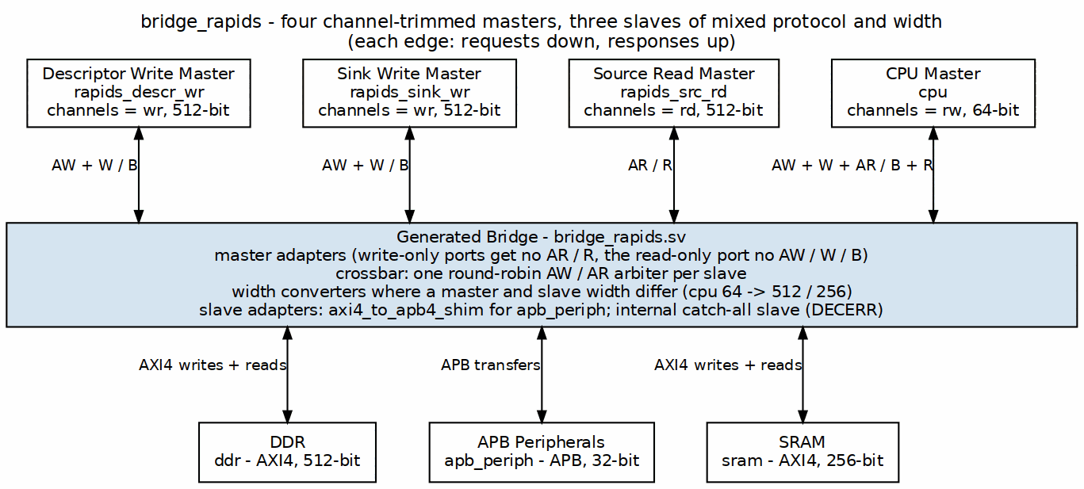
RAPIDS System Topology
Bridge topology for RAPIDS accelerator with channel-specific masters.

6.2.2 Configuration
[bridge]
name = "bridge_rapids"
masters = [
{name = "rapids_descr_wr", channels = "wr", data_width = 512},
{name = "rapids_sink_wr", channels = "wr", data_width = 512},
{name = "rapids_src_rd", channels = "rd", data_width = 512},
{name = "cpu", channels = "rw", data_width = 64}
]
slaves = [
{name = "ddr", protocol = "axi4", data_width = 512},
{name = "apb_periph", protocol = "apb", data_width = 32},
{name = "sram", protocol = "axi4", data_width = 256}
]

6.2.3 Benefits
- 40% fewer channels for write-only masters (3 of 5: AW, W, B)
- 60% fewer channels for read-only masters (2 of 5: AR, R)
Those are CHANNEL counts, which is the honest way to state it – the saving in actual wires depends on the widths. At DW=64/AW=32/IW=4/UW=1 the five channels are roughly 295 bits, and dropping AR+R saves about 48% of them while dropping AW+W+B saves about 52%; at DW=512 it is nearer 47%/53%. Earlier revisions of this page quoted “39%” and “61%”, which match neither basis. - Automatic width conversion for 64b CPU to 512b DDR - Protocol conversion for APB peripheral access

6.3 Rapid Prototyping
Bridge accelerates design exploration:
- Quick topology exploration - Try different master/slave configurations
- Performance analysis - Evaluate arbitration and bandwidth
- Design space exploration - Compare resource usage
- Educational projects - Learn AXI4 protocol and interconnects

RTL Design Sherpa · Learning Hardware Design Through Practice GitHub · Documentation Index · MIT License

7 Key Features

7.1 Configuration-Driven Generation

7.1.1 CSV/TOML Configuration
Everything about a Bridge instance is set in human-readable text files:
- ports configuration - Define each master and slave port
- connectivity matrix - Specify which masters connect to which slaves
- Version-control friendly - Text-based, easy to diff and review

7.1.2 Example Configuration
Port Definition (TOML):
masters = [
{name = "cpu", prefix = "cpu_m_axi", data_width = 64, channels = "rw"},
{name = "dma", prefix = "dma_m_axi", data_width = 256, channels = "rw"}
]
slaves = [
{name = "ddr", prefix = "ddr_s_axi", data_width = 512, protocol = "axi4"},
{name = "uart", prefix = "uart_apb", data_width = 32, protocol = "apb"}
]
Connectivity Matrix (CSV):
master\slave,ddr,uart
cpu,1,1
dma,1,0

7.2 Multi-Protocol Support
Supported Protocols
Master Protocol | Slave Protocol | Conversion Type
AXI4 | AXI4 | Direct or width convert
AXI4 | AXI4-Lite | Protocol downgrade
AXI4 | APB | Full protocol conversion
AXI5 | AXI4 / AXI4-Lite / APB | Base-subset interop; sideband terminates at the boundary (warning)
AXI5 | AXI5 (width-matched) | Native sideband pass-through; atomics (read-return classes need an rw port); poison
AXI4 / AXI5 | APB5 | APB4 conversion core + APB5 sideband surface
AXI4-Lite / AXI5-Lite | any | Lite requester: single-beat AXI4 inside; the AXI5-Lite ID and user group ride the fabric, the rest terminate at the boundary
APB / APB5 | any | APB requester: apb4_to_axi4 / apb5_to_axi4 front end, one AXI4 transaction per transfer, SLVERR and DECERR fold to PSLVERR
any | Wishbone B4 | axi4_to_wb4: one Wishbone transfer per AXI4 beat, ERR/RTY fold to SLVERR
Wishbone B4 | any | wb4_to_axi4 front end: single-beat AXI4 inside, SLVERR/DECERR terminate ERR
AMBA5 ports are declared per port (protocol = "axi5" / "axil5" / "apb5" with an optional axi5_features list); the fabric stays AXI4 internally. Every protocol value is legal on a master port as well as a slave port (bridge TASK-004, was BRIDGE-014). See AXI5 and APB5 Interfaces.

7.2.1 Protocol Features
- AXI4 Full - Complete 5-channel implementation with bursts
- AXI4-Lite - Simplified single-beat transactions
- APB - Low-power peripheral access
- Wishbone B4 - The open FPGA bus, pipelined mode, on either side (bridge TASK-008, was BRIDGE-019)

7.3 Channel-Specific Masters

7.3.1 Write-Only Masters (wr)
Generate only write channels: - AW (Write Address) - W (Write Data) - B (Write Response)
Use case: DMA write engines, descriptor writers

7.3.2 Read-Only Masters (rd)
Generate only read channels: - AR (Read Address) - R (Read Data)
Use case: DMA read engines, source data fetchers

7.3.3 Full Masters (rw)
Generate all five channels for complete read/write capability.
Use case: CPU interfaces, configuration masters

7.3.4 Resource Savings
Channel-Specific Resource Savings
Master Type | Channels | Signal Reduction
Write-only (wr) | 3 of 5 | 40% fewer channels (~48% fewer wires at DW=64)
Read-only (rd) | 2 of 5 | 60% fewer channels (~52% fewer wires at DW=64)
Full (rw) | 5 of 5 | Baseline

7.4 Automatic Converters

7.4.1 Width Conversion
Bridge automatically inserts width converters:
- Upsize - Narrow master to wide slave (e.g., 64b to 512b). Into a slave other masters share, a rate-matching buffer (rate_buffer, default 16 wide beats) keeps that slave at its full rate during the narrow master’s bursts (MAS 2.6)
- Downsize - Wide master to narrow slave (e.g., 512b to 32b)
- Per-path - Only where needed, not global conversion

7.4.2 Protocol Conversion
Bridge inserts protocol converters for mixed systems:
- AXI4 to APB - Full conversion with burst handling
- AXI4 to AXI4-Lite - Simplified conversion

7.5 Flexible Topology

7.5.1 Scalability
- Masters: 1-32 master ports
- Slaves: 1-256 slave ports
- Partial connectivity - Not all masters need access to all slaves

7.5.2 Mixed Configurations
- Mixed protocols - AXI4, AXI4-Lite, and APB slaves in same crossbar
- Mixed data widths - 32b, 64b, 128b, 256b, 512b
- Mixed channels - Write-only, read-only, and full masters

RTL Design Sherpa · Learning Hardware Design Through Practice GitHub · Documentation Index · MIT License

8 System Context

8.1 Bridge in SoC Architecture

8.1.1 Figure 2.2: Bridge System Context
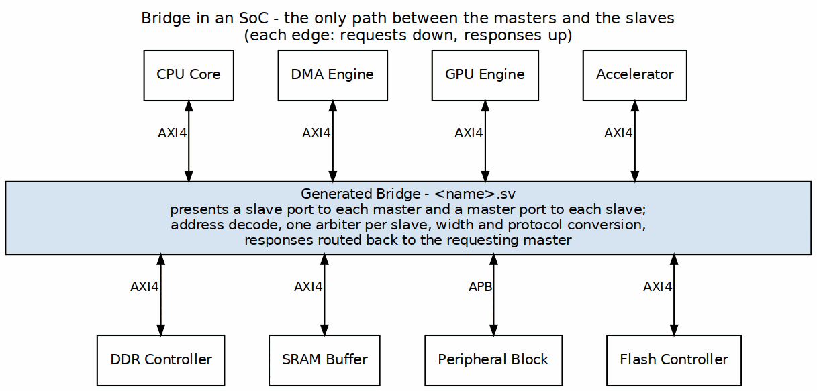
Bridge System Context
Bridge as central interconnect connecting masters to slaves with protocol conversion.

8.2 Interface Boundaries

8.2.1 Master-Side (Upstream)
Bridge presents slave interfaces to upstream masters:
- Accepts AXI4 transactions from masters
- Provides flow control via ready signals
- Returns responses (B/R channels) to correct master

8.2.2 Slave-Side (Downstream)
Bridge presents master interfaces to downstream slaves:
- Issues AXI4/APB transactions to slaves
- Accepts responses from slaves
- Routes responses back through ID tracking

8.3 Address Space

8.3.1 Address Map Organization
Each slave occupies a configurable address region:
Address Map Organization
Slave | Base Address | Address Range | Size
Slave 0 | base_addr from its own TOML entry | addr_range | Variable
Slave 1 | base_addr from its own TOML entry | addr_range | Variable
Slave N | base_addr from its own TOML entry | addr_range | Variable
Windows are not derived from a single BASE and are not contiguous. Each slave carries its own base_addr, subject only to 4 KB alignment and non-overlap (Parameters). An earlier revision of this table showed BASE + addr_range_0 and “sum of previous ranges”, which no shipped config follows – bridge_mix_d places a 1 GB ddr at 0x0000_0000, a 4 KB doorbell at 0x4000_0000 and a 64 KB apb_periph at 0x4000_1000, and gaps between windows are legal (they decode-miss).

8.3.2 Address Decode
- Subtractive decode - the ranges are tested in order and the chain ends in an else, so the one-hot result is never all-zero
- One-hot result - exactly one slave selected per transaction, always
- Out-of-range - an address matching no slave range selects the internal subtractive slave, which completes the transaction with DECERR and 0xDEADBEEF read data rather than leaving it unanswered
Until 2026-09-07 the last bullet was aspirational: the decode chain had no else, so an unmapped address produced an all-zero select, no slave ever saw AWVALID/ARVALID, READY never rose, and the master waited forever. A hang is the worst available failure here because it destroys the evidence – there is no response to inspect, no error bit to read, and the offending address is whatever the master still has latched. See 4.5 for the status/interrupt path that now reports it.

8.4 Clock and Reset

8.4.1 Clock Domain
- One fabric clock - All Bridge logic and every master port synchronous to aclk
- CDC ports - An AXI4 slave or master declared cdc = true runs on its own <port>_aclk behind an async-FIFO crossing inside its adapter (HAS 4.5a); other ports share aclk

8.4.2 Reset
- Active-low asynchronous - Standard aresetn convention
- Full reset - All internal state cleared on reset
- Transaction safety - Outstanding transactions aborted on reset

8.5 Dependencies

8.5.1 Required Infrastructure
- AXI4-compliant masters and slaves
- Proper clock and reset distribution
- Address map configuration matching slave address ranges

8.5.2 Optional Features
- Width converters (only if widths mismatch)
- Protocol converters (only if protocols differ)
- Per-slave response tracker: bridge_cam by ID for multi-master AXI4/AXI5 slaves (or enable_ooo), an in-order bridge_id FIFO otherwise

8.6 References
- Jantsch & Tenhunen (eds.), Networks on Chip, Kluwer 2003 — the resource-network-interface (RNI) concept that Bridge’s master/slave adapters map to: a protocol-dependent wrapper plus a resource-independent crossbar side (ch5 §3.4.2). (Reference archive)
- Eschemann, The FPGA Programming Handbook, Packt 2023 — educational secondary source noting that an AXI interconnect’s cost scales with active masters, buffering, and whether it is a full crossbar (ch8 §8.3). (Reference archive)

RTL Design Sherpa · Learning Hardware Design Through Practice GitHub · Documentation Index · MIT License

9 Block Diagram

9.1 Bridge Architecture Overview

9.1.1 Figure 3.1: Bridge Block Diagram
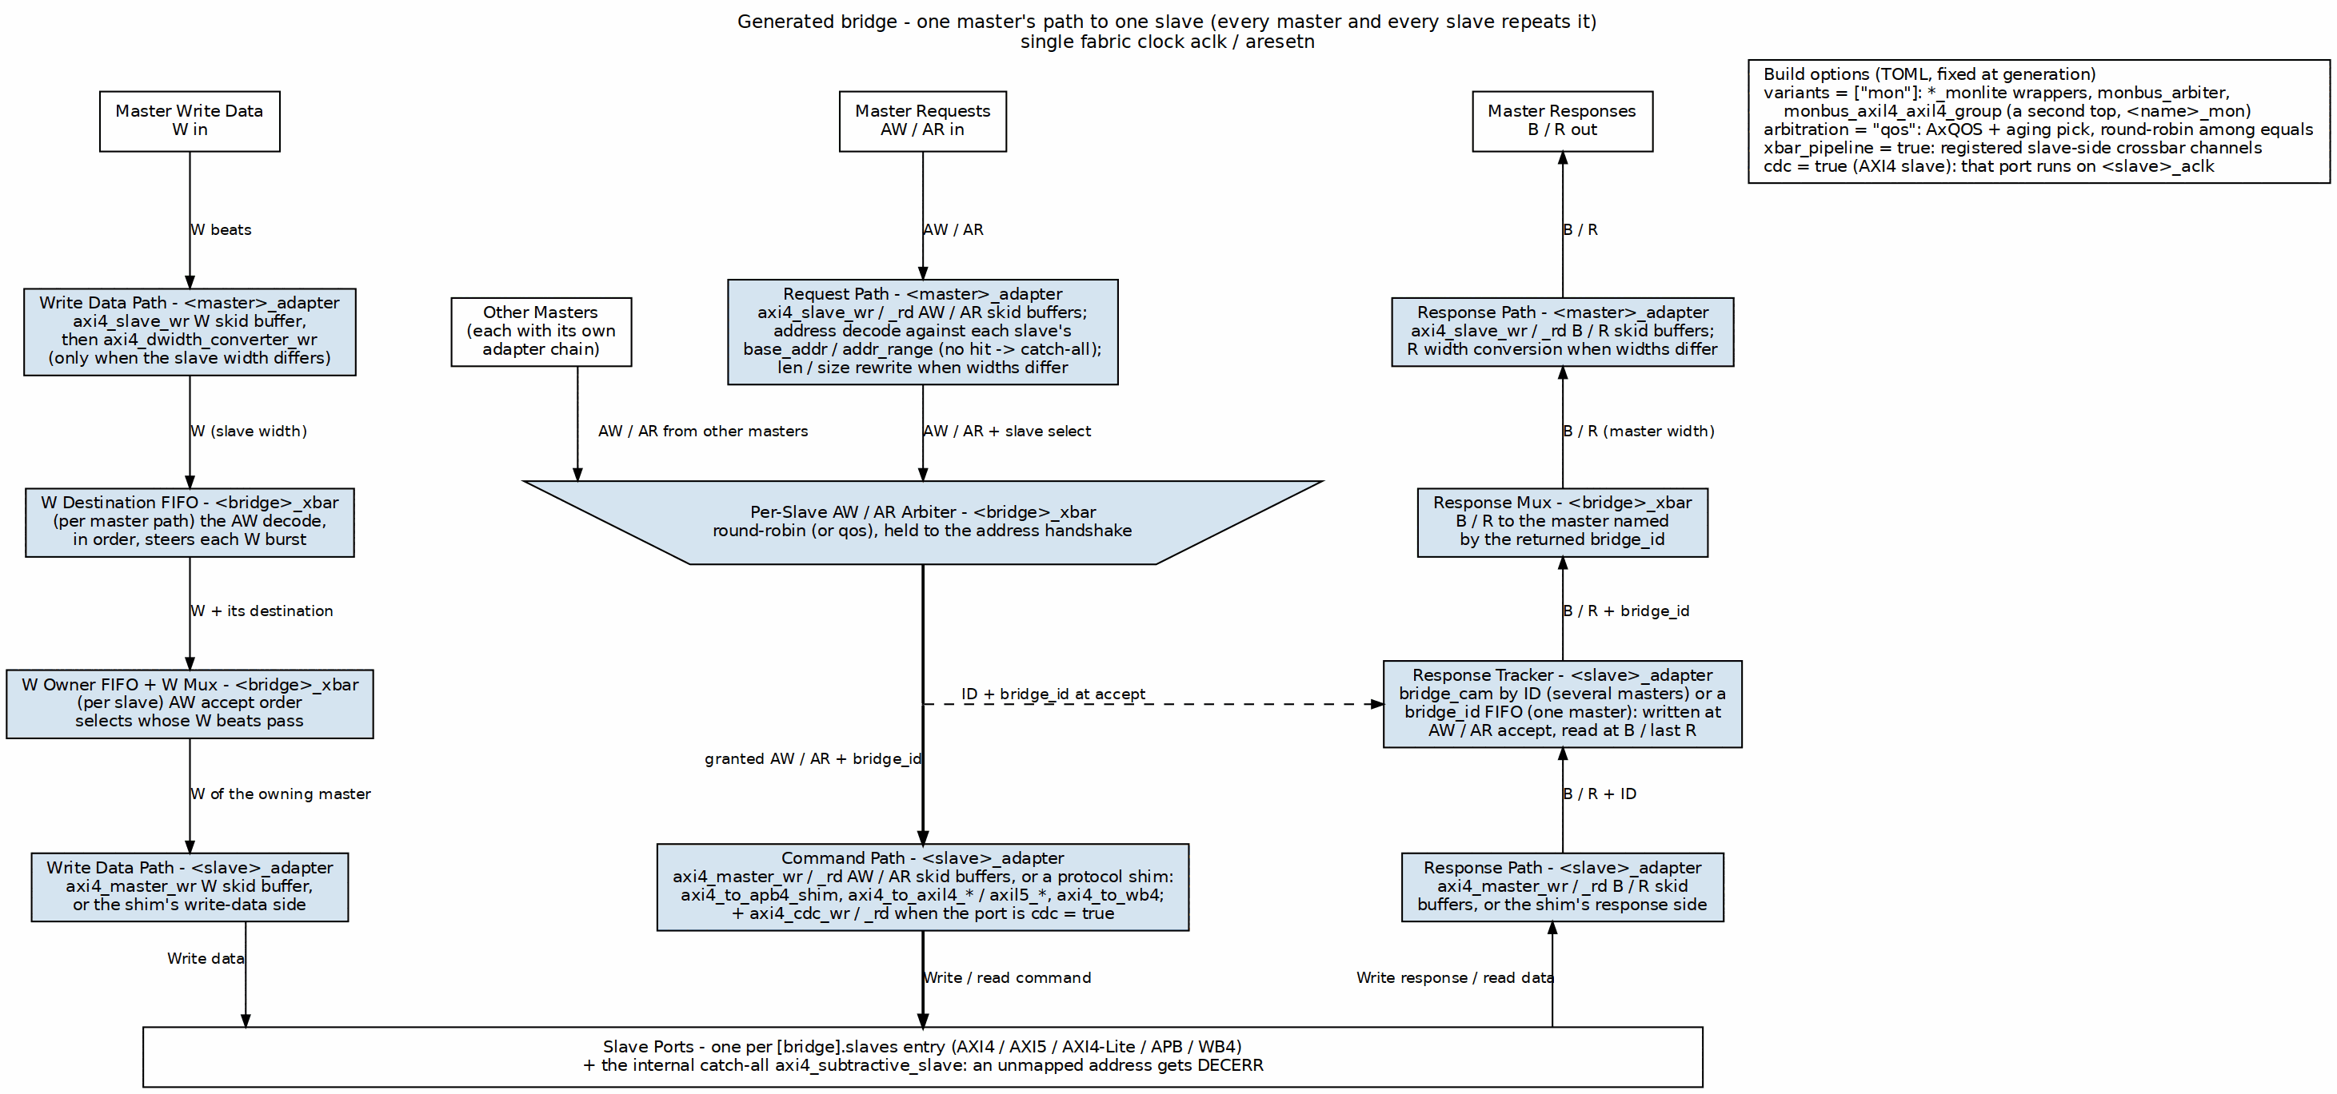
Bridge Block Diagram
One master’s path through the generated bridge to one slave; every master and every slave repeats it. Write data drops down the left lane, requests take the center through the per-slave arbiter (the trapezium, where every master’s AW / AR contend), and B / R responses climb the right lane back to the master named by the returned bridge_id. The response tracker in the slave adapter is written at AW / AR accept (dashed) and read when the response returns.

9.2 Functional Blocks

9.2.1 Master Adapter
One per master (<master>_adapter), receives transactions from the upstream master:
- Skid buffers - axi4_slave_wr / axi4_slave_rd register every channel at the port
- Address decode - a one-hot slave select from each slave’s base_addr / addr_range; no hit selects the catch-all
- Width conversion - axi4_dwidth_converter_wr / _rd, one path per distinct slave width, only where the widths differ
- Fabric ID - the AXI ID is prefixed with the master’s BRIDGE_ID ({BRIDGE_ID, id}), so a slave port’s ID is wider than a master port’s
- Clock crossing - axi4_cdc_wr / _rd ahead of the skid buffers when the master port is cdc = true (GitHub #119 L2)

9.2.2 Crossbar Core
Central switching fabric (<bridge>_xbar):
- 5-channel routing - Independent AW, W, B, AR, R paths
- Arbitration - one AW and one AR arbiter per slave, round-robin (or arbitration = "qos"), grant held until the address handshake
- W steering - a W destination FIFO per master path and a W owner FIFO per slave keep each W burst with its AW
- Response muxes - B and R return to the master named by the bridge_id the slave adapter hands back

9.2.3 Slave Adapter
One per slave (<slave>_adapter), delivers transactions to the downstream slave:
- Response tracking - bridge_cam keyed by AXI ID when several masters share the slave, or an in-order bridge_id FIFO when one master does; written at AW / AR accept, read at B / last R
- Skid buffers or protocol conversion - axi4_master_wr / _rd, or axi4_to_apb4_shim, axi4_to_axil4_* / axi4_to_axil5_*, axi4_to_wb4
- Clock crossing - axi4_cdc_wr / _rd when the slave port is cdc = true

9.3 Data Flow

9.3.1 Figure 3.2: Write Path
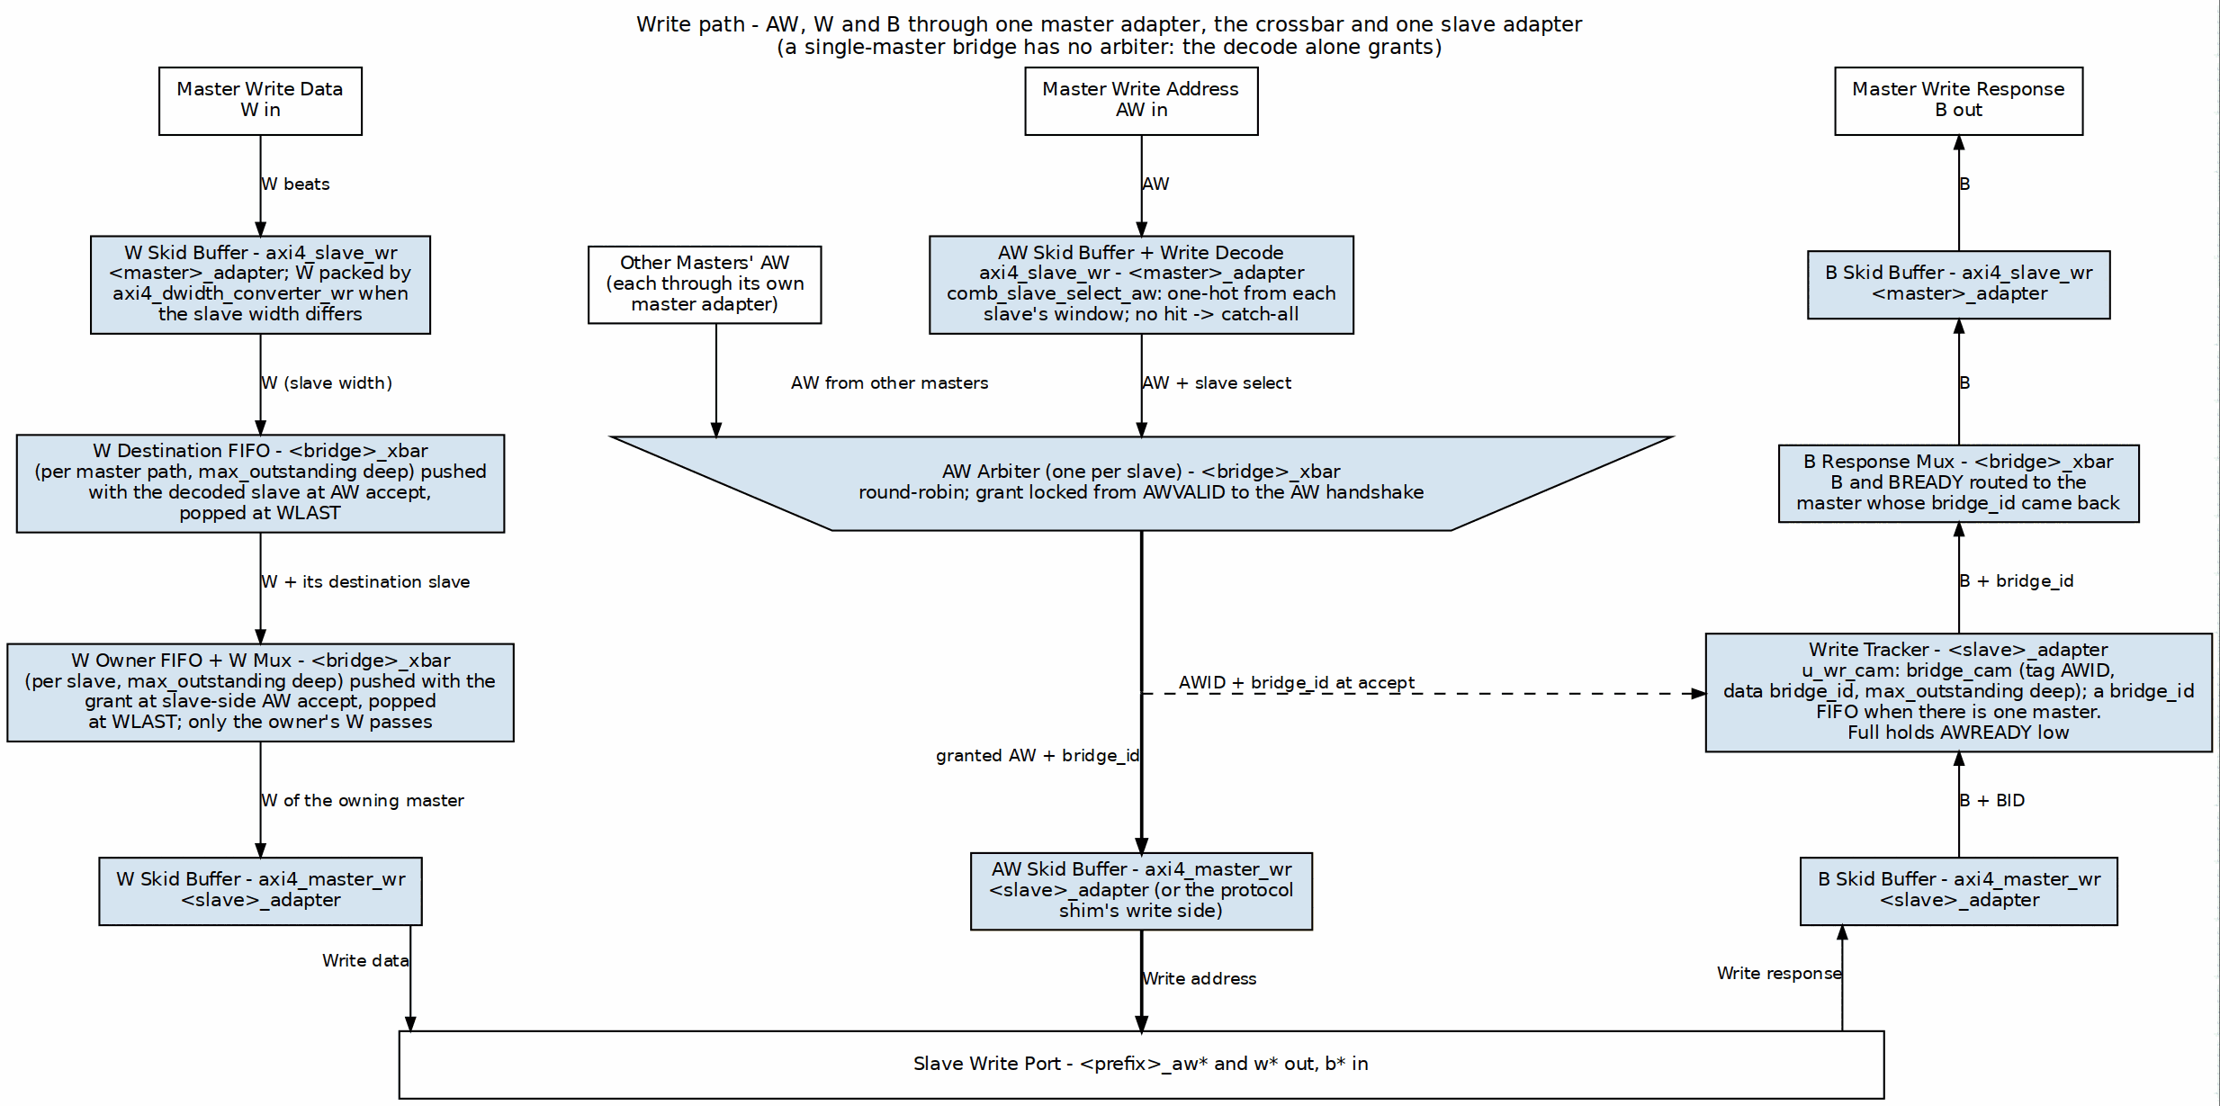
Write Path Flow

9.3.2 Figure 3.3: Read Path
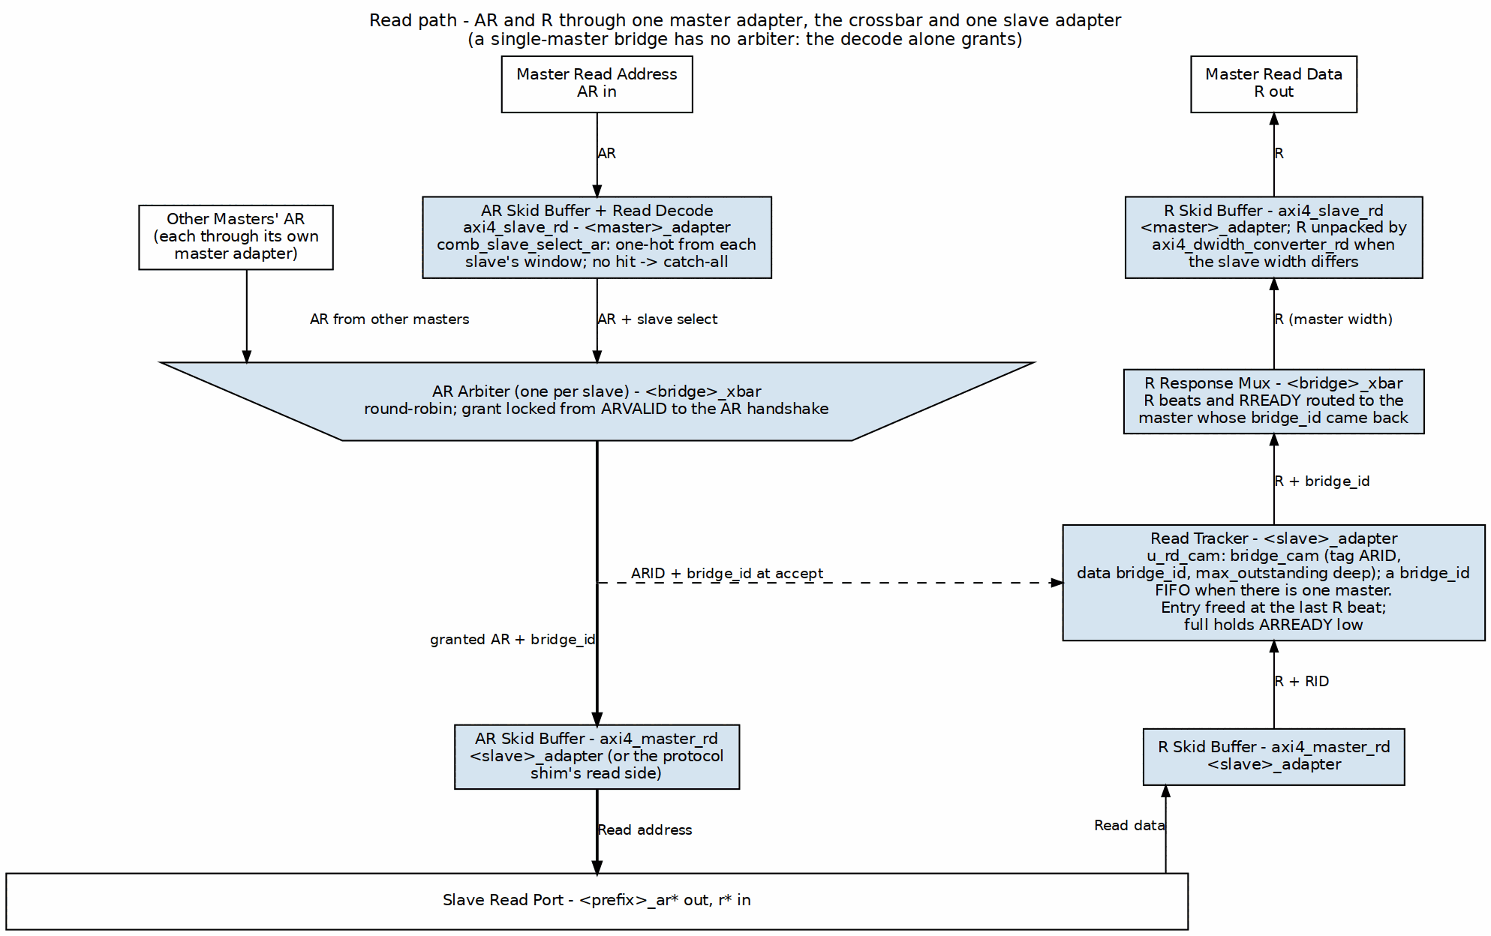
Read Path Flow

9.4 Scalability

9.4.1 Topology Parameters
Topology Parameter Scaling
Parameter | Range | Impact
NUM_MASTERS | 1-32 | Linear MUX growth
NUM_SLAVES | 1-256 | Linear decoder growth
DATA_WIDTH | 32-512 | Linear data path growth
ID_WIDTH | 1-16 | Scales the ID wires (slave side carries {BRIDGE_ID, id}) and the tracker CAM tags

9.4.2 Resource Scaling
- Logic: O(M x N) for crossbar core
- Routing: O(M + N) for address/response paths
- Memory: O(M x outstanding) for ID tracking

9.5 References
- Dally & Towles, Principles and Practices of Interconnection Networks, Morgan Kaufmann 2004 — per-slave arbiters on AW and AR as the degenerate case of a separable allocator (ch18 §19.3), and skid buffers as buffered flow control (ch12). (Reference archive)
- Roy, Advanced Digital System Design, Springer 2023 — AXI permits W to trail AW independently; the W-owner FIFO records the AW grant so the data path follows the address decision (§18.2.3). (Reference archive)
- Duato/Yalamanchili/Lionel, Interconnection Networks, Morgan Kaufmann 2003 — deterministic routing preserves order only along a single path; safe out-of-order completion requires explicit ID-keyed tracking such as the CAM mode Bridge keeps available (ch3/4). (Reference archive)

RTL Design Sherpa · Learning Hardware Design Through Practice GitHub · Documentation Index · MIT License

10 Data Flow

10.1 Transaction Flow Overview

10.1.1 Write Transaction Flow
- Master issues AW - Address and control information
- Bridge decodes address - Determines target slave
- Arbitration - Grants access if multiple masters contend
- AW forwarded to slave - ID unchanged; the originating master is pushed onto the slave adapter’s bridge_id FIFO
- Master sends W data - Following the granted AW
- W forwarded to slave - Using same grant
- Slave returns B response - with the master’s own ID; the FIFO head selects the destination
- Bridge routes B to master - Using ID to find originator

10.1.2 Read Transaction Flow
- Master issues AR - Address and control information
- Bridge decodes address - Determines target slave
- Arbitration - Grants access if multiple masters contend
- AR forwarded to slave - ID unchanged; master recorded in the read bridge_id FIFO
- Slave returns R data - Potentially multiple beats
- Bridge routes R to master - Using ID to find originator

10.2 Channel Independence

10.2.1 AXI4 Channel Separation
Each AXI4 channel operates independently:
AXI4 Channel Summary
Channel | Direction | Contents | Arbitration
AW | Master to Slave | Write address | Per-slave
W | Master to Slave | Write data | Follows AW grant
B | Slave to Master | Write response | ID-based routing
AR | Master to Slave | Read address | Per-slave
R | Slave to Master | Read data | ID-based routing

10.2.2 Parallel Operation
- Read and write transactions can proceed simultaneously
- Different masters can access different slaves in parallel
- Same slave serializes access via arbitration

10.3 Bridge ID and ID Widening

10.3.1 Bridge ID (BID) Concept
Master ID: [MASTER_ID_WIDTH-1:0]
Bridge ID (master index): BRIDGE_ID_WIDTH = clog2(NUM_MASTERS)
AXI ID on a slave port: {BRIDGE_ID, master ID}, XBAR_ID_WIDTH bits

10.3.2 IDs are widened inside the fabric
With more than one master, each master adapter prepends its index to every request ID (bridge TASK-005), so two masters can never alias an ID at a slave. In bridge_2x2_rw:
input logic [3:0] cpu_m_axi_awid // master side: 4 bits
output logic [4:0] ddr_s_axi_awid // slave side: {BRIDGE_ID, id} = 5 bits
The slave-side width is the widest master’s id_width plus $clog2(NUM_MASTERS) bits (XBAR_ID_WIDTH in <bridge>_pkg.sv); a slave declared narrower is rejected by the config validator. A single-master bridge prepends nothing. On B and R the master adapter returns only the low master-ID bits, so a master always sees its own ID.

10.4 Response Routing
The prefix bits are not decoded to route a response. Each slave adapter also receives the granted master’s index as a sideband (bridge_id), stores it at the address handshake, and returns it with the response (bid_bridge_id / rid_bridge_id); the crossbar’s B and R muxes select on that. Which store a slave gets is fixed at generation:
Response Routing
Slave | Tracker | Order the slave may complete in
AXI4 / AXI5 slave, more than one master | bridge_cam (u_wr_cam / u_rd_cam), tag = AXI ID, data = bridge_id, max_outstanding deep (default 16) | any order across IDs
any slave with enable_ooo = true | bridge_cam | any order across IDs
single-master bridge, apb / axil / wb shim slaves, internal subtractive slave | in-order bridge_id FIFO, max_outstanding deep (default 16) | request order across all IDs
// CAM form (multi-master AXI4 slave)
bridge_cam #(.TAG_WIDTH(ID_WIDTH), .DATA_WIDTH(BRIDGE_ID_WIDTH),
.DEPTH(16), .ALLOW_DUPLICATES(1), // DEPTH: the slave's max_outstanding
.PIPELINE_ALLOC(1), .PIPELINE_FREE(1)) u_wr_cam ( // registered insert / free (MAS 4.1)
.allocate_tag (xbar_ddr_axi_awid), .allocate_data (xbar_bridge_id_aw),
.deallocate_tag(xbar_ddr_axi_bid), .deallocate_data(bid_bridge_id), ...);
// FIFO form
wr_fifo[wr_ptr[...]] <= xbar_bridge_id_aw; // push on AW accept
assign bid_bridge_id = wr_fifo[rd_ptr[...]]; // route by FIFO head

10.4.1 B Channel (Write Response)
- Slave issues B carrying the fabric ID it was sent
- The slave adapter looks the BID up in its CAM (or pops its FIFO)
- The returned bridge_id selects the master
- The master adapter strips the prefix and forwards B

10.4.2 R Channel (Read Data)
- Slave issues R carrying the fabric ID
- The slave adapter’s read tracker names the master; the entry is freed on RLAST
- The master adapter strips the prefix
Either tracker holds 16 transactions; when it is full the slave’s AWREADY / ARREADY toward the crossbar drops (bridge BUG-009).

10.4.3 The requirement the FIFO form creates
A FIFO-tracked slave is routed by position, so it must return B/R in request order across ALL IDs. Those slaves are in order by construction (the protocol shims and the subtractive slave) or have a single master; a simulation-only check flags a violation (bridge BUG-008, was BRIDGE-010). A multi-master AXI4/AXI5 slave has no such requirement: the CAM routes by ID.

10.5 Ordering: what the fabric actually guarantees
Per-ID ordering is the slave’s AXI obligation; across IDs a CAM-tracked slave may complete in any order. The fabric adds one structural rule:
Per master – per-ID targets. A master may have transactions in flight at several slaves at once. The master adapter keeps a small table per ID ([bridge].id_track_bits, default 4: 16 entries indexed by the ID’s low bits) and aw_gate_ok/ar_gate_ok hold a new address phase only when its ID is already in flight to a DIFFERENT slave – the AXI same-ID ordering rule, enforced where it can be, before the request leaves. Responses from different slaves come back in whatever order the slaves produce them: the crossbar arbitrates among the slaves on each master width path, and the adapter among its paths. A new AW also waits while W is still owed to a different slave: W carries no ID and follows AW order, so two masters each owing W to two slaves could otherwise wait on each other at the slaves’ W ports. Read-return-atomic and trace-echo ports work the same way (their per-request state is held per ID too, MAS 2.1; GitHub #119 L1b). The rule was lifted 2026-10-15 (limitation fixed: GitHub #119 L1); before that every master held one target slave at a time.
Per FIFO-tracked slave – responses must come back in order. See “The requirement the FIFO form creates” above.
Worked example: master 0 issues a read to a slow slave 0 with ID 1, then a read to slave 1 with ID 2. The slave 1 response returns first. With ID 2 changed to ID 1, the second read is held at the master adapter until the first returns. test_bridge_2x2_rw_multitarget measures both cases.

10.6 References
- Dally & Towles, Principles and Practices of Interconnection Networks, Morgan Kaufmann 2004 — per-slave arbiters as a separable allocator degenerated to one resource per channel (ch18 §19.3), and skid buffers as buffered flow control (ch12). (Reference archive)
- Roy, Advanced Digital System Design, Springer 2023 — AXI’s lack of a strict timing relationship between AW and W, and the use of the stored transaction ID to correlate B back to AW (§18.2.3). (Reference archive)
- Duato/Yalamanchili/Lionel, Interconnection Networks, Morgan Kaufmann 2003 — deterministic routing preserves order only on a single path; out-of-order responses across IDs need explicit ID-keyed tables such as Bridge’s CAM mode (ch3/4). (Reference archive)

RTL Design Sherpa · Learning Hardware Design Through Practice GitHub · Documentation Index · MIT License

11 Protocol Support

11.1 Supported Protocols

11.1.1 AXI4 Full
Complete AMBA AXI4 protocol support:
- 5 channels: AW, W, B, AR, R
- Burst transactions: FIXED, INCR, WRAP
- Transaction IDs: Configurable width
- Out-of-order: across IDs at burst granularity for a CAM-tracked slave (multi-master AXI4/AXI5, or enable_ooo); FIFO-tracked slaves return in request order (bridge BUG-008, was BRIDGE-010). R beats of different IDs never interleave (HAS 4.1)
- Data widths: 32, 64, 128, 256, 512 bits

11.1.2 AXI4-Lite
Simplified AXI4 for register access:
- 5 channels: Same as AXI4
- Single-beat only: AWLEN/ARLEN = 0
- No IDs: Transaction ordering by channel
- Fixed width: Typically 32 or 64 bits

11.1.3 AXI3
Legacy AMBA AXI3 protocol support, added as a boundary conversion so the internal crossbar remains AXI4:
- 5 channels: AW, W, B, AR, R, with WID present on write data
- Burst length: 1–16 beats on the boundary; longer AXI4 bursts are chopped by the boundary converter
- Per-port data width: Same width as the paired AXI4 side; width adaptation happens inside the bridge behind the converter when necessary
- Lock mapping and interleaving constraints: set by the converter, not the crossbar — see HAS 6.5 AXI3 Integration

11.1.4 APB (Advanced Peripheral Bus)
Low-power peripheral protocol:
- Single channel: Combined address and data
- Simple handshake: PSEL, PENABLE, PREADY
- No bursts: Single transfer per transaction
- Low overhead: Minimal logic for slow peripherals

11.2 Protocol Conversion Matrix
Protocol Conversion Matrix
Master | Slave | Conversion Type | Notes
AXI4 | AXI4 | Direct | Width conversion if needed
AXI4 | AXI4-Lite | Downgrade | Burst split to single beats
AXI4 | APB | Full convert | Channel and timing conversion
AXI4-Lite | AXI4 | Upgrade | Single-beat pass-through
AXI4-Lite | AXI4-Lite | Direct | Width conversion if needed
AXI4-Lite | APB | Convert | Simplified conversion
AXI5-Lite | any | Upgrade | As AXI4-Lite plus the AXI5-Lite ID; user rides the fabric, TRACE/POISON terminate at the boundary (no LOCK/LOOP/MPAM/MECID/NSAID on AXI5-Lite, IHI 0022L B2.1.5)
APB / APB5 | any | Full convert | apb{4,5}_to_axi4 front end, then as AXI4-Lite
any | Wishbone B4 | Full convert | axi4_to_wb4: one transfer per beat, in-order termination
Wishbone B4 | any | Full convert | wb4_to_axi4 front end, then as AXI4-Lite
AXI4 | AXI3 | Protocol convert | axi4_to_axi3 slave boundary; same data width only
AXI3 | AXI4 | Protocol convert | axi3_to_axi4 master boundary; same data width only

11.3 Automatic Conversion Shims at Slave Boundary
When a slave port’s TOML entry names a protocol other than native AXI4 (e.g., protocol = "axi3", protocol = "axil" or protocol = "apb"), the generator emits the conversion shims between the crossbar core and that slave port. This happens once, at generation time; there is nothing to configure at runtime.
Supported Slave Protocols – these are the exact TOML values the generator accepts (config_validator.valid_protocols); anything else is a generation error, so spelling matters:
Slave-port protocol values
protocol | Meaning | Shim emitted at the slave boundary
axi4 | Native AXI4 | none
axi3 | AMBA AXI3 | axi4_to_axi3
axi5 | AXI5, interop mode | axi5_master_{wr,rd} boundary wrappers
axil | AXI4-Lite | axi4_to_axil4_{rd,wr}
axil5 | AXI5-Lite | axi4_to_axil5_{rd,wr}
apb | APB3/APB4 | axi4_to_apb4_shim
apb5 | APB5 | axi4_to_apb5_shim
wb4 | Wishbone B4 (pipelined) | axi4_to_wb4
Note the spelling: it is axil, not axi4lite. Earlier revisions of this page used the latter, which the generator rejects.
The shim modules live in projects/components/utility-ip/converters/rtl/; the generator instantiates them into each generated top-level module. The slave port still presents the configured protocol (AXIL or APB) to the outside; inside, the crossbar core is uniformly AXI4.

11.4 Automatic Conversion at the Master Boundary
The same protocol values are legal on a master port (bridge TASK-004, was BRIDGE-014). The bridge presents the requester’s own protocol on the boundary – the AXI4-Lite signal set, the AXI5-Lite set with its sideband, or the APB completer set – and the master adapter converts to the AXI4 the crossbar speaks:
Master-port protocol values
protocol | Boundary presents | Conversion in the master adapter
axi4 | AXI4 | none (timing wrapper only)
axi3 | AXI3 | axi3_to_axi4, then the AXI4 timing wrapper
axi5 | AXI5 (minus REGION, plus enabled features) | axi5_slave_{wr,rd} boundary wrappers
axil | AXI4-Lite | AXI4 extras tied (AxLEN=0, INCR, WLAST=1, ID = placeholder); the wide-slave aligner toward wider slaves
axil5 | AXI5-Lite: ID + optional signals | as axil, but awid/arid -> the AXI4 ID and bid/rid back; user -> the 1-bit USER fields; TRACE/POISON terminated at the top
apb | APB4 completer | apb4_to_axi4, then the AXI4 timing wrapper
apb5 | APB5 completer (+ PAUSER/PWUSER/PWAKEUP in – all requester-driven, IHI 0024E 3.7.2 – PRUSER/PBUSER out) | apb5_to_axi4 (PAUSER[0]/PWUSER[0] -> USER), then the AXI4 timing wrapper
wb4 | Wishbone B4 completer (pipelined) | wb4_to_axi4, then the AXI4 timing wrapper; SLVERR/DECERR terminate ERR
Rules the validator enforces on these ports: AXI4-Lite masters have id_width = 0 (no ID pins exist; the fabric ID is the master index, bridge TASK-005 (was BRIDGE-016)), AXI5-Lite masters id_width >= 1 (AWID/ARID are required on an AXI5-Lite Subordinate, IHI 0022L B2.1.5, GitHub #102 item 3), APB and Wishbone masters have addr_width = 32 (the requester addresses the whole fabric – an APB slave port’s PADDR is a window offset, a master’s is not), and axi5_features on an axil5 port may name only user, the one group with an AXI4 destination (exclusive, loop, mpam, mecid and nsaid are rejected as not existing on AXI5-Lite).

11.5 AXI4 to APB Conversion

11.5.1 Conversion Process

11.5.2 Figure 3.4: AXI4 to APB Conversion Sequence
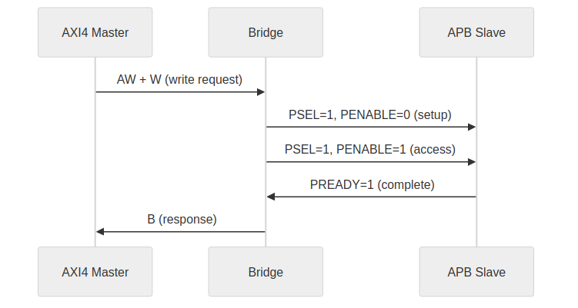
AXI4 to APB Conversion

11.5.3 Burst Handling
- AXI4 bursts split into individual APB transfers
- WSTRB converted to per-byte enables
- B response generated after all beats complete

11.5.4 Timing Considerations
- APB is inherently slower (minimum 2 cycles per transfer)
- Pipeline stalls during APB access
- Consider separate APB crossbar for multiple slow peripherals

11.6 Width Conversion

11.6.1 Upsize (Narrow to Wide)

11.6.2 Figure 3.5: Width Upsize Conversion
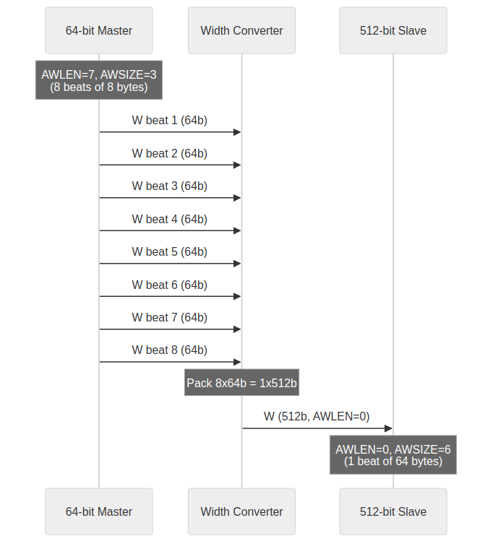
Width Upsize

11.6.3 Downsize (Wide to Narrow)

11.6.4 Figure 3.6: Width Downsize Conversion
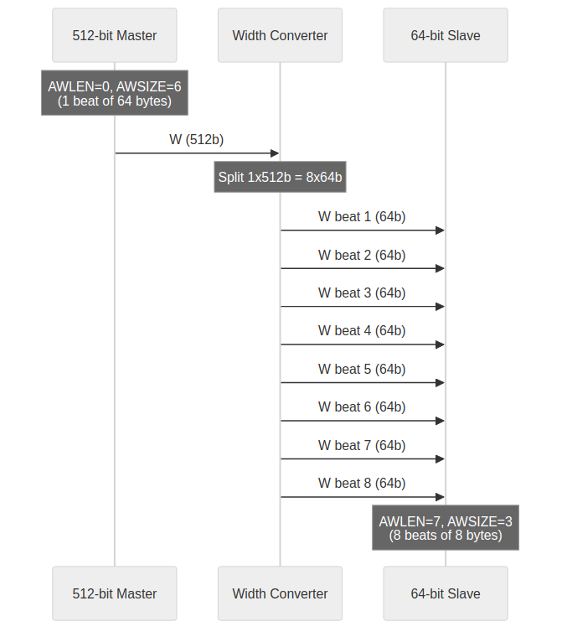
Width Downsize

11.7 Channel-Specific Protocol

11.7.1 Write-Only Masters
Only AW, W, B channels active:
- AR permanently deasserted
- R channel ignored (no routing logic)
- Reduced signal count and logic

11.7.2 Read-Only Masters
Only AR, R channels active:
- AW, W, B channels ignored
- No write arbitration for this master
- Reduced signal count and logic

11.8 ACE and Coherency — Explicitly Out of Scope
The bridge implements AMBA 5 AXI5 interop and sideband features, but it is not a coherence interconnect: there are no ACE snoop channels (AC/CR/CD), no ACVALID/ACREADY/CRVALID/CRREADY/CDVALID/CDREADY signals anywhere in the generated RTL, and cache-coherent masters are not supported. Coherent systems belong to the cache-ip domain (see the amber/jet/onxy work). This mirrors PRD.md: “No ACE protocol extensions (cache coherency).”

11.9 References
- Eschemann, The FPGA Programming Handbook, Packt 2023 — educational secondary source for AXI4 full and AXI4-Lite channel structure and handshake rules (ch8 §8.3). (Reference archive)
- Roy, Advanced Digital System Design, Springer 2023 — secondary source for AXI channel structure and headline protocol features (§18.2.2, §18.2.2.1). (Reference archive)
- Maaref, Architecting and Building High-Speed SoCs, Packt 2022 — AMBA-suite context and the evolution of AXI4 features such as QoS/Region (ch3 §4.2). (Reference archive)
- ARM, AMBA AXI and ACE Protocol Specification, ARM IHI 0022E — the authoritative AXI4 protocol definition. (Reference archive)
- ARM, AMBA 3 AXI Protocol Specification, ARM IHI 0022 — the AXI3 protocol authority; 4-bit AxLEN, 2-bit AxLOCK, write-data WID, absence of QoS/REGION. (Reference archive)

RTL Design Sherpa · Learning Hardware Design Through Practice GitHub · Documentation Index · MIT License

12 AXI4 Interface Overview

12.1 Interface Organization

12.1.1 Master-Side Interfaces
Bridge presents slave interfaces to upstream masters. Each master port includes:
Master-Side Interface Channels
Channel | Signals | Direction (to Bridge)
AW | AWVALID, AWREADY, AWADDR, AWID, AWLEN, AWSIZE, AWBURST, … | Input
W | WVALID, WREADY, WDATA, WSTRB, WLAST | Input
B | BVALID, BREADY, BID, BRESP | Output
AR | ARVALID, ARREADY, ARADDR, ARID, ARLEN, ARSIZE, ARBURST, … | Input
R | RVALID, RREADY, RDATA, RID, RRESP, RLAST | Output

12.1.2 Slave-Side Interfaces
Bridge presents master interfaces to downstream slaves. Each slave port includes:
Slave-Side Interface Channels
Channel | Signals | Direction (from Bridge)
AW | AWVALID, AWREADY, AWADDR, AWID, AWLEN, AWSIZE, AWBURST, … | Output
W | WVALID, WREADY, WDATA, WSTRB, WLAST | Output
B | BVALID, BREADY, BID, BRESP | Input
AR | ARVALID, ARREADY, ARADDR, ARID, ARLEN, ARSIZE, ARBURST, … | Output
R | RVALID, RREADY, RDATA, RID, RRESP, RLAST | Input

12.2 Signal Naming Convention

12.2.1 Custom Prefixes
Each port uses a custom prefix for signal naming:
// Example: Master 0 with prefix "cpu_m_axi_"
input logic [31:0] cpu_m_axi_awaddr,
input logic [3:0] cpu_m_axi_awid,
input logic cpu_m_axi_awvalid,
output logic cpu_m_axi_awready,
// ... remaining AW signals
// Example: Slave 0 with prefix "ddr_s_axi_"
output logic [31:0] ddr_s_axi_awaddr,
output logic [4:0] ddr_s_axi_awid, // {BRIDGE_ID, id}: master width + clog2(NUM_MASTERS)
output logic ddr_s_axi_awvalid,
input logic ddr_s_axi_awready,

12.2.2 ID Width Extension
With more than one master, slave-side IDs are WIDER than master-side:
Master ID Width: id_width of the master port (widest master = MASTER_ID_WIDTH)
Bridge ID Width: clog2(NUM_MASTERS) (ID_PREFIX_WIDTH; 0 for one master)
Slave ID Width: MASTER_ID_WIDTH + ID_PREFIX_WIDTH (XBAR_ID_WIDTH)
bridge_2x2_rw: cpu_m_axi_awid [3:0] -> ddr_s_axi_awid [4:0]
Each master adapter sends {BRIDGE_ID, id} into the fabric and strips the prefix from B and R. A slave port’s declared id_width must be at least XBAR_ID_WIDTH; the validator rejects a narrower AXI3/AXI4/AXI5 slave. Responses are routed by the bridge_id sideband the slave adapter stores: a bridge_cam looked up by BID/RID for a multi-master AXI4/AXI5 slave (any completion order), or an in-order FIFO for single-master bridges and shim slaves (request order required, bridge BUG-008). See HAS 3.2.
Either way a slave returns each R burst contiguously: beats of different IDs must not interleave. The per-master-path R arbiters hold through RLAST, and the read width converters rely on it (they are built with R_INTERLEAVE = 0, without a reassembly pool, GitHub #119); the converter flags an interleaved beat in simulation.

12.3 Channel-Specific Interfaces

12.3.1 Write-Only Master (wr)
Only AW, W, B channels generated:
// Write Address Channel
input logic [ADDR_WIDTH-1:0] descr_m_axi_awaddr,
input logic [ID_WIDTH-1:0] descr_m_axi_awid,
// ... full AW channel
// Write Data Channel
input logic [DATA_WIDTH-1:0] descr_m_axi_wdata,
input logic [STRB_WIDTH-1:0] descr_m_axi_wstrb,
// ... full W channel
// Write Response Channel
output logic [ID_WIDTH-1:0] descr_m_axi_bid,
output logic [1:0] descr_m_axi_bresp,
// ... full B channel
// NO AR or R channels

12.3.2 Read-Only Master (rd)
Only AR, R channels generated:
// Read Address Channel
input logic [ADDR_WIDTH-1:0] src_m_axi_araddr,
input logic [ID_WIDTH-1:0] src_m_axi_arid,
// ... full AR channel
// Read Data Channel
output logic [DATA_WIDTH-1:0] src_m_axi_rdata,
output logic [ID_WIDTH-1:0] src_m_axi_rid,
// ... full R channel
// NO AW, W, or B channels

12.4 Monitor Bus Output (when variants includes mon)
When monitor collection is enabled (via the bridge TOML variants list including "mon"), each bridge instance exposes a unified monitor interface at the bridge top level:
Monitor Bus Output
Signal | Type | Width | Direction | Description
s_mon_axil_* | AXIL Slave | 32-bit addr, 64-bit data | Input | Monitor packet read interface for CPU consumption
m_axil_mon_* | AXIL Master | 32-bit addr, 64-bit data | Output | Monitor packet write interface for bulk trace capture
stream_irq | logic | 1-bit | Output | Interrupt signal (asserted when error FIFO has records)
Per-port collection comes from the axi4_master_{rd,wr}_monlite and axi4_slave_{rd,wr}_monlite wrappers (axi_monitor_lite; the full _mon wrappers are no longer used in generated bridges, 2026-09-26).
Packet Format: the canonical 128-bit packet layout and field definitions live in docs/markdown/rtl-amba/includes/ocelus_package_spec.md — see that reference for bit-field descriptions, protocol-type enumerations, and packet-type codes.

12.5 Handshake Protocol

12.5.1 Valid/Ready Handshake
All channels use AXI4 valid/ready handshake:
Transfer occurs when: VALID && READY

12.5.2 Backpressure
- Bridge asserts READY when able to accept
- Masters must hold VALID until READY
- Bridge does not drop transactions

12.6 Burst Support

12.6.1 Supported Burst Types
Supported Burst Types
AWBURST/ARBURST | Type | Description
2’b00 | FIXED | Same address each beat
2’b01 | INCR | Incrementing address
2’b10 | WRAP | Wrapping at boundary
2’b11 | Reserved | Not used

12.6.2 Burst Length
- AWLEN/ARLEN: 8-bit field
- Length = AXLEN + 1 (1 to 256 beats)
- Burst does not cross 4KB boundary (AXI4 rule)

RTL Design Sherpa · Learning Hardware Design Through Practice GitHub · Documentation Index · MIT License

13 APB Interface

13.1 Overview
APB is where the slow things live: UARTs, GPIO, configuration registers. This page covers the bridge’s APB surface — the signal set, the port-naming convention, transaction timing, and what the AXI4-to-APB conversion actually does.

13.2 Ports

13.2.1 Signal Definition
APB Signal Definitions
Signal | Width | Direction | Description
PSEL | 1 | Output | Slave select
PENABLE | 1 | Output | Transaction phase
PADDR | ADDR_WIDTH | Output | Address
PWRITE | 1 | Output | Write enable
PWDATA | DATA_WIDTH | Output | Write data
PSTRB | DATA_WIDTH/8 | Output | Byte strobes
PPROT | 3 | Output | Protection
PRDATA | DATA_WIDTH | Input | Read data
PSLVERR | 1 | Input | Slave error
PREADY | 1 | Input | Slave ready

13.2.2 Signal Naming
APB slave ports use custom prefixes:
// Example: APB slave with prefix "uart_apb_"
output logic uart_apb_psel,
output logic uart_apb_penable,
output logic [31:0] uart_apb_paddr,
output logic uart_apb_pwrite,
output logic [31:0] uart_apb_pwdata,
output logic [3:0] uart_apb_pstrb,
output logic [2:0] uart_apb_pprot,
input logic [31:0] uart_apb_prdata,
input logic uart_apb_pslverr,
input logic uart_apb_pready

13.3 Functional Description

13.3.1 AXI4 to APB Conversion
When an AXI4 master accesses an APB slave, the bridge:
- Burst splitting - AXI4 bursts become multiple APB transfers
- Channel mapping - AW+W combined into PADDR+PWDATA
- Response generation - APB PSLVERR maps to AXI4 BRESP/RRESP
- Timing adaptation - Insert wait states as needed

13.3.2 Burst Handling
AXI4 to APB Burst Conversion
AXI4 AWLEN | APB Transfers
0 (1 beat) | 1 transfer
1 (2 beats) | 2 transfers
N (N+1 beats) | N+1 transfers

13.3.3 Error Mapping
APB to AXI4 Error Mapping
APB PSLVERR | AXI4 BRESP/RRESP
0 (OK) | 2’b00 (OKAY)
1 (Error) | 2’b10 (SLVERR)

13.4 Timing
Every APB transfer pays for a setup phase plus an access phase, so the floor is two cycles per transfer. There is no pipelining — transfers run sequentially — and no bursts: each beat requires the full handshake.

13.5 Waveforms

13.5.1 Write Transaction

13.5.1.1 Figure 4.1: APB Write Transfer (Zero Wait States)
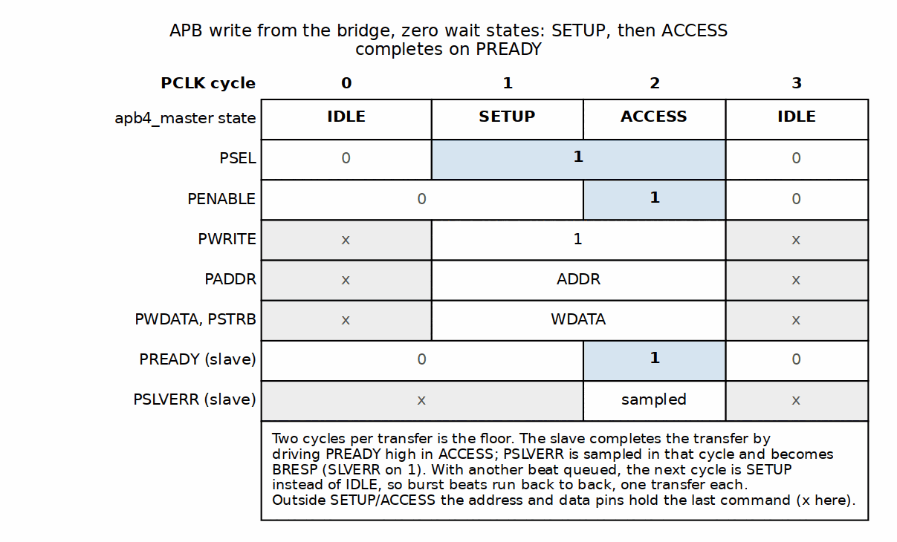
APB Write Transfer (Zero Wait States)

13.5.2 Read Transaction

13.5.2.1 Figure 4.2: APB Read Transfer (One Wait State)
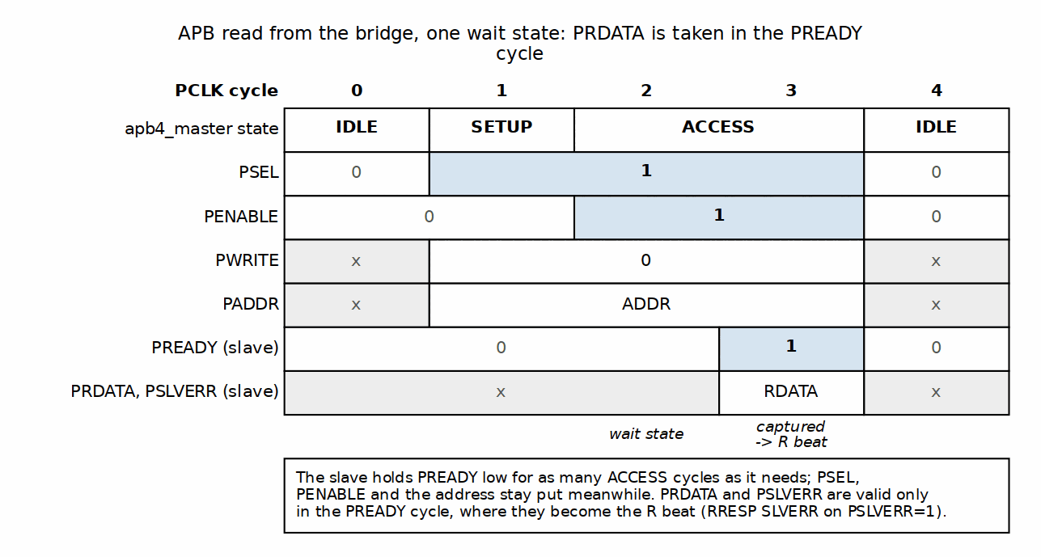
APB Read Transfer (One Wait State)

13.6 APB Requester Ports
Since bridge TASK-004 (was BRIDGE-014) an APB port can also be a master: protocol = "apb" or "apb5" in [[bridge.masters]]. The signal set is the same ten (fifteen for APB5) with the directions of the slave table reversed – the bridge is the completer, so PSEL, PENABLE, PADDR[31:0], PWRITE, PWDATA, PSTRB, PPROT are inputs and PREADY, PRDATA, PSLVERR outputs. PADDR is the full 32-bit fabric address (the validator insists on addr_width = 32); each transfer becomes one single-beat AXI4 transaction through apb4_to_axi4 / apb5_to_axi4, and both SLVERR and DECERR come back as PSLVERR. The requester is one-outstanding by nature of APB, so throughput is one transfer per fabric round trip.

13.7 Design Notes
- Use APB only for slow peripherals (UART, GPIO, config registers)
- Group APB slaves behind dedicated sub-crossbar
- Use AXI4/AXI4-Lite for higher-bandwidth slaves

RTL Design Sherpa · Learning Hardware Design Through Practice GitHub · Documentation Index · MIT License

14 Clock and Reset

14.1 Overview
One clock, one reset. The AXI fabric runs in a single synchronous domain — the exception is an AXI4 port, master or slave, declared cdc = true, which runs on its own clock and gets its own discussion below — and the reset is asynchronous, active-low. This page covers what that means for your clock tree, your reset strategy, and your constraint file.

14.2 Ports

14.2.1 Clock
Clock Requirements
Signal | Description | Requirements
aclk | System clock | All interfaces synchronous
Frequency | Operating frequency | Design-dependent
Duty cycle | Clock duty cycle | 40-60% typical

14.2.2 Reset
Reset Signal
Signal | Description | Polarity
aresetn | Async reset | Active-low

14.3 Functional Description

14.3.1 One Fabric Clock

14.3.1.1 Figure 4.3: Clock Distribution
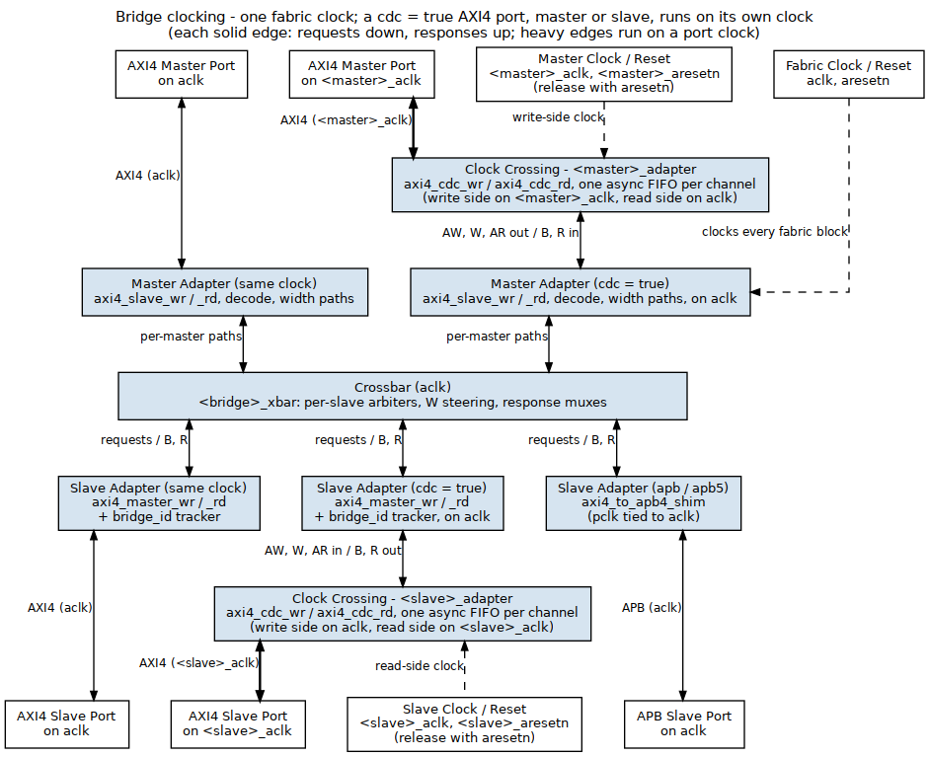
Clock Distribution
The fabric itself runs on aclk. An AXI4 master or slave port may run on its own clock when declared cdc = true (next sections); every other port shares aclk.

14.3.2 Clock Domain Crossing: CDC Slave Ports
The FABRIC is one clock domain (aclk). Since bridge TASK-006 (was BRIDGE-017) a slave port can live in another: cdc = true on an AXI4 slave adds <slave>_aclk / <slave>_aresetn to the bridge top, and the slave adapter carries AW, W and AR to the port and B, R back through axi4_cdc_{wr,rd} – one Gray-pointer async FIFO per channel (rtl/amba/axi4/axi4_cdc.md) – downstream of its timing wrapper, which stays on aclk with its monitor and the bridge-id tracking. Everything upstream of the crossing is unchanged; the port itself runs entirely on its own clock, at one beat per cycle of the slower domain.
CDC slave port clock pins (cdc = true)
Signal | Direction | Description
<slave>_aclk | Input | the CDC slave port’s clock
<slave>_aresetn | Input | its active-low reset; release together with aresetn (a one-sided reset is not safe on the async FIFOs – handbook design/cdc.md)
Limits: protocol = "axi4" (the crossing carries the AXI4 signal set; AXI5 sideband and the APB/AXIL/WB4 shims have no crossing yet – the validator rejects those), and the port keeps latency = "cut_all". Measured on bridge_2x2_rw_cdc (test_bridge_2x2_rw_cdc_ratio) with the slave clock at 3, 10 and 23 ns against a 10 ns fabric: every burst from both masters completes, the port’s beats appear on the slave clock, the sustained rate is set by the slower clock (>= 0.85 beat per cycle of it), and the same-clock port beside it is unaffected.
test_bridge_perf_char characterizes the port at 7 ns and at 13 ns (HAS 5.1, Bandwidth Characterization). Bursts of two beats or more run at the slower side’s full rate: 0.700 of the 7 ns slave’s cycles, which is the fabric’s one beat per 10 ns, and 1.000 of the 13 ns slave’s. The crossing adds about 13 fabric cycles to a round trip, two synchronizer crossings each way, so single-beat traffic needs more in flight to fill the port. One open limit (W9): the address FIFOs queue granted requests between the crossbar’s arbiter and the slave, so round-robin shares at a CDC slave follow each master’s outstanding count once the slave throttles.

14.3.3 Clock Domain Crossing: CDC Master Ports
The same crossing works on the request side (GitHub #119 L2): cdc = true on an AXI4 master adds <master>_aclk / <master>_aresetn to the bridge top, and the master adapter carries AW, W and AR from the port and B, R back to it through axi4_cdc_{wr,rd} AHEAD of its timing wrapper. The crossing’s write side runs on the port clock, its read side on aclk; the timing wrapper, its monitor, the address decode, the per-ID target tracking and the width paths all stay on aclk and see an ordinary same-clock master. A wr or rd port builds only the crossing for its direction. A transaction from a CDC master to a CDC slave crosses twice each way, once at each adapter.
CDC master port clock pins (cdc = true)
Signal | Direction | Description
<master>_aclk | Input | the CDC master port’s clock
<master>_aresetn | Input | its active-low reset; release together with aresetn
The limits are the slave port’s: protocol = "axi4" and latency = "cut_all". An APB, AXI4-Lite, WB4, AXI3 or AXI5 requester on a foreign clock still needs a crossing outside the bridge. Measured on bridge_3x2_rw_mcdc (test_bridge_3x2_rw_mcdc_ratio: CDC masters cpu, rw, and lfsr, rd only, beside the same-clock dma, against the CDC slave ddr and the same-clock sram) with cpu_aclk at 3, 10 and 23 ns and lfsr_aclk 2 ns slower, against a 10 ns fabric:
- every burst completes and every word lands and reads back, including cpu into ddr, which crosses twice each way;
- the ports’ beats appear on their own clocks;
- the rate is set by the slower clock, not the crossing. cpu alone into sram moves 1.000 W beat per aclk cycle when it is the faster side and 0.906 per cpu_aclk cycle when it is the slower; lfsr reads at 1.000 per lfsr_aclk cycle when slower and 0.501 per 5 ns cycle (the 10 ns fabric) when faster. 0.906 is the requester BFM’s own gap between bursts, the same figure a same-clock master gives; behind the async FIFO the fabric takes 1.000;
- the same-clock dma into sram runs at 0.906 alone and 0.906 with cpu’s two-crossing traffic running beside it.
An apb/apb5 slave’s axi4_to_apb4_shim core is built around two async FIFOs and has its own pclk/presetn pins, but the generator ties them to aclk/aresetn (periph_adapter.sv in bridge_2x3_apb_req), and the bridge top has no APB clock port. A generated APB slave port therefore runs on aclk. For every port that is not cdc = true:
- All inputs sampled on aclk rising edge
- All outputs generated on aclk rising edge
- External CDC required if a non-AXI4 port uses a different clock

14.3.4 Reset Behavior

14.3.4.1 Figure 4.4: Reset Timing
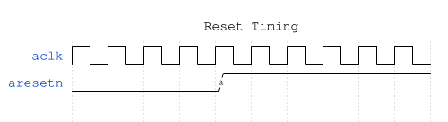
Reset Timing
Reset is active-low: the bridge is in reset whenever aresetn = 0.

14.3.5 Reset Effects
During reset (aresetn = 0):
Reset Effects
Component | State
Arbiters | Cleared (no grants)
bridge_id FIFOs | Pointers cleared (no outstanding)
FIFOs | Emptied
Outputs | Deasserted (VALID = 0)

14.3.6 Outstanding Transactions
Warning: reset discards transactions in flight:
- Master may see timeout (no response)
- Slave may receive partial transaction
- System must ensure quiescence before reset

14.3.7 Reset Release
After reset release (aresetn = 1):
- Bridge accepts new transactions after 1 cycle
- All state machines start in IDLE
- No residual grants or locks

14.4 Timing

14.4.1 Setup and Hold
All inputs must meet setup/hold relative to aclk:
Timing Constraints
Constraint | Typical Value
Setup time | Process-dependent
Hold time | Process-dependent

14.4.2 Clock-to-Output
All outputs appear after aclk rising edge:
Clock-to-Output Delays
Path | Typical Delay
aclk to VALID | 1 cycle (registered)
aclk to READY | 1 cycle (registered)
aclk to DATA | 1 cycle (registered)
READY is registered like the rest, which an earlier revision of this table gave as “Combinational”. Every external port terminates in a gaxi_skid_buffer inside its boundary wrapper – a master port’s awready is axi4_slave_wr.s_axi_awready, wired straight to the skid’s wr_ready, and that is assigned in an ALWAYS_FF_RST block. A master budgeting a combinational ready path against this bridge would be wrong by a register stage.

14.5 Usage Example

14.5.1 Recommended Constraints
# Example SDC constraints
create_clock -period 10 [get_ports aclk] ;# 100 MHz
# Reset is async - synchronize externally
set_false_path -from [get_ports aresetn]

14.6 Design Notes

14.6.1 External CDC Required
For ports that are not cdc = true AXI4 ports, in systems with multiple clock domains:

14.6.1.1 Figure 4.5: Multi-Clock CDC
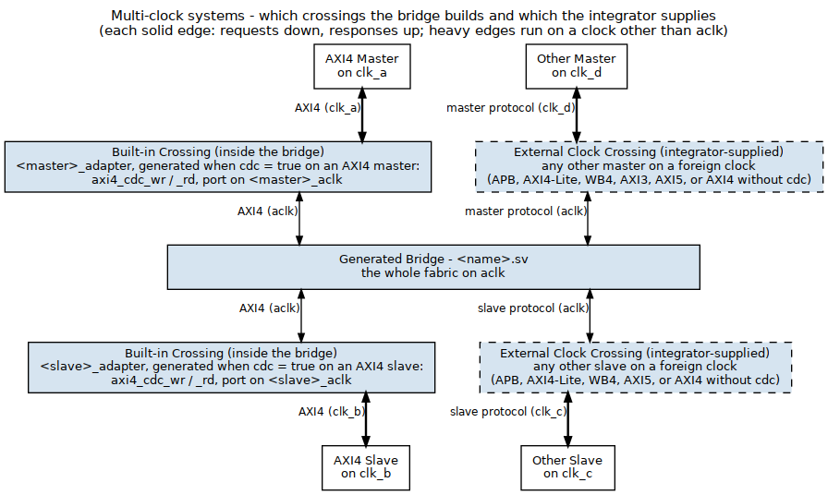
Multi-Clock CDC

14.6.2 CDC Recommendations
- Use AXI4 async FIFO bridges
- Consider AXI4 clock converter IP
- Ensure proper gray-coding for pointers

RTL Design Sherpa · Learning Hardware Design Through Practice GitHub · Documentation Index · MIT License

15 AXI5 and APB5 Interfaces (AMBA5 Support)

15.1 Overview
The bridge is AXI4-shaped internally with every AXI5 feature the library wrappers carry riding alongside in the channel structs — since bridge TASK-007 (was BRIDGE-018) that includes Memory Tagging and read-data chunking, so there is no AXI5 signal an axi5 port can present that the fabric cannot carry natively to another axi5 port. Any master or slave port can be declared AMBA5. This chapter covers the external surfaces; the mechanism lives in the MAS (AMBA5 Boundary and Native Sideband).

15.2 Parameters

15.2.1 Declaring AMBA5 Ports
AMBA5 is declared per port, in the TOML:
[[bridge.masters]]
name = "cpu_wr"
protocol = "axi5"
axi5_features = ["trace", "atomic"] # optional; empty = base AXI5
# ... standard fields unchanged
[[bridge.slaves]]
name = "periph5"
protocol = "apb5" # APB5 peripheral via the apb5 shim
channels = "rw" # APB rules unchanged (rw-only, 32-bit)
[[bridge.masters]]
name = "lite5"
protocol = "axil5" # AXI5-Lite requester (bridge TASK-004, was BRIDGE-014)
id_width = 1 # AWID/ARID: required on an AXI5-Lite Subordinate
axi5_features = ["user"] # the one group with an AXI4 destination
[[bridge.masters]]
name = "apb5m"
protocol = "apb5" # APB5 requester (bridge TASK-004, was BRIDGE-014)
id_width = 0
addr_width = 32 # the requester addresses the whole fabric
channels = "rw"

15.3 Ports

15.3.1 AXI5 Port Surface
An axi5 port exposes the AXI4 signal set minus AW/ARREGION (AXI5 removed REGION) plus the enabled features’ sideband signals. Disabled features’ signals are not exposed at all — the boundary wrapper ties them off internally.
AXI5 Port Surface
Feature | Signals added | Class
nsaid | aw/arnsaid[3:0] | Droppable sideband
trace | aw/artrace, btrace, rtrace | Droppable sideband
mpam | aw/armpam[10:0] | Droppable sideband
mecid | aw/armecid[15:0] | Droppable sideband
unique | aw/aridunq in; bidunq, ridunq out (IHI 0022L A5.2) | Droppable sideband; the response indicators are regenerated at the master port (below)
wakeup | awakeup (one signal for both request channels, present on rd-only, wr-only and rw ports alike) | Not path sideband; see “AWAKEUP” below
poison | wpoison, rpoison | Connectivity-gated
atomic | awatop[5:0] | Connectivity-gated; read-return classes native on rw ports, DECERR on write-only ports
mte | aw/artagop[1:0], wtag, wtagupdate, btagmatch[1:0], rtag (tag buses are 4 bits per 16 bytes of data, wtagupdate one bit per 16 bytes; IHI 0022L A12.2 has no AWTAG, BTAG or RTAGMATCH, and BTAGMATCH encodes Table A12.14: 00 none, 01 separate, 10 fail, 11 pass) | Connectivity-gated; 128-bit ports or wider (bridge TASK-007, was BRIDGE-018)
chunking | archunken, rchunkv, rchunknum[3:0], rchunkstrb (one bit per 128 bits of data) | Droppable sideband; 128-bit ports or wider (bridge TASK-007, was BRIDGE-018)

15.3.2 APB5 Slave Surface
An apb5 slave exposes the APB4 requester surface plus the APB5 sideband, mirroring rtl/amba/apb5/apb5_slave.sv pin-for-pin:
APB5 Slave Surface
Direction | Signals
Requester → completer | APB4 set + PAUSER, PWUSER (driven '0 — nothing upstream sources them) + PWAKEUP (below)
Completer → requester | APB4 set + PRUSER, PBUSER (accepted and terminated)
PWAKEUP is a requester output (IHI 0024E 3.7.2, Table 3-7). The bridge port used to take it as an input, following a library convention that had the direction backwards (GitHub #102 item 7). axi4_to_apb5_shim now drives it from a flop of PSEL: glitch-free, high from the cycle after the Setup phase and held through the PREADY cycle, so a completer that waits for PWAKEUP before PREADY always receives it, and low when no transfer is in progress. 3.7.2 permits assertion during or after PSEL; the recommended one-cycle lead is not available because the command queue that would predict a transfer is inside the shared APB4 conversion core. No *CHK check signals are exposed (the port is Check_Type = False).
The transfer protocol is unchanged from APB4, so the axi4_to_apb5_shim is a sideband wrapper over the APB4 conversion core; APB constraints (rw-only, 32-bit data) apply unchanged.

15.3.3 AXI5-Lite Master Surface
An axil5 master port (bridge TASK-004, was BRIDGE-014) exposes the AXI4-Lite requester set, the AXI5-Lite ID (awid/arid in, bid/rid out, id_width bits – required on an AXI5-Lite Subordinate, IHI 0022L B2.1.5, so id_width must be at least 1), and the whole AXI5-Lite optional set, every group whether or not it is enabled – the same rule as the slave surface, so the boundary keeps one shape. The directions flip relative to the slave table: requester-driven groups are bridge inputs, completer-driven groups bridge outputs.
AXI5-Lite sideband groups at an axil5 master boundary
Group | Signals | Behaviour
ID | awid, arid in; bid, rid out | reach the adapter’s AXI4 face, ride the fabric inside {master index, id} and come back unchanged
FORWARDED (when enabled) | awuser, wuser, aruser (user) | reach the adapter’s AXI4 face and ride the fabric to the slave
TERMINATED inputs | aw/artrace, wpoison; awuser/… when user is off | consumed at the bridge top (a reduction into an _unused wire), never floating
TERMINATED outputs | btrace, rtrace, rpoison; buser/ruser when user is off | driven '0
Response USER | buser, ruser with user on | connected, but read 0: the master adapters tie response-side USER (see the PRD)

15.3.4 APB5 Master Surface
An apb5 master port makes the bridge the APB5 completer: the APB4 set with the requester-driven signals as inputs and PREADY/PRDATA/PSLVERR as outputs, plus PAUSER, PWUSER, PWAKEUP in and PRUSER, PBUSER out, one bit each (the fabric USER width). PAUSER[0]/PWUSER[0] become awuser/aruser/wuser on the fabric – observable at an axil5 slave with user enabled. PWAKEUP is requester-driven (an input here, since the bridge is the completer) and is accepted and terminated: the bridge never waits for it. Behind the surface sits apb5_to_axi4 (apb4_to_axi4 for protocol = "apb"), then the same AXI4 timing wrapper an AXI4 master port gets; from there the port is an AXI4-Lite-shaped single-beat requester and takes the wide-slave aligner toward wider slaves. An unmapped address answers PSLVERR (the subtractive slave’s DECERR folds into APB’s one error bit).

15.3.5 AXI5-Lite Slave Surface
An axil5 slave gets axi4_to_axil5_{rd,wr} at the boundary: the AXI4-Lite conversion core plus the AXI5-Lite ID and optional signals. The signal set is IHI 0022L B2.1.5 / Table B2.2: AXI5-Lite has no AxLOCK (no exclusive access), AxMPAM, AxMECID, AxNSAID or xLOOP – the bridge carried all five until GitHub #102 item 3 – and it does carry AWID/BID and ARID/RID. Because the master side is AXI4, the rest splits three ways, and which group a signal falls in is the whole story of what an AXI4 front end can and cannot express.
AXI5-Lite sideband groups at an axil5 slave boundary
Group | Signals | Behaviour
ID | awid, arid (request); bid, rid (response) | The fabric ID ({master index, id}, the crossbar ID width), carried across the converter and returned unchanged.
FORWARDED | awuser, wuser, aruser (request); buser, ruser (response) | AXI4 has an equivalent, passed straight through and returned to the master. AXI4 AxLOCK has nowhere to go: an exclusive access completes as a normal one with OKAY.
TIED | awtrace, wpoison, artrace | AXI5-Lite optional signals with no AXI4 source. The port exists and is driven to '0 — never left floating. There is deliberately no ENABLE_ knob: there is nothing it could switch between.
TERMINATED | btrace, rtrace, rpoison | Completer-driven, with nothing on the AXI4 side to return them to. Accepted and dropped.

15.4 Functional Description
Droppable sideband passes natively end-to-end when both ends of a path are AXI5, feature-enabled, and width-matched; on any other path it terminates at the fabric boundary with a generation-time warning.
Connectivity-gated features are a config error unless every connected path is native (AXI5 both ends, feature enabled both ends, data widths matched — dwidth converters cannot carry per-beat sideband). Dropping POISON silently would launder corrupted data; dropping ATOP would turn an atomic into a plain write; dropping a tag operation would turn a tagged write into an untagged one and a Match into a plain access, with the requester none the wiser — so mte is gated the same way.
Chunking is permission, not demand. ARCHUNKEN tells the completer it may return the burst in chunks; a completer that cannot simply returns ordered data with RCHUNKV low, and every chunking requester must accept that. So chunking is droppable: toward an AXI4 slave, or through a width converter, the enable terminates with a generation-time warning and the read completes unchunked. Toward an AXI5 slave that chunks, the enable and the chunk fields ride the structs natively; the fabric never looks inside them — it routes each R beat by ID and frees its tracking on RLAST exactly as for an ordered burst, so chunks may arrive in any order the completer chooses.
Both need a 128-bit bus. Tags are one per 16 bytes and chunks are 128 bits; the validator rejects mte or chunking on a narrower port (bridge_2x2_axi5_native and bridge_1x2_rd_axi5c are the 128-bit fixtures; MAS 7.1a lists what their tests check).
Atomics depend on the port having a read path. AWATOP = 01xxxx (AtomicStore) and plain writes forward natively on any atomic-enabled port. Read-return classes (AtomicLoad 10xxxx, AtomicSwap/Compare 11000x) answer on the R channel with the AW’s ID:
- On an rw master port they forward natively. The slave performs the operation and returns the location’s original data on R; the bridge routes that beat back by ID (axi5_atomic_rr_tracker at the slave adapter, an extra AR->R tracking slot at the master adapter). Every connected atomic slave must be rw – the validator rejects a write-only one, since it could never return the data.
- On a write-only master port there is nowhere to deliver the R beat, so the boundary’s axi5_atomic_filter answers those classes locally with DECERR – no slave-side AW handshake, no memory side effect. IHI 0022L A6.4.8 also requires the read data transfers to be sent even when the write response is an error; the filter generates them (GitHub #102 item 2), but a write-only port has no R channel to carry them, so the bridge accepts and discards them inside the filter (its s_rready is tied high, which also keeps its read-return queue from filling and stalling AW). The atomic therefore completes with DECERR on B only. A manager that issues a load-class atomic on a write-only port is outside the spec – such a port has no read data channel to receive the result – and must not issue them; the DECERR exists so a stray one cannot hang the port. To use load-class atomics, declare the port rw.
Unique-ID indicators are regenerated, not routed back. IHI 0022L A5.2 makes BIDUNQ equal the request’s AWIDUNQ, RIDUNQ equal ARIDUNQ, and an atomic’s RIDUNQ equal its AWIDUNQ. The request indicator is droppable sideband: an AXI4 slave, a dwidth converter, the subtractive DECERR slave and the atomic filter’s local response never see it. So the response indicators do not ride the fabric; each AXI5 master port with unique keeps one bit per ID, written at every AW (and AR, and read-return atomic AW) handshake and read by BID/RID. A5.2 forbids an AxIDUNQ=1 request while any same-ID request is outstanding, and any request reusing an outstanding AxIDUNQ=1 ID, so every outstanding transaction of one ID carries the same indicator and the per-ID bit is exact under any response order. On a write-only atomic port the table sits on the wrapper side of the filter, so a local DECERR carries the right bit.
AWAKEUP (IHI 0022L A14.1.1, feature wakeup). A master port accepts AWAKEUP and does not wait for it – the bridge is always clocked, and a Subordinate is permitted, not required, to wait. A wake-capable AXI5 slave port drives AWAKEUP as the OR of (a) every connected wake-capable master’s request – the master’s AWAKEUP OR’d with requests held in its boundary wrapper – so the slave can wake before a request reaches it, which is the A14.1.1 recommendation; the bridge cannot know which slave a request decodes to before it arrives, so every connected wake-capable slave sees it; and (b) the slave wrapper’s own held requests, so AWAKEUP is high on every cycle the port presents AWVALID, WVALID or ARVALID and stays high until the handshake, as A14.1.1 requires – including traffic from a master without AWAKEUP (A14.1.1’s “derive from AxVALID” fallback). Every term is a flop or a top-level AWAKEUP input, so the OR is glitch-free (A14.1). It falls when nothing is requested. The read and write halves of a port each produce a copy and the port ORs them: AWAKEUP is one signal for both request channels.
The tied group is the honest limit of an AXI4 front end. MPAM partition IDs, MECID encryption contexts and NSAID security IDs are properties of the originating master; a bridge whose masters speak AXI4 has nowhere to learn them, so an axi5 slave reached from an axi4 master sees zeros rather than invented values. If a design needs real MPAM or MECID at the slave, the master port has to be axi5, not axi4. (AXI5-Lite has no MPAM, MECID or NSAID at all.)
Sideband is held for the whole burst, not just the address beat. AXI4 presents AWID/AWUSER once, with AW; AXI5-Lite needs them stable across every beat that follows. The shims capture on the address handshake and hold:
wire w_aw_accept = s_axi_awvalid && s_axi_awready;
wire [AXI_USER_WIDTH-1:0] w_awuser_sel = w_aw_accept ? s_axi_awuser
: r_held_awuser;
A combinational passthrough here is a real defect rather than a style question: with two bursts in flight, burst A’s later beats would carry burst B’s AWUSER.

15.4.1 Interop Matrix
Interop Matrix
Master Slave | axi4 | axi5 | apb / apb5 / axil | axil5
axi4 | native | base subset | via shim | via shim, sideband TIED to '0
axi5 | sideband drops (warning) | native sideband when width-matched | sideband drops (warning) | forwarded where AXI4-expressible
axil / axil5 | single-beat AXI4 | single-beat AXI4 | via shim | ID and user forwarded end to end (axil5 master); rest tied
apb / apb5 | single-beat AXI4 | single-beat AXI4 | via shim (APB in, APB out) | PAUSER[0] visible as awuser (apb5 master)
Connectivity-gated features tighten the axi5→axi5 cell: they require it.

16 Unmapped-Address Handling

16.1 Overview

16.1.1 Why the bridge answers an address no slave owns
A positively-decoded fabric answers only addresses that fall inside some slave’s range. An address in none of them selects nothing: the one-hot select is all-zero, no slave sees AWVALID/ARVALID, READY never rises, and the master waits forever.
A hang is the worst failure available here, because it destroys the evidence. There is no response to inspect, no error bit to read, and the offending address is whatever the master still has latched. A stray pointer in software becomes a wedged interconnect with nothing to point at the cause.
The bridge therefore ends its decode chain in an else – subtractive decode – and that else selects an internal slave that always answers.

16.2 Ports

16.2.1 Status, interrupt and clearing
The catch-all latches its status. Every bridge exposes:
Unmapped-address status and interrupt ports
Port | Dir | Meaning
unmapped_irq | out | sticky: set by the first unmapped access, held until cleared
unmapped_addr[31:0] | out | address of that first access
unmapped_count[7:0] | out | number of unmapped accesses, saturating at 255
unmapped_clear | in | pulse to clear the flag and the count
Three choices worth knowing about:
- Sticky, not a pulse. A one-cycle pulse is gone before software can look, and this is precisely the access nobody expected.
- The first address wins. A later fault does not overwrite it; the first one is usually what explains the rest.
- The address survives the clear, so a late reader still learns where the fault was after the flag is acknowledged. The count saturates rather than wrapping – “255+” is honest, a wrapped 3 is not.

16.3 Functional Description

16.3.1 Behaviour
Subtractive-slave response behaviour
Write | every W beat is accepted; one B per AW
Read | AxLEN+1 beats, RLAST on the last
Response | DECERR on both, always
Read data | 0xDEADBEEF, replicated to the bus width
DECERR rather than SLVERR is the AXI4 code for “no slave at this address”: nothing failed to service the request, there was nothing there to service it. There is no OKAY mode and no parameter to select one – a mode switch here is where lint, simulation and synthesis end up disagreeing about what the fabric does.
The read data is a recognisable pattern rather than zeros because zeros are indistinguishable from real memory. 0xDEADBEEF in a dump is a fault; 0 is a plausible value.
Write data is discarded. There is nowhere for it to go, and inventing a destination would be worse than saying so.

16.3.2 Register access (cfg regblock builds)
Bridges built with the cfg register block also expose the status over the cfg AXI4-Lite window. The port is s_cfg_axil_* – AXI4-Lite, not APB. An APB-attached CPU reaches it through an axi4_to_apb4_shim upstream of the bridge, which is an integration choice and not part of this module:
Unmapped-address status registers
Register | Field | Access | Meaning
SUBTRACTIVE_STATUS | HIT[0] | RO | mirrors unmapped_irq
 | CLEAR[1] | W | write 1 to clear the flag and count
 | COUNT[15:8] | RO | mirrors unmapped_count
SUBTRACTIVE_ADDR | ADDR[31:0] | RO | mirrors unmapped_addr
The sticky state lives in the RTL, not in the register block: one owner for one piece of state, so the two cannot disagree about whether a fault happened. These registers are a window onto it plus a clear. Clearing works from either the unmapped_clear pin or a CLEAR write; neither disables the other.
These registers are appended after every pre-existing register, so adding them did not move any existing offset. That is deliberate: a register map is an ABI. An earlier attempt inserted per-slave configuration for the catch-all midway through the map, which renumbered everything after it, silently moved the monitor-enable bits, and left the monitors switched off while every functional test still passed.

16.3.3 When it can never fire
The catch-all is the else of the decode chain, so it is reachable only if the slave ranges leave a gap. A map that tiles the whole address space has no unmapped address to catch, and the else is unreachable logic that synthesis removes – it costs nothing and reports nothing.
Most shipped variants are in exactly that position. Of the 22 generated bridges, 18 tile the space completely and 4 leave gaps. bridge_2x2_rw is typical of the first group: ddr takes <= 0x7FFF_FFFF and sram takes >= 0x8000_0000, between them the entire 32-bit range.
This is worth knowing before wiring unmapped_irq to anything: on a fully-tiled bridge it is tied low by construction, and a test that expects it to assert will wait forever. Check your own address map, not this table – it changes with the TOML.
The insurance is still worth having. A map is tiled today; the next slave added, or the next range narrowed, opens a gap, and the difference between “reports it” and “hangs the master” is decided at that moment rather than at integration time.

16.3.4 What this does not do
The catch-all does not make an unmapped access correct. It makes it visible and survivable: the master gets an error instead of stalling, and software gets an address instead of a puzzle. An address that reaches it is still a configuration or software fault.

16.4 Navigation
Previous: AXI5 and APB5 Interfaces

RTL Design Sherpa · Learning Hardware Design Through Practice GitHub · Documentation Index · MIT License

17 Wishbone B4 Interface

17.1 Overview
Wishbone B4 is the open bus of the FPGA world – the fabric OpenCores cores speak and the one most soft CPUs ship with. Since bridge TASK-008 (was BRIDGE-019) a bridge port can be Wishbone on either side: a slave port with protocol = "wb4" makes the bridge the Wishbone requester toward an external completer; a master port with protocol = "wb4" makes the bridge the completer for an external Wishbone requester. The fabric between stays AXI4.
The mode is B4 pipelined – a new STB every clock while STALL is low, in-order termination – which is what rtl/amba/wb4 and the converters implement. B4 standard (“classic”) mode exists in the converters as a parameter but is not selectable from the TOML; the two modes do not mix on one bus, so a classic peer needs a classic bridge build.

17.2 Ports

17.2.1 Signal Definition
Wishbone B4 Signal Definitions
Signal | Width | Slave port (bridge requests) | Master port (bridge completes) | Description
CYC | 1 | Output | Input | Bus cycle in progress
STB | 1 | Output | Input | Transfer request
WE | 1 | Output | Input | 1 = write, 0 = read
ADR | ADDR_WIDTH | Output | Input | Byte address (the fabric address, unwindowed)
DAT_W | DATA_WIDTH | Output | Input | Write data (the spec’s DAT_O from the requester)
SEL | DATA_WIDTH/8 | Output | Input | Byte lane select = AXI WSTRB
CTI | 3 | Output | Input | Burst hint (carried, not acted on; CLASSIC when the bridge drives it)
BTE | 2 | Output | Input | Burst type extension (LINEAR when the bridge drives it)
STALL | 1 | Input | Output | Pipelined back-pressure
ACK | 1 | Input | Output | Normal termination
ERR | 1 | Input | Output | Error termination
RTY | 1 | Input | Output | Retry termination (never driven by the bridge)
DAT_R | DATA_WIDTH | Input | Output | Read data (the spec’s DAT_I at the requester)

17.2.2 Signal Naming
Wishbone ports use the TOML prefix followed by the uppercase B4 name, the convention rtl/amba/wb4 and the RDS-DV BFMs share:
// Slave port, prefix "wbp_wb_" -- the bridge drives the bus
output logic wbp_wb_CYC,
output logic wbp_wb_STB,
output logic wbp_wb_WE,
output logic [31:0] wbp_wb_ADR,
output logic [31:0] wbp_wb_DAT_W,
output logic [3:0] wbp_wb_SEL,
output logic [2:0] wbp_wb_CTI,
output logic [1:0] wbp_wb_BTE,
input logic wbp_wb_STALL,
input logic wbp_wb_ACK,
input logic wbp_wb_ERR,
input logic wbp_wb_RTY,
input logic [31:0] wbp_wb_DAT_R
A master port has the same thirteen with the directions reversed.

17.3 Functional Description

17.3.1 Slave port: AXI4 to Wishbone
axi4_to_wb4 (converters MAS, chapter 3) sits in the slave adapter: the AXI4-Lite decomposers turn each AXI4 burst into one single-beat transfer per beat, and axil4_to_wb4 turns those into Wishbone transfers, in order. WSTRB becomes SEL. Termination maps back as:
Wishbone termination to AXI4 response
Wishbone | AXI4 response
ACK | OKAY
ERR | SLVERR
RTY | SLVERR (RTY_RESP; AXI has no retry)
The monitored (mon) variant places the axi4_master_*_monlite wrappers between the crossbar and the converter, exactly as for APB slave ports.

17.3.2 Master port: Wishbone to AXI4
wb4_to_axi4 sits in the master adapter in front of the ordinary AXI4 timing wrapper: wb4_to_axil4 merges AXI’s two response channels back into Wishbone’s single in-order termination stream, and the wrapper promotes the AXI4-Lite face to AXI4 (AxLEN = 0, full-width AxSIZE, INCR, WLAST = 1, a constant ID – the fabric prepends the master index, bridge TASK-005 (was BRIDGE-016)). From the wrapper on, the port is an AXI4-Lite-shaped single-beat requester: decode, the width converters, the wide-slave aligner toward wider slaves and the response mux are the ones every other master uses. SLVERR and DECERR both terminate ERR – an unmapped address (the subtractive slave) is indistinguishable from a failing completer on this bus. RTY is never generated.

17.3.3 Rules the validator enforces
- channels = "rw" (one bus carries both directions), id_width = 0.
- data_width is 8, 16, 32 or 64.
- A master port has addr_width = 32: ADR is the full fabric address, where an APB or Wishbone slave port’s address is whatever the fabric forwards for its window.

17.4 Design Notes
- In-order by construction. Wishbone terminates in issue order and the bridge’s slave-side tracking is in-order for shim-converted slaves, so a Wishbone completer never needs the CAM. Two masters sharing a Wishbone completer are serialised by the crossbar’s arbitration and answered in that order.
- One transfer per beat. A 16-beat AXI4 burst is sixteen Wishbone transfers; the pipelined bus takes one per clock when the completer does not stall, so the cost is latency, not bandwidth.
- Burst hints are not generated. CTI/BTE are CLASSIC/LINEAR on a slave port; a Wishbone completer that needs registered-feedback bursts to perform will not see them from the bridge.
- Best effort, by decision (2026-09-13). The Wishbone ports are spec-legal and regress green, and that is the accepted state: forming pipelined Wishbone bursts from AXI bursts and putting a Wishbone slave in its own clock domain (cdc is AXI4-only) are not owed. They cost only Wishbone throughput nobody has asked for; a consumer that needs either files a task against that need.
Verified by dv/tests/test_bridge_2x2_wb4_paths.py on bridge_2x2_wb4 (error folding both ways, SEL lanes at both a Wishbone and a 64-bit AXI4 completer, burst decomposition, both requesters in flight at the Wishbone completer) plus the generated tests of that fixture.

RTL Design Sherpa · Learning Hardware Design Through Practice GitHub · Documentation Index · MIT License

18 Slave Watchdog

18.1 Overview
A slave that stops answering hangs every master with a transaction outstanding at it, and the masters behind those. A slave port declared with timeout_cycles = N (AXI4 slaves; 0, the default, means none) puts axi4_slave_watchdog (rtl/amba/axi4/) in front of it. While the slave answers, the watchdog is a zero-latency pass-through. If the slave is silent for N cycles with work outstanding, the watchdog cuts it off and completes everything itself with DECERR (GitHub #119 L3).

18.2 Ports
Slave watchdog status (one per slave with timeout_cycles > 0)
Port | Dir | Meaning
<slave>_timeout | out | sticky: the watchdog tripped; held until reset

18.3 Functional Description

18.3.1 When it trips
The timer counts only while there is work outstanding (a transaction the slave accepted and has not finished, owed W beats, or a request it has not accepted) and the slave is the blocker: no B or R VALID from it and no handshake on any channel. Any handshake with the slave restarts the count. A slow slave that is alive never trips it, and a response held off because the bridge is not ready does not count against the slave.

18.3.2 What it does then
- The slave is cut off. It sees no VALID from then on (a request it had not accepted is withdrawn) and BREADY and RREADY high, so late responses drain and are dropped.
- Everything outstanding is answered DECERR. Each write gets one B once its W burst is complete; owed W beats are accepted and discarded. Each read gets its remaining beats, so a burst the slave had half returned is finished, not restarted, and RLAST lands on the right beat. Responses go out oldest-of-their-ID first, so per-ID order holds.
- New requests are answered the same way, as the subtractive slave answers an unmapped address: DECERR, and 0xDEADBEEF read data.
- No response is withdrawn. The trip is taken only in a cycle with no B or R VALID from the slave, so the masters never see a response vanish.
It tracks up to the slave’s max_outstanding transactions per direction, and the slave’s AWREADY/ARREADY seen by the fabric drop while that is full. It sits on aclk, between the slave adapter’s timing wrapper and the port, or the clock crossing on a cdc = true port.

18.3.3 Measured
bridge_2x2_rw_wdog (ddr behind a 64-cycle watchdog), test_bridge_2x2_rw_wdog_trip:
- a ddr answering 20 cycles late passes through untouched;
- with ddr hung on a write and a 4-beat read from two masters, both complete with DECERR 80 and 81 cycles after issue (64 plus the pipeline), and ddr_timeout rises;
- a new write and read to ddr are answered at once; sram, beside it, still reads back what was written;
- the protocol checkers on every port saw no violation throughout.

18.4 Design Notes
- Assumes W never leads its AW (the crossbar’s W steering guarantees it) and that the slave returns R bursts contiguously (PRD FR-9).
- Recovery is by reset. A slave that has been cut off is presumed dead; there is no path back to it short of reset.
- The AXI rule that VALID holds until READY is broken on the slave side when the trip withdraws a request the slave had not accepted. That is the slave the watchdog has declared dead.

RTL Design Sherpa · Learning Hardware Design Through Practice GitHub · Documentation Index · MIT License

19 Throughput Characteristics

19.1 Overview
What the fabric can move when everything goes right, and what eats into that number when it doesn’t. The short version: bursts and matched widths win; conversions and contention cost you.

19.2 Functional Description

19.2.1 Peak Throughput
One master driving one slave — no contention, no conversion:
Peak Throughput by Data Width
Data Width | Frequency | Peak Throughput
32-bit | 100 MHz | 400 MB/s
64-bit | 100 MHz | 800 MB/s
128-bit | 100 MHz | 1.6 GB/s
256-bit | 100 MHz | 3.2 GB/s
512-bit | 100 MHz | 6.4 GB/s

19.2.2 Formula
Peak Throughput = DATA_WIDTH (bits) × Frequency (Hz) / 8 bytes/bit

19.2.3 Measured (2026-09-11)
bridge_2x2_rw (two 32-bit AXI4 masters, two 32-bit AXI4 slaves, no width or protocol conversion), 16-beat INCR bursts, every BFM channel back-to-back, each figure computed over its own window from the first to the last beat at the port named. test_bridge_2x2_rw_perf asserts a floor under every row, so a change that costs bandwidth fails there instead of ageing this table.
Measured throughput, direct 32-bit AXI4 paths
Traffic | Where measured | Beats / cycle | Notes
One master streaming reads | R at the master port | 1.00 | 128 bursts, 2048 beats in 2048 cycles
One master streaming writes | W at the slave port | 0.89-0.90 | 0 cycles of WREADY low at the master port: the ~2-cycle gap per burst is the requester re-arming W between bursts, not the fabric
Two masters streaming writes to one slave | W at the shared slave port | 1.00 | the port stays full; the other master’s beats fill the gaps above
– per-master share of the contended window | W at each master port | 0.499 / 0.501 | 128 bursts each (0.475 / 0.525 at 8 bursts: round-robin, window-length effects only)
Two masters to two different slaves | W at both slave ports | 1.78-1.80 | two independent paths; neither slows the other
So the formula above holds for this fabric: a saturated port moves one beat per cycle, two masters on one port split it evenly, and paths to different slaves do not share anything. The write-stream row is the requester’s figure, not the bridge’s – the contention row is the bridge’s.
The current performance tests measure throughput floors under uniform-style patterns; a full saturation study (accepted traffic vs. applied load, latency vs. offered load) is tracked as bridge vault TASK-014.

19.2.4 On Silicon: the Genesys 2 Fabric Benchmark (2026-10-16)
The fabric benchmark (projects/fpga-systems/Genesys2/fabric-benchmark, PRD §8) compares a generated bridge, bridge_fb_data, with the Xilinx AXI Crossbar and SmartConnect. All three use the same port set and the same harness on the same board, at 128 bits and 100 MHz, with only the fabric instance changed. Every figure is the mean of 5 runs. Peak is 1525.9 MiB/s, one direction.
The bridge against the vendor fabrics on the Genesys 2
Measure | Bridge | AXI Crossbar | SmartConnect
One DMA, 8 ch x 4 x 1 MB, MiB/s | 1525.8 | 1525.8 | 1525.8
One DMA, 1 ch x 4 x 4 KB, MiB/s | 1416.6 | 1420.7 | 1358.5
Two writers into one slave, both full rate, writer B limited to 4 outstanding: B’s share | 50.0% | 50.0% | 20.0%
The same, writer B limited to 2 outstanding: B’s share | 40.0% | 50.0% | 11.1%
In steady state the bridge costs no bandwidth, and its per-transfer overhead matches the Xilinx crossbar. Under contention it is fairer than SmartConnect. One case is not at parity with the crossbar: a writer limited to 2 outstanding transactions gets 40% of a contended slave rather than 50%. The cause measured so far is a longer write round trip. STREAM’s AW-to-B time is 256-511 cycles through the bridge against 64-127 through the crossbar at the same throughput, which bounds a 2-outstanding writer. It is not the slave tracker’s depth: capping it at 4 changed nothing. Where the extra time goes is open (GitHub #119).
The fabric is also larger and slower than the crossbar. Placed and routed alone, out of context on the Genesys 2’s part, the bridge is 10,450 LUTs and 7,479 flops with an estimated Fmax of ~179 MHz; the AXI Crossbar is 2,688 LUTs and 2,190 flops at ~256 MHz; SmartConnect is 8,333 LUTs, 3,959 LUTRAM and 11,616 flops at ~268 MHz. The bridge’s estimate was ~148 MHz before the slave adapters’ CAM insert and free were registered (MAS 4.1); its worst path now runs from a master’s R skid through the response routing into the read CAM. All three close at the board’s 100 MHz.

19.2.5 Factors Affecting Throughput
Factors Affecting Throughput
Factor | Impact | Mitigation
Arbitration contention | Reduces per-master throughput | Increase slave ports
Width conversion | the narrow side’s full rate; +4 to +12 cycles of read latency (measured below) | Match widths where latency matters
Protocol conversion | 2+ cycles for APB | Use AXI4 for high-bandwidth
Response routing | Minimal (pipelined) | N/A

19.2.6 Width-Converted Paths (measured)
test_bridge_4x4_rw_width_perf (GitHub #119 L4): one master to one slave of bridge_4x4_rw at a time, 16-beat bursts at the master’s natural size, 16 bursts per direction, every word checked. Rates are beats per aclk cycle at each port. Read latency is the idle first beat, AR handshake to the first R handshake at the master port.
Width-converted paths, bridge_4x4_rw (FULL level)
Path | Master → slave | Master W | Slave W | Master R | Slave R | Ideal (master) | Read latency (cycles)
matched | 64b → 64b | 0.895 | 0.895 | 1.000 | 1.000 | 1.000 | 5
upsize 4:1 | 32b → 128b | 0.895 | 0.226 | 0.945 | 0.259 | 1.000 | 9
upsize 4:1 | 64b → 256b | 0.895 | 0.226 | 0.945 | 0.259 | 1.000 | 9
downsize 2:1 | 64b → 32b | 0.498 | 0.972 | 0.501 | 1.000 | 0.500 | 11
downsize 8:1 | 256b → 32b | 0.128 | 0.993 | 0.125 | 1.000 | 0.125 | 17
Every path runs at its narrower side’s full rate: an upsize moves a master beat per cycle, a downsize keeps the narrow slave busy every cycle. The 0.895 write figure is the requester BFM’s own gap between bursts; the same figure appears on the matched path. Conversion costs read latency: +4 cycles upsizing, +6 at 2:1 and +12 at 8:1 downsizing. A downsize has to gather a whole wide beat before the first one goes back.

19.2.7 Latency Against Offered Load (measured)
test_bridge_2x2_rw_load (GitHub #119 L4): open loop, a master starts one 4-beat read to ddr every gap cycles regardless of completions. Latency is from the call to the last beat at the requester, so it includes queueing in the requester. Peak at the ddr port is 1 beat per cycle.
Accepted throughput and latency against offered load, bridge_2x2_rw (GATE level, 24 reads per master per point)
Traffic | Gap | Offered (beats/cycle) | Accepted | Mean latency | p95 latency
cpu alone | 16 | 0.250 | 0.258 | 10.0 | 10
cpu alone | 8 | 0.500 | 0.511 | 10.0 | 10
cpu alone | 5 | 0.800 | 0.807 | 10.0 | 10
cpu alone | 4 | 1.000 | 1.000 | 10.0 | 10
cpu alone | 3 | 1.333 | 1.000 | 21.5 | 31
cpu alone | 2 | 2.000 | 1.000 | 41.8 | 52
cpu + dma | 16 | 0.500 | 0.511 | 12.0 | 14
cpu + dma | 8 | 1.000 | 1.000 | 12.0 | 14
cpu + dma | 6 | 1.333 | 1.000 | 35.0 | 56
cpu + dma | 4 | 2.000 | 1.000 | 58.0 | 98
cpu + dma | 2 | 4.000 | 1.000 | 108.4 | 174
Accepted equals offered up to the slave’s one beat per cycle and holds there past it. Latency is flat until saturation (10 cycles alone, 12 with two masters contending for the same slave), then grows with the queue. The fabric adds no queueing of its own below saturation. (Accepted reads a little above offered at light load because the window runs first beat to last.)

19.2.8 Bandwidth Characterization (measured)
test_bridge_perf_char drives each fixture with pipelined requesters (VALID held high across transactions, so a gap at a port belongs to the fabric), a fixed number of transactions in flight and rotating IDs, and checks every word. It measures inside each phase’s own window and holds every figure to a floor: one beat per cycle where the shape can saturate, otherwise Little’s law for the transactions in flight against the fixture’s measured round trip. It runs in the FUNC regression. A port on its own clock is measured in that clock’s cycles. Peak is one beat per cycle of the port’s clock, or of the slower clock across a crossing.
Bandwidth characterization, test_bridge_perf_char (FUNC level, 2026-10-18)
Fixture | What it adds | Streams, 2+ beats | Shared slave, both masters active | Single-beat round trip (one in flight)
bridge_2x2_rw | the reference | 1.000 | 0.997 writes, 1.000 reads | write 8 / read 7 cycles
bridge_2x2_rw_pipe | registered crossbar | 1.000 | 0.996 writes, 1.000 reads | write 10 / read 8
bridge_4x4_rw | mixed widths, rate buffers | 1.000 | 0.995 writes, 1.000 reads | 12 on the upsized paths
bridge_2x2_axi5 | AXI5 masters, AXI5 and AXI4 slaves | 1.000 | 0.997 writes, 1.000 reads | write 7 / read 6
bridge_2x2_rw_cdc, slave 7 ns | slave faster than the 10 ns fabric | 0.700 at the slave (the fabric’s rate), 1.000 at the masters | 0.696 writes, 0.700 reads | ~13 fabric cycles
bridge_2x2_rw_cdc, slave 13 ns | slave slower than the fabric | 1.000 at the slave, 0.770 at the masters | 0.993 writes, 0.999 reads | ~12 slave cycles
bridge_2x2_axi3_masters | AXI3 masters, 32b and 64b | reads 1.000; writes 0.674 at 16 beats, 0.111 single | writes 0.628 | read 6
bridge_mix_e | AXI3 and AXI4 masters, AXI3, AXI4 and APB slaves | reads 1.000 with 8 IDs, 0.892 at 16 beats on one ID; AXI3-master writes as above | writes 0.887 | read 5
Single-beat traffic is bounded by the round trip at a few in flight: eight in flight carry 8 / (round trip) beats per cycle, and 16 in flight saturate every same-clock path. That is latency, not lost bandwidth. A CDC port pays two synchronizer crossings each way. Eight single-beat transactions in flight reach 0.58 of the port’s peak with the slave at 7 ns and 0.62 at 13 ns. Bursts of two beats or more saturate the slower side.
Three limits remain open. The suite floors each one at its measured level, so none can get worse unnoticed:
- W7, AXI3 master writes, one at a time. axi3_to_axi4_wr holds AW from acceptance until B, so an AXI3 master has one write in flight. A write stream runs at beats / (beats + ~8): 0.111 single-beat, 0.674 at 16 beats. AXI3 reads are not limited.
- W8, the AXI3 slave converter. axi4_to_axi3_rd and axi4_to_axi3_wr:
  - issue at most one AR or AW every other cycle (single-beat reads: 0.50);
  - take one transaction per ID at a time (same-ID reads: 0.334 single-beat, 0.892 at 16 beats);
  - lose a W cycle at the end of every AXI3 burst (8/9 at 8 beats);
  - queue requests behind the crossbar’s arbiter, so against a slave that takes two at a time the shallow master’s round-robin share is 0.26.
- W9, round-robin share at a CDC slave. The address channels’ async FIFOs (8 deep) sit between the arbiter and the slave’s pins. Granted requests queue there, and against a slave that takes two at a time a master with two in flight gets 0.18-0.20 against one with eight. Bandwidth is not affected (the slave stays busy). This is the fairness limit that per-master request slots fixed at same-clock slaves.
One more limit is not about bandwidth, but it blocks any bridge with an AXI3 slave:
- W10, the AXI3 slave converter does not synthesize. axi4_to_axi3_rd and axi4_to_axi3_wr keep their request and data queues in SystemVerilog queues ([$:N]). Verilator accepts them and Vivado 2025.1 does not (“[Synth 8-27] dollar-sign operator not supported”; bridge_2x2_axi3_slaves, 2026-10-18). The AXI3 master direction synthesizes (bridge_2x2_axi3_masters: WNS -0.075 ns at 10 ns on the Artix-7).

19.2.9 Multi-Master Scaling
Arbitration is a fair round-robin (measured above: 0.499 / 0.501 at the shared port; the sum stays at one beat per cycle). The pick is made at the slave’s pins from per-master request slots, so the round-robin holds when the slave throttles too: against a slave taking two transactions at a time, a master with 2 in flight gets 0.50 of it against another master’s 8 (it got 0.34 while granted requests queued behind the arbiter). CDC slaves and AXI3 slaves still queue granted requests in their crossing or converter, so there the share follows outstanding counts (W8, W9 above). A slave that accepts many at once keeps its own queue, and the share inside it follows each master’s outstanding count. Per master, then:
Per-Master Throughput = Peak Throughput / Active Masters (to same slave)

19.2.9.1 Example: 4 Masters, 2 Slaves
All 4 masters accessing Slave 0:
Per-master = Peak / 4
2 masters to Slave 0, 2 masters to Slave 1:
Per-master = Peak / 2 (full parallelism)

19.2.10 Burst Efficiency
Burst Efficiency Comparison
Transaction Type | Overhead | Efficiency
Single beat | 1 cycle address + 1 cycle data | 50%
4-beat burst | 1 cycle address + 4 cycle data | 80%
16-beat burst | 1 cycle address + 16 cycle data | 94%
256-beat burst | 1 cycle address + 256 cycle data | 99.6%

19.2.11 Width Conversion Impact

19.2.11.1 Upsize (Narrow to Wide)
64-bit to 512-bit (8:1 ratio):
Input: 8 beats × 64 bits = 512 bits
Output: 1 beat × 512 bits = 512 bits
Throughput: Preserved (same data, fewer beats)
Latency: +1 cycle (packing delay)

19.2.11.2 Downsize (Wide to Narrow)
512-bit to 64-bit (8:1 ratio):
Input: 1 beat × 512 bits = 512 bits
Output: 8 beats × 64 bits = 512 bits
Throughput: Preserved (same data, more beats)
Latency: +7 cycles (sequential output)

19.2.12 Protocol Conversion Impact
AXI4 vs APB Protocol Impact
Metric | AXI4 Direct | AXI4 to APB
Min cycles/transfer | 1 | 2
Burst support | Yes | No (split)
Pipeline depth | 1+ | 1
Peak throughput | DATA_WIDTH/cycle | DATA_WIDTH/2 cycles

19.3 Design Notes
Bursts buy you efficiency:
- Use bursts whenever possible
- AXI4 supports up to 256 beats per burst
- APB does not support bursts (split internally)
And protocol choice matters more than most people expect:
- Keep high-bandwidth traffic on AXI4 paths
- Use APB only for low-bandwidth peripherals
- Group APB slaves to avoid impacting AXI4 traffic

19.4 References
- Duato/Yalamanchili/Lionel, Interconnection Networks, Morgan Kaufmann 2003 — the standard network-evaluation methodology plots accepted traffic vs. applied load and latency vs. applied load, normalized to network capacity (ch9). (Reference archive)
- Dally & Towles, Principles and Practices of Interconnection Networks, Morgan Kaufmann 2004 — uniform-random traffic is benign; permutation, hot-spot, and adversarial patterns are the stresses that reveal allocation limits (ch3 §3.2-3.3). (Reference archive)

RTL Design Sherpa · Learning Hardware Design Through Practice GitHub · Documentation Index · MIT License

20 Latency Analysis

20.1 Overview
Where the cycles go on the way through the bridge: address path, data path, response path, then the end-to-end best cases and the conversion costs. The headline numbers for a direct AXI4 path are measured, not estimated — the note after Table 5.7 explains how, and why an earlier version of that table was wrong.
The current latency measurements are best-case and lightly-loaded figures; a full latency-vs-offered-load sweep to find the saturation knee is tracked as bridge vault TASK-014.

20.2 Timing

20.2.1 Address Path Latency
Address Path Latency
Stage | Cycles | Notes
Master Adapter (skid) | 1 | Pipeline registration
Address Decode | 0 | Combinational
Arbitration | 0-1 | 0 if no contention, 1 if arbitrate
Slave Router | 1 | Pipeline registration: the slave adapter’s skid, or on a slave several masters share, the master’s request slot ahead of the pick
Total Address | 2-3 | Best/worst case

20.2.2 Data Path Latency
Data Path Latency
Stage | Cycles | Notes
W follows AW | 0 | Same grant
Width conversion | 0-1 | 0 if match, 1 if convert
Protocol conversion | 0-2+ | 0 for AXI4, 2+ for APB
Total Data | 0-3+ | Best/worst case

20.2.3 Response Path Latency
Response Path Latency
Stage | Cycles | Notes
Slave response | Variable | Slave-dependent
ID extraction | 0 | Combinational – routing is by FIFO position, no lookup
Response routing + master delivery | 2 | Registered; NOT a direct connection
Total Response | 2 + slave | Plus slave latency
Measured. bridge_2x2_rw, cpu master to ddr slave, idle bridge:
Path | Cycles
AW accepted at the master -> AWVALID at the slave port | 2
B accepted at the slave port -> BVALID at the master | 2
Two skid stages each way: the master adapter’s axi4_slave_wr AW skid, then the slave adapter’s axi4_master_wr AW skid. The response path has the same structure, which is why the two figures match.
The response row previously read “Master delivery 0 (Direct connection)”, total 1. It is registered, and the figure is 2.
What this measures, and what an earlier revision of this note got wrong. These are PROPAGATION times – how long a beat takes to appear on the far side. An earlier revision quoted 4 cycles for the request path, measured accept-to-accept. That metric also counts however long the far side held READY low, so it describes the attached slave’s timing as much as the bridge’s, and it was not even stable: successive runs gave 4/2 and then 2/6. Propagation is 2/2 on every run.
test_bridge_2x2_rw_latency asserts both values EXACTLY, so adding or removing a pipeline stage fails the test rather than silently ageing this table.
Other configurations differ – width converters and the APB/AXIL shims add stages – so this is the figure for a direct AXI4 path, not a universal constant.
With the registered crossbar ([bridge] xbar_pipeline = true, bridge TASK-006 (was BRIDGE-017)) both figures are 3: one skid stage each way inside the xbar. test_bridge_2x2_rw_pipe_latency asserts 3/3 on bridge_2x2_rw_pipe exactly as the baseline test asserts 2/2, and test_bridge_2x2_rw_perf runs its four phases on both fixtures with the same floors – the stage costs a cycle of latency and no bandwidth.

20.2.4 Loaded Write Latency (measured)
test_bridge_2x2_rw_perf streams 16-beat write bursts from one master and pairs the k-th AW accepted at the master port with the k-th BVALID there:
Write latency under load, bridge_2x2_rw, 32-bit direct path
Queue | AW accepted -> BVALID (cycles)
First burst, fabric empty | 23 = 16 W beats + the 2 + 2 skid stages + the slave’s turnaround
k bursts queued ahead | about 16 k + 7; maximum 323 at a 20-deep queue
The queue exists because the bridge accepts AWs ahead of their W data – the master adapter’s AW skid, the slave adapter’s max_outstanding-entry (default 16) response-tracking FIFO and its AW skid together hold about 20 bursts – so a requester that issues many AWs before its data sees its B responses spaced by the data time, not by the fabric. Read latency does not queue the same way: the R stream is one beat per cycle end to end (Table 5.1a).

20.2.5 End-to-End Latency

20.2.5.1 Write Transaction (Best Case)
Cycle 0: AW arrives at Bridge
Cycle 1: AW exits to Slave (skid buffer)
Cycle 2: Slave receives AW
Cycle 1: W arrives (same cycle as AW skid)
Cycle 2: W exits to Slave
Cycle 3: Slave receives W, generates B
Cycle 4: B routed back to Master
Total: 4 cycles (minimum)

20.2.5.2 Read Transaction (Best Case)
Cycle 0: AR arrives at Bridge
Cycle 1: AR exits to Slave (skid buffer)
Cycle 2: Slave receives AR, generates R
Cycle 3: R routed back to Master
Total: 3 cycles (minimum)

20.2.5.3 Contention Latency
When multiple masters contend for same slave:
Arbitration adds 1 cycle per contending master
Example: 4 masters requesting same slave
Worst case: Wait for 3 other masters = 3 extra cycles
Average case: Wait for 1.5 masters = 1-2 extra cycles

20.2.6 Width Conversion Latency

20.2.6.1 Upsize Latency
Upsize Latency by Ratio
Ratio | Extra Cycles | Notes
1:1 | 0 | No conversion
2:1 | 0 | Pack on fly
4:1 | 0 | Pack on fly
8:1 | 0-1 | May need accumulation

20.2.6.2 Downsize Latency
Downsize Latency by Ratio
Ratio | Extra Cycles | Notes
1:1 | 0 | No conversion
1:2 | +1 | 2 output beats
1:4 | +3 | 4 output beats
1:8 | +7 | 8 output beats

20.2.7 Protocol Conversion Latency
AXI4 to APB Conversion Latency
Phase | Cycles
AXI4 AW decode | 1
APB setup | 1
APB access | 1+ (PREADY)
B generation | 1
Total | 4+ cycles

20.2.7.1 APB Wait States
APB slaves may insert wait states:
PREADY deasserted: +1 cycle per wait
Typical UART/GPIO: 0-2 wait states
Slow peripherals: May have many wait states

20.3 Design Notes

20.3.1 Design Recommendations
- Match data widths - Avoid conversion latency
- Use AXI4 for fast paths - Avoid APB latency
- Minimize contention - Spread traffic across slaves
- Use bursts - Amortize address latency
- Pipeline responses - Don’t block on slow slaves

20.4 References
- Duato/Yalamanchili/Lionel, Interconnection Networks, Morgan Kaufmann 2003 — accepted traffic vs. applied load and latency vs. applied load are the standard evaluation plots for finding the saturation point (ch9). (Reference archive)
- Dally & Towles, Principles and Practices of Interconnection Networks, Morgan Kaufmann 2004 — uniform-random traffic is benign; permutation and hot-spot patterns expose the allocation limits that matter for worst-case latency (ch3 §3.2-3.3). (Reference archive)

RTL Design Sherpa · Learning Hardware Design Through Practice GitHub · Documentation Index · MIT License

21 Resources

21.1 Overview
What a generated bridge costs on an FPGA, measured. The numbers below come from the out-of-context synthesis and implementation flow in projects/components/fabric-gen-ip/bridge/fpga/ (HAS 6.4: how it constrains the bridge, how to repeat a run, how to read a line of reports/summary.csv), on the two parts this repository’s boards carry. Earlier revisions of this page carried hand estimates per component and per configuration; they did not reconcile with each other and had never been checked against a synthesis report, so they are gone. Anything not in the tables below is a configuration nobody has synthesized yet, and the flow takes minutes to answer for it.

21.2 Measured Utilization and Timing
Measured utilization and timing, Artix-7 100T -1 at 10 ns (HAS 6.4 flow)
Bridge | LUTs | FFs | BRAM | WNS reg-to-reg (ns) | Fmax est. (MHz) | Worst logic levels
bridge_2x2_axi5 | 5,120 | 4,013 | 0 | -0.11 | 98.9 | 10
bridge_2x2_axi5_native | 8,252 | 6,773 | 0 | -1.20 | 89.3 | 11
bridge_2x2_rw | 5,832 | 4,605 | 0 | -0.04 | 99.6 | 11
bridge_2x2_rw_cdc | 5,184 | 4,021 | 0 | +0.07 | 100.7 | 11
bridge_2x2_rw_pipe | 5,569 | 4,869 | 0 | +0.57 | 106.1 | 8
bridge_2x2_rw_qos | 5,344 | 3,925 | 0 | -0.28 | 97.3 | 11
bridge_2x2_rw_qos_pipe | 5,932 | 4,933 | 0 | -0.02 | 99.8 | 12
bridge_4x4_rw | 40,239 | 38,241 | 0 | -3.01 | 76.9 | 15
bridge_5x3_channels | 30,835 | 28,051 | 0 | -3.21 | 75.7 | 15
bridge_mix_a | 7,994 | 6,623 | 0 | -2.10 | 82.6 | 13

Measured utilization and timing, Kintex-7 325T -2 at 6.667 ns
Bridge | LUTs | FFs | BRAM | WNS reg-to-reg (ns) | Fmax est. (MHz) | Worst logic levels
bridge_2x2_axi5 | 4,949 | 4,013 | 0 | +0.59 | 164.6 | 11
bridge_2x2_axi5_native | 8,119 | 6,773 | 0 | +0.47 | 161.3 | 12
bridge_2x2_rw | 5,682 | 4,605 | 0 | +0.56 | 163.8 | 10
bridge_2x2_rw_cdc | 5,030 | 4,021 | 0 | +0.26 | 156.0 | 10
bridge_2x2_rw_pipe | 5,564 | 4,869 | 0 | +1.14 | 180.8 | 9
bridge_2x2_rw_qos | 5,176 | 3,925 | 0 | +0.48 | 161.6 | 11
bridge_2x2_rw_qos_pipe | 5,886 | 4,933 | 0 | +0.53 | 163.0 | 11
bridge_4x4_rw | 40,042 | 38,241 | 0 | -0.14 | 146.8 | 13
bridge_5x3_channels | 30,712 | 28,051 | 0 | -0.68 | 136.1 | 15
bridge_mix_a | 7,844 | 6,623 | 0 | +0.30 | 157.1 | 13
Fmax is an estimate from the register-to-register slack at the constrained period; the I/O budget and the reading of each row are in HAS 6.4. Re-measured 2026-10-16 (rev 1.3). The 2x2s, QoS included, are at 100 MHz on the Artix-7 and meet 150 MHz on the Kintex-7. The fixtures with width converters, unmeasurable until the read converters lost their reassembly pool, now miss by 2-3 ns on the Artix-7 and up to 0.7 ns on the Kintex-7, on wide response paths that xbar_pipeline registers.

21.2.1 Scaling
Resource Scaling
Component | Scales with
Crossbar core | O(M x N) muxing, plus one arbiter per slave channel
Master adapters | O(M), each holding a full beat per channel in its skid buffers
Slave adapters | O(N), plus a converter and its monitor sandwich for every non-AXI4 or width-stepped port
bridge_id FIFOs | O(N x depth), small LUT arrays, no BRAM
Registered crossbar (xbar_pipeline) | one 2-deep skid per slave-side channel
CDC slave port (cdc) | one async FIFO per channel of that port
Block RAM and DSP usage are zero in every configuration measured: the per-slave bridge_id FIFOs and the CAM are LUT arrays, and there is no arithmetic.
The current resource figures come from a small set of configurations driven with uniform-style traffic; a systematic resource-vs-load characterization across adversarial patterns is tracked as bridge vault TASK-014.

21.3 Design Notes

21.3.1 Resource Reduction
- Use channel-specific masters - a read-only or write-only master builds half the adapter and half the crossbar columns
- Match data widths - a width step costs a converter each way
- Use APB and AXI-Lite slaves sparingly - each carries a shim and a second monitor
- Limit outstanding transactions - shallower per-slave bridge_id FIFOs

21.3.2 Performance/Resource Trade-off
Performance/Resource Trade-offs
Feature | Resource Impact | Performance Impact
Deeper skid buffers | +registers | +timing margin
Deeper bridge_id FIFOs | +LUTs | +outstanding depth (no OOO support)
Pipeline stages | +registers | +frequency
Wider data paths | +routing | +throughput

21.4 References
- Duato/Yalamanchili/Lionel, Interconnection Networks, Morgan Kaufmann 2003 — accepted traffic vs. applied load and latency vs. applied load are the standard network-evaluation plots; resource counts must be paired with those load sweeps to be meaningful (ch9). (Reference archive)
- Dally & Towles, Principles and Practices of Interconnection Networks, Morgan Kaufmann 2004 — uniform-random traffic is benign; permutation and hot-spot patterns are the standard stresses that reveal allocation and buffer-sizing limits which in turn drive resource growth (ch3 §3.2-3.3). (Reference archive)

RTL Design Sherpa · Learning Hardware Design Through Practice GitHub · Documentation Index · MIT License

22 System Requirements

22.1 Overview
Everything your system owes the bridge before it will do its job: one clean clock, an asynchronous active-low reset, a single power domain, interfaces that follow the AXI4 rules, and an address map with no overlaps. Gaps in the map are allowed — the bridge answers those addresses itself — and the checklist at the end tells you how to prove all of it.

22.1.1 Clock Infrastructure
Clock Requirements
Requirement | Specification
Clock source | One fabric clock (aclk) for the fabric; a cdc = true AXI4 master or slave port brings its own <port>_aclk (HAS 4.5a)
Clock quality | Low jitter, stable frequency
Clock distribution | Must reach all Bridge ports

22.1.2 Reset Infrastructure
Reset Requirements
Requirement | Specification
Reset type | Asynchronous, active-low (aresetn)
Reset synchronization | External synchronizer recommended
Reset distribution | Must reach all Bridge ports

22.1.3 Power
Power Requirements
Requirement | Specification
Power domains | Single domain (no power gating)
Voltage | FPGA/ASIC process-dependent

22.2 Parameters

22.2.1 Address Map
Address Map Requirements
Requirement | Specification
Slave ranges | Must not overlap
Range alignment | Power-of-2 recommended
Coverage | Gaps are permitted: an address in no slave range is claimed by the internal subtractive slave and answered with DECERR (see 4.5). It is still a fault – it is reported, not tolerated.

22.2.2 Connectivity
Connectivity Requirements
Requirement | Specification
Matrix completeness | All masters must access at least one slave
Reachability | Consider traffic patterns for performance

22.3 Ports

22.3.1 Master Requirements
Masters connecting to Bridge must:
- Comply with AXI4 protocol - Valid/ready handshake
- Use correct ID width - Match configured ID_WIDTH
- Use correct data width - Match configured DATA_WIDTH
- Use correct address width - Match configured ADDR_WIDTH
- Stay within address range - Target valid slave addresses

22.3.2 Slave Requirements
Slaves connecting to Bridge must:
- Comply with AXI4/APB protocol - Based on configuration
- Accept the widened ID - a slave sees {master index, master id}: the widest master’s id_width plus $clog2(NUM_MASTERS) bits (none for a single master). Declare the slave’s id_width at least that wide; the validator refuses less.
- Match configured data width - Or use width conversion
- Respond to all transactions - No hanging

22.4 Timing

22.4.1 Setup/Hold
Timing Requirements
Constraint | Requirement
Input setup | Meet FPGA/ASIC requirements
Input hold | Meet FPGA/ASIC requirements
Clock-to-output | Per process characterization

22.4.2 Recommended Margins
Recommended Timing Margins
Margin | Value | Purpose
Setup margin | 10-20% | Variation tolerance
Hold margin | Positive | No hold violations
Clock uncertainty | Include in constraints | PLL/MMCM jitter

22.5 Testing

22.5.1 Pre-Integration Checks
- RTL lint clean - No Verilator warnings
- Parameter validation - All parameters in valid range
- Address map review - no overlaps. Complete coverage is NOT required: a gap is claimed by the subtractive slave and answered with DECERR (4.5). Decide deliberately which you want – a gap that is meant to be a gap is fine, a gap you did not know about is a bug the fabric will now report.
- ID width calculation - Sufficient for NUM_MASTERS

22.5.2 Integration Checks
- Signal connectivity - All ports connected
- Width matching - DATA_WIDTH, ADDR_WIDTH, ID_WIDTH
- Protocol matching - AXI4 vs APB correctly configured
- Clock/reset connectivity - All ports share same domain

22.5.3 Post-Integration Checks
- Basic transaction test - Read/write to each slave
- Arbitration test - Multi-master contention
- Error handling test - unmapped-address response: DECERR + 0xDEADBEEF, unmapped_irq sticky, SUBTRACTIVE_STATUS.CLEAR clears it (see 4.5)
- Performance validation - Meet throughput targets

22.6 Assumptions and Known Limitations

22.6.1 Response-Ordering Assumption
Bridge routes B and R by a sideband master index stored per slave. For an AXI4/AXI5 slave of a multi-master bridge (or any slave with enable_ooo) the store is bridge_cam, looked up by the returned BID/RID, so the slave may complete different IDs in any order (ARM IHI 0022E §A4). Every other slave – single-master bridges, AXI4-Lite/APB/Wishbone shim slaves and the internal subtractive slave – uses an in-order FIFO and must return responses in request order, which those slaves do by construction.

22.6.2 Buffer and CAM Depths
All adapter skid depths, response-tracking FIFO depths, and CAM dimensions are generation-time constants. There is no runtime sizing API. A systematic sizing rule that relates buffer depth to credit-loop latency, outstanding-transaction count, and width-converter buffering is tracked as bridge vault TASK-016.

22.7 References
- ARM, AMBA AXI and ACE Protocol Specification, ARM IHI 0022E — AXI4 ordering rules allow out-of-order completion across IDs (§A4). (Reference archive)
- Maaref, Architecting and Building High-Speed SoCs, Packt 2022 — AMBA-suite context and the AXI ID ordering rules that Bridge’s FIFO mode simplifies (ch3 §4.2). (Reference archive)
- Eschemann, The FPGA Programming Handbook, Packt 2023 — educational secondary source describing out-of-order reads as a normal AXI4 feature (ch8 §8.3). (Reference archive)

RTL Design Sherpa · Learning Hardware Design Through Practice GitHub · Documentation Index · MIT License

23 Parameter Configuration

23.1 Overview
Every bridge the generator emits starts here: port counts, bus widths, per-port configuration, and the address map. This chapter collects the full parameter set — the core knobs, the widths the generator derives from them, the per-port fields, the monitor options, and the checks the generator runs before it accepts your configuration.

23.2 Parameters

23.2.1 Core Parameters
Bridge Core Parameters
Parameter | Type | Range | Default | Description
NUM_MASTERS | int | 1-32 | 2 | Number of master ports
NUM_SLAVES | int | 1-256 | 2 | Number of slave ports
ADDR_WIDTH | int | 12-64 | 32 | Address bus width
DATA_WIDTH | int | 32-512 | 64 | Data bus width
ID_WIDTH | int | 1-16 | 4 | Master ID width
USER_WIDTH | int | 1-16 | 1 | User signal width

23.2.2 Registered Crossbar (xbar_pipeline)
Crossbar options (bridge TASK-006, was BRIDGE-017)
TOML key ([bridge]) | Type | Default | Effect
xbar_pipeline | bool | false | true puts a 2-deep skid stage on every slave-side channel (AW, W, AR, B, R) inside the crossbar. Propagation 3/3 cycles instead of 2/2 (Table 5.7), throughput unchanged. For high-fanout or wide fabrics that miss timing on the arbiter-plus-mux or the response OR-merge cone. Measured (HAS 6.4): +0.57 ns against about 0 on the plain 2x2 at 100 MHz on the Artix-7. It registers the slave-side response paths, which is where the larger width-converting fixtures still miss.
arbitration | "rr" / "qos" | "rr" | Per-slave arbitration policy. "qos" grants the highest AxQOS plus aging (MAS 2.3, Per-Slave Request Arbitration); it decides among requests pending at the arbiter, so it shows at a slave that backpressures AW, not at one that accepts every AW on arrival; equals share round-robin.
qos_aging_shift | int 0..7 | 4 | With "qos": a waiting request gains one priority level every 2**shift cycles, so the worst wait for a QoS-0 request is 15 * 2**shift cycles.
id_track_bits | int 0..8 | 4 | Per-ID target tracking in every master adapter: 2**id_track_bits entries indexed by the ID’s low bits (never more bits than the port’s ID). A request waits only when its ID is in flight to a different slave; IDs sharing the index bits are treated as one ID, which is safe and at worst stalls needlessly. 0 orders every ID as one. Every port, read-return-atomic and trace-echo ports included (GitHub #119 L1b).
max_outstanding | int, power of two 2..64 | 16 | Outstanding limit per direction, the default for every port; a port overrides it with its own max_outstanding. A master holds at most this many AWs and ARs in flight; a slave tracks at most this many (its bridge_cam or in-order FIFO), and its AWREADY/ARREADY drop when full. Fixes the fixed 16 (GitHub #119 L5); measured exactly by test_bridge_2x2_rw_depth_limits.

Per-port options: CDC (bridge TASK-006, GitHub #119 L2), latency, outstanding limit
TOML key ([[bridge.slaves]]) | Type | Default | Effect
cdc | bool | false | true gives this AXI4 slave port its own clock: <name>_aclk / <name>_aresetn on the top, axi4_cdc_{wr,rd} between the adapter’s timing wrapper and the port (HAS 4.5a). The same key on a [[bridge.masters]] entry does the same for a master port, with the crossing ahead of its wrapper (GitHub #119 L2). protocol = "axi4" only.
latency | "cut_all" / "cut_ax" / "cut_none" | "cut_all" | Which channels of this port’s timing wrapper are registered (masters take the same key). cut_ax keeps AW/AR, cut_none makes the port boundary wires: 0 cycles. Same-clock axi4/axi5 ports only. GitHub #119 L7; test_bridge_2x2_rw_lat_modes measures every pair.
timeout_cycles | int, 0 or >= 2 | 0 | > 0 puts axi4_slave_watchdog in front of this AXI4 slave: after that many cycles of silence with work outstanding it answers everything with DECERR, and the top gains a sticky <name>_timeout (HAS “Slave Watchdog”, GitHub #119 L3). 0 = no watchdog.
max_outstanding | int, power of two 2..64 | [bridge].max_outstanding | This slave’s response-tracker depth (bridge_cam or in-order FIFO), and so its outstanding limit. The same key on a [[bridge.masters]] entry sets that master adapter’s limit.

Monitor preset
TOML key ([bridge]) | Type | Default | Effect
mon_preset | "lite" (also accepted: "error_only" / "functional" / "all" / "none") | "lite" | Accepted for compatibility; since 2026-09-26 every monitored port builds axi_monitor_lite through the *_monlite wrapper (error, timeout, completion and active-count threshold packets, same monbus, about a fifth of the full monitor’s LUTs), so the cone presets no longer select hardware. Which packets a port emits is the runtime cfg_*_enable pins. To remove a monitor use use_monitor = false on the port or use_no_monitors = true on the bridge. mon_add / mon_remove are validated and ignored.

23.2.3 Derived Parameters
The generator works these out from the core set — you never write them yourself:
Derived Parameters
Parameter | Formula | Example
BRIDGE_ID_WIDTH | clog2(NUM_MASTERS), minimum 1 | 4 masters = 2 bits
MASTER_ID_WIDTH | widest master id_width | 4
ID_PREFIX_WIDTH | clog2(NUM_MASTERS), 0 for one master | 4 masters = 2 bits
XBAR_ID_WIDTH | MASTER_ID_WIDTH + ID_PREFIX_WIDTH | 4 + 2 = 6 bits
STRB_WIDTH | DATA_WIDTH / 8 | 64b = 8 strobes
BRIDGE_ID_WIDTH sizes the sideband master index stored in each slave adapter’s response tracker. XBAR_ID_WIDTH is the AXI ID width inside the fabric and on every AXI slave port, because each master adapter widens its IDs to {BRIDGE_ID, id}; a slave’s id_width must be at least this. All four are emitted into <bridge>_pkg.sv. There is no TOTAL_ID_WIDTH.

23.2.4 Per-Port Configuration
Each master and slave port carries its own field set in the configuration file.

23.2.4.1 Master Port Configuration
Master Port Configuration
Field | Type | Description
name | string | Unique identifier
prefix | string | Signal prefix
channels | enum | “rw”, “wr”, or “rd”
data_width | int | Port data width
id_width | int | Port ID width
use_monitor | bool | Optional, defaults to true. Per-port monitor wrappers. Only meaningful on a mon variant; on a no variant there is nothing to disable.

23.2.4.2 Slave Port Configuration
Slave Port Configuration
Field | Type | Description
name | string | Unique identifier
prefix | string | Signal prefix
protocol | enum | axi4, axi5, axil, axil5, apb, apb5, wb4 – the exact values config_validator.valid_protocols accepts. Note axil, not axi4lite.
axi5_features | list | On an axi5 port: any of nsaid, trace, mpam, mecid, unique (droppable), chunking (droppable, 128-bit ports), wakeup (AWAKEUP, not path sideband), poison, atomic, mte (connectivity-gated; mte 128-bit ports). On an axil5 port: user only. Classes and rules in HAS 4.4.
data_width | int | Port data width
base_addr | hex | Base address (must be 4K-aligned)
addr_range | hex | Address range size (must be multiple of 4K)
use_monitor | bool | Optional, defaults to true. Per-port monitor wrappers. Only meaningful on a mon variant; on a no variant there is nothing to disable.

23.2.4.3 Slave Address Window Rules (MANDATORY)
Every slave must occupy a 4K-aligned address window that is a multiple of 4 KB:
Rule 1: Base Address Alignment
base_addr & 0xFFF == 0x000
Valid: 0x00000000, 0x00001000, 0x80000000, 0xFFFF0000
Invalid: 0x00000001, 0x80000800, 0xC0000100
Rule 2: Range Alignment
addr_range % 0x1000 == 0
Valid: 0x1000 (4 KB), 0x2000 (8 KB), 0x10000 (64 KB)
Invalid: 0x800 (2 KB), 0x1001, 0x7FFF
Rule 3: Non-Overlapping Windows
All slaves must have non-overlapping address ranges
Valid: Slave0: 0x00000000-0x0FFFFFFF, Slave1: 0x10000000-0x1FFFFFFF
Invalid: Slave0: 0x00000000-0x10000000, Slave1: 0x0FFFFFFF-0x1FFFFFFF
Why This Rule Exists:
- Real memory systems use 4K page boundaries (virtual memory, MMU)
- Linker scripts and memory maps assume 4K granularity
- Address decoders simplify to bit masks with 4K alignment
- Prevents ambiguity in address decode logic
There’s nothing arbitrary about the 4K requirement — it’s the granularity the rest of the system already assumes.

23.2.5 Top-Level Monitor Configuration
When monitor collection is desired, the bridge TOML configuration includes:
Top-Level Monitor Configuration
Field | Type | Description
variants | list | List of bridge variants to generate. Supported: ["no"] (no monitor), ["mon"] (monitor only), ["no", "mon"] (both). Default: ["no"]

23.2.5.1 Monitor Identifiers
Each monitored port gets a unique (UNIT_ID, AGENT_ID) pair for identification in monitor packets:
UNIT_ID Assignment:
- UNIT_ID = 1: Master-side monitor wrappers (axi4_master_{rd,wr}_monlite)
- UNIT_ID = 2: Slave-side monitor wrappers (axi4_slave_{rd,wr}_monlite)
AGENT_ID Assignment (per port):
- AGENT_ID = (port_index << 4) | channel_bit
- channel_bit: 0 = read channel (AR/R), 1 = write channel (AW/W/B)
- Example: Master port 2, write direction → AGENT_ID = (2 << 4) | 1 = 0x21

23.2.5.2 AXIL→Wider-Slave Master-Side Alignment
When an AXI4-Lite master connects to a wider AXI4 slave through the bridge (e.g., 32-bit AXIL master to 64-bit AXI4 slave), the generator emits a master-side alignment converter (the axil_to_axi4_wide_align_{rd,wr} modules) between the master adapter and the crossbar core. The converter handles partial-word alignment on the narrow side while preserving AXIL’s single-beat semantics; the protocol stays AXIL — protocol shims are a slave-boundary concern, applied separately.

23.2.6 Parameter Validation

23.2.6.1 Generator Checks
The generator checks every configuration against these rules:
Generator Validation Checks
Check | Error Condition
NUM_MASTERS | < 1 or > 32
NUM_SLAVES | < 1 or > 256
DATA_WIDTH | Not power of 2
Address overlap | Slave ranges intersect
Connectivity | Master with no slaves
ID width | Insufficient for masters

23.2.6.2 Runtime Validation
Bridge includes optional assertions for:
- Address alignment
- Burst boundary crossing
- Protocol violations
- ID mismatch

23.3 Usage Example
A complete configuration is two parts: the TOML file that describes the bridge, and the CSV that describes the connectivity.

23.3.1 TOML Configuration
[bridge]
name = "my_bridge"
description = "Example bridge configuration"
defaults.skid_depths = {ar = 2, r = 4, aw = 2, w = 4, b = 2}
masters = [
{name = "cpu", prefix = "cpu_m_axi", channels = "rw",
id_width = 4, addr_width = 32, data_width = 64, user_width = 1},
{name = "dma", prefix = "dma_m_axi", channels = "rw",
id_width = 4, addr_width = 32, data_width = 256, user_width = 1}
]
slaves = [
{name = "ddr", prefix = "ddr_s_axi", protocol = "axi4",
id_width = 6, addr_width = 32, data_width = 512, user_width = 1,
base_addr = 0x80000000, addr_range = 0x40000000},
{name = "uart", prefix = "uart_apb", protocol = "apb",
addr_width = 12, data_width = 32,
base_addr = 0x00000000, addr_range = 0x00001000}
]

23.3.2 CSV Connectivity
master\slave,ddr,uart
cpu,1,1
dma,1,0
Two configurations to use as starting points:

23.3.3 Simple 2x2
[bridge]
name = "bridge_simple"
masters = [
{name = "m0", prefix = "m0_axi", data_width = 64},
{name = "m1", prefix = "m1_axi", data_width = 64}
]
slaves = [
{name = "s0", prefix = "s0_axi", base_addr = 0x0, addr_range = 0x10000000},
{name = "s1", prefix = "s1_axi", base_addr = 0x10000000, addr_range = 0x10000000}
]

23.3.4 Mixed Protocol
[bridge]
name = "bridge_mixed"
masters = [
{name = "cpu", prefix = "cpu_axi", data_width = 64, channels = "rw"}
]
slaves = [
{name = "mem", prefix = "mem_axi", protocol = "axi4", data_width = 512,
base_addr = 0x00000000, addr_range = 0x80000000},
{name = "gpio", prefix = "gpio_apb", protocol = "apb", data_width = 32,
base_addr = 0x80000000, addr_range = 0x00010000},
{name = "uart", prefix = "uart_apb", protocol = "apb", data_width = 32,
base_addr = 0x80010000, addr_range = 0x00010000}
]

RTL Design Sherpa · Learning Hardware Design Through Practice GitHub · Documentation Index · MIT License

24 Verification Strategy

24.1 Overview
Bridge gets verified at three levels — unit, integration, and system — and all of it runs on CocoTB with protocol BFMs doing the driving. This chapter lays out the test infrastructure, the execution model, the coverage targets, the debug hooks, and the regression schedule, then closes with the gaps we know about.

24.2 Testing

24.2.1 Verification Levels

24.2.1.1 Unit Level
Test individual Bridge components:
Unit Level Test Focus
Component | Test Focus
Master Adapter | Skid buffer, sideband bridge_id (IDs pass through)
Slave Router | Address decode, arbitration
Width Converter | Upsize/downsize correctness
Protocol Converter | AXI4 to APB timing
Response Router | ID extraction, routing

24.2.1.2 Integration Level
Test complete Bridge functionality:
Integration Test Coverage
Test Category | Coverage
Address routing | All master-slave paths
Arbitration | Contention, fairness
ID tracking | Response routing
Error handling | OOR, timeouts
Performance | Throughput, latency

24.2.1.3 System Level
Test Bridge in target system:
System Level Tests
Test Category | Focus
End-to-end | CPU to memory
Multi-master | DMA + CPU
Mixed protocol | AXI4 + APB
Stress | Maximum traffic

24.2.2 Test Infrastructure

24.2.2.1 CocoTB Framework with Protocol-BFM-Only Driving
Bridge verification runs on CocoTB with protocol BFMs only: all test stimulus is driven through protocol BFMs (AXI4Master, AXI4Slave, etc.) with no direct DUT signal manipulation. Each slave port is backed by an in-memory model (MemoryModel), and checking is assertion-based (readback matches write) rather than routing-based.
from CocoTBFramework.components.axi4 import AXI4Master, AXI4Slave
from TBClasses.shared.tbbase import TBBase
class BridgeTB(TBBase):
def __init__(self, dut):
super().__init__(dut)
self.masters = [AXI4Master(dut, dut.aclk, f"m{i}_axi") for i in range(NUM_MASTERS)]
self.slaves = [MemoryModel(dut, dut.aclk, f"s{i}_axi") for i in range(NUM_SLAVES)]
@cocotb.test()
async def cocotb_test_basic_write(dut):
tb = BridgeTB(dut)
await tb.setup_clocks_and_reset()
# Write transaction via BFM only
await tb.masters[0].write(addr=0x1000, data=0xDEADBEEF)
# Verify: readback matches write (memory-model assertion)
readback = await tb.masters[0].read(addr=0x1000)
assert readback == 0xDEADBEEF

24.2.2.2 Test Categories
Test Categories
Category | Description | Example
Basic | Single transactions | Read/write
Burst | Multi-beat transactions | 16-beat burst
Concurrent | Multiple masters active | M0 + M1
Boundary Probe | Address window edges | Top/mid/bottom of each slave page
Stress | Maximum utilization | Back-to-back
Error | Error conditions | SLVERR injection, timeout
Monitor | Monitor packet collection | Packet capture, IRQ assertion

24.2.2.3 Protocol Checkers on Every Port
Every generated bridge also gets <bridge>_checkers.sv: one SystemVerilog bind per external AXI4/AXI5 port, attaching formal/bridge/axi4_protocol_checker to that port on its own clock (GitHub #119 L3). It checks VALID held until READY, payload stable while VALID waits, VALID low after reset, and legal burst type and size. On a master port it checks the requester; on a slave port it checks the bridge, which no other checker in the suite does. <bridge>_checkers.f is the bridge filelist plus the checker and the binds. It is for simulation and formal only: nothing is added to the RTL or the synthesis filelist, which keeps assertions out of the RTL.
Generated tests build with it by default; BRIDGE_CHECKERS=0 builds the bare bridge. A failed check stops the simulation and fails the test. A mutation showed the checkers watch: wiring cpu’s AWREADY to 0 at its checker fails basic_connectivity on u_chk_cpu.aw_valid_stable. APB, AXI4-Lite, AXI3 and WB4 ports have no checker yet.

24.2.3 Test Execution Model

24.2.3.1 Serial Execution
Bridge tests run serially only (no parallel execution via pytest-xdist). Each test function is named per-module to avoid cross-test cocotb function name pollution:
# Naming convention: test_bridge_{N}x{M}_{variant}_{scenario}
def test_bridge_1x2_rd_basic(request): # Test name indicates 1 master, 2 slaves, read-only
def test_bridge_1x2_rd_monitor_smoke(request): # Monitor test on 1x2
def test_bridge_4x4_rw_concurrent(request): # Concurrent test on 4x4
Cocotb test functions inside each file follow the same naming pattern but with cocotb_test_* prefix to avoid pytest collection conflicts.

24.2.3.2 Boundary Probe Testing
Address-window boundary testing probes the top, middle, and bottom of each slave’s address window to catch address-decode logic errors at window edges:
for slave_idx, (base, window_size) in enumerate(slave_windows):
# Probe bottom (base address)
await master.write(base + 0x000, data)
# Probe middle (arbitrary address within window)
await master.write(base + window_size // 2, data)
# Probe top (base + window_size - 1)
await master.write(base + window_size - 1, data)

24.2.4 Coverage Goals

24.2.4.1 Functional Coverage
Functional Coverage Goals
Category | Target
Address paths | 100% master-slave combinations via boundary probes
Transaction types | Read, write, burst, error (SLVERR)
Monitor modes | Enabled and disabled
ID values | Full ID range (representative)

24.2.4.2 Code Coverage
Code Coverage Goals
Metric | Target
Line coverage | >95%
Branch coverage | >90%
FSM coverage | 100% state transitions
Toggle coverage | >80% signals

24.2.5 Debug Features

24.2.5.1 Waveform Capture
Bridge tests support VCD/FST waveform dumps:
pytest test_bridge.py --vcd=waves.vcd
gtkwave waves.vcd

24.2.5.2 Debug Signals
Bridge includes optional debug signals:
Debug Signals
Signal | Description
dbg_aw_grant | Current AW grant
dbg_ar_grant | Current AR grant
dbg_outstanding | Outstanding transaction count
dbg_state | FSM states

24.2.6 Regression Testing

24.2.6.1 Continuous Integration
CI Test Schedule
Stage | Tests | Frequency
Pre-commit | Basic sanity | Each commit
Nightly | Full regression | Daily
Weekly | Performance | Weekly

24.2.6.2 Test Matrix
Configuration Test Matrix
Config | Data Width | Protocol | Tested
2x2 | 64 | AXI4 | Yes
4x4 | 64 | AXI4 | Yes
4x4 | 256 | AXI4 | Yes
2x2 | 64 | AXI4+APB | Yes
RAPIDS | 512 | AXI4+APB | Yes

24.2.7 Known Limitations

24.2.7.1 Test Gaps
Known Test Gaps
Gap | Status | Plan
APB burst stress | Partial | Phase 3
Width downsize stress | Partial | Planned
32-master config | Not tested | Low priority

24.2.7.2 Simulator Support
Simulator Support Status
Simulator | Status
Verilator | Fully supported
Icarus Verilog | Supported
Commercial (VCS, Questa) | Not tested

RTL Design Sherpa · Learning Hardware Design Through Practice GitHub · Documentation Index · MIT License

25 Synthesis and Implementation

25.1 Overview
Everything before this page is about what a generated bridge does. This page is about what it costs and how fast it closes, measured rather than estimated: a worked Vivado flow that takes any generated bridge through synthesis, placement and routing as a stand-alone block, the numbers it produced for a reference set of configurations on the two parts this repository’s boards carry, and how to read and repeat them. Chapter 5.3 carries the resource tables; this chapter is the flow behind them.

25.2 The Flow

25.2.1 Where it lives
projects/components/fabric-gen-ip/bridge/fpga/ is an FPGA build directory in the repository’s standard shape (handbook fpga/cmn-infra/build-flows): a Makefile of variables that includes make/fpga_flow.mk, a tcl/ directory the flow discovers, and reports/. It builds no bitstream. Its one script, synth_only.tcl, is a non-project batch run: read the bridge’s filelist closure, synthesize the bridge as the top with no pins (Vivado’s out-of-context mode), constrain its clocks, place and route, and write reports.
Synthesis flow knobs
Knob | Default | Meaning
BRIDGE | bridge_2x2_rw | any generated fixture; the top module and the filelist follow from the name
PART | xc7a100tcsg324-1 | the Artix-7 on the Nexys A7; xc7k325tffg900-2 is the Kintex-7 on the Genesys 2
CLK_NS | 10.0 | the period every clock is constrained to
cd projects/components/fabric-gen-ip/bridge/fpga
make lint BRIDGE=bridge_2x2_rw_cdc # verilator on the same closure, seconds
make synth BRIDGE=bridge_2x2_rw # one run, a few minutes
make synth BRIDGE=bridge_4x4_rw PART=xc7k325tffg900-2 CLK_NS=6.667
bin/synth_sweep.sh # the reference set, both parts
bin/summary_table.py # reports/summary.csv as the tables below
Each run leaves reports/<bridge>__<part>/ (utilization after synthesis and after routing, a per-instance utilization breakdown, the timing summary, the twenty worst paths overall and register-to-register, the clock-interaction and CDC reports, and a summary.txt) and appends one line to reports/summary.csv. Two bridges, or one bridge on two parts, never overwrite each other. The flow’s build lock serializes Vivado runs in the directory, so the sweep is deliberately one run at a time.

25.2.2 How the bridge is constrained
The flow reads the constraints off the bridge’s port list, so a new fixture needs nothing written by hand:
- Clocks. Every port whose name ends in aclk gets a clock of CLK_NS. A single-domain bridge gets one; a bridge with CDC slave ports (HAS 4.5a) gets one per domain, and the domains are declared asynchronous to each other, which is exactly how a system would constrain it. The crossing itself is then checked by the CDC report, not by setup analysis across it.
- Resets. Every *aresetn input is a false path. Reset is asynchronous on assertion in every generated build (MAS 6.1) and deassertion is synchronized outside the bridge.
- Data I/O. Inputs arrive, and outputs must be valid, 30% of the period into the cycle, against the clock of the port they belong to. This is the ordinary out-of-context convention for a block whose neighbours are registered; it is not a property of the bridge, which is why the register-to-register slack is reported on its own and is the figure the tables below quote.
- Defines. XILINX is set so bridge_cam takes its distributed-RAM attributes; Vivado sets SYNTHESIS itself, which removes the simulation-only checkers in the crossbar and subtractive adapter.

25.2.3 Reading the summary line
summary.csv columns
Column | What it is
luts, ffs, bram_tiles, dsps | post-route utilization of the whole bridge
wns_ns | worst setup slack over every path, I/O budget included
wns_reg2reg_ns | worst setup slack between registers inside the bridge
fmax_reg2reg_mhz | 1000 / (CLK_NS - wns_reg2reg_ns): the clock the internal paths would close at, estimated at this constraint
worst_logic_levels | LUT depth of the worst internal path
unrouted_nets | must be 0; anything else is a failed run, not a slow one
The Fmax column is an estimate at the period you constrained. Vivado stops optimizing a path once it has margin, so a bridge that shows +2 ns of slack at 10 ns is not guaranteed to close at 8 ns until you run it at 8 ns. The handbook’s rule applies (fpga/cmn-infra/timing-closure): when a run does fail, look at the magnitude, the clock interaction and the logic levels, in that order, before touching the RTL.

25.3 Measured Results

25.3.1 What the first run found
The first bridge through this flow, bridge_2x2_rw on the Artix-7 at 10 ns, failed timing by 22 ns with every functional test green. The worst path ran from a master adapter’s tracking pointer, through the crossbar’s AR arbitration and mux, into the slave adapter’s CAM: 40 LUT levels, a 32 ns data path, 83% of it routing. The CAM’s Mode-2 allocate computed a newcomer’s ordering count as the largest count among the entries with the same ID, written as a loop over the 16 entries, and that loop synthesized to sixteen chained comparators hanging off the arbitrated ARID (MAS 4.1). The counts of one ID are always 0..k-1, so the value is the number of matching entries, a popcount; the entry to retire, the one match with count 0, is one-hot, so its index and stored master are OR reductions. With that change the same bridge meets 10 ns.
The CAM ordering-count scan, before and after (2026-09-11)
bridge_2x2_rw, Artix-7 100T -1, 10 ns | Before | After
LUTs | 5,824 | 4,615
FFs | 3,253 | 3,253
WNS register-to-register (ns) | -22.27 | +0.12
Worst logic levels | 40 | 9
Fmax estimate (MHz) | 31 | 101
No simulation, formal proof or lint had a view of this: the block was correct and its depth was invisible until synthesis. It is why the flow exists and why it runs in minutes.

25.3.2 The reference set
Ten generated fixtures cover the shapes the generator produces: the baseline 2x2, its registered-crossbar, QoS, QoS-plus-registered and CDC variants, a 4x4 with mixed widths, a shim-heavy mix, a 32-bit AXI5 pair, the 128-bit native-AXI5 2x2 with Memory Tagging and chunking on every port, and a 5x3 with channel-specific masters. Each is constrained at 100 MHz on the Artix-7 and 150 MHz on the Kintex-7, the clocks the Nexys A7 and Genesys 2 harnesses in this repository run their fabrics at. Every row has zero unrouted nets, zero block RAM and zero DSPs.
Reference set on the Artix-7 100T -1 (Nexys A7), constrained at 10 ns
Bridge | LUTs | FFs | BRAM | WNS reg-to-reg (ns) | Fmax est. (MHz) | Worst logic levels
bridge_2x2_axi5 | 5,120 | 4,013 | 0 | -0.11 | 98.9 | 10
bridge_2x2_axi5_native | 8,252 | 6,773 | 0 | -1.20 | 89.3 | 11
bridge_2x2_rw | 5,832 | 4,605 | 0 | -0.04 | 99.6 | 11
bridge_2x2_rw_cdc | 5,184 | 4,021 | 0 | +0.07 | 100.7 | 11
bridge_2x2_rw_pipe | 5,569 | 4,869 | 0 | +0.57 | 106.1 | 8
bridge_2x2_rw_qos | 5,344 | 3,925 | 0 | -0.28 | 97.3 | 11
bridge_2x2_rw_qos_pipe | 5,932 | 4,933 | 0 | -0.02 | 99.8 | 12
bridge_4x4_rw | 40,239 | 38,241 | 0 | -3.01 | 76.9 | 15
bridge_5x3_channels | 30,835 | 28,051 | 0 | -3.21 | 75.7 | 15
bridge_mix_a | 7,994 | 6,623 | 0 | -2.10 | 82.6 | 13

Reference set on the Kintex-7 325T -2 (Genesys 2), constrained at 6.667 ns
Bridge | LUTs | FFs | BRAM | WNS reg-to-reg (ns) | Fmax est. (MHz) | Worst logic levels
bridge_2x2_axi5 | 4,949 | 4,013 | 0 | +0.59 | 164.6 | 11
bridge_2x2_axi5_native | 8,119 | 6,773 | 0 | +0.47 | 161.3 | 12
bridge_2x2_rw | 5,682 | 4,605 | 0 | +0.56 | 163.8 | 10
bridge_2x2_rw_cdc | 5,030 | 4,021 | 0 | +0.26 | 156.0 | 10
bridge_2x2_rw_pipe | 5,564 | 4,869 | 0 | +1.14 | 180.8 | 9
bridge_2x2_rw_qos | 5,176 | 3,925 | 0 | +0.48 | 161.6 | 11
bridge_2x2_rw_qos_pipe | 5,886 | 4,933 | 0 | +0.53 | 163.0 | 11
bridge_4x4_rw | 40,042 | 38,241 | 0 | -0.14 | 146.8 | 13
bridge_5x3_channels | 30,712 | 28,051 | 0 | -0.68 | 136.1 | 15
bridge_mix_a | 7,844 | 6,623 | 0 | +0.30 | 157.1 | 13

25.3.3 Reading the rows
Re-measured 2026-10-16 (rev 1.3) on the generator of that date: per-ID target tracking (GitHub #119 L1), trackers sized by max_outstanding (L5), latency modes (L7), the registered CAM insert and free, the per-ID gate built from registered flags, and width converters without the read reassembly pool and with a registered B input. The 2026-09-11 rows these replace predate all of it. Rows within about 0.3 ns of zero move by that much from run to run with placement; read them as “at the target”.
- The 2x2s are at 100 MHz on the Artix-7 and 150 MHz on the Kintex-7. On the Artix-7 every 2x2 except the native-AXI5 one is within 0.3 ns of 10 ns, and bridge_2x2_rw_pipe closes with +0.57 ns. Every 2x2 meets 6.667 ns on the Kintex-7. bridge_2x2_rw grew from 4,615 LUTs and 3,253 FFs to about 5,800 and 4,600: the per-ID target tables, the CAM’s pending-insert and pending-free registers, and the gate’s registered flags.
- The September CAM-allocate path is gone, taken out by the registered CAM insert; no row’s worst path ends at a CAM allocate.
- QoS is back at 100 MHz. In September it missed by 2.91 ns (bridge_2x2_rw_qos). The per-ID gate the arbitration sees in series is now a 1-bit lookup and a one-hot AND (registered busy and full flags), so QoS and QoS behind the registered crossbar are at the target on the Artix-7 and close on the Kintex-7.
- The native-AXI5 2x2 misses the Artix-7 by 1.2 ns: 128-bit beats with every AMBA5 feature on every port, route-dominated. It meets the Kintex-7.
- Converter fixtures are measurable again and much closer. Until 2026-10-16, every read width converter carried a 16 x 272-beat reassembly pool (about 128k LUTs each). bridge_mix_a did not fit the Artix-7 and bridge_4x4_rw did not finish synthesis. With the pool gone (R_INTERLEAVE = 0, legal because slaves may not interleave R), the write converter’s B input registered and its CAM match one-hot:
  - bridge_4x4_rw went from -7.5 to -3.0 ns on the Artix-7 and is at the target on the Kintex-7 (-0.14 ns);
  - bridge_5x3_channels is -3.2 / -0.7 ns;
  - bridge_mix_a is -2.1 ns / met.
- What those three still miss on is wide-path routing. Their worst paths are route-dominated (78-83% route): the 256-bit R data return through a crossbar response mux into a master’s R skid (5x3), and a slave CAM’s pending free into its count array (mix_a). xbar_pipeline registers the response path, and none of these three fixtures uses it.
- Width steps set the size. The 4x4 with 32/64/128/256-bit ports is about seven times the 2x2: every converter carries a full wide beat each way, per path.
- No block RAM, no DSPs, anywhere. The CAMs, trackers and FIFOs are LUT arrays; there is no arithmetic.

25.4 Design Notes

25.4.1 What moves the numbers
- Data width sets the register count almost linearly: every skid buffer and every crossbar stage holds a full beat.
- Masters x slaves sets the crossbar’s mux width and the arbiter count; the master adapters and slave adapters scale with their own counts.
- xbar_pipeline adds one 2-deep skid per slave-side channel (MAS 2.3), paid in registers, and returns it as the shorter worst path.
- Protocol shims and width converters are the expensive ports: an APB or AXI-Lite slave carries a converter plus its own monitor sandwich, a width step carries a converter each way.
- CDC slave ports add one async FIFO per channel (HAS 4.5a); the cost is the FIFO storage, and the crossing does not enter the fabric’s critical path.

25.4.2 Before a board build
Run this flow first. It takes minutes, it needs no constraints file, and it answers “does this configuration fit and close on this part” before a harness, a clock wizard and a pinout are wrapped around it.

RTL Design Sherpa · Learning Hardware Design Through Practice GitHub · Documentation Index · MIT License

26 AXI3 Integration

26.1 Boundary-Conversion Architecture
The bridge crossbar is AXI4 internally. An AXI3 port is therefore converted at the boundary, not natively carried through the fabric:
- AXI3 slave port (protocol = "axi3" on a slave): the crossbar’s AXI4 master face drives axi4_to_axi3, whose AXI3 master face presents the external slave pins.
- AXI3 master port (protocol = "axi3" on a master): the external AXI3 master drives axi3_to_axi4, whose AXI4 slave face feeds the ordinary AXI4 master timing wrapper and the rest of the adapter.
Both converters require the AXI3 data width and the paired AXI4 width to match; any width adaptation is the bridge’s internal dwidth_converter or axil_to_axi4_wide_align path behind the protocol converter, exactly as it is for native AXI4 ports.

26.2 Converter-Sourced Constraints
The bridge does not enforce AXI3 semantics itself — it instantiates the converters and relies on their contracts. The constraints below are taken from the converters MAS:
- No write-data interleaving across IDs. axi4_to_axi3_wr stamps every AXI3 W beat with the current AWID and does not support interleaved W IDs; axi3_to_axi4_wr accepts only one outstanding write transaction at a time and asserts ASSERT_A3_WID_STABLE if WID changes mid-burst or differs from the active AWID. The upstream AXI3 master must keep W beats in transaction order.
- Egress bursts longer than 16 beats are chopped. axi4_to_axi3_rd and axi4_to_axi3_wr split AXI4 bursts into sequential AXI3 bursts of up to 16 beats each; INCR and FIXED bursts are advanced/regenerated, while WRAP bursts longer than 16 beats are deferred (assertion-rejected).
- QoS and REGION are absent on AXI3 pins. axi4_to_axi3 drops them; axi3_to_axi4 drives them to zero.
- Same-width converters only. AXI_DATA_WIDTH must be identical on both sides; the bridge places its existing width-adaptation logic behind the converter when the external AXI3 width differs from a target slave width.
- Lock mapping per the ARM AXI3 encoding (ARM IHI 0022: 00 normal, 01 exclusive, 10 locked), as fixed by bridge GitHub #98:
  - axi4_to_axi3: 1'b0 → 2'b00, 1'b1 → 2'b01.
  - axi3_to_axi4: 2'b01 → 1'b1; 2'b00, 2'b10 (locked — AXI4 dropped locked accesses), and the reserved 2'b11 → 1'b0.
- Bandwidth (measured, HAS 5.1). An AXI3 master has one write in flight (W7, from item 1), so its writes run at beats / (beats + ~8) beats per cycle: 0.674 at 16 beats, 0.111 single-beat. Its reads are not limited. An AXI3 slave (W8) takes one AR or AW at most every other cycle and one transaction per ID at a time, and loses a W cycle per AXI3 burst. With eight IDs in flight, reads reach 0.50 single-beat and 1.000 at two beats or more.
- AXI3 slaves do not synthesize yet (W10, HAS 5.1). axi4_to_axi3_rd and axi4_to_axi3_wr use SystemVerilog queues, which Vivado rejects. A bridge with an AXI3 slave simulates and passes its regression, but no FPGA build of it is possible until the converter’s queues are replaced with FIFOs.
See converters MAS §3.15 AXI4 to AXI3 Converter (15_axi4_to_axi3.md) and §3.16 AXI3 to AXI4 Converter (16_axi3_to_axi4.md) for the full contracts.

26.3 Validation Evidence
The following generated configurations exercise AXI3 on both boundaries and pass the bridge GATE and FUNC regression suites:
- bridge_1x2_axi3
- bridge_2x2_axi3_masters
- bridge_2x2_axi3_slaves
- bridge_mix_e

26.3.1 Configuration constraints
The bridge validator enforces these AXI3-specific rules at configuration time:
- AXI3 port data widths must be one of {32, 64, 128, 256}.
- CDC on an AXI3 port is rejected in this version.
- AXI3 masters require id_width > 0.
- AXI3 slave id_width must be at least the fabric’s master-index-prefixed width (the same rule that applies to AXI4 slaves).

26.4 References
- ARM, AMBA 3 AXI Protocol Specification, ARM IHI 0022 — the AXI3 protocol authority; 4-bit AxLEN, 2-bit AxLOCK, write-data WID, absence of QoS/REGION. (Reference archive)
- ARM, AMBA AXI and ACE Protocol Specification, ARM IHI 0022E — the AXI4 protocol authority. (Reference archive)

