
RTL Design Sherpa
Bridge Micro-Architecture Specification 1.2
October 16, 2026

Table of Contents
1 Bridge Mas Index 26
2 Document Information 27
2.1 Overview 27
2.1.1 Bridge Micro-Architecture Specification 27
2.1.2 Document Purpose 27
2.1.3 Intended Audience 27
2.2 Design Notes 28
2.2.1 Revision History 28
2.3 References 37
2.3.1 Related Documents 37
3 Overview 38
3.1 Overview 38
3.1.1 Bridge Micro-Architecture 38
3.1.2 Multi-Protocol Support 38
3.1.3 Channel-Specific Masters 38
3.1.4 Automatic Converters 38
3.2 Functional Description 40
3.2.1 Block Organization 40
3.2.2 Signal Flow 40
3.2.3 Figure 1.1: Bridge Signal Flow 40
3.3 References 41
3.3.1 Related Documentation 41
3.4 Navigation 42
3.4.1 Document Organization 42
4 2.1 Master Adapter 43
4.1 Overview 43
4.1.1 Purpose and Function 43
4.1.2 Figure 2.1: Master Adapter Architecture 44
4.2 Parameters 45
4.2.1 Per-Master Parameters (from TOML/CSV) 45
4.2.2 Global Parameters (affect all adapters) 45
4.3 Ports 46
4.3.1 External Master Interface (per master) 46
4.3.2 Internal Crossbar Interface (per master) 46
4.4 Functional Description 47
4.4.1 Channel Specialization 47
4.4.2 Per-Port Monitor Wrappers (when use_monitor = true) 48
4.4.3 Skid Buffer Architecture 48
4.4.4 Bridge ID Management 49
4.4.5 Protocol Normalization 50
4.4.6 Response Path Slave Selection Tracking 51
4.4.7 Several Targets in Flight (limitation fixed: GitHub #119 L1, L1b) 51
4.5 Timing 53
4.5.1 Latency 53
4.5.2 Throughput 53
4.5.3 Critical Paths 53
4.6 Design Notes 54
4.6.1 Resource Utilization 54
4.6.2 Future Enhancements 54
4.7 Related Modules 55
4.8 Testing 56
4.8.1 Debug and Observability 56
5 2.2 Slave Router 57
5.1 Overview 57
5.1.1 Purpose and Function 57
5.1.2 Figure 2.2: Slave Router Architecture 58
5.2 Parameters 59
5.2.1 Per-Router Parameters 59
5.2.2 Global Parameters 59
5.3 Functional Description 60
5.3.1 Address Decoding Algorithm 60
5.3.2 Request Routing 62
5.3.3 Out-of-Range Handling 63
5.3.4 Default Slave Support 64
5.3.5 Address Aliasing 65
5.4 Timing 66
5.4.1 Decode Latency 66
5.4.2 Throughput 66
5.4.3 Critical Paths 66
5.5 Design Notes 67
5.5.1 Resource Utilization 67
5.5.2 Performance Optimization 67
5.5.3 Future Enhancements 68
5.6 Related Modules 69
5.7 Testing 70
5.7.1 Debug and Observability 70
5.7.2 Verification Considerations 70
6 2.3 Crossbar Core 72
6.1 Overview 73
6.1.1 Figure 2.3: Crossbar Core Architecture 73
6.2 Parameters 74
6.3 Functional Description 75
6.3.1 Connectivity Matrix 75
6.3.2 Request Path Multiplexing 75
6.3.3 Response Path Demultiplexing 75
6.3.4 Per-Slave Request Arbitration 75
6.3.5 Request Multiplexers with Stable Address Gating 76
6.3.6 AW→W Burst Tracking FIFO 77
6.3.7 Backpressure Propagation 78
6.3.8 Bridge ID and Response Routing 78
6.3.9 Response Arbiters and Demultiplexers 78
6.3.10 AXI Ordering Requirements 79
6.3.11 Monitor Aggregation at Bridge Top (when variants includes mon) 80
6.4 Timing 81
6.4.1 Latency 81
6.4.2 Throughput 81
6.4.3 Critical Paths 81
6.5 Design Notes 83
6.5.1 Resource Utilization 83
6.5.2 Debug and Observability 83
6.5.3 Common Issues 84
6.5.4 Future Enhancements 84
6.6 Related Modules 85
6.7 Testing 86
6.7.1 Functional Tests 86
6.7.2 Corner Cases 86
6.7.3 Protocol Compliance 86
7 2.4 Arbitration 87
7.1 Overview 88
7.2 Parameters 89
7.3 Functional Description 90
7.3.1 Per-Slave, Per-Channel Arbiters 90
7.3.2 Block Diagram 90
7.3.3 Figure 2.4: Per-Slave Address Arbiter 90
7.3.4 Round-Robin Arbitration 91
7.3.5 Fixed-Priority Arbitration 92
7.3.6 Weighted Arbitration 93
7.3.7 Burst Handling 94
7.4 Timing 96
7.4.1 Arbitration Latency 96
7.4.2 Critical Paths 96
7.5 Design Notes 97
7.5.1 Resource Utilization 97
7.5.2 Performance Impact 97
7.5.3 Debug and Observability 98
7.5.4 Common Issues 98
7.5.5 Future Enhancements 99
7.6 Related Modules 100
7.7 Testing 101
7.7.1 Test Scenarios 101
7.7.2 Corner Cases 101
8 2.5 ID Management 102
8.1 Overview 103
8.1.1 Figure 2.5: ID Management Architecture 104
8.2 Parameters 105
8.3 Functional Description 106
8.3.1 Bridge ID Concept 106
8.3.2 ID Width Calculation 106
8.3.3 Multi-Master OR-Merge Gating 106
8.3.4 ID Injection (Request Path, built) 106
8.3.5 ID Stripping and Response Routing (built) 107
8.3.6 Content Addressable Memory: bridge_cam (built) 107
8.3.7 In-Order FIFO Tracker (built) 108
8.3.8 Outstanding Transaction Limits 108
8.4 Timing 109
8.5 Design Notes 110
8.5.1 Resource Utilization 110
8.5.2 Debug and Observability 110
8.5.3 Common Issues 110
8.6 Related Modules 111
8.7 Testing 112
9 2.6 Width Conversion 113
9.1 2.6.1 Purpose and Function 114
9.2 2.6.2 Internal Data Width 115
9.2.1 64-Bit Standard 115
9.2.2 Width Conversion Locations 115
9.3 2.6.3 Block Diagram 116
9.3.1 Figure 2.6: Width Conversion Architecture 116
9.4 2.6.4 Upsizing (Narrow to Wide) 117
9.4.1 Overview 117
9.4.2 Write Upsizing 117
9.4.3 Read Upsizing 117
9.4.4 Strobe Mapping (Upsizing) 118
9.5 2.6.5 Downsizing (Wide to Narrow) 119
9.5.1 Overview 119
9.5.2 Write Downsizing 119
9.5.3 Read Downsizing 119
9.5.4 Strobe Mapping (Downsizing) 120
9.6 2.6.6 Address Alignment 121
9.6.1 Address Adjustment for Width 121
9.6.2 Unaligned Access Handling 121
9.7 2.6.7 Burst Length Adjustment 122
9.7.1 Length Calculation 122
9.7.2 Odd Burst Lengths 122
9.8 2.6.8 Resource Utilization 123
9.8.1 Per-Converter Resources 123
9.8.2 Scaling 123
9.9 2.6.9 Timing Characteristics 124
9.9.1 Latency 124
9.9.2 Throughput 124
9.10 2.6.10 Configuration Parameters 125
9.10.1 Width Conversion Configuration (TOML) 125
9.11 2.6.11 Debug and Observability 126
9.11.1 Recommended Debug Signals 126
9.11.2 Common Issues and Debug 126
9.12 2.6.12 Verification Considerations 127
9.12.1 Test Scenarios 127
9.13 2.6.13 Performance Considerations 128
9.13.1 Conversion Overhead 128
9.13.2 Optimization Strategies 128
9.14 2.6.14 Future Enhancements 129
9.14.1 Planned Features 129
9.14.2 Under Consideration 129
10 2.7 Protocol Conversion 130
10.1 2.7.1 Purpose and Function 131
10.2 2.7.2 Supported Protocols 132
10.2.1 Current Support (Phase 2) 132
10.2.2 Current Limitation: AXI4-Lite Conversion 132
10.2.3 Future Support (Phase 2+) 133
10.3 2.7.3 Conversion Architecture Overview 134
10.3.1 Figure 2.7: Protocol Conversion Architecture 134
10.4 2.7.4 Block Diagram 135
10.4.1 Figure 2.8: AXI4 to APB Shim 135
10.5 2.7.5 AXI4-Lite to AXI4 Conversion (Master-Side) 136
10.5.1 AXI4-Lite Protocol Overview 136
10.5.2 Conversion Requirements 136
10.5.3 Signal Mapping 136
10.5.4 Implementation 138
10.5.5 Resource Utilization 140
10.5.6 Performance Impact 140
10.5.7 Configuration 141
10.5.8 Common Issues and Debug 141
10.6 2.7.6 AXI4 to APB Conversion (Slave-Side) 142
10.6.1 APB Protocol Overview 142
10.6.2 APB Signals 142
10.6.3 APB State Machine 142
10.6.4 Read Transaction Conversion 143
10.6.5 Write Transaction Conversion 143
10.6.6 Burst Handling 144
10.6.7 Response Mapping 144
10.7 2.7.7 Implementation 145
10.7.1 AXI4-to-APB Converter FSM 145
10.7.2 Address Generation 146
10.8 2.7.8 Resource Utilization 147
10.8.1 APB Converter Resources 147
10.8.2 Scaling 147
10.9 2.7.9 Timing Characteristics 148
10.9.1 Latency 148
10.9.2 Throughput 148
10.10 2.7.10 Configuration Parameters 149
10.10.1 Protocol Conversion Configuration (TOML) 149
10.11 2.7.11 Debug and Observability 150
10.11.1 Recommended Debug Signals 150
10.11.2 Common Issues and Debug 150
10.12 2.7.12 Verification Considerations 151
10.12.1 Test Scenarios 151
10.13 2.7.13 Performance Considerations 152
10.13.1 When to Use APB 152
10.13.2 APB vs. AXI4 Comparison 152
10.14 2.7.14 Mixed Protocol Bridges 153
10.14.1 Example Configuration 153
10.14.2 Routing Optimization 153
10.15 2.7.15 Master-Side vs Slave-Side Conversion 154
10.15.1 Comparison 154
10.15.2 When to Use Each 154
10.16 2.7.16 Generator-Emitted Conversion Shims 155
10.16.1 AXI4 to AXI4-Lite Conversion 155
10.16.2 AXI4 to APB Conversion 155
10.16.3 Master-Side APB Front End 155
10.16.4 Wishbone B4 at Either Boundary 156
10.16.5 AXI3 Boundary Conversion 156
10.16.6 Master-Side AXI5-Lite Sideband 157
10.16.7 Master-Side AXIL→Wider-Slave Alignment 157
10.17 2.7.17 Future Protocol Support 159
10.17.1 Planned Features 159
10.17.2 Under Consideration 159
10.18 2.7.18 Best Practices 160
10.18.1 Design Recommendations 160
10.18.2 Performance Tips 160
11 2.8 Response Routing 161
11.1 2.8.1 Purpose and Function 162
11.2 2.8.2 Block Diagram 163
11.2.1 Figure 2.9: Response Routing Architecture 163
11.3 2.8.3 Stable Response Routing via FIFO-Tracked Slave Select 164
11.3.1 Architecture: FIFO-Tracked Master Routing 164
11.3.2 BID Extraction 164
11.3.3 CAM-Based Extraction 165
11.4 2.8.4 Response Demultiplexing 166
11.4.1 Per-Master Response Paths 166
11.4.2 Demux Implementation 166
11.5 2.8.5 Multi-Slave Response Merging 167
11.5.1 Problem Statement 167
11.5.2 Response Arbitration 167
11.5.3 Response Buffering 167
11.6 2.8.6 Independent Write-Tracker FIFO (W-Channel Deadlock Fix) 169
11.7 2.8.7 Backpressure Management 170
11.7.1 Ready Signal Routing 170
11.7.2 Stall Conditions 170
11.8 2.8.8 Response Path Latency 171
11.8.1 End-to-End R Channel 171
11.8.2 End-to-End B Channel 171
11.9 2.8.9 Error Response Routing 172
11.9.1 Slave Error Responses 172
11.9.2 Out-of-Range Error Responses 172
11.10 2.8.10 Resource Utilization 173
11.10.1 Response Router Resources 173
11.10.2 Scaling 173
11.11 2.8.11 Configuration Parameters 174
11.11.1 Response Routing Configuration (TOML) 174
11.12 2.8.12 Debug and Observability 175
11.12.1 Recommended Debug Signals 175
11.12.2 Performance Counters 175
11.13 2.8.13 Common Issues and Debug 176
11.14 2.8.14 Verification Considerations 177
11.14.1 Test Scenarios 177
11.15 2.8.15 Performance Optimization 178
11.15.1 Techniques 178
11.16 2.8.16 Advanced Features 179
11.16.1 Response Reordering (Future) 179
11.16.2 Response Coalescing (Future) 179
11.16.3 Response QoS (Future) 179
11.17 2.8.17 Timing Considerations 180
11.17.1 Critical Paths 180
11.17.2 Optimization Strategies 180
11.18 2.8.18 Future Enhancements 181
11.18.1 Planned Features 181
11.18.2 Under Consideration 181
12 2.9 Error Handling 182
12.1 2.9.1 Purpose and Function 183
12.2 2.9.2 Error Categories 184
12.2.1 Transaction Errors 184
12.2.2 System Errors 184
12.3 2.9.3 Block Diagram 186
12.3.1 Figure 2.10: Error Handling Architecture 186
12.4 2.9.4 Out-of-Range Address Handling 187
12.4.1 Detection 187
12.4.2 Error Response Generation 187
12.4.3 Configurable Data Patterns 188
12.5 2.9.5 Protocol Violation Handling 189
12.5.1 Common Violations 189
12.5.2 Protocol Checker Implementation 189
12.6 2.9.6 Timeout Detection 191
12.6.1 Per-Transaction Watchdog 191
12.6.2 Timeout Configuration 192
12.7 2.9.7 Error Logging and Reporting 193
12.7.1 Error Status Register 193
12.7.2 Error History Buffer 193
12.7.3 Error Interrupts 194
12.8 2.9.8 Resource Utilization 195
12.8.1 Error Handling Resources 195
12.9 2.9.9 Configuration Parameters 196
12.9.1 Error Handling Configuration (TOML) 196
12.10 2.9.10 Debug and Observability 197
12.10.1 Recommended Debug Signals 197
12.11 2.9.11 Common Issues and Debug 198
12.12 2.9.12 Verification Considerations 199
12.12.1 Test Scenarios 199
12.13 2.9.13 Recovery Mechanisms 200
12.13.1 Automatic Recovery 200
12.13.2 Manual Recovery 200
12.14 2.9.14 Safety and Reliability 201
12.14.1 Error Containment 201
12.14.2 Fail-Safe Behavior 201
12.14.3 Error Injection (Debug/Test) 201
12.15 2.9.15 Future Enhancements 202
12.15.1 Planned Features 202
12.15.2 Under Consideration 202
13 AMBA5 Boundary and Native Sideband 203
13.1 Boundary Wrappers 204
13.2 Native Sideband Through the Structs (A5-2) 205
13.2.1 AWAKEUP (A14.1.1) 205
13.2.2 Data-scaled fields: Memory Tagging and chunking (bridge TASK-007, was BRIDGE-018) 206
13.3 Connectivity Gating (poison, atomic, mte) and Droppable Chunking 207
13.4 Atomic Filter (A5-3a, write-only masters) 208
13.4.1 Figure 2.11: Atomic Filter on a Write-Only Port 208
13.5 Read-Return Atomics (A5-3b, rw masters) 210
13.5.1 Figure 2.12: Read-Return Atomics 210
13.6 APB5 Slaves (A5-3c) 212
13.7 Lite and APB Requesters (bridge TASK-004, was BRIDGE-014) 213
13.8 Verification Anchors 214
14 Bridge Arbiter Finite State Machines 216
14.1 Overview 216
14.2 AW Channel Arbiter FSM 217
14.2.1 Figure 3.1: AW Arbiter FSM 217
14.3 AR Channel Arbiter FSM 219
14.3.1 Figure 3.2: AR Arbiter FSM 219
14.4 Round-Robin Arbitration Algorithm 221
14.5 Grant Locking Mechanism 222
14.6 Independent Read/Write Arbitration 224
14.7 FSM Instance Breakdown by Configuration 225
14.8 Performance Characteristics 226
14.9 Comparison with Other Crossbar Arbiters 227
14.10 Future Enhancements (Phase 3+) 228
14.11 Related Documentation 229
15 Transaction Tracking FSMs 230
15.1 Overview 230
15.2 Write Data Tracking (FIFO, not an FSM) 231
15.2.1 Purpose 231
15.2.2 Implementation 231
15.2.3 Figure 3.3: W Data Tracking FIFOs 232
15.3 Response Pending Counter 233
15.3.1 Purpose 233
15.3.2 Implementation 233
15.4 Burst Counter FSM 234
15.4.1 Purpose 234
15.4.2 States 234
15.4.3 Implementation 234
15.5 Related Documentation 235
16 CAM Architecture 236
16.1 Overview 236
16.2 Functional Description 237
16.2.1 What the CAM Does 237
16.2.2 Figure 4.1: CAM Entry Format 237
16.2.3 CAM Sizing 237
16.2.4 Insertion (AW / AR Acceptance) 238
16.2.5 Lookup and Deletion (B / last R) 238
16.2.6 Figure 4.2: CAM Insert and Free Pipeline 239
16.2.7 Duplicate IDs: the Ordering Counter (Mode 2) 239
16.2.8 Implementation 240
16.2.9 CAM Full 240
16.3 Related Modules 241
17 Response Tracking 242
17.1 Overview 242
17.2 Functional Description 243
17.2.1 Figure 4.3: ID Table Structure 243
17.2.2 Sizing 244
17.2.3 ID Extension (Master Adapter) 244
17.2.4 ID Stripping and Routing 244
17.2.5 Tracker Operations 244
17.2.6 Multi-ID Considerations 245
17.3 Design Notes 246
17.3.1 Resource Utilization 246
17.4 Related Modules 247
18 Width Converters 248
18.1 Overview 248
18.2 Functional Description 249
18.2.1 Upsize Converter 249
18.2.2 Figure 5.1: Upsize Converter (64-bit to 512-bit) 249
18.2.3 Implementation 249
18.2.4 Burst Length Conversion 250
18.2.5 Downsize Converter 251
18.2.6 Figure 5.2: Downsize Converter (512-bit to 64-bit) 251
18.2.7 Implementation 251
18.2.8 Strobe Handling 253
18.2.9 AXIL-to-Wider-Slave Master-Side Alignment Converters 253
18.3 Design Notes 255
18.3.1 Resource Utilization 255
18.4 Related Modules 256
19 APB Converters 257
19.1 Overview 257
19.2 Functional Description 258
19.2.1 Conversion Requirements 258
19.2.2 Write Conversion 259
19.2.3 Figure 5.3: AXI4 Write to APB Write 259
19.2.4 Read Conversion 260
19.2.5 Figure 5.4: AXI4 Read to APB Read 260
19.2.6 Burst Handling 261
19.2.7 Error Handling 262
19.3 Timing 263
19.3.1 Throughput Impact 263
19.3.2 Latency Impact 263
19.4 Design Notes 264
19.4.1 Resource Utilization 264
19.5 Related Modules 265
20 Module Structure 266
20.1 Overview 266
20.2 Parameters 267
20.2.1 Compile-Time Parameters 267
20.2.2 Per-Port Parameters 267
20.3 Ports 268
20.3.1 Module Declaration 268
20.3.2 Port Organization 268
20.3.3 Master-Side Signals (External) 268
20.3.4 Slave-Side Signals (External) 269
20.4 Functional Description 270
20.4.1 Component Instantiation 270
20.4.2 Internal Signals 271
20.4.3 Reset Style and the Emitted Filelist 272
20.4.4 Generated Variants 272
20.4.5 Generated File Structure 273
20.5 Related Modules 274
21 Signal Naming 275
21.1 Overview 275
21.2 Ports 276
21.2.1 External Port Naming 276
21.2.2 Master Port Examples 276
21.2.3 Slave Port Examples 276
21.2.4 APB Port Naming 277
21.3 Functional Description 278
21.3.1 Internal Signal Naming 278
21.3.2 Debug Signal Naming 278
21.3.3 Verification Pattern Matching 279
21.4 Related Modules 280
22 Test Strategy 281
22.1 Overview 281
22.2 Related Modules 282
22.3 Testing 283
22.3.1 Test Categories 283
22.3.2 Test Parameterization 284
22.3.3 Protocol-BFM-Only Testing with Memory-Backed Slaves 290
22.3.4 Coverage Goals 293
22.3.5 Test Execution 294
23 Debug Guide 296
23.1 Overview 296
23.2 Waveforms 297
23.2.1 Generating Waveforms 297
23.2.2 Key Signals to Observe 297
23.2.3 Timing Analysis 297
23.3 Related Modules 298
23.4 Testing 299
23.4.1 Debug Signal Access 299
23.4.2 Common Issues 300
23.4.3 Assertion Failures 302
23.4.4 Performance Debugging 302

List of Figures
Figure 1.1: Bridge Signal Flow 40
Figure 2.1: Master Adapter Architecture 44
Figure 2.2: Slave Router Architecture 58
Figure 2.3: Crossbar Core Architecture 73
Figure 2.4: Per-Slave Address Arbiter 90
Figure 2.5: ID Management Architecture 104
Figure 2.6: Width Conversion Architecture 116
Figure 2.7: Protocol Conversion Architecture 134
Figure 2.8: AXI4 to APB Shim 135
Figure 2.9: Response Routing Architecture 163
Figure 2.10: Error Handling Architecture 186
Figure 2.11: Atomic Filter on a Write-Only Port 208
Figure 2.12: Read-Return Atomics 210
Figure 3.1: AW Arbiter FSM 217
Figure 3.2: AR Arbiter FSM 219
Figure 3.3: W Data Tracking FIFOs 232
Figure 4.1: CAM Entry Format 237
Figure 4.2: CAM Insert and Free Pipeline 239
Figure 4.3: ID Table Structure 243
Figure 5.1: Upsize Converter (64-bit to 512-bit) 249
Figure 5.2: Downsize Converter (512-bit to 64-bit) 251
Figure 5.3: AXI4 Write to APB Write 259
Figure 5.4: AXI4 Read to APB Read 260

List of Tables
Table 1: Document information 27
Table 2: Revision history 28
Table 3: Supported Protocols 38
Table 4: Channel-Specific Master Types 38
Table 5: Document Organization 42
Table 6: Bridge ID Management 49
Table 7: Address decoder responsibilities 61
Table 8: Bridge ID and Response Routing 78
Table 9: Parameters 105
Table 10: Content Addressable Memory: bridge_cam 107
Table 11: Timeout Configuration 192
Table 12: Error Status Register 193
Table 13: AW arbiter FSM transitions 217
Table 14: AR arbiter FSM transitions 219
Table 15: Arbiter comparison 227
Table 16: Transaction tracking states 234
Table 17: Slave response tracker selection 242
Table 18: Tracker operations by event 244
Table 19: Burst Length Conversion Examples 251
Table 20: AXI4 vs APB Protocol Comparison 258
Table 21: APB to AXI4 Error Mapping 262
Table 22: External Port Naming 276
Table 23: Test Parameter Matrix 284
Table 24: AMBA5 Fixtures 284
Table 25: Test Level Depth Profile 295
Table 26: Debug Signals That Exist 299

List of Waveforms
Waveform 7.1: Expected Transaction Timing 297

1 Bridge Mas Index
Generated: 2026-10-16

RTL Design Sherpa · Learning Hardware Design Through Practice GitHub · Documentation Index · MIT License

2 Document Information

2.1 Overview

2.1.1 Bridge Micro-Architecture Specification
Document information
Property | Value
Document Title | Bridge Micro-Architecture Specification
Version | 1.2
Date | 2026-10-16
Status | Released
Classification | Open Source - MIT License

2.1.2 Document Purpose
This Micro-Architecture Specification (MAS) documents how the Bridge component is built:
- Block-level architecture and internal structure
- FSM state diagrams and transition tables
- ID management (and the CAM architecture that was never built)
- Signal-level interface details
- Width and protocol converter implementation
- Timing diagrams and debug information
Yes, the CAM gets called out in its own bullet — it was documented, never built, and the pages say so rather than letting you go looking for it in the RTL. For high-level architecture, system integration, and performance overview, refer to the companion Bridge Hardware Architecture Specification (HAS).

2.1.3 Intended Audience
- RTL designers implementing or modifying Bridge
- Verification engineers developing testbenches
- System integrators debugging Bridge behavior
- Technical staff requiring implementation details

2.2 Design Notes

2.2.1 Revision History
Revision history
Version | Date | Author | Description
1.0 | 2026-01-03 | RTL Design Sherpa | Initial release - restructured from single spec
1.1 | 2026-06-04 | RTL Design Sherpa | Content sync to RTL state at 2026-06-04. Adds (1) monitor-aggregation discussion in the crossbar-core chapter — per-port axi4_{master,slave}_{rd,wr}_mon wrappers feed a monbus_arbiter tree into a single bridge-top monbus_axil4_axil4_group, packet+timestamp carried atomically through a 192-bit skid; references the canonical 128-bit packet spec at docs/markdown/rtl-amba/includes/ocelus_package_spec.md; (2) generator-emitted protocol-conversion shims at the slave boundary — axi4_to_axil4_{rd,wr} for AXIL slaves, chained with the AXIL→APB shim for APB slaves; (3) AXIL→wider-slave master-side alignment converters in the width-converters chapter (axil_to_axi4_wide_align_{rd,wr} — partial-word alignment, not protocol bridging); (4) generated-RTL chapter now lists monitor-variant module emission and per-port (UNIT_ID, AGENT_ID) assignment conventions; (5) verification-strategy chapter rewritten for protocol-BFM-only TBs with memory-backed slaves, the new boundary_probe test pattern, and the four test_bridge_*_monitor_*.py canonical patterns (smoke/capture/error_inject/irq); (6) response-routing chapter notes the independent W-tracker FIFO + split AW/W-ready MUX fix (commit d24bd617) that closed an interleaved-master deadlock.
1.2 | 2026-09-08 | RTL Design Sherpa | Correctness and voice pass. Four external qc rounds (65/54/53/57 findings, all triaged against rtl/generated and the generator) removed the planned-but-never-built ID-table/CAM out-of-order scheme, the fixed 64-bit internal path, response arbitration/FIFOs and the AXI4-Lite-as-future-work status from the text; annotated the TOML keys the loader has never known and its three-tier unknown-key behaviour; replaced asserted latency figures with measured ones. Four RTL defects found by the rounds are fixed and mutation-checked (bridge BUG-009 (was BRIDGE-011) response-FIFO overrun, axi4_subtractive_slave simultaneous AW+AR fault loss, axi5_atomic_filter duplicate B and B-before-WLAST). Prose then voice-passed with all correctness annotations preserved.
1.3 | 2026-09-11 | RTL Design Sherpa | bridge TASK-004 (was BRIDGE-014): AXI5-Lite and APB/APB5 as master protocols (front-end converters); bridge TASK-005 (was BRIDGE-016) slave ID widening
1.4 | 2026-09-11 | RTL Design Sherpa | bridge TASK-008 (was BRIDGE-019): Wishbone B4 on both sides of the fabric
1.5 | 2026-09-11 | RTL Design Sherpa | bridge TASK-006 (was BRIDGE-017): measured throughput and latency, registered crossbar, QoS arbitration, CDC slave ports, out-of-context synthesis flow and measured resources, CAM ordering-count fix
1.6 | 2026-09-13 | RTL Design Sherpa | bridge TASK-007 (was BRIDGE-018): native AXI5 fabric – Memory Tagging and read-data chunking through the structs
1.7 | 2026-09-13 | RTL Design Sherpa | Document sync: one fabric clock plus CDC ports throughout, Wishbone best-effort stance, out-of-order chunk proof
2.0 | 2026-10-12 | RTL Design Sherpa | Protocol-set correction: overview/summary bullets now state the full eight-protocol support (axi3/axi4/axi5/axil/axil5/apb/apb5/wb4 — per-port, slave or master side; ACE coherency NOT supported) verified against bin/bridge_pkg/config_validator.py. Version strings aligned across index/front-matter/renders.
1.1 (renumbered) | 2026-10-15 | RTL Design Sherpa | The bridge document set (GAS, HAS, MAS) is renumbered to one common rev, 1.1; rows above keep the numbers they were published under. Content: the one-target-per-master limitation is fixed (GitHub #119 L1) – per-ID target tracking ([bridge].id_track_bits), B/R response arbiters per master width path, the crossed-W hold; the generated TB carries its connectivity map and the generator emits the AXIL narrow-to-wide alignment test (GitHub #119 L8); per-port outstanding limits, max_outstanding (power of two 2..64, default 16), size every tracker – the fixed 16 removed (GitHub #119 L5); per-port latency modes (cut_all / cut_ax / cut_none) and honoured TOML skid depths (GitHub #119 L7); read-return-atomic and trace-echo ports no longer limited to one target (GitHub #119 L1b).
1.2 | 2026-10-16 | RTL Design Sherpa | Slave-adapter CAM pipelining (GitHub #119): bridge_cam gains PIPELINE_ALLOC (registered insert with a pending-entry bypass; the full flag counts the pending entry) and PIPELINE_FREE (registered free; lookups see the post-free state), both on in every CAM-tracked slave adapter – MAS Figure 4.2. HAS 5.1 adds the Genesys 2 fabric-benchmark results against the Xilinx AXI Crossbar and SmartConnect; HAS 5.3 / 6.4 reference synthesis tables re-measured on the current generator. CDC on master ports (GitHub #119 L2): cdc = true on an AXI4 master puts axi4_cdc_{wr,rd} between the port and its timing wrapper, with <master>_aclk / <master>_aresetn on the top (HAS 4.5a, MAS 6.1); new fixture bridge_3x2_rw_mcdc and test_bridge_3x2_rw_mcdc_ratio. Generated TBs build their protocol checkers after reset. Read width converters are built with R_INTERLEAVE = 0 (no reassembly pool; it had grown every converter fixture past synthesis), so a slave may not interleave R beats across IDs (HAS 4.1, PRD FR-9).

2.3 References

2.3.1 Related Documents
- Bridge HAS - Hardware Architecture Specification (high-level)
- PRD.md - Product requirements and overview
- CLAUDE.md - AI development guide

RTL Design Sherpa · Learning Hardware Design Through Practice GitHub · Documentation Index · MIT License

3 Overview

3.1 Overview

3.1.1 Bridge Micro-Architecture
Bridge is a multi-protocol AXI4 crossbar generator: it turns CSV/TOML configuration files into parameterized SystemVerilog RTL. This document describes what that RTL looks like on the inside.

3.1.2 Multi-Protocol Support
Bridge supports three AMBA protocols:
Supported Protocols
Protocol | Use Case | Conversion
AXI4 Full | High-bandwidth memory | Direct or width convert
AXI4-Lite | Register access | Protocol downgrade
APB | Low-speed peripherals | Full conversion

3.1.3 Channel-Specific Masters
Masters that only read or only write don’t pay for the channels they never use:
Channel-Specific Master Types
Type | Channels | Signals | Use Case
Full (rw) | AW, W, B, AR, R | 100% | CPU, config master
Write-only (wr) | AW, W, B | ~60% | DMA write engine
Read-only (rd) | AR, R | ~40% | DMA read engine

3.1.4 Automatic Converters
Bridge inserts converters automatically:
- Width converters - Handle data width mismatches
- Protocol converters - AXI4 to APB conversion
- Per-path optimization - Only where needed
You never instantiate these by hand; the generator looks at each master/slave pairing and drops in exactly the conversion that path needs.

3.2 Functional Description

3.2.1 Block Organization
Bridge NxM
├── Master Adapters (M instances)
│ ├── Skid buffers, address decode, width paths
│ └── fabric ID = {BRIDGE_ID, id}; bridge_id sideband
├── Crossbar Core
│ ├── Address decode
│ ├── Per-slave arbiters
│ └── Channel muxes
├── Slave Adapters (N instances)
│ ├── Protocol shims (axi4_to_apb4_shim / axi4_to_axil4_*)
│ └── Response tracker: bridge_cam by ID (multi-master), or bridge_id FIFO
├── Subtractive slave (always present, internal)
│ └── Answers unmapped addresses: DECERR + 0xDEADBEEF + sticky status
└── Response Routing
├── the tracker's bridge_id selects the master
└── Master response mux (the master's own id bits returned)

3.2.2 Signal Flow

3.2.3 Figure 1.1: Bridge Signal Flow
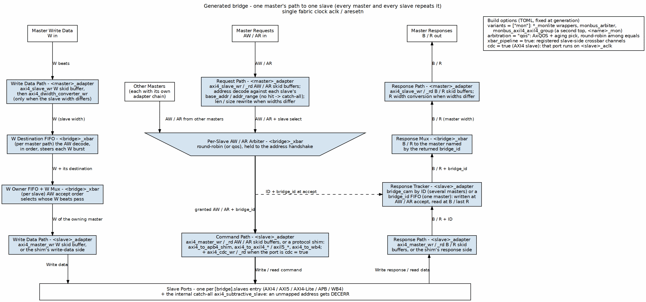
Bridge Signal Flow
One master’s path to one slave; every master and every slave repeats it. Write data takes the left lane, AW / AR the center through the per-slave arbiter, and B / R climb the right lane back to the master named by the returned bridge_id.

3.3 References

3.3.1 Related Documentation
- Bridge HAS - High-level architecture and integration
- PRD.md - Product requirements
- Generator source - bin/bridge_generator.py (with bin/bridge_pkg/)

3.4 Navigation

3.4.1 Document Organization
Document Organization
Chapter | Content
Ch 2 | Block Descriptions
Ch 3 | FSM Design
Ch 4 | ID Management
Ch 5 | Converters
Ch 6 | Generated RTL
Ch 7 | Verification

RTL Design Sherpa · Learning Hardware Design Through Practice GitHub · Documentation Index · MIT License

4 2.1 Master Adapter

4.1 Overview
Every master port in the bridge gets its own Master Adapter. The adapter sits between the master and the crossbar core, and it exists to make the crossbar’s life simple: timing is isolated at the boundary, channels are specialized to what the master actually uses, and every transaction carries a Bridge ID before it enters the fabric.

4.1.1 Purpose and Function
Concretely, the adapter does five things:
- Timing Isolation: Inserts pipeline registers (skid buffers) to break combinatorial paths from master to crossbar
- Channel Specialization: Separates read-only, write-only, and read-write masters for optimal resource utilization
- Fabric ID: Widens the AXI ID to {BRIDGE_ID, id} so IDs are unique across masters
- Address Decode and Width Paths: Selects the target slave and converts width on paths that need it (axi4_dwidth_converter_wr / _rd)
- Per-ID Target Gate and Response Steering: lets a master keep requests in flight at several slaves (same-ID requests stay on one slave), and arbitrates B / R across its width paths

4.1.2 Figure 2.1: Master Adapter Architecture
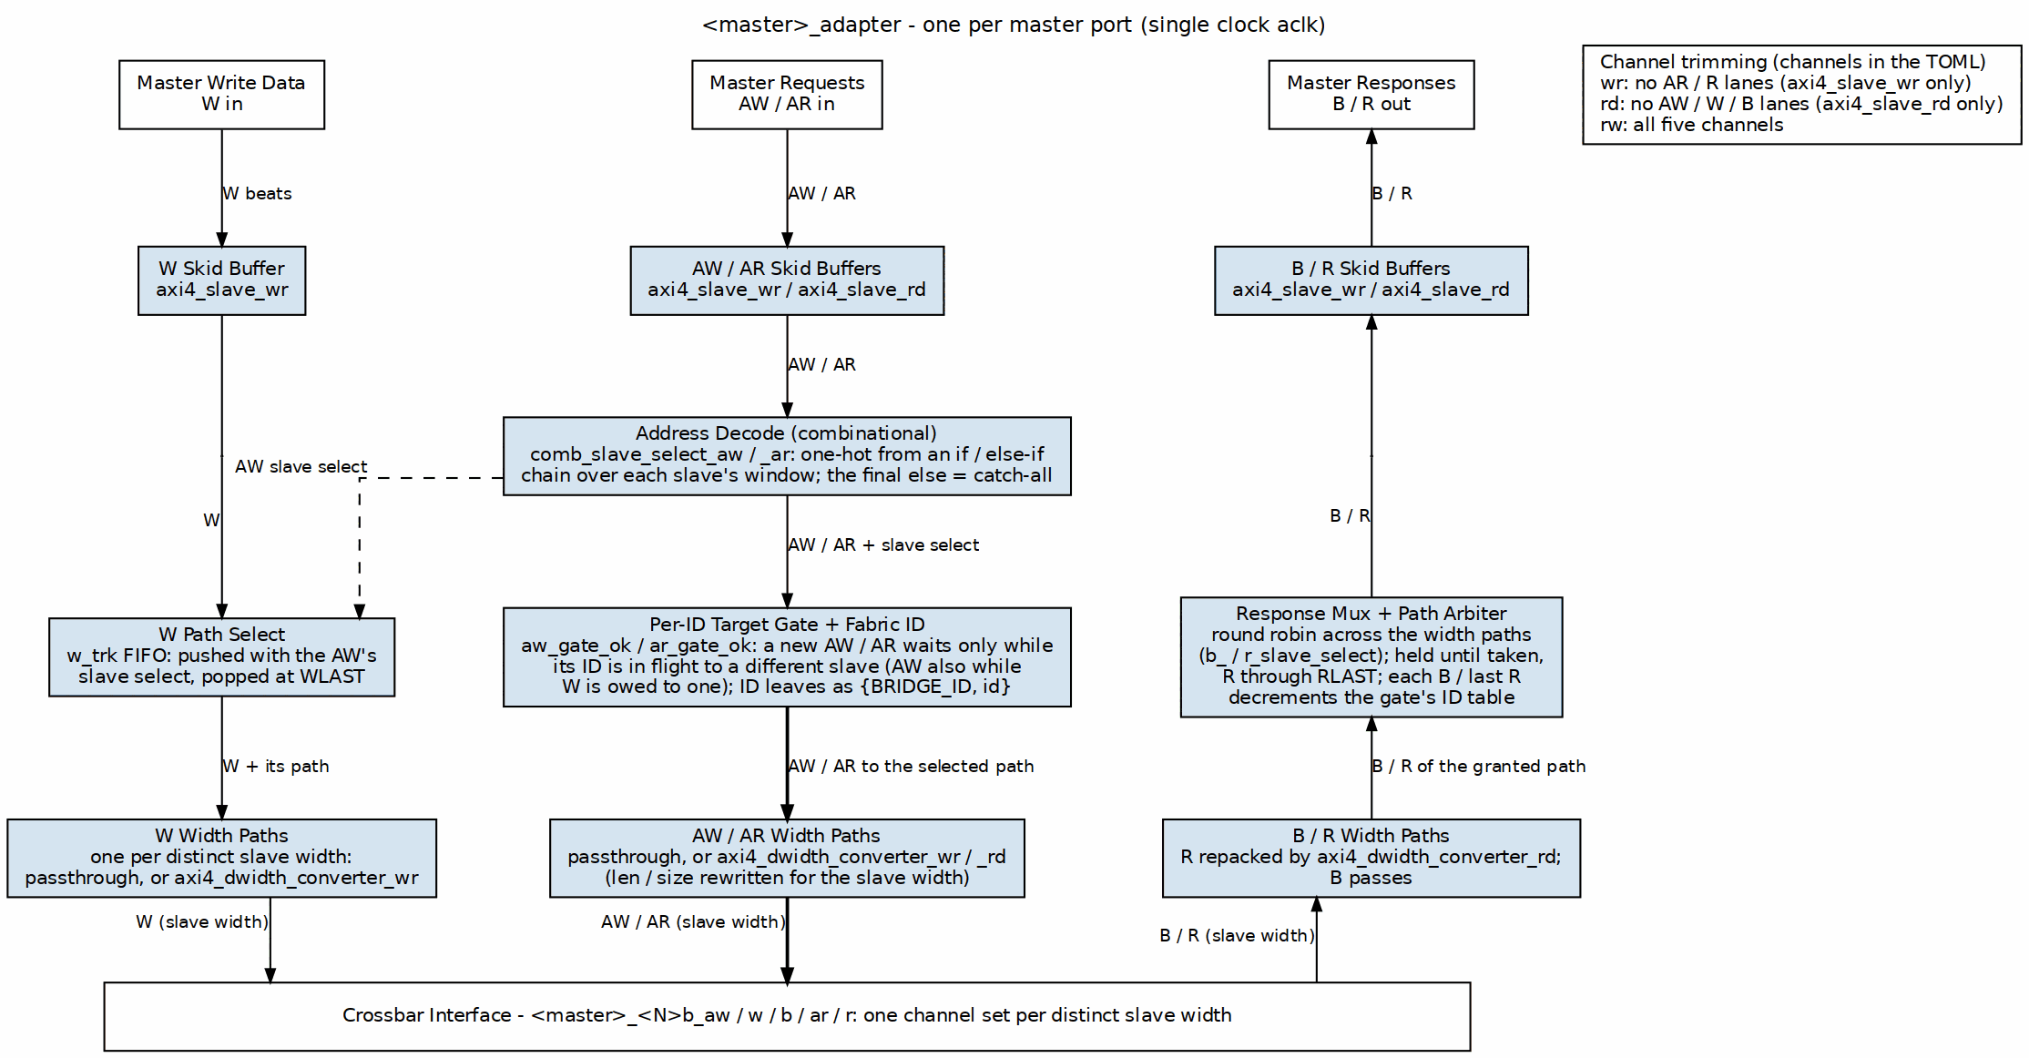
Master Adapter Architecture
The figure follows the generated <master>_adapter: skid buffers at the port, the combinational address decode, the per-ID target gate that also widens the ID to {BRIDGE_ID, id}, and one width path per distinct slave width. W follows its AW through the w_trk FIFO, and B / R climb back through a response mux whose path arbiter picks among the width paths.

4.2 Parameters
Everything here comes straight out of the TOML/CSV configuration — the generator does the arithmetic, you just declare the ports.

4.2.1 Per-Master Parameters (from TOML/CSV)
[[bridge.masters]]
name = "cpu"
channels = "rw" # "rd", "wr", or "rw"
arid_width = 4 # External ID width
awid_width = 4 # Can differ from ARID
addr_width = 32 # Address bus width
data_width = 64 # Data bus width
# pipeline_depth: NOT A KEY. Skid depth is set per channel by the generator;
# the contract is 2..8 inclusive, so 1 is rejected.

4.2.2 Global Parameters (affect all adapters)
[bridge]
# internal_data_width: NOT A KEY -- there is no fixed internal crossbar width.
# Width conversion and the ID prefix width are derived, not configured:
# converters are emitted wherever a master and slave width differ, and
# ID_PREFIX_WIDTH = $clog2(num_masters) lands in <bridge>_pkg.sv.

4.3 Ports
Two interfaces per adapter: one facing the master, one facing the fabric. Note the ID widths change across that boundary — wider on the inside.

4.3.1 External Master Interface (per master)
Input Channels (from master):
- ARVALID, ARREADY, ARADDR, ARBURST, ARCACHE, ARID, ARLEN,
ARLOCK, ARPROT, ARQOS, ARSIZE
- AWVALID, AWREADY, AWADDR, AWBURST, AWCACHE, AWID, AWLEN,
AWLOCK, AWPROT, AWQOS, AWSIZE
- WVALID, WREADY, WDATA, WSTRB, WLAST
Output Channels (to master):
- RVALID, RREADY, RDATA, RID, RLAST, RRESP
- BVALID, BREADY, BID, BRESP

4.3.2 Internal Crossbar Interface (per master)
Output Channels (to crossbar):
- AR* signals + Internal ARID (wider)
- AW* signals + Internal AWID (wider)
- W* signals (unchanged)
Input Channels (from crossbar):
- R* signals + Internal RID (wider)
- B* signals + Internal BID (wider)

4.4 Functional Description

4.4.1 Channel Specialization
The Bridge generator emits one adapter per master, named after the port: <name>_adapter.sv in the bridge’s rtl/generated/<bridge>/ directory (for example cpu_adapter.sv in bridge_2x2_rw, cpu_rd_adapter.sv in bridge_1x2_rd, where the port itself is called cpu_rd). There is no separate file per channel type; the channels key decides which channel logic the one module contains:

4.4.1.1 Read-Only Masters
Channels: AR (Address Read), R (Read Data)
Configuration: channels = "rd"
RTL Generated: <name>_adapter.sv (module <name>_adapter)
Optimizations:
- No write address channel logic
- No write data channel logic
- No write response channel logic
- Reduced arbitration participation (read path only)

4.4.1.2 Write-Only Masters
Channels: AW (Address Write), W (Write Data), B (Write Response)
Configuration: channels = "wr"
RTL Generated: <name>_adapter.sv (module <name>_adapter)
Optimizations:
- No read address channel logic
- No read data channel logic
- Reduced arbitration participation (write path only)

4.4.1.3 Read-Write Masters
Channels: AR, R, AW, W, B (Full AXI4 interface)
Configuration: channels = "rw"
RTL Generated: <name>_adapter.sv (module <name>_adapter)
Full Functionality:
- All five AXI4 channels implemented
- Participates in both read and write arbitration
- Maximum flexibility but larger resource footprint

4.4.2 Per-Port Monitor Wrappers (when use_monitor = true)
When the bridge TOML configuration sets use_monitor = true for a master port, the generator instantiates per-direction monitor wrappers immediately downstream of the master adapter:
- axi4_master_rd_mon: Wraps the AR/R channels, emits packets with UNIT_ID=1
- axi4_master_wr_mon: Wraps the AW/W/B channels, emits packets with UNIT_ID=1
Each wrapper: - Samples all channel signals and timestamp at handshake points - Emits 128-bit monitor packets on internal monbus - Passes signals through transparently in the common case, but it CAN stall: axi4_master_rd_mon gates the address channel on the monitor’s back-pressure, assign w_gated_arvalid = fub_axi_arvalid & (w_block_ready | ~cfg_monitor_enable); so a saturated transaction table holds off new addresses until it drains. With cfg_monitor_enable low the gate is bypassed and the path really is transparent. - Is instantiated only when requested (generator-time configuration)
The generated per-port monbus streams are later aggregated by a tree of monbus_arbiter instances at the bridge top.

4.4.3 Skid Buffer Architecture
Each AXI4 channel passes through a skid buffer for timing isolation. The skid buffer implements:

4.4.3.1 Registered Forward Path
// Simplified skid buffer concept
always_ff @(posedge clk) begin
if (!rst_n) begin
valid_reg <= 1'b0;
end else if (!valid_reg || ready_out) begin
valid_reg <= valid_in;
data_reg <= data_in;
end
end

4.4.3.2 Single-Cycle Backpressure Response
- When downstream is not ready, accepts one additional beat into holding register
- Signals ready_in = 0 in same cycle to upstream
- No combinatorial paths between upstream and downstream

4.4.3.3 Pipeline Depth
- Default: AW 2, W 4, B 2, AR 2, R 2; [bridge.defaults.skid_depths] and the port’s interface.skid_depths override them (they were parsed and ignored until GitHub #119 L7).
- Range: 2..8 inclusive, any integer, or 0 where the port’s latency mode cuts the stage (cut_ax: W/B/R; cut_none: all five). gaxi_skid_buffer builds DEPTH 0 as a combinational pass-through; its elaboration guard rejects 1 and anything above 8.
- Trade-off: Latency vs. timing closure
Performance Impact: - Adds 1 cycle latency per channel - Enables higher clock frequencies - Prevents critical paths through crossbar

4.4.4 Bridge ID Management
With more than one master, the adapter widens every request ID to a fabric ID {BRIDGE_ID, id} so two masters can never alias an ID at a slave (bridge TASK-005). The generated assignment in cpu_adapter.sv (bridge_2x2_rw) is:
assign xbar_axi_awid = {BRIDGE_ID_WIDTH'(BRIDGE_ID), MASTER_ID_WIDTH'(fub_axi_awid)};
assign xbar_axi_arid = {BRIDGE_ID_WIDTH'(BRIDGE_ID), MASTER_ID_WIDTH'(fub_axi_arid)};
BRIDGE_ID is a per-instance parameter (the master’s index). The widths come from <bridge>_pkg.sv:
Bridge ID Management
Package constant | Meaning | bridge_2x2_rw
MASTER_ID_WIDTH | widest master-side ID | 4
ID_PREFIX_WIDTH | master-index bits prepended, $clog2(NUM_MASTERS) | 1
XBAR_ID_WIDTH | fabric and slave-port ID width | 5
A single-master bridge prepends nothing (ID_PREFIX_WIDTH = 0; bridge_1x2_rd is 4 bits on both sides). A slave’s declared id_width must be at least XBAR_ID_WIDTH, or the config validator rejects the bridge.

4.4.4.1 ID Width Examples
ID_PREFIX_WIDTH = $clog2(num_masters) (0 for one master)
- 2 masters -> 1 prefix bit
- 4 masters -> 2 prefix bits
- 8 masters -> 3 prefix bits
Example: 4-master system, 4-bit master IDs (6-bit fabric IDs)
Master 0: BRIDGE_ID = 2'b00, ID = 4'h3 -> fabric ID = 6'b00_0011
Master 1: BRIDGE_ID = 2'b01, ID = 4'h3 -> fabric ID = 6'b01_0011
Master 2: BRIDGE_ID = 2'b10, ID = 4'h5 -> fabric ID = 6'b10_0101
Master 3: BRIDGE_ID = 2'b11, ID = 4'hA -> fabric ID = 6'b11_1010

4.4.4.2 ID Stripping (Response Path)
On B and R the adapter returns only the low MASTER_ID_WIDTH bits to the master (fub_axi_bid = cpu_32b_b.id[3:0] in bridge_2x2_rw), so the master sees its original ID.
Routing a response back to the right master does not decode those prefix bits. Each slave adapter also receives the originating master’s index as a sideband (xbar_bridge_id_aw / _ar) and stores it on the address handshake; the crossbar steers B/R by the bid_bridge_id / rid_bridge_id it returns. For an AXI4/AXI5 slave of a multi-master bridge that store is a bridge_cam looked up by the returned BID/RID; single-master bridges and shim/subtractive slaves use an in-order FIFO. See Section 2.5 and ch04.

4.4.5 Protocol Normalization
The Master Adapter enforces several protocol requirements:

4.4.5.1 Valid Address Ranges
- Checks addresses against slave address maps
- Flags out-of-range accesses for error handling
- Prevents deadlocks from illegal addresses

4.4.5.2 Burst Constraints
- Validates ARLEN/AWLEN vs. 4KB boundary rules
- Ensures burst types are supported (FIXED, INCR, WRAP)
- Checks SIZE vs. DATA_WIDTH compatibility

4.4.5.3 Signal Defaults
- Provides default values for unused signals
- Ensures ARCACHE/AWCACHE have legal values
- Sets ARPROT/AWPROT based on configuration

4.4.6 Response Path Slave Selection Tracking

4.4.6.1 Problem: Stale Slave Select Decode
Here’s the part that bites people. The master adapter decodes the incoming address combinationally to pick a target slave. When the wrapper’s skid buffer pops and fub_axi_awaddr/fub_axi_araddr reverts, the decode changes even though the converter is still in flight pushing the request to the crossbar. This causes the response MUX to route read/write responses from the wrong slave.

4.4.6.2 Solution: Capture at the Handshake, Steer by What Returns
The decode is captured when the request is accepted, never re-read later. The W path keeps a FIFO of it (w_trk_*, pushed at AW, popped at WLAST), because W carries no ID and follows AW order. B and R are no longer steered by a FIFO of targets at all: they are taken in the order the width paths offer them (path arbiter below), and what the adapter keeps per request is indexed by ID. Until 2026-10-15 an AW/AR -> B/R FIFO of targets steered the response mux, which is why a master could hold only one target at a time; read-return-atomic and trace-echo ports kept that FIFO a little longer (GitHub #119 L1b), because their per-request state rode its entries.

4.4.7 Several Targets in Flight (limitation fixed: GitHub #119 L1, L1b)
A master used to be held to one target slave at a time, because B / R were replayed in issue order from the tracking FIFO. Now the adapter keeps only the ordering AXI requires:
- Per-ID table (aw_idt_cnt[] / aw_idt_tgt[], same for AR): 2**id_track_bits entries (TOML [bridge].id_track_bits, default 4, and never more bits than the port’s ID), indexed by the ID’s low bits. Each entry holds an in-flight count and that ID’s target slave. The address handshake increments the count; a B, or an R with RLAST, decrements it by the returned ID. IDs that share the index bits are treated as one ID: safe, at worst a needless stall.
- Gates: ar_gate_ok = ar_id_ok && !ar_trk_full, and aw_gate_ok = aw_id_ok && !aw_trk_full && (w_trk empty || w_slave_select == target). Here *_id_ok means the ID is idle, or already in flight to the SAME slave. The W term exists because W has no ID and follows AW order. Two masters each owing W to two slaves would otherwise wait on each other at the slaves’ W ports.
- Outstanding limit: aw_out_cnt / ar_out_cnt cap the port at its max_outstanding (default 16; bridge GitHub #119 L5) in flight (bridge BUG-009’s not-full rule), so no count wraps.
- Path arbiter: with more than one width path, b_pgnt / r_pgnt pick a path round robin. A grant holds while offered and not taken; an R grant holds through RLAST. The selection feeds b_slave_select / r_slave_select as a representative slave of the path, so the response mux and the path readies are unchanged. One width path needs no arbiter. Among the slaves on one path, the crossbar’s response arbiter has already chosen (MAS 2.3).
- Trace echo (ports with AXI5 trace): each table entry also holds the in-flight ID’s trace bit. A request whose ID is in flight with a DIFFERENT trace waits, so the bit is single-valued per ID, and B/R echo aw_idt_trace[BID] / ar_idt_trace[RID] – also for a slave that has no trace of its own.
- Read-return atomics (rw AXI5 ports with atomic): an atomic AW is also counted in the AR table under its AWID (ar_idt_push_aw), since its R comes back with that ID. Its gate aw_rr_gate_ok is the AR per-ID rule plus a free AR slot, and it yields to an AR pushing the same ID index in the same cycle. An atomic that decodes to the subtractive slave queues its ID in a local-DECERR FIFO (lr_*), which the R path arbiter grants like one more path (r_local_head). These two were the last ports on the one-target FIFO (GitHub #119 L1b, 2026-10-15).

4.5 Timing

4.5.1 Latency
Request Path (Master → Crossbar): 1 cycle – one registered skid stage.
Response Path (Crossbar → Master): 1 cycle – one registered skid stage.
Total: 2 cycles each way through the bridge (one skid in the master adapter, one in the slave adapter). Measured, not derived: see HAS Table 5.7 and test_bridge_2x2_rw_latency, which asserts 2 exactly.
Depth is not latency. This block read “with 4-stage pipeline: 4 cycles” and a round trip of “2-8 cycles depending on pipeline depth”. A gaxi_skid_buffer presents its output one cycle after the write regardless of DEPTH; the depth sets how many beats it can ABSORB under backpressure, not how long a beat takes to cross it. The ID prefix and strip are pure wiring (a concatenation and a bit-select) and add no cycles.

4.5.2 Throughput
- Maximum: 1 transaction per cycle per channel (fully pipelined)
- Backpressure: Propagates with 1-cycle latency
- Burst Performance: No degradation; bursts flow continuously when ready

4.5.3 Critical Paths
Typical critical paths (if skid buffers not used): - Master ARVALID → Crossbar arbitration logic - Crossbar grant → Master ARREADY - Slave RDATA → Master RDATA
Solution: Skid buffers break all these paths at the cost of 1-cycle latency.

4.6 Design Notes

4.6.1 Resource Utilization

4.6.1.1 Per-Master Adapter Resources (Typical)
Read-Write Master (64-bit data, 32-bit addr, 4-bit ID):
Logic Elements: ~200-400 (depending on ID width and features)
Registers: ~150-250 (pipeline stages + control)
Block RAM: 0 (the master adapter holds no CAM; `bridge_cam` lives in the slave adapters)
Breakdown:
- Skid buffers (5 channels × ~30 regs each): ~150 regs
- ID manipulation logic: ~50 LEs
- Control FSMs: ~100 LEs
- Routing logic: ~50 LEs
Read-Only Master: ~60% of read-write resources
Write-Only Master: ~65% of read-write resources

4.6.1.2 Scaling Considerations
Resource usage scales with: - Number of masters (linear scaling, one adapter per master) - ID width (logarithmic: +BID_WIDTH bits per transaction) - Pipeline depth (linear: deeper pipelines = more registers) - Data width (linear: wider data = wider skid buffers)

4.6.2 Future Enhancements

4.6.2.1 Planned Features
- Dynamic Pipeline Depth: Adjust depth based on operating frequency
- FIFO Mode: Deeper buffering (16-256 entries) for burst-intensive masters
- QoS Support: Priority-based arbitration hints
- Performance Counters: Transaction counts, stall cycles, utilization metrics

4.6.2.2 Under Consideration
- Clock Domain Crossing: Per-master clock domains with async FIFOs
- Width Conversion at Adapter: Move width logic to adapters for distributed conversion
- Outstanding Transaction Tracking: Windowing for improved OOO performance

4.7 Related Modules
- Section 2.3: Crossbar Core (interconnect architecture)
- Section 2.4: Arbitration (how adapters compete for slaves)
- Section 2.5: ID Management (fabric ID widening, sideband bridge_id, CAM/FIFO tracking)
- HAS ch04_interfaces/01_axi4_interface.md (port signals)

4.8 Testing

4.8.1 Debug and Observability

4.8.1.1 Recommended Debug Signals
For ILA or waveform capture:
- Master adapter input valid/ready (all channels)
- Master adapter output valid/ready (all channels)
- Bridge ID assignments per transaction
- Pipeline stage occupancy
- Backpressure events (ready = 0 while valid = 1)

4.8.1.2 Common Issues and Debug
Symptom: Master hangs waiting for READY
Check: - Is adapter receiving grants from arbiters? - Is slave responding to requests? - Is response path clear?
Symptom: Incorrect data returned to master
Check: - Bridge ID extraction logic - ID width mismatches - Response routing in crossbar
Symptom: Timing violations
Check: - Increase pipeline_depth parameter - Verify clock frequency vs. design complexity - Check for combinatorial loops

RTL Design Sherpa · Learning Hardware Design Through Practice GitHub · Documentation Index · MIT License

5 2.2 Slave Router

5.1 Overview
Every master gets its own Slave Router. The router examines each request address, steers the transaction to one of the configured slaves, and produces the error response itself when the address lands nowhere.

5.1.1 Purpose and Function
The router does five things:
- Address Decoding: Matches request addresses against configured slave address ranges
- Request Routing: Directs AR/AW/W channels to the selected slave
- Out-of-Range Detection: Identifies addresses that don’t map to any slave
- Error Response Generation: Creates DECERR responses for invalid addresses
- Default Slave: unmapped addresses go to an ALWAYS-PRESENT internal subtractive slave (axi4_subtractive_slave), which answers DECERR and returns 0xDEADBEEF on reads. It is not optional and there is no default = true TOML key – the generator inserts it into every bridge.

5.1.2 Figure 2.2: Slave Router Architecture
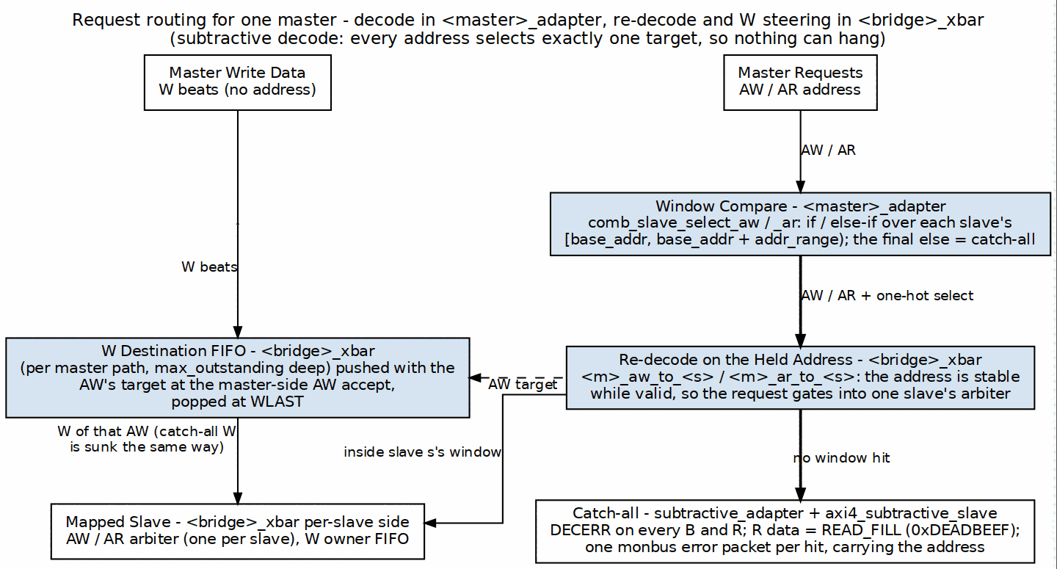
Slave Router Architecture
There is no separate router module. The window compare lives in <master>_adapter; <bridge>_xbar re-decodes the held address to gate the request into one slave’s arbiter and records each AW’s target in a W destination FIFO, so W beats (which carry no address) follow their AW. An address in no window takes the final else of the decode chain to the always-present catch-all, which answers DECERR.

5.2 Parameters

5.2.1 Per-Router Parameters
# Router behavior is defined by slave configurations
[[bridge.slaves]]
name = "ddr_memory"
base_address = 0x8000_0000
size = 0x4000_0000 # 1 GB
default = false
# (no oor_data_pattern knob: READ_FILL is a module parameter, 0xDEADBEEF)

5.2.2 Global Parameters
[bridge]
enable_default_slave = false # Allow default slave
strict_address_decode = true # Flag overlapping ranges as errors
# (no oor_response_latency knob: the responder answers as fast as the
# handshake allows; there is nothing to tune)

5.3 Functional Description

5.3.1 Address Decoding Algorithm

5.3.1.1 Configuration-Based Address Maps
Each slave is configured with:
[[bridge.slaves]]
name = "memory"
base_address = 0x4000_0000
size = 0x1000_0000 # 256 MB
default = false # Not a default slave
The router generates address ranges:
Start Address = base_address
End Address = base_address + size - 1

5.3.1.2 Decoding Priority
When multiple slaves have overlapping address ranges, the router uses first-match priority:
Priority Order = Order in configuration file (top to bottom)
Example:
Slave 0: 0x0000_0000 - 0x0FFF_FFFF (checked first)
Slave 1: 0x1000_0000 - 0x1FFF_FFFF (checked second)
Slave 2: 0x2000_0000 - 0x2FFF_FFFF (checked third)
Address 0x1000_5000 → Matches Slave 1

5.3.1.3 Range Checking Logic
For each address, the router performs:
// Simplified address decode logic
logic [NUM_SLAVES-1:0] slave_match;
for (int i = 0; i < NUM_SLAVES; i++) begin
slave_match[i] = (addr >= SLAVE_BASE[i]) &&
(addr <= SLAVE_END[i]);
end
// Priority encode: Select first matching slave
logic [$clog2(NUM_SLAVES)-1:0] slave_select;
always_comb begin
slave_select = 0;
for (int i = 0; i < NUM_SLAVES; i++) begin
if (slave_match[i]) begin
slave_select = i;
break; // First match wins
end
end
end
// Out-of-range detection
logic oor = ~(|slave_match); // No slaves matched

5.3.1.4 Subtractive decode: the else that removes the hang
The pseudocode above computes an out-of-range flag; the generated RTL goes further and gives that case a destination. The emitted decode chain ends in a bare else selecting an internal catch-all slave:
comb_slave_select_aw = '0;
if (fub_axi_awaddr <= 32'h3FFFFFFF) comb_slave_select_aw[0] = 1'b1; // ddr
else if (fub_axi_awaddr >= 32'h40000000) comb_slave_select_aw[1] = 1'b1; // scratch
else comb_slave_select_aw[3] = 1'b1; // subtractive
So the one-hot is never all-zero. Before 2026-09-07 there was no else: an unmapped address selected nothing, the AW-ready MUX fell through to default: // No slave selected with awready low, and the master hung forever. The hang is now impossible by construction rather than handled.

5.3.1.5 Three decoders, not one
The catch-all is a synthetic slave appended last to the slave list, so it reuses the crossbar’s routing rather than needing a new datapath. What made that harder than it sounds is that three independent places derive the slave list for themselves, and each needed telling:
Address decoder responsibilities
Where | What it derives | What the catch-all needed
master adapter | the if/else decode above | nothing – subtractive semantics come free from the else
crossbar | its own per-slave _to_ terms, from address RANGES | the term must be !(other ranges); a full-span slave otherwise reduces to 1'b1
cfg regblock | per-slave configuration registers | exclusion – it has no monitor wrapper to configure
The crossbar case is the instructive one. Its decode is derived from each slave’s address range independently of the adapter’s chain, so a full-span catch-all became wire cpu_32b_aw_to_subtractive = 1'b1; – matching every address. Every transaction then routed to the real slave and the catch-all at once, and because the payload muxes OR their inputs, the master read back addr = real | catchall. Silent corruption, which is worse than the hang it replaced. The term is now the negation of the other ranges, inlined rather than referencing the sibling <master>_<suffix>_<channel>_to_<slave> wires: those are emitted per channel, so a slave with no read path from a given master has no ar_to_ wire at all and naming it does not compile.
The cfg regblock case cost a whole debug cycle for a subtler reason: emitting per-slave cfg for the catch-all added 52 fields and renumbered every register after them, which moved the monitor-enable bits. One monbus stress test saw pkts=0 while all 69 other tests passed, because only that test depended on register offsets. A register map is an ABI.

5.3.1.6 Power-of-Two Optimization
For slaves with power-of-two sizes starting at aligned addresses, simplified decode:
// Optimized decode for: base=0x8000_0000, size=0x1000_0000 (256MB)
// Mask off lower bits: Only check upper bits
logic match = (addr[31:28] == 4'h8); // Much simpler than range check
The generator automatically detects and applies this optimization.

5.3.2 Request Routing

5.3.2.1 AR Channel Routing
Read address routing flow: 1. Decode: Determine target slave from ARADDR 2. Check OOR: If no slave matches, flag for error response 3. Route: Send AR transaction to selected slave’s arbiter 4. Track: Remember routing decision for R channel responses
The decode and its out-of-range branch are the center column of Figure 2.2.

5.3.2.2 AW/W Channel Routing
Write transactions require coordinated routing:
- AW Phase:
  - Decode AWADDR to determine target slave
  - Route AW transaction to selected slave’s arbiter
  - Store routing decision for subsequent W beats
- W Phase:
  - Follow AW routing (W channel has no address)
  - Route all W beats to same slave as AW
  - Continue until WLAST = 1
Figure 2.2 shows the W side: the W destination FIFO is pushed with the AW’s target at the AW handshake and popped at WLAST.

5.3.2.3 Write Data Tracking (FIFO, no FSM)
There is no state machine on the W path. The crossbar keeps one W destination FIFO per master width-path (<master>_<w>b_wdest_* in <bridge>_xbar.sv, the master’s max_outstanding entries, default 16):
Push: on the AW handshake, write the encoded target slave
(e.g. cpu_32b_wdest_enc: 0 = ddr, 1 = sram, 2 = subtractive)
Head: while the FIFO is non-empty, its head selects which slave
the master's W beats go to (cpu_32b_w_to_ddr, ..._to_sram, ...)
Pop: on the W handshake that carries WLAST
Because the FIFO holds every accepted AW, a master can have several write bursts queued to different slaves; each W burst follows its own AW in order, with no IDLE/WRITING handshake between them. On the slave side a matching W owner FIFO (<slave>_wowner_*), pushed with the AW arbiter’s grant and popped on WLAST, decides which master owns that slave’s W channel. An out-of-range AW is routed to the subtractive slave like any other target, so its W beats are drained there and it answers DECERR (see below).

5.3.3 Out-of-Range Handling

5.3.3.1 Detection
An address is out-of-range if it matches no slave’s range. The decode chain ends in an else, so such an address is not “detected and handled” – it is routed, to an internal subtractive slave that always answers.

5.3.3.2 Error Response Generation
The responder is rtl/amba/axi4/axi4_subtractive_slave.sv, instantiated by the generator as the last (internal) slave. It emits no top-level pins of its own; its behaviour is fixed, not configurable.
Read (AR -> R)
1. Accept ARVALID (ARREADY high while no read is active)
2. Return exactly ARLEN+1 beats:
RID = ARID as received (the fabric ID; the master adapter strips the prefix)
RDATA = 0xDEADBEEF, replicated to the data width
RRESP = 2'b11 (DECERR)
RLAST = 1 on the FINAL beat only
RLAST on every beat – which an earlier revision of this page specified – would make a burst master terminate early. The RTL asserts it as r_r_active && (r_beats_left == 0), and the module test checks that it appears on the last beat and no other.
Write (AW/W -> B)
1. WREADY is unconditionally high -- W beats are sunk whether or not AW has
arrived yet. AXI4 permits write data before its address, and gating WREADY
on having seen AW deadlocks such a master.
2. One B per AW:
BID = AWID, unmodified
BRESP = 2'b11 (DECERR)
3. Write data is discarded. There is nowhere for it to go.
Status. The first unmapped access latches a sticky flag with its address and a saturating count, raised on unmapped_irq and, on cfg-regblock builds, readable and clearable via SUBTRACTIVE_STATUS / SUBTRACTIVE_ADDR. See HAS 4.5.
Reachability. The catch-all is the decode else, so it can only fire if the slave ranges leave a gap. Of the 22 generated bridges, 18 tile the address space completely and the branch is unreachable logic that synthesis removes.

5.3.3.3 Read data pattern
READ_FILL, a module parameter, defaults to 32'hDEAD_BEEF and is replicated to the bus width. It is not run-time configurable and there is no menu of options: an earlier revision of this page offered four (zeros, a debug signature, an address echo, a master/slave ID indicator), none of which was ever built.
The value matters more than the choice. Zeros are indistinguishable from real memory, so an all-zero error return reads as a plausible value and the fault stays hidden; 0xDEADBEEF in a dump is unambiguous. Address-echo variants sound useful but the address is already captured in SUBTRACTIVE_ADDR, where software can read it without decoding it out of the data bus.

5.3.4 Default Slave Support

5.3.4.1 Configuration
[[bridge.slaves]]
name = "error_responder"
base_address = 0x0 # Ignored for default slave
size = 0x0 # Ignored for default slave
default = true # Catch-all for unmapped addresses

5.3.4.2 Behavior
When a default slave is configured: - Addresses that don’t match any specific slave → Routed to default slave - Default slave typically returns DECERR but with configurable response - Useful for prototyping (accept all addresses initially) - Can implement memory-mapped debug register for address capture
Note: Only ONE default slave allowed per bridge.

5.3.5 Address Aliasing

5.3.5.1 Multiple Slaves, Same Address
If configuration has overlapping ranges:
[[bridge.slaves]]
name = "fast_cache"
base_address = 0x8000_0000
size = 0x1000_0000
[[bridge.slaves]]
name = "slow_memory"
base_address = 0x8000_0000 # Same base!
size = 0x4000_0000
Result: First-match priority applies. All accesses go to fast_cache. The slow_memory range 0x9000_0000-0xBFFF_FFFF is unreachable from this master.
Warning: Generator can optionally flag this as error in DRC mode.

5.3.5.2 Intentional Aliasing Use-Cases
Legitimate uses of overlapping ranges: 1. Cache hierarchy: Small fast cache shadows larger slow memory 2. Memory remapping: Different views of same physical memory 3. Peripheral mirroring: Register block appears at multiple addresses

5.4 Timing

5.4.1 Decode Latency
Combinatorial Decode (Default): - Address → Slave selection: 0 cycles (combinatorial) - Critical path: ARADDR → Slave arbiter request - May limit maximum frequency in large systems
Registered Decode (Optional): - Address → Slave selection: 1 cycle (registered) - Adds latency but breaks critical path - Recommended for >8 slaves or >300 MHz operation

5.4.2 Throughput
- Maximum: 1 transaction per cycle per master
- No blocking: Router does not stall; arbiters handle conflicts
- Pipelining: AR and AW decode in parallel (independent paths)

5.4.3 Critical Paths
Typical critical paths: - ARADDR → Address comparators → Priority encoder → Arbiter request - w/4 slaves: ~10-15 logic levels (FPGA-dependent) - w/8 slaves: ~12-18 logic levels
Mitigation: - Enable registered decode mode (+1 cycle latency) - Use power-of-two slave sizes (simplified compare) - Synthesizer optimization directives

5.5 Design Notes

5.5.1 Resource Utilization

5.5.1.1 Per-Router Resources (Typical)
4-slave configuration (32-bit address):
Logic Elements: ~150-200 LEs
Registers: ~50 regs
Block RAM: 0
Breakdown:
- Address comparators (4 slaves × ~30 LEs): ~120 LEs
- Priority encoder: ~20 LEs
- W channel FSM: ~30 regs, ~20 LEs
- OOR error generator: ~20 regs, ~10 LEs
8-slave configuration:
Logic Elements: ~250-350 LEs (scales roughly with slave count)
Registers: ~60 regs

5.5.1.2 Scaling Considerations
Resource usage scales with: - Number of slaves: Linear (each slave adds comparator logic) - Address width: Minimal impact (wider comparators, but same structure) - Optimizations: Power-of-two sizes reduce logic significantly

5.5.2 Performance Optimization
1. Registered Decode (High Frequency)
Trade-off: +1 cycle latency for timing closure
Best for: >8 slaves, >300 MHz targets
2. Simplified Address Decode (Power-of-2)
Optimization: Mask-based compare instead of range check
Best for: Slaves with aligned, power-of-2 sizes
Savings: ~50% reduction in comparator logic
3. Parallel Decode (Low Logic)
Implementation: Separate decoders per address bit-field
Best for: Many non-overlapping slaves
Savings: Reduces logic depth for priority encoding
4. CAM-Based Decode (Many Slaves)
Trade-off: Uses block RAM for address lookup table
Best for: >16 slaves, non-contiguous ranges
Note: Requires RAM resources

5.5.3 Future Enhancements

5.5.3.1 Planned Features
- Dynamic Address Remapping: Runtime-configurable slave ranges
- Transaction Filtering: Block certain address ranges per-master
- Priority Hints: QoS-based prioritization (beyond first-match)
- Address Translation: Offset/mask transformations before slave routing

5.5.3.2 Under Consideration
- Multi-region Slaves: Slave spans multiple non-contiguous ranges
- Secure Address Spaces: Per-master access control lists
- Debug Address Capture: Log invalid addresses to register

5.6 Related Modules
- Section 2.1: Master Adapter (upstream from router)
- Section 2.3: Crossbar Core (downstream arbitration)
- Section 2.4: Arbitration (how routed requests compete)
- HAS ch04_interfaces/01_axi4_interface.md (slave port signals)

5.7 Testing

5.7.1 Debug and Observability

5.7.1.1 Recommended Debug Signals
- Address decode outputs (which slave matched)
- OOR flags (per channel)
- Default slave hit counter
- W channel FSM state
- Routing decision storage (for W tracking)

5.7.1.2 Common Issues and Debug
Symptom: Reads return all zeros
Check: - Is address out-of-range? - Check slave base/size configuration - Verify address decode logic in waveform
Symptom: Write data goes to wrong slave
Check: - W channel tracking FSM state - Did AW routing complete before W started? - Check for AWVALID/AWREADY handshake
Symptom: Unexpected DECERR responses
Check: - Address decode configuration - Overlapping slave ranges (wrong priority) - Off-by-one in size calculations

5.7.2 Verification Considerations

5.7.2.1 Address Decode Tests
Critical test scenarios: 1. Boundary conditions: base_address, base_address + size - 1 2. Just out-of-range: base_address - 1, base_address + size 3. Each slave: Verify routing to correct slave 4. Overlapping ranges: Verify priority encoding 5. Default slave: Unmapped addresses route correctly

5.7.2.2 Write Tracking Tests
W channel FSM testing: 1. Simple write: Single AW, single W (WLAST=1) 2. Burst write: AW with AWLEN=7, eight W beats 3. Back-to-back writes: New AW before previous W completes 4. Interleaved masters: Multiple masters writing simultaneously (if supported)

5.7.2.3 OOR Error Tests
Test: Read from unmapped address
- Send AR to 0xFFFF_FFFF (assuming unmapped)
- Verify R response with RRESP = DECERR
- Verify RID matches ARID
- Check response latency
Test: Write to unmapped address
- Send AW to invalid address
- Send W data
- Verify B response with BRESP = DECERR
- Verify BID matches AWID

RTL Design Sherpa · Learning Hardware Design Through Practice GitHub · Documentation Index · MIT License

6 2.3 Crossbar Core
The crossbar core is the fabric itself — any master can reach any slave through it. Arbitration, request routing, and response management, the machinery that makes any-to-any work, all live here.

6.1 Overview
The core does five things:
- Full Connectivity: Provides complete N×M master-to-slave interconnect matrix
- Independent Arbitration: Per-slave arbiters allow parallel access to different slaves
- Response Routing: Directs slave responses back to originating masters using Bridge IDs
- Transaction Ordering: Maintains AXI ordering requirements within address dependencies
- Backpressure Management: Handles flow control across multiple concurrent transactions

6.1.1 Figure 2.3: Crossbar Core Architecture
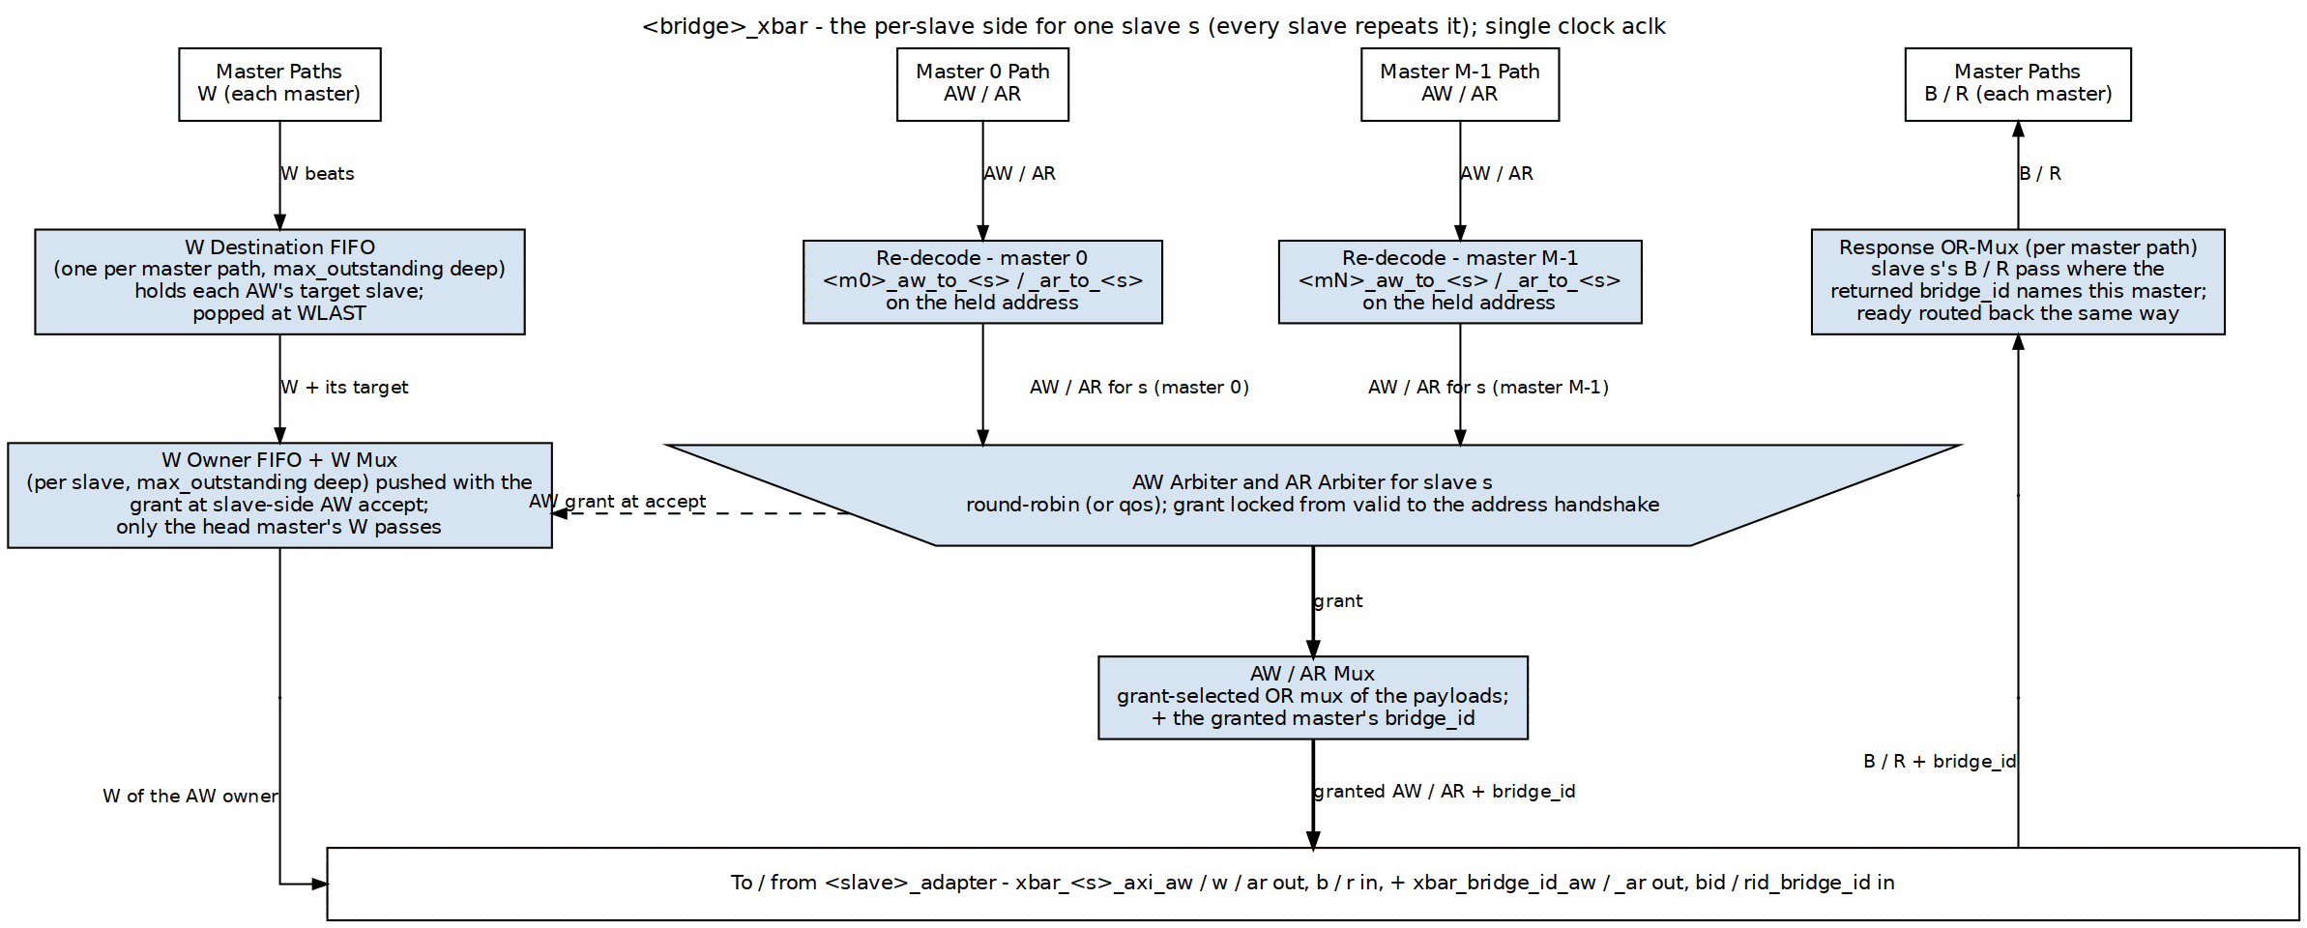
Crossbar Core Architecture
The per-slave side of <bridge>_xbar for one slave; every slave repeats it. Each master path re-decodes its held address, the AW and AR arbiters (the trapezium) pick one master per slave, and a grant-selected OR mux forwards the winner with its bridge_id. W beats are steered by a W destination FIFO per master path and a W owner FIFO per slave. B / R climb the right lane to the master named by the bridge_id the slave adapter returns.

6.2 Parameters
The crossbar-level knobs come straight from the TOML. Read the comments as carefully as the keys — several entries you’d expect to find here don’t exist, and the file says so:
[bridge]
num_masters = 4
num_slaves = 3
# internal_data_width: NOT A KEY -- the crossbar has no fixed internal width;
# each path carries its own port width and converters sit at the boundaries.
arbiter_type = "round_robin" # "round_robin", "fixed_priority", "weighted"
registered_mux = false # true = +1 cycle, better timing
registered_demux = false # true = +1 cycle, better timing
# NOTE: there is no enable_cam / cam_depth key. The CAM is chosen per slave by the
# generator (multi-master AXI4/AXI5 slave, or enable_ooo = true on [[bridge.slaves]])
# and is the slave's max_outstanding deep (default 16; [bridge] or per-port
# key, power of two 2..64 -- bridge GitHub #119 L5).

6.3 Functional Description

6.3.1 Connectivity Matrix
The bridge implements a non-blocking crossbar where: - N masters can each access different slaves simultaneously - Conflicts occur only when multiple masters target the same slave - Independent read and write paths increase parallelism
Example: 4 masters, 3 slaves
S0 S1 S2
M0 ● ● ●
M1 ● ● ●
M2 ● ● ●
M3 ● ● ●
● = Connection available

6.3.2 Request Path Multiplexing
For each slave, requests from all masters are multiplexed:
Slave 0 Request Inputs:
- M0 → S0 (AR, AW, W channels)
- M1 → S0 (AR, AW, W channels)
- M2 → S0 (AR, AW, W channels)
- M3 → S0 (AR, AW, W channels)
Arbiter selects one master per channel per cycle
→ Grants propagate through MUX
→ Selected master's transaction forwarded to slave

6.3.3 Response Path Demultiplexing
Responses from slaves are demultiplexed back to masters:
Slave 0 Response Outputs (R, B channels):
- Take the master index the slave adapter's tracker returns
(bridge_cam lookup by RID/BID, or in-order FIFO head)
- Route to corresponding master (M0, M1, M2, or M3)
- Master adapter strips the {BRIDGE_ID} prefix from the ID

6.3.4 Per-Slave Request Arbitration
Each slave has independent arbiters for: 1. AR Channel: Read address arbitration (all masters competing) 2. AW/W Channels: Write address/data arbitration (all masters competing)
This separation allows: - Simultaneous read and write to same slave (if slave supports it) - Independent grant decisions for AR vs. AW channels - Better throughput for mixed read/write workloads
Policy ([bridge] arbitration, bridge TASK-006 (was BRIDGE-017)). "rr" (default) is round-robin among the requesting masters, grant locked until the slave-side handshake. "qos" picks the requester with the highest effective priority: AxQOS plus an age term that climbs one level every 2**qos_aging_shift cycles a request waits (default 16), saturating at 15, cleared on grant; equals share round-robin. A QoS-0 requester behind a QoS-15 one is therefore served after at most 15 * 2**shift cycles of waiting – delayed, never starved. Priority reorders only what is waiting at the arbiter: a slave that accepts an AW every cycle takes each master’s AW as it arrives, faster than any master issues them, so no two requests are ever pending together and the W order is arrival order whatever the QoS values say. It takes effect where it is meant to, at a slave whose outstanding-write depth is full and whose AW channel backpressures, because that is when a backlog forms and every AW slot is a decision. Measured on bridge_2x2_rw_qos (test_bridge_2x2_rw_qos_arb) against a port that accepts one AW per 13 cycles: a QoS-8 stream against a QoS-0 stream takes >= 75% of the beats in either orientation, the QoS-0 stream’s longest wait for an AW grant stays inside the aging bound, and equal QoS splits the port like the baseline. AxQOS itself is still passed through to the slave unchanged.

6.3.5 Request Multiplexers with Stable Address Gating
After arbitration, multiplexers select the granted master’s signals. AR/AW gating uses inline address re-decode on the stable m_axi address bus (held stable across the full handshake):
// Inline address re-decode for stable gating (replaces slave_select_* gating)
// The address on m_axi is held stable from fub_axi handshake through m_axi handshake
always_comb begin
// Re-decode each master's address to determine target slave
m0_targets_s0 = (m0_m_axi_araddr >= S0_BASE) && (m0_m_axi_araddr < S0_END);
m1_targets_s0 = (m1_m_axi_araddr >= S0_BASE) && (m1_m_axi_araddr < S0_END);
m2_targets_s0 = (m2_m_axi_araddr >= S0_BASE) && (m2_m_axi_araddr < S0_END);
m3_targets_s0 = (m3_m_axi_araddr >= S0_BASE) && (m3_m_axi_araddr < S0_END);
end
// Gate with valid signals
assign m0_ar_s0_valid = m0_arvalid && m0_targets_s0;
assign m1_ar_s0_valid = m1_arvalid && m1_targets_s0;
assign m2_ar_s0_valid = m2_arvalid && m2_targets_s0;
assign m3_ar_s0_valid = m3_arvalid && m3_targets_s0;
// Simplified AR channel MUX for Slave 0
always_comb begin
case (ar_grant_s0)
2'b00: begin // Master 0 granted
s0_arvalid = m0_arvalid;
s0_araddr = m0_m_axi_araddr; // Stable across m_axi handshake
s0_arid = m0_arid; // Includes Bridge ID
// ... other AR signals
end
2'b01: begin // Master 1 granted
s0_arvalid = m1_arvalid;
s0_araddr = m1_m_axi_araddr; // Stable across m_axi handshake
s0_arid = m1_arid;
// ... other AR signals
end
// ... cases for M2, M3
endcase
end
Why this matters: The address on m_axi_* is held stable for the entire AXI handshake (arvalid && arready). This allows address re-decoding to determine the target slave even as the master’s internal address state changes.

6.3.6 AW→W Burst Tracking FIFO
For masters with multiple slave connections, W beats must follow the slave that the AW was driven to. A per-(master, slave) FIFO tracks which slave the AW was routed to:
// Track which slave the AW was driven to
always_ff @(posedge aclk or negedge aresetn) begin
if (!aresetn) begin
aw_trk_slave_id <= '0;
aw_trk_valid <= 1'b0;
end else if (m0_awvalid && m0_m_axi_awready && s_selected_aw == S0) begin
aw_trk_slave_id <= S0; // Track that AW went to slave 0
aw_trk_valid <= 1'b1;
end else if (m0_wvalid && m0_m_axi_wready && m0_m_axi_wlast) begin
aw_trk_valid <= 1'b0; // AW->W burst complete
end
end
// Gate W path based on tracked slave
logic w_to_s0, w_to_s1, w_to_s2;
always_comb begin
w_to_s0 = m0_wvalid && (aw_trk_slave_id == S0);
w_to_s1 = m0_wvalid && (aw_trk_slave_id == S1);
w_to_s2 = m0_wvalid && (aw_trk_slave_id == S2);
end
Why this matters: Without tracking, W beats would re-evaluate address decode which may have stale or different values, routing to the wrong width converter or slave.

6.3.7 Backpressure Propagation
Ready signals flow back from slave through arbiter to the granted master:
Slave S0 ARREADY → Arbiter → Granted Master ARREADY
↘ Other Masters ARREADY = 0
This ensures: - Only granted master sees READY from slave - Non-granted masters see READY = 0 (backpressure) - No combinatorial loops in ready path (registered arbitration)

6.3.8 Bridge ID and Response Routing
With more than one master, slave-side IDs are {BRIDGE_ID, id} (bridge TASK-005; 5 bits at ddr_s_axi_awid for 4-bit master IDs in bridge_2x2_rw). The crossbar does not decode those prefix bits. Each slave adapter returns the originating master’s index beside every response (<slave>_axi_bid_bridge_id / _rid_bridge_id, with a valid), produced by its tracker:
Bridge ID and Response Routing
Slave | Tracker | Lookup
AXI4 / AXI5, multi-master (or enable_ooo) | bridge_cam, max_outstanding deep (default 16), duplicates allowed | by the returned BID / RID, same cycle
single master, apb / axil / wb shim, subtractive | in-order FIFO, max_outstanding deep (default 16) | FIFO head
There is no timestamp or transaction-type field in the CAM, no timeout and no registered lookup.

6.3.9 Response Arbiters and Demultiplexers
A master may have requests in flight at several slaves (limitation fixed: GitHub #119 L1), so two slaves can offer it a response in the same cycle. Each master width path that reaches more than one slave has a B and an R response arbiter. A slave requests it when its response is valid and its tracker names this master; round robin picks one; a grant that is offered and not taken holds (AXI keeps the payload stable), and an R grant holds through RLAST so bursts never interleave:
// bridge_2x2_rw_xbar.sv: B arbiter for cpu's 32b path (excerpt)
assign cpu_32b_b_rarb_req = {
((subtractive_axi_bid_bridge_id == 0) && subtractive_axi_bid_valid) && subtractive_axi_bvalid,
((sram_axi_bid_bridge_id == 0) && sram_axi_bid_valid) && sram_axi_bvalid,
((ddr_axi_bid_bridge_id == 0) && ddr_axi_bid_valid) && ddr_axi_bvalid};
wire cpu_32b_b_rgnt_ddr = cpu_32b_b_rarb_gnt_valid && (cpu_32b_b_rarb_gnt == 2'd0);
// the mux toward the master and the slave's BREADY both follow the grant
assign cpu_32b_bvalid = (cpu_32b_b_rgnt_ddr ? ddr_axi_bvalid : '0) |
(cpu_32b_b_rgnt_sram ? sram_axi_bvalid : '0) | ...;
assign ddr_axi_bready = (cpu_32b_b_rgnt_ddr ? cpu_32b_bready : '0) |
(dma_32b_b_rgnt_ddr ? dma_32b_bready : '0);
A path with one slave keeps a plain ownership gate on the tracker’s master index; there is nothing to arbitrate. Width paths are arbitrated once more inside the master adapter (MAS 2.1, 2.8). The ID forwarded is still the fabric ID; the master adapter strips the prefix (fub_axi_bid = cpu_32b_b.id[3:0]).

6.3.10 AXI Ordering Requirements
The crossbar maintains AXI ordering rules.

6.3.10.1 Read-After-Write (RAW) Ordering
Rule: Read from address must see data from earlier write to same address
Crossbar Behavior: - Ordering enforced at slave level (slave handles RAW within itself) - Crossbar does NOT reorder transactions to same slave from same master - Different masters to same slave: No ordering guaranteed (slave must handle)

6.3.10.2 Write-After-Write (WAW) Ordering
Rule: Writes to overlapping addresses must complete in issue order
Crossbar Behavior: - Same master to same slave: Order preserved by arbiter (FIFO grant queue) - Different masters to same slave: Slave responsible for write ordering

6.3.10.3 Out-of-Order (OOO) Completion
Built, per slave. A multi-master AXI4/AXI5 slave (or one with enable_ooo) tracks with bridge_cam and may complete out of order across IDs; FIFO-tracked slaves (single master, shims, subtractive) must answer in request order. Across slaves a master sees responses in arrival order, and same-ID order is kept by the master adapter’s per-ID table.
Allowed: - Read responses must return IN ORDER; a slave that reorders between RIDs misroutes (bridge BUG-008, was BRIDGE-010) - Reads to different slaves can complete in any order - Writes to different slaves can complete in any order
Crossbar Support: - Bridge ID tracking enables OOO response routing - Master sees responses in slave-determined order - Multi-master OOO requires careful slave design

6.3.11 Monitor Aggregation at Bridge Top (when variants includes mon)
When monitor collection is enabled, per-port monitor streams from axi4_master_{rd,wr}_mon and axi4_slave_{rd,wr}_mon wrappers are aggregated through a tree of monbus_arbiter instances. The final aggregated stream feeds a single monbus_axil4_axil4_group instance at the bridge top level:
Aggregation Hierarchy:
Master-side monitors → monbus_arbiter tree (if >2 masters)
Slave-side monitors → monbus_arbiter tree (if >2 slaves)
↓
monbus_axil4_axil4_group
↓
s_mon_axil (slave), m_axil_mon (master), stream_irq
The monbus_axil4_axil4_group instance: - Provides a 64-bit slave AXIL interface for CPU read access (s_mon_axil_*) - Provides a master AXIL interface for DMA writes to system memory (m_axil_mon_*) - Contains an error FIFO tracking packets with error flags - Exposes stream_irq (asserted when error FIFO has records) - Includes an internal 64-bit free-running timestamp counter sampled at each packet arrival
Reference: See docs/markdown/rtl-amba/_book_monitor_index.md (monitor documentation book, with per-module pages under docs/markdown/rtl-amba/monitor/) for complete monitor design-surface documentation and docs/markdown/rtl-amba/includes/ocelus_package_spec.md for the packet layout.

6.4 Timing

6.4.1 Latency
Request Path (Master → Slave): - Arbiter decision: 1 cycle (registered) - MUX selection: 0 cycles (combinatorial) or +1 cycle with xbar_pipeline - Total: 1-2 cycles through crossbar (measured end to end: 2 combinational, 3 registered – HAS Table 5.7)
Response Path (Slave → Master): - BID extraction: 0 cycles (combinatorial) - DEMUX routing: 0 cycles (combinatorial) or +1 cycle with xbar_pipeline - Total: 0-1 cycles through crossbar (measured end to end: 2 combinational, 3 registered)
End-to-End (Master adapter → Slave adapter): - Adapters: 2 cycles (skid buffers) - Router: 0-1 cycles (decode) - Crossbar: 1-2 cycles (arbitration + MUX) - Total: 3-5 cycles minimum latency

6.4.2 Throughput
Best Case (no conflicts): - Each master to different slave: N transactions/cycle (N = master count) - Maximum aggregate bandwidth: N × data_width bits/cycle
Arbitration Limits: - Multiple masters to one slave: 1 transaction/cycle to that slave - Other slaves remain available for parallel access
Burst Performance: - Once granted, bursts flow at 1 beat/cycle - Grant held until burst completes (RLAST or WLAST)

6.4.3 Critical Paths
The paths that will bite you first:
- Arbiter Request → Grant:
  - All masters’ VALID signals → Arbiter logic → Grant decision
  - Depth: ~5-8 logic levels for 4 masters
- Grant → Ready Backpressure:
  - Slave READY → Arbiter → Selected master READY
  - Depth: ~4-6 logic levels
- Response Demux:
  - Slave RDATA/RID → BID extraction → Master select → Master RDATA
  - Depth: ~6-10 logic levels for 64-bit data
Mitigation Strategies:
- Registered crossbar – BUILT (bridge TASK-006 (was BRIDGE-017), [bridge] xbar_pipeline = true). Every slave-side channel gets a 2-deep gaxi_skid_buffer inside the xbar: the request stages (AW, W, AR) sit between the arbitrated mux and the slave port and carry the bridge id in their payload; the response stages (B, R) sit between the slave port and the OR-merge and carry the slave adapter’s bid/rid_bridge_id and route-open flag WITH the beat, so the merge keys on the staged id and the stage’s own valid. Both cones – decode -> arbiter -> N-way mux, and the response OR-merge – end at a register. The skid’s ready is registered too, so both directions are cut and throughput is unchanged: test_bridge_2x2_rw_perf measures the same 1.00 beat/cycle on bridge_2x2_rw_pipe as on bridge_2x2_rw, and test_bridge_2x2_rw_pipe_latency pins the cost at exactly one cycle each way (3/3 against the baseline’s 2/2). The routing and mux emitters are untouched; they drive xs_<slave>_axi_* nets and _generate_pipeline_stages() joins those to the ports. Off by default.
- Pipelined Arbitration: Multi-cycle arbiter for >8 masters (not built)
- Hierarchical Crossbar: For >16 masters, use tree structure (not built)

6.5 Design Notes

6.5.1 Resource Utilization
4 masters × 3 slaves configuration (64-bit data, 32-bit addr):
Logic Elements: ~2000-3500 LEs
Registers: ~800-1200 regs
Block RAM: 0 (no CAM is built)
Breakdown per slave:
- Arbiter (4 masters, RR): ~200 LEs, ~50 regs
- Request MUX (AR/AW/W): ~400 LEs, ~100 regs
- Response DEMUX (R/B): ~300 LEs, ~80 regs
- Control FSMs: ~100 LEs, ~50 regs
Total for 3 slaves: 3 × 1000 LEs = ~3000 LEs
Plus routing overhead: +500 LEs
Scaling with Masters and Slaves — linear: - Adding 1 master: +~500 LEs per slave (new arbiter input) - Adding 1 slave: +~1000 LEs (complete new slave port)
Example: 8 masters × 6 slaves
Estimated: ~12,000 LEs, ~3000 regs
Block RAM: 0 (no CAM is built)
Optimization Techniques:
- Read-Only/Write-Only Masters: Reduces arbiter complexity by 40-50%
- Power-of-Two Master Count: Simplifies BID width and routing logic
- Pipeline Stages: Trading latency for frequency (deeper pipelines)

6.5.2 Debug and Observability
Recommended debug signals:
Per Slave:
- Arbiter grants (which master granted)
- Arbiter requests (which masters requesting)
- Request MUX outputs (VALID, READY, ADDR, ID)
- Response DEMUX inputs (VALID, READY, DATA, ID)
Global:
- Active transactions count
- Stall counters (arbiter conflicts)
- BID extraction errors
- bridge_id FIFO occupancy (wr_ptr/rd_ptr)
Useful metrics for profiling:
- Transactions per slave (read, write separate)
- Arbiter conflict rate (requests denied due to grant contention)
- Average grant latency
- Utilization per master (% cycles active)
- Utilization per slave (% cycles busy)

6.5.3 Common Issues
Symptom: Master hangs with VALID=1, READY=0
Check: - Is another master holding grant to this slave? - Is arbiter logic functioning (check grant signals)? - Is slave responding with READY?
Symptom: Response goes to wrong master
Check: - Bridge ID values (verify correct BID per master) - bridge_id FIFO contents (wr_fifo/rd_fifo) - BID extraction logic (check bit positions)
Symptom: Throughput lower than expected
Check: - Arbiter conflicts (multiple masters to same slave?) - Pipeline depth (excessive latency reducing effective bandwidth?) - Burst efficiency (are bursts being granted properly?)

6.5.4 Future Enhancements
Planned Features: - Weighted Round-Robin: QoS support with configurable priorities - Slave-Side Arbitration Policies: Per-slave arbiter configuration - Grant Prediction: Speculative grant for lower latency - Congestion Control: Throttling to prevent hotspots
Under Consideration: - Partial Crossbar: Configurable master-to-slave connectivity (not full mesh) - Multi-Tier Hierarchy: For 32+ masters/slaves - Virtual Channels: Separate channels for different traffic classes - Register Slicing: Automatic pipeline insertion for timing

6.6 Related Modules
- Section 2.1: Master Adapter (request sources)
- Section 2.2: Slave Router (address decode before arbitration)
- Section 2.4: Arbitration (detailed arbiter algorithms)
- Section 2.5: ID Management (sideband bridge_id tracking; its CAM was never built)
- Section 3.1: Top-Level Integration (crossbar instantiation)

6.7 Testing

6.7.1 Functional Tests
- Single Master to Each Slave: Verify basic connectivity
- All Masters to One Slave: Stress arbiter fairness
- All Masters to All Slaves: Maximum parallelism test
- OOO Responses: Issue transactions with different latencies
- Burst Interleaving: Multiple masters with bursts to same slave

6.7.2 Corner Cases
- Back-to-back grants (no idle cycles)
- Grant held for maximum burst length (256 beats)
- Rapid master switching (each gets 1 transaction then switches)
- Response while request in progress (pipelining)
- All masters requesting same slave simultaneously

6.7.3 Protocol Compliance
- AXI4 protocol checker at each master/slave interface
- Verify no READY → VALID dependencies (AXI violation)
- Check ID preservation through crossbar (modulo Bridge ID)
- Verify LAST signal handling

RTL Design Sherpa · Learning Hardware Design Through Practice GitHub · Documentation Index · MIT License

7 2.4 Arbitration
When several masters ask for the same slave in the same cycle, something has to pick a winner — that’s the arbiter. Each slave gets dedicated arbiters for its read and write channels, so the pick is fair and nothing queues behind the wrong channel.

7.1 Overview
The arbiter does five things:
- Conflict Resolution: Selects one master when multiple masters request same slave
- Fairness: Ensures all masters eventually get access (starvation-free)
- Throughput Optimization: Minimizes idle cycles and maximizes utilization
- Grant Management: Maintains grants for burst transactions
- Priority Enforcement: Supports priority-based access policies (optional)

7.2 Parameters
Arbiter configuration from the TOML — though here the comments carry the real story, since two of the three policies documented later in this chapter exist nowhere in the generated RTL:
[bridge]
# arbiter_type: NOT A KEY. The policy key is `arbitration`: "rr" (default,
# round-robin) or "qos" (AWQOS / ARQOS + age, round-robin among equals; the
# age step is 2**qos_aging_shift cycles). Both lock until the address
# handshake; fixed_priority and weighted exist nowhere in bin/bridge_pkg/ or
# rtl/generated/.
[bridge.arbitration]
pipeline_stages = 1 # 1-3 (more = better timing, higher latency)
# enable_priority_aging: NOT A KEY -- aging comes with arbitration = "qos".
aging_threshold = 1000 # Cycles before priority boost
# Weighted arbitration does not exist.
[[bridge.arbitration.weights]]
master = "cpu"
weight = 4 # Relative weight (1-255)
[[bridge.arbitration.weights]]
master = "dma"
weight = 2
[[bridge.arbitration.weights]]
master = "periph"
weight = 1

7.3 Functional Description

7.3.1 Per-Slave, Per-Channel Arbiters
Each slave has two independent arbiters:
Slave 0:
- AR Arbiter (Read Address Channel)
* Inputs: M0_ARVALID, M1_ARVALID, M2_ARVALID, M3_ARVALID
* Output: Grant[1:0] → Selects one master
- AW Arbiter (Write Address Channel)
* Inputs: M0_AWVALID, M1_AWVALID, M2_AWVALID, M3_AWVALID
* Output: Grant[1:0] → Selects one master
* Coordinates with W channel data flow
Independence: AR and AW arbiters operate independently, allowing simultaneous read and write to same slave (if slave supports full-duplex operation).

7.3.2 Block Diagram

7.3.3 Figure 2.4: Per-Slave Address Arbiter
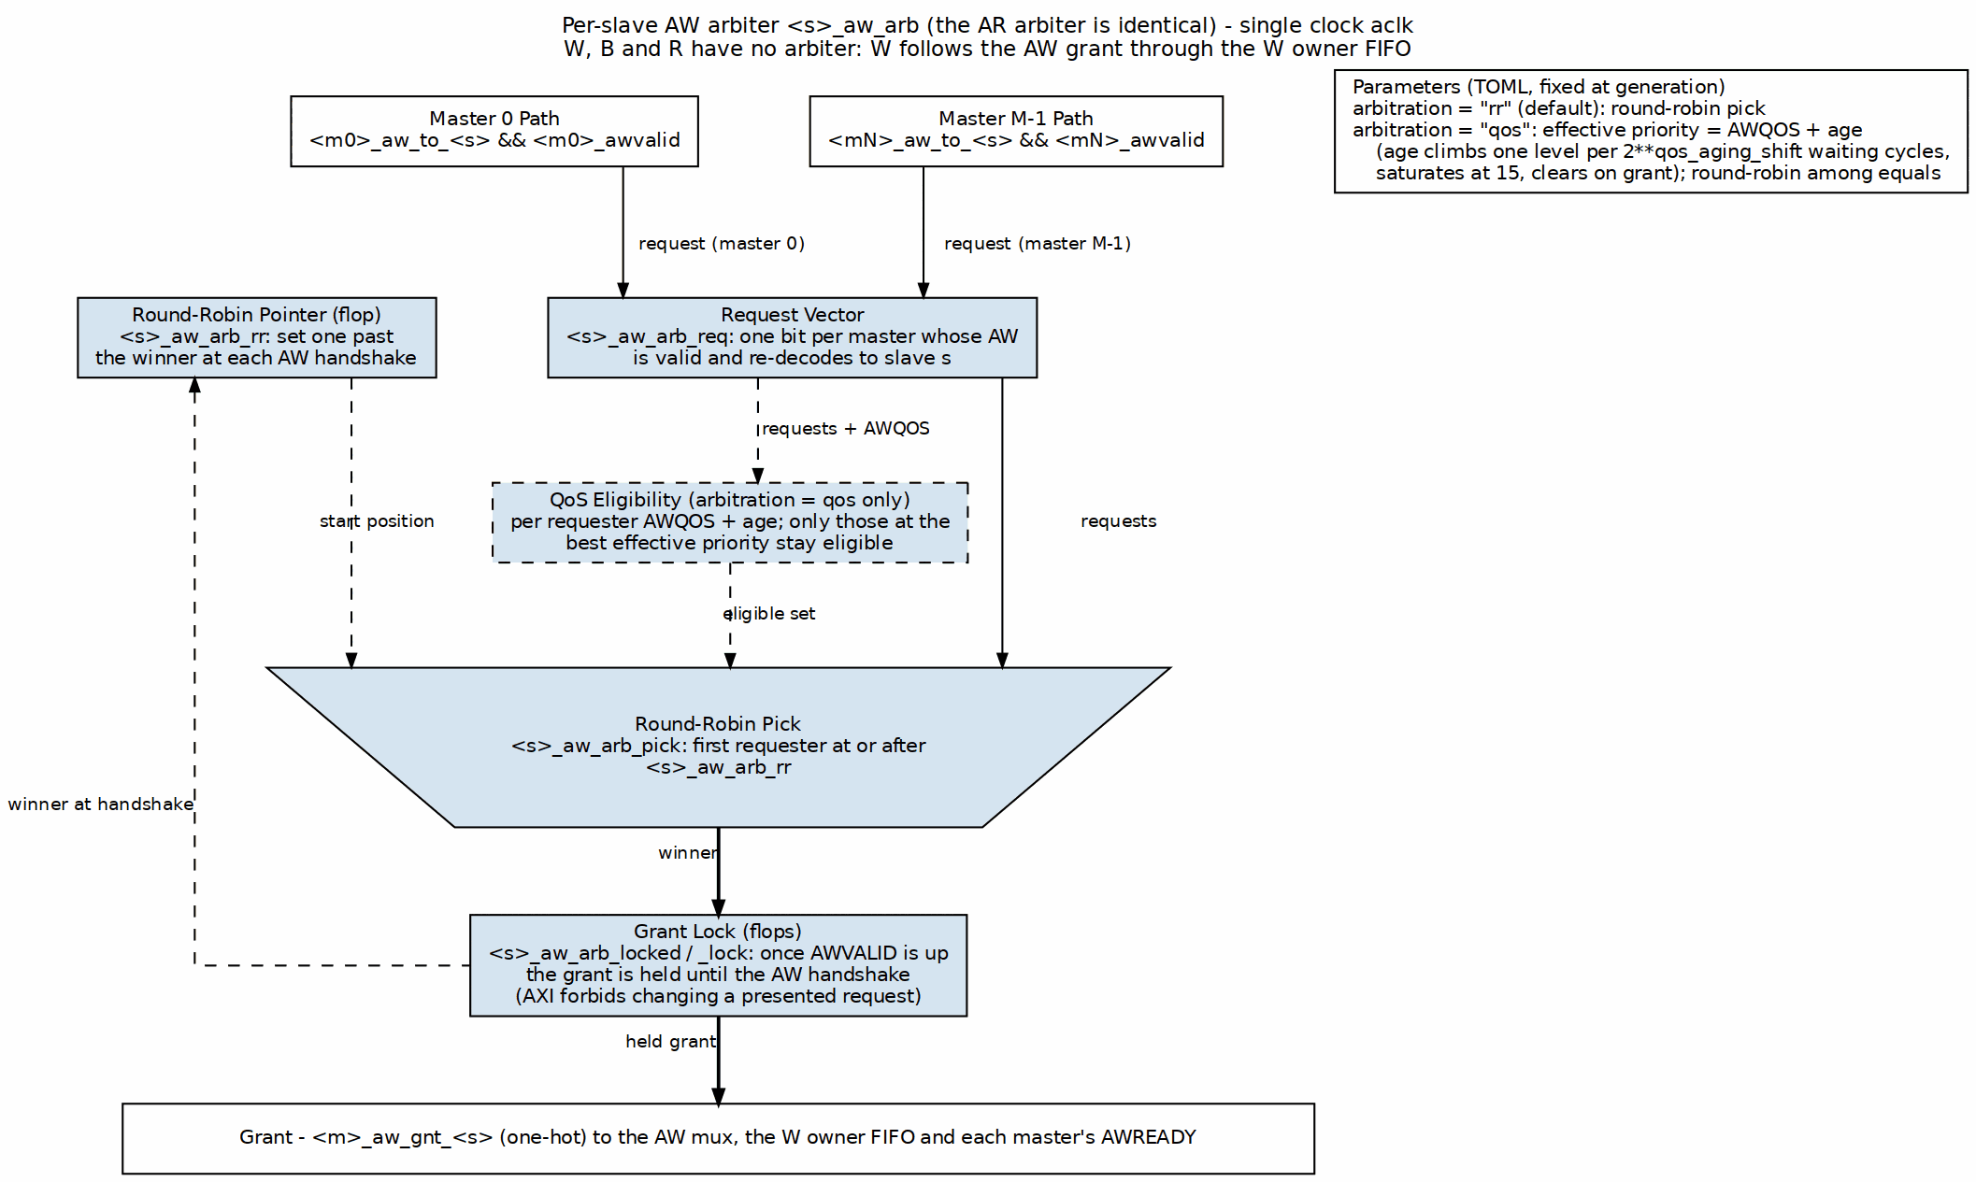
Per-Slave Address Arbiter
One AW arbiter as generated in <bridge>_xbar (the AR arbiter is identical). The request vector holds one bit per master whose AW is valid and re-decodes to this slave. The round-robin pick starts one past the last winner, and the grant is locked from AWVALID until the AW handshake, not until the burst’s last beat. With arbitration = "qos" a QoS-eligibility stage (dashed) narrows the pick to the requesters at the best AWQOS-plus-age priority.

7.3.4 Round-Robin Arbitration

7.3.4.1 Algorithm
The Round-Robin (RR) arbiter cycles through masters in order, giving each master one opportunity to access the slave:
Priority Order (rotates after each grant):
Cycle 0: M0 > M1 > M2 > M3
Cycle 1: M1 > M2 > M3 > M0 (M0 was granted, now lowest priority)
Cycle 2: M2 > M3 > M0 > M1 (M1 was granted)
Cycle 3: M3 > M0 > M1 > M2 (M2 was granted)
Cycle 4: M0 > M1 > M2 > M3 (M3 was granted, cycle repeats)

7.3.4.2 Implementation
// Simplified Round-Robin arbiter (4 masters)
logic [1:0] last_grant; // Which master was granted last
logic [3:0] request; // Current requests (VALID signals)
logic [1:0] grant; // Grant decision
always_ff @(posedge clk) begin
if (!rst_n) begin
last_grant <= 2'b00;
end else if (|request && slave_ready) begin
// Update last_grant when transaction completes
if (grant_accepted) begin
last_grant <= grant;
end
end
end
always_comb begin
// Default: No grant
grant = 2'b00;
// Priority encode starting after last grant
case (last_grant)
2'b00: begin // Last grant to M0, try M1, M2, M3, M0
if (request[1]) grant = 2'b01;
else if (request[2]) grant = 2'b10;
else if (request[3]) grant = 2'b11;
else if (request[0]) grant = 2'b00;
end
2'b01: begin // Last grant to M1, try M2, M3, M0, M1
if (request[2]) grant = 2'b10;
else if (request[3]) grant = 2'b11;
else if (request[0]) grant = 2'b00;
else if (request[1]) grant = 2'b01;
end
// ... similar for M2, M3
endcase
end

7.3.4.3 Characteristics
Fairness: Excellent - Each master gets equal access over time
Latency: Bounded - Maximum wait = (N-1) × transaction_time
Throughput: Optimal - No idle cycles when requests pending
Starvation: None - Every master eventually gets grant
Best Use Cases: - Peers with similar priority - General-purpose interconnects - Default choice for most bridges

7.3.5 Fixed-Priority Arbitration

7.3.5.1 Algorithm
The Fixed-Priority arbiter always grants to the highest-priority requesting master:
Priority Order (never changes):
M0 > M1 > M2 > M3 (M0 always highest priority)
Grant Decision:
if (M0_VALID) → Grant = M0
else if (M1_VALID) → Grant = M1
else if (M2_VALID) → Grant = M2
else if (M3_VALID) → Grant = M3

7.3.5.2 Implementation
// Fixed-priority arbiter (4 masters)
logic [3:0] request;
logic [1:0] grant;
always_comb begin
// Priority encoder: M0 highest, M3 lowest
if (request[0]) grant = 2'b00; // M0 highest priority
else if (request[1]) grant = 2'b01;
else if (request[2]) grant = 2'b10;
else if (request[3]) grant = 2'b11; // M3 lowest priority
else grant = 2'b00; // Default (no requests)
end

7.3.5.3 Characteristics
Fairness: Poor - Low-priority masters can starve
Latency: Variable - High-priority: minimal, Low-priority: unbounded
Throughput: Optimal - No idle cycles when requests pending
Starvation: Possible for low-priority masters
Best Use Cases: - Real-time systems with priority requirements - CPU (high) vs. DMA (low) scenarios - Time-critical masters need guaranteed access

7.3.5.4 Starvation Prevention
Optional enhancement: Priority aging
- Track cycles since last grant per master
- Temporarily boost priority of starved masters
- Reset age counter after grant
Example:
M0 age = 100 cycles → Boost M0 above normal priority
M1 age = 5 cycles → Normal priority

7.3.6 Weighted Arbitration

7.3.6.1 Algorithm
The Weighted arbiter assigns different access rates to masters based on weights:
Configuration:
M0 weight = 4 (50% of bandwidth)
M1 weight = 2 (25% of bandwidth)
M2 weight = 1 (12.5% of bandwidth)
M3 weight = 1 (12.5% of bandwidth)
Grant Sequence (repeating pattern):
M0, M0, M0, M0, M1, M1, M2, M3 (8 cycles total)
M0 gets 4/8, M1 gets 2/8, M2 gets 1/8, M3 gets 1/8

7.3.6.2 Implementation
// Weighted arbiter using credit counter
logic [7:0] credits [0:3]; // Credit counters per master
logic [1:0] grant;
always_ff @(posedge clk) begin
if (!rst_n) begin
credits[0] <= 8'd4; // M0 weight
credits[1] <= 8'd2; // M1 weight
credits[2] <= 8'd1; // M2 weight
credits[3] <= 8'd1; // M3 weight
end else if (grant_accepted) begin
// Decrement granted master's credits
credits[grant] <= credits[grant] - 1;
// Reload when all credits exhausted
if (all_credits_zero) begin
credits[0] <= 8'd4;
credits[1] <= 8'd2;
credits[2] <= 8'd1;
credits[3] <= 8'd1;
end
end
end
always_comb begin
// Grant to master with highest credits and active request
grant = select_highest_credit_with_request(credits, request);
end

7.3.6.3 Characteristics
Fairness: Configurable - Proportional to weights
Latency: Bounded - Depends on weight ratio
Throughput: Near-optimal - Small overhead for credit tracking
Starvation: None - All masters get share per weight
Best Use Cases: - QoS requirements (guaranteed bandwidth) - Mixed workload (video + CPU + DMA) - Service-level agreements

7.3.7 Burst Handling

7.3.7.1 Grant Locking
Once granted, a master holds the grant until its burst completes:
AR Channel Burst:
1. Master asserts ARVALID with ARLEN = 7 (8-beat burst)
2. Arbiter grants to this master
3. Grant held until slave returns RLAST
4. Other masters blocked during this time
AW/W Channel Burst:
1. Master asserts AWVALID with AWLEN = 15 (16-beat burst)
2. Arbiter grants to this master
3. Grant held until master asserts WLAST
4. Other masters blocked during W data transfer

7.3.7.2 Implementation
// Burst grant locking
logic grant_locked;
logic [1:0] locked_master;
always_ff @(posedge clk) begin
if (!rst_n) begin
grant_locked <= 1'b0;
end else begin
if (grant_accepted && !last_beat) begin
// Lock grant for burst
grant_locked <= 1'b1;
locked_master <= grant;
end else if (last_beat) begin
// Release grant when burst completes
grant_locked <= 1'b0;
end
end
end
assign grant = grant_locked ? locked_master : arbiter_decision;

7.3.7.3 Fairness Considerations
Long bursts can block other masters: - Maximum AXI burst: 256 beats - At 1 cycle/beat: Up to 256 cycles blocked - Impacts latency for other masters
Mitigation: - Limit burst lengths in master configuration - Use burst interleaving (complex, not implemented in Phase 1) - Monitor arbiter stall counters

7.4 Timing

7.4.1 Arbitration Latency
Single-Cycle Arbitration (default):
Request → Grant Decision: 1 cycle
Grant Decision → MUX Output: 0 cycles (combinatorial)
Total: 1 cycle
Multi-Cycle Arbitration (high frequency):
Request → Grant Decision: 2-3 cycles (pipelined)
Improves timing at cost of latency

7.4.2 Critical Paths
Typical critical paths in the arbiter: 1. Request collection: All master VALID signals → Arbiter input 2. Priority encode: Compare all requests → Grant decision 3. Grant propagate: Grant → MUX select → Slave interface
Path Depth: - 4 masters: ~6-8 logic levels - 8 masters: ~8-12 logic levels - 16 masters: ~12-16 logic levels

7.5 Design Notes

7.5.1 Resource Utilization
Round-Robin (4 masters):
Logic Elements: ~150 LEs
Registers: ~40 regs
Breakdown:
- Priority encoder: ~80 LEs
- Last grant tracking: ~10 regs
- Request capture: ~20 regs
- Grant FSM: ~40 LEs, ~10 regs
Fixed-Priority (4 masters):
Logic Elements: ~80 LEs
Registers: ~20 regs
Simpler than RR (no rotation logic)
Weighted (4 masters):
Logic Elements: ~200 LEs
Registers: ~60 regs
Additional credit counters and comparison logic
Scaling with Master Count — resource usage grows approximately O(N²) where N = master count:
2 masters: ~50 LEs
4 masters: ~150 LEs
8 masters: ~400 LEs
16 masters: ~1200 LEs
The N² scaling comes from: - Priority encoder: Compares all pairs of masters - Grant MUX: N-to-1 multiplexing increases with N

7.5.2 Performance Impact
Round-Robin: - Pros: Fair, starvation-free, predictable latency - Cons: Cannot prioritize time-critical masters - Use: General-purpose, peer masters
Fixed-Priority: - Pros: Guaranteed low latency for high-priority masters - Cons: Low-priority can starve, unpredictable for low-priority - Use: Real-time, priority-sensitive systems
Weighted: - Pros: Configurable bandwidth allocation, QoS support - Cons: More complex, small overhead - Use: Mixed workload, SLA requirements
Arbiter Efficiency — assuming all masters request the same slave continuously:
Best Case: 100% efficiency (one master)
- No arbitration conflicts
- Zero idle cycles
Typical Case: 25-50% per-master efficiency (4 masters, round-robin)
- Each master gets ~25% of time grants
- Load balancing to other slaves improves
Worst Case: Heavy contention
- 4 masters to 1 slave: 25% efficiency per master
- Solution: Add slaves or use more slaves in parallel

7.5.3 Debug and Observability
Recommended debug signals and counters:
Per Arbiter:
- Request vector (all masters requesting)
- Grant decision (which master granted)
- Grant locked status (burst in progress)
- Last grant (for RR rotation tracking)
Performance Counters:
- Grants per master (utilization)
- Denied requests per master (contention)
- Average grant latency per master
- Arbiter conflict cycles (multiple requests, one grant)

7.5.4 Common Issues
Symptom: Master never gets grant (starvation)
Check: - Arbiter type (fixed-priority can starve low-priority masters) - Other masters continuously requesting? - Enable priority aging if using fixed-priority
Symptom: Unfair access (one master dominates)
Check: - Arbiter type (should be round-robin for fairness) - Burst lengths (long bursts block others) - Request patterns (one master requesting more frequently)
Symptom: Low throughput despite requests
Check: - Arbiter conflicts (too many masters to one slave) - Pipeline depth (excessive arbitration latency) - Burst efficiency (short bursts waste cycles)

7.5.5 Future Enhancements
Planned Features: - Dynamic Weight Adjustment: Runtime-configurable weights via registers - QoS Classes: Multiple priority levels with configurable policies - Deadline-Based Arbitration: Grant based on transaction deadlines - Predictive Arbitration: Speculative grants to reduce latency
Under Consideration: - Multi-Level Arbitration: Hierarchical for >16 masters - Token Bucket: Rate limiting per master - History-Based: Learn access patterns and optimize grants - ECC Protection: For arbitration state (safety-critical systems)

7.6 Related Modules
- Section 2.3: Crossbar Core (arbiter integration)
- Section 2.1: Master Adapter (request sources)
- Section 2.5: ID Management (transaction tracking during grants)
- Chapter 6: Performance (arbiter impact on throughput)

7.7 Testing

7.7.1 Test Scenarios
- Fair Access Test (Round-Robin):
- All masters continuously request same slave
- Verify each master gets equal grants over 1000 cycles
- Expected: Each of 4 masters gets ~250 grants
- Priority Test (Fixed-Priority):
- High-priority master requests intermittently
- Low-priority masters request continuously
- Verify high-priority always wins when requesting
- Burst Locking Test:
- Master issues 16-beat burst
- Other masters request during burst
- Verify grant held until LAST
- Verify other masters blocked during burst
- Weighted Bandwidth Test:
- Configure M0=4, M1=2, M2=1, M3=1
- All masters request continuously for 10000 cycles
- Verify grants proportional: M0≈50%, M1≈25%, M2≈12.5%, M3≈12.5%

7.7.2 Corner Cases
- Single master requesting (trivial grant)
- All masters requesting simultaneously (worst-case arbitration)
- Grant released and new grant same cycle (back-to-back)
- Master drops request after arbiter latency (stale grant)
- Maximum length burst (256 beats blocking)

RTL Design Sherpa · Learning Hardware Design Through Practice GitHub · Documentation Index · MIT License

8 2.5 ID Management
ID Management is how the bridge remembers which master sent each outstanding transaction, so the response can find its way back.

8.1 Overview
Before anything else in this chapter, read this — it colors everything below:
What the generated bridge actually does (measured against rtl/generated/). Two mechanisms, both in Figure 2.5:
- The ID is widened. The master adapter sends {BRIDGE_ID, id} into the fabric (bridge TASK-005), so IDs are unique across masters: in bridge_2x2_rw, cpu_m_axi_awid is 4 bits and ddr_s_axi_awid is 5. The response muxes return the low bits to the master.
- Each slave adapter tracks the originating master. The granted master’s index rides beside the request as xbar_bridge_id_aw / xbar_bridge_id_ar and is written into the slave adapter’s tracker at the address handshake. An AXI4 / AXI5 slave of a multi-master bridge (or any slave with enable_ooo) gets bridge_cam (u_wr_cam / u_rd_cam), keyed by the AXI ID and looked up with the returned BID / RID, so the slave may complete different IDs in any order. A single-master bridge, the protocol shims and the catch-all keep an in-order bridge_id FIFO, which requires the slave to answer in request order (bridge BUG-008’s simulation-only check flags a violation).
Either tracker is fixed-depth (16), so the address handshake is gated on it being not full (bridge BUG-009).
An earlier revision of this chapter said there was no CAM, that IDs passed through at equal width, and that everything below described a design that was never built. The prefix and the CAM are both built; the sections below say, per item, what the generated RTL does and what was only ever proposed.
The ID management system does four things:
- Transaction Tracking: each slave adapter records which master issued each outstanding request
- Response Routing: the crossbar steers B / R by the recorded master index (bid_bridge_id / rid_bridge_id)
- Out-of-Order Support: a CAM-tracked slave may return different IDs in any order
- ID Space Isolation: the {BRIDGE_ID, id} prefix keeps two masters’ IDs distinct at every slave

8.1.1 Figure 2.5: ID Management Architecture
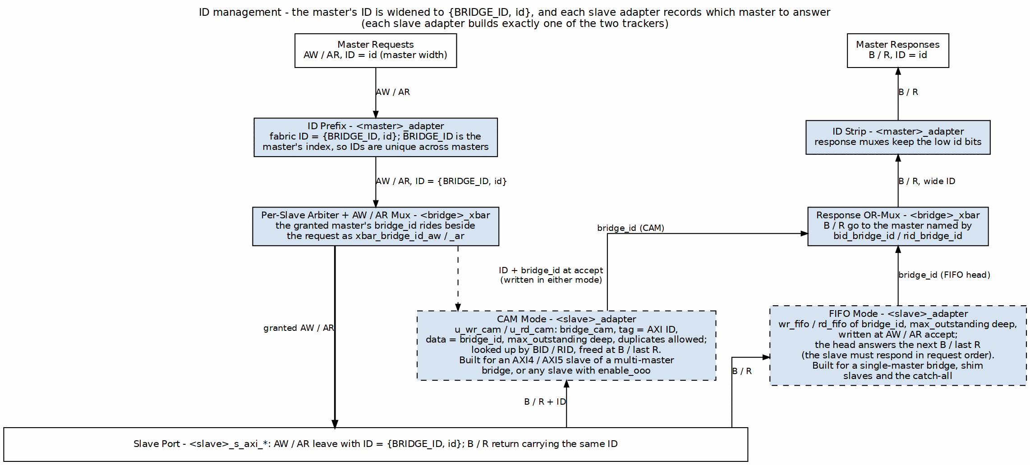
ID Management Architecture
The request takes the center column, widened to {BRIDGE_ID, id} in the master adapter and granted with its bridge_id in the crossbar. The response climbs the right side: the slave adapter’s tracker (CAM or FIFO, dashed because each slave builds exactly one) names the master, and the crossbar and master adapter return B / R with the master’s own id bits.

8.2 Parameters
There is no [bridge.id_management] table and no enable_cam, cam_type, cam_depth or max_outstanding_* key; config_validator rejects unknown keys. What decides ID handling:
[[bridge.masters]]
name = "cpu"
id_width = 4 # master-side ID width
[[bridge.slaves]]
name = "ddr"
id_width = 5 # must be >= widest master id_width + $clog2(num_masters)
enable_ooo = false # true forces bridge_cam on this slave even with one master
Derived, not configured (emitted into <bridge>_pkg.sv):
Parameters
Constant | Value | bridge_2x2_rw
BRIDGE_ID_WIDTH | $clog2(NUM_MASTERS), minimum 1 | 1
MASTER_ID_WIDTH | widest master id_width | 4
ID_PREFIX_WIDTH | $clog2(NUM_MASTERS), 0 for one master | 1
XBAR_ID_WIDTH | MASTER_ID_WIDTH + ID_PREFIX_WIDTH | 5
The tracker choice is fixed by the generator (SlaveAdapterGenerator.use_cam): bridge_cam when the slave sets enable_ooo, or when the bridge has more than one master and the slave is a real axi4 / axi5 port; an in-order FIFO otherwise (single master, apb/axil/wb shim slaves, the internal subtractive slave).

8.3 Functional Description

8.3.1 Bridge ID Concept
Problem – two masters may use the same AXI ID:
Master 0: ARID = 4'h5
Master 1: ARID = 4'h5
A slave returning RID = 4'h5 cannot say which master it answers.
Solution (built) – the master adapter prepends its index:
fabric ID = {BRIDGE_ID, master ID}
Master 0, ARID = 4'h5 -> 5'b0_0101
Master 1, ARID = 4'h5 -> 5'b1_0101 (bridge_2x2_rw)

8.3.2 ID Width Calculation
ID_PREFIX_WIDTH = $clog2(NUM_MASTERS) (0 for a single master)
2 masters: 1 bit 3-4 masters: 2 bits
5-8 masters: 3 bits 9-16 masters: 4 bits
4 masters, 4-bit master IDs: slave ports see 6-bit IDs, masters see 4.

8.3.3 Multi-Master OR-Merge Gating
Every slave-side address, ID and bridge_id field is an OR of per-master terms, each gated by that master’s AW / AR arbiter grant for the slave, so an idle master with a stale address contributes nothing:
// bridge_2x2_rw_xbar.sv
assign ddr_axi_bridge_id_aw = (cpu_32b_aw_gnt_ddr ? cpu_bridge_id_aw : '0) |
(dma_32b_aw_gnt_ddr ? dma_bridge_id_aw : '0);
The grant already implies the master is valid and decoded to this slave. An ungated OR let an idle master’s zero bridge_id corrupt the routing tag and send a B to the wrong master.

8.3.4 ID Injection (Request Path, built)
// <master>_adapter.sv
assign xbar_axi_awid = {BRIDGE_ID_WIDTH'(BRIDGE_ID), MASTER_ID_WIDTH'(fub_axi_awid)};
assign xbar_axi_arid = {BRIDGE_ID_WIDTH'(BRIDGE_ID), MASTER_ID_WIDTH'(fub_axi_arid)};
BRIDGE_ID is the per-instance master index. The concatenation is wiring and adds no cycle. There is no “registered injection” option. A single-master bridge prepends nothing.

8.3.5 ID Stripping and Response Routing (built)
The response is NOT routed by decoding the prefix bits of BID / RID. The slave adapter returns the originating master’s index on a sideband (bid_bridge_id / rid_bridge_id, with bid_valid / rid_valid), and the crossbar’s B / R muxes select on it:
// bridge_2x2_rw_xbar.sv (B toward cpu, master index 0)
((ddr_axi_bid_bridge_id == 0) && ddr_axi_bid_valid ? ddr_axi_bid : '0) | ...
The master adapter then returns the low MASTER_ID_WIDTH bits (fub_axi_bid = cpu_32b_b.id[3:0]), so the master sees its own ID.

8.3.6 Content Addressable Memory: bridge_cam (built)
rtl/bridge_cam.sv is hand-written and instantiated twice (u_wr_cam, u_rd_cam) in each CAM-tracked slave adapter:
Content Addressable Memory: bridge_cam
Parameter | Value in the slave adapter
TAG_WIDTH | ID_WIDTH (fabric ID width, 5 in bridge_2x2_rw)
DATA_WIDTH | BRIDGE_ID_WIDTH
DEPTH | the slave’s max_outstanding (default 16, GitHub #119 L5)
ALLOW_DUPLICATES | 1 (same ID may be outstanding more than once; oldest freed first)
PIPELINE_EVICT | 0 (lookup result in the same cycle)
PIPELINE_ALLOC | 1 (registered insert: the match and count run the cycle after the handshake; a response in that cycle still finds the pending entry)
PIPELINE_FREE | 1 (registered free: the lookup still routes the response this cycle; the entry free and same-ID decrements land the next)
Operation:
Allocate: on the AW / AR handshake from the crossbar
tag = awid / arid, data = xbar_bridge_id_aw / _ar
Deallocate: write on B handshake; read on the R handshake with RLAST
tag = bid / rid -> deallocate_data = bid_bridge_id / rid_bridge_id
Full: tags_full gates the crossbar-side AWREADY / ARREADY (bridge BUG-009);
it counts a pending insert and frees a slot a cycle after the
response, so it is early, never late
The insert and free registers (GitHub #119) take the CAM’s match-and-count logic out of the crossbar’s grant path and out of the response path. The mechanism and the bypass that keeps them correct: CAM Architecture, Figure 4.2.
An entry holds only the tag, the master index and the duplicate-ordering count. There is no timestamp, transaction-type field or timeout, and only the parallel, distributed-RAM form exists; the sequential-search and BRAM-based CAM variants this chapter once compared were never built.

8.3.7 In-Order FIFO Tracker (built)
Slaves that do not get the CAM keep a max_outstanding-entry (default 16) FIFO of bridge_id, pushed on the address handshake and popped on B / RLAST. Routing uses the FIFO head, so such a slave must complete in request order; a simulation-only check flags a returned ID that does not match the head (bridge BUG-008). The same not-full gate applies.

8.3.8 Outstanding Transaction Limits
The limit per slave is the tracker depth: max_outstanding writes and max_outstanding reads (default 16 each) outstanding at each slave adapter, CAM or FIFO. When the tracker is full the slave’s AWREADY / ARREADY toward the crossbar drops until a response frees an entry. There is no per-master outstanding limit key.

8.4 Timing
- ID injection / stripping: 0 cycles (concatenation and bit-select).
- CAM lookup: 0 added cycles (PIPELINE_EVICT = 0; the deallocate data is combinational in the response cycle).
- CAM insert / free: 0 added cycles on any request or response. The registered insert and free are internal; a response the cycle after its request is routed from the pending entry. The only visible effect is tags_full releasing a slot one cycle after the response.
- FIFO head: 0 added cycles.
The measured end-to-end latency (2 cycles each way in bridge_2x2_rw, HAS Table 5.7) includes whichever tracker the slave uses.

8.5 Design Notes

8.5.1 Resource Utilization
The per-master prefix is wiring. Each CAM-tracked slave adapter carries two bridge_cam instances (16 entries at the default max_outstanding) built in distributed RAM and flops (no block RAM); the FIFO tracker is two 16-entry FIFOs of BRIDGE_ID_WIDTH bits. Measured totals for the fixtures are in HAS 5.3.

8.5.2 Debug and Observability
Request: fub_axi_awid / arid vs xbar_axi_awid / arid (prefix added)
Slave: xbar_bridge_id_aw / _ar at the address handshake
CAM: u_wr_cam / u_rd_cam tags_count, tags_full, deallocate_valid
Response: bid_bridge_id / rid_bridge_id with bid_valid / rid_valid

8.5.3 Common Issues
Response goes to the wrong master - FIFO-tracked slave completing out of order (look for the BUG-008 check message) - Slave truncating the ID: its id_width must be at least XBAR_ID_WIDTH (the validator enforces this for axi3/axi4/axi5 slaves)
Address channel stalls - Tracker full: 16 outstanding at that slave with no B / RLAST returning - A hung slave stalls its path indefinitely; there is no timeout in the bridge
deallocate_valid low on a response - The slave returned an ID it was never sent

8.6 Related Modules
- Section 2.1: Master Adapter (prefix injection and stripping)
- Section 2.3: Crossbar Core (grant-gated OR-merge, B / R muxes)
- Section 2.8: Response Routing
- HAS ch04_interfaces/01_axi4_interface.md (port ID widths)

8.7 Testing
- Multi-master ID isolation: two masters issue the same ID to one slave; each response returns to its own master with the original ID.
- Out-of-order at a CAM slave: the slave answers IDs out of request order; each response still reaches its master (the mix_b / mix_d arbitration tests exercise this).
- Tracker capacity: 16 outstanding at one slave holds off the 17th address until a response frees an entry (bridge BUG-009 tests).
- Timeout: not testable – there is no timeout in the bridge. The system-level answer is a watchdog outside it.

RTL Design Sherpa · Learning Hardware Design Through Practice GitHub · Documentation Index · MIT License

9 2.6 Width Conversion
Masters and slaves rarely agree on data width, and width conversion is how the bridge copes. There is NO fixed internal width — each path carries its port’s own width, and converters sit only at the boundaries where two ports disagree. bridge_4x4_rw alone instantiates paths at 32, 64, 128 and 256 bits.

9.1 2.6.1 Purpose and Function
Width conversion has five jobs:
- Data Path Adaptation: Converts between different data widths (8, 16, 32, 64, 128, 256 bits)
- Burst Splitting: Divides wide transactions into multiple narrow transactions
- Burst Merging: Combines multiple narrow beats into fewer wide beats
- Strobe Mapping: Translates write strobes across width boundaries
- Address Alignment: Adjusts addresses for width differences

9.2 2.6.2 Internal Data Width

9.2.1 64-Bit Standard
The bridge uses 64-bit (8-byte) internal data width for the crossbar:
Rationale:
- Balance between resource usage and performance
- Common width for modern embedded processors
- Efficient for both 32-bit and 64-bit masters
- Reasonably sized multiplexers in crossbar

9.2.2 Width Conversion Locations
Converters live in the master adapter, one per distinct slave width the master reaches, so a path only pays for conversion when its two ends actually disagree. There is no fixed crossbar width:
- a 64-bit master reaching a 64-bit slave takes a direct passthrough path;
- the same master reaching a 512-bit slave goes through one axi4_dwidth_converter_wr / _rd pair set to UPSIZE;
- reaching a 32-bit slave, through one pair set to DOWNSIZE.
Each master-slave pair is converted at most once.

9.3 2.6.3 Block Diagram

9.3.1 Figure 2.6: Width Conversion Architecture
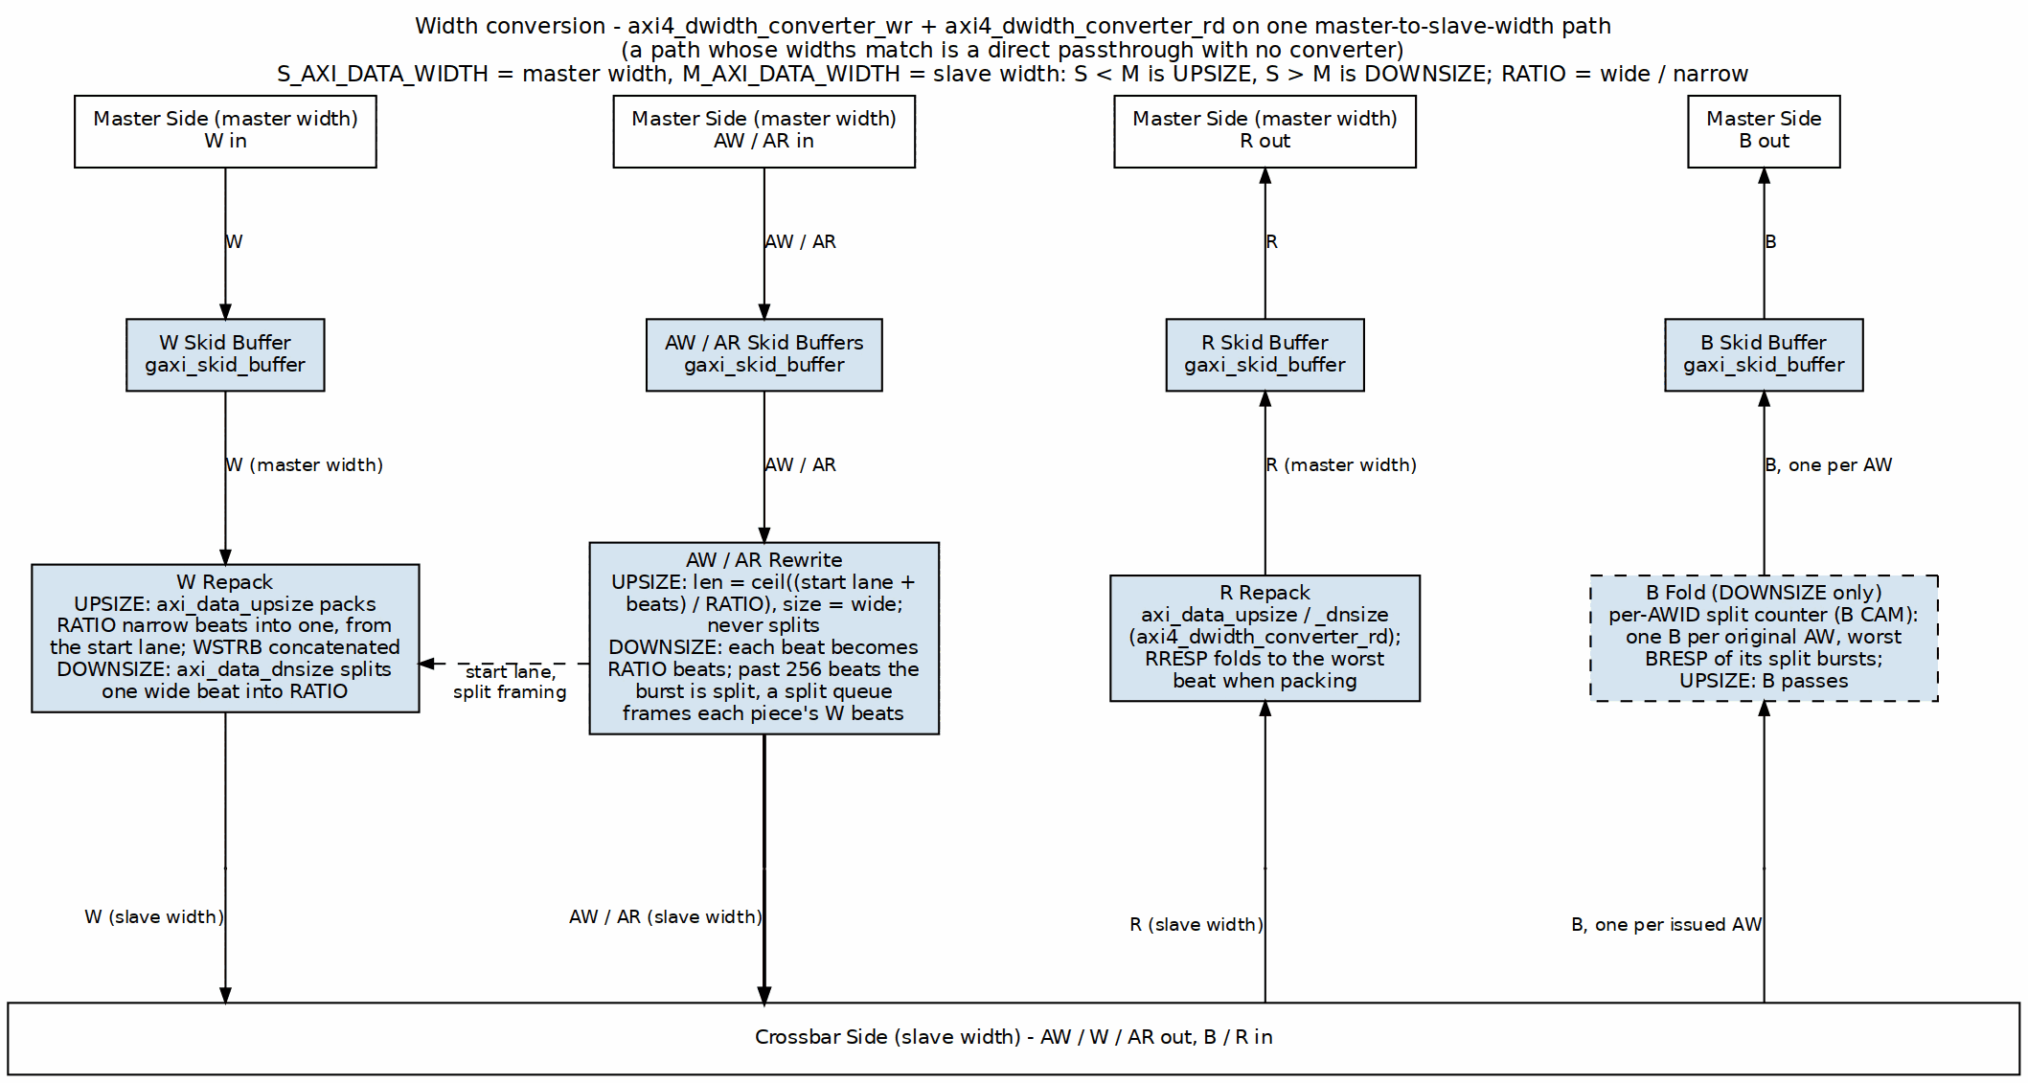
Width Conversion Architecture
One converter pair on one master-to-slave-width path. Every channel enters a skid buffer; W and R are repacked by axi_data_upsize / axi_data_dnsize; AW / AR length and size are rewritten (a DOWNSIZE burst that would exceed 256 beats is split, and a split queue frames its W beats); and in DOWNSIZE the B fold returns one B per original AW.

9.4 2.6.4 Upsizing (Narrow to Wide)

9.4.1 Overview
Upsizing converts narrow data to wide data by buffering multiple narrow beats into a single wide beat:
Example: 32-bit master → 64-bit crossbar
Master beat 0: 32'hAAAA_BBBB (bytes 3:0)
Master beat 1: 32'hCCCC_DDDD (bytes 7:4)
→ Crossbar beat: 64'hCCCC_DDDD_AAAA_BBBB

9.4.2 Write Upsizing
Burst of 4 (32-bit) → Burst of 2 (64-bit) — two master beats pack into each crossbar beat, and the burst length halves:
Master AW: AWADDR = 0x1000, AWLEN = 3, AWSIZE = 2 (4 bytes)
Master W beats:
W[0]: WDATA = 0xAAAA_BBBB, WSTRB = 4'b1111, WLAST = 0
W[1]: WDATA = 0xCCCC_DDDD, WSTRB = 4'b1111, WLAST = 0
W[2]: WDATA = 0xEEEE_FFFF, WSTRB = 4'b1111, WLAST = 0
W[3]: WDATA = 0x1111_2222, WSTRB = 4'b1111, WLAST = 1
Crossbar AW: AWADDR = 0x1000, AWLEN = 1, AWSIZE = 3 (8 bytes)
Crossbar W beats:
W[0]: WDATA = 0xCCCC_DDDD_AAAA_BBBB, WSTRB = 8'b1111_1111, WLAST = 0
W[1]: WDATA = 0x1111_2222_EEEE_FFFF, WSTRB = 8'b1111_1111, WLAST = 1

9.4.3 Read Upsizing
Burst of 8 (32-bit) → Burst of 4 (64-bit) — the same trick in reverse, where each wide crossbar beat fans back out into two narrow master beats:
Master AR: ARADDR = 0x2000, ARLEN = 7, ARSIZE = 2 (4 bytes)
Crossbar AR: ARADDR = 0x2000, ARLEN = 3, ARSIZE = 3 (8 bytes)
Crossbar R beats:
R[0]: RDATA = 0x1111_2222_3333_4444, RLAST = 0
R[1]: RDATA = 0x5555_6666_7777_8888, RLAST = 0
R[2]: RDATA = 0x9999_AAAA_BBBB_CCCC, RLAST = 0
R[3]: RDATA = 0xDDDD_EEEE_FFFF_0000, RLAST = 1
Master R beats (split from crossbar):
R[0]: RDATA = 0x3333_4444, RLAST = 0 (from R[0] low)
R[1]: RDATA = 0x1111_2222, RLAST = 0 (from R[0] high)
R[2]: RDATA = 0x7777_8888, RLAST = 0 (from R[1] low)
R[3]: RDATA = 0x5555_6666, RLAST = 0 (from R[1] high)
R[4]: RDATA = 0xBBBB_CCCC, RLAST = 0 (from R[2] low)
R[5]: RDATA = 0x9999_AAAA, RLAST = 0 (from R[2] high)
R[6]: RDATA = 0xFFFF_0000, RLAST = 0 (from R[3] low)
R[7]: RDATA = 0xDDDD_EEEE, RLAST = 1 (from R[3] high)

9.4.4 Strobe Mapping (Upsizing)
Strobes accumulate right alongside the data — each narrow WSTRB lands in the half of the wide word its beat occupied:
32-bit WSTRB → 64-bit WSTRB:
Beat 0 (lower 32 bits):
32-bit WSTRB = 4'b1010 → 64-bit WSTRB = 8'b0000_1010
Beat 1 (upper 32 bits):
32-bit WSTRB = 4'b1111 → 64-bit WSTRB = 8'b1111_0000
Combined:
64-bit WSTRB = 8'b1111_1010

9.5 2.6.5 Downsizing (Wide to Narrow)

9.5.1 Overview
Downsizing converts wide data to narrow data by splitting a single wide beat into multiple narrow beats:
Example: 128-bit master → 64-bit crossbar
Master beat: 128'h1111_2222_3333_4444_5555_6666_7777_8888
→ Crossbar beat 0: 64'h5555_6666_7777_8888 (lower)
→ Crossbar beat 1: 64'h1111_2222_3333_4444 (upper)

9.5.2 Write Downsizing
Burst of 2 (128-bit) → Burst of 4 (64-bit):
Master AW: AWADDR = 0x3000, AWLEN = 1, AWSIZE = 4 (16 bytes)
Master W beats:
W[0]: WDATA = 0xAAAA...(128 bits), WSTRB = 16'hFFFF, WLAST = 0
W[1]: WDATA = 0xBBBB...(128 bits), WSTRB = 16'hFFFF, WLAST = 1
Crossbar AW: AWADDR = 0x3000, AWLEN = 3, AWSIZE = 3 (8 bytes)
Crossbar W beats:
W[0]: WDATA = 0xAAAA_low(64), WSTRB = 8'hFF, WLAST = 0
W[1]: WDATA = 0xAAAA_high(64), WSTRB = 8'hFF, WLAST = 0
W[2]: WDATA = 0xBBBB_low(64), WSTRB = 8'hFF, WLAST = 0
W[3]: WDATA = 0xBBBB_high(64), WSTRB = 8'hFF, WLAST = 1

9.5.3 Read Downsizing
Burst of 1 (128-bit) → Burst of 2 (64-bit):
Master AR: ARADDR = 0x4000, ARLEN = 0, ARSIZE = 4 (16 bytes)
Crossbar AR: ARADDR = 0x4000, ARLEN = 1, ARSIZE = 3 (8 bytes)
Crossbar R beats:
R[0]: RDATA = 0x1111_2222_3333_4444, RLAST = 0
R[1]: RDATA = 0x5555_6666_7777_8888, RLAST = 1
Master R beat (merged):
R[0]: RDATA = 0x5555_6666_7777_8888_1111_2222_3333_4444, RLAST = 1

9.5.4 Strobe Mapping (Downsizing)
A 128-bit bus has 16 strobe bits, one per byte lane; a 64-bit bus has 8. On a 2:1 downsize each wide beat becomes two narrow beats, and the strobes split along the same boundary as the data — the low 8 bits go with beat 0, the high 8 with beat 1. No bit is recomputed; the slice is positional.
128-bit WSTRB → 64-bit WSTRB (2:1 split):
wide WSTRB = 16'b1111_0000_0000_1111 (bytes 15:12 and 3:0 written)
Beat 0 (bytes 7:0) = wide[7:0] = 8'b0000_1111
Beat 1 (bytes 15:8) = wide[15:8] = 8'b1111_0000
The example this replaces was arithmetically impossible: it wrote a 32-bit value (16'hF0F0_0FF0) into a 16-bit literal, then gave both beats the same result (8'hF0) from different bit patterns, one of them an 8-bit literal holding three hex digits (8'h0F0). Nothing in the RTL was needed to see it was wrong.

9.6 2.6.6 Address Alignment

9.6.1 Address Adjustment for Width
Change the width and the address has to align to the new beat size:
32-bit (4-byte) aligned address: 0x1004
Upsized to 64-bit (8-byte): 0x1000 (round down to 8-byte boundary)
Narrow access at 0x1004 within 64-bit word:
- Byte offset = 0x1004 & 0x7 = 4
- Data at bytes [7:4] of 64-bit word
- Lower bytes [3:0] unused (WSTRB = 8'b1111_0000)

9.6.2 Unaligned Access Handling
When a master issues an access that isn’t aligned to its own width, there are three ways to play it:
Master: 32-bit, unaligned access at 0x1002
Problem: Not aligned to 4-byte boundary
Options:
1. Error response (strict mode)
2. Round down address, use WSTRB for actual bytes
3. Split into multiple aligned accesses
Bridge default: Option 2 (use WSTRB)

9.7 2.6.7 Burst Length Adjustment

9.7.1 Length Calculation
The AXI length field is beats-minus-one, so the conversion works out like this:
Formula:
New_Length = (Old_Length + 1) × (Old_Width / New_Width) - 1
Example: Upsizing 32→64
Old: AWLEN = 7 (8 beats), WIDTH = 32
New: AWLEN = (7+1) × (32/64) - 1 = 8 × 0.5 - 1 = 3 (4 beats)
Example: Downsizing 128→64
Old: ARLEN = 3 (4 beats), WIDTH = 128
New: ARLEN = (3+1) × (128/64) - 1 = 4 × 2 - 1 = 7 (8 beats)

9.7.2 Odd Burst Lengths
When the burst doesn’t divide evenly, the last wide beat runs partial and the strobes say which bytes are real:
Example: 3 beats of 32-bit → 64-bit
3 beats × 4 bytes = 12 bytes total
12 bytes / 8 bytes per beat = 1.5 beats
Solution:
- Beat 0: Full 64-bit (8 bytes)
- Beat 1: Partial 64-bit (4 bytes, WSTRB = 8'b0000_1111)
- AWLEN = 1 (2 beats)

9.8 2.6.8 Resource Utilization

9.8.1 Per-Converter Resources
32→64 Upsizer:
Logic Elements: ~300 LEs
Registers: ~100 regs (buffering + FSM)
Block RAM: 0
Breakdown:
- Data buffer (32 bits): ~32 regs
- Strobe buffer: ~4 regs
- Beat counter: ~8 regs
- Control FSM: ~50 LEs, ~20 regs
- MUX logic: ~150 LEs
64→32 Downsizer:
Logic Elements: ~250 LEs
Registers: ~120 regs
Block RAM: 0
Similar structure but includes split logic
128→64 Downsizer:
Logic Elements: ~400 LEs
Registers: ~180 regs
Block RAM: 0
Larger data paths, more complex MUX

9.8.2 Scaling
Three things drive the cost:
- Width ratio: 2:1 vs. 4:1 vs. 8:1 conversion
- Data width: 128-bit vs. 256-bit buffers
- Buffering depth: Single vs. multi-beat buffering

9.9 2.6.9 Timing Characteristics

9.9.1 Latency
Upsizing (combining beats): - Buffering latency: 1-2 cycles (wait for N narrow beats) - First beat output: After receiving required narrow beats - Example: 32→64 requires 2 master beats before 1 crossbar beat
Downsizing (splitting beats): - Minimal latency: 1 cycle (register stage) - First beat output: Immediately (split from wide beat) - Example: 128→64 outputs first 64-bit beat immediately

9.9.2 Throughput
Upsizing Throughput:
32→64 upsizing:
Master: 32 bits/cycle = 4 bytes/cycle
Crossbar: 64 bits per 2 cycles = 4 bytes/cycle (same)
No throughput loss
Downsizing Throughput:
128→64 downsizing:
Master: 128 bits/cycle = 16 bytes/cycle
Crossbar: 64 bits/cycle = 8 bytes/cycle
Throughput halved (crossbar becomes bottleneck)
Upsizing is free; downsizing costs you the width ratio. Keep that asymmetry in mind when you pick port widths.

9.10 2.6.10 Configuration Parameters

9.10.1 Width Conversion Configuration (TOML)
[bridge]
# internal_data_width: NOT A KEY -- there is no fixed internal crossbar width.
enable_width_conversion = true # Allow width differences
[[bridge.masters]]
name = "cpu_32bit"
data_width = 32 # Narrower than crossbar (upsizing)
addr_width = 32
[[bridge.masters]]
name = "dma_64bit"
data_width = 64 # Matches crossbar (no conversion)
addr_width = 32
[[bridge.masters]]
name = "gpu_128bit"
data_width = 128 # Wider than crossbar (downsizing)
addr_width = 36
[[bridge.slaves]]
name = "memory_64bit"
data_width = 64 # Matches crossbar (no conversion)
[[bridge.slaves]]
name = "periph_32bit"
data_width = 32 # Narrower than crossbar (downsizing)

9.11 2.6.11 Debug and Observability

9.11.1 Recommended Debug Signals
When a conversion path misbehaves, these are the signals to pull into the waveform first:
Upsizer:
- Beat accumulator (partial wide beat being assembled)
- Beat counter (position in burst)
- Buffer valid (accumulated beats ready)
- Strobe accumulation
Downsizer:
- Beat splitter state (which sub-beat currently outputting)
- Remaining beats to output
- Source data register

9.11.2 Common Issues and Debug
Symptom: Data corruption after width conversion
Check: - Byte ordering (endianness) - Strobe mapping (correct bytes enabled) - Address alignment - Burst length calculation
Symptom: Stalls after width conversion
Check: - Buffer depths (upsizer needs buffering) - Backpressure propagation - LAST signaling
Symptom: Incorrect burst lengths
Check: - Length calculation formula - Odd burst handling - SIZE field matching width

9.12 2.6.12 Verification Considerations

9.12.1 Test Scenarios
- Power-of-2 Width Ratios:
- 32→64 (2:1)
- 64→128 (1:2)
- 32→128 (4:1)
- Various Burst Lengths:
- Single beat (ALEN=0)
- Even bursts (ALEN=3, 7, 15)
- Odd bursts (ALEN=1, 5, 9)
- Sub-Word Accesses:
- Byte writes (WSTRB with individual bytes)
- Half-word, word accesses
- Unaligned accesses
- Mixed Widths:
- 32-bit master → 64-bit crossbar → 32-bit slave
- 128-bit master → 64-bit crossbar → 32-bit slave
- All width combinations

9.13 2.6.13 Performance Considerations

9.13.1 Conversion Overhead
Upsizing Overhead: - Buffering latency: +1-2 cycles - Throughput maintained - Best for burst-oriented masters
Downsizing Overhead: - Split latency: +1 cycle - Throughput reduced by width ratio - Can bottleneck wide masters

9.13.2 Optimization Strategies
- Match Common Widths: match a master to its slave’s width, so no converter is inserted on that path. There is no single internal width to match.
- Burst Sizing: Use appropriate burst lengths for width ratios
- Parallel Paths: Multiple 32-bit masters can aggregate to 64-bit crossbar bandwidth
- Selective Conversion: Only convert where necessary

9.14 2.6.14 Future Enhancements

9.14.1 Planned Features
- Configurable Internal Width: Support 32, 64, 128, 256-bit crossbar
- Multi-Beat Buffering: Deeper upsizing buffers for smoother flow
- Byte Rotation: Handle unaligned access more efficiently
- Pipelined Conversion: Multi-stage for high frequency

9.14.2 Under Consideration
- Asymmetric Widths: Different widths for read vs. write paths
- Sparse Data Optimization: Skip unused bytes in conversions
- Tagged Data: Metadata preservation through width conversion
- Zero-Copy Bypass: Direct routing for matching widths

Related Sections: - Section 2.1: Master Adapter (upsizing location) - Section 2.3: Crossbar Core (internal data width) - HAS ch06_integration/02_parameters.md (per-port data_width) - HAS ch06_integration/02_parameters.md (per-port data_width)

RTL Design Sherpa · Learning Hardware Design Through Practice GitHub · Documentation Index · MIT License

10 2.7 Protocol Conversion
The crossbar speaks AXI4 internally. Protocol conversion is what lets the bridge reach slaves that speak something simpler — APB (Advanced Peripheral Bus) for low-bandwidth peripherals being the common case.

10.1 2.7.1 Purpose and Function
Protocol conversion has five jobs:
- Protocol Translation: Converts AXI4 transactions to target protocol (e.g., APB)
- Handshake Mapping: Translates ready/valid to protocol-specific handshakes
- Burst Decomposition: Breaks AXI bursts into single-beat target transactions
- Response Mapping: Converts protocol-specific responses back to AXI responses
- Timing Adaptation: Handles different timing requirements between protocols

10.2 2.7.2 Supported Protocols

10.2.1 Current Support (Phase 2)
AXI4 (Native): - Full AXI4 protocol - No conversion required - Maximum performance
AXI4-Lite (Master-Side): - Simplified AXI4 subset - Single-beat transactions only (ARLEN=0, AWLEN=0) - Converts to full AXI4 for crossbar - Common for control/status registers
APB (Slave-Side): - APB3 and APB4 support - For low-bandwidth peripherals - Simplified handshaking
APB and APB5 (Master-Side, bridge TASK-004 (was BRIDGE-014)): - The bridge is the APB completer; apb4_to_axi4 / apb5_to_axi4 (converters component) turn each transfer into one single-beat AXI4 transaction in front of the ordinary master timing wrapper - SLVERR and DECERR both fold to PSLVERR (APB has one error bit) - APB5: PAUSER[0]/PWUSER[0] ride the fabric’s USER bit; PWAKEUP is accepted and terminated
AXI5-Lite (Master-Side, bridge TASK-004 (was BRIDGE-014)): - The AXI4-Lite path plus the AXI5-Lite ID and optional signals on the boundary - awid/arid -> the AXI4 ID (returned on bid/rid) and user -> the 1-bit USER fields ride the fabric; TRACE and POISON are terminated at the bridge top. AXI5-Lite has no LOCK, LOOP, MPAM, MECID or NSAID (IHI 0022L B2.1.5, GitHub #102 item 3)
Wishbone B4 (both sides, bridge TASK-008 (was BRIDGE-019)): - Slave port: axi4_to_wb4 (the AXI4-Lite decomposers + axil4_to_wb4), one Wishbone transfer per AXI4 beat, ACK -> OKAY, ERR/RTY -> SLVERR - Master port: wb4_to_axi4 (wb4_to_axil4 + the single-beat AXI4 promotion) in front of the ordinary timing wrapper; SLVERR/DECERR -> ERR - B4 pipelined; CTI/BTE carried as CLASSIC/LINEAR, never acted on
AXI3 (both sides, GitHub #97): - Slave port: axi4_to_axi3 converts the crossbar’s AXI4 master face to an AXI3 slave face; same data width only. - Master port: axi3_to_axi4 converts the external AXI3 master face to an AXI4 slave face, then the ordinary AXI4 timing wrapper takes over. - Long egress bursts are chopped, WID is stamped/stripped, and lock mapping follows the converter’s documented encoding — see “AXI3 Boundary Conversion” below and the converters MAS §3.15/§3.16.

10.2.2 Current Limitation: AXI4-Lite Conversion
Superseded. This paragraph said AXIL slaves were treated as full AXI4 internally with no real conversion; the very next paragraph, and the RTL, say otherwise – axi4_to_axil4_{rd,wr}.sv perform genuine burst decomposition into single-beat AXI4-Lite transactions. Kept only so the contradiction is not silently deleted. The old text read: - Use the standard AXI4 timing wrapper (same as AXI4 slaves) - Expose full 5-channel AXI4 interface at the bridge boundary - Are documented as “axil” for user reference only
The bridge now emits real AXI4-to-AXIL4 conversion shims (axi4_to_axil4_{rd,wr}.sv) at the slave boundary when protocol = "axil" is specified in the TOML. These shims downgrade bursts to single beats and enforce AXIL protocol constraints transparently. See “Generator-Emitted Conversion Shims” below.

10.2.3 Future Support (Phase 2+)
AXI4-Lite conversion was listed here as future work while the section directly above states it is built and names the shims. It is built; the stale entry has been removed.
- AHB: Advanced High-performance Bus
- Wishbone: Open-source bus standard
- Custom: User-defined protocols

10.3 2.7.3 Conversion Architecture Overview

10.3.1 Figure 2.7: Protocol Conversion Architecture
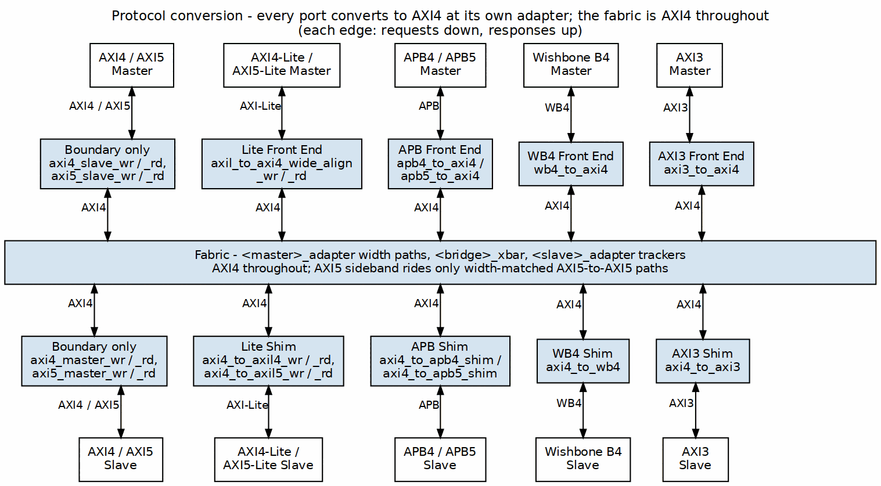
Protocol Conversion Architecture
Every port converts to AXI4 at its own adapter and the fabric is AXI4 throughout: AXI4-Lite, APB, Wishbone and AXI3 masters get a front-end converter in their master adapter, and the matching slaves get a shim in their slave adapter. AXI4 and AXI5 ports need only the boundary skid buffers.

10.4 2.7.4 Block Diagram

10.4.1 Figure 2.8: AXI4 to APB Shim
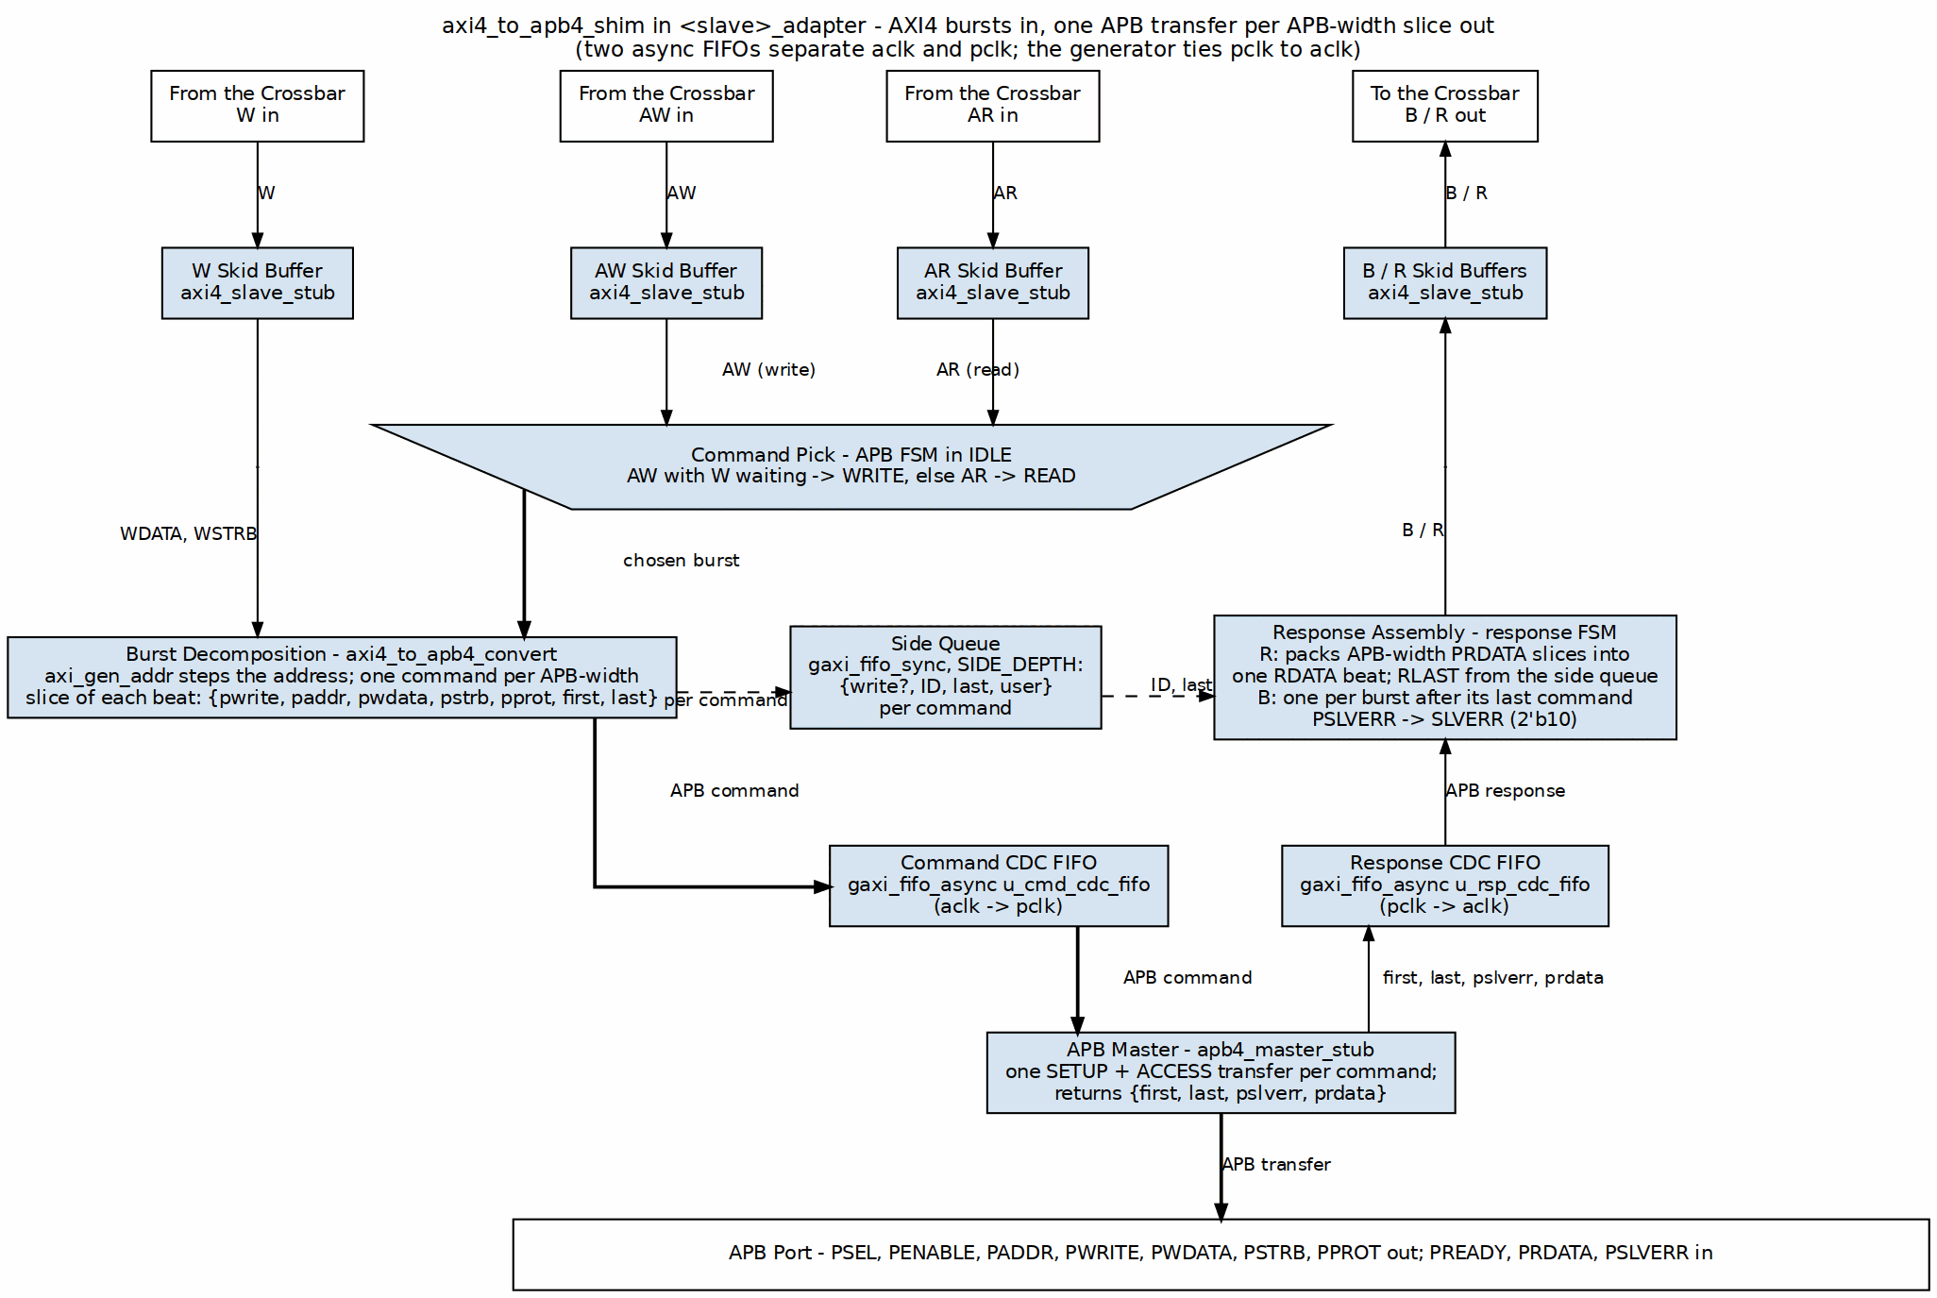
AXI4 to APB Shim
axi4_to_apb4_shim as an APB slave adapter instantiates it. The APB FSM picks a write (AW with W waiting) ahead of a read (the trapezium), axi_gen_addr decomposes the burst into one APB command per APB-width slice, and the commands cross to the APB master through an async FIFO. Responses return through a second async FIFO; the response FSM packs PRDATA into RDATA beats, issues one B per burst and maps PSLVERR to SLVERR. The generator ties pclk to aclk.

10.5 2.7.5 AXI4-Lite to AXI4 Conversion (Master-Side)

10.5.1 AXI4-Lite Protocol Overview
AXI4-Lite is a simplified subset of AXI4 aimed at simple control/status register access:
Key Differences from Full AXI4:
- FIXED burst length: ARLEN/AWLEN always = 0 (single beat)
- FIXED burst size: No SIZE field, always full data width
- FIXED burst type: No BURST field, always INCR
- NO exclusive access: No LOCK support
- NO unaligned transfers: Address must be aligned
- Simpler ID: Typically 1-4 bits (fewer outstanding transactions)
Similarities to AXI4:
- Same 5 channels: AR, R, AW, W, B
- Same valid/ready handshaking
- Response codes: OKAY, SLVERR, DECERR. NOT EXOKAY -- AXI4-Lite has no
exclusive access, so the code has no meaning on this interface.
- Same data widths: 32 or 64 bits typically

10.5.2 Conversion Requirements
Adapting an AXI4-Lite master to the full AXI4 crossbar takes three things:
- Add Missing Signals: Provide default values for burst-related signals
- Validate Constraints: Ensure single-beat assumption holds
- Pass-Through Simplicity: Most signals connect directly

10.5.3 Signal Mapping
// AXI4-Lite to AXI4 Signal Mapping
// AR Channel (Read Address)
// AXI4-Lite Input AXI4 Crossbar Output
axi4lite_arvalid → axi4_arvalid
axi4lite_arready ← axi4_arready
axi4lite_araddr → axi4_araddr
axi4lite_arprot → axi4_arprot
axi4lite_arid (opt) → axi4_arid
// Added by adapter (constants):
axi4_arlen = 8'h00 // Always 1 beat
axi4_arsize = log2(DW/8) // Full width
axi4_arburst = 2'b01 // INCR
axi4_arlock = 1'b0 // No lock
axi4_arcache = 4'b0000 // Device non-buf
axi4_arqos = 4'h0 // No QoS
axi4_arregion = 4'h0 // Region 0
// R Channel (Read Data)
// AXI4 Crossbar Input AXI4-Lite Output
axi4_rvalid → axi4lite_rvalid
axi4_rready ← axi4lite_rready
axi4_rdata → axi4lite_rdata
axi4_rresp → axi4lite_rresp
axi4_rid (opt) → axi4lite_rid (opt)
// Discarded by adapter:
axi4_rlast // Always 1 for single beat
// AW Channel (Write Address)
axi4lite_awvalid → axi4_awvalid
axi4lite_awready ← axi4_awready
axi4lite_awaddr → axi4_awaddr
axi4lite_awprot → axi4_awprot
axi4lite_awid (opt) → axi4_awid
// Added by adapter:
axi4_awlen = 8'h00
axi4_awsize = log2(DW/8)
axi4_awburst = 2'b01
axi4_awlock = 1'b0
axi4_awcache = 4'b0000
axi4_awqos = 4'h0
axi4_awregion = 4'h0
// W Channel (Write Data)
axi4lite_wvalid → axi4_wvalid
axi4lite_wready ← axi4_wready
axi4lite_wdata → axi4_wdata
axi4lite_wstrb → axi4_wstrb
// Added by adapter:
axi4_wlast = 1'b1 // Always last
// B Channel (Write Response)
axi4_bvalid → axi4lite_bvalid
axi4_bready ← axi4lite_bready
axi4_bresp → axi4lite_bresp
axi4_bid (opt) → axi4lite_bid (opt)

10.5.4 Implementation
The adapter itself is almost embarrassingly simple — mostly wires, with constants tied off for everything AXI4-Lite doesn’t have:
// AXI4-Lite to AXI4 Adapter (simplified)
module axi4lite_to_axi4_adapter #(
parameter ADDR_WIDTH = 32,
parameter DATA_WIDTH = 64,
parameter ID_WIDTH = 4 // Optional, often 0 for AXI4-Lite
) (
input logic clk,
input logic rst_n,
// AXI4-Lite Master Interface
input logic lite_arvalid,
output logic lite_arready,
input logic [ADDR_WIDTH-1:0] lite_araddr,
input logic [2:0] lite_arprot,
input logic [ID_WIDTH-1:0] lite_arid, // Optional
output logic lite_rvalid,
input logic lite_rready,
output logic [DATA_WIDTH-1:0] lite_rdata,
output logic [1:0] lite_rresp,
output logic [ID_WIDTH-1:0] lite_rid, // Optional
input logic lite_awvalid,
output logic lite_awready,
input logic [ADDR_WIDTH-1:0] lite_awaddr,
input logic [2:0] lite_awprot,
input logic [ID_WIDTH-1:0] lite_awid, // Optional
input logic lite_wvalid,
output logic lite_wready,
input logic [DATA_WIDTH-1:0] lite_wdata,
input logic [DATA_WIDTH/8-1:0] lite_wstrb,
output logic lite_bvalid,
input logic lite_bready,
output logic [1:0] lite_bresp,
output logic [ID_WIDTH-1:0] lite_bid, // Optional
// Full AXI4 Crossbar Interface
output logic axi4_arvalid,
input logic axi4_arready,
output logic [ADDR_WIDTH-1:0] axi4_araddr,
output logic [7:0] axi4_arlen,
output logic [2:0] axi4_arsize,
output logic [1:0] axi4_arburst,
output logic axi4_arlock,
output logic [3:0] axi4_arcache,
output logic [2:0] axi4_arprot,
output logic [3:0] axi4_arqos,
output logic [3:0] axi4_arregion,
output logic [ID_WIDTH-1:0] axi4_arid,
input logic axi4_rvalid,
output logic axi4_rready,
input logic [DATA_WIDTH-1:0] axi4_rdata,
input logic [1:0] axi4_rresp,
input logic axi4_rlast,
input logic [ID_WIDTH-1:0] axi4_rid,
// ... (AW, W, B channels similar)
);
// AR Channel: Pass-through with constants
assign axi4_arvalid = lite_arvalid;
assign lite_arready = axi4_arready;
assign axi4_araddr = lite_araddr;
assign axi4_arprot = lite_arprot;
assign axi4_arid = lite_arid;
// Constants for single-beat burst
assign axi4_arlen = 8'h00; // 1 beat
assign axi4_arsize = $clog2(DATA_WIDTH/8); // Full width
assign axi4_arburst = 2'b01; // INCR
assign axi4_arlock = 1'b0; // No lock
assign axi4_arcache = 4'b0000; // Device non-buf
assign axi4_arqos = 4'h0; // No QoS
assign axi4_arregion = 4'h0; // Region 0
// R Channel: Pass-through, ignore rlast
assign lite_rvalid = axi4_rvalid;
assign axi4_rready = lite_rready;
assign lite_rdata = axi4_rdata;
assign lite_rresp = axi4_rresp;
assign lite_rid = axi4_rid;
// axi4_rlast ignored (always 1 for single beat)
// AW Channel: Similar to AR
assign axi4_awvalid = lite_awvalid;
assign lite_awready = axi4_awready;
assign axi4_awaddr = lite_awaddr;
assign axi4_awprot = lite_awprot;
assign axi4_awid = lite_awid;
assign axi4_awlen = 8'h00;
assign axi4_awsize = $clog2(DATA_WIDTH/8);
assign axi4_awburst = 2'b01;
assign axi4_awlock = 1'b0;
assign axi4_awcache = 4'b0000;
assign axi4_awqos = 4'h0;
assign axi4_awregion = 4'h0;
// W Channel: Pass-through, add wlast
assign axi4_wvalid = lite_wvalid;
assign lite_wready = axi4_wready;
assign axi4_wdata = lite_wdata;
assign axi4_wstrb = lite_wstrb;
assign axi4_wlast = 1'b1; // Always last
// B Channel: Pass-through
assign lite_bvalid = axi4_bvalid;
assign axi4_bready = lite_bready;
assign lite_bresp = axi4_bresp;
assign lite_bid = axi4_bid;
endmodule

10.5.5 Resource Utilization
AXI4-Lite Adapter Resources:
Logic Elements: ~50-100 LEs (minimal, mostly wiring)
Registers: ~50 regs (if skid buffers added)
Block RAM: 0
Breakdown:
- Signal pass-through: ~20 LEs (buffering)
- Constant generation: ~10 LEs
- Optional skid buffers: ~50 regs (for timing)
Note: Most implementations are purely combinatorial wire
assignments with optional pipeline registers.

10.5.6 Performance Impact
Latency: - Zero-latency (combinatorial) if no pipeline stages - 1-2 cycles if skid buffers added for timing - No protocol conversion overhead
Throughput: - 1 transaction per cycle (same as native AXI4) - No degradation for single-beat transactions - Limited by AXI4-Lite’s single-beat constraint

10.5.7 Configuration
[[bridge.masters]]
name = "control_processor"
prefix = "cpu_axil_" # required -- prefixes every external signal
protocol = "axil" # NOT "axi4lite"; see the protocol table in the HAS
channels = "rw" # "rw" | "rd" | "wr"
id_width = 0 # AXI4-Lite carries no ID
addr_width = 32
data_width = 32
user_width = 1
Mind the field names: they are id_width / addr_width / data_width – one id_width per port, not the arid_width / awid_width pair an earlier revision of this page showed, which the loader does not read. The table is [[bridge.masters]], not [[masters]]. Compare bin/test_configs/bridge_1x5_wr_axil.toml for a config that actually generates.

10.5.8 Common Issues and Debug
Issue 1: Burst Detected on AXI4-Lite
Symptom: ARLEN/AWLEN != 0 on AXI4-Lite interface
Cause: Master not properly configured as AXI4-Lite
Check: Verify master only issues single-beat transactions
Issue 2: Unaligned Addresses
Symptom: ARADDR/AWADDR not aligned to data width
Cause: AXI4-Lite requires full-width aligned access
Check: Address[log2(DW/8)-1:0] should be zero
Issue 3: rlast/wlast Handling
Symptom: Master expects rlast/wlast but doesn't have them
Cause: True AXI4-Lite interface omits these signals
Solution: Adapter provides wlast=1 to crossbar, strips rlast

10.6 2.7.6 AXI4 to APB Conversion (Slave-Side)

10.6.1 APB Protocol Overview
APB is a simple, low-power bus protocol — it earns its keep on area and power, not speed:
Characteristics:
- Single address phase
- Single data phase
- No burst support (one transfer per operation)
- Minimal logic
- Low power consumption
- Suitable for peripherals: UARTs, timers, GPIOs

10.6.2 APB Signals
Address Phase:
PADDR[N-1:0] - Address bus
PSEL - Slave select
PENABLE - Enable (2nd cycle of transfer)
PWRITE - Write direction (1=write, 0=read)
Data Phase (Write):
PWDATA[N-1:0] - Write data
PSTRB[N/8-1:0]- Write strobes (APB4 only)
Data Phase (Read):
PRDATA[N-1:0] - Read data
Response:
PREADY - Slave ready (can extend transfer)
PSLVERR - Slave error (APB3+)

10.6.3 APB State Machine
Every APB transfer is a 2-phase handshake — SETUP, then ACCESS:
IDLE:
- Wait for AXI request (ARVALID or AWVALID)
- PSEL = 0, PENABLE = 0
SETUP:
- Assert PSEL = 1
- Drive PADDR, PWRITE, PWDATA (if write)
- PENABLE = 0
- Duration: 1 cycle
ACCESS:
- Assert PENABLE = 1
- Wait for PREADY = 1
- Capture PRDATA (if read) or PSLVERR
- Can extend multiple cycles if PREADY = 0
Complete:
- De-assert PSEL, PENABLE
- Return to IDLE or SETUP (if more beats)

10.6.4 Read Transaction Conversion
AXI4 Read:
Cycle 0: ARVALID=1, ARADDR=0x100, ARLEN=3 (4 beats)
Cycle 1: ARREADY=1
Cycles 2-5: R beats returning
Converted to APB (4 separate APB reads):
Beat 0:
Cycle 0: PSEL=1, PENABLE=0, PADDR=0x100, PWRITE=0 (SETUP)
Cycle 1: PSEL=1, PENABLE=1, wait PREADY (ACCESS)
Cycle 2: PREADY=1, capture PRDATA → First R beat
Beat 1:
Cycle 3: PSEL=1, PENABLE=0, PADDR=0x104 (SETUP)
Cycle 4: PSEL=1, PENABLE=1, wait PREADY (ACCESS)
Cycle 5: PREADY=1, capture PRDATA → Second R beat
... (beats 2 and 3 similar)
Latency: 2-3 cycles per beat (SETUP + ACCESS + ready)

10.6.5 Write Transaction Conversion
AXI4 Write:
Cycle 0: AWVALID=1, AWADDR=0x200, AWLEN=1 (2 beats)
Cycle 1: AWREADY=1
Cycle 1: WVALID=1, WDATA=0xAAAA_BBBB, WLAST=0
Cycle 2: WREADY=1
Cycle 2: WVALID=1, WDATA=0xCCCC_DDDD, WLAST=1
Cycle 3: WREADY=1
Cycle 4: BVALID=1, BRESP=OKAY
Converted to APB (2 separate APB writes):
Beat 0:
Cycle 0: PSEL=1, PENABLE=0, PADDR=0x200, PWRITE=1, PWDATA=0xAAAA_BBBB
Cycle 1: PSEL=1, PENABLE=1, wait PREADY
Cycle 2: PREADY=1 → First write complete
Beat 1:
Cycle 3: PSEL=1, PENABLE=0, PADDR=0x204, PWRITE=1, PWDATA=0xCCCC_DDDD
Cycle 4: PSEL=1, PENABLE=1, wait PREADY
Cycle 5: PREADY=1 → Second write complete, return B

10.6.6 Burst Handling
APB has no burst concept, so the converter decomposes:
AXI Burst: AWLEN = 15 (16 beats)
→ 16 separate APB transfers
→ Address increments per AWBURST type:
- INCR: Addr += SIZE each beat
- WRAP: Wrapping within boundary
- FIXED: Same address each beat

10.6.7 Response Mapping
APB → AXI Response Translation:
PREADY=1, PSLVERR=0 → RRESP/BRESP = 2'b00 (OKAY)
PREADY=1, PSLVERR=1 → RRESP/BRESP = 2'b10 (SLVERR)
PREADY stuck at 0:
The converter WAITS. There is no timeout and no DECERR.
There is no PREADY timeout anywhere in the path. apb4_master waits unconditionally in ACCESS (if (m_apb_PREADY) ... with no counter), and neither axi4_to_apb4_convert, axi4_to_apb4_shim nor axi4_to_apb5_shim contains a threshold register or cycle counter. A slave that never asserts PREADY stalls that path indefinitely, and the stall propagates back through the crossbar as backpressure. Budget for it in the system, or put a watchdog outside the bridge; the bridge will not manufacture an error response.

10.7 2.7.7 Implementation

10.7.1 AXI4-to-APB Converter FSM
// Simplified AXI4-to-APB converter
typedef enum logic [2:0] {
IDLE,
AR_SETUP,
AR_ACCESS,
AW_SETUP,
W_ACCESS,
B_RESPONSE
} state_t;
state_t state, next_state;
always_ff @(posedge clk) begin
if (!rst_n) state <= IDLE;
else state <= next_state;
end
always_comb begin
next_state = state;
case (state)
IDLE: begin
if (arvalid) next_state = AR_SETUP;
else if (awvalid) next_state = AW_SETUP;
end
AR_SETUP: begin
next_state = AR_ACCESS; // 1 cycle SETUP
end
AR_ACCESS: begin
if (pready) begin
if (more_beats) next_state = AR_SETUP; // Next beat
else next_state = IDLE;
end
end
AW_SETUP: begin
if (wvalid) next_state = W_ACCESS;
end
W_ACCESS: begin
if (pready) begin
if (!wlast) next_state = AW_SETUP; // Next beat
else next_state = B_RESPONSE;
end
end
B_RESPONSE: begin
if (bready) next_state = IDLE;
end
endcase
end
// APB signal generation
assign psel = (state != IDLE);
assign penable = (state == AR_ACCESS || state == W_ACCESS);
assign pwrite = (state == AW_SETUP || state == W_ACCESS);

10.7.2 Address Generation
// Address increment for burst
logic [ADDR_WIDTH-1:0] current_addr;
logic [7:0] beat_count;
always_ff @(posedge clk) begin
if (state == IDLE) begin
current_addr <= arvalid ? araddr : awaddr;
beat_count <= 0;
end else if ((state == AR_ACCESS || state == W_ACCESS) && pready) begin
beat_count <= beat_count + 1;
case (burst_type)
2'b01: current_addr <= current_addr + (1 << size); // INCR
2'b10: current_addr <= wrap_address(current_addr); // WRAP
2'b00: current_addr <= current_addr; // FIXED
endcase
end
end
assign paddr = current_addr;

10.8 2.7.8 Resource Utilization

10.8.1 APB Converter Resources
Per APB Slave Interface:
Logic Elements: ~400 LEs
Registers: ~150 regs
Block RAM: 0
Breakdown:
- FSM control: ~100 LEs, ~20 regs
- Address generation: ~80 LEs, ~40 regs
- Burst counter: ~50 LEs, ~20 regs
- Response accumulation: ~80 LEs, ~30 regs
- Data path MUX: ~90 LEs, ~40 regs

10.8.2 Scaling
Adding APB slaves: - Linear scaling: +~400 LEs per APB slave - Shared address decoder logic - Independent per-slave FSMs

10.9 2.7.9 Timing Characteristics

10.9.1 Latency
APB Read Latency (per beat):
Best case: 2 cycles (SETUP + ACCESS with PREADY=1)
Typical: 3-5 cycles (if slave extends with PREADY=0)
Worst case: unbounded -- the converter waits for PREADY with no timeout
For 8-beat AXI burst:
Total: 8 × 3 = 24 cycles typical
APB Write Latency (per beat):
Similar to read: 2-5 cycles per beat

10.9.2 Throughput
Severely Limited:
APB: ~0.3-0.5 transactions/cycle (due to 2-3 cycle protocol)
AXI4: 1 transaction/cycle (burst mode)
APB suitable only for low-bandwidth peripherals
No amount of buffering fixes that — the 2-3 cycle protocol itself is the bottleneck.

10.10 2.7.10 Configuration Parameters

10.10.1 Protocol Conversion Configuration (TOML)
[[bridge.slaves]]
name = "uart_peripheral"
protocol = "apb" # "axi4", "apb", "ahb" (future)
base_address = 0xF000_0000
size = 0x1000
data_width = 32
[[bridge.slaves]]
name = "ddr_memory"
protocol = "axi4" # Native, no conversion
base_address = 0x8000_0000
size = 0x4000_0000
data_width = 64

10.11 2.7.11 Debug and Observability

10.11.1 Recommended Debug Signals
APB Converter:
- FSM state
- APB phase (SETUP, ACCESS)
- Beat counter (progress through burst)
- Response accumulation (for burst)
APB Bus:
- PSEL, PENABLE, PWRITE
- PADDR, PWDATA, PRDATA
- PREADY, PSLVERR

10.11.2 Common Issues and Debug
Symptom: APB slave not responding (timeout)
Check: - PREADY signal (stuck at 0?) - APB slave clock/reset - PSEL assertion (There is no timeout threshold to check – the converter waits forever.)
Symptom: Data corruption on APB
Check: - SETUP phase duration (should be 1 cycle) - PENABLE assertion timing - Data sampling on correct cycle
Symptom: Burst to APB takes too long
Check: - Burst length (consider limiting ARLEN/AWLEN) - APB slave response time (PREADY) - Alternative: Use AXI4 slave instead

10.12 2.7.12 Verification Considerations

10.12.1 Test Scenarios
- Single APB Transfer:
- AXI ARLEN=0 (1 beat) → 1 APB read
- Verify SETUP → ACCESS sequence
- Check PREADY handling
- APB Burst Decomposition:
- AXI AWLEN=7 (8 beats) → 8 APB writes
- Verify address increment
- Check each beat completes before next
- APB PREADY Extension:
- Slave holds PREADY=0 for N cycles
- Verify converter waits
- Check no data corruption
- APB Error Response:
- Slave asserts PSLVERR
- Verify mapped to AXI SLVERR
- Check error propagated to master
- APB stall (no timeout to test):
- Slave never asserts PREADY
- Verify the path stalls and backpressures cleanly, with no lost or
duplicated beats once PREADY finally arrives
- There is NO timeout and NO DECERR to check for -- see 2.7.6

10.13 2.7.13 Performance Considerations

10.13.1 When to Use APB
Good Use Cases: - Low-speed peripherals (UART, GPIO, timers) - Infrequent accesses - Simple register interfaces - Power-sensitive designs
Poor Use Cases: - High-bandwidth devices - Burst-intensive masters - Performance-critical paths - Memory interfaces

10.13.2 APB vs. AXI4 Comparison
Feature APB AXI4
Complexity Simple Complex
Throughput Low (~0.3/cyc) High (1/cyc burst)
Latency/beat 2-5 cycles 1 cycle
Burst Support No Yes (up to 256)
Resources ~400 LEs Native (no converter)
Power Very low Moderate
Use Case Peripherals Memory, DMA

10.14 2.7.14 Mixed Protocol Bridges

10.14.1 Example Configuration
# Bridge with mixed protocols
[bridge]
num_masters = 2
num_slaves = 3
[[bridge.masters]]
name = "cpu"
protocol = "axi4"
[[bridge.masters]]
name = "dma"
protocol = "axi4"
[[bridge.slaves]]
name = "ddr_memory"
protocol = "axi4" # High bandwidth
[[bridge.slaves]]
name = "sram"
protocol = "axi4" # Medium bandwidth
[[bridge.slaves]]
name = "peripherals"
protocol = "apb" # Low bandwidth, simple

10.14.2 Routing Optimization
Walk the routes and you can see exactly where the conversion cost lands:
CPU → DDR Memory: AXI4-to-AXI4 (native, fast)
CPU → Peripherals: AXI4-to-APB (converted, slower)
DMA → SRAM: AXI4-to-AXI4 (native, fast)
DMA → Peripherals: AXI4-to-APB (rare, acceptable slowdown)

10.15 2.7.15 Master-Side vs Slave-Side Conversion

10.15.1 Comparison
Feature Master-Side (AXI4-Lite) Slave-Side (APB)
──────────────────────────────────────────────────────────────────
Complexity Very Simple Complex
Resource Usage ~50-100 LEs ~400 LEs
Latency Added 0-1 cycles 2-5 cycles/beat
Throughput Impact None Severe (3x slower)
Burst Handling Single beat only Decompose to singles
State Machine None (combinatorial) Multi-state FSM
Buffering Required Optional (timing) Essential
Use Case Control registers Peripherals

10.15.2 When to Use Each
AXI4-Lite Master Adapter: - Simple control/status register interfaces - Low-complexity masters (MCUs, simple CPUs) - Minimal resource overhead acceptable - No burst performance needed
APB Master Front End (apb{4,5}_to_axi4, bridge TASK-004 (was BRIDGE-014)): - An APB requester that needs to reach AXI4 or AXI4-Lite completers - One-outstanding by nature of APB: one transfer per fabric round trip - Same lane behaviour as an AXI4-Lite master toward wider slaves (the aligner is shared)
APB Slave Converter: - Legacy peripheral integration - Very simple slave devices (GPIO, timers) - Low-bandwidth acceptable - Power optimization critical

10.16 2.7.16 Generator-Emitted Conversion Shims
You don’t instantiate any of these converters by hand. The bridge generator automatically emits protocol conversion shims at the slave boundary based on the TOML configuration. These shims are instantiated between the crossbar core (uniformly AXI4 internally) and the external slave port.

10.16.1 AXI4 to AXI4-Lite Conversion
When protocol = "axil" is specified in the slave TOML: - Generator emits axi4_to_axil4_rd.sv (read path) and axi4_to_axil4_wr.sv (write path) - Shims downgrade bursts to single beats (set ARLEN/AWLEN = 0 on output) - Enforce single-beat semantics transparently - Data width remains unchanged (upsizing/downsizing done separately) - Shims are inserted between crossbar and slave port in the generated top-level module
Modules: projects/components/utility-ip/converters/rtl/axi4_to_axil4_{rd,wr}.sv

10.16.2 AXI4 to APB Conversion
When protocol = "apb" is specified in the slave TOML: - Generator emits ONE shim, axi4_to_apb4_shim – a direct full-AXI4-to-APB4 converter. There is no AXI4-Lite stage: the shim does its own burst decomposition (r_burst_count + axi_gen_addr), so nothing upstream has to reduce the burst first. - protocol = "apb5" emits axi4_to_apb5_shim, a sideband wrapper over that same shim – see AMBA5 Boundary. - Slave port externally presents APB signals; internally the crossbar is AXI4
Modules: projects/components/utility-ip/converters/rtl/axi4_to_apb4_shim.sv (axi4_to_apb5_shim.sv for apb5)
An earlier revision of this page described the path as an axi4_to_axil4 shim followed by an internal AXIL-to-APB bridge chain. No such chain exists, and no generated APB slave adapter instantiates axi4_to_axil4.

10.16.3 Master-Side APB Front End
When protocol = "apb" or "apb5" is specified on a master (bridge TASK-004, was BRIDGE-014): - The master adapter’s external surface is the APB completer set (the requester’s PSEL/PENABLE/PADDR/PWRITE/PWDATA/PSTRB/PPROT are inputs; PREADY/PRDATA/PSLVERR outputs; apb5 adds PAUSER/PWUSER/PWAKEUP in and PRUSER/PBUSER out). - The adapter instantiates apb4_to_axi4 / apb5_to_axi4 on an internal AXI4 face (apbx_axi_*) and feeds that to the same axi4_slave_{wr,rd} timing wrapper – _mon in the monitored variant – an AXI4 master port gets. From the wrapper onward the port is an AXI4-Lite-shaped single-beat requester: decode, the width converters and the wide-slave aligner, and the response mux are untouched. - The fabric ID is the master index alone (id_width = 0, bridge TASK-005 (was BRIDGE-016)).
Modules: projects/components/utility-ip/converters/rtl/apb4_to_axi4.sv, apb5_to_axi4.sv, apb_cmdrsp_to_axi4.sv – see the converters MAS.

10.16.4 Wishbone B4 at Either Boundary
When protocol = "wb4" is specified (bridge TASK-008, was BRIDGE-019): - On a slave, the adapter instantiates axi4_to_wb4 through the Axi4ToWb4Shim component – the same channel wiring, bridge BUG-009 (was BRIDGE-011) not-full gate and converter_* response intercepts as the APB shim, and the same axi4_master_*_mon sandwich in the monitored variant. The external surface is the thirteen-signal B4 requester set from bridge_pkg/wb4_signals.py, the one table the bridge top, the adapter and the instance component all read. - On a master, the adapter’s external surface is the B4 completer set (directions reversed) and wb4_to_axi4 drives an internal wbx_axi_* AXI4 face into the same axi4_slave_{wr,rd} wrapper an AXI4 master gets. From there the port is an AXI4-Lite-shaped single-beat requester and takes the wide-slave aligner toward wider slaves.
Modules: projects/components/utility-ip/converters/rtl/axi4_to_wb4.sv, wb4_to_axi4.sv – see the converters MAS.

10.16.5 AXI3 Boundary Conversion
When protocol = "axi3" is specified, a same-width protocol converter sits at the boundary and the crossbar behind it stays AXI4:
- Slave boundary: the generated adapter instantiates axi4_to_axi3 between the crossbar core and the external AXI3 slave port. Egress AXI4 bursts longer than 16 beats are chopped into sequential AXI3 bursts; WID is stamped per beat; QoS/REGION are dropped; lock is mapped as the converter documents it.
- Master boundary: the adapter exposes an AXI3 completer surface and instantiates axi3_to_axi4 in front of the ordinary AXI4 timing wrapper. WID is stripped, QoS/REGION are driven to zero, and lock is mapped as the converter documents it.
The bridge does not add width conversion inside the protocol converter. When an AXI3 port’s external width differs from a target slave width, the existing internal width-adaptation path (dwidth_converter or the wide-slave aligner) operates on the AXI4 side behind the converter.
Converter-sourced obligations (for full wording see converters MAS §3.15 AXI4 to AXI3 Converter and §3.16 AXI3 to AXI4 Converter):
- An AXI3 master must not interleave W data across IDs. axi3_to_axi4_wr asserts ASSERT_A3_WID_STABLE if WID changes mid-burst or differs from the active AWID.
- Egress bursts longer than 16 beats are chopped by address regeneration; INCR and FIXED are supported, WRAP longer than 16 beats is rejected.
- QoS and REGION are absent on AXI3 pins.
- The converters are same-width only; width adaptation is the bridge’s internal concern.
- Lock mapping follows the ARM AXI3 encoding (ARM IHI 0022: 00 normal, 01 exclusive, 10 locked), as fixed by bridge GitHub #98:
  - axi4_to_axi3: 1'b0 → 2'b00, 1'b1 → 2'b01.
  - axi3_to_axi4: 2'b01 → 1'b1; 2'b00, 2'b10 (locked — AXI4 dropped locked accesses), and the reserved 2'b11 → 1'b0.
Validation fixtures: bridge_1x2_axi3, bridge_2x2_axi3_masters, bridge_2x2_axi3_slaves, bridge_mix_e.
Modules: projects/components/utility-ip/converters/rtl/axi4_to_axi3.sv, axi4_to_axi3_rd.sv, axi4_to_axi3_wr.sv, axi3_to_axi4.sv, axi3_to_axi4_rd.sv, axi3_to_axi4_wr.sv.

10.16.6 Master-Side AXI5-Lite Sideband
When protocol = "axil5" is specified on a master (bridge TASK-004, was BRIDGE-014), the bridge top exposes the AXI4-Lite set plus the AXI5-Lite ID and every optional group (from bridge_pkg/axil5_sideband.py, the one table the slave side also reads, with the directions flipped for a requester). The enabled forwardable groups and the ID join the Lite surface and are wired into the adapter’s AXI4 face (awid/bid/arid/rid always, user -> aw/w/ar user); the rest is terminated at the top – requester-driven inputs consumed by a reduction into an _unused_<master>_axil5_sb wire, completer-driven outputs driven '0. Response-side USER (buser/ruser) is connected but reads 0, because the master adapters tie response USER (PRD).

10.16.7 Master-Side AXIL→Wider-Slave Alignment
When an AXI4-Lite master interfaces with a wider AXI4 slave (e.g., 32-bit AXIL master to 64-bit AXI4 slave) – and likewise an AXI5-Lite or APB master, which present the same single-beat stream: - Generator emits axil_to_axi4_wide_align_rd.sv (read) and axil_to_axi4_wide_align_wr.sv (write) at the master adapter output (before crossbar core) - These modules handle width alignment (not protocol conversion — that’s done at the slave boundary if needed) - Preserves AXIL’s single-beat constraint on the master side - Properly aligns partial-word reads/writes on the wide slave side
Modules: projects/components/utility-ip/converters/rtl/axil_to_axi4_wide_align_{rd,wr}.sv
Example: 32-bit AXIL master → 64-bit AXI4 slave - Master writes to addr 0x04 with data 0xAABBCCDD. The shim selects the lane from addr[2] (= 1), so the data lands on the UPPER half: the slave sees wdata[63:32] = 0xAABBCCDD, WSTRB = 0xF0, at row-aligned address 0x00 – the lane bits move out of the address and into the strobe. Worked through in Width Converters. - Shim is inserted after master adapter, before crossbar

10.17 2.7.17 Future Protocol Support

10.17.1 Planned Features
AXI4-Lite – NOT future work; BUILT. axi4_to_axil4_{rd,wr} shims are emitted when protocol = "axil", and bridge_1x2_rw_axil5 and the mix_* configurations ship AXIL slaves with tests in the FULL regression. It was listed here as planned while the same page describes the shims that implement it.
AHB (AMBA High-performance Bus): - More capable than APB - Pipeline support - Burst support - Suitable for moderate-bandwidth peripherals
Wishbone – NOT future work; BUILT (bridge TASK-008 (was BRIDGE-019), 2026-09-11). wb4 is a legal protocol on master and slave ports alike; see “Wishbone B4 at Either Boundary” above. Not built: B4 standard (classic) mode from the TOML, and registered-feedback bursts (CTI/BTE are carried, not generated).

10.17.2 Under Consideration
- Custom Protocol: User-defined through configuration
- Stream Interface: AXI4-Stream for data streaming
- PCIe TLP: For PCIe endpoint integration
- CHI: ARM’s Coherent Hub Interface

10.18 2.7.18 Best Practices

10.18.1 Design Recommendations
- Limit APB Burst Lengths: Configure masters to use short bursts to APB slaves
- Watchdog Outside the Bridge: the converter has no PREADY timeout, so a wedged APB slave stalls its path forever. If the system needs to survive that, the watchdog belongs upstream.
- Protocol Matching: Use native AXI4 where possible, APB only when necessary
- Address Map Planning: Group APB peripherals together for efficient decoding
- Width Matching: Match APB data width to peripheral requirements

10.18.2 Performance Tips
Inefficient: 256-beat AXI burst → APB
256 beats × 3 cyc/beat = 768 cycles
Better: Limit to 4-beat bursts → APB
64 bursts of 4 beats each
Still long, but more manageable
Best: Use AXI4-Lite slave for registers
No burst, but native protocol

Related Sections: - Section 2.3: Crossbar Core (protocol integration point) - HAS ch04_interfaces/01_axi4_interface.md (port signals) - Chapter 4: Programming (configuring protocol conversion) - Appendix A: Generator Deep Dive (protocol converter generation)

RTL Design Sherpa · Learning Hardware Design Through Practice GitHub · Documentation Index · MIT License

11 2.8 Response Routing
Requests are easy to route — the address says where they go. Responses are harder: read data and write acknowledgments have to find their way back to whichever master asked, and by then the address that launched the transaction is ancient history. Response routing does that with Bridge IDs, demultiplexing logic, and optional CAM structures.

11.1 2.8.1 Purpose and Function
Response routing does five things:
- Response Direction: Routes R and B channel responses to correct master
- Tracked Routing: each slave adapter names the master to answer – bridge_cam looked up with the returned BID/RID on a multi-master AXI4/AXI5 slave, an in-order bridge_id FIFO elsewhere
- Multi-Slave Merging: Combines responses from multiple slaves to single master
- Flow Control: Manages backpressure from master on response channels
- Error Propagation: Ensures error responses reach originating master

11.2 2.8.2 Block Diagram

11.2.1 Figure 2.9: Response Routing Architecture
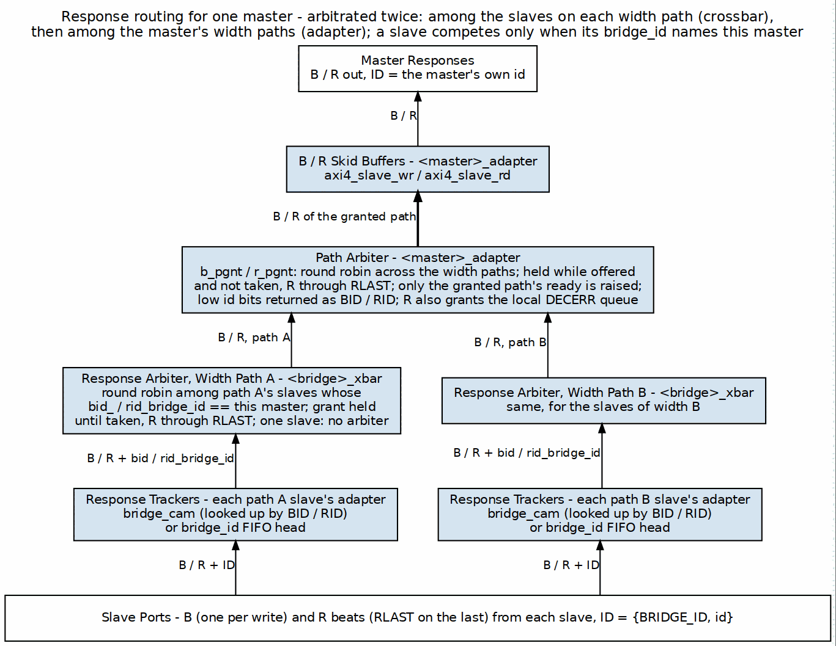
Response Routing Architecture
Responses for one master climb from the slaves. Each slave adapter’s tracker supplies the bridge_id of the master to answer; the crossbar presents that slave’s B / R on this master’s width path only when the bridge_id matches; and the master adapter takes the path at the head of its aw_trk / ar_trk FIFO. Nothing here arbitrates, so there is no trapezium.

11.3 2.8.3 Stable Response Routing via FIFO-Tracked Slave Select

11.3.1 Architecture: FIFO-Tracked Master Routing
Retired (GitHub #119 L1 and L1b, 2026-10-15). No port steers B/R with this FIFO any more: every master adapter has per-ID tracking and a path arbiter (MAS 2.1, and Response Arbitration below). The section is kept as the history of why the decode is captured at the handshake.
For multi-slave masters, responses are routed based on a stable slave-select value captured at request time, not the current address decode:
// At AW/AR time: Capture slave index
assign aw_slave_select = address_decode(fub_axi_awaddr);
always_ff @(posedge aclk) begin
if (fub_axi_awvalid && fub_axi_awready) begin
aw_trk_fifo <= aw_slave_select; // Capture now
end
end
// At B time: Use captured slave from FIFO (not current decode)
assign b_slave_select = aw_trk_fifo_out; // Stable value
logic [NUM_MASTERS-1:0] master_bvalid;
always_comb begin
master_bvalid = '0;
master_bvalid[extracted_bid] = slave_bvalid && (b_slave_select == current_slave);
end
Benefits: - B-responses route to correct master even after address reverts - Handles multi-slave masters spanning different widths - Prevents response loss due to stale address decodes

11.3.2 BID Extraction
The master is not chosen by decoding the prefix bits of the returned ID. With more than one master the slave-side ID is {BRIDGE_ID, id} (bridge TASK-005), but the crossbar steers B / R by the master index the slave adapter’s tracker returns beside the response (bid_bridge_id / rid_bridge_id). For a CAM-tracked slave that index is looked up BY the returned BID/RID; for a FIFO-tracked slave it is the FIFO head. The master adapter then strips the prefix:
// bridge_2x2_rw_xbar.sv: B toward cpu (master index 0)
((ddr_axi_bid_bridge_id == 0) && ddr_axi_bid_valid ? ddr_axi_bid : '0) | ...
// cpu_adapter.sv: return the master's own ID bits
fub_axi_bid = cpu_32b_b.id[3:0];

11.3.3 CAM-Based Extraction
Built (bridge BUG-012 (was BRIDGE-015)/016, 2026-09-10). Every real AXI slave of a multi-master bridge, and any slave declared enable_ooo = true, gets bridge_cam for both channels and routes responses by ID; single-master bridges, shim slaves and the subtractive slave keep the in-order per-slave FIFO. Per-ID tracking is sound across masters because fabric IDs are {master index, master id}; the FIFO would require the slave to complete in request order across ALL IDs, which a compliant AXI slave need not do. Fixture bridge_2x2_ooo exercises reordering slaves with two masters sharing IDs; test_bridge_cam.py covers the CAM alone. The mode had been unbuildable since c64660f47. See ch04 02_id_tracking.md.
For complex configurations with OOO or ID reordering:
// CAM lookup for response routing
logic [TOTAL_RID_WIDTH-1:0] response_id;
logic [BID_WIDTH-1:0] master_index;
logic cam_hit;
// Search CAM for matching transaction
assign {cam_hit, master_index} = cam_lookup(response_id);
// Route response to found master
if (cam_hit) begin
master_rvalid[master_index] = slave_rvalid;
end else begin
// Error: No matching transaction (protocol violation)
error_response();
end

11.4 2.8.4 Response Demultiplexing

11.4.1 Per-Master Response Paths
Each master has dedicated response channels from the demultiplexer:
Master 0 Response:
- M0_RVALID, M0_RREADY, M0_RDATA, M0_RID, M0_RRESP, M0_RLAST
- M0_BVALID, M0_BREADY, M0_BID, M0_BRESP
Source: Responses from any slave with BID=0

11.4.2 Demux Implementation
// Response demultiplexer (4 masters, 3 slaves)
// Combines responses from all slaves, routes to correct master
// Slave responses (multiple sources)
logic s0_rvalid, s1_rvalid, s2_rvalid;
logic [63:0] s0_rdata, s1_rdata, s2_rdata;
logic [5:0] s0_rid, s1_rid, s2_rid; // Includes BID
// Master responses (multiple destinations)
logic m0_rvalid, m1_rvalid, m2_rvalid, m3_rvalid;
logic [63:0] m0_rdata, m1_rdata, m2_rdata, m3_rdata;
logic [3:0] m0_rid, m1_rid, m2_rid, m3_rid; // BID stripped
// Demux logic per slave
for (genvar s = 0; s < 3; s++) begin
logic [1:0] bid;
assign bid = slave_rid[s][5:4]; // Extract BID
always_comb begin
case (bid)
2'b00: begin
if (slave_rvalid[s] && !m0_busy) begin
m0_rvalid = 1'b1;
m0_rdata = slave_rdata[s];
m0_rid = slave_rid[s][3:0]; // Strip BID
end
end
2'b01: /* Route to M1 */
2'b10: /* Route to M2 */
2'b11: /* Route to M3 */
endcase
end
end

11.5 2.8.5 Multi-Slave Response Merging

11.5.1 Problem Statement
When multiple slaves can respond to the same master in the same cycle:
Scenario:
Master 0 has outstanding transactions to Slave 0 and Slave 1
Both slaves return R responses in same cycle
Problem: Master 0 can only accept one R response per cycle
Solution: Arbitrate between slave responses

11.5.2 Response Arbitration
Built 2026-10-15, fixing the one-target-per-master limitation (GitHub #119 L1). Responses are arbitrated at two levels:
- Crossbar, per master width path (<master>_<W>b_{b,r}_rarb_*): the slaves on that path whose tracker names this master request. Round robin grants one. A grant offered and not taken holds, and an R grant holds through RLAST. The mux toward the master and the slave’s BREADY / RREADY both follow the grant (_rgnt_<slave>). A path with one slave keeps the plain ownership gate. Excerpt in MAS 2.3.
- Master adapter, across width paths (b_pgnt / r_pgnt): the same rules over the master’s width paths. Only the granted path’s ready is raised (MAS 2.1).
There are no response FIFOs. A response that loses arbitration waits in the slave’s (or the slave adapter’s skid buffer’s) valid/ready hold.

11.5.3 Response Buffering
Not built. The option would add FIFOs to buffer pending responses:
Purpose:
- Prevent response loss during arbitration conflicts
- Allow slaves to return responses even if master busy
- Smooth out bursty response patterns
Configuration:
per_master_response_fifo_depth = 4-16 entries
Trade-off:
+ No response loss
+ Better throughput
- Additional resources (~200 LEs per FIFO)
- +1-2 cycle latency

11.6 2.8.6 Independent Write-Tracker FIFO (W-Channel Deadlock Fix)
Prior to commit d24bd617, the AW and W ready signals shared a single multiplexer at the write-address arbiter output. Under interleaved master traffic patterns, this could cause deadlock: a master’s W channel could back up waiting for a non-granted write-address slot, preventing the arbiter from servicing other masters’ AW transactions.
The corrected design (current) uses an independent W-tracker FIFO alongside the AW tracker:
// AW tracker FIFO (per master)
always_ff @(posedge aclk) begin
if (master_awvalid && master_awready) begin
aw_trk_fifo <= address_decode(master_awaddr); // Capture slave
end
end
// Independent W tracker and ready MUX
logic aw_ready_mux, w_ready_mux; // Separate paths (prior: shared)
assign master_awready = aw_ready_mux; // AW gets its own ready
assign master_wready = w_ready_mux; // W gets independent ready
// W-tracker: Gate W valid against tracked slave select
always_comb begin
w_ready_mux = (aw_trk_fifo != 0) && slave_wready; // W independent
end
Result: AW and W channels can assert independently without blocking each other, preventing deadlock during interleaved multi-master write bursts.

11.7 2.8.7 Backpressure Management

11.7.1 Ready Signal Routing
The master’s RREADY/BREADY has to find its way back to the correct slave:
// Route master ready back to slaves
logic m0_rready; // From master
logic [2:0] slave_rready; // To slaves
// Only selected slave sees master's ready
for (genvar s = 0; s < 3; s++) begin
assign slave_rready[s] = (selected_slave == s) ? m0_rready : 1'b0;
end
// Non-selected slaves see ready = 0 (backpressure)

11.7.2 Stall Conditions
Response path can stall when:
1. Master not ready (M_RREADY = 0)
→ Selected slave stalls (S_RREADY = 0)
→ Other slaves buffer or stall
2. Arbitration conflict (multiple slaves ready)
→ Non-selected slaves stalled
→ Selected slave proceeds
3. bridge_id tracking FIFO full -- the address handshake is gated on it (bridge BUG-009, was BRIDGE-011); there is no response DATA FIFO
→ Slave stalled until space available

11.8 2.8.8 Response Path Latency

11.8.1 End-to-End R Channel
Slave R response → Bridge → Master R channel
Components:
1. Slave response valid
2. FIFO head read (0 cycles, combinatorial) -- no BID extraction
3. Demux routing (0-1 cycles)
4. No response arbitration: B and R follow the address-phase selection
5. Optional FIFO (0-1 cycles)
6. Master adapter (1 cycle, skid buffer)
Total: 2-4 cycles typical

11.8.2 End-to-End B Channel
Similar to R channel:
Slave B → Extraction → Demux → Arbitration → Master B
Total: 2-4 cycles

11.9 2.8.9 Error Response Routing

11.9.1 Slave Error Responses
When slave returns error:
RRESP = 2'b10 (SLVERR) or 2'b11 (DECERR)
BRESP = 2'b10 (SLVERR) or 2'b11 (DECERR)
Routing:
- Extract BID normally
- Route to originating master
- Preserve error code
- Master sees error response

11.9.2 Out-of-Range Error Responses
When router generates error for OOR address:
Process:
1. Router captures OOR request
2. Generates internal error response
- Uses cached request ID (with BID)
- Sets RRESP/BRESP = DECERR
3. Injects into response path
4. Routes to master using BID

11.10 2.8.10 Resource Utilization

11.10.1 Response Router Resources
4 masters, 3 slaves (64-bit data):
Logic Elements: ~1500-2000 LEs
Registers: ~400-600 regs
Block RAM: 0 (unless FIFOs enabled)
Breakdown:
- BID extraction (3 slaves): ~150 LEs
- Demux logic (4 masters): ~600 LEs, ~150 regs
- Response arbitration: ~300 LEs, ~100 regs
- Backpressure routing: ~200 LEs, ~50 regs
- Control FSMs: ~250 LEs, ~100 regs
Optional FIFOs (4 × 8 entries): +800 LEs, +2KB BRAM

11.10.2 Scaling
Resource usage scales with:
- Number of masters: Linear (one demux path per master)
- Number of slaves: Linear (one extraction per slave)
- Data width: Linear (wider data = wider demux)
- FIFO depth: Linear (deeper = more BRAM)

11.11 2.8.11 Configuration Parameters

11.11.1 Response Routing Configuration (TOML)
[bridge]
num_masters = 4
num_slaves = 3
[bridge.response_routing]
enable_response_fifos = false # Buffer responses per master
fifo_depth = 8 # Entries per FIFO
response_arbiter_type = "round_robin" # "round_robin", "fixed_priority"
registered_demux = false # Register demux output (+1 cycle)
# Per-master response credits (optional)
[[bridge.masters]]
name = "cpu"
max_response_credits = 16 # Outstanding responses allowed

11.12 2.8.12 Debug and Observability

11.12.1 Recommended Debug Signals
BID Extraction:
- Slave RID/BID (from each slave)
- Extracted BID (master index)
- External RID/BID (to master, BID stripped)
Response Demux:
- Demux select signals (which master per slave)
- Response valid per master
- Response valid per slave
Arbitration:
- Conflict detection (multiple responses for same master)
- Arbiter grant (which slave wins)
- Stall counters
FIFOs (if enabled):
- FIFO occupancy per master
- FIFO full/empty flags
- FIFO overflow errors

11.12.2 Performance Counters
- Responses routed per master
- Arbitration conflicts (cycles with multiple responses to same master)
- Response stall cycles (master not ready)
- Average response latency per master
- FIFO overflow counts
- bridge_id FIFO push/pop counts

11.13 2.8.13 Common Issues and Debug
Symptom: Response not reaching master
Check: - BID extraction (correct bit slicing?) - Master index (BID → master mapping) - Demux select logic - Backpressure (is master READY?)
Symptom: Response goes to wrong master
Check: - BID values (verify each master has unique BID) - BID width calculation (clog2 correct?) - bridge_id FIFO contents (wr_fifo/rd_fifo) - ID corruption in transit
Symptom: Response ordering incorrect
Check: - FIFO head (routing is by position, so order IS the mechanism) - Arbitration fairness (round-robin working?) - Multiple outstanding transactions per master
Symptom: Response loss
Check: - FIFO overflows (enable FIFOs if needed) - Dropped responses during arbitration conflicts - Protocol violations (slave not following AXI rules)

11.14 2.8.14 Verification Considerations

11.14.1 Test Scenarios
- Single Master, Single Slave:
- Basic routing test
- Verify BID extraction and stripping
- Check response reaches correct master
- Multiple Masters, Single Slave:
- Interleaved responses
- Verify each response routes to correct master
- Check BID uniqueness prevents collisions
- Single Master, Multiple Slaves:
- Simultaneous responses from multiple slaves
- Verify arbitration fairness
- Check no response loss
- All Masters, All Slaves:
- Maximum stress test
- All masters issuing to all slaves
- Responses returning in various orders
- Verify correct routing under heavy load
- OOO Responses:
- Issue transactions: ID=1, ID=2, ID=3
- Return responses: ID=3, ID=1, ID=2
- Verify the FIFO head routes each
- Check response order at master
- Backpressure Test:
- Master asserts RREADY=0
- Verify slave stalls (RREADY=0 propagated)
- Master asserts RREADY=1
- Verify responses flow

11.15 2.8.15 Performance Optimization

11.15.1 Techniques
1. Registered Demux:
Trade-off: +1 cycle latency for timing closure
Best for: High-frequency designs, many masters
2. Response FIFOs:
Trade-off: +2KB BRAM, +1-2 cycle latency
Benefit: Prevent response loss, smooth conflicts
Best for: High-throughput systems
3. Distributed Arbitration:
Implementation: Per-master arbiters instead of global
Benefit: Reduced logic depth, better timing
Best for: >8 masters
4. Priority Response Routing:
Implementation: High-priority masters get preference in conflicts
Benefit: Guaranteed low latency for critical masters
Best for: Real-time systems

11.16 2.8.16 Advanced Features

11.16.1 Response Reordering (Future)
Built (bridge BUG-012 (was BRIDGE-015)/016, 2026-09-10). Every real AXI slave of a multi-master bridge, and any slave declared enable_ooo = true, gets bridge_cam for both channels and routes responses by ID; single-master bridges, shim slaves and the subtractive slave keep the in-order per-slave FIFO. Per-ID tracking is sound across masters because fabric IDs are {master index, master id}; the FIFO would require the slave to complete in request order across ALL IDs, which a compliant AXI slave need not do. Fixture bridge_2x2_ooo exercises reordering slaves with two masters sharing IDs; test_bridge_cam.py covers the CAM alone. The mode had been unbuildable since c64660f47. See ch04 02_id_tracking.md.
Allow bridge to reorder responses for efficiency:
Scenario:
Master issues: Req A (slow slave), Req B (fast slave)
Fast slave responds first
Bridge can deliver B before A (if IDs different)
Benefit: Reduced latency for fast responses
Requirement: CAM to track outstanding in-order constraints

11.16.2 Response Coalescing (Future)
Combine multiple responses into fewer beats:
Scenario:
Multiple single-beat reads to narrow slave
Bridge coaleses into fewer wide beats
Benefit: Reduced overhead
Complexity: High (requires buffering and alignment)

11.16.3 Response QoS (Future)
Prioritize responses based on master QoS:
Feature: High-QoS masters get response priority
Implementation: Weighted arbitration in response path
Use case: RT masters need bounded response latency

11.17 2.8.17 Timing Considerations

11.17.1 Critical Paths
Common critical paths in response routing:
1. BID extraction → Demux select → Master RDATA
Depth: ~8-12 logic levels
2. Slave RVALID → Arbitration → Master RVALID
Depth: ~6-10 logic levels
3. Master RREADY → Backpressure → Slave RREADY
Depth: ~5-8 logic levels

11.17.2 Optimization Strategies
- Register demux outputs (+1 cycle, breaks path)
- Pipeline arbitration (+1-2 cycles, multi-stage)
- Complex ID scenarios are unsupported: routing is positional, not ID-keyed
- Limit response buffering depth (less MUX levels)

11.18 2.8.18 Future Enhancements

11.18.1 Planned Features
- Dynamic Response Buffering: Adjust FIFO depth based on utilization
- Response Ordering Hints: Masters specify ordering requirements
- Multi-Cycle Arbitration: Pipelined for >16 masters
- Response Compression: Pack narrow responses into wide beats

11.18.2 Under Consideration
- Response Speculation: Predictive routing before full ID available
- Virtual Response Channels: Separate paths for different QoS classes
- Response Mirroring: Duplicate responses for redundancy
- Cross-Clock Response: Async response paths with CDC

Related Sections: - Section 2.3: Crossbar Core (response path architecture) - Section 2.5: ID Management (BID extraction details) - Section 2.4: Arbitration (response arbitration algorithms) - HAS ch04_interfaces/01_axi4_interface.md (response channel signals)

RTL Design Sherpa · Learning Hardware Design Through Practice GitHub · Documentation Index · MIT License

12 2.9 Error Handling
What error handling this bridge actually has. Measured against rtl/generated/, not designed on paper. The complete inventory:
Mechanism | Where | What it does
DECERR on unmapped access | axi4_subtractive_slave | answers, so an unmapped address cannot hang the master
o_hit_irq / o_hit_count | same | sticky flag and saturating count, both cleared by i_hit_clear
o_hit_addr | same | FIRST fault address; deliberately RETAINED across a clear so the evidence survives
monbus error packet | *_mon builds only | reports the fault to a monitor bus
response-ordering check | simulation only | $error on a BID/RID that does not match the FIFO head (bridge BUG-008, was BRIDGE-010)
Everything else this chapter describes – a protocol checker, a per-transaction watchdog, an error status register, an error history buffer, error interrupt logic, and a [bridge.error_handling] TOML table – is NOT BUILT. Searches for protocol_check, error_status, error_history and error_irq across every generated file return nothing, and the config loader does not know the error_handling table name, so such a section is silently ignored. Those parts are retained as design intent and each is marked.
Error handling is everything the bridge does when something goes wrong: detecting the problem, answering with the right AXI error response, logging what happened, and keeping the rest of the system running. The covered failure modes are protocol violations, out-of-range addresses, timeout conditions, and configuration errors.

12.1 2.9.1 Purpose and Function
Error handling does five things:
- Error Detection: Identifies violations and abnormal conditions
- Error Response Generation: Creates appropriate AXI error responses
- Error Reporting: Logs and signals errors for debug
- Graceful Degradation: Maintains system stability during errors
- Recovery Support: Enables system recovery after errors

12.2 2.9.2 Error Categories

12.2.1 Transaction Errors
Out-of-Range (OOR) Addresses:
Master requests address not mapped to any slave
Response: DECERR (Decode Error)
Action: Bridge generates error response internally
Protocol Violations:
Master violates AXI4 protocol rules
Examples:
- VALID deasserted while READY=0
- Incorrect burst parameters
- ID width mismatches
Response: Configurable (error log, SLVERR, or ignore)
Slave Errors:
Slave returns SLVERR or DECERR response
Action: Bridge forwards error to master unchanged

12.2.2 System Errors
Timeout Conditions: there are none. The bridge has NO transaction timeout – not on the AXI path and not in the APB shim, where 2.7 states it three times (“There is no PREADY timeout anywhere in the path”). A slave that never responds stalls that path indefinitely; nothing in the fabric detects or breaks the stall.
This block previously described a configurable timeout returning DECERR. No such mechanism was ever built, and believing in it is worse than knowing it is absent – an integrator counting on the fabric to time out will not add the watchdog that actually protects the system.
(retained for contrast -- NOT implemented)
Slave fails to respond within configured timeout
Response: DECERR after timeout expires
Action: Force transaction completion
CAM Overflow:
Built as backpressure, not as an error. Each slave adapter’s response tracker (bridge_cam for a multi-master AXI4/AXI5 slave, an in-order FIFO otherwise) is the slave’s max_outstanding deep (default 16); when it is full the slave’s AWREADY / ARREADY toward the crossbar drops (bridge BUG-009). No error response is generated. See ch04.
Too many outstanding transactions (CAM full)
Response: Backpressure master (ARREADY/AWREADY=0)
Action: Wait for responses to free entries
Configuration Errors:
Invalid bridge configuration detected at generation time
Examples:
- Overlapping slave address ranges
- Invalid data width combinations
- Illegal parameter values
Response: Generation error, fail early

12.3 2.9.3 Block Diagram

12.3.1 Figure 2.10: Error Handling Architecture
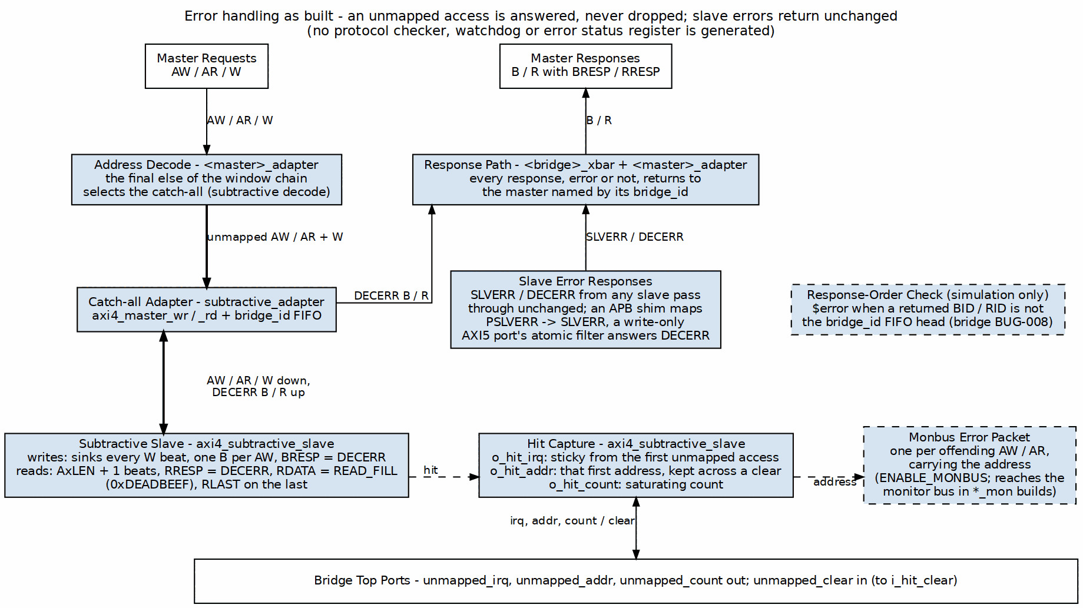
Error Handling System
Only what the generated RTL contains: the catch-all path that answers an unmapped access with DECERR (and 0xDEADBEEF read data), the sticky hit capture behind the bridge’s unmapped_* ports, the monitor-bus error packet, slave error responses returning unchanged, and the simulation-only response-order check.

12.4 2.9.4 Out-of-Range Address Handling

12.4.1 Detection
Router identifies OOR when no slave address range matches:
// Address decode with OOR detection
logic [NUM_SLAVES-1:0] slave_match;
logic oor_detected;
for (genvar i = 0; i < NUM_SLAVES; i++) begin
assign slave_match[i] = (addr >= SLAVE_BASE[i]) &&
(addr <= SLAVE_END[i]);
end
assign oor_detected = ~(|slave_match) && ~default_slave_en;

12.4.2 Error Response Generation
Read OOR Response:
// Generate R response for OOR read
always_ff @(posedge clk) begin
if (ar_oor_detected && arvalid && arready) begin
// Capture transaction details
oor_arid <= arid;
oor_arlen <= arlen;
oor_burst_count <= 0;
oor_generating <= 1'b1;
end else if (oor_generating) begin
// Generate R beats
rvalid <= 1'b1;
rdata <= OOR_DATA_PATTERN; // Configurable pattern
rid <= oor_arid;
rresp <= 2'b11; // DECERR
rlast <= (oor_burst_count == oor_arlen);
if (rready) begin
oor_burst_count <= oor_burst_count + 1;
if (rlast) oor_generating <= 1'b0;
end
end
end
Write OOR Response:
// Generate B response for OOR write
always_ff @(posedge clk) begin
if (aw_oor_detected && awvalid && awready) begin
// Capture write ID
oor_awid <= awid;
oor_w_count <= 0;
oor_sinking_w <= 1'b1;
end else if (oor_sinking_w) begin
// Sink W data (accept and discard)
wready <= 1'b1;
if (wvalid && wlast) begin
oor_sinking_w <= 1'b0;
oor_gen_bresp <= 1'b1;
end
end else if (oor_gen_bresp) begin
// Generate B response
bvalid <= 1'b1;
bid <= oor_awid;
bresp <= 2'b11; // DECERR
if (bready) begin
oor_gen_bresp <= 1'b0;
end
end
end

12.4.3 Configurable Data Patterns
Not built. The read fill value is a module PARAMETER of axi4_subtractive_slave (READ_FILL, default 32'hDEAD_BEEF). The generator does not override it – bridge_2x2_rw.sv passes only the width, UNIT_ID and AGENT_ID parameters – and no TOML key sets it. There is no [bridge.error_handling] table; the loader does not know that name, so a config that contains one is silently ignored. To change the pattern today, override the parameter at instantiation.
[bridge.error_handling]
oor_read_data_pattern = 0xDEADCAFE # Pattern for OOR reads
oor_response_latency = 2 # Cycles to generate response

12.5 2.9.5 Protocol Violation Handling

12.5.1 Common Violations
VALID Dropped While READY=0:
AXI4 Rule: Once VALID asserted, must remain until READY
Violation: Master deasserts VALID before handshake
Detection: Track VALID history per channel
Action: Log error, optionally assert error signal
Incorrect Burst Parameters:
Violations:
- SIZE > DATA_WIDTH
- LEN > 255
- Address not aligned to SIZE
- Burst crosses 4KB boundary
Detection: Parameter checking logic
Action: SLVERR response or reject transaction
ID Width Mismatch:
Violation: Master uses ID wider than configured
Detection: Check ID values against expected width
Action: Truncate or error (configurable)

12.5.2 Protocol Checker Implementation
Not built. No generated bridge contains a protocol checker: a search for protocol_check / proto_check / protocol_viol across every file in rtl/generated/ returns nothing. The section below describes hardware that was never implemented. Protocol violations by an attached master or slave are not detected – with one exception, the bridge BUG-008 (was BRIDGE-010) response-ordering check, which is simulation-only and cannot fire in silicon.
// AXI4 protocol checker (simplified)
module axi_protocol_checker #(
parameter ID_WIDTH = 4,
parameter ADDR_WIDTH = 32,
parameter DATA_WIDTH = 64
) (
input logic clk, rst_n,
// AXI signals
input logic arvalid, arready,
input logic [ADDR_WIDTH-1:0] araddr,
input logic [7:0] arlen,
input logic [2:0] arsize,
// Error outputs
output logic protocol_error,
output logic [7:0] error_code
);
// Check: VALID held until READY
logic arvalid_prev;
always_ff @(posedge clk) begin
arvalid_prev <= arvalid;
if (arvalid_prev && !arvalid && !arready) begin
protocol_error <= 1'b1;
error_code <= 8'h01; // VALID_DROPPED
end
end
// Check: SIZE <= DATA_WIDTH
always_comb begin
if (arvalid && (arsize > $clog2(DATA_WIDTH/8))) begin
protocol_error = 1'b1;
error_code = 8'h02; // INVALID_SIZE
end
end
// Check: Address alignment
always_comb begin
if (arvalid && (araddr[arsize-1:0] != 0)) begin
protocol_error = 1'b1;
error_code = 8'h03; // UNALIGNED_ADDR
end
end
// Additional checks...
endmodule

12.6 2.9.6 Timeout Detection

12.6.1 Per-Transaction Watchdog
Not built. As described, The bridge has NO per-transaction watchdog: it never terminates a stuck transaction and never manufactures a response for one. Non-monitor builds contain zero timeout logic – bridge_2x2_rw and bridge_mix_a have no timeout signal at all.
What DOES exist, and only in *_mon builds, is observability: cfg_wr_timeout_enable / cfg_wr_timeout_cycles / cfg_wr_axi_timeout_mask (and the rd equivalents) are inputs to the AXI MONITOR, which emits a timeout EVENT PACKET on monbus when a transaction outlives the programmed cycle count. It reports; it does not intervene. A hung slave still hangs the bridge – the monitor just tells you it happened.
// Timeout detector for outstanding transactions
typedef struct packed {
logic valid;
logic [TOTAL_ID_WIDTH-1:0] id;
logic [15:0] timestamp;
logic is_read; // 1=read, 0=write
} timeout_entry_t;
timeout_entry_t watchdog [0:15]; // Track up to 16 transactions
logic [15:0] global_timer;
always_ff @(posedge clk) begin
if (!rst_n) begin
global_timer <= 0;
end else begin
global_timer <= global_timer + 1;
// Check for timeouts
for (int i = 0; i < 16; i++) begin
if (watchdog[i].valid) begin
logic [15:0] elapsed;
elapsed = global_timer - watchdog[i].timestamp;
if (elapsed > TIMEOUT_THRESHOLD) begin
// Timeout detected
timeout_error <= 1'b1;
timeout_id <= watchdog[i].id;
timeout_type <= watchdog[i].is_read ? "READ" : "WRITE";
// Force completion with DECERR
force_error_response(watchdog[i]);
watchdog[i].valid <= 1'b0;
end
end
end
end
end

12.6.2 Timeout Configuration
Not built. No watchdog exists to configure. In *_mon builds the cfg_*_timeout_* inputs configure the AXI MONITOR’s reporting threshold, not any bridge behaviour.
There is none. [bridge.error_handling] is not a table the loader knows, and enable_timeout / timeout_cycles / timeout_action / per_slave_timeout are not keys.
What the loader actually does with a key it does not know – measured by feeding it a config carrying cam_depth, pipeline_depth and internal_data_width, not inferred from reading it. Three different behaviours, which is why other pages disagree:
Timeout Configuration
Where | Behaviour
[bridge.mon_group] | HARD ERROR – ValueError naming the offending keys and listing the valid ones
[bridge.defaults] | WARNS: “[bridge.defaults] is not implemented – section ignored”
anywhere else | SILENTLY ACCEPTED and ignored; nothing warns
So a TOML written from the block this section used to contain loads fine and does nothing. An earlier revision of this paragraph claimed config_validator rejects unknown keys and the config “does not load at all”; that is true only of mon_group.
A hung slave stalls its path indefinitely. If the system needs to survive that, the watchdog belongs outside the bridge.

12.7 2.9.7 Error Logging and Reporting

12.7.1 Error Status Register
Not built. No generated file contains an error status register. The nearest real thing is the subtractive slave’s o_hit_irq / o_hit_addr / o_hit_count, which are module PORTS, not a memory-mapped register.
The register as originally proposed (read/clear), kept for reference:
Error Status Register
Bits | Description
0 | OOR Read Error
1 | OOR Write Error
2 | Protocol Violation
3 | Timeout Error
4 | bridge_id FIFO overflow (gated off)
5 | Slave Error (SLVERR received)
6 | Decode Error (DECERR received)
7 | ID Match Error
15:8 | Reserved
31:16 | Error Count (saturating)

12.7.2 Error History Buffer
Not built. There is no history buffer. Only the FIRST fault address is retained (o_hit_addr), plus a saturating count.
// Circular buffer for error history
typedef struct packed {
logic [7:0] error_type;
logic [31:0] address;
logic [TOTAL_ID_WIDTH-1:0] id;
logic [31:0] timestamp;
logic [7:0] master_index;
logic [7:0] slave_index;
} error_entry_t;
error_entry_t error_log [0:15]; // 16-entry history
logic [3:0] error_wr_ptr;
always_ff @(posedge clk) begin
if (error_detected) begin
error_log[error_wr_ptr] <= {
error_type,
error_addr,
error_id,
global_timer,
error_master,
error_slave
};
error_wr_ptr <= error_wr_ptr + 1;
end
end

12.7.3 Error Interrupts
Not built as a block. The only interrupt is o_hit_irq from the subtractive slave: one sticky bit, cleared by i_hit_clear. There is no interrupt controller, mask register or priority logic.
Optional interrupt generation:
Interrupt Enable Register:
- OOR_INT_EN
- TIMEOUT_INT_EN
- PROTOCOL_INT_EN
- etc.
Interrupt when enabled error occurs
Clear on status register read or explicit clear

12.8 2.9.8 Resource Utilization

12.8.1 Error Handling Resources
Not built. These figures price a protocol checker, watchdog and error registers that do not exist. The real cost is the subtractive slave plus a few status flops.
Logic Elements: ~800-1200 LEs
Registers: ~400-600 regs
Block RAM: 0-2 KB (if error logging enabled)
Breakdown:
- OOR detection/response: ~300 LEs, ~100 regs
- Protocol checkers: ~250 LEs, ~50 regs
- Timeout watchers: ~200 LEs, ~150 regs
- Error logging: ~150 LEs, ~100 regs
- Status registers: ~100 LEs, ~50 regs
Optional error log (16 entries): +2KB BRAM

12.9 2.9.9 Configuration Parameters

12.9.1 Error Handling Configuration (TOML)
Not built. The loader does not know a [bridge.error_handling] table. A config containing one is silently ignored – nothing warns. The read fill pattern is the READ_FILL parameter of axi4_subtractive_slave, which the generator never overrides.
[bridge.error_handling]
# OOR handling
# NOT REAL KEYS. Out-of-range handling is fixed, not configured: the
# subtractive slave always answers DECERR with READ_FILL (0xDEADBEEF), there
# is no timeout anywhere in the bridge, and there is no protocol checker.
# Kept visible rather than deleted because several pages once described these
# as configuration, and a reader who saw them elsewhere should find out here
# that they do not exist.
#
# enable_oor_errors / oor_response_type / oor_read_pattern
# enable_timeout / timeout_cycles / timeout_response
# enable_protocol_checker
protocol_checker_mode = "log" # "log", "error", "ignore"
# Error logging
enable_error_log = true
error_log_depth = 16 # Entries in circular buffer
# Error reporting
enable_error_interrupts = false
error_status_register_addr = 0xFFFF_FFF0 # Optional mapped register

12.10 2.9.10 Debug and Observability

12.10.1 Recommended Debug Signals
Error Detection:
- OOR flags (per master)
- Protocol violation flags
- Timeout counters
- bridge_id FIFO occupancy
Error Response:
- Error response generation FSM states
- Active error responses
- Error data patterns
Error Logging:
- Error count
- Last error type
- Last error address
- Error log write pointer

12.11 2.9.11 Common Issues and Debug
Symptom: Unexpected DECERR responses
Check: - Address map configuration (gaps?) - Slave address ranges (overlaps?) - Default slave configuration - Timeout thresholds (too short?)
Symptom: System hangs on certain addresses
Check: - Timeout detection enabled? - Slave responsiveness - Protocol violations upstream - bridge_id FIFO overflow (prevented by the not-full gate, bridge BUG-009 (was BRIDGE-011))
Symptom: Error log filling quickly
Check: - What errors are occurring? - Master behavior (bad addresses?) - Slave configuration - Timeout thresholds

12.12 2.9.12 Verification Considerations

12.12.1 Test Scenarios
- OOR Address Tests:
- Read from unmapped address
- Write to unmapped address
- Burst to partially mapped range
- Verify DECERR response
- Timeout Tests:
- Slave never responds
- Verify timeout after N cycles
- Check error logged
- Verify forced completion
- Protocol Violation Tests:
- Drop VALID before READY
- Invalid burst parameters
- Misaligned addresses
- Verify detection and response
- Error Recovery Tests:
- Error occurs
- System continues operating
- Subsequent transactions succeed
- Error status readable
- Error Logging Tests:
- Generate multiple errors
- Verify all logged
- Check circular buffer wrap
- Verify timestamps

12.13 2.9.13 Recovery Mechanisms

12.13.1 Automatic Recovery
OOR Errors:
- Generate error response
- Continue normal operation
- No intervention needed
Timeout Errors:
- Force transaction completion
- Pop the bridge_id FIFO
- Allow new transactions
Protocol Violations:
- Log error
- Complete/reject transaction
- Continue with next transaction

12.13.2 Manual Recovery
bridge_id FIFO stuck:
- Software reset via control register
- Reset the bridge_id FIFO pointers
- Restart affected masters
Persistent Errors:
- Read error log
- Identify root cause
- Reconfigure or reset subsystem

12.14 2.9.14 Safety and Reliability

12.14.1 Error Containment
Goal: Prevent error propagation
Mechanisms:
- Isolate error to originating master
- Don't corrupt other masters' transactions
- Maintain crossbar integrity
- Log for post-mortem analysis

12.14.2 Fail-Safe Behavior
On Critical Error:
1. Generate safe error response (DECERR)
2. Log error details
3. Assert error signal (optional)
4. Continue operation if possible
5. Halt only if configured (safety-critical mode)

12.14.3 Error Injection (Debug/Test)
Not built. The loader knows no bridge.debug table and no error_injection – searching config_loader.py for either returns nothing. A config containing this section is accepted and silently ignored, which is worse than an error: the build looks configured and injects nothing.
[bridge.debug]
enable_error_injection = true
[[bridge.debug.error_injection]]
type = "oor"
trigger_address = 0xBAD_ADDR
action = "decerr"
[[bridge.debug.error_injection]]
type = "timeout"
trigger_after_n_cycles = 100
target_slave = 2

12.15 2.9.15 Future Enhancements

12.15.1 Planned Features
- Error Recovery FSM: Automatic recovery from certain error conditions
- Error Rate Limiting: Prevent error storm from misbehaving master
- Detailed Error Telemetry: Capture full transaction context on error
- Error Prediction: Detect patterns indicating impending failures

12.15.2 Under Consideration
- ECC Protection: Error correction for internal state
- Redundant Checking: Duplicate checkers for safety-critical
- Watchdog Timers: System-level health monitoring
- Error Severity Levels: Classify errors by impact

Related Sections: - Section 2.2: Slave Router (OOR detection) - Section 2.5: ID Management (bridge_id FIFO depth) - Section 2.8: Response Routing (error response paths) - Chapter 5: Verification (error testing strategies)

RTL Design Sherpa · Learning Hardware Design Through Practice GitHub · Documentation Index · MIT License

13 AMBA5 Boundary and Native Sideband
How AXI5/APB5 ports ride the AXI4 fabric (bridge TASK-002 (was BRIDGE-002) phases A5-1 through A5-3). One spec table drives every generator: bin/bridge_pkg/sideband.py::SIDEBAND_FIELDS maps each feature to its per-channel struct fields, widths, and wrapper port bases — package, adapter, crossbar, and slave-adapter emission all iterate it in the same order, so struct layout and wiring cannot drift apart.

13.1 Boundary Wrappers
- AXI5 master port → axi5_slave_{wr,rd}[_mon] at the master adapter (the bridge is a slave to the external master).
- AXI5 slave port → axi5_master_{wr,rd}[_mon] at the slave adapter.
- Both families carry every feature signal through their skid path, gated by ENABLE_<FEATURE> parameters; the generator binds every pin (enabled features connect through, the rest tie/open).

13.2 Native Sideband Through the Structs (A5-2)
The per-bridge _pkg channel structs gain feature fields as the union of features on any AXI5 port. Pure-AXI4 bridges emit no fields, so their RTL stays byte-identical — the zero-drift invariant.
- Master adapter: packs its own enabled fields from the wrapper’s fub_axi_* sideband on the direct (width-matched) arm only; converter arms pack '0 — per-beat and per-transaction sideband cannot traverse the dwidth-converter IP. Because non-qualifying sources are guaranteed '0, the crossbar forwards request fields unconditionally.
- Crossbar: explodes struct fields into discrete <slave>_axi_<sig> nets for feature-enabled AXI5 slaves; response fields (b.trace, r.trace, r.poison) mux from qualifying slaves and default '0 (they must be driven for every master since union fields exist in every struct).
- Slave adapter: rides xbar_<slave>_axi_<sig> nets into the wrapper via the component’s native_sideband flag, which stops terminating enabled features’ fub ports (fall-through to the connector prefix).
The struct field for AWIDUNQ/ARIDUNQ is named idunq (IHI 0022L A5.2; the library called the indicator awunique/arunique until GitHub #102 item 5, but AWUNIQUE is an unrelated ACE signal). BIDUNQ/RIDUNQ are deliberately not struct fields: the master adapter regenerates them from a per-ID bit table (r_awidunq_by_id / r_aridunq_by_id, written at the AW/AR handshake on the wrapper’s fub face, and for a read-return atomic at its AW), read by BID/RID (AdapterGenerator._idunq_echo_lines). A5.2 makes the response indicator a function of the request and forbids mixing indicators among outstanding same-ID transactions, so the table is exact under any response order, and it is right on every path the request indicator was dropped on. The slave adapter leaves the slave’s BIDUNQ/RIDUNQ unconnected.

13.2.1 AWAKEUP (A14.1.1)
wakeup is a port feature but not struct sideband. Both boundary wrappers of a port carry an awakeup pin (one signal covers both request channels). On a master port both axi5_slave_{wr,rd} take the top-level AWAKEUP; their fub-side copies (the input OR’d with requests held in that wrapper’s skid buffers) are OR’d into the adapter output wakeup_req. The top ORs the wakeup_req of every connected wake-capable master into each wake-capable slave adapter’s wakeup_req input (1'b0 when none), which feeds both axi5_master_{wr,rd} fub awakeup pins; each wrapper ORs in its own held requests and the slave adapter ORs the two m_axi_awakeup copies onto the port. Every term is a flop or a top-level input, so the tree is glitch-free. The bridge never waits for a master’s AWAKEUP.

13.2.2 Data-scaled fields: Memory Tagging and chunking (bridge TASK-007, was BRIDGE-018)
The last two wrapper features, mte and chunking, joined the table on 2026-09-13 and closed the native-AXI5 gap. Their fields are the only ones whose width follows the data bus: a tag bus is 4 bits per 16 bytes (wtag, rtag; IHI 0022L A12.2 has no AWTAG or BTAG, and the library’s awtag/btag/rtagmatch went with GitHub #102 item 5), wtagupdate and rchunkstrb one bit per 16 bytes / 128-bit chunk. sideband.py carries them as symbolic widths (WIDTH_TAGS, WIDTH_NTAGS, WIDTH_CHUNKSTRB) and resolves them with field_width(width, data_width):
- the per-width w/r structs size them for their own width;
- the width-independent aw/ar/b structs size them for the widest port in the bridge, and the adapters and crossbar fit a narrower port’s value with an explicit zero-extension or slice (fit_expr) – widths decided in Python, so the emitted RTL carries no casts;
- slave ports and adapter pins are sized for that port’s own width.
The fabric carries these fields and never interprets them: tags are payload routed with their beat, the 2-bit btagmatch (Table A12.14) returns through the B mux by bridge id like bresp, and a chunked burst’s R beats are routed by ID and released on RLAST whatever order the completer sends the chunks in. Both features require a port of 128 bits or more (validate_axi5_wide_features).

13.3 Connectivity Gating (poison, atomic, mte) and Droppable Chunking
AXI5_CONNECTIVITY_GATED_FEATURES in the validator: these features are legal only when every connected path is AXI5-both-ends, feature-enabled, and width-matched — otherwise a config error naming the offending pair. mte is in the set because a dropped tag operation changes what the write means. Droppable sideband that terminates mid-path is legal but prints a generation-time warning per (master, slave, feature); chunking is droppable because ARCHUNKEN is permission, not demand – a slave that cannot chunk answers with ordered data and RCHUNKV low, which every chunking requester must accept.

13.4 Atomic Filter (A5-3a, write-only masters)
A write-only atomic-enabled master’s wr path inserts axi5_atomic_filter between the boundary wrapper and the fabric:

13.4.1 Figure 2.11: Atomic Filter on a Write-Only Port
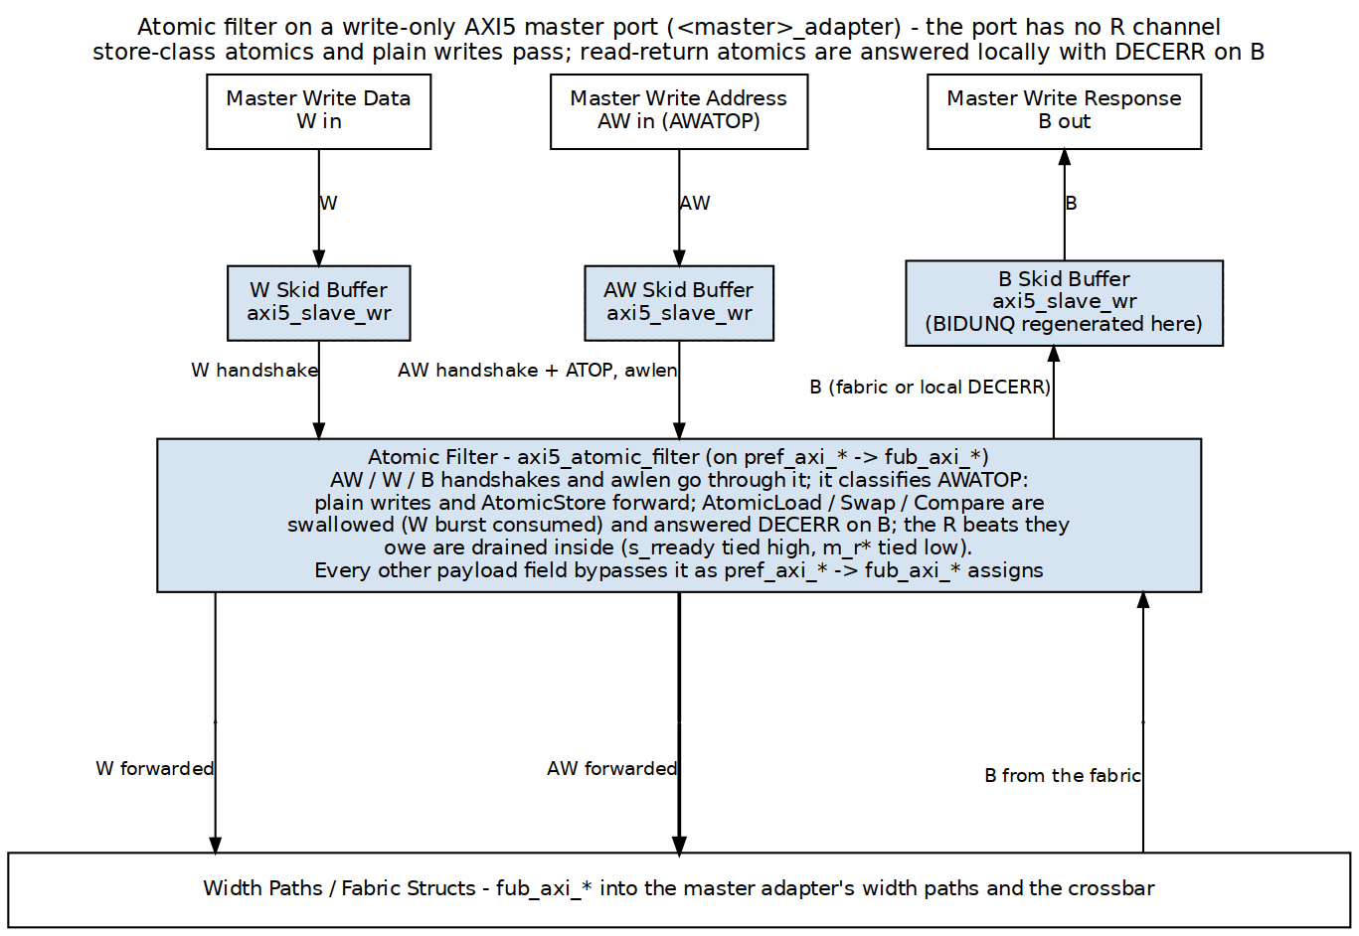
Atomic Filter on a Write-Only Port
Handshakes (AW/W/B) and the B payload (bid/bresp) go through the filter, and awlen is connected so the filter can count the read data it owes; all other payload gets pref → fub pass-through assigns. Store- class ATOP and plain writes forward; read-return classes are swallowed (W burst consumed) and answered with a local DECERR B.
Since GitHub #102 item 2 the filter also returns the read data transfers a swallowed atomic owes (IHI 0022L A6.4.8: AWLEN+1 for Load/Swap, half that for Compare, each DECERR, RLAST on the last), merged into its s_r* output with downstream priority and no burst interleave. On the bridge’s write-only port there is no R channel upstream to merge into and no downstream R, so the generator ties the filter’s s_rready high and leaves s_rvalid/s_rid/ s_rresp/s_rlast open (the beats are accepted and discarded), and ties m_rvalid/m_rid/m_rresp/m_rlast low. Draining matters: an undrained read-return queue fills after 2**DEPTH_LG2 (8) swallowed atomics and then stalls AW for good. The atomic completes with DECERR on B only; HAS 4.4 states the resulting rule – managers must not issue load-class atomics on a write-only port. When the port has unique, BIDUNQ is regenerated on the pref side, so the local DECERR carries its own AWIDUNQ. See the module doc: docs/markdown/rtl-amba/axi5/axi5_atomic_filter.md. The filter exists because a port with no read path has nowhere to deliver the R beat those classes answer with. A port that has one gets the next section instead.

13.5 Read-Return Atomics (A5-3b, rw masters)
An rw atomic-enabled master has no filter. AtomicLoad (10xxxx), AtomicSwap and AtomicCompare (11000x) ride the AW path to the slave like any write; the slave performs the operation and answers on both B and R, the R beat carrying the location’s original data under the AW’s ID. Two things in this fabric had to learn about that beat, because every R-return tracker in it is fed by AR handshakes:

13.5.1 Figure 2.12: Read-Return Atomics
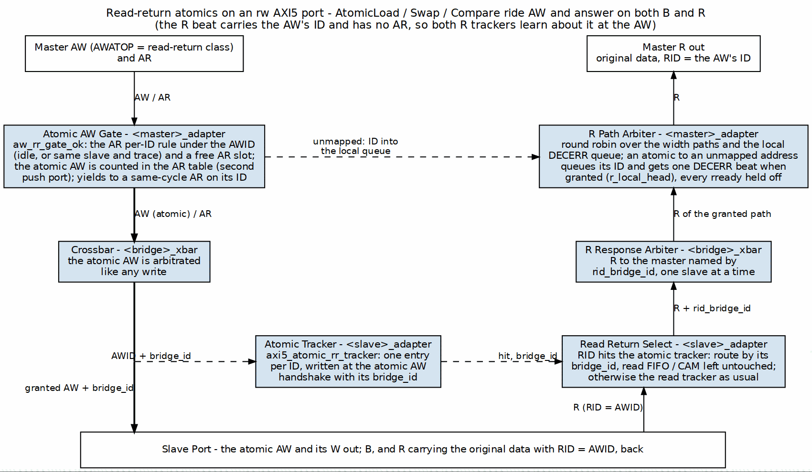
Read-Return Atomics
Master adapter. The AR per-ID table (MAS 2.1) counts the atomic AW too, under its AWID, because its R returns with that ID: a second push port (ar_idt_push_aw) beside the AR’s own. The AW’s gate (aw_rr_gate_ok) is the read side’s per-ID rule – that ID idle, or in flight to the same slave with the same trace – plus a free AR slot counting an AR that pushes this cycle, and it yields to an AR pushing the same ID index in the same cycle. The B/W paths are unchanged. The table’s trace bit is written from AWTRACE, so the R beat echoes the AW’s trace (bridge BUG-010, was BRIDGE-012). Until GitHub #119 L1b (2026-10-15) an AR->R slot FIFO did this job and held the port to one target at a time.
Out of range. A read-return atomic that decodes to the subtractive slave would otherwise wedge the port: that slave answers DECERR on B and knows nothing about R, while the master adapter is counting an R for the beat. The atomic’s ID therefore goes into a local-DECERR queue (lr_*), which joins the R path arbiter as one more source; when it is granted (r_local_head) the R mux presents a single DECERR beat with that ID itself, holding every slave’s rready off (r_path_active && !r_local_head) for that cycle. B and R both report DECERR, and the port keeps working. This is bridge BUG-007 (was BRIDGE-009)’s rule applied to the atomic path.
The invariant underneath. Nothing here depends on one target at a time any more. The crossbar’s response mux is a grant-driven mux behind a per-path response arbiter (GitHub #119 L1), and the master adapter steers by ID (L1b), so an atomic at one slave and reads at another are in flight together – test_bridge_1x2_rw_axi5a_multitarget measures exactly that, and fails on the pre-L1b RTL.
Slave adapter. axi5_atomic_rr_tracker (module doc: docs/markdown/rtl-amba/axi5/axi5_atomic_rr_tracker.md) records (AWID -> requester index) at every AW handshake with AWATOP[5] set, and answers combinationally from RID. An R beat it claims is routed by its tag and does not pop the in-order read FIFO; every other beat routes by FIFO position as before. The atomic AW’s awready is held while the tracker is full. The bridge BUG-008 (was BRIDGE-010) in-order check skips tracked beats and reports, in simulation, an R beat that matches both a tracked atomic and the FIFO head: that is two requesters aliasing one ID at this slave, which this fabric does not disambiguate.
Validator. An rw atomic master’s connected atomic slaves must be rw (a write-only slave cannot return read data). The return tracker sits beside whichever read tracker the slave uses, the in-order FIFO or the enable_ooo CAM (bridge BUG-012 (was BRIDGE-015) repaired that mode). A write-only atomic master is not subject to the rule; it keeps the filter.
Filelist. axi5_atomic_filter.f is pulled only when a write-only atomic master exists; axi5_atomic_rr_tracker.f only when an rw atomic slave exists. Pure-AXI4 bridges and the A5-3a fixture are byte-identical to before this change.

13.6 APB5 Slaves (A5-3c)
protocol = "apb5" reuses the entire APB4 path with two deltas: the slave adapter instantiates axi4_to_apb5_shim (a sideband wrapper over the APB4 shim — see the converters MAS), and the external surface adds PAUSER/PWUSER out (driven '0), PWAKEUP out and PRUSER/PBUSER in (terminated). PWAKEUP is a requester output (IHI 0024E 3.7.2; it was an input until GitHub #102 item 7): the shim drives it from a flop of PSEL, so it is glitch-free and held through the PREADY cycle. The generated TB drives the port with the APB5 BFM, which observes PWAKEUP: APB5 keeps the APB4 transfer protocol.

13.7 Lite and APB Requesters (bridge TASK-004, was BRIDGE-014)
Every protocol value is legal on a master port. Two of them needed work beyond the AXI4-Lite master path that already existed:
- axil5 master. The AXI4-Lite promotion (AXI4 extras tied at the top, axi4_slave_* wrappers, the wide-slave aligner toward wider slaves) plus the AXI5-Lite ID and optional signals on the boundary, directions flipped for a requester. The ID (awid/bid/arid/rid) and user – the one optional group with an AXI4 destination – join the Lite surface and reach the adapter’s AXI4 face; TRACE and POISON are terminated at the top. AXI5-Lite has no LOCK, LOOP, MPAM, MECID or NSAID (IHI 0022L B2.1.5, GitHub #102 item 3). validate_axil5_features applies to masters and slaves alike, so a config cannot name a group the design drops.
- apb / apb5 master. The bridge is the APB completer. apb4_to_axi4 / apb5_to_axi4 (converters: apb{4,5}_slave + apb_cmdrsp_to_axi4) sit inside the master adapter in front of the ordinary timing wrapper, so monitoring, decode, width adaptation and the response mux are untouched. One transfer -> one single-beat AXI4 transaction; SLVERR and DECERR fold to PSLVERR; PAUSER[0]/PWUSER[0] ride the fabric USER bit (visible at an axil5 slave with user). PWAKEUP is requester-driven and terminated.
Validator rules: AXI4-Lite masters id_width = 0, AXI5-Lite masters id_width >= 1; APB masters addr_width = 32 (a requester addresses the whole fabric, unlike an APB slave port’s window offset). The generated TB drives axil5 masters with the AXIL5 BFMs and apb/apb5 masters with APBMaster/APB5Master; master_read/ master_write unwrap the APB transaction and turn PSLVERR into AxiResponseError(resp=2) – APB cannot tell SLVERR from DECERR, so 2 is the honest code.

13.8 Verification Anchors
- Generator unit tests: bin/tests/test_generator_pkg.py (feature gating, poison/atomic connectivity rules, generation smoke).
- Sideband values end-to-end, driven per transaction by the AXI5 master BFM: dv/tests/test_bridge_1x2_{rd,wr}_axi5n_sideband.py (native path and drop path; the AXI5 slave BFM echoes trace on B/R).
- Sideband through the arbiter: dv/tests/test_bridge_2x2_axi5_sideband_arb.py – two AXI5 masters with distinct NSAIDs contend for the AXI5 slave; every slave-side AW/AR NSAID must belong to its issuing master and the counts must match.
- Sideband across a width converter: dv/tests/test_bridge_1x2_rd_axi5w_sideband.py – 32b AXI5 master into a 64b AXI4 slave; data round-trips, trace returns 0.
- Atomics, filtered: dv/tests/test_bridge_1x2_wr_axi5a_atomics.py (store forwards; load, swap AND compare answered DECERR by the filter, via atomic_operation; a burst of 12 load-class atomics – more than the filter’s 8-deep read-return queue – all complete and the port stays usable; BIDUNQ follows AWIDUNQ on the local DECERRs) and val/amba/test_axi5_atomic_filter.py.
- Unique-ID indicators: test_bridge_2x2_axi5_sideband_arb.py, test_bridge_1x2_rd_axi5{n,w}_sideband.py, test_bridge_1x2_rd_axi5_bfm5.py (BIDUNQ/RIDUNQ follow the request on native, AXI4, converter paths) and test_bridge_1x2_rw_axi5a_atomics.py (an atomic’s RIDUNQ and BIDUNQ).
- AWAKEUP: dv/tests/test_bridge_2x2_axi5_wakeup.py (forwarding ahead of any request, held on every request cycle including traffic from a master without AWAKEUP, low when idle).
- Atomics, read-return: dv/tests/test_bridge_1x2_rw_axi5a_atomics.py – load ADD/SET/UMAX, swap, compare (match and mismatch) on both slaves, each checked three ways (R data is the pre-op value, memory holds the post-op value, a plain read agrees), then reads and atomics in flight together across and within slaves. The slave BFM performs the operation; the AXI5 checker treats a read-return atomic as an outstanding read and flags any R beat nobody requested. val/amba/test_axi5_atomic_rr_tracker.py covers the tracker alone. Mutation-checked: with the tracker’s hit removed from rid_valid, the R beat is never routed and the test fails on a read-return timeout.
- Lite requesters: dv/tests/test_bridge_2x2_lite_req_sideband.py on bridge_2x2_lite_req (AXI4-Lite + AXI5-Lite masters, 64b AXI4 + AXI5-Lite slaves) – user/lock from the AXI5-Lite master seen at the AXI5-Lite slave and absent from the AXI4-Lite master’s traffic, terminated groups reading 0, both halves of a 64-bit row from both Lite masters (the aligner), and both ID-less masters in flight at one slave.
- APB requesters: dv/tests/test_bridge_2x3_apb_req_paths.py on bridge_2x3_apb_req (APB4 + APB5 masters, AXI4 + AXI5-Lite + APB4 slaves) – PSLVERR for unmapped addresses with the port working after, PPROT at the AXI4 slave, the APB5 USER bit at the AXI5-Lite slave and 0 from the APB4 master, APB in / APB out through the fabric from both requesters interleaved. The converters alone: projects/components/utility-ip/converters/dv/tests/test_apb{4,5}_to_axi4.py.
- AXI5 compliance at the boundary: every generated TB arms an AXI5ComplianceChecker on each AXI5 master port and every generated test asserts zero violations before PASSED; dv/tests/test_bridge_1x2_rd_axi5_bfm5.py is the read-side sign-off.

RTL Design Sherpa · Learning Hardware Design Through Practice GitHub · Documentation Index · MIT License

14 Bridge Arbiter Finite State Machines

14.1 Overview
The Bridge AXI4 crossbar arbitrates per slave, not per master — each slave owns two dedicated arbiters:
- AW Arbiter - Write Address channel arbitration
- AR Arbiter - Read Address channel arbitration
Total FSM Count: 2 × NUM_SLAVES
Each arbiter is a simple 2-state FSM. Round-robin access keeps any master from starving, and two states keep the behavior easy to reason about — there’s real value in an arbiter you can hold in your head.

14.2 AW Channel Arbiter FSM
Purpose: Arbitrate write address requests from multiple masters to a single slave
States: 2 (IDLE, GRANT_ACTIVE)
Algorithm: Round-robin with grant locking

14.2.1 Figure 3.1: AW Arbiter FSM
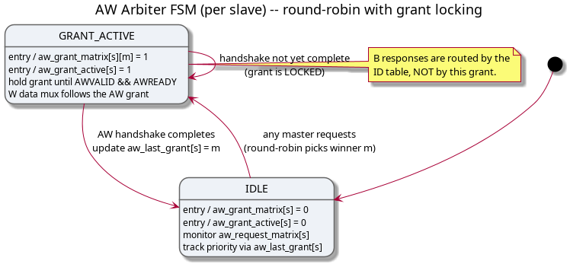
AW Arbiter FSM
State Descriptions:
IDLE State: - Entry Actions: - aw_grant_matrix[s] = 0 - No grant issued - aw_grant_active[s] = 0 - Arbiter inactive - Behavior: - Monitor aw_request_matrix[s] for master requests - Track round-robin priority via aw_last_grant[s] - Remain in IDLE until at least one master requests access
GRANT_ACTIVE State: - Entry Actions: - aw_grant_matrix[s][m] = 1 - Issue grant to winning master - aw_grant_active[s] = 1 - Mark arbiter as active - Behavior: - Hold grant until AW handshake completes (AWVALID && AWREADY) - W channel data multiplexing follows AW grant - B channel response routes by bridge_id FIFO position (no ID table, not grant-based)
State Transitions:
AW arbiter FSM transitions
From | To | Condition | Description
IDLE | GRANT_ACTIVE | \|aw_request_matrix[s]\| > 0 | At least one master requesting access
GRANT_ACTIVE | IDLE | m_axi_awvalid[s] && m_axi_awready[s] | AW handshake complete

14.3 AR Channel Arbiter FSM
Purpose: Arbitrate read address requests from multiple masters to a single slave
States: 2 (IDLE, GRANT_ACTIVE)
Algorithm: Round-robin with grant locking (same as AW)

14.3.1 Figure 3.2: AR Arbiter FSM
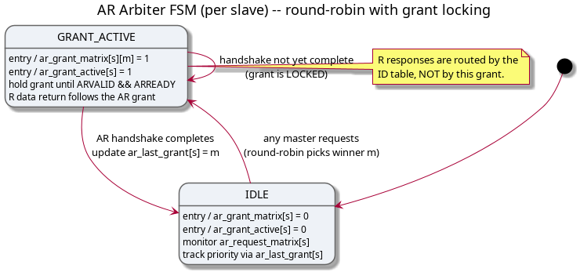
AR Arbiter FSM
State Descriptions:
IDLE State: - Entry Actions: - ar_grant_matrix[s] = 0 - No grant issued - ar_grant_active[s] = 0 - Arbiter inactive - Behavior: - Monitor ar_request_matrix[s] for master requests - Track round-robin priority via ar_last_grant[s] - Independent from AW arbiter state
GRANT_ACTIVE State: - Entry Actions: - ar_grant_matrix[s][m] = 1 - Issue grant to winning master - ar_grant_active[s] = 1 - Mark arbiter as active - Behavior: - Hold grant until AR handshake completes (ARVALID && ARREADY) - R channel data multiplexing follows AR grant - R channel response routes by bridge_id FIFO position (no ID table)
State Transitions:
AR arbiter FSM transitions
From | To | Condition | Description
IDLE | GRANT_ACTIVE | \|ar_request_matrix[s]\| > 0 | At least one master requesting read
GRANT_ACTIVE | IDLE | m_axi_arvalid[s] && m_axi_arready[s] | AR handshake complete

14.4 Round-Robin Arbitration Algorithm
Algorithm Description:
Both AW and AR arbiters use the same fair round-robin arbitration algorithm — learn it once and you’ve learned both:
Pseudocode:
1. Start search from (last_grant[s] + 1) % NUM_MASTERS
2. Search cyclically through all masters
3. Select first master with pending request
4. Update last_grant[s] = winning_master
5. Issue grant
Example with 4 Masters:
Initial state: last_grant[0] = 0
Request Pattern:
Master 0: request
Master 1: request
Master 2: no request
Master 3: request
Arbitration Sequence:
Grant 1: Master 1 (start from master 1, first requester)
last_grant = 1
Grant 2: Master 3 (start from master 2, find master 3)
last_grant = 3
Grant 3: Master 0 (start from master 0, first requester)
last_grant = 0
Grant 4: Master 1 (start from master 1, first requester)
last_grant = 1
Fairness Properties:
- No Starvation - Every requesting master will eventually receive grant
- Priority Rotation - Priority shifts after each grant
- Predictable Latency - Maximum wait time = (NUM_MASTERS - 1) × grant_duration
- Equal Opportunity - All masters treated equally

14.5 Grant Locking Mechanism
Purpose: Prevent grant changes mid-transaction
AW Grant Locking:
// AW grant locked until address handshake completes
always_ff @(posedge aclk or negedge aresetn) begin
if (!aresetn) begin
aw_grant_active[s] <= 1'b0;
aw_grant_matrix[s] <= '0;
end else begin
if (aw_grant_active[s]) begin
// GRANT_ACTIVE state: Hold grant until handshake
if (m_axi_awvalid[s] && m_axi_awready[s]) begin
aw_grant_active[s] <= 1'b0; // Return to IDLE
aw_grant_matrix[s] <= '0;
end
end else if (|aw_request_matrix[s]) begin
// IDLE state: Arbitrate if requests pending
aw_grant_matrix[s] <= round_robin_select(aw_request_matrix[s]);
aw_grant_active[s] <= 1'b1; // Enter GRANT_ACTIVE
end
end
end
AR Grant Locking:
// AR grant locked until address handshake completes
always_ff @(posedge aclk or negedge aresetn) begin
if (!aresetn) begin
ar_grant_active[s] <= 1'b0;
ar_grant_matrix[s] <= '0;
end else begin
if (ar_grant_active[s]) begin
// GRANT_ACTIVE state: Hold grant until handshake
if (m_axi_arvalid[s] && m_axi_arready[s]) begin
ar_grant_active[s] <= 1'b0; // Return to IDLE
ar_grant_matrix[s] <= '0;
end
end else if (|ar_request_matrix[s]) begin
// IDLE state: Arbitrate if requests pending
ar_grant_matrix[s] <= round_robin_select(ar_request_matrix[s]);
ar_grant_active[s] <= 1'b1; // Enter GRANT_ACTIVE
end
end
end
Why Grant Locking Matters:
- Protocol Compliance - AXI4 spec requires stable AWID/ARID during handshake
- Data Integrity - W channel must follow granted master’s AW request
- Response Routing - B/R channels need consistent transaction tracking
- Simplicity - Single grant active per slave prevents mux conflicts

14.6 Independent Read/Write Arbitration
Here’s the design decision that pays for itself: the AW and AR arbiters operate completely independently.
Benefits:
- No Head-of-Line Blocking:
  - Read requests don’t wait for write completion
  - Write requests don’t wait for read completion
- Parallel Operation:
  - Master 0 can write to Slave 0 (AW path)
  - Master 1 can read from Slave 0 (AR path)
  - Both transactions proceed simultaneously
- Resource Efficiency:
  - Full utilization of read/write bandwidth
  - No artificial serialization
Example Scenario:
Time T0: Master 0 issues write to Slave 0
- AW arbiter grants to Master 0
- AW_GRANT_ACTIVE = 1
- W data follows
Time T1: Master 1 issues read to Slave 0 (during Master 0 write)
- AR arbiter grants to Master 1 (independent!)
- AR_GRANT_ACTIVE = 1
- R data returns
Result: Read and write happen in parallel - no blocking

14.7 FSM Instance Breakdown by Configuration
2×2 Configuration (2 masters, 2 slaves): - Slave 0 AW Arbiter: 1 FSM - Slave 0 AR Arbiter: 1 FSM - Slave 1 AW Arbiter: 1 FSM - Slave 1 AR Arbiter: 1 FSM - Total: 4 FSMs
4×4 Configuration (4 masters, 4 slaves): - 4 slaves × 2 arbiters per slave = 8 FSMs
8×8 Configuration (8 masters, 8 slaves): - 8 slaves × 2 arbiters per slave = 16 FSMs
Scalability: - FSM count scales linearly with NUM_SLAVES - Arbitration complexity scales with NUM_MASTERS (search time) - Synthesis impact minimal for up to 16×16 configurations

14.8 Performance Characteristics
Latency:
- Best Case: 1 clock cycle (IDLE → GRANT_ACTIVE → IDLE with immediate handshake)
- Worst Case: (NUM_MASTERS) clock cycles (round-robin search + contention)
- Average Case: ~(NUM_MASTERS / 2) clock cycles
Throughput:
- Back-to-Back Grants: Possible if different masters (no wait)
- Same Master Repeated: 1 cycle minimum between grants (FSM state change)
Fairness:
- Guaranteed: Every master gets grant within (NUM_MASTERS - 1) arbitration cycles
- No Priority: All masters treated equally (can be extended for QoS)

14.9 Comparison with Other Crossbar Arbiters
Arbiter comparison
Feature | Bridge Arbiter | APB Crossbar | Commercial Tools
States | 2 (IDLE, GRANT_ACTIVE) | 1 (passthrough) | 3-5 (complex)
Algorithm | Round-robin | N/A (APB is 1:1) | Priority, QoS, weighted
Grant Locking | Yes (until handshake) | N/A | Burst-aware locking
Read/Write Indep | Yes (2 FSMs/slave) | N/A | Yes
Complexity | Low | Minimal | High
Predictability | High (round-robin) | N/A | Medium (priority-based)
Simplicity Trade-off:
- Advantages:
  - Easy to verify (2-state FSM)
  - Predictable latency
  - Fair resource allocation
- Limitations (future enhancements):
  - No Quality-of-Service (QoS) support
  - No priority levels
  - No weighted arbitration

14.10 Future Enhancements (Phase 3+)
QoS Support:
// Master QoS priority field (AXI4 optional)
input logic [3:0] s_axi_awqos [NUM_MASTERS];
// Arbitration considers QoS priority
function automatic [NUM_MASTERS-1:0] qos_arbitrate(
input logic [NUM_MASTERS-1:0] requests,
input logic [3:0] qos [NUM_MASTERS]
);
// Higher QoS value = higher priority
// Round-robin among same QoS level
endfunction
Weighted Arbitration:
// Master weight configuration
parameter int MASTER_WEIGHTS [NUM_MASTERS] = '{1, 2, 1, 4};
// Grant frequency proportional to weight
// Master 3 gets 4× more grants than Master 0
Burst-Aware Locking:
// Lock grant until entire burst completes
// Currently: Lock until address handshake
// Enhanced: Lock until WLAST (write) or RLAST (read)

14.11 Related Documentation
See Also: - 3.1 - Module Structure - Generated RTL organization - 3.3 - Crossbar Core - Internal crossbar instantiation
Reference: - ARM AMBA AXI4 Specification (IHI 0022E) - Section A7 (Arbitration)
Next: 3.3 - Crossbar Core

RTL Design Sherpa · Learning Hardware Design Through Practice GitHub · Documentation Index · MIT License

15 Transaction Tracking FSMs

15.1 Overview
Despite the chapter title, the generated bridge tracks outstanding transactions with FIFOs and a CAM, not state machines: the W destination and W owner FIFOs in the crossbar, the aw_trk / ar_trk / w_trk slave-select FIFOs in each master adapter, and the per-slave bridge_id tracker (bridge_cam for multi-master AXI4/AXI5 slaves, an in-order FIFO otherwise). The FSM designs this chapter used to show are kept below only where they are marked as not built.

15.2 Write Data Tracking (FIFO, not an FSM)

15.2.1 Purpose
The W channel carries no address of its own, so the bridge remembers which slave each AW selected and steers the data beats to match.

15.2.2 Implementation
There is no IDLE/WRITING state machine. Each master width-path has a max_outstanding-entry W destination FIFO in the crossbar (<master>_<w>b_wdest_*), and each master adapter has a matching w_trk FIFO of slave selects:
// bridge_2x2_rw_xbar.sv
wire cpu_32b_wdest_push = cpu_32b_awvalid && cpu_32b_awready; // record target at AW
wire cpu_32b_wdest_pop = cpu_32b_wvalid && cpu_32b_wready && cpu_32b_w.last; // retire at WLAST
assign cpu_32b_w_to_ddr = cpu_32b_wdest_valid && (cpu_32b_wdest_head == 2'd0);
Because every accepted AW is queued, a master may issue further AWs before the first burst’s W beats finish; each W burst follows its own AW in order.

15.2.3 Figure 3.3: W Data Tracking FIFOs
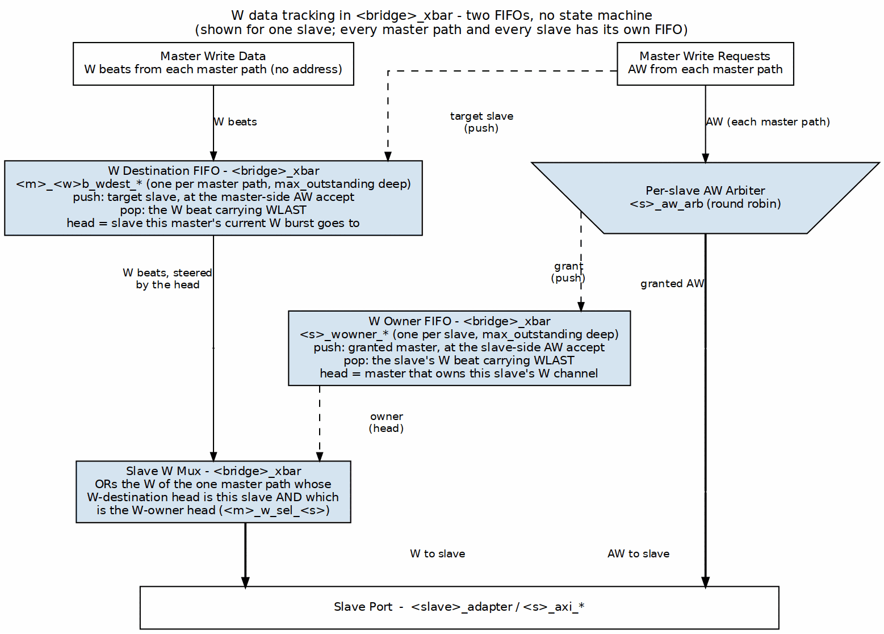
W Data Tracking FIFOs
W beats run down the left: each master path’s W destination FIFO names the slave its current burst goes to, and the slave’s W mux takes the beats of the master that is also at the head of that slave’s W owner FIFO. The AW requests run down the center through the per-slave arbiter. The dashed pushes come from the AW side: the master-side AW accept pushes the target slave, and the slave-side AW accept pushes the granted master. Both FIFOs pop on the W beat carrying WLAST, and several bursts can be queued at once.

15.3 Response Pending Counter
Not built. There is no per-master outstanding-transaction counter and no flow control derived from one. Outstanding depth is bounded by the per-slave bridge_id tracker (CAM or FIFO, max_outstanding deep, default 16), whose fullness gates the address handshake (bridge BUG-009, was BRIDGE-011). Searching the generated RTL for a response-pending counter returns nothing.

15.3.1 Purpose
Track number of outstanding transactions per master for flow control.

15.3.2 Implementation
logic [7:0] r_outstanding [NUM_MASTERS];
// Increment on AR/AW acceptance
always_ff @(posedge clk or negedge rst_n) begin
if (!rst_n) begin
for (int i = 0; i < NUM_MASTERS; i++)
r_outstanding[i] <= '0;
end else begin
for (int m = 0; m < NUM_MASTERS; m++) begin
logic inc = (ar_accepted[m] || aw_accepted[m]);
logic dec = (r_delivered[m] || b_delivered[m]);
case ({inc, dec})
2'b10: r_outstanding[m] <= r_outstanding[m] + 1;
2'b01: r_outstanding[m] <= r_outstanding[m] - 1;
default: r_outstanding[m] <= r_outstanding[m];
endcase
end
end
end
// Backpressure when outstanding limit reached
assign accept_ar[m] = (r_outstanding[m] < MAX_OUTSTANDING);
assign accept_aw[m] = (r_outstanding[m] < MAX_OUTSTANDING);

15.4 Burst Counter FSM
Not built. No generated file contains a burst-beat counter; the read tracker frees its entry on the R beat with RLAST, so no count is needed.

15.4.1 Purpose
Track burst beat count for responses spanning multiple cycles.

15.4.2 States
Transaction tracking states
State | Description
IDLE | No burst in progress
COUNTING | Tracking burst beats

15.4.3 Implementation
logic [7:0] r_burst_count;
logic r_burst_active;
always_ff @(posedge clk or negedge rst_n) begin
if (!rst_n) begin
r_burst_count <= '0;
r_burst_active <= 1'b0;
end else begin
if (!r_burst_active && rvalid && rready) begin
// Start new burst
r_burst_active <= !rlast;
r_burst_count <= rlast ? '0 : 8'd1;
end else if (r_burst_active && rvalid && rready) begin
// Continue burst
r_burst_count <= r_burst_count + 1;
r_burst_active <= !rlast;
end
end
end

15.5 Related Documentation
- Arbiter FSMs - Address channel arbitration
- ID Management - the per-slave response tracker (bridge_cam or in-order FIFO)

RTL Design Sherpa · Learning Hardware Design Through Practice GitHub · Documentation Index · MIT License

16 CAM Architecture

16.1 Overview
bridge_cam (rtl/bridge_cam.sv, hand-written) is the response tracker in every slave adapter that has to route by ID: an AXI4/AXI5 slave of a bridge with more than one master, or any slave with enable_ooo = true (SlaveAdapterGenerator.use_cam). Each such adapter instantiates two, u_wr_cam and u_rd_cam. Single-master bridges, protocol-shim slaves and the internal subtractive slave use an in-order FIFO instead (see ID Tracking).
An earlier revision of this chapter said the CAM was never built, that it was instantiated in zero bridges, and that IDs passed through at equal width. Since bridge TASK-005 the master adapter widens IDs to {BRIDGE_ID, id} (cpu_m_axi_awid 4 bits, ddr_s_axi_awid 5 bits in bridge_2x2_rw) and multi-master AXI4/AXI5 slaves are tracked here. The sizing formula and the block-RAM sequential search below were never built and are marked as such.

16.2 Functional Description

16.2.1 What the CAM Does
Transaction tracking. Each entry stores:
- the fabric transaction ID {BRIDGE_ID, id} (tag, TAG_WIDTH = ID_WIDTH)
- the originating master index (DATA_WIDTH = BRIDGE_ID_WIDTH)
- an ordering count, so one ID may be outstanding more than once
Response routing. When a response arrives:
- The returned BID / RID is the deallocate tag
- deallocate_data returns the originating master index, in the same cycle
- The crossbar steers the B / R beat by that index (bid_bridge_id / rid_bridge_id)
The slave may therefore complete different IDs in any order.

16.2.2 Figure 4.1: CAM Entry Format
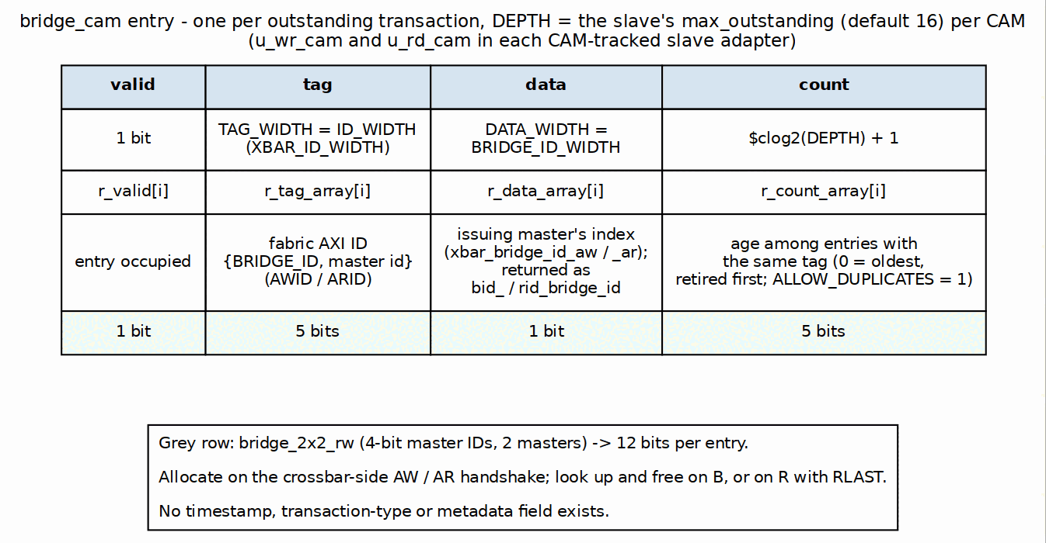
CAM Entry Format

16.2.3 CAM Sizing
As generated, every CAM is the slave’s max_outstanding entries deep (default 16, power of two 2..64, bridge GitHub #119 L5) regardless of master count:
bridge_cam #(.TAG_WIDTH(ID_WIDTH), // XBAR_ID_WIDTH, 5 in bridge_2x2_rw
.DATA_WIDTH(BRIDGE_ID_WIDTH), // 1 in bridge_2x2_rw
.DEPTH(16), // the slave's max_outstanding
.ALLOW_DUPLICATES(1),
.PIPELINE_EVICT(0),
.PIPELINE_ALLOC(1), // registered insert (below)
.PIPELINE_FREE(1)) // registered free (below)
The formula once proposed here (DEPTH = MAX_OUTSTANDING x NUM_MASTERS, with a metadata field in each entry) was never built. Depth is the slave’s own max_outstanding (GitHub #119 L5), whatever the master count, and no entry carries a metadata field.

16.2.4 Insertion (AW / AR Acceptance)
On the crossbar-side address handshake the slave adapter allocates the fabric ID against the granted master’s index (from the generated ddr_adapter.sv):
.allocate (xbar_ddr_axi_awvalid && xbar_ddr_axi_awready),
.allocate_tag (xbar_ddr_axi_awid), // {BRIDGE_ID, id}
.allocate_data(xbar_bridge_id_aw), // master index sideband
The insert is registered (PIPELINE_ALLOC = 1, GitHub #119). The handshake only captures the tag and master index into a pending-insert register. The tag match against every entry, the duplicate popcount and the entry write run the next cycle, from that register. Before this, the crossbar’s arbitrated ID drove the whole match and count in the handshake cycle. On the Genesys 2 fabric benchmark that made a 15-level path: master AW gate, crossbar grant, then the DDR slave’s CAM count. Out of context at 4 ns, the registered insert moved WNS from -2.753 to -2.056 ns.
AXI allows a response one cycle after its request, before the pending entry reaches the table, so the eviction port also checks the pending register. A response whose tag has no stored entry takes the pending one, which is then never written. A stored entry with the same tag is older, so it retires first. tags_full and tags_count include a pending insert, so an allocate cannot claim the slot it is about to use.

16.2.5 Lookup and Deletion (B / last R)
Lookup and deletion are one operation: the response handshake deallocates by the returned ID and returns the stored master index combinationally (PIPELINE_EVICT = 0):
// write side: every B; read side: the R beat with RLAST
.deallocate (xbar_ddr_axi_bvalid && xbar_ddr_axi_bready),
.deallocate_tag (xbar_ddr_axi_bid),
.deallocate_valid(bid_valid), // tag found
.deallocate_data(bid_bridge_id), // routes B in the crossbar
A response whose ID is not in the CAM leaves deallocate_valid low and routes nowhere; it means the slave returned an ID it was never sent.
The free is registered (PIPELINE_FREE = 1, GitHub #119). The lookup above stays combinational, because it routes the response in its own cycle. What a deallocate changes in storage is applied the next cycle: the count-0 entry is cleared and the same-tag survivors step down. Until then, every lookup and insert sees the post-free state. The freed entry no longer matches, and the pending decrements are already reflected in the counts used by the count-0 search and by the new entry’s count. Occupancy drops a cycle later, so tags_full is conservative for that one cycle. This moved the fabric benchmark’s WNS at 4 ns from -2.056 to -1.599 ns (about 148 to 179 MHz for the two changes together).

16.2.6 Figure 4.2: CAM Insert and Free Pipeline
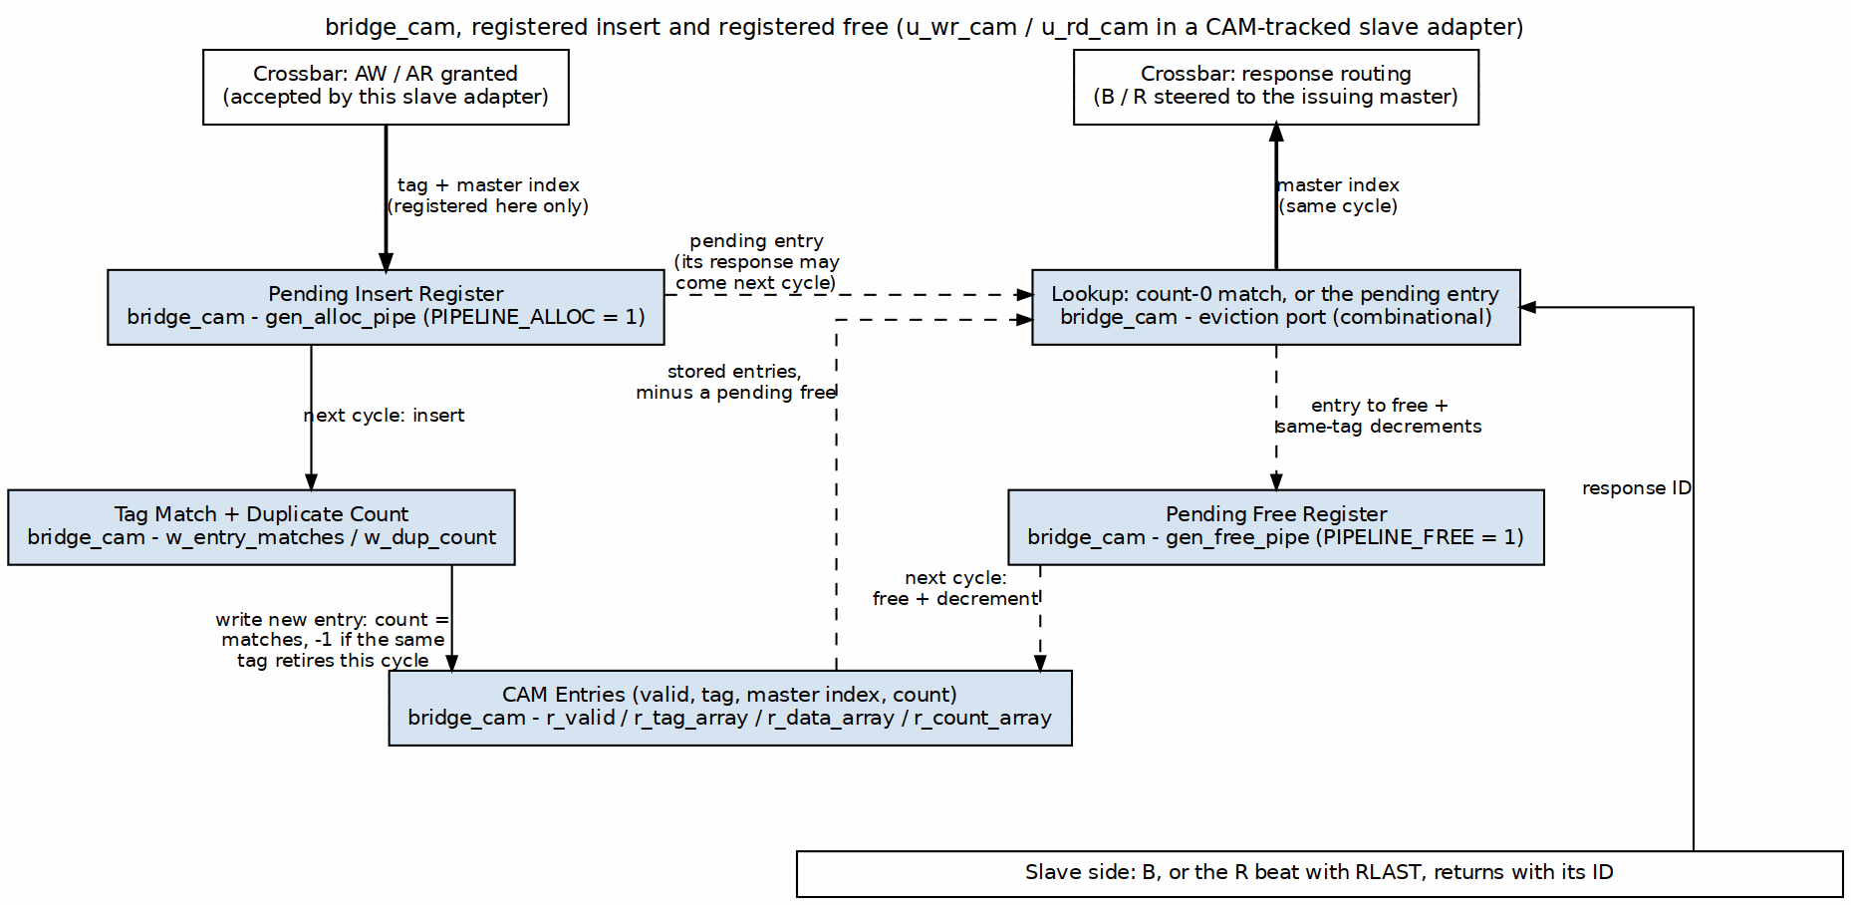
CAM Insert and Free Pipeline

16.2.7 Duplicate IDs: the Ordering Counter (Mode 2)
bridge_cam with ALLOW_DUPLICATES = 1 accepts several outstanding transactions under one ID and retires them in order. Every entry carries a small ordering counter, and the entries holding one tag always carry the counts 0..k-1: the oldest is 0, a newcomer takes k, and when the oldest retires the survivors step down by one. Two consequences shape the logic:
- The count a newcomer needs is k, which is simply how many entries match its tag: a popcount of the match vector, a few LUT levels. It is not a search for the largest existing count. That scan (DEPTH chained comparators, hanging off the crossbar’s arbitrated ARID) was the bridge’s critical path when first synthesized: 40 LUT levels and a 32 ns data path on an Artix-7 -1 (HAS 6.4), fixed 2026-09-11 by counting instead.
- The entry to retire is the one match with count 0, which is one-hot by construction, so its index and its stored master come out of OR reductions rather than a priority chain.
An allocate and a same-tag retire in one cycle take k - 1, because the survivors step down in that same cycle (MAS 2.3).

16.2.8 Implementation
Only one form exists: a parallel comparator array in distributed RAM and flops (no block RAM), every entry compared at once:
// bridge_cam.sv (simplified): one match vector per lookup port.
// w_valid_eff hides an entry whose free is pending (PIPELINE_FREE);
// w_ins_tag is the pending insert's tag (PIPELINE_ALLOC).
w_evict_matches[i] = w_valid_eff[i] && (r_tag_array[i] == deallocate_tag);
w_entry_matches[i] = w_valid_eff[i] && (r_tag_array[i] == w_ins_tag);
The block-RAM sequential-search variant that an earlier revision proposed for deeper tables was never built.

16.2.9 CAM Full
The CAM never overflows; it backpressures first. Its tags_full masks the slave adapter’s ready toward the crossbar (bridge BUG-009, was BRIDGE-011):
assign xbar_ddr_axi_awready = w_sub_awready && !wr_trk_full; // wr_trk_full = u_wr_cam.tags_full
The address phase waits until a B or last R frees an entry. Nothing is dropped and no error response is generated. With the registered insert and free, a pending insert counts as occupied and a pending free does not yet release its slot, so the flag can only be early, never late.
The four combinations of PIPELINE_ALLOC and PIPELINE_FREE are each verified by dv/tests/test_bridge_cam.py. The random test checks a per-tag FIFO model, with full and empty one cycle late under a registered free. A directed test covers a response arriving the cycle after its request, both alone and behind an older entry with the same tag.

16.3 Related Modules
- ID Tracking - which slaves use the CAM and which use the in-order FIFO
- Response Routing - how the crossbar uses the returned master index

RTL Design Sherpa · Learning Hardware Design Through Practice GitHub · Documentation Index · MIT License

17 Response Tracking

17.1 Overview
A multi-master fabric has to know which master a response belongs to. The bridge does two things:
- Widens the ID. With more than one master, each master adapter sends {BRIDGE_ID, id} into the fabric (bridge TASK-005), so IDs are unique across masters at every slave. In bridge_2x2_rw the 4-bit cpu_m_axi_awid becomes the 5-bit ddr_s_axi_awid. On B / R the master adapter returns the low bits, so the master sees its own ID.
- Records the issuing master per slave. The granted master’s index rides beside the request as xbar_bridge_id_aw / _ar and is stored by the slave adapter’s tracker at the address handshake; the crossbar steers B / R by the index the tracker returns (bid_bridge_id / rid_bridge_id).
The tracker comes in two forms, chosen at generation:
Slave response tracker selection
Slave | Tracker | Completion order allowed
AXI4 / AXI5 slave, more than one master | bridge_cam by fabric ID (CAM Architecture) | any order across IDs
any slave with enable_ooo = true | bridge_cam | any order across IDs
single-master bridge, apb / axil / wb shim slave, subtractive slave | in-order bridge_id FIFO | request order across all IDs
// FIFO form
wr_fifo[wr_ptr[...]] <= xbar_bridge_id_aw; // push on AW accept
assign bid_bridge_id = wr_fifo[rd_ptr[...]]; // route by the HEAD
A FIFO-tracked slave must return B/R in request order across ALL IDs; the slaves that get the FIFO are in order by construction or have one master. Every FIFO-tracked adapter carries a SIMULATION-ONLY check that compares the returned BID/RID against the head and $error()s on a mismatch (bridge BUG-008, was BRIDGE-010); it cannot fire in silicon.

17.2 Functional Description

17.2.1 Figure 4.3: ID Table Structure
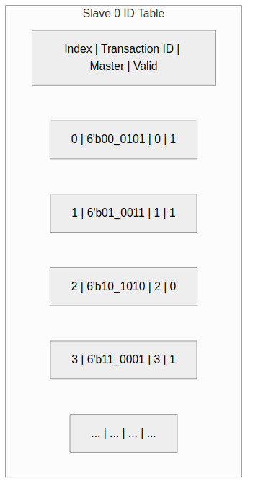
ID Table Structure
The figure shows the contents of one slave’s CAM in a 4-master bridge: the 6-bit fabric ID (2 master-index bits over a 4-bit master ID), the stored master index and the valid bit. bridge_cam also keeps a per-entry ordering count for duplicate IDs.

17.2.2 Sizing
Every tracker, CAM or FIFO, is the slave’s max_outstanding entries (default 16; configurable since bridge GitHub #119 L5) per direction per slave adapter:
CAM: TAG_WIDTH = XBAR_ID_WIDTH, DATA_WIDTH = BRIDGE_ID_WIDTH, DEPTH = 16
FIFO: BRIDGE_ID_WIDTH bits x 16 (WR_FIFO_DEPTH / RD_FIFO_DEPTH)
When it is full the slave adapter drops its AWREADY / ARREADY toward the crossbar (bridge BUG-009). There is no max_outstanding key.

17.2.3 ID Extension (Master Adapter)
// <master>_adapter.sv
assign xbar_axi_awid = {BRIDGE_ID_WIDTH'(BRIDGE_ID), MASTER_ID_WIDTH'(fub_axi_awid)};
assign xbar_axi_arid = {BRIDGE_ID_WIDTH'(BRIDGE_ID), MASTER_ID_WIDTH'(fub_axi_arid)};
// Example, 4 masters: master 2, ID 4'hA -> fabric ID 6'b10_1010
The slave port is declared at XBAR_ID_WIDTH; the config validator rejects an AXI3/AXI4/AXI5 slave whose id_width is narrower. A single-master bridge prepends nothing.

17.2.4 ID Stripping and Routing
The prefix bits are not decoded to choose the master; the tracker’s returned index is. The master adapter only narrows the ID:
fub_axi_bid = cpu_32b_b.id[3:0]; // bridge_2x2_rw: drop the 1-bit prefix

17.2.5 Tracker Operations
Tracker operations by event
Event | CAM form | FIFO form
AW / AR accepted from crossbar | allocate tag = fabric ID, data = bridge_id | push bridge_id
B handshake | deallocate by BID, return master index | pop head
R handshake with RLAST | deallocate by RID, return master index | pop head
full | tags_full holds AWREADY / ARREADY low | not-full gate holds AWREADY / ARREADY low

17.2.6 Multi-ID Considerations

17.2.6.1 Same Master ID, Different Masters
Master 0 issues ID=5 -> fabric ID 00_0101
Master 1 issues ID=5 -> fabric ID 01_0101
Master 2 issues ID=5 -> fabric ID 10_0101
All three can be outstanding at one slave at once; the prefix keeps them distinct, and a CAM-tracked slave may answer them in any order.

17.2.6.2 Same Fabric ID Twice
One master may reuse an ID while an earlier transaction with it is still outstanding (AXI allows this; same-ID responses come back in order). The CAM is built with ALLOW_DUPLICATES = 1 and retires same-tag entries oldest first using the per-entry ordering count.

17.3 Design Notes

17.3.1 Resource Utilization
Per CAM-tracked slave adapter (default depth): two 16-entry CAMs of XBAR_ID_WIDTH + BRIDGE_ID_WIDTH bits plus valid and ordering count, in distributed RAM and flops (no block RAM). Per FIFO-tracked slave adapter: two 16-entry FIFOs of BRIDGE_ID_WIDTH bits. Measured totals per fixture are in HAS 5.3.

17.4 Related Modules
- CAM Architecture - bridge_cam details
- Response Routing - the crossbar’s B / R muxes

RTL Design Sherpa · Learning Hardware Design Through Practice GitHub · Documentation Index · MIT License

18 Width Converters

18.1 Overview
When a master and slave disagree on data width, a converter sits between them: an upsizer for narrow-to-wide, a downsizer for wide-to-narrow. The generator inserts them automatically wherever the configuration needs one — you never instantiate these by hand.

18.2 Functional Description

18.2.1 Upsize Converter
Purpose. Convert narrow master data to wide slave interface.

18.2.2 Figure 5.1: Upsize Converter (64-bit to 512-bit)
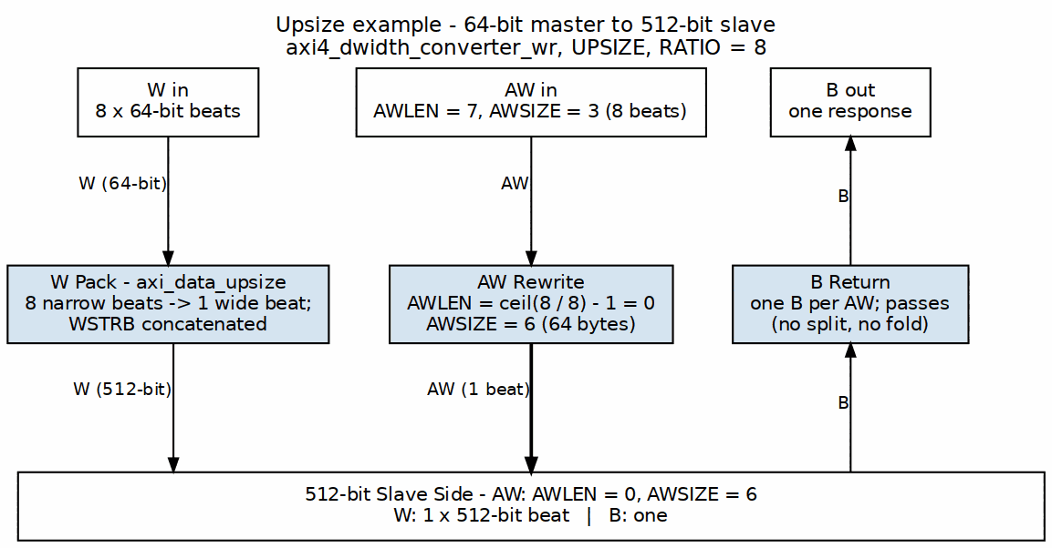
Upsize Converter

18.2.3 Implementation
The packing loop is simple in principle: fill a wide buffer one narrow beat at a time, then drain it. One thing before you read the sketch — there is no width_upsize module in the tree. The real converters are axi_data_upsize / axi_data_dnsize (beat packing) wrapped by axi4_dwidth_converter_rd / axi4_dwidth_converter_wr:
// NOTE: there is no `width_upsize` module. The real converters are
// `axi_data_upsize` / `axi_data_dnsize` (beat packing) wrapped by
// `axi4_dwidth_converter_rd` / `axi4_dwidth_converter_wr`. Sketch only:
module width_upsize #(
parameter IN_WIDTH = 64,
parameter OUT_WIDTH = 512
) (
input logic clk, rst_n,
// Narrow input
input logic s_valid,
output logic s_ready,
input logic [IN_WIDTH-1:0] s_data,
input logic s_last,
// Wide output
output logic m_valid,
input logic m_ready,
output logic [OUT_WIDTH-1:0] m_data,
output logic m_last
);
localparam RATIO = OUT_WIDTH / IN_WIDTH;
logic [OUT_WIDTH-1:0] r_buffer;
logic [$clog2(RATIO)-1:0] r_count;
always_ff @(posedge clk or negedge rst_n) begin
if (!rst_n) begin
r_count <= '0;
r_buffer <= '0;
end else if (s_valid && s_ready) begin
// Pack input into buffer
r_buffer[r_count * IN_WIDTH +: IN_WIDTH] <= s_data;
if (s_last || r_count == RATIO - 1) begin
r_count <= '0;
end else begin
r_count <= r_count + 1;
end
end
end
// Output when buffer full or last beat
assign m_valid = (r_count == RATIO - 1) || s_last;
assign m_data = r_buffer;
assign s_ready = !m_valid || m_ready;
endmodule

18.2.4 Burst Length Conversion
The burst math follows directly — eight narrow beats pack into one wide beat:
Burst Length Conversion Examples
Master AWLEN | Master Beats | Slave AWLEN | Slave Beats
7 (8 beats) | 8 × 64b | 0 (1 beat) | 1 × 512b
15 (16 beats) | 16 × 64b | 1 (2 beats) | 2 × 512b
255 (256 beats) | 256 × 64b | 31 (32 beats) | 32 × 512b

18.2.5 Downsize Converter
Purpose. Convert wide master data to narrow slave interface.

18.2.6 Figure 5.2: Downsize Converter (512-bit to 64-bit)
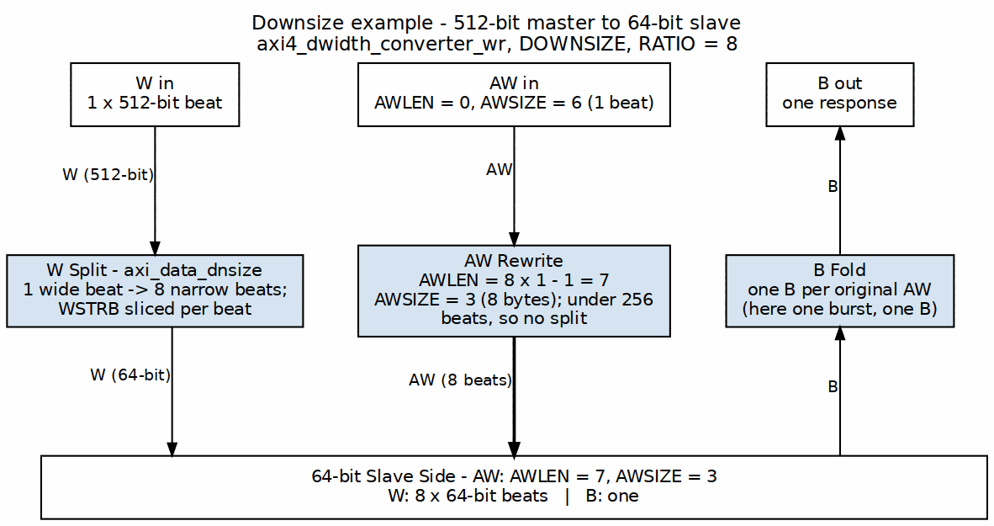
Downsize Converter

18.2.7 Implementation
The downsizer is the mirror image: latch one wide word, then slice it out one narrow beat at a time.
module width_downsize #(
parameter IN_WIDTH = 512,
parameter OUT_WIDTH = 64
) (
input logic clk, rst_n,
// Wide input
input logic s_valid,
output logic s_ready,
input logic [IN_WIDTH-1:0] s_data,
input logic s_last,
// Narrow output
output logic m_valid,
input logic m_ready,
output logic [OUT_WIDTH-1:0] m_data,
output logic m_last
);
localparam RATIO = IN_WIDTH / OUT_WIDTH;
logic [IN_WIDTH-1:0] r_buffer;
logic [$clog2(RATIO)-1:0] r_count;
logic r_active;
always_ff @(posedge clk or negedge rst_n) begin
if (!rst_n) begin
r_count <= '0;
r_buffer <= '0;
r_active <= 1'b0;
end else begin
if (!r_active && s_valid) begin
// Load new wide word
r_buffer <= s_data;
r_active <= 1'b1;
r_count <= '0;
end else if (r_active && m_ready) begin
if (r_count == RATIO - 1) begin
r_active <= 1'b0;
end else begin
r_count <= r_count + 1;
end
end
end
end
// Output from buffer slice
assign m_valid = r_active;
assign m_data = r_buffer[r_count * OUT_WIDTH +: OUT_WIDTH];
assign m_last = r_active && (r_count == RATIO - 1);
assign s_ready = !r_active;
endmodule

18.2.8 Strobe Handling
Data isn’t the only thing that rescales — the byte strobes pack and split right alongside it.

18.2.8.1 Upsize Strobe Packing
// Pack 8-byte strobes into 64-byte strobes
logic [7:0] in_strb; // 64-bit input
logic [63:0] out_strb; // 512-bit output
always_ff @(posedge clk) begin
if (s_valid && s_ready) begin
out_strb[r_count * 8 +: 8] <= in_strb;
end
end

18.2.8.2 Downsize Strobe Splitting
// Split 64-byte strobes into 8-byte strobes
logic [63:0] in_strb; // 512-bit input
logic [7:0] out_strb; // 64-bit output
assign out_strb = in_strb[r_count * 8 +: 8];

18.2.9 AXIL-to-Wider-Slave Master-Side Alignment Converters
An AXI4-Lite master talking to a wider AXI4 slave through the bridge has an alignment problem: AXIL single-beat transactions don’t know where they land in a wide word. The bridge generator emits master-side alignment converters (axil_to_axi4_wide_align_{rd,wr}.sv) to handle partial-word alignment on the AXIL side while producing properly-aligned transactions on the wide slave side.

18.2.9.1 Use Case Example
A concrete write makes the lane math clear:
32-bit AXIL Master → Bridge → 64-bit AXI4 Slave
Master writes 32-bit word to offset 0x04:
Data = 0xAABBCCDD (on bits [31:0])
The converter picks the lane from the address, then ROW-ALIGNS the address:
slot = addr[2] = 1 (SLOT_LSB=$clog2(4)=2, SLOT_W=$clog2(2)=1)
m_axi_wdata[63:32] = 0xAABBCCDD (slot 1 -> the UPPER half)
m_axi_wstrb = 0xF0 (byte lanes 4..7)
m_axi_awaddr = 0x04 & ~0x7 = 0x00 (row_addr_mask clears the lane bits)
Slave sees: 0xAABBCCDD_00000000 at address 0x00, WSTRB 0xF0
The address the slave sees is 0x00, NOT 0x04: the lane bits move out of the
address and into WSTRB. Byte lanes outside the strobe are don't-care, shown
here as zero.

18.2.9.2 Architecture
Read Path: - Master issues AXIL read (no burst, single beat) - Converter passes address to slave (unchanged) - Slave returns 64-bit word - Converter extracts the relevant 32-bit slice for the master
Write Path: - Master issues AXIL write with address offset and 32-bit data - Converter computes byte-lane position within 64-bit word - Converter expands 32-bit strobe to 64-bit strobe (8 lanes) - Converter sends full 64-bit write to slave - Slave performs a 64-bit write with byte strobes

18.2.9.3 Modules
- axil_to_axi4_wide_align_rd.sv: Read path (address → data conversion)
- axil_to_axi4_wide_align_wr.sv: Write path (strobe expansion, data placement)
Note: These converters handle width alignment, not protocol bridging. Protocol conversion (AXIL→AXI4 burst restriction) is applied separately at the slave boundary (via axi4_to_axil4_* shims if needed).

18.3 Design Notes

18.3.1 Resource Utilization
Upsize Converter (64 to 512):
Registers: ~520 (buffer + control)
Logic: ~200 LEs (packing + control)
Downsize Converter (512 to 64):
Registers: ~520 (buffer + control)
Logic: ~150 LEs (selection + control)
The register counts are dominated by the data buffer — 512 bits of storage plus control, in either direction.

18.4 Related Modules
- Width Conversion Block - Block-level description
- APB Converters - Protocol conversion
- Generator-Emitted Conversion Shims - Master-side vs. slave-side shim placement

RTL Design Sherpa · Learning Hardware Design Through Practice GitHub · Documentation Index · MIT License

19 APB Converters

19.1 Overview
APB converters turn AXI4 transactions into APB transfers — the price a high-performance master pays to talk to a low-speed peripheral.

19.2 Functional Description

19.2.1 Conversion Requirements

19.2.1.1 Protocol Differences
The two protocols differ in ways that force real work on the converter:
AXI4 vs APB Protocol Comparison
Feature | AXI4 | APB
Channels | 5 (AW, W, B, AR, R) | 1 (combined)
Bursts | Up to 256 beats | None (single)
Pipelining | Yes | No
Min cycles | 1 per beat | 2 per transfer

19.2.1.2 Conversion Strategy
The recipe, then:
- Split AXI4 bursts into individual APB transfers
- Serialize AW+W into APB write sequence
- Convert AR into APB read sequence
- Generate AXI4 responses from APB completions

19.2.2 Write Conversion

19.2.3 Figure 5.3: AXI4 Write to APB Write
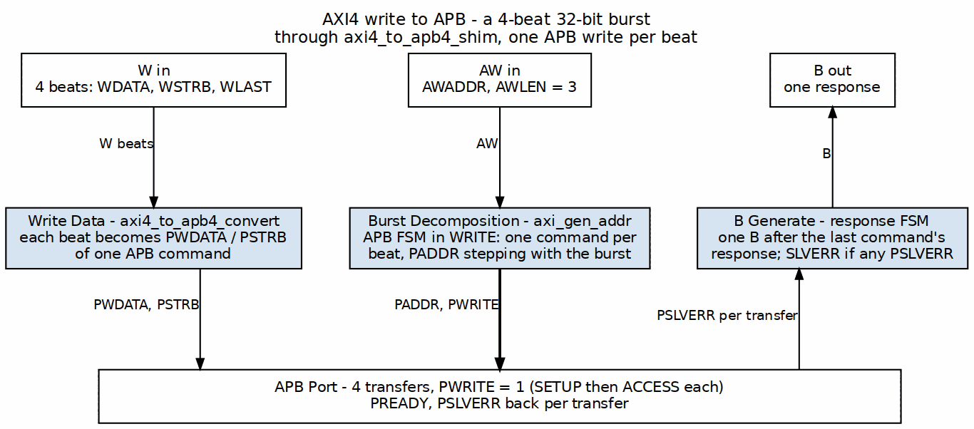
AXI4 to APB Write

19.2.3.1 State Machine
The write path walks each beat through the two-cycle APB handshake:
typedef enum logic [2:0] {
IDLE,
AW_ACCEPT,
W_ACCEPT,
APB_SETUP,
APB_ACCESS,
B_GENERATE
} apb_wr_state_t;
apb_wr_state_t r_state;
always_ff @(posedge clk or negedge rst_n) begin
if (!rst_n) begin
r_state <= IDLE;
end else begin
case (r_state)
IDLE: if (awvalid) r_state <= AW_ACCEPT;
AW_ACCEPT: begin
if (awready) r_state <= W_ACCEPT;
end
W_ACCEPT: begin
if (wvalid && wready) r_state <= APB_SETUP;
end
APB_SETUP: r_state <= APB_ACCESS;
APB_ACCESS: begin
if (pready) begin
if (r_beat_count == r_awlen)
r_state <= B_GENERATE;
else
r_state <= W_ACCEPT; // Next beat
end
end
B_GENERATE: begin
if (bready) r_state <= IDLE;
end
endcase
end
end

19.2.4 Read Conversion

19.2.5 Figure 5.4: AXI4 Read to APB Read
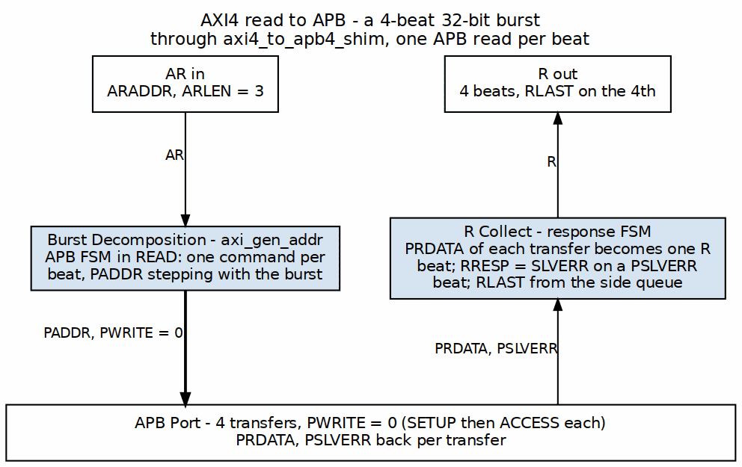
AXI4 to APB Read

19.2.5.1 Read State Machine
The read path is the same shape, minus the W channel:
typedef enum logic [2:0] {
IDLE,
AR_ACCEPT,
APB_SETUP,
APB_ACCESS,
R_GENERATE
} apb_rd_state_t;

19.2.6 Burst Handling

19.2.6.1 Burst to Single Conversion
Bursts don’t exist on APB, so each beat becomes its own transfer with its own address:
AXI4 Burst (AWLEN=7, 8 beats):
Beat 0: AWADDR + 0×SIZE
Beat 1: AWADDR + 1×SIZE
Beat 2: AWADDR + 2×SIZE
...
Beat 7: AWADDR + 7×SIZE
APB Sequence:
Transfer 0: PADDR = AWADDR + 0×SIZE
Transfer 1: PADDR = AWADDR + 1×SIZE
...
Transfer 7: PADDR = AWADDR + 7×SIZE

19.2.6.2 Address Calculation
Address generation honors all three burst types:
// Calculate APB address for each beat
logic [ADDR_WIDTH-1:0] apb_addr;
logic [7:0] beat_count;
always_comb begin
case (r_burst_type)
FIXED: apb_addr = r_base_addr;
INCR: apb_addr = r_base_addr + (beat_count << r_size);
WRAP: apb_addr = wrap_address(r_base_addr, beat_count, r_size, r_len);
endcase
end

19.2.7 Error Handling

19.2.7.1 APB Error to AXI4 Response
One error bit in, one of two response codes out:
APB to AXI4 Error Mapping
APB PSLVERR | AXI4 Response
0 (OK) | OKAY (2’b00)
1 (Error) | SLVERR (2’b10)

19.2.7.2 Error Propagation
Errors latch on first sight and ride along to the final response — one bad beat fails the burst:
// Latch first error in burst
logic r_error_seen;
always_ff @(posedge clk) begin
if (r_state == APB_ACCESS && pready && pslverr)
r_error_seen <= 1'b1;
if (r_state == IDLE)
r_error_seen <= 1'b0;
end
// Final response reflects any errors
assign bresp = r_error_seen ? 2'b10 : 2'b00;

19.3 Timing
APB costs you on both axes, and it’s inherent to the two-cycle transfer — not something you can pipeline around.

19.3.1 Throughput Impact
AXI4 alone: 1 beat per cycle (peak)
AXI4 to APB: 1 beat per 2+ cycles (minimum)
Throughput reduction: ~50% or more

19.3.2 Latency Impact
AXI4 read: 1-2 cycles (typical)
AXI4-to-APB read: 4+ cycles minimum
- 1 cycle: AR accept
- 1 cycle: APB setup
- 1+ cycles: APB access (PREADY)
- 1 cycle: R generate

19.4 Design Notes

19.4.1 Resource Utilization
Logic Elements: ~300-400 LEs
Registers: ~100-150 regs
Block RAM: 0
Breakdown:
- State machine: ~50 LEs, ~20 regs
- Address calc: ~100 LEs, ~50 regs
- Beat counter: ~30 LEs, ~8 regs
- Data buffering: ~100 LEs, ~DATA_WIDTH regs

19.5 Related Modules
- Protocol Conversion Block - Block description
- Width Converters - Data width conversion

RTL Design Sherpa · Learning Hardware Design Through Practice GitHub · Documentation Index · MIT License

20 Module Structure

20.1 Overview
The generator turns configuration files into parameterized SystemVerilog modules, and every topology gets the same internal structure. Parameterized at generation time, mind you — not at elaboration, as the next section makes clear. Once you’ve read one generated bridge, you can find your way around any of them.

20.2 Parameters

20.2.1 Compile-Time Parameters
The generated top has no parameter list. The shared constants live in the per-bridge package <bridge>_pkg.sv; this is bridge_2x2_rw_pkg.sv:
localparam int NUM_MASTERS = 2;
localparam int BRIDGE_ID_WIDTH = 1; // $clog2(NUM_MASTERS): sideband master index
localparam int MASTER_ID_WIDTH = 4; // widest master-side ID
localparam int ID_PREFIX_WIDTH = 1; // master-index bits prepended (0 for one master)
localparam int XBAR_ID_WIDTH = 5; // MASTER_ID_WIDTH + ID_PREFIX_WIDTH
BRIDGE_ID_WIDTH sizes the bridge_id sideband that the slave adapters store; XBAR_ID_WIDTH is the AXI ID width inside the fabric and on every AXI slave port, because each master adapter widens its IDs to {BRIDGE_ID, id} (Section 2.5). The package also defines the AXI channel structs used by the crossbar, one per data width present.

20.2.2 Per-Port Parameters
Per-port widths are baked straight into the port declarations; there are no M0_DATA_WIDTH-style localparams to override. Each adapter module does carry a small parameter list (for example BRIDGE_ID on a master adapter, ID_WIDTH on a slave adapter), set by the generated top.

20.3 Ports

20.3.1 Module Declaration
The generated top level has NO PARAMETER LIST. Every width is fixed for the configuration at generation time and the only shared constants live in the per-bridge package, so there is nothing to override at instantiation. This is bridge_2x2_rw.sv as emitted:
module bridge_2x2_rw
import bridge_2x2_rw_pkg::*;
(
// Clock and reset
input logic aclk,
input logic aresetn,
// Master interfaces (M0-M3)
// ... master port signals ...
// Slave interfaces (S0-S2)
// ... slave port signals ...
);

20.3.2 Port Organization
Module Ports:
├── Clock/Reset
│ ├── aclk
│ └── aresetn
├── Master Ports (per master)
│ ├── AW Channel (if rw or wr)
│ ├── W Channel (if rw or wr)
│ ├── B Channel (if rw or wr)
│ ├── AR Channel (if rw or rd)
│ └── R Channel (if rw or rd)
└── Slave Ports (per slave)
├── AW Channel
├── W Channel
├── B Channel
├── AR Channel
└── R Channel
Note the conditional channels on the master side — a write-only master gets no AR/R, a read-only master gets no AW/W/B.

20.3.3 Master-Side Signals (External)
{prefix}_aw{signal} - Write address channel
{prefix}_w{signal} - Write data channel
{prefix}_b{signal} - Write response channel
{prefix}_ar{signal} - Read address channel
{prefix}_r{signal} - Read data channel
Example (prefix = "cpu_m_axi"):
cpu_m_axi_awvalid
cpu_m_axi_awready
cpu_m_axi_awaddr
cpu_m_axi_wdata
cpu_m_axi_bvalid

20.3.4 Slave-Side Signals (External)
{prefix}_aw{signal} - Write address channel
{prefix}_w{signal} - Write data channel
{prefix}_b{signal} - Write response channel
{prefix}_ar{signal} - Read address channel
{prefix}_r{signal} - Read data channel
Example (prefix = "ddr_s_axi"):
ddr_s_axi_awvalid
ddr_s_axi_awready
ddr_s_axi_awaddr
ddr_s_axi_wdata
ddr_s_axi_bvalid
A CDC port (cdc = true; slave: bridge TASK-006, master: GitHub #119 L2) adds two clock pins:
{name}_aclk - the port's own clock
{name}_aresetn - its active-low reset
A cdc = true slave port’s adapter takes s_aclk/s_aresetn beside aclk/aresetn. Inside it the timing wrapper (and the monitor, when built) stay on aclk, driving cdc_{name}_axi_* nets; axi4_cdc_wr and axi4_cdc_rd carry those to the external port on s_aclk, one gaxi_fifo_async per channel. Nothing upstream of the wrapper knows the port is in another domain. protocol = "axi4" only (HAS 4.5a).
A cdc = true master port’s adapter takes ext_aclk/ext_aresetn beside aclk/aresetn, and the crossing sits on the other side of the wrapper: axi4_cdc_wr / axi4_cdc_rd take the external port on ext_aclk and drive cdcx_axi_* nets on aclk, which the timing wrapper takes as its external side. Only the crossing for a direction the port has is built. Everything from the wrapper on – monitor, decode, per-ID target tracking, width paths – is the same-clock adapter (GitHub #119 L2).

20.4 Functional Description

20.4.1 Component Instantiation
Adapters are named after the port, not the index, and there is no standalone address decoder, arbiter, width-converter or response-router module at the top: address decode, arbitration and response muxing are inline in the crossbar and the master adapters; width converters and protocol shims are instantiated inside the adapter that needs them. The complete instance list of bridge_2x2_rw.sv:
axi4_subtractive_slave #(...) u_subtractive (...); // unmapped-address default (DECERR)
cpu_adapter u_cpu_adapter (...); // per master, named for the port
dma_adapter u_dma_adapter (...);
bridge_2x2_rw_xbar u_xbar (...); // decode, per-slave AW/AR arbiters,
// W owner/destination FIFOs, B/R muxes
ddr_adapter u_ddr_adapter (...); // per slave, named for the port
sram_adapter u_sram_adapter (...); // (bridge_cam x2 inside, multi-master)
subtractive_adapter u_subtractive_adapter (...);
What lives inside the adapters (from bridge_mix_a_mon):
<master>_adapter axi4_dwidth_converter_{rd,wr} width paths, where widths differ
axil_to_axi4_wide_align_{rd,wr} AXI4-Lite master ports
axi4_slave_{rd,wr}_monlite monitored variants only
<slave>_adapter bridge_cam (u_wr_cam / u_rd_cam) AXI4/AXI5 slave, multi-master
axi4_master_{rd,wr}[_monlite] timing wrapper (+ monitor)
axi4_to_apb4_shim apb slave
axi4_to_axil4_{rd,wr} axil slave
A monitored variant adds two instances at the top: one monbus_arbiter merging every port’s monitor stream, and the AXIL group behind it:
monbus_arbiter #(.CLIENTS(10), ...) u_...; // bridge_mix_a_mon: 10 monitor streams
monbus_axil4_axil4_group #(
.FIFO_DEPTH_ERR (64),
.FIFO_DEPTH_WRITE (96), // in BEATS, not packets
.ADDR_WIDTH (32),
.FLUSH_TIMEOUT_CYCLES(1024),
.NUM_PROTOCOLS (3),
.USE_COMPRESSION (0)
) u_mon_axil_group (
.axi_aclk (aclk),
.axi_aresetn (aresetn),
// the monbus_arbiter's output is the group's single input
.monbus_valid (mon_arb_monbus_valid),
.monbus_ready (mon_arb_monbus_ready),
.monbus_packet (mon_arb_monbus_packet),
.monbus_timestamp (mon_arb_monbus_timestamp),
// free-running time, fanned out to every wrapper's i_mon_time
.mon_time_out (mon_time_w),
.s_axil_* (s_mon_axil_*), // slave read port (CPU access)
.m_axil_* (m_mon_axil_*), // master write port (bulk DMA)
.irq_out (mon_irq_out)
);

20.4.2 Internal Signals
// Top-level nets between crossbar and slave adapters
xbar_{slave}_axi_{aw,w,b,ar,r}{signal} e.g. xbar_ddr_axi_awid (XBAR_ID_WIDTH bits)
// Inside the crossbar
{slave}_{aw,ar}_arb_gnt per-slave round-robin grant
{master}_{w}b_{aw,ar}_gnt_{slave} master width-path granted to slave
{master}_{w}b_wdest_* W destination FIFO (per master width-path)
{slave}_wowner_* W owner FIFO (per slave)
// Response routing sideband (slave adapter -> crossbar)
{slave}_axi_bridge_id_{aw,ar} granted master's index, into the tracker
{slave}_axi_{bid,rid}_bridge_id / _valid tracker output steering B / R
// ID tracking inside a slave adapter
u_wr_cam / u_rd_cam bridge_cam (multi-master AXI4/AXI5 slave)
wr_fifo / rd_fifo in-order bridge_id FIFO (otherwise)

20.4.3 Reset Style and the Emitted Filelist
Every generated adapter, crossbar and slave adapter opens with
`include "reset_defs.svh"
and writes its flops through the macro, never a raw always_ff:
`ALWAYS_FF_RST(aclk, aresetn,
if (`RST_ASSERTED(aresetn)) begin
...
end else begin
...
end
)
Reset is asynchronous on assertion in every build. ALWAYS_FF_RST used to be conditional on USE_ASYNC_RESET and defaulted to synchronous, so make lint (which set the define) and simulation/synthesis (which did not) disagreed about what the design was. The define is now a no-op; passing it is harmless and changes nothing. Deassertion must still be synchronised externally.
Because the emitted RTL depends on that header, the generator also emits the -f that supplies it, so a generated filelist resolves standalone:
# Include directories
+incdir+$REPO_ROOT/rtl/amba/includes
# Reset macro header (`ALWAYS_FF_RST / `RST_ASSERTED)
-f $REPO_ROOT/rtl/amba/filelists/reset_defs.f
# Monitor packages (must precede any module that references them)
-f $REPO_ROOT/rtl/amba/filelists/monitor_pkgs.f
The -f matters as much as the +incdir: the header must be compiled ahead of the modules that expand the macro, not merely be findable. A consumer that hand-lists the generated .sv files instead of taking this filelist gets Cannot find include file: 'reset_defs.svh' — see /GLOBAL_REQUIREMENTS.md on resolving sources through filelists.

20.4.4 Generated Variants
The mandatory variants list in the [bridge] table picks which builds to emit. Each variant is written to its own directory under rtl/generated/ and is a complete, standalone bridge:
variants = ["no", "mon"] (bridge_mix_a)
rtl/generated/bridge_mix_a/bridge_mix_a.sv no monitors
rtl/generated/bridge_mix_a_mon/bridge_mix_a_mon.sv monitored

20.4.5 Generated File Structure
The generator always writes one directory per bridge (and per variant), one module per file. Regenerated listing of rtl/generated/bridge_2x2_rw/:
rtl/generated/bridge_2x2_rw/
├── bridge_2x2_rw.sv - top level (BridgeModuleGenerator)
├── bridge_2x2_rw_pkg.sv - constants + channel structs (PackageGenerator)
├── bridge_2x2_rw_xbar.sv - crossbar (CrossbarGenerator)
├── cpu_adapter.sv - master adapter, port "cpu" (AdapterGenerator)
├── dma_adapter.sv - master adapter, port "dma"
├── ddr_adapter.sv - slave adapter, port "ddr" (SlaveAdapterGenerator)
├── sram_adapter.sv - slave adapter, port "sram"
├── subtractive_adapter.sv - adapter for the internal DECERR slave
├── bridge_2x2_rw.toml - copy of the port configuration
└── bridge_2x2_rw_connectivity.csv - copy of the connectivity matrix
A monitored variant has the same shape with the _mon name on the top, package and crossbar (bridge_2x3_apb_req_mon/bridge_2x3_apb_req_mon_xbar.sv); the adapter files keep the port names. The emitted filelist is rtl/filelists/<bridge>.f. Shared modules (bridge_cam, axi4_subtractive_slave, the converters, shims and monitor wrappers) are not copied into the directory; the filelist pulls them from their home areas.

20.5 Related Modules
- Signal Naming - Detailed naming conventions

RTL Design Sherpa · Learning Hardware Design Through Practice GitHub · Documentation Index · MIT License

21 Signal Naming

21.1 Overview
Signal names in generated RTL follow one convention, which is what makes pattern-based verification and painless integration possible. Learn the pattern once and you can drive any generated port without opening the file.

21.2 Ports

21.2.1 External Port Naming
Pattern:
{prefix}_{channel}{signal}
Components:
External Port Naming
Component | Description | Example
prefix | User-defined port prefix | cpu_m_axi, ddr_s_axi
channel | AXI4 channel code | aw, w, b, ar, r
signal | Signal within channel | valid, ready, addr, data

21.2.2 Master Port Examples
// Master with prefix "cpu_m_axi"
input logic cpu_m_axi_awvalid,
output logic cpu_m_axi_awready,
input logic [31:0] cpu_m_axi_awaddr,
input logic [3:0] cpu_m_axi_awid,
input logic [7:0] cpu_m_axi_awlen,
input logic [2:0] cpu_m_axi_awsize,
input logic [1:0] cpu_m_axi_awburst,
input logic cpu_m_axi_awlock,
input logic [3:0] cpu_m_axi_awcache,
input logic [2:0] cpu_m_axi_awprot,
input logic [3:0] cpu_m_axi_awqos,
input logic cpu_m_axi_awuser,

21.2.3 Slave Port Examples
// Slave with prefix "ddr_s_axi"
output logic ddr_s_axi_awvalid,
input logic ddr_s_axi_awready,
output logic [31:0] ddr_s_axi_awaddr,
output logic [3:0] ddr_s_axi_awid, // SAME width as the master port -- IDs are pass-through
output logic [7:0] ddr_s_axi_awlen,
output logic [2:0] ddr_s_axi_awsize,
// ...

21.2.4 APB Port Naming
Pattern:
{prefix}p{signal}
APB Signal Examples:
// APB slave with prefix "uart_apb_"
output logic uart_apb_psel,
output logic uart_apb_penable,
output logic [11:0] uart_apb_paddr,
output logic uart_apb_pwrite,
output logic [31:0] uart_apb_pwdata,
output logic [3:0] uart_apb_pstrb,
output logic [2:0] uart_apb_pprot,
input logic [31:0] uart_apb_prdata,
input logic uart_apb_pslverr,
input logic uart_apb_pready,

21.3 Functional Description

21.3.1 Internal Signal Naming

21.3.1.1 Crossbar Signals
// Master to crossbar
logic xbar_m0_awvalid;
logic xbar_m0_awready;
logic [31:0] xbar_m0_awaddr;
// Crossbar to slave
logic xbar_s0_awvalid;
logic xbar_s0_awready;
logic [31:0] xbar_s0_awaddr;

21.3.1.2 Arbitration Signals
// Request/grant matrices
logic [NUM_MASTERS-1:0] aw_request_s0; // AW requests to slave 0
logic [NUM_MASTERS-1:0] aw_grant_s0; // AW grants from slave 0
// Arbiter state
logic aw_grant_active_s0; // Grant locked
logic [$clog2(NUM_MASTERS)-1:0] aw_last_grant_s0; // Round-robin state

21.3.1.3 ID Signals
// bridge_id: an INTERNAL routing tag carried alongside the transaction,
// never prepended to the AXI ID on the slave port
logic [TOTAL_ID_WIDTH-1:0] xbar_m0_awid; // BID + external ID
logic [TOTAL_ID_WIDTH-1:0] xbar_s0_bid; // Response with BID
// External IDs (to master)
logic [ID_WIDTH-1:0] cpu_m_axi_bid; // ID passes through unchanged

21.3.2 Debug Signal Naming
Pattern:
dbg_{category}_{description} // NOT EMITTED -- see below
One caveat before you go looking for these in a waveform: they’re illustrative only. The generator emits no dbg_* ports — the debug guide covers what you can actually reach.
// Arbitration debug
output logic [NUM_MASTERS-1:0] dbg_aw_grant_s0, // illustrative only
output logic [NUM_MASTERS-1:0] dbg_ar_grant_s0,
// Transaction debug
output logic [7:0] dbg_outstanding_m0,
output logic [7:0] dbg_outstanding_m1,
// State machine debug
output logic [1:0] dbg_aw_state_s0,
output logic [1:0] dbg_ar_state_s0,

21.3.3 Verification Pattern Matching

21.3.3.1 Factory Pattern Support
The naming convention is what makes automatic BFM connection work:
# CocoTB/GAXI pattern matching
master = AXI4Master(
dut=dut,
prefix="cpu_m_axi_", # Matches all cpu_m_axi_* signals
clock=dut.aclk
)

21.3.3.2 Pattern Rules
- Prefix must end with underscore or be directly followed by channel code
- Channel codes are lowercase (aw, w, b, ar, r)
- Signal names match AXI4 specification (valid, ready, addr, data, etc.)

21.4 Related Modules
- Module Structure - Overall RTL organization
- Verification - Pattern-based testing

RTL Design Sherpa · Learning Hardware Design Through Practice GitHub · Documentation Index · MIT License

22 Test Strategy

22.1 Overview
Bridge verification is CocoTB-based and parameterized: the same infrastructure covers every bridge topology and protocol combination.

22.2 Related Modules
- Debug Guide - Debugging failed tests
- Signal Naming - Pattern matching for BFMs

22.3 Testing

22.3.1 Test Categories

22.3.1.1 Unit Tests
Per-block verification:
Unit Test Coverage:
├── Master Adapter Tests
│ ├── {BRIDGE_ID, id} widening and strip; bridge_id sideband tagging
│ ├── Channel routing
│ └── Backpressure handling
├── Address Decoder Tests
│ ├── Address mapping
│ ├── Multi-region support
│ └── Default slave routing
├── Arbiter Tests
│ ├── Round-robin fairness
│ ├── Grant/lock behavior
│ └── Multi-master contention
└── Converter Tests
├── Width up/down sizing
├── APB protocol conversion
└── Burst handling

22.3.1.2 Integration Tests
Full bridge verification:
Integration Test Matrix:
├── 2x2 Configuration
│ ├── Basic read/write
│ ├── Concurrent transactions
│ └── Same-ID aliasing across masters (bridge_id keeps them apart)
├── 4x4 Configuration
│ ├── Full arbitration coverage
│ ├── Width conversion paths
│ └── Mixed protocol targets
└── NxM Configurations
├── Asymmetric topologies
├── Channel-specific masters
└── Protocol mixing

22.3.2 Test Parameterization

22.3.2.1 Configuration Matrix
Which parameters get swept, and why:
Test Parameter Matrix
Parameter | Test Values | Purpose
NUM_MASTERS | 2, 4, 8 | Scalability
NUM_SLAVES | 2, 3, 4 | Routing coverage
DATA_WIDTH | 32, 64, 128, 256 | Width paths
ID_WIDTH | 4, 6, 8 | ID space
OUTSTANDING | 4, 8, 16 | Depth stress

22.3.2.2 Protocol Combinations
# Test protocol matrix
PROTOCOL_COMBOS = [
{"masters": ["axi4"], "slaves": ["axi4"]},
{"masters": ["axi4"], "slaves": ["axi4", "apb"]},
{"masters": ["axi4", "axil"], "slaves": ["axi4", "apb"]},
{"masters": ["axi5"], "slaves": ["axi4", "axi5"]}, # interop + native
{"masters": ["axi5", "axi5"], "slaves": ["axi4", "axi5"]}, # sideband through the arbiter
]
The AMBA5 fixtures in bin/test_configs/, each generated with its own tests and TB class:
AMBA5 Fixtures
Fixture | Shape | What it exercises
bridge_1x2_{rd,wr}_axi5 | AXI5 master, AXI4 slaves | interop boundary; sideband terminates
bridge_1x2_rd_axi5s | AXI4 master, one AXI5 slave | AXI5 slave ports
bridge_1x2_{rd,wr}_axi5n | AXI5 both ends | native sideband values, poison (wr)
bridge_1x2_wr_axi5a | AXI5 both ends, atomic, write-only | store-class forwards; load/swap/compare DECERR at the filter
bridge_1x2_rw_axi5a | AXI5 both ends, atomic, rw | read-return atomics native: R data routed back by ID
bridge_1x2_rw_axil5, bridge_1x2_rw_apb5 | AXI4 master, AXI5-Lite / APB5 slave | the Lite and APB5 shims
bridge_2x2_axi5 | two AXI5 masters, AXI5 + AXI4 slaves; cpu and sram carry wakeup | sideband through arbitration; BIDUNQ/RIDUNQ regenerated on every path (_sideband_arb); AWAKEUP forwarding and hold (test_bridge_2x2_axi5_wakeup)
bridge_1x2_rd_axi5w | AXI5 32b master, 64b AXI4 + 32b AXI5 slaves | sideband across a width converter
bridge_2x2_lite_req | AXI4-Lite + AXI5-Lite masters, 64b AXI4 + AXI5-Lite slaves | Lite requesters (bridge TASK-004, was BRIDGE-014): sideband forwarding, the aligner, ID-less masters sharing a slave
bridge_2x3_apb_req | APB4 + APB5 masters, AXI4 + AXI5-Lite + APB4 slaves | APB requesters (bridge TASK-004, was BRIDGE-014): apb{4,5}_to_axi4, PSLVERR folding, APB in / APB out
bridge_2x2_wb4 | WB4 + AXI4 masters, 64b AXI4 + WB4 slaves | Wishbone on both sides (bridge TASK-008, was BRIDGE-019): ERR folding both ways, SEL lanes, burst decomposition at the completer, two requesters at one Wishbone completer
bridge_2x2_rw (perf) | two 32b AXI4 masters, two 32b AXI4 slaves | test_bridge_2x2_rw_perf (bridge TASK-006, was BRIDGE-017): saturating read/write streams, one shared port with per-master shares, two parallel paths, loaded AW-to-B latency; every figure windowed and floored (HAS Tables 5.1a / 5.7a)
bridge_2x2_rw_pipe | as bridge_2x2_rw with xbar_pipeline = true | generated suite plus test_bridge_2x2_rw_pipe_latency (bridge TASK-006, was BRIDGE-017): asserts the registered crossbar adds exactly the documented stages on AW, AR and B/R (HAS Table 5.7a); test_bridge_2x2_rw_perf runs on it too (BRIDGE_PERF_DUT) to show the throughput floors still hold
bridge_2x2_rw_qos | as bridge_2x2_rw with arbitration = "qos", qos_aging_shift = 4 | generated suite plus test_bridge_2x2_rw_qos_arb (bridge TASK-006, was BRIDGE-017): under saturation the higher-AxQOS master takes >= 0.75 of a shared port in both orientations, the QoS-0 master’s worst wait stays under the aging bound (15 * 2**shift plus a burst), equal QoS splits fairly, and the port stays >= 0.95 beat/cycle (MAS 2.3 policy paragraph)
bridge_1x2_rw_axi5a (L1b) | as listed above | plus test_bridge_1x2_rw_axi5a_multitarget (GitHub #119 L1b): a trace-echo read overtakes a slow one with each R echoing its own ARTRACE; a read-return atomic overtakes a slow read at another slave and returns the original value; two same-ID reads with different traces stay ordered and echo 1 then 0. Both overlap cases fail on the pre-L1b RTL; the trace case fails with the trace term removed from the ID check
bridge_2x2_rw_lat | as bridge_2x2_rw with cpu and ddr latency = "cut_none", dma "cut_ax", sram default (GitHub #119 L7) | generated suite plus test_bridge_2x2_rw_lat_modes: VALID-to-VALID propagation on AW/B/AR/R for all four pairs, sampled mid-cycle – cpu->ddr 0/0/0/0, cpu->sram 1/1/1/1, dma->ddr 1/0/1/0, dma->sram 2/1/2/1
bridge_2x2_rw_depth | as bridge_2x2_rw with [bridge].max_outstanding = 4, cpu 64, ddr 32 (GitHub #119 L5) | generated suite plus test_bridge_2x2_rw_depth_limits: dma (limit 4) holds exactly 4 AWs and 4 ARs in flight against a slow slave; ddr’s CAMs fill to exactly 32 – past the old fixed 16 – with every write landing and every read correct
bridge_2x2_rw_qos_pipe | bridge_2x2_rw_qos on the registered crossbar (xbar_pipeline = true as well) | generated suite; exists for the synthesis sweep (HAS 6.4), which in September showed the QoS compare, grant, mux and CAM allocate in one path and the crossbar’s slave-side skid as the register that split it; since the registered CAM insert the QoS path ends before that register (HAS 6.4)
bridge_2x2_axi5_native | two 128-bit AXI5 masters, two 128-bit AXI5 slaves, every port nsaid/trace/unique/poison/mte/chunking | generated suite with the AXI5 compliance checkers, plus test_bridge_2x2_axi5_native_mte_chunk (bridge TASK-007, was BRIDGE-018): Transfer writes from both masters land their per-beat tags in the slave BFM’s tag store, Transfer reads return them, Match writes report the 2-bit BTAGMATCH right (11 pass, 10 fail) for matching and mismatching tags, Update writes follow WTAGUPDATE, chunked reads carry RCHUNKV/RCHUNKNUM per beat and unchunked reads do not; with the slave BFM emitting each burst’s chunks in reverse, every burst still completes and reassembles by RCHUNKNUM – the fabric is order-agnostic
bridge_1x2_rd_axi5c | 128-bit AXI5 chunking master, one AXI5 chunking slave and one AXI4 slave | generated suite plus test_bridge_1x2_rd_axi5c_chunk (bridge TASK-007, was BRIDGE-018): the chunk enable reaches the AXI5 port and its beats come back chunked; to the AXI4 slave the enable terminates and the same read returns ordered data with RCHUNKV low
bridge_3x2_rw_mcdc | cpu (rw) and lfsr (rd) master ports on their own clocks, dma same-clock; ddr CDC slave, sram same-clock (GitHub #119 L2) | generated suite with the CDC masters at BRIDGE_CDC_MASTER_PERIOD_NS (13 ns, +2 per further port); test_bridge_3x2_rw_mcdc_ratio sweeps cpu_aclk over 3 / 10 / 23 ns: data through one and two crossings, beats on the port clocks, rate set by the slower clock, the same-clock master unaffected (HAS 4.5a)
bridge_2x2_rw_cdc | as bridge_2x2_rw, ddr on its own clock (cdc = true), sram same-clock | generated suite on the CDC port at BRIDGE_CDC_PERIOD_NS (7 ns); test_bridge_2x2_rw_cdc_ratio (bridge TASK-006, was BRIDGE-017) sweeps 3/10/23 ns: both masters’ streams land and read back, the port’s beats are counted on the slave clock, the rate follows the slower clock (>= 0.85 beat/cycle), the same-clock neighbour is unaffected (HAS 4.5a)

22.3.3 Protocol-BFM-Only Testing with Memory-Backed Slaves
Modern bridge tests use protocol BFMs only (no direct DUT signal manipulation) with memory-backed slave models. If you find yourself poking a DUT signal in a test, stop — drive the protocol and check the memory instead. That includes AMBA5 sideband and atomics: the AXI5 BFMs take nsaid/trace/idunq/poison/atop as transaction keyword arguments (write_transaction, read_transaction, atomic_operation), and the generated TB returns the echoed trace in the BFM’s result.
The generated TB picks the BFM family from each port’s protocol: AXI4 ports get the AXI4 BFMs, axi5 ports the AXI5 BFMs (which declare every AMBA5 sideband field as optional, so one BFM binds to any feature subset), axil5 ports the AXIL5 BFMs (AXIL5Master* on a master port), apb5 slave ports APB5Slave and apb/apb5 master ports APBMaster/APB5Master, all at the generator’s 1-bit USER widths, and wb4 ports WB4Slave (base-relative memory, out-of-range answers ERR) / WB4Master. Every AXI5 master port also gets an AXI5ComplianceChecker on the same prefix, armed in setup_clocks_and_reset and read by tb.assert_compliance(), which every generated test calls before it declares PASSED – a protocol violation on the AXI5 boundary fails the test that caused it even when the data still round-tripped.
Slave memory models are capped at 64 KB per slave (SLAVE_MEM_CAP_BYTES). A probe past the model is answered by the one out-of-range contract every slave BFM follows (RDS-DV shared/memory_model.py): SLVERR, nothing written, 0xDEADDEAD read data, one warning. The boundary probe swallows that error only for probes past the seeded region – the error coming back from the slave the address decodes to is the routing evidence – and master_write raises on any error response, so a SLVERR write never passes through a helper unnoticed. The model’s limit is not the design’s: an address the bridge does not decode at all is the subtractive slave’s DECERR.

22.3.3.1 BFM Instantiation and Slave Models
from CocoTBFramework.components.axi4 import AXI4Master, AXI4Slave
from TBClasses.shared.tbbase import TBBase
from TBClasses.shared.memory_model import MemoryModel
class BridgeTB(TBBase):
def __init__(self, dut):
super().__init__(dut)
# Create masters using protocol BFMs
self.masters = []
for i in range(NUM_MASTERS):
prefix = f"m{i}_axi_"
master = AXI4Master(
dut=dut,
prefix=prefix,
clock=dut.aclk,
reset=dut.aresetn
)
self.masters.append(master)
# Create slave memory models (NOT direct signal manipulation)
self.slaves = []
for i in range(NUM_SLAVES):
prefix = f"s{i}_axi_"
slave = MemoryModel(
dut=dut,
prefix=prefix,
clock=dut.aclk,
reset=dut.aresetn,
size=0x100000 # 1 MB memory per slave
)
self.slaves.append(slave)

22.3.3.2 Transaction Generation and Assertion
async def cocotb_test_concurrent_writes(dut):
"""Test multiple masters writing simultaneously."""
tb = BridgeTB(dut)
await tb.setup_clocks_and_reset()
# Generate transactions via BFMs only
tasks = []
for i, master in enumerate(tb.masters):
addr = 0x1000 + (i * 0x100)
data = 0xDEAD0000 + i
# Drive via protocol BFM (no DUT signal poke)
task = cocotb.start_soon(
master.write(addr=addr, data=data, size=2)
)
tasks.append(task)
# Wait for all writes to complete
for task in tasks:
await task
# Verify via memory readback (not via routing logic check)
for i, master in enumerate(tb.masters):
addr = 0x1000 + (i * 0x100)
readback = await master.read(addr=addr)
assert readback == 0xDEAD0000 + i, \
f"Master {i} readback mismatch at {addr:#x}"

22.3.3.3 Boundary Probe Testing
Address-window boundary probes catch address-decode errors at slave page edges:
async def test_boundary_probes(self):
"""Probe top, middle, bottom of each slave's address window."""
for slave_idx, (base_addr, window_size) in enumerate(self.slave_windows):
# Payloads carry the slave index and the probe position, so a readback
# mismatch says BOTH which probe failed and whether the write landed on
# the wrong slave -- the failure a boundary probe is actually hunting.
bottom, middle, top = (0xB0000000 | (slave_idx << 8) | pos
for pos in (0x0, 0x1, 0x2))
# Probe bottom (base address)
await self.masters[0].write(base_addr + 0x000, data=bottom)
# Probe middle (arbitrary offset)
await self.masters[0].write(base_addr + window_size // 2, data=middle)
# Probe top (last valid address)
await self.masters[0].write(base_addr + window_size - 1, data=top)
# Verify via readback
rb_bottom = await self.masters[0].read(base_addr + 0x000)
rb_middle = await self.masters[0].read(base_addr + window_size // 2)
rb_top = await self.masters[0].read(base_addr + window_size - 1)
assert rb_bottom == bottom
assert rb_middle == middle
assert rb_top == top

22.3.4 Coverage Goals

22.3.4.1 Functional Coverage
Coverage Targets:
├── Protocol Coverage
│ ├── All burst types (FIXED, INCR, WRAP)
│ ├── All sizes (1, 2, 4, 8, ... bytes)
│ └── All response types
├── Routing Coverage
│ ├── Every master to every slave path
│ ├── Default slave routing
│ └── Error response paths
├── Arbitration Coverage
│ ├── All grant combinations
│ ├── Priority scenarios
│ └── Lock sequences
└── Corner Cases
├── Maximum outstanding
├── ID exhaustion
└── Backpressure saturation

22.3.4.2 Code Coverage
Code Coverage Targets:
├── Line Coverage: >95%
├── Branch Coverage: >90%
├── FSM State Coverage: 100%
└── Toggle Coverage: >85%

22.3.5 Test Execution

22.3.5.1 Running the Suite
The bridge runs through the same four-line Makefile every val area uses (make/tests.mk): always a clean build first, then one of three levels.
cd projects/components/fabric-gen-ip/bridge/dv/tests
make clean-all && make run-all-gate-parallel # smoke: 72 cells
make clean-all && make run-all-func-parallel # development: 144 cells
make clean-all && make run-all-full-parallel # sign-off: 216 cells
make clean-all && make run-all-full-parallel-waves # same, with dump.fst per cell
make run-bridge_2x2_rw-gate-parallel # one file, by its glob stem
REG_LEVEL (set by the target) selects the grid in each wrapper: GATE runs one gate cell per test, FUNC gate+func, FULL gate+func+full. Each cell exports TEST_LEVEL and a SEED (pinned per test node, so a rerun replays the same run) and the TB scales its work from the level profile in dv/tbclasses/bridge_levels.py. Sibling cells of one test log different TEST_LEVEL=<x> banners and different wall-clock – that is the evidence the grid is real. A raw pytest run works but is the FUNC subset with no clean, and a sub-second “passed” on a stale build is a fiction.

22.3.5.2 Test Naming Convention
Cocotb test functions follow the pattern: cocotb_test_{N}x{M}_{variant}_{scenario}
# Example: test_bridge_4x4_mon_capture.py
@cocotb.test()
async def cocotb_test_4x4_mon_capture(dut):
"""Monitor packet capture on 4x4 bridge with monitor enabled."""
...
# Pytest wrapper function
def test_bridge_4x4_mon_capture(request):
"""Wrapper to invoke cocotb_test_4x4_mon_capture."""
run(
python_search=[tests_dir],
verilog_sources=verilog_sources,
toplevel="bridge_4x4_mon",
module=module,
testcase="cocotb_test_4x4_mon_capture",
...
)

22.3.5.3 Test Levels
What each depth does, per the profile in bridge_levels.py. Every count in the suite is read from here; nothing hardcodes one.
Test Level Depth Profile
Level | Connectivity | Boundary probe | Arbitration | Monitor stress | Slaves
gate | 1 offset/pair | boundary pages, low offset only | 4 txn/master | 128 reads/phase | prompt
func | 4 offsets/pair | boundary pages, low/mid/high | 8 txn/master | 256 reads/phase | prompt
full | 16 offsets/pair | every seeded page, low/mid/high | 24 txn/master | 512 reads/phase | 24-cycle response delay
Measured on the 4x4 boundary probe: 4 s, 5 s and 40 s per cell. The FULL run’s monitor stress count of 128 at gate is deliberate – the monbus err FIFO is 64 deep and the ERR_BP phase asserts it saturates, which at exactly 64 reads was a race against the drain pump.
Monitor Tests (when variants includes "mon"): - test_bridge_1x2_rd_monitor_smoke: Basic packet emission - test_bridge_1x2_rd_monitor_capture: Packet parsing and verification - test_bridge_1x2_rd_monitor_error_inject: SLVERR packet collection - test_bridge_1x2_rd_monitor_irq: IRQ assertion on error FIFO

RTL Design Sherpa · Learning Hardware Design Through Practice GitHub · Documentation Index · MIT License

23 Debug Guide

23.1 Overview
When a bridge test fails, start here. This guide lists the failure modes that actually occur and how to chase each one down.

23.2 Waveforms

23.2.1 Generating Waveforms
# Enable VCD dump
WAVES=1 pytest test_bridge_2x2.py::test_basic -v
# View with GTKWave
gtkwave sim_build/dump.vcd

23.2.2 Key Signals to Observe
Waveform Signal Groups:
├── Clock/Reset
│ └── aclk, aresetn
├── Master 0 AW Channel
│ └── m0_axi_awvalid, m0_axi_awready, m0_axi_awaddr, m0_axi_awid
├── Slave 0 AW Channel
│ └── s0_axi_awvalid, s0_axi_awready, s0_axi_awaddr, s0_axi_awid
├── Arbitration (inside u_xbar)
│ └── ddr_aw_arb_gnt, ddr_aw_arb_locked, ddr_ar_arb_gnt, ddr_ar_arb_locked
├── Target gating (inside the master adapter)
│ └── aw_gate_ok, ar_gate_ok, aw_id_ok, aw_idt_cnt/_tgt, aw_out_cnt
└── Response
└── s0_axi_bvalid, m0_axi_bvalid, ddr_axi_bid_bridge_id

23.2.3 Timing Analysis

23.2.3.1 Waveform 7.1: Expected Transaction Timing
The timing diagram below illustrates a basic write-transaction handshake.
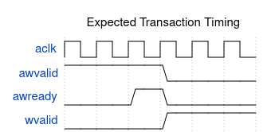
Waveform 1

23.3 Related Modules
- Test Strategy - Overall test approach
- Arbiter FSMs - FSM state details
- ID Tracking - ID table operation

23.4 Testing

23.4.1 Debug Signal Access

23.4.1.1 There are no dbg_* ports
The generator emits no debug ports. Earlier revisions of this chapter showed dbg_aw_grant_s0, dbg_outstanding_m0, dbg_resp_master and a dbg_id_table_* CAM view; none of them exist in any generated module, and every procedure written against them fails immediately with a cocotb AttributeError.
Debug instead by reaching into the real internal signals by hierarchical name. They are named after the SLAVE (<slave>_...) in the xbar and are plain logic, so cocotb can read them directly:
@cocotb.test()
async def test_with_debug(dut):
xbar = dut.u_xbar # instance name in the generated top
grant = xbar.ddr_aw_arb_gnt.value # which master holds the AW grant
locked = xbar.ddr_aw_arb_locked.value
rr = xbar.ddr_aw_arb_rr.value # round-robin pointer
routed = xbar.ddr_axi_rid_bridge_id.value # bridge_id the R beat returns to
Debug Signals That Exist
Category | Real signals | Purpose
Arbitration | <slave>_aw_arb_gnt, _locked, _rr, _req, _pick | Grant, lock and round-robin state, per slave, AW and AR
Response routing | <slave>_axi_bid_bridge_id, <slave>_axi_rid_bridge_id | The bridge_id a B/R beat is muxed to. This is the routing decision – the AXI ID is not used
Response arbitration | <master>_<W>b_{b,r}_rarb_gnt, _locked, _rgnt_<slave> (xbar); b_pgnt / r_pgnt, r_{b,r}_hold (adapter, multi-path masters) | Which slave, then which width path, a master’s B/R comes from
Outstanding tracking | aw_out_cnt / ar_out_cnt, aw_idt_cnt[] / aw_idt_tgt[] (adapter); ar_idt_push_aw, lr_* local-DECERR queue on read-return-atomic ports | In flight per port and per ID
Target gating | aw_gate_ok / ar_gate_ok, aw_id_ok / ar_id_ok, w_trk_* (adapter) | Why a new AW/AR is being held off
There is no outstanding-count output and no FSM state vector – the arbiters are two-state (locked / not) rather than an encoded FSM, so _locked plus _gnt is the whole state.

23.4.2 Common Issues

23.4.2.1 Issue: Transaction Timeout
Symptoms: - Test hangs waiting for response - TimeoutError after configured timeout
Debug Steps:
# 1. Check if request was accepted
await RisingEdge(dut.aclk)
print(f"AWVALID: {dut.m0_axi_awvalid.value}")
print(f"AWREADY: {dut.m0_axi_awready.value}")
# 2. Check arbitration state
print(f"AW grant (ddr): {dut.u_xbar.ddr_aw_arb_gnt.value}")
print(f"AW locked : {dut.u_xbar.ddr_aw_arb_locked.value}")
# 3. Check the per-ID table and the AW gate
print(f"AW in flight : {dut.u_cpu_adapter.aw_out_cnt.value}")
print(f"aw_id_ok : {dut.u_cpu_adapter.aw_id_ok.value}")
print(f"aw_gate_ok : {dut.u_cpu_adapter.aw_gate_ok.value}")
# 4. Check slave response
print(f"BVALID: {dut.s0_axi_bvalid.value}")
print(f"BREADY: {dut.s0_axi_bready.value}")
Common Causes: - Arbiter locked by another master (_arb_locked high for someone else) - The same ID is in flight to a different slave. aw_id_ok low holds AWREADY down until that ID’s earlier writes complete (AXI same-ID order). By design; use distinct IDs for independent streams. - W is still owed to a different slave. aw_gate_ok low with aw_id_ok high and w_trk_* non-empty: the AW waits for the earlier W bursts. - Slave not responding - Port at its outstanding limit (aw_out_cnt == AW_TRK_DEPTH, the port’s max_outstanding)

23.4.2.2 Issue: Wrong Response Routing
Symptoms: - Response arrives at wrong master - BID mismatch errors
Debug Steps:
# The AXI ID passes through UNCHANGED -- there is no ID extension.
print(f"Master AWID : {dut.cpu_m_axi_awid.value}")
print(f"Slave AWID : {dut.ddr_s_axi_awid.value}") # same value
# Routing is by the bridge_id sideband, not the ID:
print(f"B routed to bridge_id: {dut.u_xbar.ddr_axi_bid_bridge_id.value}")
print(f"R routed to bridge_id: {dut.u_xbar.ddr_axi_rid_bridge_id.value}")
Common Causes: - The slave returned responses out of order. Routing pops an in-order FIFO, so a reordering slave sends one master’s beats to another. Nothing detects it. This is the single most likely cause and it is a design constraint, not a bug in the bridge – see FR-2 in the PRD. - ID width mismatch between master and slave ports - (Historical, before bridge TASK-005 (was BRIDGE-016)) Two masters using the same AXI ID to one slave: their IDs aliased at the slave, and only the bridge_id sideband keeps the responses apart

23.4.2.3 Issue: Data Corruption
Symptoms: - Read data doesn’t match written data - WSTRB/data alignment issues
Debug Steps:
# Check width conversion
# There are no M0_DATA_WIDTH / S0_DATA_WIDTH parameters: the generated top
# has NO parameter list at all and widths are baked into the port
# declarations. Read the width off a port instead:
print(f"Master data width: {len(dut.cpu_m_axi_wdata.value)}")
print(f"Slave data width: {len(dut.ddr_s_axi_wdata.value)}")
# Check strobe packing
print(f"Master WSTRB: {dut.m0_axi_wstrb.value}")
print(f"Slave WSTRB: {dut.s0_axi_wstrb.value}")
# Check address alignment
print(f"AWADDR: {dut.m0_axi_awaddr.value}")
print(f"AWSIZE: {dut.m0_axi_awsize.value}")
Common Causes: - Width converter byte lane error - Unaligned access handling - Burst boundary crossing

23.4.3 Assertion Failures

23.4.3.1 There are no built-in assertions
The generated RTL contains no assert statements of any kind – not in the top, the xbar or any adapter. An earlier revision of this section showed two protocol assertions as though they shipped; they never existed, and the signals they referenced (s_awvalid, r_current_awid) match no identifier in the generated design.
Protocol checking is the testbench’s job here. Use the AXI4 BFMs and the monitor wrappers rather than expecting the DUT to flag a violation itself.

23.4.3.2 Handling Assertion Failures
- Locate assertion in RTL - Search for error message
- Check signal history - Review 10-20 cycles before failure
- Identify root cause - Usually protocol or timing issue
- Fix test or RTL - Depending on where bug exists

23.4.4 Performance Debugging

23.4.4.1 Throughput Issues
# Measure transaction throughput
start_time = cocotb.utils.get_sim_time('ns')
for i in range(100):
await master.write(addr=0x1000 + i*4, data=[i])
end_time = cocotb.utils.get_sim_time('ns')
throughput = 100 / (end_time - start_time) * 1e9 # tx/sec
print(f"Throughput: {throughput:.2f} transactions/sec")

23.4.4.2 Latency Issues
# Measure single transaction latency
start = cocotb.utils.get_sim_time('ns')
await master.read(addr=0x1000)
latency = cocotb.utils.get_sim_time('ns') - start
print(f"Read latency: {latency} ns")

