
RTL Design Sherpa
Lattice Hardware Architecture Specification 1.2
October 13, 2026

Table of Contents
Lattice Has Index 20
Lattice Hardware Architecture Specification Index 21
Document Organization 22
Front Matter 22
Chapter 1: Introduction 22
Chapter 2: System Overview 22
Chapter 3: Architecture 22
Chapter 4: Interfaces 22
Chapter 5: Performance 22
Chapter 6: Integration 22
Related Documentation 24
Document Information 25
Lattice Hardware Architecture Specification 25
Document Purpose 26
References 27
Terminology 28
Revision History 29
Purpose and Scope 30
Document Purpose 30
Component Overview 31
Document Scope 32
In Scope 32
Out of Scope 32
Specification Level 33
Document Conventions 34
Notation 34
Signal Naming 34
Parameter Naming 34
Diagrams 35
Block Diagrams 35
Address Notation 35
Table Captions 36
Requirement References 37
Definitions and Acronyms 38
Acronyms 38
Terms 39
APB Protocol Signals 40
Use Cases 41
Primary Use Cases 41
UC-1: Simple Peripheral Interconnect (1x4) 41
UC-2: Multi-Master System (2x4) 41
UC-3: Protocol Conversion (1x1) 41
Variant Selection Guide 42
Key Features 43
Feature Summary 43
F1: Parametric MxN Configuration 43
F2: Automatic Address-Based Routing 43
F3: Round-Robin Arbitration 43
F4: Back-to-Back Transactions 43
F5: Proven Building Blocks 44
Feature Comparison 45
Design Philosophy 46
Composition Over Complexity 46
Scalability 46
System Context 47
System Context Diagram 47
Figure 2.1: System Context Diagram 47
Typical Integration Topology 48
Master-Side Connections 48
Slave-Side Connections 48
Interface Boundaries 49
Input Boundary (Master-Side) 49
Output Boundary (Slave-Side) 49
Clock and Reset 49
System Integration Considerations 50
Address Map Planning 50
Multi-Master Considerations 50
Block Diagram 51
Top-Level Architecture 51
Figure 3.1: Lattice Block Diagram 51
Functional Blocks 52
Master-Side Protocol Conversion 52
Internal Crossbar Fabric 52
Slave-Side Protocol Conversion 52
Module Hierarchy 53
Data Path Width 54
Data Flow 55
Transaction Flow Overview 55
Figure 3.2: Transaction Data Flow 55
Write Transaction Flow 56
Stage 1: Master Request 56
Stage 2: Protocol Conversion (Master-Side) 56
Stage 3: Address Decode 56
Stage 4: Arbitration (if needed) 56
Stage 5: Protocol Conversion (Slave-Side) 56
Stage 6: Response Return 56
Read Transaction Flow 57
Timing Summary 58
Back-to-Back Transactions 59
Address Mapping 60
Address Map Structure 60
Figure 3.3: Address Mapping Structure 60
Default Address Map 61
Address Decode Logic 62
Example Decode 62
Customizing Base Address 63
Address Map Constraints 64
Fixed Slave Region Size 64
Maximum Configuration 64
Address Width Requirement 64
Master-Side APB Interfaces 65
Interface Overview 65
Signal Definition 66
APB5 Sideband (mixed-version variants only) 66
Signal Descriptions 68
PSEL (Input) 68
PENABLE (Input) 68
PADDR (Input) 68
PWRITE (Input) 68
PWDATA (Input) 68
PSTRB (Input) 68
PPROT (Input) 68
PRDATA (Output) 68
PSLVERR (Output) 68
PREADY (Output) 69
Transaction Timing 70
Uncontended Write (No Arbitration Wait) 70
Figure 4.1: Uncontended Write at a Master Port 70
Contended Transaction (Arbitration Wait) 70
Figure 4.2: Contended Transfer 71
Slave-Side APB Interfaces 72
Interface Overview 72
Signal Definition 73
APB5 Sideband (mixed-version variants only) 73
Signal Behavior 75
Output Signals (Crossbar to Slave) 75
Input Signals (Slave to Crossbar) 75
Slave Response Handling 76
Wait States 76
Figure 4.3: Slave Wait States 76
Error Response 76
Multi-Slave Considerations 77
Address Overlap Prevention 77
Independent Operation 77
Clock and Reset 78
Clock Interface 78
Signal Definition 78
Clock Requirements 78
Reset Interface 79
Signal Definition 79
Reset Behavior 79
Reset Safe Values 79
Clock-Reset Relationship 80
Reset Assertion 80
Reset Deassertion 80
Figure 4.4: Reset Sequence 80
Integration Notes 81
Clock Domain Crossing 81
Clock Gating 81
Throughput Characteristics 82
Maximum Throughput 82
Single Master 82
Multi-Master (Uncontended) 82
Multi-Master (Contended) 82
Arbitration Handoff 84
Grant Persistence 84
Back-to-Back Timing 84
Throughput Factors 85
Factors That Reduce Throughput 85
Optimal Usage Pattern 85
Latency Analysis 86
Transaction Latency 86
Uncontended Access 86
Contended Access 87
Latency Breakdown 89
Forward Path (Master to Slave) 89
Response Path (Slave to Master) 90
Latency Timing Diagram 91
Best Case (No Waits, No Contention) 91
Figure 5.1: Best-Case Latency Timeline 91
Worst Case (Contention + Slave Wait States) 91
Figure 5.2: Arbitration and Slave Wait States 91
Latency Optimization 92
Design Recommendations 92
Resource Estimates 93
FPGA Resource Usage 93
Pre-Generated Variants 93
Scaling Factors 93
Lines of Code 95
Power Considerations 96
Static Power 96
Dynamic Power 96
Power Optimization 96
Area Comparison 97
Custom Configuration Estimation 98
System Requirements 99
Hardware Requirements 99
Clock and Reset 99
APB Compliance 99
Software Requirements 100
Address Map Configuration 100
Driver Considerations 100
Constraints 101
Address Map Constraints 101
Transaction Constraints 101
Integration Checklist 102
Pre-Integration 102
Post-Integration 102
Parameter Configuration 103
Module Parameters 103
Core Parameters 103
Derived Parameters 104
Parameter Usage Examples 105
Default Configuration 105
Custom Base Address 105
64-bit Data Width 105
Wide Address 105
Parameter Validation 106
Address Width Check 106
Data Width Constraints 106
Custom Generation Parameters 107
Verification Strategy 108
Pre-Verified Component 108
Test Categories 109
Basic Connectivity 109
Address Decode Verification 109
Arbitration Testing 109
Stress Testing 109
APB5 Sideband Gating (mixed variant) 109
Timing and Protocol Compliance 109
Integration Testing Recommendations 110
Level 1: Basic Integration 110
Level 2: Functional Integration 110
Level 3: System Integration 110
Verification Collateral 111
Available Test Infrastructure 111
Running Verification 111
Known Limitations 112
Not Tested 112
Related Documentation 113
Lattice Micro-Architecture Specification Index 114
Document Organization 115
Main Documentation 115
Chapter 1: Architecture 116
Chapter 2: Address Decode and Arbitration 117
Chapter 3: RTL Generator 118
Quick Navigation 119
For New Users 119
For Integration 119
Common Questions 119
Visual Assets 120
Architecture Diagrams 120
Timing Diagrams 120
Component Overview 121
Key Features 121
Pre-Generated Variants 121
Design Philosophy 121
Related Documentation 122
Companion Specifications 122
Project-Level 122
Test Infrastructure 122
RTL 122
Version History 123
Product Requirements Document (PRD) 124
Lattice Generator 124
1. Executive Summary 125
1.1 Quick Stats 125
1.2 Project Goals 125
2. Key Design Principles 126
2.1 Architecture Philosophy 126
2.2 Design Trade-offs 126
3. Architecture Overview 127
3.1 Top-Level Block Diagram 127
3.2 Address Mapping 128
3.3 Arbitration Strategy 129
4. Available Variants 131
4.1 Pre-Generated Modules 131
4.2 Wrapper Modules 131
5. Functional Requirements 133
FR-1: Arbitrary MxN Configuration 133
FR-2: Round-Robin Arbitration 133
FR-3: Address-Based Routing 133
FR-4: Back-to-Back Transactions 133
FR-5: Configurable Address Map 133
6. Interface Specifications 134
6.1 Master-Side Interface (APB Slave) 134
6.2 Slave-Side Interface (APB Master) 134
7. Parameter Configuration 135
8. Generator Usage 136
8.1 Pre-Generated Variants 136
8.2 Custom Generation 136
8.3 Generator Options 136
9. Performance Characteristics 137
9.1 Latency 137
9.2 Throughput 137
9.3 Resource Utilization (Estimated) 137
10. Verification Status 138
10.1 Test Coverage 138
10.2 Test Methodology 138
11. Integration Guide 139
11.1 Simple Integration (1to4) 139
11.2 Multi-Master Integration (2to4) 139
12. Design Constraints 141
12.1 Limitations 141
12.2 Assumptions 141
13. Future Enhancements 142
13.1 Potential Features 142
13.2 Generator Improvements 142
14. References 143
14.1 Internal Documentation 143
14.2 External Standards 143
14.3 Related Components 143
Claude Code Guide: Lattice Component 144
Quick Context 145
Critical Rules for This Component 146
Rule #0: This is a GENERATOR, Not Just Modules 146
Rule #1: Address Map is Fixed Per-Slave 146
Rule #2: Know the Pre-Generated Variants 146
Rule #3: Generator Syntax 147
Architecture Quick Reference 148
Module Organization 148
Block Diagram (2×4 Example) 148
Common User Questions and Responses 150
Q: “How do I connect a CPU to 4 peripherals?” 150
Q: “I need CPU and DMA to access peripherals. Which crossbar?” 150
Q: “What if I need 3 masters and 8 slaves?” 151
Q: “How does arbitration work?” 151
Q: “Can I change the address map?” 152
Q: “How do I run tests?” 152
Integration Patterns 154
Pattern 1: Simple Peripheral Interconnect 154
Pattern 2: Multi-Master System 154
Pattern 3: Hierarchical Interconnect 155
Anti-Patterns to Catch 156
Anti-Pattern 1: Generating When Pre-Generated Exists 156
Anti-Pattern 2: Assuming Custom Per-Slave Sizes 156
Anti-Pattern 3: Not Mentioning Address Map 156
Anti-Pattern 4: Forgetting About Wrappers 156
Debugging Workflow 158
Issue: Address Not Routing Correctly 158
Issue: Arbitration Not Fair 158
Issue: Back-to-Back Transactions Stalling 158
Quick Commands 159
Remember 160

List of Figures
Figure 2.1: System Context Diagram 47
Figure 3.1: Lattice Block Diagram 51
Figure 3.2: Transaction Data Flow 55
Figure 3.3: Address Mapping Structure 60
Figure 4.1: Uncontended Write at a Master Port 70
Figure 4.2: Contended Transfer 71
Figure 4.3: Slave Wait States 76
Figure 4.4: Reset Sequence 80
Figure 5.1: Best-Case Latency Timeline 91
Figure 5.2: Arbitration and Slave Wait States 91

List of Tables
Table 1: Reference Documents 27
Table 2: Terminology and Definitions 28
Table 3: Document Revision History 29
Table 4: HAS vs MAS Coverage Comparison 33
Table 5: Signal Naming Conventions 34
Table 6: Parameter Naming Conventions 34
Table 7: Acronym Definitions 38
Table 8: Term Definitions 39
Table 9: APB Protocol Signal Definitions 40
Table 10: Variant Selection Guide 42
Table 11: Pre-Generated Variant Comparison 45
Table 12: Typical Master Connections 48
Table 13: Typical Slave Connections (1to4 example) 48
Table 14: Data Path Width Parameters 54
Table 15: Transaction Timing Summary 58
Table 16: Default Address Map (4-slave example) 61
Table 17: Address Decode Example 62
Table 18: Master Port Signal Definition 66
Table 19: APB5 Master Sideband Signals 66
Table 20: Slave Port Signal Definition 73
Table 21: APB5 Slave Sideband Signals 73
Table 22: Clock Signal 78
Table 23: Reset Signal 79
Table 24: Reset Safe Values 79
Table 25: Single-Master-Active Throughput, by Variant Class 82
Table 26: Contended Access Throughput 83
Table 27: Throughput Reduction Factors 85
Table 28: Uncontended Transaction Latency 86
Table 29: Measured Timing, Always-Ready Slave 87
Table 30: Arbitration Latency 87
Table 31: Forward Path Latency 89
Table 32: Response Path Latency 90
Table 33: Latency Optimization Recommendations 92
Table 34: Resource Scaling Factors 93
Table 35: Source Code Metrics 95
Table 36: Power Optimization Techniques 96
Table 37: Relative Area Comparison 97
Table 38: Clock and Reset Requirements 99
Table 39: APB Compliance Requirements 99
Table 40: Driver Considerations 100
Table 41: Address Map Constraints 101
Table 42: Transaction Constraints 101
Table 43: Core Parameter Definition 103
Table 44: Derived Parameters 104
Table 45: Valid Data Width Configurations 106
Table 46: Generator Command Line Options 107
Table 47: Level 1 Integration Tests 110
Table 48: Level 2 Integration Tests 110
Table 49: Level 3 Integration Tests 110
Table 50: Test Infrastructure 111
Table 51: Known Limitations 112

Lattice Has Index
Generated: 2026-10-13

RTL Design Sherpa · Learning Hardware Design Through Practice GitHub · Documentation Index · MIT License

Lattice Hardware Architecture Specification Index
Version: 1.2 Date: 2026-10-12 Purpose: High-level hardware architecture specification for Lattice component

Document Organization
Note: All chapters are linked below; this index doubles as the manifest for automated document generation.

Front Matter
- Document Information

Chapter 1: Introduction
- Purpose and Scope
- Document Conventions
- Definitions and Acronyms

Chapter 2: System Overview
- Use Cases
- Key Features
- System Context

Chapter 3: Architecture
- Block Diagram
- Data Flow
- Address Mapping

Chapter 4: Interfaces
- Master-Side APB Interfaces
- Slave-Side APB Interfaces
- Clock and Reset

Chapter 5: Performance
- Throughput Characteristics
- Latency Analysis
- Resource Estimates

Chapter 6: Integration
- System Requirements
- Parameter Configuration
- Verification Strategy

Related Documentation
- Lattice MAS - Micro-Architecture Specification (detailed block-level)
- PRD.md - Product requirements and overview
- CLAUDE.md - AI development guide

Last Updated: 2026-10-12 Maintained By: RTL Design Sherpa Project

RTL Design Sherpa · Learning Hardware Design Through Practice GitHub · Documentation Index · MIT License

Document Information

Lattice Hardware Architecture Specification
Document Number: LATTICE-HAS-001 Version: 1.2 Status: Production Ready Classification: Open Source - MIT License (matches the SPDX tags on every RTL file)

Document Purpose
This Hardware Architecture Specification (HAS) is the high-level architectural view of the Lattice: system-level design, external interfaces, performance characteristics, and integration requirements. Internal implementation specifics are deliberately left to the MAS.
Target Audience: - System architects evaluating Lattice for SoC integration - Hardware engineers planning peripheral interconnect design - Software engineers developing drivers and firmware - Verification engineers planning system-level testing
Companion Documents: - Lattice Micro-Architecture Specification (MAS) - Detailed block-level implementation - Lattice Product Requirements Document (PRD) - Requirements and rationale

References
Reference Documents
ID | Document | Description
[REF-1] | Lattice MAS v1.2 | Micro-Architecture Specification
[REF-2] | Lattice PRD | Product Requirements Document
[REF-3] | ARM AMBA APB | APB Protocol Specification (IHI 0024C)

Terminology
Terminology and Definitions
Term | Definition
APB | Advanced Peripheral Bus - ARM AMBA low-power peripheral bus
Arbiter | Logic that selects between competing requests using round-robin
Crossbar | NxM interconnect fabric connecting multiple masters to multiple slaves
Master | APB initiator device that initiates read/write transactions
PSEL | APB peripheral select signal indicating slave selection
PENABLE | APB enable signal indicating data phase of transaction
PREADY | APB ready signal indicating slave response completion
Slave | APB target device that responds to master transactions
Transaction | Complete APB read or write operation (setup + data phase)

Revision History
Document Revision History
Version | Date | Author | Description
1.0 | 2026-01-03 | seang | Initial HAS release
1.1 | 2026-10-12 | seang | Refresh: update LOC counts, verification status, and generator CLI options
1.2 | 2026-10-13 | seang | Rebrand: component codename lattice, directory lattice-apbx-xbar; book titles and document number (LATTICE-HAS-001) updated; RTL module names unchanged (apbx_xbar_*)

Last Updated: 2026-10-13

RTL Design Sherpa · Learning Hardware Design Through Practice GitHub · Documentation Index · MIT License

Purpose and Scope

Document Purpose
This Hardware Architecture Specification (HAS) describes the Lattice at the system integration level, with enough detail for:
- System architects to evaluate the component for SoC integration
- Hardware engineers to plan interconnect topology and address mapping
- Software engineers to understand register access paths and address spaces
- Verification engineers to develop system-level test plans

Component Overview
The Lattice is a parametric MxN interconnect fabric connecting multiple APB masters to multiple APB slaves:
- Automatic address-based routing to the appropriate slave
- Fair round-robin arbitration when multiple masters access the same slave
- Back-to-back transactions with no master-side idle cycles (they do not overlap inside the fabric – 10 pclk cycles each PREADY-to-PREADY with one master, 11 on an arbitrated variant, where the round-robin grant is registered; see 5.1)
- Scalable configuration from 1x1 to 16x16

Document Scope

In Scope
- System-level architecture and block organization
- External interface specifications (all APB signals)
- Address mapping and routing strategy
- Arbitration policy and fairness guarantees
- Performance characteristics (latency, throughput)
- Integration requirements and parameters

Out of Scope
- Internal RTL implementation details (see MAS)
- Detailed timing diagrams for internal signals
- Synthesis and implementation guidance
- Test infrastructure details

Specification Level
This HAS is a black-box view of the Lattice:
HAS vs MAS Coverage Comparison
Aspect | HAS Coverage | MAS Coverage
External ports | Complete | Complete
Functional behavior | Complete | Complete
Internal architecture | Overview only | Detailed
FSM states | - | Complete
Timing paths | Interface only | All paths
RTL structure | - | Complete

Next: Document Conventions

RTL Design Sherpa · Learning Hardware Design Through Practice GitHub · Documentation Index · MIT License

Document Conventions

Notation

Signal Naming
Signal Naming Conventions
Convention | Meaning | Example
m<i>_apb_* | Master-side APB port i – BOTH directions: requests in (PSEL, PADDR, …), responses out (PRDATA, PREADY, PSLVERR) | m0_apb_PSEL (in), m0_apb_PREADY (out)
s<j>_apb_* | Slave-side APB port j – BOTH directions: requests out, responses in | s2_apb_PSEL (out), s2_apb_PREADY (in)
P* | APB protocol signal prefix | PADDR, PWRITE, PRDATA
<i>, <j> | Master/slave index placeholder | m0, s3

Parameter Naming
Parameter Naming Conventions
Convention | Meaning | Example
UPPER_CASE | Module parameters | ADDR_WIDTH, DATA_WIDTH
NUM_* | Count parameters | NUM_MASTERS, NUM_SLAVES
*_WIDTH | Bit width parameters | DATA_WIDTH = 32
BASE_* | Base address parameters | BASE_ADDR = 0x10000000

Diagrams

Block Diagrams
Block diagrams here use:
- Rectangles for functional blocks
- Arrows showing data flow direction
- Dashed lines for configuration/control paths
- Labels on connections indicating signal groups

Address Notation
Addresses appear in hexadecimal with the 0x prefix:
- 0x1000_0000 - Underscores separate 16-bit groups for readability
- [31:0] - Bit range notation (MSB:LSB)
- 64KB - Size notation using standard abbreviations

Table Captions
Tables are numbered sequentially within each chapter. A colon (:) followed by the caption text appears below each table.

Requirement References
Requirements from the PRD are referenced as:
- FR-n - Functional Requirement number n
- PR-n - Performance Requirement number n
- IR-n - Interface Requirement number n

Next: Definitions and Acronyms

RTL Design Sherpa · Learning Hardware Design Through Practice GitHub · Documentation Index · MIT License

Definitions and Acronyms

Acronyms
Acronym Definitions
Acronym | Definition
AMBA | Advanced Microcontroller Bus Architecture
APB | Advanced Peripheral Bus
CPU | Central Processing Unit
DMA | Direct Memory Access
FSM | Finite State Machine
GPIO | General Purpose Input/Output
HAS | Hardware Architecture Specification
I2C | Inter-Integrated Circuit
LOC | Lines of Code
LUT | Lookup Table (FPGA resource)
MAS | Micro-Architecture Specification
PRD | Product Requirements Document
RTL | Register Transfer Level
SoC | System on Chip
SPI | Serial Peripheral Interface
UART | Universal Asynchronous Receiver/Transmitter

Terms
Term Definitions
Term | Definition
Address Decode | Logic that determines which slave should receive a transaction based on address
Arbitration | Process of selecting one request when multiple masters compete for the same slave
Back-to-back | Consecutive transactions with no idle cycles between them
Crossbar | Interconnect topology allowing any master to communicate with any slave
Grant Persistence | Maintaining arbitration grant through entire transaction duration
Master | Device that initiates APB transactions (CPU, DMA, etc.)
Round-Robin | Arbitration scheme that rotates priority among requesters
Slave | Device that responds to APB transactions (peripherals)
Starvation | Condition where a requester is indefinitely denied access
Transaction | Complete APB read or write operation including setup and data phases
Back-to-Back | Consecutive transactions with no master-side idle cycles. Note this crossbar does not OVERLAP them, and cadence is one cycle longer than single-transfer latency: 10 PREADY-to-PREADY against 9 SETUP-to-PREADY with one master, 11 against 10 when arbitrated (see 5.2)

APB Protocol Signals
APB Protocol Signal Definitions
Signal | Direction | Description
PCLK | Input | APB clock (all signals synchronous to rising edge)
PRESETn | Input | Active-low reset. Assertion is asynchronous in every build; deassertion must be synchronised to PCLK (see 4.3)
PADDR | Master to Slave | Address bus
PSEL | Master to Slave | Peripheral select (one per slave)
PENABLE | Master to Slave | Enable signal (high during data phase)
PWRITE | Master to Slave | Write/read direction (1=write, 0=read)
PWDATA | Master to Slave | Write data bus
PSTRB | Master to Slave | Write strobes (byte enables)
PPROT | Master to Slave | Protection attributes
PRDATA | Slave to Master | Read data bus
PREADY | Slave to Master | Ready signal (can extend transaction)
PSLVERR | Slave to Master | Slave error response

Next: Chapter 2: System Overview

RTL Design Sherpa · Learning Hardware Design Through Practice GitHub · Documentation Index · MIT License

Use Cases

Primary Use Cases

UC-1: Simple Peripheral Interconnect (1x4)
Scenario: Single CPU accessing multiple peripherals
A microcontroller reaches UART, GPIO, Timer, and SPI peripherals through a single APB master interface.
Configuration: - 1 Master (CPU) - 4 Slaves (UART, GPIO, Timer, SPI) - Variant: apbx_xbar_1to4
Address Map:
0x1000_0000 - 0x1000_FFFF : UART (64KB)
0x1001_0000 - 0x1001_FFFF : GPIO (64KB)
0x1002_0000 - 0x1002_FFFF : Timer (64KB)
0x1003_0000 - 0x1003_FFFF : SPI (64KB)

UC-2: Multi-Master System (2x4)
Scenario: CPU and DMA both accessing peripherals
An SoC where both the CPU and a DMA controller share the same peripherals.
Configuration: - 2 Masters (CPU, DMA) - 4 Slaves (peripherals) - Variant: apbx_xbar_2to4
Key Behavior: - Round-robin arbitration when both masters access same peripheral - No master starvation guaranteed - Back-to-back transactions on uncontended access (10 pclk cycles each for M = 1, 11 when arbitrated; they do not overlap – see 5.1)

UC-3: Protocol Conversion (1x1)
Scenario: APB timing boundary or clock domain preparation
Insert the APB crossbar as a timing stage, or as preparation for clock domain crossing.
Configuration: - 1 Master - 1 Slave - Variant: apbx_xbar_1to1
Benefits: - Isolates master from slave timing - Consistent transaction buffering - Lowest resource footprint of the family

Variant Selection Guide
Variant Selection Guide
Use Case | Recommended Variant | Rationale
Simple peripheral bus | apbx_xbar_1to4 | Most common SoC configuration
CPU + DMA system | apbx_xbar_2to4 | Fair access for both masters
Timing isolation | apbx_xbar_1to1 | Registered command and response paths on a single pairing
Multi-master arbitration | apbx_xbar_2to1 | Focus on arbitration only
Custom topology | Generator | Any MxN configuration

Next: Key Features

RTL Design Sherpa · Learning Hardware Design Through Practice GitHub · Documentation Index · MIT License

Key Features

Feature Summary

F1: Parametric MxN Configuration
- Any combination of M masters and N slaves
- Pre-generated variants for common configurations (1x1, 2x1, 1x4, 2x4, and the mixed-version 2x2)
- Python generator for custom configurations up to 16x16
- A single GENERATOR serves all configurations – not a single RTL source. Each variant is a distinct file with its M×N baked into the module name and port list; only ADDR_WIDTH, DATA_WIDTH, STRB_WIDTH and BASE_ADDR are elaboration parameters (see 6.2). The parameterized-core reading was true of the retired apbx_xbar_thin and has not been true since 2026-08-27.

F2: Automatic Address-Based Routing
- Parallel address decode for all slaves
- Fixed 64KB address space per slave
- Configurable base address via BASE_ADDR parameter
- Zero-decode-latency routing
Address Calculation:
slave_index = ((PADDR - BASE_ADDR) >> 16)[$clog2(S)-1:0]

F3: Round-Robin Arbitration
- Independent arbiter per slave
- Fair rotation of master priority
- No master starvation guaranteed
- Grant persistence through transaction completion

F4: Back-to-Back Transactions
- Accepted with no master-side idle cycles required
- Grant held for the duration of one transaction, released at the response handshake
- They do NOT overlap inside the fabric: apb4_slave is one-command-at-a-time. Sustained cadence measures 10 pclk cycles PREADY-to-PREADY, one more than the 9-cycle SETUP-to-PREADY single transfer, the extra cycle being the next transfer’s mandatory SETUP phase (see 5.1/5.2)

F5: Proven Building Blocks
- Built from production-tested apb4_slave.sv and apb4_master.sv modules
- No new protocol logic - pure composition
- Each component independently verified

Feature Comparison
Pre-Generated Variant Comparison
Feature | apbx_xbar_1to1 | apbx_xbar_2to1 | apbx_xbar_1to4 | apbx_xbar_2to4 | apbx_xbar_2to2_mixed
Masters | 1 | 2 | 1 | 2 | 2
Slaves | 1 | 1 | 4 | 4 | 2
Arbitration | No | Yes | No | Yes | Yes
Address Decode | No | No | Yes | Yes | Yes
APB5 sideband | No | No | No | No | Yes – per-port version gating
All five are generator output. LOC per variant is in HAS ch05_performance/03_resources.md, the single source of truth for it – the row that used to sit in this table drifted stale within two days of being reconciled. apbx_xbar_thin, a hand-written parameterized core that once occupied a sixth column here, was retired and deleted on 2026-08-27 along with its tests, formal harnesses and testplan; nothing in the tree depends on it.

Design Philosophy

Composition Over Complexity
The crossbar is a composition of well-tested building blocks:
- APB Slaves (M instances) - Convert incoming APB to internal cmd/rsp
- Arbiters (N instances) - Select winning master per slave
- Address Decode - Route commands to appropriate slave
- Response Routing - Return responses to originating masters
- APB Masters (N instances) - Convert internal cmd/rsp back to APB

Scalability
Resource usage scales predictably: - M x N routing paths - N independent arbiters - Linear growth with configuration size

Next: System Context

RTL Design Sherpa · Learning Hardware Design Through Practice GitHub · Documentation Index · MIT License

System Context

System Context Diagram
The Lattice in a typical SoC context:

Figure 2.1: System Context Diagram
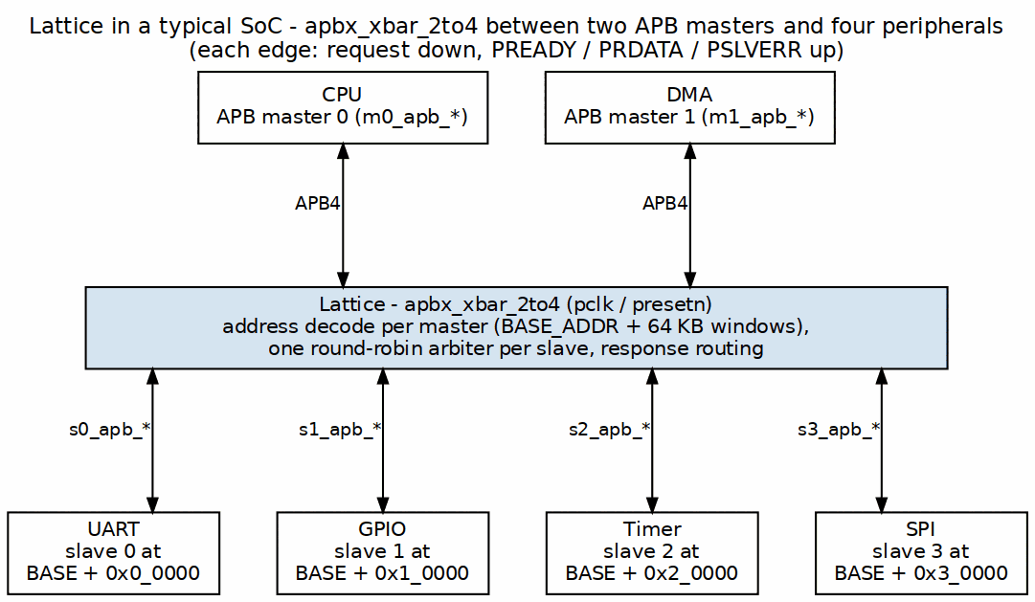
System Context Diagram

Typical Integration Topology

Master-Side Connections
The crossbar’s master ports face upstream APB masters:
Typical Master Connections
Master Type | Typical Source | Connection Point
CPU | AHB-to-APB Bridge | m0_apb_*
DMA | DMA Controller APB Port | m1_apb_*
Debug | Debug Access Port | m2_apb_* (if present)

Slave-Side Connections
The crossbar’s slave ports face downstream APB peripherals:
Typical Slave Connections (1to4 example)
Slave Type | Address Offset | Connection Point
UART | +0x0_0000 | s0_apb_*
GPIO | +0x1_0000 | s1_apb_*
Timer | +0x2_0000 | s2_apb_*
SPI | +0x3_0000 | s3_apb_*

Interface Boundaries

Input Boundary (Master-Side)
Each master port presents a complete APB slave interface:
- Receives PSEL, PENABLE, PADDR, PWRITE, PWDATA, PSTRB, PPROT
- Returns PRDATA, PSLVERR, PREADY

Output Boundary (Slave-Side)
Each slave port presents a complete APB master interface:
- Drives PSEL, PENABLE, PADDR, PWRITE, PWDATA, PSTRB, PPROT
- Receives PRDATA, PSLVERR, PREADY

Clock and Reset
Single clock domain: - pclk - APB clock (all signals synchronous) - presetn - Active-low asynchronous reset

System Integration Considerations

Address Map Planning
The fixed 64KB per-slave allocation requires planning:
- Peripheral fit: Ensure each peripheral needs <= 64KB address space
- Base address: Set BASE_ADDR to avoid conflicts with other subsystems
- Address width: ADDR_WIDTH must accommodate BASE_ADDR + (NUM_SLAVES x 64KB)

Multi-Master Considerations
When using multiple masters:
- Arbitration overhead: a contended access waits a FULL transaction, not 1-2 cycles. The grant is held to the response handshake (WAIT_GNT_ACK(1)), so each master ahead in the round-robin costs ~11 cycles (the arbitrated back-to-back period). Uncontended, the registered grant still costs exactly 1 cycle – see HAS 5.2.
- Priority: All masters have equal priority (round-robin)
- Bandwidth: Shared access reduces per-master bandwidth

Next: Chapter 3: Architecture

RTL Design Sherpa · Learning Hardware Design Through Practice GitHub · Documentation Index · MIT License

Block Diagram

Top-Level Architecture
The Lattice has three functional layers:

Figure 3.1: Lattice Block Diagram
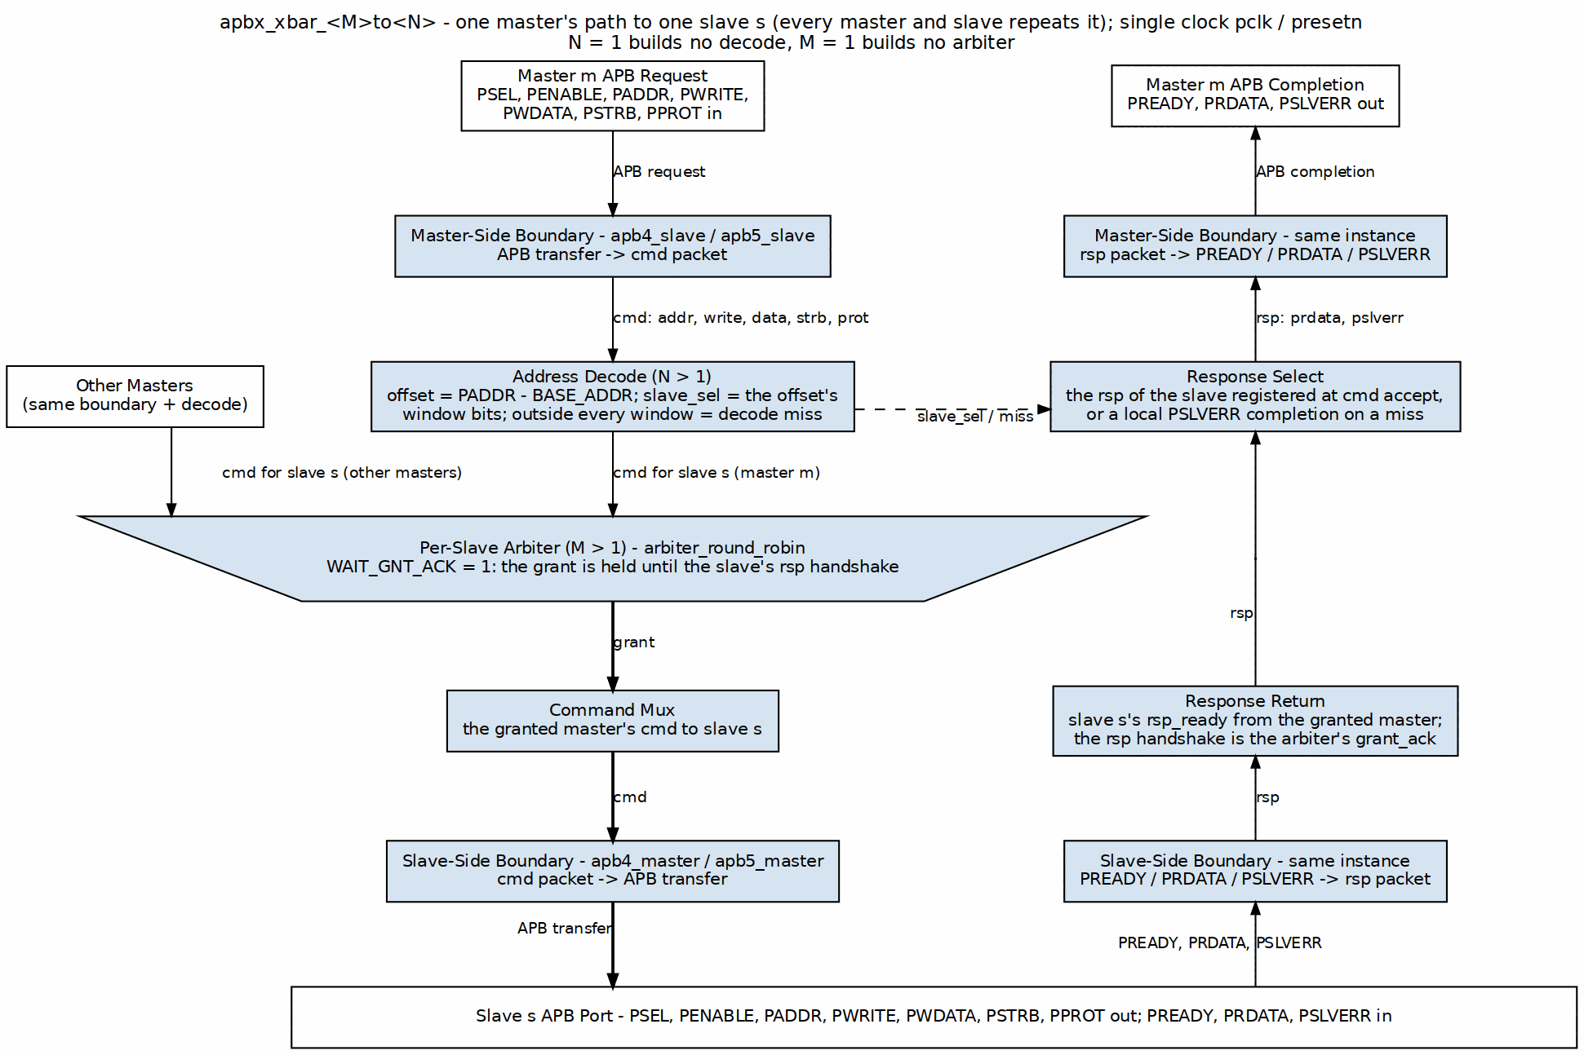
Block Diagram
One master’s path to one slave; every master and slave repeats it. The request takes the center column: the master-side apb4_slave turns the APB transfer into a cmd packet, the address decode picks the slave window, and the slave’s round-robin arbiter (the trapezium, where every master’s cmd for that slave contends) grants one master and holds the grant until the response handshake. The completion climbs the right column, routed back by the slave index registered when the command was accepted; an address outside every window completes locally with PSLVERR.

Functional Blocks

Master-Side Protocol Conversion
Component: apb4_slave[M] instances (one per master)
Each APB slave instance: - Accepts incoming APB transactions from a master - Converts the APB protocol to the internal command/response format - Buffers the transaction - Generates the response timing
Interface: - Input: Complete APB slave signals from external master - Output: Internal cmd/rsp bus to crossbar fabric

Internal Crossbar Fabric
Components: - Address Decode - Parallel decode logic - Per-Slave Arbiters - Round-robin arbiter per slave (N instances) - Response Routing - Combinational response mux (the registers on this path live in the boundary IP’s skid buffers, not the mux)
The crossbar fabric: 1. Decodes transaction address to determine target slave 2. Arbitrates when multiple masters request the same slave 3. Routes commands to the selected slave 4. Routes responses back to the originating master

Slave-Side Protocol Conversion
Component: apb4_master[N] instances (one per slave)
Each APB master instance: - Accepts internal cmd/rsp from crossbar fabric - Generates compliant APB transactions to the slave - Handles wait states via PREADY - Propagates error responses via PSLVERR
Interface: - Input: Internal cmd/rsp bus from crossbar fabric - Output: Complete APB master signals to external slave

Module Hierarchy
apbx_xbar_MxN
+-- apb4_slave[0..M-1] # Master-side conversion
+-- addr_decode # Parallel address decode
+-- arbiter[0..N-1] # Per-slave round-robin
+-- response_mux # Response routing
+-- apb4_master[0..N-1] # Slave-side conversion

Data Path Width
Data path widths are consistent throughout:
Data Path Width Parameters
Parameter | Default | Range | Description
ADDR_WIDTH | 32 | 18-64 (decoding variants: the slave-index part-select reads bit 17); 1-64 for 1to1/2to1 | Address bus width
DATA_WIDTH | 32 | 8-64 | Data bus width
STRB_WIDTH | 4 | 1-8 | Byte strobe width (DATA_WIDTH/8)

Next: Data Flow

RTL Design Sherpa · Learning Hardware Design Through Practice GitHub · Documentation Index · MIT License

Data Flow

Transaction Flow Overview

Figure 3.2: Transaction Data Flow
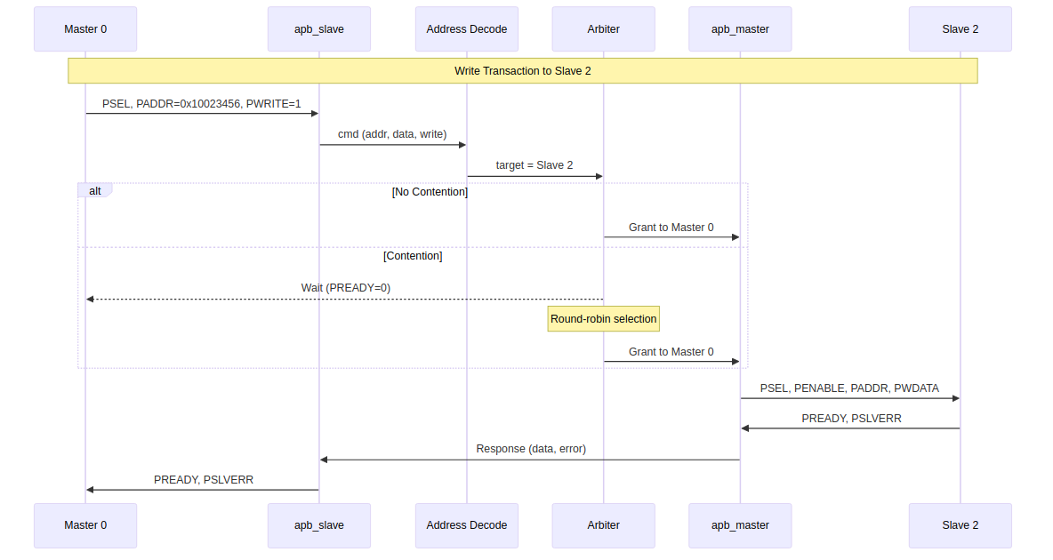
Data Flow Diagram

Write Transaction Flow
A write transaction passes through six stages:

Stage 1: Master Request
The external master initiates an APB write: 1. Master asserts PSEL and PADDR with target address 2. Master sets PWRITE=1 and provides PWDATA 3. Next cycle: Master asserts PENABLE

Stage 2: Protocol Conversion (Master-Side)
The apb4_slave module converts to internal format: 1. Captures transaction parameters (address, data, write) 2. Generates internal command 3. Routes to address decode

Stage 3: Address Decode
Parallel decode determines target slave:
slave_index = offset[16 +: $clog2(S)] // offset = PADDR - BASE_ADDR
A part-select, not a mask. & (S-1) appeared here until 2026-08-30 and is only equivalent when S is a power of two – for a generated 3-slave variant the mask would make slave 1 unreachable. The generator emits a part-select (slave_sel = m0_cmd_offset[13:12] for S = 3 at the generator’s default 4KB window; the shipped 64KB variants read offset[16 +: $clog2(S)]), and the sibling formulas in ch02/ch03 always did.

Stage 4: Arbitration (if needed)
If multiple masters target the same slave: 1. Arbiter selects one master (round-robin priority) 2. Other masters wait (PREADY low) 3. Grant held until transaction completes

Stage 5: Protocol Conversion (Slave-Side)
The apb4_master module generates the APB transaction: 1. Asserts PSEL to selected slave 2. Provides PADDR, PWRITE, PWDATA 3. Asserts PENABLE next cycle 4. Waits for slave PREADY

Stage 6: Response Return
The response flows back to the originating master: 1. Slave asserts PREADY (with optional PSLVERR) 2. apb4_master captures response 3. Response routed to correct apb4_slave 4. apb4_slave asserts PREADY to original master

Read Transaction Flow
Read transactions follow the same flow with these differences:
- PWRITE=0 indicates read operation
- No PWDATA on forward path
- PRDATA returned on response path

Timing Summary
Transaction Timing Summary
Transaction Phase | Clock Cycles | Notes
Setup phase | 1 | PSEL asserted, PENABLE low
Data phase | 1+ | PENABLE high, wait for PREADY
Decode | 0 | Combinational (parallel decode)
Arbitration | 0 or 1 | 0 when M = 1 – the generator emits no arbiter at all. 1 when M > 1, even uncontended, because the grant is REGISTERED

Back-to-Back Transactions
The crossbar accepts back-to-back transactions – but they do NOT overlap:
- A master may hold PSEL and start the next SETUP the cycle after PREADY
- apb4_slave is one-command-at-a-time, so the next command is not captured until the previous transaction completes
- Sustained cadence is therefore one cycle LONGER than single-transfer latency: measured PREADY-to-PREADY = 10 pclk cycles at the earliest legal turnaround, against 9 cycles SETUP-to-PREADY for one transfer (M = 1; 11 and 10 on an arbitrated variant). The extra cycle is the next transfer’s mandatory SETUP phase, which cannot overlap the previous ACCESS (see 5.1/5.2)

Next: Address Mapping

RTL Design Sherpa · Learning Hardware Design Through Practice GitHub · Documentation Index · MIT License

Address Mapping

Address Map Structure
The shipped Lattice variants use a 64KB address region per slave. The size is chosen at generation (--slave-size, generator default 4KB) and then baked into the decode part-select, so it is fixed for a given generated module:

Figure 3.3: Address Mapping Structure
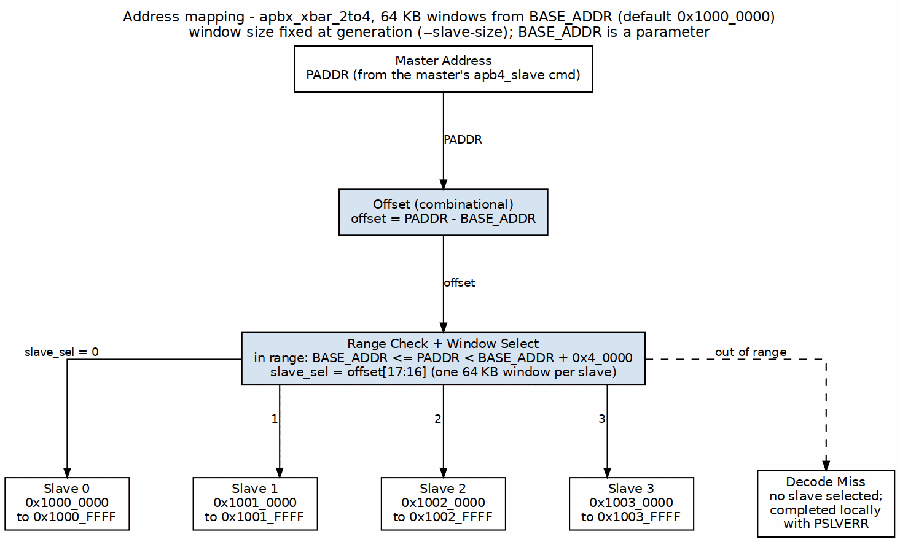
Address Mapping

Default Address Map
With default BASE_ADDR = 0x1000_0000:
Default Address Map (4-slave example)
Slave Index | Start Address | End Address | Size
0 | 0x1000_0000 | 0x1000_FFFF | 64KB
1 | 0x1001_0000 | 0x1001_FFFF | 64KB
2 | 0x1002_0000 | 0x1002_FFFF | 64KB
3 | 0x1003_0000 | 0x1003_FFFF | 64KB
… | … | … | …
N-1 | BASE + (N-1)*64KB | BASE + N*64KB - 1 | 64KB

Address Decode Logic
The target slave comes from simple bit extraction:
offset = PADDR - BASE_ADDR
slave_index = offset[16 +: $clog2(S)] // ceil(log2(S)) bits: [17:16] for S=4
local_addr = offset[15:0] // Bits 15:0 are local address within slave

Example Decode
For address 0x1002_3456 with BASE_ADDR = 0x1000_0000:
Address Decode Example
Step | Calculation | Result
1. Compute offset | 0x1002_3456 - 0x1000_0000 | 0x0002_3456
2. Extract slave index | offset[17:16] (S=4) | 0x2 (Slave 2)
3. Extract local address | offset[15:0] | 0x3456

Customizing Base Address
The BASE_ADDR parameter shifts the entire address map:
// Peripheral space at 0x4000_0000
apbx_xbar_1to4 #(
.BASE_ADDR(32'h4000_0000)
) u_xbar (...);
// Resulting map:
// Slave 0: 0x4000_0000 - 0x4000_FFFF
// Slave 1: 0x4001_0000 - 0x4001_FFFF
// Slave 2: 0x4002_0000 - 0x4002_FFFF
// Slave 3: 0x4003_0000 - 0x4003_FFFF

Address Map Constraints

Fixed Slave Region Size
Each slave occupies exactly 64KB (0x10000 bytes). This is a current design constraint.
Implications: - Peripherals requiring more than 64KB need multiple slave ports - Peripherals using less than 64KB have unused address space

Maximum Configuration
With 4-bit slave index extraction: - Maximum 16 slaves - Total address space: 16 x 64KB = 1MB

Address Width Requirement
The ADDR_WIDTH parameter must be sufficient to address: - BASE_ADDR + (NUM_SLAVES x 64KB)
Example: For 4 slaves at BASE_ADDR = 0x8000_0000, need: - 0x8000_0000 + 0x4_0000 = 0x8004_0000 - Minimum ADDR_WIDTH: 32 bits

Next: Chapter 4: Interfaces

RTL Design Sherpa · Learning Hardware Design Through Practice GitHub · Documentation Index · MIT License

Master-Side APB Interfaces

Interface Overview
Each master port presents a complete APB slave interface, accepting transactions from an external APB master (CPU, DMA, etc.).

Signal Definition
For each master index i (0 to M-1):
Master Port Signal Definition
Signal | Width | Direction | Description
m<i>_apb_PSEL | 1 | Input | Peripheral select
m<i>_apb_PENABLE | 1 | Input | Transfer enable
m<i>_apb_PADDR | ADDR_WIDTH | Input | Address bus
m<i>_apb_PWRITE | 1 | Input | Write/read direction
m<i>_apb_PWDATA | DATA_WIDTH | Input | Write data bus
m<i>_apb_PSTRB | STRB_WIDTH | Input | Write strobes
m<i>_apb_PPROT | 3 | Input | Protection attributes
m<i>_apb_PRDATA | DATA_WIDTH | Output | Read data bus
m<i>_apb_PSLVERR | 1 | Output | Slave error response
m<i>_apb_PREADY | 1 | Output | Transfer ready

APB5 Sideband (mixed-version variants only)
An APB5 master port carries five additional pins. They exist ONLY on ports the generator was told are APB5 – in the shipped apbx_xbar_2to2_mixed that is m1 alone, and m0 has none of them. That structural absence IS the version gate; there is no mask to set.
APB5 Master Sideband Signals
Signal | Width | Direction | Description
m<i>_apb_PAUSER | 1 | Input | Request user attributes; forwarded only to an APB5 slave
m<i>_apb_PWUSER | 1 | Input | Write-data user attributes; likewise
m<i>_apb_PRUSER | 1 | Output | Completer read-data user attributes, from an APB5 slave
m<i>_apb_PBUSER | 1 | Output | Completer response user attributes, from an APB5 slave
m<i>_apb_PWAKEUP | 1 | Input | Requester wake; forwarded to every APB5 slave port – see below
Reading from an APB4 slave returns '0 on PRUSER/PBUSER rather than a stale or fabricated value, and that is proven, not just tested (formal/apbx_xbar/apbx_xbar_2to2_mixed/, ap_gate_no_fab_*).
PWAKEUP is an input here. AMBA APB (IHI 0024E section 3.7.2, Table 3-7) defines PWAKEUP as a Requester output, and the external master is the Requester on this port. The crossbar ORs it into PWAKEUP on every APB5 slave port, without registering it, so a wake raised a cycle ahead of PSEL reaches the completer a cycle ahead of PSEL. An APB4 master has no PWAKEUP. Its transfers to an APB5 slave are still covered by the crossbar’s own wake, as described in Slave Side. The forwarding is proven (ap_pwakeup_forwarded in formal/apbx_xbar/apbx_xbar_2to2_mixed/). Earlier crossbars drove this pin as an output tied to '0, under the old reversed direction. That was corrected in issue #102 item 7.
The user-signal widths are fixed at 1 bit, not parameterised. This table previously named AUSER_WIDTH/WUSER_WIDTH/RUSER_WIDTH/BUSER_WIDTH as though an integrator could size them. There are no such parameters: the whole module takes only ADDR_WIDTH, BASE_ADDR, DATA_WIDTH and STRB_WIDTH, and the generator hardcodes AUSER_WIDTH(1) .. BUSER_WIDTH(1) at each boundary shim. Widening a user field means regenerating the crossbar, not overriding a parameter.
Parity pins are absent entirely: every shipped variant is generated with parity off. A variant generated with enable_parity=True adds the IHI 0024E chapter 5 check signals on each APB5 port. Inputs are PADDRCHK, PCTRLCHK, PSELCHK, PENABLECHK, PWDATACHK, PSTRBCHK, PAUSERCHK, PWUSERCHK and PWAKEUPCHK. Outputs are PRDATACHK, PREADYCHK, PSLVERRCHK, PRUSERCHK and PBUSERCHK. All are odd parity, plus m<i>_parity_error_wdata and m<i>_parity_error_ctrl. See the GAS chapter Mixed APB4/APB5 and Parity for the widths.

Signal Descriptions

PSEL (Input)
Peripheral select signal. When asserted: - Indicates the master wants to access the crossbar - Must remain asserted throughout the transaction - Combined with PADDR determines target slave

PENABLE (Input)
Transfer enable signal. APB state machine: - PSEL=1, PENABLE=0: Setup phase - PSEL=1, PENABLE=1: Access phase (data transfer)

PADDR (Input)
Address bus. Used for: - Target slave selection (upper bits) - Local address within slave (lower bits) - Must be stable while PSEL asserted

PWRITE (Input)
Transfer direction: - PWRITE=1: Write transaction (data from master) - PWRITE=0: Read transaction (data to master)

PWDATA (Input)
Write data bus: - Valid during write transactions - Sampled when PREADY and PENABLE both high - Width set by DATA_WIDTH parameter

PSTRB (Input)
Write byte strobes: - One bit per byte of DATA_WIDTH - Indicates which bytes are valid in PWDATA - Ignored during read transactions

PPROT (Input)
Protection attributes (3 bits): - Bit 0: Privileged/normal access - Bit 1: Secure/non-secure access - Bit 2: Instruction/data access

PRDATA (Output)
Read data bus: - Valid during read transactions when PREADY high - Undefined during write transactions - Width matches DATA_WIDTH parameter

PSLVERR (Output)
Slave error response: - Sampled when PREADY and PENABLE both high - PSLVERR=1 indicates error condition - Propagated from the downstream slave, or generated locally by this port when the address decodes outside the map: on the decoding variants a miss completes here with PSLVERR=1 and never reaches a slave (projects/components/fabric-gen-ip/lattice-apbx-xbar BUG-002, was APBX-005). The 1to1 and 2to1 variants have no decode and so never generate it locally.

PREADY (Output)
Transfer ready signal: - PREADY=1 allows the transaction to complete - PREADY=0 inserts wait states - Reflects downstream slave PREADY (or arbitration wait)

Transaction Timing

Uncontended Write (No Arbitration Wait)
Drawn to scale for a single-master variant: 9 pclk edges SETUP-to-PREADY, 10 on an arbitrated one (see 5.2).

Figure 4.1: Uncontended Write at a Master Port
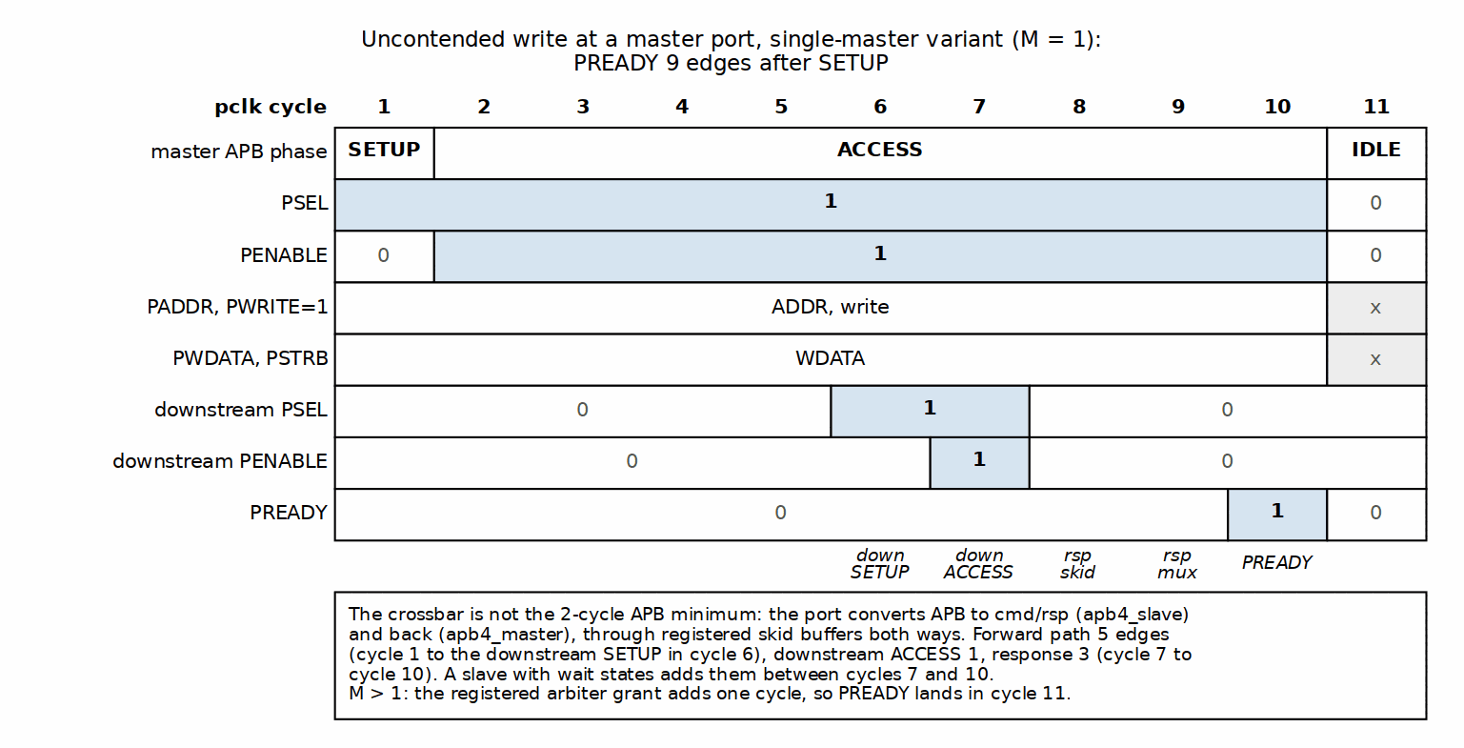
Uncontended Write at a Master Port

Contended Transaction (Arbitration Wait)
When another master holds the target slave:

Figure 4.2: Contended Transfer
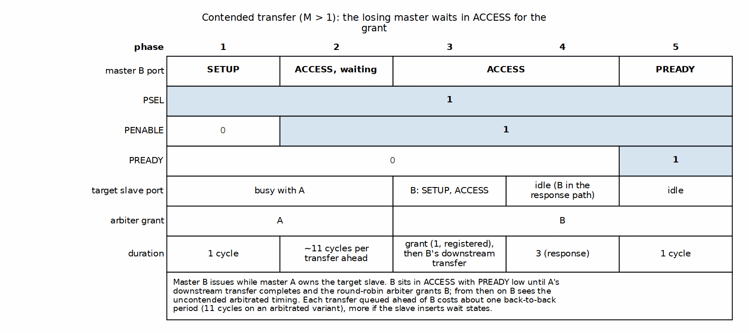
Contended Transfer

Next: Slave-Side Interfaces

RTL Design Sherpa · Learning Hardware Design Through Practice GitHub · Documentation Index · MIT License

Slave-Side APB Interfaces

Interface Overview
Each slave port presents a complete APB master interface, driving transactions to an external APB slave (peripheral).

Signal Definition
For each slave index j (0 to N-1):
Slave Port Signal Definition
Signal | Width | Direction | Description
s<j>_apb_PSEL | 1 | Output | Peripheral select
s<j>_apb_PENABLE | 1 | Output | Transfer enable
s<j>_apb_PADDR | ADDR_WIDTH | Output | Address bus
s<j>_apb_PWRITE | 1 | Output | Write/read direction
s<j>_apb_PWDATA | DATA_WIDTH | Output | Write data bus
s<j>_apb_PSTRB | STRB_WIDTH | Output | Write strobes
s<j>_apb_PPROT | 3 | Output | Protection attributes
s<j>_apb_PRDATA | DATA_WIDTH | Input | Read data bus
s<j>_apb_PSLVERR | 1 | Input | Slave error response
s<j>_apb_PREADY | 1 | Input | Transfer ready

APB5 Sideband (mixed-version variants only)
Symmetric with the master side, and equally structural: these pins exist ONLY on slave ports the generator was told are APB5. In the shipped apbx_xbar_2to2_mixed that is s0 alone – s1 has none of them – so the absence IS the version gate, with no mask to set. Note the pairing in that variant is crosswise: the APB5 port is m1 on the master side and s0 here.
APB5 Slave Sideband Signals
Signal | Width | Direction | Description
s<j>_apb_PAUSER | 1 | Output | Request user attributes, forwarded from an APB5 master
s<j>_apb_PWUSER | 1 | Output | Write-data user attributes, likewise
s<j>_apb_PRUSER | 1 | Input | Read-data user attributes returned by the slave
s<j>_apb_PBUSER | 1 | Input | Response user attributes returned by the slave
s<j>_apb_PWAKEUP | 1 | Output | Crossbar wake toward the slave – see below
Widths are fixed at 1 bit. The generator hardcodes AUSER_WIDTH(1) .. BUSER_WIDTH(1) on the boundary shim and exposes no parameter for them.
s<j>_apb_PWAKEUP is driven by the crossbar. On this interface the crossbar is the Requester, and PWAKEUP is a Requester output (IHI 0024E section 3.7.2, Table 3-7). It is the OR of two terms:
- The boundary apb5_master IP’s own registered wake. It is high while a command for this slave is pending or a transfer is in flight, it leads PSEL by a cycle, and it holds through PREADY. This term covers transfers from APB4 masters, which have no PWAKEUP. 3.7.2 lets a slave wait for PWAKEUP before PREADY, so a PSEL without it could deadlock.
- Every APB5 master’s m<i>_apb_PWAKEUP. All masters can address all slaves, so the wake goes to every APB5 slave port, not to the decoded one. The address is not known until PSEL, and 3.7.2 recommends the wake lead PSEL.
3.7.2 names a glitch-free OR tree as a valid construction. Three properties are proven in formal/apbx_xbar/apbx_xbar_2to2_mixed/:
- ap_pwakeup_forwarded: a master’s wake always reaches the slave.
- ap_pwakeup_covers_psel: the slave is never selected without PWAKEUP.
- ap_pwakeup_not_fabricated: from reset, with no master wake and no traffic, the wake stays low.
The slave’s own wake is not forwarded to any master. Earlier crossbars took this pin as an input and dropped it, under the old reversed direction. That was corrected in issue #102 item 7. With parity on, the port’s PWAKEUPCHK is ~s<j>_apb_PWAKEUP, computed over the OR.
Reading from an APB4 slave returns '0 on PRUSER/PBUSER rather than a stale or fabricated value, proven by ap_gate_no_fab_* in formal/apbx_xbar/apbx_xbar_2to2_mixed/.

Signal Behavior

Output Signals (Crossbar to Slave)
PSEL: Asserted when a transaction targets this slave. Remains high throughout the transaction.
PENABLE: Follows standard APB timing – exactly one setup cycle (PSEL high, PENABLE low) before ACCESS, on every transfer.
Until 2026-08-28 apb4_master/apb5_master drove two setup cycles when launching out of IDLE, measured [2,2,2] at a downstream port; only back-to-back transfers taking the ACCESS->SETUP shortcut were compliant. Fixed as AMBA TASK-071 by not asserting PSEL in the IDLE launch cycle, which cost no latency because the state sequence was unchanged. Now measured [1,1,1,1,1] downstream, asserted by val/amba/test_apb_master_setup_phase.py and by the downstream check in dv/tests/test_apbx_xbar_timing.py.
- Low during setup phase
- High during access phase
PADDR: Contains the full address from the master. The local address within a 64KB region is offset[15:0] – note this is the OFFSET’s low bits, not PADDR’s, so it only equals PADDR[15:0] when BASE_ADDR is 64KB-aligned (which is permitted but not required).
PWRITE, PWDATA, PSTRB, PPROT: Passed through from the winning master without modification.

Input Signals (Slave to Crossbar)
PRDATA: Captured by crossbar when both PREADY and PENABLE are high. Routed to originating master.
PSLVERR: Captured with PRDATA. Propagated to originating master as error indication.
PREADY: Controls transaction completion: - PREADY=1: Transaction completes this cycle - PREADY=0: Insert wait states

Slave Response Handling

Wait States
Slaves can insert wait states by holding PREADY low:

Figure 4.3: Slave Wait States
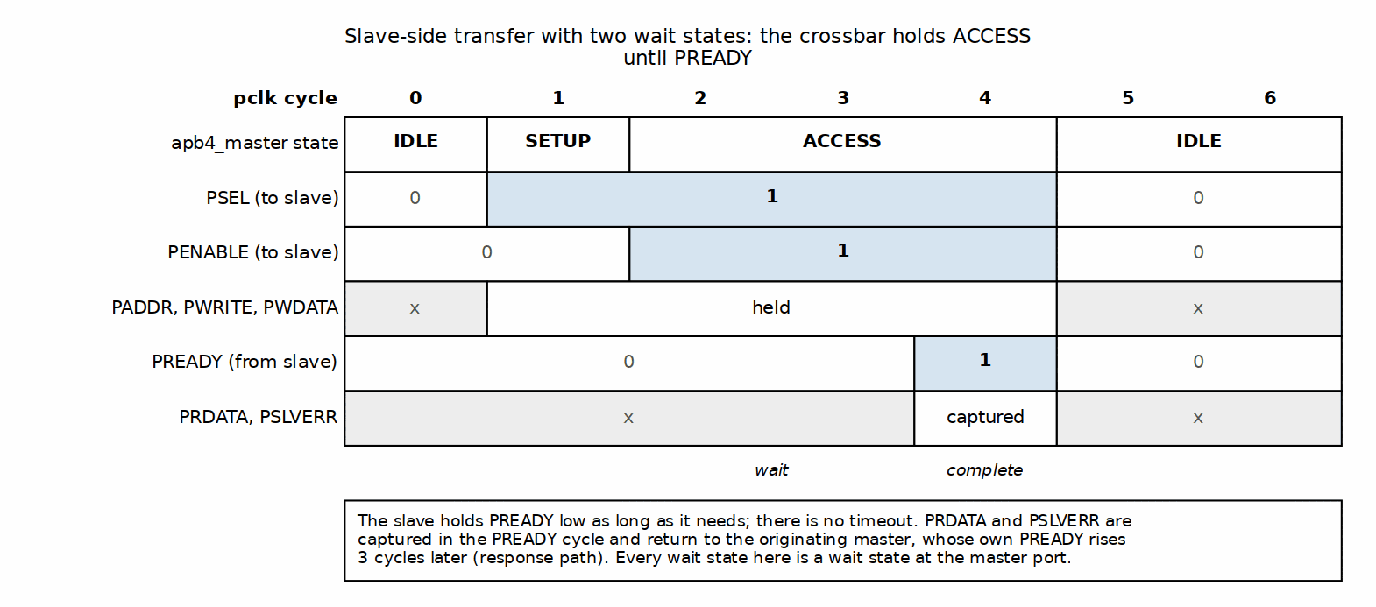
Slave Wait States
The crossbar: - Holds master PREADY low while waiting - Does not timeout (assumes slaves always respond) - Passes through all wait states to master

Error Response
When slave asserts PSLVERR:
- Crossbar captures PSLVERR with PRDATA
- Routes PSLVERR to originating master
- Master sees PSLVERR=1 when its PREADY goes high
No error handling or recovery - error indication only.

Multi-Slave Considerations

Address Overlap Prevention
Each slave port is mutually exclusive: - Only one slave receives PSEL for any given address - No overlapping address regions - Address decode is deterministic

Independent Operation
Each slave operates independently: - Own PREADY timing - No synchronization between slaves - Concurrent transactions to different slaves allowed (different masters)

Next: Clock and Reset

RTL Design Sherpa · Learning Hardware Design Through Practice GitHub · Documentation Index · MIT License

Clock and Reset

Clock Interface

Signal Definition
Clock Signal
Signal | Width | Direction | Description
pclk | 1 | Input | APB clock

Clock Requirements
Single Clock Domain: - All crossbar logic operates on the pclk rising edge - All APB signals sampled/driven synchronous to pclk - No internal clock generation or division
Frequency: - No minimum frequency requirement - Maximum frequency set by the critical path - Typical: 100-250 MHz (depends on target technology)
Duty Cycle: - No specific duty cycle requirement - Standard 50% duty cycle recommended

Reset Interface

Signal Definition
Reset Signal
Signal | Width | Direction | Description
presetn | 1 | Input | Active-low asynchronous reset

Reset Behavior
Assertion (presetn goes low): - All internal state cleared immediately - All output signals driven to safe values - Master ports: PREADY=0, PRDATA=0, PSLVERR=0 - Slave ports: PSEL=0, PENABLE=0, PADDR=0, etc.
Deassertion (presetn goes high): - Internal state begins normal operation - Reset release is NOT synchronized internally – presetn is applied directly as an asynchronous reset (ALWAYS_FF_RST) in every module. The integrator must synchronize reset DEASSERTION to pclk externally (recovery/removal timing) - Ready to accept transactions from the first pclk edge after a correctly synchronized deassertion – NOT “immediately” in the sense of the deassertion instant. Until that externally synchronized removal lands cleanly, the fabric’s state is not defined; the “Reset Deassertion” guidance later on this page (wait 1 cycle before the first transaction) is the operative rule.

Reset Safe Values
Reset Safe Values
Signal Group | Reset Value | Rationale
Master PREADY | 0 | apb4_slave asserts PREADY only in BUSY
Master PRDATA | 0 | No false data
Master PSLVERR | 0 | No false errors
Slave PSEL | 0 | No false transactions
Slave PENABLE | 0 | No false enables
Arbiter grants | 0 | No master selected

Clock-Reset Relationship

Reset Assertion
Reset can be asserted at any time: - Asynchronous assertion (immediate effect), in every build. This comes from ALWAYS_FF_RST in rtl/amba/includes/reset_defs.svh, which is unconditionally async; the old USE_ASYNC_RESET switch is a no-op. - Deassertion must be synchronous to pclk – see “Reset Deassertion” below. This bullet previously also permitted asynchronous deassertion, contradicting that section three lines later. - All in-flight transactions aborted

Reset Deassertion
For clean operation: 1. Assert reset for minimum 2 pclk cycles 2. Deassert reset synchronous to pclk rising edge 3. Wait 1 cycle before first transaction

Figure 4.4: Reset Sequence
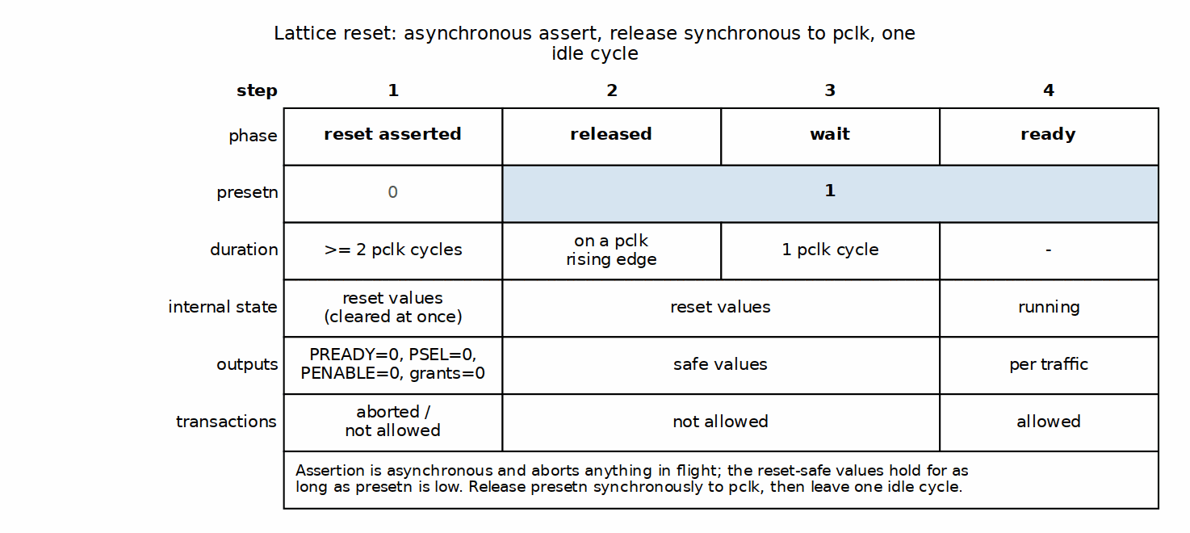
Reset Sequence

Integration Notes

Clock Domain Crossing
If masters or slaves are in different clock domains: - Insert CDC logic external to the crossbar - The crossbar assumes a single clock domain - Consider an APB clock bridge if needed

Clock Gating
The crossbar supports clock gating: - No internal activity when idle - Safe to gate pclk when no transactions pending - All registers use standard flip-flops (no clock gating cells)

Next: Chapter 5: Performance

RTL Design Sherpa · Learning Hardware Design Through Practice GitHub · Documentation Index · MIT License

Throughput Characteristics

Maximum Throughput

Single Master
With a single master accessing any slave, the figures split by arbiter presence: the generator emits an arbiter only when M > 1, and its registered grant costs a cycle on every one of them. See 5.2.
Single-Master-Active Throughput, by Variant Class
Metric | M = 1 | M > 1 | Notes
Cycles per transaction (uncontended) | 9 SETUP->PREADY; 8 fabric | 10 SETUP->PREADY; 9 fabric | measured, zero-wait slave
Sustained cycles per transaction | 10 (PREADY->PREADY) | 11 (PREADY->PREADY) | measured back-to-back, one active master
Maximum transactions per cycle | ~0.100 | ~0.091 | 1 transaction / 10 or 11 cycles
Data throughput (32-bit @ 100MHz) | ~40 MB/s | ~36 MB/s | 4 B per period
Data throughput (32-bit @ 250MHz) | ~100 MB/s | ~91 MB/s | 4 B per period
M = 1: apbx_xbar_1to1, apbx_xbar_1to4. M > 1: apbx_xbar_2to1, apbx_xbar_2to4, apbx_xbar_2to2_mixed – so the 2x4 the PRD calls the typical SoC case is the slower column. This table published the M = 1 figures unconditionally until 2026-08-29.

Multi-Master (Uncontended)
When masters access different slaves: - Each master achieves single-master throughput - Aggregate throughput = M x single-master throughput - No CONTENTION overhead – but the registered grant still costs one cycle on every M > 1 variant, contended or not (see 5.2). Only the single-master variants have no arbiter at all.

Multi-Master (Contended)
When masters compete for the same slave:
Contended Access Throughput
Masters | Effective Throughput | Notes
2 | 50% per master | Round-robin sharing
3 | 33% per master | Round-robin sharing
4 | 25% per master | Round-robin sharing

Arbitration Handoff

Grant Persistence
The crossbar implements grant persistence: - A master holds the grant for the duration of ONE transaction - The grant is released at the RESPONSE handshake, not when PSEL drops (grant_ack = grant && rsp_valid && rsp_ready, arbiter instantiated with WAIT_GNT_ACK(1)), after which the round-robin mask rotates – holding PSEL does not keep the grant if another master is requesting - A single master with no competitor re-wins immediately, so its transactions still stream back-to-back – at the fabric’s own cadence, not at APB’s 2-cycle minimum

Back-to-Back Timing
A “zero-bubble” 4-cycle two-transaction diagram appeared here in earlier revisions. It described a pipeline this RTL does not have: the apb4_slave front end is a one-command-at-a-time FSM (IDLE -> BUSY -> WAIT), so the next command is not captured until the previous transaction completes. But sustained cadence is not equal to single-transfer latency either – it is one cycle longer. A master holding PSEL high and dropping PENABLE for exactly one cycle after each PREADY (the earliest LEGAL turnaround) measures PREADY-to-PREADY = 10 pclk cycles, against a 9-cycle SETUP-to-PREADY single transfer. The extra cycle is the next transfer’s mandatory SETUP phase, which cannot overlap the previous transfer’s ACCESS. See 5.2 for the convention and the cycle-by-cycle breakdown. There is still no overlap between consecutive transactions to draw.

Throughput Factors

Factors That Reduce Throughput
Throughput Reduction Factors
Factor | Impact | Mitigation
Slave wait states | Variable | Choose faster peripherals
Arbitration conflicts | ~11 cycles per master ahead in the round-robin | Distribute access across slaves
Slave response time | Variable | Design slaves for quick response

Optimal Usage Pattern
For maximum throughput: 1. Distribute master access across different slaves 2. Minimize slave wait states 3. Use burst-like access patterns (same master, same slave) 4. Avoid rapid master switching on same slave

Next: Latency Analysis

RTL Design Sherpa · Learning Hardware Design Through Practice GitHub · Documentation Index · MIT License

Latency Analysis

Transaction Latency

Uncontended Access
When a master has exclusive access to a slave:
Uncontended Transaction Latency
Phase | Cycles | Description
Master SETUP | 1 | PSEL high, PENABLE low
apb4_slave capture + cmd skid | 2 | command registered out
apb4_master IDLE-launch / SETUP / ACCESS | 3 | downstream PSEL then PENABLE
Response + rsp skid | 2 | slave PREADY through the return skid
apb4_slave BUSY -> PREADY | 1 | master-visible completion
Total | 9 | PSEL to PREADY (8 of them ACCESS to PREADY)
These are measured numbers, not protocol minimums. A crossbar transfer is NOT the 2-cycle APB minimum: the fabric converts APB to an internal cmd/rsp protocol through apb4_slave and back through apb4_master, and both directions cross REGISTERED skid buffers.
Measurement convention. Every figure below counts rising pclk edges and names the two edges it spans. State the edges or the number means nothing – this page has been wrong twice from not doing so.
The numbers depend on whether the variant has an arbiter, and the generator only emits one when there is more than one master. A single-master variant has no arbiter_round_robin at all; a multi-master variant has one per slave, and its grant is a flop (grant <= w_next_grant), which costs exactly one cycle on every quantity below.
Measured Timing, Always-Ready Slave
Quantity | M = 1 | M > 1 | Spans
Fabric latency | 8 | 9 | first ACCESS edge -> edge where PREADY is high
Single-transfer latency | 9 | 10 | SETUP edge -> edge where PREADY is high
Back-to-back period | 10 | 11 | PREADY edge -> next PREADY edge
M = 1 is apbx_xbar_1to1 and apbx_xbar_1to4 (0 arbiters). M > 1 is apbx_xbar_2to1, apbx_xbar_2to4 and apbx_xbar_2to2_mixed (1, 4 and 2 arbiters). All six columns are measured, not derived – see dv/tests/test_apbx_xbar_timing.py, which asserts both classes.
Until 2026-08-29 this page published the M = 1 numbers unconditionally, under the heading “Uncontended Access”, having measured only apbx_xbar_1to1. They were one cycle optimistic for every arbitrated variant – including the 2x4 that the PRD calls the typical SoC case.
The period is 10, not 9, and the difference is structural. After PREADY at cycle N the bus is still in ACCESS for that cycle, so the next transfer’s mandatory SETUP cycle cannot begin before N+1; its ACCESS follows at N+2 and its PREADY at N+2+8 = N+10. Reaching 9 would require a SETUP cycle overlapping the previous transfer’s ACCESS, which is not a legal APB waveform. So sustained cadence does not equal single-transfer latency here – it is exactly one cycle longer.
Earlier revisions of this page claimed 2 cycles (the bare APB minimum for a directly-attached slave, which does not apply through this fabric), and later claimed a 9-cycle sustained cadence, which came from a probe whose turnaround was not legal APB. A qc reviewer flagged the 9-cycle cadence and was told it was a false positive; the reviewer was right. dv/tests/test_apbx_xbar_timing.py now asserts all three numbers against the RTL so the question is settled by the suite rather than by argument.

Contended Access
When multiple masters compete for the same slave:
Arbitration Latency
Scenario | Additional Latency | Description
Win arbitration | 1 cycle | grant is REGISTERED in arbiter_round_robin
Lose to 1 master | ~10+ cycles | wait one full transaction (see above)
Lose to N masters | ~10N+ cycles | wait N transactions

Latency Breakdown

Forward Path (Master to Slave)
Forward Path Latency
Component | M = 1 | M > 1 | Type
apb4_slave capture | 1 | 1 | Registered
apb4_slave cmd skid out | 1 | 1 | Registered
Address decode | 0 | 0 | Combinational
Arbitration | 0 | 1 | No arbiter is emitted when M = 1; when one is, its grant is a flop
apb4_master cmd skid in | 1 | 1 | Registered
apb4_master cmd skid out | 1 | 1 | Registered
apb4_master IDLE -> SETUP | 1 | 1 | FSM
Total | 5 | 6 | master SETUP edge to downstream PSEL edge
Both columns measured: 5 on apbx_xbar_1to1, 6 on apbx_xbar_2to1. The arbitration row is the whole difference between the two variant classes. This table carried a single unconditional column with a 1-cycle arbitration row and a 5-cycle total until 2026-08-29 – which cannot both be true, since the 5 was measured on the variant that has no arbiter.
The three numbers on this page must sum, and now do:
M = 1 M > 1 5 forward 6 forward + 1 downstream SETUP -> ACCESS + 1 downstream SETUP -> ACCESS + 3 response + 3 response = 9 SETUP-to-PREADY = 10 SETUP-to-PREADY
(With a zero-wait slave the downstream ACCESS and PREADY edges are the same cycle, which is why the response row can be read from either. A slave with wait states adds its own cycles between them and shifts the total.)
This table read 4 until 2026-08-29, which could not be reconciled with the page’s own 9-cycle total – 4 + 3 left two cycles unaccounted for. Measured on apbx_xbar_1to1 with an always-ready slave: master SETUP at cycle 1, downstream PSEL at cycle 6, downstream ACCESS at cycle 7, master PREADY at cycle 10.

Response Path (Slave to Master)
Response Path Latency
Component | Cycles | Type
Slave response | Variable | The slave’s own PREADY timing, excluded below
apb4_master captures into rsp skid | 1 | Registered
rsp skid out, through the response mux | 1 | Skid registered; the mux itself is combinational
apb4_slave drives PREADY | 1 | Registered
Total | 3 | downstream PREADY edge to master PREADY edge
Same on both variant classes – arbitration is on the command path only. The rows read “0-1 cycle” each until 2026-08-29, which could not sum to the stated 3.

Latency Timing Diagram

Best Case (No Waits, No Contention)

Figure 5.1: Best-Case Latency Timeline
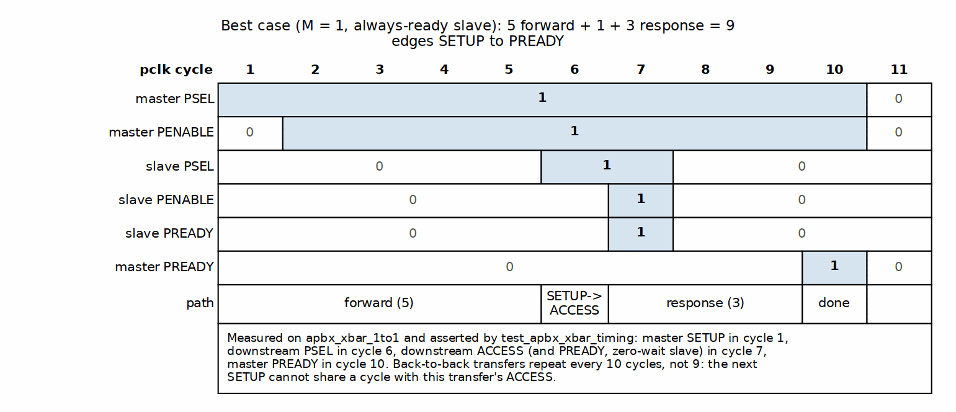
Best-Case Latency Timeline

Worst Case (Contention + Slave Wait States)

Figure 5.2: Arbitration and Slave Wait States
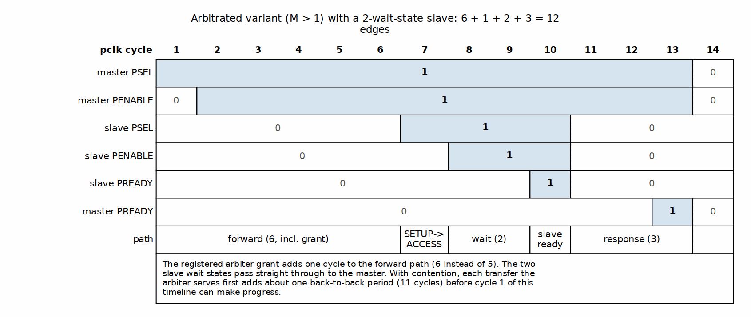
Arbitration and Slave Wait States

Latency Optimization

Design Recommendations
Latency Optimization Recommendations
Goal | Recommendation
Minimize contention | Use more slaves, spread access
Reduce arbitration wait | Lower master count per slave
Reduce slave latency | Design slaves with quick PREADY

Next: Resource Estimates

RTL Design Sherpa · Learning Hardware Design Through Practice GitHub · Documentation Index · MIT License

Resource Estimates

FPGA Resource Usage

Pre-Generated Variants
Estimated resource usage for common configurations (32-bit data width):
Variant | LUTs | FFs | Description
apbx_xbar_1to1 | ~150 | ~80 | Full 1x1 with buffering
apbx_xbar_2to1 | ~300 | ~150 | 2 masters, arbitration
apbx_xbar_1to4 | ~400 | ~200 | 4 slaves, decode
apbx_xbar_2to4 | ~800 | ~400 | Full 2x4 crossbar
Hand estimates, not synthesis results, and the single source of truth for this component. PRD §9.3 previously carried a second, different set of numbers (2-3x smaller in every cell); that table now refers here rather than competing with it. Nothing in the repo has been synthesized to confirm either set – treat these as order-of-magnitude only.
: FPGA Resource Estimates (32-bit)

Scaling Factors
Resource usage scales approximately as:
Resource Scaling Factors
Component | Scaling | Notes
apb4_slave instances | M x base | Linear with masters
apb4_master instances | N x base | Linear with slaves
Arbiters | N x log2(M) | Per slave, sized for masters
Address decode | N | Comparators per slave
Response mux | N x M | Full crosspoint for responses

Lines of Code
Source code metrics for pre-generated variants:
Source Code Metrics
Variant | Lines of Code | Complexity
apbx_xbar_1to1 | 165 | Low
apbx_xbar_2to1 | 314 | Medium
apbx_xbar_1to4 | 417 | Medium
apbx_xbar_2to2_mixed | 625 | Medium
apbx_xbar_2to4 | 806 | Medium-High
This table is the single source of truth for LOC, as it already is for the LUT/FF estimates above. Exact wc -l of rtl/*.sv, measured 2026-10-12; the PRD and the key-features page point here rather than carrying their own copies.
Three tables disagreed before that – by up to 33% on the same file (2to4 as ~1000, ~751 and 751) – because each was corrected on a different day. Even the most precise-looking set was stale: 165/314/384/751/570 was right when reconciled on 2026-08-27 and wrong two days later, once the projects/components/fabric-gen-ip/lattice-apbx-xbar BUG-002 (was APBX-005) decode-miss logic added lines. Numbers that must be hand-synced across three pages will desync; keeping one and pointing at it is the fix.

Power Considerations

Static Power
Static power scales with: - Total register count (FFs) - Routing resources used - Technology node

Dynamic Power
Dynamic power depends on: - Transaction rate (activity factor) - Data width (toggling bits) - Clock frequency

Power Optimization
Power Optimization Techniques
Technique | Benefit | Trade-off
Clock gating | Reduce idle power | Adds gating logic
Lower data width | Fewer toggling bits | Reduced throughput
Fewer slaves | Less decode logic | Reduced flexibility

Area Comparison
Relative area comparison (normalized to apbx_xbar_1to1):
Relative Area Comparison
Variant | Relative Area
apbx_xbar_1to1 | 1.0x (baseline)
apbx_xbar_2to1 | 2.0x
apbx_xbar_1to4 | 2.5x
apbx_xbar_2to4 | 5.0x

Custom Configuration Estimation
For custom MxN configuration:
Estimated LUTs ~= 50 + (M * 75) + (N * 50) + (M * N * 10)
Estimated FFs ~= 20 + (M * 40) + (N * 30)
Example: 4x8 crossbar - LUTs: 50 + (475) + (850) + (4810) = 50 + 300 + 400 + 320 = ~1070 - FFs: 20 + (440) + (830) = 20 + 160 + 240 = ~420

Next: Chapter 6: Integration

RTL Design Sherpa · Learning Hardware Design Through Practice GitHub · Documentation Index · MIT License

System Requirements

Hardware Requirements

Clock and Reset
Clock and Reset Requirements
Requirement | Specification
Clock input | Single clock (pclk)
Clock frequency | No minimum, technology-dependent maximum
Reset input | Active-low (presetn); asynchronous assertion, synchronous deassertion
Reset duration | Minimum 2 clock cycles

APB Compliance
The crossbar requires APB-compliant masters and slaves:
APB Compliance Requirements
Requirement | Description
Protocol version | APB4 (with PSTRB, PPROT); APB5 sideband supported only on mixed-version variants such as apbx_xbar_2to2_mixed
Wait states | Supported (PREADY-based)
Error response | Supported (PSLVERR)
Slave timeout | Not handled internally

Software Requirements

Address Map Configuration
Software must be configured with the correct address map:
// Example address definitions
#define PERIPHERAL_BASE 0x10000000
#define UART_BASE (PERIPHERAL_BASE + 0x00000)
#define GPIO_BASE (PERIPHERAL_BASE + 0x10000)
#define TIMER_BASE (PERIPHERAL_BASE + 0x20000)
#define SPI_BASE (PERIPHERAL_BASE + 0x30000)

Driver Considerations
Driver Considerations
Consideration | Recommendation
Polling vs interrupt | Both supported
Atomic operations | Not guaranteed across arbitration
Cache coherency | APB typically uncached

Constraints

Address Map Constraints
Address Map Constraints
Constraint | Value | Notes
Slave region size | 64KB in the shipped variants | Set at generation via --slave-size; fixed once generated
Maximum slaves | 16 | Generator limit
Maximum masters | 16 | Generator limit
Address alignment | Byte aligned | No alignment requirement

Transaction Constraints
Transaction Constraints
Constraint | Value | Notes
Outstanding transactions | 1 per master | APB protocol limit
Transaction interleaving | Not supported | APB is non-pipelined
Burst transactions | Not supported | APB single-beat only

Integration Checklist

Pre-Integration
- ☐ Verify BASE_ADDR does not conflict with other subsystems
- ☐ Confirm all slaves fit within 64KB regions
- ☐ Validate ADDR_WIDTH is sufficient for address map
- ☐ Check DATA_WIDTH matches system data width

Post-Integration
- ☐ Verify address decode routing to correct slaves
- ☐ Test all master-to-slave paths
- ☐ Validate arbitration behavior (if multi-master)
- ☐ Check reset behavior

Next: Parameter Configuration

RTL Design Sherpa · Learning Hardware Design Through Practice GitHub · Documentation Index · MIT License

Parameter Configuration

Module Parameters

Core Parameters
Core Parameter Definition
Parameter | Type | Default | Range | Description
ADDR_WIDTH | int | 32 | 18-64 for decoding variants; 1-64 for 1to1/2to1 | Address bus width in bits. The decode part-select reads bits 16 +: $clog2(S), so a 2-slave variant needs only bit 16 – but the generator emits the range-check span as a fixed 32-bit constant (paddr < BASE_ADDR + 32'h...), so anything below 18 width-expands and fails a warnings-fatal build. 17 lints clean only with -Wno-fatal; it is not usable.
DATA_WIDTH | int | 32 | 8, 16, 32, 64 | Data bus width in bits
STRB_WIDTH | int | DATA_WIDTH/8 | derived | Write strobe width. Declared as a parameter, but it is computed from DATA_WIDTH and overriding it is not supported
BASE_ADDR | logic[ADDR_WIDTH-1:0] | 0x10000000 | any address; the slave index is decoded from the OFFSET, so no span alignment is required | Base of the slave map. UNUSED on 1to1 and 2to1 – they have a single slave and no decode, so the parameter is declared only for interface uniformity and setting it changes nothing (see those modules’ RTL headers)

Derived Parameters
These are calculated automatically:
Derived Parameters
Parameter | Derivation | Description
STRB_WIDTH | DATA_WIDTH / 8 | Byte strobe width
(none) | — | Each variant declares only the four parameters above; master/slave counts are baked into the module name and port list, NOT exposed as parameters.

Parameter Usage Examples

Default Configuration
apbx_xbar_2to4 u_xbar (
.pclk(apb_clk),
.presetn(apb_rst_n),
// ... port connections
);
// Uses defaults: ADDR_WIDTH=32, DATA_WIDTH=32, BASE_ADDR=0x10000000

Custom Base Address
apbx_xbar_2to4 #(
.BASE_ADDR(32'h4000_0000)
) u_xbar (
.pclk(apb_clk),
.presetn(apb_rst_n),
// ... port connections
);
// Slaves at 0x4000_0000, 0x4001_0000, 0x4002_0000, 0x4003_0000

64-bit Data Width
apbx_xbar_2to4 #(
.DATA_WIDTH(64)
) u_xbar (
.pclk(apb_clk),
.presetn(apb_rst_n),
// ... port connections with 64-bit data buses
);
// STRB_WIDTH automatically becomes 8

Wide Address
apbx_xbar_2to4 #(
.ADDR_WIDTH(40),
.BASE_ADDR(40'h80_0000_0000)
) u_xbar (
.pclk(apb_clk),
.presetn(apb_rst_n),
// ... port connections with 40-bit address buses
);

Parameter Validation

Address Width Check
Ensure ADDR_WIDTH can accommodate the full address range:
Required minimum: log2(BASE_ADDR + NUM_SLAVES * 64KB)
Example: 4 slaves at BASE_ADDR=0x1000_0000 - Max address: 0x1000_0000 + 4*0x10000 = 0x1004_0000 - Required: 29 bits minimum - ADDR_WIDTH=32 is sufficient

Data Width Constraints
Valid Data Width Configurations
DATA_WIDTH | STRB_WIDTH | Valid APB Widths
8 | 1 | Yes
16 | 2 | Yes
32 | 4 | Yes (most common)
64 | 8 | Yes

Custom Generation Parameters
When using the Python generator for custom configurations:
python generate_xbars.py \
--masters 3 \
--slaves 6 \
--base-addr 0x80000000 \
--slave-size 0x10000
Generator Command Line Options
Option | Description | Default
–masters | Number of master ports | Required
–slaves | Number of slave ports | Required
–base-addr | Base address (hex) | 0x10000000
–slave-size | Address space per slave (0x1000 = 4KB, 0x10000 = 64KB) | 0x10000
--slave-size decides which address bits select the slave: the crossbar decodes offset[log2(slave_size) +: ceil(log2(S))], so 64KB windows give offset[16 +: n] and 4KB windows give offset[12 +: n]. Until 2026-09-07 this script did not pass the value through on the custom path, so a custom variant silently came out with 4KB windows while all four shipped variants had 64KB – one family, two address maps. It now defaults to 64KB to match them.
The lower-level apbx_xbar_generator.py takes the same flag but keeps its own historical default of 4KB; prefer generate_xbars.py so the family stays consistent.

Next: Verification Strategy

RTL Design Sherpa · Learning Hardware Design Through Practice GitHub · Documentation Index · MIT License

Verification Strategy

Pre-Verified Component
The Lattice is pre-verified:
Test / Variant | Transactions | Status | Coverage
apbx_xbar_1to1 | 100+ | Pass | Basic connectivity
apbx_xbar_2to1 | 130+ | Pass | Arbitration stress
apbx_xbar_1to4 | 200+ | Pass | Address decode
apbx_xbar_2to4 | 350+ | Pass | Full crossbar stress
apbx_xbar_2to2_mixed | 8 directed | Pass | All four APB4/APB5 pairings, sideband gating, decode miss, structural pin check
apbx_xbar_timing | 2 variants | Pass | Published latency/cadence figures, both variant classes
Overall: 100% passing (9/9), >750 transactions plus the directed mixed-version and timing checks. apbx_xbar_2to2_mixed also has a formal harness (formal/apbx_xbar/apbx_xbar_2to2_mixed/).
: Pre-Verification Status

Test Categories

Basic Connectivity
Tests for each variant include: - Single read transaction to each slave - Single write transaction to each slave - Read-modify-write sequences - All address regions exercised

Address Decode Verification
For multi-slave variants: - Verify each slave selected by correct address range - Boundary address testing - Invalid address behavior (decoding variants complete the access with PSLVERR; they do not hang – see 4.1)

Arbitration Testing
For multi-master variants: - Round-robin fairness verification - Contention handling - Grant persistence validation - No starvation testing

Stress Testing
High-intensity scenarios: - Back-to-back transactions - Random delays - Mixed read/write patterns - Concurrent multi-master access

APB5 Sideband Gating (mixed variant)
For apbx_xbar_2to2_mixed: - All four APB4/APB5 master/slave pairings exercised - Sideband signals flow only where both ends are APB5 - APB4 ports carry no sideband pins (structural check) - Decode-miss completes with PSLVERR

Timing and Protocol Compliance
test_apbx_xbar_timing asserts the published figures against the RTL: - Single-transfer latency for single-master and arbitrated classes - Back-to-back cadence (PREADY-to-PREADY) - Forward-path and response-path breakdown - Downstream setup-phase count ([1,1,1,1,1])

Integration Testing Recommendations

Level 1: Basic Integration
Level 1 Integration Tests
Test | Description | Pass Criteria
Reset test | Apply reset, verify outputs | All outputs at safe values
Single transaction | Read from each slave | Correct data returned
Write verify | Write and readback | Data matches

Level 2: Functional Integration
Level 2 Integration Tests
Test | Description | Pass Criteria
All masters | Each master accesses each slave | No errors
Arbitration | Concurrent master access | Fair grant rotation
Error propagation | Force PSLVERR from slave | Error reaches master

Level 3: System Integration
Level 3 Integration Tests
Test | Description | Pass Criteria
CPU access | Software reads/writes peripherals | Correct behavior
DMA access | DMA transfers via crossbar | Data integrity
Mixed traffic | CPU and DMA concurrent | No deadlock, fair access

Verification Collateral

Available Test Infrastructure
Test Infrastructure
Item | Location | Description
CocoTB tests | dv/tests/ | Python testbenches
Wave configs | dv/tests/GTKW/ | GTKWave configurations
Coverage | dv/tests/coverage_reports/ | Merged functional coverage reports
Build orchestration | dv/tests/Makefile | Area Makefile delegating to make/tests.mk
Formal harness (mixed variant) | formal/apbx_xbar/apbx_xbar_2to2_mixed/ | Sideband-gating proofs

Running Verification
Tests are run through the area Makefile (which delegates to the shared make/tests.mk infrastructure); bare pytest is not the supported entry point because the Makefile supplies filelists, levels, and coverage options.
cd projects/components/fabric-gen-ip/lattice-apbx-xbar/dv/tests/
# Run all crossbar tests -- clean-all first for a run you intend to trust
make clean-all && make run-all-gate
# Run specific variant
make run-apbx_xbar_2to4-gate
# Run with waveforms (WAVES=1 via the target)
make run-apbx_xbar_2to4-gate-waves
# create_view_cmd() writes the gtkwave command beside the log

Known Limitations

Not Tested
Known Limitations
Scenario | Reason | Recommendation
Slave timeout | Not implemented | Add external watchdog
>16 masters/slaves | Generator limit | Custom modification needed
Non-64KB regions | Not supported | Use multiple crossbars

End of Hardware Architecture Specification

Related Documentation
- Lattice MAS - Detailed implementation
- PRD.md - Product requirements
- README.md - Quick start guide

RTL Design Sherpa · Learning Hardware Design Through Practice GitHub · Documentation Index · MIT License

Lattice Micro-Architecture Specification Index
Component: Lattice (MxN Interconnect) Version: 1.2 Date: 2026-10-12 Purpose: Detailed micro-architecture specification for Lattice component

Document Organization
This specification covers the Lattice: a parametric MxN interconnect that routes multiple APB masters to multiple APB slaves with automatic address-based routing and round-robin arbitration.

Main Documentation
README.md

Chapter 1: Architecture
chapters/01_architecture.md

Chapter 2: Address Decode and Arbitration
chapters/02_address_and_arbitration.md

Chapter 3: RTL Generator
chapters/03_rtl_generator.md

Quick Navigation

For New Users
- Start with README.md for overview and quick start
- Read 01_architecture.md to understand the design
- Study 02_address_and_arbitration.md for operational details
- Reference 03_rtl_generator.md if you need a custom configuration

For Integration
- Pre-generated variants: See 01_architecture.md Section “Pre-Generated Variants”
- Custom generation: See 03_rtl_generator.md Section “Quick Start”
- Address mapping: See 02_address_and_arbitration.md Section “Address Decode”
- Arbitration behavior: See 02_address_and_arbitration.md Section “Arbitration”

Common Questions
All answered in README.md, section “Common Questions”.

Visual Assets
Every diagram in this specification is checked in as both source and rendered output:
- Source Files:
  - assets/graphviz/*.dot - Graphviz source diagrams
  - assets/wavedrom/*.json - WaveJSON timing diagrams
- Rendered Files:
  - assets/graphviz/*.png - PNG format (for document generation)

Architecture Diagrams
- Lattice Architecture (2x4 Example)
  - Source: assets/graphviz/apbx_xbar_architecture.dot
  - Rendered: assets/graphviz/apbx_xbar_architecture.png
- Address Decode Flow
  - Source: assets/graphviz/address_decode_flow.dot
  - Rendered: assets/graphviz/address_decode_flow.png

Timing Diagrams
- Round-Robin Arbitration
  - Source: assets/wavedrom/arbitration_round_robin.json
  - Rendered: assets/wavedrom/arbitration_round_robin.png

Component Overview

Key Features
- Parametric MxN Configuration: Any combination of M masters and N slaves (up to 16x16)
- Automatic Address Decode: 64KB per slave, simple offset-based routing
- Round-Robin Arbitration: Per-slave fair arbitration, no master starvation
- Back-to-Back Transactions: Accepted without master-side idle cycles, though they do not overlap inside the fabric (10 pclk cycles each for M = 1, 11 for arbitrated variants; one more than that variant’s single-transfer latency — see HAS 5.2)
- Grant Persistence: Grant held through transaction completion
- RTL Generation: Python-based generator for custom configurations

Pre-Generated Variants
Module | M×N | Use Case
apbx_xbar_1to1 | 1×1 | Passthrough, protocol conversion
apbx_xbar_2to1 | 2×1 | Multi-master arbitration
apbx_xbar_1to4 | 1×4 | Simple SoC peripheral bus
apbx_xbar_2to4 | 2×4 | Typical SoC with CPU+DMA
apbx_xbar_2to2_mixed | 2×2 | Mixed APB4/APB5 (m0=APB4, m1=APB5; s0=APB5, s1=APB4)

Design Philosophy
Proven Building Blocks: - Built from production-tested apb4_slave and apb4_master modules - No new protocol logic - pure composition - Each component independently verified
Parametric Generation: - Generator creates any MxN configuration - Pre-generated common variants for fast integration - Custom variants generated on-demand
Clean Separation: - Master-side: APB slaves convert protocol → cmd/rsp - Internal: Arbitration + address decoding - Slave-side: APB masters convert cmd/rsp → protocol

Related Documentation

Companion Specifications
- Lattice HAS - Hardware Architecture Specification (high-level)

Project-Level
- PRD.md: ../../PRD.md - Complete product requirements document
- CLAUDE.md: ../../CLAUDE.md - AI assistant integration guide
- README.md: ../../README.md - Quick start guide

Test Infrastructure
- Test Directory: ../../dv/tests/ - CocoTB + pytest test suite
- Test Results: 100% passing (9/9) — all pre-generated variants plus the dedicated timing test; apbx_xbar_2to2_mixed additionally has a formal harness

RTL
- Core Modules: ../../rtl/apbx_xbar_*.sv - Pre-generated crossbars
- Wrappers: ../../rtl/wrappers/ - testbench scaffolds (pclk/presetn only), not integration wrappers
- Generator: ../../bin/generate_xbars.py - Python generator script

Version History
Version 1.0 (2025-10-25): - Initial specification release - Complete visual documentation (3 diagrams) - Generator documentation - All pre-generated variants verified (100% passing)
Version 1.1 (2026-10-12): - Refreshed against current RTL, generator, and DV - Updated verification status (9/9 tests passing, mixed-variant formal harness) - Added --slave-size CLI option to generator table - Updated line-of-code counts (single source of truth remains HAS ch05_performance/03_resources.md)

Last Updated: 2026-10-12 Maintained By: RTL Design Sherpa Project

RTL Design Sherpa · Learning Hardware Design Through Practice GitHub · Documentation Index · MIT License

Product Requirements Document (PRD)

Lattice Generator
Version: 1.0 Date: 2025-10-19 Status: Production Ready Owner: RTL Design Sherpa Project Parent Document: /PRD.md Codename: lattice — directory lattice-apbx-xbar (fabric-gen-ip family with bridge and delta); RTL modules keep the apbx_xbar_* prefix

1. Executive Summary
The Lattice is a parametric generator for configurable MxN APB interconnect fabrics connecting multiple APB masters to multiple APB slaves. It is built from the proven apb4_slave and apb4_master modules: independent round-robin arbitration per slave, automatic address-based routing, and no new protocol logic.

1.1 Quick Stats
- Modules: 5 pre-generated variants + generator for custom sizes
- Max Capacity: Up to 16x16 (configurable)
- Architecture: apb4_slave → arbitration + decode → apb4_master
- Status: Production ready, all tests passing
- Generator: Python-based parametric code generation

1.2 Project Goals
- Primary: Provide production-quality APB interconnect for SoC integration
- Secondary: Demonstrate parametric RTL generation best practices
- Tertiary: Support both fixed and dynamically-generated variants

2. Key Design Principles

2.1 Architecture Philosophy
Proven Building Blocks: - Uses apb4_slave.sv and apb4_master.sv from rtl/amba/apb4 - Each module independently tested and production-proven - Crossbar = composition of proven components
Parametric Generation: - Generator creates any MxN configuration - Pre-generated common variants (1to1, 2to1, 1to4, 2to4, 2to2_mixed) - Custom variants generated on-demand
Clean Separation: - Master-side: APB slaves convert protocol to cmd/rsp - Internal: Arbitration + address decoding - Slave-side: APB masters convert cmd/rsp back to protocol

2.2 Design Trade-offs
Feature | Choice | Rationale
Arbitration | Round-robin per slave | Fair, simple, predictable
Address Map | 64KB per slave | Sufficient for most peripherals
Grant Persistence | Hold through response | One transaction per grant; mask rotates after
Address Decode | Parallel decode | Low latency, simple logic

3. Architecture Overview

3.1 Top-Level Block Diagram
Lattice (M masters × N slaves)
┌─────────────────────────────────────────────────────────────────┐
│ │
│ Master-Side (APB slaves) │
│ ┌──────────────┐ ┌──────────────┐ ┌──────────────┐ │
│ │ apb4_slave[0] │ │ apb4_slave[1] │ ... │ apb4_slave[M-1]│ │
│ │ (Master 0) │ │ (Master 1) │ │ (Master M-1) │ │
│ └──────┬───────┘ └──────┬───────┘ └──────┬────────┘ │
│ │ │ │ │
│ └──────────────────┴──────────────────────┘ │
│ │ │
│ cmd/rsp buses │
│ │ │
│ ┌──────────────────┴──────────────────────┐ │
│ │ │ │
│ ┌──────▼──────┐ ┌──────────────┐ ┌────────────▼──┐ │
│ │ Address │ │ Arbitration │ │ Response │ │
│ │ Decode │ │ per Slave │ │ Routing │ │
│ │ (parallel) │ │ (round-robin)│ │(combinational) │ │
│ └──────┬──────┘ └──────┬───────┘ └────────┬───────┘ │
│ │ │ │ │
│ └─────────────────┴───────────────────┘ │
│ │ │
│ cmd/rsp buses │
│ │ │
│ ┌──────────────────┴──────────────────────┐ │
│ │ │ │ │
│ ┌──────▼───────┐ ┌──────▼───────┐ ┌──────▼────────┐ │
│ │ apb4_master[0]│ │ apb4_master[1]│ ... │ apb4_master[N-1]│ │
│ │ (Slave 0) │ │ (Slave 1) │ │ (Slave N-1) │ │
│ └──────────────┘ └──────────────┘ └───────────────┘ │
│ │
│ Slave-Side (APB masters) │
└──────────────────────────────────────────────────────────────────┘
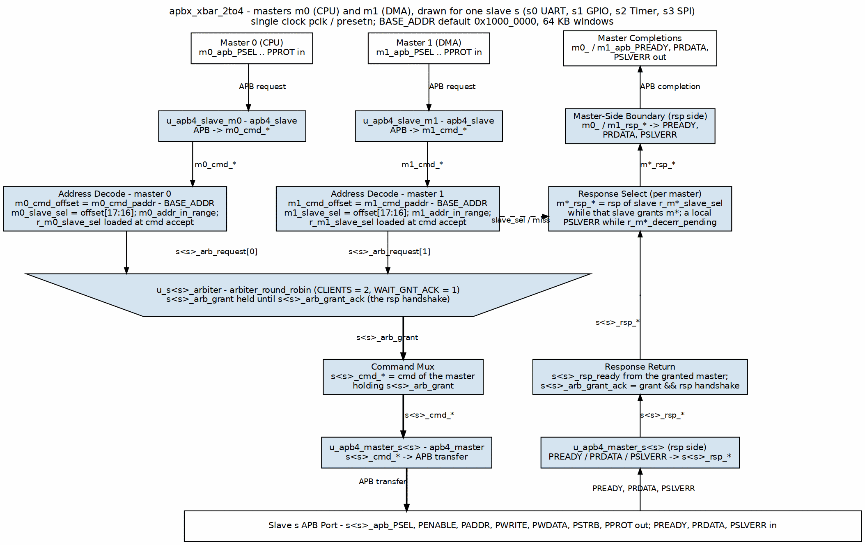 Figure: Lattice top-level architecture showing 2 masters connected to 4 slaves. Source: docs/lattice_mas/assets/graphviz/apbx_xbar_architecture.dot

3.2 Address Mapping
BASE_ADDR + 0x0000_0000 → 0x0000_FFFF : Slave 0 (64KB)
BASE_ADDR + 0x0001_0000 → 0x0001_FFFF : Slave 1 (64KB)
BASE_ADDR + 0x0002_0000 → 0x0002_FFFF : Slave 2 (64KB)
BASE_ADDR + 0x0003_0000 → 0x0003_FFFF : Slave 3 (64KB)
...
BASE_ADDR + 0x000F_0000 → 0x000F_FFFF : Slave 15 (64KB)
Default BASE_ADDR: 0x1000_0000
Address Decode Example:
The crossbar extracts the slave index from the upper bits of the address offset:
slave_index = (address - BASE_ADDR) >> 16 // Divide by 64KB (0x10000)
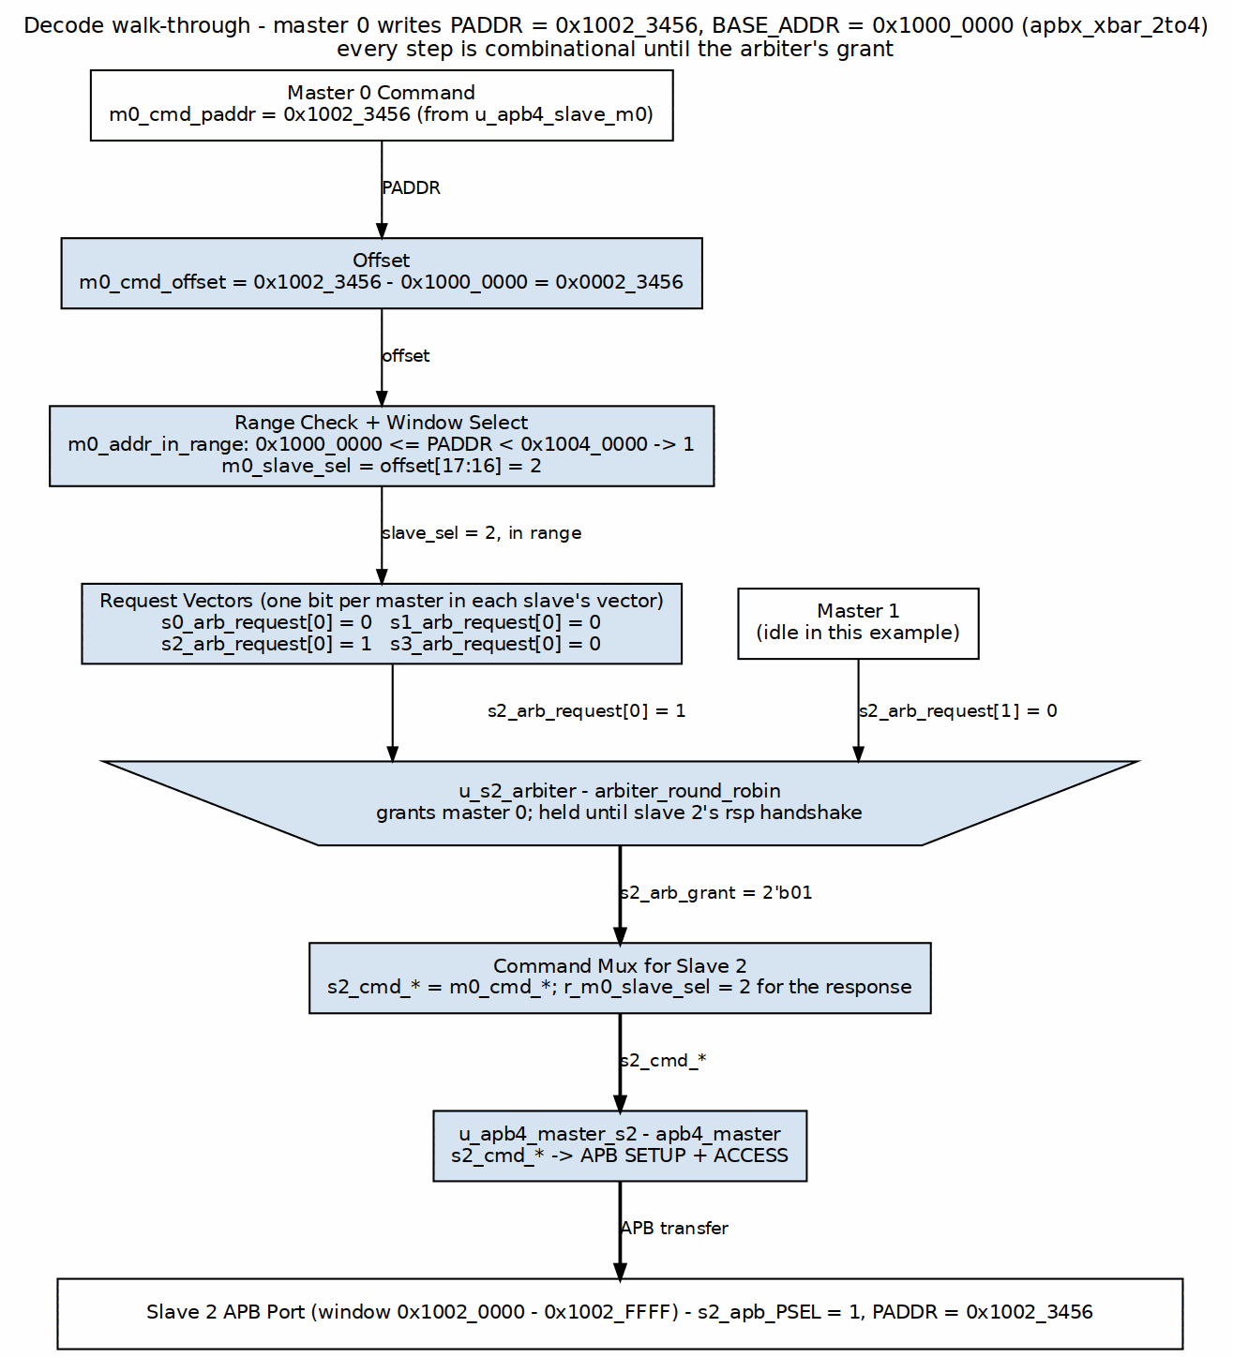 Figure: Address decode flow showing how address 0x10023456 routes to Slave 2. Source: docs/lattice_mas/assets/graphviz/address_decode_flow.dot

3.3 Arbitration Strategy
Per-Slave Round-Robin: - Each slave has independent arbiter - Master priority rotates after each grant - Grant held from command acceptance through response completion - No master can starve another master
Example:
Slave 0 accessed by M0, M1, M0 → Next grant goes to M1
Slave 1 accessed by M1, M1, M0 → Next grant goes to M1
(the winner cannot immediately re-win: after an M0 grant the
mask leaves only M1 eligible)
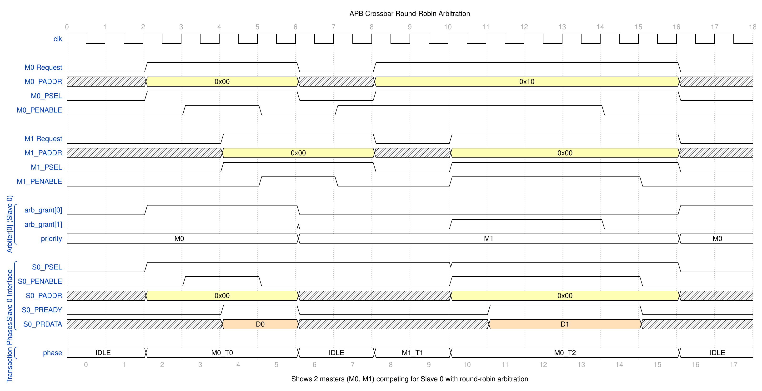 Figure: Round-robin arbitration timing showing 2 masters competing for Slave 0. Master priority rotates after each grant to ensure fair access. Source: docs/lattice_mas/assets/wavedrom/arbitration_round_robin.json

4. Available Variants

4.1 Pre-Generated Modules
Module | Masters | Slaves | Use Case
apbx_xbar_1to1 | 1 | 1 | Protocol conversion, testing
apbx_xbar_2to1 | 2 | 1 | Multi-master arbitration
apbx_xbar_1to4 | 1 | 4 | Address decode, simple SoC
apbx_xbar_2to4 | 2 | 4 | Full crossbar, typical SoC
apbx_xbar_2to2_mixed | 2 | 2 | Mixed APB4/APB5 (s0 is APB5)
LOC figures live in HAS ch05_performance/03_resources.md, which is the single source of truth for them. A duplicate column here disagreed with that table by up to 33%.

4.2 Wrapper Modules
These are TESTBENCH SCAFFOLDS, not integration building blocks. Each exposes pclk and presetn and nothing else — every APB signal is an internal net driven by the cocotb testbench. They exist because the four legacy tests drive a wrapper rather than the bare crossbar; a design cannot connect anything to one.
Wrapper | Configuration | Purpose
apbx_xbar_1to1_wrap | 1×1 | Test scaffold for test_apbx_xbar_1to1.py
apbx_xbar_2to1_wrap | 2×1 | Test scaffold for test_apbx_xbar_2to1.py
apbx_xbar_1to4_wrap | 1×4 | Test scaffold for test_apbx_xbar_1to4.py
apbx_xbar_2to4_wrap | 2×4 | Test scaffold for test_apbx_xbar_2to4.py
To integrate, instantiate the crossbar itself. apbx_xbar_2to2_mixed has no wrapper precisely because its test drives the DUT directly, which is the better pattern.

5. Functional Requirements

FR-1: Arbitrary MxN Configuration
Priority: P0 (Critical) Status: Implemented and verified
Description: Generate crossbar for any M masters and N slaves (up to 16x16)
Verification: Generator creates valid RTL for all tested configurations

FR-2: Round-Robin Arbitration
Priority: P0 (Critical) Status: Implemented and verified
Description: Fair per-slave arbitration with rotating master priority
Verification: Arbitration stress tests (130+ transactions for 2to1)

FR-3: Address-Based Routing
Priority: P0 (Critical) Status: Implemented and verified
Description: Automatic slave selection based on address ranges
Verification: Address decode validation (200+ transactions for 1to4)

FR-4: Back-to-Back Transactions
Priority: P1 (High) Status: Implemented and verified
Description: Consecutive transactions are accepted with no master-side idle cycles required. They do NOT overlap inside the fabric — apb4_slave is one-command-at-a-time. Sustained cadence is 10 pclk cycles PREADY-to-PREADY for a single-master variant and 11 for an arbitrated one, in each case one more than that variant’s SETUP-to-PREADY latency of 9 or 10 (HAS 5.1/5.2).
Verification: Performance tests show consecutive transactions

FR-5: Configurable Address Map
Priority: P1 (High) Status: Implemented and verified
Description: BASE_ADDR parameter sets base of address map
Verification: Tests with multiple BASE_ADDR values

6. Interface Specifications

6.1 Master-Side Interface (APB Slave)
Per-master APB slave interface:
input logic m<i>_apb_PSEL
input logic m<i>_apb_PENABLE
input logic [ADDR_WIDTH-1:0] m<i>_apb_PADDR
input logic m<i>_apb_PWRITE
input logic [DATA_WIDTH-1:0] m<i>_apb_PWDATA
input logic [STRB_WIDTH-1:0] m<i>_apb_PSTRB
input logic [2:0] m<i>_apb_PPROT
output logic [DATA_WIDTH-1:0] m<i>_apb_PRDATA
output logic m<i>_apb_PSLVERR
output logic m<i>_apb_PREADY

6.2 Slave-Side Interface (APB Master)
Per-slave APB master interface:
output logic s<j>_apb_PSEL
output logic s<j>_apb_PENABLE
output logic [ADDR_WIDTH-1:0] s<j>_apb_PADDR
output logic s<j>_apb_PWRITE
output logic [DATA_WIDTH-1:0] s<j>_apb_PWDATA
output logic [STRB_WIDTH-1:0] s<j>_apb_PSTRB
output logic [2:0] s<j>_apb_PPROT
input logic [DATA_WIDTH-1:0] s<j>_apb_PRDATA
input logic s<j>_apb_PSLVERR
input logic s<j>_apb_PREADY

7. Parameter Configuration
Parameter | Type | Default | Range | Description
ADDR_WIDTH | int | 32 | 18-64 for multi-slave variants (the decode part-select needs bit 17); 1-64 for 1to1/2to1 | Address bus width
DATA_WIDTH | int | 32 | 8,16,32,64 | Data bus width
STRB_WIDTH | int | DATA_WIDTH/8 | - | Strobe width (auto-calc)
BASE_ADDR | logic [ADDR_WIDTH-1:0] | 0x10000000 | Any except the top S x 64KB, where BASE_ADDR + span wraps and the range check can never pass | Base address for slave map. Inert on 1to1/2to1 (no decode)

8. Generator Usage

8.1 Pre-Generated Variants
Use existing modules directly:
# Available in projects/components/fabric-gen-ip/lattice-apbx-xbar/rtl/
apbx_xbar_1to1.sv
apbx_xbar_2to1.sv
apbx_xbar_1to4.sv
apbx_xbar_2to4.sv
apbx_xbar_2to2_mixed.sv

8.2 Custom Generation
Generate custom MxN crossbar:
cd projects/components/fabric-gen-ip/lattice-apbx-xbar/bin/
python generate_xbars.py --masters 3 --slaves 6
python generate_xbars.py --masters 4 --slaves 8 --base-addr 0x80000000

8.3 Generator Options
python generate_xbars.py --help
Options:
--masters M Number of masters (1-16)
--slaves N Number of slaves (1-16)
--base-addr ADDR Base address (default: 0x10000000)

9. Performance Characteristics

9.1 Latency
Path | M = 1 | M > 1 | Notes
Command path | 6 | 7 | master SETUP (1) + forward path (5, or 6 with a registered arbiter grant)
Response path | 3 | 3 | arbitration is on the command side only
Total | 9 | 10 | SETUP->PREADY, uncontended, zero-wait slave (8 / 9 ACCESS->PREADY)
M = 1 is 1to1 and 1to4, which the generator emits with no arbiter at all. M > 1 is 2to1, 2to4 and 2to2_mixed — including the 2x4 this document calls the typical SoC case. This table gave only the M = 1 figures, unlabelled, until 2026-08-30.
APB’s 2-cycle minimum applies to a directly-attached slave, not through this fabric: the crossbar converts APB→cmd/rsp→APB across registered skid buffers in both directions. See HAS 5.2 for the cycle-by-cycle breakdown and the measurement.

9.2 Throughput
- Back-to-back transactions: Supported, but not overlapped — apb4_slave is a one-command-at-a-time FSM, so the next command is captured only after the previous transaction completes
- Maximum rate: ~1 transaction per 10 pclk cycles (1to1, 1to4) or 11 (2to1, 2to4, 2to2_mixed) per master (measured back-to-back at an always-ready slave)

9.3 Resource Utilization (Estimated)
See HAS ch05_performance/03_resources.md — that table is the single source of truth. An earlier duplicate here quoted figures 2-3x smaller in every cell; both were unsourced hand estimates, so the duplicate is withdrawn rather than reconciled.

10. Verification Status

10.1 Test Coverage
Test | Transactions | Status | Coverage
test_apbx_xbar_1to1 | 100+ | Pass | Basic connectivity
test_apbx_xbar_2to1 | 130+ | Pass | Arbitration stress
test_apbx_xbar_1to4 | 200+ | Pass | Address decode
test_apbx_xbar_2to4 | 350+ | Pass | Full crossbar stress
test_apbx_xbar_2to2_mixed | 8 directed | Pass | All four APB4/APB5 pairings, sideband gating, decode miss, structural pin check
test_apbx_xbar_timing | 2 variants | Pass | Published latency/cadence figures, both variant classes
Overall: 100% passing (9/9), >750 transactions plus the directed mixed-version and timing checks. 2to2_mixed also has a formal harness (formal/apbx_xbar/apbx_xbar_2to2_mixed/).

10.2 Test Methodology
Test Structure: - CocoTB framework - Random transaction generation - Variable delay profiles - Address range validation - Arbitration fairness checks
Verification Points: - Correct address routing - Round-robin arbitration - Response integrity - Back-to-back transactions - Error propagation

11. Integration Guide

11.1 Simple Integration (1to4)
apbx_xbar_1to4 #(
.ADDR_WIDTH(32),
.DATA_WIDTH(32),
.BASE_ADDR(32'h1000_0000)
) u_xbar (
.pclk(apb_clk),
.presetn(apb_rst_n),
// Master interface
.m0_apb_PSEL(cpu_psel),
.m0_apb_PENABLE(cpu_penable),
.m0_apb_PADDR(cpu_paddr),
.m0_apb_PWRITE(cpu_pwrite),
.m0_apb_PWDATA(cpu_pwdata),
.m0_apb_PSTRB(cpu_pstrb),
.m0_apb_PPROT(cpu_pprot),
.m0_apb_PRDATA(cpu_prdata),
.m0_apb_PSLVERR(cpu_pslverr),
.m0_apb_PREADY(cpu_pready),
// Slave 0: UART (0x1000_0000 - 0x1000_FFFF)
.s0_apb_PSEL(uart_psel),
.s0_apb_PENABLE(uart_penable),
// ... (similar connections)
// Slave 1: GPIO (0x1001_0000 - 0x1001_FFFF)
.s1_apb_PSEL(gpio_psel),
// ... (similar connections)
// Slave 2: Timer (0x1002_0000 - 0x1002_FFFF)
// Slave 3: SPI (0x1003_0000 - 0x1003_FFFF)
);

11.2 Multi-Master Integration (2to4)
apbx_xbar_2to4 #(
.ADDR_WIDTH(32),
.DATA_WIDTH(32),
.BASE_ADDR(32'h1000_0000)
) u_xbar (
.pclk(apb_clk),
.presetn(apb_rst_n),
// Master 0: CPU
.m0_apb_PSEL(cpu_psel),
// ... (full interface)
// Master 1: DMA
.m1_apb_PSEL(dma_psel),
// ... (full interface)
// Slaves 0-3: Peripherals
// ... (slave connections)
);

12. Design Constraints

12.1 Limitations
Constraint | Value | Rationale
Max masters | 16 | Generator limit (configurable)
Max slaves | 16 | Generator limit (configurable)
Slave region size | 64KB in every shipped variant | Baked in at generation (--slave-size, default 4KB); not overridable at elaboration
No slave disable | N/A | All slaves always active
No timeout | N/A | Assumes slaves always respond

12.2 Assumptions
- Slave responses: All slaves respond eventually (no timeout handling)
- Address ranges: Slaves occupy 64KB regions starting at BASE_ADDR
- APB compliance: All masters and slaves follow APB protocol
- Single clock domain: All signals synchronous to pclk

13. Future Enhancements

13.1 Potential Features
- Configurable slave region sizes: Not just 64KB
- Slave enable/disable: Dynamic slave activation
- Timeout detection: Watchdog for hung slaves
- Transaction ordering: Optional in-order completion
- Priority arbitration: Weighted instead of round-robin

13.2 Generator Improvements
- HDL output formats: Support Verilog, VHDL, Chisel
- Automated testing: Generate tests alongside RTL
- Documentation generation: Auto-generate integration guides
- Synthesis scripts: Generate vendor-specific scripts

14. References

14.1 Internal Documentation
- README.md - Quick start guide
- CLAUDE.md - AI assistant guidelines
- bin/generate_xbars.py - Generator script
- dv/tests/ - Test implementations

14.2 External Standards
- AMBA APB Protocol v2.0 - ARM IHI 0024C
- APB4 Extensions - AMBA 5 specification

14.3 Related Components
- rtl/amba/apb4/apb4_slave.sv - Master-side building block
- rtl/amba/apb4/apb4_master.sv - Slave-side building block
- projects/components/fabric-gen-ip/lattice-apbx-xbar/bin/apbx_xbar_generator.py - Main generator

Document Version: 1.0 Last Review: 2025-10-19 Next Review: 2026-01-01 Maintained By: RTL Design Sherpa Project

RTL Design Sherpa · Learning Hardware Design Through Practice GitHub · Documentation Index · MIT License

Claude Code Guide: Lattice Component
Version: 1.0 Last Updated: 2025-10-19 Purpose: AI-specific guidance for working with Lattice component
Codename: lattice · Directory: lattice-apbx-xbar (fabric-gen-ip family with bridge and delta); RTL modules keep the apbx_xbar_* prefix

Quick Context
What: Lattice Generator - Parametric APB interconnect for connecting M masters to N slaves Status: Production Ready (all tests passing) Your Role: Help users generate, integrate, and customize APB crossbars
Complete Specification: projects/components/fabric-gen-ip/lattice-apbx-xbar/PRD.md ← Always reference this for technical details

Critical Rules for This Component

Rule #0: This is a GENERATOR, Not Just Modules
IMPORTANT: Lattice is both: 1. Pre-generated modules (1to1, 2to1, 1to4, 2to4, 2to2_mixed) in rtl/ 2. Python generator (bin/generate_xbars.py) for custom configurations
When users ask for crossbar: - Check if pre-generated variant exists first - Only suggest generation if custom size needed
Decision Tree:
User needs crossbar?
├─ 1x1, 2x1, 1x4, 2x4? → Use pre-generated module
├─ Mixed APB4/APB5 2x2? → Use apbx_xbar_2to2_mixed
└─ Custom MxN? → Run generator script

Rule #1: Address Map is Fixed Per-Slave
Each slave occupies 64KB region:
Slave 0: BASE_ADDR + 0x0000_0000 → 0x0000_FFFF
Slave 1: BASE_ADDR + 0x0001_0000 → 0x0001_FFFF
Slave 2: BASE_ADDR + 0x0002_0000 → 0x0002_FFFF
...
The window size is not a module parameter, but it IS a generator option. Every shipped variant uses 64KB windows because bin/generate_xbars.py passes slave_size=0x10000. The generator’s own default is 4KB, and apbx_xbar_generator.py --slave-size accepts any power of 2 >= 256 bytes. Once generated the size is baked into the decode part-select, so it cannot be overridden at elaboration — only BASE_ADDR can, and only on the decoding variants.
If user asks for different sizes:
WRONG: "Let me modify the generator to support custom sizes per slave"
CORRECT: "The shipped variants use 64KB per slave. You can:
1. Use BASE_ADDR to shift the whole map (decoding variants only)
2. For a different window, regenerate with --slave-size (power of 2, >= 256B)
3. Or use multiple crossbars with different BASE_ADDR values"

Rule #2: Know the Pre-Generated Variants
Available in rtl/ directory:
Module | M×N | Use Case | When to Recommend
apbx_xbar_1to1 | 1×1 | Passthrough | Protocol conversion, testing
apbx_xbar_2to1 | 2×1 | Arbitration | Multi-master to single peripheral
apbx_xbar_1to4 | 1×4 | Decode | Single CPU to multiple peripherals
apbx_xbar_2to4 | 2×4 | Full crossbar | CPU + DMA to peripherals
apbx_xbar_2to2_mixed | 2×2 | Mixed APB4/APB5 | APB5 peripheral alongside APB4
Always suggest pre-generated first!

Rule #3: Generator Syntax
Generate custom crossbar:
cd projects/components/fabric-gen-ip/lattice-apbx-xbar/bin/
python generate_xbars.py --masters 3 --slaves 6
Options:
--masters M Number of masters (1-16)
--slaves N Number of slaves (1-16)
--base-addr ADDR Base address (default: 0x10000000)
Example:
# Generate 3x8 crossbar with custom base
python generate_xbars.py --masters 3 --slaves 8 --base-addr 0x80000000
# Generate a 5x5 variant
python generate_xbars.py --masters 5 --slaves 5

Architecture Quick Reference

Module Organization
projects/components/fabric-gen-ip/lattice-apbx-xbar/
├── rtl/
│ ├── apbx_xbar_1to1.sv Core crossbar modules
│ ├── apbx_xbar_2to1.sv
│ ├── apbx_xbar_1to4.sv
│ ├── apbx_xbar_2to4.sv
│ ├── apbx_xbar_2to2_mixed.sv (m0=APB4, m1=APB5, s0=APB5, s1=APB4)
│ └── wrappers/ testbench scaffolds, not integration wrappers
│ ├── apbx_xbar_1to1_wrap.sv
│ ├── apbx_xbar_2to1_wrap.sv
│ ├── apbx_xbar_1to4_wrap.sv
│ └── apbx_xbar_2to4_wrap.sv
├── bin/
│ └── generate_xbars.py Generator script
├── dv/
│ └── tests/
│ ├── test_apbx_xbar_1to1.py
│ ├── test_apbx_xbar_2to1.py
│ ├── test_apbx_xbar_1to4.py
│ ├── test_apbx_xbar_2to4.py
│ ├── test_apbx_xbar_2to2_mixed.py
│ ├── test_apbx_xbar_timing.py published latency/cadence figures
│ ├── test_apbx_xbar_parity.py generates a parity-on all-APB5 2x2 (APB5 *CHK, PWAKEUP)
│ └── GTKW/ Waveform configs
├── PRD.md Complete specification
├── CLAUDE.md This file
└── README.md Quick start guide

Block Diagram (2×4 Example)
Master 0 Master 1
│ │
▼ ▼
┌─────────────────────┐
│ APB Slaves (M-side) │
└──────────┬────────────┘
│
┌──────────┴────────────┐
│ Address Decode │
│ + Arbitration │
│ + Response Routing │
└──────────┬────────────┘
│
┌──────────┴────────────┐
│ APB Masters (S-side) │
└──────┬────────┬───────┘
│ │ (more)
Slave 0 Slave 1 ... Slave 3

Common User Questions and Responses

Q: “How do I connect a CPU to 4 peripherals?”
A: Use the pre-generated 1to4 crossbar:
apbx_xbar_1to4 #(
.ADDR_WIDTH(32),
.DATA_WIDTH(32),
.BASE_ADDR(32'h1000_0000) // Start of peripheral space
) u_peripheral_xbar (
.pclk(apb_clk),
.presetn(apb_rst_n),
// CPU connection (master 0)
.m0_apb_PSEL(cpu_psel),
.m0_apb_PENABLE(cpu_penable),
.m0_apb_PADDR(cpu_paddr),
.m0_apb_PWRITE(cpu_pwrite),
.m0_apb_PWDATA(cpu_pwdata),
.m0_apb_PSTRB(cpu_pstrb),
.m0_apb_PPROT(cpu_pprot),
.m0_apb_PRDATA(cpu_prdata),
.m0_apb_PSLVERR(cpu_pslverr),
.m0_apb_PREADY(cpu_pready),
// Peripheral 0: UART @ 0x1000_0000
.s0_apb_PSEL(uart_psel),
.s0_apb_PENABLE(uart_penable),
// ... (full interface)
// Peripheral 1: GPIO @ 0x1001_0000
// Peripheral 2: Timer @ 0x1002_0000
// Peripheral 3: SPI @ 0x1003_0000
);
Address map: - UART: 0x1000_0000 - 0x1000_FFFF - GPIO: 0x1001_0000 - 0x1001_FFFF - Timer: 0x1002_0000 - 0x1002_FFFF - SPI: 0x1003_0000 - 0x1003_FFFF
See: PRD.md Section 11.1

Q: “I need CPU and DMA to access peripherals. Which crossbar?”
A: Use the 2to4 crossbar:
apbx_xbar_2to4 #(
.ADDR_WIDTH(32),
.DATA_WIDTH(32),
.BASE_ADDR(32'h1000_0000)
) u_soc_xbar (
.pclk(apb_clk),
.presetn(apb_rst_n),
// Master 0: CPU
.m0_apb_PSEL(cpu_psel),
// ... (full interface)
// Master 1: DMA
.m1_apb_PSEL(dma_psel),
// ... (full interface)
// Slaves 0-3: Peripherals
// ... (slave connections)
);
Key feature: Round-robin arbitration per slave ensures fair access between CPU and DMA.
See: PRD.md Section 11.2

Q: “What if I need 3 masters and 8 slaves?”
A: Generate custom crossbar:
cd projects/components/fabric-gen-ip/lattice-apbx-xbar/bin/
python generate_xbars.py --masters 3 --slaves 8 # writes apbx_xbar_3to8.sv next to the script
# Check generated file, then move it into rtl/
ls -lh apbx_xbar_3to8.sv
mv apbx_xbar_3to8.sv ../rtl/
Then instantiate like any other crossbar:
apbx_xbar_3to8 #(
.ADDR_WIDTH(32),
.DATA_WIDTH(32),
.BASE_ADDR(32'h1000_0000)
) u_custom_xbar (
// ... connections for 3 masters and 8 slaves
);
See: PRD.md Section 8

Q: “How does arbitration work?”
A: Per-slave round-robin:
Each slave has its own arbiter that rotates master priority:
Example with 2 masters accessing Slave 0:
Transaction 1: M0 requests → M0 granted
Transaction 2: M0 and M1 request → M1 granted (rotated)
Transaction 3: M1 requests → M1 granted
Transaction 4: M0 and M1 request → M0 granted (rotated)
Key points: - Independent per slave: Each slave arbitrates independently - Fair: No master can starve another - Grant persistence: Once granted, master holds slave until response completes - Back-to-back: supported, but not overlapped — 10 pclk cycles per transfer for 1to1/1to4, 11 for the arbitrated variants (2to1, 2to4, 2to2_mixed), PREADY-to-PREADY (see HAS 5.1/5.2)
See: PRD.md Section 3.3

Q: “Can I change the address map?”
A: BASE_ADDR parameter shifts entire map, but per-slave size is fixed:
// Default: 0x1000_0000
apbx_xbar_1to4 #(.BASE_ADDR(32'h1000_0000)) u_xbar1 (...);
// Slaves at: 0x1000_0000, 0x1001_0000, 0x1002_0000, 0x1003_0000
// Shifted: 0x8000_0000
apbx_xbar_1to4 #(.BASE_ADDR(32'h8000_0000)) u_xbar2 (...);
// Slaves at: 0x8000_0000, 0x8001_0000, 0x8002_0000, 0x8003_0000
Limitation: Each slave always occupies 64KB (0x10000 bytes)
Workaround for different sizes: 1. Use multiple crossbars with different BASE_ADDR 2. Modify generator’s addr_offset calculation 3. Use address masking in slaves
See: PRD.md Section 3.2

Q: “How do I run tests?”
A: Use the area Makefile (never bare pytest):
cd projects/components/fabric-gen-ip/lattice-apbx-xbar/dv/tests/
# Run specific test
make run-apbx_xbar_1to4-gate
# Run all tests -- clean-all first for a run you intend to trust
make clean-all && make run-all-gate
# Run with waveforms (WAVES=1 via the target, not --vcd)
make run-apbx_xbar_2to4-gate-waves
# create_view_cmd() writes the gtkwave command beside the log
Test coverage: - test_apbx_xbar_1to1: 100+ transactions (passthrough) - test_apbx_xbar_2to1: 130+ transactions (arbitration) - test_apbx_xbar_1to4: 200+ transactions (address decode) - test_apbx_xbar_2to4: 350+ transactions (full stress) - test_apbx_xbar_2to2_mixed: 8 directed — all four APB4/APB5 pairings, sideband gating, decode miss, structural pin check; plus _pwakeup: PWAKEUP forwarded requester -> completer (IHI 0024E 3.7.2) - test_apbx_xbar_parity: no shipped variant enables parity, so this generates one into its sim_build and checks odd *CHK parity (IHI 0024E ch. 5), error injection, and PWAKEUP forwarding - test_apbx_xbar_timing: both variant classes — asserts the published latency, cadence and per-path breakdown so the numbers cannot drift
All tests passing (22/22 at func, 2026-10-12) — and 2to2_mixed additionally has a formal harness at formal/apbx_xbar/apbx_xbar_2to2_mixed/.
See: PRD.md Section 10

Integration Patterns

Pattern 1: Simple Peripheral Interconnect
// CPU to 4 peripherals
apbx_xbar_1to4 #(
.ADDR_WIDTH(32),
.DATA_WIDTH(32),
.BASE_ADDR(32'h1000_0000)
) u_periph_xbar (
.pclk(sys_clk),
.presetn(sys_rst_n),
// CPU side
.m0_apb_PSEL(cpu_apb_psel),
.m0_apb_PENABLE(cpu_apb_penable),
.m0_apb_PADDR(cpu_apb_paddr),
.m0_apb_PWRITE(cpu_apb_pwrite),
.m0_apb_PWDATA(cpu_apb_pwdata),
.m0_apb_PSTRB(cpu_apb_pstrb),
.m0_apb_PPROT(cpu_apb_pprot),
.m0_apb_PRDATA(cpu_apb_prdata),
.m0_apb_PSLVERR(cpu_apb_pslverr),
.m0_apb_PREADY(cpu_apb_pready),
// Peripherals
.s0_apb_PSEL(uart_psel), /* ... full interface ... */
.s1_apb_PSEL(gpio_psel), /* ... */
.s2_apb_PSEL(timer_psel), /* ... */
.s3_apb_PSEL(spi_psel) /* ... */
);

Pattern 2: Multi-Master System
// CPU + DMA to peripherals
apbx_xbar_2to4 #(
.ADDR_WIDTH(32),
.DATA_WIDTH(32),
.BASE_ADDR(32'h4000_0000)
) u_soc_xbar (
.pclk(apb_clk),
.presetn(apb_rst_n),
// Master 0: CPU
.m0_apb_PSEL(cpu_psel),
/* ... full CPU interface ... */
// Master 1: DMA Controller
.m1_apb_PSEL(dma_psel),
/* ... full DMA interface ... */
// Slave 0-3: Memory-mapped peripherals
.s0_apb_PSEL(mem_ctrl_psel), /* ... */
.s1_apb_PSEL(uart_psel), /* ... */
.s2_apb_PSEL(i2c_psel), /* ... */
.s3_apb_PSEL(adc_psel) /* ... */
);

Pattern 3: Hierarchical Interconnect
// Top-level crossbar
apbx_xbar_1to4 u_top_xbar (
// .m0_apb_PSEL(cpu_apb_PSEL), .m0_apb_PENABLE(...), ... (elided)
.s0_apb_PSEL(periph_bus0_PSEL), /* ...rest of the port... */ // To sub-crossbar 0
.s1_apb_PSEL(periph_bus1_PSEL), /* ...rest of the port... */ // To sub-crossbar 1
.s2_apb_PSEL(mem_ctrl_PSEL), /* ...rest of the port... */ // Direct to memory controller
.s3_apb_PSEL(dma_ctrl_PSEL), /* ...rest of the port... */ // Direct to DMA
);
// Sub-crossbar 0 for low-speed peripherals
apbx_xbar_1to4 u_periph_xbar0 (
.m0_apb_PSEL(periph_bus0_PSEL), /* ...rest of the port... */
.s0_apb_PSEL(uart0_PSEL), /* ...rest of the port... */
.s1_apb_PSEL(gpio0_PSEL), /* ...rest of the port... */
.s2_apb_PSEL(i2c0_PSEL), /* ...rest of the port... */
.s3_apb_PSEL(spi0_PSEL), /* ...rest of the port... */
);
// Sub-crossbar 1 for high-speed peripherals
apbx_xbar_1to4 u_periph_xbar1 (
.m0_apb_PSEL(periph_bus1_PSEL), /* ...rest of the port... */
.s0_apb_PSEL(uart1_PSEL), /* ...rest of the port... */
.s1_apb_PSEL(timer_PSEL), /* ...rest of the port... */
.s2_apb_PSEL(pwm_PSEL), /* ...rest of the port... */
.s3_apb_PSEL(adc_PSEL), /* ...rest of the port... */
);

Anti-Patterns to Catch

Anti-Pattern 1: Generating When Pre-Generated Exists
WRONG:
User: "I need a 2×4 crossbar"
You: "Let me generate that for you..."
python generate_xbars.py --masters 2 --slaves 4
CORRECTED:
"Use the pre-generated apbx_xbar_2to4.sv in the rtl/ directory.
No generation needed!"

Anti-Pattern 2: Assuming Custom Per-Slave Sizes
WRONG:
User: "Can I make slave 0 256KB and slave 1 4KB?"
You: "Sure, let me modify the parameters..."
CORRECTED:
"The shipped variants use 64KB per slave. For a different window:
1. Regenerate with --slave-size (power of 2, >= 256B)
2. Or use multiple crossbars with different BASE_ADDR
3. Or implement address masking in slaves"

Anti-Pattern 3: Not Mentioning Address Map
WRONG:
User: "How do I integrate the crossbar?"
You: *Shows port connections only*
CORRECTED:
"Here's the integration with address map:
apbx_xbar_1to4 #(.BASE_ADDR(32'h1000_0000)) u_xbar (...);
Address map:
- Slave 0: 0x1000_0000 - 0x1000_FFFF
- Slave 1: 0x1001_0000 - 0x1001_FFFF
- Slave 2: 0x1002_0000 - 0x1002_FFFF
- Slave 3: 0x1003_0000 - 0x1003_FFFF"

Anti-Pattern 4: Forgetting About Wrappers
WRONG:
User: "I need a quick 10×10 crossbar"
You: "Run the generator with --masters 10 --slaves 10"
CORRECTED:
"We have pre-configured wrappers in rtl/wrappers/:
- apbx_xbar_1to1_wrap.sv, apbx_xbar_2to1_wrap.sv,
apbx_xbar_1to4_wrap.sv, apbx_xbar_2to4_wrap.sv
Those four are TESTBENCH SCAFFOLDS, not integration wrappers: each has only
pclk and presetn, with every APB signal internal to the cocotb bench, so a
design cannot connect to one. Instantiate the crossbar directly. For any
other MxS, generate one with bin/generate_xbars.py -- and there is no
m10_s10 wrapper in the tree."

Debugging Workflow

Issue: Address Not Routing Correctly
Check in order: 1. BASE_ADDR parameter set correctly? 2. Address within slave’s 64KB region? 3. PSEL signal asserted by master? 4. All APB signals properly connected?
Calculate expected slave:
slave_index = (address - BASE_ADDR) >> 16 // Divide by 64KB
Debug commands:
cd dv/tests && make run-apbx_xbar_1to4-gate-waves
# gtkwave command is written beside the log by create_view_cmd()

Issue: Arbitration Not Fair
Symptoms: - One master dominates - Other masters starved
Check: 1. Arbiters instantiated per slave? 2. Round-robin logic correct? 3. Grant persistence working?
Verify with tests:
cd dv/tests && make run-apbx_xbar_2to1-gate # Arbitration stress test

Issue: Back-to-Back Transactions Stalling
Check: 1. Grant persistence enabled? 2. Slaves responding with PREADY? 3. No unintended pipeline bubbles?
View waveforms:
cd dv/tests && make run-apbx_xbar_2to4-gate-waves
# gtkwave command is written beside the log by create_view_cmd()

Quick Commands
# List available crossbars
ls projects/components/fabric-gen-ip/lattice-apbx-xbar/rtl/*.sv
# Generate custom crossbar
cd projects/components/fabric-gen-ip/lattice-apbx-xbar/bin/
python generate_xbars.py --masters 3 --slaves 6
# Run all tests
cd projects/components/fabric-gen-ip/lattice-apbx-xbar/dv/tests
make clean-all && make run-all-gate
# Run specific test with waveforms
make run-apbx_xbar_2to4-gate-waves
# View waveforms: create_view_cmd() writes a ready-made command
# beside the log; no hand-built gtkwave path needed
# Check documentation
cat projects/components/fabric-gen-ip/lattice-apbx-xbar/PRD.md
cat projects/components/fabric-gen-ip/lattice-apbx-xbar/README.md

Remember
- Check pre-generated first - Don’t generate unnecessarily
- Address map matters - Always mention BASE_ADDR + 64KB regions
- Fair arbitration - Round-robin per slave
- Complete connections - All APB signals must be wired
- Tests available - 100% passing, comprehensive coverage
- Wrappers are TEST SCAFFOLDS - rtl/wrappers/ carries only pclk/presetn; instantiate the crossbar directly (see Anti-Pattern 4)
- Generator limits - Up to 16×16 (configurable)

Version: 1.0 Last Updated: 2025-10-19 Maintained By: RTL Design Sherpa Project

