
RTL Design Sherpa
APB GPIO Micro-Architecture Specification 1.0
January 4, 2026

Table of Contents
1 Gpio Mas Index 15
2 APB GPIO - Overview 16
2.1 Overview 16
2.1.1 Features 16
2.1.2 Applications 16
2.1.3 Figure 1.1: APB GPIO Block Diagram 17
2.2 Parameters 17
2.2.1 Register Summary 18
2.3 Navigation 19
3 APB GPIO - Architecture 20
3.1 Overview 20
3.1.1 Figure 1.2: APB GPIO Top-Level Architecture 20
3.1.2 Figure 1.3: APB GPIO Module Hierarchy 20
3.2 Functional Description 21
3.2.1 Data Flow 21
3.2.2 Clock Domains 23
3.3 Parameters 24
3.4 Design Notes 25
3.4.1 Resource Estimates 25
3.5 Navigation 25
4 APB GPIO - Clocks and Reset 26
4.1 Overview 26
4.1.1 Clock Signals 26
4.1.2 Reset Signals 26
4.2 Functional Description 27
4.2.1 Reset Behavior 27
4.2.2 Clock Domain Crossing 27
4.2.3 Input Synchronization 28
4.3 Timing 28
4.3.1 Timing Constraints 28
4.4 Navigation 29
5 APB GPIO - Acronyms and Terminology 30
5.1 Overview 30
5.1.1 Protocol Acronyms 30
5.1.2 Signal Acronyms 30
5.1.3 GPIO-Specific Terms 30
5.1.4 Interrupt Terms 31
5.1.5 Register Terms 31
5.2 Navigation 31
6 APB GPIO - References 32
6.1 References 32
6.1.1 Internal Documentation 32
6.1.2 External References 32
6.1.3 Design References 32
6.2 Navigation 33
7 APB GPIO - Block Descriptions Overview 34
7.1 Overview 34
7.1.1 Figure 2.1: APB GPIO Module Hierarchy 34
7.1.2 Block Summary 34
7.1.3 In This Chapter 34
7.2 Navigation 35
8 APB GPIO - APB Interface Block 36
8.1 Overview 36
8.1.1 Block Diagram 36
8.2 Ports 36
8.2.1 APB Slave Interface 36
8.3 Functional Description 37
8.3.1 Read Transaction 37
8.3.2 Write Transaction 37
8.4 Timing 37
8.4.1 Figure 2.2: APB Access Timing 38
8.5 Design Notes 38
8.6 Navigation 38
9 APB GPIO - Register File Block 39
9.1 Overview 39
9.1.1 Block Diagram 39
9.2 Ports 39
9.2.1 Hardware-to-Software (hw2reg) 39
9.2.2 Software-to-Hardware (reg2hw) 40
9.3 Functional Description 40
9.3.1 Byte Enable Support 40
9.3.2 Access Types 41
9.4 Design Notes 41
9.5 Navigation 41
10 APB GPIO - GPIO Core Block 42
10.1 Overview 42
10.1.1 Block Diagram 42
10.2 Ports 42
10.3 Functional Description 43
10.3.1 Input Path 43
10.3.2 Output Path 43
10.3.3 Direction Control 44
10.4 Design Notes 44
10.5 Navigation 45
11 APB GPIO - Interrupt Controller Block 46
11.1 Overview 46
11.1.1 Figure 2.5: Interrupt Controller Block Diagram 46
11.2 Functional Description 46
11.2.1 Interrupt Modes 46
11.2.2 Edge Detection Logic 48
11.2.3 Interrupt Status 48
11.2.4 Interrupt Enable 48
11.2.5 Aggregate IRQ Output 49
11.2.6 Interrupt Handling Flow 49
11.3 Design Notes 49
11.4 Navigation 49
12 APB GPIO - CDC Logic Block 51
12.1 Overview 51
12.1.1 Figure 2.7: CDC Logic Block Diagram 51
12.2 Parameters 52
12.2.1 CDC_ENABLE 52
12.3 Functional Description 52
12.3.1 Clock Domains 52
12.3.2 CDC Implementation 53
12.3.3 The irq Output 53
12.3.4 Coherency 54
12.3.5 Reset Synchronization 54
12.4 Timing 54
12.4.1 Latency 54
12.5 Navigation 54
13 APB GPIO - Interfaces Overview 56
13.1 Overview 56
13.1.1 Interface Summary Diagram 56
13.1.2 In This Chapter 57
13.2 Navigation 57
14 APB GPIO - APB Slave Interface 58
14.1 Ports 58
14.1.1 APB Slave Signals 58
14.2 Functional Description 58
14.2.1 Protocol Compliance 58
14.2.2 Address Decoding 59
14.2.3 Byte Strobes 60
14.2.4 Error Handling 60
14.3 Timing 60
14.3.1 Access Timing 60
14.3.2 Figure 3.1: APB Access Timing (CDC_ENABLE=0) 60
14.4 Navigation 61
15 APB GPIO - GPIO Pin Interface 62
15.1 Ports 62
15.1.1 GPIO Signals 62
15.2 Functional Description 62
15.2.1 Output Mode (direction[i] = 1) 62
15.2.2 Input Mode (direction[i] = 0) 63
15.2.3 Input Synchronization 63
15.2.4 Electrical Considerations 64
15.3 Timing 64
15.3.1 Output Path 64
15.3.2 Input Path 64
15.4 Navigation 64
16 APB GPIO - Interrupt Interface 65
16.1 Ports 65
16.2 Functional Description 65
16.2.1 Interrupt Generation 65
16.2.2 Per-Pin Configuration 65
16.2.3 Interrupt Modes 65
16.2.4 Interrupt Handling 67
16.3 Timing 68
16.3.1 Edge-Triggered Latency 68
16.3.2 Level-Sensitive Latency 69
16.4 Design Notes 69
16.4.1 Connection Guidelines 69
16.5 Navigation 70
17 APB GPIO - System Interface 71
17.1 Ports 71
17.1.1 pclk - APB Clock 71
17.1.2 gpio_clk - GPIO Clock 71
17.1.3 presetn - APB Reset 71
17.1.4 gpio_rstn - GPIO Reset 71
17.2 Functional Description 72
17.2.1 Clock Configurations 72
17.2.2 Reset Sequence 73
17.2.3 Figure 3.2: Power-On Reset Sequence 74
17.3 Timing 74
17.3.1 Clock Relationship 74
17.3.2 Reset Recovery 74
17.4 Navigation 74
18 APB GPIO - Programming Model Overview 76
18.1 Overview 76
18.1.1 In This Chapter 77
18.2 Navigation 77
19 APB GPIO - Basic Operations 78
19.1 Waveforms 78
19.1.1 Direction Configuration 78
19.1.2 Output Write 78
19.1.3 Input Read 79
19.1.4 Input Synchronization 80
19.1.5 Atomic Operations 81
19.2 Usage Example 82
19.2.1 Initialization 82
19.2.2 Output Operations 82
19.2.3 Input Operations 83
19.2.4 Mixed I/O Configuration 83
19.2.5 Output Enable Behavior 83
19.3 Navigation 84
20 APB GPIO - Interrupt Configuration 85
20.1 Waveforms 85
20.1.1 Rising Edge Interrupt 85
20.1.2 Falling Edge Interrupt 85
20.1.3 Level-Sensitive Interrupt 86
20.1.4 Interrupt Clear (W1C) 86
20.2 Functional Description 87
20.2.1 Interrupt Configuration Table 87
20.3 Usage Example 88
20.3.1 Interrupt Setup 88
20.3.2 Complete Setup Examples 88
20.3.3 Interrupt Handling 89
20.3.4 Level-Sensitive Considerations 90
20.4 Navigation 90
21 APB GPIO - Programming Examples 91
21.1 Usage Example 91
21.1.1 LED Control 91
21.1.2 Button Input 92
21.1.3 DIP Switch Reading 93
21.1.4 Parallel Data Interface 93
21.1.5 PWM-Style Output 94
21.1.6 Wake-On-Change 94
21.2 Navigation 95
22 APB GPIO - Software Considerations 96
22.1 Design Notes 96
22.1.1 Performance 96
22.1.2 Synchronization 97
22.1.3 Interrupt Best Practices 97
22.1.4 Error Handling 98
22.1.5 Debug Tips 98
22.2 Navigation 99
23 APB GPIO - Register Map 100
23.1 Overview 100
23.2 GPIO_CONTROL (0x000) 101
23.3 GPIO_DIRECTION (0x004) 102
23.4 GPIO_OUTPUT (0x008) 102
23.5 GPIO_INPUT (0x00C) 102
23.6 GPIO_INT_ENABLE (0x010) 103
23.7 GPIO_INT_TYPE (0x014) 103
23.8 GPIO_INT_POLARITY (0x018) 103
23.9 GPIO_INT_BOTH (0x01C) 104
23.10 GPIO_INT_STATUS (0x020) 104
23.11 GPIO_RAW_INT (0x024) 105
23.12 GPIO_OUTPUT_SET (0x028) 105
23.13 GPIO_OUTPUT_CLR (0x02C) 105
23.14 GPIO_OUTPUT_TGL (0x030) 106
23.15 Design Notes 106
23.15.1 Atomic-Register Write Semantics (SET/CLR/TGL) 106
23.15.2 Address Calculation 107
23.16 Navigation 107

List of Figures
Figure 1.1: APB GPIO Block Diagram 17
Figure 1.2: APB GPIO Top-Level Architecture 20
Figure 1.3: APB GPIO Module Hierarchy 20
Figure 1.4: Write Transaction Flow 21
Figure 1.5: Read Transaction Flow 22
Figure 1.6: Interrupt Flow 22
Figure 1.7: Synchronous Mode Clock Domains 23
Figure 1.8: Asynchronous Mode Clock Domains 24
Figure 2.1: APB GPIO Module Hierarchy 34
Figure 2.2: APB Access Timing 38
Figure 2.5: Interrupt Controller Block Diagram 46
Figure 2.6: Edge Detection Logic 48
Figure 2.7: CDC Logic Block Diagram 51
Figure 2.8: Single Clock Domain (CDC Disabled) 52
Figure 2.9: Dual Clock Domain (CDC Enabled) 53
Figure 3.1: APB Access Timing (CDC_ENABLE=0) 60
Figure 3.2: Power-On Reset Sequence 74

List of Tables
Table 1: Table 1.1: GPIO Parameters 24
Table 2: Table 1.2: Resource Estimates 25
Table 3: Table 2.1: Block Summary 34
Table 4: Table 2.5: Edge-Triggered Modes 47
Table 5: Table 2.6: Level-Sensitive Modes 47
Table 6: Table 2.7: CDC Enable Parameter 52
Table 7: Table 2.8: CDC Latency 54

List of Waveforms
No waveforms in this document.

1 Gpio Mas Index
Generated: 2026-10-13

RTL Design Sherpa · Learning Hardware Design Through Practice GitHub · Documentation Index · MIT License

2 APB GPIO - Overview

2.1 Overview
The APB GPIO controller is a 32-bit general-purpose I/O block on the APB bus. Software gets per-bit direction control, per-bit interrupt configuration, and atomic output updates; the system gets a single interrupt line and a clean tri-state interface to the pads. Nothing exotic — which is exactly what you want from a GPIO.

2.1.1 Features

2.1.1.1 Core Functionality
- 32-bit bidirectional GPIO port
- Per-bit direction control (input/output)
- Per-bit output enable control
- Input synchronization for metastability protection

2.1.1.2 Interrupt Capabilities
- Per-bit interrupt enable
- Edge-triggered interrupts (rising, falling, or both)
- Level-triggered interrupts (high or low)
- Combined interrupt output (OR of all enabled sources)
- Write-1-to-clear interrupt status

2.1.1.3 Atomic Operations
- Atomic set (OR with mask)
- Atomic clear (AND with inverted mask)
- Atomic toggle (XOR with mask)
- No read-modify-write race conditions

2.1.1.4 Clock Domain Crossing
- Optional CDC support via CDC_ENABLE parameter
- Separate GPIO clock domain for async I/O
- Multi-stage input synchronization

2.1.2 Applications

2.1.2.1 Typical Use Cases
- LED control and status indication
- Push-button and switch inputs
- External device reset control
- Interrupt generation from external events
- Bit-banged serial protocols (I2C, SPI fallback)
- Debug signals and test points

2.1.2.2 System Integration
- Memory-mapped APB peripheral
- Single interrupt line to CPU/interrupt controller
- Direct connection to FPGA I/O pads via IOBUFs
- Compatible with standard GPIO software drivers

2.1.3 Figure 1.1: APB GPIO Block Diagram
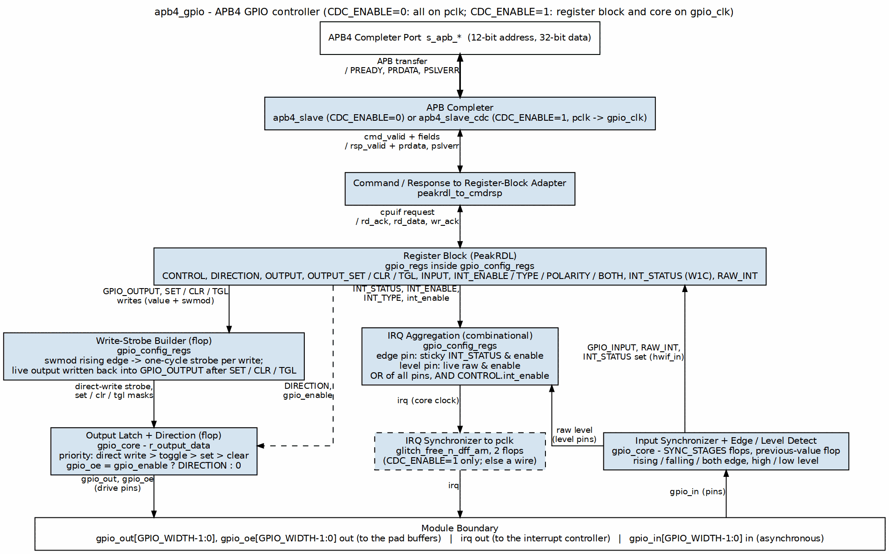
APB GPIO Block Diagram

2.2 Parameters
The headline numbers. GPIO width and synchronizer depth are parameters, so treat the 32-bit default as exactly that — a default.
Parameter | Value
GPIO Width | 32 bits (configurable)
APB Data Width | 32 bits
APB Address Width | 12 bits (4KB)
Sync Stages | 2 (configurable)
CDC Support | Optional

2.2.1 Register Summary
The full map with field-level detail is in Chapter 5. Here’s the quick reference:
Offset | Name | Access | Reset | Description
0x000 | GPIO_CONTROL | RW | 0x00000001 | Global enable and interrupt enable
0x004 | GPIO_DIRECTION | RW | 0x00000000 | Per-bit direction (1=output)
0x008 | GPIO_OUTPUT | RW | 0x00000000 | Output data value
0x00C | GPIO_INPUT | RO | - | Input data (read-only)
0x010 | GPIO_INT_ENABLE | RW | 0x00000000 | Per-bit interrupt enable
0x014 | GPIO_INT_TYPE | RW | 0x00000000 | Interrupt type (1=level, 0=edge)
0x018 | GPIO_INT_POLARITY | RW | 0xFFFFFFFF | Polarity (1=high/rising)
0x01C | GPIO_INT_BOTH | RW | 0x00000000 | Both-edge enable
0x020 | GPIO_INT_STATUS | W1C | 0x00000000 | Interrupt status (W1C)
0x024 | GPIO_RAW_INT | RO | 0 (live) | Raw interrupt (pre-mask)
0x028 | GPIO_OUTPUT_SET | WO | 0x00000000 | Atomic set
0x02C | GPIO_OUTPUT_CLR | WO | 0x00000000 | Atomic clear
0x030 | GPIO_OUTPUT_TGL | WO | 0x00000000 | Atomic toggle

2.3 Navigation
Next: 02_architecture.md - High-level architecture

RTL Design Sherpa · Learning Hardware Design Through Practice GitHub · Documentation Index · MIT License

3 APB GPIO - Architecture

3.1 Overview
Two views of the same design: the top-level block diagram, and the module hierarchy underneath it.

3.1.1 Figure 1.2: APB GPIO Top-Level Architecture
APB GPIO Architecture

3.1.2 Figure 1.3: APB GPIO Module Hierarchy
apb4_gpio top level
├── apb4_slave APB completer (CDC_ENABLE=0)
│ or apb4_slave_cdc APB completer + crossing (CDC_ENABLE=1)
├── peakrdl_to_cmdrsp cmd/rsp to register-block adapter
├── gpio_config_regs write strobes, W1C merge, irq
│ ├── gpio_regs PeakRDL register block
│ └── gpio_core sync, output latch, edge/level
└── glitch_free_n_dff_arn irq sync to pclk (CDC_ENABLE=1)

3.2 Functional Description

3.2.1 Data Flow
Three flows matter: APB writes, APB reads, and interrupts.

3.2.1.1 Figure 1.4: Write Transaction Flow
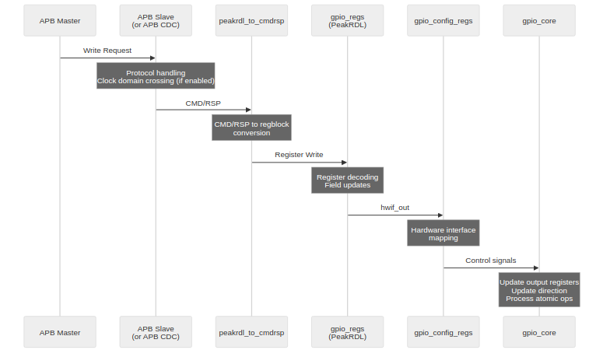
Write Transaction Flow

3.2.1.2 Figure 1.5: Read Transaction Flow
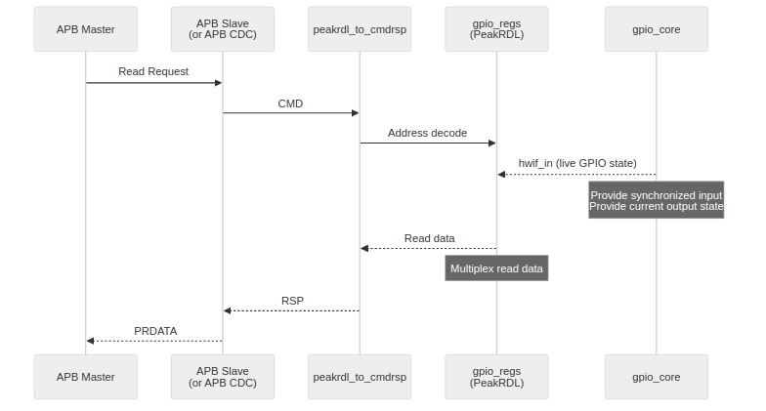
Read Transaction Flow

3.2.1.3 Figure 1.6: Interrupt Flow
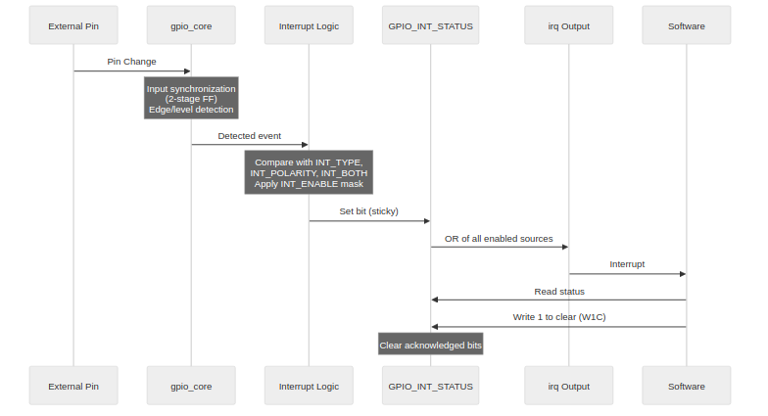
Interrupt Flow

3.2.2 Clock Domains

3.2.2.1 Figure 1.7: Synchronous Mode Clock Domains
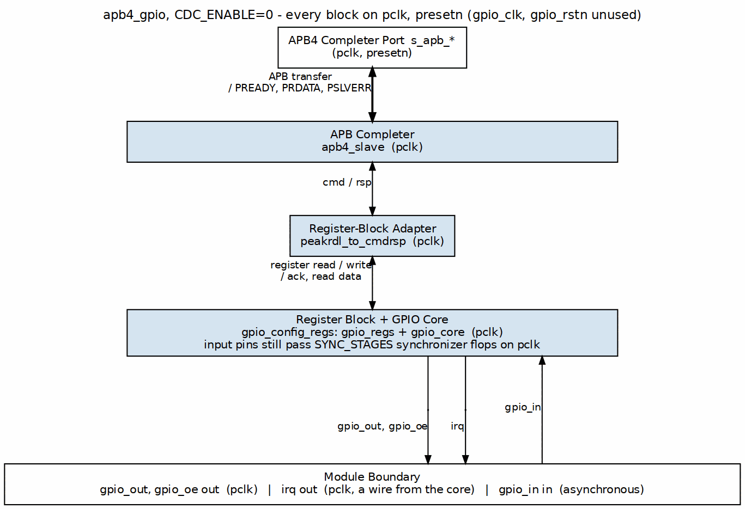
Synchronous Mode
With CDC_ENABLE = 0, everything runs on the APB clock (pclk). Input synchronization stays active on the external GPIO pins — metastability doesn’t care that your bus fabric is synchronous.

3.2.2.2 Figure 1.8: Asynchronous Mode Clock Domains
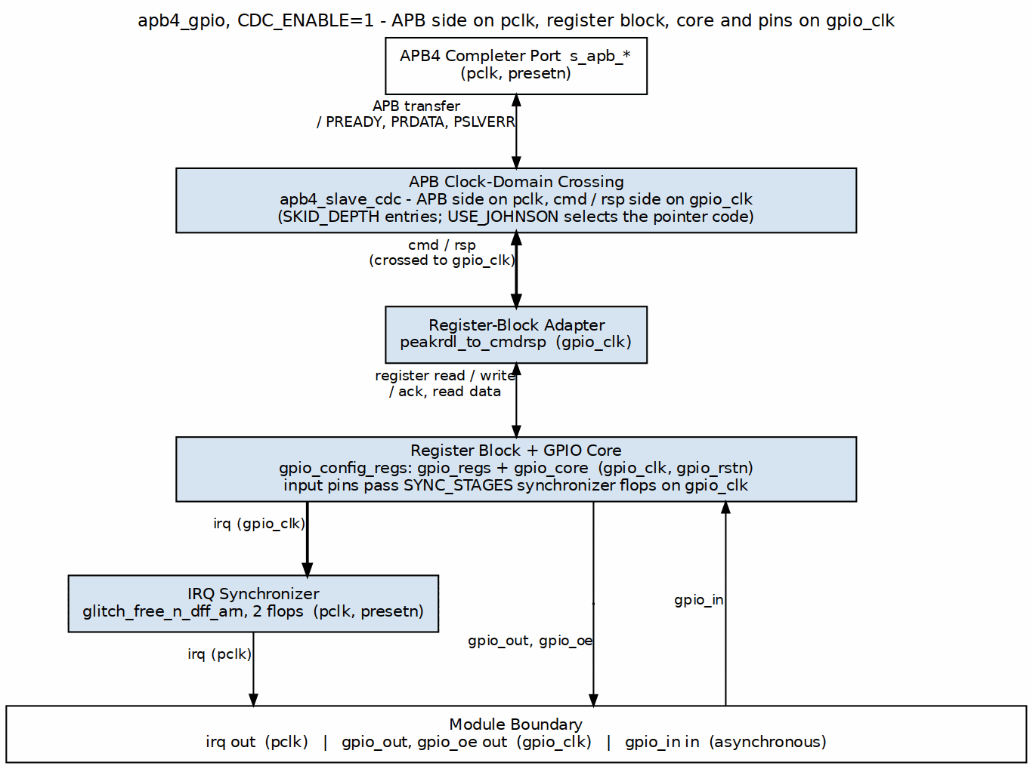
Asynchronous Mode
With CDC_ENABLE = 1, the APB clock domain handles protocol conversion while the GPIO clock domain owns the registers and I/O. The crossing is the pair of asynchronous FIFOs inside apb4_slave_cdc (command in, response out), plus a 2-flop synchronizer that brings irq back to pclk.

3.3 Parameters
Table 1.1: GPIO Parameters
Parameter | Type | Default | Description
GPIO_WIDTH | int | 32 | Number of GPIO pins
SYNC_STAGES | int | 2 | Input synchronizer stages
CDC_ENABLE | int | 0 | Enable clock domain crossing
SKID_DEPTH | int | 2 | CDC skid buffer depth
USE_JOHNSON | int | 0 | CDC counter encoding (forwarded to apb4_slave_cdc)

3.4 Design Notes

3.4.1 Resource Estimates
Rough synthesis numbers for planning purposes:
Table 1.2: Resource Estimates
Component | Flip-Flops | LUTs
gpio_core | ~200 | ~300
gpio_regs | ~400 | ~200
gpio_config_regs | ~50 | ~100
apb4_slave (no CDC) | ~20 | ~50
apb4_slave_cdc | ~100 | ~150
Total (no CDC) | ~670 | ~650
Total (with CDC) | ~750 | ~750

3.5 Navigation
Next: 03_clocks_and_reset.md - Clock and reset behavior

RTL Design Sherpa · Learning Hardware Design Through Practice GitHub · Documentation Index · MIT License

4 APB GPIO - Clocks and Reset

4.1 Overview
Two clocks, two resets, and one synchronizer chain you can’t turn off. Here’s what each piece does.

4.1.1 Clock Signals

4.1.1.1 pclk (APB Clock)
- Purpose: Primary APB bus clock
- Usage: APB protocol, register access
- Typical Frequency: 50-200 MHz

4.1.1.2 gpio_clk (GPIO Clock)
- Purpose: Optional separate GPIO clock domain
- Usage: Only when CDC_ENABLE=1
- Relationship: Can be asynchronous to pclk

4.1.2 Reset Signals

4.1.2.1 presetn (APB Reset)
- Type: Active-low asynchronous reset (exception: the PeakRDL-generated register file resets SYNCHRONOUSLY – see the note in ch03_interfaces/04_system.md)
- Scope: APB interface logic
- Behavior: Resets APB state machine, clears pending transactions

4.1.2.2 gpio_rstn (GPIO Reset)
- Type: Active-low asynchronous reset
- Scope: GPIO core logic
- Usage: Only when CDC_ENABLE=1
- Behavior: Resets GPIO outputs, interrupt state

4.2 Functional Description

4.2.1 Reset Behavior

4.2.1.1 Register Reset Values
Register | Reset Value | Notes
GPIO_CONTROL | 0x00000001 | GPIO enabled; global interrupt enable clear
GPIO_DIRECTION | 0x00000000 | All inputs
GPIO_OUTPUT | 0x00000000 | Outputs low
GPIO_INT_ENABLE | 0x00000000 | No interrupts
GPIO_INT_TYPE | 0x00000000 | Edge mode
GPIO_INT_POLARITY | 0xFFFFFFFF | Rising/high
GPIO_INT_BOTH | 0x00000000 | Single edge
GPIO_INT_STATUS | 0x00000000 | No pending
GPIO_RAW_INT | 0 (live RO readback; depends on pins after reset) | No events
GPIO_OUTPUT_SET/CLR/TGL | 0x00000000 | No pending atomic op
GPIO_CONTROL.ENABLE resets to 1, but don’t let that fool you into thinking pins drive out of reset: GPIO_DIRECTION resets to 0, so every pin is an input and high-Z until software programs directions. The irq output stays deasserted until software sets GPIO_CONTROL.INT_ENABLE (bit 1), which resets to 0.

4.2.1.2 Output Pin Behavior During Reset
During reset: - gpio_out[31:0] = 0 - gpio_oe[31:0] = 0 (all high-Z) - irq = 0

4.2.2 Clock Domain Crossing

4.2.2.1 When CDC_ENABLE = 0
- All logic runs on pclk
- gpio_clk input is ignored
- Connect gpio_clk = pclk for clean design

4.2.2.2 When CDC_ENABLE = 1
- APB interface uses pclk
- GPIO core uses gpio_clk
- apb4_slave_cdc’s asynchronous command and response FIFOs carry the APB traffic across; irq returns to pclk through a 2-flop synchronizer
- Both resets must be asserted together at power-on

4.2.3 Input Synchronization
GPIO inputs are always synchronized, CDC setting or not:
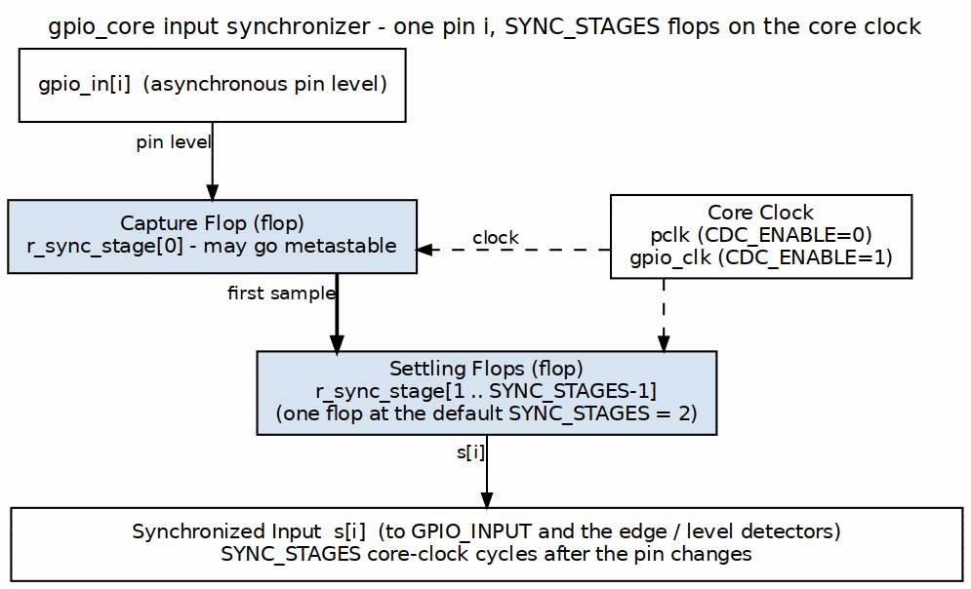
Input Synchronizer
- SYNC_STAGES parameter controls depth (default: 2)
- Prevents metastability from external signal transitions
- Adds latency equal to SYNC_STAGES clock cycles

4.3 Timing

4.3.1 Timing Constraints

4.3.1.1 Synchronous Mode
- Standard single-clock timing
- All paths constrained to pclk

4.3.1.2 Asynchronous Mode
- Set false_path between pclk and gpio_clk domains
- Set max_delay for CDC paths
- Synchronizer FFs should have ASYNC_REG attribute

4.4 Navigation
Next: 04_acronyms.md - Acronyms and terminology

RTL Design Sherpa · Learning Hardware Design Through Practice GitHub · Documentation Index · MIT License

5 APB GPIO - Acronyms and Terminology

5.1 Overview
The alphabet soup, collected in one place so the rest of the document doesn’t have to stop and define itself.

5.1.1 Protocol Acronyms
Acronym | Full Name | Description
APB | Advanced Peripheral Bus | Low-power AMBA bus protocol
AMBA | Advanced Microcontroller Bus Architecture | ARM standard bus protocols
CDC | Clock Domain Crossing | Synchronization between clock domains

5.1.2 Signal Acronyms
Acronym | Full Name | Description
CLK | Clock | Timing reference signal
RST | Reset | System initialization signal
OE | Output Enable | Tri-state buffer control
IRQ | Interrupt Request | Hardware interrupt signal

5.1.3 GPIO-Specific Terms
Term | Description
GPIO | General Purpose Input/Output - Configurable digital I/O pins
Pin | Individual GPIO signal (input or output)
Port | Group of 32 GPIO pins managed together
Direction | Input (0) or Output (1) configuration per pin
Polarity | Active-high or active-low signal interpretation

5.1.4 Interrupt Terms
Term | Description
Edge-triggered | Interrupt on signal transition
Level-sensitive | Interrupt while signal is at specified level
Rising edge | Low-to-high transition
Falling edge | High-to-low transition
Both edges | Either transition direction

5.1.5 Register Terms
Term | Description
RW | Read-Write register
RO | Read-Only register
W1C | Write-1-to-Clear register
HWIF | Hardware Interface (PeakRDL generated)

5.2 Navigation
Next: 05_references.md - Reference documents

RTL Design Sherpa · Learning Hardware Design Through Practice GitHub · Documentation Index · MIT License

6 APB GPIO - References

6.1 References

6.1.1 Internal Documentation

6.1.1.1 RTL Source Files
Worth having open in an editor while you read the rest of this MAS:
- rtl/gpio/apb4_gpio.sv - Top-level module (APB port, CDC generate)
- rtl/gpio/gpio_config_regs.sv - Register wrapper (atomic-op pulses, irq)
- rtl/gpio/gpio_core.sv - Pin I/O, synchronizers, interrupt detection
- rtl/gpio/gpio_regs.sv / gpio_regs_pkg.sv - PeakRDL-generated register file
- rdl/gpio/gpio_regs.rdl - Register description source

6.1.1.2 Related Specifications
- APB Protocol Specification (AMBA 3)
- RLB Integration Guide

6.1.2 External References

6.1.2.1 ARM AMBA Specifications
- AMBA 3 APB Protocol Specification
  - ARM IHI 0024E
  - Defines APB interface timing and protocol

6.1.2.2 Industry Standards
- GPIO Best Practices
  - Synchronization for external inputs
  - Interrupt handling patterns
  - Tri-state buffer management

6.1.3 Design References

6.1.3.1 Clock Domain Crossing
- Dual flip-flop synchronizer methodology
- Skid buffer for data path CDC
- Reset synchronization techniques

6.1.3.2 Interrupt Handling
- Edge detection circuits
- Interrupt aggregation patterns
- Software interrupt acknowledge flows

6.2 Navigation
Next: Chapter 2: Block Descriptions

RTL Design Sherpa · Learning Hardware Design Through Practice GitHub · Documentation Index · MIT License

7 APB GPIO - Block Descriptions Overview

7.1 Overview
The design splits into four blocks plus an optional CDC wrapper. Small enough to hold in your head, which is how a GPIO should be.

7.1.1 Figure 2.1: APB GPIO Module Hierarchy
apb4_gpio top level
├── apb4_slave APB completer (CDC_ENABLE=0)
│ or apb4_slave_cdc APB completer + crossing (CDC_ENABLE=1)
├── peakrdl_to_cmdrsp cmd/rsp to register-block adapter
├── gpio_config_regs write strobes, W1C merge, irq
│ ├── gpio_regs PeakRDL register block
│ └── gpio_core sync, output latch, edge/level
└── glitch_free_n_dff_arn irq sync to pclk (CDC_ENABLE=1)

7.1.2 Block Summary
Table 2.1: Block Summary
Block | File | Description
APB GPIO Top | apb4_gpio.sv | Top-level module with all GPIO functionality
Register File | gpio_regs.sv (+ gpio_regs_pkg.sv) | PeakRDL-generated control/status registers
Register Wrapper | gpio_config_regs.sv | Connects registers to the core; atomic-op pulses, irq
GPIO Core | gpio_core.sv | Pin I/O, synchronizers, interrupt detection

7.1.3 In This Chapter

7.1.3.1 1. APB Interface
Handles APB protocol conversion and register access.
See: 01_apb_interface.md

7.1.3.2 2. Register File
PeakRDL-generated registers for configuration and status.
See: 02_register_file.md

7.1.3.3 3. GPIO Core
Main GPIO functionality including I/O control and interrupts.
See: 03_gpio_core.md

7.1.3.4 4. Interrupt Controller
Edge detection, level sensing, and interrupt aggregation.
See: 04_interrupt_controller.md

7.1.3.5 5. CDC Logic
Optional clock domain crossing for asynchronous GPIO clock.
See: 05_cdc_logic.md

7.2 Navigation
Next: 01_apb_interface.md - APB Interface details

RTL Design Sherpa · Learning Hardware Design Through Practice GitHub · Documentation Index · MIT License

8 APB GPIO - APB Interface Block

8.1 Overview
The APB interface is the bridge between the system APB bus and the GPIO register file — a small FSM that turns APB’s two-phase transfers into the command/response handshake the register block speaks.

8.1.1 Block Diagram
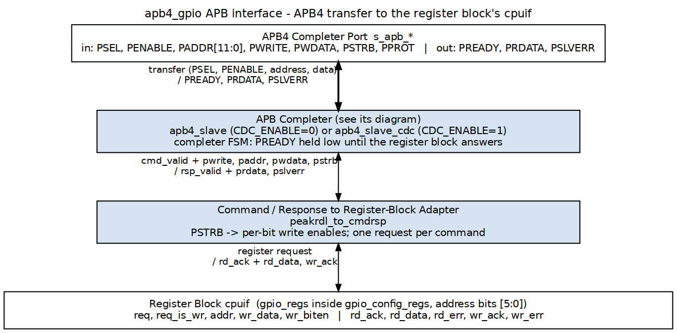
APB Interface Block

8.2 Ports

8.2.1 APB Slave Interface
Signal | Width | Direction | Description
s_apb_PSEL | 1 | Input | Slave select
s_apb_PENABLE | 1 | Input | Enable phase
s_apb_PWRITE | 1 | Input | Write operation
s_apb_PADDR | 12 | Input | Address bus
s_apb_PWDATA | 32 | Input | Write data
s_apb_PSTRB | 4 | Input | Byte strobes
s_apb_PPROT | 3 | Input | Protection attributes (accepted, unused)
s_apb_PRDATA | 32 | Output | Read data
s_apb_PREADY | 1 | Output | Ready response
s_apb_PSLVERR | 1 | Output | Error response

8.3 Functional Description

8.3.1 Read Transaction
- Master asserts psel and paddr
- Master asserts penable on next cycle
- Slave returns prdata with pready

8.3.2 Write Transaction
- Master asserts psel, paddr, pwdata, pwrite
- Master asserts penable on next cycle
- Slave samples data with pready

8.4 Timing
Figure 2.2 shows a basic APB access, start to finish.

8.4.1 Figure 2.2: APB Access Timing
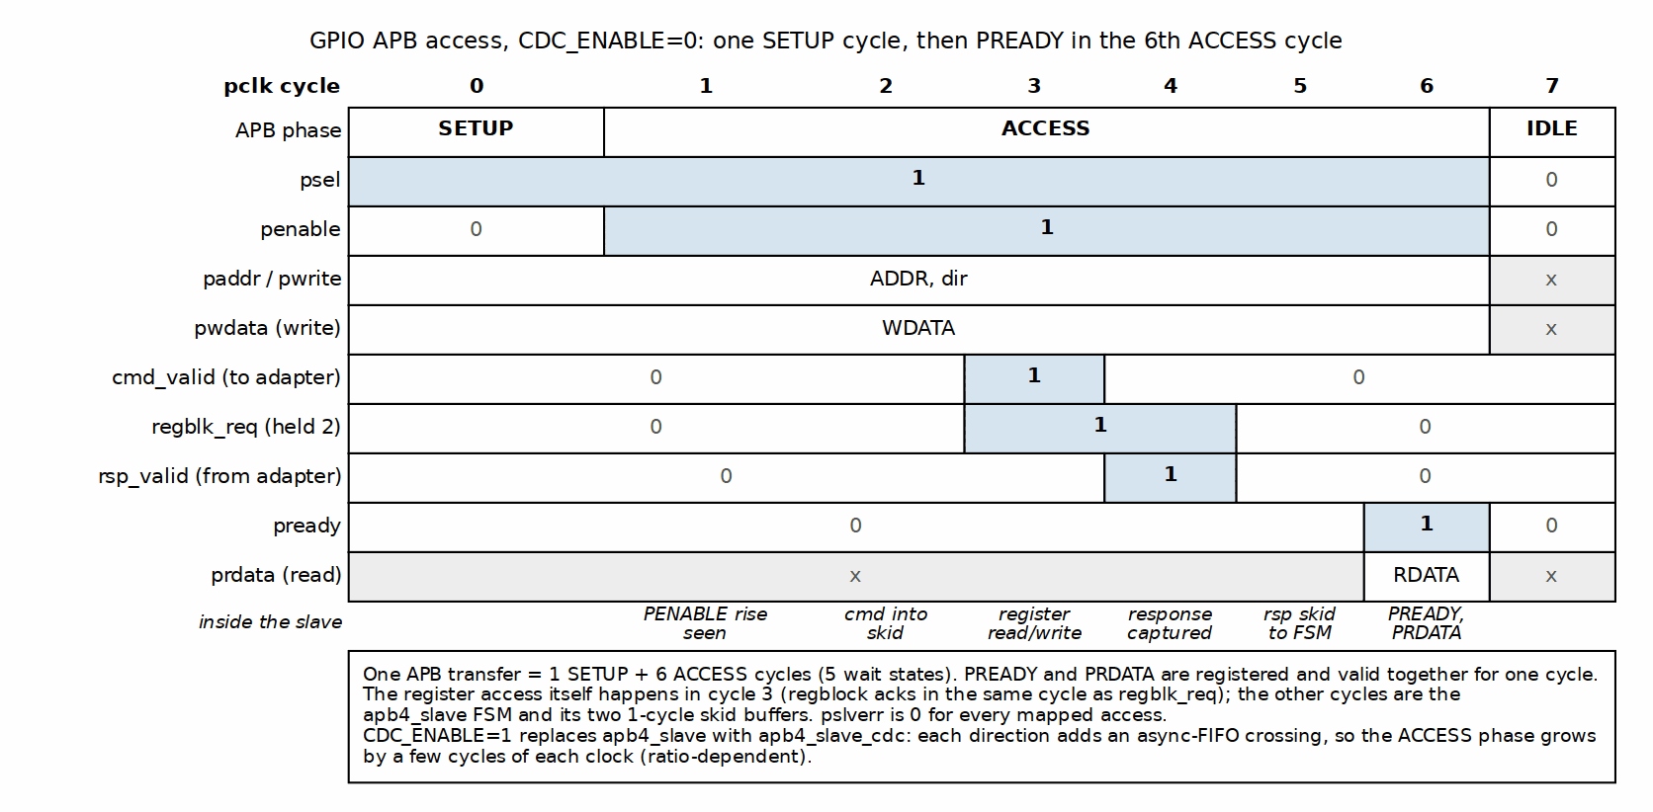
APB Access Timing
One SETUP cycle, then six ACCESS cycles: the register itself is read or written in cycle 3, and PREADY rises with PRDATA in the sixth ACCESS cycle.

8.5 Design Notes
- PREADY-gated: the bridge FSM adds five wait states per access with CDC_ENABLE=0, more with the CDC (no stalls originate in the register block itself)
- No error responses (pslverr always 0)
- 32-bit aligned access only

8.6 Navigation
Next: 02_register_file.md - Register File

RTL Design Sherpa · Learning Hardware Design Through Practice GitHub · Documentation Index · MIT License

9 APB GPIO - Register File Block

9.1 Overview
The register file is generated by PeakRDL from ../../rdl/gpio/gpio_regs.rdl and is the hardware/software contract for the whole block. If a bit isn’t in the RDL, it doesn’t exist.

9.1.1 Block Diagram
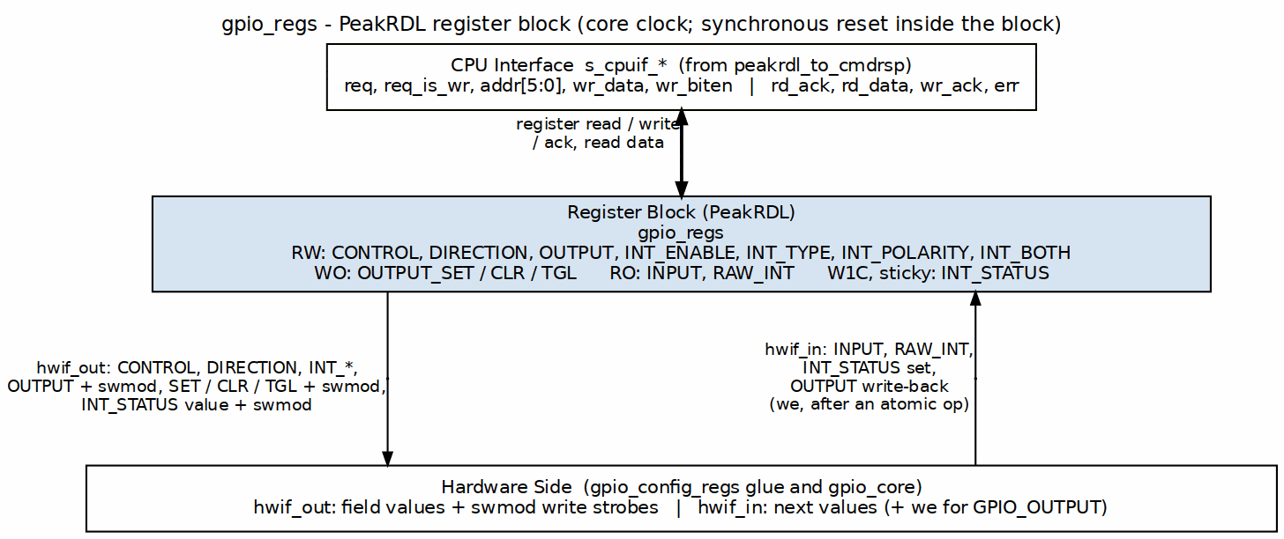
Register File Block

9.2 Ports

9.2.1 Hardware-to-Software (hw2reg)
Signals the RTL drives into the register file:
Signal | Width | Description
GPIO_INPUT.input_data | 32 | Current GPIO input values
GPIO_OUTPUT.output_data | 32 | Live output latch write-back (we-gated, the cycle after an atomic op)
GPIO_INT_STATUS.int_status | 32 | Interrupt status set requests (sticky; includes the deferred W1C-coincident set)
GPIO_RAW_INT.raw_status | 32 | Live raw event-detector status

9.2.2 Software-to-Hardware (reg2hw)
Signals the register file drives out to the RTL:
Signal | Width | Description
GPIO_CONTROL.gpio_enable | 1 | GPIO output enable (gates gpio_oe only; resets 1)
GPIO_CONTROL.int_enable | 1 | Global interrupt enable (gates irq; resets 0)
GPIO_DIRECTION.direction | 32 | Pin direction (0=in, 1=out)
GPIO_OUTPUT.output_data | 32 | Output values (+ swmod write strobe)
GPIO_INT_ENABLE.int_enable | 32 | Interrupt enable per pin
GPIO_INT_TYPE.int_type | 32 | Interrupt type (0=edge, 1=level)
GPIO_INT_POLARITY.int_polarity | 32 | Polarity (0=fall/low, 1=rise/high)
GPIO_INT_BOTH.int_both | 32 | Both edges enable
GPIO_OUTPUT_SET.set_bits | 32 | Atomic set mask (+ swmod write strobe)
GPIO_OUTPUT_CLR.clear_bits | 32 | Atomic clear mask (+ swmod write strobe)
GPIO_OUTPUT_TGL.toggle_bits | 32 | Atomic toggle mask (+ swmod write strobe)
GPIO_INT_STATUS.int_status | 32 | Sticky status value (+ swmod W1C write strobe)

9.3 Functional Description

9.3.1 Byte Enable Support
All registers support byte-granular writes via pstrb: - pstrb[0] enables bits [7:0] - pstrb[1] enables bits [15:8] - pstrb[2] enables bits [23:16] - pstrb[3] enables bits [31:24]

9.3.2 Access Types
Type | Read Behavior | Write Behavior
RW | Returns current value | Updates register
RO | Returns hardware value | No effect
W1C | Returns current value | Clears bits where 1 written

9.4 Design Notes
- Generated by PeakRDL regblock
- Clocked by the core clock (w_core_clk = gpio_clk when CDC_ENABLE=1, pclk otherwise – see the CDC chapter)
- Registers reset to 0 except GPIO_CONTROL.GPIO_ENABLE (resets to 1) and GPIO_INT_POLARITY (resets to 0xFFFFFFFF); reset is synchronous inside the generated block
- swmod on GPIO_OUTPUT, GPIO_OUTPUT_SET/CLR/TGL and GPIO_INT_STATUS is a level held for the whole command-bridge transaction and leads the field storage by one cycle; gpio_config_regs edge-detects and re-aligns it before use, so every write is one operation (see Chapter 5)

9.5 Navigation
Next: 03_gpio_core.md - GPIO Core

RTL Design Sherpa · Learning Hardware Design Through Practice GitHub · Documentation Index · MIT License

10 APB GPIO - GPIO Core Block

10.1 Overview
The core is where the pins live: input synchronization, output driving, and direction control for all 32 GPIOs.

10.1.1 Block Diagram
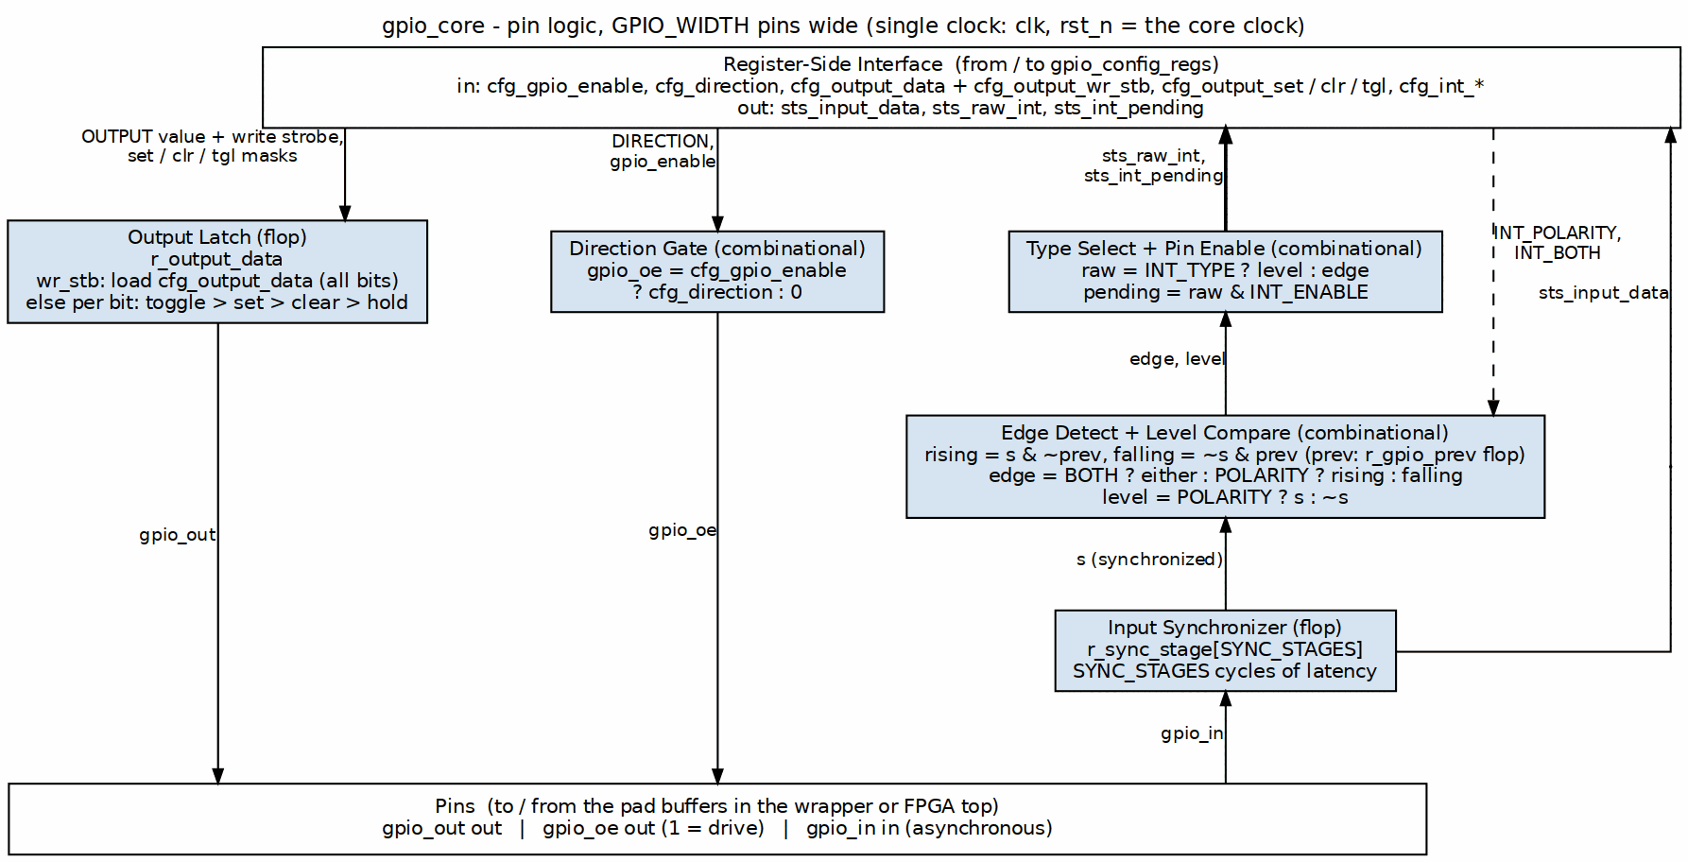
GPIO Core Block

10.2 Ports
Signal | Width | Direction | Description
gpio_out | 32 | Output | Output data values
gpio_oe | 32 | Output | Output enables (active high)
gpio_in | 32 | Input | Input data values

10.3 Functional Description

10.3.1 Input Path

10.3.1.1 Synchronization
External inputs pass through a dual flip-flop synchronizer:
Input Synchronizer
- Prevents metastability from asynchronous inputs
- Configurable depth via SYNC_STAGES parameter
- Adds SYNC_STAGES clock cycles of latency

10.3.1.2 Input Register
Synchronized inputs land in the GPIO_INPUT register, which is what software reads.

10.3.2 Output Path

10.3.2.1 Output Register
Software writes to GPIO_OUTPUT to set output values. The write reaches the core as a one-cycle strobe (cfg_output_wr_stb, built in gpio_config_regs from the register’s write strobe) alongside the data, so it is a write whether or not the value changed. A direct write takes priority over an atomic operation in the same cycle (direct > toggle > set > clear):
if (cfg_output_wr_stb) r_output_data <= cfg_output_data;
else // toggle, then set, then clear
r_output_data drives the pins and is written back into GPIO_OUTPUT after each atomic operation, so the register reads the live value.

10.3.2.2 Output Enable
The direction register controls the tri-state buffers: - direction[i] = 0: Pin is input (high-Z output) - direction[i] = 1: Pin is output (driven)

10.3.3 Direction Control

10.3.3.1 Per-Pin Configuration
Each pin is configured independently:
// gpio_oe = cfg_gpio_enable ? cfg_direction : '0; (gpio_core.sv)
if (gpio_enable && direction[i]) begin
// Output mode
gpio_oe[i] = 1'b1;
gpio_out[i] = output_reg[i];
end else begin
// Input mode, or GPIO_CONTROL.ENABLE == 0 (all pins high-Z)
gpio_oe[i] = 1'b0;
// gpio_out[i] = don't care
end
GPIO_CONTROL.ENABLE gates ONLY the output enables: when it is 0 every pin is high-Z, but output data, input synchronization, and interrupt detection/status all keep running.

10.3.3.2 Read-Back Behavior
Reading GPIO_INPUT returns: - For input pins: External signal value (synchronized) - For output pins: External signal value (may differ from output_reg if open-drain)

10.4 Design Notes
- All 32 pins processed in parallel
- Output updates one core-clock after the GPIO_OUTPUT field updates (the write strobe is aligned to the field, and r_output_data registers it)
- The core exports sts_raw_int and sts_int_pending only; the aggregate irq is built in gpio_config_regs from the sticky status register and the live level pins. The core has no irq output and no global-enable input
- Input synchronization always active

10.5 Navigation
Next: 04_interrupt_controller.md - Interrupt Controller

RTL Design Sherpa · Learning Hardware Design Through Practice GitHub · Documentation Index · MIT License

11 APB GPIO - Interrupt Controller Block

11.1 Overview
Per-pin interrupt generation with edge or level triggering and one aggregate irq. The logic is simple; the enable semantics are where people trip. There are two levels of enable and they don’t mean the same thing — read that section twice.

11.1.1 Figure 2.5: Interrupt Controller Block Diagram
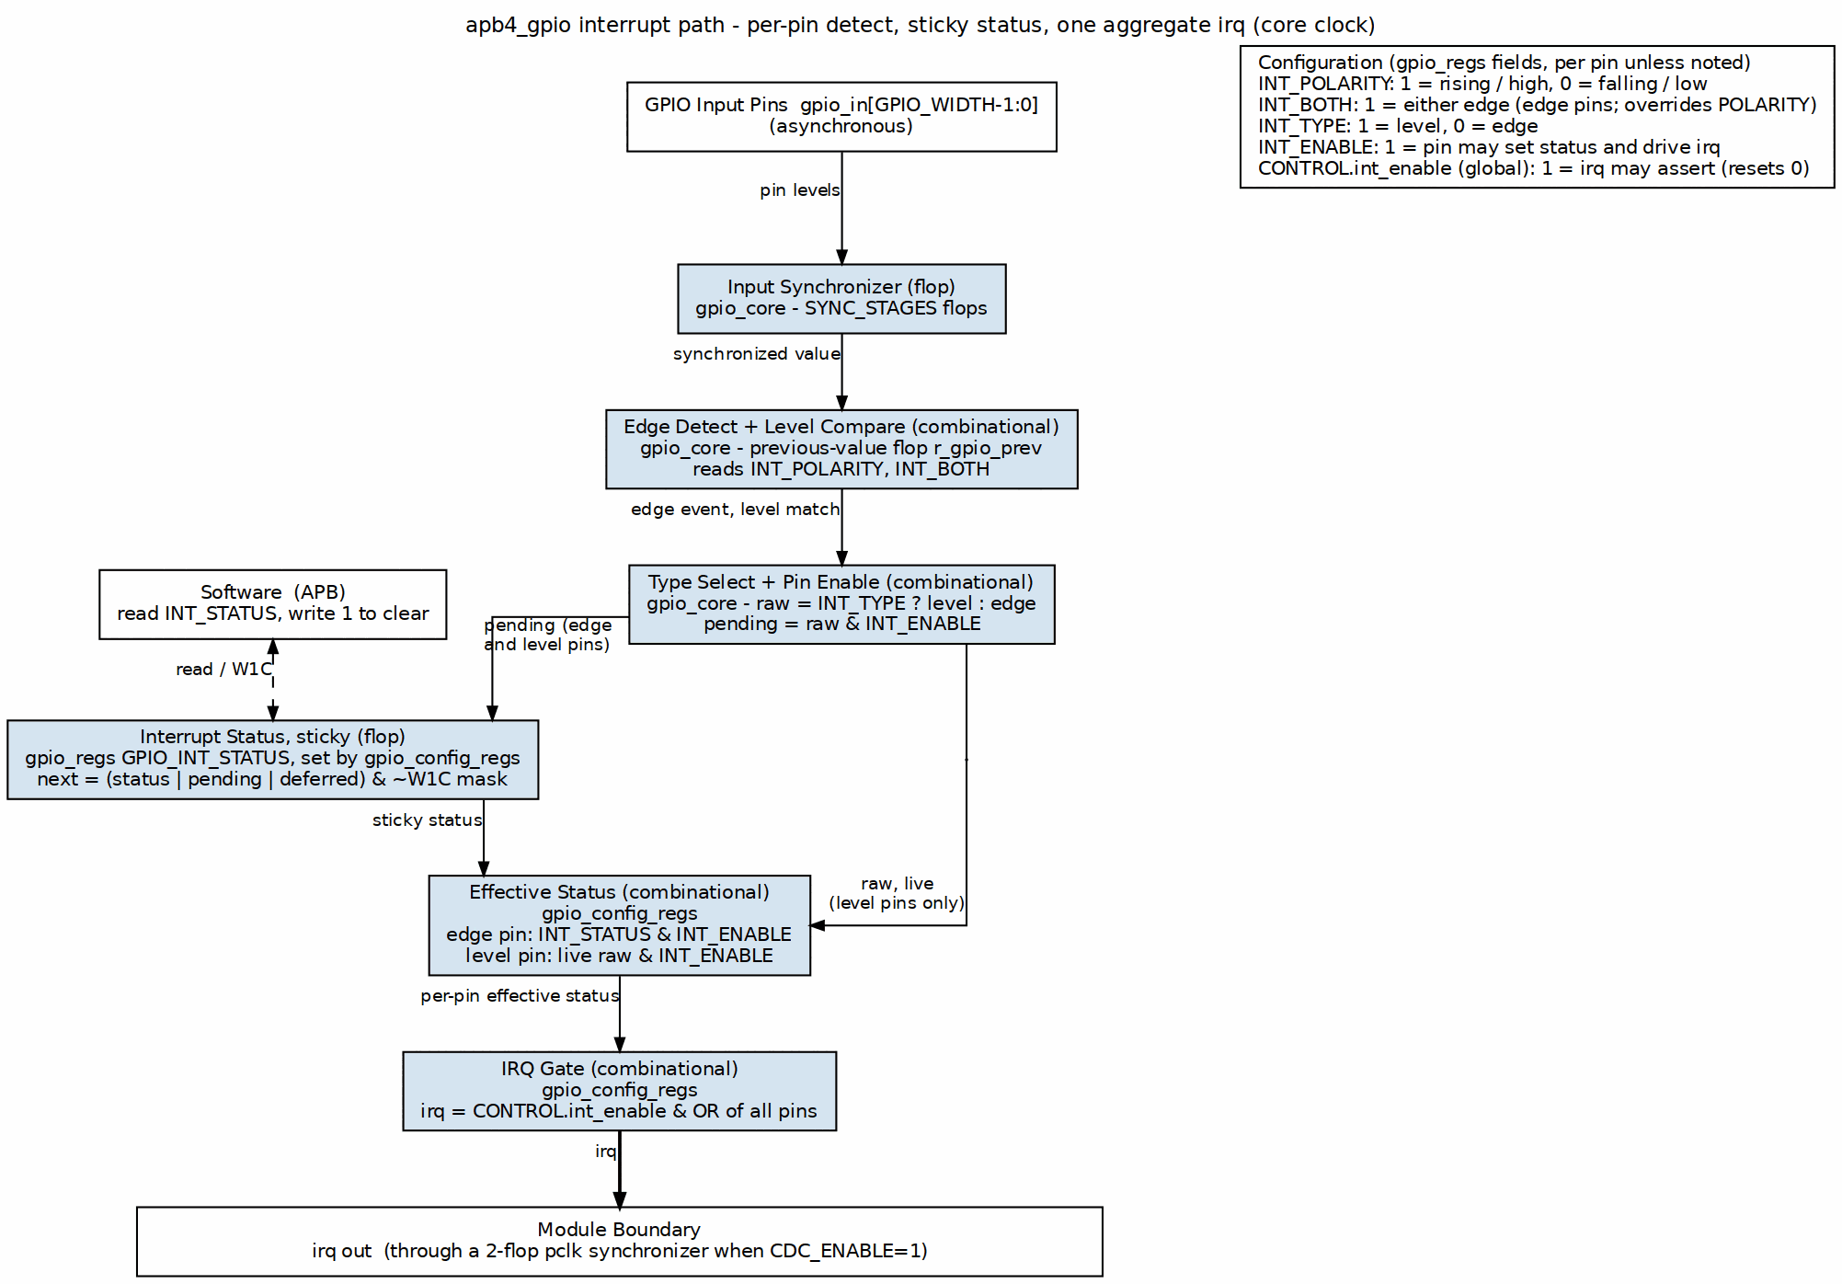
Interrupt Controller Block

11.2 Functional Description

11.2.1 Interrupt Modes

11.2.1.1 Edge-Triggered Mode
GPIO_INT_TYPE[i] = 0
Table 2.5: Edge-Triggered Modes
GPIO_INT_POLARITY | GPIO_INT_BOTH | Trigger Condition
0 | 0 | Falling edge only
1 | 0 | Rising edge only
X | 1 | Both edges

11.2.1.2 Level-Sensitive Mode
GPIO_INT_TYPE[i] = 1
Table 2.6: Level-Sensitive Modes
GPIO_INT_POLARITY | Trigger Condition
0 | Active low (interrupt while pin = 0)
1 | Active high (interrupt while pin = 1)

11.2.2 Edge Detection Logic

11.2.2.1 Figure 2.6: Edge Detection Logic
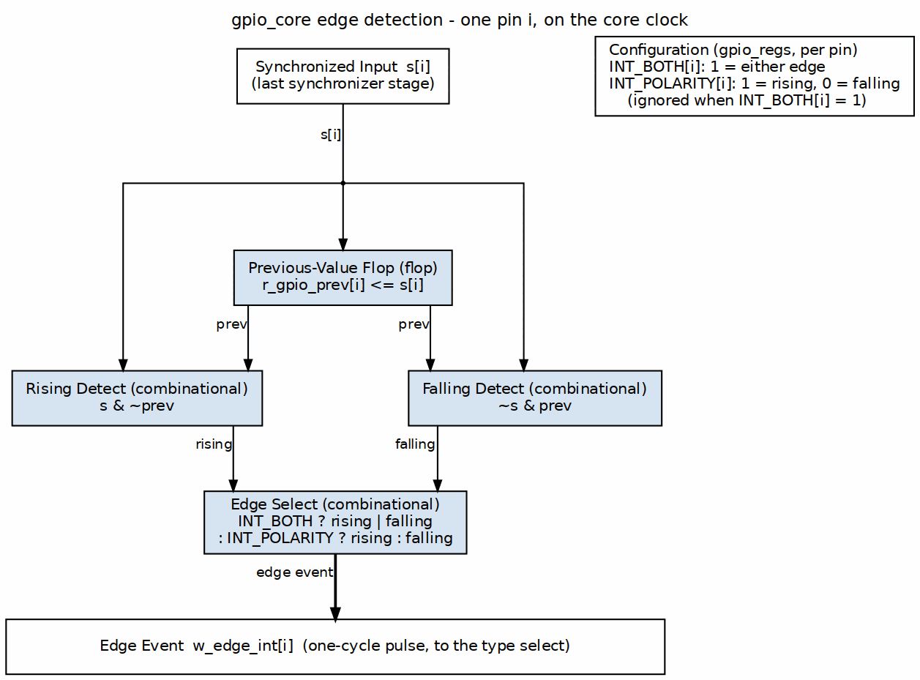
Edge Detection Logic

11.2.3 Interrupt Status
- Each bit in GPIO_INT_STATUS corresponds to one pin
- Set when the interrupt condition is detected on a pin whose GPIO_INT_ENABLE bit is 1 - events on disabled pins set nothing (sts_int_pending = raw & enable in gpio_core.sv)
- Cleared by writing 1 to the bit (W1C); bits latch in both edge and level modes until cleared
- A W1C write and a hardware event in the same cycle merge per bit (next = (value | hw_set) & ~w1c_mask, gpio_config_regs.sv): the event survives on every bit the write does not clear

11.2.4 Interrupt Enable
Two levels of enable exist:
- GPIO_INT_ENABLE[i] = 1 enables pin i. It is sampled at EVENT time: it gates whether a status bit sets, and (for level pins) whether the pin drives irq. It is also re-applied at irq: clearing it after an edge event has latched masks that pending interrupt (the status bit stays set until W1C), as described under Aggregate IRQ Output below.
- GPIO_CONTROL[1] (global INT_ENABLE) gates the final irq output and is the only control that masks everything. It resets to 0.

11.2.5 Aggregate IRQ Output
per-pin effective status:
level pin (TYPE=1): raw_detector & GPIO_INT_ENABLE (live, bypasses STATUS)
edge pin (TYPE=0): GPIO_INT_STATUS & GPIO_INT_ENABLE (sticky latch, re-gated)
irq = GPIO_CONTROL[1] && (| effective_status)
(gpio_config_regs.sv.) One difference from a plain |(STATUS & ENABLE) remains: level pins bypass GPIO_INT_STATUS entirely, so W1C on a level pin does not deassert irq while the level persists. Edge pins re-apply the current per-pin enable, so clearing GPIO_INT_ENABLE[i] masks an already-latched edge interrupt on pin i (the status bit stays set until W1C and irq re-asserts if the enable is set again).

11.2.6 Interrupt Handling Flow
- Hardware detects condition, sets status bit
- IRQ asserted to processor
- Software reads GPIO_INT_STATUS to identify source
- Software handles interrupt
- Software writes 1 to status bit to clear
- IRQ deasserts (if no other sources active)

11.3 Design Notes
- Edge detection uses synchronized input
- Level-sensitive interrupts re-trigger if not cleared
- Status bits latch until software clears

11.4 Navigation
Next: 05_cdc_logic.md - CDC Logic

RTL Design Sherpa · Learning Hardware Design Through Practice GitHub · Documentation Index · MIT License

12 APB GPIO - CDC Logic Block

12.1 Overview
When you need the GPIO core on its own clock, asynchronous to the APB bus, CDC_ENABLE moves the whole register file across the domain boundary. Everything about the crossing lives in this one block.

12.1.1 Figure 2.7: CDC Logic Block Diagram
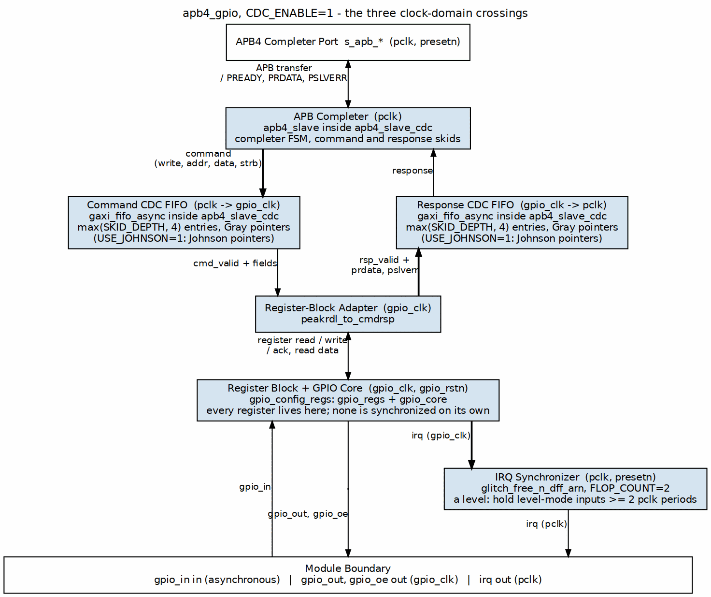
CDC Logic Block

12.2 Parameters

12.2.1 CDC_ENABLE
Table 2.7: CDC Enable Parameter
Value | Behavior
0 | Single clock domain, all logic on pclk
1 | Dual clock domain, GPIO core on gpio_clk

12.3 Functional Description

12.3.1 Clock Domains

12.3.1.1 Figure 2.8: Single Clock Domain (CDC Disabled)
CDC Disabled

12.3.1.2 Figure 2.9: Dual Clock Domain (CDC Enabled)
CDC Enabled

12.3.2 CDC Implementation
When CDC_ENABLE=1 the ENTIRE register file and GPIO core sit in the gpio_clk domain; no register value is individually synchronized. The only crossing is the APB command/response stream itself, carried through an apb4_slave_cdc instance at the bus boundary (apb4_gpio.sv, gen_cdc). An APB access therefore completes with CDC handshake latency, and once it lands in the gpio_clk domain every register behaves exactly as in the single-clock configuration.

12.3.3 The irq Output
irq is generated in the core clock domain (gpio_config_regs.sv), which is gpio_clk when CDC_ENABLE=1. apb4_gpio.sv (gen_irq_sync) then passes it through a 2-flop synchronizer (glitch_free_n_dff_arn, FLOP_COUNT=2) clocked by pclk, so the output pin is safe to consume in the pclk domain with no external synchronizer. It is a level, so a plain synchronizer is the right primitive; there is no handshake and no pulse stretching. The cost is two pclk cycles of latency. When CDC_ENABLE=0 the synchronizer is bypassed (gen_irq_direct) and irq keeps the zero-latency behaviour of the single-clock configuration.
One contract comes with that choice. For an edge-mode pin the sticky status bit holds irq asserted until software clears it, so the synchronizer always sees it. For a level-mode pin irq is only as wide as the input level itself, and a level that de-asserts within about two pclk periods (plus the input synchronizer depth) can pass between the synchronizer’s samples and never reach the pin. The event is not lost – GPIO_INT_STATUS still latches it and polling sees it – but no interrupt fires. Hold level-mode inputs for at least two pclk periods when CDC_ENABLE=1, or use edge mode for short pulses. With CDC_ENABLE=0 every core-clock assertion is visible, so the constraint only exists in the asynchronous configuration.

12.3.4 Coherency
- No guaranteed atomicity across clock domains
- Software must handle potential inconsistencies
- Interrupt status always reflects gpio_clk domain

12.3.5 Reset Synchronization
Both resets must be asserted at power-on: 1. Assert both presetn and gpio_rstn 2. Release gpio_rstn first 3. Release presetn after gpio_clk domain stable

12.4 Timing

12.4.1 Latency
Table 2.8: CDC Latency
Path | Latency
APB write to gpio_clk-domain register | APB access + apb4_slave_cdc handshake (a few cycles of each clock)
APB read of gpio_clk-domain state | Same crossing, in both directions
Interrupt detection to IRQ | gpio_clk-domain detection (Chapter 3.3) + 2 pclk cycles through the irq synchronizer

12.5 Navigation
Back to: 00_overview.md - Block Descriptions Overview
Next Chapter: Chapter 3: Interfaces

RTL Design Sherpa · Learning Hardware Design Through Practice GitHub · Documentation Index · MIT License

13 APB GPIO - Interfaces Overview

13.1 Overview
Four external interfaces: the bus, the pins, the interrupt, and the clock/reset pair.
Interface | Type | Description
APB Slave | Bus | Configuration and status access
GPIO Pins | I/O | 32 general-purpose I/O pins
Interrupt | Signal | Aggregate interrupt output
Clocks/Reset | System | Clock and reset inputs

13.1.1 Interface Summary Diagram
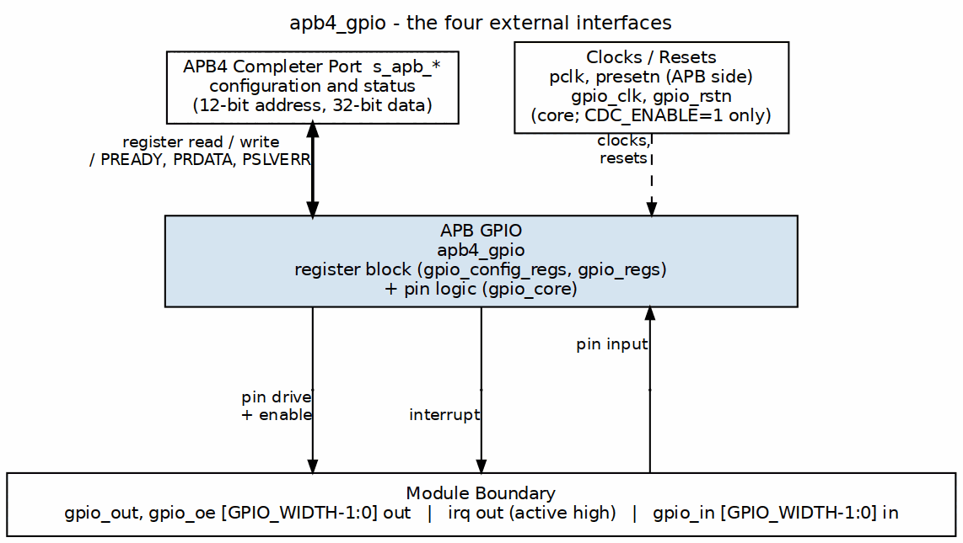
GPIO Interfaces

13.1.2 In This Chapter

13.1.2.1 APB Slave Interface
Complete APB protocol interface for register access.
See: 01_apb4_slave.md

13.1.2.2 GPIO Pin Interface
External GPIO pin connections with tri-state control.
See: 02_gpio_pins.md

13.1.2.3 Interrupt Interface
Interrupt request output signal.
See: 03_interrupt.md

13.1.2.4 System Interface
Clock and reset signal requirements.
See: 04_system.md

13.2 Navigation
Next: 01_apb4_slave.md - APB Slave Interface

RTL Design Sherpa · Learning Hardware Design Through Practice GitHub · Documentation Index · MIT License

14 APB GPIO - APB Slave Interface

14.1 Ports

14.1.1 APB Slave Signals
Signal | Width | Direction | Description
pclk | 1 | Input | APB clock
presetn | 1 | Input | APB reset (active low)
s_apb_PSEL | 1 | Input | Peripheral select
s_apb_PENABLE | 1 | Input | Enable phase
s_apb_PWRITE | 1 | Input | Write transaction
s_apb_PADDR | 12 | Input | Address bus
s_apb_PWDATA | 32 | Input | Write data
s_apb_PSTRB | 4 | Input | Byte strobes
s_apb_PRDATA | 32 | Output | Read data
s_apb_PREADY | 1 | Output | Ready response
s_apb_PSLVERR | 1 | Output | Slave error

14.2 Functional Description

14.2.1 Protocol Compliance
APB3/APB4 feature support:
Feature | Support
PSEL | Yes
PENABLE | Yes
PWRITE | Yes
PADDR | 12-bit
PWDATA | 32-bit
PRDATA | 32-bit
PREADY | Yes (inserts wait states – see Access Timing below)
PSLVERR | Yes (always 0)
PSTRB | Yes
PPROT | Present on the port (s_apb_PPROT[2:0]), accepted and ignored - no protection checking is performed

14.2.2 Address Decoding
Offset | Name | Access
0x000 | GPIO_CONTROL | RW
0x004 | GPIO_DIRECTION | RW
0x008 | GPIO_OUTPUT | RW
0x00C | GPIO_INPUT | RO
0x010 | GPIO_INT_ENABLE | RW
0x014 | GPIO_INT_TYPE | RW
0x018 | GPIO_INT_POLARITY | RW
0x01C | GPIO_INT_BOTH | RW
0x020 | GPIO_INT_STATUS | W1C
0x024 | GPIO_RAW_INT | RO
0x028 | GPIO_OUTPUT_SET | WO
0x02C | GPIO_OUTPUT_CLR | WO
0x030 | GPIO_OUTPUT_TGL | WO
Only PADDR[5:0] reaches the register block, so this map aliases every 64 bytes across the 12-bit APB window; 0x034-0x03F read as zero. No address ever raises PSLVERR.

14.2.3 Byte Strobes
Byte-granular writes supported: - pstrb[3:0] corresponds to pwdata[31:0] - Unselected bytes retain previous values

14.2.4 Error Handling
- No address decode errors (all addresses valid)
- No timeout errors
- pslverr always 0

14.3 Timing

14.3.1 Access Timing
PREADY inserts wait states: the apb4_slave bridge is a small FSM that issues the command and returns the response over a registered cmd/rsp handshake, so an access takes five pclk wait states beyond the 2-cycle APB minimum (more when CDC_ENABLE=1 crosses to gpio_clk). The register block itself never stalls (cpuif_req_stall_* = 0).

14.3.2 Figure 3.1: APB Access Timing (CDC_ENABLE=0)
APB Access Timing
The same access as Figure 2.2: PREADY and PRDATA arrive together in the sixth ACCESS cycle, and PWDATA is held from SETUP until PREADY.

14.4 Navigation
Next: 02_gpio_pins.md - GPIO Pin Interface

RTL Design Sherpa · Learning Hardware Design Through Practice GitHub · Documentation Index · MIT License

15 APB GPIO - GPIO Pin Interface

15.1 Ports

15.1.1 GPIO Signals
Signal | Width | Direction | Description
gpio_out | 32 | Output | Output data values
gpio_oe | 32 | Output | Output enables
gpio_in | 32 | Input | Input data values

15.2 Functional Description

15.2.1 Output Mode (direction[i] = 1)
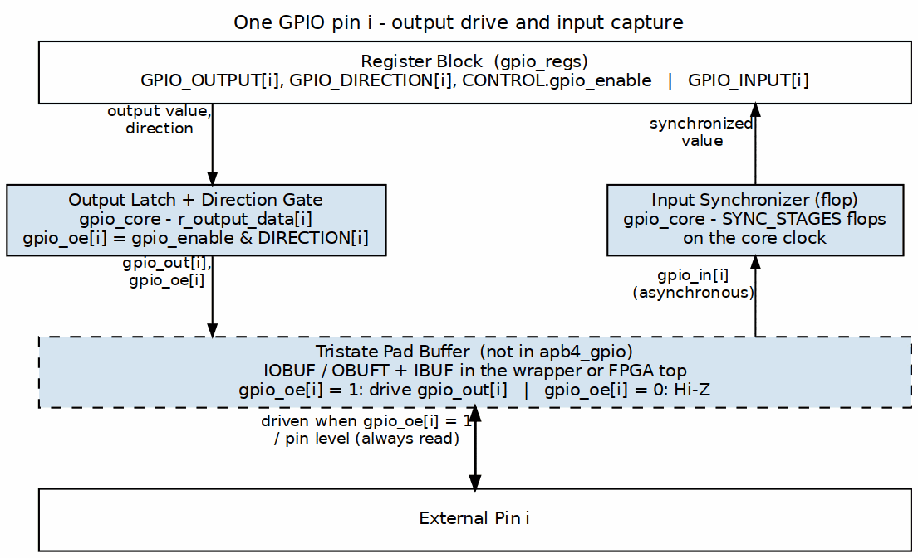
One GPIO Pin
- gpio_oe[i] = 1 (output enabled)
- gpio_out[i] = GPIO_OUTPUT register value
- Pin driven to output value

15.2.2 Input Mode (direction[i] = 0)
The same path as the figure above with gpio_oe[i] = 0: the pad buffer is Hi-Z and only the input leg, through the synchronizer, is live.
- gpio_oe[i] = 0 (tri-state)
- gpio_out[i] = don’t care
- External value captured via synchronizer

15.2.3 Input Synchronization
All inputs pass through a dual flip-flop synchronizer:
Input Synchronizer
- SYNC_STAGES parameter controls depth (default: 2)
- Prevents metastability from asynchronous inputs
- All 32 inputs synchronized in parallel
Input changes show up in the GPIO_INPUT register after: - SYNC_STAGES cycles of gpio_clk (or pclk if CDC_ENABLE=0) - Plus APB read latency

15.2.4 Electrical Considerations

15.2.4.1 Output Characteristics
Parameter | Description
Drive | Standard CMOS output
Slew | Defined by I/O cell
Protection | ESD per I/O cell design

15.2.4.2 Input Characteristics
Parameter | Description
Levels | CMOS compatible
Hysteresis | Optional per I/O cell
Pull-up/down | External to GPIO module

15.3 Timing

15.3.1 Output Path
- gpio_out updates on clock edge
- gpio_oe updates on same clock edge
- No glitch-free guarantee during direction change

15.3.2 Input Path
- Setup/hold relative to synchronizer clock
- Metastability resolved by synchronizer

15.4 Navigation
Next: 03_interrupt.md - Interrupt Interface

RTL Design Sherpa · Learning Hardware Design Through Practice GitHub · Documentation Index · MIT License

16 APB GPIO - Interrupt Interface

16.1 Ports
Signal | Width | Direction | Description
irq | 1 | Output | Interrupt request (active high)

16.2 Functional Description

16.2.1 Interrupt Generation
per-pin effective status:
level pin (TYPE=1): raw_detector[i] & GPIO_INT_ENABLE[i] (live)
edge pin (TYPE=0): GPIO_INT_STATUS[i] & GPIO_INT_ENABLE[i] (sticky latch)
irq = GPIO_CONTROL[1] && (| effective_status)
IRQ requires the global interrupt enable GPIO_CONTROL[1] (resets to 0). Level pins drive irq from the live detector output, bypassing GPIO_INT_STATUS; edge pins drive it from the latched status re-gated by the current per-pin enable, so clearing GPIO_INT_ENABLE[i] masks an already-latched edge interrupt on that pin without disturbing its status bit.

16.2.2 Per-Pin Configuration
Each GPIO pin can generate interrupts independently:
Register | Function
GPIO_INT_ENABLE | Enable/disable per pin
GPIO_INT_TYPE | Edge (0) or Level (1)
GPIO_INT_POLARITY | Falling/Low (0) or Rising/High (1)
GPIO_INT_BOTH | Both edges (edge mode only)
GPIO_INT_STATUS | Current interrupt status

16.2.3 Interrupt Modes

16.2.3.1 Edge-Triggered
GPIO_INT_TYPE[i] = 0
Edge Detection
- Captures transitions on synchronized input
- Status bit latches until cleared by software
- Both-edge mode ignores polarity setting

16.2.3.2 Level-Sensitive
GPIO_INT_TYPE[i] = 1
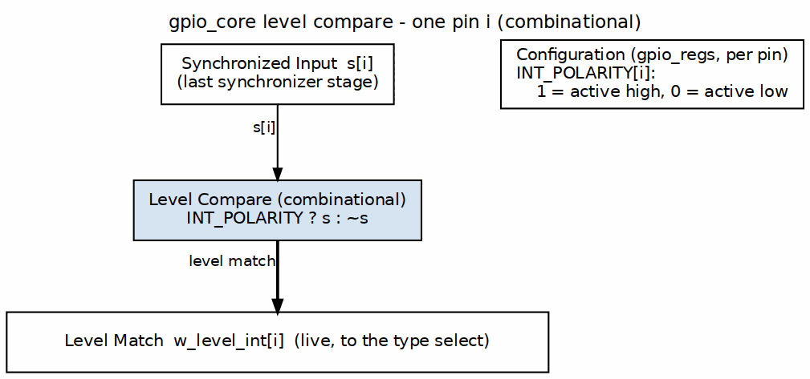
Level Compare
- Continuously compares input to polarity
- The STATUS bit is sticky: it latches on the (enabled) level event and stays set after the level clears, until W1C - same latching as edge mode
- What follows the input level is irq itself, because level pins drive irq from the live detector rather than from GPIO_INT_STATUS

16.2.4 Interrupt Handling

16.2.4.1 Software Sequence
- IRQ asserts (hardware)
- CPU vectors to interrupt handler
- Read GPIO_INT_STATUS to identify sources
- Handle interrupt condition
- Write 1 to GPIO_INT_STATUS bits to clear
- IRQ deasserts if no other sources

16.2.4.2 Clearing Interrupts
Mode | Clear Method
Edge | Write 1 to STATUS bit
Level | Clear source, then write 1 to STATUS

16.3 Timing

16.3.1 Edge-Triggered Latency
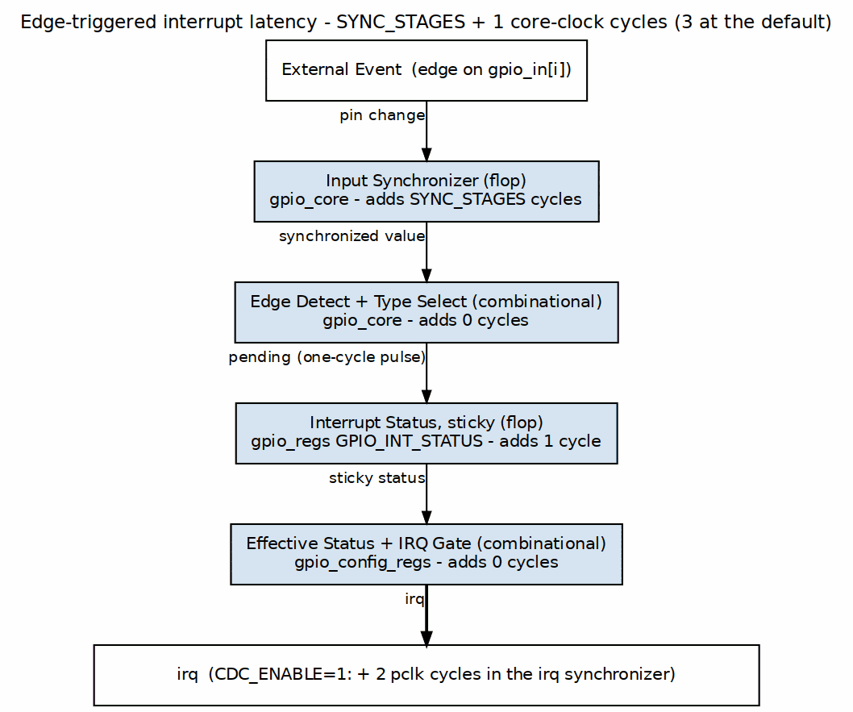
Edge-Triggered Latency
Total: 3 clock cycles typical (SYNC_STAGES=2 + 1 sticky-flop; edge detect adds no cycle)

16.3.2 Level-Sensitive Latency
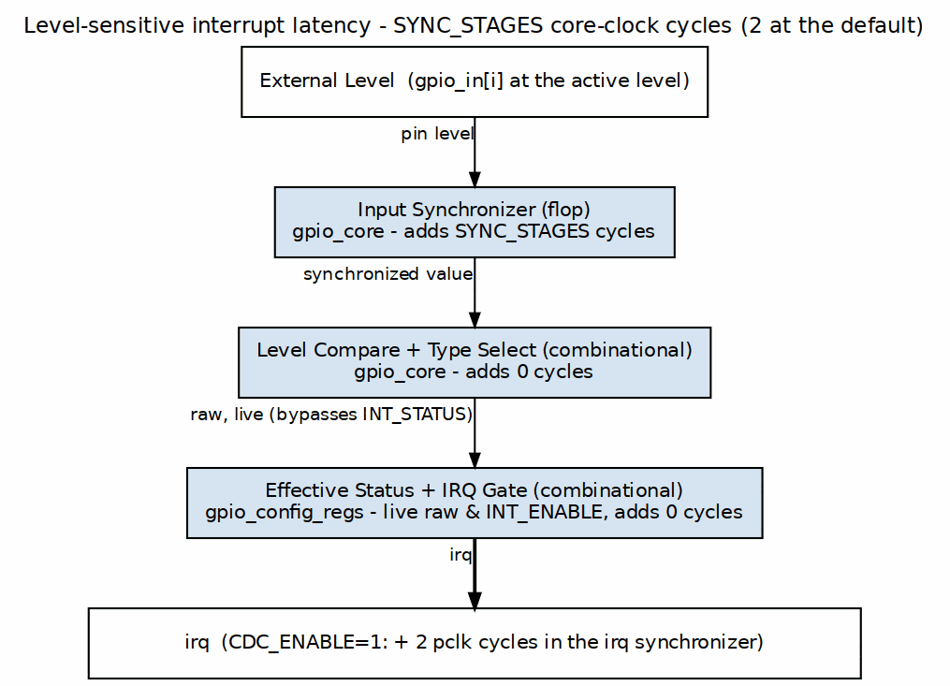
Level-Sensitive Latency
Total: 2 clock cycles typical (level irq is combinational from the synchronizer output)
Both totals are core-clock cycles. With CDC_ENABLE=1 the core clock is gpio_clk and irq then crosses a 2-flop synchronizer into pclk (apb4_gpio.sv, gen_irq_sync), adding two pclk cycles; with CDC_ENABLE=0 there is no crossing and nothing is added.

16.4 Design Notes

16.4.1 Connection Guidelines
- Connect to interrupt controller input
- Active-high, level-sensitive recommended at controller
- Single IRQ covers all 32 GPIO pins
- Already in the pclk domain when CDC_ENABLE=1 (synchronized inside apb4_gpio); no external synchronizer needed

16.5 Navigation
Next: 04_system.md - System Interface

RTL Design Sherpa · Learning Hardware Design Through Practice GitHub · Documentation Index · MIT License

17 APB GPIO - System Interface

17.1 Ports

17.1.1 pclk - APB Clock
Parameter | Value
Purpose | APB interface clock
Frequency | 50-200 MHz typical
Domain | APB bus timing
Used for: - APB protocol timing - Register file access - irq output (generated on pclk when CDC_ENABLE=0; synchronized into pclk when CDC_ENABLE=1)

17.1.2 gpio_clk - GPIO Clock
Parameter | Value
Purpose | GPIO core clock
Frequency | Application dependent
Usage | Only when CDC_ENABLE=1
Used for: - Input synchronization - Output register updates - Interrupt detection

17.1.3 presetn - APB Reset
Parameter | Value
Polarity | Active low
Type | Asynchronous assert, synchronous deassert (see note)
Scope | APB interface logic
Resets: - APB state machine - Register file - Response logic

17.1.4 gpio_rstn - GPIO Reset
Parameter | Value
Polarity | Active low
Type | Asynchronous assert, synchronous deassert (see note)
Usage | Only when CDC_ENABLE=1
Note: the PeakRDL-generated register file (gpio_regs.sv) is the one exception – it resets SYNCHRONOUSLY (plain always_ff @(posedge clk) with an active-high rst derived from the reset input), so its registers do not reset until a core-clock edge arrives.
Resets: - GPIO output registers - Input synchronizers - Interrupt state

17.2 Functional Description

17.2.1 Clock Configurations

17.2.1.1 Single Clock Domain (CDC_ENABLE = 0)
Single Clock Domain
gpio_clk: Tie to pclk or leave unconnected

17.2.1.2 Dual Clock Domain (CDC_ENABLE = 1)
Dual Clock Domain

17.2.2 Reset Sequence

17.2.2.1 Power-On Reset
- Assert both presetn and gpio_rstn low
- Keep both clocks running: the PeakRDL register file resets synchronously (see the note above)
- Hold reset for minimum 2 clock cycles
- Release gpio_rstn first
- Wait 2 gpio_clk cycles
- Release presetn
- Wait 2 pclk cycles before APB access

17.2.3 Figure 3.2: Power-On Reset Sequence
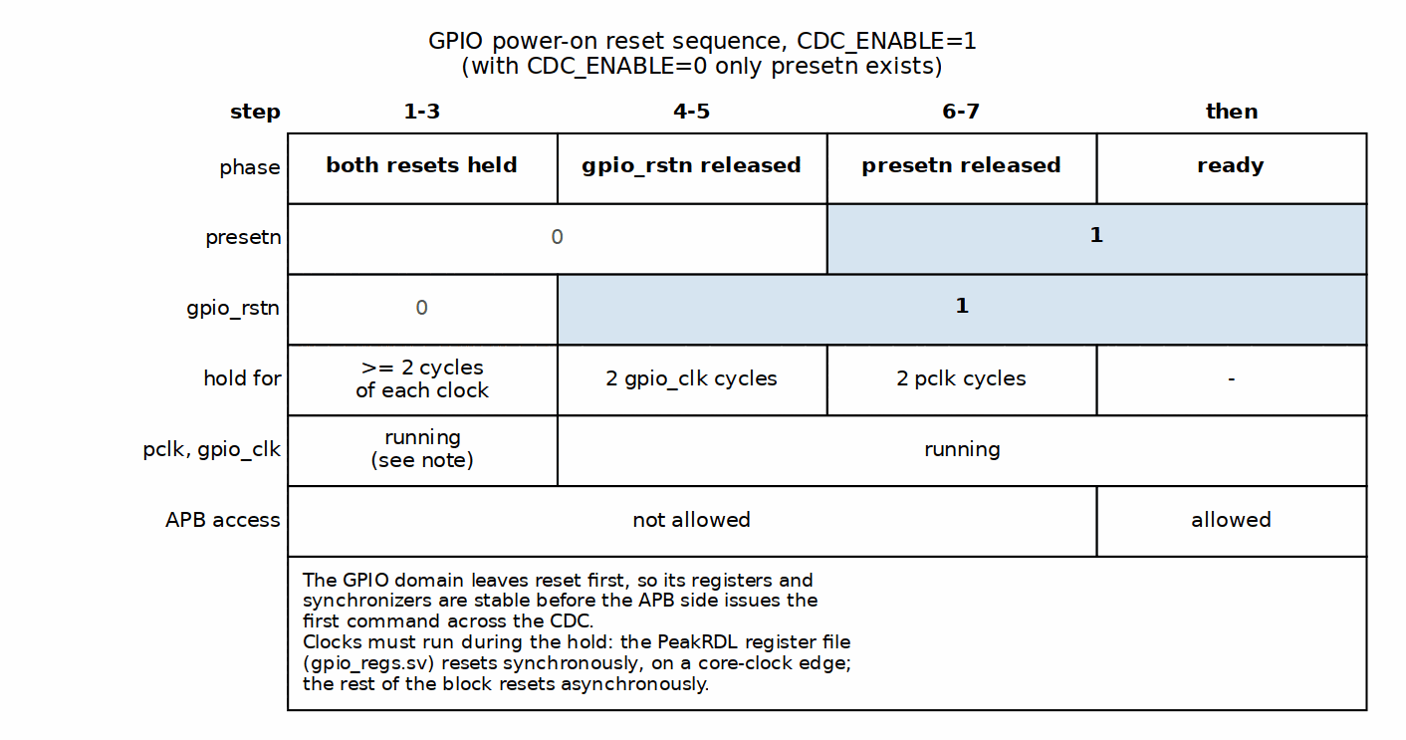
Power-On Reset Sequence

17.3 Timing

17.3.1 Clock Relationship
Mode | Constraint
CDC_ENABLE=0 | Single clock, no special constraints
CDC_ENABLE=1 | Set false_path between domains

17.3.2 Reset Recovery
- Allow minimum 2 clock cycles after reset deassert
- First APB transaction may start on 3rd cycle

17.4 Navigation
Back to: 00_overview.md - Interfaces Overview
Next Chapter: Chapter 4: Programming Model

RTL Design Sherpa · Learning Hardware Design Through Practice GitHub · Documentation Index · MIT License

18 APB GPIO - Programming Model Overview

18.1 Overview
Thirteen registers do all the work. Everything in this chapter is a recipe built on these:
Offset | Name | Access | Reset | Description
0x000 | GPIO_CONTROL | RW | 0x00000001 | Global control
0x004 | GPIO_DIRECTION | RW | 0x00000000 | I/O direction
0x008 | GPIO_OUTPUT | RW | 0x00000000 | Output data
0x00C | GPIO_INPUT | RO | - | Input data
0x010 | GPIO_INT_ENABLE | RW | 0x00000000 | Interrupt enable
0x014 | GPIO_INT_TYPE | RW | 0x00000000 | Edge/level select
0x018 | GPIO_INT_POLARITY | RW | 0xFFFFFFFF | Interrupt polarity
0x01C | GPIO_INT_BOTH | RW | 0x00000000 | Both edges
0x020 | GPIO_INT_STATUS | W1C | 0x00000000 | Interrupt status
0x024 | GPIO_RAW_INT | RO | 0 (live) | Raw (unlatched) event status
0x028 | GPIO_OUTPUT_SET | WO | 0x00000000 | Atomic output set (reads return 0)
0x02C | GPIO_OUTPUT_CLR | WO | 0x00000000 | Atomic output clear (reads return 0)
0x030 | GPIO_OUTPUT_TGL | WO | 0x00000000 | Atomic output toggle (reads return 0)

18.1.1 In This Chapter

18.1.1.1 Basic Operations
Fundamental GPIO read/write operations.
See: 01_basic_operations.md

18.1.1.2 Interrupt Configuration
Setting up and handling GPIO interrupts.
See: 02_interrupt_config.md

18.1.1.3 Programming Examples
Common use cases with code samples.
See: 03_examples.md

18.1.1.4 Software Considerations
Performance tips and best practices.
See: 04_software_notes.md

18.2 Navigation
Next: 01_basic_operations.md - Basic Operations

RTL Design Sherpa · Learning Hardware Design Through Practice GitHub · Documentation Index · MIT License

19 APB GPIO - Basic Operations

19.1 Waveforms
Before the code, the timing. These diagrams show what actually happens inside the block for each basic operation.

19.1.1 Direction Configuration
When software writes to GPIO_DIRECTION, the direction register updates and controls the output enable for each pin.
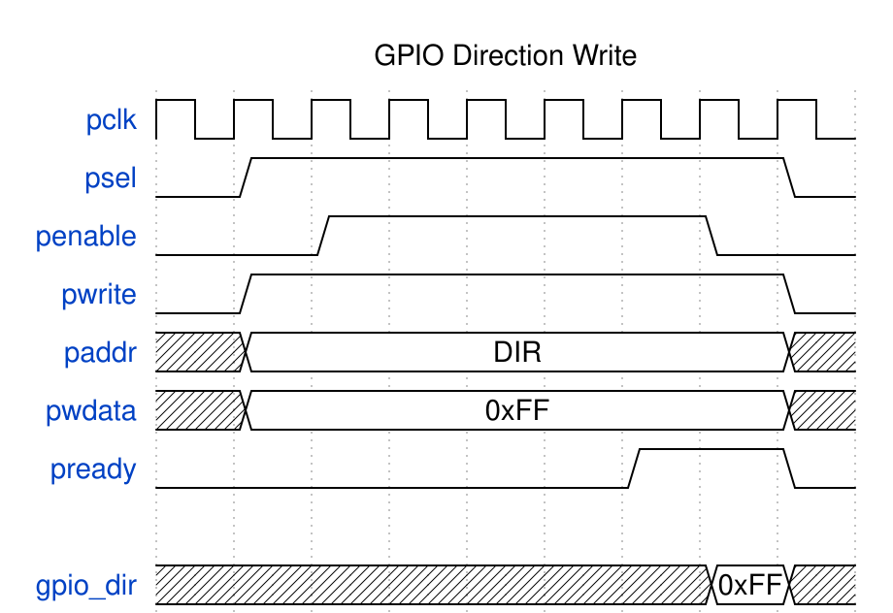
GPIO Direction Write
The APB write is PREADY-gated – a few pclk beyond the two-cycle APB minimum (see Chapter 3.1). The direction register updates on the clock edge following PREADY, and the output enable (gpio_oe) reflects the new configuration immediately.

19.1.2 Output Write
Writing to GPIO_OUTPUT sets the output data register, which drives the external pins when direction is set to output.
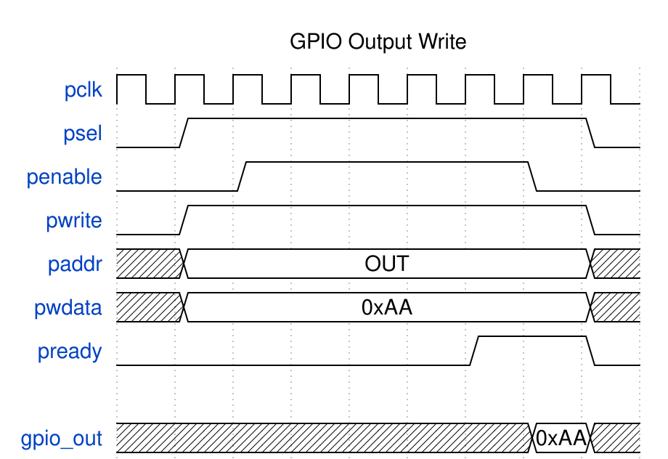
GPIO Output Write
The write data flows through the APB interface to the output register. When gpio_oe[n] is high (output mode), gpio_out[n] drives the written value to the external pin. The write is strobe-driven, so writing the value the register already holds is still a write and still lands.

19.1.3 Input Read
Reading GPIO_INPUT returns the synchronized input values from external pins.
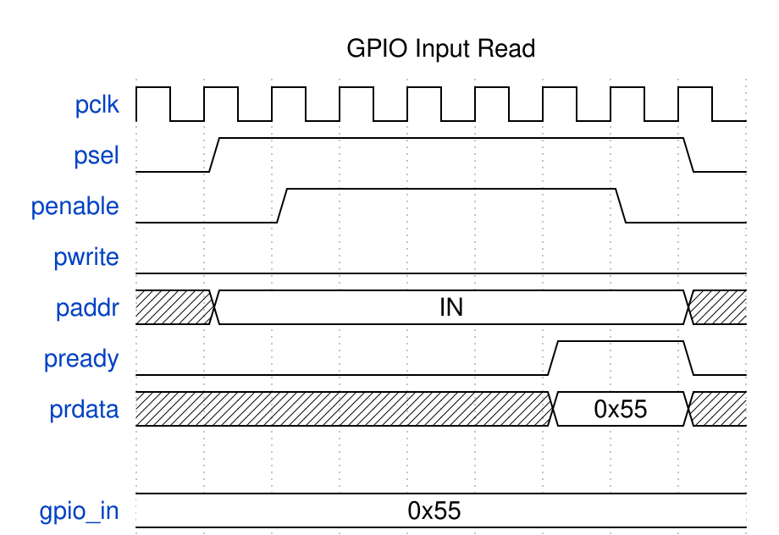
GPIO Input Read
External inputs pass through a 2-stage synchronizer before being captured. The synchronized value (w_gpio_sync) is returned on s_apb_PRDATA during the APB read transaction.

19.1.4 Input Synchronization
All GPIO inputs pass through a 2-stage synchronizer to prevent metastability.
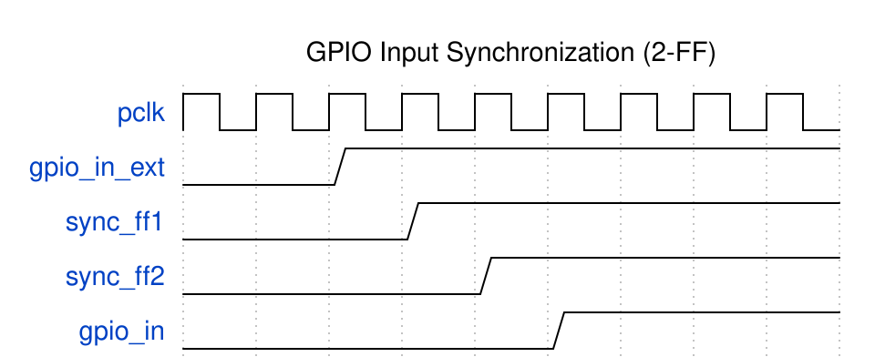
GPIO Input Sync
The synchronizer adds 2 clock cycles of latency. External asynchronous transitions on gpio_in propagate through sync_stage1 and sync_stage2 before appearing on the internal synchronized signal w_gpio_sync.

19.1.5 Atomic Operations
The SET, CLEAR, and TOGGLE registers provide atomic bit manipulation without read-modify-write races.
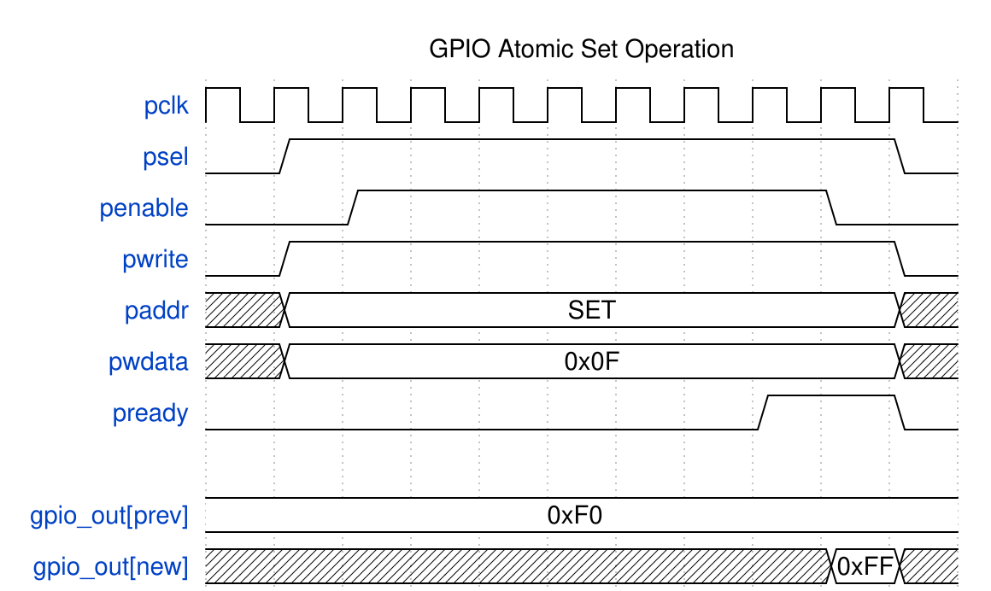
GPIO Atomic Operations
Three consecutive APB writes demonstrate: 1. GPIO_OUTPUT_SET (0x028): Sets bits where write data is 1, leaves others unchanged 2. GPIO_OUTPUT_CLR (0x02C): Clears bits where write data is 1, leaves others unchanged 3. GPIO_OUTPUT_TGL (0x030): Inverts bits where write data is 1, leaves others unchanged
Each write performs its operation: the RTL fires the atomic pulse from the register’s write strobe, so writing the same mask twice performs the operation twice, and nothing needs to be written between operations. The registers are write-only and read as 0; GPIO_OUTPUT reads back the live result. See Chapter 5 for the full semantics.

19.2 Usage Example

19.2.1 Initialization

19.2.1.1 Reset State
After reset: - GPIO_CONTROL = 0x00000001 - output stage ENABLED, global interrupt enable clear - All pins configured as inputs (GPIO_DIRECTION = 0), so every pin is high-Z despite the enable - No per-pin interrupts enabled; GPIO_INT_POLARITY resets to 0xFFFFFFFF (rising/active-high)

19.2.1.2 Enable GPIO
// GPIO_CONTROL[0] (ENABLE) already resets to 1; write it explicitly if a
// previous owner may have cleared it. ENABLE gates only the output drivers.
GPIO_CONTROL = 0x00000001;

19.2.2 Output Operations

19.2.2.1 Configure as Output
// Set pins 7:4 as outputs (bits = 1 for output)
GPIO_DIRECTION = 0x000000F0;

19.2.2.2 Write Output Values
// Set pins 7:4 to value 0101
GPIO_OUTPUT = 0x00000050;

19.2.2.3 Toggle Outputs
// Atomic toggle of pins 7:4; every write toggles, so a loop that
// writes this each iteration toggles on every pass
GPIO_OUTPUT_TGL = 0x000000F0;

19.2.2.4 Atomic Bit Operations
// Set specific bits (pins 5 and 7)
GPIO_OUTPUT_SET = 0x000000A0;
// Clear specific bits (pins 4 and 6)
GPIO_OUTPUT_CLR = 0x00000050;
Read-modify-write of GPIO_OUTPUT (GPIO_OUTPUT |= mask) mixes safely with the atomic registers: GPIO_OUTPUT reads back the live output latch, so after GPIO_OUTPUT = 0xFF and GPIO_OUTPUT_CLR = 0x0F a read returns 0xF0 and an RMW builds on the real pin state. Prefer the atomic registers where two contexts may update outputs concurrently – that is what they are for.

19.2.3 Input Operations

19.2.3.1 Configure as Input
// Set pins 3:0 as inputs (bits = 0 for input)
GPIO_DIRECTION &= ~0x0000000F;

19.2.3.2 Read Input Values
// Read all inputs
uint32_t inputs = GPIO_INPUT;
// Check specific pin (pin 2)
if (inputs & 0x00000004) {
// Pin 2 is high
}

19.2.3.3 Read with Mask
// Read only pins 3:0
uint32_t low_nibble = GPIO_INPUT & 0x0000000F;

19.2.4 Mixed I/O Configuration

19.2.4.1 Configure Mixed Directions
// Pins 31:16 = outputs, pins 15:0 = inputs
GPIO_DIRECTION = 0xFFFF0000;

19.2.4.2 Read-Modify-Write Pattern
// Change only pins 11:8 to outputs
uint32_t dir = GPIO_DIRECTION;
dir |= 0x00000F00; // Set pins 11:8
GPIO_DIRECTION = dir;

19.2.5 Output Enable Behavior

19.2.5.1 Hardware Interface
When direction bit is set: - gpio_oe[i] = 1 (output enabled) - gpio_out[i] = GPIO_OUTPUT[i] value
When direction bit is clear: - gpio_oe[i] = 0 (high impedance) - gpio_out[i] = don’t care

19.2.5.2 Glitch Considerations
To avoid output glitches when switching direction: 1. Set GPIO_OUTPUT to desired value 2. Then change GPIO_DIRECTION
// Safe direction change to output
GPIO_OUTPUT = desired_value; // Set value first
GPIO_DIRECTION |= pin_mask; // Then enable output

19.3 Navigation
Next: 02_interrupt_config.md - Interrupt Configuration

RTL Design Sherpa · Learning Hardware Design Through Practice GitHub · Documentation Index · MIT License

20 APB GPIO - Interrupt Configuration

20.1 Waveforms
First, what the hardware does. These diagrams walk through detection and clearing, one mode at a time.

20.1.1 Rising Edge Interrupt
Edge-triggered interrupts detect transitions on input pins.
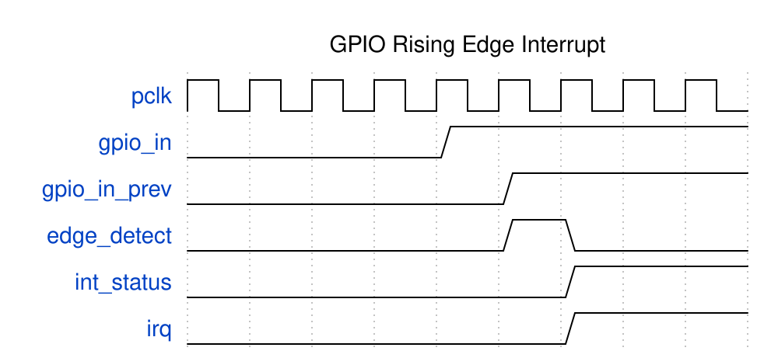
GPIO Rising Edge Interrupt
The detection sequence: 1. External input gpio_in[0] transitions from 0 to 1 2. 2-stage synchronizer captures the transition (w_gpio_sync) 3. Edge detector compares current vs. delayed value (r_gpio_prev) 4. Rising edge pulse (w_rising_edge) generated for one clock 5. Raw pulse (w_raw_int[0], combinational) sets the sticky GPIO_INT_STATUS bit in the register file 6. Combined irq output asserts

20.1.2 Falling Edge Interrupt
Falling edge detection uses inverted polarity configuration.
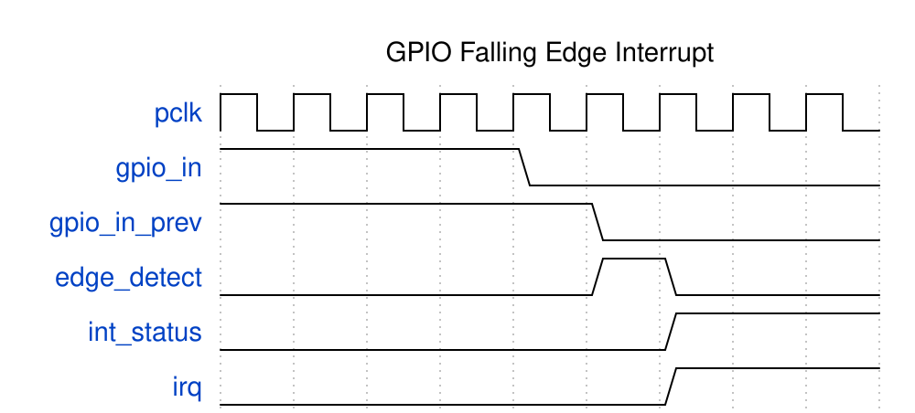
GPIO Falling Edge Interrupt
With cfg_int_type[0]=0 (edge mode) and cfg_int_polarity[0]=0 (falling edge), the detector triggers on 1-to-0 transitions.

20.1.3 Level-Sensitive Interrupt
Level-sensitive interrupts track the input state directly.
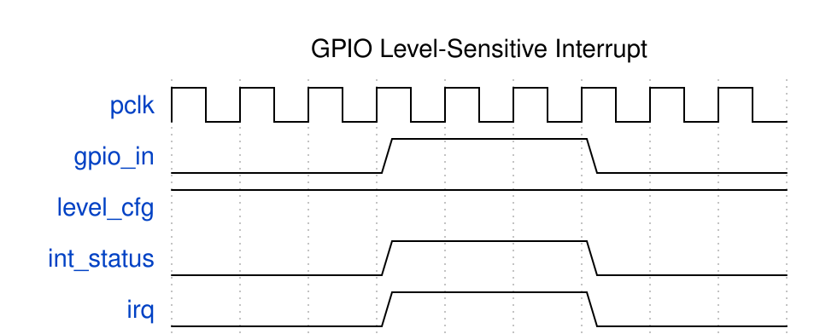
GPIO Level Interrupt
Key differences from edge mode: - irq follows the input level (not latched) - No edge detection logic involved - Interrupt re-asserts if source not cleared before ISR exit

20.1.4 Interrupt Clear (W1C)
Write-1-to-Clear mechanism clears latched interrupts.
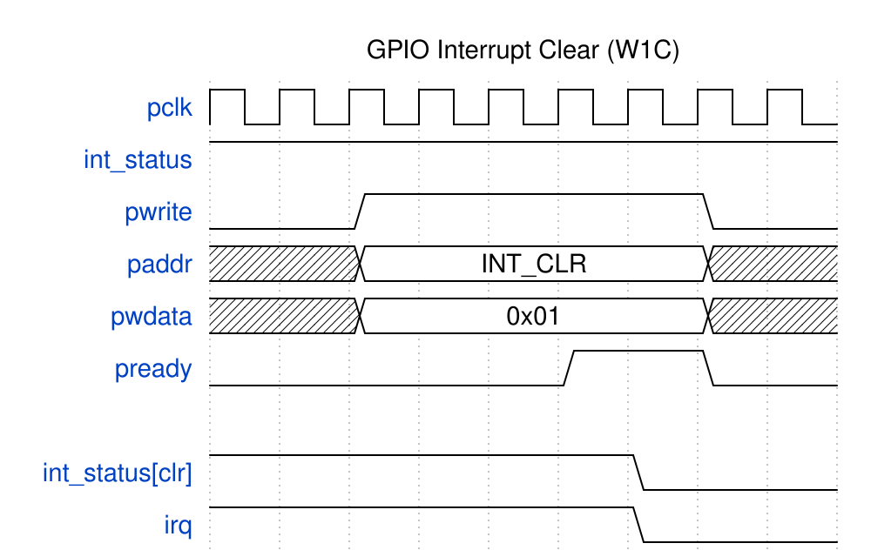
GPIO Interrupt Clear
The clear sequence: 1. GPIO_INT_STATUS[0] is set (edge was detected and latched) 2. Software writes 0x01 to INT_STATUS register 3. W1C logic clears the sticky status bit 4. irq deasserts
Note: For level-sensitive interrupts, the external source must be cleared first, otherwise the interrupt immediately re-asserts.

20.2 Functional Description

20.2.1 Interrupt Configuration Table
Every combination of the three mode fields, in one place:
INT_TYPE | INT_POLARITY | INT_BOTH | Trigger
0 | 0 | 0 | Falling edge
0 | 1 | 0 | Rising edge
0 | X | 1 | Both edges
1 | 0 | X | Active low
1 | 1 | X | Active high

20.3 Usage Example

20.3.1 Interrupt Setup
Four steps, in order. Skipping step 4 is the classic mistake — the global enable resets to 0, so nothing ever interrupts.

20.3.1.1 1. Configure Interrupt Type
// Edge-triggered (0) or Level-sensitive (1)
// Pins 3:0 edge, pins 7:4 level
GPIO_INT_TYPE = 0x000000F0;

20.3.1.2 2. Configure Polarity
For edge mode: - 0 = falling edge - 1 = rising edge
For level mode: - 0 = active low - 1 = active high
// Rising edge / active high for pins 7:0
GPIO_INT_POLARITY = 0x000000FF;

20.3.1.3 3. Configure Both-Edge Mode (Edge Mode Only)
// Enable both edges for pin 0
GPIO_INT_BOTH = 0x00000001;

20.3.1.4 4. Enable Interrupts
// Enable interrupts on pins 7:0
GPIO_INT_ENABLE = 0x000000FF;
// Set the GLOBAL interrupt enable, GPIO_CONTROL[1] - it resets to 0 and
// gates the irq output, so without this step no interrupt ever asserts.
GPIO_CONTROL |= 0x00000002;

20.3.2 Complete Setup Examples

20.3.2.1 Rising Edge Interrupt
// Configure pin 5 for rising edge interrupt
GPIO_INT_TYPE &= ~(1 << 5); // Edge mode
GPIO_INT_POLARITY |= (1 << 5); // Rising edge
GPIO_INT_BOTH &= ~(1 << 5); // Single edge
GPIO_INT_ENABLE |= (1 << 5); // Per-pin enable
GPIO_CONTROL |= 0x2; // Global INT_ENABLE (resets to 0; irq never asserts without it)

20.3.2.2 Both-Edge Interrupt
// Configure pin 3 for both-edge interrupt
GPIO_INT_TYPE &= ~(1 << 3); // Edge mode
GPIO_INT_BOTH |= (1 << 3); // Both edges
GPIO_INT_ENABLE |= (1 << 3); // Per-pin enable
GPIO_CONTROL |= 0x2; // Global INT_ENABLE

20.3.2.3 Active-Low Level Interrupt
// Configure pin 7 for active-low level interrupt
GPIO_INT_TYPE |= (1 << 7); // Level mode
GPIO_INT_POLARITY &= ~(1 << 7); // Active low
GPIO_INT_ENABLE |= (1 << 7); // Per-pin enable
GPIO_CONTROL |= 0x2; // Global INT_ENABLE

20.3.3 Interrupt Handling

20.3.3.1 Check Interrupt Status
uint32_t status = GPIO_INT_STATUS;

20.3.3.2 Clear Interrupts (Write-1-to-Clear)
// Clear specific interrupt (pin 5)
GPIO_INT_STATUS = (1 << 5);
// Clear all pending interrupts
GPIO_INT_STATUS = 0xFFFFFFFF;

20.3.3.3 Complete ISR Example
void gpio_isr(void) {
// Read status
uint32_t status = GPIO_INT_STATUS;
// Handle each pending interrupt
for (int i = 0; i < 32; i++) {
if (status & (1 << i)) {
handle_gpio_event(i);
}
}
// Clear handled interrupts
GPIO_INT_STATUS = status;
}

20.3.4 Level-Sensitive Considerations

20.3.4.1 Avoid Interrupt Storm
For level-sensitive interrupts, the source must be cleared before the status:
void level_sensitive_isr(void) {
uint32_t status = GPIO_INT_STATUS;
// For level-sensitive pins, handle source first
if (status & LEVEL_PIN_MASK) {
clear_external_source(); // Clear what's driving pin
}
// Then clear status
GPIO_INT_STATUS = status;
}

20.3.4.2 Masking During Handling
Use the global enable, GPIO_CONTROL[1]. Clearing GPIO_INT_ENABLE does NOT mask an edge interrupt that has already latched into GPIO_INT_STATUS (the per-pin enable is only sampled when the event sets the sticky bit), so an enable-save/restore recipe leaves irq asserted for pending edge sources.
// Temporarily mask everything while handling
GPIO_CONTROL &= ~0x00000002; // global interrupt enable off
// Handle interrupt source
handle_interrupt();
// Unmask
GPIO_CONTROL |= 0x00000002;

20.4 Navigation
Next: 03_examples.md - Programming Examples

RTL Design Sherpa · Learning Hardware Design Through Practice GitHub · Documentation Index · MIT License

21 APB GPIO - Programming Examples

21.1 Usage Example
Real recipes for the things people actually hang off a GPIO. Copy, paste, adjust the pin numbers.

21.1.1 LED Control

21.1.1.1 Simple LED Blink
#define LED_PIN (1 << 0)
void led_init(void) {
GPIO_CONTROL = 1; // Enable GPIO
GPIO_DIRECTION |= LED_PIN; // Set as output
}
void led_on(void) {
GPIO_OUTPUT |= LED_PIN;
}
void led_off(void) {
GPIO_OUTPUT &= ~LED_PIN;
}
void led_toggle(void) {
GPIO_OUTPUT ^= LED_PIN;
}
The read-modify-write style above is fine alongside the atomic GPIO_OUTPUT_SET/CLR/TGL registers: GPIO_OUTPUT reads back the live output latch, so an RMW always starts from what the pins are actually driving (Chapter 5). Where two contexts may update outputs at once, the atomic registers avoid the RMW race entirely, and every write takes effect:
void led_on(void) { GPIO_OUTPUT_SET = LED_PIN; }
void led_off(void) { GPIO_OUTPUT_CLR = LED_PIN; }
void led_toggle(void) { GPIO_OUTPUT_TGL = LED_PIN; }

21.1.1.2 Multiple LED Control
#define LED_MASK 0x000000FF // LEDs on pins 7:0
void leds_write(uint8_t pattern) {
uint32_t output = GPIO_OUTPUT;
output = (output & ~LED_MASK) | pattern;
GPIO_OUTPUT = output;
}

21.1.2 Button Input

21.1.2.1 Simple Button Read
#define BUTTON_PIN (1 << 8)
void button_init(void) {
GPIO_CONTROL = 1; // Enable GPIO
GPIO_DIRECTION &= ~BUTTON_PIN; // Set as input
}
bool button_pressed(void) {
return (GPIO_INPUT & BUTTON_PIN) != 0;
}

21.1.2.2 Button with Interrupt
#define BUTTON_PIN (1 << 8)
volatile bool button_event = false;
void button_init_irq(void) {
GPIO_CONTROL = 1;
GPIO_DIRECTION &= ~BUTTON_PIN;
// Configure falling edge interrupt (button press)
GPIO_INT_TYPE &= ~BUTTON_PIN; // Edge mode
GPIO_INT_POLARITY &= ~BUTTON_PIN; // Falling edge
GPIO_INT_BOTH &= ~BUTTON_PIN; // Single edge
GPIO_INT_ENABLE |= BUTTON_PIN; // Enable pin
GPIO_CONTROL |= 0x2; // Global interrupt enable (resets to 0)
}
void button_isr(void) {
if (GPIO_INT_STATUS & BUTTON_PIN) {
button_event = true;
GPIO_INT_STATUS = BUTTON_PIN; // Clear
}
}

21.1.3 DIP Switch Reading

21.1.3.1 8-Bit Switch Input
#define SWITCH_MASK 0x00FF0000 // Switches on pins 23:16
#define SWITCH_SHIFT 16
void switch_init(void) {
GPIO_CONTROL = 1;
GPIO_DIRECTION &= ~SWITCH_MASK; // All inputs
}
uint8_t switch_read(void) {
return (GPIO_INPUT & SWITCH_MASK) >> SWITCH_SHIFT;
}

21.1.4 Parallel Data Interface

21.1.4.1 8-Bit Output Port
#define DATA_MASK 0x000000FF // Data on pins 7:0
#define STROBE_PIN (1 << 8) // Strobe on pin 8
void data_port_init(void) {
GPIO_CONTROL = 1;
GPIO_DIRECTION |= (DATA_MASK | STROBE_PIN);
GPIO_OUTPUT &= ~STROBE_PIN; // Strobe low
}
void data_write(uint8_t data) {
uint32_t output = GPIO_OUTPUT;
output = (output & ~DATA_MASK) | data;
GPIO_OUTPUT = output;
// Generate strobe pulse
GPIO_OUTPUT |= STROBE_PIN;
// Small delay if needed
GPIO_OUTPUT &= ~STROBE_PIN;
}

21.1.4.2 8-Bit Input Port with Ready
#define DATA_MASK 0x000000FF // Data on pins 7:0
#define READY_PIN (1 << 8) // Ready on pin 8
void data_input_init(void) {
GPIO_CONTROL = 1;
GPIO_DIRECTION &= ~(DATA_MASK | READY_PIN);
// Interrupt on ready rising edge
GPIO_INT_TYPE &= ~READY_PIN;
GPIO_INT_POLARITY |= READY_PIN;
GPIO_INT_ENABLE |= READY_PIN;
}
uint8_t data_read(void) {
return GPIO_INPUT & DATA_MASK;
}

21.1.5 PWM-Style Output

21.1.5.1 Bit-Banged PWM (Low Frequency)
#define PWM_PIN (1 << 0)
void pwm_init(void) {
GPIO_CONTROL = 1;
GPIO_DIRECTION |= PWM_PIN;
}
// Call from timer interrupt
void pwm_update(uint8_t duty, uint8_t *counter) {
(*counter)++;
if (*counter >= 100) *counter = 0;
if (*counter < duty) {
GPIO_OUTPUT |= PWM_PIN;
} else {
GPIO_OUTPUT &= ~PWM_PIN;
}
}

21.1.6 Wake-On-Change

21.1.6.1 Power Management Integration
#define WAKE_PINS 0x0000000F // Wake sources on pins 3:0
void wake_setup(void) {
// Configure both-edge interrupts for wake pins
GPIO_INT_TYPE &= ~WAKE_PINS; // Edge mode
GPIO_INT_BOTH |= WAKE_PINS; // Both edges
GPIO_INT_ENABLE |= WAKE_PINS; // Enable
// Clear any pending before sleep
GPIO_INT_STATUS = WAKE_PINS;
}
void enter_sleep(void) {
wake_setup();
// Platform-specific sleep entry
__WFI(); // Wait for interrupt
}

21.2 Navigation
Next: 04_software_notes.md - Software Considerations

RTL Design Sherpa · Learning Hardware Design Through Practice GitHub · Documentation Index · MIT License

22 APB GPIO - Software Considerations

22.1 Design Notes
The stuff that separates a driver that works from a driver that works reliably. None of this is in the register map; all of it matters.

22.1.1 Performance

22.1.1.1 Register Access Timing
Operation | APB Cycles | Notes
Read | 2 + wait states | PREADY-gated (bridge FSM + cmd/rsp handshake)
Write | 2 + wait states | PREADY-gated
Read-Modify-Write | one read + one write | Each PREADY-gated

22.1.1.2 Optimizing Access
Batch operations when possible:
// Inefficient - 4 separate writes
GPIO_OUTPUT |= (1 << 0);
GPIO_OUTPUT |= (1 << 1);
GPIO_OUTPUT |= (1 << 2);
GPIO_OUTPUT |= (1 << 3);
// Efficient - single write
GPIO_OUTPUT |= 0x0000000F;
Cache register values:
// Inefficient - 4 reads + 4 writes
for (int i = 0; i < 4; i++) {
GPIO_DIRECTION |= (1 << i);
}
// Efficient - 1 read + 1 write
uint32_t dir = GPIO_DIRECTION;
dir |= 0x0000000F;
GPIO_DIRECTION = dir;

22.1.2 Synchronization

22.1.2.1 Input Latency
GPIO inputs have inherent latency: - SYNC_STAGES clock cycles (default 2) - Plus software polling/interrupt overhead
Account for latency in timing-critical code.

22.1.2.2 Volatile Registers
Always declare GPIO registers as volatile:
#define GPIO_INPUT (*(volatile uint32_t *)0xFEC0700C)

22.1.2.3 Multi-Core Considerations
If multiple cores access GPIO:
// Use atomic operations or locks
spin_lock(&gpio_lock);
uint32_t val = GPIO_OUTPUT;
val |= new_bits;
GPIO_OUTPUT = val;
spin_unlock(&gpio_lock);

22.1.3 Interrupt Best Practices

22.1.3.1 Clear Before Return
Always clear interrupt status before ISR return:
void gpio_isr(void) {
uint32_t status = GPIO_INT_STATUS;
// Handle interrupts
GPIO_INT_STATUS = status; // Must clear!
}

22.1.3.2 Avoid Spurious Interrupts
Disable interrupts during configuration:
void reconfigure_interrupt(int pin) {
uint32_t mask = (1 << pin);
// Disable first
GPIO_INT_ENABLE &= ~mask;
// Reconfigure
// ...
// Clear any pending
GPIO_INT_STATUS = mask;
// Re-enable
GPIO_INT_ENABLE |= mask;
}

22.1.3.3 Level-Sensitive Caution
Level interrupts can cause interrupt storms:
void level_isr(void) {
// WRONG - will re-trigger immediately
GPIO_INT_STATUS = status;
// RIGHT - handle source first
clear_external_interrupt_source();
GPIO_INT_STATUS = status;
}

22.1.4 Error Handling

22.1.4.1 No Hardware Errors
GPIO controller doesn’t generate errors: - All addresses valid - pslverr always 0

22.1.4.2 Software Validation
Validate configuration in software:
bool gpio_set_direction(uint32_t pin, bool output) {
if (pin >= 32) return false;
if (output) {
GPIO_DIRECTION |= (1 << pin);
} else {
GPIO_DIRECTION &= ~(1 << pin);
}
return true;
}

22.1.5 Debug Tips

22.1.5.1 Read-Back Verification
void gpio_debug(void) {
printf("CONTROL: 0x%08X\n", GPIO_CONTROL);
printf("DIRECTION: 0x%08X\n", GPIO_DIRECTION);
printf("OUTPUT: 0x%08X\n", GPIO_OUTPUT);
printf("INPUT: 0x%08X\n", GPIO_INPUT);
printf("INT_STAT: 0x%08X\n", GPIO_INT_STATUS);
}

22.1.5.2 Loopback Testing
Connect output to input for self-test:
bool gpio_loopback_test(int out_pin, int in_pin) {
GPIO_DIRECTION |= (1 << out_pin);
GPIO_DIRECTION &= ~(1 << in_pin);
// Test high
GPIO_OUTPUT |= (1 << out_pin);
delay_us(10); // Allow synchronization
if (!(GPIO_INPUT & (1 << in_pin))) return false;
// Test low
GPIO_OUTPUT &= ~(1 << out_pin);
delay_us(10);
if (GPIO_INPUT & (1 << in_pin)) return false;
return true;
}

22.2 Navigation
Back to: 00_overview.md - Programming Model Overview
Next Chapter: Chapter 5: Registers

RTL Design Sherpa · Learning Hardware Design Through Practice GitHub · Documentation Index · MIT License

23 APB GPIO - Register Map

23.1 Overview
Thirteen registers, verified against the RTL decode (gpio_regs.sv) and ../../rdl/gpio/gpio_regs.rdl. GPIO_REGS_SIZE = 0x34.
Offset | Name | Access | Reset | Description
0x000 | GPIO_CONTROL | RW | 0x00000001 | Global enable + global interrupt enable
0x004 | GPIO_DIRECTION | RW | 0x00000000 | Pin direction
0x008 | GPIO_OUTPUT | RW | 0x00000000 | Output data
0x00C | GPIO_INPUT | RO | - | Input data
0x010 | GPIO_INT_ENABLE | RW | 0x00000000 | Per-pin interrupt enable
0x014 | GPIO_INT_TYPE | RW | 0x00000000 | Interrupt type
0x018 | GPIO_INT_POLARITY | RW | 0xFFFFFFFF | Interrupt polarity
0x01C | GPIO_INT_BOTH | RW | 0x00000000 | Both-edge enable
0x020 | GPIO_INT_STATUS | W1C | 0x00000000 | Latched interrupt status
0x024 | GPIO_RAW_INT | RO | 0 (live) | Live (unlatched) event detector output – reads 0 at reset only because type/polarity/sync all reset to 0; depends on pins thereafter
0x028 | GPIO_OUTPUT_SET | WO | 0x00000000 | Atomic output set (reads return 0)
0x02C | GPIO_OUTPUT_CLR | WO | 0x00000000 | Atomic output clear (reads return 0)
0x030 | GPIO_OUTPUT_TGL | WO | 0x00000000 | Atomic output toggle (reads return 0)
Address decode and aliasing: only address bits [5:0] reach the register block (gpio_config_regs.sv passes regblk_addr[5:0]), so the 13-register map aliases every 64 bytes across the 4KB APB window. Offsets 0x034-0x03F within each 64-byte tile are unmapped and read as zero; no access ever raises PSLVERR.

23.2 GPIO_CONTROL (0x000)
Global control register.
Bits | Name | Access | Reset | Description
31:2 | Reserved | RO | 0 | Reserved
1 | INT_ENABLE | RW | 0 | Global interrupt enable. Gates the irq output: irq = INT_ENABLE && (any effective pending interrupt). Resets to 0, so no interrupt asserts until software sets this bit.
0 | ENABLE | RW | 1 | GPIO output enable. Gates only gpio_oe: when 0, every pin is high-Z regardless of GPIO_DIRECTION. Output data, input synchronization, and interrupt detection are unaffected. Resets to 1 (enabled).

23.3 GPIO_DIRECTION (0x004)
Pin direction control. Each bit controls one GPIO pin.
Bits | Name | Access | Reset | Description
31:0 | DIR | RW | 0 | Direction per pin (0=input, 1=output)

23.4 GPIO_OUTPUT (0x008)
Output data register. Values driven when pin configured as output.
Bits | Name | Access | Reset | Description
31:0 | DATA | RW | 0 | Output values per pin
Readback: reads return the live output latch (r_output_data in gpio_core.sv), not merely the last value software wrote. After any atomic operation (GPIO_OUTPUT_SET/CLR/TGL) the core writes its latch back into this register one cycle later, so the register and the pins stay in agreement: write 0xFF here, then 0x0F to GPIO_OUTPUT_CLR, and a read returns 0xF0. A read-modify-write of GPIO_OUTPUT therefore mixes safely with the atomic registers. The write itself is strobe-driven, so writing the value the register already holds still lands, and a software write wins over a coincident hardware write-back.

23.5 GPIO_INPUT (0x00C)
Input data register. Reflects synchronized external pin values.
Bits | Name | Access | Reset | Description
31:0 | DATA | RO | - | Input values per pin
Note: Value depends on external signals, not reset.

23.6 GPIO_INT_ENABLE (0x010)
Interrupt enable register. Controls which pins can generate interrupts.
Bits | Name | Access | Reset | Description
31:0 | IE | RW | 0 | Interrupt enable per pin (1=enabled)

23.7 GPIO_INT_TYPE (0x014)
Interrupt type select. Chooses edge or level sensitivity.
Bits | Name | Access | Reset | Description
31:0 | TYPE | RW | 0 | Type per pin (0=edge, 1=level)

23.8 GPIO_INT_POLARITY (0x018)
Interrupt polarity select.
Bits | Name | Access | Reset | Description
31:0 | POL | RW | 0xFFFFFFFF | Polarity per pin (resets to all rising/active-high)
For edge mode: 0=falling, 1=rising For level mode: 0=active-low, 1=active-high

23.9 GPIO_INT_BOTH (0x01C)
Both-edge interrupt enable. Only applicable in edge mode.
Bits | Name | Access | Reset | Description
31:0 | BOTH | RW | 0 | Both edges per pin (1=both edges)
When set, GPIO_INT_POLARITY is ignored for that pin.

23.10 GPIO_INT_STATUS (0x020)
Latched interrupt status register.
Bits | Name | Access | Reset | Description
31:0 | STATUS | W1C | 0 | Latched interrupt event per pin
Access: Read returns current status. Write 1 clears the bit.
Semantics (per the RTL):
- A bit sets only when the event occurs while that pin’s GPIO_INT_ENABLE bit is 1 (sts_int_pending = raw & enable, gpio_core.sv). Events on disabled pins set nothing.
- Bits latch (stay set) until written-1-to-clear, in both edge and level modes. In level mode the bit remains set after the input level clears.
- The irq output uses this register only for edge-mode pins. Level-mode pins drive irq from the live detector output, so W1C on a level pin does not deassert irq while the level persists (see Chapter 3.3).
- A W1C write that lands in the same cycle as a new hardware event is merged per bit, next = (value | hw_set) & ~w1c_mask: bits the write is not clearing keep the coincident event (gpio_config_regs.sv holds the set in a one-cycle deferred-set register and applies it once the write completes), and a bit the write IS clearing is cleared, as in any W1C register. No event is lost on a bit software did not ask to clear.

23.11 GPIO_RAW_INT (0x024)
Live event-detector output, before per-pin enable gating and latching.
Bits | Name | Access | Reset | Description
31:0 | RAW | RO | 0 | Raw interrupt condition per pin
Reflects the edge/level detector output combinationally; not affected by GPIO_INT_ENABLE, GPIO_CONTROL, or W1C.

23.12 GPIO_OUTPUT_SET (0x028)
Atomic output set: writing 1 to a bit sets the corresponding output pin without a read-modify-write of GPIO_OUTPUT.
Bits | Name | Access | Reset | Description
31:0 | SET | WO | 0 | Set output pins (1=set); reads return 0

23.13 GPIO_OUTPUT_CLR (0x02C)
Atomic output clear.
Bits | Name | Access | Reset | Description
31:0 | CLR | WO | 0 | Clear output pins (1=clear); reads return 0

23.14 GPIO_OUTPUT_TGL (0x030)
Atomic output toggle.
Bits | Name | Access | Reset | Description
31:0 | TGL | WO | 0 | Toggle output pins (1=toggle); reads return 0

23.15 Design Notes

23.15.1 Atomic-Register Write Semantics (SET/CLR/TGL)
Every write performs the operation, driven by the register’s write strobe (gpio_config_regs.sv). The regblock exports swmod for each register; it is a level held for the whole command-bridge transaction and it leads the field storage by one cycle, so the wrapper takes its rising edge (one write, one event), delays it one flop to line up with the stored mask, and gates the mask with that one-cycle strobe to form the pulse gpio_core acts on:
assign w_set_wr_event = w_set_swmod & ~r_set_swmod_d; // rising edge
r_set_stb <= w_set_wr_event; // align to field
assign w_output_set = r_set_stb ? GPIO_OUTPUT_SET.set_bits.value : '0;
SystemRDL restricts singlepulse to 1-bit fields, which is why the 32-bit masks are pulsed this way rather than self-clearing.
What software can rely on:
- Writing the same mask twice performs the operation twice. A toggle loop writing GPIO_OUTPUT_TGL = mask each iteration toggles on every pass.
- Alternating SET and CLR of the same mask performs every operation; nothing needs to be written in between, and no software shadow of the mask is needed.
- The registers are write-only by design (the RDL declares sw = w): reads at 0x028/0x02C/0x030 return 0. The result of an operation is observable in GPIO_OUTPUT, which reads back the live latch.
These are the conventional set/clear/toggle semantics (fixed 2026-09-08, issue #44).

23.15.2 Address Calculation
For system address:
Register_Address = BASE_ADDR + WINDOW_OFFSET + Register_Offset
Where:
BASE_ADDR = 0xFEC00000 (RLB base)
WINDOW_OFFSET = 0x7000 (GPIO window)
Register_Offset = value from table above
Example:
GPIO_INPUT = 0xFEC00000 + 0x7000 + 0x00C = 0xFEC0700C

23.16 Navigation
Back to: GPIO Specification Index

