RTL Design Sherpa
CELL Micro-Architecture Specification 0.12
October 19, 2026

Table of Contents
1 Cell Mas Index 9
2 Document Information 10
2.1 Overview 10
2.1.1 CELL Micro-Architecture Specification 10
2.1.2 Document Purpose 10
2.1.3 Intended Audience 10
2.2 Design Notes 11
2.2.1 Revision History 11
2.3 References 13
2.3.1 Related Documents 13
3 Design Philosophy and Scope 14
3.1 What This Block Is 14
3.2 Scope and Deferrals 14
3.3 MAS Decisions at a Glance 15
3.4 Relationship to the ALU 16
4 Module Tree 18
4.1 Purpose 18
4.2 Module Tree 18
4.3 Block Intent (one paragraph each) 18
4.3.1 delta_mesh_cell 18
4.3.2 cell_rx 18
4.3.3 cell_cfg_regs 19
4.3.4 cell_mem_in 19
4.3.5 cell_mem_out 19
4.3.6 cell_credit 19
4.3.7 cell_packetizer 19
4.3.8 cell_exec_fsm 19
4.4 Parameters 20
4.5 Clock and Reset 20
5 Datapath Figures 22
5.1 Whole-Cell Datapath 22
5.1.1 Figure 2.1: Whole-cell datapath 22
5.2 Credit Loop 23
5.2.1 Figure 2.2: Credit loop 23
5.3 ALU Datapath Focus 24
5.3.1 Figure 2.3: ALU datapath focus 24
6 External and Internal Interfaces 26
6.1 Cell Boundary 26
6.1.1 Mesh-Facing Ports 26
6.1.2 Local Port Contract 27
6.1.3 AXI4-Lite Register Interface 27
6.1.4 Observability 27
6.2 Internal Interfaces 28
6.2.1 cell_rx → cell_mem_in 28
6.2.2 cell_rx → cell_cfg_regs 28
6.2.3 cell_cfg_regs → datapath 29
6.2.4 cell_mem_in → cell_exec_fsm 30
6.2.5 cell_exec_fsm → cell_mem_out 30
6.2.6 cell_exec_fsm → cell_credit 30
6.2.7 cell_credit → node (credit VC) 31
6.2.8 cell_mem_out → cell_packetizer 31
6.2.9 cell_packetizer → node (data network) 31
6.2.10 cell_exec_fsm ↔ ALU 31
7 Cycle Behavior: Fill Path as Built 32
7.1 Slice-1 Fill Path 32
7.1.1 Head-Beat Reception 32
7.1.2 Coordinate Match 32
7.1.3 Demux Decision 32
7.1.4 Payload Write Timing 33
7.1.5 Occupancy Accounting 33
7.2 Expected Slice-2/3 Cycle Behavior 33
8 Credit Logic 35
8.1 MAS Decision: Memory Sizing and Advertisement 35
8.2 MAS Decision: Credit Batch Size and Timeout 35
8.3 Per-Source Owed Counters 35
8.4 Credit Packet Format 36
8.5 Boot Advertisement Packet 36
8.6 Sender-Generic Returns 37
8.7 Implementation Note: Counter Bank Sizing 37
9 Packetizer and Execution FSM 38
9.1 Packetizer 38
9.1.1 MAS Decision: Batching and Flush Conditions 38
9.1.2 MAS Decision: Strap Counter Initialization 38
9.1.3 Header Build 38
9.1.4 Destination and Tag Programming 39
9.1.5 Strap Accounting 39
9.2 Execution FSM 40
9.2.1 Pop → Issue → Push Loop 40
9.2.2 MAS Decision: Operand-Source Mux 40
9.2.3 IP/OP Pointer Behavior 40
9.2.4 Gatling as the Cell ALU Sequencer (owner ruling 2026-10-19) 41
9.2.5 ALU Hookup 41
9.2.6 Issue Tag and Same-Tag Alignment (ratified spec — RTL pending) 42
9.2.7 MAC Accumulation 42
9.2.8 Soft Reset 42
10 Verification Plan 43
10.1 House Test Grid 43
10.2 Existing Tests 43
10.3 Planned Slice-2 Credit-Loop Test 43
10.4 Planned Slice-3 ALU-Run Test 44
10.5 Verification Hooks 44
10.6 Assertions and Checks 45
11 Register Map and MAS Decisions 46
11.1 Register Map 46
11.2 Bit Fields 47
11.2.1 CTRL (0x00) 47
11.2.2 STATUS (0x04) — read-only 48
11.2.3 FUNC_SEL (0x08) 48
11.2.4 OP_SRC (0x34) 48
11.2.5 IRQ_STATUS / IRQ_EN 49
11.3 MAS Decisions Revisited 49
11.4 RTL Naming Divergence (slice 1) 50
12 References 51
12.1 Normative Specifications 51
12.2 RTL Sources 51
12.3 Verification 52
12.4 House Style and Build 52

List of Figures
Figure 2.1: Whole-cell datapath 22
Figure 2.2: Credit loop 23
Figure 2.3: ALU datapath focus 24

List of Tables
Table 1: Document information 10
Table 2: Revision history 11
Table 3: Table 1.1: Summary of MAS decisions 15
Table 4: Table 2.1: cell_top parameters 20
Table 5: Table 3.1: Mesh-facing AXI4-Stream ports 26
Table 6: Table 3.2: Observability outputs 27
Table 7: Table 3.3: Input-memory write port 28
Table 8: Table 3.4: Config-stream register interface 28
Table 9: Table 3.5: Register outputs to datapath 29
Table 10: Table 3.6: Input-memory read port 30
Table 11: Table 3.7: Result-memory write port 30
Table 12: Table 3.8: Consumed-line credit strobe 30
Table 13: Table 3.9: Result-memory read port 31
Table 14: Table 4.1: Slice-1 head-beat dispatch 32
Table 15: Table 4.2: Result-packet header fields 38
Table 16: Table 4.3: OP_SRC encoding 40
Table 17: Table 4.4: ALU↔FSM seam signals 41
Table 18: Table 5.1: House test grid 43
Table 19: Table 5.2: Verification hooks 44
Table 20: Table 6.1: Cell register map 46
Table 21: Table 6.2: CTRL bit fields 47
Table 22: Table 6.3: STATUS bit fields 48
Table 23: Table 6.4: FUNC_SEL fields 48
Table 24: Table 6.5: OP_SRC fields 48
Table 25: Table 6.6: IRQ fields 49
Table 26: Table 6.7: MAS decisions and their hardware homes 49

1 Cell Mas Index
Generated: 2026-10-19

RTL Design Sherpa · Learning Hardware Design Through Practice GitHub · Documentation Index · MIT License

2 Document Information

2.1 Overview

2.1.1 CELL Micro-Architecture Specification
Document information
Property | Value
Document Title | CELL Micro-Architecture Specification
Version | 0.12
Date | 2026-10-19
Status | Draft — slice-1 RTL built; slice-2/3 modules specified
Classification | Open Source - MIT License

2.1.2 Document Purpose
This Micro-Architecture Specification (MAS) documents how the compute cell is built and how the remaining slice-2/3 work completes it:
- The slice-1 module tree (cell_top, cell_rx, cell_cfg_regs, cell_mem_in, cell_mem_out) as it exists today
- The slice-2/3 modules (cell_credit, cell_packetizer, cell_exec_fsm) that are specified here
- The MAS decisions that close the PRD §12 open questions
- The cycle-level behavior of the fill path as built and the expected consume/emit path
- The verification plan for the credit loop and ALU-run tests
For what the cell must do and why, see the cell PRD (normative for the cell product). For the packet, credit, and coordinate protocols the cell consumes, see TILE_SPEC §11. For the ALU block itself, see the alu-infer PRD and alu-infer MAS.

2.1.3 Intended Audience
- RTL designers implementing the slice-2/3 modules inside cell/rtl/
- Verification engineers extending cell/dv/tests/test_cell.py
- Design reviewers checking the future implementation against intent
- Students reading the cell datapath top to bottom

2.2 Design Notes

2.2.1 Revision History
Revision history
Version | Date | Author | Description
0.11 | 2026-10-18 | RTL Design Sherpa | Beat-chained header rule (owner ruling): the 128-bit tile header occupies the first ceil(128/DW) payload beats, LSB-first; every link keeps its own width. Local port stays at delta DATA_WIDTH (64b) — supersedes 0.10’s 128-bit local-port widening. TILE_SPEC v1.6+ binding.
0.12 | 2026-10-19 | RTL Design Sherpa | (addendum) Owner rulings 2026-10-18/19: local-port width stays at delta DATA_WIDTH (64b) with beat-chained header; strap terminology replaces grants in registers/PRD; DEST reserved, FLUSH_DEST/FLUSH_TAG are the operational drain destination; credit-class encoding added; gatling sequences the cell ALU. Slice-1 RTL identifiers retain pre-ruling grant names (noted in ch06).
0.11 | 2026-10-18 | RTL Design Sherpa | (same-day addendum) ALU-focus datapath figure (fig 2.3, no delta side) + issue-tag / same-tag-alignment MAS decision in ch04 §4.4 — ratified owner ruling; tag assign/FIFO/align gate not yet in alu-infer RTL.
0.10 | 2026-10-18 | RTL Design Sherpa | First issue. Slice-1 RTL built; slice-2/3 specified. Closes PRD §12 open questions with MAS decisions: IN_DEPTH=OUT_DEPTH=32 lines; CREDIT_BATCH_N default 1; 64-cycle partial-batch credit timeout; EMIT_BATCH_X flush on batch-full or CTRL.flush-and-send; strap counter default 16; local-port data width widens to 128 bits to carry the §11.6 tile header.

2.3 References

2.3.1 Related Documents
- cell PRD (../../../PRD.md) — product definition, normative for the cell
- TILE_SPEC §11 (../../../../tile/docs/TILE_SPEC.md) — packet header, transport, credits/grants, coordinates
- alu-infer PRD (../../../../alu-infer/PRD.md) — normative definition of the ALU block
- alu-infer MAS (../../../../alu-infer/docs/alu_infer_mas/alu_infer_mas_index.md) — implementation-intent book for the ALU block
- delta_mesh_cell (../../../../../fabric-gen-ip/delta/rtl/delta_mesh_cell.sv) — the node the cell instantiates

Last Updated: 2026-10-19

RTL Design Sherpa · Learning Hardware Design Through Practice GitHub · Documentation Index · MIT License

3 Design Philosophy and Scope

3.1 What This Block Is
The cell is the tile’s compute unit: sixteen of them make a tile. Each cell contains exactly one delta_mesh_cell node, instantiated inside cell_top, with its local port (port index 8, P_LOCAL) facing the cell’s internal datapath and its eight mesh-facing ports passing through to the cell boundary. That containment is the entire cell↔delta relationship: the node is governed by delta’s own HAS/MAS, and everything else in the cell is the cell’s own design, speaking the tile-level contracts of TILE_SPEC §11.
The cell’s job is to turn delta-delivered operand lines into result lines that leave back through the delta mesh toward RAPIDS:
- Program. cfg packets write the §7 registers — FUNC_SEL, OP_SRC, batching knobs, and the persistent operands A–D, T.
- Fill. mem packets write operand lines into the input memory, each line tagged with the packet’s source coordinate.
- Consume. The execution FSM pops OP_LINES input lines per invocation, issues them to the ALU, and pushes result lines into the result memory.
- Credit return. As each input line is consumed, the credit logic returns credits to the recorded source.
- Emit. The packetizer batches result flits into packets and sends them toward the gatling-programmed drain destination, spending the cell’s TILE_LAND_FLITS strap counter.
Everything — data, config, and programming — arrives in-band on delta (PRD §3; TILE_SPEC §11.13; alu-infer PRD §5).

3.2 Scope and Deferrals
In scope for this MAS:
- The slice-1 RTL as built: cell_top, cell_rx, cell_cfg_regs, cell_mem_in, cell_mem_out
- The slice-2/3 modules specified here: cell_credit, cell_packetizer, cell_exec_fsm
- The ALU↔FSM seam (the ALU itself is specified in the alu-infer MAS)
- The credit-loop and result-packetization behavior
- The verification plan for the credit-loop and ALU-run tests
Out of scope or deferred (PRD §10–11):
- Tetrad/root node internals and the tetrad control core
- RAPIDS internals and the CXS migration sequencing
- Fabric-level Z stacking
- Cell-destined result sending (DEST override) pending the tile-spec cell→cell grant extension
- Loading A–D from the input memory
- Wider-than-32-bit lines and element widths other than bf16

3.3 MAS Decisions at a Glance
This book closes the PRD §12 open questions with the following implementation decisions, each marked “MAS decision” with rationale in the chapter where it lives:
Table 1.1: Summary of MAS decisions
Decision | Value | Rationale
Input memory depth (IN_DEPTH) | 32 lines | Matches result memory depth; gives a 32-flit advertisement today; simple power-of-two addressing
Result memory depth (OUT_DEPTH) | 32 lines | Sized to absorb one full input run’s results at the default OP_LINES=1; deeper than the default TILE_LAND_FLITS strap so the memory is not the emit bottleneck
Line width (LINE_W) | 32 bits (2×bf16) | bf16 element model per alu-infer PRD §2; slice-3 may pack two lines per 64-bit flit
Boot advertisement | 32 flits | One 32-bit line per 64-bit payload flit today; the value is IN_DEPTH expressed in flits
Credit batch size (CREDIT_BATCH_N) | Default 1 | Exact per-line behavior; configurable for lower fabric traffic
Partial-batch credit timeout | 64 cycles | Bounded drain latency without adding credit traffic at N=1
Result batch size (EMIT_BATCH_X) | Configurable, default 4 | Amortizes header overhead while respecting the 16-flit strap
Packetizer flush conditions | Batch-full OR CTRL.flush-and-send | Simple, deterministic; idle-timeout and end-of-job flush are deferred
Strap counter default | 16 flits | Mirrors the Hive default TILE_LAND_FLITS; restored by RAPIDS credit/add returns
Local-port data width (slice 2/3) | Delta DATA_WIDTH (64b today) | Beat-chained header rule (owner ruling 2026-10-18): the 128-bit tile header spans the first ceil(128/DW) payload beats, LSB-first; no widening, no width conversion. Supersedes the 0.10 draft’s 128-bit local port

3.4 Relationship to the ALU
The cell owns the memories, the FSM, the packetizer, and the credit logic. The ALU block — alu-infer — is the cell’s compute engine and is governed by its own PRD and MAS. The cell MAS cites the alu-infer contracts at the FSM seam and does not restate the ALU internals.

Last Updated: 2026-10-18

RTL Design Sherpa · Learning Hardware Design Through Practice GitHub · Documentation Index · MIT License

4 Module Tree

4.1 Purpose
cell_top is the compute cell top-level. It instantiates one delta_mesh_cell node and the cell’s own datapath blocks. The module tree below shows the slice-1 blocks that are built and the slice-2/3 blocks that this MAS specifies.

4.2 Module Tree
cell_top (built, slice 1)
├── delta_mesh_cell (black box — fabric-gen-ip/delta)
├── cell_rx (built, slice 1) — header parse / demux from the node's local port
├── cell_cfg_regs (built, slice 1) — AXIL slave + in-band cfg-stream register file
├── cell_mem_in (built, slice 1) — input operand memory with per-line source tag
├── cell_mem_out (built, slice 1) — result memory
├── cell_credit (specified, slice 2) — per-source owed counters + credit packet builder
├── cell_packetizer (specified, slice 2) — result-flit batching + §11.5 header builder
└── cell_exec_fsm (specified, slice 3) — pop → issue → push loop + ALU hookup
The ALU block itself (alu-infer) is instantiated inside cell_exec_fsm (or as a sibling driven by it); its specification is owned by the alu-infer PRD and MAS.

4.3 Block Intent (one paragraph each)

4.3.1 delta_mesh_cell
The network attachment. The cell instantiates one node; its local port (P_LOCAL = 8) delivers traffic to cell_rx, and its eight mesh ports pass through to the cell boundary. The node is a black box owned by fabric-gen-ip/delta; its HAS/MAS govern it. The cell depends only on the node’s local-port AXI4-Stream contract and on the node’s ability to route packets by destination coordinate.

4.3.2 cell_rx
Header parse and demux for the node’s local port. Slice 1 already parses a provisional 64-bit TUSER packing (because the instantiated delta node exposes a 64-bit TUSER) and routes mem payloads to the input memory, cfg writes to the register file, and credit packets to a counted TODO drop. Slice 2/3 reworks cell_rx to the §11.6 transport: delta’s route header rides TUSER, and the 128-bit tile header is the first data beat. Every input-memory line is tagged with the packet’s source coordinate so credit returns can be addressed correctly.

4.3.3 cell_cfg_regs
AXI4-Lite slave plus in-band cfg-stream register file per PRD §7. The register map is defined in Chapter 6. The block exposes register values to the execution FSM and packetizer, generates the one-cycle soft_rst pulse, and assembles STATUS and IRQ_STATUS.

4.3.4 cell_mem_in
Input operand memory. Sized to IN_DEPTH lines; each line carries a source-coordinate tag. It has one write port (from cell_rx) and one read port (from cell_exec_fsm). The read pointer IP is owned by the FSM; occupancy is exposed for STATUS.

4.3.5 cell_mem_out
Result memory. Sized to OUT_DEPTH lines; one write port (from cell_exec_fsm) and one read port (from cell_packetizer). The write pointer OP is owned by the FSM; occupancy is exposed for STATUS.

4.3.6 cell_credit
Credit-return logic. Maintains per-source owed counters keyed by the source coordinate recorded on each consumed input line. Batches returns to N = CREDIT_BATCH_N consumed lines per source; drains a partial batch after a 64-cycle timeout. Builds header-only credit/add packets addressed to the recorded source and sends them back through the node on the credit VC. Sends the boot credit/set advertisement to level 3 carrying the input memory’s size in flits.

4.3.7 cell_packetizer
Result drain and packetizer. Batches result flits up to EMIT_BATCH_X; flushes on batch-full or on CTRL.flush-and-send. Builds the §11.5 tile header with destination and tag supplied by the gatling-programmed drain command, and sends the packet through the node only while the TILE_LAND_FLITS strap counter covers the whole packet. Spends the strap counter per flit sent (header included) and restores it as RAPIDS returns credit/add packets.

4.3.8 cell_exec_fsm
Execution FSM and ALU hookup. Runs the pop→issue→push loop: pops OP_LINES input lines per invocation (advancing IP), presents them to the ALU’s valid/ready elastic pipeline, and pushes each retired result line into the result memory (advancing OP). Selects operand sources per OP_SRC (input-memory pop or one of A/B/C/D; T backs the threshold immediate). Clears IP/OP on CTRL.soft_reset.

4.4 Parameters
Table 2.1: cell_top parameters
Parameter | Default | Meaning
LINE_W | 32 | Line width in bits; one line is two bf16 lanes
COORD_W | 4 | Coordinate sub-field width; coordinate is {ext, level, X, Y, Z}
POS_X/Y/Z | 0 | This cell’s position in the tile grid
IN_DEPTH | 32 | Input memory depth in lines
OUT_DEPTH | 32 | Result memory depth in lines
AXIL_ADDR_WIDTH | 32 | AXIL address width
AXIL_DATA_WIDTH | 32 | AXIL data width
DATA_WIDTH | 64 | Cell↔delta local-port data width. Stays at the delta node’s DATA_WIDTH (64 today); the 128-bit §11.6 tile header is beat-chained LSB-first across ceil(128/DATA_WIDTH) beats. No local-port widening.
USER_WIDTH | 64 | Delta route header width; unchanged until delta widens it
NUM_VC | 2 | Number of delta virtual channels

4.5 Clock and Reset
Single clock domain, active-low async aresetn (house ALWAYS_FF_RST), matching the tile’s single-clock-domain decision (TILE_SPEC §9). Reset clears the memories, registers, pointers, and credit/strap state; CTRL.soft_reset clears only IP, OP, IRQ_STATUS, and selected datapath state.

Last Updated: 2026-10-19

RTL Design Sherpa · Learning Hardware Design Through Practice GitHub · Documentation Index · MIT License

5 Datapath Figures

5.1 Whole-Cell Datapath

5.1.1 Figure 2.1: Whole-cell datapath
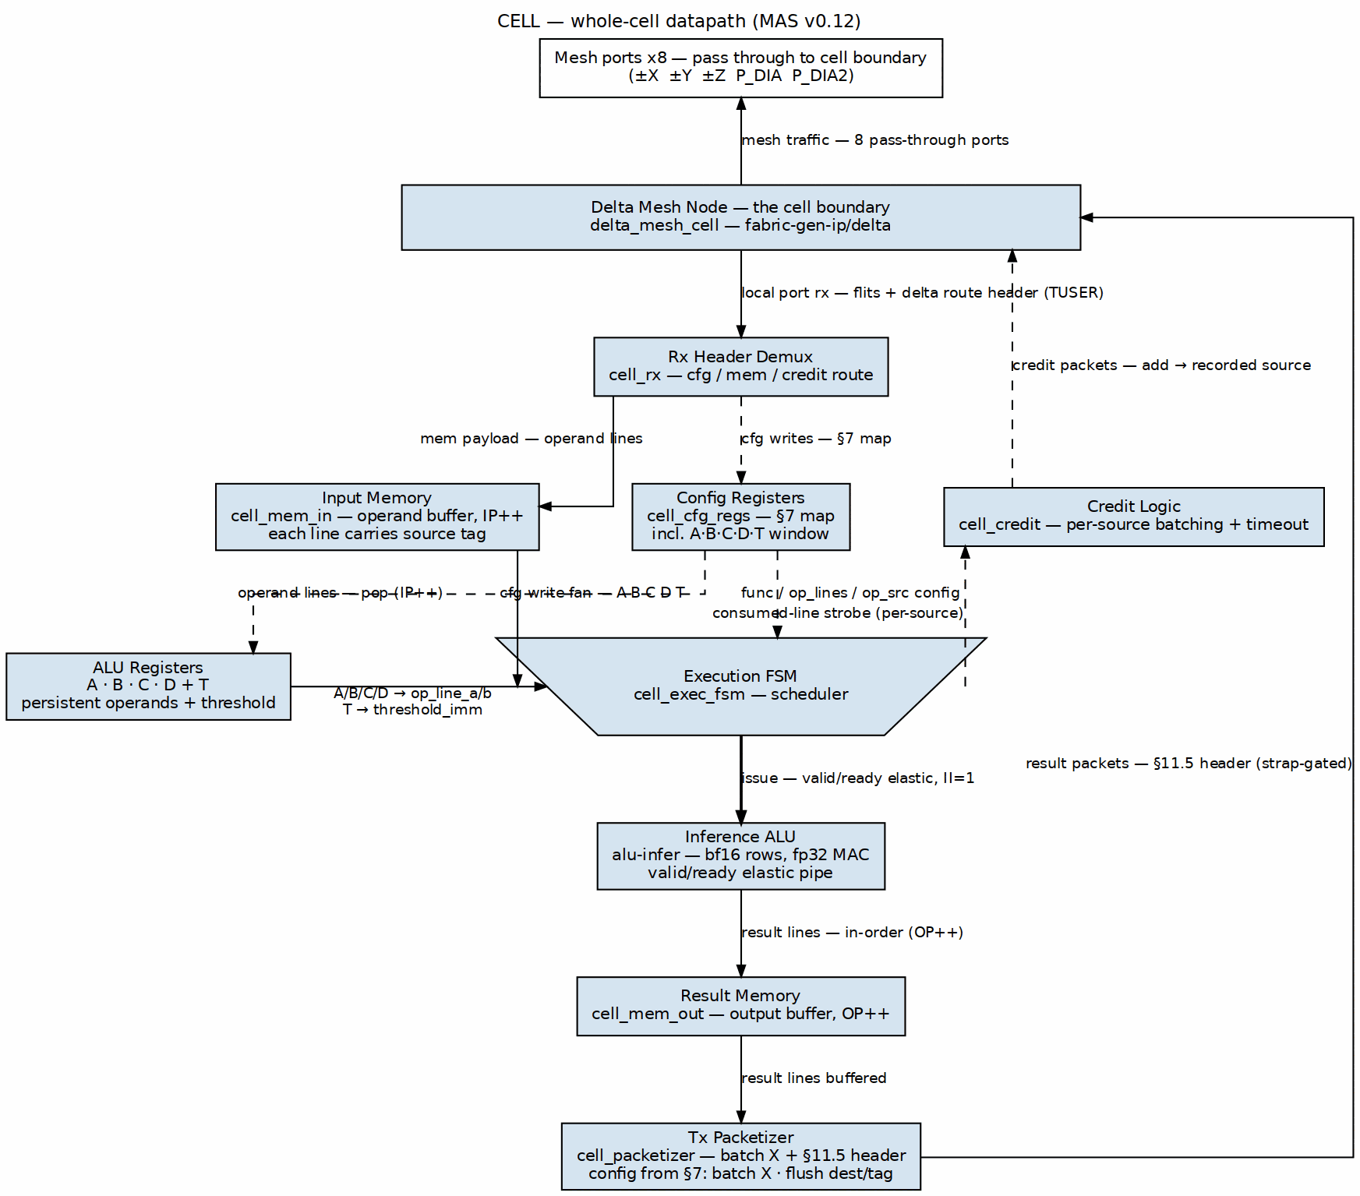
Figure 2.1: Whole-cell datapath
The figure follows the house-style rule that three flows must be traceable at a glance:
- Programming/config flows down the center: cfg packets enter through the delta node, are demuxed by cell_rx, and write the config registers; the registers in turn configure the FSM, the ALU, and the packetizer.
- Operand fill flows down the left: mem payloads are written into the input memory and are later popped by the execution FSM.
- Results and credit returns flow back up the right: result lines move from the ALU into the result memory, through the packetizer, and back out through the delta node; consumed-line credits return on their own dashed path up to the node.
The boundary bar is the delta node edge. Every arrow is labeled with the transaction class it carries; sideband/config arrows are dashed.

5.2 Credit Loop

5.2.1 Figure 2.2: Credit loop
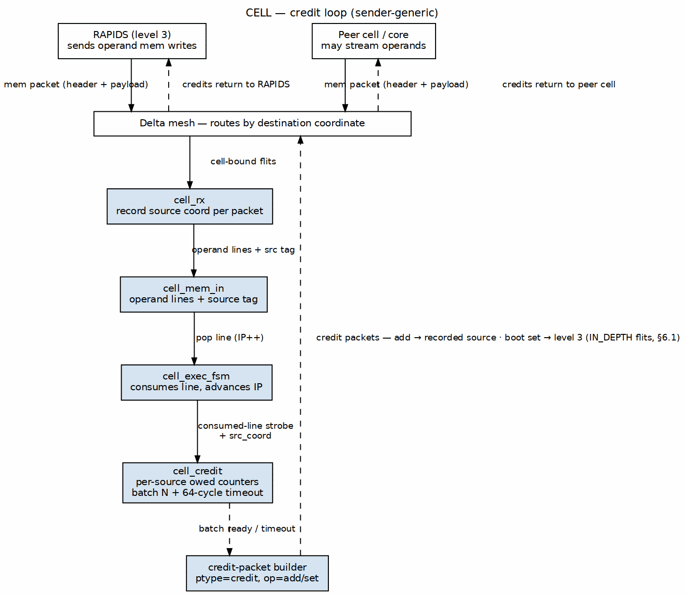
Figure 2.2: Credit loop
The credit-loop figure shows the sender-generic return path:
- An input line arrives from a source and is tagged with that source’s coordinate.
- The execution FSM consumes the line and strobes cell_credit.
- cell_credit increments a per-source owed counter and, when the batch threshold CREDIT_BATCH_N is reached (or the 64-cycle timeout expires), sends a header-only credit/add packet addressed to the recorded source.
- The packet travels back through the delta node to the source, which restores its per-destination credit counter.
The path never shares an arrow with result data; credits are a separate sideband VC.

5.3 ALU Datapath Focus

5.3.1 Figure 2.3: ALU datapath focus
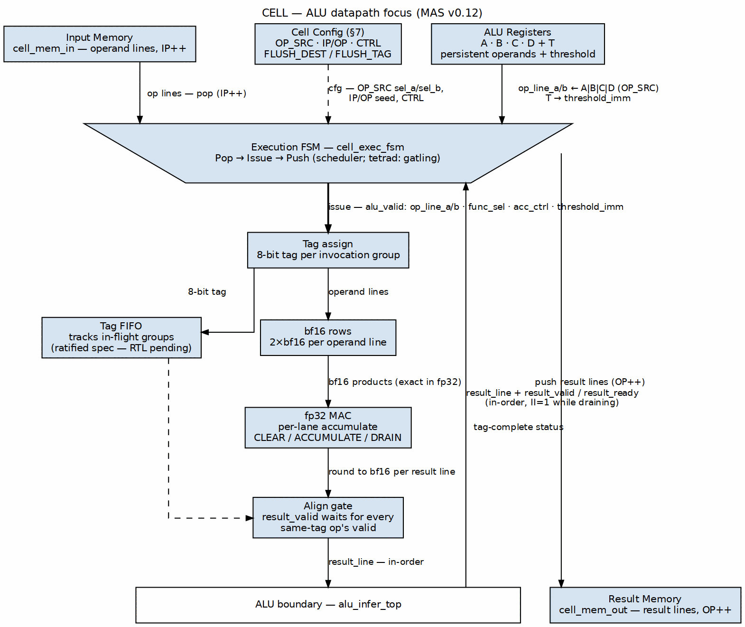
Figure 2.3: ALU datapath focus
The ALU-focus figure drops the delta/network side and traces the three cell-internal flows around alu_infer_top:
- Operand fill (left): cell_mem_in pops (IP++) and the persistent A·B·C·D/T registers feed the execution FSM, which owns the OP_SRC operand mux. Config (OP_SRC, IP/OP, CTRL) arrives dashed from §7.
- Issue (center, heavy pen): the FSM issues the bundle (op_line_a/b, func_sel, acc_ctrl, threshold_imm) with alu_valid; the tag assign gives the invocation group its 8-bit tag and the tag FIFO tracks in-flight groups (ratified spec — RTL pending). Rows multiply in bf16 exactly, the fp32 MAC accumulates per-lane under acc_ctrl, and the align gate holds result_valid until every same-tag op’s valid has asserted.
- Result flow (right): result_line returns up its own route through the ALU boundary bar (result_valid/result_ready, in-order, II=1 while draining), and the FSM pushes the accepted lines down to cell_mem_out (OP++).
The single boundary bar is the alu_infer_top edge; no flow shares an arrow with another.

Last Updated: 2026-10-18

RTL Design Sherpa · Learning Hardware Design Through Practice GitHub · Documentation Index · MIT License

6 External and Internal Interfaces

6.1 Cell Boundary

6.1.1 Mesh-Facing Ports
cell_top exposes the eight mesh-facing ports of the instantiated delta_mesh_cell node:
Table 3.1: Mesh-facing AXI4-Stream ports
Port | Direction | Width | Purpose
s_axis_tdata[8] | in | DATA_WIDTH | Data from mesh neighbors
s_axis_tvalid[8] | in | 1 | Valid from mesh neighbors
s_axis_tready[8] | out | 1 | Ready to mesh neighbors
s_axis_tlast[8] | in | 1 | Packet last from mesh neighbors
s_axis_tuser[8] | in | USER_WIDTH | Delta route header from mesh neighbors
m_axis_tdata[8] | out | DATA_WIDTH | Data to mesh neighbors
m_axis_tvalid[8] | out | 1 | Valid to mesh neighbors
m_axis_tready[8] | in | 1 | Ready from mesh neighbors
m_axis_tlast[8] | out | 1 | Packet last to mesh neighbors
m_axis_tuser[8] | out | USER_WIDTH | Delta route header to mesh neighbors
s_credit[8] | in | NUM_VC | Per-VC credit levels from neighbors
m_credit[8] | out | NUM_VC | Per-VC credit levels to neighbors
These ports are pass-through wiring in cell_top; the node performs all routing. Cell-bound traffic must be addressed to the cell’s external ID {ext=1, level=0, X, Y, Z} and ride delta QoS ≠ 0 so the node does not consume it as its own config traffic (TILE_SPEC §11.2).

6.1.2 Local Port Contract
The cell’s internal datapath sees only the node’s local port (P_LOCAL = 8). Slice 1 used a provisional 64-bit TUSER packing for the tile header because the instantiated delta node exposes 64-bit TUSER.
MAS decision: Slice 2/3 moves to the TILE_SPEC §11.6 transport binding, with the beat-chained header rule (owner ruling 2026-10-18): every link keeps its own data width, and the 128-bit tile header occupies the first ceil(128/DW) payload beats, LSB-first.
- The delta route header rides TUSER of the head beat, as delta owns it.
- The 128-bit tile header is payload: on the 64-bit local port it spans beats 0–1 (tdata[63:0] = header [63:0], next beat’s tdata[63:0] = header [127:64]), then payload beats follow. On a 128-bit-or-wider link it is beat 0 alone.
- The cell’s local-port data width stays at the delta node’s DATA_WIDTH (64 bits today) — no widening, no width conversion anywhere. The demux reassembles the two header beats; the packetizer emits the header across two beats.
This supersedes slice-1’s provisional 64-bit TUSER packing and the earlier MAS 0.10 draft’s 128-bit local-port widening.

6.1.3 AXI4-Lite Register Interface
The cell exposes a house-standard AXI4-Lite slave for debug and local control. All registers are also writable from the in-band cfg stream. The register map is in Chapter 6.

6.1.4 Observability
Table 3.2: Observability outputs
Signal | Width | Purpose
o_err_drop_cnt | 32 | Dropped-head count from the delta node
o_todo_credit_drop_cnt | 32 | Slice-1 TODO counter for unhandled credit packets
o_todo_cfg_read_drop_cnt | 32 | Slice-1 TODO counter for unhandled cfg read replies
o_irq | 1 | Interrupt output (level)
MonBus (AXI4-Lite) | - | The cell’s one MonBus stream, merged at the tetrad with the other three cells and the tetrad node (tile spec §5). Not yet in the RTL

6.2 Internal Interfaces

6.2.1 cell_rx → cell_mem_in
Table 3.3: Input-memory write port
Signal | Width | Direction | Purpose
mem_wr_valid | 1 | rx → mem | Write valid
mem_wr_ready | 1 | mem → rx | Write ready
mem_wr_addr | log2(IN_DEPTH) | rx → mem | Line index
mem_wr_data | LINE_W | rx → mem | Line data
mem_wr_src_coord | COORD_BITS | rx → mem | Source coordinate tag

6.2.2 cell_rx → cell_cfg_regs
Table 3.4: Config-stream register interface
Signal | Width | Direction | Purpose
cfg_wr_valid | 1 | rx → regs | In-band cfg write valid
cfg_wr_ready | 1 | regs → rx | In-band cfg write ready
cfg_wr_addr | 8 | rx → regs | Register offset
cfg_wr_data | 32 | rx → regs | Register value
cfg_rd_valid | 1 | rx → regs | In-band cfg read request valid (slice-2 completion)
cfg_rd_addr | 8 | rx → regs | Register offset
cfg_rd_data | 32 | regs → rx | Read data (slice-2 completion)
cfg_rd_ready | 1 | rx → regs | Read request accepted (slice-2 completion)

6.2.3 cell_cfg_regs → datapath
The register block drives the following register values:
Table 3.5: Register outputs to datapath
Signal | Width | Purpose
r_ctrl | 32 | CTRL register
r_func_sel | 32 | FUNC_SEL register
r_op_lines | 32 | OP_LINES register
r_emit_batch_x | 32 | EMIT_BATCH_X register
r_credit_batch_n | 32 | CREDIT_BATCH_N register
r_irq_en / r_irq_status | 32 | IRQ enables and status
r_a / r_b / r_c / r_d / r_t | 32 | Persistent ALU operands and threshold
r_op_src | 32 | Operand-source mux selection
r_dest | 32 | Deferred cell-destined destination
r_ip / r_op | 32 | Input/result memory pointers
o_soft_rst | 1 | One-cycle soft-reset pulse

6.2.4 cell_mem_in → cell_exec_fsm
Table 3.6: Input-memory read port
Signal | Width | Direction | Purpose
mem_in_rd_valid | 1 | fsm → mem | Read request valid
mem_in_rd_ready | 1 | mem → fsm | Read request ready
mem_in_rd_addr | log2(IN_DEPTH) | fsm → mem | Read address
mem_in_rd_data | LINE_W | mem → fsm | Read data (registered)
mem_in_rd_src_coord | COORD_BITS | mem → fsm | Source tag of read line
mem_in_empty | 1 | mem → fsm/reg | Memory empty
mem_in_full | 1 | mem → fsm/reg | Memory full
mem_in_occupancy | log2(IN_DEPTH+1) | mem → fsm/reg | Line occupancy

6.2.5 cell_exec_fsm → cell_mem_out
Table 3.7: Result-memory write port
Signal | Width | Direction | Purpose
mem_out_wr_valid | 1 | fsm → mem | Write valid
mem_out_wr_ready | 1 | mem → fsm | Write ready
mem_out_wr_addr | log2(OUT_DEPTH) | fsm → mem | Write address
mem_out_wr_data | LINE_W | fsm → mem | Result line

6.2.6 cell_exec_fsm → cell_credit
Table 3.8: Consumed-line credit strobe
Signal | Width | Direction | Purpose
credit_strobe | 1 | fsm → credit | One input line consumed
credit_src_coord | COORD_BITS | fsm → credit | Source coordinate of consumed line

6.2.7 cell_credit → node (credit VC)
cell_credit builds header-only credit/add and credit/set packets and injects them into the node’s local-port credit sideband. The packet format is defined in TILE_SPEC §11.5 and §11.9.

6.2.8 cell_mem_out → cell_packetizer
Table 3.9: Result-memory read port
Signal | Width | Direction | Purpose
pkt_rd_valid | 1 | pkt → mem | Read request valid
pkt_rd_ready | 1 | mem → pkt | Read request ready
pkt_rd_addr | log2(OUT_DEPTH) | pkt → mem | Read address
pkt_rd_data | LINE_W | mem → pkt | Result line
mem_out_empty | 1 | mem → pkt | Memory empty
mem_out_occupancy | log2(OUT_DEPTH+1) | mem → pkt | Line occupancy

6.2.9 cell_packetizer → node (data network)
cell_packetizer builds write-format packets (ptype=mem, op=0) with the §11.5 tile header and sends them through the node’s local port. The destination and tag are supplied by the gatling-programmed drain command; the source coordinate is the cell’s external ID.

6.2.10 cell_exec_fsm ↔ ALU
The ALU interface is defined in the alu-infer MAS; the cell MAS cites it in Chapter 4.3.

Last Updated: 2026-10-18

RTL Design Sherpa · Learning Hardware Design Through Practice GitHub · Documentation Index · MIT License

7 Cycle Behavior: Fill Path as Built

7.1 Slice-1 Fill Path
The slice-1 RTL already implements the receive and store side of the cell. This section documents its cycle behavior so that the slice-2/3 work can be checked against it.

7.1.1 Head-Beat Reception
A packet arrives on the node’s local port as a sequence of AXI4-Stream beats. On the head beat:
- s_user[11:0] carries the destination {X, Y, Z}.
- s_user[13:12] carries the QoS class; it must be 2'b01 (non-zero) so the node does not consume the packet as its own config traffic.
- s_user[29:15] carries the source coordinate {ext, level, X, Y, Z}.
- s_user[32:30] carries ptype: cfg=0, mem=2, credit=3, …
- s_user[33] carries op (write/read or credit add/set).
- s_user[49:34] carries a compacted 16-bit length.
- s_user[59:50] carries a compacted 10-bit target address.
- s_user[63:60] carries the 4-bit tag.
This 64-bit TUSER packing is provisional and exists only because the instantiated delta node exposes a 64-bit TUSER. It is superseded in slice 2/3 by the TILE_SPEC §11.6 two-header model.

7.1.2 Coordinate Match
cell_rx compares the destination {X, Y, Z} against its own POS_X/Y/Z. The ext bit and QoS are not part of the match; QoS is already required to be non-zero so the node did not consume the packet.

7.1.3 Demux Decision
Table 4.1: Slice-1 head-beat dispatch
ptype | op | Action
mem | 0 (write) | Accept payload beats into cell_mem_in starting at target_addr; increment mem_wr_ptr per beat
cfg | 0 (write) | Drive cfg_wr_valid to cell_cfg_regs with target_addr[7:0] and s_data[31:0]
cfg | 1 (read) | Counted TODO drop in slice 1; slice 2 builds a reply packet
credit | any | Counted TODO drop in slice 1; slice 2 routes to cell_credit
other | any | Drop head; increment o_err_drop_cnt via inc_err_drop

7.1.4 Payload Write Timing
For a mem write packet:
- Cycle 0: head beat accepted; in_pkt latches pkt_src_coord, pkt_ptype, pkt_target; mem_wr_ptr clears.
- Cycle N: each payload beat with s_valid && s_ready && mem_wr_ready writes mem_data[addr] and mem_tag[addr] and increments mem_wr_ptr, where addr = pkt_target + mem_wr_ptr.
- The last payload beat (s_last) clears in_pkt.
cell_mem_in exposes wr_ready = !o_full; cell_rx backpressures the local port while a mem payload is in flight and the memory is full.

7.1.5 Occupancy Accounting
cell_mem_in increments its occupancy counter on every accepted write and decrements it on every accepted read. The read side is held idle in slice 1 (mem_in_rd_valid = 1'b0 in cell_top), so occupancy only rises during fill tests.

7.2 Expected Slice-2/3 Cycle Behavior
Slice 2/3 keeps the same fill timing but changes the header transport:
- The head beat’s TUSER carries only the delta route header.
- The 128-bit tile header is payload, beat-chained per the owner ruling 2026-10-18: on the 64-bit local port, beat 0 carries tdata = header[63:0] and beat 1 carries tdata = header[127:64]; payload beats follow. The demux reassembles the header across the two beats before dispatching on ptype.
- Payload beats carry one 32-bit line per 64-bit flit today; slice 3 packs two lines per 64-bit flit.
The demux still records the source coordinate from the tile header’s source field (not delta’s hop-source route header) and tags each input-memory line with it.

Last Updated: 2026-10-18

RTL Design Sherpa · Learning Hardware Design Through Practice GitHub · Documentation Index · MIT License

8 Credit Logic

8.1 MAS Decision: Memory Sizing and Advertisement
MAS decision: IN_DEPTH = 32 lines and OUT_DEPTH = 32 lines.
Rationale: A 32-line depth is a power of two, matches the default credit-strap scale, and gives simple 5-bit pointers. The result memory is intentionally deeper than the default TILE_LAND_FLITS strap (16 flits) so that the landing-space strap, not the result memory, is the emit bottleneck. The input memory’s flit capacity is the cell’s boot advertisement value.
With LINE_W = 32 and a 64-bit payload flit today, one input line occupies one payload flit (low 32 bits). Therefore the boot advertisement is:
advertisement flits = IN_DEPTH = 32 flits
Note: Slice 3 may pack two 32-bit lines per 64-bit payload flit; if that packing is adopted, the advertisement value must be re-derived from the new flit count (IN_DEPTH / 2 flits) while the line count stays 32. Until then, the advertisement is 32 flits.

8.2 MAS Decision: Credit Batch Size and Timeout
MAS decision: Per-source credit batching uses N = CREDIT_BATCH_N consumed lines per source, with a default of N = 1. A partial batch that has not reached N drains after a 64-cycle timeout.
Rationale: N = 1 gives the simplest exact-per-line behavior, which is what the slice-2 credit-loop test will verify. Making N configurable lets later builds trade return latency for lower credit-packet traffic. The 64-cycle timeout bounds the latency of a trailing partial batch without adding any traffic at N = 1.

8.3 Per-Source Owed Counters
cell_credit maintains a bank of owed counters indexed by the recorded source coordinate. Each counter has:
- owed[src]: number of consumed lines not yet returned to this source
- timer[src]: cycles since the last return to this source (valid when owed is non-zero and below the batch threshold)
On every consumed-line strobe from cell_exec_fsm:
- owed[src] += 1
- If owed[src] >= CREDIT_BATCH_N, send one credit/add packet for CREDIT_BATCH_N flits, decrement owed[src] by CREDIT_BATCH_N, and clear the timer.
- Otherwise, load the timer with the timeout value (or reset it if it was already running).
Every cycle, for each source with 0 < owed[src] < CREDIT_BATCH_N:
- If timer[src] == 0, send one credit/add packet for owed[src] flits and clear owed[src].
- Else, timer[src] -= 1.
The timeout value is 64 cycles. The timer is loaded only when a new partial batch begins; additional consumed lines in the same partial batch do not reset the timer (they will be included in the same return when it fires).

8.4 Credit Packet Format
A consumed-line credit return is a header-only credit packet with:
- ptype = credit (3)
- op = 0 (add)
- length = number of flits returned (CREDIT_BATCH_N or the residual owed count)
- destination = the recorded source coordinate of the consumed line
- source = this cell’s external ID
- tag = echoed or zero (the sink does not store credit packets)
- target_address[1:0] = credit_class = 0 (sink space)
Credit packets ride the credit VC and need no grant (TILE_SPEC §11.9). TILE_SPEC §11.5 encodes the credit class in the low two bits of the target address: 0 = sink-space credit, 1 = descriptor-slot credit. Consumed-line returns and the boot advertisement below are sink-space credits (class 0).

8.5 Boot Advertisement Packet
After reset, cell_credit sends one credit/set packet to level = 3 (the tile I/O / RAPIDS) carrying the input memory’s full size in flits:
- op = 1 (set)
- length = IN_DEPTH flits (32 today)
- destination = {ext=0, level=3, X/Y/Z = tile I/O}
- source = this cell’s external ID
- target_address[1:0] = credit_class = 0 (sink space)
This advertisement is the cell’s “alive” signal; RAPIDS’s external sink-space counter for this cell starts at 0 and is filled by this packet (TILE_SPEC §11.10).

8.6 Sender-Generic Returns
The return is sender-generic: a credit goes to the source coordinate recorded on the input-memory line, not to a hard-coded RAPIDS ID. A cell that streamed into this cell’s input memory therefore receives the credits, not RAPIDS, exactly as TILE_SPEC §11.9 requires.

8.7 Implementation Note: Counter Bank Sizing
The number of legal source coordinates in a tile is bounded by the credit-counter index table in TILE_SPEC §11.9. A cell therefore needs at most enough per-source owed counters to cover every possible source that may send to it. A practical implementation allocates one counter per external ID (RAPIDS + peer cells + tetrad cores) that the tile can address, lazily allocating on first strobe if area must be minimized.

Last Updated: 2026-10-19

RTL Design Sherpa · Learning Hardware Design Through Practice GitHub · Documentation Index · MIT License

9 Packetizer and Execution FSM

9.1 Packetizer

9.1.1 MAS Decision: Batching and Flush Conditions
MAS decision: The packetizer batches result flits up to EMIT_BATCH_X and flushes on either of two conditions:
- The batch accumulator holds EMIT_BATCH_X flits.
- CTRL.flush-and-send is written (bit 2 of CTRL).
An idle-timeout flush and an end-of-job marker flush are documented as deferred (PRD §12; PRD §11). This keeps slice-2 behavior deterministic and testable: a testbench can either fill a batch or force a flush.

9.1.2 MAS Decision: Strap Counter Initialization
MAS decision: The packetizer maintains a strap counter initialized from a cell parameter TILE_LAND_FLITS with a default of 16 flits. The counter is spent per flit sent (header included) and is restored by RAPIDS credit/add returns.
Rationale: The default 16 matches the Hive-set TILE_LAND_FLITS default in TILE_SPEC §11.9. The counter is private to this cell and never goes negative; a packet is presented only while the counter covers the entire packet, header included.

9.1.3 Header Build
The packetizer builds write-format packets (ptype=mem, op=0) with the TILE_SPEC §11.5 tile header as the first payload beat(s). The header fields are:
Table 4.2: Result-packet header fields
Field | Value
Destination coordinate | Gatling-programmed drain destination (see below)
Source coordinate | This cell’s external ID {ext=1, level=0, X, Y, Z}
ptype | mem (2)
op | 0 (write)
Length | Payload bytes that follow
Target address | Programmed by the drain command (memory address in the sink channel)
Tag | Programmed sink channel
MAS decision on transport: The packetizer uses the TILE_SPEC §11.6 two-header model with the beat-chained header rule (owner ruling 2026-10-18 — every link keeps its own width):
- The delta route header is placed in TUSER of the head beat.
- The 128-bit tile header is placed in the first ceil(128/DW) payload beats, LSB-first — on the 64-bit local port: beat 0 = header[63:0], beat 1 = header[127:64].
- Payload beats follow.
The local port does not widen. This supersedes slice-1’s provisional 64-bit TUSER packing and the 0.10 draft’s 128-bit local-port widening.

9.1.4 Destination and Tag Programming
The cell does not choose the result destination. Gatling (the tetrad engine) commands the drain and tells the cell where to send it (TILE_SPEC §11.14; PRD §6.3).
Precedence: The operational drain destination is held in FLUSH_DEST (offset 0x54) and the sink-channel tag in FLUSH_TAG (offset 0x58). These are programmed by gatling (via cfg write or an extended CTRL flush command) and are what the packetizer uses when CTRL.flush-and-send is written. The legacy DEST register (offset 0x38) is reserved for the deferred cell→cell result path; it is not used for rapids-bound drains. DEST becomes operational only after the tile-spec cell→cell credit/grant extension lands (TILE_SPEC §10); until then, result traffic is RAPIDS-bound and FLUSH_DEST/FLUSH_TAG take precedence.
Rationale: This gives gatling a concrete mechanism to command a flush without requiring a new packet type or a sideband interface, while keeping the DEST register available for the future peer-cell path.

9.1.5 Strap Accounting
Each packet costs one header flit plus one flit per payload line today. The packetizer checks:
strap_counter >= 1 + payload_flits
before presenting tvalid. It decrements the counter by one per flit sent. RAPIDS returns credits as it drains the cell’s landing space; the returns are credit/add packets that increment the strap counter.

9.2 Execution FSM

9.2.1 Pop → Issue → Push Loop
cell_exec_fsm runs the compute loop:
- Pop. When enabled and not busy, pop OP_LINES input lines from cell_mem_in, advancing IP by one per line. Capture the source coordinate of the first line (all lines of one invocation are expected to come from the same source; if they differ, the first line’s source is used for credit return).
- Issue. Present the operand lines to the ALU and assert the issue valid. Wait for ready; hold operands and func_sel stable while ready is low.
- Push. When the ALU asserts result_valid and the FSM asserts result_ready, push the result line into cell_mem_out, advancing OP by one.
The loop is pipelined: while one invocation computes, the FSM can pop and issue the next, as long as the ALU’s elastic pipeline accepts it (II=1 while draining).

9.2.2 MAS Decision: Operand-Source Mux
MAS decision: The operand-source mux is configured by OP_SRC:
Table 4.3: OP_SRC encoding
OP_SRC value | op_line_a source | op_line_b source
0 | input-memory pop | input-memory pop
1 | A | A
2 | B | B
3 | C | C
4 | D | D
The two sides are controlled by independent 3-bit fields in OP_SRC: sel_a[2:0] and sel_b[2:0]. Reset value is 0 (both operands from memory). The T register supplies threshold_imm for opcode 6 (compare/threshold).

9.2.3 IP/OP Pointer Behavior
IP and OP are 32-bit registers that auto-increment on pop and push respectively. They wrap at IN_DEPTH and OUT_DEPTH:
IP_next = (IP + 1) mod IN_DEPTH
OP_next = (OP + 1) mod OUT_DEPTH
CTRL.soft_reset clears both pointers to 0 and clears IRQ_STATUS. Software may also seed them through AXIL or cfg writes.

9.2.4 Gatling as the Cell ALU Sequencer (owner ruling 2026-10-19)
MAS decision: The slice-3 cell_exec_fsm remains the standalone bring-up driver for the cell, preserving the same POP → issue → PUSH client contract. In the tetrad-integrated tile, gatling (the tetrad barrel-core engine) sequences the cell’s alu-infer ALU directly:
- POP reads operand line(s) from the cell’s input memory and presents them to the ALU issue handshake.
- PUSH retires result line(s) from the ALU and writes them into the cell’s result memory.
- FLUSH programs FLUSH_DEST/FLUSH_TAG and triggers the packetizer drain.
- CFG/ECTX/KICK/WAIT carry tetrad-level context and control.
Gatling never originates config traffic that belongs in the cell’s cfg stream; cell programming remains in-band per the standing owner ruling 2026-10-17. The gatling PRD v0.2 owns the Xcell instruction encodings (CFG, POP, PUSH, ECTX, FLUSH, KICK, WAIT).

9.2.5 ALU Hookup
The FSM drives the ALU’s elastic valid/ready interface per the alu-infer MAS:
Table 4.4: ALU↔FSM seam signals
Signal | Direction | Purpose
alu_valid | FSM → ALU | Issue valid
alu_ready | ALU → FSM | Issue ready
op_line_a | FSM → ALU | Operand A line
op_line_b | FSM → ALU | Operand B line
threshold_imm | FSM → ALU | bf16 threshold immediate (from T)
func_sel | FSM → ALU | {opcode, sub-op, reserved}
acc_ctrl | FSM → ALU | CLEAR / ACCUMULATE / DRAIN for MAC
result_line | ALU → FSM | Result line
result_valid | ALU → FSM | Result valid
result_ready | FSM → ALU | Result ready
The function/opcode table is defined in alu-infer PRD §3 and implemented per the alu-infer MAS. The cell MAS does not restate it.

9.2.6 Issue Tag and Same-Tag Alignment (ratified spec — RTL pending)
MAS decision: When the scheduler loads a new function into the ALU pipeline, an 8-bit tag is assigned, common to every op of that invocation group that must complete together. A tag FIFO tracks the in-flight groups. Each op’s result_valid asserts only when every result_valid of ops carrying the same tag has asserted — so ops that were scheduled together finish together, and the elastic pipeline’s per-op readiness is gated to the group boundary.
Rationale (owner ruling): if two ops are scheduled in the same clock they should finish at the same time, and the scheduler programs the valid/ready behavior it wants (including feedback cases) through this tag grouping rather than through pipeline-depth matching. This takes care of the elastic alignment naturally: the group is atomic at the result boundary even though individual ops may have different internal latencies.
Status: ratified with the alu-infer work at rev 0.50; not yet in the alu-infer RTL or the alu-infer MAS — the tag assign/FIFO/align gate of Figure 2.3 is the specified target, not the current implementation.

9.2.7 MAC Accumulation
MAC behavior is inherited from the alu-infer contract: the FMA computes the bf16 product exactly in fp32, accumulates per-lane in fp32, and rounds to bf16 once per result-line presentation. The FSM sequences acc_ctrl (CLEAR at layer boundaries, ACCUMULATE for steps, DRAIN for the final values) without changing the ALU interface.

9.2.8 Soft Reset
CTRL.soft_reset (bit 1) pulses o_soft_rst for one cycle. The FSM responds by clearing IP and OP and dropping any in-flight issue request. The ALU’s reset behavior is defined in the alu-infer MAS.

Last Updated: 2026-10-19

RTL Design Sherpa · Learning Hardware Design Through Practice GitHub · Documentation Index · MIT License

10 Verification Plan

10.1 House Test Grid
The cell testbench follows the house gate / func / full grid:
Table 5.1: House test grid
Level | Scope | Typical seeds | Runtime target
gate | Smoke: elaboration, reset, register reset values, basic fill | 1 seed | < 1 min
func | Directed feature tests across seeds | 8 seeds | ~5 min
full | Longer randomized runs, corner cases, coverage closure | 32+ seeds | ~30 min

10.2 Existing Tests
cell/dv/tests/test_cell.py already covers slice-1 behavior:
- Elaboration + reset + register reset values over AXIL
- AXIL and cfg-stream register access
- Input-memory fill from a ptype=mem packet
- Bad-packet drop behavior
The delta node inside cell_top is treated as a black box; slice-1 simulation drives the local rx port through the test_mode injection hook (dut.test_rx_*) so the testbench can supply cell traffic without fighting the node’s continuous driver.

10.3 Planned Slice-2 Credit-Loop Test
The slice-2 test verifies the credit return path independently of the datapath:
- Drive mem packets into the cell from multiple recorded sources (using the test-mode injection hook or a BFM on the local port).
- Force the execution FSM to consume lines without running the ALU (or run a passthrough opcode).
- Check that cell_credit emits credit/add packets whose destination equals the recorded source coordinate and whose length matches the configured batching (CREDIT_BATCH_N or residual).
- Verify the 64-cycle partial-batch timeout by sending a partial batch and waiting for the automatic drain.
- Verify the boot credit/set advertisement to level=3 carrying IN_DEPTH flits.
The test forces straps so that result emission does not gate credit returns.

10.4 Planned Slice-3 ALU-Run Test
The slice-3 test verifies the pop→issue→push loop end to end:
- Program FUNC_SEL, OP_SRC, OP_LINES, and persistent operands A–D, T via cfg or AXIL.
- Fill the input memory with known operand lines.
- Enable the FSM and run until STATUS.busy clears or an IRQ fires.
- Read the result memory (via the packetizer drain or AXIL window).
- Check results against the alu-infer golden model per opcode.
Coverage: opcode (8) × special-value classes × lane position × accumulator clear/hold/drain corners.

10.5 Verification Hooks
Table 5.2: Verification hooks
Hook | Use
test_rx_* / test_mode | Inject cell traffic without instantiating the delta mesh
inc_lines_in/out, inc_credits, inc_pkts | Count events independently of datapath
o_todo_credit_drop_cnt / o_todo_cfg_read_drop_cnt | Confirm slice-1 stubs are replaced in slice 2
STATUS / IRQ_STATUS | Observe empty/full, error, and strap-starved states

10.6 Assertions and Checks
- Credit return must match lines consumed, per source, within the batch timeout.
- Strap counter must never go negative; packetizer tvalid implies sufficient strap for the whole packet.
- ALU results retire in issue order.
- IP and OP wrap correctly at their respective depths.

Last Updated: 2026-10-19

RTL Design Sherpa · Learning Hardware Design Through Practice GitHub · Documentation Index · MIT License

11 Register Map and MAS Decisions

11.1 Register Map
The v1 register map is identical to PRD §7, with two MAS-added operational registers for the gatling-programmed drain command.
Table 6.1: Cell register map
Offset | Register | Notes
0x00 | CTRL | enable, soft reset, flush-and-send
0x04 | STATUS | busy, input-empty, result-nonempty, strap-nonzero (RTL alias status_grant_nonzero)
0x08 | FUNC_SEL | opcode (5b) + sub-op (2b) + reserved (2b)
0x0C | OP_LINES | input lines per function invocation
0x10 | EMIT_BATCH_X | flits per result packet
0x14 | CREDIT_BATCH_N | consumed lines per credit packet per source
0x18 | IRQ_EN | done, error, strap-starved (RTL alias IRQ_GRANT_STARVED_BIT), credit-timeout enables
0x1C | IRQ_STATUS | write-1-clear status
0x20 | A | persistent operand A
0x24 | B | persistent operand B
0x28 | C | persistent operand C
0x2C | D | persistent operand D
0x30 | T | bf16 threshold immediate
0x34 | OP_SRC | operand-source mux: sel_a[2:0], sel_b[2:0]
0x38 | DEST | deferred cell-destined destination
0x3C | IP | input-memory read pointer
0x40 | OP | result-memory write pointer
0x44 | CNT_LINES_IN | lines received
0x48 | CNT_LINES_OUT | results produced
0x4C | CNT_CREDITS | credit packets returned
0x50 | CNT_PKTS | result packets sent
0x54 | FLUSH_DEST | MAS-added: gatling-programmed drain destination coordinate
0x58 | FLUSH_TAG | MAS-added: gatling-programmed sink-channel tag

11.2 Bit Fields

11.2.1 CTRL (0x00)
Table 6.2: CTRL bit fields
Bit | Name | Purpose
0 | EN | Enable execution FSM
1 | SOFT_RST | Soft reset: clears IP, OP, IRQ_STATUS; pulse lasts one cycle
2 | FLUSH | Packetizer flush-and-send: emit whatever is buffered now

11.2.2 STATUS (0x04) — read-only
Table 6.3: STATUS bit fields
Bit | Name | Purpose
0 | BUSY | FSM busy (slice 3)
1 | INPUT_EMPTY | Input memory empty
2 | RESULT_NONEMPTY | Result memory not empty
3 | STRAP_NONZERO | Strap counter > 0. Slice-1 RTL still names this bit STATUS_GRANT_NONZERO_BIT / status_grant_nonzero; the doc term is canonical.

11.2.3 FUNC_SEL (0x08)
Table 6.4: FUNC_SEL fields
Bits | Field | Purpose
4:0 | opcode | ALU opcode (alu-infer PRD §3)
6:5 | sub_op | Sub-opcode, e.g. min vs max, compare vs threshold
8:7 | reserved | Reserved under the bf16-only model

11.2.4 OP_SRC (0x34)
Table 6.5: OP_SRC fields
Bits | Field | Encoding
2:0 | sel_a | 0=memory pop, 1=A, 2=B, 3=C, 4=D
5:3 | sel_b | 0=memory pop, 1=A, 2=B, 3=C, 4=D
31:6 | reserved | 0

11.2.5 IRQ_STATUS / IRQ_EN
Table 6.6: IRQ fields
Bit | Name | Purpose
0 | DONE | Computation/drain complete
1 | ERROR | Dropped packet or fatal protocol error
2 | STRAP_STARVED | Packetizer has data but no strap. Slice-1 RTL still names this bit IRQ_GRANT_STARVED_BIT; the doc term is canonical.
3 | CREDIT_TIMEOUT | Partial-batch credit timer fired (informational)

11.3 MAS Decisions Revisited
Table 6.7: MAS decisions and their hardware homes
Decision | Where in this book | Register / parameter
Input/result memory depth = 32 lines | Chapter 4.2 | IN_DEPTH, OUT_DEPTH parameters
Boot advertisement = 32 flits | Chapter 4.2 | Derived from IN_DEPTH
Credit batch default = 1 | Chapter 4.2 | CREDIT_BATCH_N register
Partial-batch timeout = 64 cycles | Chapter 4.2 | Hard-coded in cell_credit
Result batch flush conditions | Chapter 4.3 | EMIT_BATCH_X, CTRL.FLUSH
Strap default = 16 flits | Chapter 4.3 | TILE_LAND_FLITS parameter
Local-port width stays at delta DATA_WIDTH (64 bits today) | Chapter 3, Chapter 4.3 | DATA_WIDTH parameter
Gatling-programmed drain | Chapter 4.3 | FLUSH_DEST, FLUSH_TAG registers

11.4 RTL Naming Divergence (slice 1)
Slice-1 RTL (cell_pkg.sv, cell_cfg_regs.sv) predates the 2026-10-18 ruling that renamed result-path grants to straps. The canonical MAS/PRD terms are strap counter, STRAP_NONZERO, and STRAP_STARVED; the slice-1 RTL identifiers remain:
- STATUS_GRANT_NONZERO_BIT / status_grant_nonzero for STATUS bit 3
- IRQ_GRANT_STARVED_BIT for IRQ_STATUS/IRQ_EN bit 2
A future RTL pass (slice 2/3) should rename these to the strap terms. Until then, the register map above states the canonical names and notes the RTL aliases.

Last Updated: 2026-10-19

RTL Design Sherpa · Learning Hardware Design Through Practice GitHub · Documentation Index · MIT License

12 References

12.1 Normative Specifications
- cell PRD — projects/components/compute-eng-ip/cell/docs/PRD.md.
The governing product definition. The MAS implements PRD §12 open questions and cites §§3, 6, 7 throughout.
- TILE_SPEC §11 — projects/components/compute-eng-ip/tile/docs/TILE_SPEC.md.
Defines the packet header (§11.5), transport binding (§11.6), payload types (§11.2), destination coordinate (§11.3), end-to-end credits and straps (§§11.9–11.10), and result flush (§11.14).
- alu-infer PRD §3 — projects/components/compute-eng-ip/alu-infer/PRD.md.
Normative ALU function set, element model (bf16), and MAC accumulation semantics.
- alu-infer MAS — projects/components/compute-eng-ip/alu-infer/docs/alu_infer_mas/alu_infer_mas_index.md.
Implementation-intent book for the ALU block: module tree, function rows, accumulator, ALU↔FSM interface, and cycle behavior.

12.2 RTL Sources
- cell_top.sv — projects/components/compute-eng-ip/cell/rtl/cell_top.sv.
Slice-1 top-level: delta node, rx demux, registers, memories.
- cell_rx.sv — projects/components/compute-eng-ip/cell/rtl/cell_rx.sv.
Slice-1 header parse/demux with provisional 64-bit TUSER packing.
- cell_cfg_regs.sv — projects/components/compute-eng-ip/cell/rtl/cell_cfg_regs.sv.
Slice-1 AXIL + cfg-stream register file.
- cell_mem_in.sv — projects/components/compute-eng-ip/cell/rtl/cell_mem_in.sv.
Slice-1 input memory with per-line source tag.
- cell_mem_out.sv — projects/components/compute-eng-ip/cell/rtl/cell_mem_out.sv.
Slice-1 result memory.
- cell_pkg.sv — projects/components/compute-eng-ip/cell/rtl/cell_pkg.sv.
Shared types, coordinate layout, register offsets, and slice-1 compact header offsets.
- delta_mesh_cell.sv — projects/components/fabric-gen-ip/delta/rtl/delta_mesh_cell.sv.
The node the cell instantiates; defines the 9-port unpacked-array interface and P_LOCAL = 8.

12.3 Verification
- test_cell.py — projects/components/compute-eng-ip/cell/dv/tests/test_cell.py.
Existing slice-1 cocotb test suite; the base for the slice-2/3 credit-loop and ALU-run tests.

12.4 House Style and Build
- Block diagrams handbook — vault/handbook/authoring/block-diagrams.md.
Binding house style for the whole-cell and credit-loop figures.
- alu-infer MAS PDF generator — projects/components/compute-eng-ip/alu-infer/docs/generate_mas_pdf.sh.
The build script this MAS generator is modeled on.

Last Updated: 2026-10-18

