Table of Contents

Readme
Generated: 2026-06-12

RTL Design Sherpa · Learning Hardware Design Through Practice GitHub · Documentation Index · MIT License

A Portable, Macro-Optional ASIC Timing Characterization Harness
A practitioner’s guide to char_top – a benchmarking harness that measures combinational delay across ASIC standard-cell libraries by forcing the synthesis tool to build the structures we actually want it to build.
Version: 3.1 (ASAP7 worked example landed) Last Updated: 2026-06-12 Status: RTL + verification + ASIC synthesis flows in place; ASAP7 RVT characterization run + budget worksheet live under work/. (45 tests passing; Yosys + OpenSTA + Synopsys DC + Cadence Genus drivers; 99-row ASAP7 sweep at TT/FF/SS clean.)
An FPGA-side companion – with the same workflow and an analogous spreadsheet – is published as a separate addendum README. This document is ASIC-only.

Abstract
The sole purpose of this methodology is to allow the designer to predict and close timing before synthesis ever starts. This flow lets the designer characterize various structures at various technology nodes and frequencies so that, by the time the production design enters synthesis, each combinational shape has a known per-node, per-frequency budget – and the answer to “will this pipeline stage close?” is already on a table. The same characterization run also yields an accurate per-structure gate count: because the harness pins every internal net through dont_touch and emits a per-FUB cell-count + area summary from both Yosys (build/$TOP.stat.txt) and the commercial flows (report_area), the designer gets a real, technology-mapped gate-count estimate for any combinational shape long before the production netlist exists.
This methodology is explicitly proactive. It is not a debugger you reach for after a synthesis run reveals a violation; it is a design-time budget the designer (or uArch) consults before writing the first always_ff. The whole point is to flip the loop – characterize once per node, then build with a known-good budget – so synthesis becomes a confirmation step rather than the first time anybody finds out the pipeline doesn’t close. Concretely, the methodology exists to prevent, as much as possible, the designer being surprised when synthesis happens: every shape on the critical path has already been measured at this node and frequency, every gate count has already been totalled, and the answer is on the worksheet long before the synthesis tool ever weighs in.
char_top is a synthesizable harness that wraps nine Functional Unit Blocks (FUBs) – each a different shape of combinational logic – between registered endpoints driven by a shared 32-bit Galois LFSR. By driving every flop input with a maximal-length pseudo-random sequence and routing every flop output to a top-level port, the design forecloses every optimisation a modern synthesis tool would otherwise use to make the benchmark disappear (constant propagation, dead-code elimination, common-subexpression elimination, retiming-into-pads, and so on). Within that frozen scaffold, each FUB exposes a specific combinational pattern (NAND tree, ripple-carry adder, mux tree, structural multiplier, …) so that the slack reported for its path group is a clean, comparable measure of that pattern’s depth in the target technology.
The component ships in two source-equivalent flavours, both targeted at ASIC characterization:
- rtl/ – the default, macro-driven tree that supports compile-time switches for reset style (USE_ASYNC_RESET, RESET_ACTIVE_HIGH) and FIFO memory type. Use this tree when the cell library has multiple flop topologies (sync / async reset, active-low / active-high) and you want one source to characterise all of them.
- rtl/asic_only/ – a macro-free fork hard-wired to async-negedge active-low reset. Use this tree when the library has exactly one flop topology (async, active-low) and you want the source you read to match the gates that get built, with no preprocessor in the way. Ships with an open-source Yosys + OpenSTA flow plus reference scripts for Synopsys Design Compiler and Cadence Genus.

1. Why this harness, and not just RTL we already have?
A synthesis tool is, by design, free to delete logic whose output is unobserved or whose input is constant. Without explicit countermeasures any benchmark “design” collapses to a few wires before it ever reaches mapping. This harness solves four problems at once:
- it gives every standard combinational pattern (tree, chain, multiplier, mux, memory, counter) a registered envelope so STA reports the pattern’s own delay, not an I/O delay;
- it drives every flop input from a shared maximal-length LFSR so the tool cannot prove any input constant;
- it routes every flop output to a top-level port so the tool cannot prune any output;
- it carries (* dont_touch = "true" *) on every chain net as a belt-and-suspenders defence against aggressive remapping.
The result is a single source that runs through any flow you point at it and lets you measure – not estimate – how a 12-level XOR tree, or a 64-bit ripple-carry adder, or a 16x16 Dadda multiplier behaves in the target technology.

2. High-level architecture
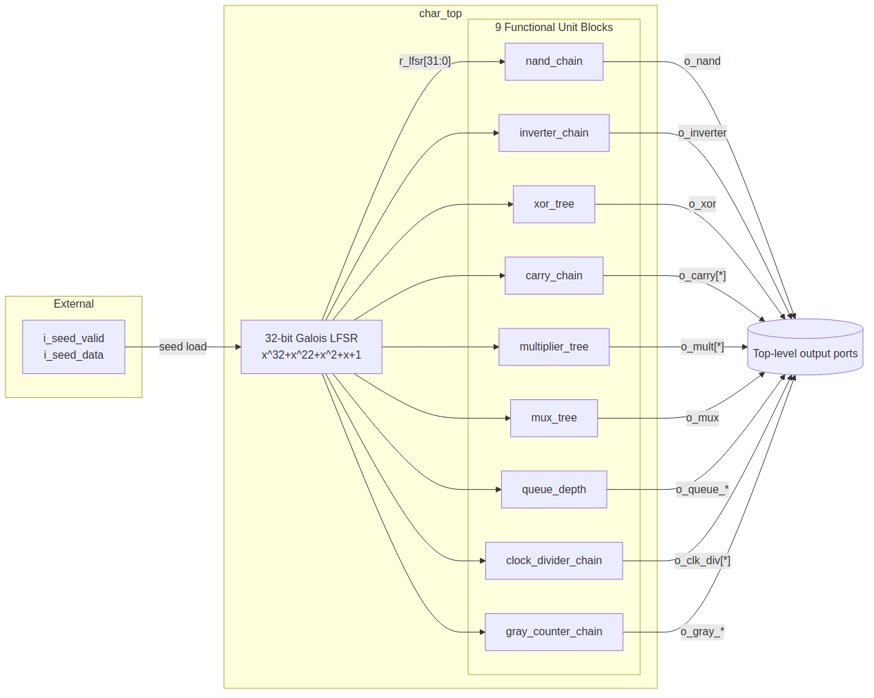
Architecture overview
Each FUB is gated by an EN_* parameter. When disabled (EN_*=0) the corresponding generate block emits a tie-to-zero and consumes zero logic – this is how targeted “just the multiplier” or “everything but the FIFO” sweeps work.

3. The 3-edge pipeline
The harness deliberately registers both endpoints of every FUB’s combinational logic so STA reports slack for the register-to-register path itself, not the I/O path. Because the LFSR is the source for every input, the design has a fixed three-edge pipeline:
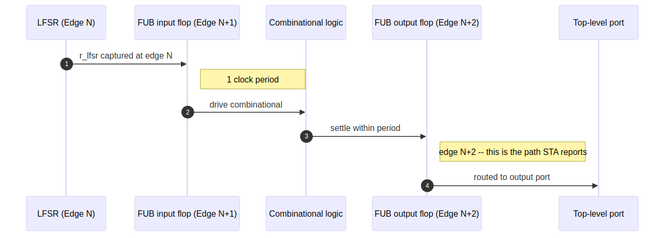
3-edge pipeline
A char_top-level testbench that compares an expected value against an observed output sampled after rising edge C reads lfsr_idx = C - 2 from the reference model (dv/tbclasses/timing_char_tb.py:lfsr_step / lfsr_sequence).
The LFSR in char_top is a left-shift Galois LFSR (polynomial 0x0040_0007). This is architecturally different from the right-shift tap-based Galois LFSR in val/common/test_shifter_lfsr_galois.py – do not reuse that model.

4. Anti-optimisation strategy
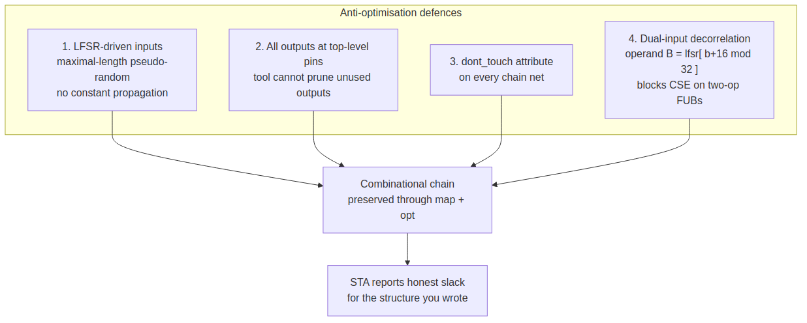
Anti-optimisation defences
Defence | Threat it blocks
LFSR-driven inputs | Constant propagation, dead-input elimination
Outputs at the pads | Dead-output elimination, sweep
dont_touch attribute | Aggressive remapping that erases internal nets
Dual-input decorrelation (r_lfsr[(b+16) % 32]) | CSE on a OP a
All four work together. Remove any one and a sufficiently aggressive synthesis tool will find a shortcut; with all four in place the gates you wrote are the gates that land in the netlist.

5. The FUB catalog
FUB | File | Key parameters | Critical path | What it measures
nand_chain | fub/nand_chain.sv | LEVELS, NUM_FLOPS | LEVELS NAND-gate delays | Raw 2-input NAND propagation through the target technology
inverter_chain | fub/inverter_chain.sv | INVERTER_COUNT | Linear inverter chain | Best-case per-gate delay (no fan-in overhead)
xor_tree | fub/xor_tree.sv | LEVELS, NUM_FLOPS | LEVELS XOR delays | XOR cell vs. NAND cell / LUT packing
carry_chain | fub/carry_chain.sv | WIDTH | WIDTH carry-propagation delays | Dedicated carry-chain (CARRY4 / CARRY8 / ALM-carry / stdcell ripple)
multiplier_tree | fub/multiplier_tree.sv | WIDTH, MULT_TYPE | Reduction-tree depth | Inferred * (DSP) vs. structural Dadda / Wallace / CSA
mux_tree | fub/mux_tree.sv | LEVELS, NUM_FLOPS | LEVELS 2:1-mux delays | Mux-cell delay vs. logic-cell delay
queue_depth | fub/queue_depth.sv | DATA_WIDTH, DEPTH | FIFO read path + output flop | Memory inference thresholds (LUTRAM / BRAM / URAM / SRAM compiler)
clock_divider_chain | fub/clock_divider_chain.sv | STAGES, CW, PICKOFF | Counter increment + pickoff mux | Counter-based clock generation
gray_counter_chain | fub/gray_counter_chain.sv | WIDTH | Binary carry + XOR tree | Binary-to-Gray conversion delay
Per-FUB rationale, recommended sweep ranges, and result interpretation live in rtl/syn/SYNTHESIS_GUIDE.md.

6. The two source trees
The component ships two source-equivalent trees so that the same nine FUBs can be characterised with the right amount of preprocessor indirection for the job.
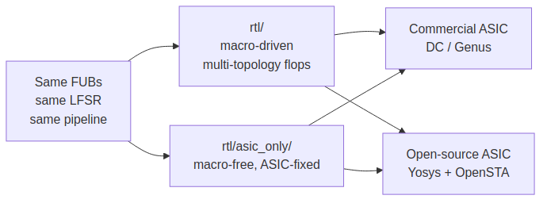
Two source trees

6.1 rtl/ – the macro-driven default
The default tree includes reset_defs.svh and fifo_defs.svh so a single source set covers every flop topology a target ASIC library might expose:
Switch | Effect
\USE_ASYNC_RESET| Includenegedge rstin the flop sensitivity list | |`RESET_ACTIVE_HIGH| Flip reset polarity | |MEM_STYLE = FIFO_{AUTO,SRL,BRAM}| Drive the inferred memory style ofgaxi_fifo_sync`
Use this tree when the cell library you’re characterising has more than one flop topology (sync-reset cells in addition to async, or active-high reset cells in addition to active-low) and you want a single source sweep all of them.

6.2 rtl/asic_only/ – the macro-free ASIC fork
The asic_only fork strips all three abstractions:
- \include “reset_defs.svh”and`include “fifo_defs.svh”` removed
- \ALWAYS_FF_RST(clk, rst, BODY)rewritten toalways_ff @(posedge clk or negedge rst) begin BODY end`
- \RST_ASSERTED(rst)rewritten to!(rst)`
- fifo_mem_t parameter type replaced with int; FIFO_AUTO, FIFO_SRL, FIFO_BRAM inlined as 0, 1, 2
The behaviour is identical to the upstream tree when configured for USE_ASYNC_RESET + active-low; the asic_only variant just bakes that single posture into source so every flop is one obvious always_ff block and every reset condition is one !rst_n test. Use this tree when:
- the target library exposes a single flop topology (async, active-low) anyway, so the macro switches are dead options;
- you want the source you read to match the netlist the tool builds, with no preprocessor gates in between;
- you want the open-source Yosys + OpenSTA flow without library-defs in your include path.

7. The synthesis flow
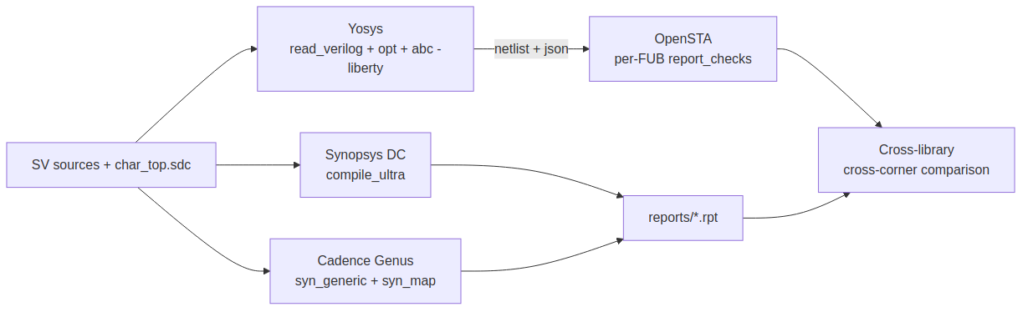
Synthesis flow back ends
Three ASIC back ends are wired up: one open-source (Yosys + OpenSTA), two commercial (Synopsys DC, Cadence Genus). All three source the same char_top.sdc so reports use the same path groups and are directly comparable.

7.1 Open-source flow (Yosys + OpenSTA, asic_only tree)
cd projects/components/timing_characterization/rtl/asic_only/syn
# Minimal invocation -- 500 MHz, every FUB enabled
make report LIB_PATH=/path/to/stdcell.lib
# 800 MHz, no multiplier (isolates the rest of the harness)
make report LIB_PATH=/path/to/stdcell.lib \
TARGET_FREQ_MHZ=800 EN_MULTIPLIER=0
# Just rerun STA against the existing netlist
make sta LIB_PATH=/path/to/stdcell.lib
Outputs land under syn/build/:
File | Contents
build/$TOP.netlist.v | Post-mapped gate-level netlist
build/$TOP.json | Yosys JSON (for graph tools, formal, ABC reruns)
build/$TOP.stat.txt | Cell-count + area summary per Liberty
build/sta.log | Full OpenSTA log incl. WNS per group
build/timing/GRP_*.rpt | Per-FUB worst-path report
build/area.rpt | Hierarchical area
build/yosys.log | Synthesis trace for diffing across runs

7.2 Commercial reference flows (asic_only tree)
dc_shell -f rtl/asic_only/syn/dc_synth.tcl # Synopsys DC
genus -files rtl/asic_only/syn/genus_synth.tcl # Cadence Genus
Both reference scripts source the same char_top.sdc and declare the same per-FUB path groups, so reports are directly comparable to the open-source flow’s output.

8. Reading the reports
The interesting line in the OpenSTA log (or the DC / Genus equivalent) is the per-group worst-negative-slack:
Path Group: GRP_NAND WNS = 0.1234 ns
Path Group: GRP_INVERTER WNS = 0.4567 ns
...
Positive WNS = the FUB meets the target frequency with that much slack to spare. Negative WNS = the FUB misses by that much; the absolute value is the additional period the technology needs at this depth.
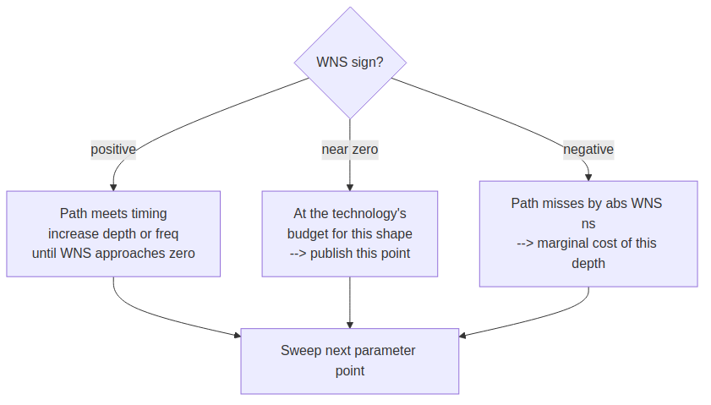
WNS-sign decision tree
Sweep protocol:
- Fix TARGET_FREQ_MHZ.
- For each FUB, sweep its depth / width parameter until WNS crosses zero.
- Record the parameter value at WNS = 0 – that’s the technology’s max depth for that pattern at the chosen frequency.
- Repeat across libraries / devices for an apples-to-apples cross-target view.

8.1 Comparing technologies
Run the same sweep against two libraries (asic_only flow):
make report LIB_PATH=lib_A.lib TARGET_FREQ_MHZ=500
mv build/timing build/timing.A
make clean
make report LIB_PATH=lib_B.lib TARGET_FREQ_MHZ=500
mv build/timing build/timing.B
diff -u build/timing.A/GRP_CARRY.rpt build/timing.B/GRP_CARRY.rpt
The path structures are identical; only the cell delays differ. Any WNS delta therefore comes purely from the technology, not from a synthesizer mood swing or a netlist topology change.

9. Verification
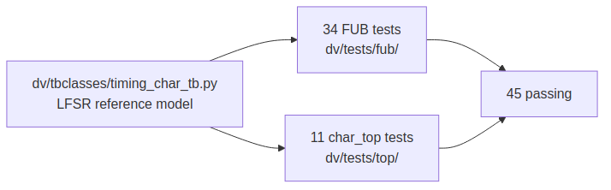
Verification topology
Suite | Location | Tests | Status
Per-FUB sweeps | dv/tests/fub/ | 34 | All passing
char_top enable-mix configurations | dv/tests/top/ | 11 | All passing
PYTHONPATH=bin:$PYTHONPATH pytest \
projects/components/timing_characterization/dv/tests/ -v
The TB class lives in dv/tbclasses/timing_char_tb.py and implements the mandatory three methods (setup_clocks_and_reset, assert_reset, deassert_reset); the lfsr_step / lfsr_sequence reference functions match the left-shift LFSR baked into char_top.

10. Directory layout
projects/components/timing_characterization/
├── README.md <-- this file
├── CLAUDE.md AI assistance guide
├── PRD.md Product Requirements
├── TASKS.md Task tracking
├── assets/ diagram sources + rendered PNGs
│ ├── Makefile `make` to re-render every *.mmd -> *.png
│ ├── puppeteer.json mmdc no-sandbox config
│ ├── *.mmd diagram source (mermaid)
│ └── *.png diagram renders (embedded above)
├── docs/ Characterization results (future)
├── dv/
│ ├── tbclasses/
│ │ └── timing_char_tb.py TB base + LFSR reference model
│ └── tests/
│ ├── fub/ 9 FUB tests (34 parameter points)
│ └── top/ char_top tests (11 enable-mixes)
├── work/ <-- the worked example artifacts
│ ├── asap7_characterization.xlsx 3-sheet methodology workbook
│ ├── timing_char_sweep.py 9-primitive 2-point probe driver
│ ├── timing_char_data.csv 54-row primitive characterization data
│ ├── abc_sweep.py 11-row STREAM library sweep driver
│ ├── timings.csv 99-row per-block ASAP7 sweep output
│ ├── build_characterization_xlsx.py CSV -> xlsx generator
│ └── merge_lib_corner.py ASAP7 RVT Liberty merger (TT/FF/SS)
└── rtl/
├── common/ shared primitives (counters, math, gaxi_fifo_sync)
├── fub/ 9 FUBs
├── filelists/char_top.f flat source list for the multi-flow tree
├── top/ char_top.sv + nand_chain_top.sv
├── syn/ multi-flow SDC + SYNTHESIS_GUIDE
└── asic_only/ <-- macro-free ASIC fork
├── common/ same primitives, macros expanded
├── fub/ same FUBs, macros expanded
├── filelists/char_top.f flat source list (asic_only)
├── top/ char_top.sv + nand_chain_top.sv (asic_only)
└── syn/ ASIC-only flow
├── Makefile Yosys + OpenSTA driver
├── yosys_synth.ys
├── sta_run.tcl
├── dc_synth.tcl Synopsys DC reference
├── genus_synth.tcl Cadence Genus reference
├── char_top.sdc ASIC-only SDC
└── SYNTHESIS_GUIDE.md

10.1 Regenerating the diagrams
The seven figures in this document live as mermaid source in assets/ and are rendered to PNG by mmdc (@mermaid-js/mermaid-cli). Re-render after editing the source:
cd projects/components/timing_characterization/assets
make # render every *.mmd -> *.png
make clean # delete the PNGs
assets/puppeteer.json passes --no-sandbox so headless Chrome runs inside sandboxed environments and CI runners.

11. Limitations and intentional non-features
- No memory compiler integration. queue_depth is mapped by the tool to whatever the Liberty file exposes; an SRAM-compiler wrapper is out of scope.
- No SDF back-annotation. STA against the synth Liberty is wire-load estimated, not parasitic-aware. Round-trip P&R + extraction is out of scope of a characterization harness.
- No power numbers from the open-source flow. Add a switching activity file and a power-aware Liberty to extend the OpenSTA invocation with report_power.
- asic_only is async-reset only. The harness models the worst case (async reset path through every flop) so the cell library’s reset recovery / removal delay is reflected in the report. Sync-reset numbers come from the macro-driven rtl/ tree with USE_ASYNC_RESET left undefined.

13. From characterization to design: the ASAP7 worked example
The methodology’s design-time artifact is a single workbook with three linked sheets: work/asap7_characterization.xlsx. It’s built bottom-up against ASAP7 RVT (the same flow described in section 7) and lets a designer answer “will this pipeline close?” by changing one cell – before any RTL exists for the production block.
The three sheets stack:
- characterization – the technology data. Per-gate-type delay (NAND, XOR, MUX, CARRY, MULT, …) at TT / FF / SS, plus Tflop, wire delay per metal layer, and the Design clocks table that names the clocks the design uses.
- building blocks – a SWAG estimator for every reusable RTL block (skid buffer, gaxi_fifo_sync, arbiter_round_robin, axi4_master_rd/wr, SRAMs). Each row’s data->D / flop->out / fmax / slack are formulas that look up the planning corner and freq from the characterization sheet.
- stream – a worked example: every port of every STREAM FUB walked by hand, one row per (FUB, port) pair. The slack cell on each row is corner- and freq-aware via VLOOKUP into the clocks table.
Editing the clocks table on sheet 1 propagates to slack columns on sheets 2 and 3. Negative slack cells render bold red so failing paths jump off the page during the sweep.

13.1 Sheet 1: characterization – the technology data
The top of the sheet is a sweep grid: TT / FF / SS x five frequencies (currently 2.0 / 2.25 / 2.5 / 2.75 / 3.0 GHz). Each cell shows what’s achievable in that corner+freq combination. The two driving rows are:
- Per-level gate delay (ps, freq-independent) – the slope from a two-point synth probe per primitive at that corner. This is what gets pulled by the downstream sheets.
- Max combinational levels per cycle – the budget: (period - Tflop) / per_level_delay. Tells you how deep a chain of that gate type can be before it busts the period.
TT corner, freq sweep | NAND | XOR | MUX | CARRY | MULT (proxy) | GRAY_CTR | QUEUE
per-level delay (ps) | 7.25 | 26.8 | 16.3 | 30.8 | 30.0 | 58.4 | 11.6
max levels @ 2.0 GHz | 66 | 18 | 29 | 15 | 16 | 8 | 41
max levels @ 3.0 GHz | 43 | 12 | 19 | 10 | 10 | 5 | 27
The MULT row is highlighted yellow on the sheet – it doubles as the recommended proxy for mixed-bag combinational logic (a real mult tree contains AND, XOR, full-adder, and carry cells, so its per-level delay blends realistically).
Below the per-corner data lives the Design clocks table – one configurable row per clock the design uses (up to six slots):
clock name | freq (MHz) | target corner | period (ps) | input 60% | output 40% | wire/hop
clk_main | 1000 | TT | =1e6/B | =D*0.6 | =D*0.4 | 100
(5 empty slots)
Yellow cells are editable; the rest derive. This table is what sheets 2 and 3 read – their slack columns are wired here via VLOOKUP.
Last two sections on the sheet: Wire delay per mm by metal layer (M2/M3 through M8/M9 – 120 to 22 ps/mm TT), and notes.

13.2 Sheet 2: building blocks – per-block SWAGs
One row per reusable RTL block, in two sections. The SRAMs section holds the storage primitives:
block | params | flops | NAND_eq | data->D (TT, ps) | flop->out | slack @ clk_main
SRAM (raw macro) | W=512, D=512 | 0 | ~2110 | 7 | 7 | (depends on clock)
gaxi_fifo_sync (REG=1, SRAM-backed) | W=512, D=512 | 28 | 2188 | 7 | 7 | …
flops on the SRAM rows is the control-only count – storage bits (W * D) live in the BRAM/SRAM macro, not in std cells. A reference block below the table shows storage = W*D in bits and KB.
The Building Blocks section follows with the rest:
block | base params | flops | NAND_eq | in mux/nand | out mux/nand | slack @ clk_main
gaxi_skid_buffer | W=1, D=2 | 6 | 18 | 1 / 1 | 0 / 0 | (computed)
gaxi_fifo_sync (REG=0) | W=1, D=2 | 6 | 40 | 1 / 2 | log2(D) / 0 | …
arbiter_round_robin | N=2 | 4 | 16 | 0 / 1 | log2(N) / 1 | …
axi4_master_rd | AW=DW=32, IW=4 | 212 | 848 | 1 / 1 | 1 / 1 | …
axi4_master_wr | similar | 222 | 888 | 1 / 1 | 1 / 1 | …
Each row’s clock column (yellow) defaults to clk_main – change it to point a block at a different clock entry on sheet 1. data->D covers the input-side combinational delay; flop->out covers the output-side; delay_in defaults to 30 percent of the target period (STA input arrival); slack = period - delay_out - 40 percent of period - wire_per_hop.
Skid buffers have out_mux = out_nand = 0 because the head flop’s Q drives the output directly – there’s no internal output muxing. The other blocks have non-zero output-side levels (the read mux tree on FIFOs, the priority encoder on the arbiter, the skid output select on the AXI masters).

13.3 Sheet 3: stream – per-FUB port trace
This is the worked example proper: 11 STREAM FUBs, 144 rows total, one row per (FUB, port) pair. Walking rtl/fub/stream_latency_bridge.sv by hand gave the first ten rows; the other ten FUBs were filled in the same way.
Each row has:
col | content
A | FUB name
B | port name
C | clock (defaults clk_main; edit to point at a different clock)
D | direction (in / out / local)
E | building block crossed (if the port enters / leaves a BB)
F | MUX lv on this row’s path
G | NAND lv on this row’s path
H | source/sink flop or BB port the path terminates at
I | target period (VLOOKUP from clocks table)
J | target corner (VLOOKUP)
K | local delay (corner-aware: F * per_MUX(corner) + G * per_NAND(corner))
L | delay_in (30 percent of target period by default; override with =M_prev to chain)
M | delay_out = delay_in + local delay
O | slack = period - delay_out - output_40% - wire/hop
P | places it goes (which downstream FUB / CSR / system bus consumes this)
A local direction marks an internal flop hop (r_state -> r_next inside one FUB). 39 of the 144 rows are local-flop hops; 26 cross a building block boundary; the rest are external ports.
The “places it goes” column carries the partition story. For example:
FUB | port | dir | terminator | places it goes
stream_latency_bridge | m_valid | out | u_skid_buffer.rd_valid (Q) | to sram_controller_unit.axi_wr_sram_valid -> axi_write_engine
scheduler | axi_rd_req_valid | out | r_axi_rd_req (Q) | to axi_read_engine (per-channel request)
descriptor_engine | descriptor_valid | out | i_descriptor_fifo.rd_valid (Q) | to scheduler (descriptor dispatch)

13.4 The workflow: planning at the spreadsheet
The whole point of the three-sheet stack is to make pipeline planning a spreadsheet exercise:
- Open the workbook, go to characterization, find the Design clocks table, set clk_main freq + corner to your target.
- Flip to building blocks – which BB rows light up red in the slack column? Those are the blocks you need to either pipeline harder or stop relying on at this freq.
- Flip to stream – which FUB ports are red? Those tell you which inter-FUB hops won’t close. The “places it goes” column maps a red row back to a concrete RTL location.
- Iterate: lower the freq until everything’s green (the design’s actual ceiling); switch to FF corner to model best-case silicon; bump wire/hop to model long routes.
Three knobs to play with:
- clk_main freq (B29) – walk the period; watch slack flip.
- clk_main target corner (C29) – TT for sign-off, FF for best-case silicon, SS for worst-case.
- clk_main wire/hop (G29) – default 100 ps; bump to 200-300 for long inter-FUB routes, drop to 0 for paths that stay inside one FUB.
Add more clocks (clk_apb, clk_cdc, …) in slots 30-34 and re-point specific rows on sheets 2 / 3 by editing their clock cell.

13.5 Grounding: how the data got there
The numbers on sheet 1 come from a single Python driver work/timing_char_sweep.py that:
- Reads the nine asic_only/fub/*.sv primitives.
- Synthesizes each at two probe sizes (small + large) per corner through Yosys + ABC against ASAP7 RVT, using work/merge_lib_corner.py’s merged Liberty.
- Reads ABC’s stime -c output for each run to get delay (ps) and logic-level count.
- Derives per-level slope and Tflop via linear extrapolation, drops them in work/timing_char_data.csv.
Then work/build_characterization_xlsx.py turns the CSV plus hand-walked FUB tables into the three-sheet workbook.
A parallel driver work/abc_sweep.py runs every STREAM library row (11 distinct blocks) through the same Yosys + ABC flow at TT / FF / SS x three target frequencies (99 cells, all clean, ~9 minutes wall-clock). Output is work/timings.csv; it’s the “ground truth” measurement to calibrate the SWAGs on sheet 2 against – the SWAG model is first-order and underestimates real wide-bus buffering by ~10x, so production planning should treat the spreadsheet slack as an upper bound and lean on the CSV for the hard numbers.

13.6 The point
The same exercise can run against any ASIC technology you point the flow at: rerun the per-primitive probes against a different Liberty, regenerate the workbook, and the methodology recomputes. The characterization runs once per (technology, corner); the rest of the workflow is a spreadsheet.
The same workflow runs on an FPGA target – different delay model, different primitives, different gate units – and the worksheet shape stays the same; only the library columns change. That companion is the subject of a separate addendum README, not this document.

14. Navigation
- AI assistance guide: CLAUDE.md
- Product requirements: PRD.md
- Task tracking: TASKS.md
- Per-FUB synthesis recipes: rtl/syn/SYNTHESIS_GUIDE.md
- Multi-flow constraint file: rtl/syn/char_top.sdc
- ASIC-only constraint file: rtl/asic_only/syn/char_top.sdc
- Open-source flow driver: rtl/asic_only/syn/Makefile
- Design-time budget worksheet: work/asap7_characterization.xlsx
- Workbook generator: work/build_characterization_xlsx.py
- Per-primitive ASAP7 probe driver: work/timing_char_sweep.py
- Per-block STREAM library sweep: work/abc_sweep.py
- Merged ASAP7 RVT Liberty builder: work/merge_lib_corner.py
- Primitive characterization data: work/timing_char_data.csv
- STREAM library sweep results: work/timings.csv
- Components area: ../README.md
- Repository guide: /CLAUDE.md

