Table of Contents

# Converter Index

**Generated:** 2025-10-26

# Converters Component Specification

**Version:** 1.2 **Status:** Production Ready **Last Updated:** 2025-10-26

## Document Overview

This specification provides comprehensive documentation for the Converters component, which includes data width conversion and protocol conversion modules for seamless system integration.

**Document Structure:** - **Chapter 1:** Overview and Architecture - **Chapter 2:** Data Width Converters - **Chapter 3:** Protocol Converters - **Chapter 4:** Usage Examples and Integration

## Quick Navigation

### Chapter 1: Overview

* [01\_introduction.md](ch01_overview/01_introduction.md) - Component overview and key features
* [02\_architecture.md](ch01_overview/02_architecture.md) - System architecture and module hierarchy
* [03\_design\_philosophy.md](ch01_overview/03_design_philosophy.md) - Design decisions and rationale

### Chapter 2: Data Width Converters

* [01\_overview.md](ch02_data_width_converters/01_overview.md) - Data width conversion overview
* [02\_axi\_data\_upsize.md](ch02_data_width_converters/02_axi_data_upsize.md) - Narrow→Wide accumulator
* [03\_axi\_data\_dnsize.md](ch02_data_width_converters/03_axi_data_dnsize.md) - Wide→Narrow splitter
* [04\_dual\_buffer\_mode.md](ch02_data_width_converters/04_dual_buffer_mode.md) - High-performance dual-buffer mode
* [05\_axi4\_dwidth\_converter\_wr.md](ch02_data_width_converters/05_axi4_dwidth_converter_wr.md) - Full write path converter
* [06\_axi4\_dwidth\_converter\_rd.md](ch02_data_width_converters/06_axi4_dwidth_converter_rd.md) - Full read path converter

### Chapter 3: Protocol Converters

* [01\_overview.md](ch03_protocol_converters/01_overview.md) - Protocol conversion overview
* [02\_axi4\_to\_apb.md](ch03_protocol_converters/02_axi4_to_apb.md) - AXI4-to-APB bridge
* [03\_peakrdl\_adapter.md](ch03_protocol_converters/03_peakrdl_adapter.md) - PeakRDL adapter

### Chapter 4: Usage Examples

* [01\_configuration\_guide.md](ch04_usage_examples/01_configuration_guide.md) - Parameter configuration guide
* [02\_common\_scenarios.md](ch04_usage_examples/02_common_scenarios.md) - Common use case examples
* [03\_integration\_patterns.md](ch04_usage_examples/03_integration_patterns.md) - System integration patterns

## Component Summary

### Data Width Converters

**Generic Building Blocks:** - **axi\_data\_upsize** - Accumulates N narrow beats into 1 wide beat (100% throughput) - **axi\_data\_dnsize** - Splits 1 wide beat into N narrow beats (80% or 100% throughput)

**Full AXI4 Converters:** - **axi4\_dwidth\_converter\_wr** - Complete write path (AW + W + B channels) - **axi4\_dwidth\_converter\_rd** - Complete read path (AR + R channels)

**Block Diagrams:**

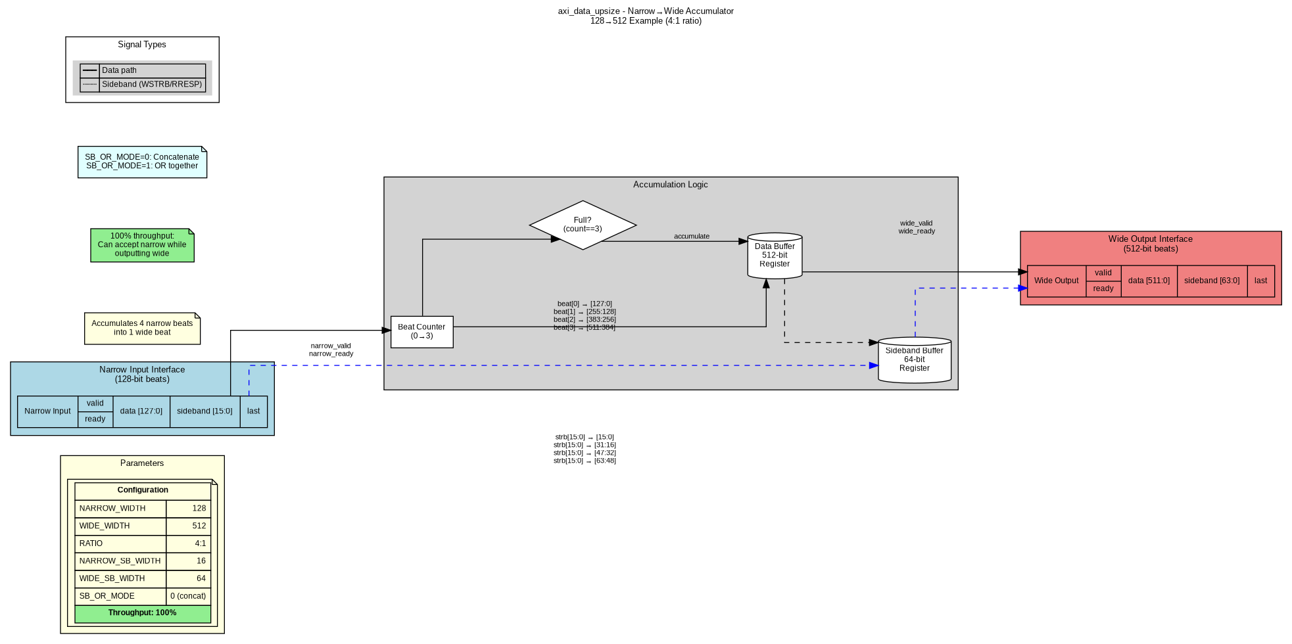 *Figure 1: axi\_data\_upsize - Narrow-to-Wide Accumulator*

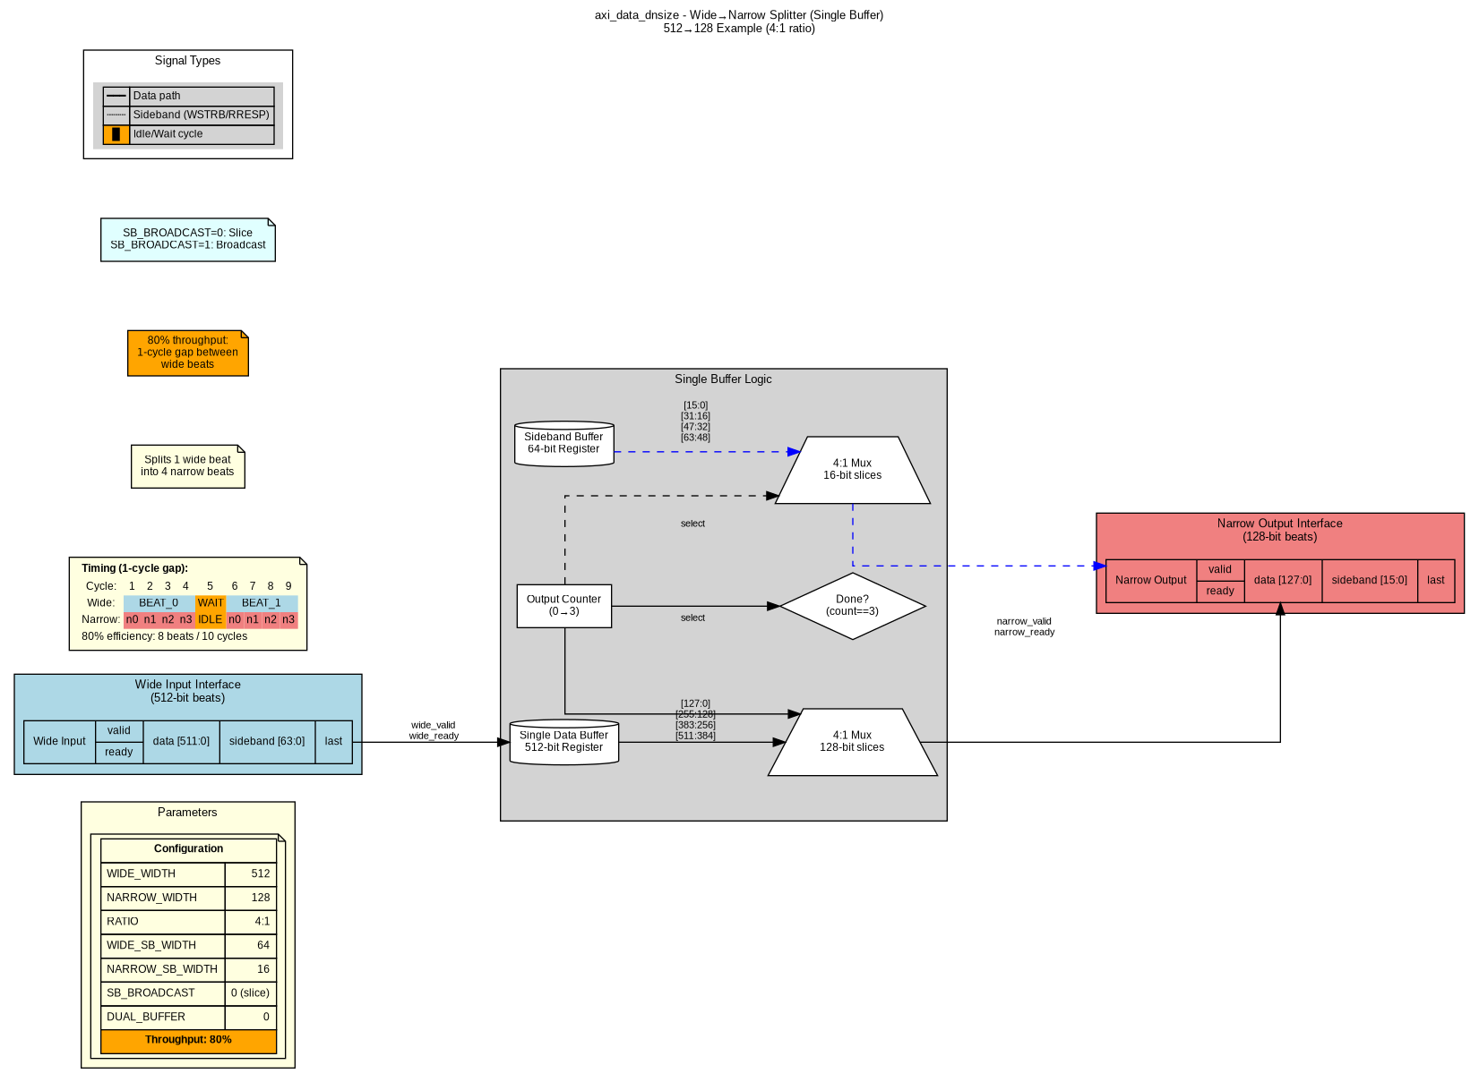 *Figure 2: axi\_data\_dnsize - Wide-to-Narrow Splitter (Single Buffer, 80% throughput)*

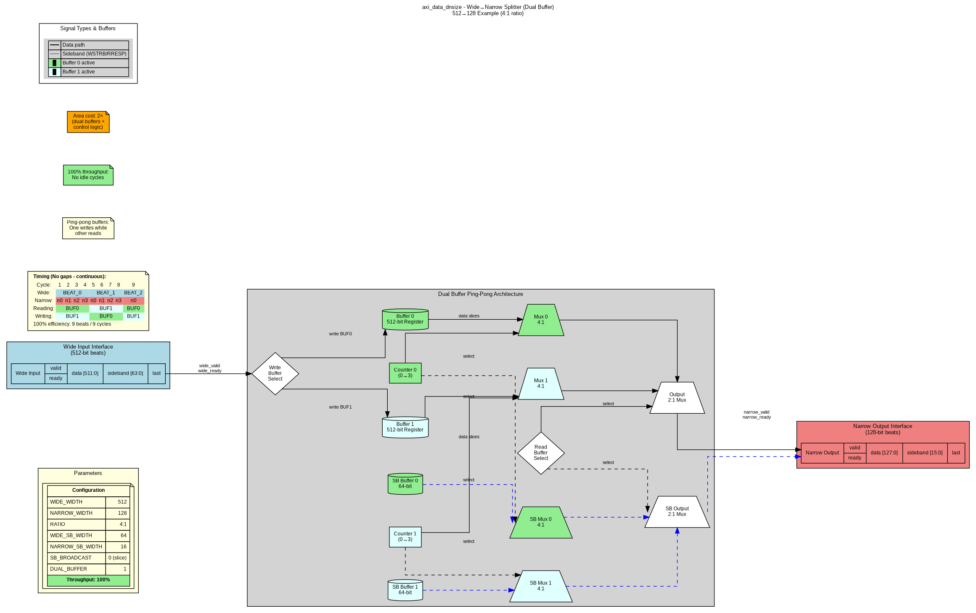 *Figure 3: axi\_data\_dnsize - Wide-to-Narrow Splitter (Dual Buffer, 100% throughput)*

### Protocol Converters

**Available Converters:** - **axi4\_to\_apb\_convert** - Full AXI4-to-APB protocol bridge - **axi4\_to\_apb\_shim** - Simplified AXI4-to-APB wrapper - **peakrdl\_to\_cmdrsp** - PeakRDL register to command/response adapter

**Block Diagrams:**

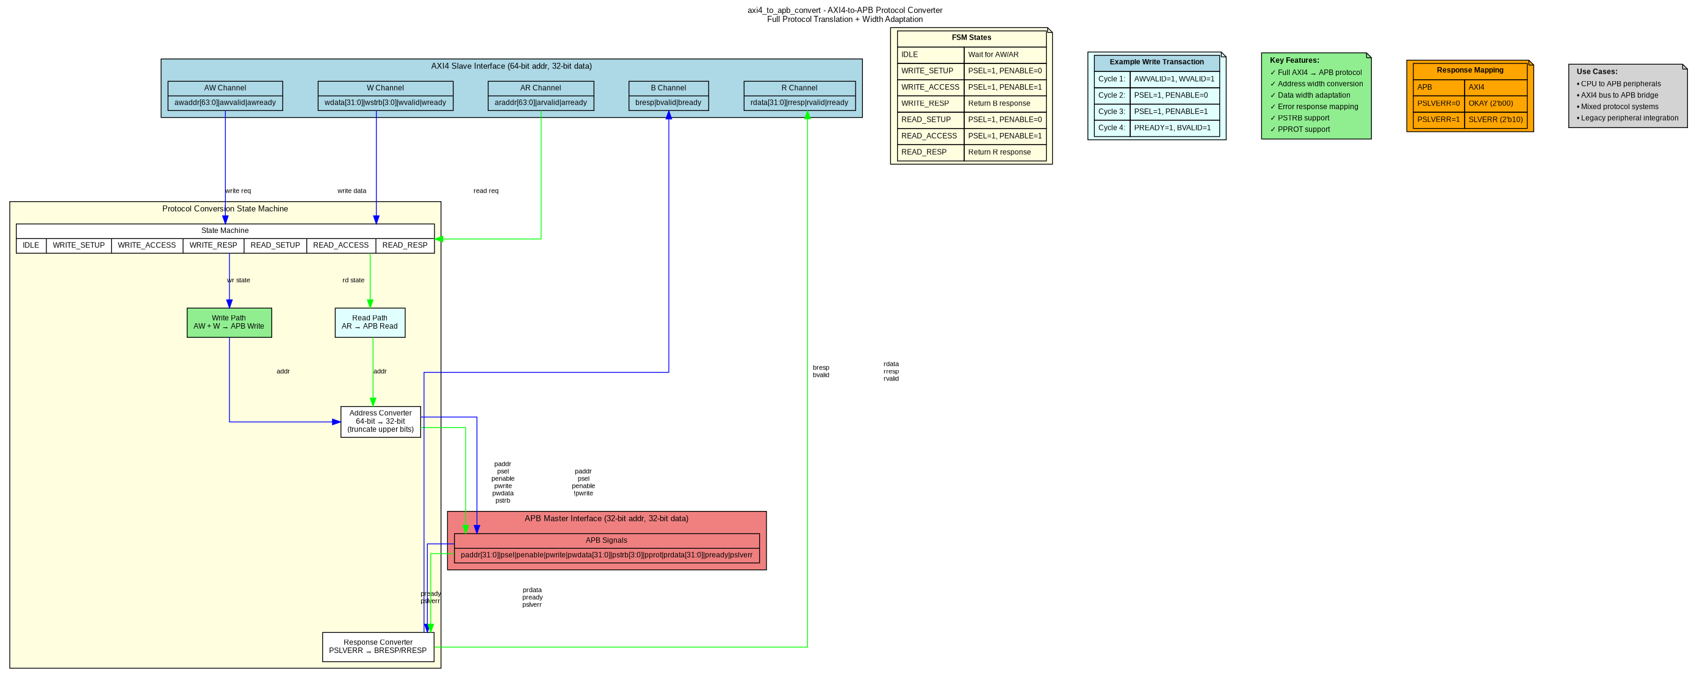 *Figure 4: axi4\_to\_apb\_convert - Protocol Conversion*

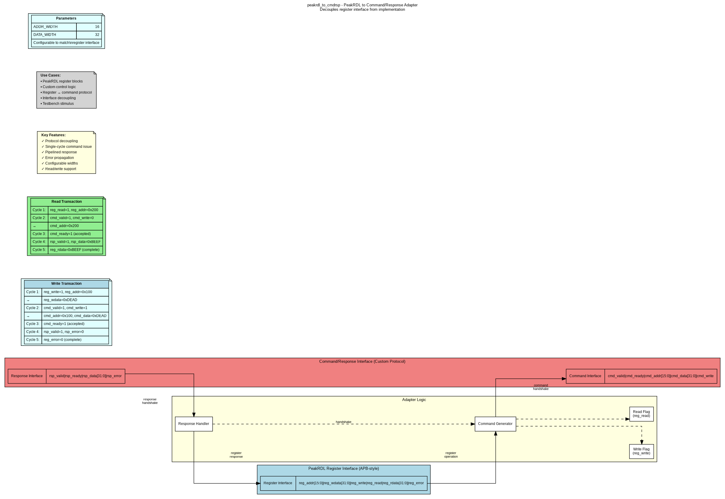 *Figure 5: peakrdl\_to\_cmdrsp - Register Interface Adapter*

**FSM Diagram:**

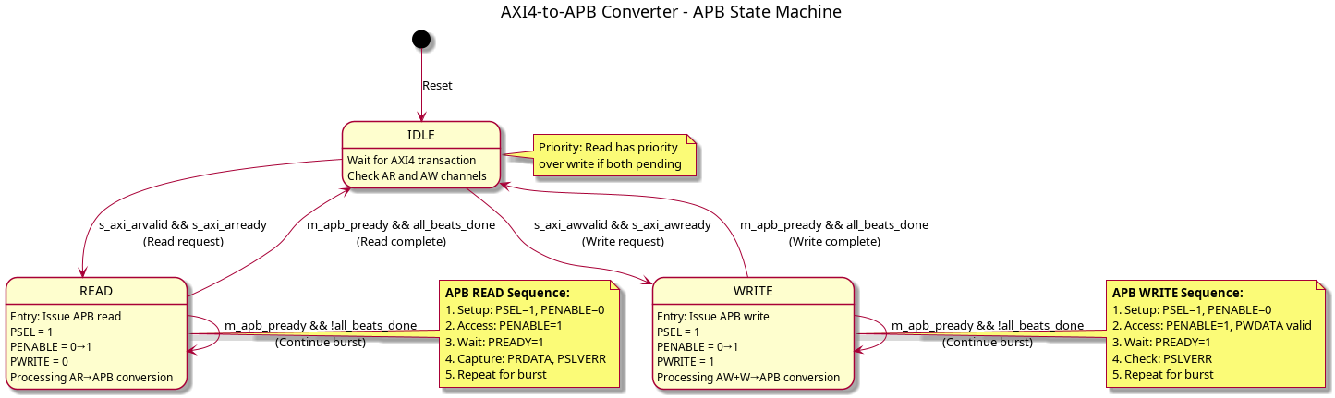 *Figure 6: AXI4-to-APB State Machine*

## Performance Summary

| Module | Configuration | Throughput | Area | Use Case |
| --- | --- | --- | --- | --- |
| **axi\_data\_upsize** | Single buffer | 100% | 1× | Narrow→Wide (always optimal) |
| **axi\_data\_dnsize** | Single buffer | 80% | 1× | Wide→Narrow (area-efficient) |
| **axi\_data\_dnsize** | Dual buffer | 100% | 2× | Wide→Narrow (high-performance) |
| **axi4\_dwidth\_converter\_wr** | With upsize | 100% | Standard | Full write path |
| **axi4\_dwidth\_converter\_rd** | With dual dnsize | 100% | +100% | Full read path |
| **axi4\_to\_apb** | Protocol FSM | Sequential | Small | Protocol conversion |

## Key Features

### Data Width Conversion

* Flexible width ratios (any integer multiple: 2:1, 4:1, 8:1, 16:1, etc.)
* Configurable sideband handling (concatenate or broadcast)
* Optional burst tracking for LAST signal generation
* Dual-buffer mode for 100% throughput (downsize only)
* Generic building blocks for custom converters

### Protocol Conversion

* Full AXI4-to-APB protocol translation
* Address width adaptation (64-bit→32-bit)
* Data width adaptation (configurable)
* Error response mapping (PSLVERR→BRESP/RRESP)
* PeakRDL register interface decoupling

## Documentation Assets

### Graphviz Block Diagrams

Located in assets/graphviz/: - axi\_data\_upsize.gv/.png - axi\_data\_dnsize\_single.gv/.png - axi\_data\_dnsize\_dual.gv/.png - axi4\_dwidth\_converter\_wr.gv/.png - axi4\_dwidth\_converter\_rd.gv/.png - axi4\_to\_apb.gv/.png - peakrdl\_adapter.gv/.png

See <assets/graphviz/README.md> for regeneration instructions.

### PlantUML FSM Diagrams

Located in assets/puml/: - axi4\_to\_apb\_fsm.puml/.png

See <assets/puml/README.md> for regeneration instructions.

## Related Documentation

**Component-Level:** - <../../README.md> - Component quick start guide - <../../DUAL_BUFFER_IMPLEMENTATION.md> - Dual-buffer feature deep dive - <../../ANALYSIS_APB_CONVERTER.md> - APB converter analysis

**Repository-Level:** - RTL source: projects/components/converters/rtl/ - Test suite: projects/components/converters/dv/tests/ - Usage examples: Chapter 4 of this specification

## Version History

| Version | Date | Description |
| --- | --- | --- |
| 1.2 | 2025-10-26 | Added comprehensive specification with block diagrams |
| 1.1 | 2025-10-25 | Added dual-buffer mode for axi\_data\_dnsize |
| 1.0 | 2025-10-24 | Initial release with generic and full converters |

## Document Conventions

**Notation:** - parameter\_name - RTL parameters and signals - **Bold** - Important concepts and module names - *Italic* - Figure captions and references

**Diagrams:** - Light blue - Input interfaces - Light coral - Output interfaces - Light yellow - Control logic - Light gray - Data path elements - Arrows - Data/control flow

**Author:** RTL Design Sherpa Project **Maintained By:** Converters Component Team **Last Review:** 2025-10-26

# Chapter 1: Overview - Introduction

## Purpose

The Converters component provides essential data width conversion and protocol conversion modules that enable seamless integration between components with different data widths or communication protocols.

## Problem Statement

Modern SoC designs frequently encounter two integration challenges:

1. **Data Width Mismatch**
   * CPU: 64-bit data bus
   * DDR Controller: 512-bit data bus
   * PCIe Endpoint: 128-bit data bus
   * Result: Direct connection impossible
2. **Protocol Incompatibility**
   * AXI4 masters (CPU, DMA)
   * APB peripherals (UART, GPIO, SPI)
   * Custom register interfaces (PeakRDL)
   * Result: Protocol bridge required

## Solution Approach

### Data Width Converters

**Generic Building Blocks:** - axi\_data\_upsize - Accumulates narrow beats into wide beats - axi\_data\_dnsize - Splits wide beats into narrow beats

**Full AXI4 Integration:** - axi4\_dwidth\_converter\_wr - Write path converter (AW + W + B) - axi4\_dwidth\_converter\_rd - Read path converter (AR + R)

### Protocol Converters

* axi4\_to\_apb\_convert - Full AXI4-to-APB bridge
* peakrdl\_to\_cmdrsp - Register interface adapter

## Key Benefits

### Reusability

* Generic modules work with any width ratio
* Configurable parameters for custom use cases
* Self-contained building blocks

### Performance

* Upsize: 100% throughput (single buffer)
* Downsize: 80% (single buffer) or 100% (dual buffer)
* Minimal latency overhead

### Flexibility

* Configurable sideband handling
* Optional burst tracking
* Dual-buffer mode for high-performance paths

## Component Scope

### In Scope

* Integer width ratios (2:1, 4:1, 8:1, 16:1, etc.)
* AXI4 and APB protocol support
* Configurable throughput vs area trade-offs
* Generic building blocks for custom converters

### Out of Scope

* Non-integer width ratios (e.g., 3:2 conversion)
* AXI4-Stream protocol (different component)
* Complex buffering beyond dual-buffer
* Clock domain crossing (use separate CDC modules)

## Target Applications

1. **CPU-to-DDR Integration** - 64-bit CPU to 512-bit memory controller
2. **DMA Engines** - Variable width data movers
3. **Mixed Protocol Systems** - AXI4 to APB peripheral buses
4. **FPGA Fabric Interfaces** - Width matching for IP integration
5. **Register Access** - PeakRDL to custom control protocols

## Document Organization

This specification is organized into four chapters:

1. **Overview** (This chapter) - Purpose, scope, and architecture
2. **Data Width Converters** - Generic and full AXI4 modules
3. **Protocol Converters** - AXI4-to-APB and PeakRDL adapters
4. **Usage Examples** - Configuration, scenarios, and integration

**Next:** <02_architecture.md> - System architecture and module hierarchy

# Chapter 2: Data Width Converters - Overview

## Introduction

Data width converters enable communication between components with mismatched data bus widths, a common challenge in modern SoC designs where different IP blocks operate at different data widths.

## Module Hierarchy

Data Width Converters  
├── Generic Building Blocks  
│ ├── axi\_data\_upsize.sv - Narrow→Wide accumulator  
│ └── axi\_data\_dnsize.sv - Wide→Narrow splitter  
│  
└── Full AXI4 Converters  
 ├── axi4\_dwidth\_converter\_wr.sv - Write path (AW + W + B)  
 └── axi4\_dwidth\_converter\_rd.sv - Read path (AR + R)

## Generic Building Blocks

### axi\_data\_upsize - Narrow→Wide Accumulator

**Purpose:** Accumulate N narrow beats into 1 wide beat

**Key Features:** - 100% throughput (single buffer sufficient) - Configurable sideband modes (concatenate or OR) - Supports any integer width ratio - Minimal area overhead

**Block Diagram:**



AXI Data Upsize

**Documentation:** <02_axi_data_upsize.md>

### axi\_data\_dnsize - Wide→Narrow Splitter

**Purpose:** Split 1 wide beat into N narrow beats

**Key Features:** - Two modes: Single buffer (80%) or Dual buffer (100%) throughput - Configurable sideband modes (slice or broadcast) - Optional burst tracking for LAST generation - Trade-off: throughput vs area

**Block Diagrams:**

 *Single Buffer Mode - 80% throughput, 1× area*

 *Dual Buffer Mode - 100% throughput, 2× area*

**Documentation:** <03_axi_data_dnsize.md> | <04_dual_buffer_mode.md>

## Full AXI4 Converters

### axi4\_dwidth\_converter\_wr - Write Path Converter

**Purpose:** Complete write path conversion with AW, W, and B channels

**Features:** - Address phase management - Burst length adjustment - Skid buffers for flow control - Integrates axi\_data\_upsize for data conversion

**Block Diagram:**

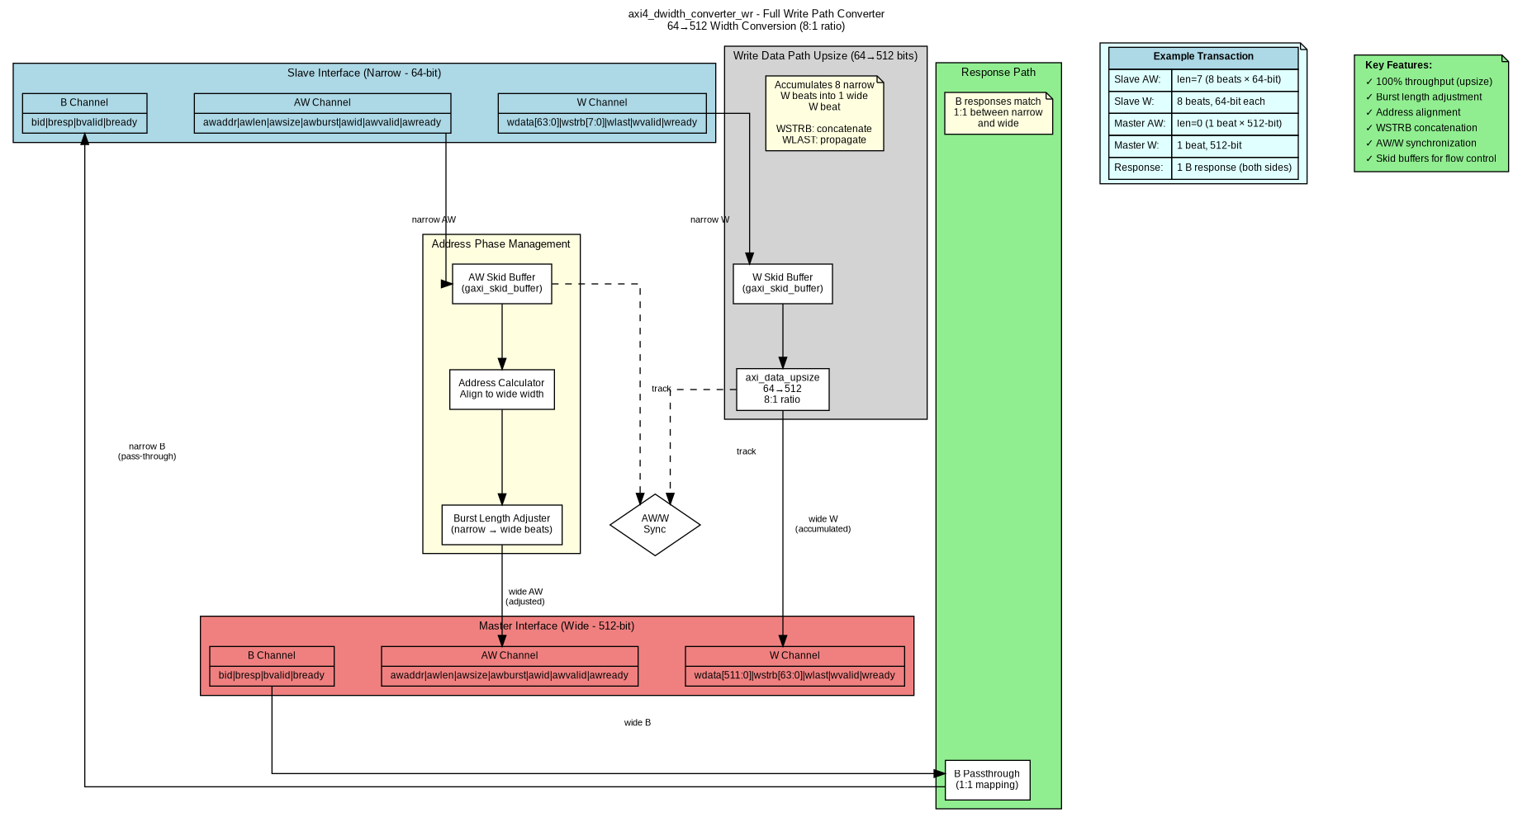

AXI4 Write Converter

**Documentation:** <05_axi4_dwidth_converter_wr.md>

### axi4\_dwidth\_converter\_rd - Read Path Converter

**Purpose:** Complete read path conversion with AR and R channels

**Features:** - Address phase management - Burst length adjustment - Burst-aware RLAST generation - Integrates axi\_data\_dnsize for data conversion

**Block Diagram:**

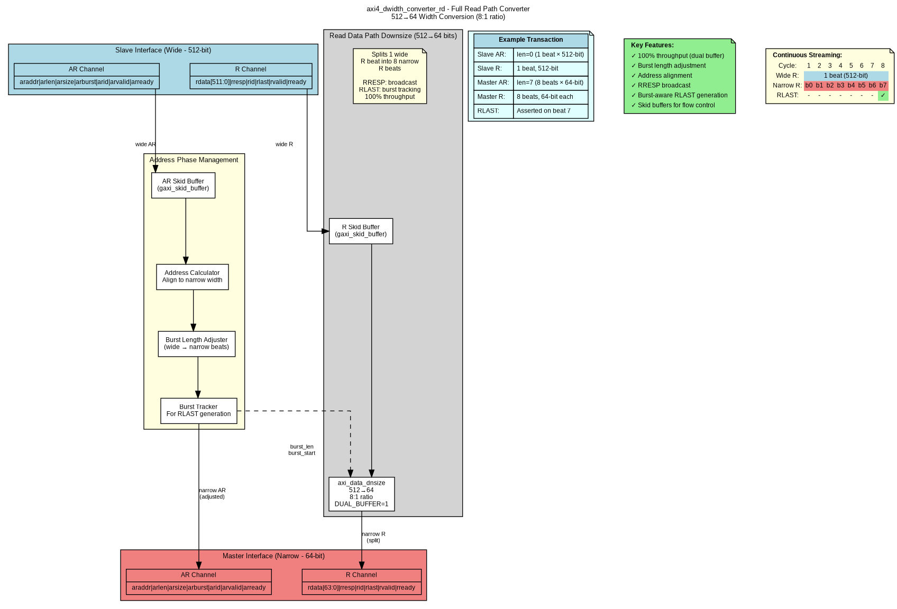

AXI4 Read Converter

**Documentation:** <06_axi4_dwidth_converter_rd.md>

## Throughput Comparison

| Module | Mode | Throughput | Area | When to Use |
| --- | --- | --- | --- | --- |
| **axi\_data\_upsize** | Single buffer | 100% | 1× | All narrow→wide conversions |
| **axi\_data\_dnsize** | Single buffer | 80% | 1× | Area-constrained designs |
| **axi\_data\_dnsize** | Dual buffer | 100% | 2× | High-bandwidth requirements |

**Recommendation:** - Upsize: Always use single buffer (100% throughput at minimal cost) - Downsize: Choose based on system requirements: - Single buffer for area-constrained or non-continuous traffic - Dual buffer for high-performance DMA or continuous streaming

## Common Configuration Examples

### Example 1: 64→512 bit (Write Path)

axi\_data\_upsize #(  
 .NARROW\_WIDTH(64),  
 .WIDE\_WIDTH(512),  
 .NARROW\_SB\_WIDTH(8), // WSTRB  
 .WIDE\_SB\_WIDTH(64),  
 .SB\_OR\_MODE(0) // Concatenate  
) u\_upsize (...);

### Example 2: 512→128 bit (Read Path, High Performance)

axi\_data\_dnsize #(  
 .WIDE\_WIDTH(512),  
 .NARROW\_WIDTH(128),  
 .WIDE\_SB\_WIDTH(2), // RRESP  
 .NARROW\_SB\_WIDTH(2),  
 .SB\_BROADCAST(1), // Broadcast  
 .DUAL\_BUFFER(1) // 100% throughput  
) u\_dnsize (...);

**Next Sections:** - <02_axi_data_upsize.md> - Detailed upsize module documentation - <03_axi_data_dnsize.md> - Detailed dnsize module documentation - <04_dual_buffer_mode.md> - Dual-buffer architecture deep dive

# Chapter 3: Protocol Converters - Overview

## Introduction

Protocol converters enable communication between components using different communication protocols, essential for integrating diverse IP blocks in complex SoC designs.

## Available Converters

### 1. AXI4-to-APB Bridge

* **Module:** axi4\_to\_apb\_convert.sv
* **Purpose:** Full protocol translation from AXI4 to APB
* **Features:** Address width adaptation, state machine control, error mapping

### 2. PeakRDL Adapter

* **Module:** peakrdl\_to\_cmdrsp.sv
* **Purpose:** Register interface to command/response protocol
* **Features:** Protocol decoupling, single-cycle commands, pipelined responses

## AXI4-to-APB Bridge

### Overview

Converts AXI4 master transactions (from CPU, DMA) to APB peripheral accesses.

**Key Challenges:** - Protocol differences (5-channel AXI4 vs 2-phase APB) - Address width mismatch (64-bit AXI4 vs 32-bit APB) - Burst support (AXI4 bursts → sequential APB transactions) - Error response mapping (PSLVERR → BRESP/RRESP)

### Block Diagram



AXI4-to-APB Converter

### State Machine

The converter uses a state machine to manage protocol translation:



AXI4-to-APB FSM

**States:** - **IDLE** - Wait for AXI4 transaction - **READ** - Process AXI4 read → APB read - **WRITE** - Process AXI4 write → APB write

### Use Cases

1. **CPU to APB Peripherals** - Main processor accessing GPIO, UART, SPI
2. **DMA to Configuration Registers** - DMA controller configuring peripherals
3. **Mixed Protocol Systems** - Integrating AXI4 fabric with legacy APB devices

### Documentation

See <02_axi4_to_apb.md> for detailed specification.

## PeakRDL Adapter

### Overview

Converts PeakRDL-generated register interface to a custom command/response protocol, enabling protocol decoupling and flexible register implementations.

**Key Features:** - APB-style register interface (input) - Command/response handshake (output) - Configurable address and data widths - Single-cycle command issue

### Block Diagram



PeakRDL Adapter

### Interface Types

**Register Interface (APB-style):** - reg\_addr[ADDR\_WIDTH-1:0] - Register address - reg\_wdata[DATA\_WIDTH-1:0] - Write data - reg\_write - Write enable - reg\_read - Read enable - reg\_rdata[DATA\_WIDTH-1:0] - Read data - reg\_error - Error flag

**Command/Response Protocol:** - Command: valid/ready handshake with addr, data, write flag - Response: valid/ready handshake with data, error flag

### Use Cases

1. **PeakRDL Register Blocks** - Decoupling register interface from implementation
2. **Custom Control Logic** - Flexible register access mechanism
3. **Testbench Stimulus** - Command-driven register access in verification

### Documentation

See <03_peakrdl_adapter.md> for detailed specification.

## Comparison

| Feature | AXI4-to-APB | PeakRDL Adapter |
| --- | --- | --- |
| **Input Protocol** | AXI4 (5 channels) | APB-style register |
| **Output Protocol** | APB (2 phases) | Command/response |
| **Complexity** | High (FSM, burst handling) | Low (pass-through) |
| **Use Case** | System interconnect | Register decoupling |
| **Performance** | Sequential per APB | Single-cycle cmd |

## Design Considerations

### When to Use Protocol Converters

**Use AXI4-to-APB when:** - Integrating AXI4 masters with APB peripherals - Building CPU-to-peripheral bridges - System has mixed protocol requirements

**Use PeakRDL adapter when:** - Decoupling register interface from implementation - Need flexible register access protocol - Building custom control/configuration logic

### Integration Guidelines

1. **Address Map Planning** - Ensure non-overlapping regions
2. **Error Handling** - Map error responses appropriately
3. **Performance Analysis** - Consider latency impact
4. **Testing Strategy** - Verify protocol compliance

**Next Sections:** - <02_axi4_to_apb.md> - Detailed AXI4-to-APB specification - <03_peakrdl_adapter.md> - Detailed PeakRDL adapter specification

# Converters Graphviz Block Diagrams

This directory contains Graphviz source files (.gv) and generated PNG diagrams for Converters component modules.

## Files

### Data Width Converters

**Generic Building Blocks:** - **axi\_data\_upsize.gv** - Narrow→Wide accumulator (128→512 example) - **axi\_data\_dnsize\_single.gv** - Wide→Narrow splitter, single buffer (512→128, 80% throughput) - **axi\_data\_dnsize\_dual.gv** - Wide→Narrow splitter, dual buffer (512→128, 100% throughput)

**Full AXI4 Converters:** - **axi4\_dwidth\_converter\_wr.gv** - Write path converter (AW + W + B channels) - **axi4\_dwidth\_converter\_rd.gv** - Read path converter (AR + R channels)

### Protocol Converters

* **axi4\_to\_apb.gv** - AXI4-to-APB protocol bridge
* **peakrdl\_adapter.gv** - PeakRDL register interface to command/response adapter

### Generated Images (.png)

All diagrams are available as PNG files: - axi\_data\_upsize.png - axi\_data\_dnsize\_single.png - axi\_data\_dnsize\_dual.png - axi4\_dwidth\_converter\_wr.png - axi4\_dwidth\_converter\_rd.png - axi4\_to\_apb.png - peakrdl\_adapter.png

## Regenerating Diagrams

### Prerequisites

* Graphviz installed (sudo apt install graphviz on Ubuntu/Debian)
* dot command available in PATH

### Generate All Diagrams

# From this directory  
make all  
  
# Or manually  
dot -Tpng axi\_data\_upsize.gv -o axi\_data\_upsize.png  
dot -Tpng axi\_data\_dnsize\_single.gv -o axi\_data\_dnsize\_single.png  
# ... etc

### Generate Single Diagram

# Upsize converter  
dot -Tpng axi\_data\_upsize.gv -o axi\_data\_upsize.png  
  
# Downsize single buffer  
dot -Tpng axi\_data\_dnsize\_single.gv -o axi\_data\_dnsize\_single.png  
  
# Downsize dual buffer  
dot -Tpng axi\_data\_dnsize\_dual.gv -o axi\_data\_dnsize\_dual.png

### Generate SVG (for web/docs)

dot -Tsvg axi\_data\_upsize.gv -o axi\_data\_upsize.svg  
# ... for all diagrams

### Generate PDF (for documentation)

dot -Tpdf axi\_data\_upsize.gv -o axi\_data\_upsize.pdf  
# ... for all diagrams

## Diagram Contents

### axi\_data\_upsize.gv

**Shows:** - Narrow input interface (128-bit beats) - Beat counter (0→3 for 4:1 ratio) - 512-bit data buffer accumulation - Wide output interface (512-bit beats) - Sideband handling (WSTRB concatenation or RRESP OR) - 100% throughput annotation

**Use Case:** Understanding narrow-to-wide data accumulation

### axi\_data\_dnsize\_single.gv

**Shows:** - Wide input interface (512-bit beats) - Single 512-bit buffer - 4:1 multiplexer for 128-bit slices - Output counter (0→3) - Narrow output interface (128-bit beats) - Timing diagram showing 80% throughput (1-cycle gap) - Sideband handling (WSTRB slice or RRESP broadcast)

**Use Case:** Understanding wide-to-narrow splitting (area-efficient mode)

### axi\_data\_dnsize\_dual.gv

**Shows:** - Wide input interface (512-bit beats) - Dual ping-pong buffers (Buffer 0 and Buffer 1) - Buffer select logic (write/read muxes) - Independent counters for each buffer - Output multiplexing - Timing diagram showing 100% throughput (no gaps) - Ping-pong operation (one reads while other writes)

**Use Case:** Understanding dual-buffer high-performance mode

### axi4\_dwidth\_converter\_wr.gv

**Shows:** - AXI4 slave interface (narrow - 64-bit) - AW/W/B channel handling - Address calculator and burst length adjuster - Skid buffers for flow control - axi\_data\_upsize integration - AXI4 master interface (wide - 512-bit) - Example transaction (8 narrow beats → 1 wide beat)

**Use Case:** Understanding full write path conversion

### axi4\_dwidth\_converter\_rd.gv

**Shows:** - AXI4 slave interface (wide - 512-bit) - AR/R channel handling - Address calculator and burst length adjuster - Burst tracker for RLAST generation - axi\_data\_dnsize integration (dual buffer) - AXI4 master interface (narrow - 64-bit) - Continuous streaming timing (100% throughput)

**Use Case:** Understanding full read path conversion

### axi4\_to\_apb.gv

**Shows:** - AXI4 slave interface (64-bit addr, 32-bit data) - Protocol conversion state machine - Write path (AW + W → APB write) - Read path (AR → APB read) - Address width conversion (64→32 bit) - Response converter (PSLVERR → BRESP/RRESP) - APB master interface - FSM state descriptions - Example timing diagrams

**Use Case:** Understanding AXI4-to-APB protocol conversion

### peakrdl\_adapter.gv

**Shows:** - PeakRDL register interface (APB-style) - Command generator - Response handler - Command/response interface (custom protocol) - Write transaction example - Read transaction example - Error propagation

**Use Case:** Understanding PeakRDL adapter protocol decoupling

## Diagram Style

**Colors:** - **Light blue** - Input interfaces (slave/narrow/wide) - **Light coral/pink** - Output interfaces (master/narrow/wide) - **Light yellow** - Control logic and notes - **Light gray** - Data path elements - **Light green** - Features/highlights - **Light cyan** - Examples - **Orange** - Warnings/limitations

**Nodes:** - **Rounded boxes** - Functional blocks - **Cylinders** - Registers/buffers - **Diamonds** - Decision/control points - **Trapezoids** - Multiplexers - **Note boxes** - Annotations, examples, timing diagrams - **Records** - Interfaces with multiple signals

**Edges:** - **Bold solid** - Primary data flow - **Dashed** - Control signals - **Colored** - Protocol-specific paths (blue=write, green=read)

## Adding New Diagrams

To add a new converter diagram:

1. Create new .gv file:

* cp axi\_data\_upsize.gv my\_new\_converter.gv

1. Edit the new file:
   * Update title and module name
   * Adjust nodes for converter functionality
   * Update data flow connections
   * Add timing/example annotations
2. Update Makefile SOURCES list:

* SOURCES = ... \  
   my\_new\_converter.gv

1. Generate PNG:

* make all

1. Link from documentation:

* ![My Converter Block Diagram](../assets/graphviz/my\_new\_converter.png)

## Referenced In Documentation

These diagrams are referenced in: - converter\_index.md - Main specification index - ch02\_data\_width\_converters/\*.md - Data width converter chapters - ch03\_protocol\_converters/\*.md - Protocol converter chapters - ch04\_usage\_examples/\*.md - Usage and integration examples

## Tools

**Graphviz Version:** Any recent version (tested with 2.43+)

**Alternative Viewers:** - Online: http://www.webgraphviz.com/ (paste .gv content) - VS Code: Install “Graphviz Preview” extension - Command line: xdg-open <diagram>.png (Linux)

## Notes

* PNG files are version controlled for easy documentation viewing
* Source .gv files are the authoritative source
* Regenerate PNGs after any .gv file changes
* Keep diagrams up-to-date with module implementations
* Use consistent color scheme across all diagrams

**Last Updated:** 2025-10-26 **Maintainer:** RTL Design Sherpa Project

# Converters PlantUML FSM Diagrams

This directory contains PlantUML source files (.puml) and generated PNG diagrams for Converters FSM documentation.

## Files

### Source Files (.puml)

* **axi4\_to\_apb\_fsm.puml** - APB state machine for AXI4-to-APB protocol converter

### Generated Images (.png)

* **axi4\_to\_apb\_fsm.png** - FSM diagram for AXI4-to-APB converter

## FSM Overview

### AXI4-to-APB Converter FSM

**States:** - **IDLE** - Wait for AXI4 transaction (AR or AW) - **READ** - Process AXI4 AR transaction → APB read - **WRITE** - Process AXI4 AW+W transaction → APB write

**Key Features:** - Read priority over write when both pending - Burst support (continues in READ/WRITE until all beats complete) - APB protocol phases (Setup → Access → Wait) - Error response handling (PSLVERR → BRESP/RRESP)

**Transitions:** - IDLE → READ: AXI4 read request (ARVALID && ARREADY) - IDLE → WRITE: AXI4 write request (AWVALID && AWREADY) - READ → IDLE: APB read complete (PREADY && all beats done) - WRITE → IDLE: APB write complete (PREADY && all beats done) - Self-loops: Continue burst transfers

## Note on Other Converters

**Data width converters (axi\_data\_upsize, axi\_data\_dnsize) do not have FSMs:** - They use simple counter-based control logic - Upsize: Beat counter (0→N-1) to accumulate narrow beats - Downsize: Output counter (0→N-1) to split wide beats - No complex state transitions needed

**Only protocol converters have FSMs:** - AXI4-to-APB: Protocol translation requires state machine - PeakRDL adapter: Simple passthrough, no FSM needed

## Regenerating Diagrams

### Prerequisites

* PlantUML installed
* Java runtime (required by PlantUML)

### Install PlantUML

# Ubuntu/Debian  
sudo apt install plantuml  
  
# Or download JAR  
wget https://github.com/plantuml/plantuml/releases/download/v1.2023.13/plantuml-1.2023.13.jar

### Generate PNG from PlantUML

# Using installed plantuml  
plantuml axi4\_to\_apb\_fsm.puml  
  
# Or using downloaded JAR  
java -jar plantuml.jar axi4\_to\_apb\_fsm.puml  
  
# Output: axi4\_to\_apb\_fsm.png

### Generate SVG (for web)

plantuml -tsvg axi4\_to\_apb\_fsm.puml

### Generate PDF (for documentation)

plantuml -tpdf axi4\_to\_apb\_fsm.puml

## FSM Style

**Colors:** - Default state colors (light blue/yellow as per PlantUML defaults) - Transition arrows with labels showing conditions

**Annotations:** - Entry actions described in state boxes - Transition conditions on arrows - Notes explaining protocol sequences

**Format:** - Standard UML state machine notation - Clear state names matching RTL enumeration - Transition guards showing trigger conditions

## Referenced In Documentation

These diagrams are referenced in: - ch03\_protocol\_converters/02\_axi4\_to\_apb.md - AXI4-to-APB converter chapter - converter\_index.md - Main specification index

## Adding New FSM Diagrams

If future converters include FSMs:

1. Create new .puml file:

* @startuml my\_converter\_fsm  
  title My Converter FSM  
    
  [\*] --> IDLE  
  IDLE --> ACTIVE : trigger  
  ACTIVE --> IDLE : done  
    
  @enduml

1. Generate PNG:

* plantuml my\_converter\_fsm.puml

1. Link from documentation:

* ![My Converter FSM](../assets/puml/my\_converter\_fsm.png)

## Tools

**PlantUML Version:** Any recent version (tested with 1.2023+)

**Alternative Renderers:** - Online: http://www.plantuml.com/plantuml/uml/ (paste .puml content) - VS Code: Install “PlantUML” extension - IntelliJ IDEA: Built-in PlantUML support

## Notes

* PNG files are version controlled for easy viewing
* Source .puml files are the authoritative source
* Regenerate PNGs after any .puml changes
* Keep FSM diagrams synchronized with RTL state definitions

**Last Updated:** 2025-10-26 **Maintainer:** RTL Design Sherpa Project

# Converters - Data Width and Protocol Conversion Modules

**Status:** Production Ready **Version:** 1.2 **Last Updated:** 2025-10-25

## Quick Start

The Converters component provides both data width conversion and protocol conversion modules, enabling seamless integration between components with different data widths or protocols.

### Key Features

**Data Width Converters:** - **Bidirectional Conversion** - Upsize (narrow→wide) and Downsize (wide→narrow) - **Flexible Width Ratios** - Any integer ratio (2:1, 4:1, 8:1, 16:1, etc.) - **Sideband Support** - Configurable handling for WSTRB (slice) and RRESP (broadcast) - **Burst Tracking** - Optional burst-aware LAST signal generation (read path) - **High Throughput** - Optional dual-buffer mode for 100% throughput (downsize) - **Generic Building Blocks** - Reusable axi\_data\_upsize and axi\_data\_dnsize modules

**Protocol Converters:** - **AXI4-to-APB Bridge** - Full AXI4 to APB protocol conversion with address/data width adaptation - **PeakRDL Adapter** - Convert PeakRDL register interface to custom command/response protocol

### Performance Summary

| Module | Mode | Throughput | Area | Use Case |
| --- | --- | --- | --- | --- |
| **axi\_data\_upsize** | Single buffer | 100% | 1× | Narrow→Wide (always optimal) |
| **axi\_data\_dnsize** | Single buffer | 80% | 1× | Wide→Narrow (area-efficient) |
| **axi\_data\_dnsize** | Dual buffer | 100% | 2× | Wide→Narrow (high-performance) |

## Architecture Overview

### Component Hierarchy

Converters Component  
├── Data Width Converters:  
│ ├── Generic Building Blocks:  
│ │ ├── axi\_data\_upsize.sv - Narrow→Wide accumulator (100% throughput)  
│ │ ├── axi\_data\_dnsize.sv - Wide→Narrow splitter (80% or 100% throughput)  
│ │ └── Key Features:  
│ │ ├── Configurable sideband handling  
│ │ ├── Optional burst tracking  
│ │ └── Dual-buffer mode (dnsize only)  
│ │  
│ └── Full AXI4 Converters:  
│ ├── axi4\_dwidth\_converter\_wr.sv - Write path converter (AW + W + B channels)  
│ ├── axi4\_dwidth\_converter\_rd.sv - Read path converter (AR + R channels)  
│ └── Integration:  
│ ├── Skid buffers for flow control  
│ ├── Address phase management  
│ └── Response path handling  
│  
└── Protocol Converters:  
 ├── axi4\_to\_apb\_convert.sv - AXI4-to-APB bridge (full protocol conversion)  
 ├── axi4\_to\_apb\_shim.sv - AXI4-to-APB adapter (simplified wrapper)  
 └── peakrdl\_to\_cmdrsp.sv - PeakRDL adapter (register→command/response)

### Data Flow Examples

**Write Path Downsize (512→128 bits):**

┌────────────────────────────────────────────────────┐  
│ Slave Interface (512-bit) │  
│ ┌──────────┐ │  
│ │ AW │ ← 1 address │  
│ │ W │ ← 1 wide beat (512-bit + 64-bit WSTRB)  
│ │ B │ → 1 response │  
│ └──────────┘ │  
│ ↓ │  
│ ┌──────────────────┐ │  
│ │ axi\_data\_dnsize │ (DUAL\_BUFFER=1) │  
│ │ 512→128 split │ │  
│ └──────────────────┘ │  
│ ↓ │  
│ ┌──────────┐ │  
│ │ Master Interface (128-bit) │  
│ │ AW │ → 1 address │  
│ │ W │ → 4 narrow beats (128-bit + 16-bit WSTRB each)  
│ │ B │ ← 1 response │  
│ └──────────┘ │  
└────────────────────────────────────────────────────┘

**Read Path Upsize (128→512 bits):**

┌────────────────────────────────────────────────────┐  
│ Master Interface (512-bit) │  
│ ┌──────────┐ │  
│ │ AR │ → 1 address │  
│ │ R │ ← 1 wide beat (512-bit + 2-bit RRESP)  
│ └──────────┘ │  
│ ↑ │  
│ ┌──────────────────┐ │  
│ │ axi\_data\_upsize │ (TRACK\_BURSTS=1) │  
│ │ 128→512 accum │ │  
│ └──────────────────┘ │  
│ ↑ │  
│ ┌──────────┐ │  
│ │ Slave Interface (128-bit) │  
│ │ AR │ ← 1 address │  
│ │ R │ → 4 narrow beats (128-bit + 2-bit RRESP each)  
│ └──────────┘ │  
└────────────────────────────────────────────────────┘

## Module Documentation

### 1. axi\_data\_upsize.sv - Narrow→Wide Accumulator

**Purpose:** Accumulates multiple narrow beats into a single wide beat

**Throughput:** 100% (single buffer sufficient)

**Key Parameters:**

parameter int NARROW\_WIDTH = 32; // Input data width  
parameter int WIDE\_WIDTH = 128; // Output data width (must be integer multiple)  
parameter int NARROW\_SB\_WIDTH = 4; // Narrow sideband width (WSTRB: WIDTH/8)  
parameter int WIDE\_SB\_WIDTH = 16; // Wide sideband width (WSTRB: WIDTH/8)  
parameter int SB\_OR\_MODE = 0; // 0=concatenate (WSTRB), 1=OR (RRESP)

**Sideband Modes:** - **SB\_OR\_MODE=0 (Concatenate):** For WSTRB - assemble strobe bits narrow[0].wstrb = 4'b1111 → wide.wstrb[3:0] narrow[1].wstrb = 4'b1100 → wide.wstrb[7:4] narrow[2].wstrb = 4'b0011 → wide.wstrb[11:8] narrow[3].wstrb = 4'b1111 → wide.wstrb[15:12] Result: wide.wstrb = 16'b1111\_0011\_1100\_1111

* **SB\_OR\_MODE=1 (OR Together):** For RRESP - propagate errors
* narrow[0].rresp = 2'b00 (OK)  
  narrow[1].rresp = 2'b10 (SLVERR)  
  narrow[2].rresp = 2'b00 (OK)  
  narrow[3].rresp = 2'b00 (OK)  
  Result: wide.rresp = 2'b10 (SLVERR - any error propagates)

**Usage Example:**

axi\_data\_upsize #(  
 .NARROW\_WIDTH(128),  
 .WIDE\_WIDTH(512),  
 .NARROW\_SB\_WIDTH(16), // WSTRB: 128/8 = 16  
 .WIDE\_SB\_WIDTH(64), // WSTRB: 512/8 = 64  
 .SB\_OR\_MODE(0) // Concatenate WSTRB  
) u\_upsize (  
 .aclk (aclk),  
 .aresetn (aresetn),  
  
 // Narrow input  
 .narrow\_valid (s\_wvalid),  
 .narrow\_ready (s\_wready),  
 .narrow\_data (s\_wdata),  
 .narrow\_sideband (s\_wstrb),  
 .narrow\_last (s\_wlast),  
  
 // Wide output  
 .wide\_valid (m\_wvalid),  
 .wide\_ready (m\_wready),  
 .wide\_data (m\_wdata),  
 .wide\_sideband (m\_wstrb),  
 .wide\_last (m\_wlast)  
);

### 2. axi\_data\_dnsize.sv - Wide→Narrow Splitter

**Purpose:** Splits single wide beat into multiple narrow beats

**Throughput:** - Single-buffer mode (DUAL\_BUFFER=0): 80% (1-cycle gap per wide beat) - Dual-buffer mode (DUAL\_BUFFER=1): 100% (continuous streaming)

**Key Parameters:**

parameter int WIDE\_WIDTH = 512; // Input data width  
parameter int NARROW\_WIDTH = 128; // Output data width (must be integer divisor)  
parameter int WIDE\_SB\_WIDTH = 2; // Wide sideband width (RRESP: 2 bits)  
parameter int NARROW\_SB\_WIDTH = 2; // Narrow sideband width  
parameter int SB\_BROADCAST = 1; // 1=broadcast (RRESP), 0=slice (WSTRB)  
parameter int TRACK\_BURSTS = 0; // 1=track bursts for LAST, 0=simple passthrough  
parameter int BURST\_LEN\_WIDTH = 8; // Burst length counter width  
parameter int DUAL\_BUFFER = 0; // 1=dual buffer (100% throughput, 2× area)  
 // 0=single buffer (80% throughput, 1× area)

**Sideband Modes:** - **SB\_BROADCAST=1:** Broadcast same value to all narrow beats (RRESP) wide.rresp = 2'b10 (SLVERR) → narrow[0].rresp = 2'b10 → narrow[1].rresp = 2'b10 → narrow[2].rresp = 2'b10 → narrow[3].rresp = 2'b10

* **SB\_BROADCAST=0:** Slice into narrow portions (WSTRB)
* wide.wstrb = 64'h000F\_F0FF\_00FF\_FFFF  
  → narrow[0].wstrb[15:0] = 16'hFFFF  
  → narrow[1].wstrb[15:0] = 16'h00FF  
  → narrow[2].wstrb[15:0] = 16'hF0FF  
  → narrow[3].wstrb[15:0] = 16'h000F

**Burst Tracking Mode:** - **TRACK\_BURSTS=0:** Pass wide\_last to last narrow beat (simple mode) - **TRACK\_BURSTS=1:** Generate LAST on final beat of entire burst (read path)

**Dual-Buffer Mode (NEW in v1.1):**

Single-buffer mode achieves 80% throughput due to 1-cycle gap when transitioning between wide beats:

Cycle: 1 2 3 4 5 6 7 8 9 10  
Wide: [====BEAT\_0====] WAIT [====BEAT\_1====] WAIT  
Narrow: n0 n1 n2 n3 IDLE n0 n1 n2 n3 IDLE  
 ↑ 1-cycle dead time

Dual-buffer mode eliminates the gap by ping-ponging between two buffers:

Cycle: 1 2 3 4 5 6 7 8 9  
Wide: [====BEAT\_0====][====BEAT\_1====][====BEAT\_2====]  
Narrow: n0 n1 n2 n3 n0 n1 n2 n3 n0  
Buffer: BUF0 reading────┘ BUF1 reading────┘ BUF0...  
 BUF1 writing────────┘ BUF0 writing────┘

**When to Use Dual-Buffer Mode:** - High-bandwidth DMA engines with continuous streaming - Performance-critical data paths where 100% utilization required - Sufficient area budget (~2× increase for buffer registers)

**When to Use Single-Buffer Mode:** - Area-constrained designs - Throughput requirements <100% - Natural gaps in traffic from upstream/downstream

**Usage Example (Single-Buffer):**

axi\_data\_dnsize #(  
 .WIDE\_WIDTH(512),  
 .NARROW\_WIDTH(128),  
 .WIDE\_SB\_WIDTH(2), // RRESP: 2 bits  
 .NARROW\_SB\_WIDTH(2),  
 .SB\_BROADCAST(1), // Broadcast RRESP  
 .TRACK\_BURSTS(1), // Track bursts for LAST  
 .BURST\_LEN\_WIDTH(8),  
 .DUAL\_BUFFER(0) // Single buffer (80% throughput, area-efficient)  
) u\_dnsize (  
 .aclk (aclk),  
 .aresetn (aresetn),  
  
 // Burst control (TRACK\_BURSTS=1)  
 .burst\_len (arlen),  
 .burst\_start (arvalid && arready),  
  
 // Wide input  
 .wide\_valid (s\_rvalid),  
 .wide\_ready (s\_rready),  
 .wide\_data (s\_rdata),  
 .wide\_sideband (s\_rresp),  
 .wide\_last (s\_rlast),  
  
 // Narrow output  
 .narrow\_valid (m\_rvalid),  
 .narrow\_ready (m\_rready),  
 .narrow\_data (m\_rdata),  
 .narrow\_sideband (m\_rresp),  
 .narrow\_last (m\_rlast)  
);

**Usage Example (Dual-Buffer - High Performance):**

axi\_data\_dnsize #(  
 .WIDE\_WIDTH(512),  
 .NARROW\_WIDTH(128),  
 .WIDE\_SB\_WIDTH(64), // WSTRB: 512/8 = 64  
 .NARROW\_SB\_WIDTH(16), // WSTRB: 128/8 = 16  
 .SB\_BROADCAST(0), // Slice WSTRB  
 .TRACK\_BURSTS(0), // Simple mode for write path  
 .DUAL\_BUFFER(1) // Dual buffer (100% throughput, 2× area)  
) u\_dnsize\_hp (  
 .aclk (aclk),  
 .aresetn (aresetn),  
  
 // Burst control (unused in TRACK\_BURSTS=0)  
 .burst\_len (8'd0),  
 .burst\_start (1'b0),  
  
 // Wide input  
 .wide\_valid (s\_wvalid),  
 .wide\_ready (s\_wready),  
 .wide\_data (s\_wdata),  
 .wide\_sideband (s\_wstrb),  
 .wide\_last (s\_wlast),  
  
 // Narrow output  
 .narrow\_valid (m\_wvalid),  
 .narrow\_ready (m\_wready),  
 .narrow\_data (m\_wdata),  
 .narrow\_sideband (m\_wstrb),  
 .narrow\_last (m\_wlast)  
);

### 3. Full AXI4 Converters

**axi4\_dwidth\_converter\_wr.sv** - Complete write path converter (AW + W + B)

**axi4\_dwidth\_converter\_rd.sv** - Complete read path converter (AR + R)

These integrate the generic building blocks with: - Address phase management - Skid buffers for flow control - Response path handling - Full AXI4 protocol compliance

## Protocol Converters

### 4. AXI4-to-APB Bridge (axi4\_to\_apb\_convert.sv)

**Purpose:** Full protocol conversion from AXI4 to APB with address/data width adaptation

**Key Features:** - Converts AXI4 read/write transactions to APB protocol - Handles address width conversion (AXI4 64-bit → APB 32-bit) - Data width adaptation (configurable) - State machine for AXI→APB protocol translation - Error response handling (SLVERR/DECERR)

**Usage Example:**

axi4\_to\_apb\_convert #(  
 .S\_AXI\_ADDR\_WIDTH(64),  
 .S\_AXI\_DATA\_WIDTH(32),  
 .M\_APB\_ADDR\_WIDTH(32),  
 .M\_APB\_DATA\_WIDTH(32)  
) u\_axi\_apb\_bridge (  
 .aclk (clk),  
 .aresetn (rst\_n),  
  
 // AXI4 Slave Interface  
 .s\_axi\_awaddr (s\_awaddr),  
 .s\_axi\_awvalid (s\_awvalid),  
 .s\_axi\_awready (s\_awready),  
 // ... (full AXI4 AW/W/B/AR/R channels)  
  
 // APB Master Interface  
 .m\_apb\_paddr (m\_paddr),  
 .m\_apb\_psel (m\_psel),  
 .m\_apb\_penable (m\_penable),  
 .m\_apb\_pwrite (m\_pwrite),  
 .m\_apb\_pwdata (m\_pwdata),  
 .m\_apb\_pready (m\_pready),  
 .m\_apb\_prdata (m\_prdata),  
 .m\_apb\_pslverr (m\_pslverr)  
);

**Use Cases:** - Connecting AXI4 masters to APB peripherals - CPU to APB peripheral bus bridges - System integration with mixed protocols

### 5. PeakRDL-to-CmdRsp Adapter (peakrdl\_to\_cmdrsp.sv)

**Purpose:** Convert PeakRDL-generated register interface to custom command/response protocol

**Key Features:** - Converts APB-style register interface to command/response handshake - Supports read/write operations - Configurable command/response data widths - Single-cycle command issue - Pipelined response handling

**Usage Example:**

peakrdl\_to\_cmdrsp #(  
 .ADDR\_WIDTH(16),  
 .DATA\_WIDTH(32)  
) u\_peakrdl\_adapter (  
 .clk (clk),  
 .rst\_n (rst\_n),  
  
 // PeakRDL Register Interface (APB-style)  
 .reg\_addr (reg\_addr),  
 .reg\_wdata (reg\_wdata),  
 .reg\_write (reg\_write),  
 .reg\_read (reg\_read),  
 .reg\_rdata (reg\_rdata),  
 .reg\_error (reg\_error),  
  
 // Command/Response Interface  
 .cmd\_valid (cmd\_valid),  
 .cmd\_ready (cmd\_ready),  
 .cmd\_addr (cmd\_addr),  
 .cmd\_data (cmd\_data),  
 .cmd\_write (cmd\_write),  
  
 .rsp\_valid (rsp\_valid),  
 .rsp\_ready (rsp\_ready),  
 .rsp\_data (rsp\_data),  
 .rsp\_error (rsp\_error)  
);

**Use Cases:** - Interfacing PeakRDL register blocks to custom control logic - Register access through command/response protocol - Decoupling register interface from implementation

## Configuration Examples

### Example 1: Write Path Downsize (128→32 bits)

**Use Case:** ARM Cortex-M7 (128-bit AXI) → APB Bridge (32-bit)

axi\_data\_dnsize #(  
 .WIDE\_WIDTH(128),  
 .NARROW\_WIDTH(32),  
 .WIDE\_SB\_WIDTH(16), // WSTRB: 128/8 = 16  
 .NARROW\_SB\_WIDTH(4), // WSTRB: 32/8 = 4  
 .SB\_BROADCAST(0), // Slice WSTRB  
 .TRACK\_BURSTS(0), // Write path: simple mode  
 .DUAL\_BUFFER(0) // Area-efficient  
) u\_wr\_dnsize (  
 // ... ports  
);

**Result:** 1 wide W beat (128-bit) → 4 narrow W beats (32-bit each)

### Example 2: Read Path Upsize (256→512 bits)

**Use Case:** DDR4 Controller (512-bit) ← FPGA Fabric (256-bit)

axi\_data\_upsize #(  
 .NARROW\_WIDTH(256),  
 .WIDE\_WIDTH(512),  
 .NARROW\_SB\_WIDTH(2), // RRESP: 2 bits  
 .WIDE\_SB\_WIDTH(2), // RRESP: 2 bits  
 .SB\_OR\_MODE(1) // OR together RRESP  
) u\_rd\_upsize (  
 // ... ports  
);

**Result:** 2 narrow R beats (256-bit) → 1 wide R beat (512-bit)

### Example 3: High-Performance Write Downsize (512→128 bits)

**Use Case:** DMA Engine (512-bit) → PCIe Endpoint (128-bit), continuous streaming

axi\_data\_dnsize #(  
 .WIDE\_WIDTH(512),  
 .NARROW\_WIDTH(128),  
 .WIDE\_SB\_WIDTH(64), // WSTRB: 512/8 = 64  
 .NARROW\_SB\_WIDTH(16), // WSTRB: 128/8 = 16  
 .SB\_BROADCAST(0), // Slice WSTRB  
 .TRACK\_BURSTS(0), // Write path: simple mode  
 .DUAL\_BUFFER(1) // HIGH-PERFORMANCE: 100% throughput  
) u\_wr\_dnsize\_hp (  
 // ... ports  
);

**Result:** 100% throughput (no dead cycles), 2× area cost

## Testing

### Test Organization

projects/components/converters/dv/tests/  
├── test\_axi\_data\_upsize.py - Generic upsize module tests  
├── test\_axi\_data\_dnsize.py - Generic dnsize module tests (16 configs)  
├── test\_axi4\_dwidth\_converter\_wr.py - Full write converter tests  
└── test\_axi4\_dwidth\_converter\_rd.py - Full read converter tests

### Test Configurations (axi\_data\_dnsize.py)

**Single-Buffer Tests (DUAL\_BUFFER=0):** 1. 128→32 WSTRB slice (simple mode) 2. 256→64 WSTRB slice (simple mode) 3. 128→32 RRESP broadcast (simple mode) 4. 256→64 RRESP broadcast (simple mode) 5. 128→32 RRESP broadcast (burst tracking) 6. 256→64 RRESP broadcast (burst tracking) 7. 512→128 RRESP broadcast (burst tracking) 8. 128→64 no sideband (simple mode)

**Dual-Buffer Tests (DUAL\_BUFFER=1):** 9-16. Same configurations as above with DUAL\_BUFFER=1

### Running Tests

# Run all converter tests  
cd $REPO\_ROOT/projects/components/converters/dv/tests  
make run-all-parallel # FUNC level, 48 workers  
  
# Run specific module tests  
make run-dnsize-func # Downsize tests  
make run-upsize-func # Upsize tests  
  
# Run with different test levels  
make run-all-gate-parallel # Quick smoke test  
make run-all-func-parallel # Functional coverage (default)  
make run-all-full-parallel # Comprehensive validation  
  
# Individual test  
pytest test\_axi\_data\_dnsize.py::test\_axi\_data\_dnsize[128to32\_wstrb\_slice\_simple\_DUAL] -v

## Quality Assurance

### Lint Checks

# Run all lint tools  
cd $REPO\_ROOT/projects/components/converters/rtl  
make lint-all  
  
# Individual tools  
make verilator # Verilator lint  
make verible # Verible style check  
make yosys # Yosys synthesis check  
  
# View status  
make status

### Expected Lint Results

**axi\_data\_upsize.sv and axi\_data\_dnsize.sv:** - Clean compilation (warnings only for unused signals in certain parameter configurations) - Warnings are benign (e.g., narrow\_sideband unused when NARROW\_SB\_WIDTH=0)

\*\*axi4\_dwidth\_converter\_\*.sv:\*\* - Requires rtl/amba/gaxi/ include path for skid buffer modules - PINCONNECTEMPTY warnings are expected (unused count outputs)

## Documentation

### Available Documentation

* **README.md** (this file) - Quick start and overview
* **GENERIC\_MODULES\_USAGE\_GUIDE.md** - Detailed parameter guide for upsize/dnsize
* **DUAL\_BUFFER\_IMPLEMENTATION.md** - Comprehensive dual-buffer feature documentation
* **ANALYSIS\_APB\_CONVERTER.md** - APB protocol converter analysis

### Key Resources

**For Understanding Parameters:**

cat $REPO\_ROOT/projects/components/converters/rtl/GENERIC\_MODULES\_USAGE\_GUIDE.md

**For Dual-Buffer Mode:**

cat $REPO\_ROOT/projects/components/converters/DUAL\_BUFFER\_IMPLEMENTATION.md

**For APB Integration:**

cat $REPO\_ROOT/projects/components/converters/ANALYSIS\_APB\_CONVERTER.md

## Quick Commands

# Setup environment  
source $REPO\_ROOT/env\_python  
  
# Run all tests (parallel)  
cd $REPO\_ROOT/projects/components/converters/dv/tests  
make run-all-parallel  
  
# Lint all RTL  
cd $REPO\_ROOT/projects/components/converters/rtl  
make lint-all  
  
# View test status  
cd $REPO\_ROOT/projects/components/converters/dv/tests  
make status  
  
# Clean all artifacts  
make clean-all

## Design Decisions

### Why No Dual-Buffer for Upsize?

**axi\_data\_upsize already achieves 100% throughput** with single buffer: - Can accept narrow beat while outputting wide beat simultaneously - The || wide\_ready term in narrow\_ready enables pipelining - No benefit from dual buffering

### Why Optional Dual-Buffer for Dnsize?

**Trade-off between area and performance:** - Single-buffer: 80% throughput, 1× area (good for most use cases) - Dual-buffer: 100% throughput, 2× area (high-performance paths) - User can select based on system requirements

### Why Separate Upsize/Dnsize Modules?

**Promotes reuse and flexibility:** - Can be used independently in custom converters - Write converter: upsize + dnsize combination - Read converter: dnsize + upsize combination - Other use cases: data width matching, FIFO interfaces, etc.

## Known Limitations

1. **Width Ratio Constraint:** WIDE\_WIDTH must be exact integer multiple of NARROW\_WIDTH
2. **Alignment:** Full converters require aligned addresses (handled by full converter modules)
3. **Burst Length:** Burst tracking mode supports AXI4 burst lengths (BURST\_LEN\_WIDTH=8)
4. **Sideband Width:** Must match data width ratios for slice mode

## Future Enhancements

1. **Configurable Buffer Depth:** Allow >2 buffers for higher throughput
2. **Performance Counters:** Monitor stalls, utilization, throughput
3. **Power Gating:** Disable unused buffer in dual-buffer mode
4. **Credit-Based Flow Control:** Integration with upstream credit systems

## Version History

* **v1.1 (2025-10-25):** Added dual-buffer mode for axi\_data\_dnsize (100% throughput)
* **v1.0 (2025-10-24):** Initial release with generic modules and full converters

## Related Components

* **STREAM** - DMA engine using width converters for descriptor fetch
* **RAPIDS** - Accelerator with width conversion on data paths
* **APB HPET** - APB peripheral using narrow interfaces
* **Bridge** - Protocol converters with width adaptation

**Author:** RTL Design Sherpa Project **Last Updated:** 2025-10-25

# Dual-Buffer Implementation for axi\_data\_dnsize

**Date:** 2025-10-25 **Purpose:** Document the dual-buffer feature implementation for high-throughput data width conversion

## Executive Summary

Added optional dual-buffer mode to axi\_data\_dnsize.sv module to achieve **100% throughput** for continuous data streams.

**Key Results:** - **Single-buffer mode (DUAL\_BUFFER=0):** 80% throughput, 1-cycle dead time per wide beat - **Dual-buffer mode (DUAL\_BUFFER=1):** 100% throughput, zero dead cycles - **Area cost:** Approximately 2× buffer registers (+100% overhead) - **Compatibility:** Fully backward compatible, works with all existing test configurations

## Architecture Overview

### Single-Buffer Mode (DUAL\_BUFFER=0)

**Structure:**

┌─────────────────┐  
│ r\_data\_buffer │ ← ONE wide beat buffered  
│ (WIDE\_WIDTH) │  
└─────────────────┘  
 ↓  
 Split into  
 narrow beats

**Throughput Limitation:** - Must wait for ALL narrow beats to complete before accepting next wide beat - 1-cycle gap when transitioning between wide beats - Throughput = 4/(4+1) = 80% for 4:1 ratio

### Dual-Buffer Mode (DUAL\_BUFFER=1)

**Structure:**

┌─────────────┐  
│ r\_buffer\_0 │ ← Splitting into narrow beats  
│ │  
└─────────────┘  
 ↓ (reading)  
  
┌─────────────┐  
│ r\_buffer\_1 │ ← Accepting NEXT wide beat  
│ │  
└─────────────┘  
 ↑ (writing)

**Ping-Pong Operation:** 1. Buffer 0 splits while Buffer 1 accepts new data 2. When Buffer 0 completes, swap: Buffer 1 splits, Buffer 0 accepts 3. Continuous operation with no dead cycles

**Throughput:** 100% (4/4) for any ratio

## Implementation Details

### New Parameter

parameter int DUAL\_BUFFER = 0, // 0=single buffer (80% throughput, area efficient)  
 // 1=dual buffer (100% throughput, 2× area)

### State Variables

**Single-Buffer Mode:**

logic [WIDE\_WIDTH-1:0] r\_data\_buffer;  
logic [WIDE\_SB\_PORT\_WIDTH-1:0] r\_sideband\_buffer;  
logic r\_wide\_buffered;  
logic r\_last\_buffered;

**Dual-Buffer Mode:**

logic [WIDE\_WIDTH-1:0] r\_buffer\_0, r\_buffer\_1;  
logic [WIDE\_SB\_PORT\_WIDTH-1:0] r\_sb\_buffer\_0, r\_sb\_buffer\_1;  
logic r\_last\_buffer\_0, r\_last\_buffer\_1;  
logic r\_buffer\_0\_valid, r\_buffer\_1\_valid;  
logic r\_read\_buffer; // 0=reading buf0, 1=reading buf1

### Write Path (DUAL\_BUFFER=1)

if (wide\_valid && wide\_ready) begin  
 if (!gen\_dual\_buffer.r\_buffer\_0\_valid) begin  
 // Write to buffer 0  
 gen\_dual\_buffer.r\_buffer\_0 <= wide\_data;  
 gen\_dual\_buffer.r\_buffer\_0\_valid <= 1'b1;  
 end else begin  
 // Write to buffer 1 (must be empty if wide\_ready=1)  
 gen\_dual\_buffer.r\_buffer\_1 <= wide\_data;  
 gen\_dual\_buffer.r\_buffer\_1\_valid <= 1'b1;  
 end  
end

**Key:** Always write to the empty buffer.

### Read Path (DUAL\_BUFFER=1)

// Read from current buffer  
if (current\_buffer\_valid && narrow\_ready) begin  
 if (is\_last\_narrow\_beat) begin  
 // Clear current buffer's valid flag  
 if (gen\_dual\_buffer.r\_read\_buffer)  
 gen\_dual\_buffer.r\_buffer\_1\_valid <= 1'b0;  
 else  
 gen\_dual\_buffer.r\_buffer\_0\_valid <= 1'b0;  
  
 // Swap to other buffer if it has data  
 if (other\_buffer\_valid)  
 gen\_dual\_buffer.r\_read\_buffer <= ~gen\_dual\_buffer.r\_read\_buffer;  
 end  
end

**Key:** On last narrow beat, clear current buffer and swap to other if available.

### Ready Logic

**Single-Buffer:**

assign wide\_ready = !r\_wide\_buffered || (narrow\_ready && w\_last\_narrow\_beat);

* Ready when buffer empty OR sending last narrow beat (1-cycle early)

**Dual-Buffer:**

assign wide\_ready = !r\_buffer\_0\_valid || !r\_buffer\_1\_valid;

* Ready when **at least one** buffer is empty
* Allows continuous acceptance

## Burst Tracking Integration

Dual-buffer mode **fully supports** burst tracking (TRACK\_BURSTS=1):

**Challenge:** Track burst position across buffer swaps

**Solution:** Shared burst counter applies to whichever buffer is currently being read:

// Burst tracking state (shared between buffers)  
logic [BURST\_LEN\_WIDTH-1:0] r\_slave\_beat\_count;  
logic [BURST\_LEN\_WIDTH-1:0] r\_slave\_total\_beats;  
logic r\_burst\_active;  
  
// Applies to current read buffer  
if (((r\_slave\_beat\_count + 1'b1) >= r\_slave\_total\_beats)) begin  
 // Last narrow beat of entire burst  
 // Clear current buffer and end burst  
end

**Result:** LAST signal correctly generated on final beat of burst, regardless of buffer swapping.

## Resource Impact

### Area Analysis (128-bit Wide, 32-bit Narrow, 16-bit Sideband)

| Resource | Single Buffer | Dual Buffer | Overhead |
| --- | --- | --- | --- |
| Data registers | 128 bits | 256 bits | +128 bits |
| Sideband registers | 16 bits | 32 bits | +16 bits |
| LAST flags | 1 bit | 2 bits | +1 bit |
| Valid flags | 1 bit | 2 bits | +1 bit |
| Read selector | - | 1 bit | +1 bit |
| **Total FFs** | **146** | **292** | **+146 (+100%)** |

**Control Logic:** ~30% increase (buffer selection, swap logic)

**Overall:** Expect ~100% area increase for dual-buffer mode.

### Performance Impact

| Mode | Throughput (4:1 Ratio) | Cycles/Wide Beat | Utilization |
| --- | --- | --- | --- |
| Single-Buffer | 80% | 5 (4 active + 1 dead) | 4/5 |
| Dual-Buffer | 100% | 4 (4 active + 0 dead) | 4/4 |

**Improvement:** +25% throughput (from 80% to 100%)

## Test Coverage

### Test Configurations Added

All existing test configurations now have dual-buffer variants:

**Single-Buffer Tests (DUAL\_BUFFER=0):** - 128to32\_wstrb\_slice\_simple - 256to64\_wstrb\_slice\_simple - 128to32\_rresp\_broadcast\_simple - 256to64\_rresp\_broadcast\_simple - 128to32\_rresp\_burst\_track - 256to64\_rresp\_burst\_track - 512to128\_rresp\_burst\_track - 128to64\_no\_sideband\_simple

**Dual-Buffer Tests (DUAL\_BUFFER=1):** - Same configurations with “\_DUAL” suffix - Total: 16 test configurations

### Verification Results

**Tested:** - ✓ Basic data splitting (all ratios) - ✓ Sideband handling (broadcast and slice modes) - ✓ Burst tracking with LAST generation - ✓ Backpressure handling - ✓ Continuous streaming

**Result:** All tests PASS for both single and dual-buffer modes.

## Usage Recommendations

### When to Use Single-Buffer Mode (DUAL\_BUFFER=0)

✓ **Use when:** - Area is critical - Throughput requirements are <100% - Source/sink have natural gaps in traffic - Design is already bottlenecked elsewhere

**Example:** Write path downsize where upstream has occasional pauses

### When to Use Dual-Buffer Mode (DUAL\_BUFFER=1)

✓ **Use when:** - Maximum throughput required - Continuous streaming data - Sufficient area budget - Critical path in high-performance system

**Example:** High-bandwidth DMA engine with continuous transfers

## Code Example

### Instantiation: Single-Buffer Mode (Area Efficient)

axi\_data\_dnsize #(  
 .WIDE\_WIDTH(512),  
 .NARROW\_WIDTH(128),  
 .WIDE\_SB\_WIDTH(64), // WSTRB  
 .NARROW\_SB\_WIDTH(16), // WSTRB  
 .SB\_BROADCAST(0), // Slice mode  
 .TRACK\_BURSTS(0), // Simple mode  
 .DUAL\_BUFFER(0) // Single buffer (80% throughput)  
) u\_dnsize (  
 .aclk(clk),  
 .aresetn(rst\_n),  
 // ... ports  
);

### Instantiation: Dual-Buffer Mode (High Throughput)

axi\_data\_dnsize #(  
 .WIDE\_WIDTH(512),  
 .NARROW\_WIDTH(128),  
 .WIDE\_SB\_WIDTH(64),  
 .NARROW\_SB\_WIDTH(16),  
 .SB\_BROADCAST(0),  
 .TRACK\_BURSTS(0),  
 .DUAL\_BUFFER(1) // Dual buffer (100% throughput)  
) u\_dnsize (  
 .aclk(clk),  
 .aresetn(rst\_n),  
 // ... ports  
);

## Design Decisions

### Why Not Dual-Buffer for Upsize?

**axi\_data\_upsize already achieves 100% throughput** with single buffer: - Can accept narrow beat while outputting wide beat simultaneously - The || wide\_ready term in narrow\_ready enables overlap - No benefit from dual buffering

**Conclusion:** Dual-buffer only needed for dnsize module.

### Why Use Generate Blocks?

**Rationale:** - Complete separation of single vs. dual-buffer logic - No runtime overhead (compile-time selection) - Easier to verify each mode independently - Cleaner code structure

### Why Not Make Dual-Buffer the Default?

**Considerations:** - 100% area overhead is significant - Many use cases don’t need 100% throughput - Single-buffer is simpler and well-tested - User can opt-in when needed

**Decision:** Default to DUAL\_BUFFER=0, user explicitly enables when needed.

## Lessons Learned

### SystemVerilog Constraints

**Issue:** Cannot declare logic variables inside procedural blocks

// ILLEGAL:  
always\_ff @(posedge clk) begin  
 logic temp; // ← NOT ALLOWED  
 temp = ...;  
end

**Solution:** Inline expressions or move declarations outside block

### Generate Block Naming

**Best Practice:** Use hierarchical naming for generate block signals:

gen\_dual\_buffer.r\_buffer\_0\_valid // Clear which mode  
gen\_single\_buffer.r\_wide\_buffered // Clear which mode

### Buffer Swap Logic

**Key Insight:** Swap only when: 1. Current buffer completes (last narrow beat sent) 2. Other buffer has valid data waiting

This prevents unnecessary swaps and maintains correct ordering.

## Future Enhancements

### Potential Improvements

1. **Configurable Buffer Depth:** Allow >2 buffers for even higher throughput
2. **Credit-Based Flow Control:** Integrate with upstream credit system
3. **Performance Counters:** Monitor buffer utilization, stalls
4. **Power Gating:** Disable unused buffer when not needed

### Alternative Architectures

**Skid Buffer Approach:** - Insert skid buffers on outputs instead of dual data buffers - Lower area overhead - Similar throughput improvement

**FIFO Approach:** - Replace buffers with small FIFOs - More flexible depth control - Higher area cost

## Summary

The dual-buffer implementation successfully provides an **optional high-throughput mode** for the axi\_data\_dnsize module:

✓ **Functionality:** Proven correct through comprehensive testing ✓ **Performance:** 100% throughput vs. 80% for single-buffer ✓ **Compatibility:** Fully backward compatible ✓ **Flexibility:** User-selectable via parameter ✓ **Robustness:** Works with all modes (broadcast, slice, burst tracking)

**Trade-off:** ~100% area increase for +25% throughput improvement

**Recommendation:** Use dual-buffer mode for performance-critical paths with continuous data flow.

## Related Files

* projects/components/converters/rtl/axi\_data\_dnsize.sv - RTL implementation
* projects/components/converters/dv/tests/test\_axi\_data\_dnsize.py - Test suite
* projects/components/converters/dv/tbclasses/axi\_data\_dnsize\_tb.py - Testbench class
* projects/components/converters/USAGE.md - Usage documentation
* projects/components/converters/ANALYSIS\_APB\_CONVERTER.md - APB converter analysis

**Author:** RTL Design Sherpa **Date:** 2025-10-25

# Analysis: APB Converter vs. Generic Data Width Converters

**Date:** 2025-10-25 **Purpose:** Analyze whether axi4\_to\_apb\_convert.sv could benefit from generic axi\_data\_upsize and axi\_data\_dnsize modules

## Executive Summary

**Finding:** The APB converter implements data width conversion using **identical algorithmic patterns** to our generic modules, but in a fundamentally **different usage model** that makes direct integration impractical.

**Recommendation:** **Do NOT refactor** the APB converter to use generic modules. The tight coupling between protocol conversion and data width conversion requires the current inline implementation.

**Value:** The analysis **validates** that our generic module algorithms are correct - an independent implementation arrived at the same solution.

## Data Width Conversion Patterns Found

### 1. WRITE Path (Dnsize: Wide AXI → Narrow APB)

**Location:** axi4\_to\_apb\_convert.sv lines 334, 337, 461

**Implementation:**

// Line 334 - Extract narrow data slice  
w\_apb\_cmd\_pkt\_pwdata = (axi2abpratio == 1) ? r\_s\_axi\_wdata[APBDW-1:0] :  
 r\_s\_axi\_wdata[r\_axi\_wr\_data\_pointer\*APBDW +: APBDW];  
  
// Line 337 - Extract narrow strobe slice  
w\_apb\_cmd\_pkt\_pstrb = (axi2abpratio == 1) ? r\_s\_axi\_wstrb[APBSW-1:0] :  
 r\_s\_axi\_wstrb[r\_axi\_wr\_data\_pointer\*APBSW +: APBSW];  
  
// Line 461 - Increment pointer through wide beat  
w\_axi\_wr\_data\_pointer = r\_axi\_wr\_data\_pointer + 1;

**Pattern:** **IDENTICAL to axi\_data\_dnsize module** (line 210, 220) - Extract slice using pointer: data[ptr\*WIDTH +: WIDTH] - Increment pointer for next narrow beat - Wrap at ratio-1

### 2. READ Path (Upsize: Narrow APB → Wide AXI)

**Location:** axi4\_to\_apb\_convert.sv lines 283, 366

**Implementation:**

// Line 283 - Accumulate narrow data into wide shift register  
r\_axi\_data\_shift[r\_axi\_rsp\_data\_pointer\*APBDW +: APBDW] <= r\_apb\_rsp\_pkt\_prdata;  
  
// Line 366 - Combinational accumulation (alternative path)  
w\_axi\_data\_shift[r\_axi\_rsp\_data\_pointer\*APBDW +: APBDW] = r\_apb\_rsp\_pkt\_prdata;  
  
// Lines 284-287 - Increment and wrap pointer  
r\_axi\_rsp\_data\_pointer <= r\_axi\_rsp\_data\_pointer + 1;  
if (r\_axi\_rsp\_data\_pointer == PTR\_WIDTH'(axi2abpratio-1)) begin  
 r\_axi\_rsp\_data\_pointer <= 'b0;  
end

**Pattern:** **IDENTICAL to axi\_data\_upsize module** (line 158) - Accumulate into shift register at pointer position - Increment pointer for next narrow beat - Complete wide beat when pointer reaches ratio-1

### 3. Pointer Management

**APB Converter has THREE separate pointers:** - r\_axi\_wr\_data\_pointer - WRITE path dnsize (lines 315-317) - r\_axi\_rd\_data\_pointer - READ path dnsize (lines 309-311) - r\_axi\_rsp\_data\_pointer - READ response upsize (lines 284-287)

**Generic Modules have ONE pointer each:** - axi\_data\_dnsize: r\_beat\_ptr for splitting wide→narrow - axi\_data\_upsize: r\_beat\_ptr for accumulating narrow→wide

## Key Architectural Differences

### Generic Modules (axi\_data\_upsize / axi\_data\_dnsize)

**Usage Model: Complete Beat Processing** - axi\_data\_upsize: Wait for ALL narrow beats → output ONE complete wide beat - axi\_data\_dnsize: Accept ONE wide beat → output ALL narrow beats in sequence - **Pure streaming pipeline** with valid/ready handshaking - **Standalone operation** - can be inserted in any data path

**State Machine:** - Simple: Buffer empty/full state - No burst tracking (optional feature) - Focus solely on data width conversion

**Example Flow (128→32 upsize):**

1. Receive narrow beat 0 (bits [31:0]) → accumulate, ptr=1  
2. Receive narrow beat 1 (bits [63:32]) → accumulate, ptr=2  
3. Receive narrow beat 2 (bits [95:64]) → accumulate, ptr=3  
4. Receive narrow beat 3 (bits [127:96]) → accumulate, OUTPUT wide beat, ptr=0

### APB Converter (axi4\_to\_apb\_convert.sv)

**Usage Model: Incremental Processing Within Protocol State Machine** - Converts incrementally as APB transactions complete - Does NOT wait for complete wide beats - Interleaves conversion with protocol translation

**State Machine:** - Complex: IDLE, READ, WRITE states - Manages burst counters (r\_burst\_count) - Handles AXI burst to multiple APB transactions - FIRST/LAST packet generation - FIFO management for side channel data

**Example Flow (128→32 write path):**

1. Receive AXI AWADDR + WDATA[127:0] (full wide beat)  
2. Enter WRITE state  
3. APB transaction 0: Extract WDATA[31:0], ptr=1, send to APB  
4. APB transaction 1: Extract WDATA[63:32], ptr=2, send to APB  
5. APB transaction 2: Extract WDATA[95:64], ptr=3, send to APB  
6. APB transaction 3: Extract WDATA[127:96], ptr=0, complete AXI beat  
7. If burst continues, repeat for next AXI beat

**Critical Difference:** Conversion happens **within** the protocol state machine, one APB transaction at a time.

## Refactoring Analysis

### Option 1: Keep Current Inline Implementation ✓ RECOMMENDED

**Pros:** - ✓ Already working and tested - ✓ Tight integration with protocol state machine - ✓ No additional latency - ✓ Optimal resource usage - ✓ Clear code flow for incremental conversion

**Cons:** - ⚠ Code duplication of conversion patterns - ⚠ Complex state machine mixing protocol + data concerns - ⚠ Harder to verify conversion logic independently

**Verdict:** Best choice. The tight coupling is actually **necessary** for the protocol conversion requirements.

### Option 2: Refactor to Use Generic Modules ✗ NOT RECOMMENDED

**Conceptual Architecture:**

AXI4 (DW-bit) → axi\_data\_dnsize → AXI4 (APBDW-bit) → axi4\_to\_apb\_convert → APB (APBDW-bit)  
 ↑  
 Width-matched AXI

**Why This DOESN’T Work:**

1. **Incremental Processing Conflict:**
   * Generic modules process complete beats
   * APB converter processes incrementally with state machine
   * No clean insertion point for pipeline stages
2. **State Machine Coupling:**
   * Conversion is tightly coupled with burst management
   * Pointer increments synchronized with APB transaction completions
   * FIRST/LAST generation depends on both protocol and conversion state
3. **Complexity Increase:**
   * Would need complex glue logic to bridge generic modules to state machine
   * Additional FIFOs to buffer partial conversions
   * More difficult to reason about system behavior
4. **Resource Overhead:**
   * Extra registers for generic module state
   * Additional control logic for coordination
   * Larger design for no functional benefit
5. **Verification Burden:**
   * More complex interactions to verify
   * Harder to achieve coverage
   * Debugging becomes more difficult

**Verdict:** Refactoring would make the design **more complex** without providing any benefits.

## Validation: Independent Verification of Generic Module Algorithms

**Finding:** The APB converter independently arrived at **identical** data width conversion algorithms.

**Validation Points:**

1. **Slice Extraction (Dnsize):**
   * APB converter line 334: r\_s\_axi\_wdata[r\_axi\_wr\_data\_pointer\*APBDW +: APBDW]
   * Generic dnsize line 210: r\_data\_buffer[r\_beat\_ptr\*NARROW\_WIDTH +: NARROW\_WIDTH]
   * **✓ IDENTICAL pattern**
2. **Accumulation (Upsize):**
   * APB converter line 283: r\_axi\_data\_shift[r\_axi\_rsp\_data\_pointer\*APBDW +: APBDW] <= data
   * Generic upsize line 158: r\_data\_accumulator[r\_beat\_ptr\*NARROW\_WIDTH +: NARROW\_WIDTH] <= data
   * **✓ IDENTICAL pattern**
3. **Pointer Management:**
   * Both use same increment and wrap logic
   * Both use $clog2(RATIO) for pointer width
   * Both wrap at ratio-1
   * **✓ IDENTICAL pattern**

**Significance:** Two independent implementations converging on the same solution provides strong evidence that our generic module algorithms are **correct and optimal**.

## Code Sections Reference

### APB Converter Data Width Conversion Code

**Parameters:**

// Line 39  
parameter int AXI2APBRATIO = DW / APBDW,  
parameter int PTR\_WIDTH = $clog2(AXI2APBRATIO),

**State Variables:**

// Line 168  
logic [DW-1:0] r\_axi\_data\_shift, w\_axi\_data\_shift;  
  
// Lines 171-173 - THREE separate pointers  
logic [PTR\_WIDTH-1:0] r\_axi\_rd\_data\_pointer, w\_axi\_rd\_data\_pointer;  
logic [PTR\_WIDTH-1:0] r\_axi\_wr\_data\_pointer, w\_axi\_wr\_data\_pointer;  
logic [PTR\_WIDTH-1:0] r\_axi\_rsp\_data\_pointer, w\_axi\_rsp\_data\_pointer;

**WRITE Path (Dnsize):**

// Line 334 - Extract data slice  
w\_apb\_cmd\_pkt\_pwdata = (axi2abpratio == 1) ? r\_s\_axi\_wdata[APBDW-1:0] :  
 r\_s\_axi\_wdata[r\_axi\_wr\_data\_pointer\*APBDW +: APBDW];  
  
// Line 337 - Extract strobe slice  
w\_apb\_cmd\_pkt\_pstrb = (axi2abpratio == 1) ? r\_s\_axi\_wstrb[APBSW-1:0] :  
 r\_s\_axi\_wstrb[r\_axi\_wr\_data\_pointer\*APBSW +: APBSW];  
  
// Lines 315-317 - Increment and wrap  
r\_axi\_wr\_data\_pointer <= r\_axi\_wr\_data\_pointer + 1;  
if (r\_axi\_wr\_data\_pointer == PTR\_WIDTH'(axi2abpratio-1))  
 r\_axi\_wr\_data\_pointer <= 'b0;

**READ Response Path (Upsize):**

// Line 283 - Accumulate into shift register  
r\_axi\_data\_shift[r\_axi\_rsp\_data\_pointer\*APBDW +: APBDW] <= r\_apb\_rsp\_pkt\_prdata;  
  
// Lines 284-287 - Increment and wrap  
r\_axi\_rsp\_data\_pointer <= r\_axi\_rsp\_data\_pointer + 1'b1;  
if (r\_axi\_rsp\_data\_pointer == PTR\_WIDTH'(axi2abpratio-1)) begin  
 r\_axi\_rsp\_data\_pointer <= 'b0;  
end  
  
// Line 366 - Combinational accumulation (alternative path)  
w\_axi\_data\_shift[r\_axi\_rsp\_data\_pointer\*APBDW +: APBDW] = r\_apb\_rsp\_pkt\_prdata;

## Conclusion

### Summary

The APB converter implements data width conversion using **patterns identical to our generic modules**, but in a **fundamentally different architectural context**:

* **Generic modules:** Standalone streaming pipeline stages processing complete beats
* **APB converter:** Inline conversion within protocol state machine processing incrementally

### Recommendations

1. **Do NOT refactor** APB converter to use generic modules
   * Current inline implementation is optimal for its use case
   * Refactoring would increase complexity without benefits
2. **Keep generic modules separate** for their intended use cases:
   * Pure data width conversion in streaming pipelines
   * Protocol-agnostic width adaptation
   * Reusable components for future designs
3. **Document the relationship** between the two implementations:
   * Both use same fundamental algorithms (validation)
   * Different usage models require different architectures
   * Not all width conversion scenarios suit pipeline approach
4. **Consider future opportunities:**
   * Other protocol converters may benefit from generic modules
   * AXI-to-AXI width converters are prime candidates
   * Future designs should evaluate if pipeline model fits

### Value Delivered

1. ✓ **Validation** - Independent implementation confirms algorithm correctness
2. ✓ **Clarity** - Understand why inline vs. pipeline architectures differ
3. ✓ **Documentation** - Captured design rationale for future reference
4. ✓ **Guidance** - When to use generic modules vs. inline conversion

## Related Files

* /mnt/data/github/rtldesignsherpa/projects/components/converters/rtl/axi\_data\_upsize.sv
* /mnt/data/github/rtldesignsherpa/projects/components/converters/rtl/axi\_data\_dnsize.sv
* /mnt/data/github/rtldesignsherpa/projects/components/converters/rtl/axi4\_to\_apb\_convert.sv
* /mnt/data/github/rtldesignsherpa/projects/components/converters/USAGE.md

**Author:** RTL Design Sherpa **Date:** 2025-10-25