**Figure 1:** Schematic representation of different methods of estimating cost effectiveness of bariatric surgery. The intervention or exposure for each analysis is in the blue box with bold text. Blue arrows represent what is estimated in each study, while green arrows represent estimates from previous studies used to inform the study. In **panel** **a**, the estimate of cost-effectiveness is not confounded as the intervention is randomised. In **panel** **b**, the estimate of cost-effectiveness could be confounded as receiving bariatric surgery is not randomly assigned. In **panel c**,the estimate of cost-effectiveness could be confounded, as could be the estimates from previous studies, there may be effects of bariatric surgery on QALYs and healthcare costs that don’t go through BMI, and there may be effects of BMI on QALYs and healthcare costs that do not go through the modelled health conditions. In **panel d**, the estimate of cost-effectiveness is less likely to be affected by confounding, as genetic variants are randomly distributed within families at conception, though there may be effects of bariatric surgery on QALYs and healthcare costs that don’t go through BMI.

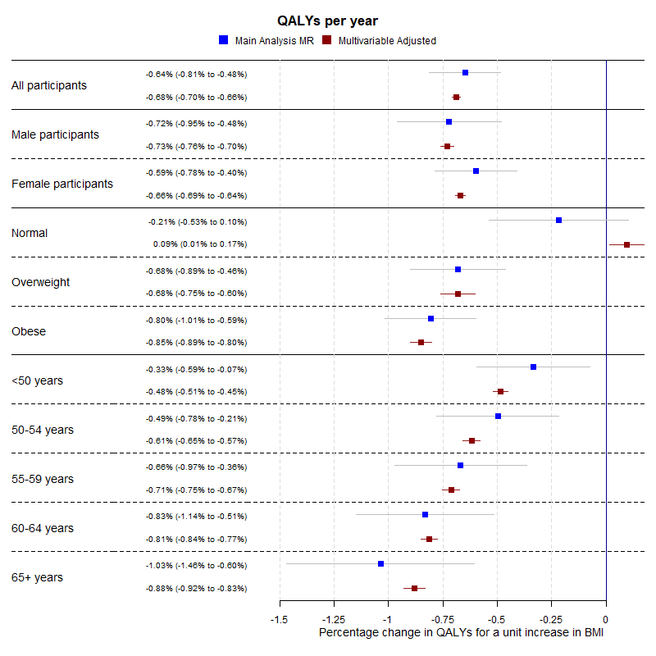

**Figure 2:** Forest plot showing the estimated effect of a unit increase in BMI on average QALYs per year for the main Mendelian randomization, sex-specific, BMI categorical (where “Normal” is a BMI below 25 kg/m2, “Overweight” is a BMI between 25 kg/m2 and 30 kg/m2, and “Obese” is a BMI of above 30 kg/m2) and age categorical analyses.

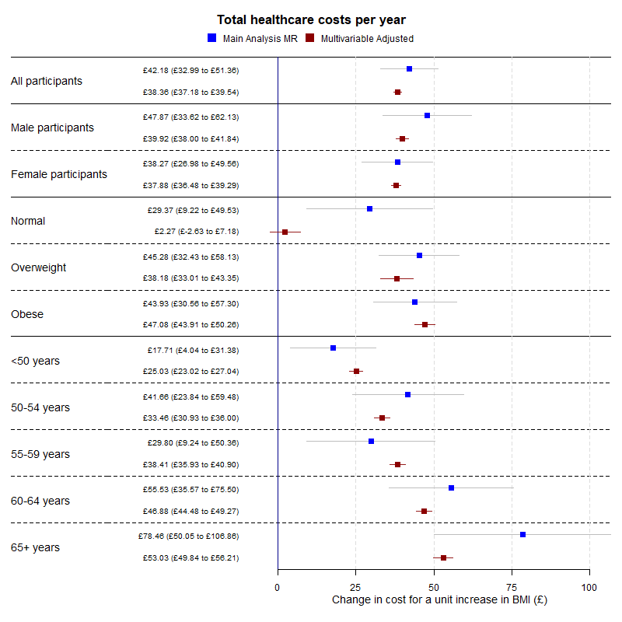

**Figure 3:** Forest plot showing the estimated effect of a unit increase in BMI on average total healthcare costs per year for the main Mendelian randomization, sex-specific, BMI categorical (where “Normal” is a BMI below 25 kg/m2, “Overweight” is a BMI between 25 kg/m2 and 30 kg/m2, and “Obese” is a BMI of above 30 kg/m2) and age categorical analyses.

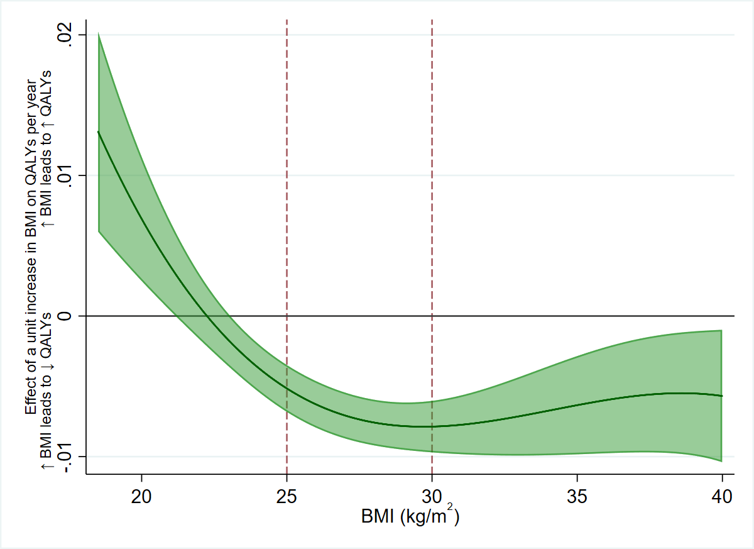

**Figure 4:** The estimated effect of one kg/m2 increase in BMI on QALYs per year, across BMI levels. A positive value indicates an increase in BMI would increase QALYs, and vice versa. An increase in BMI is beneficial to QALYs up to around 22 kg/m2, then becomes increasingly detrimental until the effect plateaus in overweight and remains steady relatively in obesity.

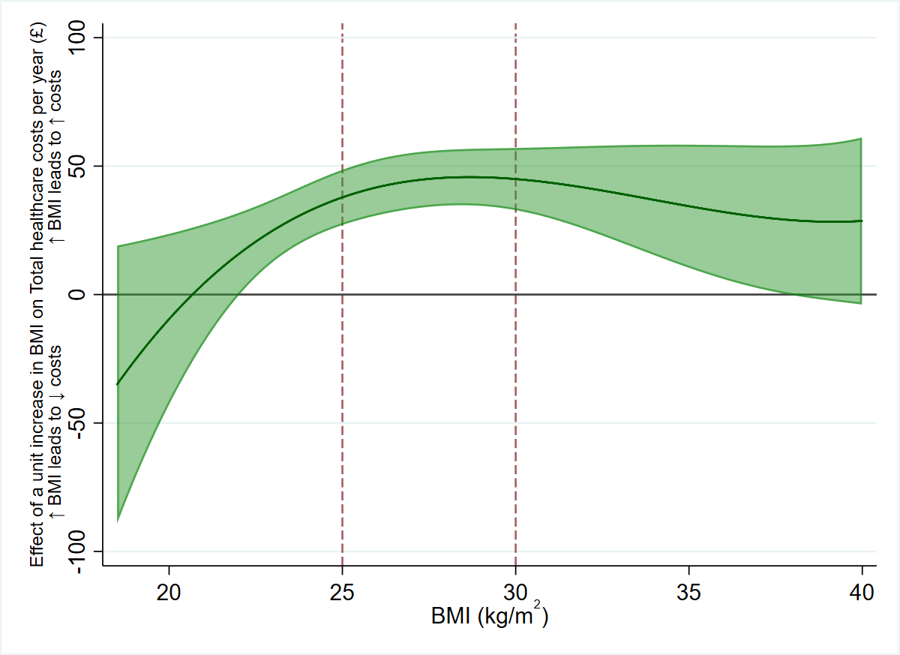

**Figure 5:** The effect of one kg/m2 increase in BMI on total healthcare costs per year, across BMI levels. A positive value indicates an increase in BMI would increase total healthcare costs, and vice versa. Due to the uncertainty in the estimates, there is little statistical evidence of non-linearity in the effect of BMI on total healthcare costs, though descriptively it appears a one kg/m2 increase in BMI has a smaller effect on costs in the normal weight category, and a larger effect in overweight and obesity.