SOP. Load bobbin and hook assembly
1  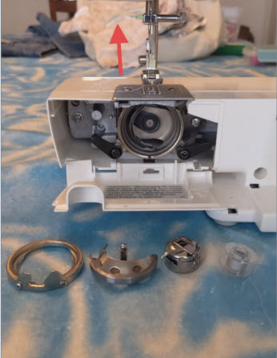  Gather the retainer, hook, bobbin holder, and bobbin (left to right). Start with the needle in the highest position. | 2  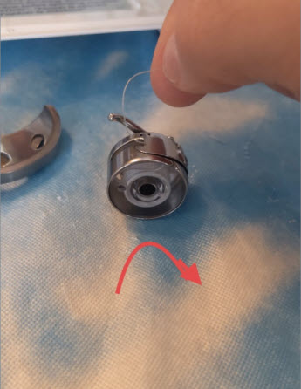  Place the bobbin in the holder so pulling the thread makes it spin clockwise. | 3  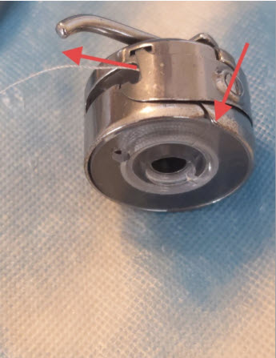  Slide the thread into the side groove until it exits below the tension plate. Let 4 inches of thread hang loose.
4  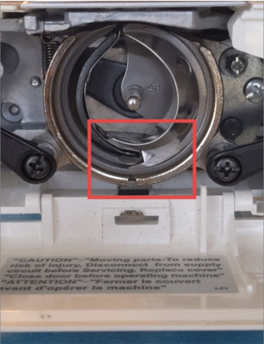  Place the half-moon hook in the machine. Ensure the point faces 6 o'clock, matching the machine's half-moon shape. | 5  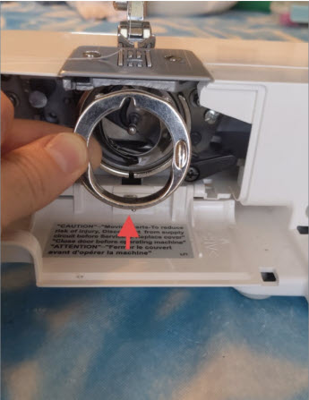  Insert the retainer. Align the hook's nib at the bottom with the slot at the 6 o'clock position. | 6  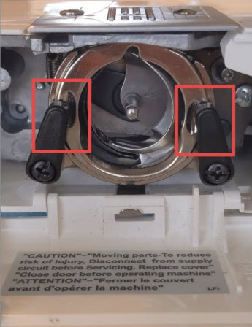  Clamp the black arms around the retainer.
SOP. Load bobbin and hook assembly
7  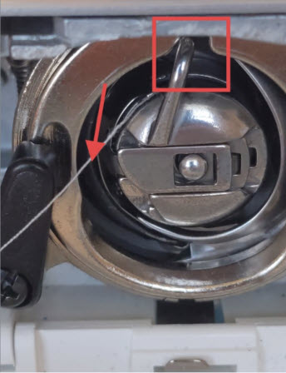  Place the bobbin with its arm at 12 o'clock. Let the thread hang freely LEFT of the arm (critical) about 4 inches. | 8  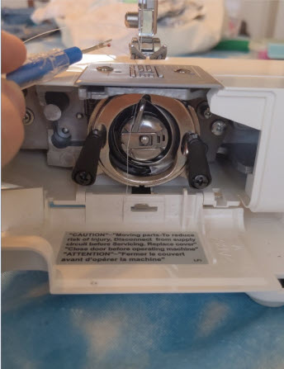  Rotate the manual knob once towards you, slide a straight edge under the foot, and pull both threads left. | 9  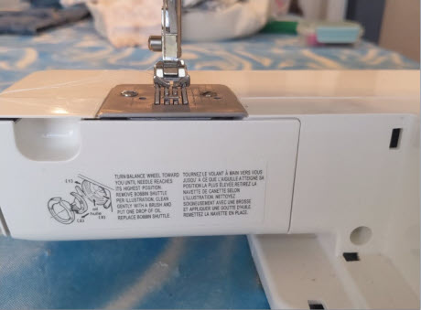  Close the door. You are ready to sew.

