Contents

Q1.1 2

Q1.2 2

Q1.3 2

Q1.4 2

Q1.5 2

Q2.1 3

Q2.2 4

Q2.3.1 12

Q2.3.2 13

Q2.4 13

# Q1.1

|  |  |  |  |  |  |
| --- | --- | --- | --- | --- | --- |
|  | 1 | 0 | 1 | 1 |  |
|  | 1 | 1 | 0 | 1 | 1 |
| + |  | 1 | 0 | 1 | 1 |
| 1 | 0 | 0 | 1 | 1 | 0 |

|  |
| --- |
| 27 |
| +11 |
| 38 |

# Q1.2

-31 → (to binary) 0001 1111 → (invert) 1110 0000 → (add one) 1110 0001

-59 → (to binary) 0011 1011 → (invert) 1100 0100 → (add one) 1100 0101

# Q1.3

1110 1001 → (take one) 1110 1000 → (invert) 0001 0111 → (to base 10) -23

# Q1.4

|  |  |  |  |  |
| --- | --- | --- | --- | --- |
| X | Y | Dout | Bin | Bout |
| 0 | 0 | 0 | 1 | 0 |
| 0 | 1 | 1 | 1 | 1 |
| 1 | 0 | 1 | 0 | 0 |
| 1 | 1 | 0 | 0 | 0 |

# Q1.5

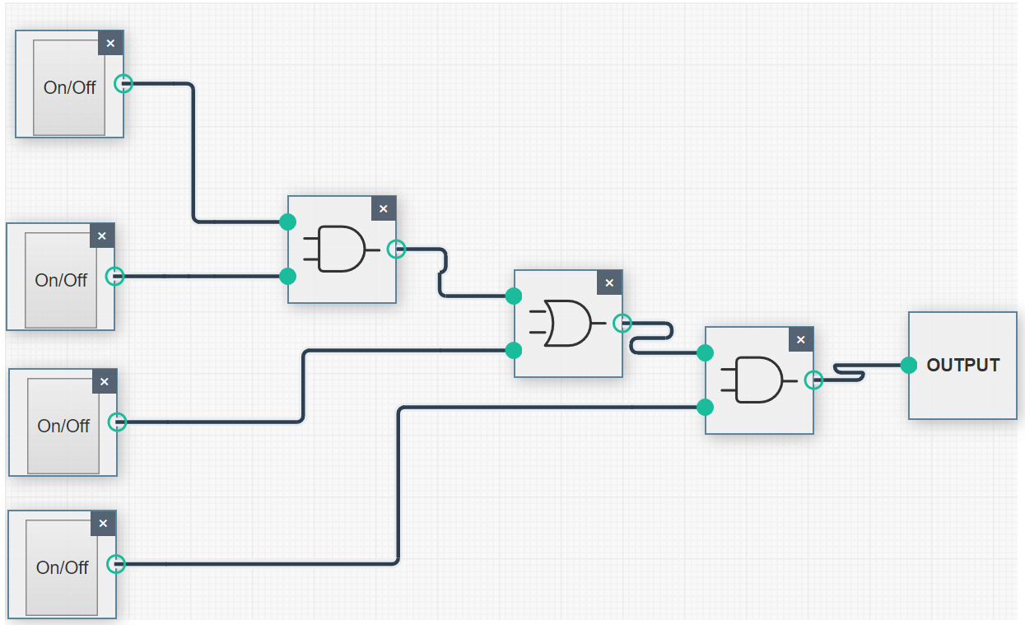

# Q2.1

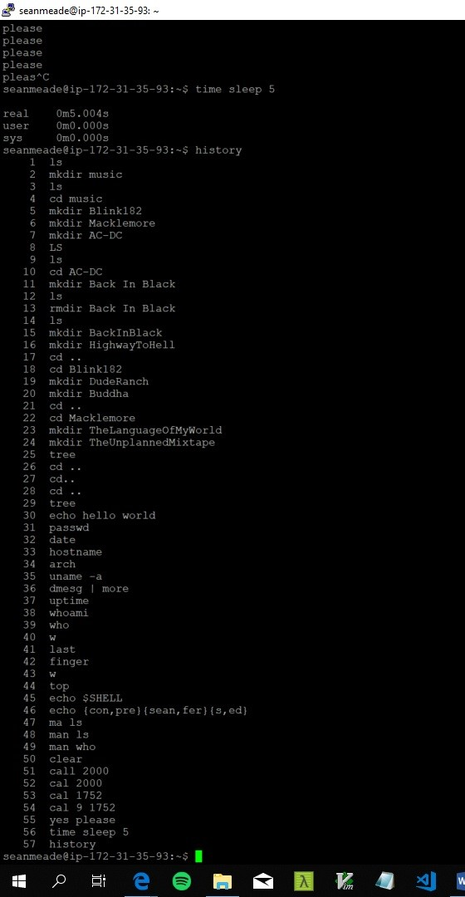

echo hello world: Prints whatever comes after echo to terminal.

passwd: Allows the user to change password.

date: Prints current date and time in format of day, month, time and year.

host name: Prints current IP.

arch: Prints the computer architecture.

uname -a: Prints info about computer software and hardware with -a providing the name of the kernel, network node host name, kernel version number and release level, kernel release date, machine hardware name, CPU type, hardware platform and operating system name.

dmesg | more: Prints kernel message one line at a time.

uptime: Prints current time, how long system has been running (in minutes), how many users and load averages

whoamI: Prints your username

who: Prints users currently on in order, date and time they logged on and terminal they used

last: List the history of successful logons

finger: List users currently logged in, how long they have been idle, login time and current terminal

w: summary of every user logged into a computer, what each user is currently doing, and what load all the activity is imposing on the computer itself

top: displays processor activity of your Linux box and also displays tasks managed by kernel in real-time

echo $SHELL: prints preferred shell

echo {con,pre}{sent,fer}{s,ed}: Prints every combination between the brackets (eg. Starting with con = consents and conferred)

man ls: prints detailed documentation on the ls command

man who: prints detailed documentation on the who command

clear: clears all commands and outputs from terminal window

cal 2000: prints a calendar of the months and their days for the year 2000

cal 9 1752: prints the month and days in calendar form. The full month is not printed out. The Gregorian Reformation is assumed to have occurred in 1752 on the 3rd of September. Ten days following that date were eliminated by the reformation, so the calendar for that month is a bit unusual.

yes please: prints the same string over and over to the terminal in the case the work please.

time sleep 5: pauses the terminal for specified time (default is seconds).

# Q2.2

Current Time and date

Wed May 1 21:54:37 UTC 2019

Current IP

ip-172-31-35-93

Computer Architecture

x86_64

Computer Software and Hardware

Linux ip-172-31-35-93 4.4.0-1075-aws #85-Ubuntu SMP Thu Jan 17 17:15:12 UTC 2019 x86_64 x86_64 x86_64 GNU/Linux

General Info

21:54:37 up 44 days, 11:08, 14 users, load average: 0.06, 0.02, 0.00

My username

seanmeade

Users currently on

garycunningham pts/1 2019-05-01 20:52 (51.37.55.20)

zaraquail pts/2 2019-05-01 21:13 (93.107.12.34)

mariedillane pts/3 2019-05-01 21:44 (78.18.54.245)

neilmoran pts/4 2019-05-01 21:09 (89.127.3.244)

seamuskeating pts/5 2019-05-01 19:34 (146.90.238.252)

mariedillane pts/6 2019-05-01 20:21 (78.18.54.245)

kevindooley pts/7 2019-05-01 20:06 (51.171.92.125)

sasikalavaratharajan pts/8 2019-05-01 20:42 (109.79.242.181)

babubaskaran pts/9 2019-05-01 20:46 (86.41.91.52)

martinaobrien pts/10 2019-05-01 20:58 (37.228.248.163)

katarzynacconnell pts/11 2019-05-01 21:01 (37.228.252.119)

neilmoran pts/12 2019-05-01 21:15 (89.127.3.244)

seanmeade pts/13 2019-05-01 21:31 (89.127.33.229)

colinmorrow pts/14 2019-05-01 21:52 (86.45.76.59)

Users currently on

Login Name Tty Idle Login Time Office Office Phone

babubaskaran pts/9 May 1 20:46 (86.41.91.52)

colinmorrow pts/14 May 1 21:52 (86.45.76.59)

garycunningham pts/1 May 1 20:52 (51.37.55.20)

katarzynacconnell pts/11 23 May 1 21:01 (37.228.252.119)

kevindooley pts/7 May 1 20:06 (51.171.92.125)

mariedillane pts/3 May 1 21:44 (78.18.54.245)

mariedillane pts/6 1:23 May 1 20:21 (78.18.54.245)

martinaobrien pts/10 56 May 1 20:58 (37.228.248.163)

neilmoran pts/4 39 May 1 21:09 (89.127.3.244)

neilmoran pts/12 3 May 1 21:15 (89.127.3.244)

sasikalavaratharajan pts/8 7 May 1 20:42 (109.79.242.181)

seamuskeating pts/5 May 1 19:34 (146.90.238.252)

seanmeade pts/13 May 1 21:31 (89.127.33.229)

zaraquail pts/2 19 May 1 21:13 (93.107.12.34)

Details of current users

21:54:37 up 44 days, 11:08, 14 users, load average: 0.06, 0.02, 0.00

USER TTY FROM LOGIN@ IDLE JCPU PCPU WHAT

garycunn pts/1 51.37.55.20 20:52 5.00s 0.18s 0.03s vim shellscript

zaraquai pts/2 93.107.12.34 21:13 19:17 0.17s 0.17s -bash

mariedil pts/3 78.18.54.245 21:44 3.00s 0.04s 0.04s -bash

neilmora pts/4 89.127.3.244 21:09 39:00 0.08s 0.03s vim cupoftea.sh

seamuske pts/5 146.90.238.252 19:34 5.00s 0.21s 0.05s vi CACT

mariedil pts/6 78.18.54.245 20:21 1:23m 0.04s 0.04s -bash

kevindoo pts/7 51.171.92.125 20:06 13.00s 0.19s 0.09s vim ss.sh

sasikala pts/8 109.79.242.181 20:42 7:47 0.05s 0.05s -bash

babubask pts/9 86.41.91.52 20:46 21.00s 0.08s 0.02s vi babutest.txt

martinao pts/10 37.228.248.163 20:58 56:35 0.02s 0.02s -bash

katarzyn pts/11 37.228.252.119 21:01 23:07 0.07s 0.07s -bash

neilmora pts/12 89.127.3.244 21:15 3:03 0.05s 0.05s -bash

seanmead pts/13 89.127.33.229 21:31 5.00s 0.07s 0.00s w

colinmor pts/14 86.45.76.59 21:52 4.00s 0.14s 0.10s vim tea.txt

Processes

[?1h=[?25l[H[2J(B[mtop - 21:54:37 up 44 days, 11:08, 14 users, load average: 0.06, 0.02, 0.00(B[m[39;49m(B[m[39;49m[K

Tasks:(B[m[39;49m[1m 193 (B[m[39;49mtotal,(B[m[39;49m[1m 1 (B[m[39;49mrunning,(B[m[39;49m[1m 192 (B[m[39;49msleeping,(B[m[39;49m[1m 0 (B[m[39;49mstopped,(B[m[39;49m[1m 0 (B[m[39;49mzombie(B[m[39;49m(B[m[39;49m[K

%Cpu(s):(B[m[39;49m[1m 0.1 (B[m[39;49mus,(B[m[39;49m[1m 0.1 (B[m[39;49msy,(B[m[39;49m[1m 0.0 (B[m[39;49mni,(B[m[39;49m[1m 99.8 (B[m[39;49mid,(B[m[39;49m[1m 0.0 (B[m[39;49mwa,(B[m[39;49m[1m 0.0 (B[m[39;49mhi,(B[m[39;49m[1m 0.0 (B[m[39;49msi,(B[m[39;49m[1m 0.0 (B[m[39;49mst(B[m[39;49m(B[m[39;49m[K

KiB Mem :(B[m[39;49m[1m 1014436 (B[m[39;49mtotal,(B[m[39;49m[1m 92764 (B[m[39;49mfree,(B[m[39;49m[1m 180552 (B[m[39;49mused,(B[m[39;49m[1m 741120 (B[m[39;49mbuff/cache(B[m[39;49m(B[m[39;49m[K

KiB Swap:(B[m[39;49m[1m 0 (B[m[39;49mtotal,(B[m[39;49m[1m 0 (B[m[39;49mfree,(B[m[39;49m[1m 0 (B[m[39;49mused.(B[m[39;49m[1m 598360 (B[m[39;49mavail Mem (B[m[39;49m(B[m[39;49m[K

[K

[7m PID USER PR NI VIRT RES SHR S %CPU %MEM TIME+ COMMAND (B[m[39;49m[K

(B[m 1 root 20 0 185328 5848 3880 S 0.0 0.6 0:56.49 systemd (B[m[39;49m[K

(B[m 2 root 20 0 0 0 0 S 0.0 0.0 0:00.03 kthreadd (B[m[39;49m[K

(B[m 3 root 20 0 0 0 0 S 0.0 0.0 0:23.83 ksoftirqd/0 (B[m[39;49m[K

(B[m 5 root 0 -20 0 0 0 S 0.0 0.0 0:00.00 kworker/0:0H (B[m[39;49m[K

(B[m 7 root 20 0 0 0 0 S 0.0 0.0 0:24.72 rcu_sched (B[m[39;49m[K

(B[m 8 root 20 0 0 0 0 S 0.0 0.0 0:00.00 rcu_bh (B[m[39;49m[K

(B[m 9 root rt 0 0 0 0 S 0.0 0.0 0:00.00 migration/0 (B[m[39;49m[K

(B[m 10 root rt 0 0 0 0 S 0.0 0.0 0:19.94 watchdog/0 (B[m[39;49m[K

(B[m 11 root 20 0 0 0 0 S 0.0 0.0 0:00.00 kdevtmpfs (B[m[39;49m[K

(B[m 12 root 0 -20 0 0 0 S 0.0 0.0 0:00.00 netns (B[m[39;49m[K

(B[m 13 root 0 -20 0 0 0 S 0.0 0.0 0:00.00 perf (B[m[39;49m[K

(B[m 14 root 20 0 0 0 0 S 0.0 0.0 0:00.01 xenwatch (B[m[39;49m[K

(B[m 15 root 20 0 0 0 0 S 0.0 0.0 0:00.00 xenbus (B[m[39;49m[K

(B[m 17 root 20 0 0 0 0 S 0.0 0.0 0:01.00 khungtaskd (B[m[39;49m[K

(B[m 18 root 0 -20 0 0 0 S 0.0 0.0 0:00.00 writeback (B[m[39;49m[K

(B[m 19 root 25 5 0 0 0 S 0.0 0.0 0:00.00 ksmd (B[m[39;49m[K

(B[m 20 root 39 19 0 0 0 S 0.0 0.0 0:09.37 khugepaged (B[m[39;49m[K

(B[m 21 root 0 -20 0 0 0 S 0.0 0.0 0:00.00 crypto (B[m[39;49m[K

(B[m 22 root 0 -20 0 0 0 S 0.0 0.0 0:00.00 kintegrityd (B[m[39;49m[K

(B[m 23 root 0 -20 0 0 0 S 0.0 0.0 0:00.00 bioset (B[m[39;49m[K

(B[m 24 root 0 -20 0 0 0 S 0.0 0.0 0:00.00 kblockd (B[m[39;49m[K

(B[m 25 root 0 -20 0 0 0 S 0.0 0.0 0:00.00 ata_sff (B[m[39;49m[K

(B[m 26 root 0 -20 0 0 0 S 0.0 0.0 0:00.00 md (B[m[39;49m[K

(B[m 27 root 0 -20 0 0 0 S 0.0 0.0 0:00.00 devfreq_wq (B[m[39;49m[K

(B[m 30 root 20 0 0 0 0 S 0.0 0.0 0:01.65 kswapd0 (B[m[39;49m[K

(B[m 31 root 0 -20 0 0 0 S 0.0 0.0 0:00.00 vmstat (B[m[39;49m[K

(B[m 32 root 20 0 0 0 0 S 0.0 0.0 0:00.00 fsnotify_mark (B[m[39;49m[K

(B[m 33 root 20 0 0 0 0 S 0.0 0.0 0:00.00 ecryptfs-kthrea (B[m[39;49m[K

(B[m 49 root 0 -20 0 0 0 S 0.0 0.0 0:00.00 kthrotld (B[m[39;49m[K

(B[m 50 root 0 -20 0 0 0 S 0.0 0.0 0:00.00 bioset (B[m[39;49m[K

(B[m 51 root 0 -20 0 0 0 S 0.0 0.0 0:00.00 bioset (B[m[39;49m[K

(B[m 52 root 0 -20 0 0 0 S 0.0 0.0 0:00.00 bioset (B[m[39;49m[K

(B[m 53 root 0 -20 0 0 0 S 0.0 0.0 0:00.00 bioset (B[m[39;49m[K

(B[m 54 root 0 -20 0 0 0 S 0.0 0.0 0:00.00 bioset (B[m[39;49m[K

(B[m 55 root 0 -20 0 0 0 S 0.0 0.0 0:00.00 bioset (B[m[39;49m[K

(B[m 56 root 0 -20 0 0 0 S 0.0 0.0 0:00.00 bioset (B[m[39;49m[K

(B[m 57 root 0 -20 0 0 0 S 0.0 0.0 0:00.00 bioset (B[m[39;49m[K[H(B[mtop - 21:54:40 up 44 days, 11:08, 14 users, load average: 0.06, 0.01, 0.00(B[m[39;49m(B[m[39;49m[K

Tasks:(B[m[39;49m[1m 193 (B[m[39;49mtotal,(B[m[39;49m[1m 1 (B[m[39;49mrunning,(B[m[39;49m[1m 192 (B[m[39;49msleeping,(B[m[39;49m[1m 0 (B[m[39;49mstopped,(B[m[39;49m[1m 0 (B[m[39;49mzombie(B[m[39;49m(B[m[39;49m[K

%Cpu(s):(B[m[39;49m[1m 0.7 (B[m[39;49mus,(B[m[39;49m[1m 0.3 (B[m[39;49msy,(B[m[39;49m[1m 0.0 (B[m[39;49mni,(B[m[39;49m[1m 99.0 (B[m[39;49mid,(B[m[39;49m[1m 0.0 (B[m[39;49mwa,(B[m[39;49m[1m 0.0 (B[m[39;49mhi,(B[m[39;49m[1m 0.0 (B[m[39;49msi,(B[m[39;49m[1m 0.0 (B[m[39;49mst(B[m[39;49m(B[m[39;49m[K

KiB Mem :(B[m[39;49m[1m 1014436 (B[m[39;49mtotal,(B[m[39;49m[1m 92764 (B[m[39;49mfree,(B[m[39;49m[1m 180528 (B[m[39;49mused,(B[m[39;49m[1m 741144 (B[m[39;49mbuff/cache(B[m[39;49m(B[m[39;49m[K

[K

(B[m10414 mariedi+ 20 0 92912 3592 2564 S 0.3 0.4 0:00.01 sshd (B[m[39;49m[K

(B[m10567 colinmo+ 20 0 52864 8608 5520 S 0.3 0.8 0:00.11 vim (B[m[39;49m[K

(B[m[1m10625 seanmea+ 20 0 40532 3672 3000 R 0.3 0.4 0:00.01 top (B[m[39;49m[K

(B[m29186 roisinf+ 20 0 40516 3640 2940 S 0.3 0.4 8:34.00 top (B[m[39;49m[K

(B[m 1 root 20 0 185328 5848 3880 S 0.0 0.6 0:56.49 systemd (B[m[39;49m[K

(B[m 2 root 20 0 0 0 0 S 0.0 0.0 0:00.03 kthreadd (B[m[39;49m[K

(B[m 3 root 20 0 0 0 0 S 0.0 0.0 0:23.83 ksoftirqd/0 (B[m[39;49m[K

(B[m 5 root 0 -20 0 0 0 S 0.0 0.0 0:00.00 kworker/0:0H (B[m[39;49m[K

(B[m 7 root 20 0 0 0 0 S 0.0 0.0 0:24.72 rcu_sched (B[m[39;49m[K

(B[m 8 root 20 0 0 0 0 S 0.0 0.0 0:00.00 rcu_bh (B[m[39;49m[K

(B[m 9 root rt 0 0 0 0 S 0.0 0.0 0:00.00 migration/0 (B[m[39;49m[K

(B[m 10 root rt 0 0 0 0 S 0.0 0.0 0:19.94 watchdog/0 (B[m[39;49m[K

(B[m 11 root 20 0 0 0 0 S 0.0 0.0 0:00.00 kdevtmpfs (B[m[39;49m[K

(B[m 12 root 0 -20 0 0 0 S 0.0 0.0 0:00.00 netns (B[m[39;49m[K

(B[m 13 root 0 -20 0 0 0 S 0.0 0.0 0:00.00 perf (B[m[39;49m[K

(B[m 14 root 20 0 0 0 0 S 0.0 0.0 0:00.01 xenwatch (B[m[39;49m[K

(B[m 15 root 20 0 0 0 0 S 0.0 0.0 0:00.00 xenbus (B[m[39;49m[K

(B[m 17 root 20 0 0 0 0 S 0.0 0.0 0:01.00 khungtaskd (B[m[39;49m[K

(B[m 18 root 0 -20 0 0 0 S 0.0 0.0 0:00.00 writeback (B[m[39;49m[K

(B[m 19 root 25 5 0 0 0 S 0.0 0.0 0:00.00 ksmd (B[m[39;49m[K

(B[m 20 root 39 19 0 0 0 S 0.0 0.0 0:09.37 khugepaged (B[m[39;49m[K

(B[m 21 root 0 -20 0 0 0 S 0.0 0.0 0:00.00 crypto (B[m[39;49m[K

(B[m 22 root 0 -20 0 0 0 S 0.0 0.0 0:00.00 kintegrityd (B[m[39;49m[K

(B[m 23 root 0 -20 0 0 0 S 0.0 0.0 0:00.00 bioset (B[m[39;49m[K

(B[m 24 root 0 -20 0 0 0 S 0.0 0.0 0:00.00 kblockd (B[m[39;49m[K

(B[m 25 root 0 -20 0 0 0 S 0.0 0.0 0:00.00 ata_sff (B[m[39;49m[K

(B[m 26 root 0 -20 0 0 0 S 0.0 0.0 0:00.00 md (B[m[39;49m[K

(B[m 27 root 0 -20 0 0 0 S 0.0 0.0 0:00.00 devfreq_wq (B[m[39;49m[K

(B[m 30 root 20 0 0 0 0 S 0.0 0.0 0:01.65 kswapd0 (B[m[39;49m[K

(B[m 31 root 0 -20 0 0 0 S 0.0 0.0 0:00.00 vmstat (B[m[39;49m[K

(B[m 32 root 20 0 0 0 0 S 0.0 0.0 0:00.00 fsnotify_mark (B[m[39;49m[K

(B[m 33 root 20 0 0 0 0 S 0.0 0.0 0:00.00 ecryptfs-kthrea (B[m[39;49m[K

(B[m 49 root 0 -20 0 0 0 S 0.0 0.0 0:00.00 kthrotld (B[m[39;49m[K

(B[m 50 root 0 -20 0 0 0 S 0.0 0.0 0:00.00 bioset (B[m[39;49m[K

(B[m 51 root 0 -20 0 0 0 S 0.0 0.0 0:00.00 bioset (B[m[39;49m[K

(B[m 52 root 0 -20 0 0 0 S 0.0 0.0 0:00.00 bioset (B[m[39;49m[K

(B[m 53 root 0 -20 0 0 0 S 0.0 0.0 0:00.00 bioset (B[m[39;49m[K[H(B[mtop - 21:54:43 up 44 days, 11:08, 14 users, load average: 0.06, 0.01, 0.00(B[m[39;49m(B[m[39;49m[K

%Cpu(s):(B[m[39;49m[1m 0.3 (B[m[39;49mus,(B[m[39;49m[1m 0.3 (B[m[39;49msy,(B[m[39;49m[1m 0.0 (B[m[39;49mni,(B[m[39;49m[1m 99.3 (B[m[39;49mid,(B[m[39;49m[1m 0.0 (B[m[39;49mwa,(B[m[39;49m[1m 0.0 (B[m[39;49mhi,(B[m[39;49m[1m 0.0 (B[m[39;49msi,(B[m[39;49m[1m 0.0 (B[m[39;49mst(B[m[39;49m(B[m[39;49m[K

KiB Mem :(B[m[39;49m[1m 1014436 (B[m[39;49mtotal,(B[m[39;49m[1m 92640 (B[m[39;49mfree,(B[m[39;49m[1m 180624 (B[m[39;49mused,(B[m[39;49m[1m 741172 (B[m[39;49mbuff/cache(B[m[39;49m(B[m[39;49m[K

KiB Swap:(B[m[39;49m[1m 0 (B[m[39;49mtotal,(B[m[39;49m[1m 0 (B[m[39;49mfree,(B[m[39;49m[1m 0 (B[m[39;49mused.(B[m[39;49m[1m 598288 (B[m[39;49mavail Mem (B[m[39;49m(B[m[39;49m[K

[K

(B[m 1133 root 20 0 5220 112 0 S 0.3 0.0 1:50.11 iscsid (B[m[39;49m[K

(B[m10567 colinmo+ 20 0 52864 8608 5520 S 0.3 0.8 0:00.12 vim (B[m[39;49m[K

(B[m10606 seamusk+ 20 0 52876 8732 5552 S 0.3 0.9 0:00.06 vi (B[m[39;49m[K

(B[m29186 roisinf+ 20 0 40516 3640 2940 S 0.3 0.4 8:34.01 top (B[m[39;49m[K

# Q2.3.1

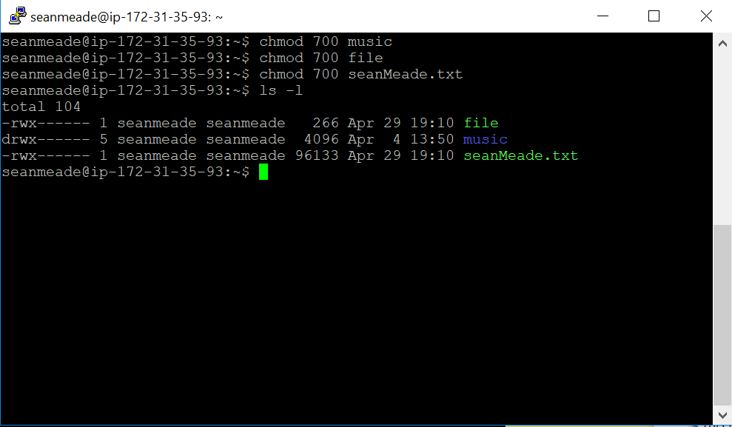

# Q2.3.2

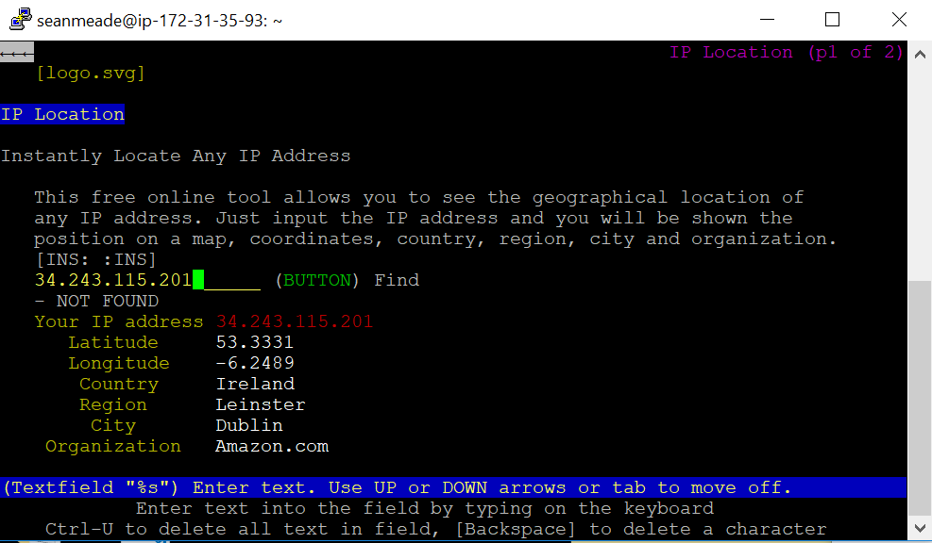

# Q2.4

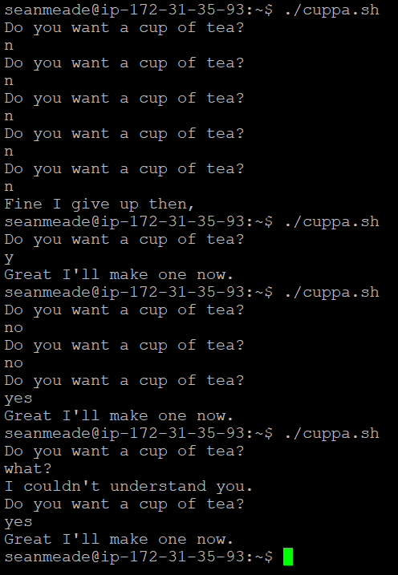

#!/bin/bash

count=0

while [ $count -lt 5 ]

do

echo "Do you want a cup of tea?"

read answer

if [ $answer = "yes" ] || [ $answer = "y" ]

then

echo "Great I'll make one now."

break

elif [[ $answer = "n" || $answer = "no" ]] && [ $count -lt 4 ]

then

count=$((count+1))

elif [ $count == 4 ]

then

echo "Fine I give up then,"

break

else

echo "I couldn't understand you."

fi

done