X00154002 Sean O Riordain EAD CA3

URI Deployed APP: <https://sorstorageacc1ca3.z13.web.core.windows.net/>

URI GitHub Repo: <https://github.com/sean-o-riordain/EAD-CA3_movies/>

URI for One Drive: https://tudublin-my.sharepoint.com/personal/x00154002_mytudublin_ie/_layouts/15/onedrive.aspx?id=%2Fpersonal%2Fx00154002%5Fmytudublin%5Fie%2FDocuments%2FEAD%20CA3

Description of System:

My system is a website that will allow users to check the movies and tv shows on different streaming services while also being able to get information on those movies and tv shows, as well as the cast and crew who work on them.

When the Website is loaded users will be dropped onto the services screen in which users can select a streaming service or every movie on the website. They can also filter by payment type for the streaming service and what region it is available in.

After clicking into one of the streaming services, users will be redirected to a page which lists all the movies on that streaming service. Users can navigate between pages on this website, they will automatically start on page one. They will be able to filter the genre and region for the movies they have in front of them. If the user sees a title they like they can click in and get redirected to the title to get more information about it.

The user will see information such as title, run time, age rating, Genre and so forth. The user can also expand the cast and crew section and similar titles section, On a tv show they will have a season section which they can expand as well.

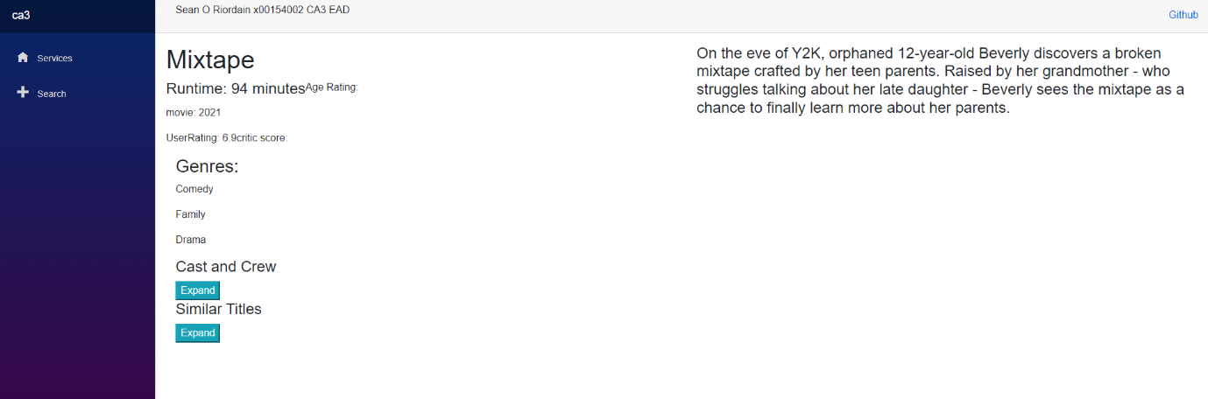

In the cast and crew section a user will get a list of all cast and crew for that title. A user can click into the cast/crew members name and be redirected to their information page.

If a user clicks the similar titles, they will reveal a drop down with a list of titles similar to the one they are checking out currently. If they click into the names they are redirected to that titles page.

If the user goes a cast or crew members page, they will see some basic information.

They will be a dropdown for work they are known for.

There is a search section on the website as well. When a user searches for something, it will be separated into two sections. Either people or title. The user will be able to click the name of either and be taken to the information page where they will see everything discussed above.

Description of Testing:

For testing of my website, I used Selenium web testing.

I tested that the website loaded, making sure the website was being hosted.

I tested the Navigation between screens. My goal was to make sure that the screens were going to the correct location when the user clicked on any links and that the pages were loading.

I also tested the search to make sure that the search logic was connected and working correctly.

I also made use of sonar lint to make sure that my code quality was at a high standard.