OS HW4 108820018 蔡翔宇

Code 安裝&執行方式:

Q.11.13

以下皆在ubuntu vm中執行，需先安裝vim

(1)

* What are the inode values of file1.txt and file2.txt? Are they the same or different?
  + Both 656679, they are the same.
* Do the two files have the same or different contents?
  + Yes, they have the same contents.
* Code執行步驟

在treminal進入question_11_13資料夾後輸入./11_13_1.sh

11_13_1.sh內容:

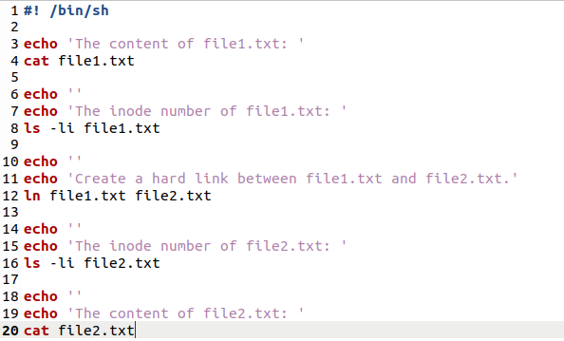

執行結果:

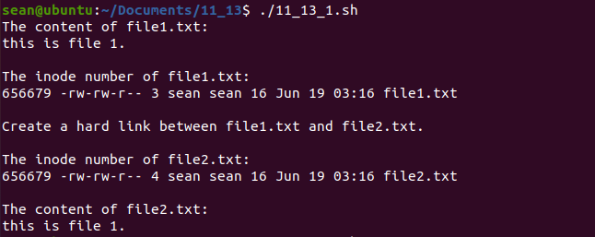

(2)

* Are the contents of file1.txt and file2.txt the same or different?
  + They are the same.
* Next, remove file1.txt. Does file2.txt still exist as well?
  + Yes.
* Check what system call is used for removing file2.txt by the following command: *strace rm file2.txt*.
* Code執行步驟

修改file2.txt內容後在terminal輸入./11_13_2.sh

11_13_2.sh內容:

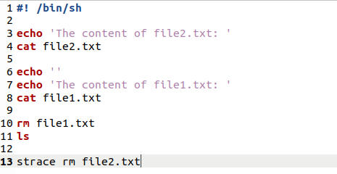

11_13_2.sh執行結果:

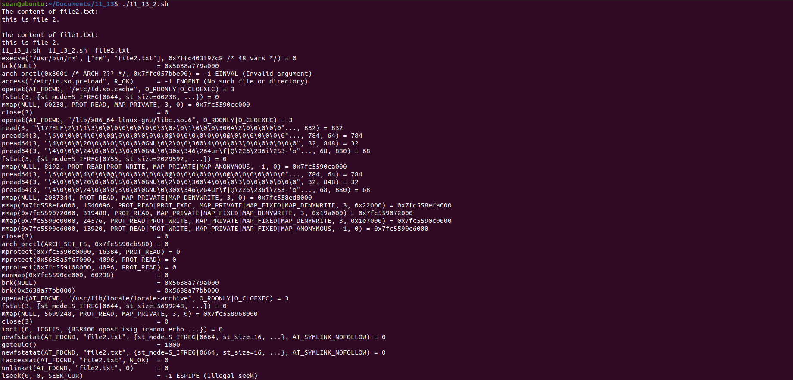



(3)

* Are the inode numbers of file3.txt and file4.txt the same, or is each unique?
  + They are each unique.
* Next, edit the contents of file4.txt. Have the contents of file3.txt been altered as well?
  + Yes.
* Last, delete file3.txt. Explain what happens when you attempt to edit file4.txt
  + Once file3.txt is deleted, the content of file4.txt become empty. Then, when attempting to edit file4.txt, the system creates a file3.txt which the content is the same as file4.txt.
* Code執行步驟

在terminal輸入./11_13_3.sh

11_13_3.sh內容:

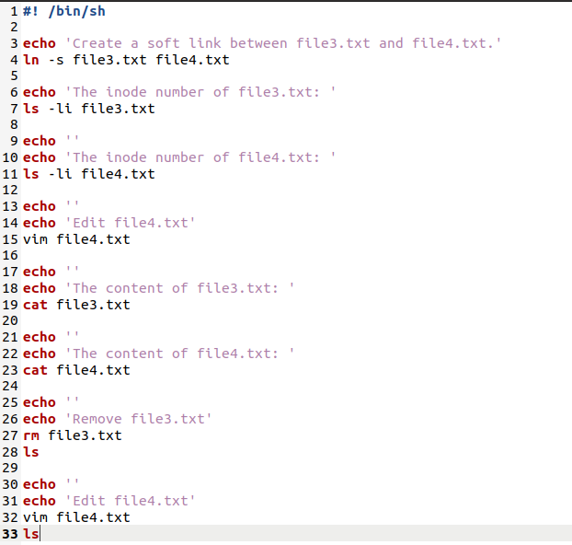

11_13_3.sh執行結果:

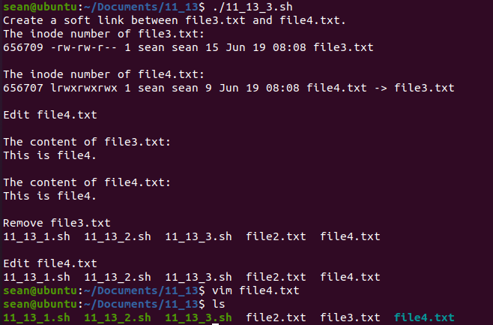

移除file3.txt後嘗試編輯file4.txt時內容為空:

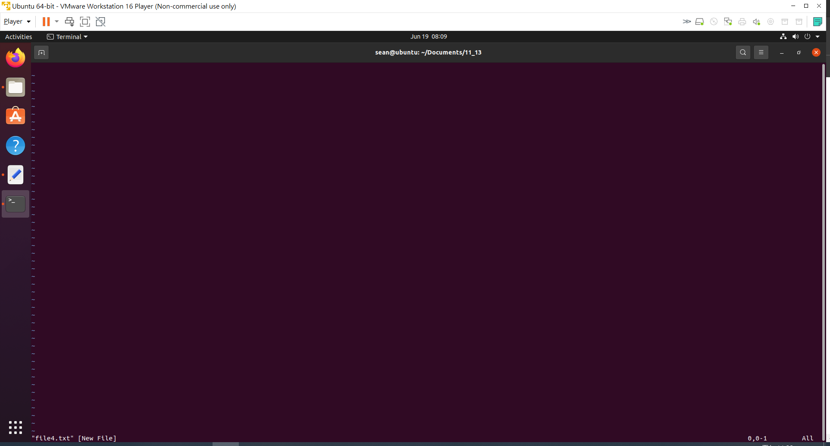

Q.12.16

* 在bash進入question_12_16資料夾
* 輸入g++ q_12_16.cpp
* 輸入./a.out

即可執行

*注意*

輸入每個request後皆須按一下enter，欲結束輸入時輸入-1

程式會自行去除超出max. disk storage或 <0 之request

