Homework #3 – Motion Estimation & Compensation
314552036 周子翔
Objective
The goal of this homework is to implement and analyze motion estimation (ME) and motion compensation (MC) algorithms for video compression. Specifically:
- Implement full search block matching for motion estimation with different search ranges ([±8], [±16], [±32]).
- Implement motion compensation to reconstruct the frame and calculate residuals.
- Compare the results (PSNR and runtime) for different search ranges.
- Implement a three-step search algorithm and compare its results with the full search algorithm.

Implementation Details
1. Motion Estimation (ME)
- Algorithm: Full Search Block Matching
- Parameters:
  - Block Size: 8x8
  - Search Range: [±8], [±16], [±32]
- Method:
  - Divide the frame into non-overlapping blocks of size 8x8.
  - For each block in the current frame, search for the best matching block in the reference frame within the specified search range.
  - Use Mean Squared Error (MSE) as the matching criterion.
- Output:
  - Motion Vectors: Displacement values (dx, dy) for each block.
  - Residuals: Difference between the original block and the reconstructed block.
2. Motion Compensation (MC)
- Purpose: Reconstruct the current frame using motion vectors and the reference frame.
- Method:
  - Use motion vectors to fetch the best matching blocks from the reference frame.
  - Combine these blocks to reconstruct the current frame.
- Output:
  - Reconstructed Frame: Approximated version of the current frame.
3. PSNR Evaluation
- Purpose: Measure the quality of the reconstructed frame.
- Method:
  - Calculate the Peak Signal-to-Noise Ratio (PSNR) between the original frame and the reconstructed frame.
- Output: PSNR value in dB.
4. Runtime Comparison
- Purpose: Compare the computational efficiency of different search ranges.
- Method:
  - Measure the execution time for motion estimation and motion compensation using Python's time module.
- Output: Runtime statistics.
Results

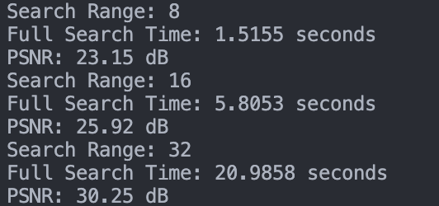
    - search range 8:
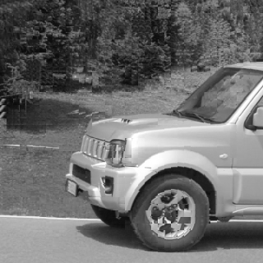
    - search range 16:
    - search range 31:
Conclusion
- Search Range:
  - Increasing the search range improves PSNR but increases runtime significantly.
  - A balance between search range and runtime must be considered for practical applications.
- Three-Step Search:
  - Three-step search is faster than full search but may result in slightly lower PSNR.
  - It is suitable for scenarios where computational efficiency is critical.
- Residuals:
  - Residuals highlight the areas where motion compensation fails to perfectly reconstruct the frame.

