Given way points (xi, yi­), i=0, 1,…, (n-1) and initial pose (xinit, yinit,init)

Look ahead distance l

Constant linear velocity v

Sampling time $∆t$

At time t, robot with pose (xt, yt,t)

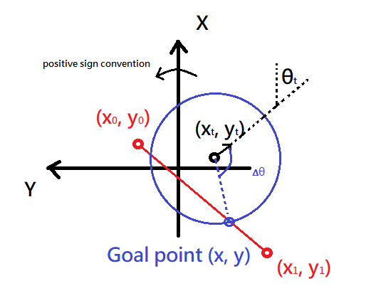

Goal point: the intersection between the segment of two consecutive way points and the circle centered at the position of time t and radius l, which is closer to the next way point.

Change state when there is not intersection available, that is, the intersection is at next two consecutive way points.

Alogrithm:

1. Find goal point
2. Give velocity command

$${\left(x-x_{t}\right)}^{2}+{\left(y-y_{t}\right)}^{2}=l^{2} \left(1\right)$$

$$x=x_{0}+\left(x_{1}-x_{0}\right)t \left(2-1\right)$$

$$y=y_{0}+\left(y_{1}-y_{0}\right)t (2-2)$$

$$Take \left(2\right) into \left(1\right), gets$$

$${\left[\left(x_{0}-x_{t}\right)+\left(x_{1}-x_{0}\right)t\right]}^{2}+{\left[\left(y_{0}-y_{t}\right)+\left(y_{1}-y_{0}\right)t\right]}^{2}=l^{2}$$

$$or \left[{\left(x_{1}-x_{0}\right)}^{2}+{\left(y_{1}-y_{0}\right)}^{2}\right]t^{2}+2\left[\left(x_{0}-x_{t}\right)\left(x_{1}-x_{0}\right)+\left(y_{0}-y_{t}\right)\left(y_{1}-y_{0}\right)\right]t+\left[{\left(x_{0}-x_{t}\right)}^{2}+{\left(y_{0}-y_{t}\right)}^{2}-l^{2}\right]=0$$

$$Define K_{1}∶=x_{1}-x_{0}$$

$$K_{2}∶=x_{0}-x_{t}$$

$$K_{3}∶=y_{1}-y_{0}$$

$$k_{4}∶=y_{0}-y_{t}$$

$$then \left(k_{1}^{2}+k_{3}^{2}\right)t^{2}+2\left(K_{1}K_{2}+K_{3}K_{4}\right)t+\left(K_{2}^{2}+K_{4}^{2}-l^{2}\right)=0$$

$$or t=t_{goal}=\frac{-\left(K_{1}K_{2}+K_{3}K_{4}\right)+\sqrt{l^{2}\left(K_{1}^{2}+K_{3}^{2}\right)-{\left(K_{1}K_{4}-K_{2}K_{3}\right)}^{2}}}{K_{1}^{2}+K_{3}^{2}}$$

$$Since goal point closer to the next way point, we must take the bigger one.$$

$$So, x=x_{0}+\left(x_{1}-x_{0}\right)t_{goal}$$

$$y=y_{0}+\left(y_{1}-y_{0}\right)t_{goal}$$

$$For go straight state, ∆θ=atan2\left(y-y_{t}, x-x_{t}\right)-θ_{t}$$

$$Let ω=\frac{∆θ}{N∆t} where N is positive integer. Divided by N for better dynamic.$$