Chapter 4 Implementation and Experiment

4.1 Introduction
This chapter explains how the MedVoice Assist prototype and its evaluation procedures are implemented. The implementation integrates a browser interface, a Python API, audio enhancement, Whisper transcription, narrative-to-symptom extraction, urgency rules, bounded clarification, a trained BioBERT disease classifier and deterministic responses. The classifier investigation also retains the TF-IDF with Logistic Regression and fine-tuned BERT comparisons on two different datasets. The purpose is to make the implemented operations traceable rather than to infer system quality from classification scores alone.
Implementation is presented before experimental procedure. Algorithms 4.1 to 4.12 describe the principal routines at an abstract level, while selected source excerpts and code-screenshot positions link these routines to the actual files. The algorithms explain inputs, decisions, outputs and failure handling; they are not additional models or evidence of additional training. Numerical model rankings, transcription results and participant feedback belong in Chapter 5. Existing completed experiments are distinguished from the planned evaluation of the current integrated pipeline and the planned five-person usability study.
The prototype provides research classifications and preliminary guidance, not clinical diagnosis. In particular, a model score, a detected symptom and a matched urgency rule are different kinds of output. The implementation keeps them separate so that an apparently confident disease label cannot override an emergency or urgent rule, and a withheld disease label does not erase symptoms already recognised in the user's account.

4.2 Development Environment and Project Organisation

4.2.1 Software Components
The application is implemented as a React frontend and a FastAPI backend. React manages the conversation display, typed input, microphone recording, audio upload, transcript confirmation and the research drawer. FastAPI validates requests and delegates processing to PipelineService. This is a locally hosted application rather than a Streamlit service or a frontend that simply forwards all decisions to a remote generative API. The browser communicates with the API through JSON requests or a multipart audio upload.
The backend reuses the modules in voice_biobert_pipeline rather than implementing separate extraction or safety logic inside each endpoint. ModelRuntime manages Whisper and BioBERT, and PipelineService controls the ordering of the stages. Separating these responsibilities allows rule-level tests to run without loading transformer weights and allows API tests to replace the model runtime with a controlled test double. Such tests examine orchestration, not the medical accuracy of the real classifier.
Table 4.1: Implemented software components and responsibilities
Component | Principal files | Responsibility
Browser interface | App.jsx; ResponseCard.jsx; ResearchPanel.jsx | Conversation state, recording, transcript review and result presentation
API layer | backend/app/main.py; schemas.py | Request validation, endpoint routing, errors and static frontend serving
Pipeline service | services/pipeline_service.py | Stage ordering, clarification round control, response assembly and timings
Model runtime | services/model_runtime.py | Reusable Whisper and trained BioBERT loading and inference
Rule modules | symptom_extractor.py; urgency_detector.py; clarification_questions.py; rule_based_response.py | Deterministic evidence and conversation decisions
Classifier training | train_three_models.py and preliminary notebooks | Dataset-specific training and comparison artifacts
Speech pilot | evaluation/evaluate_audio_datasets.py | Paired audio conditions, error rates and direct-classifier diagnostics

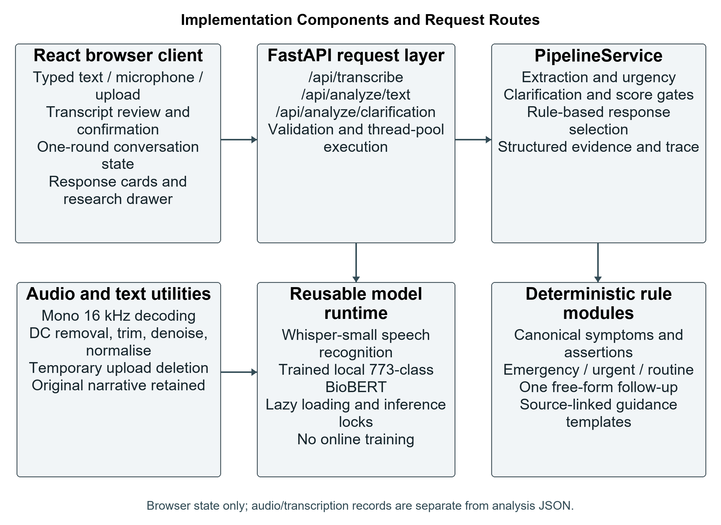
Figure 4.1: Implementation components and request routes

4.2.2 Runtime and Environment Records
The frontend manifest declares React 19.1.1-compatible dependencies and Vite 7.1.3-compatible development tooling. The backend declares FastAPI, Uvicorn, Pydantic, multipart-upload support and PyAV, together with the voice-pipeline dependencies. These manifest ranges are not a complete record of the exact package versions installed for every historical experiment. A final experimental record should retain the Python version, installed package versions, operating system, selected inference device and the relevant saved run configuration.
Expanded transformer training was conducted on the school server described by the researcher as having an RTX 4090. The local prototype can execute on CPU and can select CUDA when the active PyTorch environment exposes it. The availability of a GPU on a server does not prove that a particular process used it. Device information, training logs and precision settings must therefore be reported from the corresponding run rather than inferred from hardware availability. This chapter does not invent unrecorded CPU, memory or driver specifications.
The local launcher starts Uvicorn on the loopback address and serves the built frontend from frontend/dist. During development, Vite can forward API requests to FastAPI. A ready health endpoint verifies the model directory and reports runtime state, but it does not run an accuracy test or imply that both large models have already been loaded. Lazy loading means that the first eligible request may include a substantial cold-start cost, which is separated from subsequent inference timing in the experimental protocol.

4.3 Dataset Preparation and Progression

4.3.1 Preliminary Dataset Implementation
The preliminary experiments use Symptom2Disease.csv. The comparison notebook excludes unnamed index columns, removes missing or empty text and labels, strips surrounding whitespace and assigns a source row identifier. Disease labels are converted to integer IDs using LabelEncoder. The outer partition is reproduced with test_size equal to 0.2 and random_state equal to 42, without stratification. Its 960 training and 240 test records are shared by the final three-model comparison.
The row identifiers support a check that the same source row is not assigned to both partitions. This check does not establish that similar or identical text cannot occur in different rows. Accordingly, row-disjoint partitioning is not described as a completed duplicate-aware split. The comparison notebook loads the previously saved BERT and BioBERT models and checks their output-label compatibility, while fitting its TF-IDF baseline on the reproduced training partition.

4.3.2 Expanded Dataset Implementation
The expanded experiments read disease_diagnosis_train_cleaned.csv and disease_diagnosis_test_cleaned.csv. The input column is text_cleaned and the target is diagnosis. The cleaned field removes the original prompt-and-answer material, including the explicit answer naming the diagnosis, while preserving symptom content. The training loader does not perform this prompt conversion from raw records; it consumes the already prepared cleaned files. This distinction avoids attributing an earlier dataset-conversion step to a function that only validates its output.
The loader checks the required columns, removes missing entries, converts text and labels to strings, strips whitespace and excludes empty values. It builds a consistent encoded label vocabulary from the supplied training and test labels, then retains the existing partition assignments. The complete expanded run does not apply the optional sample-limit arguments. There is no automatic text deduplication or group-aware repartitioning in this retained training procedure.
Table 4.2: Separate text classification settings
Property | Symptom2Disease | Expanded dataset
Usable records | 1,200 | 493,890
Output labels | 24 | 773
Outer training records | 960 | 469,195
Designated test records | 240 | 24,695
Main representation | Full-sentence descriptions | Mainly cleaned symptom lists
Partition origin | 80:20 random split; seed 42 | Supplied training/test files
Internal validation | BioBERT: 864/96 for epoch selection, then final training on 960 | No separate validation partition in the retained common training module

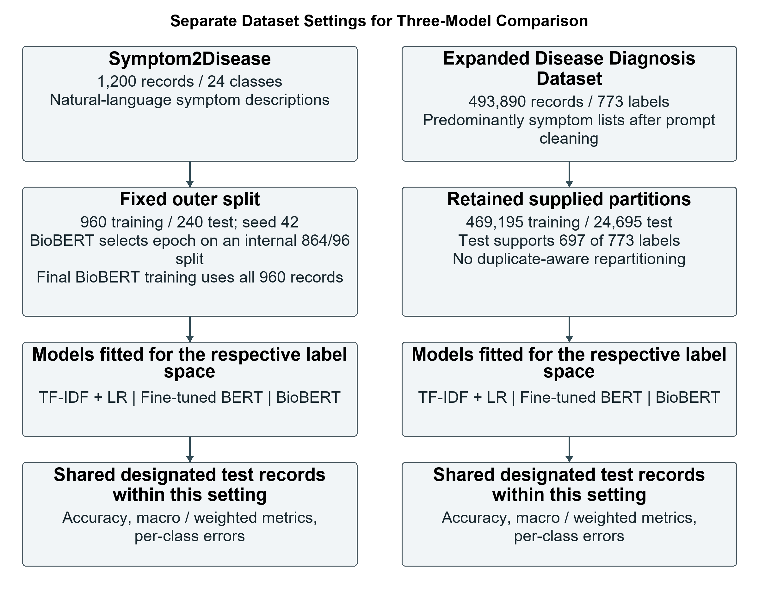
Figure 4.2: Separate dataset settings used in classifier development
[Insert Algorithm 4.1 from Chapter_4_Algorithms.tex here.]
Algorithm 4.1: Load prepared text data and retain the experiment partitions
Algorithm 4.1 distinguishes the two dataset modes rather than merging them into one corpus. The preliminary branch reproduces the original random partition; the expanded branch reads the two supplied files independently. Both branches produce usable text-label frames and a class mapping. Missing-column and empty-value checks prevent silent training on the wrong fields. The algorithm intentionally does not claim an unseen-text guarantee, because the retained code does not construct that guarantee.
[Insert the implementation screenshot for Figure 4.3 here; capture locations are given in Screenshot_and_Assembly_Guide.md.]
Figure 4.3: Validation of prepared input fields and consistent label encoding

4.3.3 Dataset Audit and Training Implications
The expanded-data audit identified 23,863 test records whose exact cleaned-text and diagnosis-label pair also occurs in the training data. This is approximately 96.63% of the test partition. The supplied test file also contains support for only 697 of the 773 labels. These observations affect interpretation of the comparison: the retained test scores do not establish independent generalisation, and unsupported labels cannot be evaluated as though test examples existed for them.
The existing checkpoints are retained; no corrected split or subsequent retraining is claimed. The progression increases label coverage and the number of records, but repeated symptom combinations do not provide the same information as independently collected narratives. It also changes the text domain from fuller sentences to symptom lists. Larger feature matrices, a larger classification head and more optimisation steps increase computational work, while the label and language changes also alter task difficulty. Differences between the two dataset results cannot be attributed solely to having more data.

4.4 Implementation of the Three Classifiers

4.4.1 TF IDF and Logistic Regression
The traditional classifier is implemented as a scikit-learn Pipeline containing TfidfVectorizer and LogisticRegression. The vectoriser learns its vocabulary and document-frequency weights from training text. Using a single fitted pipeline ensures that the saved classifier and its feature representation remain aligned at inference. The test text is transformed by the fitted training representation rather than fitting a second vocabulary on the test set.
The preliminary vectoriser uses unigrams and bigrams, English stop-word removal, lowercasing, sublinear term frequency and a 20,000-feature cap. Logistic Regression permits 2,000 iterations. The expanded implementation retains the unigram/bigram design but increases the feature cap to 50,000, sets a minimum document frequency of two and uses the SAGA solver with a 1,000-iteration limit. These choices describe the actual configured comparisons; they are not a completed exhaustive hyperparameter search.
[Insert Algorithm 4.2 from Chapter_4_Algorithms.tex here.]
Algorithm 4.2: Train and evaluate TF-IDF with Logistic Regression
Algorithm 4.2 separates fitting from prediction. The timer surrounds pipeline fitting, predictions are then produced for the designated test records, and metrics are exported using the recorded label convention. Saving the entire pipeline with joblib preserves both the vocabulary transformation and classifier coefficients. The feature cap is an upper bound, and the iteration limit does not prove that the optimiser converged. Convergence warnings, where present, should be retained in the corresponding experiment record.
Listing 4.1: Expanded TF-IDF and Logistic Regression configuration
model = Pipeline(
steps=[
(
"tfidf",
TfidfVectorizer(
lowercase=True,
stop_words="english",
ngram_range=(1, args.tfidf_ngram_max),
max_features=args.tfidf_max_features,
min_df=args.tfidf_min_df,
sublinear_tf=True,
),
),
(
"classifier",
LogisticRegression(
solver="saga",
max_iter=args.tfidf_max_iter,
random_state=args.seed,
),
),
]
)
Source excerpt: TF-IDF and Fine Tune BERT/train_three_models.py, lines 283-305.
[Insert the implementation screenshot for Figure 4.4 here; capture locations are given in Screenshot_and_Assembly_Guide.md.]
Figure 4.4: Fitted TF-IDF pipeline and test-set prediction

4.4.2 Fine Tuned BERT
The BERT classifier uses bert-base-uncased as its pretrained starting point. AutoTokenizer supplies the checkpoint's tokenisation, and AutoModelForSequenceClassification creates a task-specific head with the required number of classes. In the expanded implementation, id2label and label2id are passed when loading the model so that numerical outputs can later be translated into diagnosis names. A new output head is required when moving from a 24-class task to a 773-class task; the earlier head is not reused unchanged.
Prepared frames are converted to datasets containing text and integer targets. Tokenisation is batched, applies truncation at 128 tokens and removes the raw-text field after encoding. DataCollatorWithPadding performs batch padding. TrainingArguments specify the learning rate, batch sizes, duration, weight decay, seed, logging and checkpoint behaviour. The script accounts for Transformers API changes when choosing the evaluation-strategy and tokeniser-related argument names. These compatibility checks are engineering details rather than additional model architectures.

4.4.3 Fine Tuned BioBERT
BioBERT uses dmis-lab/biobert-base-cased-v1.2 and the same sequence-classification structure as BERT. The supervised training updates the encoder and classification head together. In the preliminary notebook, an internal stratified split of 864 training and 96 validation records is used to choose the epoch with the highest validation macro F1. The stored notebook output selects three epochs. A fresh model is then trained for that duration on all 960 outer-training records before evaluation on the 240-record test partition.
The preliminary BERT notebook instead evaluates its 240 test records at epoch boundaries. This is a different validation protocol and limits claims that all model-selection procedures were identical. The expanded common training module creates no separate validation dataset and predicts the supplied test partition after training. Saved expanded metadata includes a BioBERT run with automatic checkpoint resumption and a step-based saving setting, whereas the retained common module shows epoch-based saving. These files demonstrate why the actual run metadata must accompany the reported checkpoint rather than assuming every historical artifact came from an identical script revision.
[Insert Algorithm 4.3 from Chapter_4_Algorithms.tex here.]
Algorithm 4.3: Fine-tune an expanded-dataset transformer classifier
Algorithm 4.3 abstracts the common expanded training path. Loading the checkpoint and creating the labelled classification head occur before training. The train and test frames are tokenised independently with the same tokeniser, but only the training frame supplies optimisation targets. Test logits are converted to predictions by argmax. The model, tokeniser and trainer history are exported together. The algorithm is not the preliminary BioBERT validation-selection routine, which is described separately above.
Listing 4.2: Construction of the task-specific transformer classification head
id2label = {index: label for index, label in enumerate(label_names)}
label2id = {label: index for index, label in enumerate(label_names)}
model = AutoModelForSequenceClassification.from_pretrained(
pretrained_model_name,
num_labels=len(label_names),
id2label=id2label,
label2id=label2id,
ignore_mismatched_sizes=True,
)
Source excerpt: TF-IDF and Fine Tune BERT/train_three_models.py, lines 439-448.
Listing 4.3: Training, designated-test inference and checkpoint export
start_time = time.perf_counter()
trainer.train()
training_seconds = time.perf_counter() - start_time
prediction_output = trainer.predict(test_dataset)
predictions = np.argmax(prediction_output.predictions, axis=-1)
trainer.save_model(model_output_dir)
tokenizer.save_pretrained(model_output_dir)
Source excerpt: TF-IDF and Fine Tune BERT/train_three_models.py, lines 470-478.
[Insert the implementation screenshot for Figure 4.5 here; capture locations are given in Screenshot_and_Assembly_Guide.md.]
Figure 4.5: Transformer head construction and supervised training with artifact export
Table 4.3: Configured classifier settings across the two experiments
Setting | Preliminary experiment | Expanded experiment
TF-IDF feature cap | 20,000 | 50,000
TF-IDF n-grams | Words of length 1 and 2 | Words of length 1 and 2
LR iteration limit | 2,000 | 1,000; SAGA solver
Transformer learning rate | 0.00002 | 0.00002
Transformer weight decay | 0.01 | 0.01
Transformer input length | 128 tokens | 128 tokens
Training batch size | BERT 8; saved BioBERT run 8 | 16
Evaluation batch size | BERT 8; GPU BioBERT configuration 8 | 32
Training duration | BERT 3 epochs; BioBERT selected 3 | Configured 3 epochs

4.4.4 Loading the Retained BioBERT Checkpoint
The prototype does not substitute a generic Hugging Face encoder for the trained classifier. Its default path resolves to 3 Models After Training/outputs/models/biobert. Directory validation requires config.json, model.safetensors, tokenizer_config.json and tokenizer.json. It checks that the saved class mapping contains 773 entries and that the weight file includes classifier.weight and classifier.bias. These checks detect a wrong label space or an incomplete classification artifact before ordinary inference.
ModelRuntime loads both the tokeniser and classifier from this directory with local_files_only enabled. It moves the model to the selected device, sets evaluation mode and caches the loaded objects. Separate locks protect loading and inference. This avoids repeated downloads or training during a consultation and ensures that the application uses the retained supervised model. Validation confirms structural suitability; it does not certify medical accuracy or establish that every class has been independently evaluated.

4.5 Audio Preprocessing Implementation
Audio processing begins with decoding and format standardisation. The file route uses librosa to obtain a mono floating-point waveform at 16 kHz. Browser WebM recordings use a PyAV decoder and resampler, with a fallback decoding path for other supported formats when the initial loader fails. The audio is checked for emptiness, non-finite values and very low amplitude. Unsupported or unusable content is treated as an input failure rather than passed to the recogniser as if valid speech had been recorded.
When enhancement is enabled, preprocess_audio applies four operations in a fixed order. It subtracts the waveform mean to remove DC offset, trims low-energy leading and trailing regions using a 30 dB threshold, applies stationary noise reduction with a proportion of 0.5, and normalises the remaining peak to 0.95. If boundary trimming produces no samples, the centred waveform is retained. After noise reduction, non-finite values are replaced, and normalisation is performed only when the measured peak is positive.
[Insert Algorithm 4.4 from Chapter_4_Algorithms.tex here.]
Algorithm 4.4: Enhance a decoded mono 16 kHz waveform
The input to Algorithm 4.4 has already been decoded and resampled. This matters for the comparison: the original route also uses a standardised mono 16 kHz signal; it skips enhancement, not decoding. The fallback after empty trimming avoids a silent failure in the next stage, and the non-zero peak condition prevents division by zero. The final validation can still reject a processed waveform that is unusably quiet. The output metadata records original and processed duration, removed DC offset, trim indices and the configured enhancement parameters.
Amplitude normalisation changes signal level but does not inherently increase SNR. Stationary spectral gating may attenuate noise-like components, but it can also alter weak speech. These operations are therefore evaluated through paired recordings rather than described as guaranteed improvements. The user-facing enhancement toggle is a controlled way to select the route without changing Whisper or the disease classifier.
[Insert the implementation screenshot for Figure 4.6 here; capture locations are given in Screenshot_and_Assembly_Guide.md.]
Figure 4.6: DC removal, boundary trimming, stationary denoising and peak normalisation

4.6 Whisper Transcription and Text Preparation

4.6.1 Acoustic Processing and Transcription
The shared runtime uses openai/whisper-small with WhisperProcessor and WhisperForConditionalGeneration. Once loaded, the objects remain available for subsequent requests. Recordings are split into consecutive chunks of up to 25 seconds. The processor creates the acoustic features and an attention mask, available tensors are moved to the selected device, and generation is performed in inference-only mode with English and the transcribe task specified.
[Insert Algorithm 4.5 from Chapter_4_Algorithms.tex here.]
Algorithm 4.5: Transcribe audio with the reusable Whisper runtime
Algorithm 4.5 processes chunks in recording order, decodes each generated token sequence and joins non-empty text segments. If no transcript remains, the service raises an empty-transcription error. The implementation has no overlapping-chunk reconciliation or speaker diarisation. Consequently, context near a boundary may be lost and the prototype is intended for a user's symptom account rather than automated analysis of an unrestricted multi-speaker consultation.
[Insert the implementation screenshot for Figure 4.7 here; capture locations are given in Screenshot_and_Assembly_Guide.md.]
Figure 4.7: Chunk-level acoustic processing and Whisper token generation

4.6.2 Temporary Files and Transcript Confirmation
The upload service checks that the submitted content is non-empty and within the 25 MB limit before writing a temporary file. Decoding, optional preprocessing and transcription occur inside a try block. The finally block removes the temporary file even when one of these operations fails. This is an implemented storage policy, not a claim that all possible copies of audio are securely erased: a browser recording may also remain available through a temporary object URL while the transcript is reviewed.
The browser displays the automatic transcript in an editable review component and requires confirmation before text analysis. A corrected transcript is submitted through the same narrative-analysis route as typed text. The original automatic transcription remains a separate transcription result in frontend state. For evaluation, the automatic and corrected versions must be recorded separately. Automatic WER and CER use the unedited recognition output; any corrected version belongs to a human-assisted interaction condition.

4.6.3 Parallel Text Representations
preprocess_text produces a normalised inspection copy using Unicode normalisation, lowercasing, controlled punctuation replacement and whitespace consolidation. The original narrative is not discarded. SymptomExtractor receives the original narrative and performs its own matching normalisation, while urgency detection also considers the complete original account. The canonical list of current symptoms becomes the classifier input. Thus, a simplified statement that every downstream module consumes one punctuation-stripped string would not describe the actual implementation.

4.7 Symptom Extraction Urgency and Prediction Gates

4.7.1 Canonical Phrase Matching
The deployed symptom vocabulary contains 333 canonical entries derived from the underlying SymptomsDisease246k source. The extractor supplements eligible entries with common patient expressions and excludes generic entries that are unsuitable for direct matching. For instance, dry cough maps to cough, scratchy throat maps to sore throat, and a blocked nose maps to nasal congestion. The mechanism is deterministic phrase matching, not a newly trained clinical NER model.
[Insert Algorithm 4.6 from Chapter_4_Algorithms.tex here.]
Algorithm 4.6: Extract canonical symptoms and their assertion states
Algorithm 4.6 first collects boundary-aware candidates, then resolves overlaps. Longer matches are preferred when candidates begin in the same region, reducing unwanted shortening of a specific symptom phrase. Each accepted mention receives a canonical label and an assertion status. The latest recognised mention of a canonical symptom determines its retained status, while first occurrence determines ordering in the output. Only distinct currently present symptoms are joined into the BioBERT input.
Assertion handling examines context bounded by sentence punctuation and contrast expressions. It distinguishes a user's current symptom from a denial, an uncertain statement, a historical account or a reference to another person. Positive idioms containing apparent negation receive exceptions, so an expression such as cannot breathe is not treated as a denial of breathing difficulty. These heuristics have limited scope and do not guarantee correct parsing of every correction or complex sentence. Evidence offsets identify the matching normalised text, not necessarily identical positions in the raw narrative.
[Insert the implementation screenshot for Figure 4.8 here; capture locations are given in Screenshot_and_Assembly_Guide.md.]
Figure 4.8: Mention evidence, latest assertion consolidation and canonical classifier input

4.7.2 Urgency Override
detect_urgency runs after extraction and before disease inference. It evaluates current-symptom combinations and eligible raw warning phrases. Clear negated, historical and other-person phrase hits are excluded from ordinary warning matching, while specified uncertain warning phrases may remain actionable. Each matching rule stores its identifier, level and supporting evidence. The level ordering is emergency, then urgent, then routine.
[Insert Algorithm 4.7 from Chapter_4_Algorithms.tex here.]
Algorithm 4.7: Choose urgency by the highest-priority matching rule
Algorithm 4.7 selects the highest matched urgency level. Emergency and urgent both set should_bypass_classification to true. Clarification is also deferred so that the warning action does not wait for a routine class prediction or additional symptom detail. No matching rule produces the routine state, which means only that the configured rules found no warning pattern. The source-informed rules remain incomplete and require clinical review; they must not be described as a validated triage system.
[Insert the implementation screenshot for Figure 4.9 here; capture locations are given in Screenshot_and_Assembly_Guide.md.]
Figure 4.9: Highest-priority urgency selection and classification-bypass decision

4.7.3 Local BioBERT Inference and Score Gates
Eligible canonical symptom text is tokenised with the trained checkpoint's tokeniser and truncated to 128 tokens. ModelRuntime performs inference without gradient tracking and applies softmax to the returned logits. The three highest-scoring classes are retained with the model's saved disease names. Scores are recorded to six decimal places; the first-to-second difference is used as an ambiguity measure.
[Insert Algorithm 4.8 from Chapter_4_Algorithms.tex here.]
Algorithm 4.8: Run the trained BioBERT model and apply score display gates
Algorithm 4.8 gives priority to the low-score check. If the highest score is below 0.50, the result is marked for symptom review. If the score passes but the top-two difference is below 0.10, the result is marked ambiguous. Otherwise, the classifier proposes that its dataset-class result is available. The surrounding conversation controller may still withhold it. These thresholds are configurable research heuristics and were not calibrated on a clinically reviewed validation cohort.
[Insert the implementation screenshot for Figure 4.10 here; capture locations are given in Screenshot_and_Assembly_Guide.md.]
Figure 4.10: Loading the retained local BioBERT checkpoint and applying display thresholds
Table 4.4: Implemented control settings for the current prototype
Control | Default | Effect
Minimum current symptoms | 2 | Insufficient distinct symptoms pause classification
Follow-up question count | 1 | One adaptive free-form question
Clarification rounds | 1 | Unresolved cases close with a fallback
Minimum top score | 0.50 | Below this, the disease result is withheld
Minimum top-two margin | 0.10 | Closely competing classes trigger clarification
Ranked class count | 3 | Retained for research inspection, not a clinical differential

4.8 Conversation Control and API Integration

4.8.1 Pipeline Orchestration
PipelineService.analyze_text is the central controller. It validates the narrative, records a normalised copy, performs extraction, checks urgency and generates preclassification clarification. If urgency requires a bypass, it creates a skipped-classification record with the urgency reason. If current information is insufficient or uncertain, it creates a skipped record with the clarification reason. Otherwise, it invokes the trained model when a canonical input exists.
[Insert Algorithm 4.9 from Chapter_4_Algorithms.tex here.]
Algorithm 4.9: Orchestrate extraction, urgency, clarification and classification
The distinction between skipped inference and inferred-but-withheld output is important. Algorithm 4.9 sets inference_performed only when the model actually runs. After inference, clarification is recalculated using the model's status; a weak or ambiguous result can therefore be hidden even though predictions were produced internally. The response generator receives the updated decisions rather than independently inferring a new disease. The final analysis object records inputs, extracted evidence, urgency, clarification, classification, response, stage trace, timings and runtime information.
[Insert the implementation screenshot for Figure 4.11 here; capture locations are given in Screenshot_and_Assembly_Guide.md.]
Figure 4.11: Urgency and clarification branches around disease-model inference

4.8.2 One Round of Natural Language Clarification
The frontend stores the original narrative when the response requests clarification. The next submitted message is sent to the clarification endpoint with the original text. The backend strips and joins the two pieces, then reanalyses the combined account. This preserves the first symptom when an answer merely adds detail or states that there are no other symptoms. Sending only the short reply to the classifier would lose the context the user had already provided.
[Insert Algorithm 4.10 from Chapter_4_Algorithms.tex here.]
Algorithm 4.10: Process one clarification answer without losing the original context
When the reanalysis still returns clarification, Algorithm 4.10 preserves the pre-limit status, sets clarification_limit_reached, hides the class, removes the question and regenerates a non-diagnostic response. The returned conversation object retains the original narrative, answer and combined text separately. If the answer introduces a recognised urgent warning pattern, the ordinary reanalysis gives urgency priority. Duration and severity do not create extra canonical symptoms, so a truthful one-symptom case may close without disease classification.
The fallback explains whether the model was not run because there were too few current symptoms or whether it ran but failed the score or margin requirements. The current approach avoids an indefinite interrogation loop, but it cannot understand arbitrary discourse corrections with the sophistication of a general language model. In particular, a yes/no answer or an indirect correction may not supply recognisable canonical evidence. These are interaction limitations to examine in the usability study rather than reasons to encourage a user to fabricate additional symptoms.
[Insert the implementation screenshot for Figure 4.12 here; capture locations are given in Screenshot_and_Assembly_Guide.md.]
Figure 4.12: Combining the follow-up with original text and closing unresolved clarification

4.8.3 Request Schemas and Error Handling
The text schema accepts non-empty stripped text with a maximum of 5,000 characters. The clarification schema stores an original narrative of up to 5,000 characters and an answer of up to 3,000 characters. Audio uses multipart form fields for the file, preprocessing option and language. Pydantic validation, explicit service checks and endpoint error mapping address different failure points: an invalid schema is rejected before processing, while a decoder or model error occurs within the service.
Table 4.5: API endpoints used by the interface
Endpoint | Input | Primary output
GET /api/health | No symptom input | Model-directory and selected-device status
POST /api/transcribe | Audio file; preprocessing flag; language | Automatic transcript and audio-stage metadata
POST /api/analyze/text | Confirmed or typed narrative | Analysis, conversation decisions and rule response
POST /api/analyze/clarification | Original narrative and answer | Combined-context reanalysis or closed fallback

Processing is delegated to a thread pool so expensive synchronous operations do not run directly inside the asynchronous endpoint body. ValueError is translated into a bad-request response, missing required files into a service-unavailable response, and unexpected errors into a generic server error while details are logged on the backend. Model inference locks serialize access within the runtime; this is not a measured high-concurrency production deployment. The schema and error behaviour should be tested separately from classifier quality.

4.9 Rule Based Response Implementation
generate_rule_based_response selects deterministic content from the current pipeline state. Its order is emergency, urgent, clarification, accepted research prediction and no-prediction fallback. The function uses classification.display_prediction when deciding whether the disease class may be shown. It does not take the mere presence of predicted_disease as permission to disclose it. This design connects the model-output gate to the ordinary response card.
[Insert Algorithm 4.11 from Chapter_4_Algorithms.tex here.]
Algorithm 4.11: Select deterministic response content from pipeline state
Algorithm 4.11 omits routine self-care and class output for emergency or urgent states. In a clarification state it presents the free-form question and hides the class. For an accepted research prediction it describes similarity to a training-dataset category and selects any relevant guidance through present symptom groups. Following an unresolved clarification round, it can still provide supported symptom-level guidance without naming a disease. Actions and sources are deduplicated so that multiple matching groups do not repeatedly present identical wording.
GuidanceRule stores a rule identifier, symptom set, self-care wording, safety-net wording and source title and URL. The current groups address headache, respiratory symptoms, nausea or vomiting or diarrhoea, fever or chills, dizziness, and itchy skin or rash. This is not a disease-to-treatment database for 773 classes. Medication names, doses, antibiotics and disease-specific treatment plans are excluded. Unsupported symptoms receive general professional-assessment messaging rather than generated recommendations.
Each response has structured fields for the headline, explanation, actions, self-care, safety net, clarification questions, selected rule IDs, sources and disclaimer. Source links provide traceability to public information, not medical verification of the implementation. The prototype does not systematically establish all age, pregnancy, immune-status and fluid-restriction conditions before general guidance. A disclaimer acknowledges this limitation but does not replace eligibility checks or qualified review. A student's favourable opinion of the interface cannot certify that the medical wording is safe.
[Insert the implementation screenshot for Figure 4.13 here; capture locations are given in Screenshot_and_Assembly_Guide.md.]
Figure 4.13: Response priority and explicit permission to display a dataset class

4.10 Chatbot Interface Implementation

4.10.1 Conversation and Voice Controls
App.jsx stores messages, the input draft, busy state, the latest analysis, the transcription result and clarification context. The layout separates the main conversation from status and evidence panels. Typed text and confirmed speech ultimately use processNarrative, which selects a normal analysis request or a clarification request depending on session state. A new consultation resets the conversation state rather than creating a persistent patient record.
Microphone recording uses the browser's MediaRecorder and microphone permission mechanism. Recorded chunks are combined into a Blob, and a File is supplied to the same upload workflow as an audio attachment. The browser retains an object URL for playback during transcript review and releases it during cleanup. Error cards explain failed requests, and the busy state prevents ordinary duplicate submissions while processing is underway. This is a practical interaction control, not a fully evaluated accessibility certification.

4.10.2 Transcript and Response Presentation
TranscriptReview provides an editable text area, playback when available, processed-duration information, and confirm/cancel controls. Confirmation submits the text for medical-language analysis. The response card displays a state-specific headline and explanation, recognised symptom tags, guidance and sources. It shows the disease-class panel only when displayed_prediction is provided by the response object. The ordinary class display is labelled as a model score and a closest dataset class rather than a diagnostic probability.
[Insert a screenshot of the current TranscriptReview interface here.]
Figure 4.14: Editable transcript confirmation before symptom analysis
The clarification card summarises what the system understood and asks one adaptive follow-up. An unresolved case is a legitimate non-diagnostic outcome: the interface should make it clear whether current symptoms were recognised even if no class is available. Emergency and urgent cards must remain visually distinct from ordinary research results, while source links and the disclaimer remain accessible. The presentation should not encourage users to interpret the three research scores as a clinically validated differential diagnosis.
[Insert two current interface screenshots: clarification and its unresolved fallback.]
Figure 4.15: One-round clarification and an explained no-prediction outcome

4.10.3 Research Inspection and Experimental Records
ResearchPanel exposes evidence, the canonical BioBERT input, classification status, ranked classes and stage timings. It also displays the separate audio/transcription result when one exists. The current Download complete JSON button serialises the analysis object only. It does not merge the separate transcription object, raw audio, audio-preprocessing metadata and ASR duration into a single complete speech-evaluation record. Those additional records must therefore be captured separately for the voice experiments.
The panel's total-time field also chooses the text-analysis processing time when an analysis exists; it does not automatically add the earlier transcription duration. A reported end-to-end voice latency must therefore be measured externally or assembled from appropriately identified stage records. Keeping this distinction prevents a fast text-analysis number from being described as complete speech-pipeline latency. Research details may expose withheld internal rankings, so this view remains an evaluator-facing diagnostic facility rather than evidence that hidden medical predictions are inaccessible everywhere in the prototype.
[Insert the current research drawer showing input evidence, status, scores and timings.]
Figure 4.16: Research inspection of pipeline evidence and model outputs

4.11 Classifier Experimental Procedure

4.11.1 Preliminary Three Model Comparison
The preliminary procedure begins by reproducing the cleaned 1,200-record dataset and its fixed 960/240 outer split. TF-IDF with Logistic Regression is fitted on the outer-training records, while saved BERT and BioBERT checkpoints are loaded from their respective model folders. The model output dimension and label mapping are checked against the dataset vocabulary. The older BERT checkpoint uses generic LABEL identifiers that must correspond to the integer encoding used during its original training; BioBERT stores explicit disease names.
All three models generate one prediction for every designated test record in the same row order. Comparison uses the same reference labels and metric functions, avoiding an artificial difference caused by evaluating different examples. However, the validation-procedure difference described earlier remains: BERT monitored the test partition during training, whereas BioBERT selected its epoch through an internal validation split. The fixed shared test set makes the comparison consistent at prediction time but does not remove this model-selection limitation.
The outputs include the comparison table, class reports and a comparison chart. Results are kept specific to the 24-class setting. An untrained BERT output head is not substituted for the supervised BERT classifier, and the preliminary results are not relabelled as 773-class performance. The numerical findings and errors are presented in Chapter 5 rather than embedded in the implementation description.

4.11.2 Expanded Three Model Comparison
The expanded procedure reads the prepared supplied partitions, uses text_cleaned as input and diagnosis as target, and configures the complete 773-label mapping. The three classifiers are trained for that setting and evaluated on the same 24,695-record test file. The baseline changes its feature and solver settings for the larger task, while the transformers use their respective pretrained checkpoints and the recorded supervised training settings. No symptom-extraction or chatbot abstention filter removes difficult test examples from this standalone classifier comparison.
Artifact provenance is maintained by dataset and run folder. The top-level comparison CSV belongs to the earlier 24-class experiment, so it must not be mistaken for the expanded comparison simply because its filename is similar. The retained expanded folder contains separate TF-IDF, BERT and BioBERT class reports, model weights and trainer logs. A combined results table should be derived from these dataset-specific outputs with an explicitly consistent averaging convention. Reassembling metrics from saved reports is not a new training run.
The class reports explicitly enumerate all 773 labels, whereas the common comparison-row function infers a label set from reference and predicted arrays. Macro results can therefore differ between the two exports. The report must state whether it uses all configured labels, supported labels or the recorded inferred convention, and must not mix these definitions. Weighted F1 and accuracy remain important, but they do not erase the limited support for rare classes or the substantial train-test duplicate overlap. The retained split is reported honestly, not described as an independent generalisation benchmark.

4.11.3 Cross Dataset Interpretation and Computational Cost
The two experiments answer different questions: the preliminary comparison examines a small balanced 24-class corpus, whereas the expanded comparison covers many more output labels and repeated symptom-list combinations. A direct percentage difference between them is not an estimate of the causal benefit of more training data because input style, label space, class support and training settings change simultaneously. A model ranking may change without establishing that one model is universally superior for medical chatbots.
Training duration is taken only from records that cover the complete relevant run. Checkpoint resumption, device allocation and loading overhead must be identified before comparing logs. A BioBERT trainer runtime from a resumed phase cannot be treated as the full training time and compared directly with an uninterrupted BERT run. Inference-time comparison should instead use the same machine, a fixed test batch and repeated warm predictions, with first-load cost reported separately. These controls allow computational claims without requiring a fabricated timing estimate.
Table 4.6: Controls and qualifications for the two classifier comparisons
Aspect | Control or qualification
Within-dataset examples | Use the same designated test records and reference labels for all three models
Across-dataset differences | Treat the 24- and 773-class tasks separately; do not attribute changes only to size
Input fitting | Fit TF-IDF on training text; use the corresponding pretrained tokeniser for each transformer
Validation | Report preliminary BERT/BioBERT differences and absence of an expanded validation split
Overlap | Retain and disclose supplied-split duplicates; no corrected retraining claimed
Averaging | Identify the exact label set and source export for macro measures
Runtime | Separate resumed phases, full training, cold start and warm inference

4.12 Speech and Integrated Pipeline Experiments

4.12.1 Implemented Legacy Speech Pilot
The implemented pilot uses three selected recordings from Medical Speech, Transcription, and Intent and three curated patient-only cases from PriMock57. The latter are mapped to migraine, urinary tract infection and asthma labels already present in the model vocabulary. The pilot excludes administrative speech, clinician turns and diagnosis disclosure from the selected patient intervals. Medical Speech symptom prompts are not treated as 773-class diagnosis ground truth. The dataset inventory and selected cases are distinct from the number of observations actually evaluated.
For each of the six recordings, five audio conditions are constructed: clean, 20 dB, 10 dB, 5 dB and 0 dB. Every condition is processed through an original and an enhanced route, producing 60 condition-route observations. These are repeated measurements of six source recordings, not 60 independent patients or speakers. The pilot uses one noise recording, so it does not demonstrate robustness across all noise types in the downloaded environmental dataset.
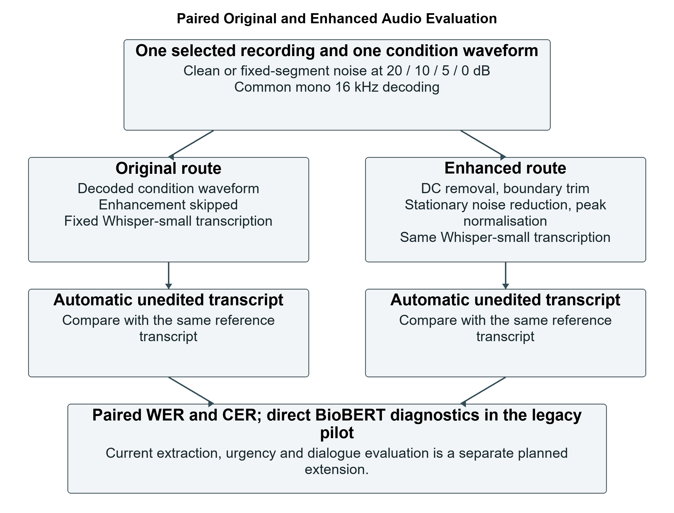
Figure 4.17: Paired original and enhanced routes in the speech evaluation
[Insert Algorithm 4.12 from Chapter_4_Algorithms.tex here.]
Algorithm 4.12: Evaluate the legacy paired speech and noise experiment
Algorithm 4.12 preserves the sample identity, reference and fixed model settings across the two routes. It normalises the reference and hypothesis using the same procedure, then calculates WER and CER. It also obtains direct BioBERT predictions from the reference transcript and generated transcript to measure agreement. Agreement is stability, not necessarily correctness, because both inputs may yield the same wrong label. Disease correctness is recorded only for cases with an appropriate mapped reference label.
The legacy evaluator sends transcripts directly to the classifier. It does not call the current extractor, urgency gate, clarification controller or response generator. Its results therefore cannot be presented as the completed end-to-end performance of the latest chatbot. Empty normalised hypotheses are assigned a recorded error-rate value of 1.0 and an empty prediction. Per-condition records are written incrementally so that partial execution remains inspectable; a partial run must still be labelled partial.

4.12.2 Reproducible Noise Construction
mix_at_snr selects a noise segment using a stable sample-specific seed or tiles the recording when it is too short. The segment is centred before its mean squared power is measured. Speech power and noise power determine the noise scaling required for the requested SNR. The same selected segment is retained for a sample across SNR levels, so its amplitude rather than its content changes. The mixed waveform is scaled jointly when necessary to keep its peak within the permitted range, which preserves the mixture's signal-to-noise ratio.
The original and enhanced routes receive the same mixed condition waveform. This prevents a comparison from being confounded by different random noise in the two routes. Saved summaries use arithmetic mean WER and CER over the selected recordings, not a pooled corpus rate. Negative or small differences in the enhanced route remain legitimate observations; the procedure does not select only conditions where denoising appears beneficial.
[Insert the implementation screenshot for Figure 4.18 here; capture locations are given in Screenshot_and_Assembly_Guide.md.]
Figure 4.18: Fixed-segment noise scaling at a requested SNR
Table 4.7: Implemented pilot scope and controls
Property | Recorded pilot setting
Medical recordings | 3 Medical Speech recordings and 3 selected PriMock57 patient cases
Conditions per recording | Clean; 20, 10, 5 and 0 dB
Routes per condition | Original and enhanced
Condition-route observations | 6 x 5 x 2 = 60 repeated observations
Environmental noise | One fixed selected RIRS noise recording
Automatic metrics | WER and CER before user correction
Downstream diagnostic | Direct transcript-to-BioBERT; not the current complete conversation pipeline

4.12.3 Planned Evaluation of the Current Pipeline
A separate current-pipeline experiment is planned to examine the full sequence from audio through extraction and response decisions. Each recording will retain a manually checked transcript, an annotated current-symptom set and, where defensible, a mapped disease label. The original and enhanced routes will use the same recordings and condition waveforms. The untouched Whisper output will be analysed for an automatic condition, while any manually corrected transcript will be evaluated as a separate assisted condition.
The resulting records will include sample and speaker IDs, source dataset, recording duration, noise condition, preprocessing route, automatic transcript, extracted present/negated/uncertain symptoms, canonical classifier input, urgency, clarification status, inference-performed flag, model ranking and final response state. Speech quality will be measured through WER and CER; extraction through annotated symptom precision, recall and F1; and disease classification through accuracy and weighted F1 only on an appropriately labelled subset. Bypassed and withheld cases will be counted rather than silently discarded.
Reference transcripts can also be passed through the same extractor to separate recognition errors from extraction or classifier errors. A reference-text failure indicates that correcting Whisper alone would not resolve the downstream problem. Where the pipeline withholds a class, conditional correctness among displayed results must be accompanied by display coverage and the withheld count. Broader speaker and noise coverage is proposed, but no larger completed test size or resulting score is claimed in this chapter.

4.12.4 Timing and Record Collection
Automatic-stage measurements exclude the time a user spends reviewing text or answering a question unless interaction time is reported separately. A complete voice-route timer includes upload/decode, optional enhancement, transcription and subsequent analysis, not merely the research drawer's text-analysis time. The current JSON download exports analysis only, so the transcription endpoint output and its timing must be retained independently, or an external experiment recorder must assemble them. No automatic unified evaluation logger is claimed to be implemented where the present interface does not provide one.

4.13 Functional and Behavioural Test Procedure
Functional tests establish whether the implementation follows its programmed contract. The rule-level suites cover alias mapping, assertion categories, positive-negation idioms, urgency rule combinations, clarification triggers and response priorities. The API tests cover the same stage ordering through request/response behaviour. Test doubles provide controlled classifier outputs, permitting deliberate low-score and ambiguity cases without retraining or depending on an arbitrary real-model prediction.
A FakeRuntime prediction in an API test is not a measured BioBERT result. It demonstrates, for example, that a sufficiently supported non-urgent input reaches the classifier call or that a warning input bypasses it. Mocked transcription similarly checks upload routing rather than WER. These distinctions prevent unit-test success from being misreported as medical model accuracy. Actual checkpoint inference and real-audio decoding need separate integration checks.
Table 4.8: Representative functional scenarios and expected behaviour
Scenario | Expected programmed behaviour
Empty or whitespace text | Reject unusable input
One currently present symptom | Ask one follow-up without running the classifier
Free-form cough follow-up adds sore throat and blocked nose | Retain original cough and add recognised current symptoms
No other symptoms after one-symptom input | Retain original symptom; close with explained fallback if still insufficient
Recognised dangerous chest-pain pattern | Urgency overrides and classifier call is bypassed
Controlled low classifier score | Hide the disease class and ask clarification or close after the round limit
Controlled close top-two scores | Treat the result as ambiguous rather than display it as accepted
Missing model files or corrupt head | Return an explicit model availability/validation failure
Browser WebM recording | Decode to a usable mono 16 kHz waveform before recognition

Tests should retain the executed command, software environment and observed outcome in the experiment log. Existing suite files provide the scenarios, but the number of passed cases belongs to an executed test report, not an invented count in this chapter. Error scenarios and negative feedback are kept because they show the boundaries of the implementation. Clinically reviewed sensitivity or specificity requires independent urgency reference decisions; matching a developer-defined scenario alone is not clinical validation.

4.14 Planned Human Usability Study

4.14.1 Study Purpose and Recruitment
A five-person exploratory study is planned to investigate the usefulness and usability of the prototype. Adult volunteers will be recruited through convenience sampling, with variation in course background, self-reported English confidence, speaking style and chatbot familiarity where feasible. Five participants meet the intended small pilot scope, but the sample does not justify population-wide estimates or statistically reliable subgroup comparisons. The study examines interaction, comprehension and perceived usefulness, not diagnostic safety.
Before testing, participants will be told that the scenarios are fictional and that the chatbot is not a medical service. Consent will cover the study activities and any retained audio or screenshots, and the applicable faculty or institutional approval process will be followed. Participants can decline a question or withdraw. Actual symptoms, patient identifiers and other sensitive disclosures are unnecessary for the task. A participant who describes a genuine concerning health situation should not be asked to continue testing that situation as an experiment.

4.14.2 Demographic and Speech Profile Records
The demographic record will include age or age range, self-described gender and course or academic background. The speech profile will record self-reported English proficiency, relevant accent or colloquial-language preferences and prior chatbot experience. Fluency and slang use will be described neutrally, preferably from participant self-report and observed task behaviour rather than inferred from nationality, gender or appearance. Speaking rate can be recorded as words per second for a common utterance if the transcript and duration are available.
P01 to P05 are reserved participant identifiers, not fabricated recruited people. The public report will use these codes. Names may be kept in a separate confidential consent record and included in the thesis only when the participant explicitly agrees and institutional requirements permit it. Tables 4.9 and 4.10 are data-collection structures; their pending entries must be replaced with actual consented observations after the study, not plausible-looking invented demographics.
Table 4.9: Planned demographic record awaiting participant data
Reserved ID | Age / range | Gender | Course / background
P01 | Pending | Pending | Pending
P02 | Pending | Pending | Pending
P03 | Pending | Pending | Pending
P04 | Pending | Pending | Pending
P05 | Pending | Pending | Pending

Table 4.10: Planned speech profile record awaiting participant data
Reserved ID | English proficiency | Accent / speaking style | Chatbot familiarity
P01 | Pending self-report | Pending self-report / observation | Pending self-report
P02 | Pending self-report | Pending self-report / observation | Pending self-report
P03 | Pending self-report | Pending self-report / observation | Pending self-report
P04 | Pending self-report | Pending self-report / observation | Pending self-report
P05 | Pending self-report | Pending self-report / observation | Pending self-report

4.14.3 Common Tasks and Test Conditions
All participants will complete comparable interface tasks. A short practice activity will explain recording and transcript confirmation without coaching a disease prediction. The main tasks cover typed entry, voice recording, transcription inspection, a free-form follow-up, recognition of an urgent-action message and interpretation of a withheld result. A task is successful when the intended interaction is completed and understood, not merely when the system displays a disease label.
Table 4.11: Planned usability tasks and success criteria
Task | Activity | Success criterion
T1 | Enter a fictional symptom account as typed text | Submit a narrative and locate what the system understood
T2 | Record a common short fictional symptom account | Use recording controls and obtain a transcript for review
T3 | Inspect and confirm or correct the transcript | Identify the automatic text and submit an appropriate confirmed version
T4 | Answer one clarification in natural language | Reply without special formatting and recognise that context is retained
T5 | Inspect a scripted warning-sign response | Recognise priority action and absence of routine class prediction
T6 | Inspect an unresolved or withheld result | Explain why a disease class is not shown without inventing symptoms

Task order, instructions, equipment, room conditions and researcher assistance will be recorded. A common recorded utterance supports a descriptive comparison of transcription across speakers, while a separate natural free-form task assesses whether users can explain symptoms in their own wording. Reading the same text and describing a scenario freely are different conditions and will not be merged without explanation. Noise, microphone distance and preprocessing settings will be held consistent where possible; any variation will be logged rather than attributed automatically to accent or fluency.
The researcher will note completion, errors, help required, time spent reviewing text, corrected words and difficulties with clarification. No participant will be instructed to add symptoms they do not genuinely have within the fictional scenario merely to raise a score. A no-prediction response can be an appropriate prototype outcome, but the user's understanding of that outcome still requires evaluation. A test limited to successful demonstrations would miss this central usability issue.

4.14.4 Questionnaire and Qualitative Feedback
After the tasks, participants will complete the standard ten-item System Usability Scale using its original wording and five-point agreement responses (Brooke, 1996). The original questionnaire should be obtained from the cited source rather than rewritten and still labelled SUS. Odd-numbered contributions are response minus one, even-numbered contributions are five minus response, and the sum is multiplied by 2.5. The score is on a 0-100 scale, not a percentage of correct diagnoses or task completion.
Supplementary prototype-specific questions will ask whether explaining symptoms felt easy, the transcript review was clear, the follow-up was understandable, response wording was useful and the non-diagnostic limitation was understood. These custom responses will be analysed separately from SUS. Open comments will ask what was confusing, what worked well and what should change. Participants will also be asked to explain the difference between recognised symptoms, a dataset class and a model score, because apparent confidence can otherwise create misleading expectations.

4.14.5 Recording and Analysis Plan
The record for each participant will contain the consented profile, task outcomes, assistance, completion times, transcript observations, SUS item responses and qualitative comments. The analysis will present individual outcomes and descriptive summaries, preserving both favourable and unfavourable feedback. With five participants, averages can hide individual difficulties, so the report will retain the spread and relevant case-level comments. One person's heavily colloquial input or several corrected words will be reported as an observed case, not a general finding about an accent group.
Usability results are not available yet and no participant scores or comments are invented. The eventual Chapter 5 discussion will connect genuine feedback to interface and pipeline limitations. Clinical review of medical content remains a separate requirement that five student or volunteer reviewers cannot replace. Participant records and any identifiable screenshots will be stored according to the consent and institutional arrangements; the chatbot's lack of a database does not automatically manage the researcher's saved study files.

4.15 Chapter Summary
The implementation combines supervised classifier development with a structured speech-enabled application. Its complexity is evidenced by separate dataset settings, reusable model runtimes, canonical extraction, assertion scope, urgency priority, one-round clarification, score-based withholding, deterministic source-linked response selection and browser/API integration. The algorithms and selected source excerpts make these operations inspectable without presenting entire scripts as the explanation.
The experimental procedures distinguish the retained classifier comparisons and legacy paired speech pilot from the proposed current-pipeline and human evaluations. Chapter 5 will present collected outcomes, error patterns, genuine usability feedback and limitations. Shared test records support within-setting comparison, but supplied-split overlap, differing validation procedures, limited speech samples and incomplete clinical validation remain qualifications rather than being concealed by a visually complete application.

References Cited in This Chapter
Brooke, J. (1996). SUS: A quick and dirty usability scale. In P. W. Jordan, B. Thomas, B. A. Weerdmeester, and I. L. McClelland (Eds.), Usability evaluation in industry (pp. 189-194). Taylor & Francis. https://hci-studies.org/methods-and-measures/downloads/SUS_Brooke1996.pdf

