2024

Sean Young ec2140476

Edinburgh college

1/1/2024

Capstone Project



Contents

User Requirements summary 2

hardware requirements summary 3

Computer System Planning Form 4

Film Crew x5 4

Production Manager 5

Administration Manager 6

Production Editor 7

Office hardware and extras 9

Printer specifications 10

Isp comparison table 11

ISP selection 11

Total hardware costs 12

Networking planning report 13

A physical network diagram showing the position of equipment 13

A logical network diagram showing the device names and IP addresses 14

An IP addressing scheme and a table showing device IP addresses, subnet masks and gateway addresses 15

A schedule for what should be implemented and in what order, giving estimated timescales 16

Network setup and testing with pings 16

Emails and responses 20

Email 1: Film Crew Member 3 - Sarah 20

Email 2: Film Crew Member - Bryan 20

Email 3: Administration Manager 21

# User Requirements summary

|  |  |  |  |
| --- | --- | --- | --- |
| Staff Member Name | Role | Hardware Requirement | Software Requirements |
| Admin Manager | Payroll, spreadsheets, emailing using the isp hiring of staff scheduling of work | Desktop pc with an internet connection through a switch, printer/scanner for his office | office software for spread sheets and databases, email application |
| Film and Graphics Production Editor | Produces the final edits of film for release | Desktop pc with graphics card for video editing,32GB RAM, internet connectivity through a switch and a pcie capture card | Modern Operating System to work with Specialised editing software, email application |
| Production Manager | In charge of the film crew and their work including editing film files | Laptop powerful enough to edit video and connect to internet and shared storage | Matching operating system |
| Production assistant 1 | Spend long amounts of time on site | Laptop large hard drive, wireless connectivity | Matching operating system |
| Production assistant 2 | Spend long amounts of time on site | Laptop large hard drive, wireless connectivity | Matching operating system |
| Camera person 1 | Spend long amounts of time on site | Laptop large hard drive, wireless connectivity | Matching operating system |
| Camera person 2 | Spend long amounts of time on site | Laptop large hard drive, wireless connectivity | Matching operating system |
| Film director | Spend long amounts of time on site | Laptop large hard drive, wireless connectivity | Matching operating system |
| Office |  | Wireless Colour printer/scanner, wireless access point, router, switch, shared storage accessed from anywhere at any time. | none |

# hardware requirements summary

|  |  |  |
| --- | --- | --- |
| Hardware Name | Purpose | Who will use this? |
| Desktop pc | Admistritive tasks | Admin Manager |
| Desktop pc | For rendering and editing film files | Production Manager |
| Laptop | For sharing video files and other files with internet connectivity | Film Crew |
| Wireless router | To connect the office users wirelessly to the internet | All staff |
| Network Switch | Switch for the Lan connections in the office and for future upgrades | Admin Manager & Production Manager |
| Office printer/scanner 1 | To print out sensitive paperwork and for general administrative paperwork | Admin manager |
| Office printer/scanner 2 | Used as the general office printer | Production Crew |
| Network attached storage / server | For storing media files and work files to be shared throughout the office and on site | All staff |
| Cabling | For connecting network devices to the internet | All user with Lan devices |
| Wireless access point | For the wireless portion of the network | Users with Wireless devices |

## Computer System Planning Form

### Film Crew x5

|  |  |
| --- | --- |
| Job Role: Film Crew x5 | |
| Location: off site | |
| Component | Recommendation & Price including VAT |
| Processor:  (Manufacturer, Model, Speed, Socket) | Intel® Core™ i5 1230U (12th Generation) |
| Motherboard:  (Manufacturer, Model, Features) | n/a |
| Case  (Manufacturer, Form factor, Features) | n/a |
| Memory:  (Type, Amount) | 8 GB RAM |
| Hard Drive:  (Type, Capacity) | 512gb SSD |
| CD-ROM/DVD:  (Read, Read/Write, Speed) | n/a |
| USB Ports:  (Number, Location) | 2x Thunderbolt 4 with USB Type C  DisplayPort 1.4, HP Sleep and Charge) 2x USB Type-A  1x headphone/microphone combo |
| Video Card:  (Manufacturer, Model, Video RAM) | Intel Iris Xᵉ Graphics |
| Sound Card:  (Manufacturer, Model) | On-board |
| Network Card(s):  (Ethernet: speed, Wireless, Standard) | Intel® Wi-Fi 6E |
| Operating System:  (Manufacturer, Version, Compatibility) | Windows 11 |
| Monitor:  (Size, Resolution, Refresh Rate) | 14” (1920x1200) IPS touch screen |
| Keyboard:  (Manufacturer, Model, Type) | n/a |
| Mouse:  (Manufacturer, Model, Type) | Track pad |

[Laptop website](https://www.hp.com/gb-en/shop/product.aspx?id=6P0U1EA&opt=ABU&sel=NTB&utm_source=affiliate&utm_medium=cpa&utm_campaign=Tech%20Radar&utm_content=trdpro-gb-5811807575124869366_)  **£699.00**

### Production Manager

|  |  |
| --- | --- |
| Job Role: Production Manager | |
| Location: Off site | |
| Component | Recommendation & Price including VAT |
| Processor:  (Manufacturer, Model, Speed, Socket) | AMD Ryzen 7 5800U |
| Motherboard:  (Manufacturer, Model, Features) | n/a |
| Case  (Manufacturer, Form factor, Features) | n/a |
| Memory:  (Type, Amount) | 16GB |
| Hard Drive:  (Type, Capacity) | 1TB SSD |
| CD-ROM/DVD:  (Read, Read/Write, Speed) | n/a |
| USB Ports:  (Number, Location) | 2x usb 3 type A  1x usb 3 type c |
| Video Card:  (Manufacturer, Model, Video RAM) | Dedicated Nvidia 3050TI |
| Sound Card:  (Manufacturer, Model) | n/a |
| Network Card(s):  (Ethernet: speed, Wireless, Standard) | dual-band Wi-Fi 6 |
| Operating System:  (Manufacturer, Version, Compatibility) | Windows 11 |
| Monitor:  (Size, Resolution, Refresh Rate) | 14” 4k monitor |
| Keyboard:  (Manufacturer, Model, Type) | n/a |
| Mouse:  (Manufacturer, Model, Type) | n/a |

[Laptop Website](https://www.amazon.co.uk/Acer-Swift-SFX14-41G-inch-Laptop/dp/B0B1VRJRVM/ref=pd_rhf_dp_s_di_int_pop_multi_srecs_sabr_cn_d_sccl_1_4/257-2743264-2995803?pd_rd_w=M5FmE&content-id=amzn1.sym.140ed8c8-f7ad-4184-908d-64107d20c104&pf_rd_p=140ed8c8-f7ad-4184-908d-64107d20c104&pf_rd_r=S7SV1XD35PBEF6BQP1M8&pd_rd_wg=z2NW9&pd_rd_r=d9efeac7-11c7-4d53-a00f-a799a04a4bc2&pd_rd_i=B09JZGD513&th=1) **£882.99**

### Administration Manager

|  |  |
| --- | --- |
| Job Role: Administration Manager | |
| Location: Office | |
| Component | Recommendation & Price including VAT |
| Processor:  (Manufacturer, Model, Speed, Socket) | AMD Ryzen 7 5700u |
| Motherboard:  (Manufacturer, Model, Features) | Hp branded |
| Case  (Manufacturer, Form factor, Features) | AIO system |
| Memory:  (Type, Amount) | 16GB |
| Hard Drive:  (Type, Capacity) | 1 TB SSD |
| CD-ROM/DVD:  (Read, Read/Write, Speed) | n/a |
| USB Ports:  (Number, Location) | Rear ports  1 USB Type-C 5Gbps signaling rate 1 USB Type-A 5Gbps signaling rate 2 USB 2.0 Type-A 1 RJ-45 |
| Video Card:  (Manufacturer, Model, Video RAM) | integrated AMD Radeon Graphics |
| Sound Card:  (Manufacturer, Model) | n/a |
| Network Card(s):  (Ethernet: speed, Wireless, Standard) | Ethernet 1Gbit  Realtek Wi-Fi 6 |
| Operating System:  (Manufacturer, Version, Compatibility) | Windows 11 |
| Monitor:  (Size, Resolution, Refresh Rate) | 27” IPS AIO monitor |
| Keyboard:  (Manufacturer, Model, Type) | HP 710 White Wireless Keyboard |
| Mouse:  (Manufacturer, Model, Type) | Hp710 white wireless mouse |

[Pc link](https://www.currys.co.uk/products/hp-27cr0020na-27-allinone-pc-amd-ryzen-7-512-gb-ssd-white-10251888.html) **£899.00**

### Production Editor

|  |  |
| --- | --- |
| Job Role: Production Editor | |
| Location: Office | |
| Component | Recommendation & Price including VAT |
| Processor:  (Manufacturer, Model, Speed, Socket) | Intel Core i7 12700(12th Gen) |
| Motherboard:  (Manufacturer, Model, Features) | Hp motherboard |
| Case  (Manufacturer, Form factor, Features) | All in one hp pc case |
| Memory:  (Type, Amount) | 32gb ddr5 4000mt/s |
| Hard Drive:  (Type, Capacity) | 1TB nvme SSD |
| CD-ROM/DVD:  (Read, Read/Write, Speed) | n/a |
| USB Ports:  (Number, Location) | Rear  2 Thunderbolt 4 with USB Type-C 40Gbps4 USB Type-A 10Gbps signaling rate 1 headphone/microphone combo 1 RJ-45  Side  1 USB Type-C 5Gbps signaling rate 2 USB Type-A 5Gbps signaling rate |
| Video Card:  (Manufacturer, Model, Video RAM) | Nvidia GeForce RTX 3060 |
| Sound Card:  (Manufacturer, Model) | On-board |
| Network Card(s):  (Ethernet: speed, Wireless, Standard) | On-board 2.5gbs |
| Operating System:  (Manufacturer, Version, Compatibility) | Windows 11 home |
| Monitor:  (Size, Resolution, Refresh Rate) | 34” WUHD 144hz |
| Keyboard:  (Manufacturer, Model, Type) | HP 915 Black Wireless Keyboard |
| Mouse:  (Manufacturer, Model, Type) | HP 915 Black Wireless Mouse |

[Pc link](https://www.hp.com/gb-en/shop/product.aspx?id=7M4Z1EA&opt=ABU&sel=DTP) **£2,500.00**

|  |  |
| --- | --- |
| Job Role: on premise server | |
| Location: office | |
| Component | Recommendation & Price including VAT |
| Processor:  (Manufacturer, Model, Speed, Socket) | Intel Xeon s 12 core 2 GHz 4410y 11th gen |
| Motherboard:  (Manufacturer, Model, Features) | Hp branded server mother board |
| Case  (Manufacturer, Form factor, Features) | Hp desktop server case |
| Memory:  (Type, Amount) | 32GB DDR5 SDRAM |
| Hard Drive:  (Type, Capacity) | 4x 10TB Seagate Exos |
| CD-ROM/DVD:  (Read, Read/Write, Speed) | N/A |
| USB Ports:  (Number, Location) | Front I/O 2x usb3  Rear I/O 2x rj45 2.5GBps 1x console port 2x usb3 |
| Video Card:  (Manufacturer, Model, Video RAM) | Nvidia tesla gfx card |
| Sound Card:  (Manufacturer, Model) | onboards |
| Network Card(s):  (Ethernet: speed, Wireless, Standard) | 2.5GBps onboard |
| Operating System:  (Manufacturer, Version, Compatibility) | Proxmox |
| Monitor:  (Size, Resolution, Refresh Rate) | N/A |
| Keyboard:  (Manufacturer, Model, Type) | N/A |
| Mouse:  (Manufacturer, Model, Type) | N/A |

[HPE ProLiant](https://www.serversdirect.co.uk/p/1879483/hewlett-packard-hpe-proliant-ml110-gen11-performance-server-tower-4.5u-1-way-1-x-xeon-silver-4410y-2-ghz-ram-32-gb-satasaspci-express-hot-swap-2.5-bays-no-hdd-gige-mon) **£1962.48**

[Nvidia tesla](https://www.amazon.co.uk/Dell-Tesla-K80-Accelerator-Refurbished/dp/B07GJ45V3D/ref=sr_1_2?crid=20HYGL258KCS7&dib=eyJ2IjoiMSJ9.PYlGDqiAvADD87ynp5Y9KxHz8KQ5Z23sk5MblINojyp5tS24d2Isab1XSZv98Hh7PEUyA-iV2IyWfTmmTzm17RVLKdAQk-85hPesgat8i_3HJ9KRkpCWGBBcSWP5sD9QqWAJyv-PZUWqfFmOnkwNoAkovKc2IHhN2Xs2q-N9NKFC8x1VvNVYAkVLSbYdnR-HgWixU8eXFMxs9xrLeDvPylB_v28LAzEiwSYEIXMtxhNCo7U7CSaU1x_JYVBXtsNoyp8rLGNQ0NDmukq7hl2wCltefsfvbOOCJRH3PXCTxZM.rycl_zahvwsFoJ7WcfSxH64xdxJYfammjwAAias3_uQ&dib_tag=se&keywords=nvidia+tesla&qid=1712148583&s=computers&sprefix=nvidia+tesla%2Ccomputers%2C115&sr=1-2) **£119.99**

[Seagate HDD](https://www.scan.co.uk/products/10tb-seagate-st10000nm017b-exos-7e10-sata-hard-drive-512e-4kn-35-hdd-sata-6gb-s-7200rpm-256mb-cache) **£815.96**

## Office hardware and extras

|  |  |
| --- | --- |
| Wireless Access Point | [Netgear WPA Wi-Fi 6 ax1800](https://www.amazon.co.uk/dp/B0BSG1F5JY/ref=asc_df_B0BSG1F5JY1712001840000?tag=georiot-trd-21&ascsubtag=trdpro-gb-8320347156743218166-21&geniuslink=true) **£129.68** |
| Display Capture Card | [Elgato HD60 capture card](https://www.amazon.co.uk/dp/B09V1KJ3J4?ascsubtag=06MnrkQ9s6ME9n41VexB94R&linkCode=g12&tag=ignonelink-21) **£139.99** |
| Network switch | [Tp-link 52-port managed switch](https://www.comms-express.com/products/tp-link-tl-sg3452p-52-port-gigabit-l2-managed-switch/?keyword=&campaign=421473151&ad=1136895918525648&ADtype=&Productcode=406298828&msclkid=006948265c9e1b78b6fd2e6111e45213&utm_source=bing&utm_medium=cpc&utm_campaign=Shoptimised%20%7C%20All%20Products&utm_term=4574655576881014&utm_content=Ad%20group%20%231) **£475.93** |
| Patch panel | [24 port cat6 patch panel](https://www.amazon.co.uk/kwmobile-Port-Cat6-Patch-Panel/dp/B07BRX73M5/ref=sr_1_5?dib=eyJ2IjoiMSJ9.PadOCygRA2h8bPC8z8We4AocNj52giC6BV_-5S7cwilE5C0YaME01_uHl3NewE_0OEVw7ZOyrfgCHTXD9-iYt9fV3Me_sBeOWQrZ7UFRDV5y6LUVBQPfZdx47nuZrHVUufccIA3ShkvNryc7xoHMHFriMoG6gQAqtAAL_x8ZiiDzT9Nx2sPnef7UUhFHnm28rhI0LO2gaqGLrThwuQYE34uHpbOAA-vf2b6fXRfafEo.cLbjhg6TWyyocUlT2cKIxWc7hX6aTDPW6oWkIN52MlI&dib_tag=se&keywords=patch+panel&qid=1716388565&sr=8-5) **£42.99** |
| Cat6 ethernet cable | [100mm roll of cat6 cable](https://www.amazon.co.uk/JUSTOP-Outdoor-Ethernet-Networking-Pull-Box/dp/B0CJLYS3TT/ref=sr_1_6?crid=348HSEQBJPWJW&dib=eyJ2IjoiMSJ9.TX7xXj9olGksUSbWU6bhxg9CbAM1mTJef8x8bpgX-U3sTWu_VgtWsCN3lOkotnGNK6LUZ1_7sVbyIAprRSnL9qt933PRo_PMAjWKt1viHVcQcEgiG9USjghaCs75J0kcQaU3OLqALbMyXYP5cyz9C-E7S6dhwmGS-iEiWuYlaKhLVKpaz8PmwGyGuAB66XJENL0ldGLXoE8VsAhwLYexARZ6_cjRrZcsBGpo13hXsdw.zDTWB6hQbVEeQ_KtI-r1h7VBTM7m0PHhDHiT_yzggXM&dib_tag=se&keywords=cat+6+armored+ethernet+cable&qid=1716388752&sprefix=armored+cat+6+cable%2Caps%2C101&sr=8-6) **£34.95** |
| RJ45 connectors | [100-piece RJ45 connectors](https://www.amazon.co.uk/Cable-Matters-Through-Stranded-Connectors/dp/B07PXMN2VK/ref=sr_1_9?crid=2AWDN7O7KU519&dib=eyJ2IjoiMSJ9.HLhCN_wVWUAUBhD21KqNbWj0VFMFb5nhDqDyz_8ohEHkr9hBj6aW1dd0nzRzB7fogDCTsl11LFuEWFlkMgonLkBerywWlyC7mgmxFZ3S-T51t7hn-hsUF9wiQ8VldxRjdLdgpMXoYLBXeCt351C6va49zQOA7tC2faDs235SV0cPc6KblORHEEc2-nXsizI_NnNQKEENSfXlWQducJWRX_wMqg8Qe50-CN30N5THELA.4X8hv7vDOlEI2tR3MBTBzcLORAU4KCiPQoEMQn2xHms&dib_tag=se&keywords=rj45+connector&qid=1716389024&sprefix=rj45%2Caps%2C114&sr=8-9)**£13.99** |

# Printer specifications

[Brother MFC-L8900CDW A4 Colour Multifunction Laser Printer](https://www.printerland.co.uk/product/brother-mfc-l8900cdw/139127)

Price **£682.90**

**Specification**

|  |  |
| --- | --- |
| **Speed Monochrome** | Up to 31ppm Mono Print |
| **Printer Resolution** | Up to 600 x 600 dpi Print |
| **Speed Colour** | Up to 31ppm Colour Print |
| **Double Sided Printing Unit (Duplex)** | Yes |
| **Double Sided Printing** | Automatic Double-Sided Printing |
| **First Page** | As Fast as 15 Seconds First page |
| **Product Group Output** | A4 |
| **Warm Up Time** | As Fast as 31 Seconds |

I have chosen this printer as it has every feature needed in an office from copying, scanning, label and letter printing. It also has good reviews for colour accuracy which could be important to a media company. The printer has a few ways to connect to it wireless networking and a Lan connection if needed so easily accessible from anywhere in the office. It also has usb connectivity and Bluetooth. This printer has good efficiency so in the long run low costs and has features for secure document scanning to.

# Isp comparison table

|  |  |  |  |
| --- | --- | --- | --- |
|  | **Vodafone** | **BT** | **Virgin** |
| **Price** | £23 pm avg | £24.95 pm avg | £33 pm avg |
| **Speed** | Down 900Mbps up 100Mbps | 150Mbps to 900Mbps | Down 400Mbps up 40Mbps |
| **Customer service** | Excellent rating by Ofcom | Poor rating by Ofcom | Excellent rating by Ofcom |
| **Reliability** | 99% uptime | 99% uptime | 98% uptime |
| **Extras** | Unlimited data | Range of extras at additional cost ip phone, static ip address etc | Unlimited downloads fixed price guarantee |
| **Support** | Standard Support, plus dedicated setup support for your first 45 days. | 24/7 support | 24hrs working hours issue resolution time. |

## ISP selection

The isp I have looked at all offer the same kinds of deals with only being a few pounds a month in difference for their services, so I have chosen to use Vodafone as their ISP. The reasons for choosing Vodafone are their customer reviews and Ofcom ratings as being reliable is one of the major factors in selecting an ISP. The also offer a higher upload speed than most witch will be good for uploading to sites outside the premises and for the price savings over a year with the same services is a win.

# Total hardware costs

|  |  |
| --- | --- |
| Film crew laptop x5 | **£3495.00** |
| Production Manger Laptop | **£882.99** |
| Administration Manager desktop PC | **£899.00** |
| Production Manager Desktop PC | **£2500.00** |
| Office server/storage | **£2898.43** |
| Network Switch | **£583.00** |
| Wireless Access Point | **£129.68** |
| Capture Card | **£139.99** |
| Patch Panel | **£42.99** |
| Cat6 Cable | **£34.95** |
| RJ45 Connectors | **£13.99** |
| Office Printer x 2 | **£1365.80** |
| Isp monthly price | **£23.99m/o** |
| Microsoft 365 business | **£10.30m/o** |
| **TOTAL COST** | **£12985.82** |

# Networking planning report

|  |  |
| --- | --- |
| Are wired connections required? | Number: 6 |
| Are wireless connections required? | Number: 5 |
| Wireless standard | 802 11 AX |
| Firewall required? | Yes/No |
| ISP connectivity required? | Yes |
| Type of ISP connectivity | Fiber |
| Internal or external modem required? | No modem required |
| Cables required? | Yes cat 7 |
| Battery backup required? | No |

# A physical network diagram showing the position of equipment

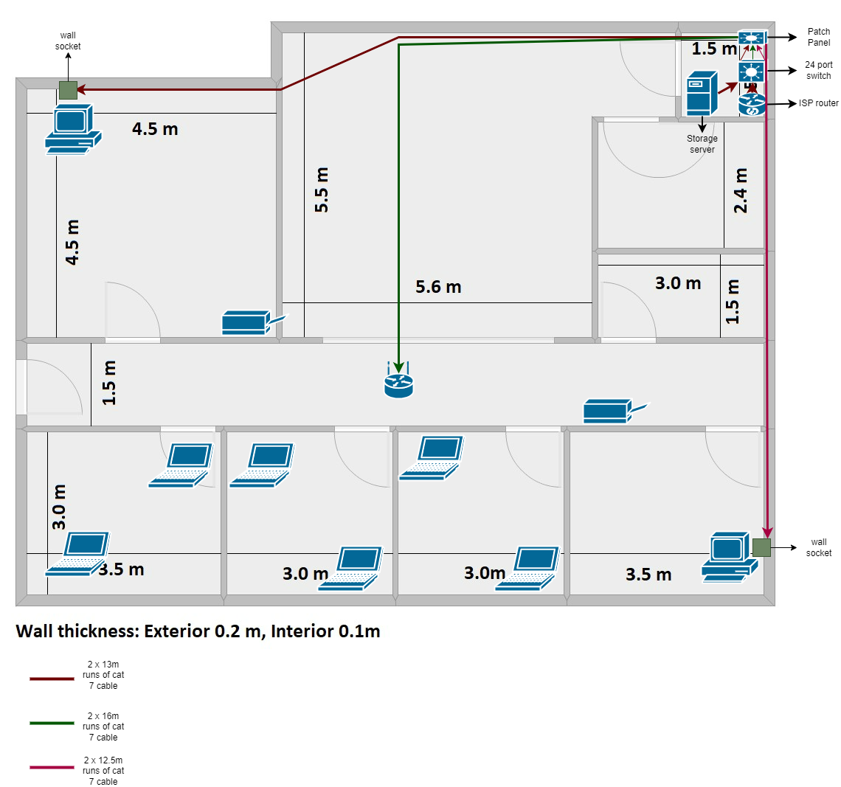

|  |  |
| --- | --- |
| **AREA** | **Length** |
| Server room to admin office | 2 x 13m |
| Server room to directors’ office | 2 x 16m |
| Server room to hallway for Wi-Fi access point | 2 x 12m |

All routes have two pairs of cat6 cables terminating at a duel ethernet socket for redundancy.

# A logical network diagram showing the device names and IP addresses

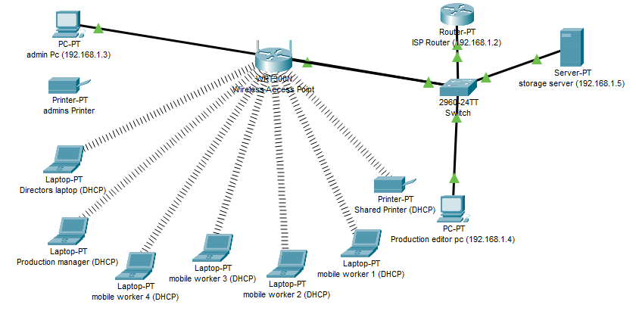

# An IP addressing scheme and a table showing device IP addresses, subnet masks and gateway addresses

|  |  |  |  |
| --- | --- | --- | --- |
| **Device** | **IP Address** | **Gateway** | **Subnet Mask** |
| Router | 192.168.1.2 |  | 255.255.255.0 |
| Admin pc | 192.168.1.3 | 192.168.1.2 | 255.255.255.0 |
| Production editor pc | 192.168.1.4 | 192.168.1.2 | 255.255.255.0 |
| Storage server | 192.168.1.5 | 192.168.1.2 | 255.255.255.0 |
| Production manager laptop | Configured by DHCP | Configured by DHCP | Configured by DHCP |
| Production assistant laptop 1 | Configured by DHCP | Configured by DHCP | Configured by DHCP |
| Production assistant laptop 2 | Configured by DHCP | Configured by DHCP | Configured by DHCP |
| Camera person laptop 1 | Configured by DHCP | Configured by DHCP | Configured by DHCP |
| Camera person laptop 2 | Configured by DHCP | Configured by DHCP | Configured by DHCP |
| Director laptop | Configured by DHCP | Configured by DHCP | Configured by DHCP |
| Printer 1 | Configured by DHCP | Configured by DHCP | Configured by DHCP |
| Printer 2 | Configured by DHCP | Configured by DHCP | Configured by DHCP |
| Wireless access point | 192.168.1.6 | 192,168.1.2 | 255.255.255.0 |

# A schedule for what should be implemented and in what order, giving estimated timescales

Estimated time for completion is four days.

DAY 1: Establish routes for cabling and wall sockets run conduit for cables then run cable pairs to all location detailed in the plan.

DAY 2: Finish off able runs to locations crimp RJ45 connectors to cables and then install cable to the duel fac e plates and install face plates to the walls.

DAY 3: Install patch panel in cupboard and mount wireless access point to the hall way ceiling. Install switch and cable to ISP router and connect switch to patch panel.

DAY 4: Setup all equipment and preform testing for the connectivity and software updates.

# Network setup and testing with pings

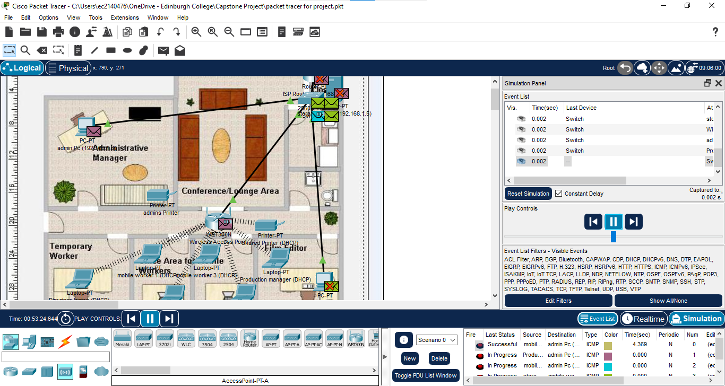

Admin Pc to gateway

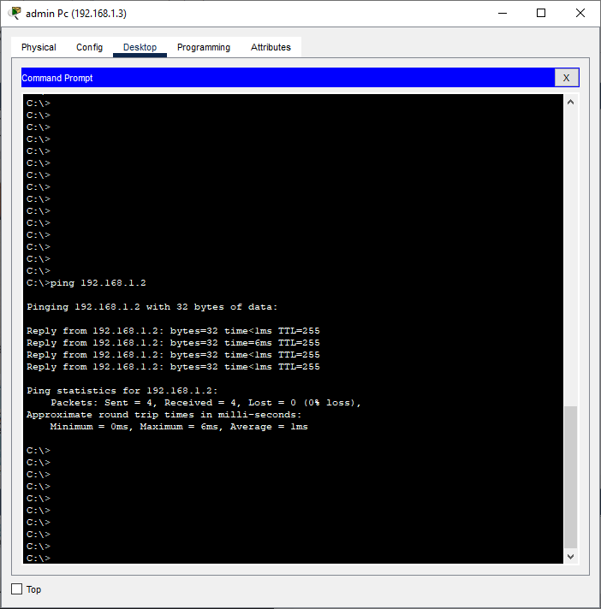

Admin pc to laptop

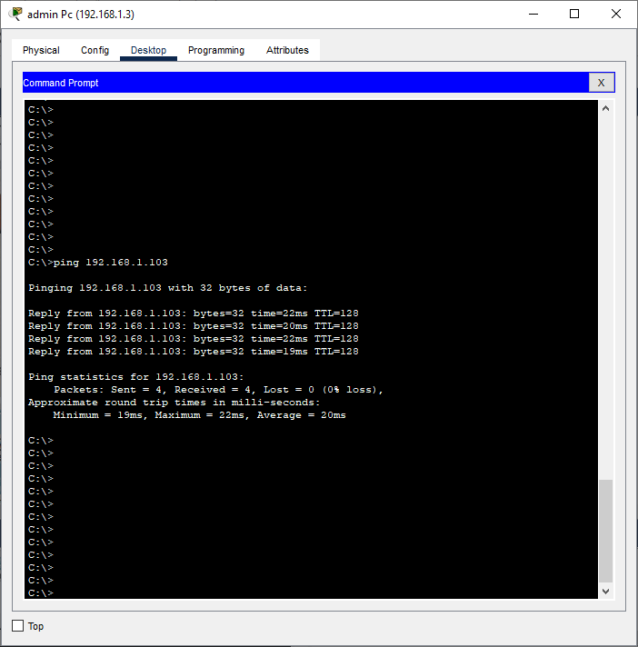

Laptop to gateway

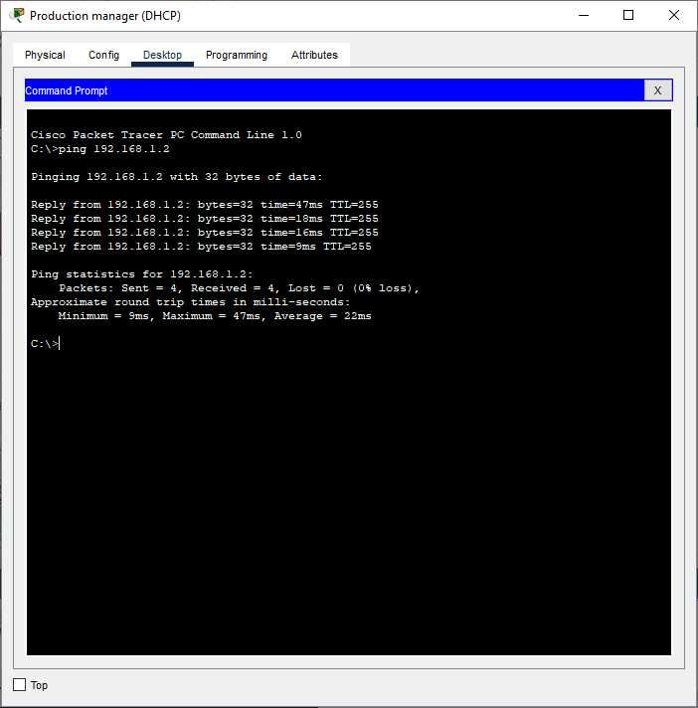

Laptop to laptop

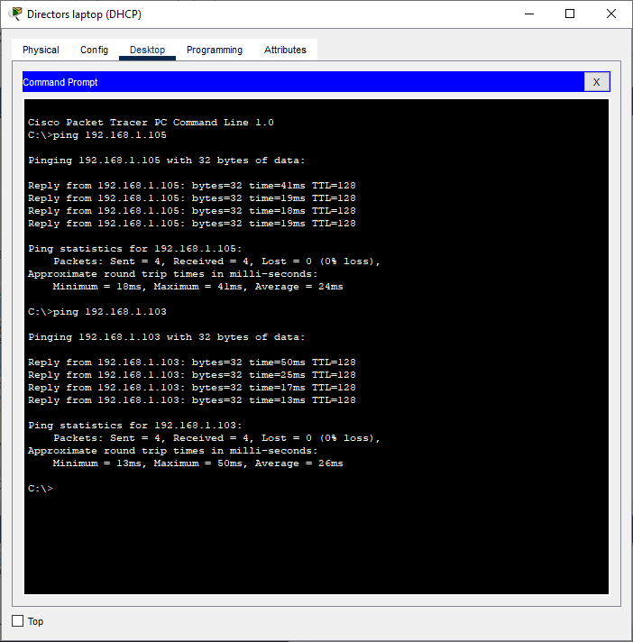

Laptop to server

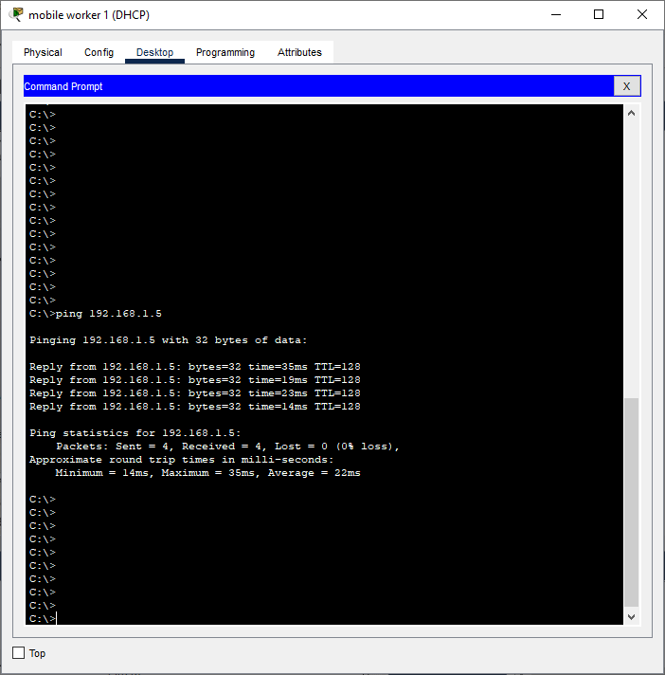

# Emails and responses

### Email 1: Film Crew Member 3 - Sarah

Hello Technical Support

Everything was working fine with my company laptop, but I came in yesterday morning, and I cannot connect to the Wi-Fi network, I think the Wi-Fi has frozen on my computer and I can’t get logged into the printer to print off the scripts for the actors in the film and I don't know what to do now.

I thought your network was good up until today but actually think that it is pretty shocking now, why can’t it just work.

Thanks

Sarah

Email response.

Hi Sarah

Sorry to hear you are having some issues with connectivity to the new network I’m sure we will be able to sort that out for you. If you could try for me to go to the Wi-Fi symbol on the lower right-hand side, then click on it to turn it off then after that click again to turn it back on and re-enter your details we will see if that sorts the Wi-Fi issue. As for the printer issue if your need things printed off and are still having Wi-Fi issues the printer also has Bluetooth that your laptop can connect to as well so you should still be able to use the printer. If the Wi-Fi problem persists with your laptop I will come in and give it a look over and see what the issues are. Again, sorry for the problems you are having but I will find a solution to these problems please mail me back straight away if your issues persist.

Thanks

Sean Young

### Email 2: Film Crew Member - Bryan

Hi IT

Your printer doesn’t work, we were told this new network would fix the problems we had in the past; however, I’ve been trying to plug my usb cable into the printer in the office, but I cannot find any USB port? Do you have any advice I took a picture of the side of the printer have attached it here:

Thanks

Bryan

Email response.

Hi Bryan

Its Sean from IT support sorry to hear you are having trouble with the new printer, the usb socket on the printer is on the front lower left-hand side. If you’re looking to print from your laptop the printer is setup on the network and can be used wirelessly from the laptop. If you need help in setting that up let me know I can help with that.

Thanks

Sean Young

### Email 3: Administration Manager

Hi IT Support

I have just had David and Sarah from the film crew in my office telling me that the wifi has frozen and that they can't print out any scripts for the actors. We paid you good money, almost £15,000 for this network and it doesn't even work. How do you explain this? Really disappointed!

Regards

Susan Roberts

Email response.

Hello Susan

Its Sean here from IT support I’m sorry about the issues your colleges are having with the network, I emailed Sarah and David with some responses to remediate some of the issues they are having. I chose those printers as they come with several ways to connect including Bluetooth and actual wired connections as fail safes that I did mention in the brief that was given to the company when pricing the job for the new setup. As for the Wi-Fi connection issues, I’m sure it’s just a setup issue where we can arrange for a time and day, I can come look at the laptops and just check all the settings are correct and there isn’t a problem with the network. again, sorry for your issues but we will get them sorted out for you.

Thanks

Sean Young

IT Support