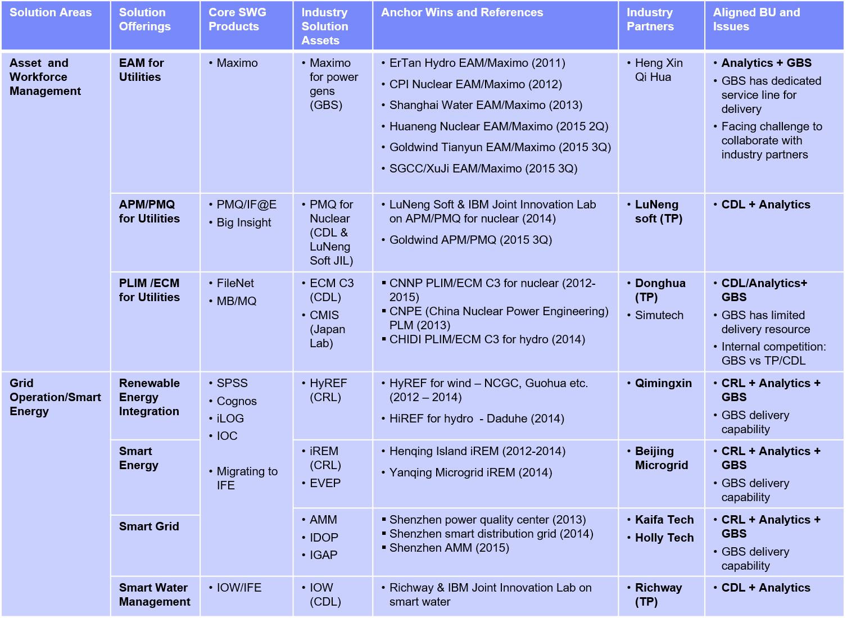

Predictive Maintenance and Quality Plant Lifecycle Information Management

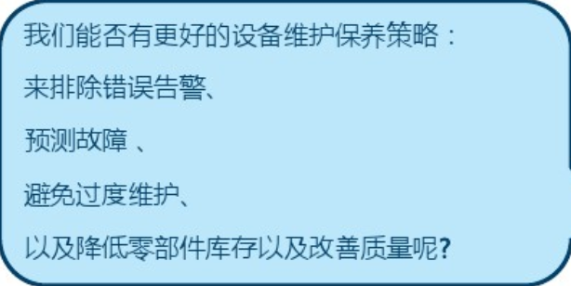 Transfer from investment driven to biz driven

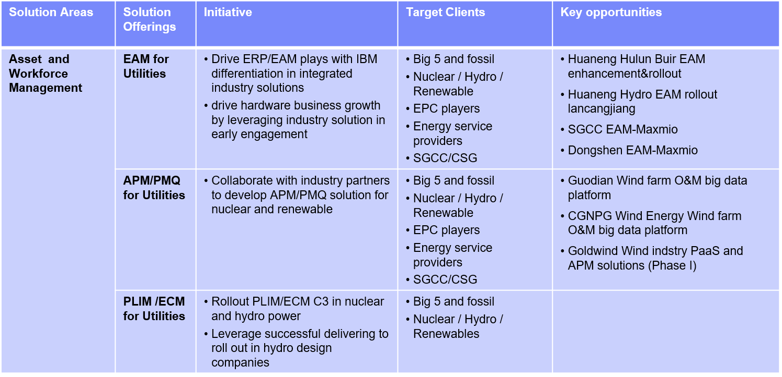

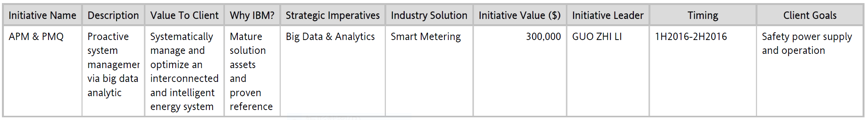

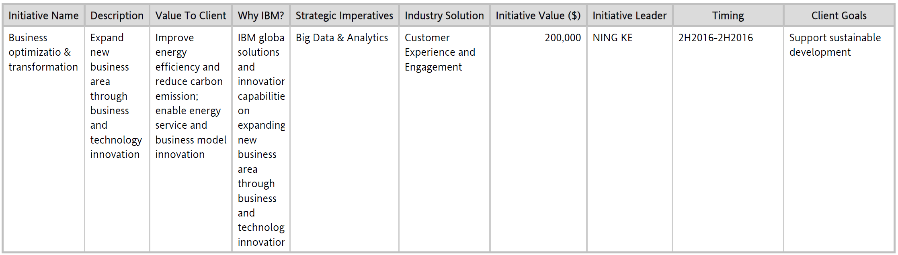

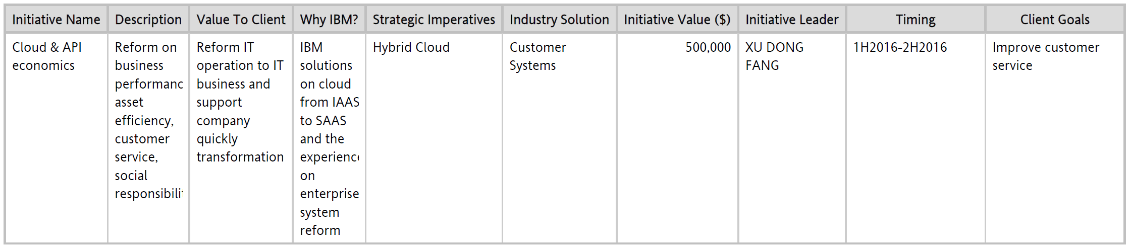

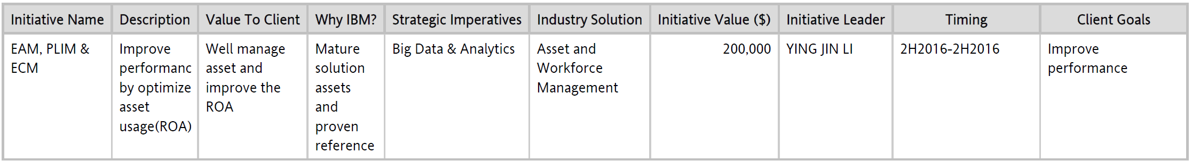

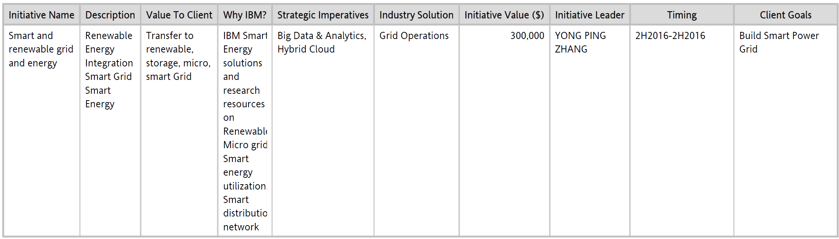

1. The solution and function of the products
2. Application scenario
3. Case Sharing
4. Competition analysis
5. Benefit & Advantage
6. Principle
7. Architecture
8. Supporting platform
9. Development path, environment, schedule…
10. Integration with current system
11. Resources