DROP IT: ON-DEMAND PARCEL DELIVERY SYSTEM
System Information Architecture, Application Sitemap, and Low-Fidelity UI Wireframes
Course & Subject | Web Systems and Technologies 2 (WebDev 2) — Final Project
Student / Developer | Alexander Daniel S. Delos Reyes (Section III – F2)
Project Repository | Drop IT · Built on LavaLust PHP MVC Framework
Architecture Model | Multi-Role Web Application (Public Guest, Customer, Driver, Admin)
Core Integrations | MariaDB/MySQL `dropit`, Leaflet/OSM Coordinate Mapping, PayMongo GCash API, SMTP Auth OTP

1. System Information Architecture & Sitemap
The Drop IT application is structured around a centralized modular routing architecture implemented in LavaLust PHP. The system segregates user interactions across four primary role boundaries: (1) Public Guest Access, (2) Customer Portal, (3) Courier/Driver Dispatch Portal, and (4) System Administrator Operations Console. Each portal enforces strict role-based access control (RBAC) middleware, session token validation, and contextual views.
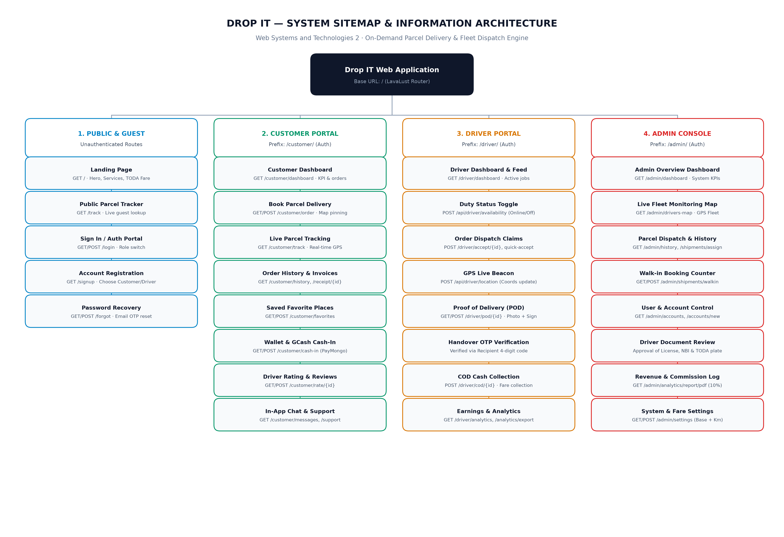
Figure 1.0: Drop IT System Sitemap & Information Architecture Tree
1.1 Comprehensive Module & Route Directory
Portal | Feature Name | HTTP Route | Target View / Handler | Functional Description
Public | Landing & Hero | GET / | app/views/landing.php | Public guest showcase, fare matrix, service benefits
Public | Guest Parcel Tracker | GET /track/{code} | app/views/public_track.php | Real-time timeline & driver status without login
Public | Authentication / Sign In | GET/POST /login | app/views/login.php | Unified login modal with Customer/Driver/Admin tabs
Public | Account Registration | GET /signup | app/views/signup/choose.php | Role selection & multi-step onboarding registration
Public | Password Recovery | GET/POST /forgot | app/views/forgot.php | Email OTP dispatch and password reset routine
Customer | Customer Dashboard | GET /customer/dashboard | app/views/customer/dashboard.php | KPI metrics, active orders, saved favorite places
Customer | Book Parcel Delivery | GET/POST /customer/order | app/views/customer/order.php | Interactive route map pinning, fare calculation, COD/GCash
Customer | Live Shipment Tracking | GET /customer/track | app/views/customer/track.php | GPS driver position beacon, ETA, and progress timeline
Customer | Order History & Invoices | GET /customer/history | app/views/customer/history.php | Past shipment logs, electronic receipts, POD verification
Customer | Saved Places & Contacts | GET/POST /customer/favorites | app/views/customer/favorites.php | Quick-fill pickup and dropoff address bookmarks
Customer | Drop IT GCash Wallet | GET/POST /customer/cash-in | app/views/customer/cash_in.php | In-app balance top-up via PayMongo GCash gateway
Customer | Courier Rating & Feedback | GET/POST /customer/rate/{id} | app/views/customer/rate.php | 5-star service rating and performance review submission
Customer | Live Support & Messaging | GET /customer/messages | app/views/customer/messages.php | Two-way in-app dispatch and driver messaging
Driver | Driver Duty Dashboard | GET /driver/dashboard | app/views/driver/dashboard.php | Available delivery requests feed, earnings KPIs
Driver | Online/Offline Status | POST /api/driver/availability | app/views/api/driver_availability.php | Broadcast driver readiness to dispatch queue
Driver | Claim Delivery Request | POST /driver/accept/{id} | app/views/actions/driver_accept.php | Lock job and assign driver to parcel lifecycle
Driver | GPS Location Beacon | POST /api/driver/location | app/views/api/driver_location.php | Periodically stream coordinates to live tracking map
Driver | Proof of Delivery (POD) | GET/POST /driver/pod/{id} | app/views/driver/pod.php | Mobile camera photo proof, recipient signature, OTP check
Driver | COD Cash Collection | POST /driver/cod/{id} | app/views/actions/pay_cod_collect.php | Record cash collection and driver commission balance
Driver | Earnings & Payout Analytics | GET /driver/analytics | app/views/driver/analytics.php | 90% fare breakdown, trip summaries, daily export
Admin | Admin Operations Console | GET /admin/dashboard | app/views/admin/dashboard.php | Platform analytics, fleet status, 10% revenue share
Admin | Live Fleet Monitoring Map | GET /admin/drivers-map | app/views/admin/drivers_map.php | Real-time geographical map of all online/active drivers
Admin | Parcel Dispatch Records | GET /admin/history | app/views/admin/history.php | Complete order log, re-assignment, and filter tools
Admin | Walk-In Dispatch Counter | GET/POST /admin/shipments/walkin | app/views/admin/walkin.php | Manual counter booking for physical hub senders
Admin | User & Driver Accounts | GET /admin/accounts | app/views/admin/accounts.php | Role permissions, account activation, status control
Admin | Driver Document Review | GET /admin/account_form | app/views/admin/account_form.php | Verification of driver licenses, TODA franchises, NBI
Admin | Financial Reports & Audit | GET /admin/analytics/report/pdf | app/views/admin/report_pdf.php | Export daily GMV, driver payouts, and revenue share
Admin | System & Fare Settings | GET/POST /admin/settings | app/views/admin/settings.php | Configurable base fare (₱30), per-km rate (₱3), API keys

2. Low-Fidelity UI Wireframes & Specifications
The following section presents the low-fidelity wireframe blueprints developed for Drop IT. These wireframes establish the spatial hierarchy, user navigation flows, data input fields, and layout proportions before high-fidelity visual styling. Each screen follows clean, accessible geometric boundaries and standardized UI component patterns matching professional software design specifications. The embedded mockup figures are fully editable vector/raster assets in Word that can be selected, resized, or adjusted.
Screen 01: Public Landing Page & Guest Parcel Tracker
Portal / Access Level | Public (Guest / Unauthenticated)
Primary URL Route | GET / and GET /track/{tracking}
Target Codebase File | app/views/landing.php & app/views/public_track.php
Core Design Pattern | Marketing Hero + Integrated Public Inquiry Component + Value Pillars

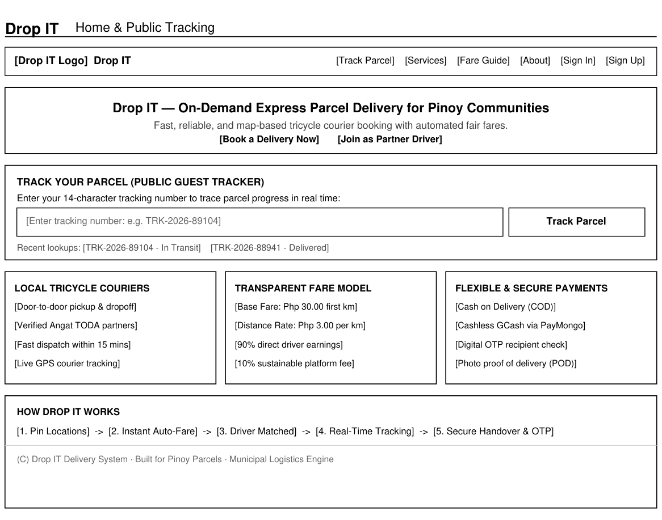
Figure 01.0: Low-Fidelity Wireframe Blueprint — Public Landing Page & Guest Parcel Tracker
Functional & Architectural Overview
The Landing Page serves as the public gateway to Drop IT. It features an integrated guest parcel tracker allowing any customer or recipient to input their 14-digit tracking code without logging in. Below the hero section, three structured feature cards emphasize local tricycle courier availability, the transparent fare formula (₱30 base + ₱3/km), and flexible payment options (COD and GCash cashless). A five-stage horizontal process flowchart outlines the user journey from location pinning to secure OTP handover.
Key UI Components & Layout Specification
• Top navigation bar with logo, public tracking link, services guide, and authentication buttons.
• Prominent centered tracking inquiry card with text input, instant lookup button, and recent search badges.
• Three service highlight cards outlining local dispatch, fair pricing, and multi-mode payment.
• Step-by-step 'How Drop IT Works' sequential workflow banner with call-to-action onboarding buttons.

Screen 02: Unified Sign In & Role Portal Access
Portal / Access Level | Public / All Roles
Primary URL Route | GET/POST /login
Target Codebase File | app/views/login.php & app/views/actions/login_action.php
Core Design Pattern | Centered Modal Authentication Card with Dynamic Role Context

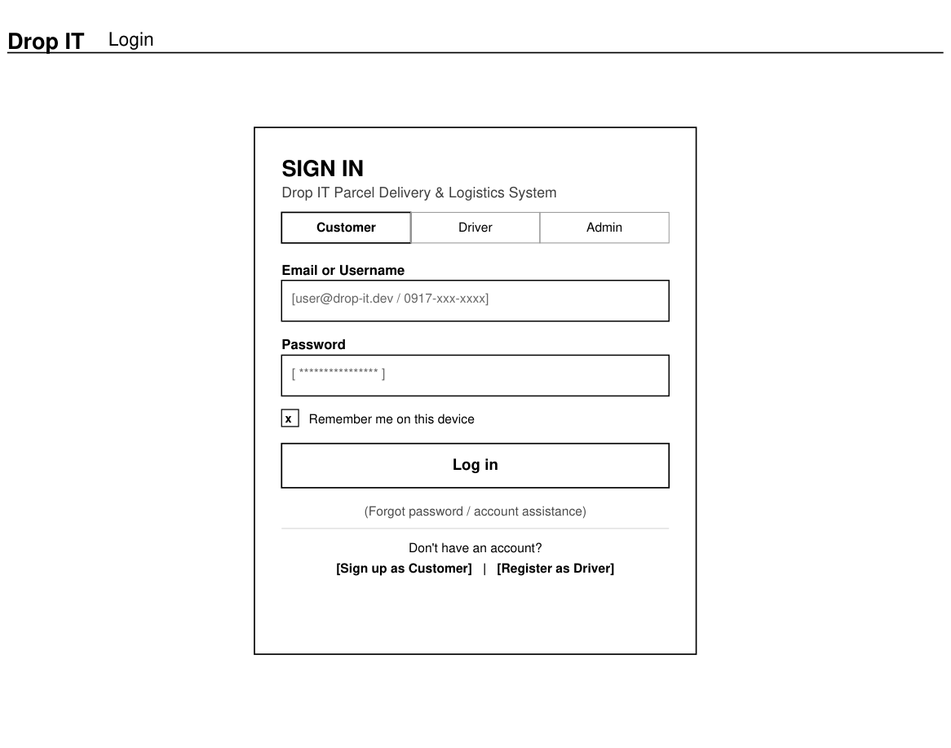
Figure 02.0: Low-Fidelity Wireframe Blueprint — Unified Sign In & Role Portal Access
Functional & Architectural Overview
Following the classic single-card authentication layout, this screen centralizes access for Customers, Drivers, and Administrators. Role selector tabs allow users to indicate their operating context. The form captures credentials, supports persistent device sessions via a 'Remember me' checkbox, and provides direct pathways for password recovery and new user registration.
Key UI Components & Layout Specification
• Centered container card (260pt width) with system header and purpose subtitle.
• Role switcher segment tabs: Customer | Driver | Administrator.
• Input fields for Email / Username and Password with clear placeholder guides.
• Device persistence checkbox and full-width primary submission button.
• Account recovery helper links and split registration links (Customer vs. Partner Driver).

Screen 03: Customer Dashboard & Account Overview
Portal / Access Level | Customer (Authenticated)
Primary URL Route | GET /customer/dashboard
Target Codebase File | app/views/customer/dashboard.php
Core Design Pattern | Sidebar Navigation Layout + Summary Metric Cards + Multi-Panel Feeds

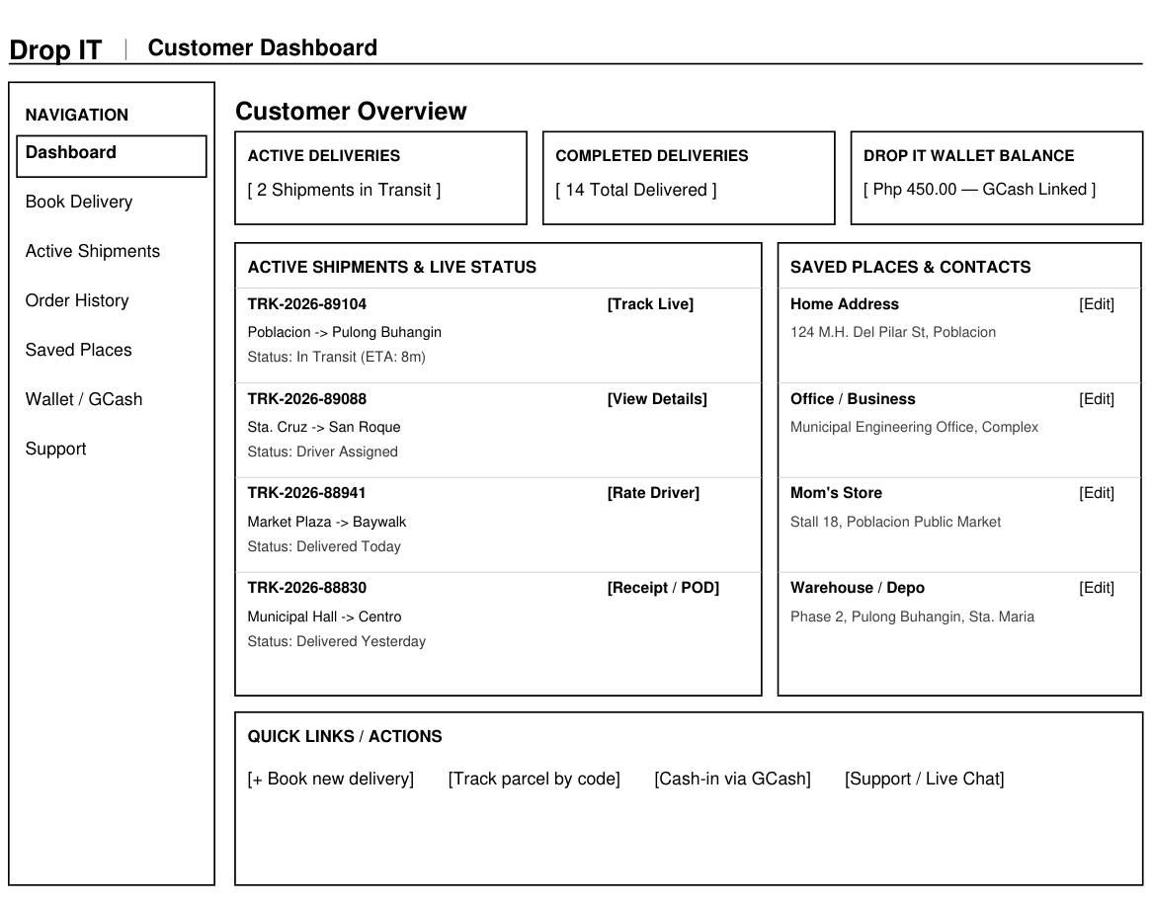
Figure 03.0: Low-Fidelity Wireframe Blueprint — Customer Dashboard & Account Overview
Functional & Architectural Overview
The Customer Dashboard provides an immediate operational overview of ongoing shipments, completed deliveries, and linked wallet balances. The left navigation sidebar clearly outlines the customer's portal features with an active rectangular bounding indicator. The main stage is divided between an active shipment feed and a saved addresses panel for rapid one-click booking.
Key UI Components & Layout Specification
• Left navigation sidebar enclosing menu items with an active outline box on 'Dashboard'.
• Three top KPI metric containers displaying Active Deliveries, Completed Orders, and Drop IT Wallet balance.
• Active Shipments panel detailing tracking number, route endpoints, live status badges, and tracking action links.
• Saved Places & Frequent Contacts card listing stored addresses (Home, Office, Shop) with quick edit options.
• Bottom action bar providing shortcuts for new bookings, tracking lookups, and GCash top-ups.

Screen 04: Customer — Book Delivery & Interactive Route Planner
Portal / Access Level | Customer (Authenticated)
Primary URL Route | GET/POST /customer/order
Target Codebase File | app/views/customer/order.php & app/views/actions/customer_order.php
Core Design Pattern | Split Parameters / Map Canvas Layout + Sticky Fare Breakdown

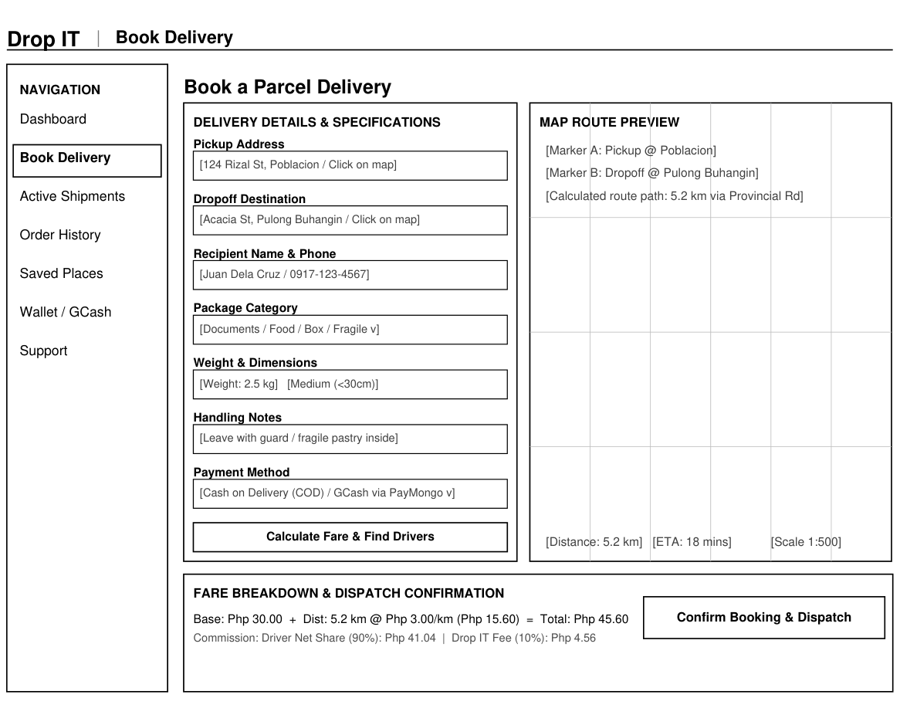
Figure 04.0: Low-Fidelity Wireframe Blueprint — Customer — Book Delivery & Interactive Route Planner
Functional & Architectural Overview
This screen enables customers to specify parcel pickup and dropoff coordinates, package specifications, handling instructions, and payment mode. The right pane provides an interactive Leaflet/coordinate grid map canvas that visualizes pickup marker A, dropoff marker B, and the calculated transit route. The bottom summary calculates the exact fare based on the TODA tricycle model (₱30 base + ₱3.00/km).
Key UI Components & Layout Specification
• Left booking parameter form with inputs for addresses, recipient mobile, parcel category, weight, and notes.
• Interactive Map Canvas with coordinate grid lines, waypoint pins A & B, route polyline, and scale indicators.
• Distance and ETA badges showing real-time road distance and anticipated transit duration.
• Bottom Fare Breakdown panel showing base fare, distance increment, commission split (90/10), and confirmation button.

Screen 05: Customer / Guest — Live Parcel Tracking & Status
Portal / Access Level | Customer & Public Trackers
Primary URL Route | GET /customer/track & GET /track/{tracking}
Target Codebase File | app/views/customer/track.php & app/views/api/parcel_tracking.php
Core Design Pattern | Real-Time Map Tracker + Chronological Stepper Timeline + Contact Cards

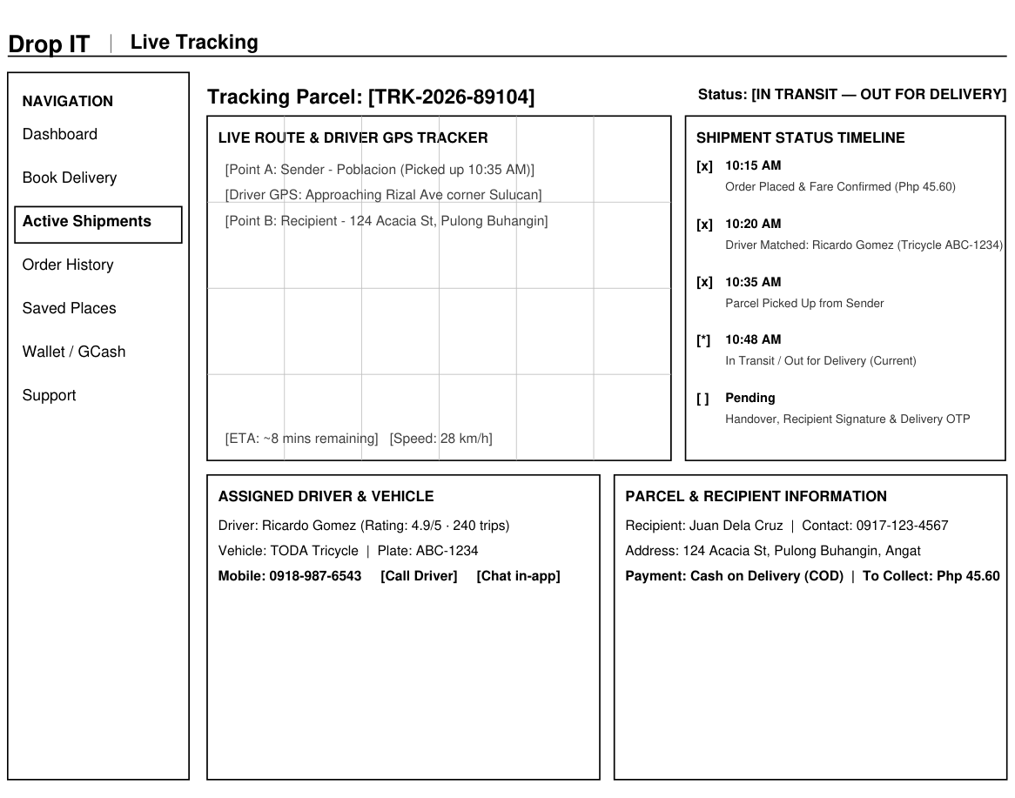
Figure 05.0: Low-Fidelity Wireframe Blueprint — Customer / Guest — Live Parcel Tracking & Status
Functional & Architectural Overview
The Live Tracking screen offers end-to-end visibility into active shipments. A map canvas tracks the moving GPS coordinates of the assigned tricycle courier relative to pickup and destination points. A vertical status timeline indicates milestone timestamps (Order Created, Driver Assigned, Picked Up, In Transit, Delivered). Bottom cards display the driver's profile, tricycle plate, contact options, and parcel payment status.
Key UI Components & Layout Specification
• Prominent tracking identification header with real-time delivery status badge.
• Live Route Map Canvas featuring sender waypoint, moving driver beacon, destination pin, and speed/ETA indicators.
• Vertical Shipment Timeline with checked milestone indicators and exact event timestamps.
• Assigned Driver Information card with rating, plate number, phone number, and in-app call/chat triggers.
• Parcel and Recipient Summary card confirming destination address and payment collection mode.

Screen 06: Driver Portal — Available Orders & Dispatch Feed
Portal / Access Level | Driver / Courier (Authenticated)
Primary URL Route | GET /driver/dashboard
Target Codebase File | app/views/driver/dashboard.php & app/views/actions/driver_accept.php
Core Design Pattern | Duty Status Bar + Earnings Rollup + Order Dispatch Data Table

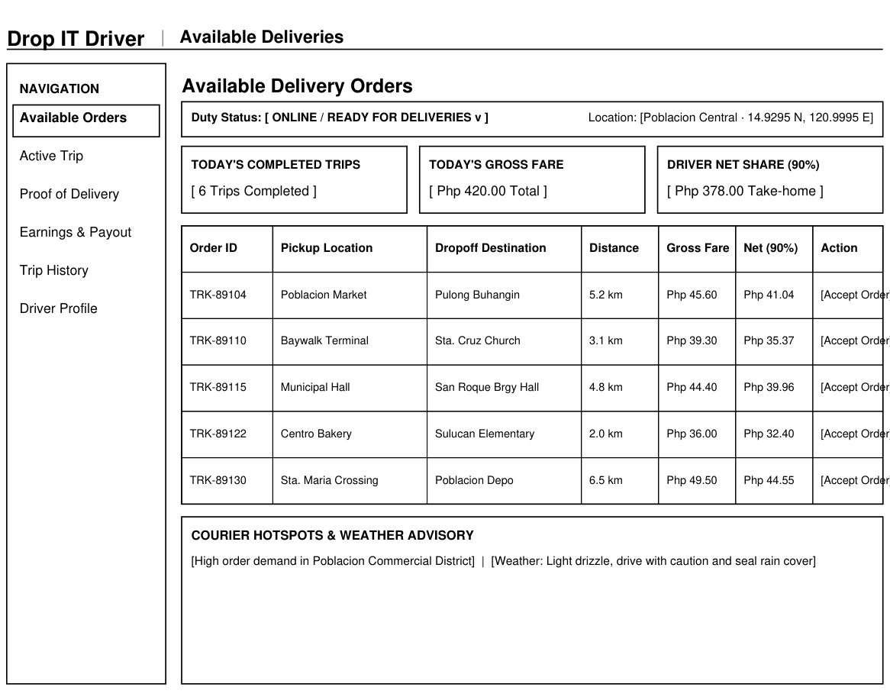
Figure 06.0: Low-Fidelity Wireframe Blueprint — Driver Portal — Available Orders & Dispatch Feed
Functional & Architectural Overview
The Driver Portal centers around rapid job acquisition and earnings transparency. At the top, a duty toggle allows drivers to broadcast availability to the municipal dispatch queue. Metric cards calculate today's trips, gross fares, and the driver's 90% take-home share. The central table lists available nearby parcels with pickup, dropoff, distance, net earnings, and one-click 'Accept Order' triggers.
Key UI Components & Layout Specification
• Top Duty Status Bar with online/offline toggle and current GPS coordinates display.
• Three financial summary cards: Today's Trips, Gross Fares, and Net Driver Take-Home Share (90%).
• Structured Available Orders Table with columns for Order ID, Pickup, Dropoff, Distance, Fare, Net Payout, and Action.
• Courier Hotspot and Safety Advisory card displaying demand surges and local weather warnings.

Screen 07: Driver Portal — Mobile Proof of Delivery (POD)
Portal / Access Level | Driver / Mobile Handover
Primary URL Route | GET/POST /driver/pod/{id}
Target Codebase File | app/views/driver/pod.php & app/views/actions/pod_submit.php
Core Design Pattern | Mobile Viewport Frame + Multi-Factor Verification + Touch Handover

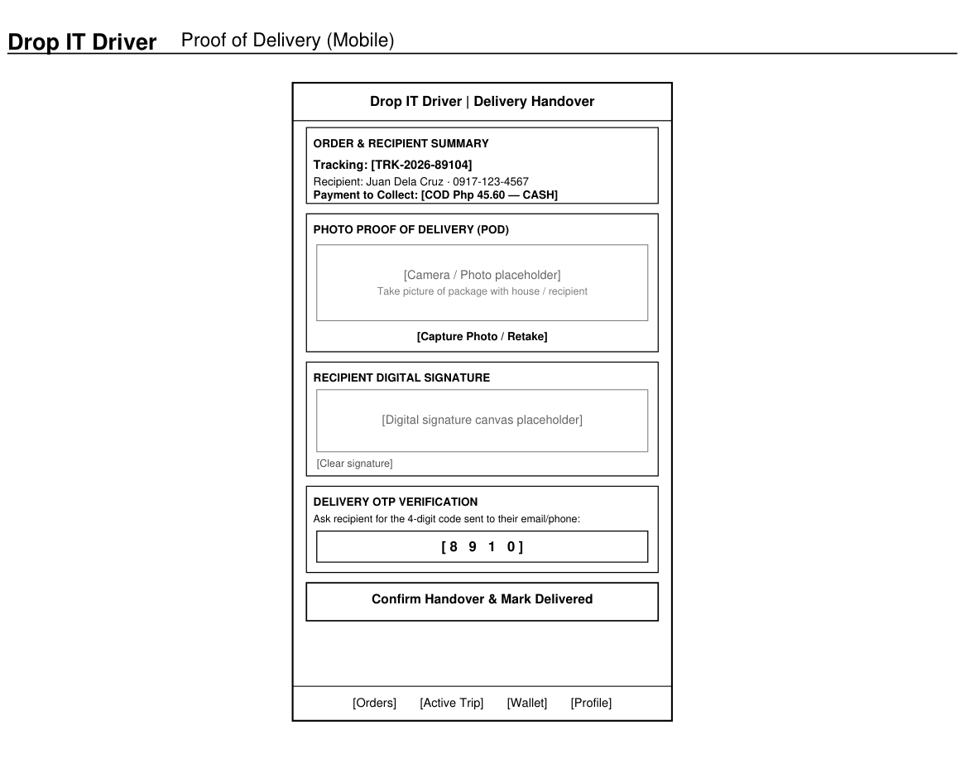
Figure 07.0: Low-Fidelity Wireframe Blueprint — Driver Portal — Mobile Proof of Delivery (POD)
Functional & Architectural Overview
Modeled within a dedicated mobile device frame, this screen represents the critical handover stage of the delivery lifecycle. It prevents delivery fraud through a three-tier verification process: (1) capturing a photo of the parcel at the recipient's doorstep, (2) collecting the recipient's digital signature on a canvas, and (3) verifying the secret 4-digit OTP issued to the recipient's registered device.
Key UI Components & Layout Specification
• Smartphone viewport container with mobile navigation header and bottom tab bar.
• Order and Recipient summary card specifying COD cash collection requirements.
• Camera / Photo capture placeholder for doorstep parcel proof with photo upload triggers.
• Digital Signature canvas container with clear signature reset options.
• Delivery OTP verification input box for entering the customer's 4-digit authentication code.
• High-contrast confirmation button: 'Confirm Handover & Mark Delivered'.

Screen 08: Admin Console — Fleet Overview & Analytics Dashboard
Portal / Access Level | System Administrator (Authenticated)
Primary URL Route | GET /admin/dashboard
Target Codebase File | app/views/admin/dashboard.php & app/views/admin/drivers_map.php
Core Design Pattern | Executive KPI Metrics + Live Fleet Canvas + Dispatch Queue Monitor

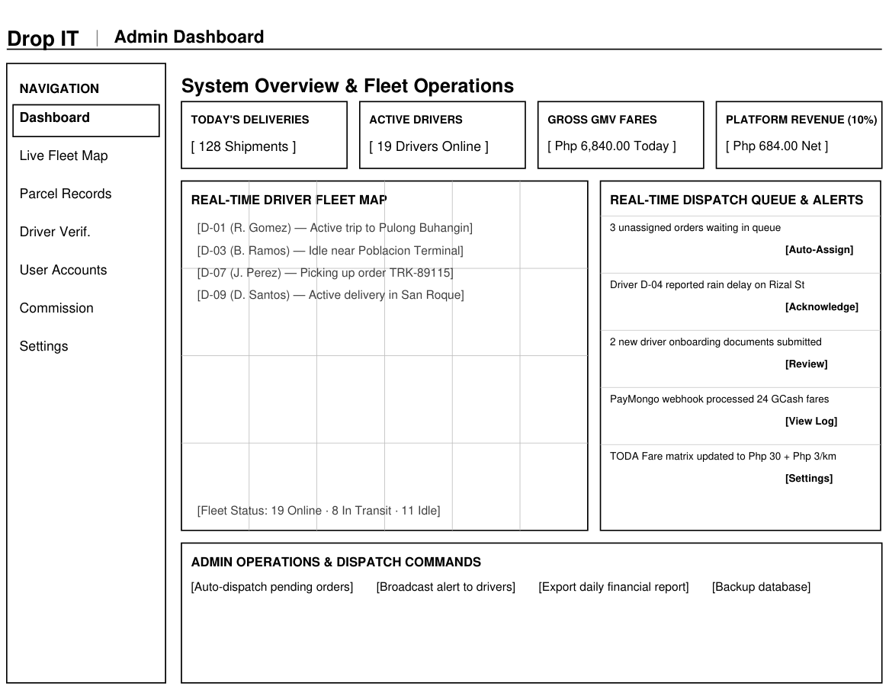
Figure 08.0: Low-Fidelity Wireframe Blueprint — Admin Console — Fleet Overview & Analytics Dashboard
Functional & Architectural Overview
The Admin Dashboard provides high-level administrative governance over municipal fleet operations. Four primary cards monitor daily order volume, active drivers online, total gross merchandise value (GMV), and the platform's 10% commission revenue. The central area is split between a live GPS fleet monitoring canvas and an incident alert feed showing unassigned orders, SOS signals, and driver onboarding documents.
Key UI Components & Layout Specification
• Executive KPI metric cards: Total Deliveries Today, Active Drivers, Gross GMV, and Platform Share (10%).
• Real-Time Driver Fleet Map Canvas displaying geographical positions and active trip statuses of all drivers.
• Real-Time Dispatch Queue and System Alerts panel highlighting unassigned shipments and urgent issues.
• Administrative command bar with triggers for auto-dispatch, fleet broadcast notifications, and financial exports.

Screen 09: Admin Console — Parcel Management & Dispatch Records
Portal / Access Level | System Administrator
Primary URL Route | GET /admin/history & GET /admin/shipments/walkin
Target Codebase File | app/views/admin/history.php & app/views/admin/walkin.php
Core Design Pattern | Enterprise Data Table + Search/Filter Bar + Bulk Dispatch Tools

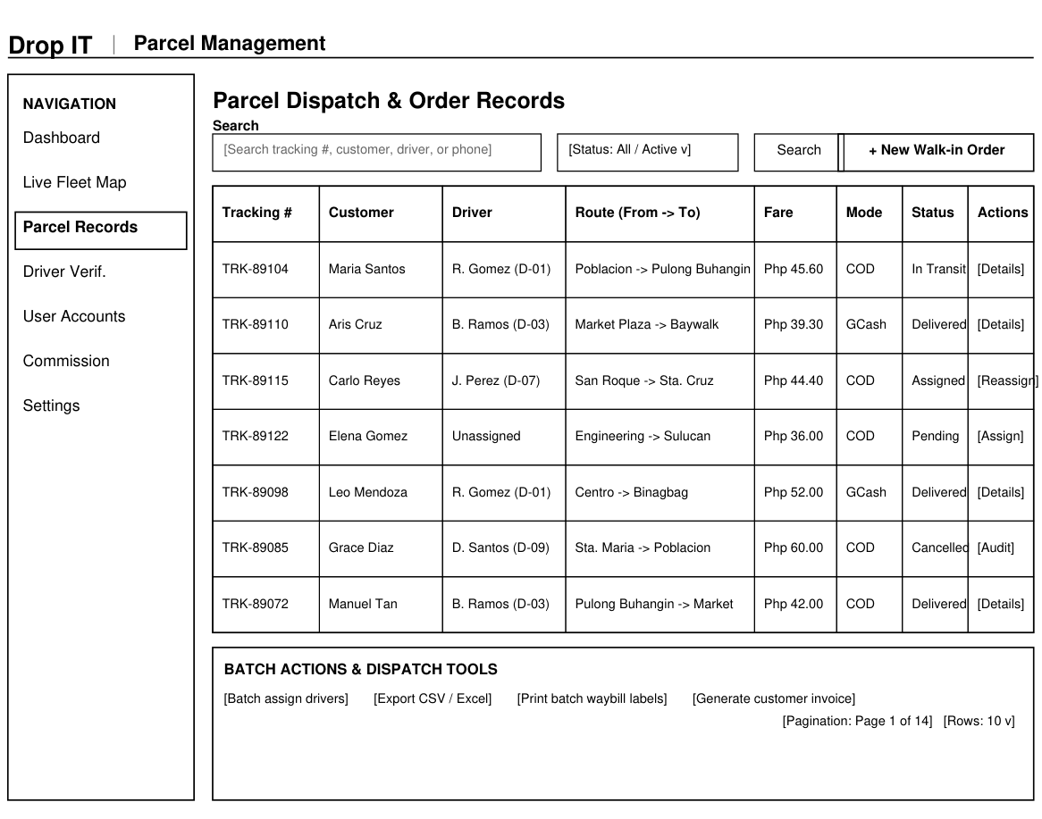
Figure 09.0: Low-Fidelity Wireframe Blueprint — Admin Console — Parcel Management & Dispatch Records
Functional & Architectural Overview
This screen provides administrative oversight of all parcels across all lifecycle stages. Administrators can filter records by tracking number, customer, assigned driver, payment mode, or delivery status. A dedicated button triggers the walk-in counter booking interface for manual parcels, while bulk dispatch tools allow batch driver assignments, CSV exports, and batch printing of waybill labels.
Key UI Components & Layout Specification
• Multi-criteria search bar with keyword search input, status dropdown filter, and payment mode dropdown.
• Action button '+ New Walk-in Order' for counter-based dispatch creation.
• Comprehensive Data Table with columns for Tracking #, Customer, Driver, Route, Fare, Payment, Status, and Actions.
• Bulk Actions and Dispatch panel offering batch assignment, CSV/Excel export, and waybill printing tools.
• Pagination controls indicating active record ranges and customizable rows-per-page selectors.

Screen 10: Admin Console — User & Driver Account Management
Portal / Access Level | System Administrator
Primary URL Route | GET /admin/accounts
Target Codebase File | app/views/admin/accounts.php & app/views/admin/account_form.php
Core Design Pattern | User Directory Table + Role Filtering + Driver Onboarding Controls

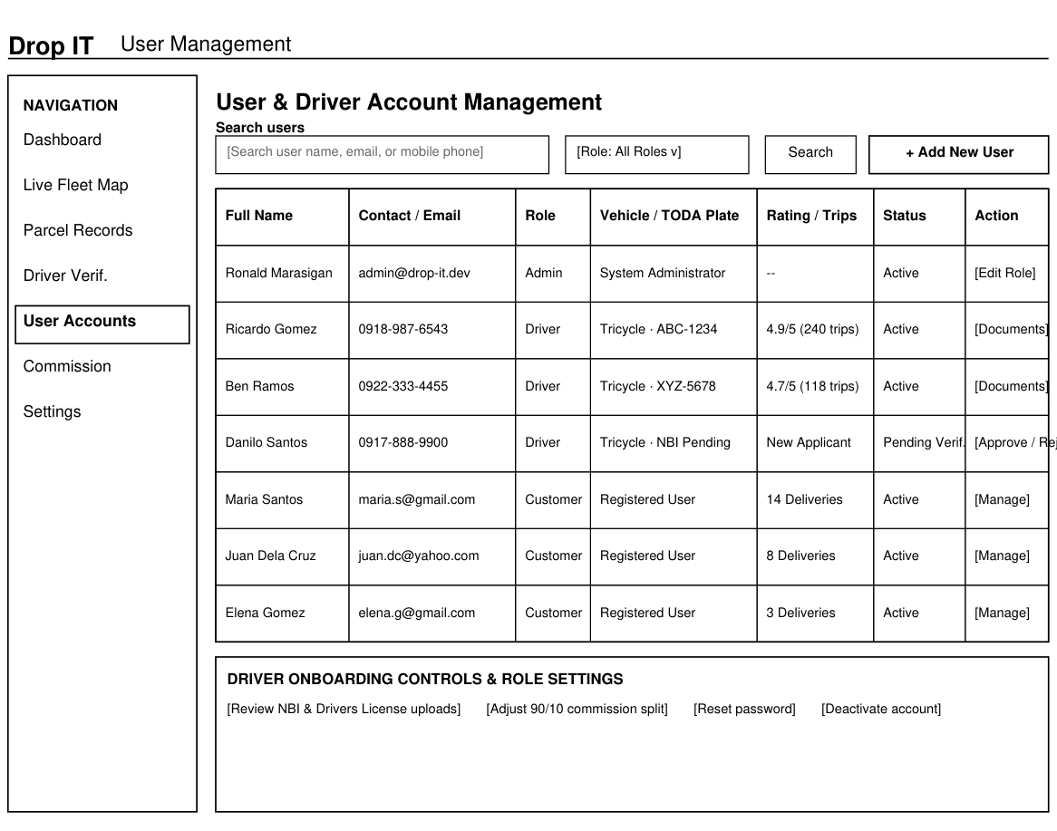
Figure 10.0: Low-Fidelity Wireframe Blueprint — Admin Console — User & Driver Account Management
Functional & Architectural Overview
The User Management screen handles access control, credential verification, and account lifecycle management. Administrators can filter users by role (Customer, Driver, Admin) and account status. For couriers, the table displays vehicle details, TODA plate numbers, customer ratings, and completed trips. The bottom control panel facilitates document verification (NBI clearance, driver's license), commission tuning, and password resets.
Key UI Components & Layout Specification
• User search bar with role selector (All, Customer, Driver, Admin) and status filter.
• Action button '+ Add New User' for creating administrative or staff accounts.
• Directory Table displaying Full Name, Contact/Email, Role, Vehicle/Plate, Rating/Trips, Status, and Action links.
• Driver Onboarding and Role Settings panel for reviewing uploaded legal credentials and managing account status.

