NBA Player Prop Comparison and Prediction Dashboard Project Proposal

Project Title

NBA Player Prop Comparison and Prediction Dashboard

Developer: Sean Alamo

Target Audience: NBA bettors, sports analytics enthusiasts, and users interested in player prop market comparison
Technology Stack: Python, Dash, Pandas, Plotly, Odds API, player statistics API, CSV storage

Introduction / Background
This project proposes the development of an interactive sports betting dashboard focused on NBA player props. The application will allow users to view active prop betting markets from multiple sportsbooks in one place while also adding a statistical prediction layer that estimates expected player outcomes for selected prop categories.
“Player prop betting means wagering on the performance of a single player in a game, such as how many points, rebounds, or assists they will record, rather than betting on which team wins. For example, a sportsbook might post a line of 24.5 points for an NBA player and allow users to bet on whether the player will go over or under that number. Different sportsbooks often post different lines and odds for the same player and statistic, which creates comparison opportunities. This dashboard collects those player prop lines from multiple sportsbooks and compares them to simple, transparent statistical projections built from recent performance and matchup context, giving users a clearer, data-driven reference point when evaluating individual player props.”
Player prop betting is a strong area for analysis because sportsbooks often post different lines for the same player and market, creating opportunities for more effective comparison and better-informed decision-making. A centralized application can reduce the time users spend switching between sportsbook platforms while giving them a clearer view of market differences and relevant player context.
This project expands on the existing betting-dashboard concept by adding a lightweight statistical analysis framework. Rather than only displaying current betting lines, the application will also estimate expected player performance using recent trends, matchup context, and historical statistics so users can compare model projections against posted sportsbook lines.

Problem Statement
Sportsbook player prop lines are not standardized across platforms, making it difficult for users to efficiently compare options and identify the best available value. Bettors may be able to see available wagers, but they often lack a simple, data-driven reference point that helps them evaluate whether a posted line appears high, low, or reasonable based on player performance trends and game context.

This project addresses the need for a centralized NBA player prop application that not only aggregates sportsbook lines but also applies a statistical framework to estimate expected outcomes for selected props. The result will be a more informative tool that supports faster comparison and stronger analytical decision-making.

Objectives (Specific Aims)
  - Extract relevant NBA player prop betting data from sportsbook APIs.
  - Extract supporting player, team, injury, and schedule data from sports statistics APIs.
  - Transform and clean JSON data into structured tables for analysis and visualization.
  - Store processed data in a local database or CSV-based storage layer for repeated querying and historical comparison.
  - Build an interactive Dash application that displays active player prop lines, sportsbook comparisons, and supporting game information.
  - Develop a basic statistical prediction framework for selected player props such as points, rebounds, and assists using recent performance trends and matchup indicators. Due to time constraints this may be reduced to just points
  - Compare predicted player outcomes against sportsbook lines and highlight potential discrepancies for user review.
  - Ensure application data refreshes within a defined time period so the dashboard remains current.

Methodology / Technical Approach
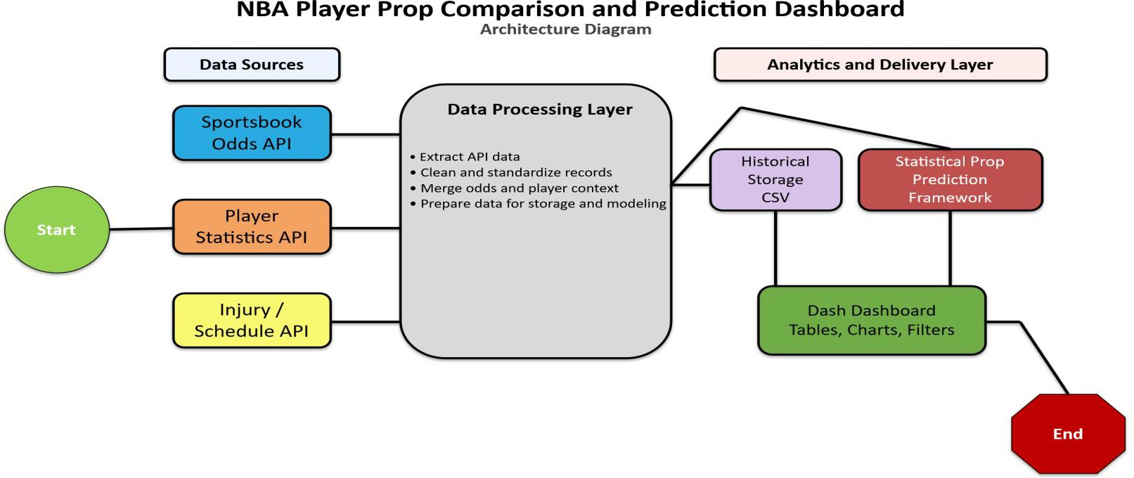

Data Sources and APIs
The application will rely on sportsbook odds APIs to retrieve current NBA player prop lines and pricing data. Additional player, team, injury, and schedule information will be collected through sports statistics APIs so the dashboard can provide broader context for each betting market.

Tools and Technologies
Python will be used for API extraction, data transformation, and statistical calculations. Pandas will support data cleaning and table creation, while Dash and Plotly will be used to build the interactive web application and visual outputs. Processed data will be stored in CSV files depending on the final implementation needs.

Workflow Design
- Extract sportsbook odds, player statistics, injury data, and schedule information from selected APIs.
- Transform JSON responses into structured tables by standardizing player names, team identifiers, prop categories, timestamps, and sportsbook labels.
- Load the cleaned datasets into local storage for querying, comparison, and historical trend tracking.
- Build calculations that generate rolling averages, opponent-based context metrics, and baseline statistical projections for selected player props.
- Present the results in a dashboard that allows users to compare sportsbook lines against model-generated expectations.

Statistical Analysis Framework
To ensure the project remains feasible within five weeks, the predictive layer will focus on a small set of NBA prop markets such as points, rebounds, and assists. The model will use transparent, interpretable methods such as recent-game rolling averages, minutes trends, home-versus-away splits, and simple matchup adjustments instead of a complex machine learning system.
This approach is appropriate for the timeline because it adds meaningful analytical value without making the project overly complex. The dashboard will present projected values as decision-support information rather than as guaranteed outcomes, keeping the scope realistic and academically appropriate.

Visualization Strategy
The dashboard will include sportsbook comparison tables, player trend charts, filters by player and prop category, and summary indicators that show the difference between the model projection and the sportsbook line. These visual components will help users identify where a posted prop may differ from recent statistical expectations.

Timeline

Week | Tasks
Week 1 | Finalize project scope, confirm APIs, design the data model, and build initial scripts for extracting odds and player statistics.
Week 2 | Clean and standardize incoming data, create the storage layer, and validate joins across player, team, odds, and schedule datasets. [file:1]
Week 3 | Build the first version of the Dash dashboard with filters, prop-line tables, and basic player trend visualizations. [file:1][file:2]
Week 4 | Develop and test the statistical prediction framework for selected prop categories and integrate projected values into the dashboard. [file:2]
Week 5 | Refine the interface, test functionality, fix bugs, finalize documentation, and prepare the final presentation and submission. [file:1][file:2]

- Expected Outcomes
The completed project will produce a working pipeline that collects and processes NBA player prop betting data and supporting player statistics. It will also produce a stored dataset for line comparison and a functional Dash dashboard that allows users to review sportsbook offerings in one place.
In addition, the project will deliver a basic statistical projection module for selected player props, allowing users to compare posted sportsbook lines against model-estimated performance values. The final deliverables will include the application, underlying data pipeline, and a presentation or demonstration of findings.

NOTE:

Perplexity AI was used to assist in the creation of this document by brainstorming, revising, and assisting in the the creation of the technical diagram.

