Version Control at Hazen

# GitHub

Packages

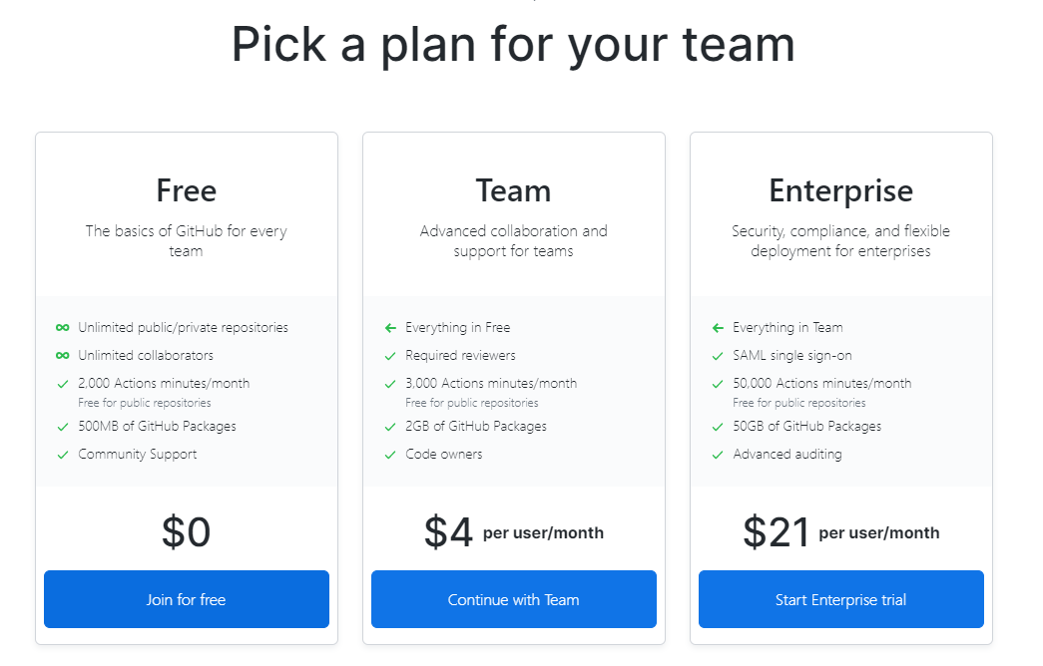

Set Up

* do we need appropriate consent to represent the firm on GitHub?

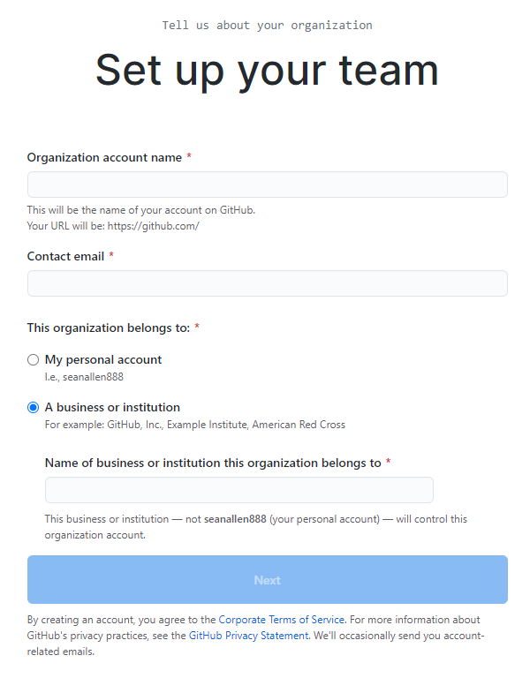

Download Git

* install
* run
  + $ git config --global user.name "First Last"
  + $ git config --global user.email [email@hazenandsawyer.com](mailto:email@hazenandsawyer.com)

ArcGIS Jupyter Notebooks

<https://www.esri.com/en-us/arcgis/products/arcgis-notebooks/get-started>

ArcGIS Notetbook Server

<https://enterprise.arcgis.com/en/notebook/latest/install/linux/introduction-to-arcgis-notebook-server.htm>