# This is a header

This is the paragraph. This is a paragraph.

$$1+1=2$$

## This is a subheader

This is a value derived from R: 99.

Here is a figure crated in R:

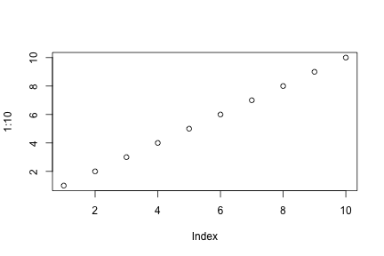

This is the caption.