============================================================
EMOTION SENSE - MODEL COMPARISON
============================================================

Dataset Shape: (227, 2)

Emotion Distribution:
Emotion
आश्चर्य 39
आनंदी 38
दुःखी 38
भीती 38
राग 37
सामान्य 37
Name: count, dtype: int64

Training Records: 181
Testing Records : 46

TF-IDF Feature Extraction Completed
Training Feature Matrix: (181, 294)
Testing Feature Matrix : (46, 294)

============================================================
Logistic Regression
============================================================

Accuracy: 41.3 %

Classification Report:
precision recall f1-score support

आनंदी 0.36 0.50 0.42 8
आश्चर्य 0.67 0.50 0.57 8
दुःखी 0.00 0.00 0.00 8
भीती 0.67 0.75 0.71 8
राग 0.20 0.43 0.27 7
सामान्य 0.67 0.29 0.40 7

accuracy 0.41 46
macro avg 0.43 0.41 0.40 46
weighted avg 0.43 0.41 0.40 46

============================================================
Linear SVM
============================================================

Accuracy: 34.78 %

Classification Report:
precision recall f1-score support

आनंदी 0.36 0.50 0.42 8
आश्चर्य 0.57 0.50 0.53 8
दुःखी 0.00 0.00 0.00 8
भीती 0.57 0.50 0.53 8
राग 0.18 0.43 0.25 7
सामान्य 0.50 0.14 0.22 7

accuracy 0.35 46
macro avg 0.36 0.35 0.33 46
weighted avg 0.36 0.35 0.33 46

============================================================
Naive Bayes
============================================================

Accuracy: 39.13 %

Classification Report:
precision recall f1-score support

आनंदी 0.40 0.50 0.44 8
आश्चर्य 0.32 0.75 0.44 8
दुःखी 0.00 0.00 0.00 8
भीती 0.60 0.75 0.67 8
राग 0.33 0.14 0.20 7
सामान्य 0.50 0.14 0.22 7

accuracy 0.39 46
macro avg 0.36 0.38 0.33 46
weighted avg 0.36 0.39 0.33 46

============================================================
MODEL COMPARISON
============================================================
Logistic Regression : 41.30%
Linear SVM : 34.78%
Naive Bayes : 39.13%

============================================================
BEST MODEL
============================================================
Model: Logistic Regression
Accuracy: 41.3 %

Final model saved as: emotion_model.pkl
TF-IDF vectorizer saved as: tfidf_vectorizer.pkl

============================================================
MODEL COMPARISON COMPLETED

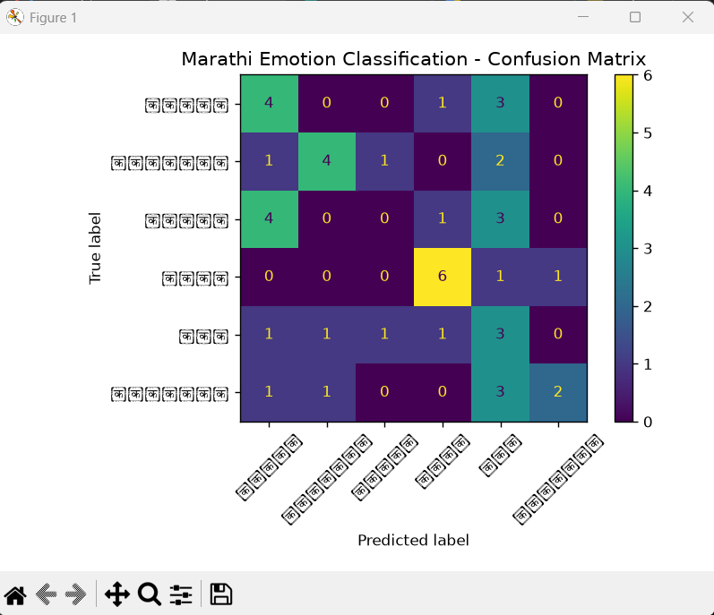

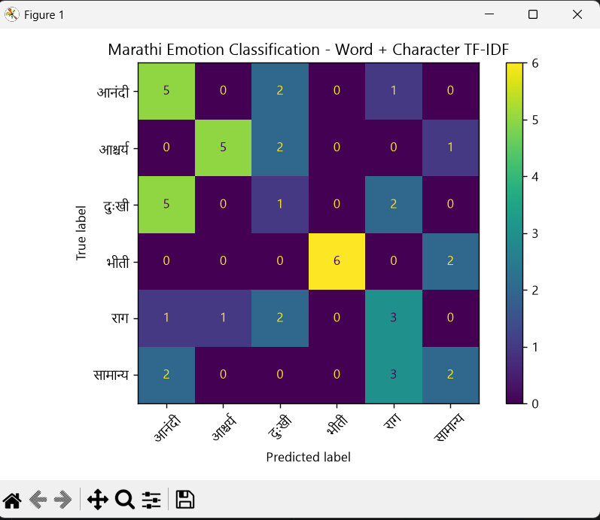

=================================================================
EMOTION SENSE - IMPROVED FEATURE EXTRACTION
=================================================================

Dataset Shape: (227, 2)

Emotion Distribution:
Emotion
आश्चर्य 39
आनंदी 38
दुःखी 38
भीती 38
राग 37
सामान्य 37
Name: count, dtype: int64

Training Records: 181
Testing Records : 46

=================================================================
FEATURE EXTRACTION
=================================================================

Word + Character TF-IDF completed
Training Feature Matrix: (181, 4834)
Testing Feature Matrix : (46, 4834)

Logistic Regression Training Completed

Training Accuracy: 98.9 %

=================================================================
MODEL EVALUATION
=================================================================

Accuracy: 47.83 %

Classification Report:
precision recall f1-score support

आनंदी 0.38 0.62 0.48 8
आश्चर्य 0.83 0.62 0.71 8
दुःखी 0.14 0.12 0.13 8
भीती 1.00 0.75 0.86 8
राग 0.33 0.43 0.38 7
सामान्य 0.40 0.29 0.33 7

accuracy 0.48 46
macro avg 0.52 0.47 0.48 46
weighted avg 0.52 0.48 0.49 46

=================================================================
CONFUSION MATRIX
=================================================================

Labels:
['आनंदी', 'आश्चर्य', 'दुःखी', 'भीती', 'राग', 'सामान्य']

Matrix:
[[5 0 2 0 1 0]
[0 5 2 0 0 1]
[5 0 1 0 2 0]
[0 0 0 6 0 2]
[1 1 2 0 3 0]
[2 0 0 0 3 2]]

=================================================================
FILES SAVED
=================================================================

Model:
emotion_model.pkl

Feature Extractor:
tfidf_vectorizer.pkl

Confusion Matrix:
confusion_matrix_improved.png

=================================================================
IMPROVED MODEL TRAINING COMPLETED
=================================================================

