Team Raspberry Pi

Sean Bennett

Kristopher Walker

We successfully built and deployed a smaller version of the sensor suite we planned with just temperature functionality. Flow rate was initially part of the spec as well, but due to hardware limitations of the Raspberry Pi chosen to control the sensors was dropped. A second version will be implemented shortly with data acquisition offloaded to an Arduino board, which will obviate any process limitations inherent to the Raspberry Pi. The data we currently have is visualized below via line graph, with individual lines representing the four different tanks.

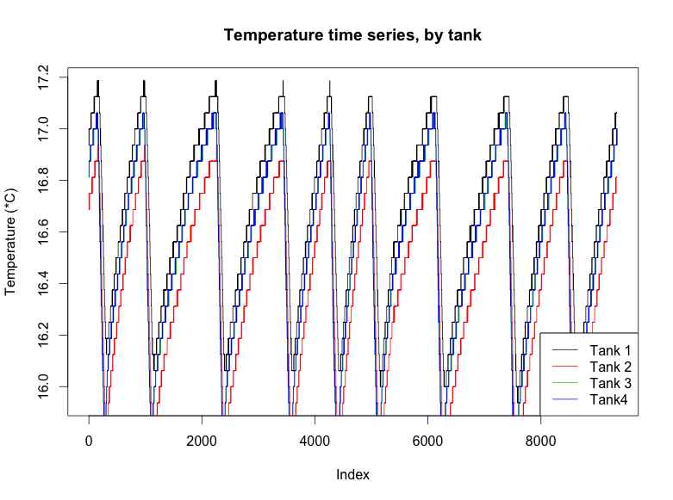

Figure : Temperature observed in the four aquaria at 16-second intervals over 2 days.

The above graph shows an interesting trend, with aquaria 1 and 2 showing a roughly ½ degree difference throughout the duration of data collection. While one would initially write this off as probe-based bias, the probes were corrected for bias before deployment by the addition of correction factors per probe, determined by the placement of the probes in a temperature controlled incubator for two days and differences quantified after that time period. The two tanks are next to each other in the larger sump in which they reside, so there may be some environmental factor that we do not currently understand which may be leading to the temperature differential.

We are currently working towards some form of time series analysis appropriate for this style of data. The ARMA model we were initially looking at may be inappropriate due to the high levels of autocorrelation within the data after a lagged difference is applied in effort to create a stationary process, more reading of appropriate analysis types will be required here. An Arduino board has been ordered and should be here early next week, so if it is possible to implement water sensors in the time we have left, that will be done and we will have a second set of data to look at.