Group 53

Mandi Wilby / Sean Bilissis / Lucas Austin / Luke Newman

CISC/CMPE 204: Knights & Knaves

Modelling Report

**

# Project Summary

This puzzle takes place on an island inhabited by two groups of people: Knights, who always tell the truth, and Knaves, who always tell lies. The object of the game is to determine who the Knaves and Knights are by analyzing the statements they make about the other inhabitants.

A model will determine whether each person is truthful (Knight) or a liar/is untruthful (Knave).

# Propositions

The original proposal for this project had many more categories of variables, however, it was suggested that we could simplify the problem to only use the following category and many of the original proposal’s variables could be absorbed into the constraints of a given “version” of the problem.

ti: This is true when person i is truthful (Knight).

|  |  |
| --- | --- |
| **Variables** | **Assigned Name** |
| t1 | Olivia |
| t2 | Ulric |
| t3 | Alice |
| t4 | Yates |
| t5 | Bob |
| t6 | Zara |
| t7 | Sam |
| t8 | Jeff |
| t9 | Quentin |
| t10 | Valerie |
| t11 | Roslina |
| t12 | Wallace |
| t13 | Nate |
| t14 | Harry |
| t15 | Karen |
| t16 | Eva |
| t17 | Gale |
| t18 | Chloe |
| t19 | Larry |
| t20 | Farrel |
| t21 | Michelle |
| t22 | Perry |

Table - This tables assigns a variable to a name for future use.

|  |  |
| --- | --- |
| **Proposition** | **Translation** |
| Olivia says “Ulric and Alice lie” | (t1 → (¬t2 ∧ ¬t3)) ∧ ((¬t2 ∧ ¬t3) → t1) |
| Yates says “Yates lies, and also Bob is truthful” | (t4 → (¬t4 ∧ t5)) ∧ ((¬t4 ∧ t5) → t4) |
| Olivia says “Zara is truthful” | (t1 → (t6)) ∧ ((t6) → t1) |
| Sam says “At least one of Jeff or Quentin lies” | (t7 → (¬t8 ∨ ¬t9)) ∧ ((¬t8 ∨ ¬t9) →t7) |
| Valerie says “Roslina lies” | (t10 → (¬t11)) ∧ ((¬t11) → t10) |
| Wallace says “Either Sam lies, or Olivia is truthful” | (t12 → (¬t7 ∨ t1) ∧ ¬(¬t7 ∧ t1)) ∧ ((¬t7 ∨ t1) ∧ ¬(¬t7 ∧ t1) → t12) |
| Nate says “At least one of Harry or Karen is truthful” | (t13 → (t14 ∨ t ∧15)) ∧ ((t14 ∨ t ∧15 → t13) |
| Eva says “Sam lies” | (t16 → (¬t7)) ∧ ((¬t7) → t16) |
| Sam says “Nate is truthful” | (t7 → (t13)) ∧ ((t13) → t7) |
| Valerie says “Gale would say ‘Eva lies, and also Yates is truthful’” | (t10 → (t17 → (¬t16 ∧ t4))) ∧ ((t17 → (¬t16 ∧ t4)) → t10) |
| Quentin says “At least one of Chloe or Larry lies” | (t9 → (¬t18 ∨ ¬t19)) ∧ ((¬t18 ∨ ¬t19) → t9) |
| Farrel says “Harry and Michelle are truthful” | (t20 → (t14 ∧ t21)) ∧ ((t14 ∧ t21) → t20) |
| Bob says “At least one of Valerie or Perry is truthful” | (t5 → (t10 ∨ t22)) ∧ ((t10 ∨ t22) → t5) |
| Roslina says “Karen would say ‘Either Quentin lies, or Harry is truthful’” | (t11 → (t15 → (¬t9 ∨ t14))) ∧ |
| Wallace says “Valerie is truthful” | (t12 → (t10)) ∧ ((t10) → t12) |
| Valerie says “Either Michelle lies, or Yates is truthful” | (t10 → (¬t21 ∧ t4)) ∧ ((¬t21 ∧ t4) → t10) |
| Larry says “Perry is truthful” | (t19 → (t22)) ∧ ((t22) → t19) |
| Chloe says “Nate and Bob lie, and also Sam is truthful” | (t18 → (¬t13 ∧ ¬t5) ∧ t7) ∧ ((¬t13 ∧ ¬t5) ∧ t7) → t18 |
| Alice says “Michelle lies, and also Eva and Perry are truthful” | (t3 → (¬t21 ∧ (t16 ∧ t22))) ∧ ((¬t21 ∧ (t16 ∧ t22)) → t3) |

Table - This table shows the propositions and their corresponding logic translation.

# Jape Proofs

**Jape Proof 1**

A Knave can claim that a Knight tells the truth, a true claim, as long as it is conjoined with a false statement

A says “B lies”

B says “A and B tell the truth”

Solution: A tells the truth, B lies

(Picture in proofs.jp)

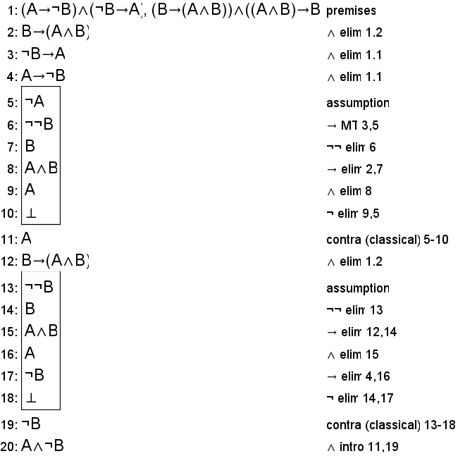

**Jape Proof 2**

A Knave can claim another Knave is truthful

A says "A would say 'B lies'"

B says "A is truthful"

Solution: A and B lie

(Picture in proofs.jp)

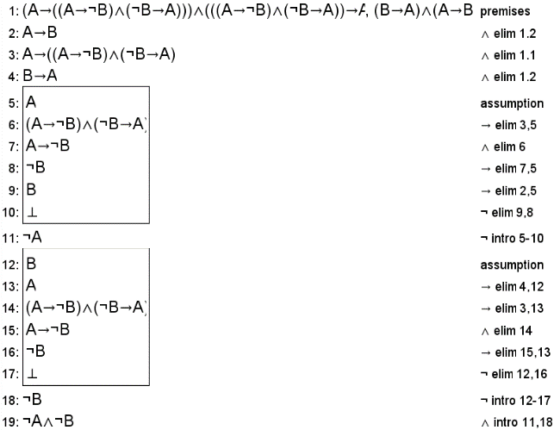

**Jape Proof 3**

A says “One of us lies and the other tells the truth”

B says “A tells the truth”

Solution: A and B lie

(Picture in proofs.jp)

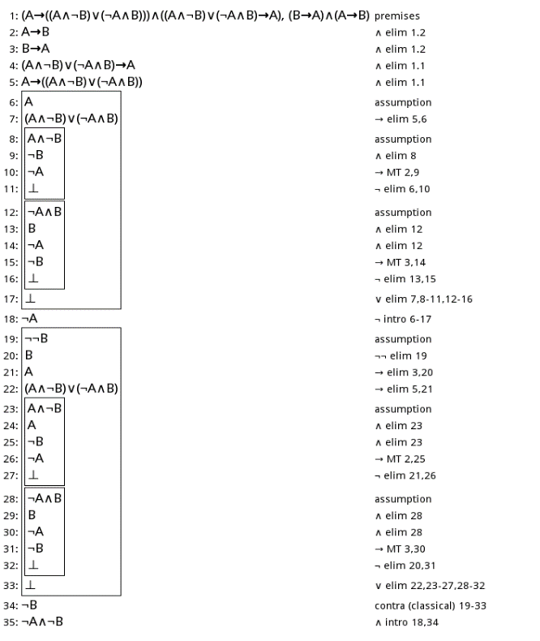

# Constraints

Knights and Knaves will make statements about whether other inhabitants are truthful or not. Using our proposition ti we can view person i's statement as a bi-directional implication (if and only if statement). If person i is truthful (ti), that implies that their statement about the other inhabitants must be true.  Conversely, if they are not truthful (¬ti), then it can be determined that their statement is false. For the general case, we can say person I makes statement p, and thus if person i is telling the truth (a Knight), we have:

(ti → p) ∧ (p → ti)

Where p is a statement about the other inhabitant,

ex.        tj∧ ¬tk : person j is truthful and person k is lying

¬tj ∨ ¬tk : at least one of person j and person k is lying

( tj ∧ ¬tk ) ∨ ( ¬tj ∧ tk ) : either person j or person k is lying

( tj → p ) ∧ (p → tj ) : person j would say p

The people can make statements in several different forms, which follow the structure of logical arguments (AND, OR, NOT, IF AND ONLY IF, etc...).

# Model Exploration

In our first model exploration, we initially tried changing one of our statements to the opposite. It was a simple statement made by one person about one person, going from “Larry says ‘Perry is truthful’” to “Larry says ‘Perry lies’”. This only had the effect of changing whether Larry was a Knight or a Knave, interestingly, since the only other statement about Larry was made by Quentin, who must be a Knight, saying "At least one of Chloe or Larry lies". Chloe must always be a Knave in this situation; therefore, Larry can be either a Knight or a Knave without affecting any of the other people or affecting the solvability of the model.

The model originally had two possible solutions. Our second exploration was to find a way to reduce that number to only one solution. After seeing the likelihoods of all the different people being truthful, we made a new statement regarding two of them, Olivia and Ulric, who each had a 50% chance of being truthful. After studying the original results, we realized that no matter what Olivia is, Ulric will always be the opposite. We decided to let Quentin, who tells the truth in both original solutions, say “Olivia is truthful, and also Ulric lies”. We only really needed one of Olivia and Ulric to be assigned as a truth teller or liar, but both worked well so long as neither were the same. Making them the same would result in a non-satisfiable model. With this new statement, the number of possible solutions for our puzzle dropped to one.

The last model exploration is where we tried removing different constraints to see if the final solution (found by using the second exploration) would change. As expected, most statements, when removed, changed the number of possible solutions along with the assignment of knights and knaves. The statement that increased the number of solutions the most was statement 2, resulting in 11 possible solutions. Furthermore, there were five statements that could be individually removed without affecting the final solution at all. We extended this finding to determine the lowest number of statements needed to arrive at the solution. Ultimately, we were able to successfully remove four statements simultaneously without affecting the final solution. From this, we can conclude that only 15 of the 19 statements were required to obtain the same solution.

# First-Order Extension

For a basic first order extension, we could use predicates that define if a person is a Knight or Knave, as well as predicates that specify whether certain types of statements are being made.

If:

-T(x): person x is a Knight

-L(x): person x is a Knave

And:

* 1. ∀x∀y((C(x,y) ∧ T(x)) → L(y)): A Knight x claiming person y lies means person y must be a Knave.
  2. ∀x∀y((C(x,y) ∧ L(x)) → T(y)): A Knave x claiming person y lies means person y must be a Knight.
  3. ∀x(T(x)→¬L(x)): A Knight x cannot also be a Knave.
  4. ∀x(L(x)→¬T(x)): A Knave x cannot also be a Knight.

As an example, we could illustrate the rule that no inhabitant, Knight or Knave, can claim that they are lying using:

C(x,y): person x is claiming person y lies

We could then say:

∀x(¬ C(x,x)): This states that for all possible people x, it cannot be true that person x is claiming they themselves are lying. You could then theoretically use statements 1) through 4) to prove ∀x(¬ C(x,x)).