Sean Blanchard

3/3/2021

COMP429

L05: IP Addresses and Routing

Task 1: Enumeration

1. What is your computers IP address?

**192.168.0.23**

1. What is your address on the global Internet?

**107.185.56.212**

Task 2: DNS is Hierarchical

* Use nslookup [host] [dns server] on Windows
* Use nslookup -type=any [host] [dns server] on macOS
* Use you can figure it out yourself on *nix.

1. Draw a diagram of a DNS request to resolve google.com.
   * It should look like the diagram in Figure 2.19 from the textbook.
   * Query a.root-servers.net as the root DNS server.
   * The a.root-servers.net response will contain a list of TLD DNS servers (Top Level Domain), pick one of them and query that server.
   * The TLD DNS server will return a DNS server related to google at this point. Pick one and query that server.
   * Google's DNS server will return an IP address similar to the result from nslookup google.com.
   * Use the information from the queries above to fill in your diagram with real data.

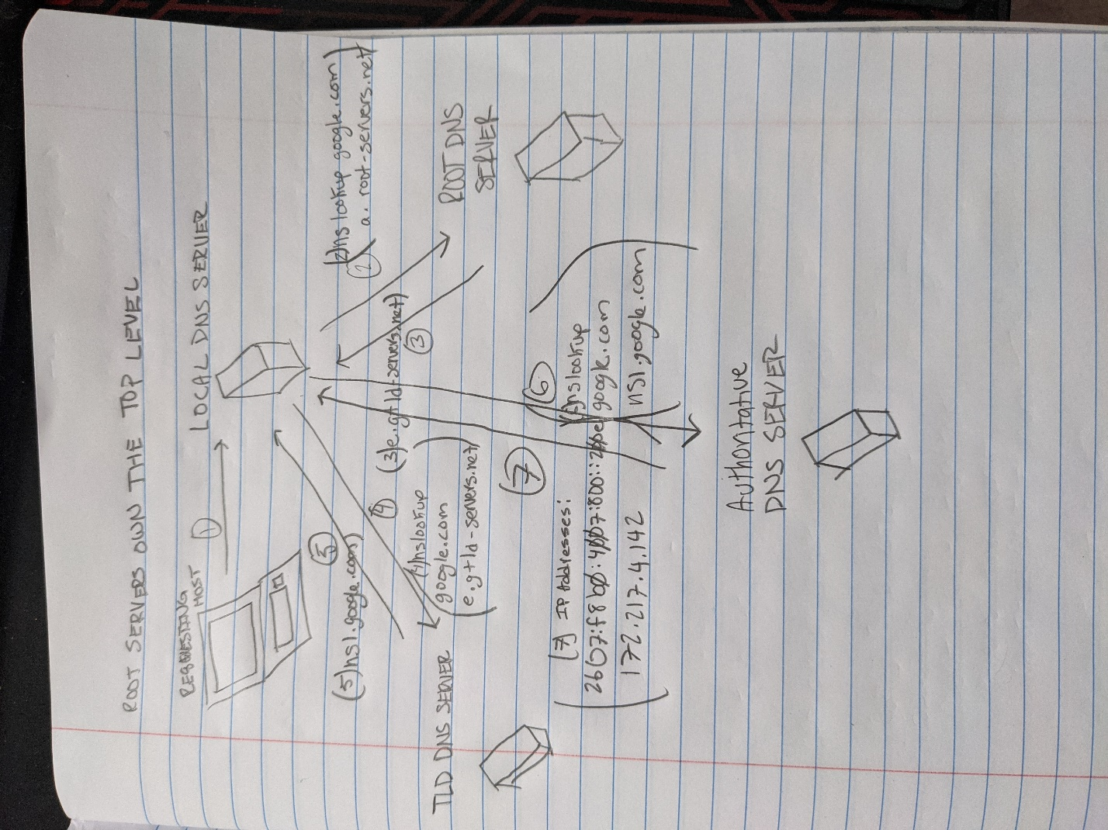

1. What is the TLD (Top Level Domain) DNS server for csuci.edu?

**l.edu-servers.net**

**Internet Address = 192.41.162.30**

**Has AAAA address 2001:500:d937::30**

Task 3: NATty Lite

* You need Wireshark for this question.
* Using www.ipchicken.com draw a diagram like Figure 4.25 in the textbook. 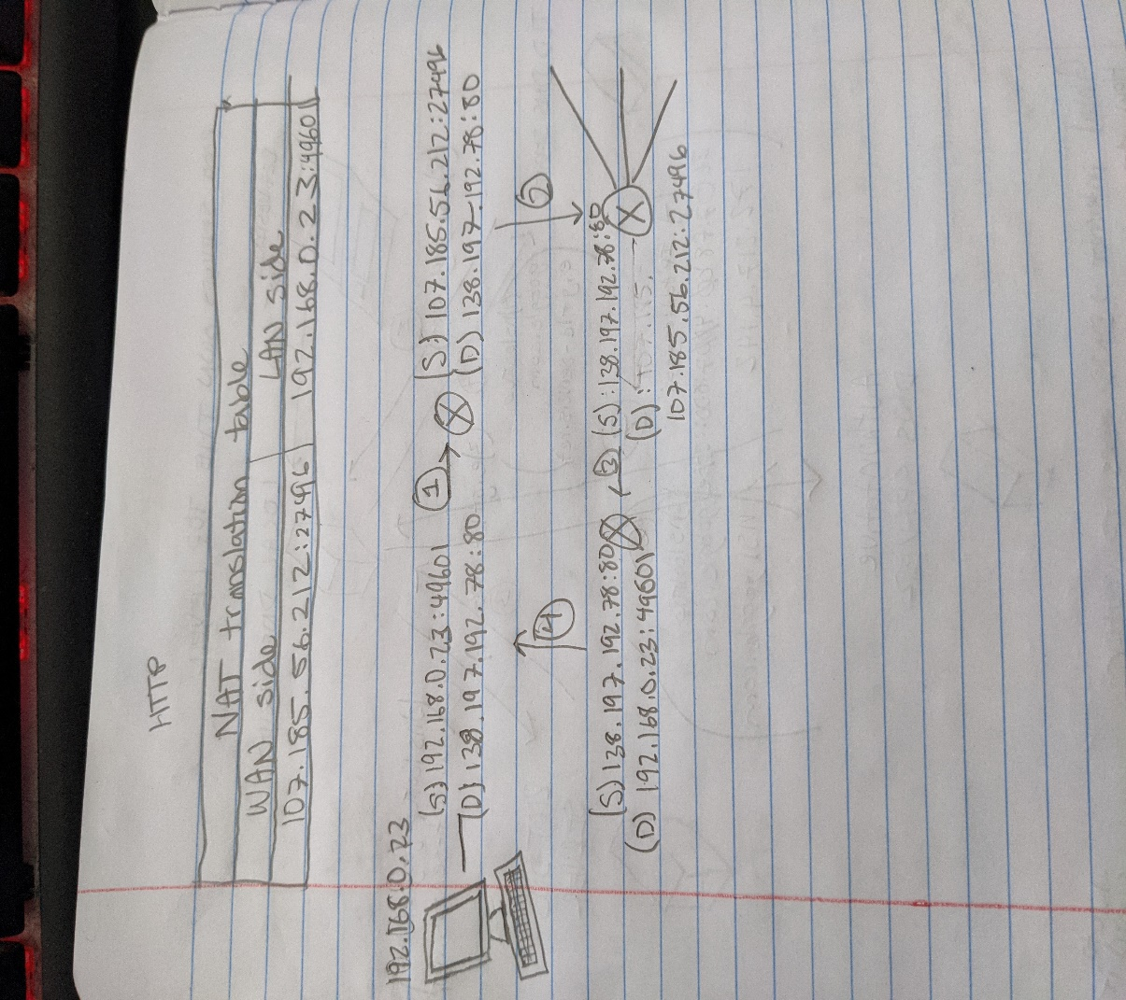

Task 4: Linux Networking

1. Remote into your Linux Virtual Machine (IT, use 421 VM):
   * ssh -p 2222 student@localhost
   * Using ss on the Linux VM, list the unique socket tuples for all connections.
     + Submit the ss command and the socket tuples.
   * Using netstat on your host OS (windows or macOS), find the sockets associated with port 2222:
     + macOS: netstat -nf inet -p tcp | egrep 2222
     + Windows: netstat -na | Select-String "2222"
     + Submit the unique socket tuples.
   * VirtualBox is actually NAT'ing the traffic into your VM's network interface.
     + Draw a diagram like Figure 4.25 in the textbook with information.

$ ss

Netid State Recv-Q Send-Q Local Address:Port Peer Address:Port

u_str ESTAB 0 0 /var/run/dbus/system_bus_socket 13402 * 12744

u_str ESTAB 0 0 * 548140 * 548141

u_str ESTAB 0 0 * 12806 * 12807

u_str ESTAB 0 0 * 12350 * 12351

u_str ESTAB 0 0 * 548141 * 548140

u_str ESTAB 0 0 * 13056 * 13057

u_str ESTAB 0 0 * 10994 * 11226

u_str ESTAB 0 0 /var/run/dbus/system_bus_socket 13403 * 12745

u_str ESTAB 0 0 * 13221 * 13222

u_str ESTAB 0 0 * 12745 * 13403

u_str ESTAB 0 0 * 12744 * 13402

u_str ESTAB 0 0 * 12869 * 12870

u_str ESTAB 0 0 * 447408 * 447409

u_str ESTAB 0 0 * 447412 * 447413

u_str ESTAB 0 0 * 447406 * 447407

u_str ESTAB 0 0 * 447413 * 447412

u_str ESTAB 0 0 * 538098 * 538097

u_str ESTAB 0 0 * 447410 * 447411

u_str ESTAB 0 0 * 447407 * 447406

u_str ESTAB 0 0 * 447409 * 447408

u_str ESTAB 0 0 /run/systemd/journal/stdout 11226 * 10994

u_str ESTAB 0 0 * 538097 * 538098

u_str ESTAB 0 0 * 447411 * 447410

u_str ESTAB 0 0 * 468653 * 468654

u_str ESTAB 0 0 * 468658 * 468657

u_str ESTAB 0 0 /run/systemd/journal/stdout 12351 * 12350

u_str ESTAB 0 0 * 468656 * 468655

u_str ESTAB 0 0 * 468654 * 468653

u_str ESTAB 0 0 * 468659 * 468660

u_str ESTAB 0 0 * 468655 * 468656

u_str ESTAB 0 0 /run/systemd/journal/stdout 12807 * 12806

u_str ESTAB 0 0 * 468660 * 468659

u_str ESTAB 0 0 * 468657 * 468658

u_str ESTAB 0 0 * 538087 * 538088

u_str ESTAB 0 0 /run/systemd/journal/stdout 13894 * 13893

u_str ESTAB 0 0 * 538085 * 538086

u_str ESTAB 0 0 * 448246 * 448245

u_str ESTAB 0 0 /run/systemd/journal/stdout 13057 * 13056

u_str ESTAB 0 0 * 538084 * 538083

u_str ESTAB 0 0 * 448243 * 448244

u_str ESTAB 0 0 * 538083 * 538084

u_str ESTAB 0 0 * 448245 * 448246

u_str ESTAB 0 0 * 13401 * 13400

u_str ESTAB 0 0 * 547217 * 0

u_str ESTAB 0 0 * 538082 * 538081

u_str ESTAB 0 0 * 447423 * 447422

u_str ESTAB 0 0 * 538086 * 538085

u_str ESTAB 0 0 * 448244 * 448243

u_str ESTAB 0 0 * 538088 * 538087

u_str ESTAB 0 0 * 448247 * 448248

u_str ESTAB 0 0 * 538081 * 538082

u_str ESTAB 0 0 * 447422 * 447423

u_str ESTAB 0 0 * 13400 * 13401

u_str ESTAB 0 0 * 13893 * 13894

u_str ESTAB 0 0 /var/run/dbus/system_bus_socket 15181 * 15180

u_str ESTAB 0 0 * 13449 * 13450

u_str ESTAB 0 0 * 13427 * 13428

u_str ESTAB 0 0 * 15143 * 15144

u_str ESTAB 0 0 /run/systemd/journal/stdout 12870 * 12869

u_str ESTAB 0 0 /run/systemd/journal/stdout 13222 * 13221

u_str ESTAB 0 0 /var/run/dbus/system_bus_socket 13428 * 13427

u_str ESTAB 0 0 /var/run/dbus/system_bus_socket 13450 * 13449

u_str ESTAB 0 0 * 15180 * 15181

u_str ESTAB 0 0 /run/systemd/journal/stdout 15144 * 15143

u_str ESTAB 0 0 * 448248 * 448247

u_str ESTAB 0 0 * 538614 * 538615

u_str ESTAB 0 0 * 538618 * 538619

u_str ESTAB 0 0 * 538615 * 538614

u_str ESTAB 0 0 * 538617 * 538616

u_str ESTAB 0 0 * 538619 * 538618

u_str ESTAB 0 0 * 538616 * 538617

tcp ESTAB 0 0 10.0.2.15:ssh 10.0.2.2:50776

C:\Users\sean1>netstat -na | findstr "2222"

TCP 0.0.0.0:2222 0.0.0.0:0 LISTENING

TCP 127.0.0.1:2222 127.0.0.1:50776 ESTABLISHED

TCP 127.0.0.1:50776 127.0.0.1:2222 ESTABLISHED