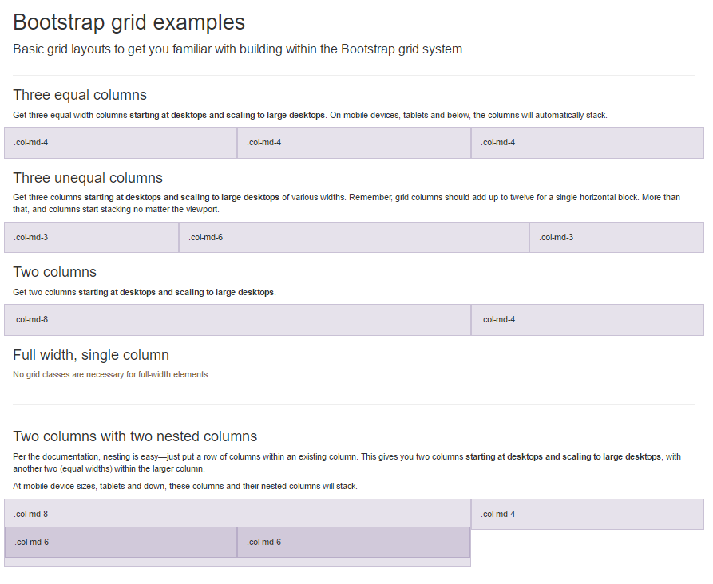Grid Classes

* xs (phones)
* sm (tablets)
* md desktop

monitor

* lg large desktop

monitor

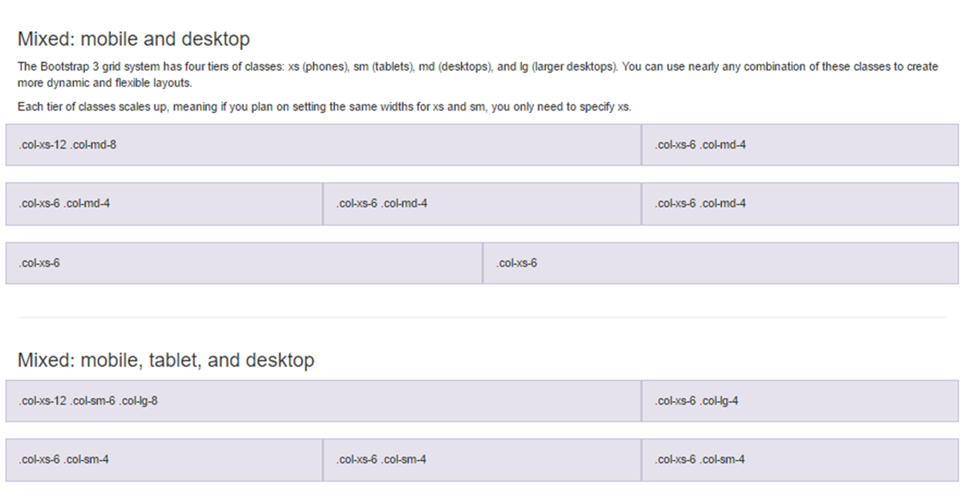

Contextual classes that can be used to provide "meaning through colors".

The classes for text colors are:.text-muted, .text-primary, .text-success, .text-info, .text-warning, and .text-danger

background colors are:.bg-primary, .bg-success, bg-info, bg-warning, and .bg-danger

.small Indicates smaller text (set to 85% of the size of the parent)

.text-left Indicates left-aligned text

.text-center Indicates center-aligned text

.text-right Indicates right-aligned text

.text-justify Indicates justified text

.text-nowrap Indicates no wrap text

.text-lowercase Indicates lowercased text

.text-uppercase Indicates uppercased text

.text-capitalize Indicates capitalized text

.initialism Displays the text inside an <abbr> element in a slightly smaller font size

.list-unstyled Removes the default list-style and left margin on list items (works on both <ul> and <ol>).

This class only applies to immediate children list items (to remove the default list-style from any nested lists, apply this class to any nested lists as well)

.list-inline Places all list items on a single line

.dl-horizontal Lines up the terms (<dt>) and descriptions (<dd>) in <dl> elements side-by-side. Starts off like default <dl>s, but when the browser window expands, it will line up side-by-side

.pre-scrollable Makes a <pre> element scrollable

