<https://api.genmymodel.com/>

Sign up for an account

Log in

From Dashboard Select New Project

Choose UML

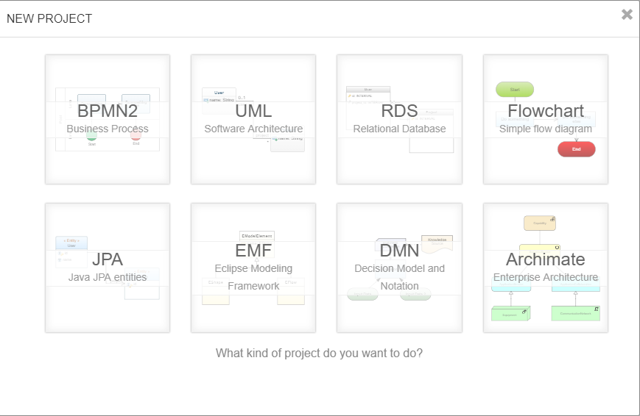

Select Blank Project

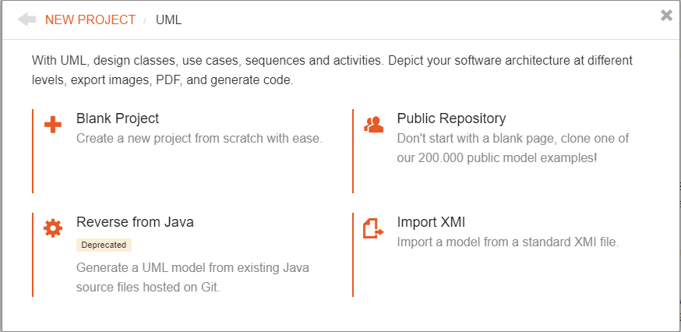

Name your project (no spaces in name), enter description, click Public, click Create

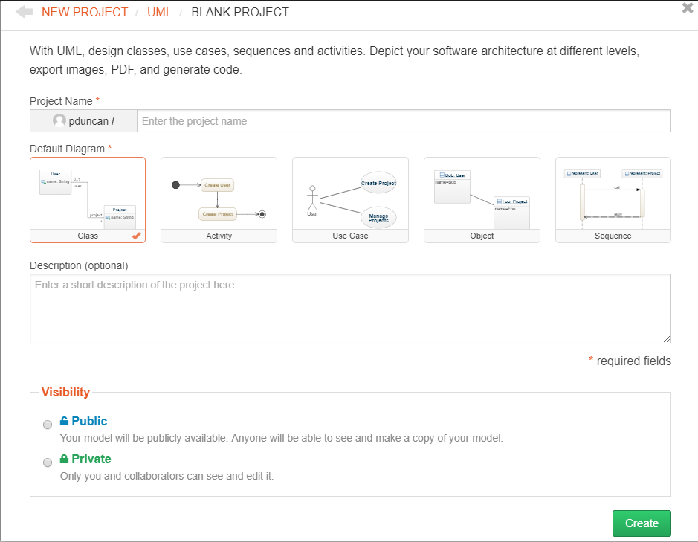

Click Open in Editor

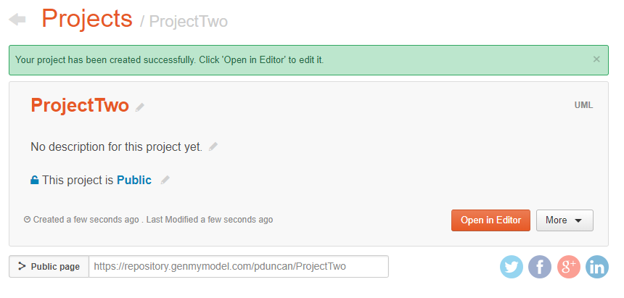

After the start up screen this is your project view

Right click the Project to add more diagram types

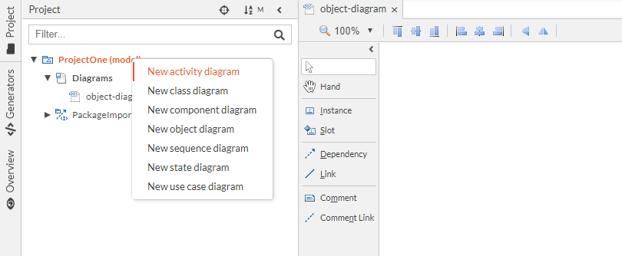

See the new diagrams

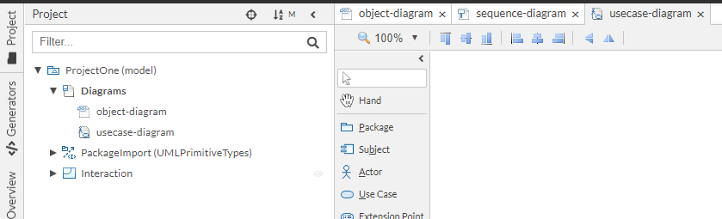

Use the drawing tools in the center to do the work

