Character Capture

*Brought to you by* [*http://seanbruce.hopto.org/*](http://seanbruce.hopto.org/)

*Sean Bruce*

*05/2020*

*Character Capture rev.1*

# Software Requirements Specification (SRS)

## High Level Product Description

Character Capture is an answer to tabletop gamers to completely digitize their tabletop gaming experience. Character Capture can take pictures of paper character sheets and create editable, sharable digital copies of their character. Users can take their device of choice to game sessions and forego all the physical media normally needed to play. Finally, game masters can access their players digital character sheets for optimal oversight of their game.

## Scope

With Character Capture, users can create, edit and store character sheets for their favorite tabletop games. To start, the user can either start from scratch with a new digital character sheet or import an existing character from physical copies using a devices camera. From there, the user can edit the sheet in real time during gaming sessions as if it was a traditional, physical copy. Lastly, users can upload their digital character sheets to a secure server that can be shared with other players and game masters.

In the first revision, the team looks to create a proof of concept. The first features to be developed will be the camera’s character sheet recognition features from a predetermined game system. The next plan for development with be local storage development followed by the basics of character editing.

## Sequence Diagram

|  |  |
| --- | --- |
|  | **Scan**: The user can scan paper character sheets from tabletop role-playing games (such as Dungeons & Dragons) into digital copies.  **Create**: The user can create new characters using the apps built in character editors.  **Edit**: The user can edit existing digital copies of character sheets or update the digital sheets via Scanning.  **Store/Save**: Users can save the digital copies to either local storage or the server to share with other users. |

## List of Steps

1. Launch the App
   1. Authenticate User
   2. Establish Camera Access
   3. Establish Server Connection
   4. Interface
      1. Design Layout
      2. Main Menu
         1. Scan
         2. New
         3. Load
2. Select **Scanner** (1)
3. Use Scanner
   1. If !CameraAccess, ask user to grant access
      1. Request Camera Access alert
         1. Accept (Go to Open Camera)
         2. Deny (Back to Start Screen)
   2. Scan Options
      1. New
      2. Existing
   3. Select New
      1. Take picture of (2) **Character Sheet**
      2. Create digital copy of the sheet into the app
      3. Save Option
         1. Save
         2. Discard
   4. Select Update
      1. Select file to update
      2. Take picture of (2) **Character Sheet**
      3. Update digital copy of the sheet into the app
      4. Update Option
         1. Update
         2. Discard
4. Select New
   1. Open (3) **Game Selector**
   2. Select desired game
   3. Open (4) **Character Editor**
5. Select Load
   1. Select location
      1. Local
         1. Select Local
         2. Select data from local storage
         3. Open character editor with saved data
      2. Server
         1. Select Server
         2. Authenticate Server Access
         3. Select data from Server
         4. Open character editor with saved data
6. Launch character editor
   1. Interface
      1. Design Layout
         1. Main Bar
         2. (5) **Statistic** editor
         3. Save Options
            1. Local
            2. Sever
7. **Scanner** is the feature used to load paper character sheets into the app.
8. **Character Sheet** is a sheet of paper form with a user’s character statistics on it. Usually filled in by hand.
9. **Game Selector** contains a list of supported games for the user to choose from.
10. **Character Editor** is a UI for modifying **Character Sheets**.
11. **Statistic** is an umbrella term for the properties that make up a **Character Sheet**.

## Tests

|  |  |  |  |
| --- | --- | --- | --- |
| ID | Step | ID | Test |
| 1 | Establish Connection to server | 1 | Successful connection |
| 2 | Connect to device’s camera | 2 | Device allows app access |
| 3 | Launch App | 3 | Main menu can be reached without error |
| 4 | Main Menu Scan | 4 | Scan option opens Scan features |
| 5 | Scan | 5 | Character sheet successfully scanned |
| 6 | Store/Save | 6 | Save files successfully created |
| 7 | Discard | 7 | No save file created |
| 8 | Scan Update | 8 | Save file is successfully updated |
| 9 | Load Save | 9 | Save files successfully loaded |
| 10 | Character Editor | 10 | Character Editor opens when selected |
| 11 | Edit | 11 | Character sheets can be manually edited in the app |

## Activity Diagram

|  |
| --- |
|  |
| 1. Launch Application 2. Authenticate access for user to the server and use of the device’s camera 3. Server that stores user ID and remote save files 4. Main Menu is a hub for the app’s features 5. Scan is the feature that translates paper character sheets into digital versions 6. Camera is the devices camera hardware 7. New creates a new digital character template 8. Save represents the user’s decision to save a digital character sheet to local or remote storage 9. Load opens existing character sheets into the Character Editor from either local or remote storage |

## Class Diagram

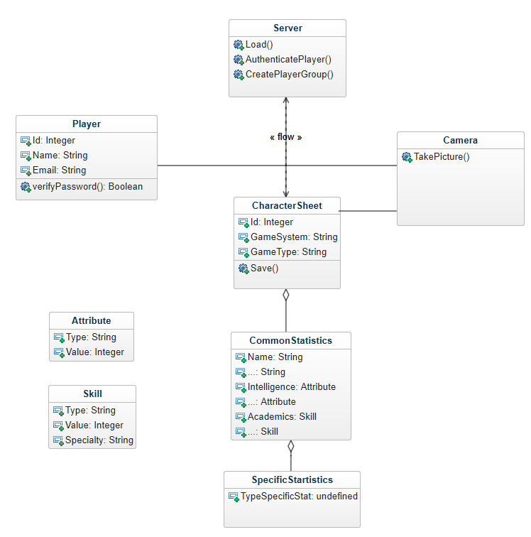

## Sequence Diagram

