 2. Add Parts to Base File (J553003B)

F3003_B is the base file used for comparison. It contains all routings as of Jan 1, 2014, plus all routings added in the succeeding years, 2014, 2015 and 2016 up until Jan 1,2017. The file used for the base is indicated by the Julian date in field IRURDT. Routings are never replaced, only new ones added. Changes were made to crew sizes to various work centers in previous years to more accurately reflect the actual crew size used at the time.

Program: P553003B Version AFP0001

This program looks at F3003 and adds routings for all items (IRKIT) missing from F3003_B to the F3003_B file.

Results: The same fields as in F3003 are in F3003_B. When an item is added to F3003_B it also writes the add date in Julian format to field IRURDT, user date.

Data Selection: Branch 350 and Branch 100 Only (IRMMCU). IRTRT = ‘M’

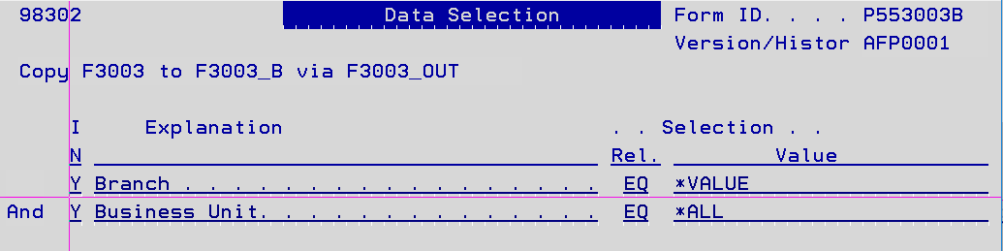

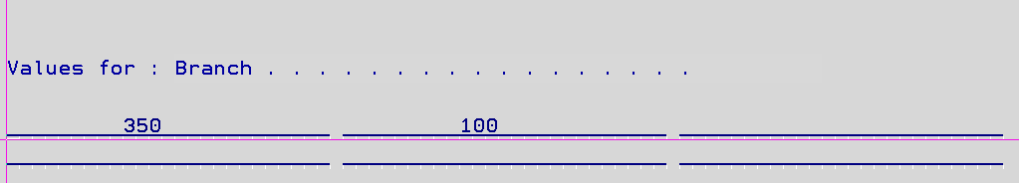

Sorted by: IRMMCU, IRKIT, IROPSQ

6. Create W/C Report Base J553003WC

This creates the first comparison file. It takes the records in the F3003_B file and summarizes each record by item (IRKIT) and work center (IRMCU) using three separate programs. Note: Three programs were used because of changes requested after the original program was developed.

Program 1: P553003WC Version AFP0001

Clears work file F3003_WWC and recreates data based on data selection.

Calculates Hours to be placed in workfile.

The following files are also read for additional information:

Work Center Master File (F30006) for CrewSize (IWSETC)

MCU Master File (F0006) for MCU Desc (MCDL01)

Item Master File (F4101LA) for item info (IMPRP4, IMSRP1, IMSRP5)

Dates File (F00365) for date conversion

Results: F3003_WWC

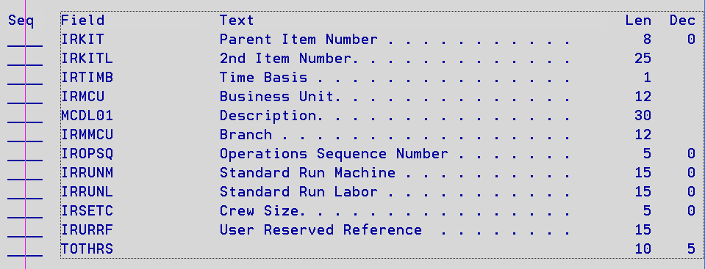

Note: The program uses the time basis code (IRTIMB) and crew size (IRSETC) to determine total hours.

Data Selection: Branch 350 and Branch 100 Only (IRMMCU), IRTRT=’M’, Date Updated (IRUPMJ) selected by user: Since final use of this file is in EXCEL, user selects date range for these records to avoid recreating entire base every time it is run.

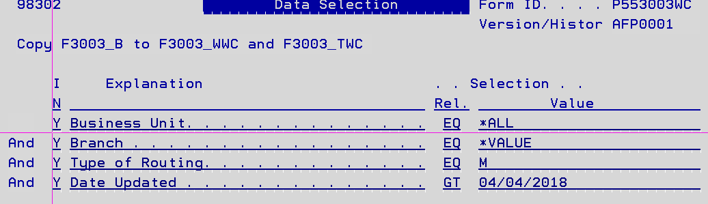

Sorted by: IRKIT, IRMCU

Program 2: P553003TWC

Reads F3003_WWC workfile and adds to F3003_TWC.

Hours are summarized by short item no (IRKIT) then work center (IRMCU).

Results F3003_TWC:

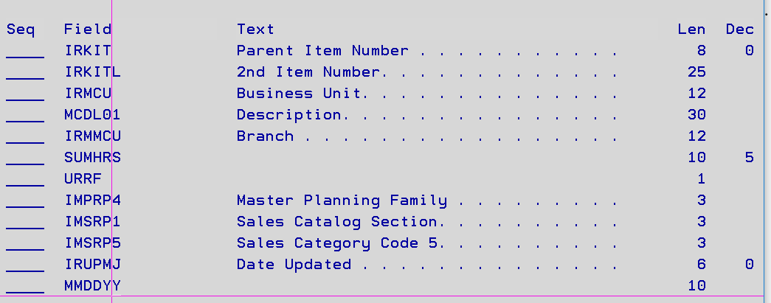

Data Selection: None required, in original data selection.

Sorted by: IRKIT, IRMCU

Program 3: P553003IT1

This program places a flag (‘X’) in the field URRF in file F3003_TWC if the IRKIT is in file F3003_XITM. The F3003_XITM file was created from user input to assist in EXCEL comparisons. The file can be amended by the user at selection 24 on the menu. Note: The ‘X’ is most important during the original file build from the four years of routings.

Shown below is the menu, DFU access, and sample of the file.

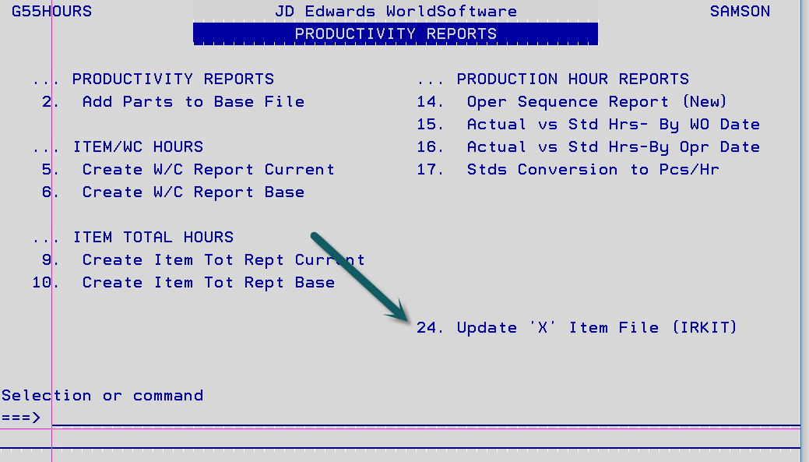

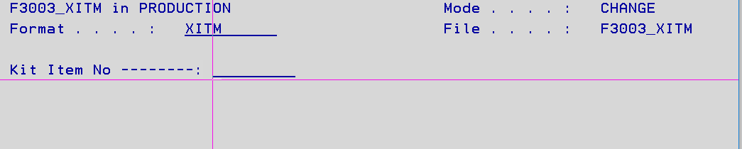

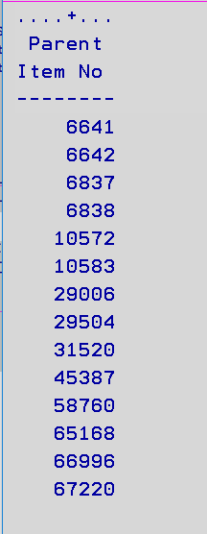

Data Selection: From master program, no additional needed.

10. Create Item Tot Rept Base J553003BWK

This creates the second comparison file. It takes the records in the F3003_B file and summarizes each record by short item (IRKIT) using three separate programs. Note: Three programs were used because of changes requested after the original program was developed.

Program 1: P553003BWK Version AFP0001

Clears work file F3003_BWK and F3003_BT and recreates their data based on data selection.

Calculates Hours to be placed in workfile.

The following files are also read for additional information:

Work Center Master File (F30006) for CrewSize (IWSETC)

Results: F3003_BWK

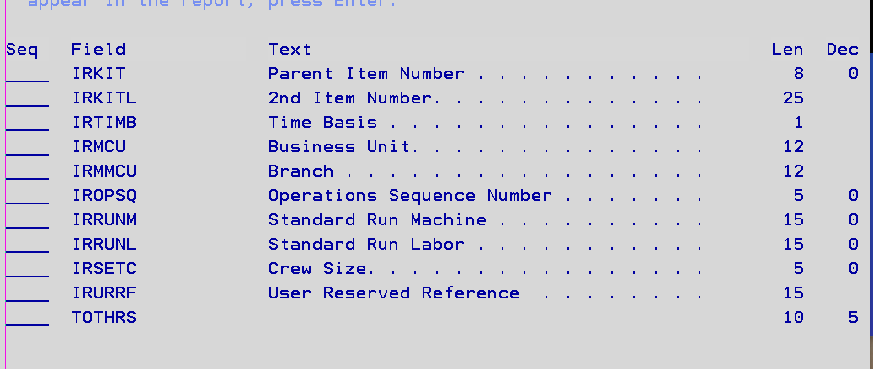

Data Selection: Branch 350 and Branch 100 Only (IRMMCU), IRTRT=’M’.

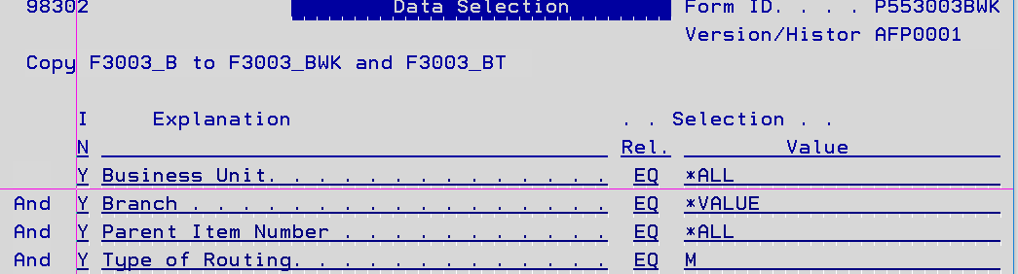

Sorted by: IRKIT, IRMCU

Program 2: P553003BT

Reads F3003_BWK workfile and adds to F3003_BT.

Hours are summarized by short item no. (IRKIT)

Results F3003_BT:

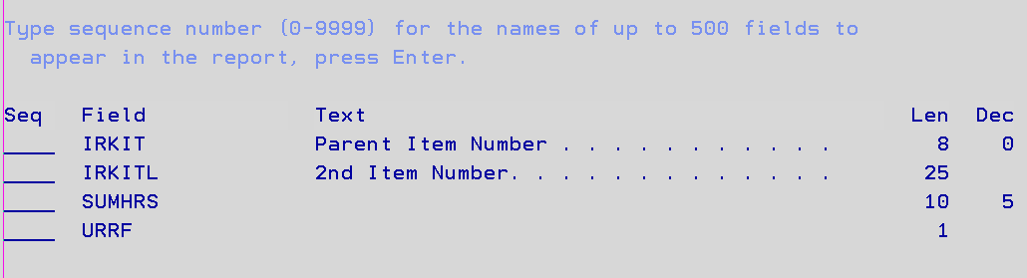

Note: The program uses the time basis code (IRTIMB) and crew size (IRSETC) to determine total hours.

Data Selection: None required, in original data selection.

Sorted by: IRKIT

Program 3: P553003ITM

This program places a flag (‘X’) in the field URRF in file F3003_BT file if the IRKIT is in file F3003_XITM. The F3003_XITM file was created from user input to assist in EXCEL comparisons. This is the same file as described in the previous section.

Data Selection: From master program, no additional selections needed.