Course: System Integration and Architecture 1
Activity 1: Lab Orientation & Development Tools Setup

Name: Sean Carlo Magadan Course:BSIT
Date:12/01/2025 Year & Section: 3B

LABORATORY REPORT
PRE-LAB ACTIVITY

Introduction

Lab Orientation & Development Tools Setup introduces students to the essential tools, environments, and processes required for starting their web development journey. This activity familiarizes learners with the laboratory guidelines, development workflow, and the proper use of software such as Laragon, Laravel, and command-line interfaces. By understanding how these tools work together, students gain the foundational skills needed to create, manage, and run web applications efficiently. The activity also aims to build confidence in navigating development environments and preparing a stable workspace that will support all future programming tasks throughout the course.

Installing Laragon

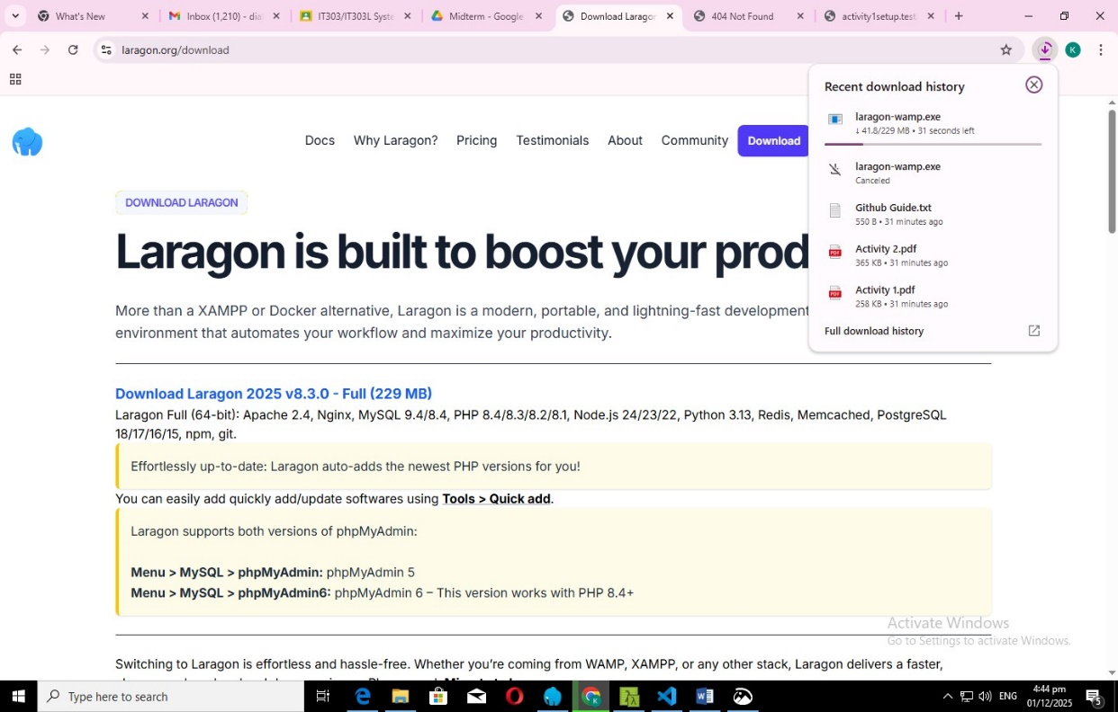

Installing Laravel inside Laragon
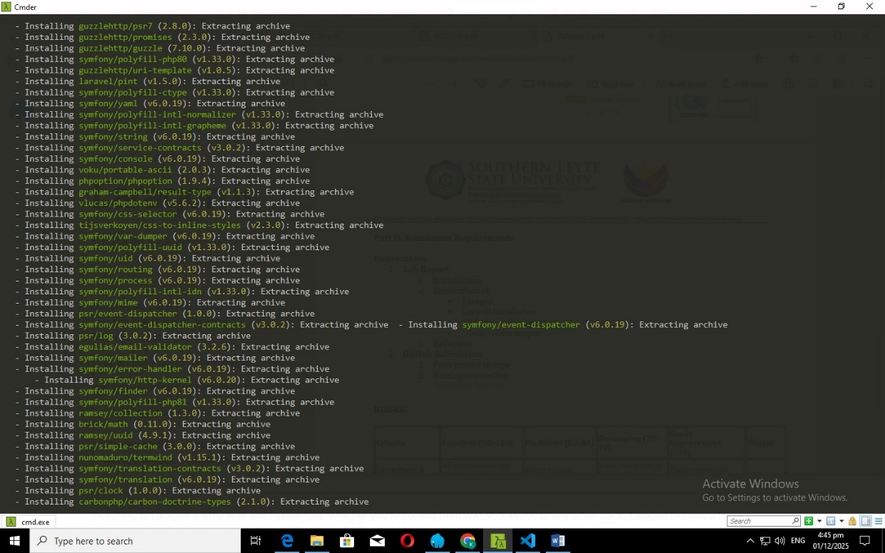

Opening Laravel projects in VS Code / VS Code Environment
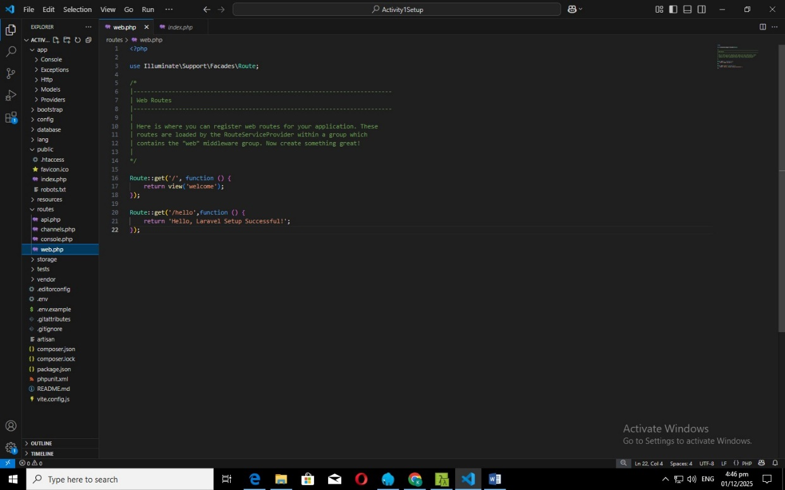

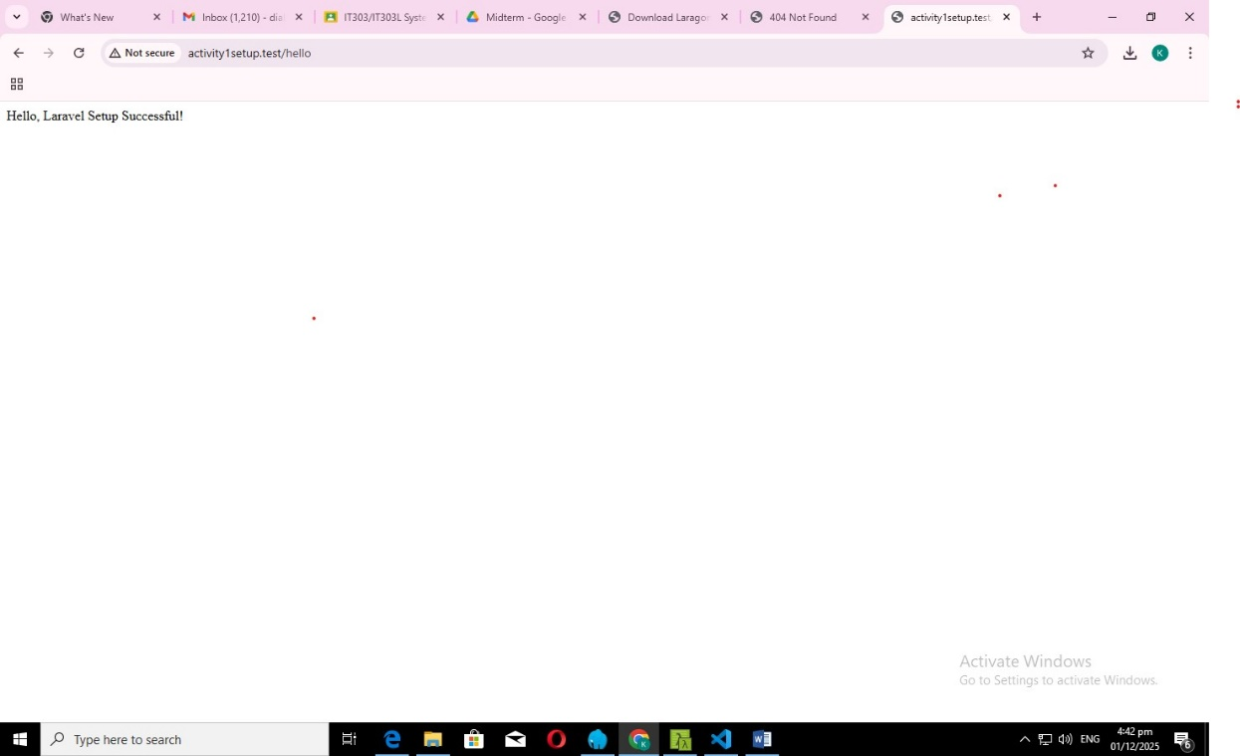

Reflection

Reflecting on these photos, the experience of installing Laravel and configuring Laragon highlights how essential a smooth and organized development environment is. Watching packages install in the terminal and seeing the Laravel homepage load successfully brings a sense of accomplishment, showing that the setup was done correctly. This process reinforces patience, attention to detail, and the willingness to troubleshoot when necessary. It also deepens appreciation for modern tools that simplify development workflows. Overall, completing this setup boosts confidence in handling backend frameworks and prepares me for building more complex web applications using Laravel’s powerful and developer-friendly features.

