**Ex-3 Practical Part**

1. We chose the book "Alice’s Adventures in Wonderland"
2. .

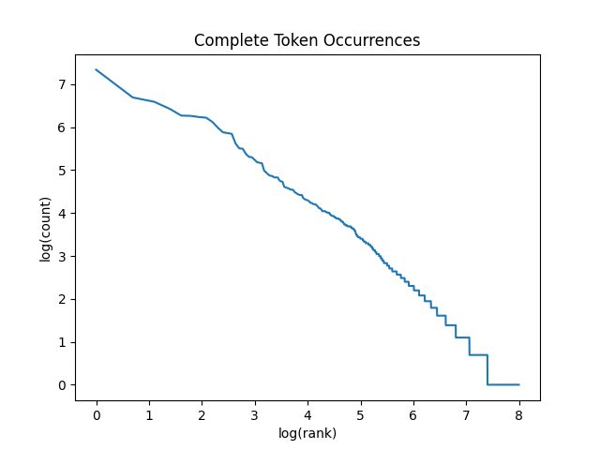

1. .

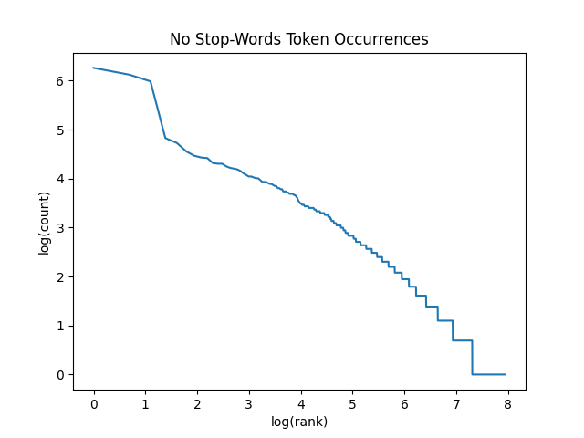

1. .

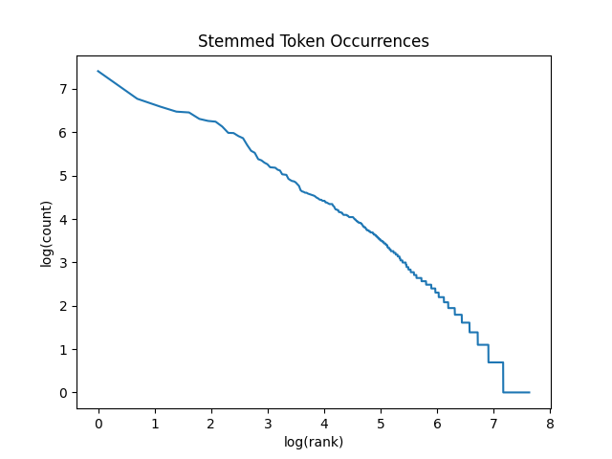

1. 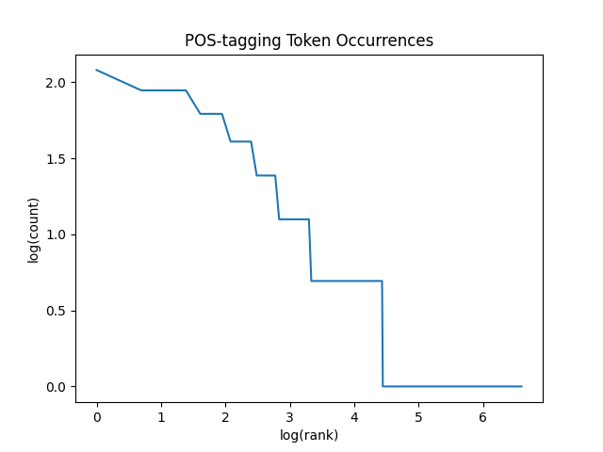
2. Example: "won't talk" – the POS tagging took 't talk' as a phrase and tagged 't' as adjective. Because of our tokenizer tokenize the negative parts separately, it took 't' as separate token and it made the POS tagging to tag it wrong.