Traffic volume for 7 day moving average 2021 - 2025 the following, https://www.tii.ie/en/roads-tolling/tolling-information/tolling-dashboards/covid-traffic-patterns/ -> Transport infrastructure Ireland
M50 | Year | Average moving
 | 2025 | 178,330
 | 2024 | 161,191
 | 2023 | 161,547
 | 2022 | 151,178
 | 2021 | 148,012
 | Average from 2021-2025 | 163,062
M50 daily traffic volume

NB* From this source it mentions the last 3 data points are anomalies so I will disregard the drop in data

M1 | Year | Average moving
 | 2025 | 148,646
 | 2024 | 138,568
 | 2023 | 138,568
 | 2022 | 135,403
 | 2021 | 127,887
 | Average from 2021-2025 | 137,814

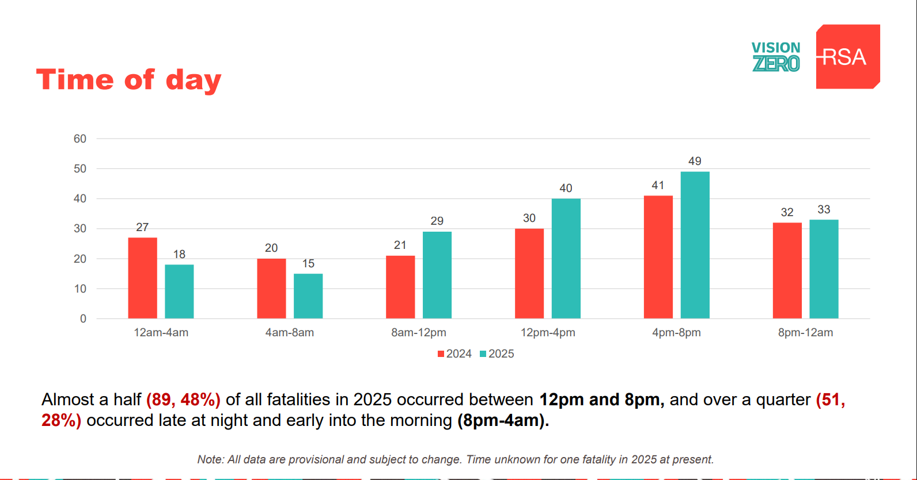
https://www.rsa.ie/docs/default-source/road-safety/road-users/rrd-res-20251201-end-of-year-report.pdf?sfvrsn=ef8b5d65_1

yearly traffic volumes. Road traffic volumes csv yearly traffic volumes. Road traffic volumes csv

