*Sean Coogan*

*MSIM 772 Fall 2016*

*A study of Irish Emigration*

19th Century Population Displacement

Table of Contents

Abstract 3

Introduction 3

Political View 4

A New World 4

Great Emigration 5

Research Question 5

Methodology 6

RiftLand Model 6

Haiti Study 7

Climate Migration Modeling 8

Aleppo Model 8

Ireland Model 8

Model Development 9

Assumptions 9

Conceptual Model (Causal Loop) 10

Push/Pull Index 11

NetLogo Model 13

Pseudo Code 15

Continuation 15

References 16

Appendix A – Screenshots 18

Appendix B - NetLogo Code 20

# Abstract

The latter half of the 19th century was marked by two major turning points for the Irish people. Over a million Irish perished due to the Great Famine and over two million Irish immigrated to the United States in one of our country’s largest migratory events. The following study examines this historic series of events, using agent-based modeling to evaluate the factors relevant in triggering the difficult decision to leave Ireland for the United States.

# Introduction

Great Famine

In 1801 the Irish voted to voluntarily dissolve the Irish parliament in order to join the United Kingdom. This led to most of the high quality Irish grain crops to be exported to Britain. Soon the potato became the sole primary food source for much of the population. Despite these facts, by the early 1840’s, Ireland reached its highest population to date at 8.5 million. By the late 1840’s, after unseasonably cold winters and a devastating potato disease (*Phytophthora infestans*) that decimated most of the potato crops, Ireland was in the midst of a Great Famine. During the years of 1845-1852, the island was ravaged by starvation and disease, mainly typhus and cholera, which killed roughly 1 million people (12% of the population). The Irish received very little relief from Britain. This was made worse by oppressive British land owners and harsh landlords whose primary goal was to export as much money and resources from Irish lands as possible. “The impoverished Irish peasantry, lacking the money to purchase the foods their farms produced, continued throughout the famine to export grain, meat, and other high-quality foods to Britain.” [3]

## Political View

In 1838 the British Poor Laws were enacted in Ireland. This would be the primary vehicle to assist those affected by the Great Famine to come. By 1845, then Prime Minister, Sir Robert Peel attempted to provide relief in the form of soup kitchens and increased workhouses, but had little effect on the devastation. Peel’s successor, Prime Minister Lord John Russell shifted to British reliance on exporting Irish resources. This exacerbated the situation and left the Irish with no relief which increased poverty, evictions, and starvation. By 1870, the Home Rule Movement ushered in legitimate Irish political representation in UK Parliament which lead to better conditions for the Irish. Ultimately, in 1914, the Third Home Rule Act established self-governed Ireland by UK Parliament.

## A New World

There was a growing folklore of a "land that flows with milk and honey--the land

of work and peace" and the “land of gold” [7] proliferated by existing Irish immigrants in the United States. This perception made the United States the primary destination for any potential Irish emigrant. In 1862, President Lincoln passed the Homestead Acts and Pacific Railway Act which provided free land to settlers. By 1870, the Second Industrial Revolution had begun which enabled an “unprecedented movement of people and ideas” [9] and required an enormous labor force. The prosperity was clouded by a devastating Civil War (1861-1865) in which the Irish fought in large numbers and were viewed as a huge asset to both the Union and Confederate forces.

## Great Emigration

Ireland suffered a massive emigration throughout the nineteenth century whether to escape starvation, disease, and political oppression; or to strive for opportunity and adventure in the New World. During the 1840’s, Irish accounted for more than half of immigrants to the United States. By 1890, 40% of all Irish-born people were living abroad. Between 1820 and 1930, 4.5 million Irish immigrated to the United States.

Table

* Irish population census data:
  + 1841 - 8.2 million
  + 1851 - 6.6 million
  + 1891 - 4.7 million

# Research Question

The underlying goal is to characterize the historic crisis in Ireland which affected millions, compelling population displacement. Modeling the struggle provides a computational means to understand what factors persuaded citizens to flee. This was accomplished by constructing a comprehensive agent-based model representationof population displacement to characterize the Irish population (agents), capture the effects of famine and disease compared to potential safety and opportunity in the United States, and how those factors affect agent decision-making. The resulting research question is as follows:

*What do outputs of an agent-based model drawn from real-world data related to the mid-19th century immigration of Irish to the United States express being stronger between circumstances pulling the Irish to the US or pushing the Irish from their land?*

I hypothesize the model will show more Irish emigrating due to circumstances in Ireland and that trend will change toward the latter part of the 19th century to which circumstances in the United States will be the primary motivation for Irish to immigrate.

# Methodology

“Empirical modelling techniques are the only way to effectively simulate migration resulting from a complex combination of pressures and opportunities.” [10] To accomplish the goal of this study, quantitative research was conducted. No case studies were found that investigated 19th century Irish emigration from a modeling perspective. To subsidize, similar population displacement case studies and existing population displacement assessment tools were taken into account.

## RiftLand Model

“The RiftLand agent-based model seeks to model human subsistence, conflict and displacement in East Africa at multiple spatial scales. The RiftLand model covers and area approximately 2.5 million km2 including all of Kenya, Uganda, Rwanda and Burundi; and parts of Sudan, Democratic Republic of Congo and Tanzania.” [1] This model is interesting based on the large scope of the project. I looked at two sub-models of RiftLand. The first (“Agent-based modeling for Humanitarian Issues: Disease and Refugee Camps” [1]) modeled the spread of Cholera in African refugee camps and claimed to model social behavior. I found the so-called social behavior to be somewhat based on predetermined scheduled movements representative of a rule-based engine. While interesting, it showed little value to the emigration model at hand. The second sub-model (“Modeling Cities and Displacement through an Agentbased Spatial Interaction Model” [5]) used an agent-based spatial interaction model to study refugee movement patterns from rural areas to cities. This model leveraged hybrid of the pruned spatial interaction model with the local interaction model. While potentially relevant for the spatial aspect, it did not have a human social behavior of why the refugees move in such patterns. It did provide some validation by showing displaced people had a natural tendency to move toward urban areas.

## Haiti Study

“Predictability of population displacement after the 2010 Haiti earthquake” [13] tracked social bonds and movement patterns using cell phone data. This study provided insight in that based on tracking data, such as cell phone data, the authors were able to compile mathematical equations for population movement, providing predictability. “Existing research has found that people displaced by natural disasters typically stay within their country of residence, that sudden-onset disasters often lead to more short-term displacement than do slow-onset disasters” [13] The implication here is that slow-onset disasters, such as a multi-year famine, would result in long-term displacement.

## Climate Migration Modeling

This was a general discussion on the ABM approach to modeling mass migration due to climate change. Important points were raised by the authors related to agent behavior. “It is important to consider the influence of social structures, institutional influences and the actions of individuals. The individual context of each agent’s unique combination of experiences, biases, assets and perceptions defines the differences among individual agents and their different responses to both environmental stimuli and the actions of others” [10]. Though this was in the context of climate change, the same principals apply to the situation in 19th century Ireland.

## Aleppo Model

“Modeling Population Displacement in the Syrian City of Aleppo” [11] was referenced in quite a large number of resources and was subsequently proven valid by later population displacement events. This model served as a primary guide for representing human behavior and decision making. It also supported the use of ABM as the best modeling paradigm. I chose to leverage this work in a number of ways. I used agent zero to manage the human behavior’s emotional, cognitive, and social aspects and influence the agents’ decision to flee their location. I also elected to use NetLogo patches to represent the population.

## Ireland Model

Agent-based modeling was selected as the preferred paradigm for investigating human and social phenomena for many reasons. ABM is effective at modeling population displacement and can effectively represent agent (human) interactions with the environment and surrounding agents at both micro and macro levels. ABM also allows dynamic coordination of interactions and activities while providing comprehensive visual representation and enabling the integration of qualitative and quantitative values. An index was developed to represent factors that pushed Irish from Ireland and pulled them to the United States. This was combined with agent zero to represent motivation, decision making, and ultimate movement of agents.

# Model Development

Approach

Overall development started by defining the conceptual model (figure 1) which was the basis for influencing factors on the Irish citizens’ desire to emigrate from Ireland. From the conceptual model, I developed push and pull indices and applied weights to each factor based on conditions, historical events, and/or location. Once the conceptual model and push/pull indices were defined, I used an iterative approach in coding the NetLogo model. I started by importing the GIS dataset for Ireland. Next, I incorporated the push/pull index. Finally, I implemented agent zero to finalize the decision making and agent movements. I chose to add a population plot early in development to aid me in visually observing population changes as I added subsequent features of the model. Also for development and testing purposes, I used both a single step button and a continuous “go” button.

## Assumptions

There are a number of assumptions that must be well defined for this system to be valid in representing the real world.

* Population is evenly distributed within the rural land patches and city land patches. In reality population density would vary throughout the country.
* The timeframe for this model is limited to the years 1840 – 1900.

## Conceptual Model (Causal Loop)

Below, figure 1, shows the conceptual model in the form of a Causal Loop diagram. The focus is the person’s desire to emigrate which is influenced by push factors from Ireland and pull factors from the US. The push factors have direct positive influences from political oppression, lack of economic diversity, over population, and disease. Starvation is an indirect positive influence via disease and is effected by over population. Pull factors are directly, positively influenced by an established Irish population in the US, land availability, employment, and safety. Employment is also an indirect positive influence on safety. Note, there are now identified feedback loops.



Figure 1

## Push/Pull Index

I defined a “push” factor as condition(s) or event(s) taken place in Ireland that influenced citizens to emigrate. Whereas, I define a “pull” factor as condition(s) or event(s) taken place in the United States that influenced Irish citizens to immigrate. An interesting aspect I discovered in research was a folklore-type embellishment of the conditions and opportunity in the New World, which I factored into the pull factors detailed below. I created two sets of indices that represent what I found through research to be the leading factors, both pushing and pulling the Irish. Most of these factors are independent from each other and based on time, and in most cases major historical events.

* Starvation and Disease – Represents the massive death toll due to disease following the Great Potato Famine in the late 1840’s.
* Over Population – Represents the overwhelming population of the 1840’s.
* Political Oppression – Represents both social and religious discrimination by way of laws imposed by the British to exploit the peasant class Irish, until the 1870’s, when the Irish gained legitimate representation in British Parliament.
* Lack of Economic Diversity – Represents the fact that rural Ireland was limited to only farming as means of employment. Urban areas offered slightly more options, such as textile manufacturing. Note, this is a constant value based on location.
* Safety – Is a factor of plentiful food sources and much less disease in the United States. I elected to base this off the starvation push factor in Ireland. This serves to increase the importance of basic human necessity, while adding variability to what would be a somewhat constant factor. People are more sensitive to food availability when they are coming from a place that has very little.
* Industry – Represents the turning point in the 1870’s when the Second Industrial Revolution ushered in a requirement for a huge workforce
* Land – Is the notion of free land available in the United States due to a number of acts passed in 1862
* Existing Irish Population – Represents the booming number of Irish immigrants accumulating in the United States throughout the late 19th century. This was attractive to would be emigrants because it meant established Irish communities and culture to aid integration into the US This also serve as a catalyst of the embellishment of opportunity previously discussed in this section.



Table 2

## NetLogo Model

Ireland is represented in a 16x21 environment on which GIS border data is projected. Two major cities are represented, Dublin and Belfast. Implementing the GIS dataset established 958 land patches, which are divided into rural (908 patches) and city (50 patches). City patches extend a radius of 3 land patches from the city points. As Ireland had an approximate area of 84,409 square kilometers (32,599 square miles), each patch is ~88 Km2. At setup, an even distribution of ~8.2 million population is established with a larger number in the cities.

The simulation is time stepped at one month per tick and defaults to run for 60 years at 720 ticks. Once the time limit is reached, the simulation terminates. Output is in the form of plots of the push/pull index and emigrated population percentage. Various monitors exist for year, initial population, current population, push factor, and pull factor. At each tick, the patches are recolored based on population change. A population decrease from the initial population ranging from 1% - 10% colors the patch yellow; more than 10% results in an orange patch. Rational human behavior is based on the ratio of areas of high population loss, within vision of the patch, to areas with little population loss. The ratio is averaged over the memory time of the population represented on the given patch. The patch affect is updated if the patch is orange. Probability is set based on orange patches in visual range and memory. Disposition is then updated, given the patch population is not flagged as displaced. Displacement occurs when disposition is greater than the allowed threshold. Once displaced, the patch is colored red. I would like to have implemented a dynamic threshold based of the push/pull index, given more time. At this point in development I notice no real movement of population. So, I added a way for patch population to recover. All land patches have a 1 in 30 chance to see a slight increase multiplier, based the push or pull factor of the patch. City patches have a 50% chance to see an increase. This represents the natural behavior of displaced people to move to nearest urban areas. It also represents the fact that people emigrating the country did so through the major port cities. There are some noticeable, high-level validation aspects. The observed output, based on total population numbers, is pretty close to the historical data. Also, the noticeable population shift to the cities is representative of historical data.

## Pseudo Code

Set patch color based on pop

Update push/pull factor

Update disposition of population

Displace population who meet criteria

Calculation percentage of population that emigrate

Repeat for 720 months (60 years)

# Continuation

There a number of continuations and improvement possible for this model. The list below centers mainly around refining the social behavior modeling.

* Implement a dynamic agent zero emigration threshold based on the push/pull index
* Incorporate additional relevant cities, such as Cork and Galway
* Implement and track destinations for emigrants
* Incorporate risk/reward analysis by agents, such that there would be a weighed risk of emigrating to counteract the desire to leave.
* Incorporate factors that influence citizens to stay and not emigrate, such as lack of resources, ill family member, or belief conditions shall improve

# References

[1] Hailegiorgis, Atesmachew, and Andrew T. Crooks. "Agent-based Modeling for Humanitarian Issues: Disease and Refugee Camps." *Academia.edu - Share Research*. N.p., n.d. Web. 06 Dec. 2016.

[2] "Emigre." *Irish Emigration History| | EMIGRE: Current Irish Emigration and Return UCC*. N.p., n.d. Web. 08 Dec. 2016.

[3] "Great Famine." *Encyclopedia Britannica Online*. Encyclopedia Britannica, n.d. Web. 04 Dec. 2016.

[4] "Great Famine (Ireland)." *Wikipedia*. Wikimedia Foundation, n.d. Web. 08 Dec. 2016.

"Push and Pull Factors of Irish Migration." *Push and Pull Factors of Irish Migration for Kids \*\*\**. N.p., n.d. Web. 08 Dec. 2016.

[5] Gulden, Timothy, Joseph F. Harrison1, and Andrew T. Crooks. "Modeling Cities and Displacement through an Agent-based Spatial Interaction Model." *Academia.edu - Share Research*. N.p., n.d. Web. 06 Dec. 2016.

[6] "Irish - Irish-Catholic Immigration - Immigration...- Classroom Presentation | Teacher Resources - Library of Congress." *Irish - Irish-Catholic Immigration - Immigration...- Classroom Presentation | Teacher Resources - Library of Congress*. N.p., n.d. Web. 08 Dec. 2016.

[7] Miller, Kerby A., and Bruce D. Boling. "Golden Streets, Bitter Tears: The Irish Image of America during the Era of Mass Migration." *Journal of American Ethnic History* 10.1/2 (1990): 16-35. Web.

[8] "Population of Ireland 1500 to 2000." *Population of Ireland 1500 to 2000*. N.p., n.d. Web. 08 Dec. 2016.

[9] "Second Industrial Revolution." *Wikipedia*. Wikimedia Foundation, n.d. Web. 04 Dec. 2016.

[10] Smith, Christopher, Dominic Kniveton, Sharon Wood, and Richard Black. "Predictive Modeling." N.p., n.d. Web. 06 Dec. 2016.

[11] John A. Sokolowski, Catherine M. Banks, and Reginald L. Hayes. 2014. Modeling population displacement in the Syrian city of Aleppo. In *Proceedings of the 2014 Winter Simulation Conference* (WSC '14). IEEE Press, Piscataway, NJ, USA, 252-263.

[12] John A. Sokolowski, Catherine M. Banks. *Modeling and Simulation for Analyzing Global Events*. United States: Wiley, John & Sons, 2009. Print.

[13] Lu, Xin, Linus Bengtsson, and Petter Holme. “Predictability of Population Displacement after the 2010 Haiti Earthquake.” *Proceedings of the National Academy of Sciences of the United States of America* 109.29 (2012): 11576–11581. *PMC*. Web. 7 Dec. 2016.

# Appendix A – Screenshots

Model GUI layout

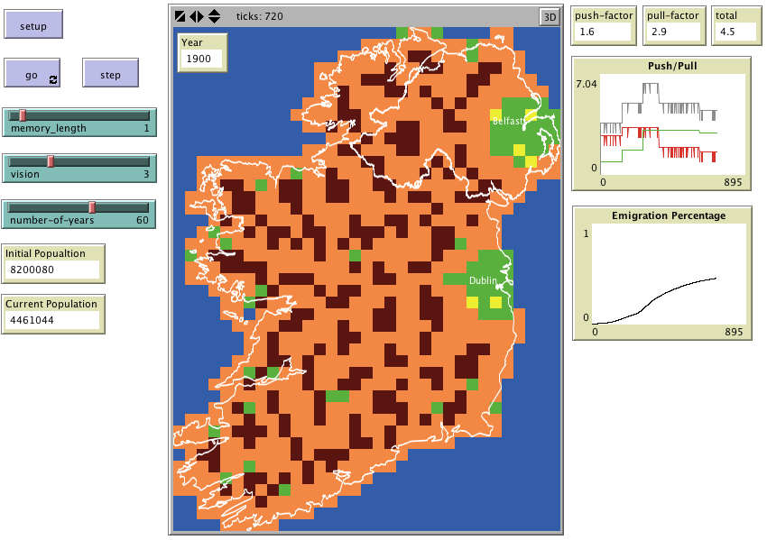

Image 1

Model map initialized and postmortem

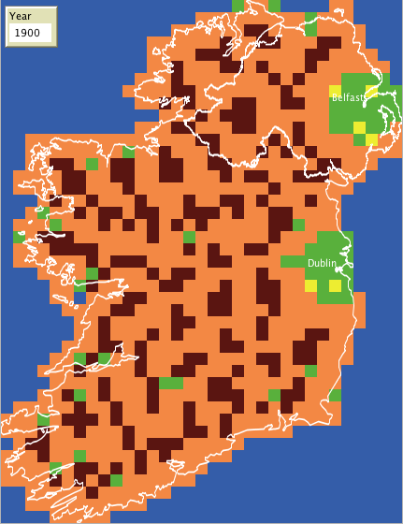

Image 3

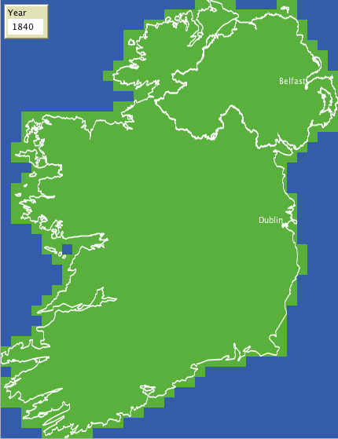

Image 2

# Appendix B - NetLogo Code

