**Spring**

16

**https://github.com/seangoogan/netlogo-mosquito**

Mosquito Eradication Model

Sean Coogan & Haotian Yang

BNAL 722 Wed 4:20

08

**Fall**

Table of Contents

Introduction & Motivation 2

Operating Instructions 3

Model Description & Technical Implementation 5

Experiments, Results, and Observations 7

Conclusion & Potential Extensions 11

References & Credits 13

Appendix A - Model Design 14

Appendix B – Code 18

Appendix C – Project Proposal 24

# Introduction & Motivation

This model explores the eradication of Aedes aegypti mosquitoes through the use of genetically modified (GMO) male mosquitoes. The Aedes aegypti has turned to a significant public health threat. It is a vector of several for transmitting ZIKA and other tropical fevers. Conventional control methods have failed to control the population of mosquitoes so far. Novel genetics-based strategies offer a promising alternative or aid towards efficient control of this mosquito.

Current genetics-based strategies have two different methods, Bi-sex RIDL and fs-RIDL (female specific). Bi-sex RIDL will cause that both male and female offspring die before adulthood. This method requires continuous releases of the GMO mosquitoes to the wild. It could significantly reduce the population but hard to eradicate the mosquitoes. On the other hand, fs-RIDL (female specific) targets on the female offspring ensuring they fail to survive until adulthood. Meanwhile, male offspring will grow up with the lethal gene and continue to mate with other wild female. In favorable circumstances, modified gene is spread automatically.

This model focuses exclusively on the fs-RIDL method. The goal of this model is to help the user choose the ideal locations and quantity of GMO mosquitoes to release while providing the most effective results for the practice.

The advantage of using ABMS to modeled this system is that ABMS could show the characteristic of different mosquito in the model. In the real wild environment, every difference mosquito’s life time, mate times, reproduce number and many other variables is a different number. In addition, release GMO mosquitoes at difference location will cause difference result. Using a model with some equations could not show the real situation in a wild environment. Therefore, design and operation an ABMS model to simulate this system is the best way which would help us to find the most efficiency way of using novel genetics-based strategies.

# Operating Instructions

Prior to Setup, the initial release locations should be set using the initial-release-locations slider. This sets the number of GMO deployment locations ranging from 0 to 10. These deployment locations are represented by red boxes in the environment.

Next simulation initialization is invoked using the SETUP button. This creates the aforementioned deployment locations as well as three bodies of water represented by cyan colored patches. Within these patches are an initial random (0-49) amount of wild (non-GMO) eggs.

To start the simulation, the GO button is pressed. This button has the forever option selected to keep the simulation running continuously until subsequent pressing of the GO button. Once running, eggs will hatch producing adult mosquitoes. These mosquitoes will attempt to reproduce as detailed in the previous sections.

While the simulation is running the user can position the release locations for the genetically modified mosquitoes by dragging each red box using the mouse to place them anywhere in the environment.

The number of GMO male mosquitoes to be released per location is set using the gmo-release-per-deployment slider, ranging from 0 to 100. Note, this is per location so multiply this number by the total number of locations to get the total number of GMO males that will be deployed each time the Release GMO button is pressed.

Once release settings are configured, press the Release GMO button. This can be pressed any number of times. Each press will release the set number of GMO mosquitoes from the current locations. Locations and gmo-release-per-deployment can be changed through out the simulation run.

Survival rate of wild (non GMO) and GMO mosquitoes are controlled by the wild-survival-rate and gmo-survival-rate respectively. This is the success rate that a hatched egg will produce an adult mosquito. This represents the reality that not all eggs laid result in adult mosquitoes that are able to reproduce in their own rite.

On the bottom left side you will find several counters display the total tally of wild (non-GMO) egg, GMO eggs, uninfected adult mosquitoes, and adult mosquitoes that have been infected with the mutated gene.

On the right side there are two plots that historically track the eggs and mosquito populations. The plot titled Eggs plots wild (non-GMO) egg in blue and GMO eggs in red. The plot titled Mosquitoes plots wild (non-GMO) mosquitoes in blue and GMO mosquitoes in red.

# Model Description & Technical Implementation

Mosquitoes hatch from eggs in bodies of water represented by cyan colored patches. Once hatched, the adult mosquitoes attempt to mate with compatible mosquitoes of the opposite sex. Genetically modified (GMO) male mosquitoes are released by the user who controls release locations, quantities, and number of releases. The mosquito agents fly around in the open, unbound world, interacting with others, testing compatibility, and attempting to mate.

Successful mating requires a non-pregnant, fertile female and a male within a radius of 3 units of the female. There is a compatibility variable (0-9) that must match for the female and male to mate successfully. This represents the variable frequency used for mosquitoes to find a mate. Once a suitable mate is found, the fertilized female seeks out the nearest water patch within her field of view (180 degree, 10 distance). After waiting a rest period of 5 ticks, she lays 0 to 300 eggs. The eggs laid are of type wild (non-GMO) or GMO depending on the genetic makeup of her male partner. Females can get pregnant a random number of times (1 - 3). After eggs have been laid, the female resumes seeking a mate.

Male mosquitoes have a life span, randomly set, ranging from 3 to 10 ticks. The life span of females is also a random number between 3 and 10 but with a random multiplier between 2 and 5. This represents the fact that female mosquitoes can live up to 5 times longer than males.

On each tick each water patch, if applicable, hatches 1 egg. If both wild (non-GMO) and GMO eggs exist on said patch, one is chosen at random. A user controlled survival rate for both wild (non-GMO) and GMO determines the odds that the egg will successfully hatch. Since females produced from GMO eggs do not survive to adulthood, only GMO males are produced. The new generations of mosquitoes then proceed to seek mates, thus continuing the cycle.

The code demonstrates many examples of sprouting turtles from a patch.

The code also demonstrates the use of the watch, subject, and reset-perspective primitives in conjunction with mouse-down and mouse coordinates to automatically pause model and allow user to select and drag a turtle.

The model shows how to leverage the in-cone reporter to create a field of vision then uses max-one-of and face to find the closest water patch.

# Experiments, Results, and Observations

If the survival rate of GMO mosquitoes is higher than the survival rate of wild (non GMO) mosquitoes, the extinction will happen very fast. If GMO mosquitoes and wild (non GMO) mosquitoes have the same survival rate, with the same release number, it will take a much longer time to generate a complete eradication. In a wild environment, the survival rate of wild mosquitoes is about 20%.

Changing the position of deployment points, such as put them together, or put them far from each other, would not significantly affect the result. However, putting deployment points near the water could accelerate the eradication time, especially when the number of deployment points is low.

Adjusting the survival rate of the wild mosquitoes and letting the model run can control the initial population, prior to GMO release, allowing the population to increase or decrease to the desired number.

Try different values for the INITIAL-RELEASE-LOCATIONS, GMO-REALEASE-PER-DEPLOYMENT, WILD-SURVIVAL-RATE, and GMO-SURVIVAL-RATE sliders. How do they affect the number of eggs and number of mosquitoes?

Try to drag the DEPLOYMENT POINT. Does it affect the eradication process?

Is there a significant change in results when pressing the Release GMO button multiple time to simulate multiple deployments?

Test result:

|  |  |  |  |  |  |  |  |  |
| --- | --- | --- | --- | --- | --- | --- | --- | --- |
|  | Initial release  location | GMO release per  deployment | Wild survival  rate | GMO  survival  rate | GMO release number | GMO release ticks | Release Location | Extinction at ticks |
| TEST 1 | **1** | **100** | **20%** | **40%** | **1000** | **1496** | **Near water** | **60925** |
| TEST 2 | **1** | **100** | **20%** | **40%** | **1000** | **1563** | **Far from water** | **119258** |
| TEST 3 | **1** | **100** | **20%** | **20%** | **1000** | **1465** | **Near water** | **167893** |
| TEST 4 | **5** | **20** | **20%** | **40%** | **1000** | **1460** | **Randomly** | **50237** |
| TEST 5 | **5** | **20** | **20%** | **40%** | **1000** | **1491** | **Near water** | **74846** |
| TEST 6 | **5** | **20** | **20%** | **20%** | **1000** | **1504** | **Randomly** | **241024** |
| TEST 7 | **10** | **10** | **20%** | **40%** | **1000** | **1495** | **Randomly** | **79211** |
| TEST 8 | **10** | **10** | **20%** | **40%** | **1000** | **1438** | **Near water** | **53408** |
| TEST 9 | **10** | **10** | **20%** | **20%** | **1000** | **1480** | **Randomly** | **167397** |
| TEST 10 | **10** | **100** | **20%** | **40%** | **1000** | **1608** | **Randomly** | **50877** |
| TEST 11 | **10** | **100** | **20%** | **20%** | **1000** | **1508** | **Randomly** | **Fail** |
| TEST 12 | **10** | **100** | **20%** | **40%** | **10000** | **1470** | **Randomly** | **46721** |
| TEST 13 | **10** | **100** | **20%** | **20%** | **10000** | **1473** | **Randomly** | **88609** |









# Conclusion & Potential Extensions

From all the tests above, we could find several phenomena:

1. With the same GMO release number, putting deployment points near the water could accelerate the eradication time, especially when the number of deployment points is low.
2. With several release locations, increase the location number would not significantly affect the eradicate efficiency.
3. The eradication speed is faster when the survival rate of GMO mosquitoes is higher than the survival rate of wild (non GMO) mosquitoes.
4. With the same GMO release number, increase the release times would increase the possibility of eradication, but not significantly affect the eradicate efficiency
5. Release only one time may cause none GMO mosquitoes could survive, and the mission will fail
6. Increase the GMO release number from 1000 to 10000 would give us a decrease return to scale, it is not efficiency.

Therefore, the most efficiency way to release the GMO mosquitoes is that, set about 5 release locations, we could put them randomly, but not too far from water source will better, set GMO release number equal to 10%-20% of wild mosquitoes, and release GMO mosquitoes about 10 times.

Consider that in a wild environment, the survival rate of wild mosquitoes is about 20%, and we could not expect that the GMO survival rate would higher in wild, so set both survival rate at 20% is closer to reality.

There are a number of ways to alter the model, so it will make the model closer to reality. Some will require new elements to be coded in or existing behaviors to be changed.

Add more user control of different species of mosquitoes. This somewhat implied by the compatibility variable but could be expanded upon.

Add hatch time to closer resemble the developmental stages of the mosquito, from egg to adulthood.

Add agent predation behavior. In reality, female mosquitoes need feeding on blood, which they need to mature their eggs. This feature embeds a full life cycle in the model. This could incorporate additional factors that decrease mosquito populations such as bats and spray treatments.

Add and track a variety of diseases such as Zika virus, West Nile Virus, Malaria, and Dengue Fever.

Modified layouts including building structures and different water sources to closer resemble a target environment of study.

# References & Credits

[https://www.megacatch.com/mosquito-faqs/mosquito-facts/](https://www.megacatch.com/mosquito-faqs/mosquito-facts/" \t "_blank)

[http://www.livescience.com/5976-mosquitoes-harmonize-find-mate.html](http://www.livescience.com/5976-mosquitoes-harmonize-find-mate.html" \t "_blank)

<http://www.isb.vt.edu/articles/may0006.htm>

<http://www.ncbi.nlm.nih.gov/pmc/articles/PMC3393675/>

<http://www.oxitec.com/ridl-science/understanding-ridl-science/molecular-biology/>

<https://github.com/seancoogan/netlogo-mosquito>

# Appendix A - Model Design

**Prototypes**

The design process was an agile prototype paradigm. We began with our initial research. Based on our research, we quickly determined the model would need mosquito agents, possibly multiple breeds, and water sources to support the reproductive cycle. The original proposal focused on Zika carrying mosquitoes and the process of reducing the pathegon carrying insects. Once we understood the science of what researchers were doing the scope of the model changed to an eradication model of an entire population of mosquitoes.

The prototype process started by creating the water sources similar to the food sources in the ant model cover in class. The major difference is the water patches had eggs which the patches sprouted in the mosquito agents. This how the initial mosquito population is established. I like this because it mimics the real world in which researchers would enter an environment with an established random population. Next the mosquito agents received attributes to enable mating, followed by the ability to fly around seeking a mate. This was the basis for the entire system.

Phase one of the project focused on the Bi-sex RIDL method of genetic manipulation. In that version the GMO impregnanted females simply did not lay any eggs to model the fact that the none of the offspring survive to adulthood. Phase two, and the current version, models the fs-RIDL (female specific) method. As discussed early, the female offspring does nto survive to adulthood and the males mature thus passing the modified gene to the next generation. Both these versions are captured as branches in the github repository.

An early prototyped expeirement was to include structures that might interfere with the reproduction process by allowing a small percentage of mosqitoes to enter the sturcure. Those that enter would have a hard time getting out but could still mate if the opportunity presented itself. I quickly found this this feature had almost no impact on the greater simulation. Mosquitoes rarely entered the structure and those that did, died. Though a valuable investigation, the building did not serve in the understanding the real problem at hand. I chose to remove this feature.

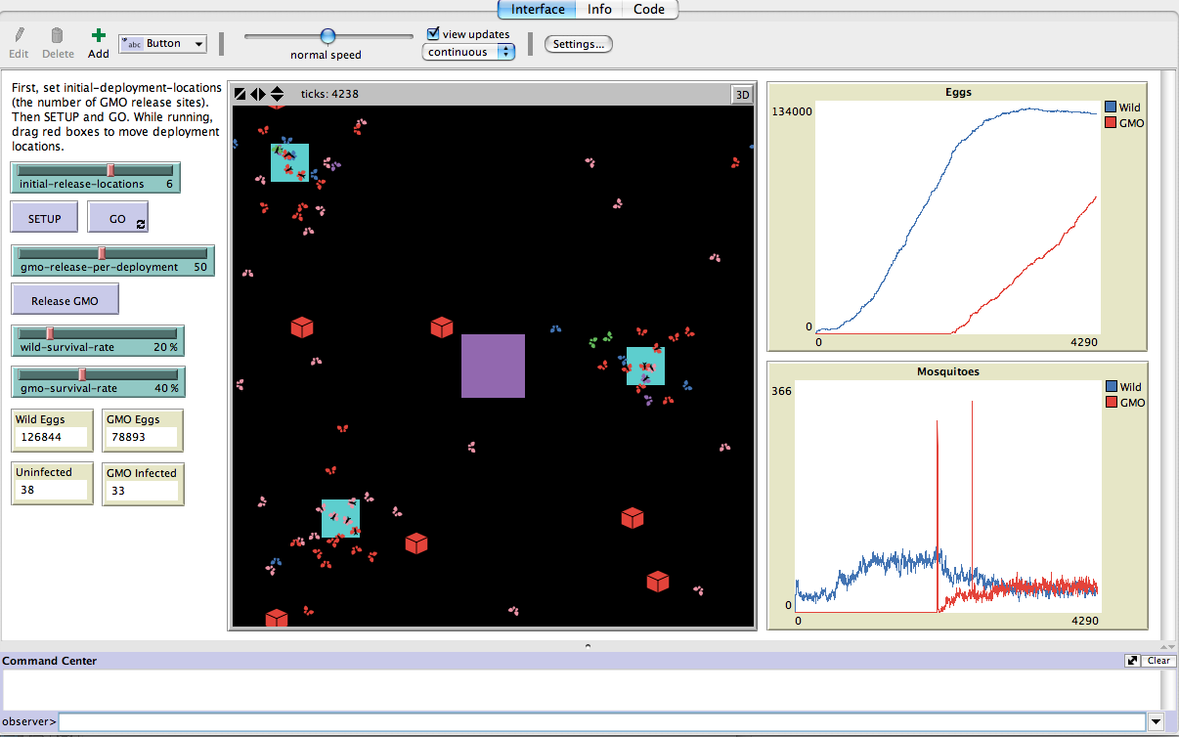

**Assumptions**

A number of assumptions were made in interest of time.

The developmental stages from egg to adult are not represented. Eggs simpley hatch and produce an adult mosquito that is ready to mate. To counter the lack of temporal delay while the mosquito develops through the lifecycle, I have up to one egg hatch per patch, per tick. To simplify the code and reduce clutter int eh environment, there are no GMO female offspring, since they will not survive to adult hood. The initial wild egg count on water patches is hard coded to a random number from zero to 49. As explained earlier, this is only intended to kick start a preexisting population. A mating compatibility variable exists to add a challenge to the success of mating. Without this in place, the mosquitoes would not need to seek a mate. They would simpley spawn and imedieatly mate with the nearest suitable partner. The random compatibility forces the agent to move around and actually seek out a mate. In nature the pregnant females rest to allow the eggs to develop after she feeds on the nessacery protiens, blood. To mimic this behavior, I added a hard coded rest period of 5 ticks that must elapse before eggs can be laid. This period can elapse while the female is seeking a water patch. Another assumption is pregnant females head straight for water. In reality they need to feed to develop the eggs so they would not go straight to water. In seeking water they were given a vision cone of 180 degrees and distance of 10. In addition to these assumptions, there are a number of random values generated to maintain variability in the model.

|  |  |  |  |
| --- | --- | --- | --- |
| **Color** | **Sex** | **GMO Infected** | **Pregnant** |
| **Macintosh HD:Users:scoogan:Desktop:Screen Shot 2016-04-25 at 10.17.47 PM.png** | **Female** | **Wild (non-GMO)** | **No** |
| **Macintosh HD:Users:scoogan:Desktop:Screen Shot 2016-04-25 at 10.18.06 PM.png** | **Female** | **Wild (non-GMO)** | **Yes** |
| **Macintosh HD:Users:scoogan:Desktop:Screen Shot 2016-04-25 at 10.17.09 PM.png** | **Female** | **GMO** | **Yes** |
| **Macintosh HD:Users:scoogan:Desktop:Screen Shot 2016-04-25 at 10.17.31 PM.png** | **Male** | **Wild (non-GMO)** | **N/A** |
| **Macintosh HD:Users:scoogan:Desktop:Screen Shot 2016-04-25 at 10.18.40 PM.png** | **Male** | **GMO** | **N/A** |

Random Values:

* Life expectancy – Males 3-10, Females 3-50
* Compatibility value – 0-9
* Max pregnancies in a lifetime – 0-3
* Number of eggs laid per pregnancy – 0-299

**Agent Identification**

Agents are identified by color that is changed and checked based on reproductive events and GMO status.

**Agent Relationships**

**Verification & Validation**

The primary methods of verification employed were inspection. Debug statements using show and show word were used to confirm correct values were produced and procedures were utilized correctly. Iterative development was used in coding and testing small features and procedures before incorporating them into the main code base. Verification in the environment was performed by watching and following agents and patches to confirm the correct behavior and values.

Design process

Decisions (sean and haotian)

Assumptions (sean)

Agent ID (Sean)

Rule determination (sean)

Agent relationships (haotian)

V&V

Verification – “is the model correct” (sean)

Debug using show and show word to confirm correct values

Iterative development coding and test small features and procedures before incorporating them into the main code base

Watch and follow agents and patches to confirm the correct behavior and values

Validation – “is it the correct model” (haotian)

# Appendix B – Code

**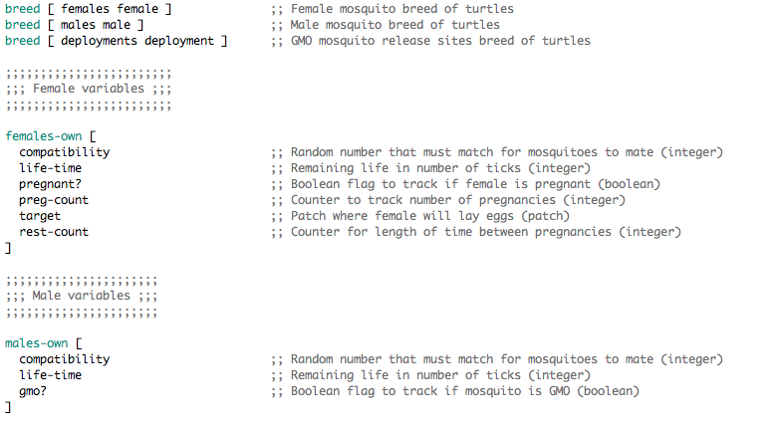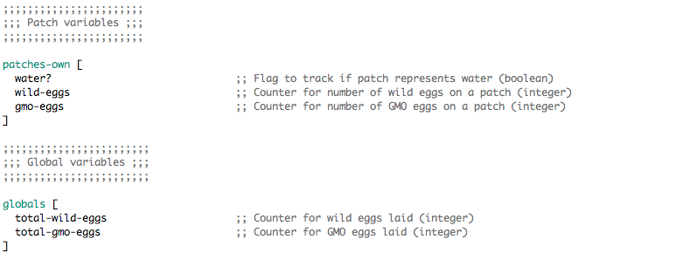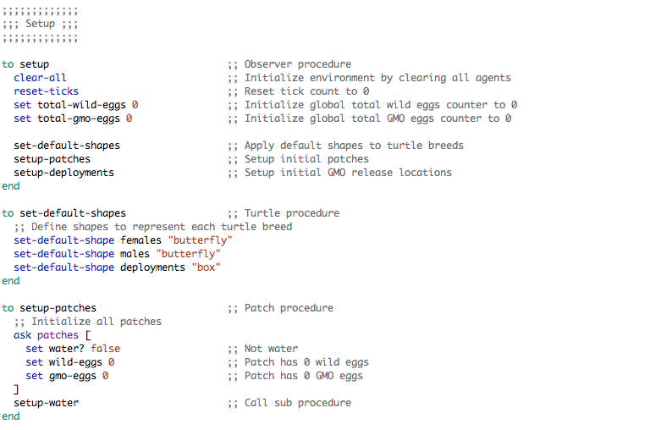**

**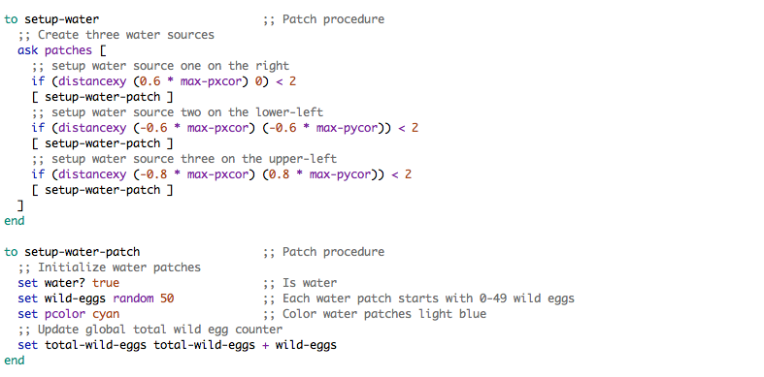**

**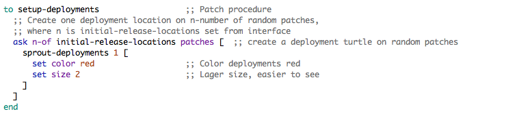**

**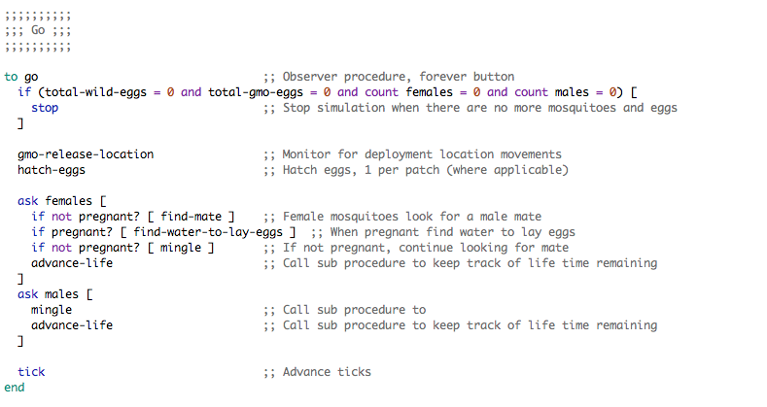**

**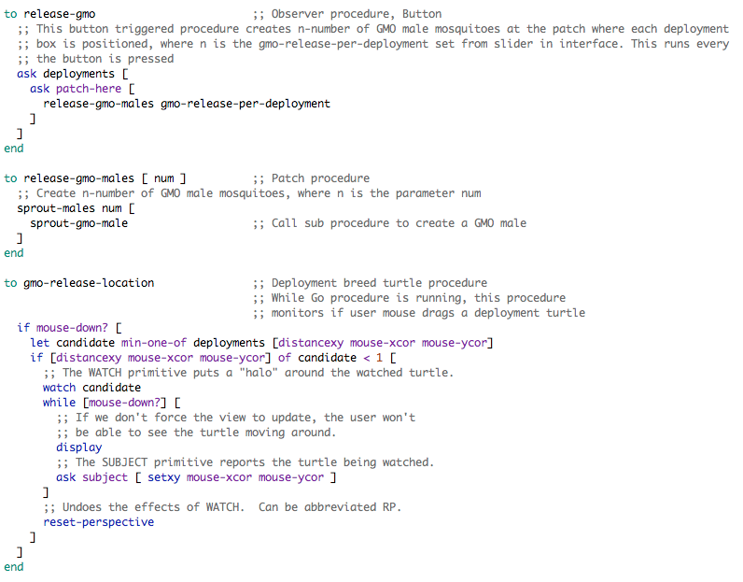**

**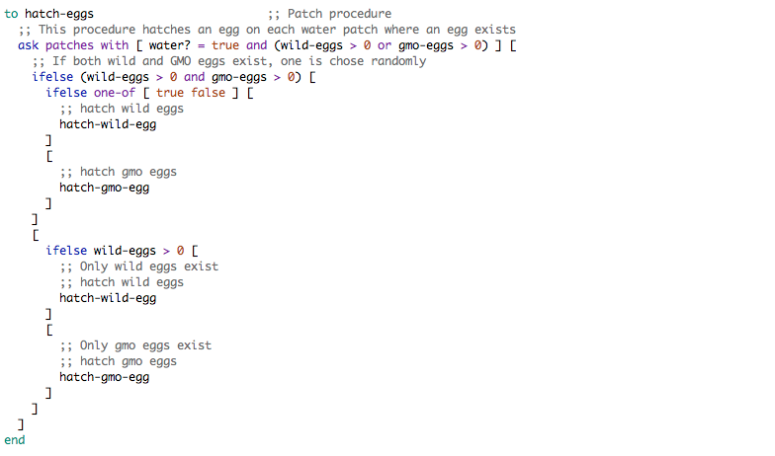**

**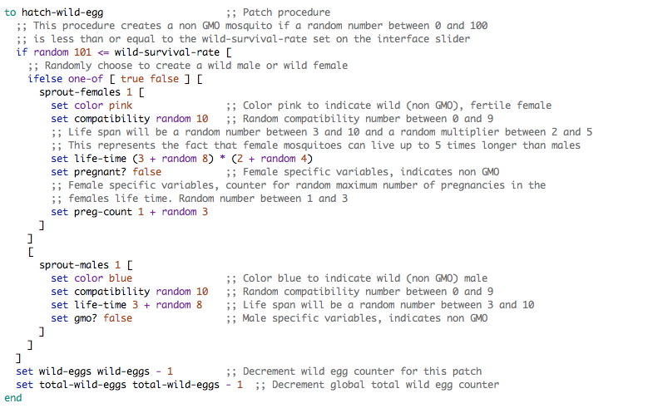**

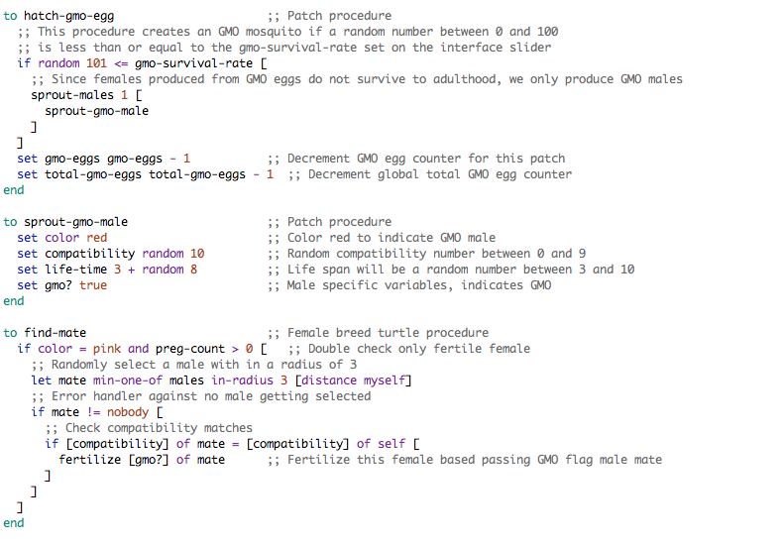

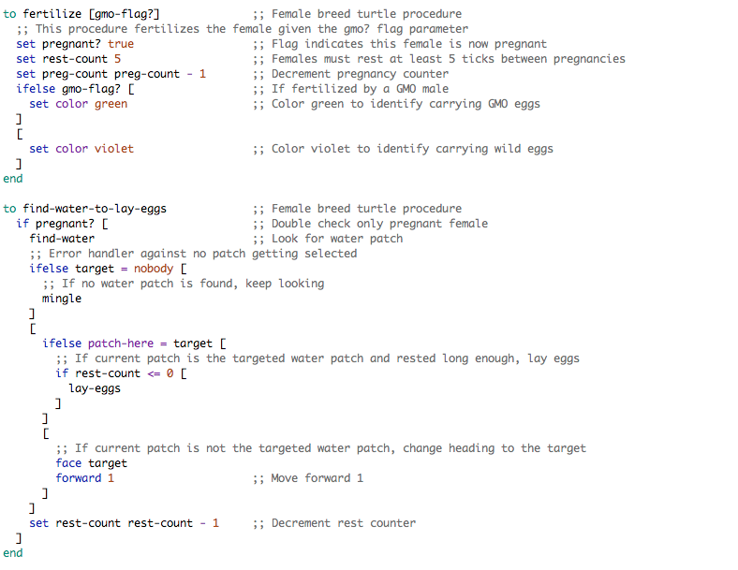

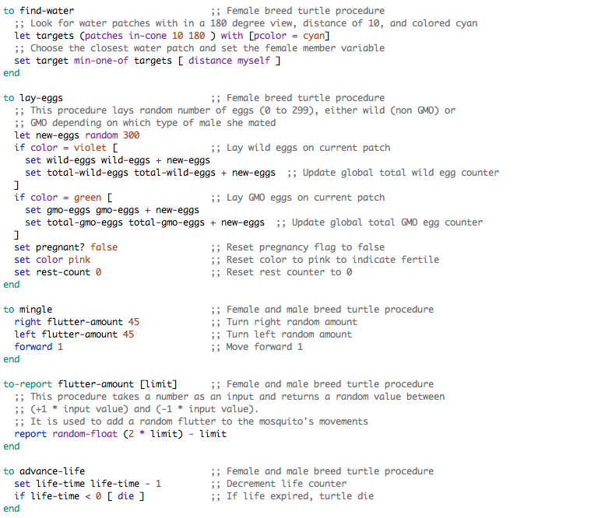

# Appendix C – Project Proposal