This Test Run uses to code in project3_stone_challange_pom.
It is run with the pom_test_trial_page.py file.
A browser window is opened and directed to the https://techstepacademy.com/trial-of-the-stones website.

Step0: The string “rock” is entered into the input associated with the section called Riddle Of Stone.
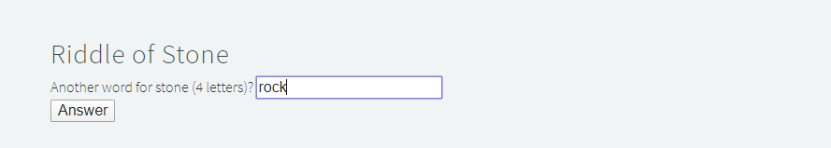

Step1: The button with the text “Answer” in the Riddle Of Stone section is clicked. A hidden word appears.
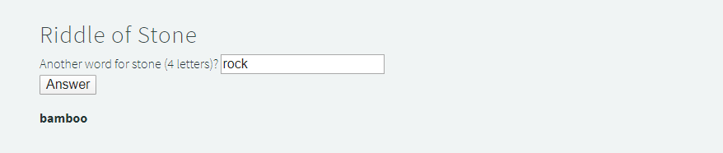

Step2: The hidden word “bamboo” is entered into the input associated with the Riddle Of Secrets section.
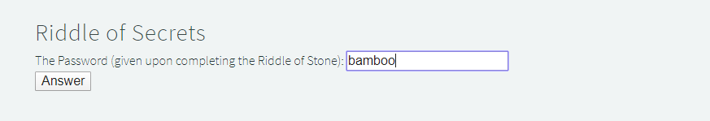

Step3: The button with the text “Answer” in the Riddle Of Secrets section is clicked. A hidden word appears.
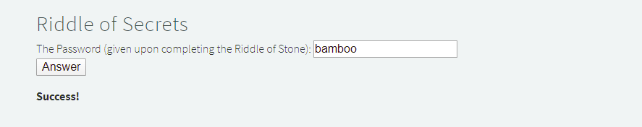
Step4: The name of the merchant with the higher wealth is entered into the input associated with The Two Merchants section.
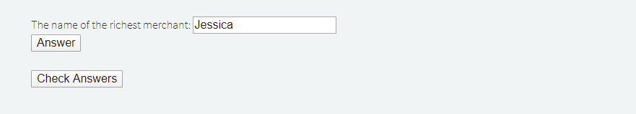

Step5: The button with the text “Answer” in The Two Merchants section is clicked. A hidden word appears.
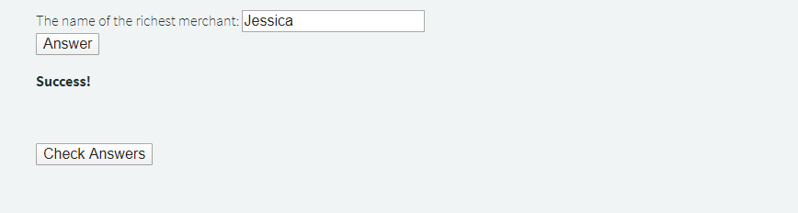

Step6: The button with the text “Answer” in The Two Merchants section is clicked. A hidden word appears.
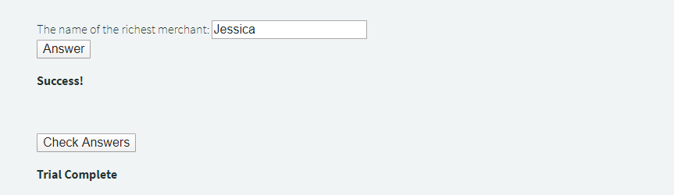

Step7: The string “Test Passed” is printed on the commandline.
