**Programming AE2**

**Sean Davies**

**2243317D**

The program I created meets most of the specifications. The program will leave characters other than uppercase letters in the text file unaffected. It checks that there are duplicate characters in the keyword in the case of the monoalphabetic cipher. It also checks the validity of the keyword: only upper-case letters otherwise the user is prompted to correct the keyword. I have not implemented the VCipher using a two-dimensional array. The method I used involved shifting the array index using the index of the current keyword character as an offset and then using the remainder operator (Modular arithmetic) to ensure that the characters shifted off the end of the array bounds are cycled back.

In the case of the VCipher under normal circumstances the program progresses through the keyword characters but when the program encounters a message character that is not an upper-case letter it halts this process. The letter frequency report shows the frequencies of the encrypted message if performing an encryption or the frequencies of the decrypted message if performing a decryption.

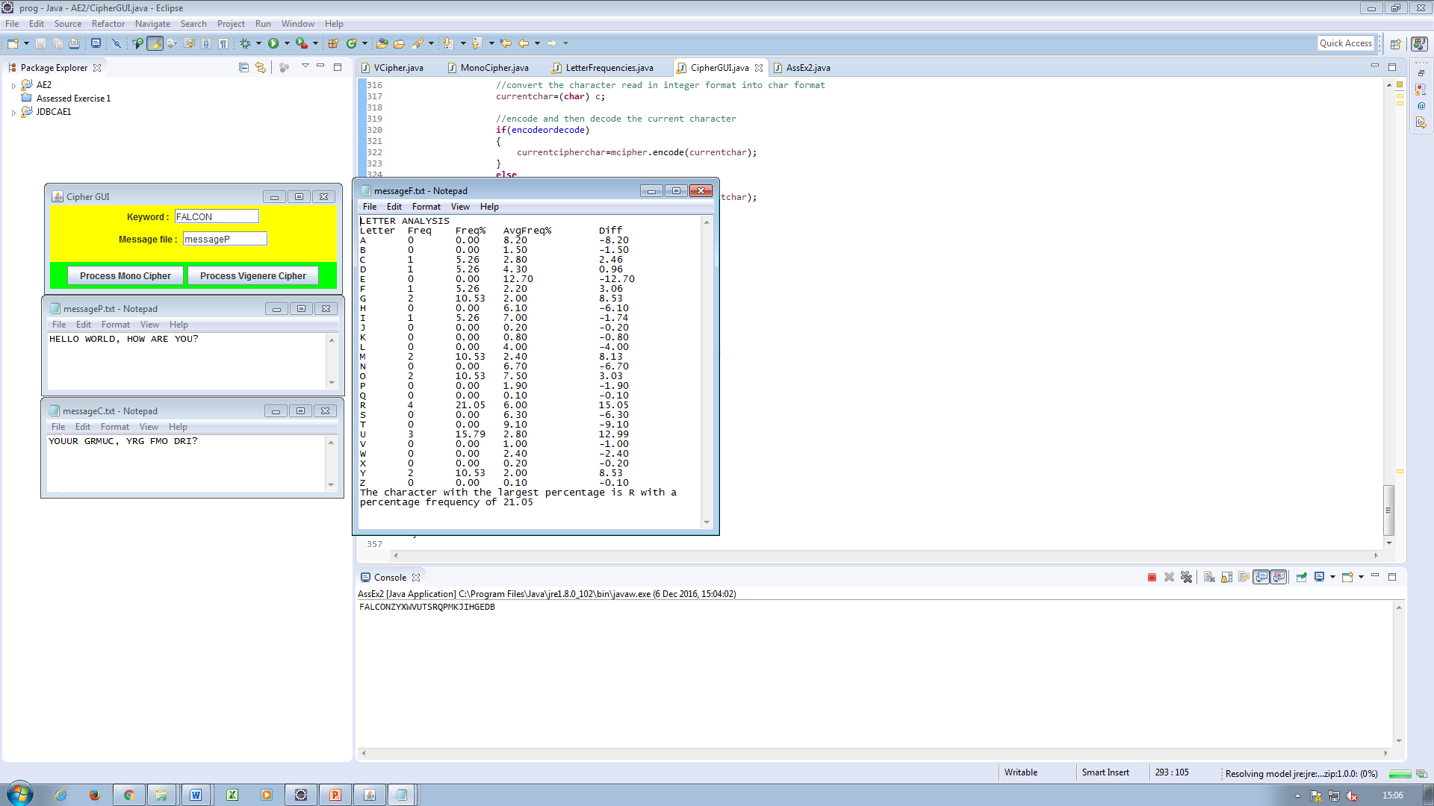

Figure 1: This shows that the cipher generated from the keyword in the case of the monocipher is as it should be. It also demonstrates that the success of the encryption algorithm.

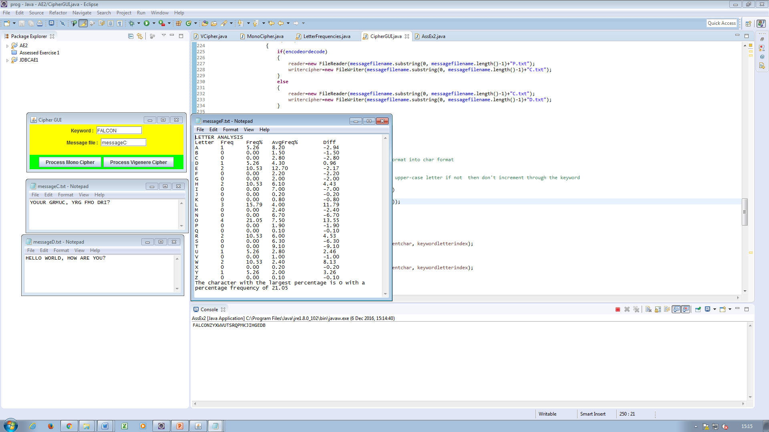

Figure 2: This demonstrates the success of the decryption algorithm. The frequency report of the decrypted message is also shown.

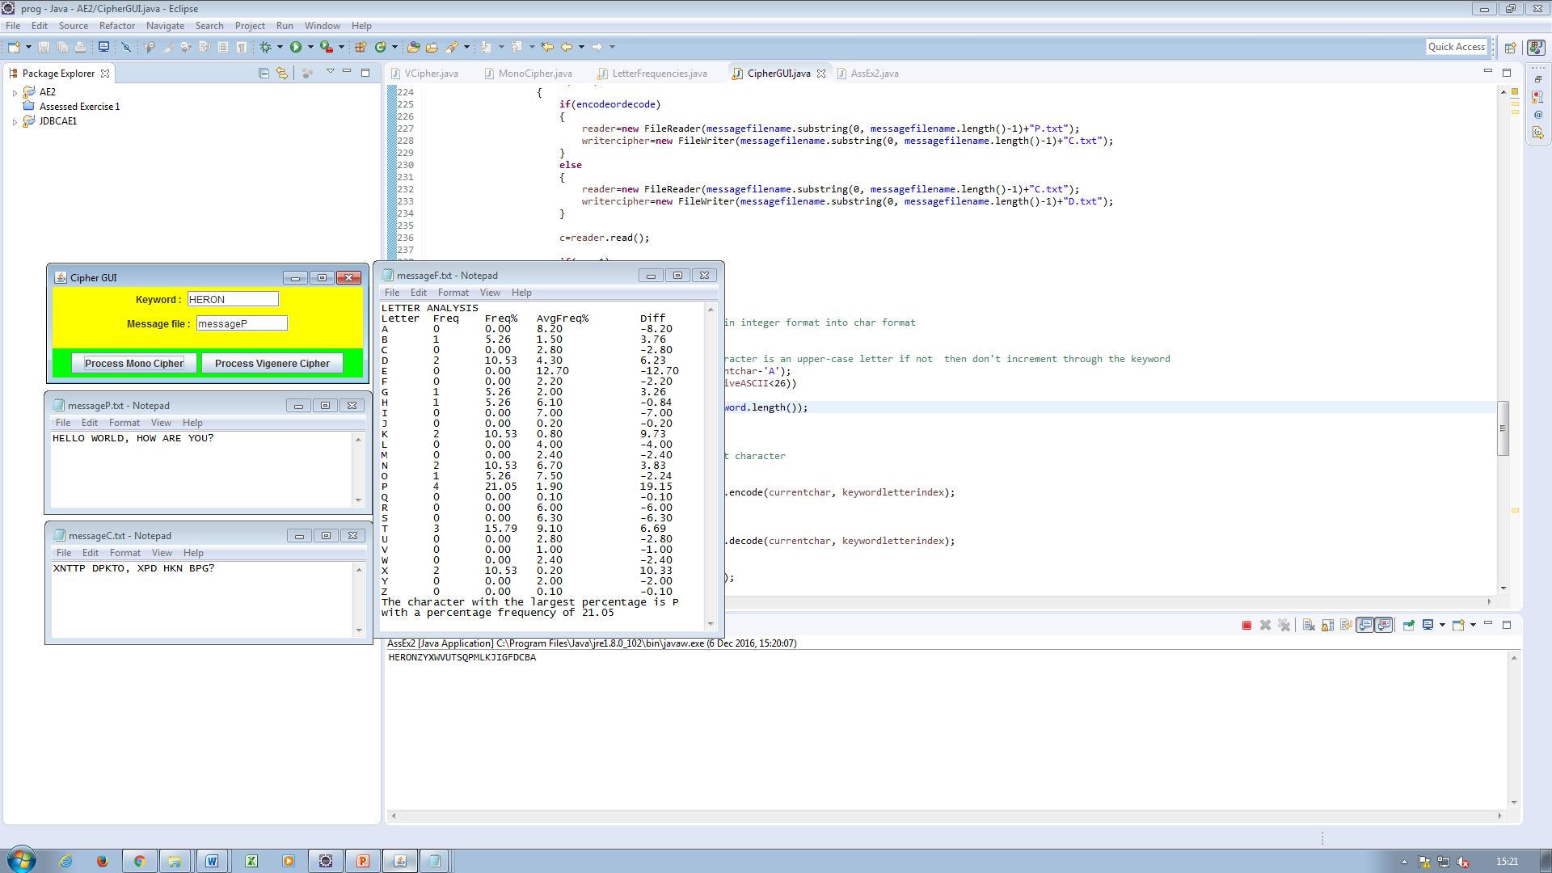

Figure 3: Another monocipher encryption demonstration.

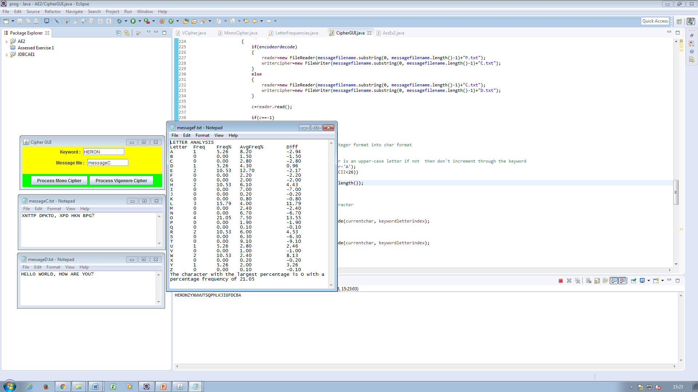

Figure 4: This shows the decryption of the previous encryption.

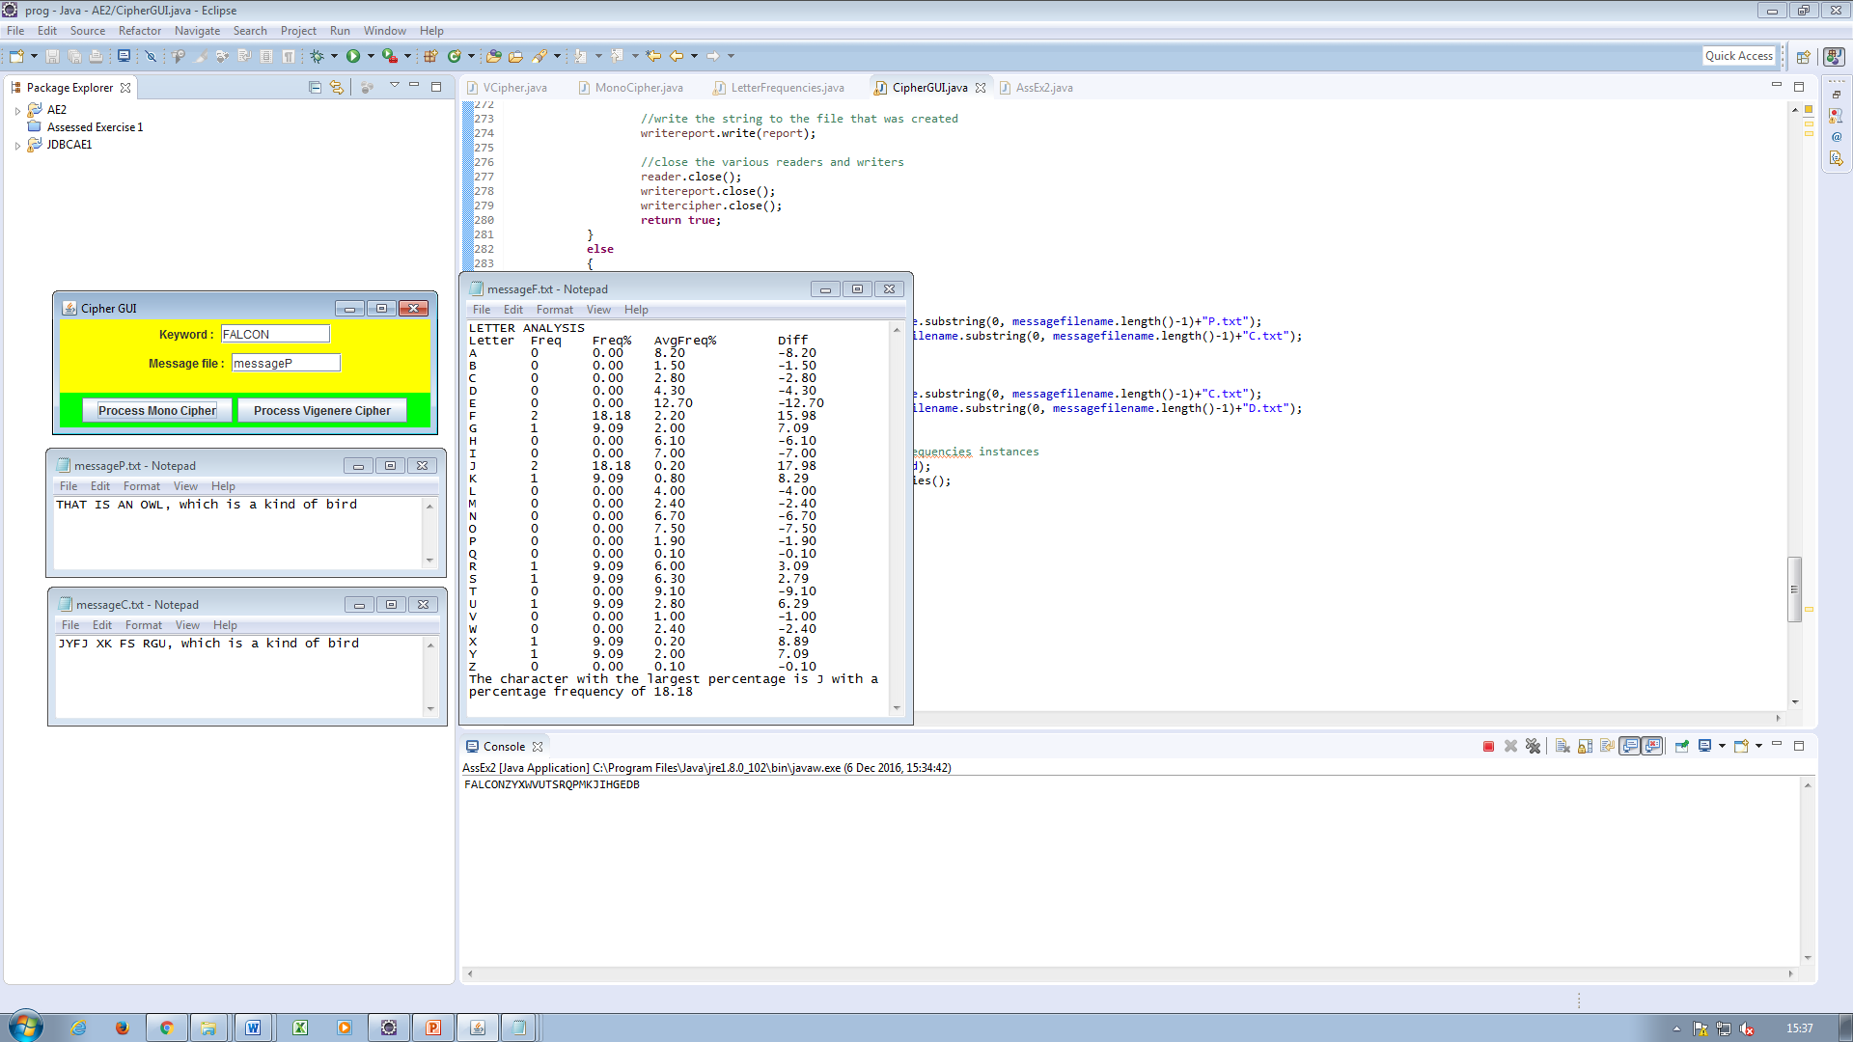

Figure 5: Yet another demonstration of the moncipher functionality, showing how the program handles non-alphabetic characters and lower case letters.

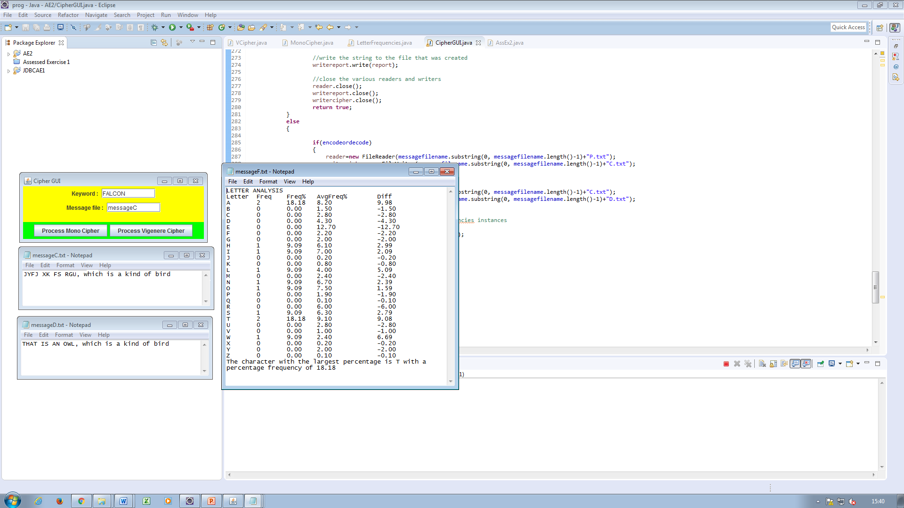

Figure 6: This shows the decryption of the previously encrypted message.

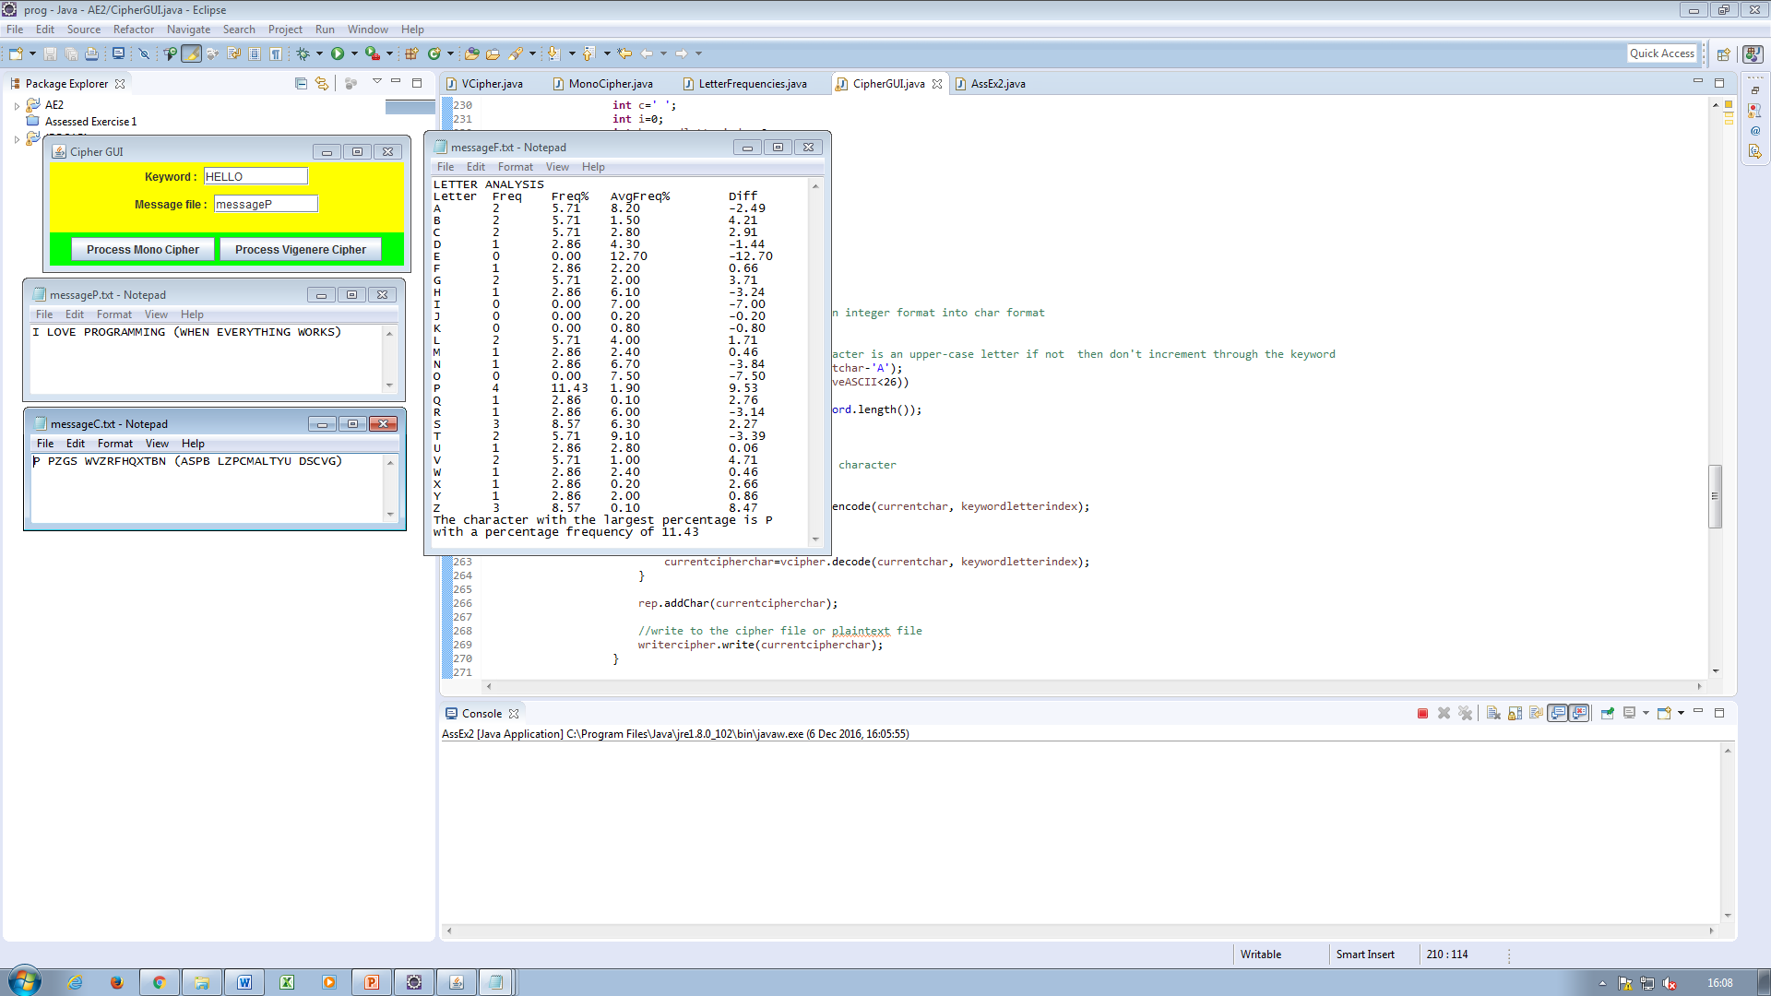

Figure 7: This demonstrates the Vigenere cipher encryption.

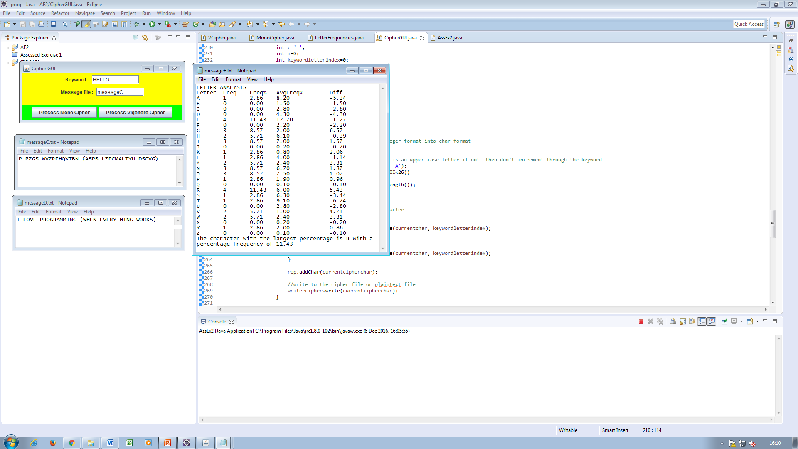

Figure 8: This shows the decryption of the previously encrypted message.

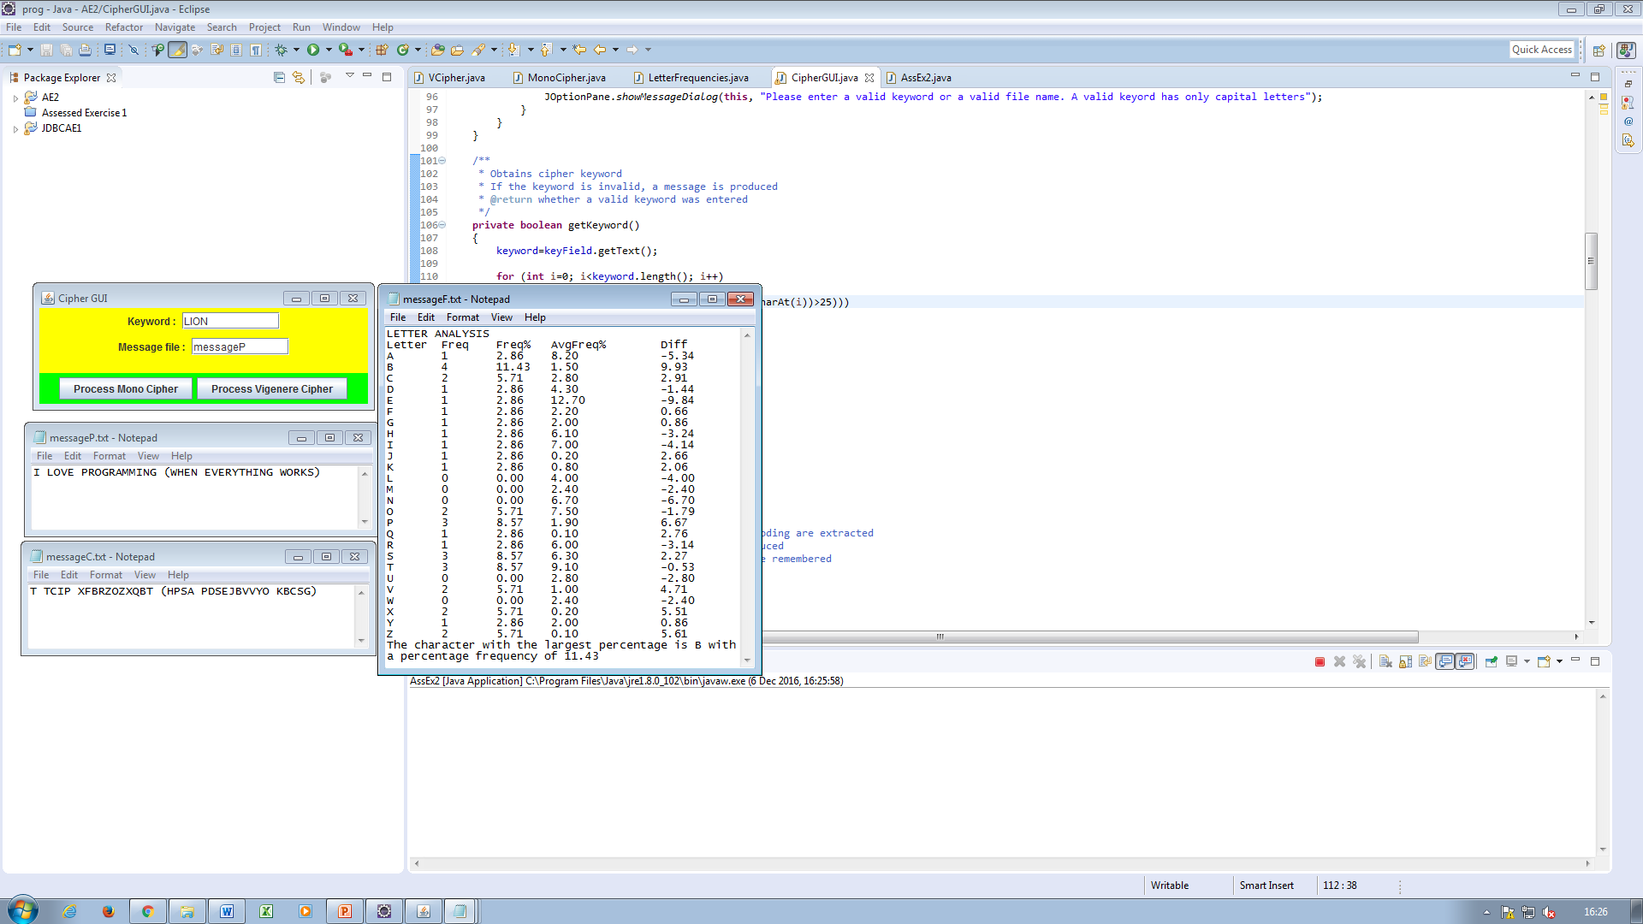

Figure 9: Another Vigenere encryption.

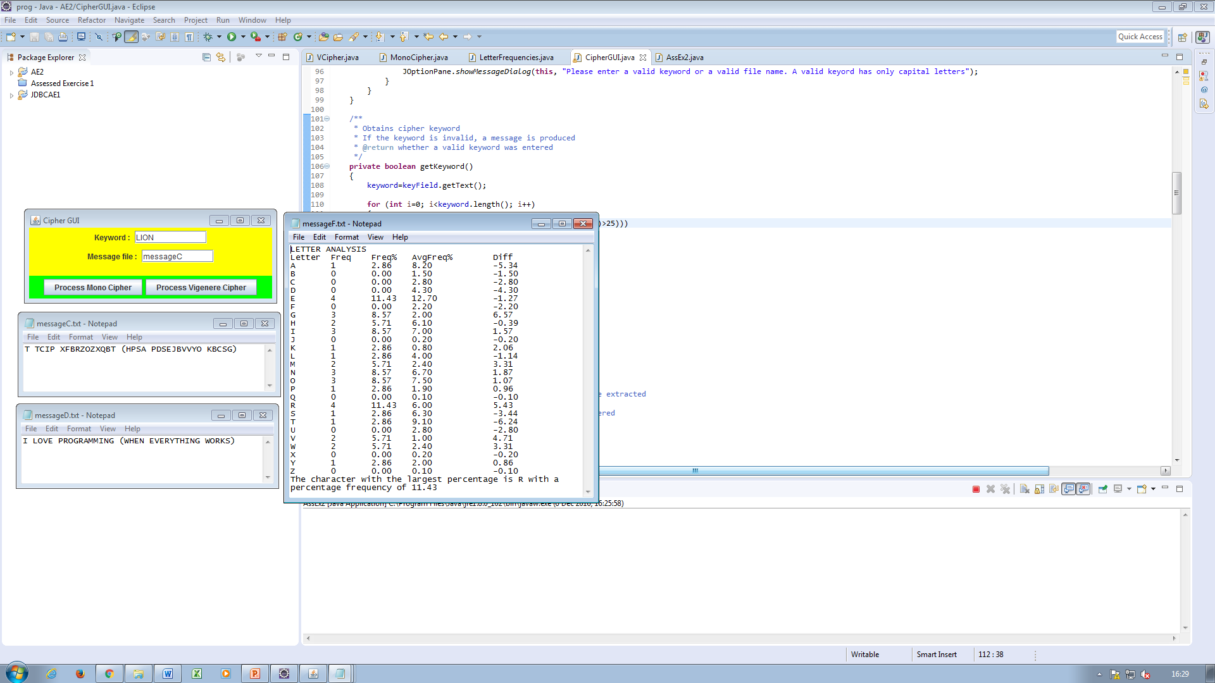

Figure 10: Vigenere decryption of the previously encrypted file.

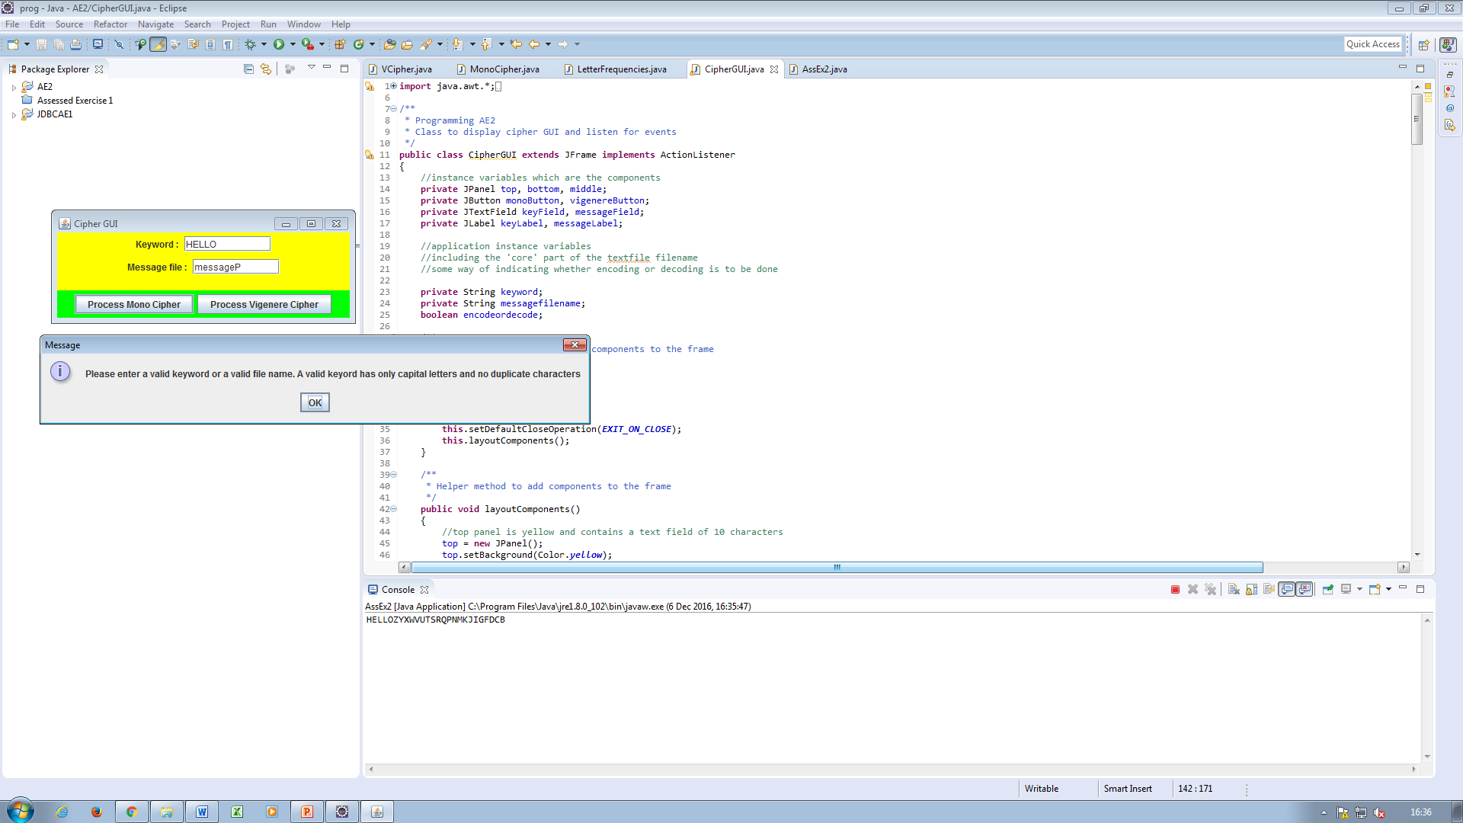

Figure 11: This image shows what happens when the user tries to process the file if there are duplicate characters in the keyword.

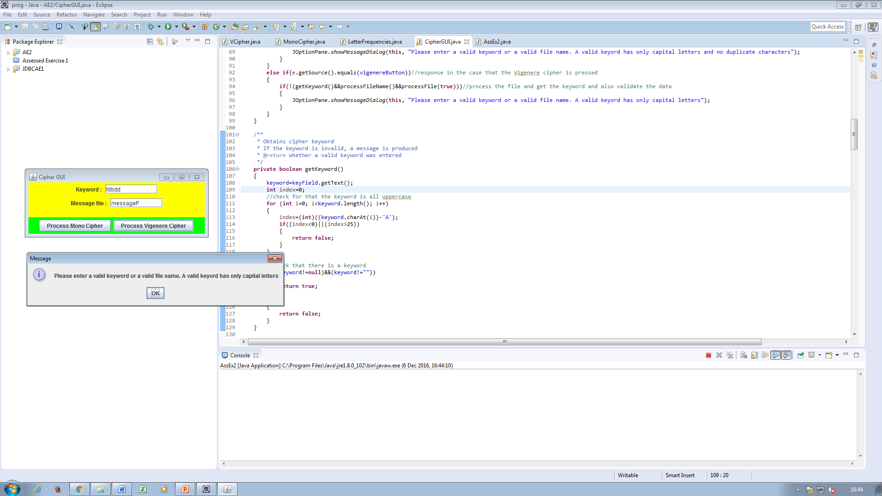

Figure 12: This is what happens when the user attempts to process a cipher with an invalid keyword.

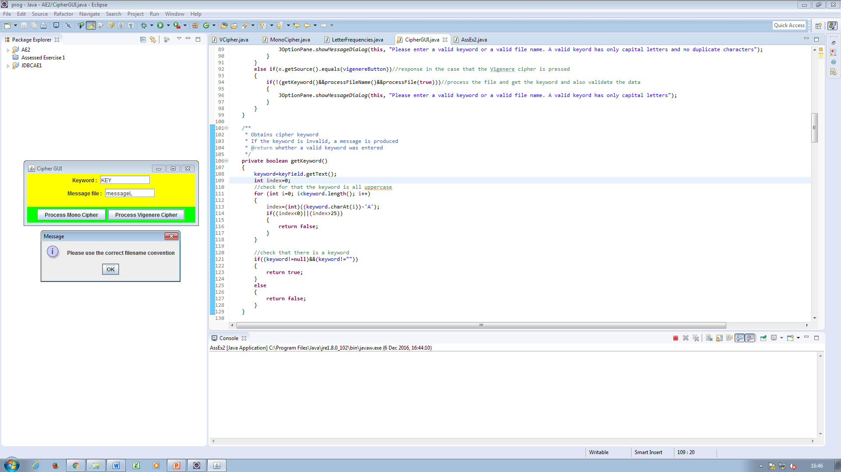

Figure 13: This is what is displayed if the user uses an incorrect file name convention.