对象的序列化（Serialization）用于将对象编码成一个字节流，以及从字节流中重新构建对象。“将一个对象编码成一个字节流”称为序列化该对象（Serializing）；相反的处理过程称为反序列化（Deserializing）。

Java内建序列化机制
Java序列化机制将对象转换为连续的byte数据，这些数据可以在日后还原为原先的对象状态，该机制还能自动处理不同操作系统上的差异，在Windows系统上序列化的Java对象，可以在UNIX系统上被重建出来，不需要担心不同机器上的数据表示方法，也不需要担心字节排列次序。
在Java中，使一个类的实例可被序列化非常简单，只需要在类声明中加入implements Serializable即可。Serializable接口是一个标志，不具有任何成员函数，其定义如下：
public interface Serializable {
}
Serializable接口没有任何方法，所以不需要对类进行修改，Block类通过声明它实现了Serializable 接口，立即可以获得Java提供的序列化功能。代码如下：
public class Block implements Writable, Comparable<Block>, Serializable
由于序列化主要应用在与I/O相关的一些操作上，其实现是通过一对输入/输出流来实现的。如果想对某个对象执行序列化动作，可以在某种OutputStream对象的基础上创建一个对象流ObjectOutputStream对象，然后调用writeObject()就可达到目的。
writeObject()方法负责写入实现了Serializable接口对象的状态信息，输出数据将被送至该OutputStream。多个对象的序列化可以在ObjectOutputStream对象上多次调用writeObject()，分别写入这些对象。下面是序列化对象的例子：
Block block1=new Block(7806259420524417791L,39447755L,56736651L);
... ...
ByteArrayOutputStream out =new ByteArrayOutputStream();
ObjectOutputStream objOut=new ObjectOutputStream(out);
objOut.writeObject(block1);
但是，序列化以后的对象在尺寸上有点过于充实了，以Block类为例，它只包含3个长整数，但是它的序列化结果竟然有112字节。包含3个长整数的Block对象的序列化结果如下：
-84, -19, 0, 5, 115, 114, 0, 23, 111, 114, 103, 46, 115, 101, 97, 110, 100, 101, 110, 103, 46, 116, 101, 115, 116, 46, 66, 108, 111, 99, 107, 40, -7, 56, 46, 72, 64, -69, 45, 2, 0, 3, 74, 0, 7, 98, 108, 111, 99, 107, 73, 100, 74, 0, 16, 103, 101, 110, 101, 114, 97, 116, 105, 111, 110, 115, 83, 116, 97, 109, 112, 74, 0, 8, 110, 117, 109, 66, 121, 116, 101, 115, 120, 112, 108, 85, 103, -107, 104, -25, -110, -1, 0, 0, 0, 0, 3, 97, -69, -117, 0, 0, 0, 0, 2, 89, -20, -53

Hadoop序列化机制
和Java序列化机制不同（在对象流ObjectOutputStream对象上调用writeObject()方法），Hadoop的序列化机制通过调用对象的write()方法（它带有一个类型为DataOutput的参数），将对象序列化到流中。反序列化的过程也是类似，通过对象的readFields()，从流中读取数据。值得一提的是，Java序列化机制中，反序列化过程会不断地创建新的对象，但在Hadoop的序列化机制的反序列化过程中，用户可以复用对象，这减少了Java对象的分配和回收，提高了应用的效率。
public static void main(String[] args) {
try {
Block block1 = new Block(1L,2L,3L);
... ...
ByteArrayOutputStream bout = new ByteArrayOutputStream();
DataOutputStream dout = new DataOutputStream();
block1.write(dout);
dout.close();
... ...
}
... ...
}
由于Block对象序列化时只输出了3个长整数，block1的序列化结果一共有24字节。

Hadoop Writable机制
Hadoop引入org.apache.hadoop.io.Writable接口，作为所有可序列化对象必须实现的接口，在eclipse开发工具里看到的大纲视图如下：
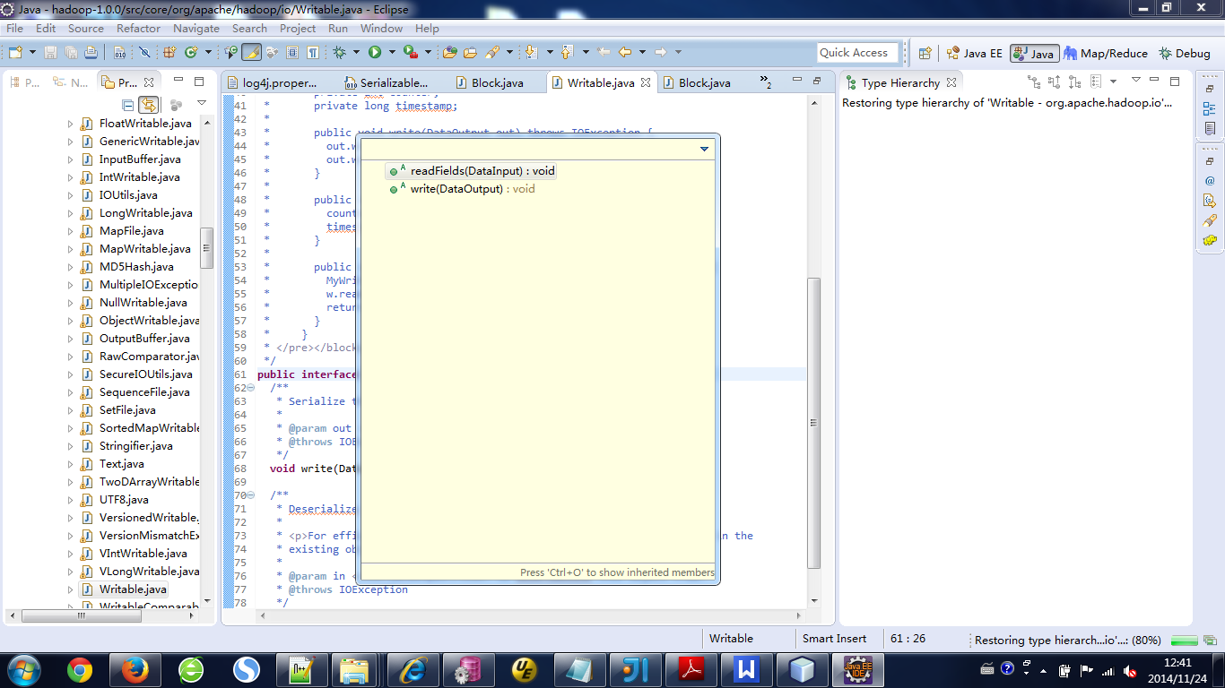
和java.io.Serializable不同，Writable接口不是一个说明性接口，它包含两个方法：
public interface Writable {
/**
* Serialize the fields of this object to <code>out</code>.
* @param out <code>DataOuput</code> to serialize this object into.
* @throws IOException
*/
void write(DataOutput out) throws IOException;
/**
* Deserialize the fields of this object from <code>in</code>.
* For efficiency, implementations should attempt to re-use storage in the
* existing object where possible.</p>
* @param in <code>DataInput</code> to deseriablize this object from.
* @throws IOException
*/
void readFields(DataInput in) throws IOException;
}
Writable.write(DataOutput out)方法用于将对象写入二进制的DataOutput中，反序列化的过程由readFields(DataInput in)从DataInput流中读取状态完成。下面是一个例子：
public class Block {
private long blockId;
private long numBytes;
private long generationsStamp;
public void write(DataOutput out) throws IOException {
out.writeLong(blockId);
out.writeLong(numBytes);
out.writeLong(generationsStamp);
}
public void readFields(DataInput in) throws IOException {
this.blockId = in.readLong();
this.numBytes = in.readLong();
this.generationsStamp = in.readLong();
if (numBytes < 0 ) {
throw new IOException("Unexpected block size:" + numBytes);
}
}
}
Hadoop序列化机制中还包括另外几个重要接口：WritableComparable、RawComparator和WritableComparator。
Comparable是一个对象本身就已经支持自比较所需要实现的接口（如Integer自己就可以完成比较大小操作），实现Comparable接口的方法compareTo()，通过传入要比较的对象即可进行比较。
而Comparator是一个专用的比较器，可以完成两个对象之间大小的比较。实现Comparator接口的compare()方法，通过传入需要比较的两个对象来实现对两个对象之间大小的比较。

典型的Writable类详解

Java基本类型的Writable封装
Java基本类型对应的Writable封装如下表：
Java基本类型 | Writable
布尔型(Boolean) | BooleanWritable
字节型(byte) | ByteWritable
整型(int) | IntWritable  VIntWritable
浮点型(float) | FloatWritable
长整型(long) | LongWritable  VLongWritable
双精度浮点型(double) | DoubleWritable
下面以VIntWritable为例，代码如下：
public class VIntWritable implements WritableComparable {
private int value;
public VIntWritable() {}
public VIntWritable(int value) { set(value); }
/** Set the value of this VIntWritable. */
public void set(int value) { this.value = value; }
/** Return the value of this VIntWritable. */
public int get() { return value; }
public void readFields(DataInput in) throws IOException {
value = WritableUtils.readVInt(in);
}
public void write(DataOutput out) throws IOException {
WritableUtils.writeVInt(out, value);
}
/** Compares two VIntWritables. */
public int compareTo(Object o) {
int thisValue = this.value;
int thatValue = ((VIntWritable)o).value;
return (thisValue < thatValue ? -1 : (thisValue == thatValue ? 0 : 1));
}
}
VIntWritable是通过调用Writable工具类中提供的readVInt()和writeVInt()读/写数据。

ObjectWritable类的实现
针对类实例，ObjectWritable提供了一个封装。相关代码如下：
public class ObjectWritable implements Writable, Configurable {
private Class declaredClass;
private Object instance;
private Configuration conf;
public ObjectWritable() {}
public ObjectWritable(Object instance) {
set(instance);
}
public ObjectWritable(Class declaredClass, Object instance) {
this.declaredClass = declaredClass;
this.instance = instance;
}
/** Return the instance, or null if none. */
public Object get() { return instance; }
/** Return the class this is meant to be. */
public Class getDeclaredClass() { return declaredClass; }
/** Reset the instance. */
public void set(Object instance) {
this.declaredClass = instance.getClass();
this.instance = instance;
}
public void readFields(DataInput in) throws IOException {
readObject(in, this, this.conf);
}
public void write(DataOutput out) throws IOException {
writeObject(out, instance, declaredClass, conf);
}
/** Write a {@link Writable}, {@link String}, primitive type, or an array of
* the preceding. */
public static void writeObject(DataOutput out, Object instance,
Class declaredClass,
Configuration conf) throws IOException {
if (instance == null) { // null
instance = new NullInstance(declaredClass, conf);
declaredClass = Writable.class;
}
UTF8.writeString(out, declaredClass.getName()); // always write declared
if (declaredClass.isArray()) { // array
int length = Array.getLength(instance);
out.writeInt(length);
for (int i = 0; i < length; i++) {
writeObject(out, Array.get(instance, i),
declaredClass.getComponentType(), conf);
}
} else if (declaredClass == String.class) { // String
UTF8.writeString(out, (String)instance);
} else if (declaredClass.isPrimitive()) { // primitive type
if (declaredClass == Boolean.TYPE) { // boolean
out.writeBoolean(((Boolean)instance).booleanValue());
} else if (declaredClass == Character.TYPE) { // char
out.writeChar(((Character)instance).charValue());
} else if (declaredClass == Byte.TYPE) { // byte
out.writeByte(((Byte)instance).byteValue());
} else if (declaredClass == Short.TYPE) { // short
out.writeShort(((Short)instance).shortValue());
} else if (declaredClass == Integer.TYPE) { // int
out.writeInt(((Integer)instance).intValue());
} else if (declaredClass == Long.TYPE) { // long
out.writeLong(((Long)instance).longValue());
} else if (declaredClass == Float.TYPE) { // float
out.writeFloat(((Float)instance).floatValue());
} else if (declaredClass == Double.TYPE) { // double
out.writeDouble(((Double)instance).doubleValue());
} else if (declaredClass == Void.TYPE) { // void
} else {
throw new IllegalArgumentException("Not a primitive: "+declaredClass);
}
} else if (declaredClass.isEnum()) { // enum
UTF8.writeString(out, ((Enum)instance).name());
} else if (Writable.class.isAssignableFrom(declaredClass)) { // Writable
UTF8.writeString(out, instance.getClass().getName());
((Writable)instance).write(out);
} else {
throw new IOException("Can't write: "+instance+" as "+declaredClass);
}
}
/** Read a {@link Writable}, {@link String}, primitive type, or an array of
* the preceding. */
public static Object readObject(DataInput in, Configuration conf)
throws IOException {
return readObject(in, null, conf);
}
/** Read a {@link Writable}, {@link String}, primitive type, or an array of
* the preceding. */
@SuppressWarnings("unchecked")
public static Object readObject(DataInput in, ObjectWritable objectWritable, Configuration conf)
throws IOException {
String className = UTF8.readString(in);
Class<?> declaredClass = PRIMITIVE_NAMES.get(className);
if (declaredClass == null) {
try {
declaredClass = conf.getClassByName(className);
} catch (ClassNotFoundException e) {
throw new RuntimeException("readObject can't find class " + className, e);
}
}
Object instance;
if (declaredClass.isPrimitive()) { // primitive types
if (declaredClass == Boolean.TYPE) { // boolean
instance = Boolean.valueOf(in.readBoolean());
} else if (declaredClass == Character.TYPE) { // char
instance = Character.valueOf(in.readChar());
} else if (declaredClass == Byte.TYPE) { // byte
instance = Byte.valueOf(in.readByte());
} else if (declaredClass == Short.TYPE) { // short
instance = Short.valueOf(in.readShort());
} else if (declaredClass == Integer.TYPE) { // int
instance = Integer.valueOf(in.readInt());
} else if (declaredClass == Long.TYPE) { // long
instance = Long.valueOf(in.readLong());
} else if (declaredClass == Float.TYPE) { // float
instance = Float.valueOf(in.readFloat());
} else if (declaredClass == Double.TYPE) { // double
instance = Double.valueOf(in.readDouble());
} else if (declaredClass == Void.TYPE) { // void
instance = null;
} else {
throw new IllegalArgumentException("Not a primitive: "+declaredClass);
}
} else if (declaredClass.isArray()) { // array
int length = in.readInt();
instance = Array.newInstance(declaredClass.getComponentType(), length);
for (int i = 0; i < length; i++) {
Array.set(instance, i, readObject(in, conf));
}
} else if (declaredClass == String.class) { // String
instance = UTF8.readString(in);
} else if (declaredClass.isEnum()) { // enum
instance = Enum.valueOf((Class<? extends Enum>) declaredClass, UTF8.readString(in));
} else { // Writable
Class instanceClass = null;
String str = "";
try {
str = UTF8.readString(in);
instanceClass = conf.getClassByName(str);
} catch (ClassNotFoundException e) {
throw new RuntimeException("readObject can't find class " + str, e);
}
Writable writable = WritableFactories.newInstance(instanceClass, conf);
writable.readFields(in);
instance = writable;
if (instanceClass == NullInstance.class) { // null
declaredClass = ((NullInstance)instance).declaredClass;
instance = null;
}
}
if (objectWritable != null) { // store values
objectWritable.declaredClass = declaredClass;
objectWritable.instance = instance;
}
return instance;
}
... ...
}
通过readFields方法反序列化一个object。而如果DataInput中传过来的是Writable 类型，则会在readObject再去调用readFields方法（writable.readFields(in)），直到DataInput中传递 的是非Writable 类型，就这样递归的反序列化DataInput中的Writable对象。
readObject()方法依赖于WritableFactories类。WritableFactories类允许非公有的Writable子类定义一个对象工厂，由该工厂创建Writable对象。相关代码如下：
public class WritableFactories {
private static final HashMap<Class, WritableFactory> CLASS_TO_FACTORY =
new HashMap<Class, WritableFactory>();
private WritableFactories() {} // singleton
/** Define a factory for a class. */
public static synchronized void setFactory(Class c, WritableFactory factory) {
CLASS_TO_FACTORY.put(c, factory);
}
/** Define a factory for a class. */
public static synchronized WritableFactory getFactory(Class c) {
return CLASS_TO_FACTORY.get(c);
}
/** Create a new instance of a class with a defined factory. */
public static Writable newInstance(Class<? extends Writable> c, Configuration conf) {
WritableFactory factory = WritableFactories.getFactory(c);
if (factory != null) {
Writable result = factory.newInstance();
if (result instanceof Configurable) {
((Configurable) result).setConf(conf);
}
return result;
} else {
return ReflectionUtils.newInstance(c, conf);
}
}
/** Create a new instance of a class with a defined factory. */
public static Writable newInstance(Class<? extends Writable> c) {
return newInstance(c, null);
}
}
WritableFacories.newInstance()方法根据输入的类型查找对应的WritableFactory工厂对象，然后调用该对象的newInstance()创建对象，如果该对象是可配置的，newInstance()还会通过对象的setConf()方法配置对象。

