gzip和zip是通用的压缩工具，在时间/空间处理上相对平衡，gzip2压缩比gzip和zip更有效，但速度较慢，而且gzip2的解压缩速度快于它的压缩速度。
当使用MapReduce处理压缩文件时，需要考虑压缩文件的可分割性。如果文件是一个bzip2格式的压缩文件，那么，MapReduce作业可以通过bzip2格式压缩文件中的块，将输入划分为若干输入分片，并从块开始处开始解压缩数据。Bzip2格式压缩文件中，块与块间提供了一个48位的同步标记，因此，bzip2支持数据分割。下表列出了一些可以用于Hadoop的常见压缩格式以及特性。
压缩格式 | UNIX工具 | 算法 | 文件扩展名 | 支持多文件 | 可分割
DEFLATE | 无 | DEFLATE | .deflate | 否 | 否
gzip | gzip | DEFLATE | .gz | 否 | 否
zip | zip | DEFLATE | .zip | 是 | 是
bzip | bzip2 | bzip2 | .bz2 | 否 | 是
LZO | lzop | LZO | .lzo | 否 | 否
目前，Hadoop支持的编码/解码器如下表：
压缩格式 | 对应的编码/解码器
DEFLATE | org.apache.hadoop.io.compress.DefaultCodec
gzip | org.apache.hadoop.io.compress.GzipCodec
bzip | org.apache.hadoop.io.compress.BZip2Codec
Snappy

Hadoop压缩API应用实例
compress()方法接受一个字符串参数，用于指定编码/解码器，并用对应的压缩算法对文本文件README.txt进行压缩。
public static void compress(String method) throws Exception {
File fileIn = new File("README.txt");
InputStream in = new FileInputStream(fileIn);
Class<?> codecClass = Class.forName(method);
Configuration conf = new Configuration();
// 通过名称找对应的编码/解码器
CompressionCodec codec = (CompressionCodec) ReflectionUtils.newInstance(codecClass, conf);
File fileOut = new File("README.txt" + codec.getDefaultExtension());
fileOut.delete();
OutputStream out = new FileOutputStream(fileOut);
// 通过编码/解码器创建对应的输出流
CompressionOutputStream cout = codec.createOutputStream(out);
// 压缩
IOUtils.copyBytes(in, cout, 4096, false);
in.close();
cout.close();
}
需要解压缩文件时，通常通过其扩展名来推断它对应的编码/解码器，进而用相应的解码流对数据进行解码。
public static void decompress(File file) throws IOException {
Configuration conf = new Configuration();
CompressionCodecFactory factory = new CompressionCodecFactory(conf) ;
// 通过文件扩展名获得相应的编码/解码器
CompressionCodec codec = factory.getCodec(new Path(file.getName()));
if (codec == null) {
System.out.println("找不到文件。");
return ;
}
File fileOut = new File(file.getName()+".txt");
InputStream in = codec.createInputStream(new FileInputStream(file));
... ...
}

Hadoop压缩框架

编码/解码器
前面已经提过，CompressionCodec接口实现了编码/解码器，使用的是抽象工厂的设计模式，用于创建一系列相关或互相依赖的对象。CompressionCodec可以获得和某一个压缩算法相关的对象，包括压缩流和解压缩流等。
public interface CompressionCodec {
/**
* Create a {@link CompressionOutputStream} that will write to the given
* {@link OutputStream}.
* @param out the location for the final output stream
* @return a stream the user can write uncompressed data to have it compressed
* @throws IOException
*/
CompressionOutputStream createOutputStream(OutputStream out)
throws IOException;
/**
* Create a {@link CompressionOutputStream} that will write to the given
* {@link OutputStream} with the given {@link Compressor}.
* @param out the location for the final output stream
* @param compressor compressor to use
* @return a stream the user can write uncompressed data to have it compressed
* @throws IOException
*/
CompressionOutputStream createOutputStream(OutputStream out,
Compressor compressor)
throws IOException;

/**
* Get the type of {@link Compressor} needed by this {@link CompressionCodec}.
* @return the type of compressor needed by this codec.
*/
Class<? extends Compressor> getCompressorType();
/**
* Create a new {@link Compressor} for use by this {@link CompressionCodec}.
* @return a new compressor for use by this codec
*/
Compressor createCompressor();
/**
* Create a stream decompressor that will read from the given input stream.
* @param in the stream to read compressed bytes from
* @return a stream to read uncompressed bytes from
* @throws IOException
*/
CompressionInputStream createInputStream(InputStream in) throws IOException;
/**
* Create a {@link CompressionInputStream} that will read from the given
* {@link InputStream} with the given {@link Decompressor}.
* @param in the stream to read compressed bytes from
* @param decompressor decompressor to use
* @return a stream to read uncompressed bytes from
* @throws IOException
*/
CompressionInputStream createInputStream(InputStream in,
Decompressor decompressor)
throws IOException; /**
* Get the type of {@link Decompressor} needed by this {@link CompressionCodec}.
* @return the type of decompressor needed by this codec.
*/
Class<? extends Decompressor> getDecompressorType();

/**
* Create a new {@link Decompressor} for use by this {@link CompressionCodec}.
* @return a new decompressor for use by this codec
*/
Decompressor createDecompressor();

/**
* Get the default filename extension for this kind of compression.
* @return the extension including the '.'
*/
String getDefaultExtension();
}
compressionCodecFactory是Hadoop压缩框架中的另一个类，它应用了工厂方法（参数化工厂方法），用于创建多种产品，如CompressionCodec，GzipCodec，BZip2Codec对象。实现代码如下：
public class CompressionCodecFactory {
/**
* A map from the reversed filename suffixes to the codecs.
* This is probably overkill, because the maps should be small, but it
* automatically supports finding the longest matching suffix.
*/
private SortedMap<String, CompressionCodec> codecs = null;
private void addCodec(CompressionCodec codec) {
String suffix = codec.getDefaultExtension();
codecs.put(new StringBuffer(suffix).reverse().toString(), codec);
}
/**
* Find the codecs specified in the config value io.compression.codecs
* and register them. Defaults to gzip and zip.
*/
public CompressionCodecFactory(Configuration conf) {
codecs = new TreeMap<String, CompressionCodec>();
List<Class<? extends CompressionCodec>> codecClasses = getCodecClasses(conf);
if (codecClasses == null) {
addCodec(new GzipCodec());
addCodec(new DefaultCodec());
} else {
Iterator<Class<? extends CompressionCodec>> itr = codecClasses.iterator();
while (itr.hasNext()) {
CompressionCodec codec = ReflectionUtils.newInstance(itr.next(), conf);
addCodec(codec);
}
}
}

/**
* Find the relevant compression codec for the given file based on its
* filename suffix.
* @param file the filename to check
* @return the codec object
*/
public CompressionCodec getCodec(Path file) {
CompressionCodec result = null;
if (codecs != null) {
String filename = file.getName();
String reversedFilename = new StringBuffer(filename).reverse().toString();
SortedMap<String, CompressionCodec> subMap =
codecs.headMap(reversedFilename);
if (!subMap.isEmpty()) {
String potentialSuffix = subMap.lastKey();
if (reversedFilename.startsWith(potentialSuffix)) {
result = codecs.get(potentialSuffix);
}
}
}
return result;
}

}
getCodec()方法的代码看似复杂，但通过灵活使用有序映射SortedMap，实现其实还是非常简单的。

压缩器和解压器
压缩器（Compressor）和解压缩器（Decompressor）中Hadoop压缩框架中的一对重要概念。Compressor可以插入压缩输出流的实现中，提供具体的压缩功能；相反，Decompressor提供具体的解压缩功能并插入CompressionInputStream中。
在eclipse开发工具中Compressor和Decompressor的大纲视图如下所示：
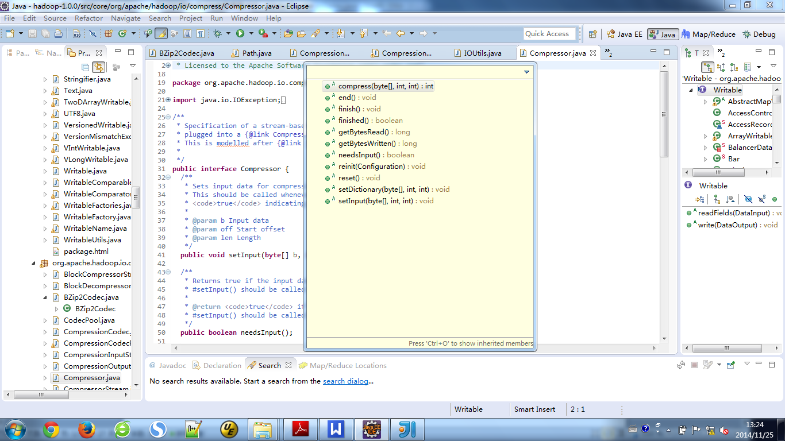
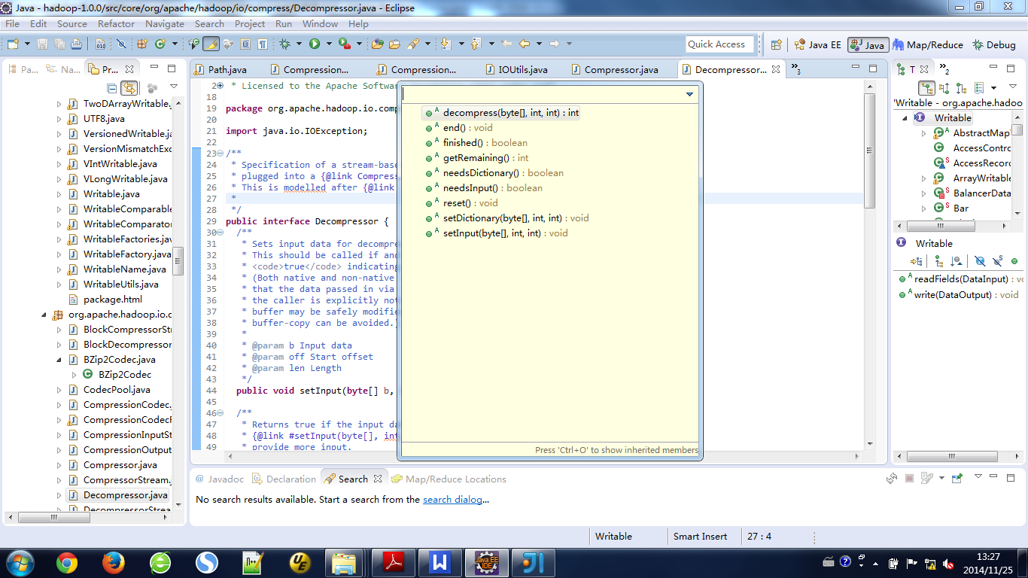
使用Compressor的一个典型实例如下：
public static void compressor() throws ClassNotFoundException, IOException {
// 读入被压缩的内容
File fileIn = new File("README.txt");
InputStream in = new FileInputStream(fileIn);
int datalength = in.available();
byte[] inbuf = new byte[datalength];
in.read(inbuf, 0, datalength);
in.close();

// 长度受限制的输出缓冲区，用于说明finished()方法
int compressorOutputBufferSize = 100;
byte[] outbuf = new byte[compressorOutputBufferSize];
Compressor compressor = new BuiltInZlibDeflater(); // 构造压缩器
int step = 100; // 一些计数器
int inputPos = 0;
int putcount = 0;
int getcount = 0;
int compressedlen = 0;

while (inputPos < datalength) {
// 进行多次setInput
int len = (datalength-inputPos>=step)?step:datalength-inputPos;
compressor.setInput(inbuf, inputPos, len);
putcount++;

while (!compressor.needsInput()) {
compressedlen = compressor.compress(outbuf, 0 , 100);
if (compressedlen>0) {
getcount++
}
}
inputPos+=step;
}
compressor.finish();
while (!compressor.finished()) {
getcount++;
compressor.compress(outbuf, 0, compressorOutputBufferSize);
}
System.out.println(compressor.getBytesRead());
System.out.println(compressor.getBytesWritten());
System.out.println(putcount);

compressor.end();
}
以上代码实现了setInput()、needsInput()、finish()、compress()和finished()的配合过程。

压缩流和解压缩流
压缩流（CompressionOutputStream）和解压缩流(CompressionInputStream)是Hadoop压缩框架中另一对重要概念，它提供了基于流的压缩解压能力。相关代码如下：
public abstract class CompressionOutputStream extends OutputStream {
/**
* The output stream to be compressed.
*/
protected final OutputStream out;
/**
* Create a compression output stream that writes
* the compressed bytes to the given stream.
* @param out
*/
protected CompressionOutputStream(OutputStream out) {
this.out = out;
}
public void close() throws IOException {
finish();
out.close();
}
public void flush() throws IOException {
out.flush();
}
/**
* Write compressed bytes to the stream.
* Made abstract to prevent leakage to underlying stream.
*/
public abstract void write(byte[] b, int off, int len) throws IOException;
/**
* Finishes writing compressed data to the output stream
* without closing the underlying stream.
*/
public abstract void finish() throws IOException;
/**
* Reset the compression to the initial state.
* Does not reset the underlying stream.
*/
public abstract void resetState() throws IOException;
}
CompressorStream使用压缩器实现了一个通用的压缩流，主要代码如下：
public class CompressorStream extends CompressionOutputStream {
protected Compressor compressor;
protected byte[] buffer;
protected boolean closed = false;
public CompressorStream(OutputStream out, Compressor compressor, int bufferSize) {
super(out);
if (out == null || compressor == null) {
throw new NullPointerException();
} else if (bufferSize <= 0) {
throw new IllegalArgumentException("Illegal bufferSize");
}
this.compressor = compressor;
buffer = new byte[bufferSize];
}
public void write(byte[] b, int off, int len) throws IOException {
// Sanity checks
if (compressor.finished()) {
throw new IOException("write beyond end of stream");
}
if ((off | len | (off + len) | (b.length - (off + len))) < 0) {
throw new IndexOutOfBoundsException();
} else if (len == 0) {
return;
}
compressor.setInput(b, off, len);
while (!compressor.needsInput()) {
compress();
}
}
protected void compress() throws IOException {
int len = compressor.compress(buffer, 0, buffer.length);
if (len > 0) {
out.write(buffer, 0, len);
}
}
public void finish() throws IOException {
if (!compressor.finished()) {
compressor.finish();
while (!compressor.finished()) {
compress();
}
}
}
public void resetState() throws IOException {
compressor.reset();
}
public void close() throws IOException {
if (!closed) {
finish();
out.close();
closed = true;
}
}
private byte[] oneByte = new byte[1];
public void write(int b) throws IOException {
oneByte[0] = (byte)(b & 0xff);
write(oneByte, 0, oneByte.length);
}
}
CompressorStream利用压缩器Compressor实现了一个通用的压缩流，在Hadoop中引入一个新的压缩算法，如果没有特殊的考虑，一般只需要实现相关的压缩器和解压缩器，然后通过CompressorStream和DecompressorStream，就实现相关压缩算法的输入/输出流了。

