Homework 5: ToDo Web Application with Database

CMSC 374: Mobile Apps

Building on Part IV of the tutorial found at https://blog.miguelgrinberg.com/post/the-flask-mega-tutorial-part-i-hello-world you will modify the application to allow input of basic information for a ToDo list. The ToDo Web App will support two web pages: one for input and one for viewing the database. You will use the Postgres database rather the the Sqlite one used in the tutorial. Once this is complete, we will be able to interact with our phones via this application.

Outline
These directions are a sketch of how you might approach this problem. You will have to fill in many details for yourself as you work.
I recommend that you download the code developed by Grinberg at the end of Part IV. This provides a good base from which to work. Of course, you need to download and install all dependencies discussed in Part I. I am assuming you have worked through the first four sections of the tutorial.

Modify localhost:5000/index to show tasks in a ToDo list.
The view.py code includes an index method (realized by the index.html template). You can modify this method and the index.html template to print a table of tasks that would look something like this when you visit localhost:5000/index. At present the data is statically created, not from a database. Here is how your index page will appear. It will work for any number of todo rows. Eventually, these will come from user input into localhost:5000/in.

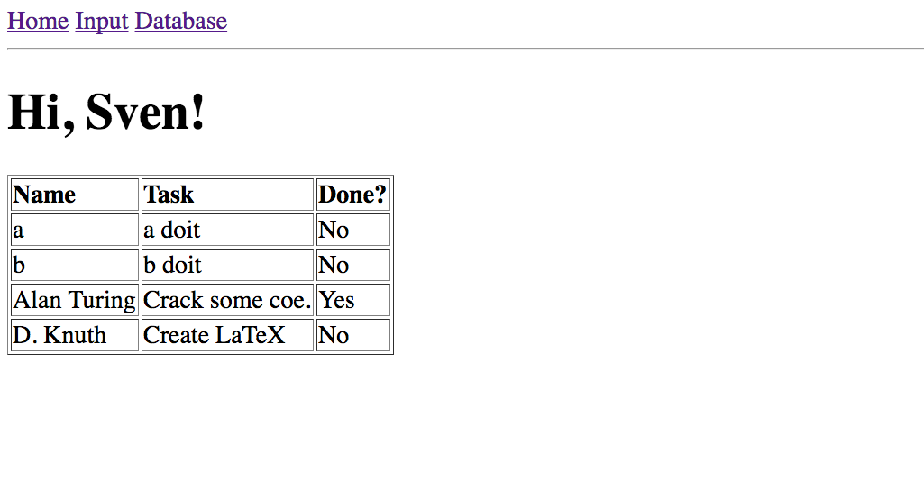
Postgres
For supporting databases on an actual live server, we will need to abandon Sqlite and use Postgres. You need to install Postgres. The Mac version is found at http://postgresapp.com/ and is very easy to use. On Ubuntu you will need to install it as follows (as superuser)

sudo apt-get install postgresql postgresql-contrib

Information on running postgres can be found at https://www.digitalocean.com/community/tutorials/how-to-install-and-use-postgresql-on-ubuntu-16-04

The postgres psql command runs a shell that allows you to create a database. (On a Mac you run the postgres.app and then start psql, whereas on Ubuntu you simply run psql from the command line.) Create you database by running
createdb tododb
Within the postgres terminal you can run
=# \list
You will see the tododb database (empty) listed. Check out postgres documentation to learn how to view rows, tables, etc.

Most of the time you will interact with the database using SQLAlchemy in Python, but directly looking at the database in psql is also quite useful. The versions of db_create.py developed in the tutorial will work just fine. I recommend that you simply ignore the material on automating the upgrade process for now.

You also need to add the following to your configuration file, config.py.
SQLALCHEMY_DATABASE_URI = 'postgresql:///tododb'
If you have any references to sqlite, get rid of them.

Database Model

Modify the user model in the database (models.py) so that it maintains four fields:
- id (unique, primary key)
- nickname (a string)
- task (a string)
- done (a string, “Yes” or “No”)

Using SQLAlchemy, a little Python script like the following will allow you dump all data in the database.

from app import db,models
users = models.User.query.all()
print(users)
for u in users:
print(u.id,u.nickname,u.task,u.done)
Similarly, you can add data using db.session.add(user) and db.session.commit().

Input Data (POST)
As with the login() method developed in the tutorial, you will create an input() method that allows both GET and POST. If form.validate_on_submit() is True, you will set the fields of a User object using the form values (e.g., form.task.data) and then add them to the database via add and commit. You then redirect user to the page where the user can see all data in the database arranged into a nice table.

If the form.validate_on_submit() is False, then you will render an input.html template that is tied to a new form you make in the forms.py file. The input page looks like this.

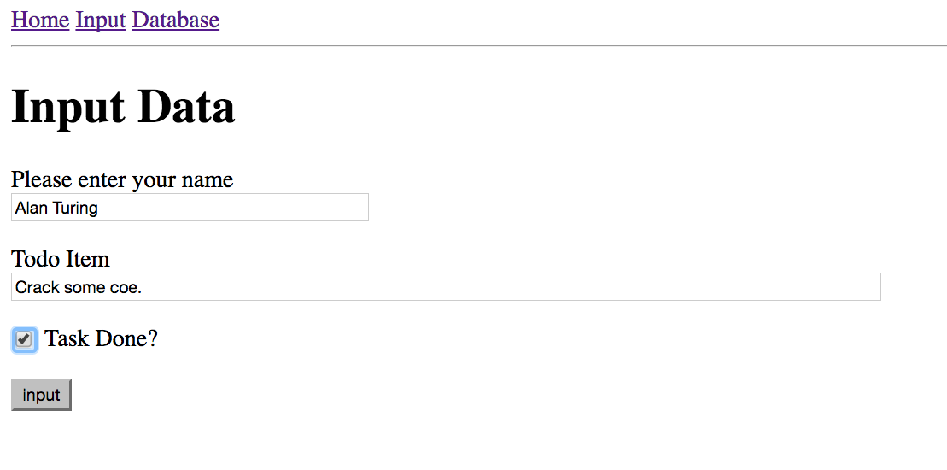
View the Database
Once you have some data in the database, you can return to the index route and fix it up to display all data in the database. This is just a query and loop over the data to build a list. The template can loop over this list to output the actual HTML for the table.

Submission

Once again, you will submit this by demonstrating it for me on your computer.

