**Chapter 1:**

*Quickdive.R*:

Reads in seal one at a time and computed the broken stick model. First accounts for drift in depth readings by performing Zero offset correction analysis on dives to omit drift in pressure sensor using offset method at 2hr intervals. Resolution of depth readings are at 0.5 [m] and resolution of temperature data is 0.05 [DegC]. Dives are identified every time the seal exceeds 4m (Dives > 4m) and given a dive number.

Creates:

* df_init_tmp2 –> First-stage processed data frame of depth and temperature data.

Adds columns:

* "dur" –> duration of a single dive from start to finish (>4m to <4m)
* "max.d" –> maximum depth of the dive
* "bottom_depth" –> defined as 80% of maximum depth to categorise bottom phase
* "bottom_time/dive time" –> foraging effort relative to bottom time where foraging effort is given by bottom time because studies have shown that fur seals spend most of their time foraging in the bottom phase of dives.

Creates:

* all_dives–> Second-stage processed data frame of depth and temperature data where only potential foraging dives are accessed (>4m and >60sec).

For purposes of looking at the influence of water column physical characteristics on diving behaviour I only calculated thermoclines for these ‘potential foraging’ dives. I also excluded these shorter dive (<=60sec) for purposes of computational efficiency i.e. each script run took on average 3 hours and I have 72 seals.

*Loop_for_divestats_2020_10_19.ipynb:*

Downcast dataframe – taken from start time of dive to the time of maximum depth and then ordered by depth.

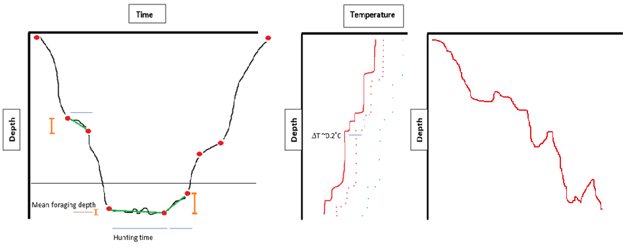

Sort by depth not time

Gridded from a 0.5m grid onto a 1m custom grid. Irrelevant of how fast seals are swimming as the temperature readings are highly responsive. Calibrated and tested by Mia.

Thermocline depth function: def calc_mldepths(flr_gridded_xds, TDiff_lim>0.1, deltaT_lim>0.25, ref_dpt=10)

Hybrid method of using first derivative greater than 0.1 DegC and temperature difference between surface and given depth greater than 0.25 DegC with reference depth of 10m.

Nt calculation for each depth using where alpha = -0.000125 (average for this area using UK.MET objective analysis product) and g = 9.8 [m.s-2]

Dives west and east of the island.

Exclude seal 57 dives East of the island because I am reading in each seal in a loop as a time series and not as points in space (West or East dives).

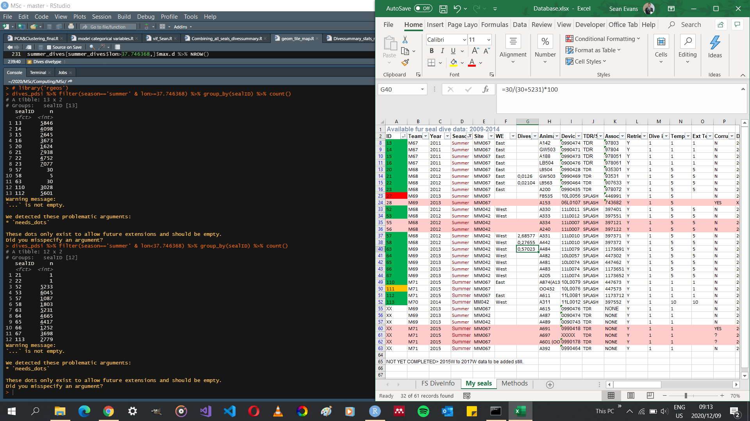

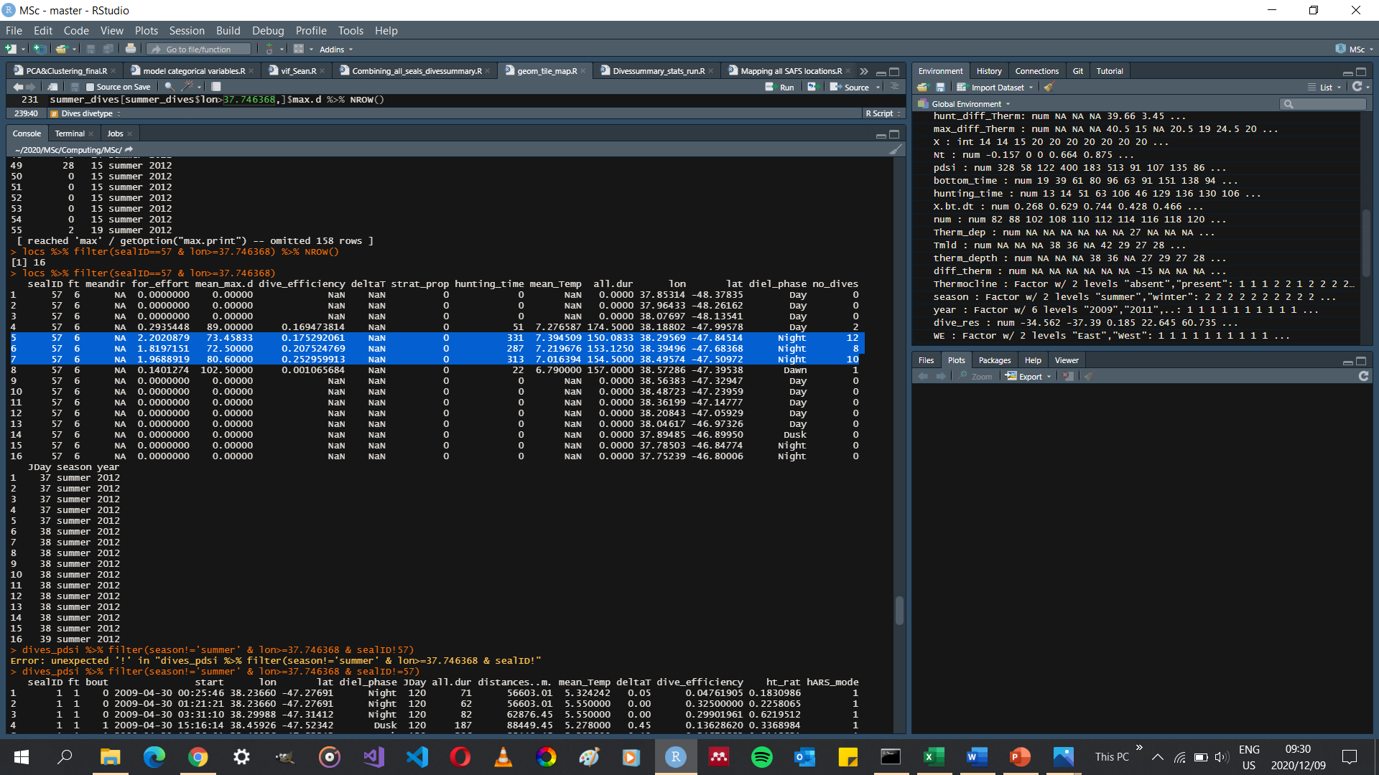

All dives for sealID==57 on the East of the island are in a single night, but quite far East and so would skew my findings if I were to include them as West dives. Exclude dives in R before reading into python.

I could say I used a radius threshold from the island of a certain distance before excluding any dives that were categorized as being East or West of the island.

