**Command Line Instructions Document**

1. Go to directory where code is located using cd command, ensure csv files in are same folder.

2. Input javac CLIRun.java

3. Input java CLIRun

4. Follow prompts to interact with command line.

For example, you will be met with this after java CLIRun



To make your choice you input 1/2

Let’s say you input 2, you can then register a new owner as one option:

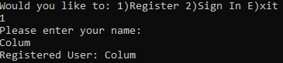

Once registered you now have access to the following commands



In this screenshot the new user registers and views a property:

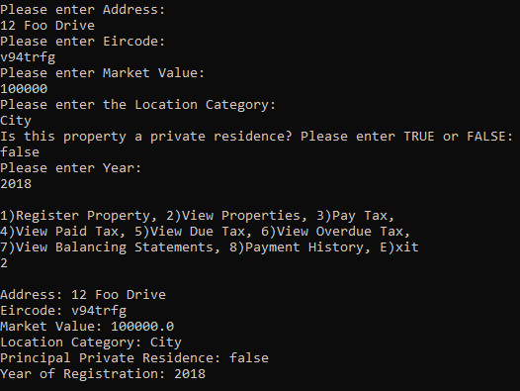

In this example a User that has already been registered and their data stored signs in and views their properties:

