Case 1: From Human Genetics and Society, Yashon and Cummings

ATHLETE DOESN’T PASS TEST
Sex testing was used in the Olympics and other world class competitions following charges that some countries were having men compete as women in events reserved for women.
Maria Patino was a first rate athlete, a hurdler who represented Spain. At the World University Games in Japan in 1985 she was instructed to report to "Sex Control", where cells were scraped from the inside of her cheek to examine her sex chromosomes. That didn't bother her; she had already passed such a "sex check" at the Helsinki World Championships in 1983. But she had forgotten to bring her "certificate of femininity" to Japan and had to be retested.
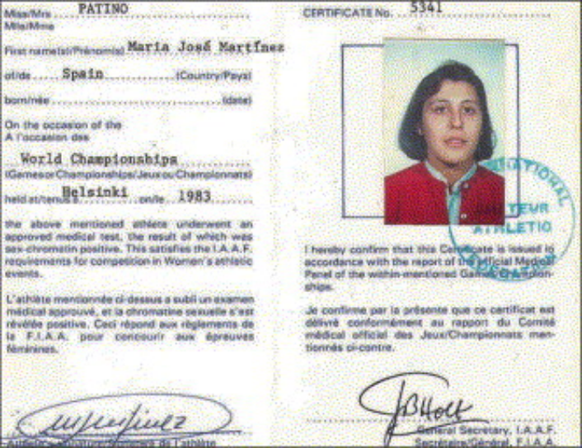

A few hours after the test, an official told her the results were abnormal. “What did that mean,” she wondered? They asked her to go to the hospital in the morning, before her race, to be retested. She was assured she would definitely make her race.
Maria was in and out of the hospital in a few minutes. The doctors spoke only Japanese, and no one said a word to her. It wasn't until she was being driven to the stadium, just before the start of her race, that Maria was told to fake an injury and withdraw from the games. Stunned, she did.
She had failed the sex test.
After returning home, Maria went to an endocrinologist who diagnosed her condition as complete androgen insensitivity (CAI). This meant that although she was raised as a female and looked like a woman, her sex chromosomes were XY, not XX. Chromosomally, she was a man!

