TECHNICAL SPECIFICATION & IMPLEMENTATION GUIDE
Enterprise DHCP Server Implementation Guide

Overview & Workflow Roadmap
This implementation guide provides complete, battle-tested step-by-step instructions (both Graphical User Interface and PowerShell) to deploy an enterprise-grade Windows DHCP Server integrated with our Two-Tier DNS Architecture (192.168.1.10 Windows DNS + 192.168.1.11 AdGuard Home Docker).
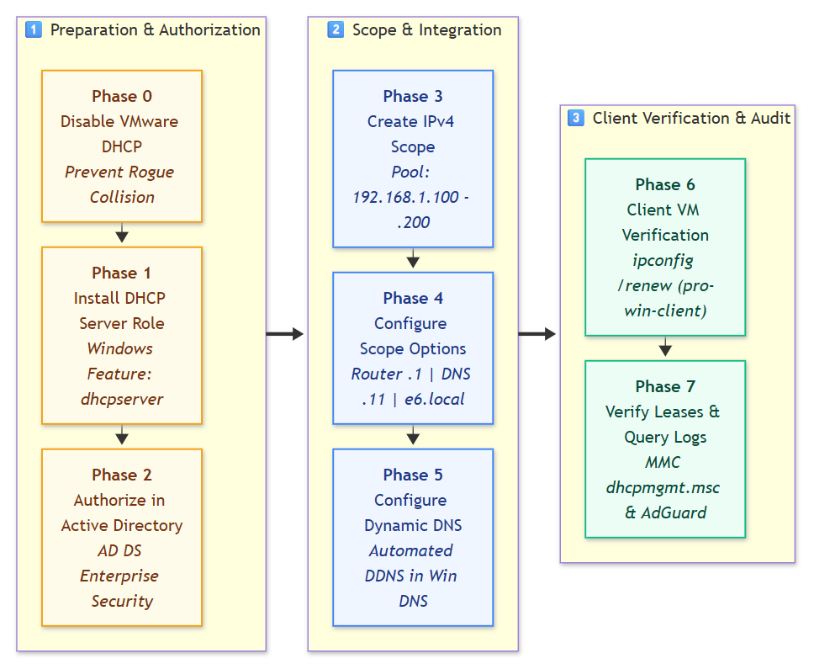
Master Subnet & IP Pool Reference (`192.168.1.0/24`)
Network Parameter | Value | Description
Subnet ID | 192.168.1.0 | Class C private network
Subnet Mask | 255.255.255.0 (/24) | 256 total IP addresses
Default Gateway | 192.168.1.1 | VMware Virtual NAT Router (vmnat.exe)
Windows Server (AD DC) | 192.168.1.10 | Domain Controller, Windows DNS, DHCP Server
AdGuard Home (Docker) | 192.168.1.11 | Network-wide ad blocker & Cloudflare DoH
Static Server Pool | 192.168.1.12 - 192.168.1.99 | Excluded from DHCP (infrastructure servers)
DHCP Distribution Pool | `192.168.1.100` - `192.168.1.200` | Dynamic IP leasing range for client VMs
Scope Option 003 (Router) | 192.168.1.1 | Assigned to all DHCP clients
Scope Option 006 (DNS) | `192.168.1.11` | Assigned to all DHCP clients (AdGuard)
Scope Option 015 (Domain) | e6.local | Search suffix for Active Directory
Lease Duration | 8 days (Default) | Standard enterprise lease

Phase 0: Disable VMware Workstation Built-in DHCP (Critical!)
🛑 CAUTION —
Why this step is mandatory:
VMware Workstation includes its own virtual DHCP server (vmnetdhcp.exe) on VMnet8. If you run Windows Server DHCP while VMware's DHCP is active, a DHCP Race Condition occurs. Whichever server replies first gives the client its IP. If VMware wins, the client receives VMware's DNS (192.168.1.2), completely bypassing AdGuard and breaking Active Directory domain resolution!

Execution Steps (On Host Laptop: Windows 11):
- On your physical host machine (Windows 11), open the Start Menu and type:
Virtual Network Editor (Run as Administrator).
- Click Change Settings at the bottom-right (shield icon) to grant Administrator privileges.
- In the top table, select `VMnet8` (NAT).
- At the bottom, look for the checkbox:
❌ Uncheck: "Use local DHCP service to distribute IP address to VMs".
- Click Apply, then click OK.
(Alternative via Windows 11 Host Services: Open `services.msc` ➔ locate VMware DHCP Service ➔ Right-click ➔ Stop, and set Startup type to Disabled).

Phase 1: Install DHCP Server Role on Windows Server 2022
Perform these steps inside your Windows Server VM (`pro-win-server`):
Option A: Via PowerShell (Fastest)
Open PowerShell as Administrator:
# Install the DHCP server role and RSAT management tools
Install-WindowsFeature -Name DHCP -IncludeManagementTools
# Verify installation status
Get-WindowsFeature -Name DHCP

Option B: Via Server Manager GUI
- Open Server Manager ➔ Click Manage (top-right) ➔ Select Add Roles and Features.
- Click Next until you reach the Server Roles page.
- Check the box for DHCP Server.
- In the popup window (Add features that are required for DHCP Server?), click Add Features.
- Click Next ➔ Next ➔ Next ➔ Click Install.
- When the installation finishes, click Close.

Phase 2: Authorize DHCP Server in Active Directory (AD DS)
📌 NOTE —
In an Active Directory forest, an unauthorized DHCP server is treated as a rogue device and will refuse to distribute IP leases. You must authorize the DHCP server in Active Directory.

Option A: Via PowerShell
# Add DHCP security groups
netsh dhcp add securitygroups
# Restart the DHCP service to apply security group membership
Restart-Service dhcpserver
# Authorize this server in Active Directory forest (e6.local)
Add-DhcpServerInDC -DnsName WIN-J17IMHCEMA9.e6.local -IPAddress 192.168.1.10
# Verify authorization
Get-DhcpServerInDC

Option B: Via Server Manager GUI
- In Server Manager, look at the top-right notification flag (yellow exclamation mark ⚠️).
- Click the notification ➔ Click "Complete DHCP configuration".
- In the DHCP Post-Install configuration wizard:
- Description page: Click Next.
- Authorization page: Select "Use the following user's credentials" (should show E6\Administrator) ➔ Click Commit.
- Click Close.

Phase 3: Create IPv4 DHCP Scope (`192.168.1.0/24`)
We will create a scope named `E6-Clients-Scope` distributing IPs from 192.168.1.100 to 192.168.1.200.
Option A: Via PowerShell
# Create the DHCP Scope
Add-DhcpServerv4Scope -Name "E6-Clients-Scope" `
-StartRange 192.168.1.100 `
-EndRange 192.168.1.200 `
-SubnetMask 255.255.255.0 `
-State Active `
-LeaseDuration (New-TimeSpan -Days 8) `
-Description "Scope for lab client virtual machines"

Option B: Via DHCP Management Console GUI (`dhcpmgmt.msc`)
- Press Win + R ➔ type `dhcpmgmt.msc` ➔ press Enter.
- In the left tree, expand your server name: `WIN-J17IMHCEMA9.e6.local`.
- Right-click IPv4 ➔ Select New Scope....
- Click Next on the welcome screen.
- Scope Name:
- Name: E6-Clients-Scope
- Description: Scope for lab client virtual machines
- Click Next.
- IP Address Range:
- Start IP address: 192.168.1.100
- End IP address: 192.168.1.200
- Length: 24
- Subnet mask: 255.255.255.0
- Click Next.
- Add Exclusions and Delay:
- Leave blank (our range already starts at .100, excluding our .1 to .99 static infrastructure) ➔ Click Next.
- Lease Duration:
- Leave default (8 Days) ➔ Click Next.
- Configure DHCP Options:
- Select "Yes, I want to configure these options now" ➔ Click Next.

Phase 4: Configure Scope Options (Router, DNS, Domain)
This is the most critical configuration phase that connects DHCP to AdGuard Home.
1. Scope Option Settings Table
Option Code | Parameter Name | Setting Value | Purpose
`003` | Router (Default Gateway) | 192.168.1.1 | VMware Virtual NAT Gateway
`006` | DNS Servers | `192.168.1.11` | AdGuard Home Container (Port 53)
`015` | Domain Name | e6.local | Primary Active Directory DNS Suffix

Option A: Via PowerShell
# Set Router (Gateway) -> 192.168.1.1
Set-DhcpServerv4OptionValue -ScopeId 192.168.1.0 -OptionId 3 -Value "192.168.1.1"
# Set DNS Server -> 192.168.1.11 (AdGuard Home)
Set-DhcpServerv4OptionValue -ScopeId 192.168.1.0 -OptionId 6 -Value "192.168.1.11"
# Set Domain Name (DNS Suffix) -> e6.local
Set-DhcpServerv4OptionValue -ScopeId 192.168.1.0 -OptionId 15 -Value "e6.local"

Option B: Via GUI (Continuation of New Scope Wizard)
- Router (Default Gateway) [Option 003]:
- In IP address box, type: `192.168.1.1` ➔ Click Add ➔ Click Next.
- Domain Name and DNS Servers [Option 006 & 015]:
- Parent domain: Type `e6.local`.
- Under IP address:
- Remove any existing addresses (like 127.0.0.1 or 192.168.1.10).
- Type: `192.168.1.11` ➔ Click Add.
(If a prompt says "The DNS server is not valid or does not respond", click Yes to add it anyway).
- Click Next.
- WINS Servers:
- Leave blank ➔ Click Next.
- Activate Scope:
- Select "Yes, I want to activate this scope now" ➔ Click Next ➔ Click Finish.

Phase 5: Configure Dynamic DNS (DDNS) Integration
Configure DHCP to automatically register client lease hostnames into Windows Active Directory DNS (e6.local).
Option A: Via PowerShell
# Enable Dynamic DNS updates for clients in the scope
Set-DhcpServerv4DnsSetting -ScopeId 192.168.1.0 `
-DynamicDnsUpdates "Always" `
-DeleteDnsRROnLeaseExpiry $true `
-UpdateDnsRRForClientsNotRequestingUpdates $true

Option B: Via GUI (`dhcpmgmt.msc`)
- In DHCP Manager, expand IPv4 ➔ Right-click Scope [192.168.1.0] E6-Clients-Scope ➔ Click Properties.
- Select the DNS tab:
- Check: "Enable DNS dynamic updates according to the settings below:"
- Select: "Always dynamically update DNS records".
- Check: "Discard A and PTR records when lease is deleted".
- Check: "Dynamically update DNS A and PTR records for DHCP clients that do not request updates".
- Click Apply ➔ Click OK.

Phase 6: Client VM Verification (`pro-win-client`)
Now test the complete DORA cycle by configuring your client VM (`pro-win-client`) to obtain its IP address automatically.
Step 1: Set Client to DHCP Mode
On `pro-win-client`:
Via GUI (`ncpa.cpl`):
- Press Win + R ➔ type `ncpa.cpl` ➔ press Enter.
- Right-click Ethernet0 ➔ select Properties.
- Double-click Internet Protocol Version 4 (TCP/IPv4):
- Select: 🔘 "Obtain an IP address automatically"
- Select: 🔘 "Obtain DNS server address automatically"
- Click OK ➔ Click Close.
Via PowerShell (Alternative):
Set-NetIPInterface -InterfaceAlias "Ethernet0" -Dhcp Enabled
Set-DnsClientServerAddress -InterfaceAlias "Ethernet0" -ResetServerAddresses

Step 2: Trigger the DORA Exchange
In PowerShell on `pro-win-client`:
# Release current IP
ipconfig /release
# Request a new lease from Windows DHCP (Triggers DORA!)
ipconfig /renew
# Inspect all received parameters
ipconfig /all

Step 3: Verify Received Configuration
Examine the ipconfig /all output on the client. It must show:
Ethernet adapter Ethernet0:
Connection-specific DNS Suffix . : e6.local
Description . . . . . . . . . . . : Intel(R) 82574L Gigabit Network Connection
DHCP Enabled. . . . . . . . . . . : Yes
Autoconfiguration Enabled . . . . : Yes
IPv4 Address. . . . . . . . . . . : 192.168.1.100(Preferred)
Subnet Mask . . . . . . . . . . . : 255.255.255.0
Lease Obtained. . . . . . . . . . : Friday, October 9, 2026
Lease Expires . . . . . . . . . . : Saturday, October 17, 2026
Default Gateway . . . . . . . . . : 192.168.1.1
DHCP Server . . . . . . . . . . . : 192.168.1.10
DNS Servers . . . . . . . . . . . : 192.168.1.11

- ✅ DHCP Server: Shows 192.168.1.10 (Windows Server issued the lease!).
- ✅ IPv4 Address: Shows 192.168.1.100 (First address in our pool).
- ✅ DNS Server: Shows 192.168.1.11 (AdGuard Home).
- ✅ Gateway: Shows 192.168.1.1 (VMware NAT router).

Step 4: Run End-to-End DNS Verification Suite on Client
# 1. Test Active Directory Resolution
nslookup WIN-J17IMHCEMA9.e6.local
# 2. Test Short Computer Name (Option 015 Suffix Resolution)
ping WIN-J17IMHCEMA9
# 3. Test Network-Wide Ad Blocking
nslookup adservice.google.com
# 4. Test Encrypted Internet Browsing
nslookup google.com

Phase 7: Verification in DHCP MMC & AdGuard Query Log
1. View Active Leases in Windows Server DHCP MMC
On Windows Server:
- Press Win + R ➔ type `dhcpmgmt.msc` ➔ press Enter.
- Expand: `WIN-J17IMHCEMA9.e6.local` ➔ `IPv4` ➔ `Scope [192.168.1.0] E6-Clients-Scope` ➔ Click Address Leases.
- In the right pane, you will see your client VM listed:
- Client IP Address: 192.168.1.100
- Host Name: pro-win-client.e6.local
- Lease Expiration: 8 days from today
- Type: DHCP
Via PowerShell:
Get-DhcpServerv4Lease -ScopeId 192.168.1.0

2. Verify Dynamic DNS Registration in Windows DNS MMC
- Press Win + R ➔ type `dnsmgmt.msc` ➔ press Enter.
- Expand Forward Lookup Zones ➔ Click `e6.local`.
- Notice that a new A record for `pro-win-client` pointing to `192.168.1.100` was created automatically by DHCP!

3. Verify in AdGuard Dashboard
- Open http://localhost:8080/#querylog on the server.
- Watch incoming DNS requests from client `192.168.1.100`!

Phase 8: Troubleshooting & Diagnostic Reference
1. Client Receives IP from Wrong Range (e.g. `192.168.1.128+`)
- Root Cause: VMware's built-in DHCP (vmnetdhcp.exe) is still running on VMnet8.
- Fix: Open Virtual Network Editor on Windows 11 host ➔ Uncheck "Use local DHCP service to distribute IP address to VMs" on VMnet8 ➔ Click Apply. On client, run ipconfig /release && ipconfig /renew.
2. DHCP Server Icon Has Red Exclamation / Refuses Leases
- Root Cause: DHCP server is not authorized in Active Directory.
- Fix: In PowerShell on the server, run:
Add-DhcpServerInDC -DnsName WIN-J17IMHCEMA9.e6.local -IPAddress 192.168.1.10
Restart-Service dhcpserver

3. Client Receives IP but Cannot Access Internet
- Root Cause: Option 003 (Router) is misconfigured or pointing to an invalid gateway.
- Fix: Verify Scope Option 003 is set to 192.168.1.1 (VMware Virtual NAT Gateway). Test with ping 192.168.1.1 from the client.

