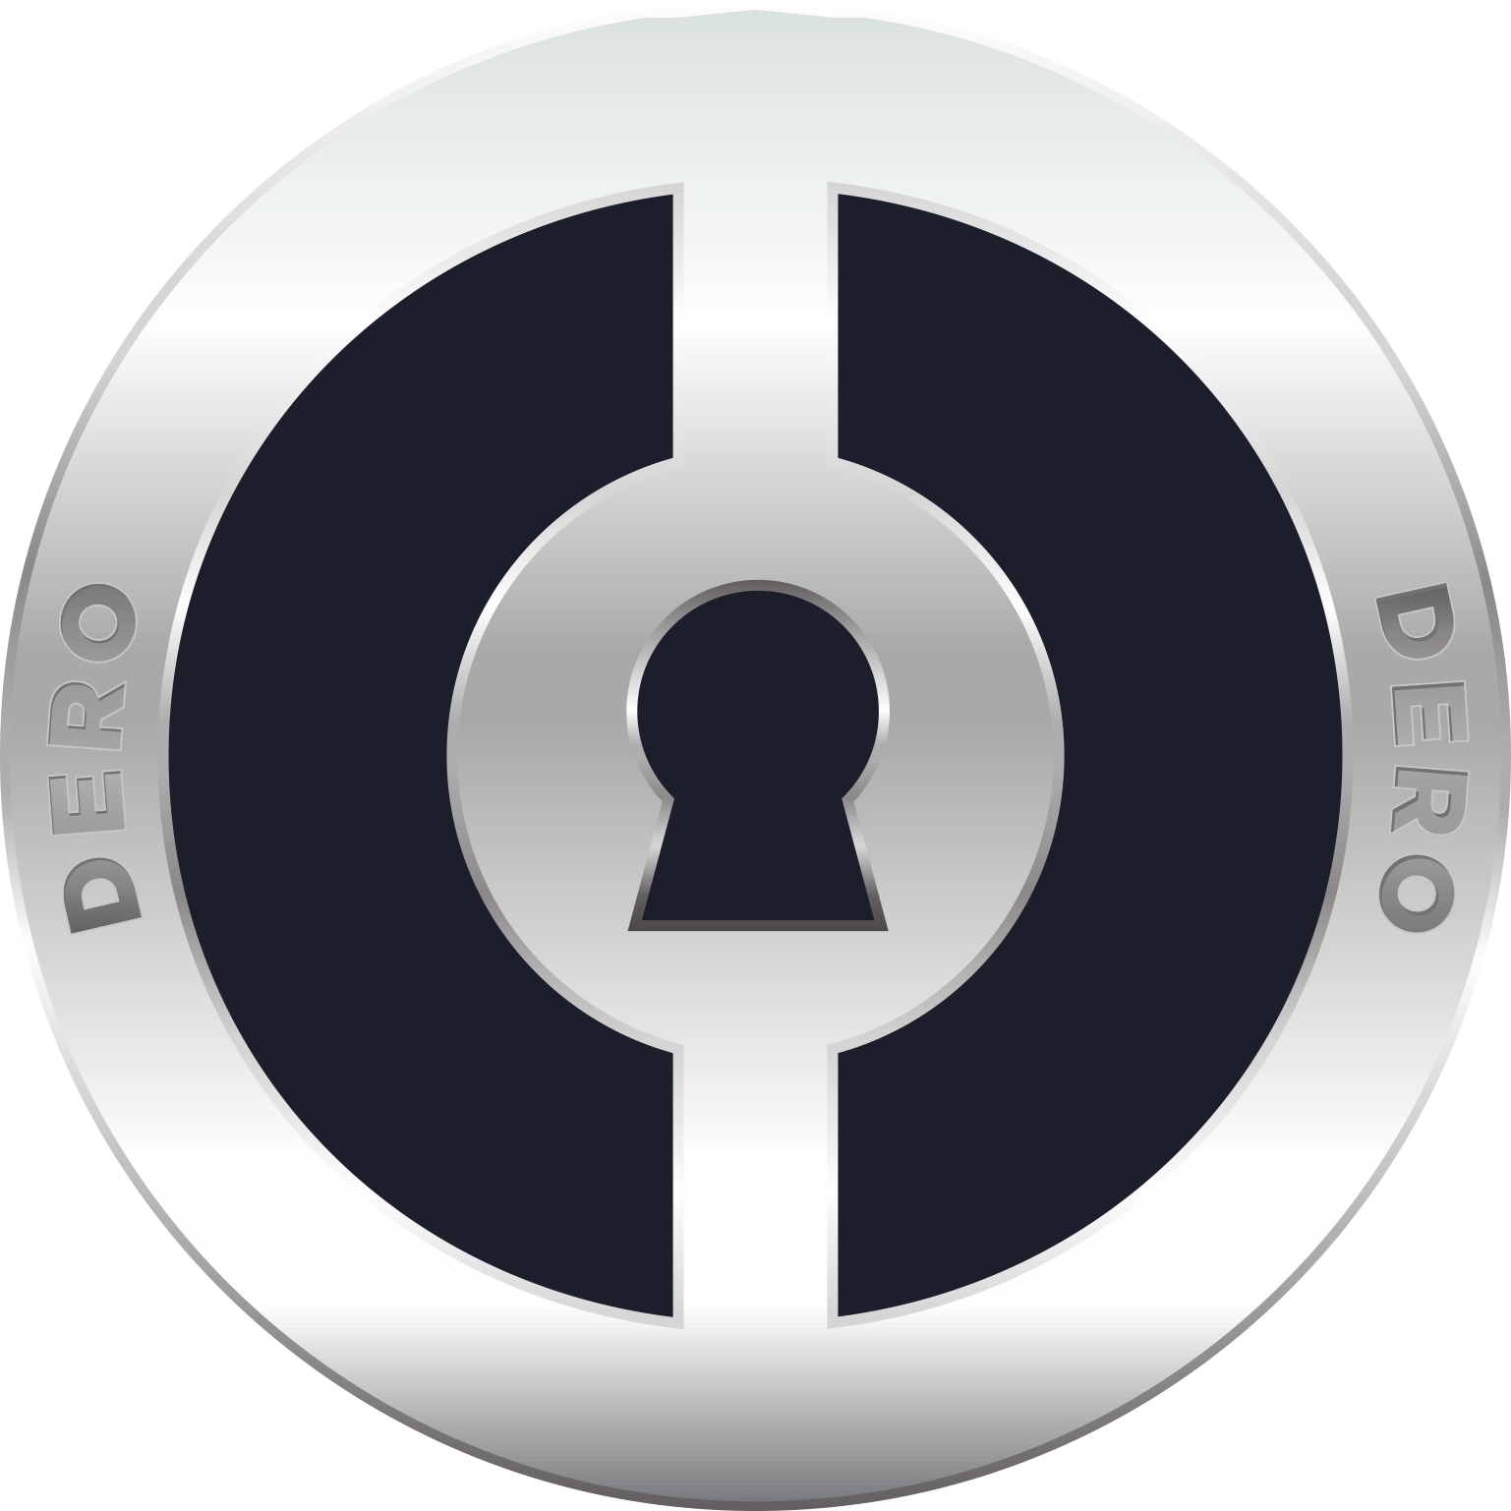

DERO: Privacy + Smart Contracts
Whitepaper Draft 1a
Expect modifications based on community inputs.

CAPTAIN DERO
0F39 E425 8C65 3947 702A 8234 08B2 0360 A03A 9DE8
support@dero.io

SUMMARY
DERO is completely new experimental blockchain technology with focus on enhanced Privacy and Smart Contracts as well as maintaining the transparency and security of the blockchain.
DERO tries to explore and expand the capabilities of blockchain by bringing together some of the best proven blockchain technologies like CryptoNote Protocol and Smart Contracts.

Blockchain is "an open, distributed ledger that can record transactions between two parties efficiently and in a verifiable and permanent way".

CryptoNote Protocol use a distributed public ledger that records all balances and transactions of its in-built currency like Bitcoin. Unlike Bitcoin, CryptoNote's transactions cannot be followed through the blockchain in a way that reveals who sent or received coins. The approximate amount of a transaction can be known, but the origin, destination, or actual amount cannot be learned. The only information available is that the actual amount was lower than the displayed amount. The only people with access to the whole set of data about a transaction are the sender or receiver of the transaction and the person who possesses one or both secret keys.

Smart Contract is a computer protocol intended to digitally facilitate, verify, or enforce the negotiation or performance of a contract . Smart contracts allow the performance of credible transactions without third parties. These transactions are trackable and irreversible.[1] Smart contracts were first proposed by Nick Szabo in 1994.[2]

For more details about Blockchain, CryptoNote Protocol and Smart Contract see:
https://en.wikipedia.org/wiki/Blockchain
https://en.wikipedia.org/wiki/CryptoNote
https://en.wikipedia.org/wiki/Smart_contract

Enhanced Reliability, Privacy, Security, Usability, Portability are the key points from the very beginning on DERO blockchain.

On DERO blockchain, Assume a smart contract to access/authorize a building/open a door or any other service like asset-management/purchasing-tickets or any other products.
Normally all would not like to share and view details of all other users or customers who used, participated, access that contract or service.
Everyone like transparency in contract details but would not like to share or disclose their details to rest of the world.

DERO KEY FEATURES:
CryptoNote Privacy
Smart Contracts
Atomic Swap
Mobile wallet
Light offline wallet for minor tasks like balance checks.
Ghost Addresses

DERO Virtual Machines:
Smart Contracts on DERO blockchain will run in DERO Virtual Machine(DVM).
DVM is Turing complete 256-bit Virtual Machine runtime environment for DERO Smart Contracts with CryptoNote Protocol Privacy and additional modifications.
DVM is unique and first of its kind because in-addition to executing smart contracts it will maintain the privacy and fungiblity of the identities involved in the Smart Contracts.
DVM will support Solidity and Golang languages.

DVM is in-development phase and several other features and optimizations are planned.

DERO PRACTICAL BLOCKCHAIN DEVELOPMENT
DERO will take reverse approach in development: From real world examples, usages, community suggestions to develop and enhance practical blockchain which can be deployed and used widely. DERO welcome all users to participate in development. Please contribute your ideas and suggestions.

ROADMAP 2017-18
DERO Blockchain full Activation. First Quarter-2018.
GUI Wallets, Ghost Addresses, Atomic Swap, Smart Contracts Testing. Second Quarter-2018.
Smart Contracts support on chain. Third Quarter-2018.
Bigger Exchanges: In talks.

SPECIFICATIONS

PoW algorithm: CryptoNight
Max supply: 18.4 million for first 8 years,Infinite
Block reward: Smoothly varying
Block time: 120 seconds
Difficulty: Retargets at every block
Ticker: DERO

PREMINE
Premine 2 million(1.2 million locking for 4 years straight).
First 0.3 million reserved for various activities. Get unlocked only 10%, 20%, 30%, 40% each year.
Second 0.5 million for development. Get unlocked only 20%, 20%, 30%, 30% each year.

Why premine:
For long term development and success of the project.
Coins will be locked to various heights for next 4 years and portion of premine will be used for various community activities. Cryptonote protocol can lock coins to various block heights.

STATUS UPDATE RELEASE 1:
Track the progress of DERO blockchain: https://github.com/deroproject/derosuite

